NATIONAL INSTITUTE FOR HEALTH AND CARE EXCELLENCE

Research to Access Pathway for Investigational Drugs in COVID-19 (RAPID C-19): interim process for NICE activities
- Introduction
  - This document describes NICE’s interim process for the Research to Access Pathway for Investigational Drugs in COVID-19 (RAPID C-19).
  - The document sets out the main stages of the RAPID C-19 process. Because of the need for rapid action the stages and the steps within them will often run in parallel and may evolve as needed. An overview of the process is provided in Annex 1.
- RAPID C-19 partners and Oversight Group
  - RAPID C-19 is a multi-agency initiative to ensure safe and timely patient access to treatments that show evidence of benefit in preventing and treating COVID-19. It involves the following partner agencies:
- the Medicines and Healthcare Regulatory Agency (MHRA)
- NHS England and Improvement (NHSE&I) Specialised Commissioning
- NICE
- the National Institute for Health Research (NIHR)
- the Department of Health and Social Care (DHSC)
- the Scottish Medicines Consortium (Health Improvement Scotland)
- the All Wales Therapeutics and Toxicology Centre
- the All Wales Medicines Strategy Group and
- the Northern Ireland Health and Social Care Board.
  - NHSE&I has overall responsibility for establishing RAPID C-19, in close collaboration with NICE, NIHR, MHRA and the Therapeutics Task Force (TTF) at DHSC. Different activities in the RAPID C-19 process are done by different partners. For example:
- NICE with the NIHR Innovation Observatory (NIHRIO) is responsible for:
  - coordinating horizon-scanning activities
  - supporting NHSE&I’s clinical policy development
  - health technology assessments of approved topics and maintenance of NICE’s living guideline on managing COVID-19.
- The MHRA is responsible for regulatory and authorisation functions (clinical trials, early access and marketing authorisation).
- NHSE&I is responsible for clinical policy development.
- The TTF at DHSC is responsible for purchase and supply.

The RAPID C-19 Oversight Group
  - The RAPID C-19 Oversight Group considers potential COVID-19 topics in development and prioritises those likely to be expedited for patient access in the NHS. It is a forum for decision makers and advisory members from MHRA, NHSE&I, NICE, DHSC and NIHR. Health technology assessment representatives from the devolved nations also attend.
  - For topics in development and likely to be expedited, the RAPID C-19 Oversight Group advises on the actions needed to inform and support the development of potential access routes. This is part of a joint agency agreement on the approach to development, implementation and patient access. This includes the period between significant data emerging and a marketing authorisation being granted (if applicable).
  - Topics considered by the RAPID C-19 Oversight Group are expected to be off-label or unlicensed treatments entering a pathway to be licensed. The scope of the work is currently limited to preventing and treating COVID-19. This excludes vaccines and devices unless the device is a necessary part of delivering the treatment (such as a nebuliser).
- Process overview

Primary horizon scanning
  - Every day, the NIHRIO does primary horizon scanning. This identifies all registered clinical trials of treatments for COVID-19 in the UK and internationally. The primary horizon scans are available at the NIHRIO website.

Prioritisation
  - The outputs of the primary horizon scans are sent to NICE weekly. This is used to identify topics for discussion at the weekly RAPID C-19 Oversight Group meeting.
  - NICE extracts and prioritises the data from the scans using a set of filtering principles. These can include:
- number and size of trials
- trial location
- phase of trial
- timing of trial reporting.
These criteria are amended depending on the needs of the health system at the time. The following are also considered:
- treatment pathway
- patient populations
- severity of disease
- combinations and classes of treatments
- new variants
- regulatory status.
This helps to ensure that the RAPID C-19 initiative considers the treatments with the most potential value to the system, according to need at different times during the pandemic.

Enrichment and monitoring
  - After being prioritised, the NIHRIO horizon-scanning reports are reviewed by NICE. They are enriched with information from literature searches done by NICE information specialists, which identify evidence on treatments used in COVID-19. Further information on individual topics is gathered from several sources in the UK and internationally.
  - More information on the progress of the clinical trials and the likelihood of substantive new evidence becoming available for each topic is derived from:
- information on UK platform trials from the TTF and other partners in the RAPID C-19 initiative
- engagement with principal investigators or commercial sponsors of studies (UK and international)
- trial tracking to identify changes in anticipated key trial reporting dates
- weekly literature searches to identify emerging evidence and clinical development updates announced by companies
- obtaining preliminary results from principal investigators or commercial sponsors, if available.
  - When possible, more information on market access plans for individual topics is collected from commercial sponsors. This may include:
- Regulatory intention, such as if there are plans to apply for an Early Access to Medicines Scheme (EAMS). EAMS aims to give people with life-threatening or seriously debilitating conditions access to medicines that do not yet have a marketing authorisation when there is a clear unmet medical need. This might also include plans to seek regulatory and scientific advice, or if there will be a submission for a licence or licence extension (and if so, the anticipated population, indication and timings).
- Clinical development strategy and key trial reporting dates or available preliminary results.
- Commercial availability and supply (particularly for treatments not currently available in the UK) and the company’s ability to upscale production. This information will be used to support TTF discussions at DHSC.
- Identifying and clarifying the outcome of any previous engagement with relevant organisations, such as NHSE&I, MHRA or DHSC.
  - When there are ongoing trials of generic drugs sponsored by academic centres or hospitals but without a commercial sponsor, information on identifying a commercial sponsor is first sought from the British Generic Manufacturers Association via the NHSE&I Repurposing Medicines Programme.

Briefings
  - NICE collates and interprets the horizon-scanning outputs and additional information from enrichment and monitoring, to develop briefings on priority topics for the RAPID C-19 Oversight Group to consider. Each briefing takes up to 5 working days to develop.
  - The briefings provide a comprehensive overview of the treatment and the existing and forthcoming evidence about its use in COVID-19. Information in the briefing includes:
- mechanism of action and anticipated place in the treatment pathway
- method of administration, dose and schedule
- cost of the treatment, where known
- current regulatory status and regulatory plans, where known
- information known about current and future supply
- existing guidance, where applicable
- existing evidence
- ongoing trials, including key trials and trials expected to report soon
- other relevant issues for consideration.

RAPID C-19 Oversight Group meeting
  - The RAPID C-19 Oversight Group meets weekly and considers each topic using the briefing. Briefings are circulated by the NICE secretariat using NICE’s secure document sharing system (NICE Docs) no later than 24 hours before the meeting.
  - For each topic, the RAPID C-19 Oversight Group looks for signals of efficacy from the evidence and assesses the strength of these to inform next steps. It uses the information from the briefing with insight from members to consider what preparations are needed for patient access.
  - The RAPID C-19 Oversight Group determines the potential access routes for a treatment should emerging evidence show it to be effective. Considerations around potential access routes can include the following:
- Timelines for an early-stage regulatory support package, for example joint MHRA and NICE scientific advice.
- Suggested steps and timelines for sponsor submission to MHRA for an EAMS Scientific Opinion.
- Suggested steps and timelines for an NHSE&I commissioning policy or different commissioning approaches from NHSE&I for patient access.
- Plans for development of an early NICE output, such as an evidence summary to support an NHSE&I commissioning policy.
- Plans for development of formal NICE guidance (if applicable), in the context of existing arrangements for NICE topic selection.
- Suggested steps and timelines managing the supply chain for the treatment, including liaison with the TTF at the DHSC.
  - The RAPID C-19 Oversight Group agrees the next steps for each topic considering the emerging evidence. Options include:

Progress
Where good evidence of efficacy is sufficient for further action to be taken. The Oversight Group’s assessment of the evidence and suggested next steps will be summarised in a briefing to the Chief Medical Officer.

Monitor
Where good evidence of efficacy is currently insufficient but there are other ongoing trials. The topic will remain in the enrichment and monitoring stage and will be brought back to the RAPID C-19 Oversight Group when results from the identified key trial(s) are due.

Stand down
Where there is no evidence of efficacy and none likely to be forthcoming. The topic will be deprioritised for active monitoring but can be brought back to the RAPID C-19 Oversight Group if new evidence emerges.
  - Information from the topic briefings will be shared within NICE where relevant to inform or to handover to next stage activities (for example the Centre for Guidelines and Centre for Health Technology Evaluation).
- Contact and confidentiality
  - The NICE secretariat is the first point of contact for the RAPID C-19 Oversight Group meeting attendees and is responsible for collating and disseminating the agenda and briefing in advance, along with noting relevant actions and decisions from the meeting.
  - All member organisations of the group are required to sign a Confidentiality and Undertaking agreement that states how confidential information can be shared with and used by all agencies. Individual members are required to sign a Declarations of Interest form for each briefing before every meeting and receiving the meeting papers.
- Review and update
  - Because of the ongoing pandemic this process will be regularly reviewed and updated.

- Annex 1: Process overview
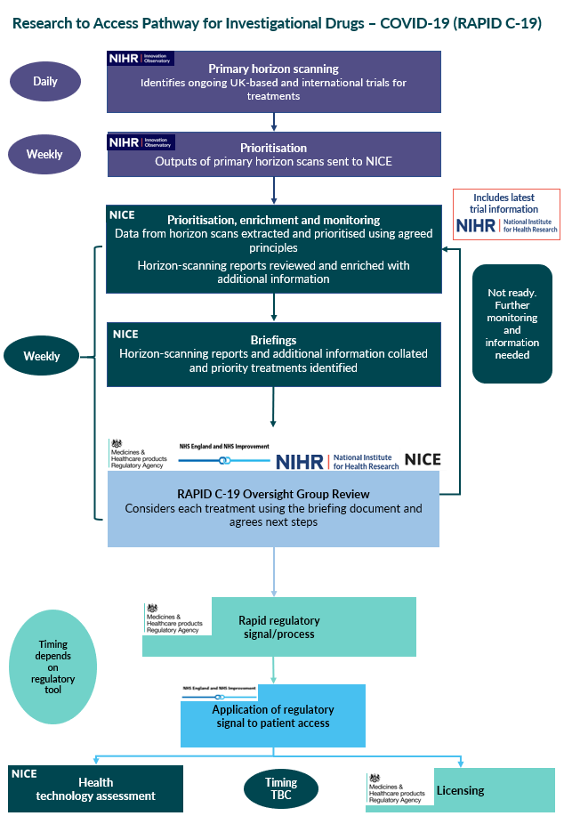
- Summary of changes to the process guide
Year | Chapter | Title | Revisions
2021 | General | NA | The process guide has been updated throughout to reflect that Rapid Action Plans (RAPs) are no longer produced. All information previously documented in a RAP is now included in the topic briefing.
2021 | 3.13 | RAPID C-19 Oversight Group meeting | Further detail has been added regarding the next steps for topics considered by the RAPID C-19 Oversight Group
2021 | Annex 2 | Horizon scanning prioritisation principles | This table has been removed and the principles have been added to paragraph 3.3.

