National Institute for Health and Care Excellence

Health technology evaluation   
process and methods review:   
Second consultation

This report gives details of the launch of the second consultation for the health technology evaluation process and methods review.

The Board is asked to note progress made to date, approve the plans to launch the second consultation for the health technology evaluation process and methods review, and support an extended consultation period and further opportunities for engagement in the autumn leading to final publication in January 2022.

Meindert Boysen

Director, Centre for Health Technology Evaluation

July 2021

Introduction

We regularly review the processes and methods for health technology evaluation at NICE. We initiated the current review in 2019.

The purpose of the review is to optimise NICE's evaluation methods and processes to support the ambition of the NHS to provide high quality care that offers good value to patients and to the NHS.

Ensuring rapid access to clinically and cost-effective health technologies is critically important to patients and their families, the NHS and the life sciences industry. To continue to support the needs and aspirations of all parts of the healthcare and life sciences ecosystem, we must ensure that its processes of health technology evaluation maintain and improve upon key objectives regarding quality, dependability, speed, flexibility and value for money.

One of the four key priorities of the NICE 5-year strategy is the development of 'rapid, robust and responsive technology evaluation'. Implementation of this strategy will require us to focus on investing in the path towards creating final guidance as an output of a collaborative process and a holistic approach of ‘health technology management’. Health Technology Management will facilitate effective HTA ecosystem support for early development, early advice, adoption, real world performance and reassessment and disinvestment that are targeted to ensuring that the needs of the patients are front and centre in our activities.

The review is not starting with a blank sheet of paper. This is an incremental development of our existing world class approach to evaluating new health technologies.

The review further responds to a commitment in the voluntary scheme for branded medicines pricing and access, agreed by government and the Association of the British Pharmaceutical Industry (ABPI) in December 2018, for NICE to review its processes and methods for the Technology Appraisal Programme and the Highly Specialised Technologies Programme.

We are taking this opportunity to extend the review to include the methods and processes of the Medical Technologies Evaluation Programme and the Diagnostics Assessment Programme and align them where appropriate to ensure that health technology evaluation is pragmatic, agile and robust, while also being able to adapt to environmental changes and system partners' requirements.

The review accounts for the remit of the individual programmes, arrangements for topic identification and selection, and the ability to receive evidence from sponsors of the technology of interest, amongst others. It also includes removing the interim nature of the current Highly Specialised Technologies methods and processes.

Together these proposals will provide a clear foundation stone for the recently published Life Sciences Vision. They represent the ambition expressed in the Vision for our methods, our role in the system, the processes of engagement we use, and the synergistic collaborations with health system partners across the landscape and countries of the UK, for a wide-ranging set of technologies from drugs and devices to diagnostics and digital.

We have been making excellent progress and are ready for the second consultation. This paper is aimed at seeking Board approval for the launch of that consultation.

The proposals have been considered by colleagues in the Department of Health and Social Care, NHS England and NHS Improvement as members of the Steering Group.

Background

We broadly divided the review in 2 stages:

* In the first stage, we reviewed the evidence and engaged with stakeholders to develop the case for change for aspects of the process and methods included in the scope for the review.
* In stage 2, we considered responses from stakeholders to the cases for change and developed proposals for implementation where we received adequate support.

We further divided the review into one focussing on topic selection, one on processes in general and one on methods. When we launch the consultation, we will continue with this separation to allow stakeholders to engage efficiently with the various topics.

A core objective of the process and methods review is to produce a single, modular, programme manual covering 4 health technology evaluation guidance programmes (Diagnostic Assessment, Highly Specialised Technologies, Medical Technologies Evaluation and Technology Appraisal). This will remove multiple existing individual process and methods guides, reduces unnecessary duplication of content and aligns to the presentation of NICE Guideline development on the website. This approach to communicating our methods and processes is anticipated to be easier for stakeholders to engage with.

Details of the governance arrangements for the methods review were presented in the NICE Board paper of July 2019, referring to the steering group, working group and task and finish groups. During the second phase of development, there have been 6 working group meetings and 5 steering group meetings, and the 5 task and finish groups have involved approximately 50 external participants.

Publishing updated process and methods is a key deliverable in our 2021-22 business plan, supporting pillar 1 and 4 of our 5-year strategic plan; 'rapid, robust and responsive technology evaluation: providing independent, world-leading assessments of new treatments at pace, quickening access for patients and increasing uptake', and 'leadership in data research and science: becoming scientific leaders by driving the research agenda, using real-world data to resolve gaps in knowledge and drive forward access to innovations for patients'.

Areas of interest from case for change

In the first consultation we focussed on 'what' we considered suitable to change in our process and methods of health technology evaluation. Presented as cases for change across several domains. The second consultation will focus on the implementation of these cases for change: the 'how'.

For Topic Selection, the key areas of interest were identified within the following themes:

* Clarification of criteria used for selection of medical technologies, diagnostics and digital health products
* Routing all diagnostic technologies to the diagnostic assessment programme, irrespective of value proposition
* Establishment of a formal Topic Selection Oversight Panel responsible for the selection and routing of topics to the Centre for Health Technology Evaluation programmes.
* Transparency of decision making and publishing topic selection decisions
* Sharing information within NICE

For processes of guidance development, 50 proposals were presented across the key areas of changes were classified in 4 key themes:

* Alignment of the current guidance development processes
* Opportunities for new process improvements and ways of working
* Commercial and Managed Access processes
* Criteria for selection and routing for the Highly Specialised Technologies evaluation programme

For the methods of guidance development, 56 proposals were presented across 5 broad topics:

* Valuing the benefits of health technologies
* Understanding and improving the evidence base
* Structured decision making
* Challenging technologies, conditions and evaluations
* Aligning methods across programmes

Consultation response

Spanning all 3 individual consultations we received a strong response from a variety of internal and external stakeholders across the life sciences industry, patient organisations, academia and the NHS. Over 195 organisations or individuals responded to at least 1 of the consultations with a total of over 7000 comments received across all. The pharmaceutical industry and patient/carer charities represent the largest groups of stakeholders that have responded to the consultations held so far.

Topic Selection

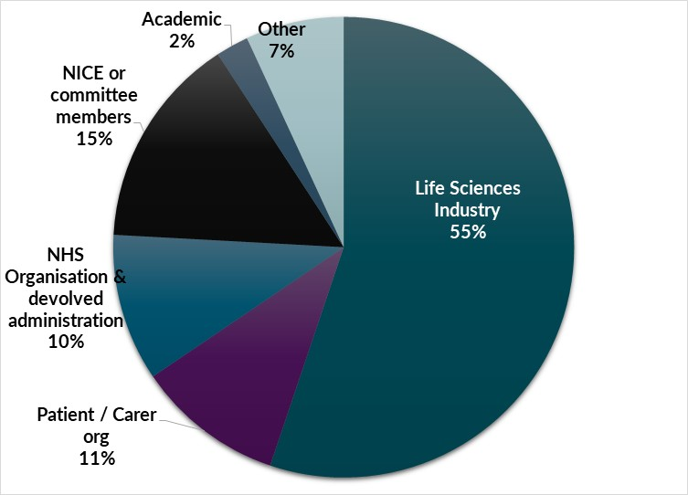The topic selection consultation received responses from 89 organisations and individuals.

Process

Chart describing the breakdown of responses to the process consultation by organisation type.  Life sciences industry 51% Academic 4% Individuals 2% NHS Organisation and devolved administrations 8% NICE or committee members 5% other 1% patient and carer organisations 27% professional organisations 2%The process consultation received responses from 131 organisations and individuals. Generally, stakeholders welcomed the case for change and expressed broad support for many of the proposals, although some challenges were received across several proposals.

Methods

The methods consultation received responses from 195 organisations and individuals. Generally, stakeholders welcomed the case for change and expressed broad support for many of the proposals, although challenges were raised across several key topics.

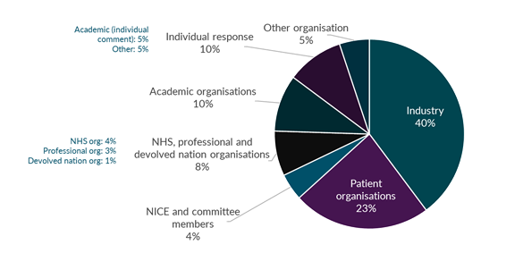

Next steps

We expect to launch the second consultation on 11 August 2021. We initially planned for a 6-week consultation but are concerned that this doesn’t allow participants enough time to fully engage with the broad range of proposals.

We propose to extend the consultation window to 8 weeks, finishing on 06 October 2021. A longer consultation period will also accommodate the challenge of it starting during the summer months. Considering the breadth and depth of the proposals, we further expect to need significant time to work through the consultation response.

We will be engaging with the Board as planned over the Autumn, but do not expect to be able to present the final manual for sign-off in November, with publication in December. We are instead seeking the Board's support for publication in January 2022. If the Board supports this change, we will amend the accompanying business plan objective. We will provide an update to the Board in November 2021 and also highlight where there may be opportunities to implement interim changes where appropriate and where they will add value, in advance of publication of the final manual.

Participants in consultation will be presented with papers describing key proposals for topic selection, process and methods in detail with the supporting rationale. We will also make a draft of the full manual available to allow for a clear picture of how the proposals fit together.

Webinars and targeted engagement sessions will be held with key stakeholder groups to support consultation. And we will be developing materials to support further understanding of the proposals.

Issues for decision

The Board is asked to:

* Note the progress made to date.
* Approve the plans to launch the second consultation for the health technology evaluation process and methods review.
* Support an extended consultation period and further opportunities for engagement in the autumn leading to final publication in January 2022.

© NICE 2021. All rights reserved. [Subject to Notice of rights](https://www.nice.org.uk/terms-and-conditions#notice-of-rights).

July 2021