National Institute for Health and Care Excellence

NICE impact report: prostate cancer

This report gives details of how NICE's evidence-based guidance is being used to help improve outcomes for people with prostate cancer.
It provides information about NICE's communication activity in relation to the previous impact report on end of life care in adults.
The Board is asked to review the NICE impact prostate cancer report, and to note the communications activities.
Dr Judith Richardson
Acting Director, Health and Social Care
November 2020

Introduction
The attached NICE impact report focuses on prostate cancer and reviews the uptake of NICE guidance in this area. It covers: recognition and diagnosis of prostate cancer, treatment, managing adverse effects of treatment and people's experience of care.

System support for implementation
The system support for implementation (SSI) team is currently reviewing this impact report and will consider how to address any implementation issues highlighted.
As highlighted at the last board meeting a new way of working is being implemented for the cardiovascular disease management impact report, which will be published in January 2021.

Promoting NICE impact reports
The NICE impact report on end of life care was published on 21 September.
The following is a summary of key communications and engagement activities to promote the report. As in previous months, it should be noted that many stakeholder organisations have been focussing on COVID-19 and have either reduced the number and range of e-newsletters they produce (in which we might usually seek to achieve coverage) or have diverted the focus of their newsletters exclusively onto COVID-19.

Impact report: end of life care

Working with partners and stakeholders
The report was shared widely across the health and care system, including regional strategic clinical networks and NHS England and NHS Improvement's regional communications teams so that they could cascade it to providers and commissioners in their areas.
- Partner organisations involved in the report were encouraged to share it through their networks. The partner organisations were NHS England, Marie Cure, Macmillan, NHS Benchmarking Network (providers of the National Audit for Care at the End of Life) and the Department of Health and Social Care.
- The Association of Palliative Care Social Workers put details of the report on its website.
- The report was featured in NHS England and NHS Improvement's primary care e-bulletin, which goes out twice per week to around 22,000 primary care subscribers.
- National Health Executive featured a blog on their website in which Judith Richardson, acting director for health and social care, discussed the main findings from the report.
- Our commentators for the impact report, Julie Pearce, chief nurse and executive director of Caring Services and Dr Sarah Holmes, Marie Curie medical director and consultant in palliative care wrote a blog on the Marie Curie website, which talks about and links to the impact report.
- Activity on Twitter included retweets by the charity Sue Ryder (10,440 followers).
- NICE Newsletters and Website

The impact report was featured in the September issues of NICE News and Update for Primary Care, reaching a combined circulation of 45,013.
Between 21 September and 23 October, the impact report was viewed more than 2,000 times.

Social media
We promoted the end of life care impact report over a two-week period on Twitter, Facebook and LinkedIn. By posting on 3 channels we reached a varied audience: professionals in health and care on Twitter and LinkedIn and the public on Facebook. We were careful to include notes in each post explaining that the findings related to pre-COVID work.

Twitter:
On Twitter our 3 posts were viewed 25,624 times overall and received 194 total clicks, likes, comments or shares. Our first post received the highest engagement rate of 1.0%. The Twitter average for an individual post is 0.06%.
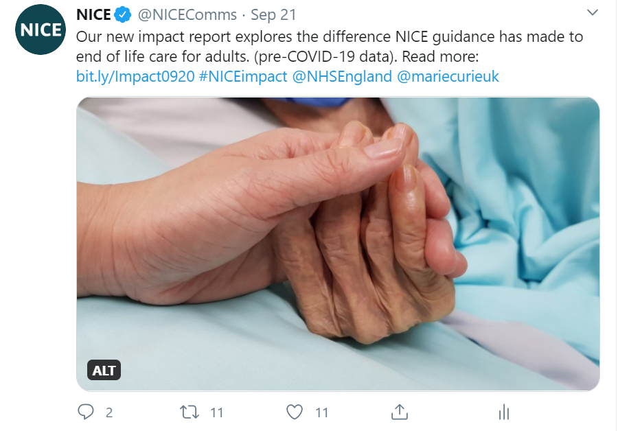

© NICE 2020. All rights reserved. Subject to Notice of rights.
November 2020

