Supporting data for NICE Shared Learning Application:
Reducing incidence of Urinary Tract Infections by promoting hydration in care homes

Materials for implementing the project are now all available on this web link:
http://www.patientsafetyoxford.org/clinical-safety-programmes/reducing-the-incidence-of-acute-kidney-injury/hydration-project-in-care-homes-in-partnership-with-windsor-ascot-and-maidenhead-ccg/

Figure 1: PDSA Cycles of change within the project
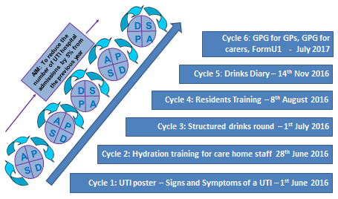

RESULTS
All four care homes demonstrated sustained compliance of 98% with the seven structured drinks rounds each day and a reduction in UTIs.

UTI Admission to hospital/Year (financial year):
2015/2016 18
2016/2017 12
2017/2018 4 to date of submission

The graphs below demonstrate a reduction in both UTIs requiring hospital admission and UTIs treated with antibiotics.

Figure 2: UTIs requiring admission to hospital in 4 care homes

UTI requiring antibiotics:
The incidence of UTIs has reduced from 1 every 13 days at baseline to 1 every 47 days since the project commenced.

One residential home has been UTI free for 230 days.

Figure 3: UTIs requiring antibiotics in 4 care homes
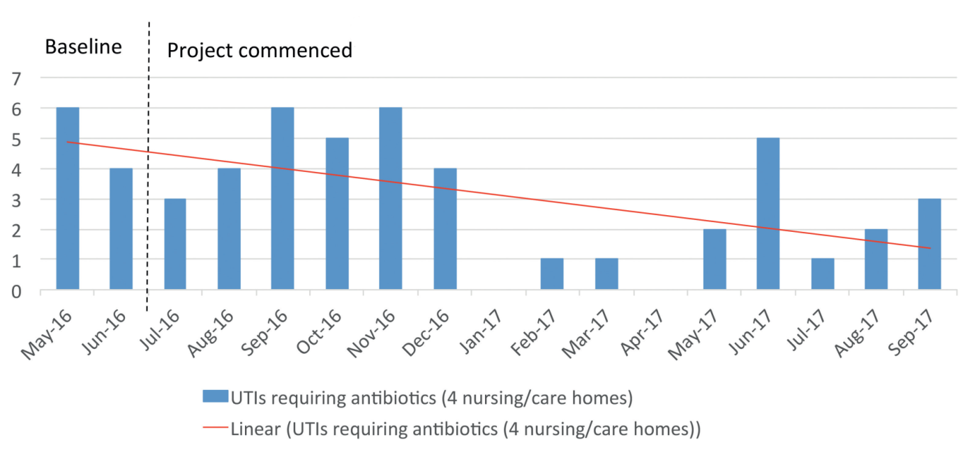

Table 1: Number of days between UTIs requiring antibiotics data
Care Home | Started Project | Average Baseline (May-June 2016) | Average to date  (1st December 2017) | Greatest number of days in a row between UTIs (July 2016-Nov 2017)
1H (Residential) | 01/07/2016 | No UTIs | 1 UTI per 80 days | 243 days
2E(Residential) | 01/07/2016 | 1 UTI per 16 days | 1 UTI per 54 days | 174 days
3M (Residential) | 01/07/2016 | 1 UTI per 15 days | 1 UTI per 55 days | 225 days
4L (Nursing) | 01/07/2016 | 1 UTI per 10 days | 1 UTI per 19 days | 92 days

Good practice guidance for GPs and Carers
GPG for care home staff was also developed and this focused on ensuring care staff were looking for correct signs and symptoms of UTI and not relying on urine smell, urine colour or dip stick tests as signs/symptoms which had become quite common poor practice in the pilot care homes. Depending on urine smell or colour and dip stick testing is what may be contributing to UTIs being over-diagnosed and so ultimately over-treating unnecessarily with anti-microbials and so enhancing anti-microbial resistance in this population. To implement the guidance and ensure it becomes embedded in practice, a form (Form U1) was designed and introduced for use by care homes to communicate signs and symptoms of UTIs with patients’ GPs and better manage residents’ UTIs in addition to promoting hydration.
The development and implementation of such good practice guidance and Form U1 ensures that medicines optimisation is being promoted throughout for all patients by preventing UTIs and the need of anti-microbial treatment through better hydration; correct identification and evidence-based diagnosis of UTIs but also effective evidence –based treatment and management of UTIs and making this part of routine practice.

The project also educated carers and nurses working in care homes of the risks and causes of dehydration including medicines. Hydration training included information on medicines that can increase risk of dehydration or affect fluid balance and those medicines that are linked to Acute Kidney Injury (AKI). This promoted and raised awareness of the need for care home staff to be more vigilant of patients on medicines linked to dehydration and AKI and so promoting medicines safety. It also raised awareness amongst care staff of the DAMN medicines and risks of anti-microbial resistance with antibiotics and the need for safe use of medicines.
A poster was designed to emphasise the importance of hydration and signs and symptoms of a UTI. Leaflets to raise awareness of medicines and their effect on urine and fluid levels in the body were also designed and shared with care staff.

