Figure 1: Investigation of cryptogenic stroke pathway before and after pathway implementation
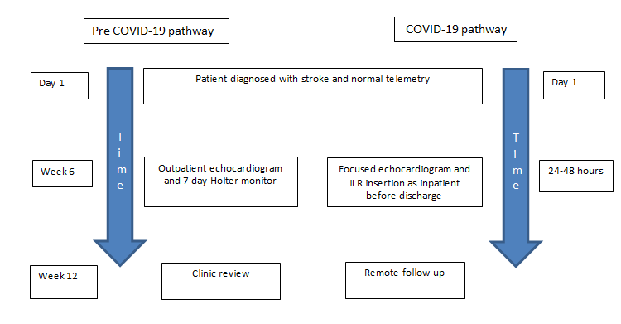
Figure 2: Inclusion and exclusion criteria for ICM implantation
