Page 1: Discussing the stroke risk

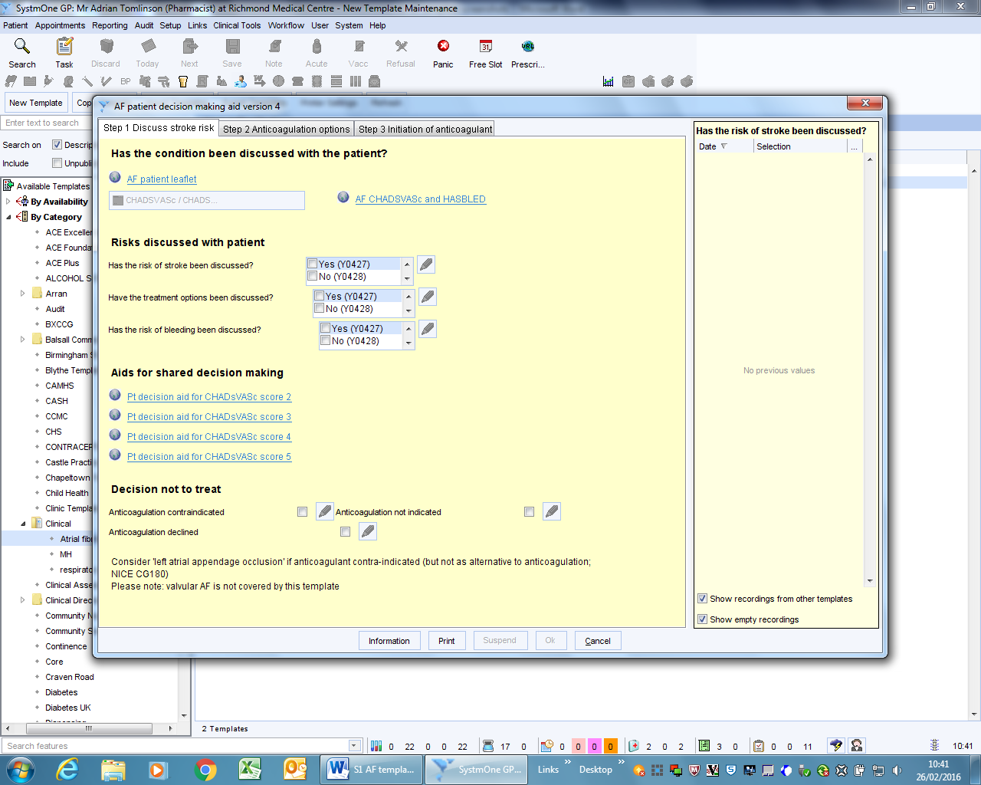

Page 2: Options for anticoagulation
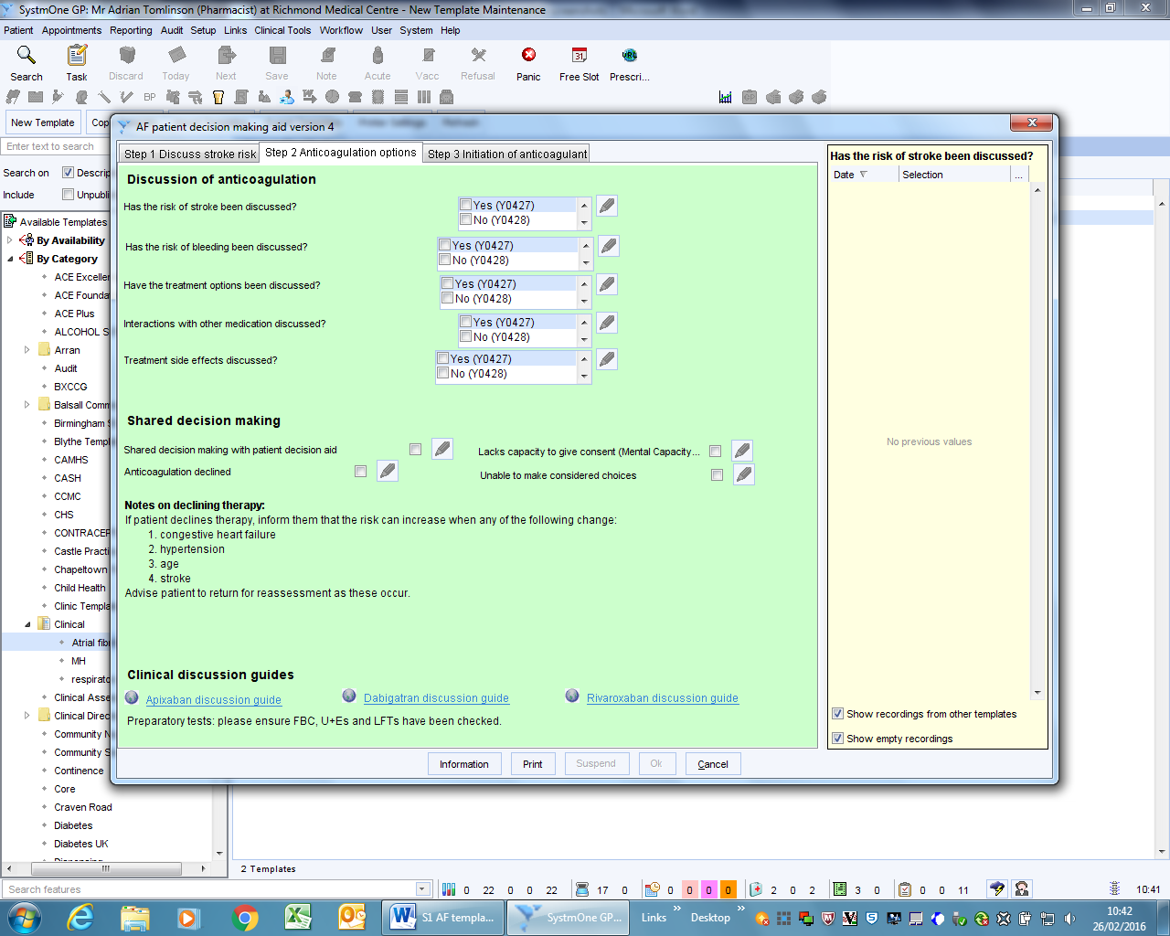

Page 3: initiation of anticoagulant
