NATIONAL INSTITUTE FOR HEALTH AND
CARE EXCELLENCE

Quality standards

Briefing paper: Diabetes in pregnancy (update)
Quality Standards Advisory Committee meeting: 17 May 2022

Contents
1 Introduction 2
2 Overview 2
3 Summary of suggestions 5
3.1 Responses 5
3.2 Feedback on the current quality standard 5
3.3 Areas for quality improvement 5
4 Suggested improvement areas 7
4.1 Preconception management and care 7
4.2 Gestational diabetes 10
4.3 Antenatal care 12
4.4 Postnatal care 16
4.5 Additional areas 18
Appendix 1: Comments from registered stakeholders on current quality standard 21
Appendix 2: Suggestions from registered stakeholders 34

- Introduction
This briefing paper presents a structured overview of potential quality improvement areas for diabetes in pregnancy. It provides the committee with a basis for discussing and prioritising quality improvement areas for development into draft quality statements and measures for public consultation.
This briefing paper includes a brief description of the topic, a summary of each of the suggested quality improvement areas and supporting information.
Recommendations selected from the key development source are included to help the committee in considering potential statements and measures.
  - Development source
The key development source referenced in this briefing paper is:
Diabetes in pregnancy: management from preconception to the postnatal period (NG3) (2015, updated 2020).
- Overview
  - Focus of quality standard
This quality standard covers managing diabetes and its complications in women who are planning a pregnancy or are already pregnant. It includes care for women with pre-existing diabetes before and during pregnancy, and diagnosis and management of gestational diabetes. It describes high-quality care in priority areas for improvement. It will update and replace the existing NICE quality standard for diabetes in pregnancy (QS109).
The executive team at NICE has agreed to making all of our content gender-neutral with the aim of being more inclusive. The current quality standard, and this briefing paper, use the term 'women' throughout because they were written before the decision was made. The updated quality standard will avoid gender where possible and use people instead of women where it works best. We may also use an additive approach where appropriate, for example, women and trans and non-binary people.
  - Definition
Diabetes is a chronic disease that occurs either when the pancreas does not produce enough insulin or when the body cannot effectively use the insulin it produces. Insulin is a hormone that regulates blood sugar. Hyperglycaemia, or raised blood sugar, is a common effect of uncontrolled diabetes and over time leads to serious damage to many of the body's systems, especially the nerves and blood vessels.
Diabetes is classified as:
- Type 1 diabetes is characterized by deficient insulin production and requires daily administration of insulin.
- Type 2 diabetes results from the body’s ineffective use of insulin.
- Gestational diabetes is hyperglycaemia (a higher than normal level of glucose in the blood) that develops during pregnancy and resolves after delivery.
The women identified with glucose intolerance in pregnancy as a result of screening
comprise 3 sub-groups. The majority have exclusively pregnancy-specific
glucose intolerance (gestational diabetes). However, some women will be identified
in screening with previously undetected type 2 diabetes. There are also a small
number of women who present with type 1 diabetes in pregnancy.
  - Incidence and prevalence
Around 1% of pregnancies are in women with existing diabetes and there are now more women with type 2 than type 1. Gestational diabetes affects about 4% of pregnancies.
The prevalence of all 3 types of diabetes is increasing. The incidence of gestational
diabetes is increasing as a result of higher rates of obesity in the general
population and more pregnancies in older women.
Diabetes in pregnancy is associated with risks to the woman and to the developing
fetus. Miscarriage, pre‑eclampsia and preterm labour are more common in women
with pre‑existing diabetes. In addition, diabetic retinopathy can worsen rapidly during
pregnancy. Stillbirth, congenital malformations, macrosomia, birth injury, perinatal
mortality and postnatal adaptation problems (such as hypoglycaemia) are more
common in babies born to women with pre‑existing diabetes.
  - Current service delivery and management
Diabetes in pregnancy is primarily managed within secondary care by joint antenatal
and diabetes services. Diabetes services are commissioned by clinical commissioning groups, integrated care systems and strategic transformation partnerships. Providers are NHS hospital trusts, community providers and primary care providers. Some aspects of care, specifically postnatal care, take place within primary care and there are points along the pathway when community care services are also involved.
  - Resource impact
We do not expect this quality standard to have a significant impact on resources. When NICE’s guideline on diabetes in pregnancy: management from preconception to the postnatal period was developed, a resource impact statement was produced which noted that:
- the resource impact of implementing any single guideline recommendation will be less than £1 million per year in England (or £1,800 per 100,000 population) and
the resource impact of implementing the whole guideline in England will be less than £5 million per year (or £9,100 per 100,000 population).
This is because the updated recommendations are unlikely to lead to a significant change in practice. Most centres currently offer flash and/or continuous glucose monitoring to pregnant women with type 1 diabetes (in accordance with the NHS long-term plan).

- Summary of suggestions
  - Responses
In total 14 registered stakeholders responded to the 2-week engagement exercise.
- 8 stakeholders responded to questions on the current quality standard
- 7 stakeholders suggested areas for inclusion in the updated quality standard
- 5 stakeholders had no comments
4 specialist committee members suggested areas
  - Feedback on the current quality standard
We asked stakeholders for their views on some of the current quality statements in Diabetes in pregnancy (QS109). These comments have been included in the relevant section of the suggested improvement areas in section 4 of this briefing paper.
There was general agreement that two of the existing quality statements are now being routinely achieved and are therefore no longer priorities. These statements have therefore not been included for committee consideration:
- Statement 3: Pregnant women with pre-existing diabetes have their HbA1c levels measured at their booking appointment.
- Statement 4: Pregnant women with pre-existing diabetes are referred at their booking appointment for retinal assessment.
  - Areas for quality improvement
The responses have been summarised in table 1 for further consideration by the committee. The table includes relevant responses from the questions on the current quality standard.

Table 1 Summary of suggested quality improvement areas
Area for improvement | Stakeholders
Preconception management and care  - Folic acid  - HbA1c levels  - Prevention and access to weight management | - SCM4  - NPID, SCM4  - BB, DUK, NHSE&I, NPID, UHB
Gestational diabetes  - Dietary advice  - Blood glucose control during labour and birth | - GDUK  - GDUK
Antenatal care  - Screening  - Continuous glucose monitoring  - Multi-disciplinary team management  - Breastfeeding information | - LDCN  - DUK, LDCN, SCM2, UHB  - SCM1  - SCM4
Postnatal care  - Postnatal testing following gestational diabetes  - National Diabetes Prevention Programme | - DUK, LDCN, NPID, SCM4  - NPID, NHSE&I, SCM1
Additional areas  - Additional guidance and comments on the guideline  - Education  - Continuous glucose monitoring pre-pregnancy  - Mental health  - Health resources  - Prevalence rates | - BB, GDUK  - NHSE&I  - NHSE&I  - BB  - BB  - BB
Abbreviations:
- BB, Best Beginnings
- DUK, Diabetes UK
- GDUK, Gestational Diabetes UK
- LDCN, London Diabetes Clinical Network
- NHSE&I, NHS England and NHS Improvement
- NPID, National Pregnancy in Diabetes Audit
- SCM, Specialist Committee Member
- UHB, University Hospitals Birmingham
Full details of all the suggestions provided are given in appendix 2 for information.
- Suggested improvement areas
Section 4 presents a summary of the suggested improvement areas, with provisional recommendations that may support statement development and information on current UK practice.
  - Preconception management and care

Folic acid
A stakeholder commented that women with pre-existing diabetes should be offered folic acid 3 months prior to pregnancy.

Selected recommendations
NICE’s guideline on diabetes in pregnancy (NG3):
1.1.11 Advise women with diabetes who are planning a pregnancy to take folic acid (5 mg/day) until 12 weeks of gestation to reduce the risk of having a baby with a neural tube defect.

Current quality statements
NICE’s quality standard on diabetes in pregnancy (QS109), statement 1:
Women with diabetes planning a pregnancy are prescribed 5 mg/day folic acid from at least 3 months before conception.

Current UK practice
The National Pregnancy in Diabetes Audit report 2020 stated that the percentage of women using 5mg of folic acid prior to pregnancy had not improved in the last 7 years. In 2020, 43% of those with type 1 diabetes and 21% of those with type 2 diabetes had used 5mg of folic acid prior to pregnancy.

HbA1c levels
Stakeholders commented that some women become pregnant whilst they have a high HbA1c, which can have a significant impact on the developing foetus and lead to an increased risk of pregnancy loss. Better pathways to support women with diabetes to access safe effective contraception and pre-pregnancy care are needed with an emphasis on targeting a HbA1c of <48mmol/mol applicable for all women aged 15 – 50 years.

Selected recommendations
NICE’s guideline on diabetes in pregnancy (NG3):
1.1.18 Advise women with diabetes who are planning a pregnancy to aim to keep their HbA1c level below 48 mmol/mol (6.5%), if this is achievable without causing problematic hypoglycaemia.

Current UK practice
The National Pregnancy in Diabetes Audit report 2020 stated that 17.5% of women with type 1 diabetes and 38.4% of women with type 2 diabetes had an HbA1c of less than 48mmol/mol during early pregnancy.

Prevention and access to weight management
Stakeholders felt that all adult women with type 2 diabetes should be offered referral to the national weight management programmes, ideally before pregnancy.
Stakeholders commented that preconception diabetes care is needed for all women of childbearing age. One noted that healthcare system changes are needed across all clinics so that women with diabetes are prepared for pregnancy.
A stakeholder commented that digital health apps can be used to support behaviour change related to the prevention and management of gestational diabetes.

Selected recommendations
NICE’s guideline on diabetes in pregnancy (NG3):
1.1.7 Advise women with diabetes who are planning to become pregnant:
- that the risks associated with diabetes in pregnancy will increase the longer they have had diabetes
- to use contraception until they have good blood glucose control (assessed by HbA1c levels – see recommendation 1.1.18)
- that blood glucose targets, glucose monitoring, medicines for treating diabetes (including insulin regimens) and medicines for complications of diabetes will need to be reviewed before and during pregnancy
- that extra time and effort is needed to manage diabetes during pregnancy, and that more frequent contact is needed with healthcare professionals.
1.1.9 Offer individualised dietary advice to women with diabetes who are planning a pregnancy.
1.1.10 For women with diabetes who are planning a pregnancy and who have a body mass index (BMI) above 27 kg/m², offer advice on how to lose weight, in line with the NICE guideline on identifying, assessing and managing obesity. See the NICE guideline on BMI for guidance on using variations on the BMI cut-off, based on the risk for different ethnic groups.

Current UK practice
The National Pregnancy in Diabetes Audit report 2020 stated that there has been no improvement in the preparation for pregnancy over the past 7 years, with seven out of eight women with diabetes not prepared for pregnancy. It stated that there are no changes in pregnancy preparation with widespread above target HbA1c, low rates of folic acid supplementation and up to 12% of women taking potentially harmful medications.
No current practice information was identified on pre-pregnancy referrals to national weight management programmes or the use of digital health apps to support behaviour change related to the prevention and management of gestational diabetes.

Issues for consideration
For discussion:
- The National Diabetes in Pregnancy audit suggests that the current statement on high-dose folic acid before pregnancy is still an area for quality improvement. However, the guideline does not state 5mg folic acid should be prescribed at least 3 months before conception therefore this statement would need to be amended (and measurement considered) if it is included in the updated quality standard.
- What are the priorities for improvement? High-dose folic acid, HbA1c levels, prevention and access to weight management?
- What are the key actions that will lead to improvement?
- Can we develop specific, measurable statement?
For decision:
- Should one or more of these areas be prioritised for inclusion in the updated quality standard?

  - Gestational diabetes

Dietary advice
One stakeholder commented that dietary advice varies across the UK. They stated there is no consistency with the advice being given, leading to confusion and many women receiving medication unnecessarily when better dietary advice could mean they could control gestational diabetes through diet alone.
The stakeholder also commented that many women with gestational diabetes are not seen by a dietitian for weeks or months post-diagnosis. They stated that after being diagnosed it is important that women are seen by a dietitian for dietary advice as blood glucose levels are impacted greatly by diet. The stakeholder felt this should be within a week of diagnosis so that the positive changes can be made close to diagnosis.

Selected recommendations
NICE’s guideline on diabetes in pregnancy (NG3):
1.2.15 Advise women with gestational diabetes to eat a healthy diet during pregnancy, and to switch from high to low glycaemic index food.
1.2.16 Refer all women with gestational diabetes to a dietitian.

Current UK practice
Unpublished data provided by Gestational Diabetes UK found that 75.4% of the 1222 women who responded had seen a dietitian. 44% of 960 responders were offered referral to a dietitian at their first appointment following booking, with 17% offered within 1 week of diagnosis, 25% within 2 weeks of diagnosis and the remaining 14% offered after 2 weeks of diagnosis or longer. This was from an online survey however the date of the survey is unknown.

Blood glucose control during labour and birth
One stakeholder commented that many NHS Trusts advise women that they will be on an intravenous dextrose and insulin infusion just because they have a diagnosis of gestational diabetes, or because they have insulin-controlled gestational diabetes. The use of this during labour severely limits the movement the woman has. The stakeholder commented that the guideline should be used and followed for those who have uncontrolled blood glucose levels, not as a precautionary measure for all.

Selected recommendations
NICE’s guideline on diabetes in pregnancy (NG3):
1.4.12 Use intravenous dextrose and insulin infusion during labour and birth for women with diabetes whose capillary plasma glucose is not maintained between 4 mmol/litre and 7 mmol/litre.

Current UK practice
No current practice data was identified in this area.

Issues for consideration
For discussion:
- Are dietary advice or blood glucose control during labour and birth priorities for improvement for women with gestational diabetes?
- Note that the stakeholder’s comment on blood glucose control during labour and birth is that the recommendation is being followed for the majority of women with gestational diabetes, not just those outlined in the recommendation.
- What is the key action that will lead to improvement?
- Can we develop a specific, measurable statement?
For decision:
- Should this area be prioritised for inclusion in the updated quality standard?

  - Antenatal care

Screening
A stakeholder suggested screening for pre-existing diabetes at the pregnancy booking appointment and at 28 weeks for gestational diabetes.

Selected recommendations
No recommendations were identified relating to screening for pre-existing diabetes.
NICE’s guideline on diabetes in pregnancy (NG3):
1.2.2 Assess the risk of gestational diabetes using risk factors in a healthy population. At the booking appointment, check for the following risk factors:
- BMI above 30 kg/m2
- previous macrosomic baby weighing 4.5 kg or more
- previous gestational diabetes
- family history of diabetes (first‑degree relative with diabetes)
- an ethnicity with a high prevalence of diabetes.
Offer women with any of these risk factors testing for gestational diabetes (see recommendations 1.2.5 to 1.2.7).
1.2.7 Offer women with any of the other risk factors for gestational diabetes (see recommendation 1.2.2) a 75-g 2‑hour OGTT at 24 to 28 weeks.

Current UK practice
No current practice was identified for screening for pre-existing diabetes at the pregnancy booking appointment or at 28 weeks for gestational diabetes.

Current quality statements
NICE’s quality standard on antenatal care (QS22), statement 6:
Pregnant women are offered testing for gestational diabetes if they are identified as at risk of gestational diabetes at the booking appointment.

Continuous glucose monitoring
Stakeholders commented that rtCGM (real time continuous glucose monitoring), or isCGM (intermittently scanned continuous glucose monitoring, commonly referred to as ‘flash’) if preferred, should be offered to pregnant women with type 1 diabetes to help them meet their blood glucose targets and improve neonatal outcomes.
Stakeholders commented that women with type 2 diabetes should be offered continuous glucose monitoring. One suggested they should be offered isCGM.
A stakeholder suggested that face to face instruction on using the equipment should be offered.

Selected recommendations
NICE’s guideline on diabetes in pregnancy (NG3):
1.3.17 Offer real-time continuous glucose monitoring (rtCGM) to all pregnant women with type 1 diabetes to help them meet their pregnancy blood glucose targets and improve neonatal outcomes.
1.3.18 Offer intermittently scanned continuous glucose monitoring (isCGM, commonly referred to as 'flash') to pregnant women with type 1 diabetes who are unable to use rtCGM or express a clear preference for isCGM.
1.3.19 Consider rtCGM for pregnant women who are on insulin therapy but do not have type 1 diabetes, if:
- they have problematic severe hypoglycaemia (with or without impaired awareness of hypoglycaemia) or
- they have unstable blood glucose levels that are causing concern despite efforts to optimise glycaemic control.

Current quality statements
NICE’s quality standard on diabetes in pregnancy (QS109), statement 6:
Pregnant women with diabetes are supported to self-monitor their blood glucose levels.

Current UK practice
Unpublished data from NHS England and NHS Improvement shows that between October – December 2021, 98% of eligible pregnant women with type 1 diabetes were offered CGM and 78% accepted this, however they feel there is scope to improve uptake of this technology by women of reproductive age living with Type 1 diabetes.

Multi-disciplinary team management
A stakeholder commented that women with diabetes in pregnancy should be managed by a multidisciplinary team, comprising of an obstetrician, endocrinologist or diabetologist, diabetes specialist midwife, diabetes specialist nurse and dietician.
The existing quality standard includes a statement on first contact with the joint diabetes and antenatal care team. No stakeholder comments were received on this quality statement at topic engagement.

Selected recommendations
1.3.37 Offer immediate contact with a joint diabetes and antenatal clinic to pregnant women with diabetes. [2008]
No recommendations were identified on the composition of the multi-disciplinary team.

Current quality statements
NICE’s quality standard on diabetes in pregnancy (QS109), statement 2:
Women with pre-existing diabetes are seen by members of the joint diabetes and antenatal care team within 1 week of their pregnancy being confirmed.
NICE’s quality standard on diabetes in pregnancy (QS109), statement 5:
Women diagnosed with gestational diabetes are seen by members of the joint diabetes and antenatal care team within 1 week of diagnosis.

Current UK practice
No current practice data was identified relating to the composition of the MDT.

Breastfeeding information
A stakeholder commented that, at 36 weeks, information and advice should be provided about starting to breastfeed and effect of breastfeeding on blood glucose levels.

Selected recommendations
NICE’s guideline on diabetes in pregnancy (NG3):
1.3.49 includes a timetable of antenatal appointments. This lists interventions and advice at the 36 weeks appointment including:
Provide information and advice about:
- starting to breastfeed and the effect of breastfeeding on blood glucose control

Current UK practice
No current practice data was identified for this area.

Issues for consideration
For discussion:
- What is the priority for improvement?
- Note that no recommendations were identified relating to screening for pre-existing diabetes, the composition of the multi-disciplinary team or targeting HbA1c<43mmol/mol after 24 weeks gestation.
- Note the existing quality statement in the antenatal care quality standard on offering testing for gestational diabetes to women who are identified as at risk of gestational diabetes at the booking appointment.
- Note the existing quality statements on women being seen by the joint diabetes and antenatal care team. Stakeholder feedback was that statement 5 is not always met but is worked towards and there were no comments on statement 2. Should one or both of these statements be in the updated quality standard?
- Current quality statement on continuous glucose monitoring. Should the statement:
  - remain unchanged and supporting information updated to include rtCGM and isCGM?
  - be changed to focus on offering rtCGM or isCGM to women with type 1 diabetes?
  - be removed?
- Is providing information on breastfeeding and its impact on blood glucose levels a priority?
- What is the key action that will lead to improvement?
- Can we develop a specific, measurable statement?
For decision:
- Should one or more of these areas be prioritised for inclusion in the updated quality standard?
  - Postnatal care

Postnatal testing following gestational diabetes
Stakeholders noted the importance of annual HbA1c testing. One commented that a system wide change is needed to ensure women diagnosed with gestational diabetes are recalled for their annual Hba1c and not lost to follow up. Another commented that better pathways between maternity clinics and primary care are needed to ensure that all women with gestational diabetes are offered a postnatal glucose check, annual HbA1c and referral to the National Diabetes Prevention Programme (NDPP).
One stakeholder commented that women diagnosed with gestational diabetes should also be offered a HbA1c test at 13 weeks postnatal. There was also a suggestion to have HbA1c testing at 3 or 6 months following birth to identify women with undiagnosed type 1 diabetes.

Selected recommendations
NICE’s guideline on diabetes in pregnancy (NG3):
1.6.11 For women who were diagnosed with gestational diabetes and whose blood glucose levels returned to normal after the birth:
- offer a fasting plasma glucose test 6 to 13 weeks after the birth to exclude diabetes (for practical reasons this might take place at the 6‑week postnatal check)
- after 13 weeks offer a fasting plasma glucose test if this has not been done earlier, or an HbA1c test if a fasting plasma glucose test is not possible
1.6.14 Offer an annual HbA1c test to women with gestational diabetes who have a negative postnatal test for diabetes.
No recommendations were identified on pathways between maternity clinics and primary care.

Current quality statements
NICE’s quality standard on diabetes in pregnancy (QS109), statement 7:
Women who have had gestational diabetes have an annual HbA1c test.

Current UK practice
A review of gestational diabetes screening uptake in 2020 noted a 2019 study showing 16% of women who had gestational diabetes had an annual HbA1c. At topic engagement, stakeholders commented that the current quality statement is not being achieved.

National Diabetes Prevention Programme
Stakeholders commented that women who have had gestational diabetes should be offered referral to the National Diabetes Prevention Programme following pregnancy as type 2 diabetes can be prevented by diet/lifestyle interventions.

Selected recommendations
NICE’s guideline on diabetes in pregnancy (NG3):
1.6.11 For women who were diagnosed with gestational diabetes and whose blood glucose levels returned to normal after the birth:
- offer a referral into the NHS Diabetes Prevention Programme if eligible based on the results of the fasting plasma glucose test or HbA1c test.

Current UK practice
No current practice data was identified for this area.

Issues for consideration
For discussion:
- What is the priority for improvement?
- Note the existing statement on annual HbA1c testing for women who have had gestational diabetes.
- Is offering women who had gestational diabetes a fasting plasma glucose test 6 to 13 weeks after the birth to exclude diabetes a priority?
- Is referral to the National Diabetes Prevention Programme for women who had gestational diabetes a priority?
- What is the key action that will lead to improvement?
- Can we develop a specific, measurable statement?
For decision:
- Should one or more of these areas be prioritised for inclusion in the updated quality standard?
  - Additional areas

Summary of suggestions
The improvement areas below were suggested as part of the stakeholder engagement exercise. However, they were felt to be either unsuitable for development as quality statements or outside the remit of this particular quality standard.
There will be an opportunity for the committee to discuss these areas at the end of the Advisory Committee meeting.
Table 2 Summary of information available for additional areas
Suggested area for improvement | Within remit of NICE QS | In scope | Guideline recs | Relevant  existing QS
Additional guidance and comments on the guideline | No | No | No | No
Education | Yes | No | No | Yes
Continuous glucose monitoring pre-pregnancy | Yes | No | No | Yes
Mental health | Yes | Yes | No | Yes
Health resources | No | No | No | No
Prevalence rates | No | No | No | No

Additional guidance and comments on the guideline
A stakeholder suggested nutritional and dietary guidelines for different ethnicities and cultures to control blood sugar levels. Another stakeholder commented that some recommendations are causing difficulties for women with gestational diabetes and requested clarity on these areas of the Diabetes in Pregnancy (NG3) guideline. Another stakeholder suggested that the guideline should include aiming for a target of HbA1c<43mmol/mol after 24 weeks gestation.
This area has not been progressed because additions or changes to the guidance are outside of the remit of quality standards. Suggestions for amendments and additional guidance will be passed on to the NICE centre for guidelines.
Equality and diversity considerations will be made for all areas for quality improvement that are included in the quality standard.

Education
A stakeholder commented that it is important to support women aged 15 – 50 years to self-manage diabetes by providing structured education.
This area has not been progressed because there are existing quality statements on education in the quality standards on Diabetes in children and young people (QS125) and Diabetes in adults (QS6).

Continuous glucose monitoring pre-pregnancy
A stakeholder commented that it is important to improve access to rtCGM (real time continuous glucose monitoring) and isCGM (intermittently scanned continuous glucose monitoring, commonly referred to as ‘flash’) for women with type 1 diabetes of reproductive age to support pre-conception glycaemic control. An early pregnancy HbA1c of less than or equal to 48mmol/mol is associated with lower rates of congenital anomaly and perinatal death but is achieved only in a minority of women with diabetes and is least likely in women who live in deprived areas.
This area has not been progressed because there is an existing quality statement on continuous glucose monitoring for people with type 1 diabetes in the quality standard on Diabetes in children and young people (QS125). Continuous glucose monitoring is in the scope of the Diabetes in adults (QS6) quality standard which is being updated and separated into quality standards on Type 1 diabetes and Type 2 diabetes.

Mental health
A stakeholder suggested the provision of information on how different mental health conditions and social support factors have an impact on gestational diabetes, foetus health, and the delivery of the baby.
This area has not been progressed. There is an existing quality standard on antenatal and postnatal mental health (QS115).

Health resources
A stakeholder felt the general population should have access to more health resources by connecting to different organisations and charity groups through the UK Government and NHS website.
This suggestion has not been progressed. The content of national websites is not within the scope of NICE quality standards.

Prevalence rates
A stakeholder requested that NICE provides the prevalence rate of gestational diabetes in different communities based on factors such as genetics, diet, socioeconomic status and mental health illnesses.
This suggestion has not been progressed. Measurement of prevalence rates is outside the remit of quality standards. However, the quality standard will include links to national audits, where relevant, to help organisations to measure achievement of the quality statements.
© NICE 2022. All rights reserved. Subject to Notice of rights.

Appendix 1: Comments from registered stakeholders on current quality standard

ID | Stakeholder | NICE questions on current QS | Stakeholder comments | Supporting information
Comments on statement 3
1 | Aintree University Hospital | Statement 3 states that pregnant women with pre-existing diabetes have their HbA1c levels measured at their booking appointment. Is this now routine practice? | Yes. We have found this really helpful.
2 | Gestational Diabetes UK | Statement 3 states that pregnant women with pre-existing diabetes have their HbA1c levels measured at their booking appointment. Is this now routine practice? | Yes, in the majority of Trusts that I am aware of.
3 | National Pregnancy in Diabetes (NPID) audit | Statement 3 states that pregnant women with pre-existing diabetes have their HbA1c levels measured at their booking appointment. Is this now routine practice? | Yes despite increased use of Continuous Glucose Monitoring (CGM) and intermittent glucose monitoring (Flash), HbA1c remains an important measure of pregnancy risk. Data from NPID demonstrate the crucial importance of measuring maternal HbA1c both at booking and after 24 weeks gestation for identifying babies at increased risk of perinatal morbidity and mortality. We recommend further strengthening this recommendation to advise that pregnant women with pre-existing diabetes have their HbA1c levels measured at their booking appointment and after 24 weeks gestation. Recent national data suggest that higher glucose targets HbA1c <43mmol/mol after 24 weeks are associated with lower risk of preterm birth, large for gestational age birthweight, neonatal intensive care unit admission and perinatal death. These targets which are required for optimal obstetric and neonatal outcomes are now more safely achievable with increased use of CGM/Flash in type 1 and type 2 diabetes pregnancies. | (https://pubmed.ncbi.nlm.nih.gov/33516295/, https://digital.nhs.uk/data-and-information/publications/statistical/national-pregnancy-in-diabetes-audit/2019-and-2020)
4 | NHS England and Improvement | Statement 3 states that pregnant women with pre-existing diabetes have their HbA1c levels measured at their booking appointment. Is this now routine practice? | Data from NPID demonstrate the importance of measuring maternal HbA1c at booking and 24 weeks for identifying babies at increased risk of perinatal morbidity and mortality.  Targets are now more safely achievable with increased use of CGM/Flash in type 1 and type 2 diabetes pregnancies.
5 | University Hospitals Birmingham | Statement 3 states that pregnant women with pre-existing diabetes have their HbA1c levels measured at their booking appointment. Is this now routine practice? | Yes
6 | SCM1 | Statement 3 states that pregnant women with pre-existing diabetes have their HbA1c levels measured at their booking appointment. Is this now routine practice? | Yes, to the best of my knowledge this is widely done as it forms part of the NPID audit.
7 | SCM2 | Statement 3 states that pregnant women with pre-existing diabetes have their HbA1c levels measured at their booking appointment. Is this now routine practice? | I am unsure if this is routine practice, but I believe an HbA1c to be a very good indicator of blood glucose levels and measuring this at the booking appointment would give a good baseline figure to work from.
8 | SCM3 | Statement 3 states that pregnant women with pre-existing diabetes have their HbA1c levels measured at their booking appointment. Is this now routine practice? | Yes.
9 | SCM4 | Statement 3 states that pregnant women with pre-existing diabetes have their HbA1c levels measured at their booking appointment. Is this now routine practice? | Yes this is certainly routine practice within my Trust.
Comments on statement 4
10 | Aintree University Hospital | Statement 4 states that, at their booking appointment, pregnant women with pre-existing diabetes are referred for retinal assessment. Is this now routine practice? | Yes, this has been routine for many years in our service.
11 | Gestational Diabetes UK | Statement 4 states that, at their booking appointment, pregnant women with pre-existing diabetes are referred for retinal assessment. Is this now routine practice? | Yes, in the majority of Trusts that I am aware of
12 | National Pregnancy in Diabetes (NPID) audit | Statement 4 states that, at their booking appointment, pregnant women with pre-existing diabetes are referred for retinal assessment. Is this now routine practice? | Yes, this is now routine antenatal practice. Evidence of a retinal assessment having been performed was available for 61% of pregnant women with type 1 and 56% of pregnancy women with type 2 diabetes in 2019-2020. We expect that this is an underestimate due to ongoing challenges linking the retinal screening results with NDA/NPID but this remains an important quality standard. See slide 21 NPID 2019-2020. | https://digital.nhs.uk/data-and-information/publications/statistical/national-pregnancy-in-diabetes-audit/2019-and-2020)
13 | NHS England and Improvement | Statement 4 states that, at their booking appointment, pregnant women with pre-existing diabetes are referred for retinal assessment. Is this now routine practice? | No comment.
14 | University Hospitals Birmingham | Statement 4 states that, at their booking appointment, pregnant women with pre-existing diabetes are referred for retinal assessment. Is this now routine practice? | Yes.
15 | SCM1 | Statement 4 states that, at their booking appointment, pregnant women with pre-existing diabetes are referred for retinal assessment. Is this now routine practice? | Yes, to the best of my knowledge this is widely done as it forms part of the NPID audit.
16 | SCM2 | Statement 4 states that, at their booking appointment, pregnant women with pre-existing diabetes are referred for retinal assessment. Is this now routine practice? | I am unsure if this is routine practice, but it is standard at annual diabetes review appointments to be asked when the patient’s last retinal screening took place with the ideal being within the past 12 months.
17 | SCM3 | Statement 4 states that, at their booking appointment, pregnant women with pre-existing diabetes are referred for retinal assessment. Is this now routine practice? | Yes.
18 | SCM4 | Statement 4 states that, at their booking appointment, pregnant women with pre-existing diabetes are referred for retinal assessment. Is this now routine practice? | I consider this to be routine practice. Within my Trust women with Pre-existing diabetes are referred for retinal screening following booking with their community midwife.
Comments on statement 5
19 | Aintree University Hospital | Statement 5 states that women diagnosed with gestational diabetes are seen by members of the joint diabetes and antenatal care team within 1 week of diagnosis. Is this now routine practice? | No, not always. It is however our aim. We would benefit from having a more widespread referral policy particularly for women who are not already under secondary care: they present late.
20 | Gestational Diabetes UK | Statement 5 states that women diagnosed with gestational diabetes are seen by members of the joint diabetes and antenatal care team within 1 week of diagnosis. Is this now routine practice? | No, we still have many reports of long waits to be seen by anyone following diagnosis and have to bridge the gap whilst patients wait to be contacted
21 | Kings College Hospital NHS Foundation Trust | Statement 5 states that women diagnosed with gestational diabetes are seen by members of the joint diabetes and antenatal care team within 1 week of diagnosis. Is this now routine practice? | We presume that ‘seen’ includes online?
22 | National Pregnancy in Diabetes (NPID) audit | Statement 5 states that women diagnosed with gestational diabetes are seen by members of the joint diabetes and antenatal care team within 1 week of diagnosis. Is this now routine practice? | Yes, this is now routine antenatal practice. However, with increasing numbers of women with GDM we are increasingly struggling to meet this target. We aim to establish contact within 1 week of diagnosis, but clinical appointments may take longer.
23 | NHS England and Improvement | Statement 5 states that women diagnosed with gestational diabetes are seen by members of the joint diabetes and antenatal care team within 1 week of diagnosis. Is this now routine practice? | No comment.
24 | University Hospitals Birmingham | Statement 5 states that women diagnosed with gestational diabetes are seen by members of the joint diabetes and antenatal care team within 1 week of diagnosis. Is this now routine practice? | Yes.
25 | SCM1 | Statement 5 states that women diagnosed with gestational diabetes are seen by members of the joint diabetes and antenatal care team within 1 week of diagnosis. Is this now routine practice? | This has been challenging during COVID and at our hospital we have amended our local guideline to 2 weeks to reflect operational challenges.
26 | SCM2 | Statement 5 states that women diagnosed with gestational diabetes are seen by members of the joint diabetes and antenatal care team within 1 week of diagnosis. Is this now routine practice? | If this isn’t the case, it certainly should be. Gestational diabetes can come as a surprise and shock to the patient who will often have no understanding of the condition and how to manage it. The sooner in the pregnancy this is addressed, the better.
27 | SCM3 | Statement 5 states that women diagnosed with gestational diabetes are seen by members of the joint diabetes and antenatal care team within 1 week of diagnosis. Is this now routine practice? | Yes.
28 | SCM4 | Statement 5 states that women diagnosed with gestational diabetes are seen by members of the joint diabetes and antenatal care team within 1 week of diagnosis. Is this now routine practice? | With the increasing number of women diagnosed with GDM, this standard is not always possible to achieve. At my Trust we may be made aware of the women within a week of diagnosis, but it is not always possible to see them face to face within this time. They are more likely to be seen within 2 weeks, unless their GTT result was > 7.0 fasting or >11.0mmols at 2 hours when we would make provision for them to be seen outside of the routine Antenatal GDM clinics.
Comments on statement 6
29 | Aintree University Hospital | Statement 6 states that pregnant women with diabetes are supported to self-monitor their blood glucose levels. Should this quality statement be updated to include continuous glucose monitoring for women with type 1 diabetes? | Yes, and Flash monitoring with Type 2 DM. We tend to do the latter even though it is not officially a NICE requirement.
30 | Diabetes UK | Statement 6 states that pregnant women with diabetes are supported to self-monitor their blood glucose levels. Should this quality statement be updated to include continuous glucose monitoring for women with type 1 diabetes? | Yes – The Diabetes in Pregnancy guideline [NG3] recommends real-time continuous glucose monitoring (rtCGM) to all pregnant women with type 1 diabetes to help them meet their pregnancy blood glucose targets and improve neonatal outcomes. It also recommends that intermittently scanned continuous glucose monitoring be offered (isCGM, commonly referred to as 'Flash') to pregnant women with type 1 diabetes who are unable to use rtCGM or express a clear preference for isCGM.
31 | Gestational Diabetes UK | Statement 6 states that pregnant women with diabetes are supported to self-monitor their blood glucose levels. Should this quality statement be updated to include continuous glucose monitoring for women with type 1 diabetes? | Yes
32 | Kings College Hospital NHS Foundation Trust | Statement 6 states that pregnant women with diabetes are supported to self-monitor their blood glucose levels. Should this quality statement be updated to include continuous glucose monitoring for women with type 1 diabetes? | Yes, and for women with t2 diabetes too please.
33 | National Pregnancy in Diabetes (NPID) audit | Statement 6 states that pregnant women with diabetes are supported to self-monitor their blood glucose levels. Should this quality statement be updated to include continuous glucose monitoring for women with type 1 diabetes? | Yes, this quality statement should be updated in line with the December 2021 NICE guideline update on continuous glucose monitoring.
34 | NHS England and Improvement | Statement 6 states that pregnant women with diabetes are supported to self-monitor their blood glucose levels. Should this quality statement be updated to include continuous glucose monitoring for women with type 1 diabetes? | Yes, this quality statement should be updated in line with the December 2021 NICE guideline update on continuous glucose monitoring.
35 | University Hospitals Birmingham | Statement 6 states that pregnant women with diabetes are supported to self-monitor their blood glucose levels. Should this quality statement be updated to include continuous glucose monitoring for women with type 1 diabetes? | Should be updated. All women with type 1 DM are officered CGM at our organisation.
36 | SCM1 | Statement 6 states that pregnant women with diabetes are supported to self-monitor their blood glucose levels. Should this quality statement be updated to include continuous glucose monitoring for women with type 1 diabetes? | Yes. NHSE now provide funding for CGM for ll women with T1DM and this should be a marker of quality in units providing care to pregnant women.
37 | SCM2 | Statement 6 states that pregnant women with diabetes are supported to self-monitor their blood glucose levels. Should this quality statement be updated to include continuous glucose monitoring for women with type 1 diabetes? | Yes definitely. Technology has advanced considerably in the past few years regarding monitoring blood glucose levels. To reflect the upcoming changes in the NICE guidelines, I believe this statement should be amended so that ‘pregnant women with diabetes are supported to self-monitor their blood glucose levels with either a continuous glucose monitor (CGM) or a flash glucose device.' In my opinion capillary blood glucose testing should also be used before mealtimes and to help calibrate the CGM in the 24 hours after a new sensor is administered.
38 | SCM3 | Statement 6 states that pregnant women with diabetes are supported to self-monitor their blood glucose levels. Should this quality statement be updated to include continuous glucose monitoring for women with type 1 diabetes? | Yes.
39 | SCM4 | Statement 6 states that pregnant women with diabetes are supported to self-monitor their blood glucose levels. Should this quality statement be updated to include continuous glucose monitoring for women with type 1 diabetes? | The technology relating to blood glucose monitoring is having a significant impact on diabetes management.  It is imperative that women and staff have a full understanding of this new technology and are supported to use it to its full potential. This includes technology offered to those with Type 1, Type 2 and Gestational Diabetes.
Comments on statement 7
40 | Aintree University Hospital | Statement 7 states that women who have had gestational diabetes have an annual HbA1c test. Is this now routine practice? | In our region there is an impaired glucose tolerance pathway, that Primary care have designed. Women are put onto this pathway.
41 | Diabetes UK | Statement 7 states that women who have had gestational diabetes have an annual HbA1c test. Is this now routine practice? | The academic literature and personal correspondence with diabetes midwives indicates that women with a history of gestational diabetes are not being recalled for their annual HbA1c. Given the evidence that these women are likely to go onto develop type 2 diabetes, this is concerning. Timely diagnosis to ensure the right treatment, education and support is provided is vital to help reduce the short and long term complications of diabetes. | Reference: Walker, E., Flannery, O. and Mackillop, L. (2020) “Gestational Diabetes and Progression to Type Two Diabetes Mellitus: Missed Opportunities of Follow Up and Prevention?,” Primary care diabetes, 14(6), pp. 698–702.
42 | Gestational Diabetes UK | Statement 7 states that women who have had gestational diabetes have an annual HbA1c test. Is this now routine practice? | No, many women have to request this or push to be tested annually. Or they are only offered a fasting plasma glucose test
43 | Kings College Hospital NHS Foundation Trust | Statement 7 states that women who have had gestational diabetes have an annual HbA1c test. Is this now routine practice? | This will be impossible to measure because this will be done in primary care. However, we could measure that we are asking the GP to do this.
44 | National Pregnancy in Diabetes (NPID) audit | Statement 7 states that women who have had gestational diabetes have an annual HbA1c test. Is this now routine practice? | No this is not happening and only a minority of women with GDM are having annual HbA1c measurements. This is a multifactorial systems failure and requires better coding of GDM (SNOMED code 11687002) and better pathways between maternity clinics and primary care. Women with GDM should be offered a glucose check at their 6-8 weeks postnatal appointment to exclude type 2 diabetes. In addition, all women with GDM (who do not already have diabetes) should be offered referral to the National Diabetes Prevention Programme (NDPP). This quality statement should be updated in line with the December 2021 NICE guideline update to emphasise the postnatal glucose check, NDPP referral and annual HbA1c.  All women with all forms of diabetes should also be offered safe effective contraception so that they can safely plan future pregnancies.
45 | NHS England and Improvement | Statement 7 states that women who have had gestational diabetes have an annual HbA1c test. Is this now routine practice? | This quality statement should be updated in line with the December 2020 NG3 NICE guideline update to emphasise the postnatal glucose check and NHS Diabetes Prevention Programme (NHS DPP) referral, in addition to an annual HbA1c.  - Women with GDM should be offered a fasting glucose check at their 6-8 weeks postnatal appointment to exclude type 2 diabetes.  - all women with GDM whose blood glucose levels returned to normal after the birth should be offered referral to the NHS DPP.
46 | University Hospitals Birmingham | Statement 7 states that women who have had gestational diabetes have an annual HbA1c test. Is this now routine practice? | This is a recommendation for primary care and out with our control in secondary care.
47 | SCM1 | Statement 7 states that women who have had gestational diabetes have an annual HbA1c test. Is this now routine practice? | Sadly not. The most recent data show that after the first year, very few women (around 20%) have any form of follow up after GDM.
48 | SCM2 | Statement 7 states that women who have had gestational diabetes have an annual HbA1c test. Is this now routine practice? | I believe it should be sooner than annually after birth. Sometimes a patient may present with gestational diabetes which may turn out to be Type 1 diabetes. An earlier HbA1c at 3 or 6 months after the birth would help pick up any of these undiagnosed women.
49 | SCM3 | Statement 7 states that women who have had gestational diabetes have an annual HbA1c test. Is this now routine practice? | Not always depends on the GP
50 | SCM4 | Statement 7 states that women who have had gestational diabetes have an annual HbA1c test. Is this now routine practice? | We know that women who have had Gestational Diabetes are at significant risk of developing Type 2 diabetes within 5 to 10 yrs of the index pregnancy. Though annual HbA1c levels would help to detect Type 2 Diabetes, sadly in my local observations this does not appear to be routine practice in many local GP Practices. More work needs to be done to improve the uptake of this screening.
Additional comments on existing quality standard
51 | Aintree University Hospital | Do you have any other comments on the current quality standard that you feel we should consider during the update? (Please note there is a section below to add your key areas for quality improvement so please do not include them here.) | The statements need to be made a bit clearer to improve care. Confirmation of pregnancy needs to be specified. I will go off a patient’s own pregnancy test: we educate women about this in our normal clinic. But women in primary care often get referred after a dating scan (11-13 weeks).  Also, you need to specify (in statement 2 and 5) not only referral to be seen by MDT but who needs to see the patient. It should be Diabetes team and obstetrics, and ideally specialist midwives, high banded DSNS and consultants, but you do not specify this.  In statement 5 I think it is important that GDM patient are taught blood glucose monitoring within a week of diagnosis. You do not mention this but talk about education more generically. I think the guidance about monitoring will help both patients and services to be optimised.
52 | Best Beginnings | Do you have any other comments on the current quality standard that you feel we should consider during the update? (Please note there is a section below to add your key areas for quality improvement so please do not include them here.) | As a charity focused on supporting parental wellbeing through relevant health promotive messages, we feel that the current NICE guidance could include evidence-based prevention and management guidelines on GDM that analyse risk through key demographic variations. | Please refer to the comments on key areas for quality improvement.
53 | Gestational Diabetes UK | Do you have any other comments on the current quality standard that you feel we should consider during the update? (Please note there is a section below to add your key areas for quality improvement so please do not include them here.) | Statement 5. Women diagnosed with gestational diabetes should be seen within 1 week of diagnosis and this should be face to face so that the patient can discuss and fears or concerns  Statement 6. pregnant women with diabetes are supported to self-monitor their blood glucose levels. This support should be face to face, showing the woman how to use the equipment being given with clear instructions on how and when to monitor. Many patients are just collecting a monitor from the clinic and are not being given a live example of how to use the equipment leading to a lot of confusion and worry. They should also understand who and how to contact someone should their levels be out of range.
54 | National Pregnancy in Diabetes (NPID) audit | Do you have any other comments on the current quality standard that you feel we should consider during the update? (Please note there is a section below to add your key areas for quality improvement so please do not include them here.) | Women with GDM should be advised about their increased risk of type 2 diabetes, with annual HbA1c checks and referral to diabetes prevention programmes.
55 | NHS England and Improvement | Do you have any other comments on the current quality standard that you feel we should consider during the update? (Please note there is a section below to add your key areas for quality improvement so please do not include them here.) | N/A
56 | SCM1 | Do you have any other comments on the current quality standard that you feel we should consider during the update? (Please note there is a section below to add your key areas for quality improvement so please do not include them here.) | No.
57 | SCM2 | Do you have any other comments on the current quality standard that you feel we should consider during the update? (Please note there is a section below to add your key areas for quality improvement so please do not include them here.) | I understand dental care for Type 1 patients is being looked at under the NICE guidelines with an annual dental check-up perhaps being considered along the lines of the annual foot review and retinal screening.
58 | SCM3 | Do you have any other comments on the current quality standard that you feel we should consider during the update? (Please note there is a section below to add your key areas for quality improvement so please do not include them here.) | No.

Appendix 2: Suggestions from registered stakeholders
ID | Stakeholder | Key area for quality improvement | Why is this a key area for quality improvement? | Supporting information
Preconception management and care
1 | Best Beginnings | Prevention and managing methods for individuals with Gestational Diabetes Mellitus GDM. | The dissemination of key evidence-based information including the specific understanding of consequences and risk how to be active in the prevention and management of GDM should be freely available and signposted adequately. The Government of UK and NHS website does not have any specific information on how to be active for individuals with GDM or at risk.  To support behaviour, change related to the prevention and management of GDM (blood glucose monitoring) we can utilise digital health apps that are verified and recommended to support monitoring and feedback | https://bmcpregnancychildbirth.biomedcentral.com/articles/10.1186/s12884-021-04335-x
2 | Diabetes UK | Pre-conception care so women with type 1 and type 2 diabetes are prepared for pregnancy. Health-care system changes are needed across all clinics | There are now more pregnancies in women with type 2 diabetes, than in women with type 1 diabetes (54% of diabetes’ pregnancies, compared to 47% in 2014). Women with type 2 diabetes face additional health inequalities and are frequently not prepared for pregnancy (reduced use of insulin and folic acid before pregnancy).There are persistent adverse pregnancy outcomes in women with type 1 or type 2 diabetes. Maternal glycaemia and BMI are the key modifiable risk factors. No maternity clinics had appreciably better outcomes than any others. | Murphy, HR, Howgate, C, O'Keefe, J et al. (10 more authors) (2021) Characteristics and outcomes of pregnant women with type 1 and type 2 diabetes: national population based 5-year cohort study. The Lancet Diabetes and Endocrinology, 9 (3). pp. 153-164. ISSN 2213-8587  https://www.hqip.org.uk/wp-content/uploads/2021/10/REF232_NPID-2020-Report_v20211010_FINAL.pdf
3 | National Pregnancy in Diabetes (NPID) audit | Targeting HbA1c<48mmol/mol in women with diabetes aged 15-50 years. | The National Pregnancy in Diabetes (NPID) audit has demonstrated that pregnancy preparation rates are lowest in women from the most deprived communities – only 6% of women with type 2 diabetes and 21% with type 1 diabetes living in deprived quintiles were adequately prepared for pregnancy. Despite two thirds of women with type 2 diabetes having HbA1c>48mmol/mol and widespread metformin use, only 18% were prescribed insulin.  Better pathways to support women with diabetes to access safe effective contraception and/or pre-pregnancy care are needed with an emphasis on targeting a HbA1c of <48mmol/mol applicable for all women with diabetes of reproductive years. Women aged 15-50 years with HbA1c >48mmol/mol should be offered safe effective contraception and, if applicable, referred for pre-pregnancy care. | See slide 4 executive summary https://digital.nhs.uk/data-and-information/publications/statistical/national-pregnancy-in-diabetes-audit/2019-and-2020)
4 | National Pregnancy in Diabetes (NPID) audit | Improving access to weight management programmes for women with type 2 diabetes. | Type 2 diabetes is potentially reversible. All women aged 18-39 years with early-onset type 2 diabetes should be offered referral to one of the national weight management programmes which have achieved substantial weight loss ( ~13kg at 3-6 months) both in randomised trials and in real-world settings. Women with type 2 diabetes should be offered referrals ideally before pregnancy and otherwise at 6-12 months postnatally.
5 | NHS England and Improvement | Improving access to weight management programmes for women with Type 2 diabetes. | All adult women with Type 2 diabetes should be offered referral to the national weight management programmes i.e. the Digital Weight Management programme or the Low Calorie Diet programme (if eligible and available in their ICS).  Women with Type 2 diabetes should be offered referrals ideally before pregnancy and otherwise at 6-12 months postnatally.
6 | University Hospitals Birmingham | Recommendations for primary and secondary diabetes care regarding pre-conception care for all women of childbearing age. There is very low uptake of this, particularly among type 2 diabetes patients
7 | SCM4 | Preconception planning  Women with pre-existing diabetes to be offered Folic acid 5 mg 3 months prior to pregnancy | National Pregnancy in Diabetes Audit (NPID 2020) Stated that the percentage of women receiving 5mg of folic acid prior to pregnancy has not improved in the last 6 years – 45% of those with Type 1 diabetes and only 20 % of those with Type 2. In addition those with Type 2 diabetes now account for up to 60% of pregnant women with Pre-existing diabetes. They are often, older have a higher BMI, more likely to be from an ethnic minority group and live a deprived area. | Additional support and information given to GP services to provide for those hard to reach groups.  Future NPID Audit Data
8 | SCM4 | Preconception planning  Advise women with diabetes who are planning a pregnancy to aim to keep their HbA1c level below 48 mmol/mol (6.5%) | Women are often embarking on a pregnancy with a significantly high HbA1c, which can have a significant impact on the developing foetus and lead to an increased risk of pregnancy loss.  In the 2020 NPID data only 40% of those with Type 2 diabetes had an HbA1c of less than 48mmols /mol at booking and this reduced further to 18% for those with Type 1 Diabetes. | All services involved in diabetes care should consider women of child bearing age – having the potential for pregnancy and aim to reduce HbA1c levels to within target range.  In addition those involved in fertility services both in the UK and abroad should be made aware of pre-pregnancy targets for this with pre-existing diabetes.  Further NPID audit data to capture IVF and ICSI pregnancies……
Gestational diabetes
9 | Gestational Diabetes UK | 1.2.15 Advise women with gestational diabetes to eat a healthy diet during pregnancy, and to switch from high to low glycaemic index food. [2015] | Dietary advice varies dramatically all over the UK. There is no consistency with the advice being given and this leads to confusion and many women being medicated unnecessarily when better dietary advice could mean remaining diet-controlled. | Please see this article from my Gestational Diabetes UK website where I have shared some of the most commonly used dietary information shared and comments from multiple women with gestational diabetes: https://www.gestationaldiabetes.co.uk/typical-gd-dietary-advice/  Results from a Google Survey Gestational Diabetes UK conducted:  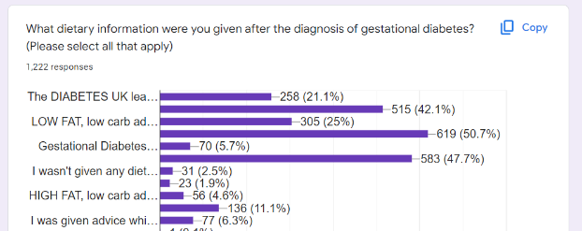  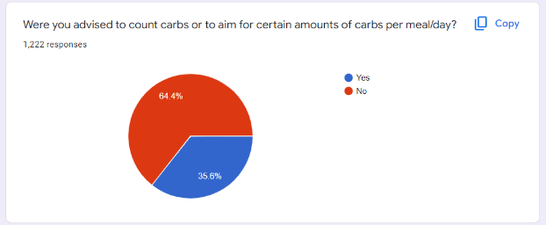  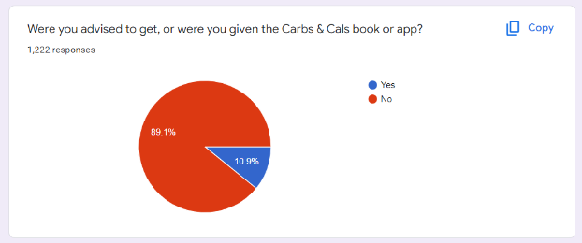  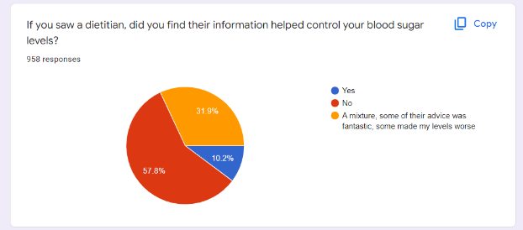  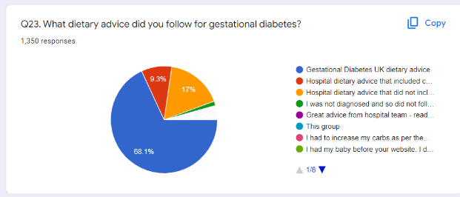  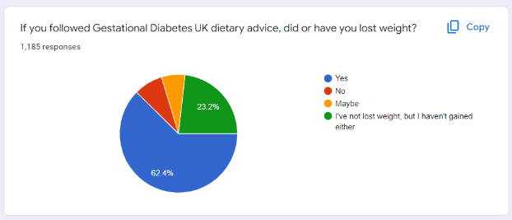  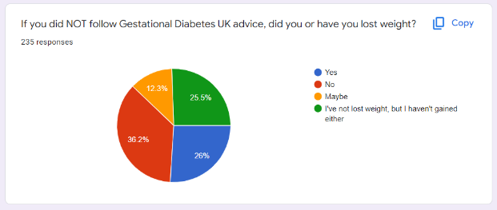  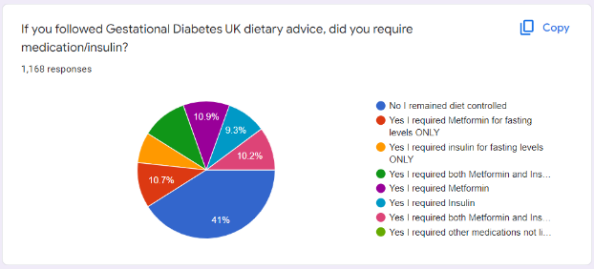  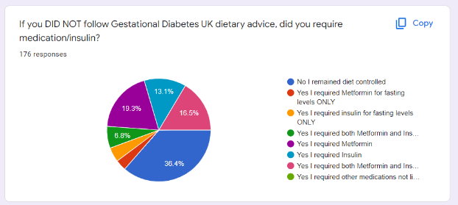  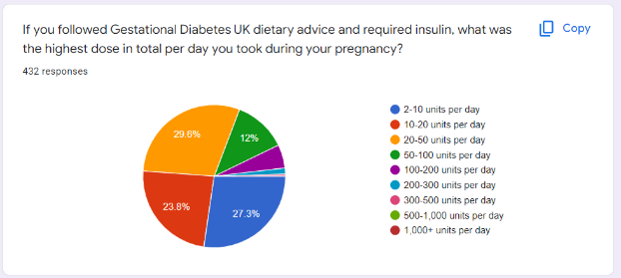  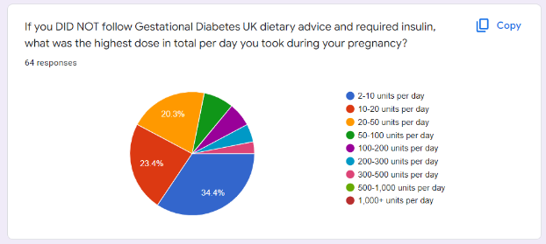
10 | Gestational Diabetes UK | 1.2.16 Refer all women with gestational diabetes to a dietitian. | Many women are not seen by a dietitian for weeks to months post diagnosis. After being diagnosed it is imperative to be seen by a dietitian to obtain dietary advice as blood glucose levels are impacted greatly by diet. This needs to be within a week of diagnosis so that the mother can make positive changes on diagnosis. It is pointless later down the line and leads to confusion, stress and concern. | This feedback from members of my Gestational Diabetes UK Facebook support group (20.7k members) www.facebook.com/groups/gestationaldiabetesuk/  Results from a Google Survey Gestational Diabetes UK conducted:  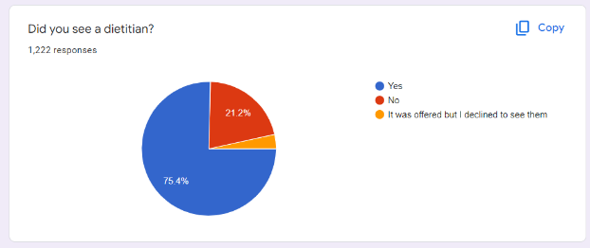  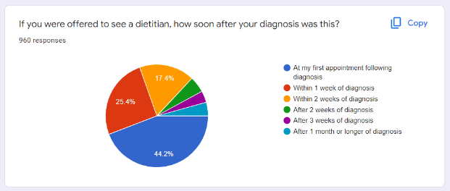  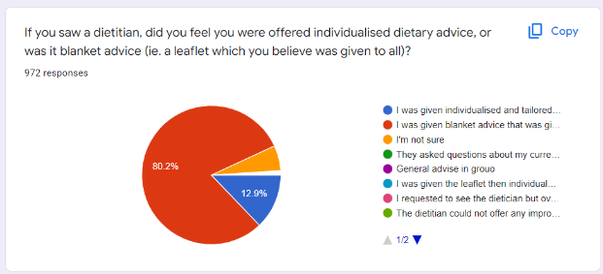  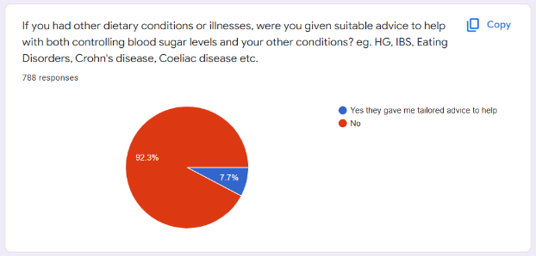
11 | Gestational Diabetes UK | 1.4.12 Use intravenous dextrose and insulin infusion during labour and birth for women with diabetes whose capillary plasma glucose is not maintained between 4 mmol/litre and 7 mmol/litre. [2008, amended 2015] | Many NHS Trusts advise women will be on an intravenous dextrose and insulin infusion just because they have a diagnosis of gestational diabetes, or because they have insulin-controlled gestational diabetes. The use of this during labour severely limits the movement the patient has and the guideline needs to be used and followed, for those who have uncontrolled blood glucose levels, not as a precautionary measure for all. | This feedback from members of my Gestational Diabetes UK Facebook support group (20.7k members) www.facebook.com/groups/gestationaldiabetesuk/
Antenatal care for women with diabetes
12 | Diabetes UK | Continuous Glucose Monitoring for women with type 1 during pregnancy | The ‘Diabetes in Pregnancy’ guidelines [NG3] recommended that rtCGM – or isCGM if someone expresses a clear preference - should be offered to pregnant women with T1D to help them meet their blood glucose targets and improve neonatal outcomes in a 2020 update. | https://www.nice.org.uk/guidance/ng3/chapter/Recommendations#intermittently-scanned-cgm-and-continuous-glucose-monitoring
13 | London Diabetes Clinical Network | Looking at evidence for screening for pre-existing diabetes at booking, and whether this should be in certain high-risk groups
14 | London Diabetes Clinical Network | Screening at 28 weeks for GDM: regional scoping exercise
15 | London Diabetes Clinical Network | Flash glucose monitoring for type 2 diabetes pregnancy
16 | University Hospitals Birmingham | Women with type 2 diabetes should also be offered CGM. There outcomes are often worse than women with Type 2
17 | SCM1 | Women with diabetes in pregnancy should be managed by a multidisciplinary team, comprising obstetrician, endocrinologist/diabetologist, diabetes specialist midwife, diabetes specialist nurse and dietician. | Involvement of the multidisciplinary team is essential in the care of all women with diabetes in pregnancy. For example, we have had to fight very hard in our Trust (a tertiary centre) to get DSN support for our pregnancy clinic. DSNs are essential given the complexity of the technology for women with T1DM and supporting an ever-increasing number of women with T2DM and GDM.  By explicitly setting a QS around the core team needed to support women with diabetes in pregnancy this could help clinicians lobby their Trust for adequate staffing to provide the best care. | MBRRACE report stating the 5 core members of the multidisciplinary team for diabetes in pregnancy.
18 | SCM2 | CGM/Flash in pregnancy | The NICE guidelines which are currently being updated have found that CGM and flash glucose monitoring be recommended for Type 1 patients as a way of managing their diabetes. | Amending 1.3.17 to cover ‘offer CGM or flash glucose monitors.’ Maybe it could follow the latest guidance/wording being published on this from NICE
19 | SCM4 | Information about outcomes and risks for Mother and baby. – Risk of the baby developing obesity, diabetes and other health problems  Organisation of Antenatal Care  At 36 weeks- Provide information and advice about starting to breastfeed and effect of breastfeeding on blood glucose levels. | There is evidence that breastfed babies have lower risk of developing type 1 diabetes and becoming overweight or obese later in life, which is a risk factor for type 2 diabetes.  Local audit data on breastfeeding rates  Offer more support and information on breastfeeding and colostrum harvesting for those women with Diabetes especially for those infants who are likely to require neonatal care.  NPID Audit 2020 identified that 51% of infants of those mothers with Type 1 diabetes and 31% of infants from those with Type 2 diabetes required admission to the neonatal unit. | https://www.diabetes.org/diabetes/gestational-diabetes/diabetes-breastfeeding  Capture local breastfeeding rates amongst women with Diabetes.  Method of infant feeding to be added to NPID AUDIT
Postnatal care
20 | Diabetes UK | A system wide change to ensure women diagnosed with gestational diabetes are annually recalled for their annual Hba1c, and not lost to follow up. | The academic literature and personal correspondence with diabetes midwives indicates that women with a history of gestational diabetes are not being recalled for their annual HbA1c and given the evidence that these women are likely to go onto develop type 2 diabetes is concerning. Timely diagnosis, so that the right treatment, education and support is vital to help reduce the short and long term complications of diabetes. | A system wide change to ensure women diagnosed with gestational diabetes are annually recalled for their annual Hba1c, and not lost to follow up.
21 | London Diabetes Clinical Network | A measure of number of referrals and uptake of the NHS Diabetes Prevention Programme following GDM pregnancy
22 | London Diabetes Clinical Network | Measuring the number of women who have postnatal glucose or HbA1c test
23 | National Pregnancy in Diabetes (NPID) audit | Improving pathways for postnatal management and diabetes prevention for women with GDM | The rates of early-onset type 2 diabetes have doubled in the past two decades (increasing from 27% during 2002-02 to 54% in 2019-20). Type 2 diabetes can be prevented by diet/lifestyle interventions but women with GDM are not accessing postnatal glucose checks, annual HbA1c or the National Diabetes Prevention Programme (NDPP). Recent data from NHSE suggest a 37% reduction in type 2 diabetes in those who completed the 9-month NDPP. Importantly for women the programme was as, and possibly more effective when delivered digitally compared to face to face. This could make NDPP far more accessible for women with new-borns. | https://digital.nhs.uk/data-and-information/publications/statistical/national-pregnancy-in-diabetes-audit/2019-and-2020)  Better pathways between maternity clinics and primary care are needed to ensure that all women with GDM are offered a postnatal glucose check, annual HbA1c and referral to the National Diabetes Prevention Programme (NDPP).
24 | NHS England and Improvement | Type 2 Diabetes prevention for women with a history of GDM | Type 2 diabetes can be prevented by diet/lifestyle interventions.  The University of Manchester, NIHR funded ‘Diploma’ study suggest the NHS DPP resulted in a 7 percent reduction in the number of new diagnoses of Type 2 diabetes in England between 2018 and 2019. Someone completing the nine-month NHS scheme reduces their chances of getting the condition by more than a third (37 percent).  All women who have had GDM and whose blood glucose levels returned to normal after the birth, should be offered referral to the NHS DPP by their GP, for example during their postnatal 6–8 week check. | Since Feb 2021 women with a history of GDM and normoglycaemia (fasting glucose less than 5.5mmol/l or HbA1c less than 42 mmol/mol) have been eligible for the NHS DPP, In addition to those with non-diabetic hyperglycaemia (NDH).  There is an opportunity to increase the numbers of referrals to the NHS DPP of women with a history of GDM and normoglycaemia.
25 | SCM1 | Referral of women with a diagnosis of GDM to the National Diabetes Prevention Program following pregnancy | Prevention of progression from GDM to T2DM is a priority in the current NG3 NICE guideline. Whilst currently there is an indicator on rates of postnatal screening, alone this is unlikely to bring about a change in outcomes (i.e., reduce progression). Since 2021 women with a history of GDM has been eligible for the DPP, however anecdotally referral, attendance and uptake have been very low. | National Diabetes Prevention Program
26 | SCM4 | Information and follow up after birth  For those women diagnosed with Gestational Diabetes, offer a HbA1c at 13 weeks postnatal and annually thereafter.  Current Quality Statement. | We know that women who have had Gestational Diabetes are at significant risk of developing Type 2 diabetes within 5 to 10 yrs of the index pregnancy. In addition we have witnessed an increase in Type 2 Diabetes in pregnancy.  Though data on previous Gestational Diabetes is part of the NPID Audit, it does not appear in the latest report.  Locally we find that the uptake of HbA1c at 13 weeks postnatal or annually is generally poor, especially in the minority ethnic groups. | Local audit and on uptake of HbAc at 13 weeks postnatal and annually in those diagnosed with Gestational Diabetes.  Additional resources and support for Community commissioning groups and GP practices.  Reporting of those with previous GDM from NPID audit.
Additional areas
27 | Best Beginnings | Nutritional and dietary guidelines for different ethnicities and cultures to control blood sugar levels. | As psychological and physiological responses to diet vary based on cultures and communities, there is a need for diverse dietary and nutritional standards and behaviour change strategies for individuals with GDM/at risk. | There is no culture or ethnic diet-related information given to the individuals at risk or with GDM on NICE Diabetes in Pregnancy website.
28 | Best Beginnings | Information on how different mental health conditions and social support factors have an impact on gestational diabetes, foetus health, and the delivery of the baby. | Compared with normal GDM pregnant women, GDM pregnant women with anxiety and depression were more likely to have adverse outcomes in terms of blood glucose during pregnancy, delivery mode, and maternal and infant outcomes. | Please see this study: https://gtr.ukri.org/projects?ref=MR%2FP019293%2F1  Additionally: Please see a study of systemic review - https://www.hindawi.com/journals/jdr/2021/9959779/
29 | Best Beginnings | Further referrals to support groups by health practitioners and/or via government websites to community organizations and charities. | The general population should have access to more health resources by connecting to different organizations and charity groups through the Government of UK and NHS website. | Best Beginnings has been working with UCL to develop a digital intervention to encourage and support healthy eating and activity during pregnancy for its pregnancy and parenting app Baby Buddy. The ‘Baby Steps’ feature should be launched later this year.  UCL research shows that expectant parents are motivated to make changes to their lifestyle behaviours to improve both their own health and well-being and their baby’s health and development. Whilst they acknowledge that advice on healthy eating and activity is widely available, there is limited advice and support tailored specifically to pregnancy, which is culturally inclusive and relevant to those managing on a tight budget.  Rooted in behaviour change and habit theory, this intervention will encourage and support expectant parents to develop healthier dietary and activity habits by making a series of tiny, incremental lifestyle changes. Users will set their own goals and be shown how to break these down into manageable steps. Self-monitoring and personalised weekly feedback will encourage users to stay on track. In addition, users will receive regular information, tips, recipe ideas and exercise videos.  The team is in discussion with Gestational Diabetes experts to determine how this intervention can serve as both a prevention and management tool for women at risk of or with GDM.
30 | Best Beginnings | Provide prevalence rate of GDM in different communities based on distinct factors such as genetics, diet, socioeconomic status, mental health illnesses etc. | The prevalence of GDM is increasing in the UK; the offer of an oral glucose tolerance test to all women, the lowering of diagnostic thresholds, and increases in the proportion of women at risk, either because of their ethnicity or increasing weight or age, are all contributing factors. | Please see the data collected from the following systemic review:  https://www.ncbi.nlm.nih.gov/books/NBK401113/
31 | Gestational Diabetes UK | 1.4.5 Consider elective birth before 40 weeks plus 6 days for women with gestational diabetes who have maternal or fetal complications. [2015] | There is far too much confusion over what entails ‘maternal or fetal complications’. In many Trusts women are being advised to have early induction of labour or elective birth (from 37 weeks onwards) due to being Metformin or insulin-treated, yet they have no complications. More clarification is needed. | I have shared a lot of evidence around this subject on these two articles of the Gestational Diabetes UK website: https://www.gestationaldiabetes.co.uk/gestational-diabetes-birth/  https://www.gestationaldiabetes.co.uk/induction/  Results from a Google Survey Gestational Diabetes UK conducted:  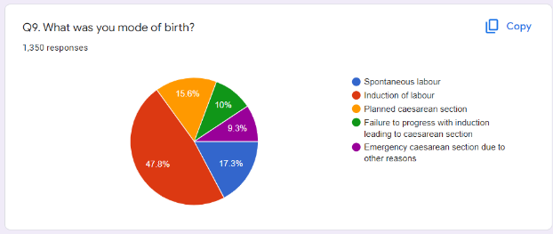  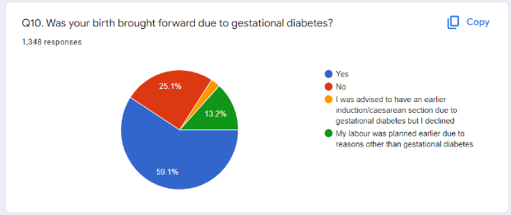
32 | Gestational Diabetes UK | 1.5.1 Advise women with diabetes to give birth in hospitals where advanced neonatal resuscitation skills are available 24 hours a day. [2008] | This point needs far more clarity as it prevents those diagnosed with diabetes and gestational diabetes from being signed off for use of some midwife-led birthing units, water births, or for home births. Evidence is lacking to suggest that all babies born to mothers with diabetes require this and a more individual approach is necessary. | Gestational Diabetes UK website: https://www.gestationaldiabetes.co.uk/gestational-diabetes-birth/  https://www.gestationaldiabetes.co.uk/induction/  https://www.gestationaldiabetes.co.uk/gestational-diabetes-waterbirth/  https://www.gestationaldiabetes.co.uk/gestational-diabetes-homebirth/
33 | National Pregnancy in Diabetes (NPID) audit | Targeting HbA1c<43mmol/mol after 24 weeks gestation to reduce perinatal morbidity and mortality. | The National Pregnancy in Diabetes (NPID) audit has demonstrated that the risk of perinatal morbidity and mortality is lowest in pregnancies with HbA1c<43mmol/mol after 24 weeks gestation. Women with HbA1c <43mmol/mol after 24 weeks had lower rates of preterm birth, large for gestational age birthweight, neonatal intensive care unit admission and perinatal death.  Strengthening the glycaemic target in late pregnancy (in line with previous 2008 NICE guideline recommendations) may help to improve obstetric and neonatal outcomes, which have remained unchanged during the past 7 years. This is particularly important for the growing numbers of women with type 2 diabetes, for whom glucose remains the key modifiable risk factor for adverse pregnancy outcome. | See slide 4 executive summary https://digital.nhs.uk/data-and-information/publications/statistical/national-pregnancy-in-diabetes-audit/2019-and-2020)
34 | NHS England and Improvement | Supporting women with diabetes of reproductive age (15-50 years) to self-manage their condition, via provision of structured education. | Structured Education contributes to improved diabetes self-management - and glycaemic control is a key modifiable risk factor for adverse pregnancy outcomes.  NHSEI has rolled out national digital structured education offers.  - MyType1 Diabetes, for adults with Type 1 diabetes  - Healthy Living, for adults with Type 2 diabetes  - DigiBete for children and young people with Type 1 diabetes.  Access to HeLP-Diabetes [which the Healthy Living programme is based on] has been shown to improved glycaemic control over 12 months. Participants in the intervention group had 0.24 percent lower HbA1c than those in the control (Murray E, Sweeting M, Dack C, et al. Web-based self-management support for people with type 2 diabetes (HeLP-Diabetes): randomised controlled trial in English primary care. BMJ Open2017;7) | NICE guidance NG28 and NG17 recommend structured education is offered at the time of diagnosis, with annual reinforcement and review.  There is also a NHS long term plan commitment to increased numbers of people attending structured education.  There is room for improvement for overall uptake of structured education, although women are overrepresented in Structured Education attendance as compared to the National Diabetes Audit (NDA) population data.
35 | NHS England and Improvement | Improving access, and equity of access to rtCGM (and or Flash) by women with type 1 diabetes of reproductive age (15-50 years) to support pre -conception glycaemic control | Glycaemic control is a key modifiable risk factor for adverse pregnancy outcomes and use of rtCGM (and or Flash) can improve diabetes self-management and glycaemic control.  An early pregnancy HbA1c of less than or equal to 48mmol/mol is associated with lower rates of congenital anomaly and perinatal death but is achieved only in a minority of women with diabetes and is least likely in women who live in deprived areas.  The National Pregnancy in Diabetes (NPID) audit has demonstrated that overall, seven out of eight women were not well prepared for pregnancy and pregnancy preparation rates are lowest in women from the most deprived communities – only 21% with type 1 diabetes living in deprived quintiles were prepared for pregnancy as per NICE guidelines. | Whilst 97 percent of pregnant women with type 1 diabetes are being offered CGM and 78 percent are accepting there is scope to improve uptake of this technology by women of reproductive age living with Type 1 diabetes.  NG18 states (rtCGM) should be offered to all children and young people with type 1 diabetes. Improving access to either rtCGM or Flash (whichever is the most appropriate) for adult women with Type 1 diabetes, is line with in NG17 (March 2022)
No comments
36 | NHSE&I patient safety |  | We are currently working on a specific patient safety issue that may have some relevance to this topic, in relation to ‘risk of harm associated with remote monitoring of diabetes in pregnancy’. However, we are at the early stages of our investigation and don’t currently have anything to share.
37 | Royal College of General Practitioners | We have reviewed the QS and have no comments to add at this time and we are happy with the suggestions. | N/A
38 | Royal College of Nursing | We do not have any comments to add on this occasion, thank you for the opportunity to contribute. | N/A
39 | Royal College of Pathologists | no comments to add for this consultation.
40 | Royal College of Obstetricians and Gynaecologists | we had no responses this time around.

World Health Organisation

