- APPENDIX F- Network meta-analysis of interventions in the treatment of bedwetting
  - Introduction
The results of conventional meta-analyses of direct evidence alone (as previously presented in chapters 7-20) make it difficult to determine which intervention is most effect in the treatment of bedwetting. The challenge of interpretation has arisen for two reasons:
- Some pairs of alternative strategies have not been directly compared in a randomised controlled trial (for example, dry bed training with alarm vs desmopressin).
- There are frequently multiple overlapping comparisons (for example, alarm vs desmopressin, alarm vs imipramine and desmopressin vs imipramine), that could potentially give inconsistent estimates of effect.
To overcome these problems, a hierarchical Bayesian network meta-analysis (NMA) was performed. This type of analysis allows for the synthesis of data from direct and indirect comparisons and allows for the ranking of different interventions in order of efficacy, defined as the achievement of a full response without the recurrence of bedwetting after treatment discontinuation. The analysis also provided estimates of effect (with 95% credible intervals) for each intervention compared to one another and compared to a single baseline risk. These estimates provide a useful clinical summary of the results and facilitate the formation of recommendations based on the best available evidence. Furthermore, these estimates were used to parameterise treatment effectiveness of first line interventions in the de novo cost-effectiveness modelling presented in appendix G.

Conventional meta-analysis assumes that for a fixed effect analysis, the relative effect of one treatment compared to another is the same across an entire set of trials. In a random effects model, it is assumed that the relative effects are different in each trial but that they are from a single common distribution and that this distribution is common across all sets of trials.

Network meta-analysis requires an additional assumption over conventional meta-analysis. The additional assumption is that intervention A has the same relative effect across all trials of intervention A compared to intervention B as it does across trials of intervention A versus intervention C, and so on. Thus, in a random effect network meta-analysis, the assumption is that intervention A has the same effect distribution across all trials of A versus B, A versus C and so on.

This specific method is usually referred to as mixed-treatment comparisons analysis but we will continue to use the term network meta-analysis to refer generically to this kind of analysis. We do so since the term “network” better describes the data structure, whereas “mixed treatments” could easily be misinterpreted as referring to combinations of treatments.

  - Methods
    - Study selection and data collection
To estimate the odds ratios and relative risks, we performed a NMA that simultaneously used all the relevant randomised controlled trial evidence from the clinical evidence review¹⁸. As with conventional meta-analyses, this type of analysis does not break the randomisation of the evidence, nor does it make any assumptions about adding the effects of different interventions. The effectiveness of a particular treatment strategy combination will be derived only from randomised controlled trials that had that particular combination in a trial arm.
From the outset, we sought to minimise any clinical or methodological heterogeneity by focusing the analysis on specific patient subgroups, identifying similar outcomes and including only RCTs that followed patients for a minimum and comparable length of time. Thus, three networks of evidence were identified, defined by their outcome measure and population:
Network 1: Full response (bedwetting only)
- Evidence for patient populations explicitly identified as either mono-symptomatic or having only bedwetting.
- Evidence only for treatment periods of at least 12 weeks for enuresis alarms or behavioural interventions and at least 8 weeks for pharmacological interventions.
Network 2: Full response (bedwetting with possible daytime symptoms)
- Evidence for patient populations not positively identified as either mono-symptomatic or having only night time wetting (referred to as patients with bedwetting with possible daytime symptoms).
- Evidence only for treatment periods of at least 12 weeks for enuresis alarms or behavioural interventions and at least 8 weeks for pharmacological interventions.
Network 3: Recurrence of bedwetting at 6 months following discontinuation of treatment (bedwetting only)
- Evidence for patient populations explicitly identified as either mono-symptomatic or having only bedwetting.
- Evidence only for treatment periods of at least 12 weeks for enuresis alarms or behavioural interventions and at least 8 weeks for pharmacological interventions and with reports of a bedwetting recurrence within 6 months of successful treatment.

    - Outcome measures
The NMA evidence reviews for interventions considered two clinical outcomes identified from the clinical evidence review were full response and risk of bedwetting recurrence at 6 months following discontinuation of treatment.
A full response refers to
- the number of children who achieved 14 consecutive dry nights, or
- the number of children who had a ≥90% increase in the number of dry nights, or
- the number of children who had 0 to 1 wet nights per month by the end of treatment.
These outcomes demonstrate the initial likelihood of response and are suggestive of future dryness. The GDG discussed these three clinical outcomes and judged them to be similar measures of effect. Therefore, the three were combined for the NMA
The second outcome observed in a selection of trials and evaluated in the NMA was the risk of bedwetting recurrence at 6 months after achieving a full response and treatment being withdrawn. The outcome of bedwetting recurrence at 6 months shows the long term risk of recurrence, showing the potential long term success rates of interventions for the treatment of bedwetting.
Dichotomous outcome measures were chosen mainly for pragmatic reasons. They represented the outcome measures reported in most trials and ones that the GDG had previously encountered in other reviews. The proportion fully responding to treatment seemed a reasonable and common measure of efficacy, was more useful than a continuous outcome measure, such as mean reduction in number of wet nights per week or month, and allowed for easier GDG interpretation. Responders to treatment were calculated on an intention-to-treat basis (i.e. the analysis was based on the total number of randomly assigned participants), regardless of how the original study investigators analysed their data. Approaching the data conservatively, we assumed that missing participants did not respond to treatment.

    - Comparability of interventions
The interventions compared in the model were those found in the randomised controlled trials included in the clinical evidence review already presented in chapters 7 to 20. If an intervention was evaluated in a study that met the inclusion criteria for the network (that is if it reported at least one of the outcomes of interest and was undertaken in one of the populations of interest for the minimum required length of treatment) then it was included in the network meta-analysis. If the outcome, population or treatment length did not meet the inclusion criteria, then the study data was excluded from the network meta-analysis.
The interventions included were

Behavioural:
- Alarms
- alarm and information leaflets
- alarm and information CD
- dry bed training with an alarm
- dry bed training without an alarm
- retention control training and an alarm
- star charts
- stop start training
- retention control training with placebo
Pharmacological:
- desmopressin (intranasal and tablet)
- imipramine
- amitriptyline
- oxybutynin
Combination:
- desmopressin and amitriptyline
- desmopressin and oxybutynin
- imipramine and oxybutynin
- alarm and tablet desmopressin
- retention control training and desmopressin
Psychological:
- psychotherapy
- play therapy
- a 3 step programme
- 3 step programme and motivational therapy
Alternative therapies:
- homotoxiciological remedies
The details of these interventions can be found in the clinical evidence review chapters of the guideline.
The GDG decided the effectiveness of pharmacological treatments could be assessed after 8 weeks of treatment. The GDG felt that because of the way that pharmacological interventions work, their effectiveness could be adequately assessed within 8 weeks of treatment. This was long enough to determine whether a child was likely to respond to a given pharmacological intervention and long enough for them to achieve any of the time-dependent outcome measures. Enuresis alarms and other behavioural interventions, on the other hand, work in a very different way. The GDG felt that the effectiveness of these interventions could only be measured if treatment was administered for at least 12 weeks.

    - Baseline risk
The baseline risk is defined here as a child or young person’s ‘risk,’ or probability, of becoming dry without any intervention. This figure is useful because it allows us to convert the results of the NMA from odds ratios to relative risks. We identified two possible ways of deriving this baseline risk figure:
- Randomised controlled trials
- Longitudinal studies
Deriving the figure from our randomised controlled trials involved aggregating the number of complete responders (achieving 14 dry nights) across the no treatment and placebo arms of studies included in our NMA and dividing by the aggregate sample size from the same arms.
Using this method produced a baseline probability of 15.2% for becoming dry in the bedwetting only population, 4% and in the bedwetting with possible daytime symptoms population. For the recurrence of bedwetting, using the trials produced a baseline probability of 56.6%.
Although the figures from the randomised evidence may seem plausible, a few limitations should be noted. First, it is difficult to tell in some of the studies what ‘no treatment’ actually entailed and whether keeping a record of wet and dry nights whilst on a waiting list may have actually had some minor treatment effect. Secondly, patients participating in a clinical trial, even when allocated to a ‘no treatment’ or placebo arm are not necessarily representative of the general population. Although they are representative of a population seeking treatment, they are not necessarily a good example of the natural history of bedwetting within the general population.
Therefore, for the results presented here, the probability of becoming dry without treatment was derived from a UK prevalence study of infrequent bedwetting and nocturnal enuresis by Butler and Heron (2008) ⁵. Using data from the Avon Longitudinal Study of Parents and Children (ALSPAC), an ongoing population-based study investigating the effect of a wide range of environmental and other influences on the health and development of children¹⁰ the authors reported prevalence of infrequent bedwetting (wetting less than twice per week) and nocturnal enuresis (wetting more than twice per week) at 5 time points, 54, 65, 78, 91 and 115 months of age. The study reported enough data such that the probability of becoming dry or of relapsing in a 3-month time period could be generated. Calculating these 3-month probabilities from the data required that we assume a constant rate of achieving dryness or relapsing over the time observed in the study. Finally, we lumped together data for infrequent bedwetting and nocturnal enuresis, as we are looking fundamentally at going from wet to dry and vice versa.
As the Butler and Heron study reported prevalence of wetting at several different time points, we had to choose a specific time point from which to generate a baseline risk. Because the average population across the trials is between 8 and 10 years, we decided to base the baseline risk of becoming dry and experiencing a recurrence of bedwetting on the data reported at 91 and 115 months (approximately 7.5 and 9.5 years of age). Using this data, the 3-month probability of becoming dry without treatment is 10.34% and the 6-month probability of bedwetting recurrence is 0.6134%. We tested the effect of this data source on the results by using the data from placebo and no treatment arms from the RCTs in a sensitivity analysis.
    - Statistical analysis
A hierarchical Bayesian network meta-analysis (NMA) was performed using the software WinBUGS¹⁹. We adapted a multi-arm random effects model template from the University of Bristol website (https://www.bris.ac.uk/cobm/research/mpes/mtc.html). This model accounts for the correlation between arms in trials with any number of trial arms.
In order to be included in the analysis, a fundamental requirement is that each treatment is connected directly or indirectly to every other intervention in the network. For each population and outcome subgroup, a diagram of the evidence network was produced in figures 1a-1b and presented in section 1.3.
The model used was a random effects logistic regression model, with parameters estimated by Markov chain Monte Carlo Simulation. As it was a Bayesian analysis, the evidence distribution is weighted by a distribution of prior beliefs. A non-informative prior distribution was used to maximise the weighting given to the data. These priors were normally distributed with a mean of 0 and standard deviation of 10,000.
For each analysis, a series of 20,000 burn-in simulations were run to allow convergence and then a further 20,000 simulations were run to produce the outputs. Convergence was assessed by examining the history and kernel density plots.
We tested the goodness of fit of the model by calculating the residual deviance. If the residual deviance is close to the number of unconstrained data points (the number of trial arms in the analysis) then the model is explaining the data well.
The results, in terms of relative risk, of pair-wise meta-analyses are presented in the clinical evidence review (Chapters 7-20). In preparation for the NMA, these conventional meta-analyses were re-run to produce odds ratios and these are presented as part of the NMA results section.
The outputs of the NMA were odds ratios. Odds ratios and their 95% credible intervals were generated for every possible pair of comparisons by combining direct and indirect evidence in the network. To be consistent with the comparative effectiveness results presented elsewhere in the clinical evidence review and for ease of interpretation, relative risks were computed from the outputs of the NMA. Relative risks (RR) were derived from the odds ratios for each intervention compared back to a single ‘no treatment’ baseline risk, using the baseline risk as described above and the following formula:
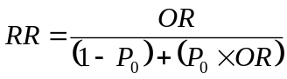
where P_{o} is the baseline risk.
We estimated the RR for each of the 20,000 simulations, treating P_{o} as a constant. The point estimate of the RR was taken to be the median of the 20,000 simulations and the 95% confidence intervals for the RR were taken to be the 2.5th and 97.5th centiles from the distribution of the RR.
We also assessed the probability that each intervention was the best treatment by calculating the relative risk of each intervention compared to no treatment (baseline risk), and counting the proportion of simulations of the Markov chain in which each intervention had the highest relative risk. Using this same method, we also calculated the overall ranking of interventions according to their relative risk compared to no treatment.
A key assumption behind NMA is that the network is consistent. In other words, it is assumed that the direct and indirect treatment effect estimates do not disagree with one another. Discrepancies between direct and indirect estimates of effect may result from several possible causes. First, there is chance and if this is the case then the network meta-analysis results are likely to be more precise as they pool together more data than conventional meta-analysis estimates alone. Second, there could be differences between the trials included in terms of their clinical or methodological characteristics. Differences that could lead to inconsistency include:
- Different populations (e.g. sex, age, risk factors)
- Different interventions (e.g. doses, modes of delivery)
- Different measures of outcome (e.g. 14 consecutive dry nights, 90% reduction in wetting frequency)
- Different follow-up periods (e.g. 2 weeks, 6 months, 1 year)
This heterogeneity is a problem for network meta-analysis and should be dealth with by subgroup analysis and sometimes by re-defining inclusion criteria. Inconsistency, caused by heterogeneity, was assessed subjectively by comparing the odds ratios from the direct evidence (from pair-wise meta-analysis) to the odds ratios from the combined direct and indirect evidence (from NMA). We assumed the evidence to be inconsistent where the odds ratio from the NMA did not fit within the confidence interval of the odds ratio from the direct comparison. Where inconsistency between observed treatment effects was identified, we sought to find the heterogeneity by examining the details of the study design, population, interventions and outcomes of the relevant trials.

  - Results
A total of 27 studies from the original evidence review met the inclusion criteria for at least one network. Figures 1a-1c show the 3 networks created by eligible comparisons for each NMA. Of the 66 possible pair-wise comparisons between the 12 interventions in the bedwetting only network, 21 have been studied directly in at least one trial. Of the 179 possible pair-wise comparisons between the 20 interventions in the network of patients with bedwetting with possible daytime symptoms, 30 have been studied directly in at least one trial. Of the 21 possible pair-wise comparisons between the 7 interventions in the 6-month bedwetting recurrence network, 9 have been compared directly in at least one trial.
Figures 1a: Network 1: Full response for children with bedwetting only
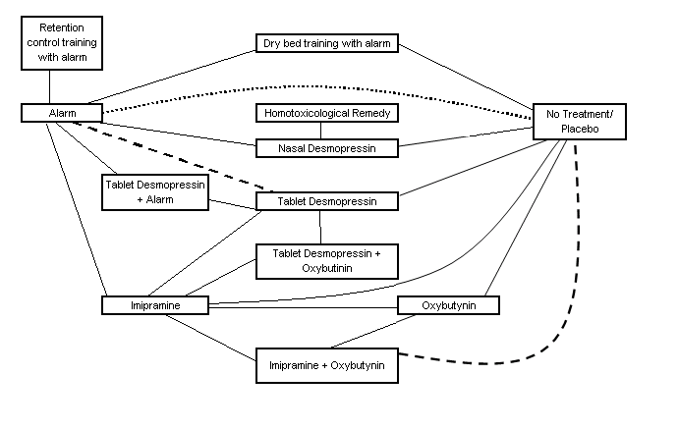
Figure 1b: Network 2: Full response for children with bedwetting with possible daytime symptoms
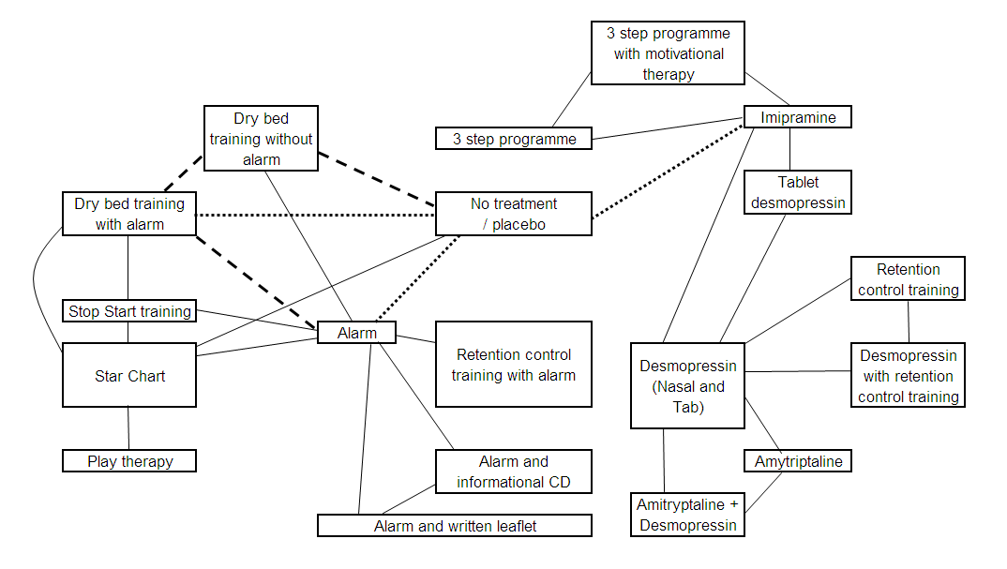
Figure 1c: Network 3: Recurrence of bedwetting at 6 months following discontinuation of treatment for children with bedwetting only
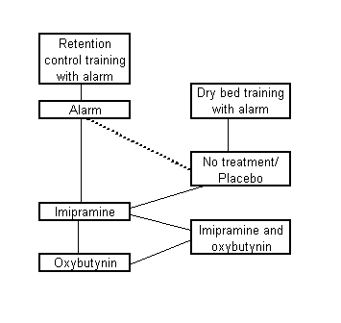
Lines represent direct comparisons: solid lines indicate 1 study contributing to the results, dashed indicates 2 studies.
The trial data from the 10 studies among patients diagnosed with monosymptomatic nocturnal enuresis or experienced bedwetting only are shown in table 1. The trial data from the 17 studies among participants with bedwetting with possible daytime symptoms, are presented in table 2. Data relating to bedwetting recurrence at 6 months is included in table 3.

Table 1: Trial data of full responders for children with bedwetting only
Study | Other Treatment | Other Treatment |  | No Treatment / Placebo |  | Enuresis Alarm |  | Desmo-pressin (tablet or nasal) |  | Imipra-mine |  | Oxybutynin
 |  | N | R | N | R | N | R | N | R | N | R | N | R
Wagner²⁸ |  |  |  | 13 | 1 | 13 | 8
Wagner^{27,27} |  |  |  | 12 | 1 | 12 | 10 |  |  | 12 | 4
Nawaz ^{21,21} | Dry Bed Training+Alarm | 12 | 8 | 12 | 1 | 12 | 3
Longstaffe ^{17,17,17} |  |  |  | 61 | 23 | 61 | 35 | 60 | 29
Tahmaz ^{25,25,25,25} | Imipramine+Oxybutynin | 24 | 16 | 23 | 5 |  |  |  |  | 14 | 7 | 16 | 6
Ferrera ^{7,7,7,7,7} | Homotoxicological Remedy | 50 | 10 | 51 | 0 |  |  | 50 | 26
Ng ^{22,22,22,22,22,22} | Desmopressin+ Alarm | 32 | 20 |  |  | 35 | 8 | 38 | 16
Tuygun ^{26,26,26,26,26,26} |  |  |  |  |  | 35 | 20 | 49 | 25
Fielding ^{8,8,8,8,8,8,8} | Retention Control Training + Alarm | 16 | 11 |  |  | 17 | 14
Lee ^{16,16,16,16,16,16} | Desmopressin+Oxybutynin | 22 | 14 |  |  |  |  | 23 | 14 | 23 | 3
N, number of participants; R, number experiencing a full response

Table 2: Trial data of full responders from studies for children with bedwetting with possible daytime symptoms
Study | Other Treatment | Other Treatment |  | Placebo / No Treatment |  | Alarm |  | Imipramine |  | Amitrip-yline |  | Desmo |  | DBT+Alarm |  | Star Chart
Study | Other Treatment | N | R | N | R | N | R | N | R | N | R | N | R | N | R | N | R
Bollard ² |  |  |  | 15 | 0 | 15 | 9
Jehu ¹³ |  |  |  | 20 | 0 | 19 | 18
Moffatt ²⁰ |  |  |  | 55 | 1 | 61 | 42
Bollard ² | DBT without alarm | 20 | 5 | 20 | 2 | 20 | 16 |  |  |  |  |  |  | 20 | 20
Bollard³ | DBT without alarm | 10 | 2 | 10 | 0 |  |  |  |  |  |  |  |  | 10 | 9
Smellie ²⁴ |  |  |  | 29 | 4 |  |  | 25 | 11
Khorana ¹⁵ |  |  |  | 34 | 0 |  |  | 42 | 19
Bennett ¹ | Stop Start Training | 12 | 2 |  |  | 9 | 4 |  |  |  |  |  |  | 10 | 5 | 9 | 0
Gefken ⁹ | RCT + Alarm | 18 | 20 |  |  | 20 | 19
Houts ¹¹ | RCT + Alarm | 15 | 13 |  |  | 15 | 9
Werry ²⁹ | Psychotherapy | 21 | 2 |  |  | 22 | 7
Redsell ²³ | Alarm + CD | 99 | 51 |  |  | 73 | 36
Redsell ²³ | Alarm + written | 76 | 41
Iester ¹² | 3 step programme | 36 | 24 |  |  |  |  | 36 | 14
Iester e | 3 step programme + motivational therapy | 96 | 81
Lee ¹⁶ | Desmo + Oxybutynin | 26 | 7 |  |  |  |  | 25 | 3 |  |  | 26 | 9
Fava ⁶ | Play Therapy | 10 | 1 |  |  |  |  |  |  |  |  |  |  |  |  | 10 | 8
Burke ⁴ | Amitriptyline + Desmo | 14 | 3 |  |  |  |  |  |  | 17 | 4 | 17 | 1
Kahan ¹⁴ | Retention Control Training + Desmo | 70 | 22 |  |  |  |  |  |  |  |  | 76 | 31
Kahan ¹⁴ | Retention Control Training + Placebo | 75 | 12
DBT, Dry Bed Training; RCT, Retention Control Training; Desmo, Desmopressin; N, number of participants; R, number experiencing a full response

Table 3: Trial data on incidence of bedwetting recurrence from studies for children with bedwetting only
Study | Other Treatment | Other Treatment |  | No Treatment / Placebo |  | Enuresis Alarm |  | Imipra-mine |  | Oxy-butynin
 |  | N | R | N | R | N | R | N | R | N | R
Wagner²⁸ |  |  |  | 1 | 1 | 8 | 2
Wagner²⁷ |  |  |  | 1 | 1 | 10 | 5 | 4 | 4
Tahmaz ²⁵ | Imipramine + Oxybutynin | 16 | 4 | 5 | 2 |  |  | 7 | 5 | 6 | 5
Nawaz ²¹ | DBT with alarm | 8 | 1 |  |  | 3 | 1
Fielding ⁸ | RCT with alarm | 11 | 3 |  |  | 14 | 5
DBT, Dry Bed Training; RCT, Retention Control Training; N, number of participants; R, number experiencing a recurrence of bedwetting at 6 months
The age range of participants in the included studies was 5 to 17 years old, the range of sample sizes was from 20 participants to 228 participants. The range of treatment lengths was 8 weeks to 6 months, with the minimum treatment length for pharmacological interventions was 8 weeks and for enuresis alarms and behaviour interventions was 12 weeks. The doses for pharmacological interventions were all within the BNFC stated ranges.
6 studies were two-arm placebo (or no treatment) controlled trials, 5 studies were 3-arm placebo controlled trials with 2 active arms and 2 studies were 4-arm placebo controlled trials with 3 active arms. Among trials comparing two or more active treatments, 6 studies had 2 active arms, 7 had 3 active arms and 1 had 4 active arms.
The clinical evidence reviews considered the quality of the outcome measures according to the modified GRADE evidence profiles. The clinical evidence reviews showed the methodological quality of the outcome measures included in the NMA was moderate to very low.

Network 1: Full response for children with bedwetting only
Figure 2 summarises the results of the conventional meta-analyses in terms of odds ratios generated from studies directly comparing different interventions. Figure 2 also presents the results of the NMA in terms of odds ratios for every possible treatment comparison.

Figure 2: Effectiveness of interventions in a population of children with bedwetting only, results of conventional and network meta-analyses
No Treatment/ Placebo | 7.38  (1.55 - 35.14) | 4.04  (1.18 - 13.84) | 22.00  (2.05 - 236.05) | 1.55  (0.75 - 3.19) | 2.16  (0.52 - 8.90) | 7.20  (1.95 - 26.54) | 111.41  (6.52 - 1904.71) | 26.70  (1.52 - 469.44)
11.42  (3.244-44) | Alarm | 0.10  (0.01 - 0.69) | 6.00  (1.02 - 35.37) | 0.69  (0.34 - 1.42) |  |  | 1.34  (0.44 - 4.11) |  | 5.63  (1.94 - 16.32) | 0.47  (0.09 - 2.42)
2.643  (0.4855, 15.29) | 0.2336  (0.03572 - 1.44) | Imipramine |  |  | 0.60  (0.14 - 2.58) | 2.00  (0.52 - 7.70) | 10.37  (2.37 - 45.30) |  |  |  | 11.67  (2.62 - 51.89)
45.24  (3.086 - 558.6) | 3.907  (0.2659 - 48.73) | 16.82  (0.8051 - 330.5) | DBT with alarm
3.507  (0.3614 - 34.82) | 0.3099  (0.03004 - 2.81) | 1.335  (0.0818 - 19.82) | 0.07935  (0.0028 - 2.367) | Nasal Desmo
1.843  (0.1396 - 26.36) | 0.1622  (0.0099 - 2.666) | 0.7015  (0.0497 - 9.501) | 0.04141  (0.0011 to 1.571) | 0.5264  (0.017 - 16.27) | Oxybutynin | 3.33  (0.89 - 12.49)
6.623  (0.5335 - 81.08) | 0.5842  (0.0362 - 8.389) | 2.529  (0.1928 - 30.44) | 0.152  (0.0041 - 5.362) | 1.892  (0.0639 - 54.88) | 3.582  (0.2241 - 57.65) | Imipramine+  Oxybutynin
26.42  (5.438 - 140.4) | 2.296  (0.5266 - 10.39) | 9.803  (1.545 to 67.79) | 0.5916  (0.0355 - 11.46) | 7.514  (0.5885 - 109.1) | 14.27  (0.7791 - 262.6) | 3.984  (0.249 - 69.76) | Tab Desmo | 0.23  (0.09 - 0.56) | 2.29  (0.88 - 6.00) |  | 1.13  (0.34 - 3.76)
9.162  (0.8029 - 122.5) | 0.8019  (0.0601 - 11.47) | 3.396  (0.2083 - 61.66) | 0.2016  (0.0067 - 7.656) | 2.556  (0.0993 - 79.32) | 5.009  (0.1542 - 178.1) | 1.371  (0.04757 - 48.03) | 0.3453  (0.0314 - 4.144) | Homotoxicological Remedy
64.14  (5.067 - 888.9) | 5.622  (0.5116 - 61.04) | 24.27  (1.409 - 421.4) | 1.44  (0.0457 - 52.33) | 18.34  (0.7699 - 483.2) | 35.02  (0.9892 - 1253) | 9.863  (0.3211 - 318.7) | 2.454  (0.2105 - 26.94) | 7.071  (0.2431 - 183.9) | Desmo+Alarm
4.884  (0.2051 - 122.3) | 0.423  (0.02155 - 7.83) | 1.821  (0.0583 - 58.64) | 0.1078  (0.0022 - 5.456) | 1.376  (0.0358 - 56.75) | 2.591  (0.0473 - 146.3) | 0.7253  (0.01375 - 39.01) | 0.1825  (0.0065 - 4.979) | 0.5271  (0.00995 - 25.85) | 0.07508  (0.0016 - 3.275) | RCT with alarm
32.62  (2.278 - 563.8) | 2.819  (0.1884 - 44.52) | 12.1  (0.9584 - 171.3) | 0.7262  (0.01991 - 30.6) | 9.133  (0.3144 - 337.7) | 17.46  (0.5384 - 636.5) | 4.937  (0.1688 - 167.5) | 1.243  (0.0947 - 15.42) | 3.552  (0.1089 - 106.7) | 0.5008  (0.0176 - 16.16) | 6.822  (0.13 - 357.7) | Desmo+  Oxybutynin
DBT, Dry bed training; Desmo, Desmopressin; RCT, Retention Control Training
Results in white are the odds ratios and 95% confidence intervals from the conventional meta-analyses of direct comparisons between the column-defining treatment and the row-defining treatment. Odds ratios greater than 1 favour the column-defining treatment.
Results in grey are the median odds ratios and credible intervals from the NMA of direct and indirect comparisons between the row-defining treatment and the column-defining treatment. Odds ratios greater than 1 favour the row-defining treatment.
Based on the direct comparisons, in white in Figure 2, efficacy favours alarm, imipramine, dry bed training with an alarm, combined imipramine and oxybutynin, tablet desmopressin and homotoxicological remedy over no treatment / placebo; alarm, tablet desmopressin and combined desmopressin and oxybutynin over imipramine; dry bed training with alarm and combined desmopressin and alarm over alarm alone; tablet desmopressin over homotoxicological remedy.
The random effects model used for the NMA fit well, with a residual deviance of 28.28 reported. This corresponds well to the total number of trial arms, 28.
Based on the results of the NMA, in grey in Figure 2, alarm, dry bed training with alarm, tablet desmopressin, combined desmopressin and alarm, and combined desmopressin and oxybutynin are significantly more effective than no treatment / placebo. Tablet desmopressin and combined desmopressin and alarm are significantly more effective than imipramine. No other treatment effects reached statistical significance.
Inconsistency was identified between the direct and NMA analysis results for the comparison on nasal desmopressin versus no treatment and nasal desmopressin versus alarm. The median odds ratio of nasal desmopressin compared to no treatment from the NMA (3.507) is outside of the 95% confidence interval from the direct comparison (0.75 to 3.19). Similarly, the median odds ratio of nasal desmopressin compared to alarm from the NMA (0.3099) is outside of the 95% confidence interval from the direct comparison (0.34 to 1.42). The study conducted by Longstaffe (2000) ¹⁷ was the only study which considered these three treatments; however there was no obvious reason for why this may have contributed to the inconsistency observed. The inclusion criteria of participants, treatment methods and length, and outcome measures were all consistent with the evidence review protocol and other evidence included in the NMA.
Table 4 presents the relative risk of each intervention compared to no treatment, a baseline risk of getting dry without any treatment. It also gives a probability that the intervention is most effective.
Table 4: Effectiveness of interventions in network 1 compared to no treatment
Interventions | Median relative risk  (95% Credible Interval) | Probability intervention  is most effective (%)
Tablet desmopressin and alarm | 8.519 (3.567 – 9.578)* | 41.16
Dry bed training with alarm | 8.116 (2.538 – 9.523)* | 29.23
Tablet desmopressin and oxybutynin | 7.640 (2.012 – 9.525)* | 18.89
Tablet desmopressin | 7.281 (3.727 – 9.109)* | 3.22
Alarm | 5.497 (2.633 – 8.079)* | 0.11
Homotoxicological Remedy | 4.969 (0.820 – 9.032) | 2.7
Imipramine and oxybutynin | 4.188 (0.561 – 8.737) | 1.85
Retention control training with alarm | 3.484 (0.224 – 9.031) | 2.28
Nasal Desmopressin | 2.785 (0.387 – 7.743) | 0.35
Imipramine | 2.259 (0.513 - 6.172) | 0.01
Oxybutynin | 1.696 (0.153 – 7.277) | 0.23
Relative risk greater than 1 favours the intervention. *Statistically significant.
Combined desmopressin and alarm, dry bed training with alarm, combined desmopressin and oxybutynin, tablet desmopressin alone and alarm alone are all more effective than no treatment. The other interventions were not statistically significantly better than no treatment. Figure 3 shows the distribution of probabilities of each intervention being ranked at each of 12 positions.
Figure 3: Ranking of interventions in network 1 (full response for children with bedwetting only)
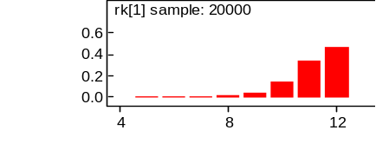  Rank of no treatment | 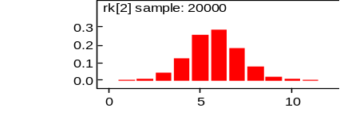  Rank of alarm
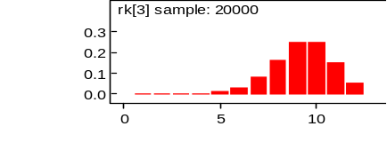  Rank of imipramine | 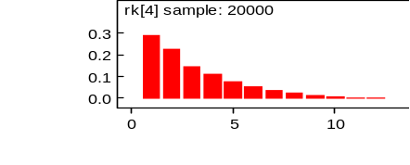  Rank of dry bed training with alarm
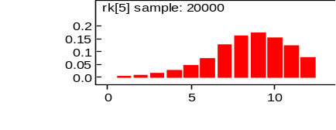  Rank of nasal desmopressin | 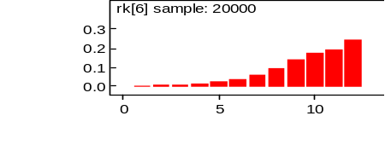  Rank of oxybutynin
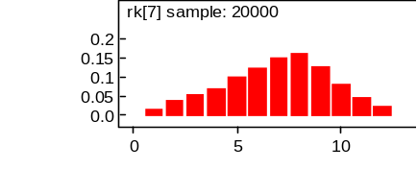  Rank of combined imipramine and oxybutynin | 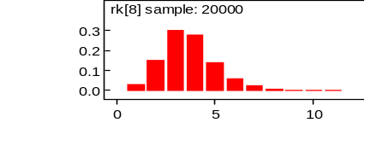  Rank of tablet desmopressin
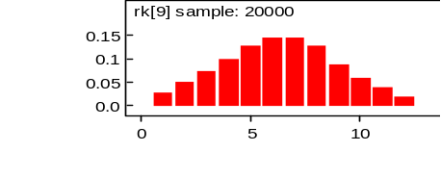  Rank of homotoxicological remedy | 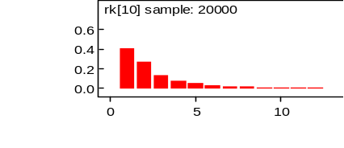  Rank of combined desmopressin and alarm
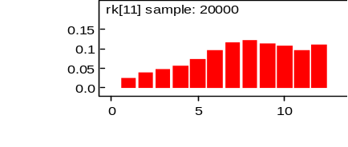 | 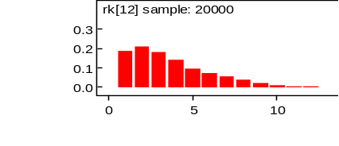
Rank of retention control training and alarm | Rank of combined desmopressin and oxybutynin
Ranking is based on the relative risk compared to no treatment and indicates the probability of being the best treatment, second best, third best and so on among the 12 different interventions being evaluated.

Dry bed training with alarm, combined desmopressin and alarm and combined desmopressin and oxybutynin were among the most effective treatments. No treatment or placebo, imipramine, nasal desmopressin and oxybutynin were among the least effective.
In a sensitivity analysis using the baseline risk calculated from the placebo and no treatment arms of included randomised controlled trials (15.2%), the overall ranking and probability a given intervention is most effective does not change, nor do the odds ratios. The relative risks diminish in magnitude slightly, but those that have 95% credible intervals crossing 1 in the base case (summarised in table 4) still produce credible intervals that cross 1 when 15.2% is used as the baseline risk.
Network 2: Full response for children with bedwetting and possible daytime symptoms
Figure 4 summarises the results of the conventional meta-analyses in terms of odds ratios generated from studies directly comparing different interventions. Figure 4 also presents the results of the NMA in terms of odds ratios for every possible treatment comparison.

Figure 4: Effectiveness of interventions in a population of children with bedwetting with possible daytime symptoms, results of conventional and network meta-analyses
No Treatment / Placebo | 76.35  (23.94-243.47) | 206.58  (21.43-1990.98) |  | 12.65  (0.97-165.61)
69.67  (26.61-139) | Alarm | 2.71  (0.33-22.33) | 0.08  (0.02-0.37) |  | 0.06  (0.00-1.43) | 0.25  (0.03-1.86) | 1.70  (0.20-14.49) | 0.23  (0.04-1.25) | 1.09  (0.60-2.0) | 1.20  (0.63-2.29)
102.9  (34.67-229.7) | 1.439  (0.5141-4.455) | DBT with alarm | 0.02  (0.00-0.12) |  | 0.05  (0.00-1.14) | 0.20  (0.03-1.42)
3.019  (0.7327-11.57) | 0.04263  (0.0105-0.1992) | 0.02993  (0.00728-0.126) | DBT without alarm
15.14  (4.091-65.27) | 0.216  (0.04931-1.303) | 0.1534  (0.0326-0.897) | 4.98  (0.8021-39.03) | Imipra-mine |  |  |  |  |  |  | 3.14  (1.20-8.24) | 8.49  (3.56-20.20) | 2.70  (0.61-11.93) | 3.88  (0.91-16.58)
2.108  (0.2599-34.07) | 0.03137  (0.0048-0.4998) | 0.02138  (0.0027-0.3203) | 0.7551  (0.06741-13.7) | 0.1359  (0.01076-3.739) | Star Chart | 4.52  (0.19 - 106.70) |  |  |  |  |  |  |  |  | 0.03  (0.00-0.37)
15.8  (1.307-134.4) | 0.2372  (0.0198-2.095) | 0.1651  (0.01454-1.268) | 5.601  (0.3393-60.77) | 1.002  (0.05706-13.97) | 7.239  (0.2612-107.9) | Stop Start Training
141.9  (19-894) | 2.04  (0.3867-11.21) | 1.447  (0.1807-9.907) | 48.93  (4.665-373.2) | 9.559  (0.7433-79.93) | 68.53  (2.181-868.2) | 8.509  (0.581-135.4) | RCT+  Alarm
14  (1.077-112.2) | 0.1964  (0.02005-1.534) | 0.1361  (0.01016-1.256) | 4.41  (0.2902-53.7) | 0.8878  (0.05129-9.883) | 5.42  (0.1943-114) | 0.8262  (0.03154-21.5) | 0.09776  (0.005383-1.503) | Psycho-therapy
78.24  (14.47-307) | 1.097  (0.2999-4.109) | 0.7663  (0.133-3.902) | 26.07  (3.511-171.3) | 5.198  (0.5274-33.59) | 34.41  (1.659-343.5) | 4.699  (0.4041-65.06) | 0.5237  (0.06843-4.623) | 5.811  (0.48-75.55) | Alarm +  CD | 1.10  (0.61-2.01)
84.43  (15.16-333.6) | 1.197  (0.3168-4.651) | 0.8435  (0.1477-4.136) | 28.77  (3.885-188.6) | 5.614  (0.5832-37.36) | 38.08  (1.735-390.6) | 5.14  (0.4302-77.77) | 0.5666  (0.07109-5.401) | 6.338  (0.5067-82.44) | 1.091  (0.2847-4.296) | Alarm +  Written
48.83  (6.802-428.8) | 0.6795  (0.08538-7.465) | 0.4939  (0.05653-5.312) | 16.7  (1.584-216.4) | 3.244  (0.7333-14.89) | 22.44  (0.6179-437.4) | 3.25  (0.1517-83.66) | 0.3354  (0.02761-6.966) | 3.837  (0.224-94.66) | 0.6323  (0.05831-9.976) | 0.5844  (0.04867-9.474) | 3 step pro-gramme | 2.70  (1.11-6.54)
130.7  (18.24-1079) | 1.796  (0.2446-20.77) | 1.34  (0.1514-13.62) | 44.06  (4.271-580) | 8.611  (2.025-37.76) | 59.32  (1.711-1280) | 8.422  (0.4361-222.5) | 0.872  (0.07892-18.8) | 10.21  (0.06128-251) | 1.624  (0.1605-27.62) | 1.529  (0.14-25.58) | 2.652  (0.6303-11.75) | 3 step programme + motivation therapy
46.13  (5.004-584.2) | 0.6634  (0.0692-10.55) | 0.448  (0.04449-7.389) | 14.93  (1.175-289.4) | 3.026  (0.4709-23.89) | 19.74  (0.4677-662.9) | 2.946  (0.1314-109.3) | 0.3182  (0.02074-8.34) | 3.355  (0.1712-124) | 0.6048  (0.04581-14.14) | 0.5541  (0.04091-13.44) | 0.9657  (0.07954-11.79) | 0.3638  (0.03128-3.799) | Desmo+  Oxybutynin | 1.44  (0.44-4.70)
72.77  (8.134-812.3) | 1.001  (0.1095-14.55) | 0.7463  (0.0715-10.8) | 23.49  (1.813-442) | 4.863  (0.7602-38.74) | 31.86  (0.6946-915.4) | 4.656  (0.2185-176.8) | 0.4987  (0.03595-10.83) | 5.246  (0.2413-193.6) | 0.9192  (0.07128-20.07) | 0.8496  (0.0664-18.1) | 1.493  (0.1279-17.84) | 0.5654  (0.05156-6.345) | 1.649  (0.2815-7.948) | Desmo-pressin |  | 4.92  (0.49-49.61) | 4.36  (0.40-47.61) | 0.67  (0.34-1.31) | 0.28  (0.13-0.60)
0.06137  (0.003371-2.874) | 0.000902  (0.00006-0.044) | 0.000622  (0.000035-0.0296) | 0.02087  (0.00092-1.206) | 0.004098  (0.00017–0.24) | 0.02554  (0.00455-0.308) | 0.004372  (0.00014-0.23) | 0.000412  (0.000018-0.0323) | 0.005281  (0.00014-0.463) | 0.000818  (0.000041-0.0463) | 0.000739  (0.000038-0.044) | 0.001291  (0.000035-0.097) | 0.000481  (0.000013-0.035) | 0.001291  (0.000031-0.0948) | 0.000848  (0.000021-0.0591) | Play Therapy
524.2  (21.66-20700) | 7.388  (0.3141-353.9) | 5.243  (0.1802-248.9) | 165.5  (5.941-10270) | 32.9  (1.808-1014) | 227.1  (3.231-15710) | 32.29  (0.7178-2446) | 3.564  (0.1161-252.4) | 39.86  (0.8604-4399) | 6.512  (0.2189-419.1) | 6.086  (0.2049-393.8) | 10.21  (0.3575-443.6) | 3.98  (0.1441-158.1) | 11.21  (0.613-251.3) | 7.302  (0.667-97.16) | 8415  (70.4-754400) | Amitrip-tyline | 0.89  (0.16-4.85)
431.5  (17.31-18110) | 6.05  (0.2465-314.2) | 4.198  (0.1602-212) | 147.3  (4.706-8462) | 28.76  (1.319-927.5) | 201.7  (2.273-12820) | 28.86  (0.5463-2109) | 3.172  (0.08741-197.6) | 33.97  (0.6552-3866) | 5.576  (0.1743-328) | 5.01  (0.1552-289.8) | 8.887  (0.2956-410.5) | 3.464  (0.1069-138.9) | 9.164  (0.461-204.5) | 5.885  (0.4698-83.69) | 7421  (49.15-659900) | 0.8319  (0.09825-6.774) | Amitrip-tyline +  Desmo
48.24  (4.007-837.9) | 0.659  (0.05587-14.98) | 0.4736  (0.03681-10.67) | 15.07  (0.9152-426.6) | 3.206  (0.3229-38.4) | 2106  (0.4028-816.8) | 2.79  (0.1196-162.2) | 0.328  (0.01843-10.44) | 3.433  (0.1306-181.6) | 0.5939  (0.03778-18.47) | 0.5569  (0.03464-17.84) | 0.9844  (0.05854-17.95) | 0.3738  (0.02342-5.97) | 1.08  (0.1156-8.387) | 0.6462  (0.1672-2.689) | 772.8  (8.901-41190) | 0.08982  (0.00487-1.343) | 0.1107  (0.00585-2.082) | Desmo +  RCT | 0.42  (0.19-0.92)
19.22  (1.507-328.9) | 0.259  (0.02157-6.263) | 0.1945  (0.01326-4.256) | 6.285  (0.3677-183.3) | 1.304  (0.1239-15.96) | 8.395  (0.1461-323.1) | 1.191  (0.04922-68.21) | 0.1281  (0.0071-4.602) | 1.421  (0.05066-79.76) | 0.2359  (0.01449-7.817) | 0.2227  (0.01319-6.88) | 0.4004  (0.02145-8.38) | 0.1488  (0.009338-2.664) | 0.4262  (0.04606-3.619) | 0.2673  (0.06572-1.105) | 303.3  (3.38-16990) | 0.03691  (0.00213-0.554) | 0.04508  (0.00236-0.884) | 0.4095  (0.09713-1.666) | Placebo +  RCT
DBT, dry bed training; RCT, retention control training; Desmo, desmopressin
Results in white are the odds ratios and 95% confidence intervals from the conventional meta-analyses of direct comparisons between the column-defining treatment and the row-defining treatment. Odds ratios greater than 1 favour the column-defining treatment.
Results in grey are the median odds ratios and credible intervals from the NMA of direct and indirect comparisons between the row-defining treatment and the column-defining treatment. Odds ratios greater than 1 favour the row-defining treatment.
Based on the direct comparisons, in white in Figure 4, alarm and dry bed training with an alarm are more effective than no treatment / placebo; alarm and dry bed training with an alarm are more effective than dry bed training without an alarm; 3-step programme with and without motivational therapy is more effective than imipramine; 3-step programme with motivational therapy is more effective than 3-step programme without motivational therapy; star chart alone is more effective than play therapy; desmopressin alone is more effective than combined placebo and retention control training; combined desmopressin and retention control training is more effective than combined placebo and retention control training.
The random effects model used for this NMA fit reasonably well, with a residual deviance of 52.39 reported. This corresponds reasonably well to the total number of trial arms, 44.
Based on the results of the NMA, in grey in Figure 4, alarm, dry bed training with alarm, imipramine, stop start training, retention control training with alarm, psychotherapy, alarm with informational CD, alarm with written informational leaflet, 3-step programme with and without motivational therapy, desmopressin, combined desmopressin and oxybutynin, amitriptyline, combined desmopressin and amitriptyline, combined desmopressin and retention control training and combined placebo and retention control training are significantly more effective than no treatment / placebo. Alarm, dry bed training with alarm, imipramine, star chart, stop start training, retention control training with alarm, psychotherapy, alarm with informational CD, alarm with written informational pamphlet, 3-step programme with and without motivational therapy, desmopressin, combined desmopressin and oxybutynin, amitriptyline, combined desmopressin and amitriptyline, combined desmopressin and retention control training and combined placebo and retention control training are significantly more effective than play therapy. Alarm, dry bed training with alarm, retention control training with alarm, alarm with informational CD, alarm with written informational pamphlet, 3-step programme with and without motivational therapy, desmopressin, combined desmopressin and oxybutynin, amitriptyline and combined desmopressin and amitriptyline are significantly more effective than dry bed training without alarm. Dry bed training with alarm, 3-step programme with motivational therapy, amitriptyline and combined desmopressin and amitriptyline are significantly more effective than imipramine. Alarm, dry bed training with alarm, retention control training with alarm, alarm and informational CD, alarm and written informational pamphlet, 3-step programme with motivational therapy, amitriptyline and combined desmopressin and amitriptyline are significantly more effective than star chart. Amitriptyline and combined desmopressin and amitriptyline are significantly more effective than combined placebo and retention control training. No other treatment effects reached statistical significance.
Table 5 presents the relative risk of each intervention compared to no treatment, a baseline risk of getting dry without any treatment. It also gives a probability that the intervention is most effective.
Table 5: Effectiveness of interventions in network 2 compared to no treatment
Interventions | Median relative risk  (95% Credible Interval) | Probability intervention  is most effective (%)
Amitriptyline | 9.514 (6.906– 9.667)* | 35.59
Desmopressin and amitriptyline | 9.481 (6.444 – 9.667)* | 26.92
Retention control training with alarm | 9.114 (6.641 – 9.578)* | 11.71
3 step programme and motivational therapy | 9.070(6.555 – 9.594)* | 9.80
Dry bed training with alarm | 8.919 (7.736 – 9.319)* | 2.73
Alarm and informational leaflet | 8.770 (6.153 – 9.426)* | 3.12
Alarm and informational CD | 8.706 (6.047 – 9.406)* | 2.36
Alarm | 8.601 (7.294 – 9.103)* | 0.07
Desmopressin and oxybutynin | 8.141 (3.539 – 9.53)* | 0.49
3 step programme | 8.213 (4.251 – 9.479)* | 0.61
Desmopressin | 8.641 (4.681 – 9.569)* | 0.27
Desmopressin and retention control training | 8.198 (3.057 – 9.572)* | 0.55
Stop start training | 6.245 (1.267 – 9.085)* | 0.20
Imipramine | 6.149 (3.100 – 8.537)* | 0
Psychotherapy | 5.972 (1.068 – 8.977)* | 0.16
Placebo and retention control training | 6.664 (1.432 – 9.423)* | 0.07
Star chart | 1.891 (0.282 – 7.709) | 0
Dry bed training without alarm | 2.497 (0.754 – 5.528) | 0
Play therapy | 0.068 (0.004 – 2.407) | 0
Relative risk greater than 1 favours the intervention. *Statistically significant.
Figure 5 shows the distribution of probabilities of each intervention being ranked at each of 20 positions.
Figure 5: Ranking of interventions in network 2 (full response for children with bedwetting with possible daytime symptoms)
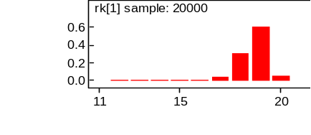  Rank of no treatment | 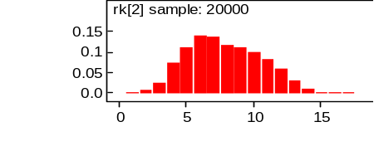  Rank of alarm
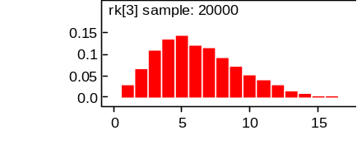  Rank of dry bed training with alarm | 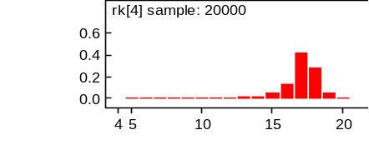  Rank of dry bed training without alarm
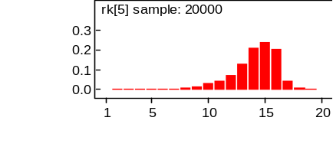  Rank of imipramine | 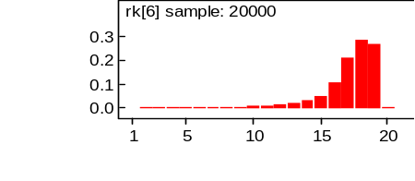  Rank of star chart
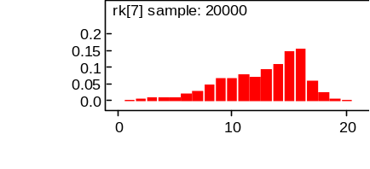  Rank of stop start training | 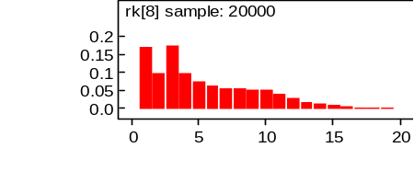  Rank of retention control training with alarm
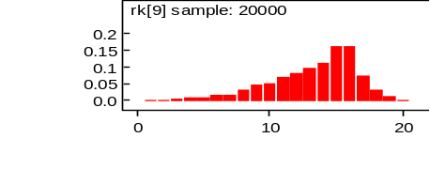  Rank of psychotherapy | 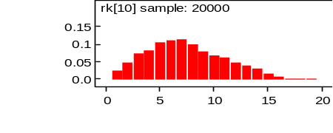  Rank of alarm with informational CD
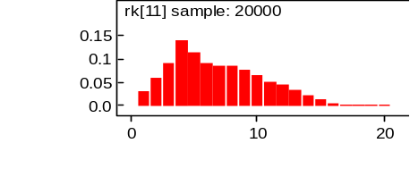  Rank of alarm with written informational pamphlet | 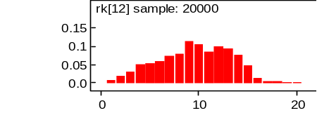  Rank of 3-step programme
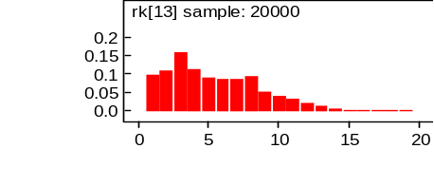  Rank of 3-step programme with motivational | 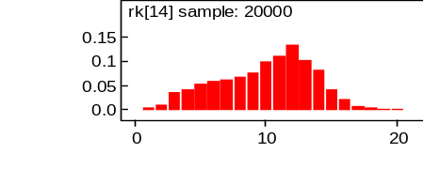  Rank of combined desmopressin and oxybutynin
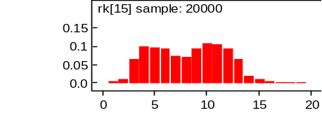  Rank of desmopressin | 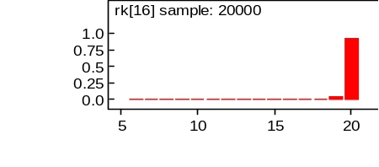  Rank of play therapy
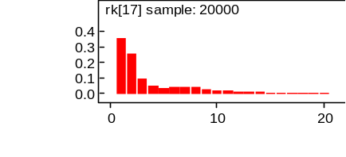  Rank of amitriptyline | 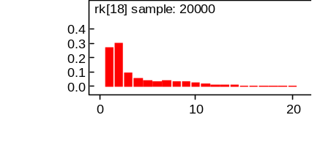  Rank of combined amitriptyline and desmopressin
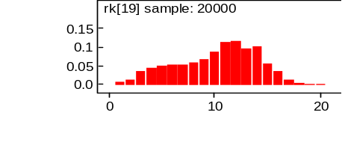  Rank of combined desmopressin and retention control training | 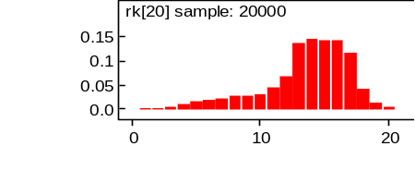  Rank of combined placebo and retention control training
Ranking is based on the relative risk compared to no treatment and indicates the probability of being the best treatment, second best, third best and so on among the 20 different interventions being evaluated.

Dry bed training with alarm, retention control training with alarm, 3-step programme with motivational therapy, amitriptyline and combined desmopressin and amitriptyline were among the most effective interventions. No treatment or placebo, dry bed training without alarm, star chart and play therapy were among the least effective interventions.
In a sensitivity analysis using the baseline risk calculated from the placebo and no treatment arms of included randomised controlled trials (4.0%), the overall ranking and probability a given intervention is most effective does not change, nor do the odds ratios. The relative risks increase in magnitude, but those that have 95% credible intervals crossing 1 in the base case (summarised in table 5) still produce credible intervals that cross 1 when 4.0% is used as the baseline risk.

Network 3: Recurrence of bedwetting at 6 months following discontinuation of treatment for children with bedwetting only
Figure 6 summarises the results of the conventional meta-analyses in terms of odds ratios generated from studies directly comparing different interventions. Figure 6 also presents the results of the NMA in terms of odds ratios for every possible treatment comparison.
Figure 6: Probability of bedwetting recurrence at 6 months following discontinuation of treatment in a population of children with bedwetting only, results of conventional and network meta-analyses
No Treatment / Placebo | 0.21  (0.02 - 2.43) | 3.75  (0.33 - 42.47) | 7.50  (0.46 - 122.70) | 0.50  (0.06 - 4.15)
0.03619  (0.004627 - 0.8389) | Alarm | 9.0  (0.38 - 210.39) |  |  | 0.29  (0.01 - 6.91) | 0.68  (0.12 - 3.77)
4.669  (0.2755 - 77.05) | 110.8  (3.255 - 3922) | Imipramine | 2.0  (0.13 - 29.81) | 0.13  (0.02 - 0.98)
9.779  (0.3684 - 230.2) | 227.6  (3.526 - 11890) | 2.115  (0.07981 - 57.74) | Oxybutynin | 0.07  (0.01 - 0.75)
0.5217  (0.02865 - 8.85) | 12.79  (0.2222 - 443.7) | 0.1134  (0.005438 - 1.621) | 0.05604  (0.001818 - 1.034) | Imipramine + Oxybutynin
0.01088  (0.000137 - 2.795) | 0.2568  (0.006618 - 20.24) | 0.002496  (0.0000114 - 0.6809) | 0.001173  (0.00000402 - 0.5478) | 0.02146  (0.000107 - 11.17) | DBT with alarm
0.02363  (0.000676 - 1.403) | 0.6195  (0.03472 - 9.555) | 0.006004  (0.0000548 - 0.5177) | 0.002433  (0.0000201 - 0.3862) | 0.0486  (0.000521 - 6.13) | 2.401  (0.01235 - 260.1) | RCT+alarm
DBT, Dry bed training; RCT, Retention control training
Results in white are the odds ratios and 95% confidence intervals from the conventional meta-analyses of direct comparisons between the column-defining treatment and the row-defining treatment. Odds ratios less than 1 favour the column-defining treatment.
Results in grey are the median odds ratios and credible intervals from the NMA of direct and indirect comparisons between the row-defining treatment and the column-defining treatment. Odds ratios less than 1 favour the row-defining treatment

Based on the direct comparisons, in white in Figure 6, patients treated with combined imipramine and oxybutynin are less likely to experience a recurrence of bedwetting than patients treated with either imipramine alone or oxybutynin alone. No other treatment effects reached statistical significance.
The random effects model used for this NMA fit reasonably well, with a residual deviance of 11 reported. This corresponds reasonably well to the total number of trial arms, 13.
Based on the results of the NMA, in grey in Figure 6, patients treated with alarm are less likely to experience a recurrence of bedwetting than patients receiving no treatment or placebo, imipramine or oxybutynin. Patients treated with either dry bed training with alarm or retention control training with alarm are less likely to experience a recurrence of bedwetting than patients treated with imipramine or oxybutynin. No other treatment effects reached statistical significance.
Table 6 presents the relative risk of each intervention compared to no treatment, a baseline risk of bedwetting recurrence following a full response. It also gives a probability that the intervention is the least likely to result in a recurrence of bedwetting.
Table 6: Probability of bedwetting recurrence at 6 months following discontinuation of treatment in network 3 compared to no treatment
Interventions | Median relative risk  (95% Credible Interval) | Probability intervention is most effective (%)
Dry bed training with alarm | 0.011 (0.000 – 2.764) | 58.73
Retention control training with alarm | 0.024 (0.001 – 1.400) | 30.32
Alarm | 0.036 (0.005 – 0.840)* | 7.55
Imipramine and oxybutynin | 0.523 (0.029 – 8.444) | 3.19
Imipramine | 4.566 (0.277 – 52.540) | 0.04
Oxybutynin | 9.279 (0.370 – 95.690) | 0.04
Relative risk less than 1 favours the intervention. *Statistically significant.
Figure 7 shows the distribution of probabilities of each intervention being ranked at each of 7 positions, with first having the lowest likelihood of bedwetting recurrence and last having the highest.
Figure 7: Ranking for interventions in network 3: probability of bedwetting recurrence at 6 months in children with bedwetting only
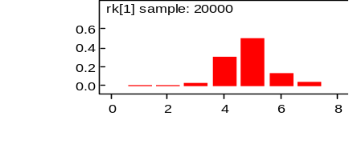 | 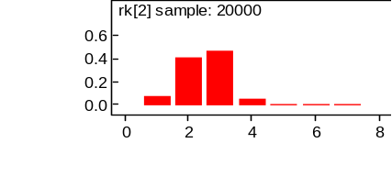
Rank of No Treatment | Rank of alarm
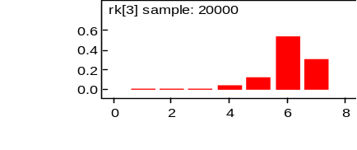 | 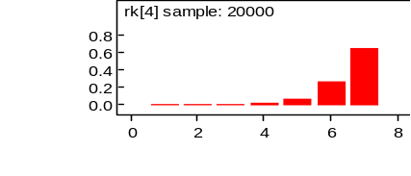
Rank of imipramine | Rank of oxybutynin
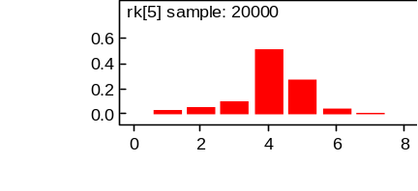 | 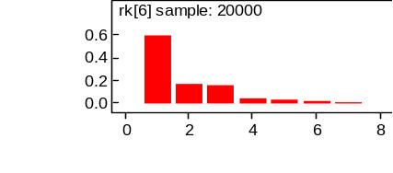
Rank of combined imipramine and oxybutynin | Rank of dry bed training with alarm
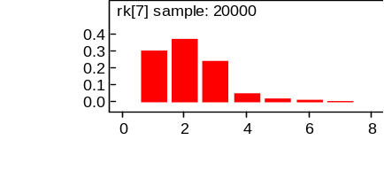
Rank of retention control training with alarm
Ranking is based on the relative risk compared to no treatment and indicates the probability of having the fewest reports of bedwetting recurrence, second fewest, third fewest and so on among the 7 different interventions being evaluated.

Dry bed training with alarm, retention control training with alarm and alarm alone are among the most effective interventions in preventing the recurrence of bedwetting. Imipramine and oxybutynin are among the least effective interventions in preventing the recurrence of bedwetting.
In a sensitivity analysis using the baseline risk calculated from the placebo and no treatment arms of included randomised controlled trials (56.6%), the overall ranking and probability a given intervention has the lowest incidence of recurrence does not change, nor do the odds ratios. The relative risks show a lesser magnitude of effect, but those that have 95% credible intervals crossing 1 in the base case (summarised in table 6) still produce credible intervals that cross one when 56.6% is used as the baseline risk.
  - Discussion
Based on the results of conventional meta-analyses of direct evidence, as has been previously presented in chapters 7-20, deciding upon the most effective intervention for the treatment of bedwetting is difficult, even impossible. First, most interventions have not been directly compared to one another in a randomised controlled trial and second, there are many instances of overlapping comparisons that could potentially give inconsistent estimates of effect. In order to overcome the difficulty of interpreting the conclusions from these numerous separate comparisons and to identify any inconsistency within estimated treatment effects, network meta-analyses of the direct evidence were performed.
Our analyses were based on a total of 27 studies including 2,147 individuals randomised to 23 different interventions used in the treatment of bedwetting. These studies, individuals and interventions formed three networks of evidence. The first network was formed using data from studies that included only children with bedwetting and was used to assess effectiveness of interventions in achieving a full response. The second network was formed using data from studies that did not explicitly exclude children with daytime symptoms or wetting and was also used to evaluate effectiveness in achieving a full response. Finally, a third network was formed using the data from the studies including children with bedwetting only and was used to measure the probability that patients would experience a recurrence of bedwetting, or sustaining the treatment response. The findings from these network meta-analyes have been used to facilitate decision-making for the GDG such that they could develop recommendations for the treatment of children with bedwetting based on the best available direct and indirect evidence.
As was anticipated, small trials and fairly inconclusive direct evidence fed into the NMA and produced estimates of effect with very wide credible intervals. Despite this, some treatments were clearly better than no treatment and some were clearly more effective than others. In terms of achieving a full response, enuresis alarm, dry bed training with alarm, tablet desmopressin, combined alarm and desmopressin, combined desmopressin and oxybutynin are all significantly more effective than no treatment in both networks of evidence. In the network of evidence for children with bedwetting with possible daytime symptoms imipramine, stop start training, retention control training with alarm, psychotherapy, alarm with electronic or written information, 3-step programme with and without motivational therapy, amitriptyline with and without combined desmopressin and retention control training (with placebo) were also significantly more effective than no treatment.
Play therapy seems to be among the least effective treatments, along with dry bed training without alarm and star chart on its own. Other than when compared to no treatment or play therapy, dry bed training without alarm, imipramine, star chart, stop start, psychotherapy, combined desmopressin and retention control training and retention control training alone are not statistically significantly more effective than any other treatment. All interventions except for imipramine, star chart, stop start training, psychotherapy and retention control training with and without combined desmopressin were significantly better than dry bed training without alarm. Therefore, it seems clear from this analysis that the most effective element of dry bed training is the alarm. And interestingly, there is no statistical difference between dry bed training with an alarm and alarm alone.
Although there are many treatments that are clearly among the least effective and others that are demonstrably more effective than no treatment, the analysis does not show many statistically significant differences between interventions such that one or several could be clearly identified as most effective or among the most effective. The one intervention that did not seem to perform very well compared to others was imipramine. Tablet desmopressin, amitriptyline, combined alarm and desmopressin and the 3-step programme with motivational therapy are all statistically significantly more effective than imipramine alone in one network or the other.
Although the analysis was able to generate probabilities of a given intervention being the best treatment, defined as having the greatest relative risk compared to no treatment, the probability estimates illustrate the considerable uncertainty around which intervention is truly optimal. For example, amitriptyline comes out as the treatment with the highest relative risk compared to no treatment but it is only the best in 35.59% of simulations. This means that some other intervention or interventions are best in 64.41% of simulations.
Similarly, when examining the results from the network of evidence about recurrence of bedwetting at 6 months post treatment, alarm is the only intervention with a lower risk of bedwetting recurrence than no treatment, and the result is statistically significant. However, it only has a probability of being most effective in 7.55% of simulations. This is indicative of the wide credible intervals surrounding the relative effect of other interventions such as dry bed training with alarm and retention control training with alarm. Although neither of these was significantly more effective than no treatment, they were ranked as best in 58.73% and 30.32% of simulations, respectively. Pair-wise odds ratios from the NMA indicate that alarm, dry bed training with alarm and retention control training with alarm are more effective at achieving a sustained response (i.e. preventing the recurrence of bedwetting) than both imipramine and oxybutynin.
One of the other advantages of performing a network meta-analysis is that it can help to diagnose inconsistency between evidence comparisons. That is, it can help to identify differences between measures of treatment effect observed in different trials. Inconsistency was identified in network 1 when the median odds ratios of two comparisons in network meta-analysis fell outside of the 95% confidence interval of the odds ratio derived from the direct comparative data. Although the source of and an explanation for the inconsistency was sought, it was not ultimately identified. Because of this, the results of the network 1 were interpreted with some caution.
Because of the way the networks were split, it meant that most interventions were only evaluated in one network or another. Only data for enuresis alarm, dry bed training with alarm, imipramine, desmopressin, retention control training and combined desmopressin and oxybutynin were available to populate both effectiveness networks. Additionally, there was even less data to inform the network on bedwetting recurrence due to the lack of longer term follow up in most studies. Therefore, the only interventions included in all three networks were enuresis alarm, imipramine, retention control training with alarm and dry bed training with alarm. When looking across all three networks, the evidence points to a statistically significant advantage of alarm over no treatment in terms of the achievement of both full and sustained response at 6 months following treatment. Dry bed training with alarm was significantly more effective than no treatment in achieving a full response, but not in sustaining that success at 6 months. Imipramine and retention control training did not have a statistically significant advantage over no treatment in the bedwetting only population in terms of initial or longer term response, but did seem to be superior in the network of children with bedwetting with possible daytime symptoms.
The distinction between the two networks of evidence used to measure effectiveness of achieving full response was a pragmatic one, and one that has been explained previously in the review of direct evidence (Chapters 7-20). The GDG felt strongly that there may be a difference in measured treatment effect if the population included patients with bedwetting who also experienced daytime symptoms. On this basis, it was necessary to separate these groups in order to ensure the highest level of population homogeneity as well as to reduce the likelihood of inconsistency in the networks. But, it should be kept in mind that the studies that did not positively exclude patients with daytime symptoms or wetting may not have comprised a population any different from the studies that did exclude these patients. They are classified this way largely because the authors failed to adequately describe their inclusion and exclusion criteria.
There are several outcome measures that could be used to evaluate the effectiveness of different interventions used in the treatment of bedwetting, but only two were used in this analysis: probability of full response and recurrence of bedwetting at 6 months. Dichotomous outcomes such as these were easier to evaluate and interpret and ultimately feed into the cost-effectiveness analysis conducted as part of the guideline development. Data networks on bedwetting recurrence at other follow-up points (i.e. 1 to 2 weeks, 3 months, 1 year) were sought, but could not be constructed due to insufficient direct evidence.
In addition to summarising the direct evidence into single measures of relative risk compared to no treatment, another aim of the NMA was to inform the effectiveness parameters of first line treatments in the economic model built to evaluate the cost-effectiveness of different intervention sequences used in the treatment of bedwetting. Although not all of the interventions included in the NMA were ultimately included in the economic model, they collectively formed a network of evidence that was used to derive the best estimates of effect for those interventions that were included in the model.
The median point estimates from the network measuring the probability of achieving a full response in the bedwetting only population were used in the deterministic cost-effectiveness analysis. For the probabilistic sensitivity analysis, the 20,000 simulated Markov chains from the same network were used, thereby preserving the joint posterior distributions and incorporating all uncertainty and correlation of treatment effects.

  - Conclusion
Overall, the results of the network meta-analyses demonstrate that most interventions are better at achieving dryness than not treating at all. However, the results were less clear in showing which treatment was the best.
The results of the network meta-analysis did demonstrate the ineffectiveness of some interventions, namely play therapy, dry bed training without alarm and star charts on their own. And, although psychotherapy, stop start training, and retention control training with and without combined desmopressin were statistically better than no treatment and play therapy, they were not any better or worse than any other treatments.
Across all the networks, enuresis alarms showed statistically significant superiority in achieving a full response over a do nothing strategy and was the only intervention to have a statistically significant advantage in sustaining that success at 6 months following discontinuation of treatment. Desmopressin and combined desmopressin and oxybutynin also showed consistently significant results that they were each more effective than no treatment, but no data on their risk of bedwetting recurrence were available. The evidence of these 3 treatments compared to one another fails to show any statistically significant difference either in terms of the results from the conventional or network meta-analysis.

  - Winbugs code
Random effect model template: includes correlation structure for multi-arm trials
Adapted from code found here: https://www.bris.ac.uk/cobm/research/mpes/mtc.html
Some sections need to be edited for each analysis.
Substitute these for the numerical values:
NS=number of studies
NT=number of treatment strategies
BR=baseline risk
model{

for(i in 1:NS){

w[i,1] <-0
delta[i,t[i,1]]<-0
mu[i] ~ dnorm(0,.0001) # vague priors for NS trial baselines
for (k in 1:na[i]) {

logit(p[i,t[i,k]])<-mu[i] + delta[i,t[i,k]] # model

r[i,k] ~ dbin(p[i,t[i,k]],n[i,k]) # binomial likelihood

rhat[i,k] <- p[i,t[i,k]] * n[i,k]
dev[i,k] <- 2 * (r[i,k] * (log(r[i,k])-log(rhat[i,k])) + (n[i,k]-r[i,k]) * (log(n[i,k]-r[i,k]) - log(n[i,k]-rhat[i,k]))) #Deviance residuals for data i
}

sdev[i]<- sum(dev[i,1:na[i]])

for (k in 2:na[i]) {
delta[i,t[i,k]] ~ dnorm(md[i,t[i,k]],taud[i,t[i,k]])I(-5,5) # trial-specific LOR distributions

md[i,t[i,k]] <- d[t[i,k]] - d[t[i,1]] + sw[i,k] # mean of LOR distributions

taud[i,t[i,k]] <- tau *2*(k-1)/k #precision of LOR distributions

w[i,k] <- (delta[i,t[i,k]] - d[t[i,k]] + d[t[i,1]]) #adjustment, multi-arm RCTs

sw[i,k] <-sum(w[i,1:k-1])/(k-1) } # cumulative adjustment for multi-arm trials
}

d[1]<-0
for (k in 2:NT){d[k] ~ dnorm(0,.0001) # vague priors for basic parameters

sd~dunif(0,2) # vague prior for random effects standard deviation

tau<-1/pow(sd,2)

rr[1]<-1
for (k in 2:NT) {logit(v[k])<-logit(BR)+d[k]
rr[k]<-v[k]/BR } # calculate relative risk

sumdev <- sum(sdev[]) # Calculate residual deviance

for (k in 1:NT) {
rk[k]<-(NT+1)-rank(rr[],k)
best[k]<-equals(rank(rr[],k),NT)} # Ranking and probability treatment is best

for (c in 1:(NT-1))
{ for (k in (c+1):NT)
{ lor[c,k] <- d[k] - d[c]
log(or[c,k]) <- lor[c,k] # Pairwise ORs

}
}
}
# Data from NS trials

r[,1] n[,1] r[,2] n[,2] r[,3] n[,3] r[,4] n[,4] t[,1] t[,2] t[,3] t[,4] na[]
Insert data here (one row for each study) e.g.
5 23 7 14 6 16 16 24 1 3 6 7 4
1 13 8 13 NA 1 NA 1 1 2 NA NA 2
END
r[ ]=events by trial arm
n[ ]=number of patients in trial arm
t[ ]=treatment number
na[ ]=number of trial arms in study

#initial values
list(
d=c(NA,0,0,0, 0,0,0,0, 0,0,0,0), # one for each treatment (NT)
sd=1,
mu=c(0,0,0,0,0, 0,0,0,0,0) # one for each trial (NS)
Bibliography

1. Bennett GA, Walkden VJ, Curtis RH, Burns LE, Rees J, Gosling JA. Pad-and-buzzer training, dry-bed training, and stop-start training in the treatment of primary nocturnal enuresis. Behavioural Psychotherapy 1985, 13:309-19
2. Bollard J, Nettelbeck T. A comparison of dry-bed training and standard urine-alarm conditioning treatment of childhood bedwetting. Behaviour Research and Therapy 1981, 19(3):215-26
3. Bollard J, Nettelbeck T. A component analysis of dry-bed training for treatment for bedwetting. Behaviour Research and Therapy 1982, 20(4):383-90
4. Burke JR, Mizusawa Y, Chan A, Webb KL. A comparison of amitriptyline, vasopressin and amitriptyline with vasopressin in nocturnal enuresis. Pediatric Nephrology 1995, 9(4):438-40
5. Butler RJ, Heron J. The prevalence of infrequent bedwetting and nocturnal enuresis in childhood. A large British cohort. Scandinavian Journal of Urology and Nephrology 2008, 42(3):257-64
6. Fava GA, Cracco L, Facco L. Positive reinforcement and enuresis. Italian Journal of Psychology 1981, 8(2):149-52
7. Ferrara P, Marrone G, Emmanuele V, Nicoletti A, Mastrangelo A, Tiberi E et al. Homotoxicological remedies versus desmopressin versus placebo in the treatment of enuresis: a randomised, double-blind, controlled trial. Pediatric Nephrology 2008, 23(2):269-74
8. Fielding D. The response of day and night wetting children and children who wet only at night to retention control training and the enuresis alarm. Behaviour Research and Therapy 1980, 18(4):305-17
9. Geffken G, Johnson SB, Walker D. Behavioral interventions for childhood nocturnal enuresis: the differential effect of bladder capacity on treatment progress and outcome. Health Psychology 1986, 5(3):261-72
10. Golding J, Pembrey M, Jones R, ALSPAC Study Team. ALSPAC--the Avon Longitudinal Study of Parents and Children. I. Study methodology. Paediatric and Perinatal Epidemiology 2001, 15(1):74-87
11. Houts AC, Peterson JK, Whelan JP. Prevention of relapse in full-spectrum home training for primary enuresis. Behavior Therapy 1986, 17(4):462-9
12. Iester A, Marchesi A, Cohen A, Iester M, Bagnasco F, Bonelli R. Functional enuresis: pharmacological versus behavioral treatment. Childs Nervous System 1991, 7(2):106-8
13. Jehu D, Morgan RT, Turner RK, Jones A. A controlled trial of the treatment of nocturnal enuresis in residential homes for children. Behaviour Research and Therapy 1977, 15(1):1-16
14. Kahan E, Morel D, Amir J, Zelcer C. A controlled trial of desmopressin and behavioral therapy for nocturnal enuresis. Medicine 1998, 77(6):384-8
15. Khorana AB. Controlled trial of imipramine hydrochloride on enuresis. Current Medical Practice (India) 1972, 16(7):305-8
16. Lee T, Suh HJ, Lee HJ, Lee JE. Comparison of effects of treatment of primary nocturnal enuresis with oxybutynin plus desmopressin, desmopressin alone or imipramine alone: a randomized controlled clinical trial. Journal of Urology 2005, 174(3):1084-7
17. Longstaffe S, Moffatt ME, Whalen JC. Behavioral and self-concept changes after six months of enuresis treatment: a randomized, controlled trial. Pediatrics 2000, 105(4 Pt 2):935-40
18. Lu G, Ades AE. Combination of direct and indirect evidence in mixed treatment comparisons. Statistics in Medicine 2004, 23(20):3105-24
19. Lunn DJ, Thomas A, Best N, Spiegelhalter D. WinBUGS -- a Bayesian modelling framework: concepts, structure, and extensibility. Statistics and Computing 2000, 10:325-37
20. Moffatt ME, Kato C, Pless IB. Improvements in self-concept after treatment of nocturnal enuresis: randomized controlled trial. Journal of Pediatrics 1987, 110(4):647-52
21. Nawaz S, Griffiths P, Tappin D. Parent-administered modified dry-bed training for childhood nocturnal enuresis: Evidence for superiority over urine-alarm conditioning when delivery factors are controlled. Behavioral Interventions 2002, 17(4):247-60
22. Ng CFN, Wong SN, Hong Kong Childhood Enuresis Study Group. Comparing alarms, desmopressin, and combined treatment in Chinese enuretic children. Pediatric Nephrology 2005, 20(2):163-9
23. Redsell SA, Collier J, Garrud P, Evans JH, Cawood C. Multimedia versus written information for nocturnal enuresis education: a cluster randomized controlled trial. Child: Care, Health and Development 2003, 29(2):121-9
24. Smellie JM, McGrigor VS, Meadow SR, Rose SJ, Douglas MF. Nocturnal enuresis: a placebo controlled trial of two antidepressant drugs. Archives of Disease in Childhood 1996, 75(1):62-6
25. Tahmaz L, Kibar Y, Yildirim I, Ceylan S, Dayanc M. Combination therapy of imipramine with oxybutynin in children with enuresis nocturna. Urologia Internationalis 2000, 65(3):135-9
26. Tuygun C, Eroglu M, Bakirtas H, Gucuk A, Zengin K, Imamoglu A. Is second-line enuretic alarm therapy after unsuccessful pharmacotherapy superior to first-line therapy in the treatment of monosymptomatic nocturnal enuresis? Urologia Internationalis 2007, 78(3):260-3
27. Wagner W, Johnson SB, Walker D, Carter R, Wittner J. A controlled comparison of two treatments for nocturnal enuresis. Journal of Pediatrics 1982, 101(2):302-7
28. Wagner WG, Matthews R. The treatment of nocturnal enuresis: a controlled comparison of two models of urine alarm. Journal of Developmental and Behavioral Pediatrics 1985, 6(1):22-6
29. Werry JS, Cohrssen J. Enuresis: an etiologic and therapeutic study. Journal of Pediatrics 1965, 67(3):423-31

Credible intervals are the Bayesian equivalent of confidence intervals and are based on the percentiles of the posterior distribution of the parameter of interest.

