History-taking: Childhood constipation – 1 year and older
Section A: Key components of history-taking
Stool patterns and symptoms: indicate by circling the correct response for each question Stool type is based on the Bristol Stool Form Scale

Does the child or young person have a bowel movement (poo) fewer than three times a week (stool type 3 or 4)? | YES | NO

Does the child or young person pass large hard stools? | YES | NO
Does the child or young person pass ‘rabbit droppings’ (type 1) | YES | NO

Have you noticed any soiling (very loose, very smelly stool passed without sensation) in recent days? | YES | NO

Does the child or young person have poor appetite that improves with the passage of a large stool? | YES | NO
Does the child or young person experience abdominal pain that comes and goes with the passage of stool? | YES | NO
Is there evidence of retentive posturing typically straight-legged, tiptoed, back arching posture)? | YES | NO
Does the child or young person strain when passing stools? | YES | NO
Does the child or young person experience anal pain? | YES | NO
Has the child or young person had any previous episodes of constipation or the present symptoms? | YES | NO
Have you noticed any cracks or tears in the anal region? | YES | NO
Does the child or young person bleed when passing stools? | YES | NO

Total number of YES answers

Two or more YES answers indicate constipation
Put your trust logo here

Section B: Key questions to diagnose idiopathic constipation
If the result of part 1 indicates constipation use these questions to excluding underlying causes and establish a positive diagnosis of idiopathic constipation.
Tick findings in relevant box
- When was the onset of constipation?
After a few weeks of life | Indicates idiopathic constipation
Birth or first few weeks of life | Indicates an underlying disorder
- When did the child pass meconium?
Within 48 hours after birth (in term baby) | Indicates idiopathic constipation
More than 48 hours after birth (in term baby) or not at all | Indicates an underlying disorder
- Does the child or young person pass ‘ribbon stools’??
Yes | Indicates an underlying disorder
- Are there any concerns about the growth and general wellbeing of the child?
No: generally well, weight and height within normal limits, fit and active | Indicates idiopathic constipation
Yes: faltering growth
Possible idiopathic constipation
- Does the child or young person have a good diet with adequate fluid intake?
No | Indicates idiopathic constipation
- Is the abdomen of the child or young person distended and are they vomiting?
Yes | Indicates an underlying disorder

If any symptoms indicate an underlying disorder, refer the child or young person urgently to a healthcare professional with experience in the specific aspect of child health that is causing concern. Do not treat them for constipation.
Section C: Key components of physical examination to diagnose idiopathic constipation

Tick findings in relevant box
Normal appearance of anus and surrounding area | Indicates idiopathic constipation
Abnormal appearance / position / patency of anus: fistulae, bruising, multiple fissures, tight or patulous anus, anteriorly placed anus, absent anal wink | Indicates an underlying disorder

Soft abdomen: flat or distension that can be explained because of age or excess weight | Indicates idiopathic constipation
Gross abdominal distension | Indicates an underlying disorder

Normal appearance of the skin and anatomical structures of lumbosacral/gluteal regions | Indicates idiopathic constipation
Abnormal: asymmetry or flattening of the gluteal muscles, evidence of sacral agenesis, discoloured skin, naevi or sinus, hairy patch, lipoma, central pit (dimple that you can’t see the bottom of), scoliosis | Indicates an underlying disorder

Normal gait; normal tone and strength in lower limbs | Indicates idiopathic constipation
Deformity in lower limbs such as talipes  Abnormal neuromuscular signs unexplained by any existing condition, such as cerebral palsy | Indicates an underlying disorder

Reflexes present and of normal amplitude | Indicates idiopathic constipation
Abnormal reflexes | Indicates an underlying disorder

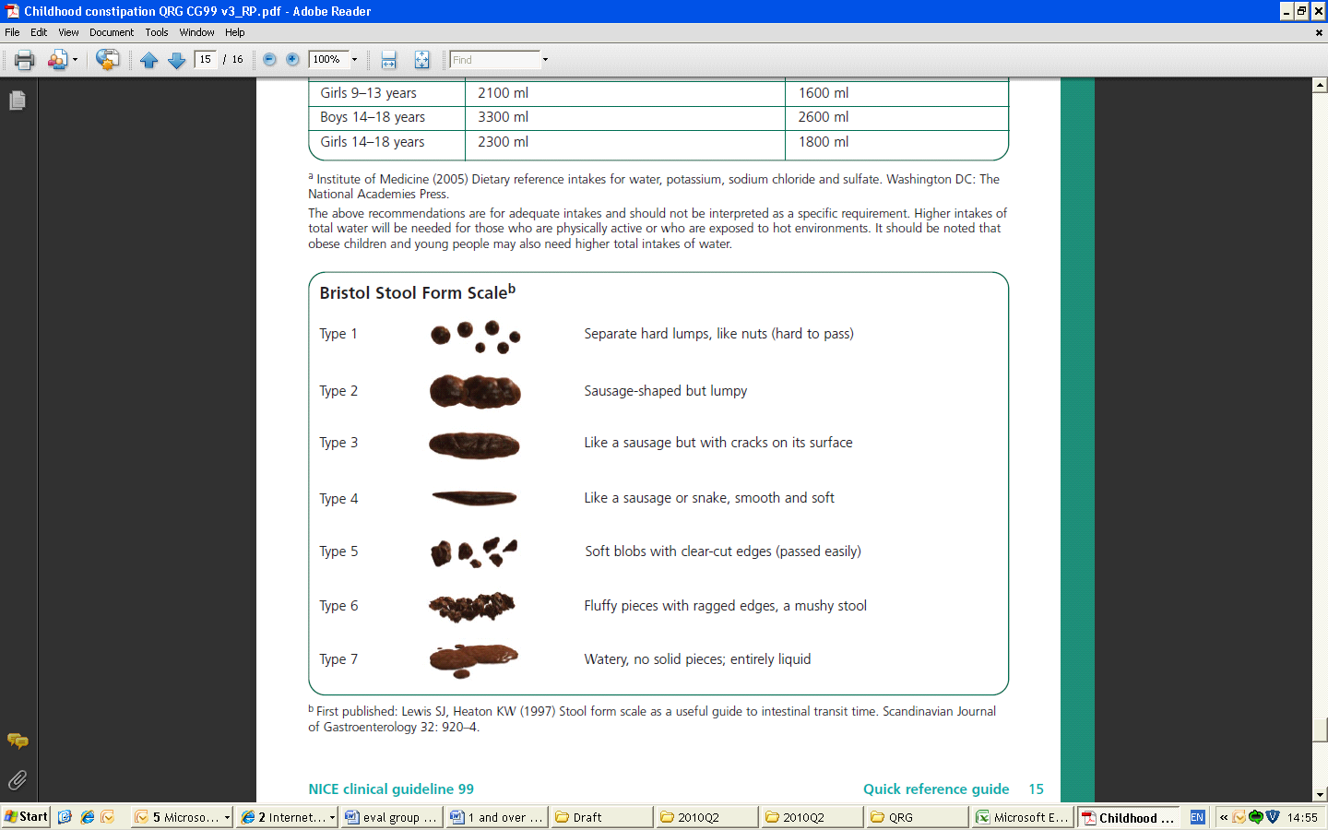

If the history-taking and/or physical examination show evidence of faltering growth treat for constipation and test for hypothyroidism and coeliac disease. See also ‘Coeliac disease: recognition and assessment of coeliac disease’ (2009) NICE clinical guideline 86.
If either the history-taking or the physical examination show evidence of possible maltreatment treat for constipation and refer to NICE guidance on ‘When to suspect child maltreatment’, NICE clinical guideline 89 (2009).

