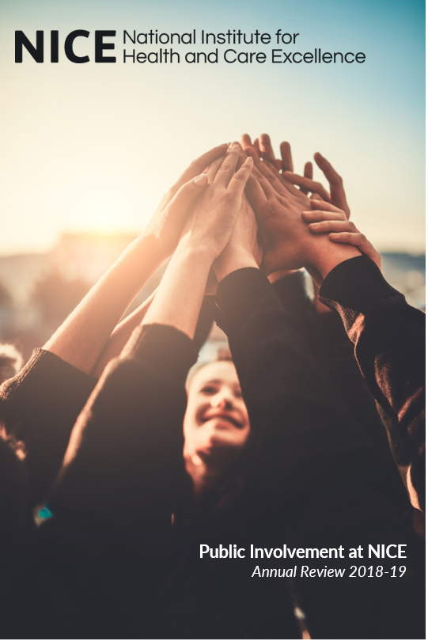

Contents
Introduction 3
Facts and figures 3
Recruiting and identifying people to take part in our work 3
Inclusive opportunities 5
Involving people with learning disabilities in the development of NICE quality standards. 5
Engaging with children and young people 6
Improving how we reach and recruit new lay committee members 7
Exit surveys 10
Working together 11
Expanding the public involvement programme's international reach 11
Supporting shared decision making 12
Support and learning 14
Supporting people to take part in our work 14
Training days 14
NICE lay member event 15
Online training modules 16
Communications 17
Social media 17
Public involvement on the NICE website 20
Speaking engagements and meetings with voluntary and community sector organisations 21
Identifying and sharing examples of impact 21
Collating and sharing the impact of patient involvement for interventional procedures and highly specialised technologies 21
Voluntary and community sector use of NICE guidance 22
Evaluating a new approach to including young people’s voices in NICE guidance 22
Commentary from patients for interventional procedures guidance 24
Conclusion and future plans 24

Introduction
- This report describes the work of the Public Involvement Programme (PIP), and broader public involvement activities across NICE, in 2018/19.
- We have structured our report this year by drawing on the National Standards for Public Involvement in Research as developed by the National Institute for Health Research (NIHR). The themes identified in the standards align with NICE's approach to public involvement and PIP contributed to their development via our membership of INVOLVE.
- The past year has been an increasingly busy one for PIP as NICE has continued to expand and develop its offer to the health and social care systems. We have focussed activities this year particularly on engaging and supporting people who are often seldom heard or whose needs may not be adequately met by standard involvement practices.
- We have continued to support and promote public involvement at a national and international level through our work with the Health Technology Assessment International (HTAi) Patient and Citizen’s Involvement Group (PCIG) and through the Guidelines International Network (G-I-N) Public Working Group, as well as attending and presenting at a range of national and international conferences.
- In 2017 we published the outcomes of our strategic review of public involvement and took forward 7 commitments which have now been embedded into our work. Improving how we reach and recruit people, expanding our use of social media and providing feedback to people who have submitted evidence to us are three examples of this continuing work. We have also been contributing to work across NICE to improve our taxonomy and harmonise the terms we use to describe different aspects of our work.
- Finally, our work supporting the shared decision making agenda has continued and expanded over the year with the 5th meeting of NICE’s Shared Decision Making Collaborative; publication of processes for developing decision aids; and an increase in the profile of shared decision making activities across NICE.

Facts and figures

Recruiting and identifying people to take part in our work
- PIP supports the recruitment of people who use services, carers and members of the public across all NICE work programmes. In most cases we describe the people we recruit as lay members but some variation in that terminology occurs across NICE. In 2018/19 we received 434 applications for 68 vacancies and in the end recruited 71 people to NICE committees.
- The disparity between the number of vacancies and the number of people recruited was due to more people being recruited for 9 committees than was initially planned. This was due to a combination of:
- receiving high quality applications which led committee teams to opt to recruit more people
- additional populations being identified during scoping and recruitment
recruiting from an existing pool of previous applicants rather than running a new recruitment activity.
- These additional lay members offset five topics where we were either unable to recruit a lay member or not able to recruit to all vacancies on a committee. This was due to either the topic being very specialised or it being a topic area where there is little voluntary and community sector organisation presence. In these cases, we are exploring other ways of capturing patient views and experiences.

Figure 1 – recruited lay members and applicants

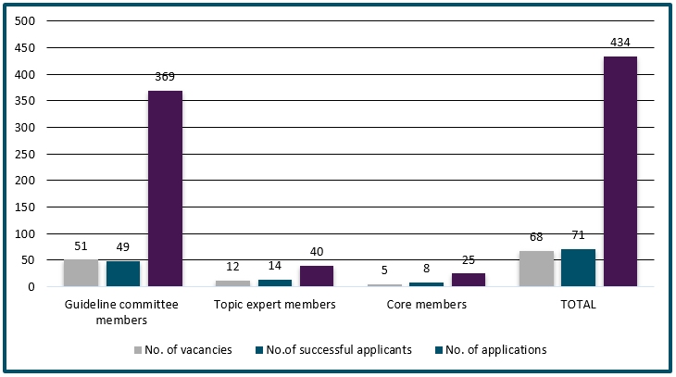
Download the data set for this chart
At any one time we are supporting around 200
lay members

- We have helped to support interviews for lay member positions by developing a suite of interview questions, a scoring matrix, and an accompanying guide to assist NICE teams and developer centres when holding interviews for lay members. This is in addition to the shortlisting criteria developed the previous year.
130
invited members and patient experts supported this year
- As well as recruiting lay members we have supported 23 people to join our quality standards advisory committees as invited specialist committee members, 10 people to contribute to NICE scientific advice meetings, and 97 people to share their knowledge and experience with committees as a patient expert.

Figure 2 – patient experts and invited specialist members

Download the data set for this chart

Inclusive opportunities

Involving people with learning disabilities in the development of NICE quality standards.
- For two quality standards addressing the needs of people with learning disabilities in development this year we adjusted our standard support to enable people with learning disabilities to participate fully in the work.
- For this work four experts by experience (the equivalent of lay members) were appointed to the NICE quality standards advisory committee. All four people use NHS and/or social care services, and have extensive experience of contributing the experiences, views and preferences of people with learning disabilities to inform policy development and service improvement strategies.
- We explored the needs of the experts by experience and in partnership with the committee and the experts by experience themselves we decided to:
- commission a specialist facilitator to support the experts by experience and provide advice to NICE staff and committee chairs
- increase the length of the committee meetings from a half day to a full day
- provide the facilitator and experts by experience with the facilities and resources to meet to prepare for the committee meeting in advance
develop EasyRead versions of papers and slides at every stage.
- For the topic engagement exercise for the two quality standards we produced EasyRead versions of the documents for stakeholders. However, a follow up survey into their usefulness yielded a poor response and stakeholders who did respond said that they didn’t need to use the EasyRead documents as they were responding as an organisation rather than eliciting responses from people who use services. We therefore decided not to go ahead with producing an EasyRead version of the draft quality standard for consultation.
- The audience insight team are assessing the experiences of the experts by experience, their supporters, and other committee members including the chair and NICE staff to report on the impact of the adjustments on the development of the quality standards. We would like to thank the quality standards, publishing and audience insight teams for their help with this work.

Engaging with children and young people
- NICE is starting work on a number of topics that relate to the health and wellbeing of children and young people. These include (but are not limited to):
- Looked after children and young people
- Children and young people with disabilities and severe complex needs
- Babies, children and young people’s experience of healthcare
- Social and emotional wellbeing in primary and secondary education
- In addition, the myalgic encephalomyelitis/chronic fatigue syndrome (ME/CFS) guideline will focus in part on the needs and experiences of children and young people affected by the condition.
- To produce meaningful guidance, the views and experiences of children and young people must be included in the products that seek to address their needs. However, the way we work poses some challenges in involving this sub-population:
- NICE committees cannot recruit members who are under the age of 16
- committee meetings take place during weekdays, which would pose a challenge for young people in full time/ mainstream education
the NICE process is not typically young person friendly and would need to be adapted in order to engage with children and young people satisfactorily.
- PIP have worked with senior colleagues in NICE to explore a cohesive strategy to involve young people in a way that genuinely brings their voices into the guidance we produce. Initial ideas include:
- commissioning a specialist organisation to set up an external reference group that conducts this work in a focused way, alongside the relevant NICE committees
- using the same group(s) across multiple guidelines to optimise the use of resources
- ensuring we incorporate lessons from similar work done on the child abuse and neglect guideline
providing enough lead-in time when procuring external support in case a tender process is needed, based on estimate of cost.
- As of March 2019, the scope for the guideline on children and young people with disabilities and severe complex needs is changing to reflect feedback from Department of Education and the Department for Health and Social Care. The guideline will now focus on service delivery. Given that specific remit a focus group of children and young people is being considered for this guideline.

Improving how we reach and recruit new lay committee members
- This year we continued the work we began in 2017/18 to help achieve the first objective in NICE’s Equality Scheme: to increase the proportion of advisory body position applications that are from individuals who describe themselves as from black, Asian and minority ethnic (BAME) groups.
- Following successful focus groups in Manchester and London with BAME groups, one significant barrier to involvement the groups identified was the lay member recruitment documents. They were seen to be too long, technical, corporate and not user-friendly.
- As a response to this feedback, PIP re-designed all the lay member recruitment documents. The key changes included:
- changing the layout to allow key information to be more prominent
- using images and colour
- removal or explanation of formal language to increase accessibility
addition of a 1-page poster to use on social media and for organisations to promote to their members.
Overall, 106 individuals attended the focus groups to help improve lay member recruitment at NICE

- We held a third focus group in Sandwell and Dudley to user-test the draft recruitment paperwork, resulting in the documents being finalised and piloted in lay member recruitment across NICE programmes. It was felt that the issues identified during the focus groups were not specific to BAME applicants and might be barriers for others. Therefore, we piloted the documents with a view to using them for all lay recruitments, after receiving positive feedback from NICE corporate office.

Image 1: recruitment paperwork development
Before
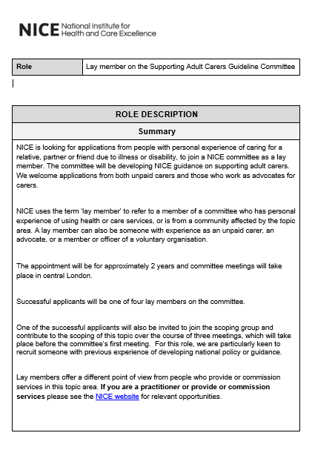
After
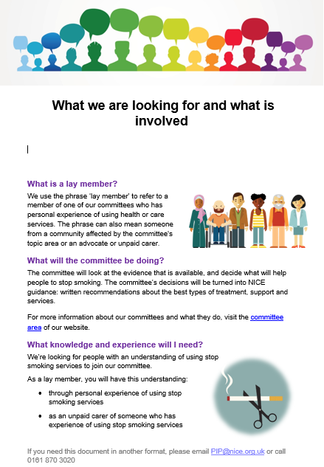
- We first used the new formats for recruiting to the babies, children and young people’s experience of health care guideline which yielded 31 applications with 6 lay members being recruited. This topic was selected due to the main target audience for the recruitment being young people aged between 16-19. We engaged with national and local youth organisations via Twitter to inform them of the guideline and inform their members of the recruitment, with one tweet alone generating over 14,000 impressions.
- Following further successful piloting with recruitment for clinical guidelines for management of common infections and in the diagnostics assessment programme we will use the documents for all future lay member recruitments.
- To ensure the NICE website complies with standards for accessibility, the pictures in the new recruitment documents had to be removed as they were not compatible with screen readers. To address this issue, in 2019/20 PIP will be working with the communications directorate to explore options to develop online recruitment. This would allow the pictures to be included and ensure that all our content is accessible for all those using the NICE website.

Exit surveys
- In 2018/19 we sent all lay committee members whose work came to an end that year an exit survey to hear about their experience of working with NICE. We received 37 responses to the survey out of 78 sent, yielding an overall response rate of 47%. This is consistent with the response rate from the previous year.
- This year we developed and implemented a simplified survey, reducing the number of questions from 9 to 6 to make it easier for people to complete and focus on the key issues they wanted to tell us about. Ninety-five percent of people rated their experience of working with us as ‘good’ or ‘excellent’.

Figure 3 – overall experience of working on a NICE committee

Download the data set for this chart
‘I am very grateful to NICE and the other committee members for making me welcome and valuing my contribution’ – NICE lay member

- Participants reflected on both the positive and negative aspects of their work with NICE and no single issue dominated their comments as a cause for concern. We have shared the data from the exit survey with teams across NICE to both reflect on what has gone well and to address any issues or challenges that lay members have identified.
‘For the first few meetings, certain confident academia-orientated colleagues had more of the 'floor'. However, after being in touch with the Chair, the ensuing meetings were more equally managed’ – NICE lay member

Working together

Expanding the public involvement programme's international reach
- In 2018/19 PIP has taken part in international conferences and initiatives, sharing best-practice developed through NICE's extensive experience in involving people who use services, their families and carers in guidance development.

European Society of Cardiology
- In June 2018 the PIP collaborated with the European Society of Cardiology on a patient engagement workshop in Brussels to prepare patients and healthcare professionals for working together to develop clinical guidelines. We ran a training session with patients from across Europe.

Guidelines International Network (G-I-N)
- In September 2018 the PIP gave an oral presentation discussing our innovative approach to involving young people in guideline development at the G-I-N annual conference hosted in Manchester by NICE and SIGN (Scottish Intercollegiate Guidelines Network). We also presented 4 posters covering:
- the contribution of voluntary and community sector organisations to the development and use of NICE guidance (2 posters)
- our use of social media
our work on shared decision making.
- PIP is a core member and vice-chair of G-I-N Public working group which promotes good practice on involving patients and the public in developing and implementing guidelines. In February 2019 we surveyed all G-I-N members for their feedback on the G-I-N Public Toolkit to inform its update and development. The toolkit assembles international experience and best practice examples of successful patient involvement to support guideline developers who are considering involving patients.

Health Technology Assessment International (HTAi)
- Members of the PIP team belong to the Health Technology Assessment International’s Patient and Citizens’ Involvement Group (HTAi PCIG). The group brings together international organisations and individuals across sectors with a keen interest in patient and citizen involvement in health technology assessment.
- Over the year we have worked on a number of projects with our colleagues in PCIG. These include:
- contributing to an upcoming publication in the International Journal of Technology Assessment in Health Care titled 'Two case study comparisons of sightings of patient input in HTA appraisal final recommendations and committee discussion summaries for the HTA agencies CADTH, NICE and SMC'
- speaking at the PCIG workshop and giving two oral presentations at the 2018 HTAi conference in Vancouver
- sharing and developing best practice in HTA, and contributing to projects and conference plans at the annual HTAi PCIG face-to-face meeting in Stockholm
- successfully submitting abstracts for the 2019 HTAi conference in Cologne. We will be taking part in the HTAi PCIG workshop, two panel sessions and one oral presentation and two vignettes (short oral sessions) showcasing patient involvement at NICE.

PARADIGM
- We have also worked with PCIG on a European project called PARADIGM (Patients Active in Research And Dialogues for an Improved Generation of Medicines) focusing on the area of patient involvement in early dialogues with HTA bodies and life sciences companies, in a similar way to NICE scientific advice.
- Via a scoping meeting and workshop, we have identified the following areas where additional tools, resources and guidance are needed:
- patient recruitment processes
- patient interview guidance
- minimum standards framework for patient involvement
rationale for patient involvement in Early Dialogues.
- This work was presented at the ISPOR meeting in Barcelona by members of the HTAi PCIG group, including NICE.

Supporting shared decision making

NICE Shared Decision Making Collaborative
- In June 2018 PIP facilitated the 5th meeting of the NICE Shared Decision Making Collaborative. A total of 81 people took part in the meeting, with a wide range of organisations and people with an interest in shared decision making taking part. Delivered through a combination of plenary and parallel sessions, lunchtime networking and demonstrations the agenda covered:
- NICE’s role in the shared decision making landscape
- an overview of shared decision making in the system
- technology to support shared decision making
- values-based practice in support of shared decision making
- parallel sessions covering:
  - describing the evidence
  - developing initiatives
  - decision making in challenging fields
future developments.
Collaborative member Sam Finnikin summarised the day in his blog for the BMJ.

A process guide for producing patient decision aids
- In collaboration with the NICE medicines and technology programme and the publishing team, PIP published a process guide for developing NICE patient decision aids in April 2018. The guide drew on international best practice in the field such as the International Patient Decision Aids Standards (IPDAS) and the Development Methods for Ottawa Patient Decision aids.
- The process guide details in what circumstances a patient decision aid might be a helpful addition to a guideline or other NICE guidance and provides a referral route for suitable topics. The guide then gives an overview of the decision aid development process and who should be involved in reviewing and refining the decision aid.

Support and learning

Supporting people to take part in our work
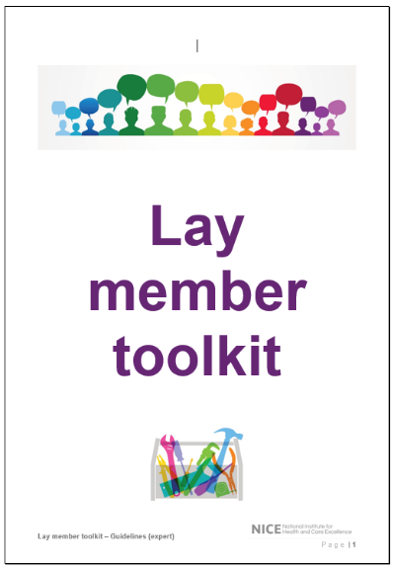
- As part of the support offered to lay members, we reviewed and updated the toolkit we send to people when they start working with us.
- The toolkit equips lay members with the knowledge and understanding of what to expect during guidance development, how to prepare for meetings and how they can have the greatest impact on their committee.
- We co-produced the toolkit with current and previous lay members who were able to highlight key areas where they felt support and information was needed and share some hints and tips of what worked best for them.
- Feedback, to inform future development of the toolkit is generated through regular conversations with lay members and through the exit survey.

Training days
- As part of our support for new lay members joining guideline committees, we ran 5 face-to-face training days to equip them with the knowledge and skills to get the most out of their time on the committee. Our agenda included:
- developing guidelines – what evidence we use and how we find it
- preparing for meetings and what to expect
making an impact – sharing knowledge, experience and ideas.

Training day rating

4.7/5.0

Very good!
- We invited speakers from both within NICE and our developer centres, and former lay members who shared their experiences of working with NICE and provided top tips for working effectively as a lay member. In total 46 people received training this year.
- We asked lay members to evaluate each training day to let us know what went well and what could be improved. 100% of lay members who responded rated the day as a whole as ‘very good’ or ‘good’ giving a mean score of 4.7 out of 5.
- Attendees found the day inclusive and really valued the opportunity to speak and share experiences and concerns with other lay members. They also appreciated the mix of presentations and exercises throughout the day. There was some difference of opinion as to whether the training day worked better depending or not on whether a lay member had already been to their first committee meeting. Our upcoming online training modules may help to mitigate some of the issues around the timing of training days. Finally, some lay members expressed an interest in further training particularly around health economics.
‘The mix of attendees was excellent. The experienced lay members were generous and thoughtful in the points they offered. The interaction between the PIP team and the attendees was superb – knowledgeable, approachable team’ – NICE lay member

NICE lay member event
- On 27 March 2019 the PIP hosted a successful event with 17 lay members of standing committees to celebrate their contribution to NICE guidance. The event also explored the challenges they faced as lay members, allowed them to share their experiences, and learn about new developments at NICE.

Lay member event rating

4.4/5.0

Good!
- We developed the programme for the day by consulting with lay members to ensure the day was shaped around their needs. Consequently, the programme included a mix of learning and sharing experiences, with presentations, exercises, and discussion.
- Participants gave very positive feedback about the event, with an average score of 4.4/5.0. All sessions received high average scores, and comments indicated that it had been a useful and valuable day.
‘Feel part of [the] NICE ‘family’. Inspired to improve’ – NICE lay member

- Lay members appreciated the opportunity to network, share experiences and ideas, and learn about new developments at NICE. Discussions around patient evidence in guidance development and how guidance is implemented, and a Q&A with NICE senior staff were also highly valued.
- In celebrating 20 years of the patient/public voice in NICE’s work and the role of lay members, participants enjoyed hearing about the impact they have had, and how the guidance they’ve supported to produce was being used and making an impact. Lay members also suggested actions for NICE to improve our public involvement and how they can have a greater impact on committees as lay members. This included offering annual performance reviews for lay members and establishing a buddying scheme.
‘Once again it was a privilege to meet lay members of NICE committees at the annual event on 27th March. Their commitment and enthusiasm for the complex tasks they undertake is truly impressive and NICE would be a lesser organisation without them’– Angela Coulter, NICE non-executive director

Online training modules
- We have begun developing a series of online training modules as part of a plan to widen our training offer to all lay members of NICE committees and make the most effective use of resources. This approach offers training content in short and easy to assimilate modules that can be accessed at any time. This independent learning will be supplemented with telephone sessions run by a public involvement adviser or using webinar technology.
- The modules for the online learning are a combination of those identified in a survey of lay members, the current content of induction material and face-to-face training, and the collective experience of the staff team. Some are generic modules applicable to all lay members, with a smaller number tailored to a specific type of topic or NICE guidance. The planned module content ranges from how we use evidence and develop guidance, to tips on effective committee working and supporting the use of NICE guidance.
- We have produced content for the first two modules which focus on the role and value of the lay member and tips for being effective on a NICE committee. Lay members are providing us with feedback on the content and will be taking part in user testing of the online products which will be hosted on an e-learning platform.

Communications

Social media
- We have continued to increase our presence on social media using the PIP team’s @NICEgetinvolved account. This has helped us to reach more members of the public and different communities, and work and communicate more effectively with our stakeholders.

Table 1 - A snapshot of social media activities
@NICEgetinvolved – 2018/19 impact
1226 tweets
1.6 million impressions
30 thousand profile views
61% more followers

Using Twitter to tackle issues people have with NICE
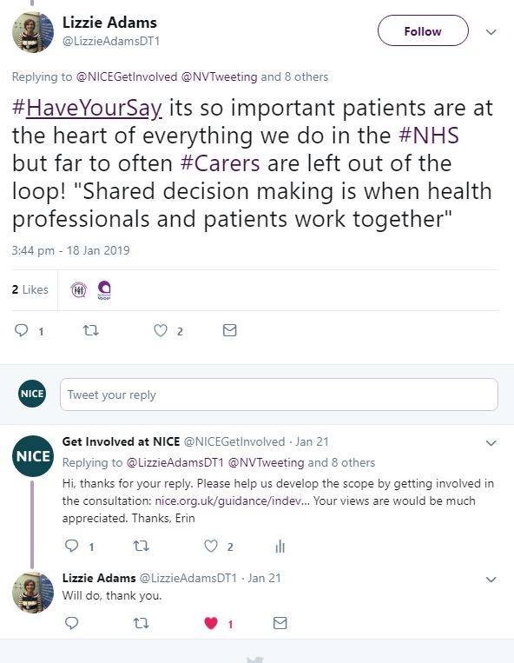
- We use Twitter to have conversations with people who we wouldn’t normally be in touch with. This includes being able to address any concerns people have about NICE. There are many misconceptions about NICE, so by using social media we’re able to inform people and promote how they can help develop our guidance.

Celebrating public involvement at NICE
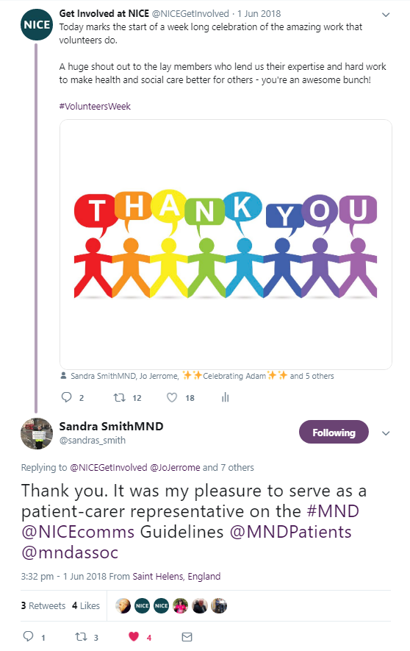
- We continue to use Twitter to work more closely with our lay members, both past and present. We also run campaigns and participate in national conversations, such as volunteer’s week.
- This helps us to publicly thank our lay members, promote how valued lay members are at NICE and celebrate achievements. We’re also able to promote how we encourage public involvement at NICE and promote opportunities for people to help shape our guidance.

Working in partnership with key stakeholders
- Voluntary and community sector organisations play a huge role in helping NICE recruit lay members and patient experts; develop our guidance; and implement it.
- Through targeted campaigns, we’ve worked with organisations to promote NICE guidance. This conversation with Together for Shorter Lives helped to raise awareness of advanced care planning and signpost people to additional resources.
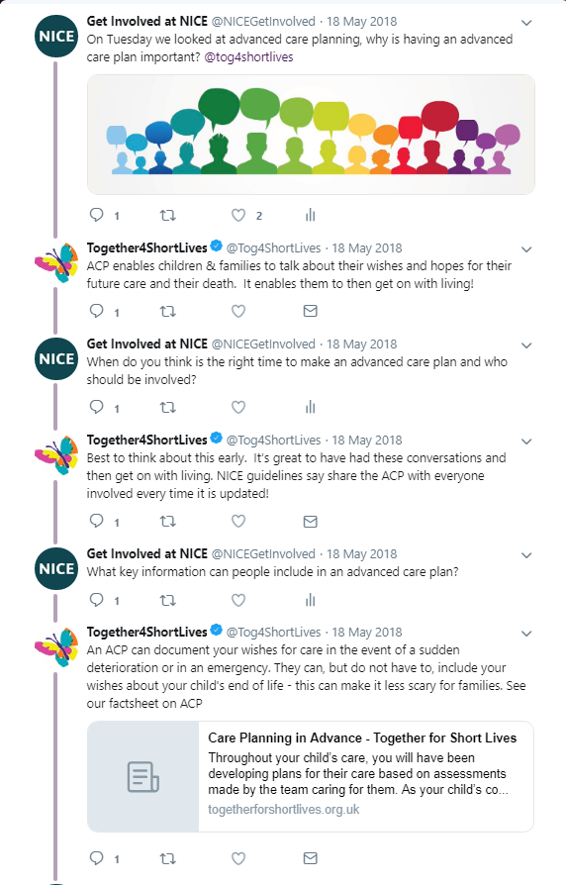

Public involvement on the NICE website
- Throughout 2018/19 PIP has worked in partnership with the NICE web team to redevelop all the public involvement webpages on the NICE website. We have revamped the whole structure of the public involvement section of the site to help people find the information they need more quickly, starting with a new landing page which offer routes to advice about using NICE guidance and information about getting involved in NICE’s work.
- The new pages include testimony from people who have worked with NICE about their experience, examples of how patient input and evidence can inform NICE recommendations, and information about the public involvement programme and the support we offer. We are grateful to our colleagues in the web team for all their hard work creating the pages with us.

Speaking engagements and meetings with voluntary and community sector organisations
- In 2018/19 PIP presented at 18 national and international events. Our talks covered patient and public involvement in guidelines, technology appraisals and highly specialised technology evaluation. We also presented NICE’s work on shared decision making and contributed to discussions around how evidence-based guidance can support individual decisions.
- In 2018/19 we also held 15 meetings with voluntary and community sector organisations or umbrella groups. These meetings either discussed NICE work in a specific topic area and the opportunities for organisations to get involved in the work, or they covered our public involvement activities at a more strategic level.

Identifying and sharing examples of impact

Collating and sharing the impact of patient involvement for interventional procedures and highly specialised technologies
- Best practice in public involvement tells us that feedback on evidence submitted to us by voluntary and community sector organisations is both desirable and beneficial. Feedback helps organisations to understand what the impact and usefulness of the evidence they submitted to us was and helps them to develop their future submissions. The act of providing feedback also helps HTA agencies to reflect on how they consider and use patient evidence.
- Following pilot work started in response to the public involvement review, we have now implemented a feedback process in the interventional procedures and highly specialised technologies programmes. There are two elements to this work:
- capturing the committee’s views on the impact of submissions of evidence from voluntary and community sector organisations, via forms designed and piloted by the committees and NICE staff
summarising and feeding back to the organisations who submitted evidence via a letter to help them to see where their input has been useful and help improve further submissions.
- Information from the impact forms, highly specialised technology evaluations and the feedback letters will form the basis for an oral session at the 2019 HTAi conference in Cologne.

Voluntary and community sector use of NICE guidance
- There are many ways voluntary and community sector organisations use NICE guidance. From using NICE recommendations to evaluate services to providing information to the public, there is no standard practice within the sector.
- As part of the development of the new public involvement webpages we produced information to encourage and enable organisations to use our guidance, including sharing examples of how organisations have used NICE guidance to support their work. These included:
- developing questions informed by NICE guidance to ask service providers and commissioners to evaluate local services
- assessing public concerns to understand if services didn’t meet expected standards.
- using NICE guidance to support service improvement recommendations
- checking if strategic plans and commissioning decisions align with NICE guidance
enhancing the information voluntary and community sector organisations provide to the public to include NICE guidance.
- To support this information, we worked with six local and national organisations to provide real life examples of where organisations had used NICE guidance to enhance their work. One example was Healthwatch Manchester, who spoke to patients to understand their experience of a patient transport service following relocation of dialysis from one hospital to another. Using our renal replacement therapy quality standard, they were able to measure their findings and develop recommendations to improve patient experience and access.

Evaluating a new approach to including young people’s voices in NICE guidance
- At the Guidelines International Network conference in 2018, PIP presented an evaluation of a new approach to involving young people in developing a NICE guideline on child abuse and neglect. For this guideline, an external reference group was convened to help the committee identify the perspectives and priorities of young people affected by abuse and neglect. This method of involvement was chosen as a way of providing input at key stages of guideline development, considering the sensitivity of the topic and the benefits to young people of a peer group environment.
- Facilitated by a voluntary organisation with expertise in involving children and young people who have experienced abuse the reference group met separately on 4 occasions during guideline development. Young people were asked to:
- provide insight on specific questions and issues
- comment on the recommendations
contribute ideas to a version of the final guideline for young people.
- Each reference group meeting took place in a workshop style, with a support worker present. Young people reported feeling included, able to contribute and that their experiences were heard and validated. Reference group facilitators presented the group’s feedback to the guideline committee after each meeting, feeding back the committee’s use of their contributions to the young people at each subsequent meeting. Young people also met some committee members.
- The way that young people’s views were heard, validated and incorporated into the guideline was valued enormously by the reference group. Their experiences were often difficult to hear and raised serious concerns about current practice. The reference group felt that the guideline committee and staff responded empathetically and sensitively, which allowed them to continue to take part in what could have been a re-traumatising experience but was instead felt to be an empowering and healing journey.
- The reference group approach was evaluated, including feedback from the young people taken from the facilitator’s report, plus findings from a survey of the committee and the guideline’s technical lead. All committee members who responded to the survey felt that the reference group worked well to bring young people’s experiences and views to guideline development but had mixed views on how helpful these contributions were to their work. The guideline’s technical lead felt the reference group made a substantial contribution to the recommendations, specifically:
- giving more detail about how young people wanted professionals to work with them
- helping to provide more detail in the recommendations about reasons why young people don’t disclose abuse and neglect
- giving strong importance to the issue of choice of therapeutic interventions.
- The reference group concluded their work by co-producing a version of the guideline for other young people.

Commentary from patients for interventional procedures guidance
- We use the term patient commentary to describe questionnaire-based evidence from people who have experience of the procedures considered by our interventional procedures (IP) programme. We summarise and present information provided by patients with direct experience of a procedure to the committee alongside other forms of evidence.
- Last year we started to ask committee members about the impact of patient commentary in developing interventional procedures guidance. This year we analysed and considered the results of the information committee members gave to us. Our analysis again told us that commentary from patients routinely had an impact on the committee’s decision making. Key findings identified that patient commentary is equally useful for guidance updates as for new guidance. The interpretation and assessment of ‘impact’ varied across committee members, but the majority agreed the patient commentary reinforced the other evidence.
- Measuring the impact of commentary from patients appears to have raised its profile with committee members as our analysis of published guidance shows that it includes more reference to patient issues since we have started asking the committee about the impact of the commentary than in preceding years. To date no discernible patterns of impact have been identified, and we are working on criteria for when patient commentary should not be sought. These patterns may emerge as the quantity of data increases.

Table 2 - Interventional procedures case study
Transurethral water vapour ablation for benign prostatic hyperplasia
We received 15 questionnaires from people who had had transurethral water vapour ablation for benign prostatic hyperplasia. The committee noted the published evidence demonstrated the procedure to be safe and to work well. Patients were supportive of the procedure with most people reporting improvement in symptoms. The committee added a comment that patients may need a urinary catheter for several days after the procedure.

Conclusion and future plans
- 2018/19 was a year filled with new initiatives and development of our more established areas of work. We expect that 2019/20 will deliver much of the same and we look forward to embracing new opportunities for public involvement in NICE Connect and in response to changes in the Centre for Health Technology Evaluation. We’ll also reaffirm our commitment to shared decision making at our 6th Collaborative meeting in June 2019. Finally, we look forward to continuing to work with the people and voluntary and community sector organisations who contribute so much to NICE’s work through their lived experience, knowledge and commitment to improving health and social care services and outcomes for all.
© NICE 2019. All rights reserved. Subject to Notice of rights.
July 2019

https://www.htai.org/interest-groups/patient-and-citizen-involvement/pcig-home/values-and-standards

