NICE Evidence search: a quick guide for social care www.evidence.nhs.uk

NICE Evidence search brings together high-quality evidence from hundreds of trustworthy sources.
It combines evidence on social care, health, medicines, public health, and commissioning all in one place.
This includes guidance, systematic reviews, evidence summaries and resources for people who are supported by health and social care services, all freely available without needing to log in.

Evidence can be used to inform social care interventions, academic assignments and reflective case studies. It can also be used to support learning for continuous professional development and to maintain professional registrations.

Step 1: Think about your question
What are the keywords? Are there alternative terms for your topics? You might need to play around with your terms to get the best results (see Search tips).
Type your search terms into the box, then press Enter on your keyboard or click the Search button. 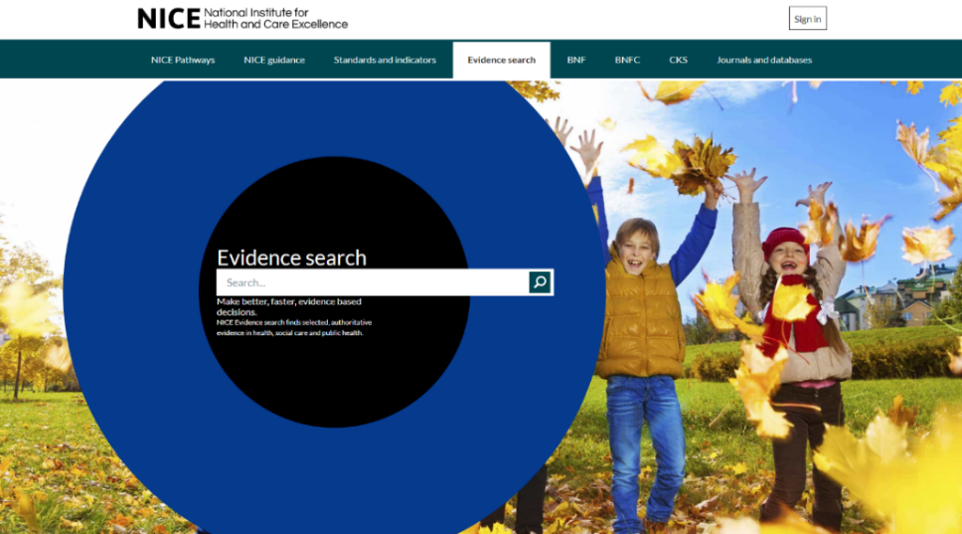

Step 2: View your results
SEARCH TIPS
- Use OR where you want either term or concept in your results: eg elderly OR older
You don’t need to type AND, as terms are automatically combined.
- Plurals are automatically searched for: eg entering carer will automatically also find carers as well.
- Use inverted commas in the search box to find exact phrases when looking for something very specific: eg “expert patient”, “child attachment”
- Acronyms and alternative spellings are automatically searched for: eg entering MCA will find results with MCA and Mental Capacity Act, and entering colour will also find results with color.

Click on a title to go straight to the full text of the document, or click Read Summary (where it’s available) to help determine the usefulness of a document.
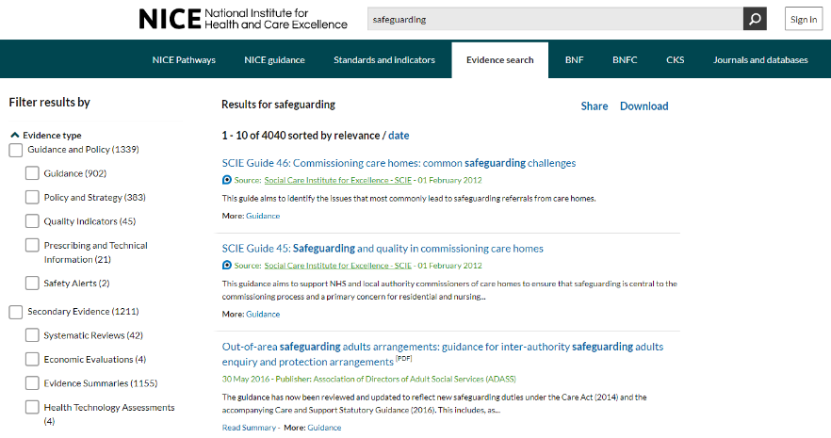
Step 3: Refine your search
You can refine your search results using the filters on the left-hand side of your search results (you will need to scroll down the page to see all the available filters).
The Evidence type filter allows you to narrow your search results down to certain types of evidence.
Particularly useful filters for social care resources, include:

• Guidance (sets of statements or recommendations intended to guide decisions)
• Policy and Strategy (a set of principles, course of action, framework, method or plan to bring about a desired future—at a national or international level)
• Quality Indicators (agreed levels of practice or service that are intended to set thresholds)
• Evidence summaries (critical assessments of the current evidence)
• Practice Based Information.

The Sources filter allows you to choose results from individual organisations or publishers. Click on the word Sources to open out the list.
You can select as many filters as you like, including more than one option within a filter.
Remember to clear your filters between searches, if you want to see the full set of results for your next search. You can click on the Clear filters button at the top of the list of filters to do this.

Step 4: Sharing and downloading your results
Clicking on Share at the top of the search results page allows you to share your results via Facebook, Twitter, or email.
Clicking on Download allows you to select results and export them as either a CSV file (to open in a spreadsheet) or RIS file (to use with reference management software). You have the option to download all the results on a page (up to a maximum of 250) or to choose relevant results by clicking in the checkboxes that appear next to each one.

Still not finding what you want? 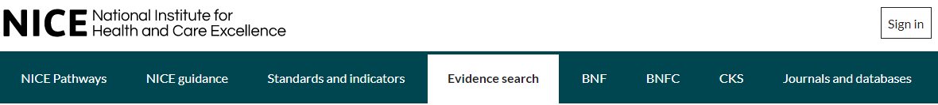
You can use the Journals and databases link at the top of the page to access a set of full text journals and bibliographic databases purchased by NICE on behalf of the NHS. While the focus of the journals collection is healthcare, there are some social care titles available, including the British Journal of Social Work and Social Work Research. You can search and browse the A-Z list of journals (https://journals.nice.org.uk) from the link above.

You need an NHS OpenAthens username and password to access most of the journals. Employees of organisations which receive government funding to provide social care services (such as local authorities) are eligible. You can register for one at https://openathens.nice.org.uk. (When registering, type social care and your region (eg social care Derbyshire) into the organisation box, wait for a list of options to appear, and then click on the most appropriate choice. This will speed up your application.)

