NATIONAL INSTITUTE FOR HEALTH AND CARE EXCELLENCE

Accreditation process manual - renewals

Process manual for renewing accreditation for producers of guidance, advice and recommendations for practice already NICE accredited

First version: August 2017
This version: January 2021

Review date: January 2024
- Introduction
NICE continues to have an ongoing relationship with accredited guidance producers and encourages producers to maintain and ideally continue to improve their processes via this renewal process.
The accreditation programme will be more closely aligned with the development and maintenance of NICE guideline recommendations. Accreditation adds value to NICE guideline development by utilising high quality guidance produced by others. This will support the ambition to evolve existing NICE guidelines into suites of recommendations around priority topics. These may use guidance from accredited producers to inform the development of recommendations where there is no existing NICE guidance on a particular topic.

- Aims, scope and approach
- Aims and scope
    - The purpose of NICE accreditation is to help users identify the most trusted sources of guidance that have been developed using critically evaluated high-quality processes. In the long term, this will improve the quality of information produced for health and social care decision-makers. The accreditation programme assesses the processes by which guidance is developed and not the content. Individual pieces of guidance produced via an accredited process bear the Accreditation Mark.
    - New applications are no longer accepted, but NICE has a renewal process to ensure that existing accredited producers maintain the standards of accreditation. Their process and guidance examples will continue to be reviewed every 5 years.
- Criteria used in accreditation
    - The accreditation criteria are based on the Appraisal of Guidelines Research and Evaluation (AGREE) II instrument. The AGREE instrument was developed to assess the quality of individual clinical guidelines, and has been expanded to encompass other types of guidance that fit the definition for NICE accreditation. The assessment criteria may be applied according to the type of guidance product under consideration. This allows for a complete assessment on a case-by-case basis. Appendix A details the Accreditation criteria.
- Term of accreditation
    - The term of Accreditation lasts for 5 years from the date of the last accreditation decision (new or renewal).
- Equality statement
    - The Accreditation programme operates in accordance with the NICE equality scheme (available from NICE equality objectives and equality programme).
- Overview of the accreditation renewal process
- Summary of key stages in the process
    - Figure 1 summarises the key stages in the accreditation renewal process. Further detail on each of the steps in the accreditation renewal process is provided in sections 3.2 to 3.10.
    - For transparency, accredited guidance producers terms are published on the NICE accreditation website.
- Pre-renewal application support and advice
    - To help NICE accredited guidance producers assess their readiness for accreditation renewal and understand how to apply, NICE will maintain contact and discuss the process with a producer during their 5-year term. Information, tools and materials are available in the accreditation renewal section on the NICE website.
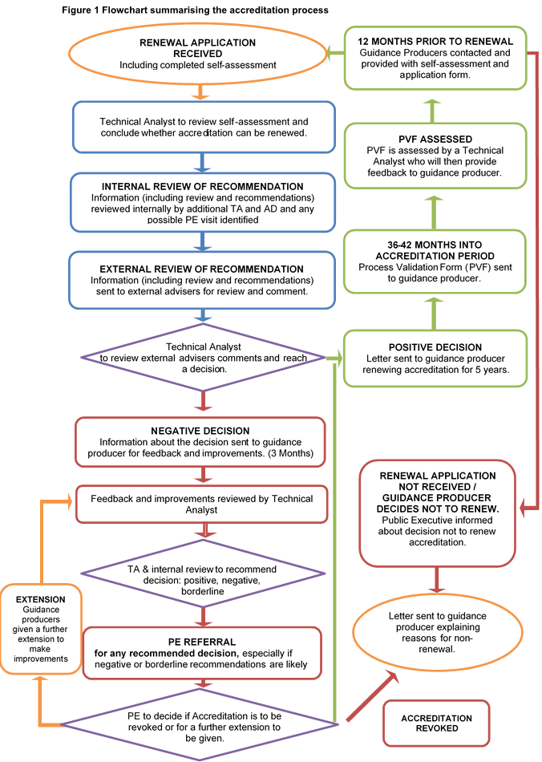
- 3 years into an accreditation term
    - During the term NICE will make reasonable efforts to contact the guidance producer. It is incumbent on the guidance producer to ensure that NICE has an up to date point of contact to liaise with.
    - Between 36 and 42 months into their term an accredited guidance producer is provided with a process validation form (PVF). By completing this, it enables the producer to identify any changes that have taken place since the last assessment and to identify any issues with the analyst ahead of time and before accreditation renewal. Details of what is required for completion are included within the form.
    - The producer should use the PVF to describe any substantive changes to their process and is encouraged to complete the PVF within 3 months of receipt.
    - Where NICE has accredited a single guideline, this accreditation is specific to the guideline assessed and cannot be renewed. Guidance producers for a single guideline do not need to complete a PVF.
- Producing the process validation assessment response
    - The PVF and any other information provided by the guidance producer is assessed by a technical analyst. This is followed up in a conversation between the guidance producer and the technical analyst. A check of a minimum of 2 examples of guidance produced under the accredited process is also carried out. An outline of the points discussed and the result of a check of the example guidance is given in a confirmatory letter to the guidance producer.
- Nearing the end of term of accreditation
    - The guidance producer will be contacted by NICE 12 months before the end of the 5-year accreditation period to formally notify them of the upcoming expiry of their accreditation term. The guidance producer will be asked to confirm if they intend to apply for accreditation renewal. The accreditation renewal application form may be submitted up to 6 months before the accreditation term expires.
    - Guidance producers are requested to also provide their documented policy or process for the production of guidance and some examples of guidance with their application, which provide evidence that the process has been used to develop them.
    - The guidance producer should submit their application before their term expires, unless an alternative date has been agreed. At NICE’s discretion, a guidance producer’s term may be extended by a maximum period of three months if required to complete the application and associated documentation in order to apply for renewal. Extensions will be considered on a case by case basis.
    - If the guidance producer confirms that they will not apply for accreditation renewal at the end of the term, the guidance producer will be expected to stop using the Accreditation Mark at the appropriate expiry date in line with the agreed accreditation terms and conditions. Existing guidelines already carrying the Accreditation Mark will remain accredited as they were produced to an accredited process. Any guidelines produced to this process after the expiry date will not carry the Accreditation Mark.
    - If the guidance producer does not submit a renewal application or does so later than the end of the month in which their term expires, despite engagement, the producer will be deemed to have terminated their accreditation status and will no longer be able to use the Accreditation Mark in future. This is outlined in the signed terms and conditions they have agreed to work with.

- Producing the renewal application response
    - The application and any other information provided by the guidance producer is assessed and validated against the accreditation criteria by a technical analyst. The analyst summarises whether the guidance producer’s process for guidance development still meets the assessment criteria. Where any criteria are not fully met, the reason for this will be explained in the report to the guidance producer.
    - Having completed the assessment the analyst will have concluded:
- That the producer is maintaining a robust development process and that accreditation can be renewed or:
- That there are concerns suggesting the producer is not maintaining the standard required or that further details are required to confirm a conclusion.
    - The assessment is then checked, firstly by another technical analyst in the accreditation team and then by the Associate Director (and Programme Director, System Engagement where appropriate). They identify whether the application can proceed to external peer review and whether it also needs to be considered by Publication Executive (PE), so that it can be scheduled.
- External peer review
    - In order to provide an independent and reliable review of the recommendation, the assessments are seen by at least 2 external advisers. The team will endeavor to ensure that one of these advisers will come from a lay background.
    - External advisers are selected to review an application based on their expertise and experience. Typically, external advisers have up to 10 working days to peer review the assessment produced by the analyst. They advise whether they agree or disagree with the criteria assessments and the recommendation and why.
- If the producer is maintaining a robust process
    - If the producer is identified as maintaining an accreditable process a letter confirming this is sent to the producer. The guidance producer is invited to re-sign the necessary terms and conditions (provided separately). This document includes a statement about ensuring the same process will continue to be used to produce guidance, and that any changes to this process will be notified to the NICE Accreditation team.
    - The renewal date is amended on the accreditation pages of the NICE website, and the guidance producer can continue to use the Accreditation Mark.
    - If the producer is identified as only just maintaining an accreditable process and the recommendation is considered to be borderline, the reports will be updated and discussed at PE. Improvements may be identified and recommended and a period to begin making them may be given before the final decision is made (see following section).
- If the producer is not maintaining a robust process
    - If either the analyst or the external advisers consider that improvements are required before accreditation renewal can be granted, the reasons for this will be fed back to the guidance producer. They will then have 3 months to agree a plan to make the required improvements and demonstrate substantial progress towards them.
    - If, following the improvement period and subsequent review, the decision is to discontinue accreditation for the producer, they will be sent the report explaining the decision. They will then have 20 working days from the date the report is sent to challenge it. See section 3.11. If accreditation has been discontinued, the guidance producer must stop using the Accreditation Mark. Content developed by guidance producers no longer accredited continues to be available through NICE Evidence, where applicable (non-accreditation does not result in a producer’s content being removed from NICE Evidence).
    - If the decision is to renew accreditation the producer is notified as in 3.8.
    - The status of the guidance producer is amended on the accreditation pages of the NICE website.
- Resolving any challenges to the decision
    - Where guidance producers are not maintaining a robust process, the team will provide the guidance producer with the best possible opportunity to improve this and retain their accredited status. This will be through guidance and support as set out in section 3.9.
    - In exceptional circumstances, for example, where a guidance producer fundamentally disagrees with the outcome of an assessment made by the NICE Accreditation team and dialogue between the two parties has not resolved this, a resolution process set out from paragraph 3.10.3 is available as a final quality assurance step. This is intended to ensure that the accreditation process is fair and that accreditation decision-making has not unreasonably deviated from the process described in this document.
    - Only resolution requests made on the grounds that there has been a ‘breach of process’ will be considered. The request should clearly specify the breach of process and provide supporting information so that NICE can fully understand the nature of the concern and provide an appropriate remedy if there has been a breach of process. This should be submitted to Accreditation@nice.org.uk
    - The Director of Health and Social Care will decide whether the request falls within the scope of the resolution process. If the Director considers that there has been no breach of process, or that the request does not have a reasonable prospect of success, the decision is relayed to the guidance producer.
    - If the Director considers that there has been a breach of process, they will chair a meeting of the Resolution Panel which includes a non-executive director from the NICE Board and another executive director, independent of the accreditation team. The panel is convened within 20 working days of the conclusion of the initial scrutiny process. The Resolution Panel decides whether there has been a breach of process and, if so, what action is appropriate.
    - The decision reached by the Resolution Panel is final.
- Notifying process changes
    - Guidance producers are also encouraged to contact the accreditation team at any time if they need any support or advice on process changes.
    - Throughout the accreditation period, an accredited guidance producer should contact NICE in order to update on any changes to accredited guideline production processes. They should do so by emailing Accreditation@nice.org.uk outlining the key aspects of any change to existing accredited processes.
    - Whilst this is not a comprehensive list, some general examples of process changes where NICE would like to hear from a producer may include:
  - broadening scope to consider another area e.g. social care or medical devices
  - adding additional lay members, where they were under-represented
  - now only considering evidence from existing systematic reviews
  - Changing who declares interests or how they are managed

Some examples of where the guidance producer does not need to contact NICE may include:
- moving from one kind of grading system for evidence to another
- the order or location of items changes in the guidance, but the items remain the same
- different guideline group composition, but sufficient stakeholder involvement is maintained
- new items added to existing audits
- an existing funding source increases or reduces its funding
    - A member of the team will review this update and consider any implications for current accreditation status, to ensure there is no lowering of standards. The producer is updated as appropriate. It may be that these changes are reflected in the PVF which forms the basis of the 3 year meeting outlined in section 3.3. If the changes are considered to be significant, an earlier meeting between NICE and the producer may be suggested.
- Who is involved in the accreditation renewal process?
- Key participants in the accreditation renewal process
    - Guidance producer
The guidance producer is the accreditation applicant.
Guidance producers prepare 'systematically developed statements to guide decisions about appropriate health and social care to improve individual and population health and wellbeing.'
The key roles of the guidance producer include:
- contributing to a discussion with the accreditation team around 3 years into their term
- completing the PVF
- providing the information necessary to complete a renewal application if they wish to continue accreditation status
- complying with the Terms and Conditions.

    - System Engagement programme
The accreditation programme is managed by the System Engagement programme and is accountable to the Director of Health and Social Care.
Key roles of the programme include:
- engagement with guidance producers before, during and after the accreditation renewal process
- reviewing and validating the information provided by guidance producers and requesting additional information if necessary
- preparing a report based on the guidance producer’s submission, which provides an analysis of compliance with the criteria
- notifying the guidance producer of the final decision.
    - External advisers

The external advisers are individuals who have expertise and experience in guidance development. They may also have expertise in a specific subject or topic area. Some advisers will have a lay perspective. They review the report and application and provide an independent opinion particularly when the recommendation is not to renew.
    - NICE Publication Executive

The NICE Publication Executive is an executive committee that acts under delegated authority of the NICE board to review and approve documents

for publication and ensure the accreditation renewal process has been followed.

The key role of the NICE Publication Executive is to review and approve any borderline decisions and consider any decisions to revoke accreditation status.

Appendix A: Criteria for the accreditation programme
The accreditation criteria provide a framework for assessment by the accreditation team of the quality and rigour of the process used by guidance producers to develop guidance. These criteria are based on the AGREE Instrument. The NICE accreditation team has adapted the instrument to cover a wider range of guidance, and to focus on development processes. The criteria focus on the process used for developing guidance rather than the content of individual guidance or products. Please note that this is a guide only and each application is considered on its own merits according to the type of guidance, audience and organisation.
There are 25 assessment criteria, organised in 6 domains. Each domain is intended to capture a separate dimension of the quality of the process used to develop guidance. Table 2 describes each of the 6 accreditation domains and their associated assessment criteria. Guidance producers are assessed to review the extent to which their process for developing guidance meets these criteria. In addition, the accreditation technical analysts evaluate an arbitrarily selected sample of guidance to ensure that the guidance producer’s processes are implemented consistently.

Accreditation domains and criteria
Domain 1. Scope and purpose is concerned with the overall aim of the guidance, the specific health questions and the target population.
Domain 1 criteria:
These criteria consider whether the guidance producer has a policy in place and adhered to that requires them to explicitly detail:
  - The overall objective of the guidance
  - The clinical, healthcare or social questions covered by the guidance
  - The population and/or target audience to whom the guidance applies
  - That the producer ensures guidance includes clear recommendations in reference to specific clinical, healthcare or social circumstances
Domain 2. Stakeholder involvement focuses on the extent to which the guidance represents the views of its intended users and those affected by the guidance (patients and service users).
Domain 2 criteria:

These criteria consider whether the guidance producer has a policy in place and adhered to that means it includes:
  - Individuals from all relevant stakeholder groups including patients’ groups in developing guidance
  - Patient and service user representatives and seeks patients’ views and preferences in developing guidance
  - Representative intended users in developing guidance

Domain 3. Rigour of development relates to the process used to gather and synthesise information and the methods used to formulate recommendations and update them.
Domain 3 criteria:

These criteria consider whether the guidance producer has a clear policy in place and adhered to that:
  - Requires the guidance producer to use systematic methods to search for evidence and provide details of the search strategy
  - Requires the guidance producer to state the criteria and reasons for inclusion or exclusion of evidence identified by the evidence review
  - Describes the strengths and limitations of the body of evidence and acknowledges any areas of uncertainty
  - Describes the method used to arrive at recommendations
  - Requires the guidance producer to consider the health benefits, side effects and risks in formulating recommendations
  - Describes the processes of external peer review
  - Describes the process of updating guidance and maintaining and improving guidance quality

Domain 4. Clarity and presentation deals with the language and format of the guidance.
Domain 4 criteria:

These criteria consider whether the guidance producer ensures that:
  - The recommendations are specific, unambiguous and clearly identifiable
  - The different options for management of the condition or options for intervention are clearly presented
  - The date of search, the date of publication or last update and the proposed date for review are clearly stated
The content and style of the guidance is suitable for the specified target audience; if the public, patients or service users are part of this audience, the language should be appropriate

Domain 5. Applicability deals with the likely organisational, behavioural and cost implications of applying the guidance.
Domain 5 criteria:

These criteria consider whether the guidance producer routinely considers:
  - Publishing support tools to aid implementation of guidance
  - Discussion of potential organisational and financial barriers in applying its recommendations
Reviewing criteria for monitoring and/or audit purposes within each product
Domain 6. Editorial independence is concerned with the independence of the recommendations, acknowledgement of possible conflicts of interest, the credibility of the guidance in general and their recommendations in particular.
Domain 6 criteria:

These criteria consider whether the guidance producer:
  - Ensures editorial independence from the funding body
  - Is transparent about the funding mechanisms for its guidance
  - Records and states any potential conflicts of interest of individuals involved in developing the recommendations
  - Takes account of any potential for bias in the conclusions or recommendations of the guidance

Appendix B: Glossary

Accreditation
The process by which credibility, authority and competence are certified, and processes used by a producer of guidance are recognised by NICE as meeting the accreditation criteria.

Accreditation criteria
The criteria developed by the NICE accreditation team that guidance producers must meet if they are to be accredited. The particular set of criteria that must be met depends on the type of product that the guidance producer develops. Different criteria apply to different types of product.

Accreditation Mark
The graphic that can be displayed by guidance producers on guidance produced via the accredited process in accordance with the terms and conditions.
Associate Director (AD)
The Associate Director – System Engagement has overall responsibility for the operation and delivery of NICE Accreditation renewals programme.

Guidance
Systematically developed statements to guide decisions about appropriate health and social care to improve individual and population health and wellbeing.

Guidance producer
An organisation (or organisations in the case of jointly produced processes and guidance) that owns the process used to produce guidance and recommendations for practice.

NICE Publication Executive (PE)
An executive committee that acts under delegated authority of the NICE board to review and approve documents for publication and ensure the accreditation process has been followed.

Process Validation Form (PVF)
Assessment by the producer of how they meet the accreditation criteria to enable identification of any improvements required.

Stakeholder
An organisation or individual with an interest in the accredited guidance producer. Stakeholders may include organisations representing health and social care professionals, NHS organisations, local authorities, national patient and carer organisations or manufacturers of drugs or equipment.

Technical analyst (TA)
The NICE Technical Analyst leads on the technical assessment of new accreditation renewal applications and liaises with the guidance producer as this application progresses through the process.

Terms and conditions
The terms and conditions of accreditation set out the rules that guidance producers must comply with when displaying the Accreditation Mark.

The AGREE Collaboration. Brouwers M, Kho ME, Browman GP, Burgers JS, Cluzeau F, Feder G, et al for the AGREE Next Steps Consortium (2010) AGREE II: Advancing guideline development, reporting and evaluation in healthcare. Canadian Medical Association Journal

