NICE Evidence standards framework update 2022 – consultation responses

Executive summary
The 2022 update to the NICE evidence standards was commissioned by NHSX with the aim to streamline the standards, improve alignment to regulatory requirements and add new standards to allow the evaluation of DHTs that use AI.
The NICE Office for Digital Health team conducted the update in partnership with an academic consortium comprising experts from Imperial College London, The University of Birmingham and the Alan Turing Institute. Stakeholder consultation was key to the ESF update. The NICE team facilitated workshops with industry, commissioner, academic, devolved nation, and public expert partners. The academic consortium used a modified Delphi approach to identify key factors for inclusion in the AI standards. This approach included a global perspective, with academic and industry experts from around the world.
A public consultation on the updated ESF was held in April 2022. 50 consultation responses were received, 28 of which were responding on behalf of an organisation. Key feedback included:
- An overall positive reception to the updated standard set and the way that the standards are presented
- Over half (55%) of responders felt that the ESF would not create barriers to innovation.
- Several comments indicated that greater clarity was needed in the ESF and supporting documents, to accurately describe the ESF’s place in the innovation landscape, and how it interfaces with regulation, NICE evaluation and reimbursement decisions.
- Responders noted the challenges of implementing the ESF in practice, and whether additional training would be needed for local evaluators to use the ESF.
Following the consultation, all comments were reviewed by the ODH team, and the following changes were made:
- Improved description of the ESF’s position in the wider innovation landscape in the user guide
- Some standards covering similar aspects were merged for simplicity
- Wording in the standards was improved where there was a need for greater clarity.
The outcome of the 2022 update to the ESF is a greatly simplified set of standards that describes the dimensions and levels of evidence that should be met, for different kinds of DHTs to be commissioned in the NHS and care system.
The ESF is a non-mandated tool to enable a consistent approach to the evaluation of DHTs at a local level. We have included the key dimensions that should be considered for DHTs that use AI, while taking an approach that avoids AI exceptionalism. The ESF has been designed to be mindful of the challenges for DHT companies in developing traditional types of clinical and economic evidence, by taking a broader approach to what kinds of evidence can be useful for health and care system evaluators.

Background/Introduction
The NICE Evidence Standards Framework (ESF) for digital health and care technologies was commissioned in 2018 by NHS England, and first published in March 2019.
The ESF is a set of evidence standards that digital health and care technologies (DHTs) should meet before commissioning in the NHS and care system. The ESF can be used by local evaluators (such as innovation leads or commissioners) who are considering whether to purchase/commission a new DHT. It can also be used by companies developing DHTs, to help them understand what kind of evidence they should produce to support their technologies.
In May 2021 NHS England transformation directorate commissioned a major update to the ESF, to review and simplify the evidence standards and to expand it to include standards for DHTs that use AI.
In April 2022 a public consultation was held on the updated standards. The consultation was open for 17 days from 12th to 29th April 2022, and comments were invited from any interested parties. The consultation was hosted on the ESF pages of the NICE website and used a SNAP survey (facilitated by NICE Audience Insight Team) to gather feedback through questions with Likert scale and free text responses.
45 SNAP responses were received within the consultation window. In addition, 5 email responses were received.
This report summarises the feedback received from the consultation, along with the actions taken in response to this feedback.

Survey
Participants were asked to read the draft ESF document and the draft user guide before completing the survey. The survey had 2 sections; a short section on the overarching concepts of the ESF, and a second section where survey participants could share their views on each standard individually. Both survey sections included questions that were scored on a 5-point Likert scale and open response questions. In section 2 of the survey the 24 standards contained in the ESF were arranged in the 5 groups (design factors, describing value, demonstrating performance, delivering value and deployment considerations). The groups were presented on separate pages. This section also included the ‘Early deployment’ (ED) subset of standards. The survey also collected information on demographics of the participants. See Appendix 1 for survey.

Survey results

Demographics of participants
Most survey participants worked in the UK with 80% working in England.
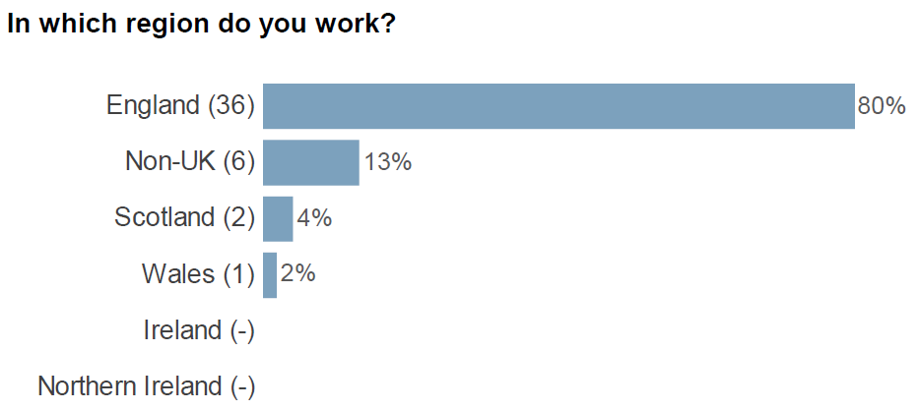
Figure 1 Work location of survey participants
There was a good spread of stakeholder groups participating in the survey, over 1 third of survey participant worked for digital health technologies or the MedTech Industry. Participants working for ‘other’ organisations included people working for the Academic health and science network and device regulators.
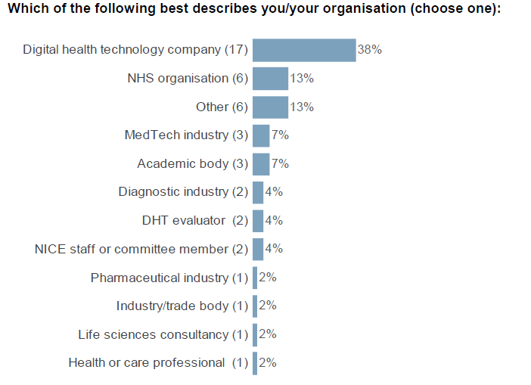
Figure 2 Organisations survey participants work for

Most participants completed the survey as representative of an organisation rather than individuals.
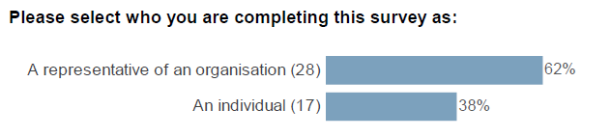
Figure 3: shows the role of the participants in completing the survey

Feedback on the ESF in general
There was an overall positive sentiment among survey participants toward the ESF. Most participants agreed or strongly agreed that the ESF had a clear purpose and that it was clear how the ESF fits into the wider digital health and innovation ecosystem (Figure 4). Survey participants also agreed or strongly agree that the classification of digital health technologies in the ESF made sense and that they could see how this aligns with the medical device regulation (Figure 4). Most survey participants agreed or strongly agreed that the grouping of the standards was appropriate. However, there was a wide spread of opinions on whether the ESF covers all factor relevant for the evaluation of digital health technologies (Figure 4).
In general survey participants felt that the ESF allowed detection of DHTs with positive patient and system impact without creating a barrier for innovation (Figure 5).
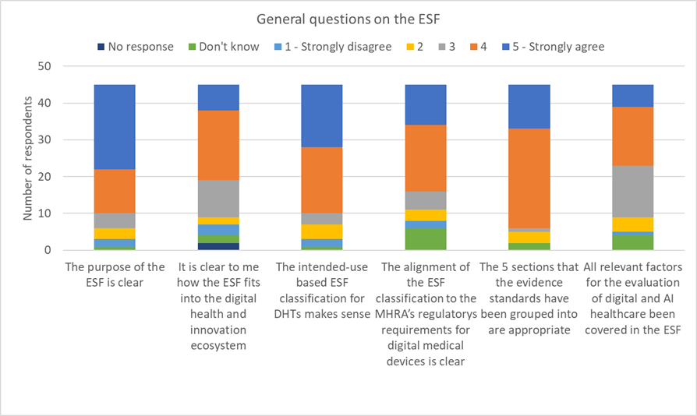
Figure 4 graph showing response to general question
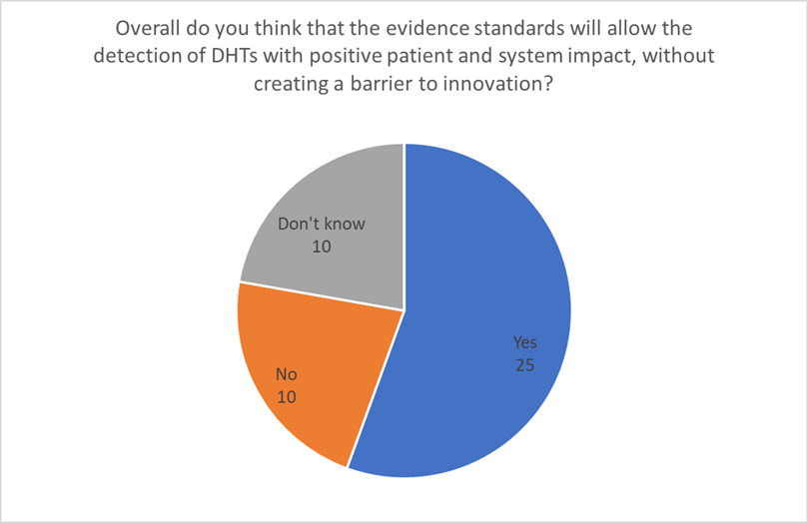
Figure 5 respondents thoughts on whether the ESF would allow the detection of DHTs with positive patient impact

Themes identified in survey responses
Over half of survey participants provided additional feedback on the ESF in general. There was a broad spectrum of opinions reaching from broad support to detailed suggestions of changes. Several overarching themes emerged from the comments. Some of these were specific to the ESF and we were able to address these directly in the ESF document and the user guide to increase usability of the ESF (Table 1). Other themes are concerned with the wider health and care ecosystem and how DHTs are used within it and are therefore outside of the remit of the ESF (Table 2).
Table 1 Themes with direct impact on the wording of the ESF
Themes
Place of ESF in the digital healthcare ecosystem
- More clarity how it sits with other frameworks, NICE guidance, regulations and standards
- Value of ESF to the system
Clarifications and definitions
- Clarity on tiers and standards
- Clarity on early deployment subset (for example types of DHTs eligible for early deployment; length of early deployment)
Place of patient safety in the ESF
- ESF should address patient safety alongside effectiveness

Table 2 Themes concerning the wider health and care ecosystem
Themes
Place of ESF in the digital healthcare ecosystem
- Building a map for journey of DHTs in health and care system
Impact of ESF
- Possible barrier to innovation
- Impact on small and medium enterprises (SME)
- Resource intense
- Evidence generation barrier
Use of ESF in practice
- Implementation and adoption of ESF by the NHS and the health care ecosystem
- Real-world use and barriers
- Training needs
- Needs for workforce upskilling
- Lack of awareness
- Acceptance and testing
- Link between ESF, adoption and reimbursement

Some responders also commented on individual standards.
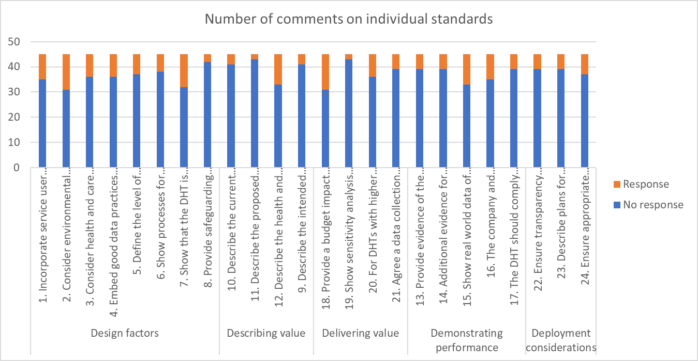

In response to these comments we:
- Rearranged standards, for example brought the standard on compliance with relevant safety and quality standards into the design factor group
- Combined standards that addressed similar topics for example long-term data collection
- Restructured and amended standards in:
- the demonstrating performance group
- the delivering value group.

Feedback on the early deployment subset
Responders were also asked about a subset of standards, called the early deployment (ED) subset. The ED subset is a minimal viable subset of standards meant for technologies early in their development and evidence generation. Most responders agreed that such an approach would meet the needs of early-stage DHTs (Figure 6). At the time of consultation, the ED subset included 15 standards out of the initial 24 standards. Generally, respondents agreed that these standards should be included in the early deployment subset (Figure 7).
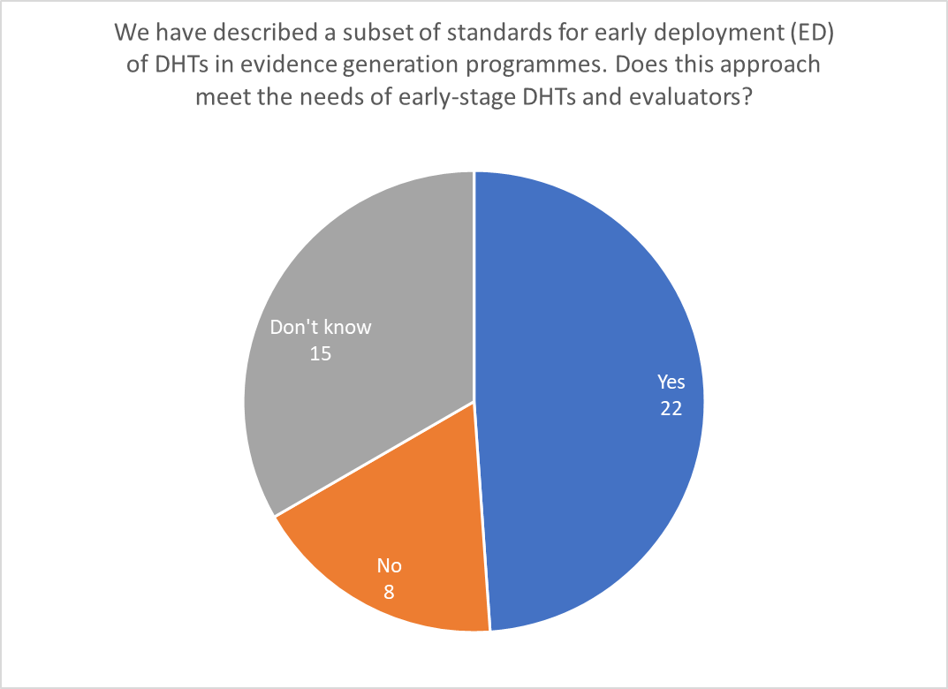
Figure 6 respondents thoughts on whether the early development subset of standards meets the needs of early stage DHTs

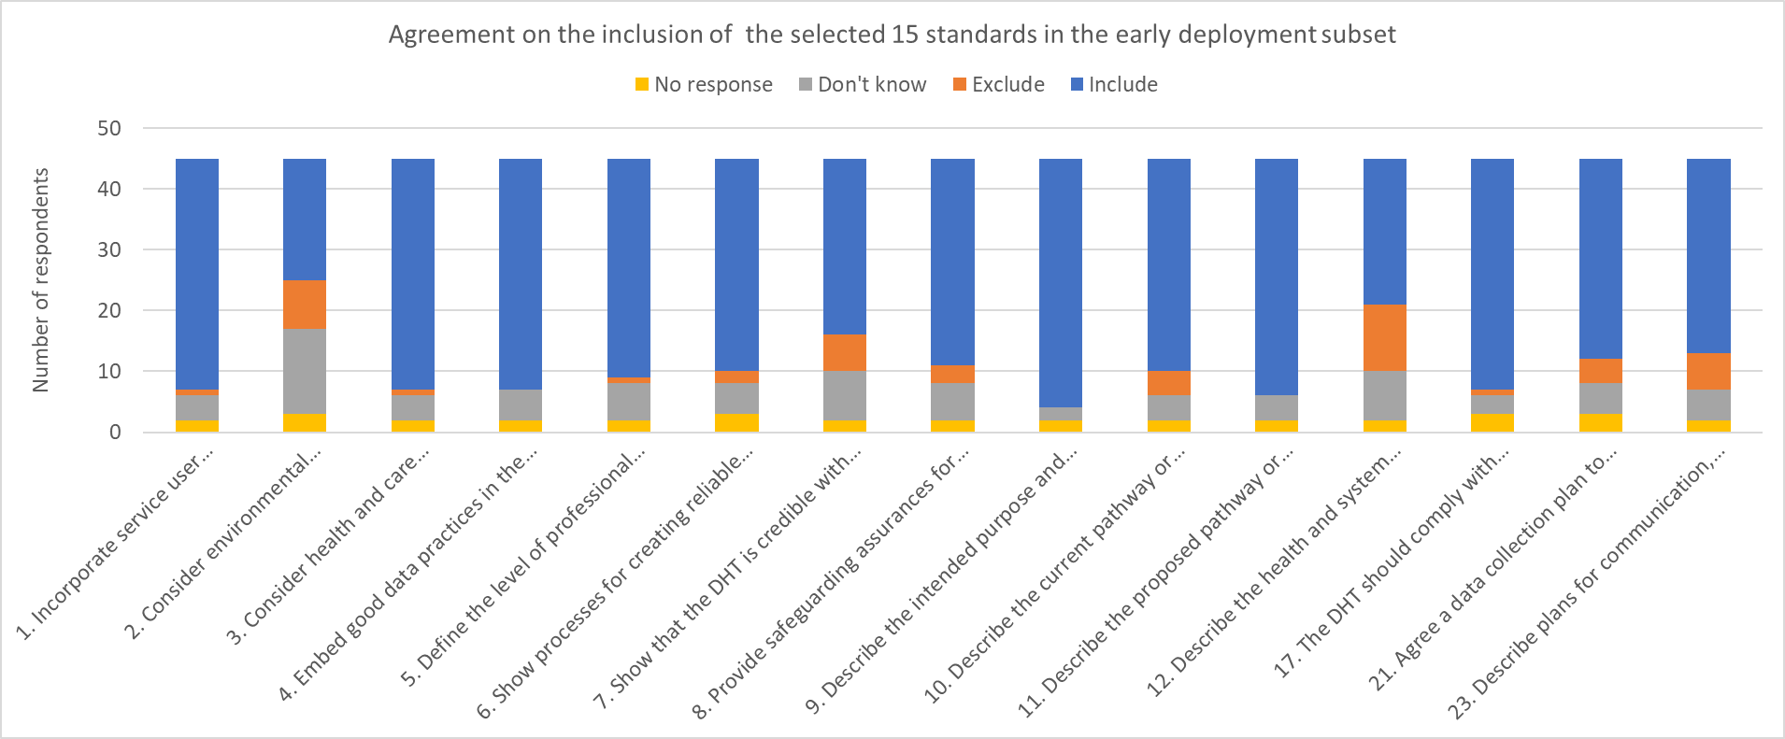
Figure 7 respondents agreement with the 15 standards that were included in the early deployment subset

Based on the consultation comments, we expanded the ED subset to 16 standards adding another standard from the deployment considerations. While survey participants found an early deployment subset useful, they were less clear about its applicability and the eligibility criteria for DHTs. We updated both the ESF document and the user guide to address these concerns.

People involved in the survey

NICE Office for digital health
Bernice Dillon (technical adviser)
Jessica Linville-Boud (project manager)
Ian Saunders (program manager)
Harriet Unsworth (technical adviser)
Verena Wolfram (technical adviser)

NICE Audience insights team
James Jagroo (senior audience insights manager)
Harry Topps (audience insights officer)

Thanks
NICE would like to thank all the stakeholders who spent their time working with us to update the ESF including the people and organisations who responded to the consultation. The following consultation respondents chose to identify themselves:
- ABHI
- AHSN network
- Alliance Medical
- Annalise.ai
- Baxter Healthcare Ltd
- Behold.AI Technologies Limited
- Big Health
- Biogen
- Boehringer-Ingelheim
- Brainomix
- Cibiltech
- Cognitant Group
- Gleamer AI
- Health Technology Wales
- Kheiron Medical Technologies
- Mendelian
- Mendelian Ltd
- MHRA
- National Pathology Imaging Co-operative (NPIC)
- NHS AI Lab
- NHS England - Digital Care Models, part of Transformation
- NICE (DAP)
- Orcha
- Oviva
- PinPoint Data Science Ltd
- Roche (Pharmaceuticals and Diagnostics - joint response)
- Skin Analytics
- Spirit Health
- Tangoscan Diagnostics PLC (Director, Consultant Radiologist)
- TechUK
- University of the Highlands and Islands
- York Health Economics Consortium

Appendix 1 – Survey

Evidence Standards Framework (ESF) feedback survey

Introduction

Please complete this short survey to share your feedback on NICE’s updated evidence standards framework for digital and AI healthcare technologies. The NICE Evidence standards framework (ESF) is a tool to allow local evaluators to assess digital health technologies (DHTs), please ensure you have reviewed the ESF before completing this survey. You can access the consultation documents here.
Each tier of evidence is linked to a set of evidence standards. There are 24 standards arranged in 5 groups. We have also described an ‘Early deployment’ (ED) subset of standards. This subset will be relevant for DHTs at an early stage in their evidence development process and which are being deployed within a defined evidence-generation programme.
The survey has 2 sections; a short section on the overarching concepts of the ESF, and then a second section where you can share views on each standard individually. The information collected will be used to further improve the ESF before its publication in June 2022.
You can save your responses at any point and return to complete these by selecting 'save' at the bottom of the page. You will be directed to a webpage specifying the link to resume completion of the form. You can bookmark this page or add your email address, so a resume link is emailed to you. Please note, if you choose the latter, your email address will not be stored.
The survey is open from 09:00 on 12th April to 5pm on 25th April 2022.
Data Protection

For more information about how your data will be processed please see our Privacy Notice
Please note we use a third party, SNAP, to administer this survey. For more information about how SNAP process personal data please see their Privacy Notice
Please select 'next' to continue
About you

In which region do you work?
q England
q Ireland
q Northern Ireland
q Scotland
q Wales
q Non-UK

Non-UK (please specify)
____________________________________________________________________________________________________________________

Which of the following best describes you/your organisation (choose one):
q Digital health technology company
q MedTech industry
q Diagnostic industry
q Pharmaceutical industry
q Industry/trade body
q Life sciences consultancy
q NHS organisation
q Patient organisation
q Academic body
q Professional body
q Health or care professional
q Health and care service user
q DHT evaluator
q Health or care commissioner
q NICE staff or committee member
q Other

Other (please specify)
____________________________________________________________________________________________________________________

Please select who you are completing this survey as:
q An individual
q A representative of an organisation

Please specify your organisation
____________________________________________________________________________________________________________________

Your views on the ESF

We are now going to ask you some questions about your overall views on the ESF, you will get the opportunity to comment on the individual standards in the next section.

Overall, how strongly do you agree with the following statements on a scale of 1-5 (where 1 is strongly disagree, and 5 is strongly agree)?
If you have any other comments or would like to explain any of your responses to Q1, please provide further detail here:
___________________________________________________________________________________________________________________________________________________________________________________________________________________________________________________________________________________________________________________________________________________________________________________________________________________________________________________________________________________________________________________________________________________________________________________________________

Overall, do you think that the evidence standards will allow the detection of DHTs with positive patient and system impact, without creating a barrier to innovation?
q Yes
q No
q Don't know

Please provide any additional comments below:
____________________________________________________________________________________________________________________________________________________________________________________________________________________________________________________________________________________________________________________________________________________________________________________________________________________________________________________________________________________________________________________________________________________________________________________________________

We have described a subset of standards for early deployment (ED) of DHTs in evidence generation programmes. Does this approach meet the needs of early-stage DHTs and evaluators?
q Yes
q No
q Don't know

Please provide any additional comments below:
____________________________________________________________________________________________________________________________________________________________________________________________________________________________________________________________________________________________________________________________________________________________________________________________________________________________________________________________________________________________________________________________________________________________________________________________________

Feedback on the individual standards

We are now going to ask you some questions about the standards within the ESF, you will have an opportunity to comment on specific elements of the framework.
Design considerations

If you would like to see the detail beneath each standard in this section, please select 'show' below:
q Show
q Hide

1. Incorporate service user acceptability in the design of the DHT

Describe how representatives from intended user groups were involved in the design, development or testing of the DHT. Depending on who is intended to operate the DHT, the intended users may include patient groups and service users, or health and care professionals. Describe how user satisfaction was appraised and provide any available data to show user satisfaction with the DHT. DHTs that have passed section D1 of the NHS digital technology assessment criteria may be considered to have already demonstrated compliance with the ESF design factor standard 1. IEC 62366-1 also covers usability engineering for medical devices.
2. Consider environmental sustainability

The NHS has set ambitions to have a net zero carbon footprint by 2040. Environmental sustainability should be factored into the design of the DHT. The company should provide a narrative description of any expected environmental sustainability benefits and negative impacts from using the DHT. This should focus on impacts on greenhouse gas emissions, in line with the NHS carbon footprint and carbon footprint plus.
3. Consider health and care inequalities and bias mitigation

Health inequalities considerations should be factored into the design of the DHT. Describe how this has been approached and how this has been included in the design of the DHT. Describe any specific positive impacts and of any efforts to reduce negative impacts on health inequalities.
If the DHT has a claim of addressing a health or care inequality, it should also show evidence that the DHT contributes to:
- Challenging health inequalities in the UK health and social care system or improving access to care among hard-to-reach populations.
- Promoting equality, eliminating unlawful discrimination, and fostering good relations between people with protected characteristics (as described in the Equalities Act 2010) and others.

For early deployment (ED) DHTs being used in evidence generation programmes, plans for collecting evidence to support the health inequalities claims should be provided.
NHS Digital’s guide on digital inclusion for health and social care provides information for companies and providers to understand digital inclusion and steps that can be taken to evaluate and support digital inclusion.
For data driven DHTs (including those with artificial intelligence), the company should describe any actions taken in the design of the DHT to mitigate against algorithmic bias that could lead to unequal impacts between different groups of service users or citizens.
4. Embed good data practices in the design of the DHT

When developing data driven DHTs, companies should follow the Medicines and Healthcare products Regulatory Agency (MHRA) guiding principles on good machine learning practice for medical device development. Any datasets used to train, validate, or develop the DHT should be of a high quality. One indicator of quality is that the following information can be provided by the company:
- Which datasets (title, source, version) were used for training and validating the DHT?
- The size of the training and validation datasets
- Why these datasets were collected, and by what means (manual input, through monitors, or other devices)
- Diversity (demographics, age, clinically relevant subgroups) in these datasets used and how this reflects the intended target population for the DHT
- Any synthetic training or validation data should be highlighted. Synthetic data should be supported by real data
- How any decision thresholds have been set and how these align to current best practice

5. Define the level of professional oversight

The company must clearly describe the level of professional oversight when the DHT is used in practice.
Professional oversight may include (among others):
- Expert review of each decision or output on a case-by-case basis
- Periodic overarching review of the trends in the decision outputs of the DHT, to ensure that the decisions are aligned to, or calibrated against, best practice
- Monitoring for occasions where the DHT’s decision output has been overridden by professionals.
The level of professional oversight should be proportionate to the level of risk associated with failure of the DHT to perform as expected. Higher levels of professional oversight may be needed when the consequences of the DHT’s failure are serious or critical.
6. Show processes for creating reliable health information

Be able to show that processes are in place to maintain any health information provided by the DHT:
- Valid (aligned to best available sources, such as NICE guidance, relevant professional organisations or recognised UK patient organisations, and appropriate for the target population)
- Accurate
- Reviewed and updated by relevant experts at defined intervals, such as every year
- Sufficiently comprehensive.

7. Show that the DHT is credible with UK professionals

Be able to show that the DHT has a plausible mode of action that is viewed as useful and relevant by professional experts or expert groups in the relevant field. This could include providing evidence to support key factors such as the choice of behaviour change techniques used in the DHT.
Show that relevant clinical or social care professionals working in the UK health and social care system have either been involved in designing, developing or testing the DHT, or given their support to the UK deployment of the DHT.
8. Provide safeguarding assurances for DHTs where users are considered to be in vulnerable groups, or where peer-to-peer interaction is enabled

Show that appropriate safeguarding measures are in place around peer support and other communication functions within the platform.
- Describe who has access to the platform and their roles within the platform.
- Describe why these people or groups are suitable and qualified to have access.
Describe any measures in place to ensure safety in peer-to-peer communication, for example, through user agreements or moderation.
How strongly do you agree that these standards are relevant to the purpose of the ESF on a scale of 1-5 (where 1 is strongly disagree, and 5 is strongly agree)?

If you would like to provide additional comments about any of the standards listed, please select them below: (select all that apply)
q 1. Incorporate service user acceptability in the design of the DHT
q 2. Consider environmental sustainability
q 3. Consider health and care inequalities and bias mitigation
q 4. Embed good practices in the design of the DHT
q 5. Define the level of professional oversight
q 6. Show processes for creating reliable health information
q 7. Show that the DHT is credible with UK professionals
q 8. Provide safeguarding assurances for DHTs where service users are considered to be in vulnerable groups, or where peer-peer interaction is enabled

1. Incorporate service user acceptability in the design of the DHT
Please provide any additional comments below:
_____________________________________________________________________________________________________________________________________________________________________________________________________________________________________________________________________________________________________________________________________________________________________________________________________________________________________________________

2. Consider environmental sustainability
Please provide any additional comments below:
_____________________________________________________________________________________________________________________________________________________________________________________________________________________________________________________________________________________________________________________________________________________________________________________________________________________________________________________

3. Consider health and care inequalities and bias mitigation
Please provide any additional comments below:
_____________________________________________________________________________________________________________________________________________________________________________________________________________________________________________________________________________________________________________________________________________________________________________________________________________________________________________________

4. Embed good data practices in the design of the DHT
Please provide any additional comments below:
_____________________________________________________________________________________________________________________________________________________________________________________________________________________________________________________________________________________________________________________________________________________________________________________________________________________________________________________

5. Define the level of professional oversight
Please provide any additional comments below:
_____________________________________________________________________________________________________________________________________________________________________________________________________________________________________________________________________________________________________________________________________________________________________________________________________________________________________________________

6. Show processes for creating reliable health information
Please provide any additional comments below:
___________________________________________________________________________________________________________________________________________________________________________________________________________________________________________________________________________________________________________________________________________________________________________________________________________________________________________________

7. Show that the DHT is credible with UK professionals
Please provide any additional comments below:
_____________________________________________________________________________________________________________________________________________________________________________________________________________________________________________________________________________________________________________________________________________________________________________________________________________________________________________________

8. Provide safeguarding assurances for DHTs where service users are considered to be in vulnerable groups, or where peer-peer interaction is enabled
Please provide any additional comments below:
_____________________________________________________________________________________________________________________________________________________________________________________________________________________________________________________________________________________________________________________________________________________________________________________________________________________________________________________

Feedback on the individual standards

Describing value

If you would like to see the detail beneath each standard in this section, please select 'show' below:
q Show
q Hide

9. Describe the intended purpose and target population

Describe the intended use, target population or user group, and claimed benefits for the DHT. Include any inclusion and exclusion criteria that apply. Describe the expected uptake profile of the DHT.
The target population can be defined by a particular health condition or position in the care pathway. Any important subgroups should also be identified.
The size of the intended target population should be calculated using appropriate and current national or local sources (for example, accurate epidemiological data of prevalence and incidence of the relevant health problem), or expert estimates if this is not available. Note that NICE’s resource impact assessment manual describes an approach to calculating population size.

The expected uptake profile describes the proportion of people within the target population who are expected to use the DHT, and their usage rates. This may be impacted by digital literacy within the intended user population, availability of necessary connectivity, and access to necessary hardware or devices.
Demonstrate that the expected uptake profile is:
- Calculated using uptake rates from pilot data or other usage data from the company
- Validated as an accurate representation of what is expected (including any variations by subgroup and over time) by showing agreement and support from relevant professionals in the UK health and social care system
- Mindful of subgroups with different expected uptake rates and how these may change over time.

10: Describe the current pathway or system process

Use national clinical guidelines, national guidance or academic literature and consultation with healthcare professionals and service users to map out the existing care pathway or system processes.

Use a comprehensive, detailed and stepwise approach (for example, using a flow chart).

The representation of current care or system processes should be comprehensive and should be checked and validated by relevant professionals in the UK health and social care system.

If there is no existing care pathway or system process, the impact of adopting the technology should be clearly specified using an approach that can be used as a basis for an economic evaluation.

If there is more than 1 existing care pathway or system process, describe each of them.

11: Describe the proposed pathway or system process using the DHT

Provide details of how the proposed care pathway or system process using the DHT will be different to the current pathway or system process, including:
- Whether using the DHT would replace an existing technology or step in current care, or whether it would be in addition to current care
- Any changes that would need to be made to infrastructure, service provision and workforce, compared with current care or process
- Whether the proposed pathway crosses between existing care boundaries, such as between primary and secondary care
- Changes needed to implement, operate and maintain the proposed pathway or process using the DHT
- Any costs associated with training and education for health and care professionals or end users, in order to effectively implement and use the DHT
- Any influential contextual issues that may act as barriers for enablers to implementation.

12. Describe health and system impacts and associated cost and resource impacts compared with standard or current care

To assess impact of the DHT, we need to understand and compare the health and system benefits from the current pathway or process and the proposed pathway or process using the DHT:

- Describe the health benefits and other outcomes (such as system efficiency, care outcomes, or structural and procedural effects) associated with current practice. If possible, quantify the uncertainty associated with these figures (for example, with confidence intervals or probability distribution).
- Describe the health benefits and other outcomes (such as system efficiency, care outcomes, or structural and procedural effects) associated with using the DHT. If possible, quantify the uncertainty associated with these figures (for example, with confidence intervals or probability distribution).

Structural and procedural effects could include access to care, health literacy, adherence to care plans, or coordination of care.

Also, it is important to understand whether there are any expected additional costs or cost savings as well as resource impact from the DHT compared with current practice:

- Describe the costs and resource use associated with current practice. If possible, quantify the uncertainty associated with these figures (for example, with confidence intervals or probability distribution).
- Describe the expected costs and resource use associated with using the DHT. If possible, quantify the uncertainty associated with these figures (for example, with confidence intervals or probability distribution).

The sources for this information should:

- Be from the most robust evidence available. This could be from clinical studies on the DHT and on current care options (if available), real world evidence, observational studies, or from expert opinion.
- Be the same as referred to in the performance and effectiveness standards (if these apply).

Evidence synthesis can be used if there are several studies, in which case a sensitivity analysis should be shown.

Estimates should have minimal bias and all uncertainties should be accurately characterised.

How strongly do you agree that these standards are relevant to the purpose of the ESF on a scale of 1-5 (where 1 is strongly disagree, and 5 is strongly agree)?

If you would like to provide additional comments about any of the standards listed, please select them below: (select all that apply)
q 9. Describe the intended purpose and target population
q 10. Describe the current pathway or system process
q 11. Describe the proposed pathway or system process using the DHT
q 12. Describe the health and system impacts compared with standard or current care

9. Describe the intended purpose and target population
Please provide any additional comments below:
____________________________________________________________________________________________________________________________________________________________________________________________________________________________________________________________________________________________________________________________________________________________

10. Describe the current pathway or system process
Please provide any additional comments below:
____________________________________________________________________________________________________________________________________________________________________________________________________________________________________________________________________________________________________________________________________________________________

11. Describe the proposed pathway or system process using the DHT
Please provide any additional comments below:
____________________________________________________________________________________________________________________________________________________________________________________________________________________________________________________________________________________________________________________________________________________________

12. Describe the health and system impacts compared with standard or current care
Please provide any additional comments below:
____________________________________________________________________________________________________________________________________________________________________________________________________________________________________________________________________________________________________________________________________________________________

Feedback on the individual standards

Demonstrating performance

If you would like to see the detail beneath each standard in this section, please select 'show' below:
q Show
q Hide

13. Provide evidence of the DHT’s performance to support its claimed benefits

For tier C DHTs, evidence for effectiveness must be shown.

The evidence should show that using the DHT impacts on clinical management of the relevant condition, in a setting relevant to the UK health and social care system. Outcomes relevant to the intended purpose should be captured.

Choice of study design should be guided by the intended purpose of the DHT, and comparative studies are generally more informative than non-comparative studies. Some general guidance on assessing the quality of evidence includes:

- The results of studies done in a setting that is similar to the UK health and care system (such as where the care pathway is similar, patients have similar care options, and/or similar kinds of staff are involved in care) are easier generalisable to the UK system than those of studies done in settings that are very different to the UK system.
- Prospective studies are often considered to be more valuable than retrospective studies as they can be designed to capture the most relevant outcomes.
- Studies that are published in peer-reviewed journals have usually had some independent assessment of their quality before publication.
- There are different ways to appraise the quality of research studies. Appendix H of Developing NICE guidelines: the manual provides a comprehensive list of checklists that can be used to assess risk of bias or quality of different study types.

NICE is developing a framework on best practice in developing real world evidence, which is expected to be published in June 2022.

Effectiveness of DHTs that inform clinical management

Evidence to support the claimed benefits of the DHT can include published or unpublished studies on the DHT and can include real-world evaluations of its clinical utility. This could include a single arm study done to support regulatory requirements.

Effectiveness of DHTs that drive clinical management

The evidence should include 1 or more high-quality studies to support the claimed benefits, done in a setting relevant to the UK health and social care system. This could include:

- Interventional studies or
- Prospective observational studies (including real-world evidence), test accuracy studies, using an appropriate reference standard, or a concordance study (to show agreement with currently used tests).
- Retrospective studies can be useful in addition to evidence from prospective studies.

Effectiveness of DHTs that treat a specific condition

1 or more high-quality interventional studies (experimental or quasi-experimental design) to support the claimed benefits of the DHT, done in a setting relevant to the UK health and social care system and showing improvements in relevant outcomes, such as:

- Clinically relevant outcomes
- Patient-relevant outcomes

The choice of study design should be appropriate for the intended purpose of the DHT. Randomised controlled trials would be preferrable where this study design is appropriate.

The comparator should be a care option that reflects the current NHS care pathway, such as a commonly used active intervention.

User satisfaction and engagement measures may also be useful.

Performance of DHTs that diagnose a specific condition:

1 or more high-quality test accuracy studies, using an appropriate reference standard, or a concordance study to show agreement with current practice.

If the test provided by the diagnostic DHT is new to the clinical pathway and no other similar tests exist for comparison, show a high-quality clinical study showing clinical consequences of the diagnosis.

14. Additional evidence for critical conditions or functions

If the DHT is intended to be used for situations or conditions where accurate and/or timely diagnosis or treatment action is vital to avoid death, long-term disability or other serious deterioration of health, more evidence or better-quality evidence is required. For DHTs intended to drive clinical management, this would mean an interventional study would be needed.

Additional evidence could include any well-designed studies or data in addition to those required for the 4 different functional groups in tier C.

This could be real-world data, prospective or retrospective studies that can serve to reduce uncertainty about the performance of the DHT.

15. Show real-world evidence that the claimed benefits can be realised in practice

Evidence to show that the DHT has been successfully piloted in the UK health and social care system, showing that it is relevant to:

- Current service provision in the UK (for tier A DHTs) or
- Current best practice in the UK (for tier B and tier C DHTs).

This may include a statement from pilot site(s) to confirm that during pilot testing, the DHT:

- Was acceptable to users
- Performed its intended purpose to the expected level
- Successfully integrated into current service provision or current best practice
- Caused no negative impacts on service users or services
- Showed improvements in outcomes (costs saved, efficiencies achieved, health and care improvements)
- Was used in line with expectation (who, how, for how long).

For DHTs that are expected to have high costs or service impact (such as requiring significant service redesign), then higher levels of evidence may help to reduce uncertainty. This could include larger-scale studies or longer-term outcomes.

For DHTs whose performance may be affected by local deployment factors (such as DHTs using artificial intelligence), this may include deploying the DHT to run offline or evaluating it ‘in silent mode’.

Silent mode evaluations allow the DHT’s performance on local data inputs to be observed (but not used in care decisions), before the DHT is integrated into clinical or care pathways. This can show whether the DHT’s performance reaches the expected levels using input data generated in the local environment.

16. The company and evaluator should agree a plan for measuring changes in the DHT’s performance over time

For DHTs whose performance is expected to change over time (such as DHTs that use artificial intelligence or machine-learning algorithms, DHTs whose algorithm is updated in subsequent version), the company and evaluator should agree on post-deployment reporting of changes in performance. This may include:

- Future plans for updating the DHT, including how regularly the algorithms are expected to retrain
- The sources of retraining data, and how the quality of this data will be assessed
- Processes in place for measuring performance over time, to detect any impacts of planned changes or environmental factors that may impact performance
- Processes in place to detect decreasing performance in certain groups of people over time
- Whether there is an independent overview process for reviewing changes in performance
- An agreement on how and when changes in performance should be reported to commissioners and users (patients, carers, health and care professionals).

17. The DHT should comply with relevant safety and quality standards

Companies should demonstrate that all safety and quality standards relevant to their DHT have been met. Examples of standards that may apply to different DHTs include:

- UKCA marking under the UK medical device regulations MHRA provides guidance on medical devices: software applications [apps]).
- Regulation by the Care Quality Commission for digital health services.
- Following regulations outlined in the UK General Data Protection Regulation (GDPR).
- Registration with the Information Commissioner’s Office as a data processor.
- For use in the NHS, DHTs may need to show compliance with the Digital Technology Assessment Criteria (DTAC), which includes DCB0129 and DCB0160, NHS Digital’s data security and protection toolkit and interoperability toolkit, and NHS service standard.
- Local information governance requirements including data protection impact assessments.
- ISO 13485 for quality management systems, ISO 11073 for personal health data
- IEC 82304-1 – a non-mandated standard. Compliance with this standard demonstrates safety and security for health software.

How strongly do you agree that these standards are relevant to the purpose of the ESF on a scale of 1-5 (where 1 is strongly disagree, and 5 is strongly agree)?

If you would like to provide additional comments about any of the standards listed please select them below: (select all that apply)
q 13. Provide evidence of the DHT's performance to support its claimed benefits
q 14. Additional evidence for critical conditions or functions
q 15. Show real world data of performance in practice
q 16. The company and evaluator should agree a plan for measuring changes in the DHT's performance over time
q 17. The DHT should comply with relevant safety and quality standards

13. Provide evidence of the DHT's performance to support its claimed benefits
Please provide any additional comments below:
____________________________________________________________________________________________________________________________________________________________________________________________________________________________________________________________________________________________________________________________________________________________

14. Additional evidence for critical conditions or functions
Please provide any additional comments below:
____________________________________________________________________________________________________________________________________________________________________________________________________________________________________________________________________________________________________________________________________________________________

15. Show real world data of performance in practice
Please provide any additional comments below:
____________________________________________________________________________________________________________________________________________________________________________________________________________________________________________________________________________________________________________________________________________________________

16. The company and evaluator should agree a plan for measuring changes in the DHT's performance over time
Please provide any additional comments below:
____________________________________________________________________________________________________________________________________________________________________________________________________________________________________________________________________________________________________________________________________________________________

17. The DHT should comply with relevant safety and quality standards
Please provide any additional comments below:
____________________________________________________________________________________________________________________________________________________________________________________________________________________________________________________________________________________________________________________________________________________________

Feedback on the individual standards

Delivering value

If you would like to see the detail beneath each standard in this section please select 'show' below:
q Show
q Hide

18. Provide a budget impact analysis

Provide a budget impact analysis relevant to the setting the DHT is used, which should include:
- Size of target population
- All direct costs associated with the technology and implementing the technology, including cost of the technology (purchasing, updating, maintenance), costs of staffing and training, costs of supportive IT infrastructure needed to implement the technology
- All direct costs associated with the comparator
- Relevant indirect costs associated with the technology and the comparator, reference test or current practice
- Uptake estimates

Estimates of resource use should include:

- Length of hospital or care home stay
- Number of hospitalisations
- Outpatient or primary care consultations
- Changes in infrastructure, use and maintenance
Show that the costs used are relevant to the UK health and care system and they should relate to NHS and personal social services resources. Suitable sources include:
- NHS reference costs
- National tariff

Show that the estimates for resource use are based on clinical practice, which can be based on data from:

- A clinical study
- Real-world data including from pilot studies
- Information obtained from relevant clinical or social care professionals
- Other appropriate sources.

State the source of the data for the cost and resource estimates. State whether the estimates are recognised as accurate and comprehensive by a relevant health and social care professional. Include any expected variations for different groups of service users.

19. Show sensitivity analysis to explore uncertainties

Explore the uncertainty of the estimate obtained from the budget impact analysis by varying the assumptions used (for example, using best- and worst-case values for target population size, resource use).

20. For DHTs with higher financial risk, provide a cost–comparison or cost–utility analysis

We define a DHT with higher financial risk as: where the costs of commissioning, purchasing or implementing the DHT are deemed to be substantial within the context of local budgets and system priorities. This will vary between different commissioning organisations, and contributing factors may include:

- Coverage of commissioning of the technology, for example whether it’s commissioned at 1 site, multiple sites or nationwide
- The extent of changes needed within an organisation to use the DHT; this could include changes to IT systems, staffing or care pathways
- The extent of implementation costs needed to use the DHT

Cost comparison analysis is preferred if the DHT provides similar or greater health and care benefits at similar or lower costs

Cost utility analysis is preferred if the DHT:

- Provides similar or greater health or care benefits at higher cost
- Provides marginally lower health benefits for significantly lower costs.

For all analyses, explore the uncertainty of the obtained estimate by using sensitivity and scenario analyses.

If a cost–utility analysis is being done, an appropriate standard measure should be used for utility data (such as EQ-5D). Describe why this measure was chosen. The NICE health technology evaluations: the manual gives further guidance on how these analyses can be done.

21. Agree a data collection plan to show value

The company and the evaluator should reach an agreement for ongoing data collection to report:

- Ongoing usage of the DHT in the target population in line with the expected usage profile (to be agreed at commissioning)
- Anonymised, aggregate data to show service user outcomes, if this is collected by the DHT
- Include analysis to show cost per use or per service user of the DHT, based on the data collected
- Whether any changes (such as algorithmic changes, upgrades or operational environment or updates) have occurred.

How strongly do you agree that these standards are relevant to the purpose of the ESF on a scale of 1-5 (where 1 is strongly disagree, and 5 is strongly agree)?

If you would like to provide additional comments about any of the standards listed please select them below: (select all that apply)
q 18. Provide a budget impact analysis
q 19. Show sensitivity analysis to explore uncertainties
q 20. For DHTs with higher financial risk: provide a cost-comparison or cost-utility analysis
q 21. Agree a data collection plan to show value

18. Provide a budget impact analysis
Please provide any additional comments below:
____________________________________________________________________________________________________________________________________________________________________________________________________________________________________________________________________________________________________________________________________________________________

19. Show sensitivity analysis to explore uncertainties
Please provide any additional comments below:
____________________________________________________________________________________________________________________________________________________________________________________________________________________________________________________________________________________________________________________________________________________________

20. For DHTs with higher financial risk: provide a cost-comparison or cost-utility analysis
Please provide any additional comments below:
____________________________________________________________________________________________________________________________________________________________________________________________________________________________________________________________________________________________________________________________________________________________

21. Agree a data collection plan to show value
Please provide any additional comments below:
____________________________________________________________________________________________________________________________________________________________________________________________________________________________________________________________________________________________________________________________________________________________

Feedback on the individual standards

Deployment considerations

If you would like to see the detail beneath each standard in this section please select 'show' below:
q Show
q Hide

22. Ensure transparency about requirements for deployment

The company should provide clear descriptions of the data used in deployment. This should include:

- A full description of the input data for the DHT
- Quantifying the level of tolerance that the DHT has for incomplete data (such as inputs that are missing or of insufficient quality), and how outlier data is handled
- A data flow map for deployment of the DHT to allow efficient deployment
- Data requirements for the DHT, such as specific data formats, completeness or quality
- The minimum infrastructure requirements for deploying the DHT.

23. Describe plans for communication, consent and training processes in place to allow the DHT to be understood by end users

The company must ensure that appropriate communication strategies are in place for service users and health and care professionals, to describe the outputs, key features, benefits and limitations of the DHT. This may include providing a model card for end users (such as health and care professionals or patients) to allow them to understand when and whether to use the DHT in a person’s care.

If service user consent is needed, the company should describe this process. The company should describe the outputs for the DHT. Examples could include:

- Risk scores
- Probabilities of different diagnoses
- Recommendations for other tests.

The company should describe their planned approach for training end-users of the DHT to allow the benefits of the DHT to be realised in practice.

24. Ensure appropriate scalability

The company should ensure that load testing has been done, to show that the DHT can perform to the scale needed (for example, having servers that can scale to manage the expected number of service users).

Describe the process for load testing and how this relates to the expected uptake for the DHT.

How strongly do you agree that these standards are relevant to the purpose of the ESF on a scale of 1-5 (where 1 is strongly disagree, and 5 is strongly agree)?

If you would like to provide additional comments about any of the standards listed please select them below: (select all that apply)
q 22. Ensure transparency about requirements for deployment
q 23. Describe plans for communication, consent and training processes in place to allow the DHT to be understood by end users
q 24. Ensure appropriate scalability

22. Ensure transparency about requirements for deployment
Please provide any additional comments below:
____________________________________________________________________________________________________________________________________________________________________________________________________________________________________________________________________________________________________________________________________________________________

23. Describe plans for communication, consent and training processes in place to allow the DHT to be understood by end users
Please provide any additional comments below:
____________________________________________________________________________________________________________________________________________________________________________________________________________________________________________________________________________________________________________________________________________________________

24. Ensure appropriate scalability
Please provide any additional comments below:
____________________________________________________________________________________________________________________________________________________________________________________________________________________________________________________________________________________________________________________________________________________________

Early Deployment standards

In this final section we ask you to provide your opinion relating to the Early Deployment standards, a subset of the main set of standards.

Please select which of the following standards you think should be included for early deployment technologies

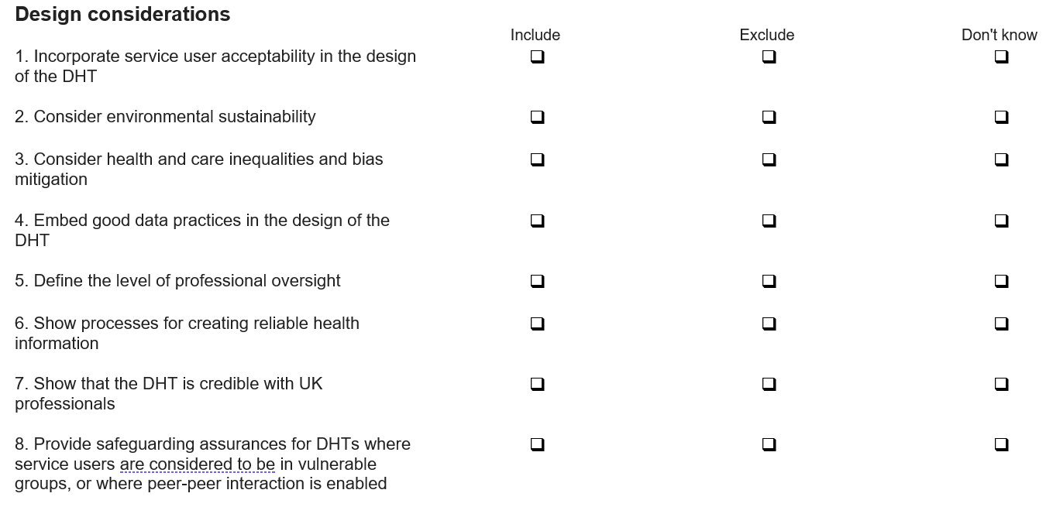

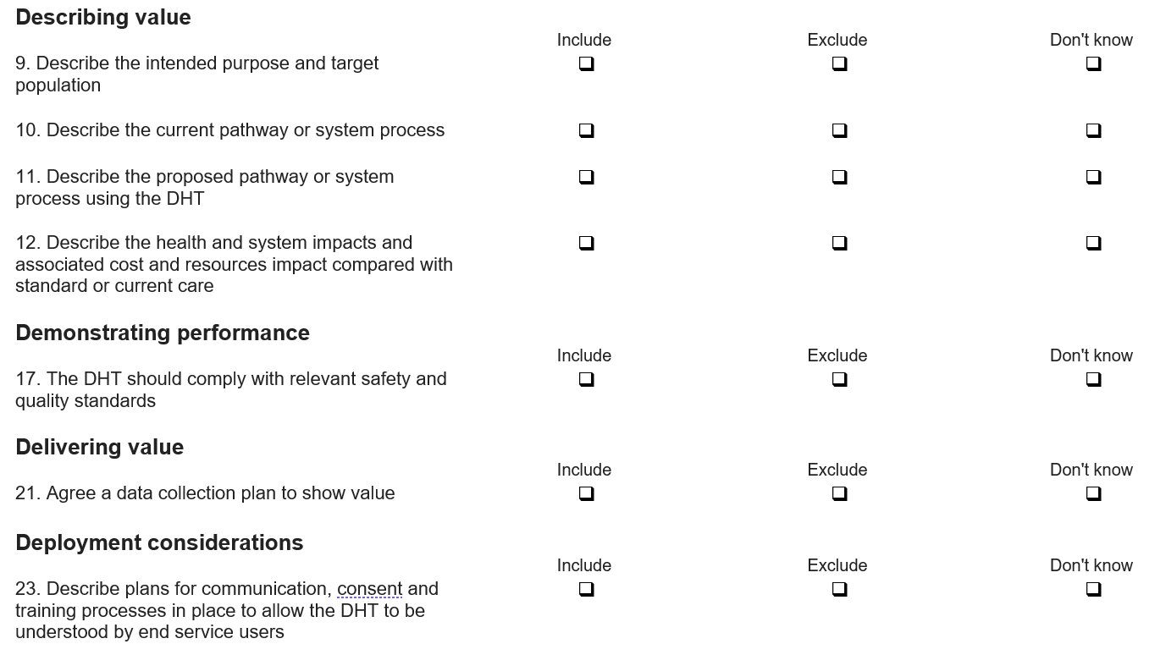

Please provide any further comments relating to the Early Deployment standards below:
____________________________________________________________________________________________________________________________________________________________________________________________________________________________________________________________________________________________________________________________________________________________

Thank you for completing the survey

Once you press 'Submit' your responses will be sent to the team and you will not be able to make any further changes

Please click 'Back' or 'Submit'

