Methods proposals second consultation response

NICE task and finish group report

January 2022

Contents
Methods proposals second consultation response 1
NICE task and finish group report 1
Contents 2
Tables and Figures 3
1 Background and objectives 4
2 Project overview 4
3 Results 5
3.1 General overview 5
3.2 Valuing the benefits of health technologies 7
3.2.1 Severity of disease 7
3.2.2 Consideration of uncertainty 9
3.2.3 Health inequalities 10
3.2.4 Highly specialised technologies 11
3.2.5 Discounting 12
3.3 Understanding and improving the evidence base 14
3.3.1 Guidance on the use of real-world evidence 14
3.3.2 Costs 15
3.3.3 Understanding and presenting uncertainty 17
3.4 Structured decision-making 18
3.4.1 Net benefit approaches 18
3.4.2 Subgroups 18
3.4.3 Technologies which are not cost effective at low or £0 cost 18
3.5 Challenging technologies, conditions and evaluations 19
3.6 Aligning methods across programmes 20
3.7 Other comments 21
3.7.1 Health-related quality of life 21
3.7.2 Surrogate outcomes 22
3.7.3 Qualitative and quantitative data 22
3.8 Equalities issues 23
3.9 Impact 23
3.10 Further research 24
3.11 Limitations 25
4 Conclusion 25
5 Appendices 26
5.1 Quantitative results 26
5.2 Comments on the draft manual 32

Tables and Figures
Table 1. Consultation responses: breakdown of stakeholders 5

Figure 1. Overall agreement with proposals 25
Figure 2. Breakdown of levels of agreement with the proposal for a disease severity modifier by stakeholder group 25
Figure 3. Breakdown of choices between severity modifier option 1 and option 2 by stakeholder group 26
Figure 4. Breakdown of level of agreement with the proposal for consideration of uncertainty within decision making 26
Figure 5. Breakdown of level of agreement with the proposal for health inequalities 27
Figure 6. Breakdown of level of agreement with the proposal for aligning methods across programmes 27
Figure 7. Breakdown of level of agreement with the proposal for discounting 28
Figure 8. Breakdown of level of agreement with the proposal for implementing the proposed cases for change for sourcing, synthesising and presenting evidence, and considering health-related quality of life 28

1 Background and objectives
The review of NICE’s methods, processes and topic selection for health technology evaluation programmes aims to optimise them to support the ambition of the NHS to provide high-quality care that offers good value to patients and to the NHS.
The review and subsequent consultation was divided into 3 key aspects: one focussing on topic selection, one on processes in general and one on methods.
The consultation paper Review of methods for health technology evaluation programmes: proposals for change was published on 19 August 2021, along with a draft manual for NICE health technology evaluations. Stakeholders were given the opportunity to comment on these documents using an online form. This form included quantitative questions to assess agreement with key proposals on a Likert scale, from ‘strongly agree’ to ‘strongly disagree’. It also included free text boxes in which respondents could share written comments.
This report reviews and summarises the 157 responses received on the methods proposals. This includes stakeholder agreement, concerns, and any differences in opinion between stakeholder groups. The report aims to indicate where stakeholder feedback suggests that changes to the draft manual, or further consideration, may be required.

2 Project overview
The consultation responses were reviewed in full by members of the NICE technical team. Responses to the quantitative questions were used to identify where there was greatest agreement or disagreement with the proposals. Greatest disagreement was apparent in relation to the following proposals: discounting (see Section 3.2.5), severity of disease (see Section 3.2.1) and costs (see Section 3.3.2). These proposals were prioritised during the analysis of the written comments to ensure that all key themes were identified. The quantitative results are presented in Appendix 5.1.
The strength of reasoning behind the arguments in the qualitative responses was taken into account during the analysis. A summary of the qualitative and quantitative analysis was presented to the Working Group to obtain feedback and guide the development of the report.

3 Results

3.1 General overview
Responses from 157 stakeholders were received, including organisations and individuals ranging from the life sciences industry (about 44% of the responses, most of which were from pharmaceutical companies), patient organisations (31%), the NHS, academia and professional organisations (11%), and committee members and NICE staff (4%). See Table 1.
Table 1. Consultation responses: breakdown of stakeholders
Stakeholder | Percentage*
Industry | 44% (pharmaceutical industry 27%, device industry 6%, diagnostic industry 3%, industry body 6%, life sciences consultancy, 6%)
Patient organisations | 31%
NHS, academic and professional organisations | 11% (NHS organisations 1%, academia 6%, professional organisations 4%)
Committee members and NICE staff | 4%
Members of the public or other stakeholders | 18%
* Respondents could select more than 1 option
In general, stakeholders broadly agreed with the principles behind most of the proposals. They particularly welcomed the proposals around accepting greater uncertainty, improving the guidance on real-world evidence and using a broader evidence base, and considering health inequalities. However, many stakeholders, particularly those from industry, considered that the proposals lacked ambition. Stakeholders broadly disagreed with retaining the current reference discount rate of 3.5%, as they argued it would not be aligned with the HM Treasury Green Book and is likely to disadvantage advanced therapy medicinal products (ATMPs). Stakeholders also had some methodological concerns with the proposed severity modifier. They disagreed with the opportunity cost neutral approach to its design. They also considered that the severity cut-offs were too high and the maximum quality-adjusted life year (QALY) weighting of 1.7 was too low.
Many stakeholders felt that greater clarity or guidance is needed for some proposals. These include:
- how QALY shortfall will be calculated for the severity modifier
- when and how greater uncertainty will be considered in decision making
- the types of evidence included under real-world evidence (RWE) and the specific situations when this would be accepted
- how surrogate outcomes and other types of evidence (for example, qualitative evidence) will be considered in decision making
- timelines for next steps regarding discounting and the research into societal preferences regarding disease severity
- the health inequalities modifier.
Stakeholders considered that there remains a need for a modifier for rare disease. They felt that the perceived ‘gap’ between the technology appraisals (TA) and highly specialised technologies (HST) processes remains, and that the proposals do not go far enough to address the data collection challenges in rare disease.
Stakeholders noted the importance of committee training to ensure consistency of decision making in applying the updated methods. They stated that adherence to the new methods should be monitored over time. Stakeholders considered that committees are risk-averse and that a culture change may be needed in accepting RWE and surrogate outcomes, as well as greater uncertainty.
Further engagement with stakeholders was stated to be important. For example, in the development of the visualisation framework and in relation to the health inequalities modifier.

3.2 Valuing the benefits of health technologies

3.2.1 Severity of disease
Stakeholders broadly supported the concept of a severity modifier. This was because they considered it to be fairer than the current end of life criteria as it would apply to more disease areas. They also broadly agreed with defining disease severity using both absolute shortfall and proportional shortfall. Stakeholders mentioned that committee training would be important for the modifier to be implemented accurately and consistently.
However, stakeholders stated that the proposed severity cut-offs were too high. Stakeholders considered that they provide an extreme definition of severe disease, meaning that few technologies will qualify for the most severe category and the highest QALY weighting. They stated that most technologies will likely only achieve the lower QALY weighting, which would not be high enough to have a significant impact on decision making. Some stakeholders noted that in the Netherlands a proportional shortfall of 0.7 is used to define the most severe disease. This is compared with 0.95 for the highest severity tier in the NICE proposal paper. They suggested that NICE could take a proportional shortfall of 0.7 as an interim position to define severe disease while further research into societal preferences is undertaken.
Two QALY weight approaches were proposed in NICE’s consultation paper. Option 1 had a medium severity weight of 1.2 and a highest severity weight of 1.7. Option 2 had a medium severity weight of 1.25 and a highest severity weight of 1.5. Stakeholders felt that the QALY weights for both proposed options were too low, particularly the maximum proposed weight for either option of 1.7. Stakeholders from industry and patient organisations tended to prefer Option 1 over Option 2 as it had a higher maximum weight, but generally considered both options inadequate. Stakeholders felt that the QALY weights would be insufficient to bridge the perceived ‘gap’ between TA and HST, thereby discouraging innovation. It was noted that in NICE’s 2014 consultation on the Value Based Assessment of Health Technologies, most respondents said that a maximum QALY weight of 2.5 (applied to a threshold of £20,000 per QALY) was not reasonable.
Stakeholders suggested that NICE should consider implementing a scaled approach to the modifier, or an additional tier. They had some concern that technologies that would be recommended based on the end of life modifier would not be recommended based on the proposed severity modifier, negatively impacting patient access.
Stakeholders also raised concerns about the potential double counting of QALYs, and the impact of the severity modifier on equalities, particularly age. It was noted that the proposed severity modifier may discriminate against the elderly, because few diseases affecting people aged 75 or older would qualify for it.
Stakeholders requested greater clarity be provided on certain aspects of the proposal, including:
- How absolute and proportional shortfall are to be calculated. The provision of a tool to calculate these was suggested.
- Whether QALY shortfall would need to be calculated for subgroups.
- What should be done if QALY shortfall cannot be calculated, particularly for rare diseases. Stakeholders noted that the evidence requirements to demonstrate disease severity are likely to be harder to meet for rare disease.
- What approach should be taken in situations where there are multiple standards of care. Stakeholders suggested that potentially a weighted comparator could be used.
Stakeholders from industry in particular were opposed to the proposed severity modifier not being applied similarly for the Medical Technologies Evaluation Programme (MTEP) or Diagnostics Assessment Programme (DAP) (see Section 3.6).
There was almost unanimous disagreement amongst stakeholders from industry with the opportunity cost-neutral approach taken to designing the severity modifier. This was because, they argued, the 2019 Voluntary Scheme for Branded Medicines Pricing and Access (2019 Voluntary Scheme) limits NHS spending on branded medicines, so there is no need for an approach that they considered to be budget-driven. Stakeholders were concerned that this may reduce patient access to innovative technologies.
Stakeholders also considered that the retrospective review of absolute and proportional QALY shortfall described in the proposal paper should have been done from the start of when the end-of-life modifier was introduced, rather than an apparently arbitrary timepoint.

3.2.2 Consideration of uncertainty
Stakeholders supported the concept of committees accepting a higher degree of uncertainty in situations in which evidence generation is particularly difficult. However, they had some concern that the proposals do not go far enough in outlining the circumstances in which uncertainty will be accepted, and how this will be applied in practice. Stakeholders felt that the updated manual should explicitly state the circumstances in which greater uncertainty will be accepted. For example, they were unclear how ‘innovative and complex technologies’ would be defined, and which system partner designations of rarity or innovation will be accepted.
Stakeholders suggested incorporating the degree of unmet need as a criterion for defining when greater uncertainty can be accepted, with patient groups noting that patient input should be factored into this. Patient groups also considered that the proposals do not go far enough to address data collection challenges in rare diseases.
Consistency in implementation across committees was a concern for stakeholders. They requested that committee training and governance measures be implemented to ensure consistency in decision making. They also felt that guidance documents should clearly detail the way in which uncertainty has been factored into decision making, and the impact of the proposal on decision making should be monitored.
Stakeholders generally disagreed with the proposal that uncertainty should not overlap with other modifiers to create ‘double counting’.
Some specific concerns were raised by stakeholders for diagnostics in relation to this proposal. They felt that committee members may be less accepting of uncertainty if they are unfamiliar with the technology. This was considered likely to be more common for diagnostics. The following specific considerations were noted by one stakeholder with regard to uncertainty in diagnostics evaluations: imprecision in estimating diagnostic accuracy; the influence of prevalence, skillset or local infrastructure on accuracy; imperfect reference standards; and the imperfect application of novel care pathways when using observational data.

3.2.3 Health inequalities
There was generally a positive consensus amongst stakeholders that NICE is addressing health inequalities. However, stakeholders felt that there was a lack of detail in the proposals that made them challenging to comment on. For example, they noted that it is unclear how health inequalities are being defined and how a modifier is expected to work in practice. Stakeholders acknowledged that research into this area needs to be conducted thoroughly and urged for NICE to not rush this research. However, stakeholders are keen to receive an update as soon as possible on when the proposed changes would be implemented and what they will involve. They see this as a matter of urgency to prevent further health inequalities.
One committee member disagreed with the concept of a health inequalities modifier, as they considered that it is not the role of NICE to introduce such a modifier independently. This would undermine the credibility of the process, and it may be better to use a flexible, case-by-case approach rather than a more formal modifier. Other stakeholders agreed that it is important to distinguish health inequalities relevant to health technology assessment when introducing the modifier.
Rarity was thought by stakeholders to be a significant factor that needs to be considered within the context of a health inequalities modifier. There was some disagreement among stakeholders with the claim that society does not value rarity in decision making. They therefore welcomed expanding the definition of health inequalities beyond socioeconomic factors as it meant that rare diseases could be considered within it. Stakeholders from pharmaceutical companies considered that the current TA process does not allow technologies for rare diseases to be evaluated satisfactorily. They provided evidence that orphan medicines spend longer in the NICE process than non-orphan medicines. There was a view that the addition of a rarity modifier will help bridge the perceived ‘gap’ between the TA and HST processes.
All stakeholder groups requested that they be involved in further research to inform the modifier, and there was consensus that sufficient engagement is needed with relevant stakeholders. NICE Listens was identified as an important mechanism to obtain stakeholder views.
Academia and public or individual stakeholders highlighted a preference for a quantitative approach to the health inequalities modifier, as this would be more objective and allow greater consistency across appraisals. Stakeholders from pharmaceutical companies proposed an interim health inequalities modifier, which can be updated in the proposed future modular updates. They suggested this for factors such as sex and race.

3.2.4 Highly specialised technologies
Stakeholders generally considered that the proposals do not do enough to align the HST and TA processes. For instance, stakeholders suggested that the proposals around accepting greater uncertainty should be applied to the HST process, and the scope for aligning uncertainty between the HST and TA processes should be broadened. Stakeholders felt that the proposals maintain and potentially increase the perceived ‘gap’ between the HST and TA programmes by ‘unfairly’ routing technologies to TA. This is particularly the case for rare and/or severe diseases that do not meet the HST criteria. This is because of the proposed changes to the HST criteria and the limitations of using an opportunity cost neutral approach to designing the severity modifier for TA. Additionally, stakeholders highlighted that the proposed maximum QALY weighting of 1.7 for very severe disease corresponds to a cost-effectiveness threshold of £50,000 per QALY gained. This is lower than the £100,000 to £300,000 threshold for therapies that are routed through HST. As such, stakeholders felt that this could hinder patient access to new medicines for rare disease that do not meet the HST criteria. Stakeholders considered that there is still a need for a ‘rarity’ modifier (see Section 3.2.3).
Some stakeholders were concerned that the HST methods are not clear enough, with some patient groups suggesting there is a lack of understanding about rare diseases. In particular, stakeholders felt that simply stating that the proposed updates to the TA methods are implicitly captured in HST is too informal, and insufficient in formally aligning the process for handling uncertainties between TA and HST. Additionally, they suggested that more explicit explanations and acknowledgements should be provided in the manual about what the ‘different ethical and normative principles’ used for HST are and the data collection challenges in HST for rare and complex conditions, respectively.

3.2.5 Discounting
Support for the proposal was split across stakeholder groups, with strong disagreement from industry, patient organisations and the public. Stakeholders noted that reducing the discount rate to 1.5% per year is supported by evidence and appears justified; however, no details, timelines or clear steps were made available for when the change would be implemented. Stakeholders also raised concerns that retaining the discount rate of 3.5% per year is misaligned with the recommendations of the HM Treasury Green Book. Stakeholders suggested that NICE start the discussions on changing the discount rate to 1.5% as soon as possible so that an approach can be agreed and incorporated into the next Voluntary Scheme for Branded Medicines Pricing and Access (Voluntary Scheme) in 2024. This would avoid further delays by waiting to start discussion until the next Voluntary Scheme. In addition, stakeholders highlighted that reducing the discount rate would increase the attractiveness of England and Wales as an early launch market for new medicines. It would also improve its image as a world leader in providing access to preventative medicines and ATMPs, and improve the ability of the TA process to assess advanced therapy medicinal products. However, academic stakeholders, NHS organisations and committee members were more supportive of retaining the current discount rate. They acknowledged the need for further work, consultation, and coordination with other health bodies to understand the impact on the overall healthcare system. They pointed out that discount rates and the cost-effectiveness threshold are linked. So, NICE’s cost-effectiveness threshold may need to be reconsidered in light of changing the discount rate and in coordination with other health bodies.
Stakeholders felt that retaining the current reference case discount rate is likely to hinder innovation and delivery of health outcomes in key disease areas, specifically for treatments with high upfront one-off costs and long-term benefits such as cell and gene therapies and other ATMPs. Additionally, some stakeholders indicated that having 2 discount rates (a reference case discount rate of 3.5% and a non-reference case discount rate of 1.5%) is likely to lead to vastly different incremental cost-effectiveness ratios (ICERs) and avoidable unfairness in borderline cases.
Some stakeholders suggested alternative approaches to NICE’s proposal. These include:
- Reducing the reference case discount rate to 1.5% for treatments which impact manifestations of rare and severe conditions, or treatments for chronic conditions.
- Using a ‘cure’ modifier to support the value of some technologies.
- Allowing for an incremental added value or maintenance of a steady state situation when considering technologies with long-term benefits.
Stakeholders considered that clarity is needed on the appropriate circumstances to use the non-reference discount rate, and how to meet the criteria for using the non-reference discount rate. These include how to demonstrate long-term benefits, what constitutes a ‘very long period’ or an appropriate time horizon, and how committees can use the non-reference case discount appropriately and effectively.

3.3 Understanding and improving the evidence base

3.3.1 Guidance on the use of real-world evidence
The proposal was broadly supported by stakeholders, particularly for rare diseases and medical devices where randomised controlled trials (RCTs) may not always be feasible. Stakeholders also mentioned the potential benefits of RWE in exploring biological sex-driven differences and other potential heath inequalities. However, they cautioned against using RWE to replace RCTs due to the risk of bias, noting that RWE and RCT evidence should never be naively compared.
Stakeholders felt that there has previously been little acceptance RWE by committees to demonstrate treatment effects and that a culture change is needed, perhaps through training or education. Stakeholders mentioned that the RWE Framework is focused on study design. While committees can assess evidence against these criteria to decide if the data is credible, stakeholders remain concerned that committees will view RWE inconsistently. They suggested that the language in the updated manual should be strengthened to ensure that committees take RWE into account, particularly for ATMPs. Stakeholders also requested that the way committees have interpreted and weighted differing findings from RCTs and RWE, and the impact of RWE on decision making, should be clearly communicated.
Stakeholders agreed that clarification and further guidance is needed regarding:
- The kinds of evidence included under RWE. For example, retrospective versus prospective data, and the role of patient experience data and data from other countries.
- The different levels of RWE, and what constitutes sufficient quality evidence by what it is being used to demonstrate (for example, comparative effectiveness compared with contextualisation).
- What would be considered ‘high-quality RWE’ by technology type.
- Use cases, data standards, study design, statistical analysis including sensitivity analysis, evidence synthesis, and research governance with respect to RWE. There was a suggestion that NICE could reference the Food and Drug Administration (FDA) guidance on the use of RWE for how best to present this content.
- The circumstances when the inclusion of non-RCT evidence in company submissions and/or evidence review group reports is warranted, and the timeframe for this.
In addition to this, stakeholders considered that the guidance on the use of different types of evidence must be clear, and robustly followed at all stages of decision making. This is from topic selection through to guidance development.
Some stakeholders, particularly diagnostics companies and patient organisations, requested support from NICE in generating and/or gaining access to RWE.

3.3.2 Costs
Feedback on these proposals was generally neutral across stakeholder groups. Stakeholders supported the concept that prices should reflect as closely as possible that are paid in the NHS. However, there were concerns, particularly from stakeholders from industry, that this would result in a lack of transparency. Stakeholders felt that prices should be nationally available, sufficiently stable over time, and should not change throughout the course of an appraisal. They requested that companies be provided with as much guidance as possible when confidential comparator prices are taken into account in an appraisal. There was general disagreement among stakeholders with considering analyses based on the lowest and highest available Commercial Medicines Unit (CMU) prices, as it may inaccurately bias the cost-effectiveness results. If this is to be included, stakeholders requested that an analysis of price distributions be done to assess the potential for bias. Stakeholders considered that the prices used should reflect known pricing dynamics; for example, loss of exclusivity. There were also some comments on the specific price sources mentioned in the draft manual. In particular, these noted that NICE should consider using British National Formulary (BNF) or Drugs and Pharmaceutical Electronic Market Information Tool (eMIT) prices rather than Drug Tariff prices for primary care drugs. Stakeholders also requested that guidance be provided to assist companies in identifying and prioritising the price sources to be used in submissions.
Stakeholders agreed that there should be circumstances in which a particular cost is apportioned or adjusted. However, they felt that this should be part of the reference case in certain circumstances, such as for highly innovative or first-in-class technologies. This was because they considered that committees rarely take non-reference case analyses into account during decision making.
Stakeholders requested clarity on some aspects of the proposals. These include: what costs are included under Personal Social Services (PSS); how costs incurred outside of the National Health Service (NHS) or PSS will factor into decision making; and whether a submission would need a separate systematic review of costs. Stakeholders suggested that non-reference case analyses that include costs outside of the NHS or PSS should be possible without necessarily needing agreement from the Department of Health and Social Care (DHSC). Stakeholders were also unclear why value-added tax (VAT) should be excluded from economic evaluations. They noted that this appears to contradict the aim of using prices reflecting those paid by the NHS, where VAT is often incurred.
Some comments related specifically to diagnostics. Stakeholders noted that further guidance is needed on how to include the costs of high-cost drugs recommended via a technology appraisal in the context of a diagnostic evaluation. They also noted concern with using the prices submitted by the company in the absence of a published list price and price agreed by a national institution, because this may create inconsistencies. Instead, they suggested NICE should consider using the average cost per reportable test from a survey of laboratories.

3.3.3 Understanding and presenting uncertainty
Most stakeholders supported these proposals. The proposal to develop a visualisation framework was welcomed by stakeholders, and it was felt that incorporating stakeholder input into its design would be important. Stakeholders requested that the visualisation framework submission templates be ready at the same time as the updated manual. They also noted that the visualisation framework should clearly group different types of uncertainty. For example, those that are inherent to the technology or are unavoidable, and those that can be resolved.
Stakeholders suggested that committees should focus only on the key uncertainties driving the ICER, using clinically plausible estimates informed by clinical input. Stakeholders from industry highlighted the need for a more risk-neutral mindset, focusing on mid-point ICERs for decision making to split decision risk between the company and the NHS. Stakeholders noted that the 2019 Voluntary Scheme mitigates budget impact risk to the NHS, which should allow for greater emphasis on ‘best-case’ rather than ‘worst-case’ scenarios. There was concern among stakeholders that the methods as proposed may not encourage a risk-neutral mindset as they encourage exploration of all conceivable uncertainties. Stakeholders were also concerned that the requested scenarios around duration of treatment effects may lead to unrealistic scenarios being presented to committee.
Stakeholders from industry highlighted the need to be pragmatic, and that running probabilistic sensitivity analyses for every scenario or uncertainty would be resource-intensive and potentially add little value. They were concerned that this would contradict the proposal to accept greater uncertainty in defined circumstances, as probabilistic ICERs are likely to be higher where there is greater uncertainty. Academic stakeholders cautioned that probabilistic sensitivity analyses have limitations and can produce misleading results. They advised that committee members should be given training in how to interpret these analyses, and additional guidance for model developers should be provided.
In general, stakeholders agreed with not adopting Expected Value of Perfect Information (EVPI) into the NICE methods.

3.4 Structured decision-making

3.4.1 Net benefit approaches
Few comments were received in relation to this proposal. There was a request for clarity as to whether net benefits should be presented in submissions as standard.

3.4.2 Subgroups
There was strong disagreement from several stakeholders with the proposal that committees may choose not to recommend a technology for a particular subgroup for which the technology is not cost-effective when the technology is found to be clinically and cost-effective for the whole population. These stakeholders considered that an optimised recommendation should only be possible if a technology was found to not be cost effective for the whole population. They stated that the proposal appeared to be cost driven, and would cause ethical and equality issues. They were also concerned that it would lead to more optimised recommendations. Stakeholders noted that clinical trials are usually not powered for subgroups and so there would be greater uncertainty associated with the data. They also noted that the ICER represents the average cost effectiveness across the whole population, and so there should be no reason to exclude some subgroups from the recommendation.
Some stakeholders stressed that adjusting utilities so that they do not exceed general population values at a given age should not mean that committees make subgroup recommendations based on age.

3.4.3 Technologies which are not cost effective at low or £0 cost
Stakeholders supported the direction of the proposal, but felt that the wording should be strengthened. This was because they considered that non-reference case analyses are rarely considered by committees for decision making. Either removing background care costs should be possible within the reference case, or another methodological solution may be needed. Suggestions included an approach in which value could be attributed between therapies, or allowing a higher ICER threshold.
Another comment suggested that the proposal may be too broad, and was not justifiable. The stakeholder noted that removing background care costs entirely, rather than just reducing them, would be too favourable for the technology being appraised.
Stakeholders requested more guidance on combination therapies, as it was felt that the current appraisal process unfairly penalises them. In particular, what commercial solutions might be acceptable, and clarity on the status of the company manufacturing the partner therapy within the appraisal.

3.5 Challenging technologies, conditions and evaluations
There was general agreement, particularly from stakeholders from industry, that the proposals go some way to addressing the challenges for ATMPs. For example, allowing increased flexibility in accepting greater uncertainty, different health-related quality of life (HRQoL) measures, RWE, surrogate outcomes and apportioned costs. However, there was a perception from stakeholders that the proposals may be insufficient to keep pace with scientific developments in this area. Stakeholders also reiterated the need for a modifier for rare disease.
The importance of committees adhering to these proposals around increased flexibility during decision making was reiterated by stakeholders, who noted that training may be required. Stakeholders requested that the considerations of the limitations of the evidence base and the flexibilities applied be routinely recorded in guidance documents for ATMPs and treatments for rare diseases. They also raised concerns that the current manual wording may not go far enough to ensure committees fully consider RWE for challenging technologies. They noted that the language in the manual should be strengthened to this effect.
As described in Section 3.2.5, stakeholders disagreed with retaining the current discount rate and considered that it will disadvantage ATMPs.
Stakeholders also considered that NICE should provide more detailed guidance on the different methodological approaches that can be used in sourcing and synthesising evidence for ATMPs. This could be in the form of a technical support document.
There was some disagreement amongst stakeholders as to whether it is appropriate to specify that basket trials should include relevant comparators. One stakeholder considered that this is an unrealistic expectation, while another felt that a basket trial could include a comparator arm with baskets as a stratification variable. There was also a concern from stakeholders that there is currently a lack of understanding of and willingness to use histology independent cancer data sets by NICE. They considered that more guidance is needed on how to present them and their associated uncertainties to committees.

3.6 Aligning methods across programmes
There was general agreement among stakeholders that aligning the methods across NICE’s programmes for health technology evaluation is sensible when it is appropriate. This is because it promotes fairness, and reduces the potential for subjectivity between individual committees. However, some stakeholders considered that the methods proposals have been heavily influenced by the evaluation of medicines, rather than medical devices and diagnostics. It was felt that some challenges for the MTEP and DAP programmes had not been addressed by the update. As such, the update may widen the perceived disparity between the programmes.
Ensuring consistency between committees and programmes was a key concern for stakeholders. They suggested that training be provided for all those involved in the appraisal process, and that a review be done of committee decision making after implementation of the updated methods. Such a review should be conducted in a transparent manner, with results made publicly available.
Stakeholders from industry in particular were opposed to the proposed severity modifier (see Section 3.2.1) not being applied similarly for the MTEP or DAP programmes. They considered this decision had not been sufficiently justified, and that not applying it would lack the consistency that NICE is seeking to achieve. A different approach to the modifier may be needed that can be applied across all programmes. Stakeholders noted that diagnostics could prevent severe disease from developing, and in these circumstances future or potential severity could be evaluated.
Some stakeholders from industry disagreed with not using ICERs in the evaluation of medical technologies, as this introduces inconsistency.
A minority of stakeholders felt that aligning the methods across the programmes may not be practical or possible. The reasons cited for this were: the differences between disease areas makes it difficult to generalise modifiers; seeking alignment may come at the expense of a more nuanced or informative appraisal; and taking a one-size-fits-all approach may unfairly penalise certain technologies, particularly those for rare diseases.
There was a comment that the terminology around cost comparisons, cost-minimisation analysis and cost-consequence analysis should be clarified and harmonised.

3.7 Other comments

3.7.1 Health-related quality of life
Stakeholders appreciated the hierarchy of HRQoL methods and the recognition that the EQ-5D may not always be the most appropriate measure, particularly in rare or severe diseases. However, they raised some drawbacks about the strict application of a hierarchy. For example, stakeholders felt that condition-specific measures may be preferable to other generic measures as the next step after the EQ-5D in some circumstances. More detail or a clear framework on how to assess the appropriateness of the EQ-5D was requested, including the potential use of qualitative data. Stakeholders considered that NICE’s requirements to demonstrate that the EQ-5D is inappropriate are too high, particularly for rare diseases or diseases where literature is sparse. They also noted that the EQ-5D-3L value set is from 1993 and needs to be updated as soon as possible. Some stakeholders were unclear as to whether a submission would require a systematic review of condition-associated utility values.
There was general support from stakeholders for not recommending specific HRQoL measures in children and young people. However, stakeholders are keen to get clarity on timelines for future updates. Several patient organisations and pharmaceutical companies commented on the need to include carer HRQoL in the reference case. More detailed guidance was requested on carer quality of life, and timelines for future updates including research into its valuation. Some comments advocated NICE consider HRQoL more broadly, including non-clinical benefits.

3.7.2 Surrogate outcomes
There was broad support from stakeholders for allowing greater use of surrogate outcomes, but clearer guidance is needed on how they will be used in committee decision making. Stakeholders stated that flexibility needs to be applied by committees when considering the validation of surrogate outcomes, as demonstrating surrogate relationships with level 1 evidence (RCTs) is not always possible. This is particularly the case for rare diseases. Stakeholders considered that in some circumstances clinical expert opinion may be the only feasible way to provide any validation beyond biological plausibility or the natural history of the disease. They stated that committees could also consider accepting the surrogate outcome if it has already been validated for other populations or technology types. Stakeholders considered that committees should be provided with training or education on how to assess the acceptability of surrogate outcomes. They noted that further guidance is also needed on the acceptability of surrogate outcomes in specific disease contexts, such as cancers with relatively long survival times.

3.7.3 Qualitative and quantitative data
Stakeholders sought further guidance on how other forms of evidence will be incorporated into the appraisals process, including patient-reported outcomes measures, expert elicitation or Delphi studies, and patient preference studies. Academic stakeholders commented that there needs to be a clear differentiation between patient preference elicitation and qualitative data. Stakeholders also felt that more detail is needed on appropriate statistical methods to support using a broader evidence base.
A stakeholder from industry also commented that the same standards of eliciting clinical expert opinion should apply for the company, ERG and at the committee meeting. For example, in terms of the size of the sample.

3.8 Equalities issues
In relation to the modifier for severity of disease, stakeholders considered that the proposed cut-offs for absolute and proportional shortfall are imbalanced. They felt that this makes it less likely that the elderly would qualify for the QALY weighting. Conversely, one stakeholder noted that using discounted results for the QALY shortfall calculations would be biased against the young.
Although not a protected characteristic under the Equality Act 2010, the requirement for the highest standard possible of evidence generation to be achieved was considered to discriminate against rare diseases. Stakeholders also noted that people with rare disease have inequitable access to treatments, and reiterated the need for a rarity modifier to bridge the perceived ‘gap’ between TA and HST. However, stakeholders acknowledged that the additional guidance on the use of RWE would help to address the data collection challenges in these populations.
The proposal that committees may choose not to recommend a technology for a particular subgroup for which the technology is not cost-effective even when the technology is found to be clinically and cost-effective for the whole population was thought to unnecessarily restrict access and increase inequalities amongst patient populations.

3.9 Impact
Stakeholders were concerned that the proposed severity modifier would reduce patient access to new treatments compared with end of life. This was because they considered that few treatments would qualify for the highest QALY weighting, and the middle tier weighting would not be sufficient to make a meaningful difference to decision making.
Stakeholders considered that retaining the current discount rate could hinder innovation, specifically for treatments with high up-front costs and benefits realised over a long-time horizon, such as ATMPs.
There were some comments about the increased workload that would be placed on companies by some of the proposals. For example, the preference for probabilistic analysis and requirement to not use filters for diagnostic studies during systematic literature reviews.

3.10 Further research
NICE Listens was suggested as a good way of understanding the views of the public relating to several proposals, such as severity of disease, discounting and health inequalities.
Stakeholders agreed that research into the societal perspective on disease severity is important, and should be prioritised. One stakeholder suggested that this research should:
- Be led by a research consortium with investigators from a range of UK-based institutions, guided by a steering group containing academic and policy experts from a range of institutions internationally.
- Determine the scores that are considered ‘severe’ on the 2 proposed measures of QALY shortfall, to define the cut-off points. NICE should consider whether these may be different for the patient, caregiver and the wider public.
- Assess the strength of societal preferences for different levels and types of severity, which can be translated into QALY weights.
- Explore whether the approach proposed by Lakdawalla and Phelps (2020) of using measures of citizen risk aversion to serious loss of health, could offer another route into assessing severity.
With respect to the health inequalities modifier, stakeholders reiterated the importance of consulting with people from a diverse array of backgrounds in its development. They noted that ideally any future research should identify potential quantitative approaches that will ensure the modifier is applied transparently and fairly. It should also distinguish inequalities relevant to a health technology appraisal from all possible inequalities. Stakeholders felt that a balance of speed and robustness is needed for any future research in this area.
Stakeholders suggested that NICE look into the work done by Health Technology Assessment International (HTAi) in order to align with industry best practice on analysing and measuring uncertainty. They also suggested that NICE should work with industry, academia and the Government to establish a robust evidence base for surrogate markers of overall survival.

3.11 Limitations
There were limitations associated with categorising and interpreting stakeholders’ comments given the time and resource constraints.
Some stakeholders appeared to have grouped together and submitted multiple responses with identical statements. In some cases, the wording was changed slightly but very similar points were made. Therefore, any interpretation of the quantitative results should be treated with caution.
Industry was strongly represented within the sample (44% of respondents), with relatively few responses from some stakeholder groups (for example, academia at 6% of respondents).

4 Conclusion
In general, stakeholders broadly agreed with the principles behind most of the proposals. They welcomed the proposals around accepting greater uncertainty, improving the guidance on real-world evidence, and considering health inequalities. However, many stakeholders opposed retaining the current reference discount rate, and had some methodological concerns with the proposed severity modifier. There remains a strong desire for a modifier for rare disease. Greater clarity and guidance will be needed in several areas of the updated methods guidance and their implementation. Consideration should be given to further stakeholder engagement in some areas.

5 Appendices

5.1 Quantitative results
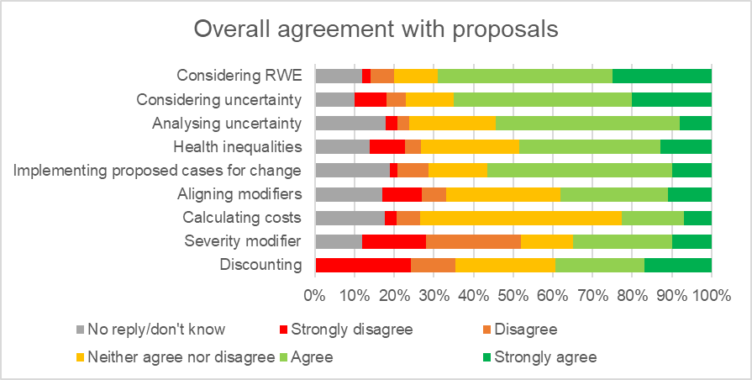Figure 1. Overall agreement with proposals
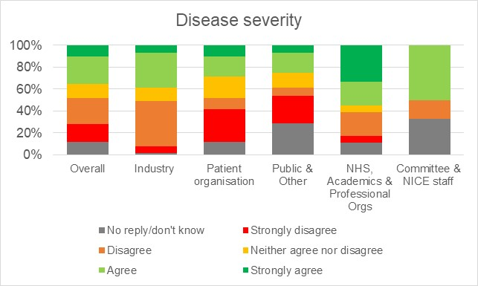
Figure 2. Breakdown of levels of agreement with the proposal for a disease severity modifier by stakeholder group
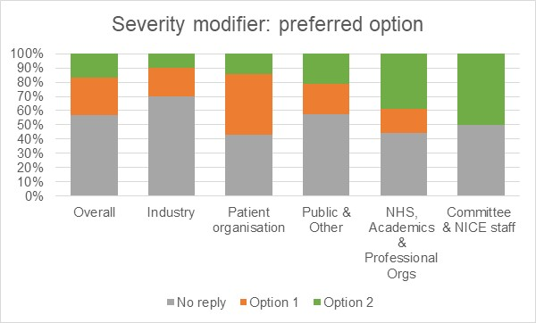
Figure 3. Breakdown of choices between severity modifier option 1 and option 2 by stakeholder group. In option 1, a medium severity weight of 1.2 and a highest severity weight of 1.7 was suggested. In option 2, a medium severity weight of 1.25 and a highest severity weight of 1.5 was suggested.

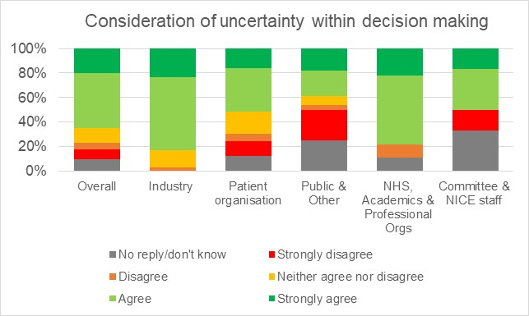
Figure 4. Breakdown of level of agreement with the proposal for consideration of uncertainty within decision making
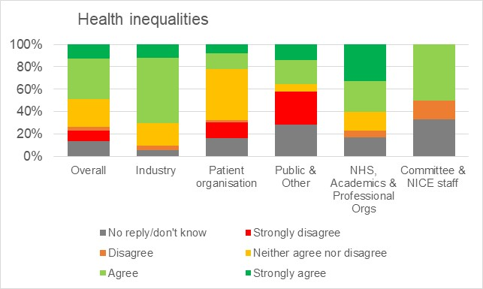
Figure 5. Breakdown of level of agreement with the proposal for health inequalities
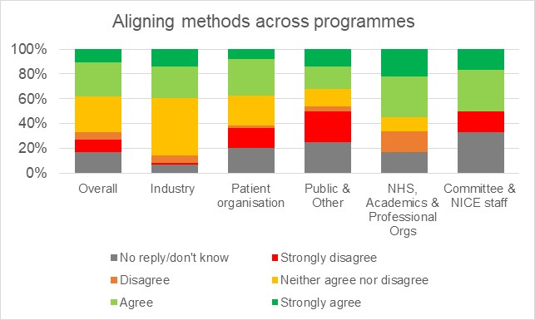
Figure 6. Breakdown of level of agreement with the proposal for aligning methods across programmes
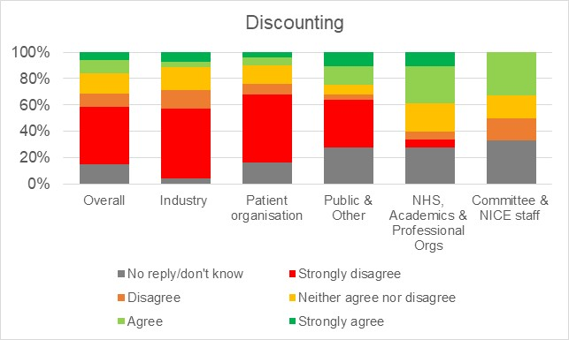
Figure 7. Breakdown of level of agreement with the proposal for discounting

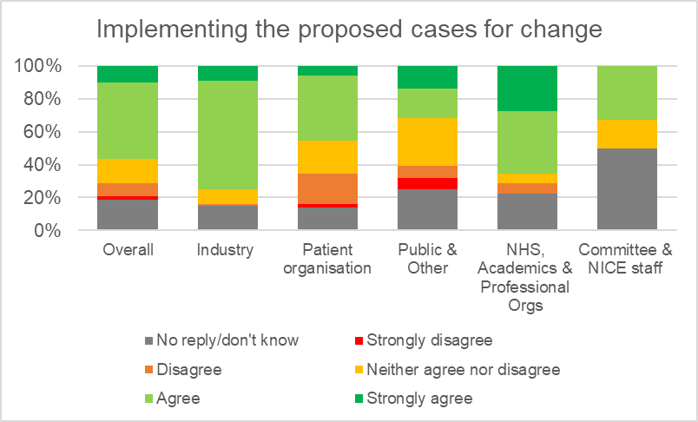
Figure 8. Breakdown of level of agreement with the proposal for implementing the proposed cases for change for sourcing, synthesising and presenting evidence, and considering health-related quality of life

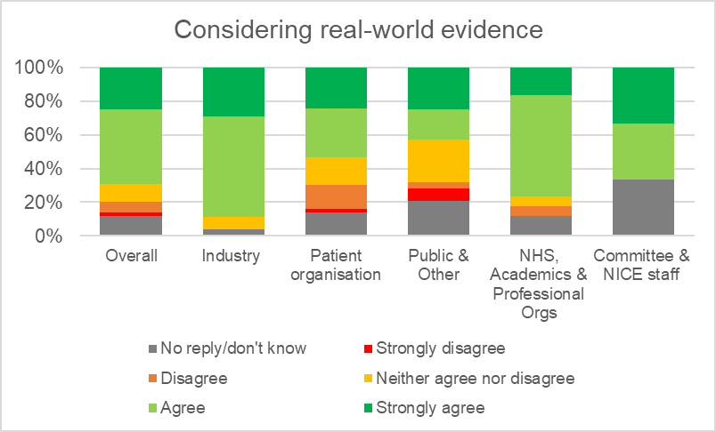
Figure 9. Breakdown of level of agreement with the proposal for considering real-world evidence

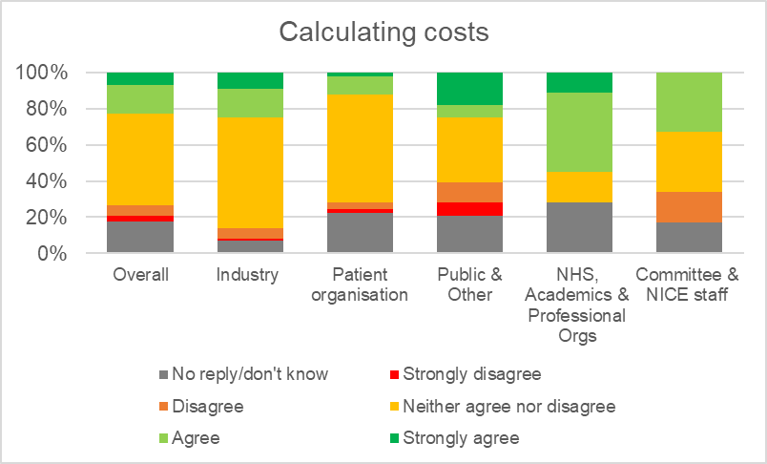
Figure 10. Breakdown of level of agreement with the proposal for calculating the costs of introducing health technologies

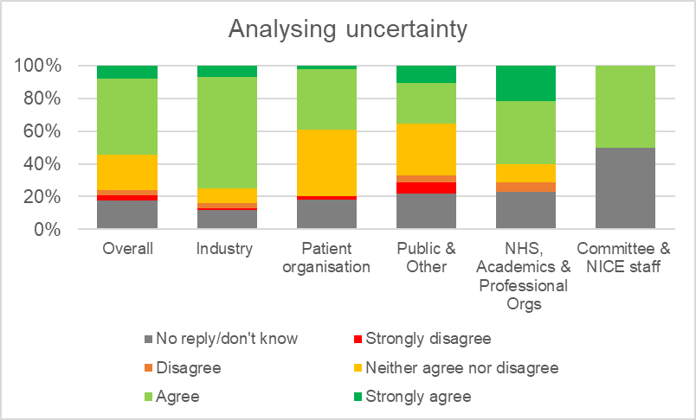
Figure 11. Breakdown of level of agreement with the proposal for analysing uncertainty

5.2 Comments on the draft manual
A number of comments were received on the specific wording of the draft manual. These can broadly be categorised as below:
- Minor spelling and grammatical corrections
- Corrections of obvious inaccuracies, or contradictory or outdated text (for example, references to the 2014 Pharmaceutical Price Regulation Scheme)
- Comments on:
  - The interactions between NICE staff and companies, and on some aspects of handling confidential information
  - The rights of the company to: nominate experts; contribute to committee meeting discussions; comment on the draft protocol for multiple technology evaluations
  - The impact of the updated methods on rare diseases
  - The presentation and reporting of results and committee decision making
  - Survival analysis and/or treatment effect waning
- Requests for clarification regarding the following:
  - Some terminology perceived as being too vague
  - The identification of comparators
  - The identification and input of relevant stakeholders
  - The use of non-randomised or qualitative evidence
  - The timing of some steps, particularly in the context of scoping.

