NICE Listens: Public dialogue on health inequalities
Methodology annex
January 2022

Table of Contents
Table of Contents 2
Overview of the process 3
Preparation stage 4
Expert interview topic guide 4
Workshops 8
Workshop one 8
Workshop one pre-task 8
Workshop one stimulus 9
Workshop one topic guide 9
Workshop one post-task 14
Workshop two 15
Workshop two topic stimulus 15
Workshop two topic guide 16
Workshop three 23
Workshop three pre-task 23
Workshop three stimulus 27
Workshop three topic guide 50
Workshop four 62
Workshop four stimulus 62
Workshop four topic guide 66

Overview of the process
The NICE Listens public dialogue was run from 16th September 2021 until 16th November 2021. This involved four individual workshops taking place two weeks apart, supported by asynchronous, online engagement tasks between workshops. Figure 1, below, provides a visual overview of the process. The dialogue was supported by Incling an online community platform designed for running research projects.
Figure 1: Overview of methodology
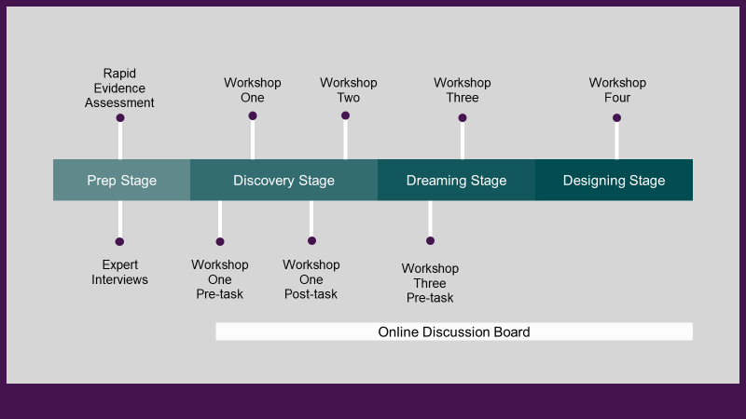

Preparation stage
During the preparation stage a rapid evidence review was conducted on health inequalities in the UK and the public’s views on the topic. This was used to help develop the approach and materials used during the project, as well as inform the background section of the main report. Five interviews were also conducted with experts and stakeholders across the fields of health, policy, and health inequalities (see table 1, below). Interviewees were identified by Basis Social and NICE, to ensure a coverage of views on health inequalities from a number of different perspectives including academics, charitable organisations, and those with lived experience. The interviews were used to help inform the design of the project and clips of recordings from the interviews were used to introduce the topic to participants during the workshops.
Table 1: Expert contributors
Name | Organisation
Dr Ann Hoskins | Independent public health consultant
Clenton Farquharson MBE | Think Local Act Personal
Ethan Williams | The King’s Fund
Professor Richard Cookson | University of York
Professor Sir Michael Marmot | University College London

Expert interview topic guide
The following topic guide was used to guide the discussions with expert contributors.
- Introduce and explain aims of the study
- Explain speaking with 6 expert stakeholders. Note use of the interview is to help contextualise research and inform stimulus for our workshops.
- As part of this, we would ideally like to use aspects of discussion in presenting different issues and considerations to members of the public. Explain different options we have for this, consent, right to review and retract consent.
- Permission to record the session and for use of video.
- Any questions?
- Can you tell me your name, role/organisation, and a little bit about your background?
- As mentioned, the purpose of this interview is to help inform discussions and the material we are using as part of a public dialogue around health inequalities in the UK. This dialogue will involve a series of four workshops with lay members of the public. We are assuming no prior knowledge on the part of those participating.
- In your own words, how would you define health inequalities?
I’m going to read you the NHS England definition of health inequalities is as follows. “Health Inequalities are unfair and avoidable differences in health across the population, and between different groups within society. Health inequalities arise because of the conditions in which we are born, grow, live, work and age. These conditions influence our opportunities for good health, and how we think, feel and act, and this shapes our mental health, physical health and wellbeing.”
- What is your view toward the NHS England definition?
- Would you alter it at all, or supplement it, if it were to be used in introducing health inequalities to members of the public?
- Who do you feel is most impacted by health inequalities in the UK? And why? Probe on:
- the main factors (or wider determinants) driving health inequalities in the UK (e.g. income, education, employment, environment, housing etc.)
- the intersectionality of determinants and socio-demographic characteristics (including protected characteristics)
- the relative influence of different drivers (and therefore importance in addressing health inequalities)
- What impact do you feel the pandemic, and the response to the pandemic, have had on health (and socio-economic) inequalities? Probe on their likely effects in the future.
- How do you feel health inequalities can be made most real or understandable for members of the public? Can you give me any examples?
- What do you consider to be the key trade-offs that are likely to be faced (e.g. by Government and public health services) in addressing health inequalities? Probe:
- Is there a perceived trade-off to be made – with finite resources - between working to improve the health of the overall population and focusing in on more disadvantaged groups?
- Is it acceptable to deepen health inequalities if the overall population health was to benefit?
- Is a policy that worsens overall population health acceptable if it reduces health inequalities
- Where are some of the key opportunities for tackling health inequalities in our society?
- What do you understand to be NICE’s role and remit? Explain if needed that NICE’s guidance aims to meet population needs by identifying care that is high quality, good value, and provides the best outcomes for people using health and social care services within the budget available. Probe:
  - the role of an organisation such as NICE in helping to address health inequality?
  - implications of how health inequalities framed in legislation (such as the Health and Social Care Act) for an organisation such as NICE?
  - should NICE should support the redistribution of health from the most advantaged to the least advantaged?
  - what are some of the limitations and challenges for NICE in addressing health inequalities?
- Are there any other points you’d like to raise?
As mentioned, we will be looking to pull together a short video to help introduce health inequalities to members of the public and would ideally like to include some edited footage of this discussion to form part of this stimulus. Based on this discussion, and subject to your review are you happy for us to do this? We would share the video with you before use.
Finally, as part of the dialogue process, we will invite the public to select different stakeholder perspectives that they would like to hear from in more depth. In principle can I ask whether you would you be willing to participate – along with other stakeholders – in our second workshop with members of the public on 19th October 6:00-8:00pm

Workshops
Please note a number of minor changes and corrections have been made to the workshop topic guides and stimuli since they were presented in the workshops, for clarity and accessibility.

Workshop one

Workshop one pre-task
In advance of the first workshop, participants were asked to record one video and take six pictures and post them on Incling. The purpose was to understand participants’ views on what good health is to them, and what influences their and other’s health.
Participants submitted these videos and pictures in response to the prompts below:
- The meaning of ‘good health’
Please make a short video (no longer than 60 seconds) in or around your home, explaining what ‘good health’ means to you. There is no right or wrong answer to this. We’re just interested in what aspects of health you value, or you think are valued in our society. In your video you could reflect on whether you feel in good health or not, and why you feel that way.
- Influences on your health
Please use your phone to take three pictures of things that you feel have a strong impact on your health, either positively or negatively. These could be both in and outside of your home. Don’t worry about the photo looking perfect – as long as we can see what it is a picture of. For each photo please briefly explain what you have taken a picture of and what impact you think it has on your health.
- Influences on the health of other people
Please use your phone to take three pictures of things that you feel have a strong impact on people’s health more generally, either positively or negatively. Here we want you to think of other people, such as your neighbours or other people in your local community. Again, for each photo please briefly explain what you have taken a picture of and what impact you think it has on your health.

Workshop one stimulus
Workshop one was held on Zoom on Tuesday, 5th October from 6 to 8pm and was attended by all 28 participants. This session involved five moderated breakout discussions, consisting of five to six participants. The discussions were designed to enable participants to begin to understand and engage with health inequalities as a topic, and to begin gathering evidence of how participants are framing the issues around health inequalities.
The stimulus for this workshop included:
- “Good Health”: This was a 3 minute video compiled of clips from the pre-task submissions about what is good health to them.
- “What influences health?”: This was a 4.5 minute video compiled of photos from the second and third pre-task prompts.
- “What are ‘health outcomes’?”: This was a 3 minute video about health outcomes in England which was developed using clips from a video created by NHS Bradford District and Craven.
- “Health Inequalities”: This was a 6 minute video introducing health inequalities. It was developed using clips from the expert interviews conducted during the preparation stage.

Workshop one topic guide
The following is the topic guide used for workshop one.
Timings | Content
6.00 to 6.10pm | Welcome  Purpose: to introduce format and purpose of the public dialogue; to ensure participants get to know one another and feel comfortable engaging in the dialogue  Moderator to introduce themselves and the dialogue:  ‘Hi everyone. I’m [NAME] from Basis and will be helping to manage discussions we’ll be having as part of this public dialogue. You are here alongside around 25 other members of the public. We’ve specifically brought you together to help us to represent a range of different communities across England.  The focus of this dialogue is on understanding your perspectives on health and how we can improve the health of people across different sections of society. We are running this dialogue on behalf of the National Institute for Health and Care Excellence or NICE, who have asked us to undertake this to help provide them with independent evidence.  We will tell you more about NICE as we go through this process but their role is to improve outcomes for people using the NHS and other public health and social care services.  They are keen to hear from you to help them understand how members of the public think and feel in respect of decisions that are taken around who and what to prioritize in improving people’s health.  Rest assured we don’t expect you to come into this dialogue with any prior knowledge. You have shown already that you have a view on what good health means to you. This is what we are here to understand. As we move through this process you will be introduced to different viewpoints and we will help you to have more detailed conversations about health and decisions on prioritizing resources to improve health outcomes, such as how long people live.  So, what do we need from you? We would like you to take part in the discussions we will have by giving your perspective and by listening and responding to the perspectives of other people. The key ground rule in this process is to be respectful of other people’s views. We have brought together a very diverse group of people and it is likely that people will have different views. We want to hear and understand this diversity of views. We also know that discussions around health may be a sensitive topic for some people so please don’t hesitate to take a time out if you need it.  My job today – along with the other moderators - is to help us to have a good conversation and this will cover off various different topics. As we move through the conversation you might feel you haven’t had the opportunity to say as much as you have wanted. I would encourage you to use the chat function if you want to, and also the Incling community has an open forum for you to raise additional thoughts.  So, a big welcome to everyone. Now we’ll break out into some smaller groups where we can have some more manageable discussions….
6.10 to 6.20pm  6.20 to 6.45pm | Good health  Purpose: to provide participants with a sense of how other members of the public understand, conceptualise, and value health outcomes.  Moderator to manage introductions and consent:  Hi everyone. I’m XXX. We’ll spend the majority of this session and the forthcoming workshops in this little group so it would be great to spend a bit of time getting to know one another. Before we start, we mentioned previously that we will be recording the session today. Does anyone have any questions or concerns about this? [Moderator to gain verbal consent. All participants have previously provided written consent.]  [If necessary. We also have a member of NICE joining us today to observe the session and hear people’s honest opinions. XXX do you want to briefly say Hi?’ Explain that they are here to listen only and will have their camera and microphone off]  We do want you all to be as open and honest as you want throughout this discussion. As we get to know one another please feel free to share as much or as little personal information as you feel comfortable with. As XXX mentioned before, we are going to be talking about health which I know can be a very personal and sensitive subject. Please say as much or as little about your own circumstances as you want. If you feel like you need to take a little break then please do so, and feel free to also message me in the chat if needed.  [Note to moderator: it is unlikely, but if people experience distress because of the nature of discussions please can you (i) encourage them to take a break and (ii) contact XXX and he will follow up with each participant directly to signpost aftercare.]  Now, if we can briefly go around the virtual table and introduce ourselves that would be great. Perhaps if you can say your name and tell everyone in a few sentences a little bit about the neighborhood where you live and what you like or dislike about it. I’ll start… XXX do you want to go next?  When I say the word ‘health’ what words, images or examples come to mind? What does ‘health’ mean to you?  And when we talk about ‘good health’, what do you think that means? Probe around:  Outcomes relating to longevity as well as quality of life (for example diseases, life limiting conditions, prevalence of mental health issues etc.)  If and how concepts of good health might differ depending on age  Influences on their views toward what good health means  Before we carry on the conversation, we thought it would be good for you to get a short introduction to some of the other participants taking part in the dialogue, so I’m going to play you some short clips taken from your pre-task videos where you talked about the meaning of good health.  Moderator to show Stimulus Set 1 (3 to 4 minute video clip of participant responses to pre-task question on what good health means to them)  I’d like to get your reflections on what you heard from the pre-task videos, specifically what do you identify with? What was different from your own views and experiences? Probe and draw out how people conceptualise health  What aspects of your health do you most value and why? Explore positive health outcomes (such as mental wellbeing, physical wellbeing, healthy weight, long life) Specifically explore: length of life and quality of life; absence/presence of illness or disease; mental wellbeing vs physical wellbeing  When thinking about your health what, if anything, do you worry about? Explore negative health outcomes (such as diseases, physical or mental illnesses)  Is it better to live a longer life but with a number of those years being in poor health, or a shorter life which is lived in good health? Explore reasons for views and any notable differences/qualifications.
6.45 to 7.00pm | Influences on health outcomes  Purpose: to start to understand people’s perceptions of what factors influence positive or negative health outcomes, and the extent to which some of these factors go beyond individual choices/behaviours or the health services available to them.  Again, thinking about your own lives and your own health. What do you think are some of the factors which influence your health for better or for worse? Listen for and probe around:  Positive and negative influences  The most powerful/impactful influences on health  Factors that relate to individual behaviours, wider determinants, inequalities, opportunities, services etc.  Let’s cast the net wider. If you were to think about your friends and family members. Are there other factors which you think influence their health?  Moderator to show Stimulus Set #2 (3 to 4 minute photo montage of participant responses to pre-task question on influences on health)  So, we saw in that last video some of the photos that you all took as part of your homework activity before this workshop. Was there anything here that stood out or surprised you? Explore what/why.  OK. We’ll return to talking a little more about the different influences on health later in our discussions today and when we meet again in a few weeks. Let’s take a very quick comfort break for 5 mins and when we come back together at 7.05, I want to talk with you about some of the differences we see in health across different parts of our society.
7.00 – 7.05pm | COMFORT BREAK
7.05 to 7.40pm  7.40 to 7.55pm | Introducing health inequalities  Purpose: To introduce health inequalities and the social determinants of health, starting to open up discussions around equity and inequality, and opportunities for addressing health inequality at a macro level.  Moderator to show Stimulus Set 3 (4 minute video presentation on health outcomes, life expectancy and healthy life expectancy differences)  What are your thoughts around what you have just heard? Was there anything there that you found particularly surprising?  The example used there was from Bradford and represented an area where – across a distance of 10 miles – the life expectancy of a man dropped by 10 years, and the healthy life expectancy dropped by 20 years. So, someone living in one part of Bradford can expect to live 20 years more of their life free of ill-health than someone 10 miles down the road. The same kind of situation exists in various parts of the country.  Why do you think these differences in life expectancy and healthy life expectancy between people in different parts of Bradford exist?  Are there particular groups of people who you think are more vulnerable to poor health outcomes? Probe:  Socio-demographics (ages, genders, ethnicities, nationalities)  Other protected characteristics (e.g. disability, religion, sexual orientation)  Income  Environmental  Any other factors? If not mentioned, specifically explore vulnerable groups such as homeless people, vulnerable migrants, people who have left prison etc.)  Thinking back to some of the things we discussed earlier, what factors do you think might be influencing whether someone living in one part of Bradford dies 10 years earlier than someone living in another area?  How might other influences such as your local environment, housing, education, employment, or income impact health outcomes? Probe on each in turn to understand extent to which these are understood and resonate.  Which of these factors do you think has the greatest influence over individual health outcomes, such as how long someone lives, or whether they live in good health or not? Why?  Which of these factors are you most concerned about? Why? Probe extent to which participants see outcome/situation as fair or avoidable.  How would you explain this difference in life expectancy and healthy life expectancy in Bradford to a child in primary school?  Moderator to show Stimulus Set 4 (6-minute video presentation introducing health inequalities) Note please pause after first 3 minute section to get initial reflections before playing remainder of video.  What are your reflections on what you have just heard?  What are your thoughts on the extent to which these wider inequalities are linked to difference in health?  What are your thoughts on the five social determinants of health outlined there by Sir Michael Marmot? Probe on relative importance of the following factors on health outcomes:  Giving every child the best start to life (parenting, early years support, addressing child poverty)  Enabling all children, young people, and adults to maximise their capabilities and have control over their lives (education and attainment)  Creating fair employment and good work for all (employment opportunities, security and living wage)  Ensuring a healthy standard of living for all (addressing poverty, fair taxes and benefits, food security and social mobility)  Creating and developing healthy and sustainable places and communities (housing, pollution, investment in communities)  How would you describe ‘health inequality’ in your own words? Or what examples would you give from your own lives or the communities to which you belong to illustrate health inequalities? Probe on what factors people see as influencing health inequality.  Moderator to thank everyone and explain that we will be moving back into the plenary room to close the session off.
7.55pm | Close  Thank you all for your time this evening. It was wonderful to meet everyone, and I hope you found this an interesting process.  As we go through this dialogue, we will be talking more about health inequalities, the role of NICE and some of the opportunities for tackling health inequality.  The next workshop will be on 19th October. Between then and now we’d really like you to start posting thoughts on the discussion board we have set up. If everyone can take some time in the next few days to introduce themselves and post some thoughts on the key things you’ve taken away from the discussions today and whether there were any immediate questions you had that we might want to explore in the next workshop that would be great. We have also included links to some reports there for those of you who are interested in reading more about health inequalities.  Thanks again for all your time and energy and have a great rest of your evening.

Workshop one post-task
Participants then completed a post-task via the Incling platform. They were asked to provide two to three takeaways from the workshop and to engage with others’ posts on the topic. The submissions for this task helped to inform the next workshop and were used in the analysis in the main report.

Workshop two
Workshop two was held on Zoom on Tuesday, 19th October from 6 to 8pm and was attended by all 28 participants. This session involved five breakout sessions, followed by a panel discussion between four experts (see table 2 below) and participants, and was concluded with five breakout sessions consisting of five to six participants. The experts were identified in collaboration with NICE to represent a variety of topics related to public health and health inequalities and facilitate discussions about NICE’s role across health, public health, and social care.
The session aimed to allow participants to further grapple with the topic of health and to help people to see themselves/others reflected in inequalities data. It also sought to understand the factors that influence participant views on the prioritisation of health services and resources, including when it is justifiable to prioritise one group over another. Lastly, the workshop aimed to introduce NICE and its role in the health and care system to the participants.
Table 2: Workshop two panellists
Name | Role and organisation
Charlotte Goulding | Social care policy and practice support manager at NICE
Muna Abdel Aziz | Director of public health for Salford
Stephen O'Brien | Professor of haematology at Newcastle University and chair of NICE technology appraisal committee
Deb O’Callaghan | Associate director at NICE

Workshop two topic stimulus
The following stimulus was used to support the discussion and panel session
Stimulus 1: Health inequalities statistics: This 5 minute video introduced specific health inequalities in England related to various factors such as location, income, ethnicity, sexuality, and education.
Stimulus 2: NICE introduction: A 3.5 minute video created by the NICE Public Involvement Programme (PIP) used during the panel discussion to introduce NICE and its role in the health and care system.
Stimulus 3: Equality vs equity: An image, shown in figure 2, depicting “equality”, “equity”, and “systematic change” using a metaphor of children viewing a sports game.
Figure 2: Equality vs equity graphic
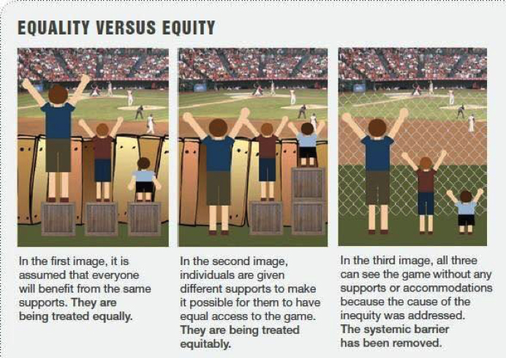

Workshop two topic guide
The following is the topic guide used for workshop two.
Timings | Content
6.00 to 6.05pm | Welcome  Purpose: to reintroduce format and purpose of the public dialogue; to explain how Workshop two will run  Moderator to introduce themselves and the dialogue:  ‘Hi again everyone. Great to see you all back again. I’m [NAME] from Basis and will be helping to manage discussions we’ll be having as part of this public dialogue.  As you might remember, you are here alongside around 25 other members of the public so we can benefit from understanding your perspectives on health and how we can improve the health of people across different sections of society.  We are running this dialogue on behalf of the National Institute for Health and Care Excellence or NICE. Today you will hear more about their role and how it relates to health and social care services in England. They are keen to hear from you to help them understand how members of the public think and feel in respect of decisions that are taken around who and what to prioritize in improving people’s health.  As before, we would like you to take part in the discussions we will have by giving your perspective and by listening and responding to the perspectives of other people. The key ground rule in this process is to be respectful of other people’s views. We have brought together a very diverse group of people and it is likely that people will have different views. We want to hear and understand this diversity of views. We also know that discussions around health may be a sensitive topic for some people so please don’t hesitate to take a time out if you need it.  My job today – along with the other moderators is to help us to have a good conversation and this will cover off various different topics. As we move through the conversation you might feel you haven’t had the opportunity to say as much as you have wanted. Again, I would encourage you to use the chat function if you want to, and also the Incling community has an open forum for you to raise additional thoughts.  For this session we’ll again break out into some smaller groups where we can have some more manageable discussions, but we’ll come together again just before 7pm for you to hear from one another, and to meet some people who can tell you more about NICE’s role and some of the decisions it has to make.
6.05 to 6.20pm | Reflections on Workshop one [Breakout groups]  Purpose: to enable participants to reflect on the discussions from Workshop one, discussions taking place on Incling and their conversations/thoughts in the intervening period.  Moderator to manage introductions and consent:  Hello again everyone. Nice to see you all again. Just as a reminder I’m XXX. It would be great to softly introduce ourselves again and just take a moment to reflect again on what was discussed at the first workshop two weeks ago.  Before we start, we mentioned previously that we will be recording the session today. Does anyone have any questions or concerns about this? [Moderator to gain verbal consent. All participants have previously provided written consent.]  [If necessary. We also have a member of NICE joining us today to observe the session and hear people’s honest opinions. XXX do you want to briefly say Hi?’ Explain that they are here to listen only]  We do want you all to be as open and honest as you want throughout this discussion. As before please feel free to share as much or as little personal information as you feel comfortable with. We fully understand that health can be a very personal and sensitive subject so please say as much or as little about your own circumstances as you want. If you feel like you need to take a little break then please do so, and feel free to also message me in the chat if needed.  [Note to moderator: it is unlikely, but if people experience distress because of the nature of discussions please can you (i) encourage them to take a break and (ii) contact XXX and he will follow up with each participant directly to signpost aftercare.]  Now, if we can briefly go around the virtual table to reintroduce ourselves that would be great:  If you can remind people of your name and maybe reflect a little bit about what you took away from what was discussed in Workshop one. XXX do you want to start for me? Try to encourage range of coverage and areas of consensus/disconsensus by probing on:  Health priorities and good health outcomes  Gaps in health between different individuals/groups (e.g. Bradford, and whether similar situations thought to exist in own communities)  Influences on health inequality  Did anyone have any further conversations with friends, families, or colleagues about the session? Probe  How did you explain what we had been discussing?  Did it prompt any further thoughts? Areas of agreement or disagreement?  Last time we met we shared information which showed that there are some large gaps in life expectancy, and healthy life expectancy between different parts of society. In Bradford there was a 20 year gap in healthy life expectancy (that’s the length of life lived in good health) within a 10 miles radius. Why do you think these gaps in health outcomes between different communities in England exist? Probe on responses to identify:  What do you think are the most influential factors?  Which factors concern/worry you most? Why? [Explore influence of ethical frames such as whether certain factors seen to be fair or just, and how this relates to what is perceived to be within/outside of control]  If you can remember, ‘health inequalities’ relate to differences in health between different individuals or groups in society. Who do you think is most impacted by health inequalities in your local community? I.e. which groups of people or individual characteristics? Explore why these groups/individuals.
6.20 to 6.45pm | Unpicking health inequalities [Breakout groups]  Purpose: to start to understand people’s perceptions of what factors influence positive or negative health outcomes, and the extent to which some of these factors go beyond individual choices/behaviours or the health services available to them.  Before we carry on the conversation, we thought it would be good for you to hear a little more about some of the differences in health outcomes that we can see across different groups in society.  Moderator to show Stimulus 1: health inequalities statistics (5 minute video clip)  So, that video provided some facts and figures around who might be impacted by health inequalities. Was there anything here that stood out for you? Explore what/why.  Do you think you might be impacted by health inequalities based on your circumstances or characteristics such as your ethnicity, education level, where you live, how much you earn etc?  Explore:  whether/why/when people see themselves as impacted by health inequalities (for example by virtue of where they live)  characteristics they self-identify with which they see as being most tied to inequalities  whether/when they feel concerned about the impact of factors such as their ethnicity, housing, income etc. on their health  How important is it for public services to address health inequalities? Probe:  Why/why not?  Which public services do you think have a role to play in tackling health inequalities? For example: education, housing, transportation, healthcare, social services, environmental protection, urban planning.  I’d like you to imagine that you, as a group, were tasked to help tackle health inequalities in a particular location in England. You have been given a pot of money to spend and free reign over how to spend it.  What information do you think you would want to help you make your decision/s?  What questions would you have?  Would you prefer to prioritise certain groups over others, or just look to improve everyone’s health? Just as a reminder I will share the Venn diagram we saw in the video with the various factors that influence health  Which groups do you imagine you might prioritise (and why)?  Would your aim be to increase length of life or quality of life?  What kind of factors would you take into account to determine quality of life? And which of these tie into health specifically?  OK. We’ll take a quick comfort break now, and when we return, we’ll give you the chance to talk to some people who are involved in making some of these decisions around health. Please have a 5 minute break and we’ll all come together again as a whole group at 6.50pm.
6.45 to 6.50pm | COMFORT BREAK
6.50 to 7.00pm  7.00-7.35pm | Panel discussion [Plenary]  Purpose: To enable participants to understand what NICE does and what its role/influence is within the wider context of the health and care system.  Chair to introduce 4 panel members and explain purpose of this next part of the session.  We are very pleased to introduce you all to [Chair to give panel member’s names]. In this dialogue we are trying to understand your view on reducing inequalities in health – that is addressing avoidable differences in health outcomes - and therefore what actions NICE should take to best reflect your views. To help with this we wanted NICE to introduce what they currently do, and for you to hear from people working in services that are affected by their decisions.  Chair to play stimulus 2: NICE introduction video to introduce NICE, their role in the health system (specifically focusing on technology appraisal and guidelines), and where they do/could play a role in tackling HI  Rest of panel to each introduce themselves and to explain how their work/services are influenced by the decisions taken by NICE.  Chair to facilitate discussion between panelists, and opening floor to participants, to ensure coverage of:  How do different (health) services currently think about and respond to health inequalities / differential services?  What do participants think about these?  How do participants feel about people getting differential level/quality of services?  What are some of the key challenges and opportunities for health and care services in tackling health inequalities?  Which of these challenges/opportunities feel most important to participants?  What could/should NICEs role be in relation to some of these challenges/opportunities?  What does NICE currently do at different points to help reduce health inequalities (i.e. to effect change at an individual healthy lifestyle level, within the health and care system, on wider determinants, and on the places/communities where we live), and what could they (or should they) do?  In looking to tackle health inequalities, should NICE prioritise people in terms of different characteristics/circumstances? What would be the implications for services?  How do participants feel about NICE prioritizing people?  Throughout Chair to encourage questions and reflections from participants. Thank panel members for input and close panel session for 7.35pm – all to move back into break out groups.
7.35 to 7.55pm | Participant priorities [Breakout groups]  Purpose: To understand if, when and how participants think that different groups should be prioritized when thinking about health services and resources directed to healthcare. This is to help us tee up the trade-off exercises and discussions in Workshop three.  We heard from a number of people there who are involved in helping to deliver services to members of the public, many directly impacting on people’s health and quality of life. It would be good to hear:  your thoughts on what was discussed during the panel discussion  points you particularly agreed or disagreed with  parts of the discussion that you found confusing  questions that you have around NICE and its role  questions that you have around health inequalities and differences between different groups in society  Moderator to show Stimulus 3 (Equality vs Equity graphic) and talk through each image. Explain: You can think about the way in which health services work with different groups in terms of equity and equality. The first image illustrates 3 people, each with different needs, being treated equally to view a game. The second image illustrates 3 people, each with different needs, being treated equitably. In the third, the cause of inequity is removed.  Thinking about public health and care services, do you think the aim should be to treat people equally or equitably? Explore why and differences in views.  How would you feel if, to achieve greater equity for the smallest person, it meant the tallest person’s view was disadvantaged in some way?  Do you think NICE (and therefore health and care services) should take into account personal characteristics, circumstances and the conditions affecting people when making their decisions? Just as a reminder I will share the Venn diagram we saw in the video with the various factors that influence health. Probe on accounting for:  particular population groups, for example:  would you take into account someone’s age / gender / ethnicity?  what about other protected characteristics (such as sexual orientation or disability)?  what about specific groups, like homeless people, or asylum seekers?  circumstances, for example, would you take into account people’s income, where they live?  health related behaviours, for example, would you take into account whether someone was a current/ex-smoker / whether they were overweight or exercised regularly  impact of different types of conditions  mental health vs physical health issues  common vs rare conditions (e.g. asthma and diabetes vs Lupus and ALS/Lou Gehrig’s Disease)  treatable vs terminal illnesses (e.g. diabetes and arthritis vs late-stage cancers or some forms of heart disease)
7.55 to 8.00pm | Close [Breakout groups]  Thank you again for your time this evening. It was wonderful to meet everyone, and I hope you found this an interesting process.  The next workshop will be on 2nd November. Before then we will invite you to take part in a short survey to help us understand how you would make the kind of decisions that NICE needs to make. We’ll then spend the next workshop discussing these in more detail so please do complete this in advance. As before, it would be great if you also took the opportunity to chat with others involved in this dialogue about what you’re taking away from the discussions.  Thanks again for all your time and energy and have a great rest of your evening.

Workshop three
Workshop three was held on Zoom on Tuesday, 2nd November from 6 to 8pm and was attended by 26 of the 28 participants. This session involved five moderated breakout discussions consisting of five to six participants where the discussed various trade-off scenarios. These scenarios addressed various ways in which health inequalities exist and participants were asked to choose where they would prioritise resources and to discuss and debate the justification for their choices.

Workshop three pre-task
In advance of the third workshop, participants were asked to complete a pre-task. This task involved seven trade-off exercises in which they had to choose between one of two programmes or determine that both programmes were equally good. This task involved trade-offs between prioritising individuals with shorter life expectancy over those with longer life expectancy.
The seven exercises, shown in figures 3 to 9, were presented to participants via Incling with the prompt ‘Which programme should the government choose?’. They could select one of three choices for each of the scenarios:
- programme A
- programme B
- programme A and B are equally good
These images were adapted from Richard Cookson (2018) E-learning and health inequality aversion: A questionnaire experiment’.
Figure 3: Workshop 3 pre-task exercise 1
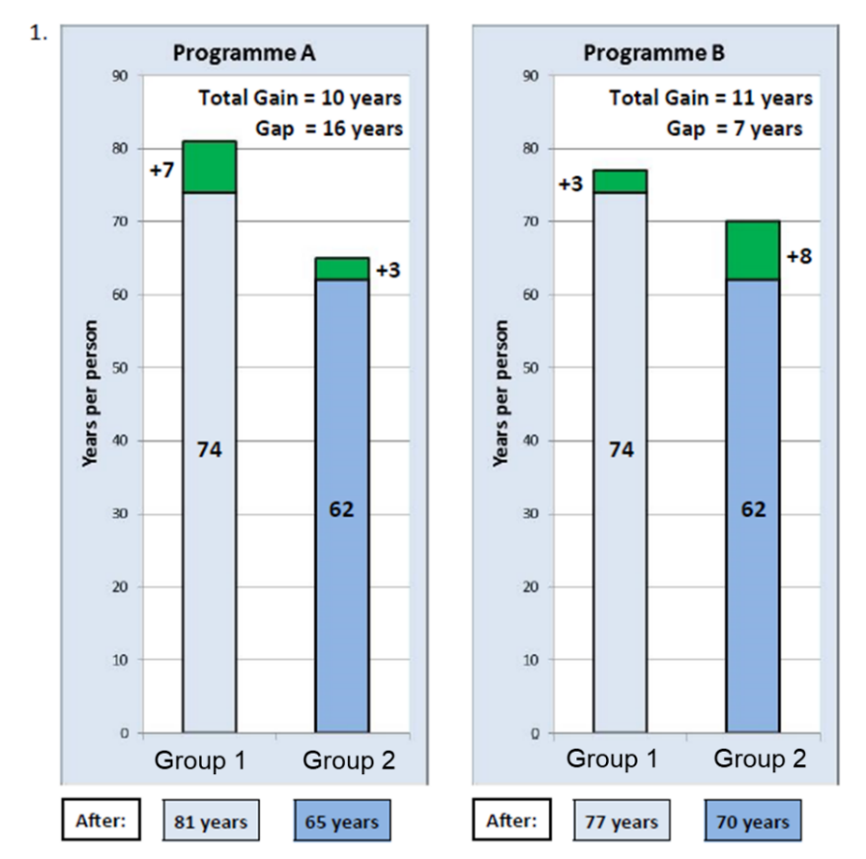

Figure 4: Workshop 3 pre-task exercise 2
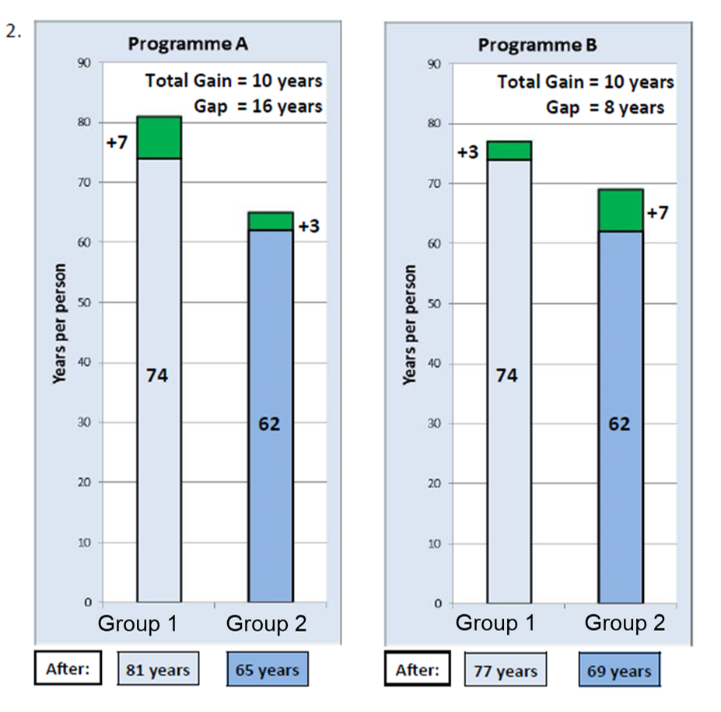
Figure 5: Workshop 3 pre-task exercise 3
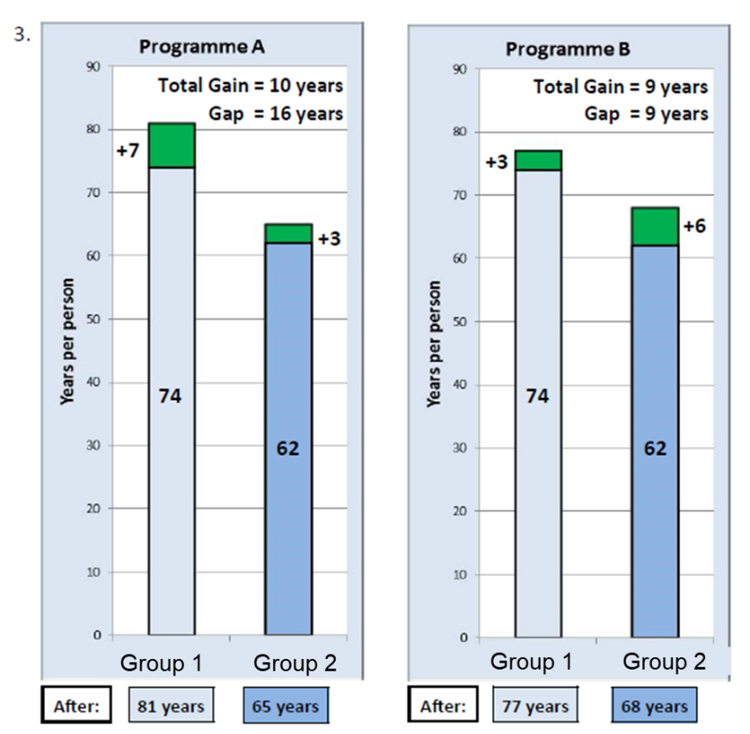

Figure 6: Workshop 3 pre-task exercise 4
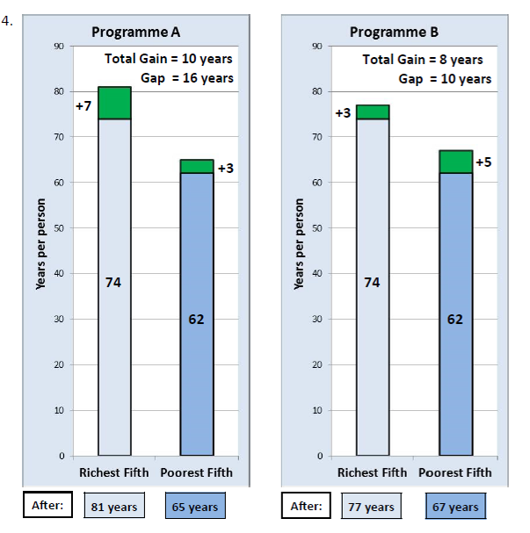
Figure 7: Workshop 3 pre-task exercise 5
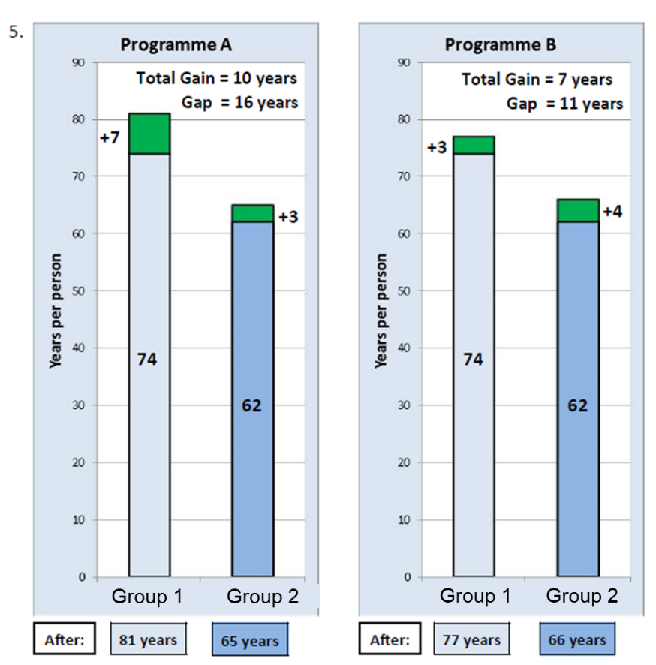
Figure 8: Workshop 3 pre-task exercise 6
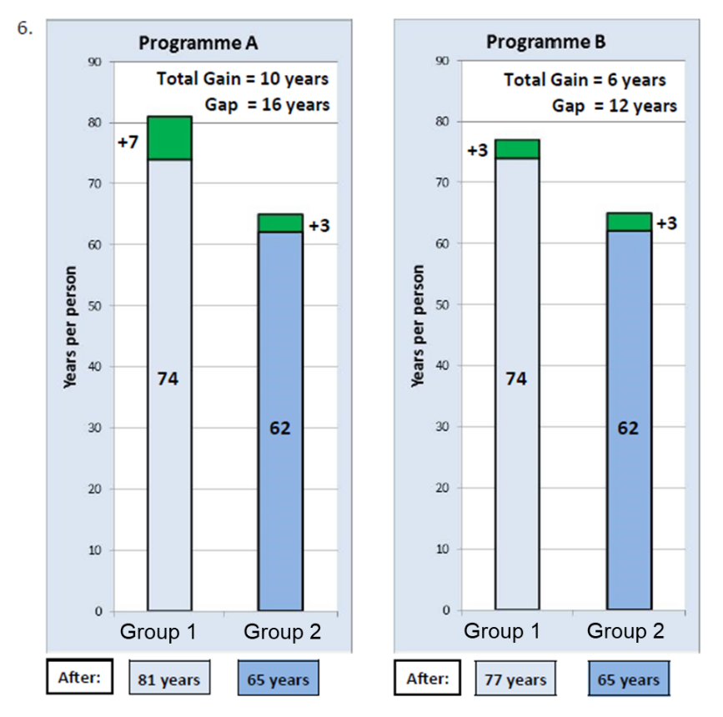
Figure 9: Workshop 3 pre-task exercise 7
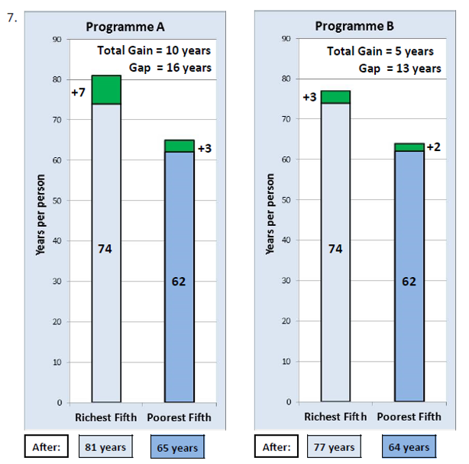

Workshop three stimulus
Stimulus 1: a 3 minute video film explaining the results from the pre-workshop activity was shown at the start of workshop 3 to start discussions about trade-offs.
Stimulus 2: a series of six trade-off scenarios presented visually to the breakout groups, labelled scenario one, scenario two A, scenario two B, scenario three, scenario four and scenario five. Each group saw five of the six scenarios in different orders. All groups saw scenario one, three, four and five. Half of the groups saw scenario two A and half, two B. Each of the scenarios asks the participants to imagine that there are two groups of people with different life expectancies. The characteristics of the two groups of people changes across the scenarios. These exercises were designed collaboratively with NICE with an aim to capture a breadth of topics that may trigger discussion, such as varying demographics and conditions. The average life expectancies used in these scenarios are examples only and may not reflect real life.
Workshop three: scenario one – slide 1
Imagine that there are two groups of people with different life expectancies. Group 1 lives (on average) 10 years longer than Group 2. A choice needs to be made on how to spend part of the health services budget to improve life expectancy.

Workshop 3 scenario one – slide 2
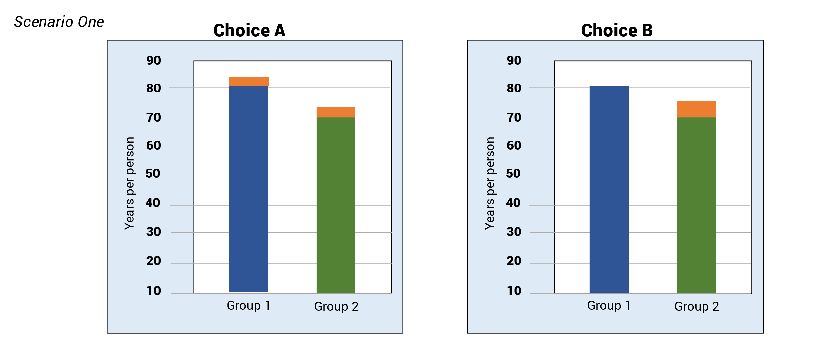

Choice A:
Group 1 will now live 2 years extra life.
Group 2 will now live 2 years extra life
The inequalities between the groups remain the same

Choice B
Group 1 will have no change in life expectancy
Group 2 will now live 4 years extra life
Smaller gap in life expectancy between these groups

Workshop 3 scenario one – slide 3
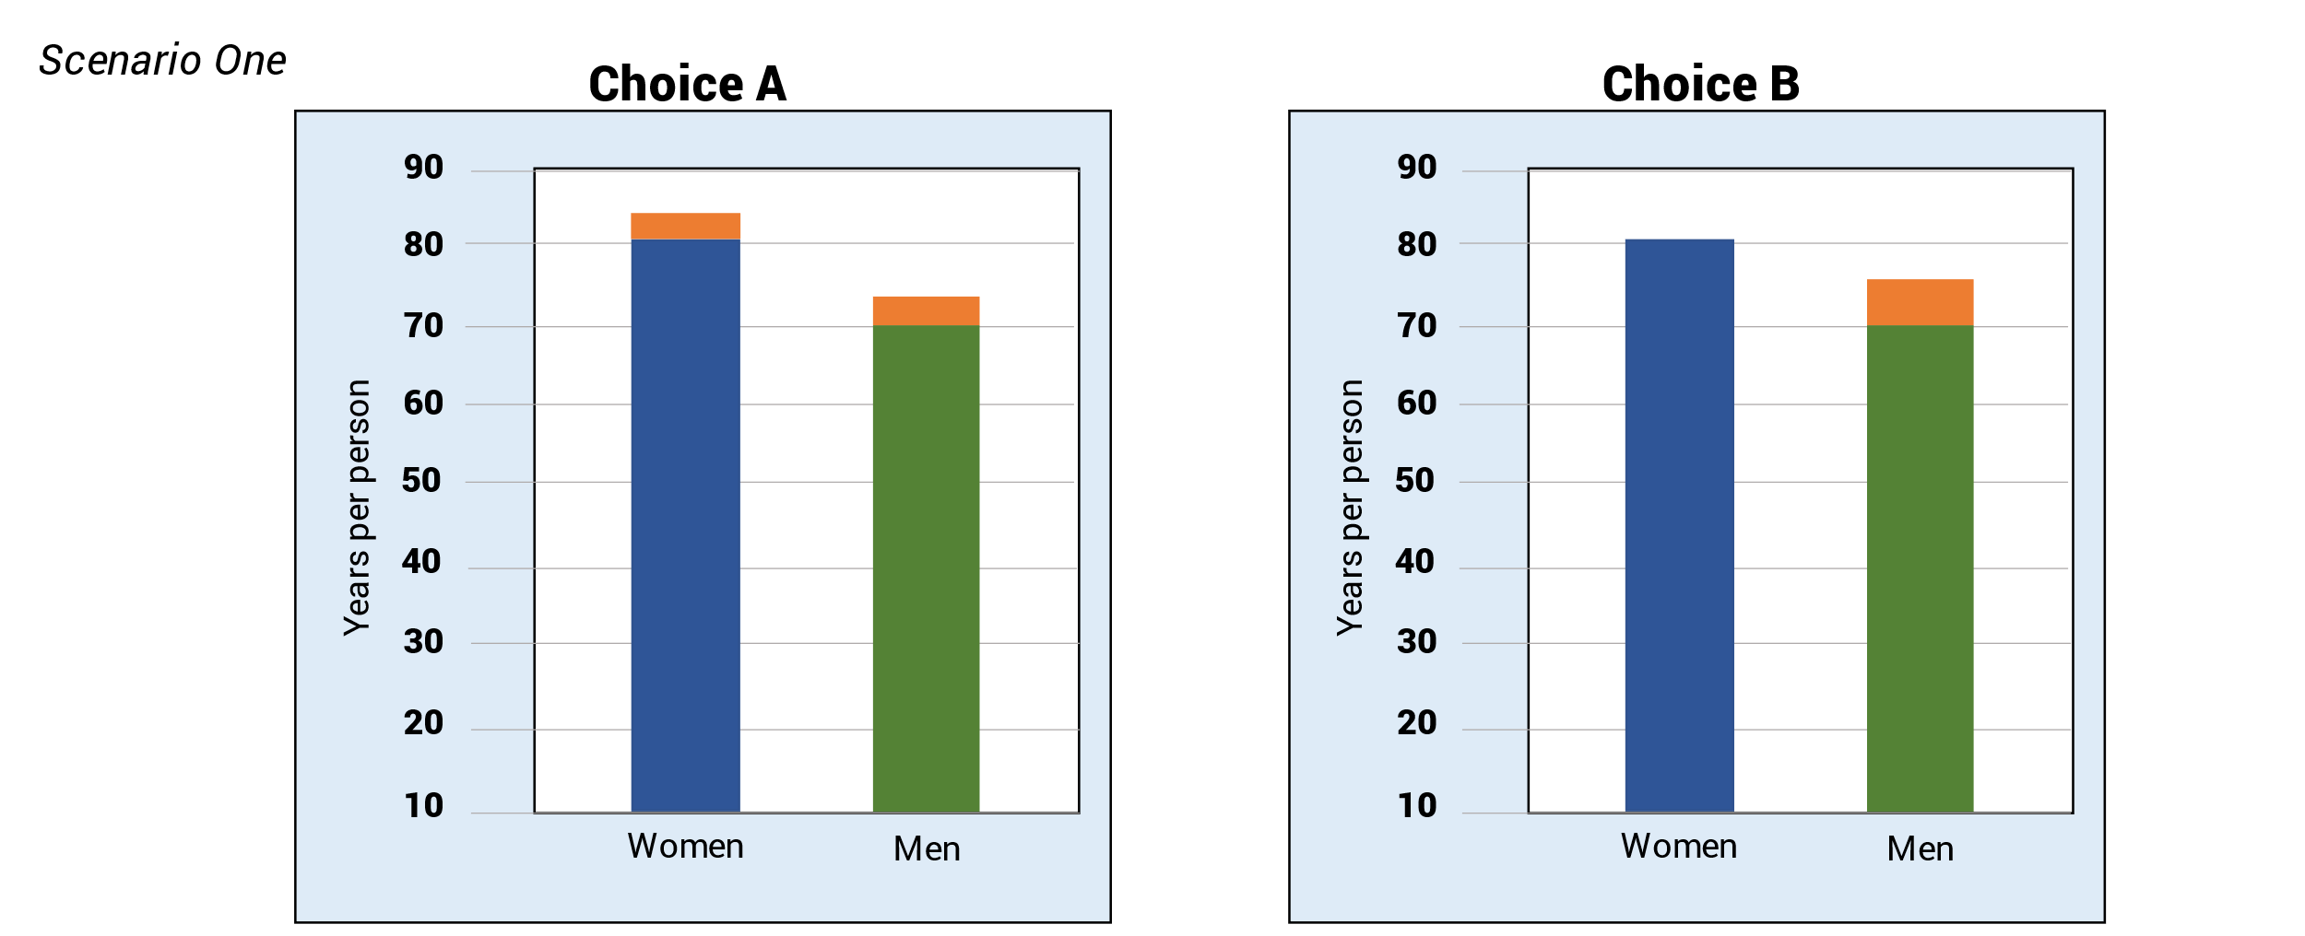

Choice A
- Women will now live 2 years extra life
- Men will now live 2 years extra life
- The inequalities between the groups remain the same

Choice B
- Women will have no change in life expectancy
- Men will now live 4 years extra life
- Smaller gap in life expectancy between these groups

Scenario two A – slide 1
Group 1 is the general population
- 500,000 individuals
Group 2 is individuals experiencing homelessness
- 3500 individuals
- On average live 10 years less life than Group 1 for a variety of reasons including:
  - greater incidences of drug and alcohol addiction
  - low or no-incomes
  - poorer living conditions
  - difficulty accessing health and support services
Scenario two A – slide 2

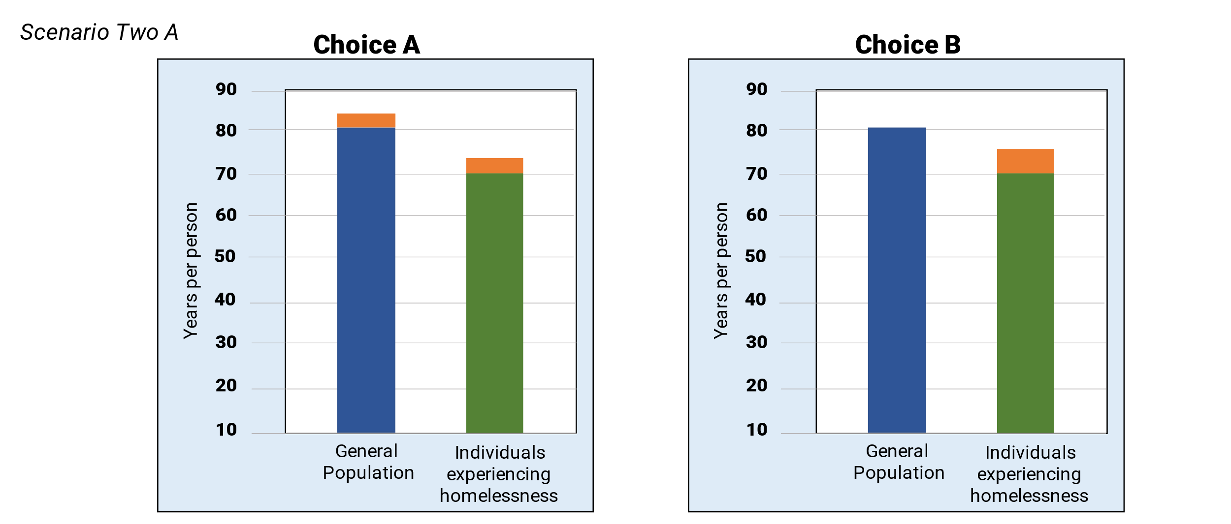

Choice A
- General population will now live 2 years extra life
- Individuals experiencing homelessness will now live 2 years extra life
- The inequalities between the groups remain the same

Choice B
- Individuals experiencing homelessness will now live 4 years extra life
- General population will have no change in life expectancy
- Smaller gap in life expectancy between these groups
Scenario two A – slide 3

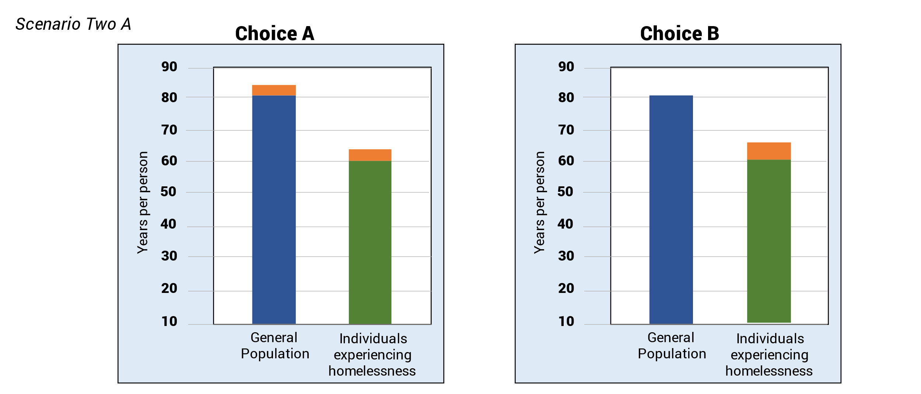
Choice A
- General population will now live 2 years extra life
- Individuals experiencing homelessness will now live 2 years extra life
- The inequalities between the groups remain the same
Choice B
- Individuals experiencing homelessness will now live 4 years extra life
- General population will have no change in life expectancy
- Smaller gap in life expectancy between these groups

Scenario two A – slide 4

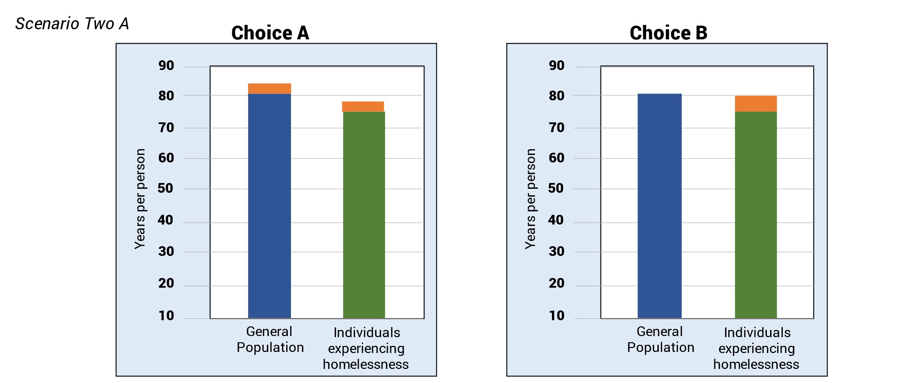

Choice A
- General population will now live 2 years extra life
- Individuals experiencing homelessness will now live 2 years extra life
- The inequalities between the groups remain the same

Choice B
- Individuals experiencing homelessness will now live 4 years extra life
- General population will have no change in life expectancy
- Smaller gap in life expectancy between these groups

Scenario two A – slide 5

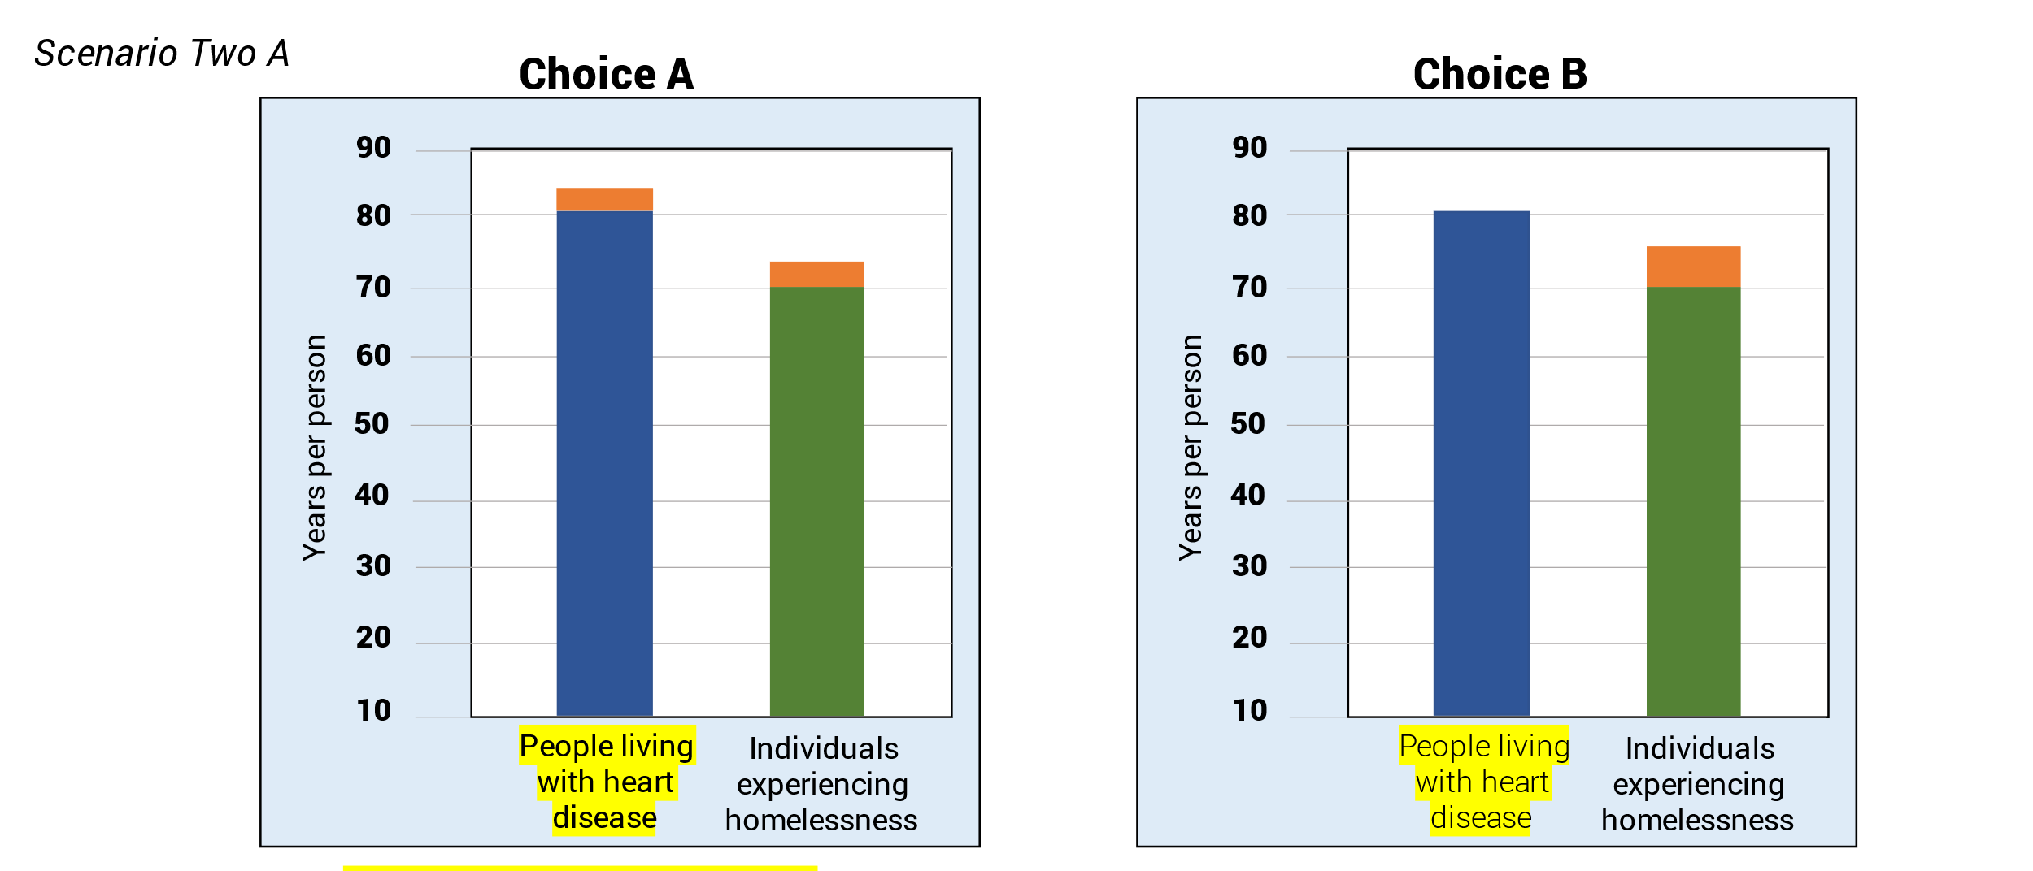

Choice A
- People living with heart disease will now live 2 years extra life
- Individuals experiencing homelessness will now live 2 years extra life
- The inequalities between the groups remain the same

Choice B
- Individuals experiencing homelessness will now live 4 years extra life
- People living with heart disease will have no change in life expectancy
- Smaller gap in life expectancy between these groups

Scenario two A – slide 6

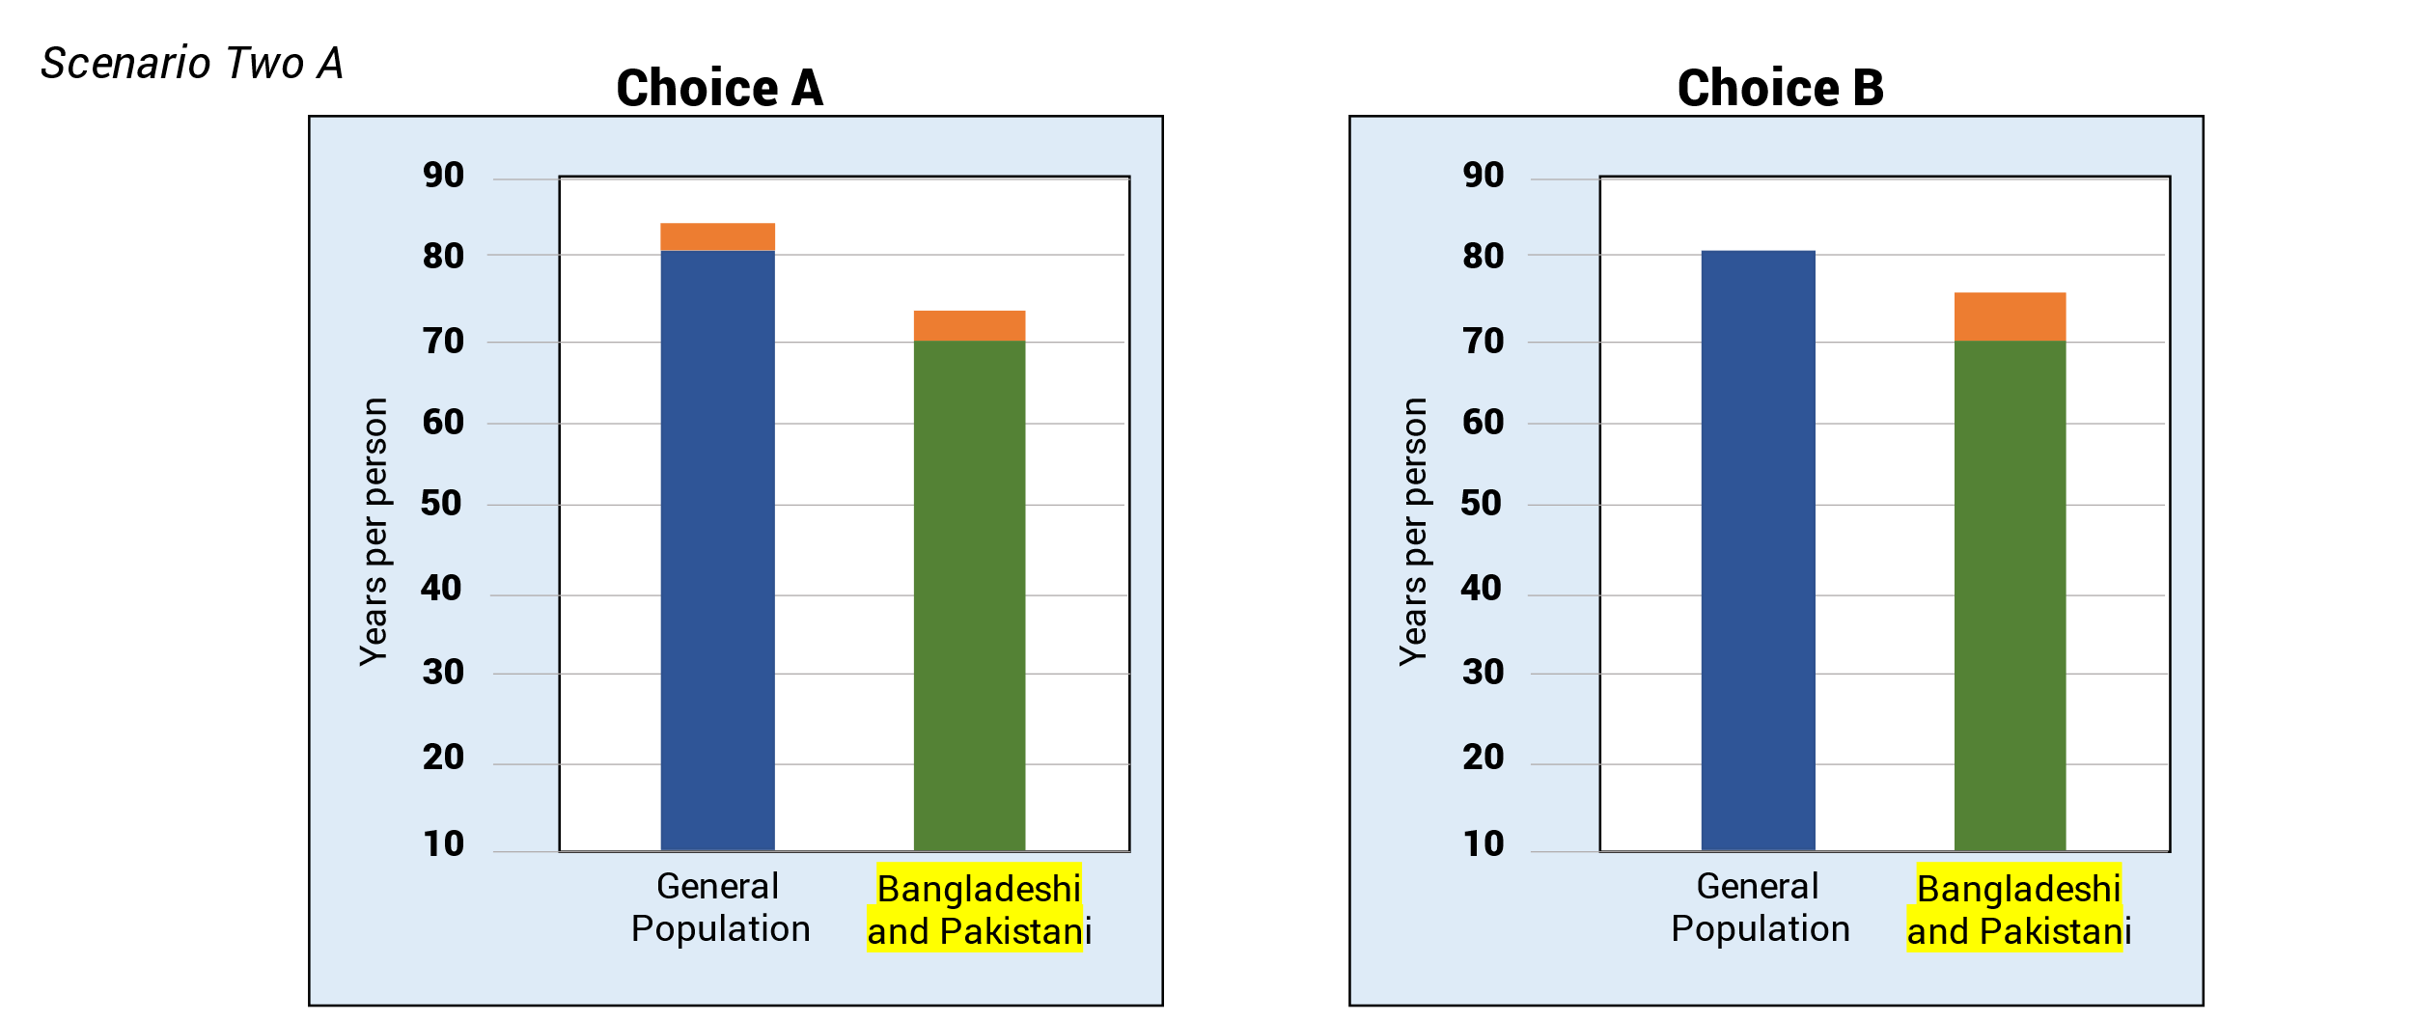

Choice A
- General Population will now live 2 years extra life
- Bangladeshi and Pakistani individuals will now live 2 years extra life
- The inequalities between the groups remain the same

Choice B
- Bangladeshi and Pakistani individuals will now live 4 years extra life
- General population will have no change in life expectancy
- Smaller gap in life expectancy between these groups

Scenario two B – slide 1
Group 1 = general population
- 500,000 individuals

Group 2 = Gypsy/Roma/Travellers
- 3500 individuals
- On average Group 2 live 10 years less life than Group 1 for a variety of reasons such as:
  - lower levels of participation in formal education
  - higher levels of discrimination
  - higher rates of mental illness including depression

Scenario two B – slide 2

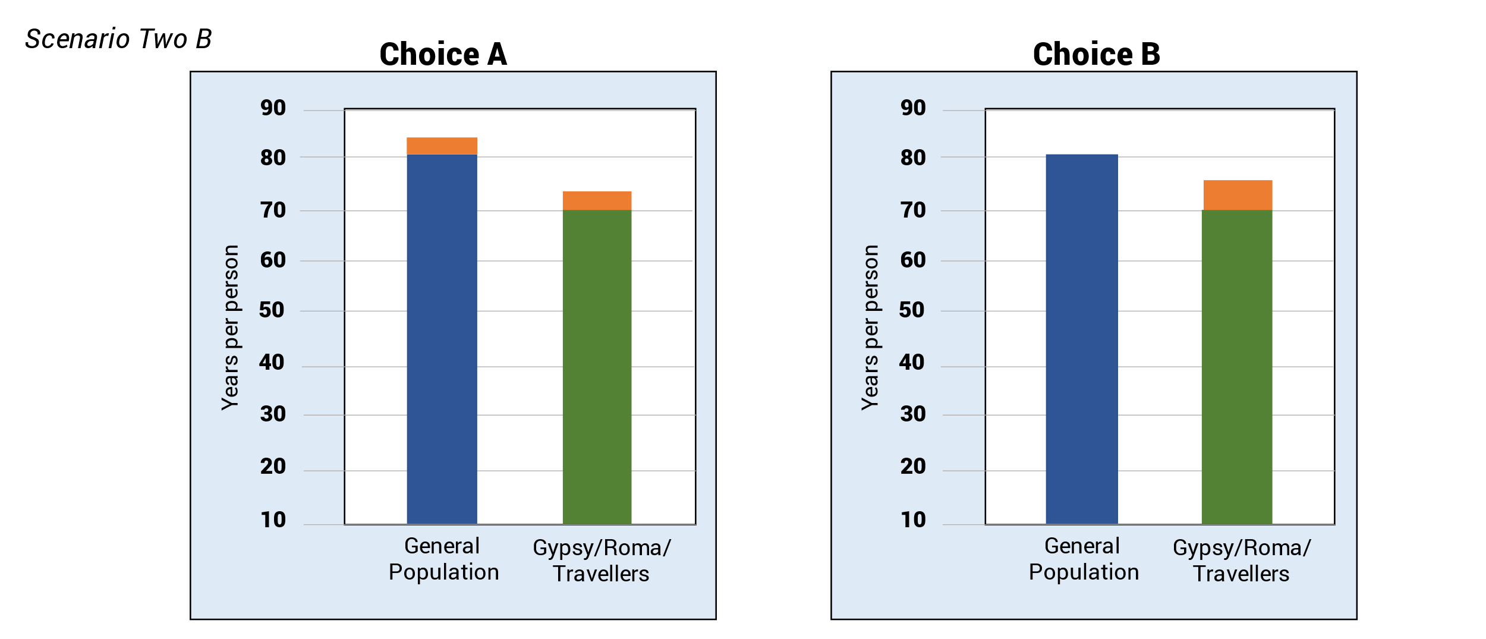

Choice A
- General Population will now live 2 years extra life
- Gypsy/Roma/Travellers will now live 2 years extra life
- The inequalities between the groups remain the same
Choice B
- Gypsy/Roma/Travellers will now live 4 years extra life
- General population will have no change in life expectancy
- Smaller gap in life expectancy between these groups

Scenario two B – slide 3
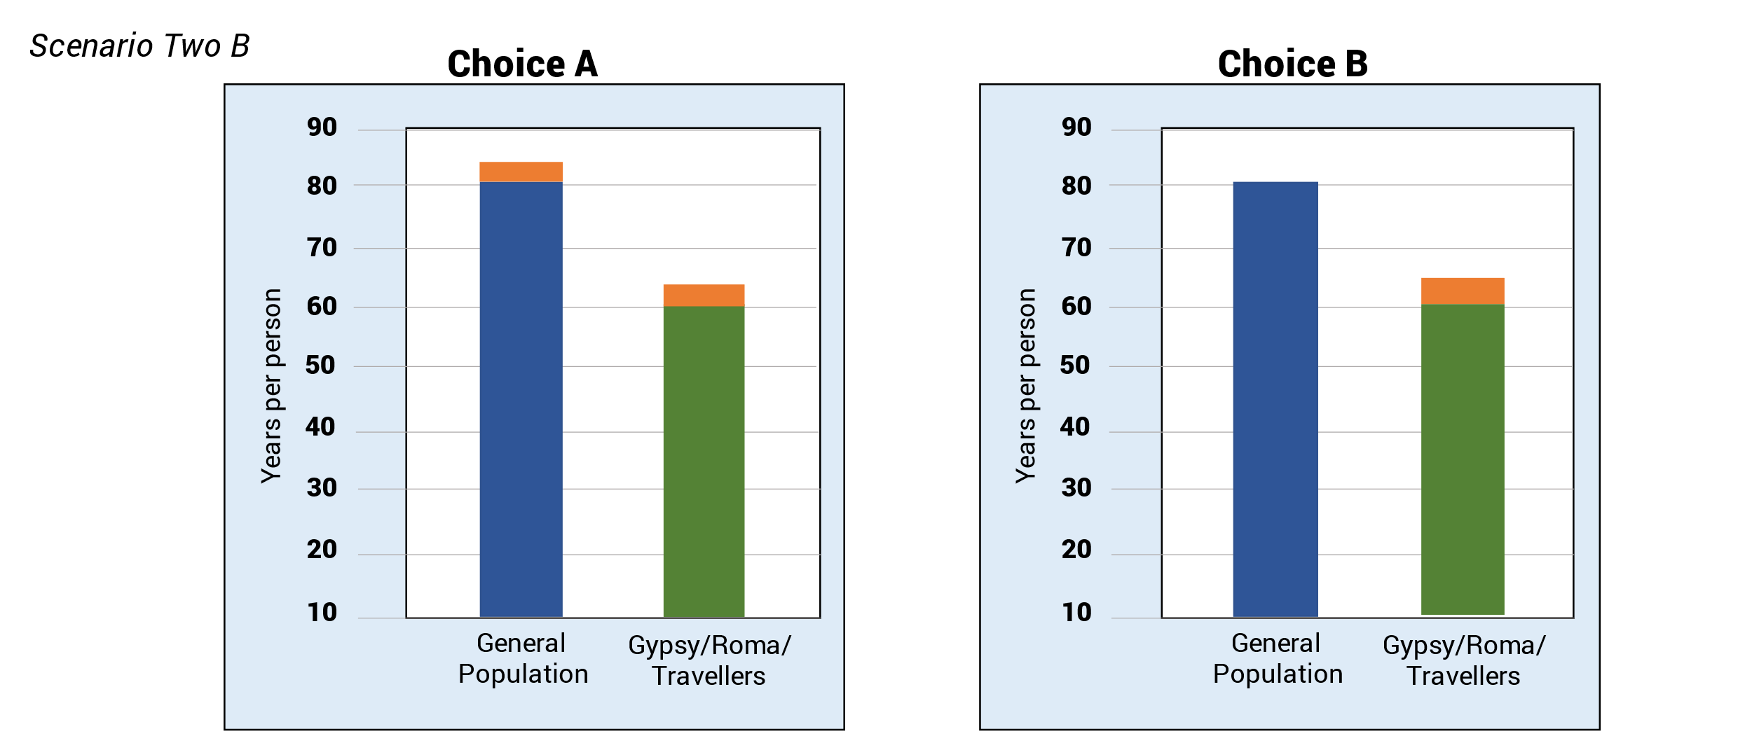

Choice A
- General Population will now live 2 years extra life
- Gypsy/Roma/Travellers will now live 2 years extra life
- The inequalities between the groups remain the same

Choice B
- Gypsy/Roma/Travellers will now live 4 years extra life
- General population will have no change in life expectancy
- Smaller gap in life expectancy between these groups

Scenario two B – slide 4
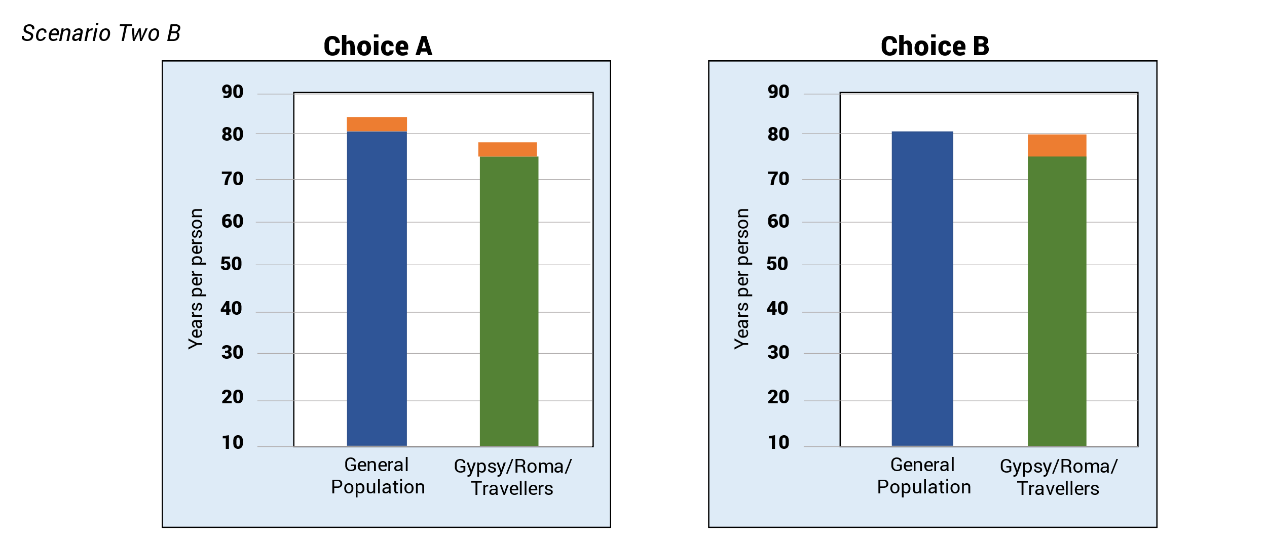

Choice A
- Gypsy/Roma/Travellers will now live 4 years extra life
- General population will have no change in life expectancy
- Smaller gap in life expectancy between these groups

Choice B
- Gypsy/Roma/Travellers will now live 4 years extra life
- General population will have no change in life expectancy
- Smaller gap in life expectancy between these groups

Scenario two B – slide 5
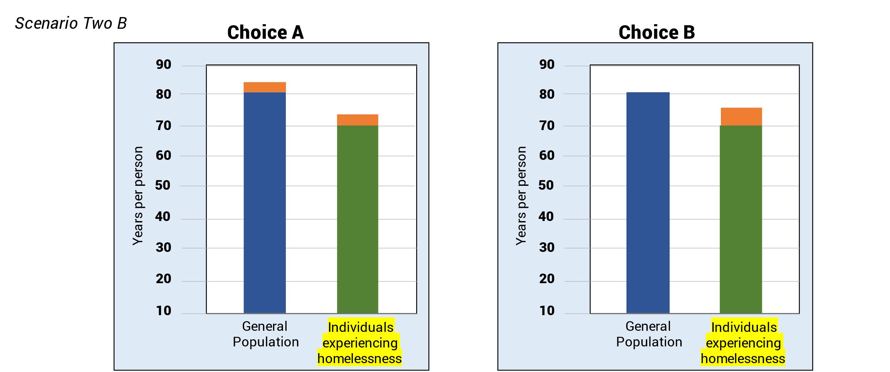

Choice A
- General Population will now live 2 years extra life
- Individuals experiencing homelessness will now live 2 years extra life
- The inequalities between the groups remain the same
Choice B
- Individuals experiencing homelessness experiencing homelessness will now live 4 years extra life
- General population will have no change in life expectancy
- Smaller gap in life expectancy between these groups

Scenario three – slide 1
Group 1 is people living in the 20% wealthiest areas of England
Group 2 is people living in the 20% most deprived areas of England
- On average Group 2 live 10 years less life than Group 1 for a variety of reasons such as:
  - people are much less likely to be in employment
  - the environment is more built up
  - quality of housing is often poorer
  - more pollution
  - greater number of fast-food outlets
  - higher proportion of people from ethnic minorities
  - younger
Groups 1 and 2 are the same size.

Scenario 3 – slide 2
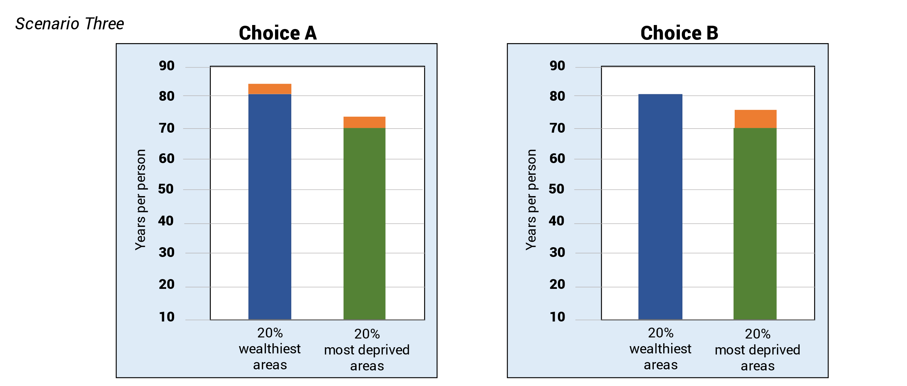

Choice A
- People living in the 20% wealthiest areas will now live 2 years extra life
- People living in the 20% most deprived areas will now live 2 years extra life
- The inequalities between the groups remain the same

Choice B
- People living in the 20% most deprived areas will now live 4 years extra life
- People living in the 20% wealthiest areas will have no change in life expectancy
- Smaller gap in life expectancy between these groups

Scenario three – slide 3
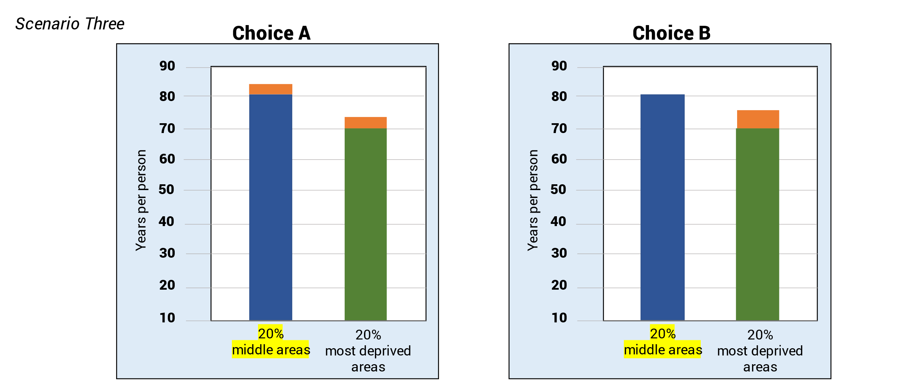

Choice A
- People living in the 20% middle areas will now live 2 years extra life
- People living in the 20% most deprived areas will now live 2 years extra life
- The inequalities between the groups remain the same

Choice B
- People living in the 20% most deprived areas will now live 4 years extra life
- People living in the 20% middle areas will have no change in life expectancy
- Smaller gap in life expectancy between these groups

Scenario 3 – slide 4
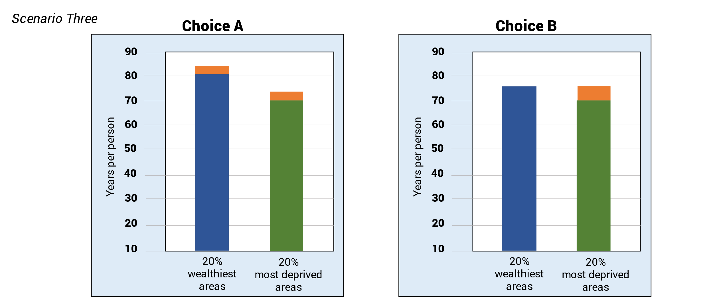

Choice A
- People living in the 20% wealthiest areas will now live 2 years extra life
- People living in the 20% most deprived areas will now live 2 years extra life
- The inequalities between the groups remain the same

Choice B
- People living in the 20% most deprived areas will now live 4 years extra life
- People living in the 20% wealthiest areas will have a reduction in life expectancy by 6 years
- Smaller gap in life expectancy between these groups

Scenario four – slide 1

Group 1 = Individuals with Type 1 Diabetes
- 10% of diabetes cases in the UK
- Genetic disorder so can impact people from childhood
- Controlled by medication
- Over time, high blood sugar levels can damage your heart, eyes, feet, and kidneys.

Group 2 = Individuals with Type 2 diabetes
- 90% of diabetes cases in the UK
- Common condition – often linked to being “overweight or inactive, or having a family history of Type 2 diabetes” - where risk can be lowered
- Controlled by medication and/or exercise and changes to diet
- “People from Black African, African Caribbean and South Asian (Indian, Pakistani, Bangladeshi) backgrounds are at a higher risk of developing Type 2 diabetes from a younger age.” (Diabetes UK)

Scenario 4 – slide 2

Choice A
Slightly improve quality of life for both Type 1 and 2 diabetes

Choice B
Greatly improve quality of life for Type 1 diabetes only

Choice C
Greatly improve quality of life for Type 2 diabetes only

Scenario five – slide 1

Group 1 = Individuals with chronic obstructive pulmonary disease (COPD)
- 1.2 million people in UK
- Symptoms include: breathing difficulty, chest infections
- Affects all ages, but most commonly diagnosed in those aged 40+ and higher amongst men
- Usually associated with long-term exposure to harmful substances such as cigarette smoke or air pollution
- Certain occupations such as mining, and construction are link with increased risks of COPD
- Treatment can control symptoms and slow progression of the disease

Group 2 = Individuals with Multiple Sclerosis (MS)
- 110,000 people in UK
- Symptoms include: fatigue, difficulty walking, problems with vision, balance and co-ordination, incontinence, problems with speech, thinking, learning, and planning
- Affects all ages, but most commonly diagnosed in those aged 20-40 and higher amongst women
- Can cause serious disability
- There's no cure for MS, but it's possible to treat the symptoms

Scenario five – slide 2

Choice A
Slightly improve quality of life for both individuals with COPD and individuals with MS

Choice B
Greatly improve quality of life for individuals with COPD only

Choice C
Greatly Improve quality of life for individuals with MS only

Scenario five – slide 3

Choice A
Slightly improve quality of life for both individuals with COPD and individuals with MS

Choice B
Greatly improve quality of life for individuals with COPD only

Choice C
Greatly Improve quality of life for individuals with MS only

Workshop three topic guide
The following is the topic guide used for workshop three.
Timings | Content
6.00 to 6.05pm | Welcome  Purpose: to reintroduce format and purpose of the public dialogue; to explain how Workshop three will run  Moderator to introduce themselves and the dialogue:  ‘Hi again everyone. Great to see you all back again. As a reminder I’m XXX from Basis.  As I’m sure you will remember by this point, you are here alongside around 25 other members of the public so we can benefit from understanding your perspectives on health and how we can improve the health of people across different sections of society.  We are running this dialogue on behalf of the National Institute for Health and Care Excellence or NICE. You heard more about their role in the last workshop and how this relates to health and social care services in England. Essentially NICE consider the evidence base relating to medicines and technologies and produce guidance that is used to make decisions in the NHS. They also produce guidelines to support broader services to improve the health of communities – so this could be used by those in charge of housing or education services.  This dialogue is to help NICE understand how members of the public think and feel about those decisions that are taken as to who and what to prioritize in improving people’s health. As with anything in life, there are decisions that organisations have to take around where money and efforts should be directed, including who to prioritise. This is as true in health and social care as it is to other services. There is no objective right or wrong here. These are decisions where arguments can be made for one group over another, and one type of intervention over another. NICE are interested in how you think about these kinds of decisions and the factors you think are important.  As before, we would like you to take part in the discussions we will have by giving your perspective and by listening and responding to the perspectives of other people. The key ground rule in this process is to be respectful of other people’s views.  My job today – along with XXX - is to help us to have a good conversation and this will cover off various different topics. As we move through the conversation you might feel you haven’t had the opportunity to say as much as you have wanted. Again, I would encourage you to use the chat function if you want to, and also the Incling community has an open forum for you to raise additional thoughts.  For this session we’re going to split you out into small groups again though we’ll be mixing these up from the groups you’ve been in for the first two workshops, so you get to meet and hear from some new people. We’ll come together again toward the end of the session to recap on some of the things discussed as a whole group.
6.05 to 6.10pm | Feeding back on interim task [Plenary]  Purpose: to feedback on the interim trade-off survey activity, and ensure everyone can see the results from the whole group  Moderator to present back findings from task completed between Workshop two and Workshop three:  Before we move into our smaller breakout groups, I wanted to present back some of the findings from the short survey you undertook following the last workshop. If you remember, this was a task where you were asked to make a choice between two different programmes both of which will improve health outcomes. However, similar to in real life, not all of the population is starting from the same point.  PLAY TRADE OFF VIDEO  We spoke a little about equality and equity in the last session. That is the difference between treating people the same, regardless of their needs or characteristics, and treating people differently, to account for differences in needs. This survey was a useful warm up exercise to understand where priorities lie when making decisions about different groups. We will spend the rest of this session exploring this a little further with some more specific examples.
6.10 to 6.20pm | Reflections on trade-off pre-task [Breakout groups]  Purpose: for participants to introduce themselves to one another and to begin to discuss the decision-making process and criteria by which trade-off choices are made in relation to services supporting health and social care  Moderator to manage introductions and consent:  Hello everyone. I’ve not met many of you before so I’m XXX. As we’ve mixed the groups up a little it would be great if you could take a moment to introduce yourselves to one another and to reflect on what we’ve been discussing over the past couple of sessions.  Before we start, we mentioned previously that we will be recording the session today. Does anyone have any questions or concerns about this? [Moderator to gain verbal consent. All participants have previously provided written consent.]  [If necessary. We also have a member of NICE joining us today to observe the session and hear people’s honest opinions. XXX do you want to briefly say Hi?’ Explain that they are here to listen only]  We do want you all to be as open and honest as you want throughout this discussion. As before please feel free to share as much or as little personal information as you feel comfortable with. We fully understand that health can be a very personal and sensitive subject so please say as much or as little about your own circumstances as you want.  [Note to moderator: if people experience distress because of the nature of discussions please can you (i) encourage them to take a break and (ii) contact Dan and he will follow up with each participant directly to signpost aftercare.]  Now, if we can briefly go around the virtual table to introduce ourselves that would be great. XXX do you want to start?  We’re going to spend the majority of this session looking at some example scenarios which relate to prioritising resources to tackle health inequalities, but before we do so it would be good to pick up where we left off in the last workshop. Now, I don’t want you to imagine you are NICE, the NHS or your local authority. You are you, a member of the general public. You may have specific health conditions or needs, as might your friends and loved ones.  In making decisions around how you would prioritise services that focus on health and care, what factors do you think are important to take into account? Probe around mentions of:  Equality and inequalities  Equity (i.e. accounting for differences in needs to achieve similar outcomes)  Utility (i.e. greatest good for greatest number)  Impact  Value for money  Specific conditions, circumstances, or population groups
6.20 to 6.30pm  6.30 to 6.40pm  6.40 to 6.55pm  6.55 to 7.10pm | Trade-off scenarios Pt1 [Breakout groups]  Purpose: to identify those factors influencing trade-off decisions, and how/when decisions change depending on assumptions/beliefs  What were your thoughts on the survey task you were asked to complete after the last workshop? Probe whether people found it challenging or straightforward, and why?  How did you go about making your decisions as to which programme the NHS should choose? What criteria were you using to make your decisions? Please do be open and honest about your views, as opposed to how you think the NHS or NICE should make their decisions. Probe on:  Absolute gain vs reducing inequalities  Whether anyone prioritized Programme A over Programme B in most scenarios, and why  At what point people switched from Programme B to Programme A, and why  If helpful please reinforce to participants that these scenarios have been created to allow discussion, though they relate to real conditions and groups of people, their decisions will not have any direct effect on any funding decision i.e. we aren’t putting real scenarios to them to decide how NICE should act for that particular scenario…their input, however, will help NICE understand broader public perceptions on priorities and reasons for those priorities.  We’re now going to show you another scenario. I’m going to share my screen so you can see it and review in your own time, but I’ll just read it out in case that is helpful. [Moderator to share screen with Scenario 1 and read text out loud].  Scenario one:  Imagine that there are two groups of people with different life expectancies. Group 1 lives (on average) 10 years longer than Group 2. A choice needs to be made on how to spend part of the health services budget to improve life expectancy.  You will now need to choose between two choices. They both cost the same and the budget is fixed and cannot be changed.  Choice A would be to invest the money in a way that improves life expectancy for both groups by 2 years.  Choice B would be to invest the money in programmes that benefit the group with shorter life expectancy (Group 2). This would mean that Group 2 will now live 4 years extra life while Group 1 will have no change in life expectancy. This means there would be a smaller gap in life expectancy between these groups.  Please put your selection in the chat  Who opted for Choice A? Choice B? What was the thought process behind your decisions?  Did one choice seem more equal? Or fair?  Imagine you were in Group 1, would that affect your decision?  Now what choice would you pick if I was to say that Group 1 is women and Group 2 is men in England? [Repeat scenario and choices A and B if needed]  We’re now going to show you another scenario where we know even more about the two groups. I’m going to share my screen again so you can see it and review in your own time but I’ll just read it out in case that is helpful. [Moderator to share screen with Scenario and read text out loud].  Scenario two A :  In this instance, we’re talking about Manchester. Group 1 is the general population, of which there are 500,000 people while Group 2 refers to individuals experiencing homelessness, of which there are 3,500 people. Group 2 actually lives 10 years less life than Group 1 for a variety of reasons related to living in homelessness. This includes higher numbers of people living with drug and/or alcohol addiction, low or no-incomes, poorer living conditions which are all related to worse overall health. They can also struggle with access to health and support services.  You will now need to choose between two choices. They both cost the same and the budget is fixed and cannot be changed.  Choice A would be to invest money in services in a way that improves life expectancy by 2 years for both Group 1 and Group 2.  Choice B would be to invest the money in a way that instead improves life expectancy by 4 years for Group 2, those with an experience of homelessness, while Group 1, the general population would see no improvements in life expectancy. This means there would be a smaller gap in life expectancy between these groups.  Please put your selection in the chat  Who opted for Choice A? For those of you that opted for Choice A can you talk us through your thinking process. Explore the criteria that participants were using to help them make their decision.  Who opted for Choice B? For those of you that opted for Choice B can you talk us through your thinking process. Explore the criteria that participants were using to help them make their decision.  Was anyone undecided? Or did anyone find it difficult to make this decision? Why?  What factors were most influential in influencing your decisions?  Does one choice seem more equal?  Does one choice seem more fair?  Is it morally right or wrong to choose one over the other?  (How and why) would your decision change if:  the actual difference in life expectancy was larger than 10 years, so if it were 20 years for example?  the actual difference in life expectancy was smaller than 10 years, so if it were 5 years for example?  Group 1 were not the general population in Manchester, but people impacted by heart disease, one of the leading causes of death in the UK  Group 2 were not homeless people, but a specific ethnic group, like people of Bangladeshi and Pakistani ethnicities?  Scenario two B:  Now imagine we know even more about the different groups and why there is a difference in life expectancy. In this instance, we’re talking about Manchester. Group 1 is the general population, of which there are 500,000 people while Group 2 refers to Gypsy/Roma/Travelers, of which there are 3,500 people. Group 2 actually lives on average 10 years less life than Group 1 for a variety of reasons. Compared to the general population Gypsy/Roma/Travelers have lower levels of participation in formal education and face higher levels of discrimination, both of which are both linked to poor health. They also have higher rates of mental illness including depression.  You will now need to choose between two choices. They both cost the same and the budget is fixed and cannot be changed.  Choice A would be to invest money in services in a way that improves life expectancy by 2 years for both Group 1 and Group 2.  Choice B would be to invest the money in a way that instead improves life expectancy by 4 years for Group 2, Gypsy/Roma/Travelers in Manchester, while Group 1, the general population would see no improvements in life expectancy. This means there would be a smaller gap in life expectancy between these groups.  Who opted for Choice A? For those of you that opted for Choice A can you talk us through your thinking process. Explore the criteria that participants were using to help them make their decision.  Who opted for Choice B? For those of you that opted for Choice B can you talk us through your thinking process. Explore the criteria that participants were using to help them make their decision.  Was anyone undecided? Or did anyone find it difficult to make this decision? Why?  What factors were most influential in influencing your decisions?  Does one choice seem more equal?  Does one choice seem fairer?  Is it morally right or wrong to choose one over the other?  Would your decision change if the actual difference in life expectancy was larger than 10 years, so if it were 20 years for example?  (How and why) would your decision change if:  the actual difference in life expectancy was larger than 10 years, so if it were 20 years for example?  the actual difference in life expectancy was smaller than 10 years, so if it were 5 years for example?  group 2 were not Gypsy, Roma, and Travellers, but instead people impacted by homelessness?  We’re now going to show you another scenario. I’m going to share my screen again so you can see it and review in your own time, but I’ll just read it out in case that is helpful. [Moderator to share screen with Scenario 3 and read text out loud].  Scenario three:  Now let us take another scenario. This time Group 1 live in the 20% wealthiest areas of England, while Group 2 are people living in the 20% most deprived areas of England. There are equal numbers of people in each of these groups. People in Group 2 are living 10 years shorter lives than Group 1. This is due to a number of reasons. In more deprived areas people are much less likely to be in employment, the environment is more built up and quality of housing is often poorer, there is more pollution and a greater number of fast-food outlets which are a negative influence on the choices of people living nearby. There are a higher proportion of people from ethnic minorities living in more deprived areas and the population in these areas tends to be younger.  You will now need to choose between two choices. They both cost the same and the budget is fixed and cannot be changed.  Choice A would be to invest money in a way the improves life expectancy by 2 years for Group 1 and Group 2.  Choice B would be to invest the money in a way that prioritises Group 2. This would lead to an improvement in life expectancy by 4 years for Group 2, the individuals living in deprived areas, while Group 1, the individuals living in the wealthier areas would stay the same. This means there would be a smaller gap in life expectancy between these groups.  Please put your selection in the chat  Who opted for Choice A? For those of you that opted for Choice A can you talk us through your thinking process. Explore the criteria that participants were using to help them make their decision.  Who opted for Choice B? For those of you that opted for Choice B can you talk us through your thinking process. Explore the criteria that participants were using to help them make their decision.  Was anyone undecided? Or did anyone find it difficult to make this decision? Why?  What factors were most influential in influencing your decisions?  Does one choice seem more equal?  Does one choice seem fairer?  Is it morally right or wrong to choose one over the other?  (How and why) would your decision change if:  you knew that you lived in one of the 20% wealthiest areas?  Group 2 remained the 20% most deprived areas of England, but Group 1 were actually those 20% in the middle (i.e. not the richest or the poorest areas of the country)?  Choice B led to a reduction in life expectancy amongst Group 1 (for example, this programme increased the life expectancy of the poorest communities, but to achieve this, there was a decrease in life expectancy among the wealthiest communities, for example because health/care services are reduced)?  OK. We’ll take a quick comfort break now before looking at some alternative scenarios where we consider your choices in the context of specific conditions. Please have a 5 minute break and we’ll all come together again at 7.15pm.
7.10 to 7.15pm | COMFORT BREAK
7.15 to 7.30pm  7.30 to 7.45pm  7.45 to 7.50pm | Trade-off scenarios Pt2 [Break out groups]  Purpose: to identify those factors influencing trade-off decisions, and how/when decisions change depending on assumptions/beliefs  Now we are going to take another scenario, but this time instead of comparing the general population and a specific group, we’re now going to look at groups which each have a specific condition.  I’m going to share my screen again so you can see it and review in your own time but I’ll just read it out in case that is helpful. [Moderator to share screen with Scenario 4 and read text out loud].  Scenario four:  Now let us take another scenario, this time instead of comparing the general population and a specific group these groups each have a specific condition. Specifically, Group 1 is a small group of individuals with Type 1 diabetes, while Group 2 is a larger group of individuals with Type 2 diabetes.  Type 1 diabetes is a genetic disorder which you are born with. It makes up only about 10% of diabetes cases in the UK. According to the NHS “Type 1 diabetes causes the level of sugar (glucose) in your blood to become too high.”  Type 2 diabetes makes up about 90% of the cases of diabetes in the UK. According to the NHS: “Type 2 diabetes is a common condition that causes the level of sugar (glucose) in the blood to become too high.” “It's caused by problems with a chemical in the body (hormone) called insulin. It's often linked to being overweight or inactive, or having a family history of type 2 diabetes.” Also, according to Diabetes UK: “People from Black African, African Caribbean and South Asian (Indian, Pakistani, Bangladeshi) backgrounds are at a higher risk of developing type 2 diabetes from a younger age.” The causes of this could be genetic or lifestyle or both, but it is actually not fully understood why this is.  Type 2 diabetes is often milder than Type 1 in terms of its impacts.  You will now need to choose between three choices. They all cost the same and the budget is fixed and cannot be changed.  Choice A would invest money equally for both Type 1 and 2 diabetes, improving the quality of life of both groups slightly.  Choice B would invest the money in a way that would more greatly improve quality of life for Group 1, the smaller group of people with Type 1 diabetes.  Choice C would be to invest the money in a way that would more greatly improve quality of life for Group 2, the larger group of people with Type 2 diabetes.  Please put your selection in the chat  Who opted for Choice A? For those of you that opted for Choice A can you talk us through your thinking process. Explore the criteria that participants were using to help them make their decision.  Who opted for Choice B? For those of you that opted for Choice B can you talk us through your thinking process. Explore the criteria that participants were using to help them make their decision.  Who opted for Choice C? For those of you that opted for Choice B can you talk us through your thinking process. Explore the criteria that participants were using to help them make their decision.  Was anyone undecided? Or did anyone find it difficult to make this decision? Why?  What factors were most influential in influencing your decisions? Probe specifically on:  the size of each of the two groups, and whether if the sizes were the same, would this influence their choice  the influence of how common conditions are on views (Type 2 is more common than Type 1)  the influence of individual behaviours/choices on views  the influence of the severity of conditions on views (Type 1 is more severe than Type 2 – Type 1 is incurable, whereas Type 2 can be prevented and put into remission e.g. through weight loss)  The number of available treatments, T1D had only one treatment (insulin), whereas T2D has several.  Does one choice seem more equal?  Does one choice seem fairer?  Is it morally right or wrong to choose one group over the other?  Given that Type II diabetes is more likely to impact ethnic minority groups, whose health is also more likely to be negatively impacted by other factors (such as lower than average income, larger households, living in urban areas), does this influence your views at all? I.e. is it important to account for health inequalities which result not from the condition itself, but from wider factors like housing, education, income etc.?  We’re now going to show you one final scenario. I’m going to share my screen again so you can see it and review in your own time, but I’ll just read it out in case that is helpful. [Moderator to share screen with Scenario 5 and read text out loud].  Scenario five:  Similarly, to scenario four, we will now compare two specific groups again. In this case, Group 1 consists of individuals with Chronic Obstructive Pulmonary Disease (COPD), while Group 2 consists of individuals with Multiple Sclerosis  COPD is the name for a group of lung conditions which includes emphysema and chronic bronchitis. It impacts over 1 million people in the UK, though most often men over 40. According to the NHS: “COPD is a common condition that mainly affects middle-aged or older adults who smoke. Many people do not realise they have it. The breathing problems tend to get gradually worse over time and can limit normal activities, although treatment can help keep the condition under control.” It is worth highlighting that COPD can also be impacted by environmental pollution and occupational exposure to dusts, gases, and fumes. It has been found to be linked with certain occupations such as mining and construction. In some cases, it can also be genetic.  Multiple Sclerosis (MS) is a rare condition that impacts about 130,000 people in England. According to the NHS “Multiple sclerosis (MS) is a condition that can affect the brain and spinal cord, causing a wide range of potential symptoms, including fatigue, difficulty walking, problems with vision, balance and co-ordination and problems with thinking, learning and planning.” It is a lifelong condition that can cause serious disability although is some cases it is milder. MS is an autoimmune condition. This is when something goes wrong with the immune system and it mistakenly attacks a healthy part of the body – in this case, the brain or spinal cord of the nervous system. MS is most commonly diagnosed between the ages of 20 and 40 and is approximately three times more common in women than men.  You will now need to choose between three choices. They all cost the same and the budget is fixed and cannot be changed.  Choice A would be to invest money equally for both groups, improving the quality of life of both groups slightly.  Choice B would invest the money in a way that would more greatly improve quality of life for Group 1, the individuals with COPD, this option would involve no change in quality of life for individuals with MS  Choice C to invest the money in a way that would more greatly improve quality of life for Group 2, individuals with MS. This option would have no change in quality of life for individuals with COPD  Please put your selection in the chat  Who opted for Choice A? For those of you that opted for Choice A can you talk us through your thinking process. Explore the criteria that participants were using to help them make their decision.  Who opted for Choice B? For those of you that opted for Choice B can you talk us through your thinking process. Explore the criteria that participants were using to help them make their decision.  Who opted for Choice C? For those of you that opted for Choice B can you talk us through your thinking process. Explore the criteria that participants were using to help them make their decision.  Was anyone undecided? Or did anyone find it difficult to make this decision? Why?  What factors were most influential in influencing your decisions? Probe specifically on:  the size of each of the two groups, and whether if the sizes were the same, would this influence their choice  the influence of how common conditions are on views  the age of diagnosis  the influence of individual behaviours/choices on views  the fact that COPD can be caused by the type of job someone has had e.g. manual jobs which are often lower paid, where people are exposed to dust and fumes  the influence of the severity of conditions on views  the gender differences in likelihood of developing condition  Does one choice seem more equal?  Does one choice seem fairer?  Is it morally right or wrong to choose one group over the other?  What if Option B only moderately improved the QoL of group 1, but significantly improved the life of Group 2?  We’ve covered a lot this evening so thank you for all your time, energy, and attention. Before we go back into plenary I just want to spend a few minutes as a group reflecting on the key criteria that you have been using in making your judgements this evening. Based on the discussions we have had it seems like X, Y and Z are important. [Moderator to call out factors/criteria seen to be important].  Do you agree with this? Probe for any thoughts/builds/points of consensus or disconsensus  If you had to prioritise these criteria, for you personally, which do you think are most important, and why?  We’re going to go back into plenary now. What would be great is if one of you wouldn’t mind feeding back some thoughts/reflections to the main group around how you found making these judgements, just to very briefly share what we have discussed. Other groups will be doing the same thing. Would anyone be ok to do this? [If not, then moderator to be prepared to feedback from session]
7.50 to 8.00pm | Feedback and close [Plenary]  Just before we close off for the evening it would be good to hear from each group to understand how they approached the trade-off scenarios, what criteria were used to make decisions and why.  Representative from each group to feedback.  Thank you again for your time this evening.  The next and final workshop will be on 16th November. We’ll post some short discussion tasks for you online in between now and then, so please do log on to Incling when prompted and take part in the discussions.  Thanks again for all your time and energy and have a great rest of your evening.

Workshop four

Workshop four stimulus
Workshop four was held on Zoom on Tuesday, 16th November from 6 to 8pm and was attended by 27 of the 28 participants. This session again involved five moderated breakout discussions of five to six participants where they discussed various prioritisation areas related to actions NICE can take. The participants discussed scenarios that addressed various ways in which health inequalities exist and participants were asked to choose where they would prioritise addressing health inequalities if they were a public representative in a NICE committee and to discuss and debate their justification for this. They also discussed ways in which NICE can address health inequalities and their prioritisation for different approaches.
The following stimulus was used to support the discussion:
- Stimulus 1: NICE process for developing guidelines: a 3-minute video clip introducing NICE’s process for developing guidelines
- Stimulus 2: Participants were tasked with prioritising 10 factors that may influence NICE guideline topic selection. A PowerPoint slide with the following text was used to aid the discussion:
Please order these factors by priority
A. Conditions or topics where there are no existing guidelines
B. Conditions or topics where guidelines are old (and where the evidence base may have changed)
C. Conditions or topics which are placing most demand on the health/care system
D. Conditions or topics which impact the most people (regardless of severity)
E. Conditions or topics which impact some groups more than others for reasons that are avoidable and unfair
F. Conditions or topics where there is a risk to patient safety
G. Conditions or topics which can be seen as severe in terms of their health impacts (loss of life or quality of life)
H. Conditions or topics which are rare and therefore aren’t well understood, not well funded and have few treatment options
I. Guidelines focusing on prevention rather than treatment
J. Guidelines focusing on treatment rather than prevention

- Stimulus 3.1: Participants were tasked with making a hypothetical priority decision. A PowerPoint slide with the following text was used to aid the discussion.
You are a public representative on a NICE committee.
Would you rather:
- NICE spent more time and resources choosing guidelines that help to address health inequalities but produce fewer guidelines overall
– OR –
B. NICE spent less time and resources focusing on health inequalities but was able to achieve greater coverage of topics in their guidelines

- Stimulus 3.2: Participants were tasked with making a hypothetical priority decision. A PowerPoint slide with the following text was used to aid the discussion.
You are a public representative on a NICE committee.
Would you rather:
- NICE spent more time and resources choosing guidelines to address health inequalities, although this may mean less consistent coverage of care across the country
– OR –
B. NICE spent less time and resources choosing guidelines to address health inequalities, which may mean more consistent coverage of care across the country

- Stimulus 4.1: Participants were tasked with making a hypothetical priority decision. A PowerPoint slide with the following text was used to aid the discussion:
People with learning disabilities may have greater difficulty in identifying health problems and getting treatment for them
They are more likely to have physical health problems such as epilepsy and diabetes; as a result, they have a shorter life expectancy and reduced quality of life
An annual physical health check could lead to identification and management of underlying physical health problems at an earlier stage for adults living with learning disabilities. This could mean they have a better quality of life and may live for longer.
In recommending the health checks for adults with learning disabilities funds will need to be removed from another part of the health and care system.
Should NICE recommend the health checks for adults with learning disabilities?

- Stimulus 4.2: Participants were tasked with making a hypothetical priority decision. A PowerPoint slide with the following text was used to aid the discussion:
‘Diabetes for you’ is a small device that enables patients to monitor their condition and record ECGs and blood sugar levels at home
It analyses the results and sends a weekly report to the patient’s doctor. If needed, the patient receives a text and an email asking them to arrange to see their GP
The device costs £175 and links to the patient’s smartphone so is affordable for the NHS
The device can’t be used without a smartphone and requires good wifi or mobile data. This means that patients who do not have a smartphone and wifi or good mobile network would not be able to use the device. It also requires patients to be able to receive text messages and/or emails.
This would save the NHS money, and it may improve health outcomes, but it may widen inequalities.
Should NICE recommend ‘Diabetes for you’?

- Stimulus 5: Participants were tasked with prioritising 10 possible actions or approaches NICE could take to address health inequalities, based on importance. A PowerPoint slide with the following text was used to aid the discussion.
Please order these factors by priority:
- Encouraging health and care organisations to address health inequalities
- Encouraging other organisations outside of the health and care system (e.g. schools, local authorities) to address health inequalities
- Having clear and accessible information on how NICE can support efforts to reduce health inequalities
- Provide training to all NICE staff on what health inequalities are and what NICE’s role is in addressing them
- Prioritising NICE guidance on topics and areas that focus on health inequalities
- Recommending activities in NICE’s guidance to address health inequalities in specific disadvantaged groups
- Recommending that research is done to help us understand where there are health inequalities, who is most impacted and what are the likely causes
- Monitoring and evaluating how organisations are using NICE guidance to address health inequalities
- Involving people from groups affected by health inequalities in NICE’s work
- Actively working with partner organisations to ensure that NICE guidance is implemented in a way that will help reduce health inequalities

Workshop four topic guide
The following is the topic guide used for workshop four.
Timings | Content
6.00 to 6.05pm | Welcome  Purpose: to recap on the format and purpose of the public dialogue; to explain how Workshop four will run  Moderator to introduce themselves and the dialogue:  ‘Hi again everyone. Great to see you all back here again. As a reminder I’m XXX from Basis.  This is the fourth time we’ve regrouped so it probably goes without saying now but you are here alongside around 25 other members of the public so we can benefit from understanding your perspectives on health and improving the health of people across different sections of society.  We are running this dialogue on behalf of the National Institute for Health and Care Excellence or NICE to help them understand how members of the public think and feel about those decisions that are taken as to who and what to prioritize in improving people’s health. In the last session we presented you with a number of challenging scenarios where decisions needed to be made about prioritizing the support given to different groups. The thinking process you went through in making those decisions was what was important for us to understand, moreso than the decisions themselves.  This time around we are going to focus back on NICE, the decisions they have to take in relation to writing guidelines and to get your view on the extent to which health inequalities should be prioritized in these decisions.  As before, we would like you to take part in the discussions we will have by giving your perspective and by listening and responding to the perspectives of other people. The key ground rule in this process is to be respectful of other people’s views.  My job today – along with the other moderators - is to help us to have a good conversation and this will cover off various different topics. As we move through the conversation you might feel you haven’t had the opportunity to say as much as you have wanted. Again, I would encourage you to use the chat function if you want to, and also the Incling community has an open forum for you to raise additional thoughts should you wish.  For this session we’re going to split you out into small groups again though we’ll come together again toward the end of the session to recap on some of the things we’ve learned over the past 8 weeks.
6.05 to 6.15pm | Reflections on trade-off scenarios from workshop 3 [Breakout groups]  Purpose: for participants to reintroduce themselves to one another and to warm-up the discussion  Moderator to manage introductions and consent:  Hello again everyone. As a reminder, I’m XXX. Great to see everyone again and hopefully you might recognize one another from the last discussion.  Before we start, we mentioned previously that we will be recording the session today. Does anyone have any questions or concerns about this? [Moderator to gain verbal consent. All participants have previously provided written consent.]  [If necessary. We also have a member of NICE joining us today to observe the session and hear people’s honest opinions. XXX do you want to briefly say Hi?’]  We do want you all to be as open and honest as you want throughout this discussion. As before please feel free to share as much or as little personal information as you feel comfortable with. We fully understand that health can be a very personal and sensitive subject so please say as much or as little about your own circumstances as you want.  [Note to moderator: if people experience distress because of the nature of discussions please can you (i) encourage them to take a break and (ii) contact XXX and he will follow up with each participant directly to signpost aftercare.]  Just to kick-off with, it would be great to hear your reflections from the last workshop? As needed probe on:  Which decisions were hardest to make and why?  Which groups did they tend to prioritise and why?
6.15 to 6.20pm  6.20 to 6.35pm  6.35 to 6.45pm | Prioritising guidelines [Breakout groups]  Purpose: To get the public’s views on where Health Inequalities should be considered when prioritising guidelines  Now we’re going to talk a little more about how NICE go about making their decisions on which conditions or topics to focus on. Before we carry on the conversation, to make this a little less abstract for people I want to play a short video to explain how the process currently works.  Moderator to show Stimulus 1 (3 minute video clip introducing NICE process for developing guidelines)  Do you have any immediate questions about what you just heard in terms of the guidelines? [NICE staff to be on standby to answer queries]  Moderator to explain:  ‘In choosing which topics to focus on, NICE have choices to make about when and how much to prioritise tackling health inequalities over other things, like reaching greater overall numbers of people, or in updating older guidelines which may not capture the latest evidence. As we’ve discussed before, there are always limited resources – time and money - and it is necessary to make decisions about where best to allocate this resource.  I want you now to imagine you were public representatives sitting on a NICE committee and you were involved in deciding which guidelines NICE should prioritise to develop or update next. Please remember these could cover a wide variety of topics: from diagnosing diabetes to treating COVID, and from safeguarding care home residents to indoor air quality in residential buildings. However, it is only possible to select some topics as there isn’t the time or staff to look at them all.  On the screen I’m sharing with you a series of factors that could influence decisions on which guidelines to create or update.  Working as a group, I would like you prioritise these factors in assessing topics in order of the degree to which you think they are most important. I.e. the factor at the top is the most important consideration, and the factor at the bottom is the least important. I can move the order of these around, so please discuss amongst yourselves what order you think these should go in and why.’  Moderator to show Stimulus 2 (PowerPoint slide with 10 factors) and help participants to prioritise ordering by working through one by one and gaging broad level of importance, re-ordering as needed, including if any are equally important. Note there is a hidden slide with examples for each factor if helpful/needed.  For each please ensure discussion takes place around:  Why/when seen to be important  Reasons for consensus/disconsensus  Any caveats/assumptions  How combinations of factors influence views (e.g. if ‘severe plus changing evidence base’, does this change ordering of higher/lower level factors)  There was one factor here which related to health inequalities, which you placed in # position. If this was altered to reflect different aspects of health inequality, how would that influence its importance? For example, ‘Conditions which…’:  impact people from some ethnic groups more than others  occur more in socio-economically disadvantaged groups, though the health impact on each person is the same impact everyone equally but occur more in disadvantaged groups  impact people living in some parts of the same region more than others  impact people living in some parts of the same town more than others  For each of the above explore whether this alters the degree to which it is seen to be a factor which warrants greater or lesser priority. Probe  Why additional information does/does not alter priority  Which of these differences feel more ‘unfair and avoidable’?  Which of these differences are more important for NICE to account for, and why?
6.45 to 6.55pm  6.55 to 7.10pm | Additional health inequality related trade-off considerations [Breakout groups]  Purpose: for participants to understand and discuss the other trade-offs that NICE has to make when prioritizing health inequalities in guidelines  Moderator to explain: When selecting guidelines based on the criteria we just discussed and prioritised there are other trade-offs to be made when addressing certain topics such as health inequalities. They require time and staff expertise, and because health inequalities relate to a wide range of factors (demographics, education, housing, income etc.) they can require much more time and resource to address. This resource has to come from somewhere – effectively from the time NICE can spend on other topics and conditions. Fewer guidelines mean delays in getting up-to-date guidance to practitioners on those areas that have not been prioritised, with a direct impact on patients.  Moderator to show Stimulus 3.1 and read out:  Again, assuming you are a public representative on a NICE committee. Would you rather NICE spent more time and resources choosing guidelines that help to address health inequalities but produce fewer guidelines overall – OR – would you rather NICE spent less time and resources focusing on health inequalities but was able to achieve greater coverage of topics in their guidelines? Explore:  reasoning behind responses (including fairness, equality, equity, perceived utility etc.)  additional information needs  areas of consensus and disconsensus  Just to make this a little more tangible, this might mean:  choosing to develop a guideline that is aimed at mothers who are at higher risk of maternity complications (such as those from certain ethnic minority backgrounds) vs. updating guidance on post-natal care for all that brings recommendations up to date  focusing a guideline on the diagnosis and treatment of prostate cancer for all or focusing it specifically on how to increases diagnoses in Black men who are twice as likely to get prostate cancer than other men. People from Black African and Black Caribbean backgrounds are also more likely to be living in the 10% most deprived neighbourhoods, which is also linked to experiencing worse health outcomes  For each of these examples, explore whether this alters views on priorities.  Moderator to show Stimulus 3.2 and read out:  Again, assuming you are a public representative on a NICE committee. Would you rather NICE spent more time and resources choosing guidelines to address health inequalities although this may mean that there would be less consistent coverage of care across the country? Explore:  reasoning behind responses (including fairness, equality, equity, perceived utility etc.)  additional information needs  areas of consensus and disconsensus  Just to make this a little more tangible, this might mean:  Producing guidelines for managing the care of all lung cancer patients versus producing guidance on treatment for mesothelioma, a type of lung cancer that is more commonly seen in people who have had manual jobs such as shipbuilding and railway engineering (due to exposure to asbestos), so mesothelioma cases are concentrated in regions associated with these industries.  Focusing mental health guidelines on the mental health and wellbeing of the general population versus supporting people living in urban areas which have higher levels of deprivation and where there is a higher incidence of mental illness. Only 1 in 3 people who experience mental health problems are able to access the support they need. Those facing the highest levels of poor mental health often experience the greatest difficulty in accessing services.  For each of these examples, explore whether this alters views on priorities.  OK. Please have a 5 minute break and we’ll all come together again at 7.15pm.
7.10 to 7.15pm | COMFORT BREAK
7.15 to 7.25pm | Cost effectiveness [Breakout groups]  Purpose: to get the public’s views on whether health inequalities should be prioritised at the cost of other services in the healthcare system  Moderator to explain: If NICE is to prioritise guidance that reduces health inequalities, then this means that resources in the health and care system will have to be allocated to tackling these health inequalities, which means that these resources – staff, services, and care - will not be used elsewhere in the health and care system, especially for services that may serve more general populations.  Moderator to show Stimulus 4.1 and read out:  People with learning disabilities may have more difficulty than those without in identifying health problems and getting treatment for them. As well as being less likely to receive treatment, people with a learning disability are more likely to have physical health problems such as epilepsy and diabetes. As a result, they have a shorter life expectancy and reduced quality of life than the general population.  An annual physical health check could lead to identification and management of underlying physical health problems at an earlier stage for adults living with learning disabilities. This could mean they have a better quality of life and may live for longer.  In recommending the health checks for adults with learning disabilities funds will need to be removed from another part of the healthcare system for example:  less nursing staff or,  less funding for services to address mental health or,  reduction in smoking cessation services  It is usually impossible to be able to tell exactly where the funds will be taken from, but they will be taken from somewhere in the health and social care system.  Should NICE recommend the health checks for adults with learning disabilities, and in doing so reduce health inequalities but at the expense of other services for the general population? Explore:  reasoning behind responses (including fairness, equality, equity, perceived utility etc.)  additional information needs  areas of consensus and disagreement  what if, instead of people with learning disabilities, we were talking about:  people of Black African ethnicity?  people living in overcrowded housing?  what if, instead of health screening, we were talking about a new medicine? Would this change your views? Why/why not?
7.25 to 7.35pm | Moderator to show Stimulus 4.2 and read out:  ‘Diabetes for you’ is a small device that links via Bluetooth to smartphones. It enables patients to monitor their condition and record ECGs (which check the heart is working properly) and blood sugar levels at home. It then analyses the results and sends (via wifi) a weekly report to the patient’s doctor. If the test results show that the patient’s condition is worsening, the patient receives a text and an email asking them to arrange to see their GP. The device costs £175 and links to the patient’s smartphone so is affordable for the NHS. It would avoid patients needing to make repeat visits to their GP and hospital as patients could use the device to monitor their own condition. It also allows their clinician to monitor them remotely, freeing up some clinician time. The device can’t be used without a smartphone and requires good wifi or mobile data (e.g. 4G). This means that patients who do not have a smartphone and/or wifi or good mobile network would not be able to use the device. It also requires patients to be able to receive text messages and/or emails.  This could save the NHS money, and it may improve health outcomes, but it may widen inequalities because it may exclude certain groups, especially the most deprived.  Should NICE recommend ‘Diabetes for you’? Explore:  reasoning behind responses (including fairness, equality, equity, perceived utility etc.)  additional information needs  areas of consensus and disconsensus  other circumstances where NICE could recommend interventions that widen inequalities
7.35 to 7.55pm | Additional ways to address health inequalities [Break out groups]  Purpose: to get the public’s views on where NICE should spend their resources in addressing health inequalities  Moderator to explain: There are many ways in which NICE can address health inequalities in their work. Here is a list of some of the ways they may do this beyond what we have just discussed here. We will spend time prioritising these as we did before, ideally selecting our top 3 most important areas for NICE to focus their efforts.  Moderator to show Stimulus 5 (PowerPoint slide) and help participants to prioritise ordering by working through one by one and gaging broad level of importance, re-ordering as needed, including if any are equally important. Start with the first 3-4, and then add 1-2 at a time so people don’t feel overwhelmed.  Please enable NICE colleagues to participate in the discussion to ask exploratory/clarifying questions of participants.  Are there any other ways that you think an organization such as NICE could help to address health inequalities? Where would these sit in your priorities?  We’re going to go back into plenary now. It’s been a pleasure speaking with you all over the past few weeks.
7.55 to 8.00pm | Feedback and close [Plenary]  Hello again everyone. Before we finish up, I wanted to give the floor to Katharine Cresswell, Senior Public Engagement Analyst at NICE who has been patiently listening in the background over the past four workshops to say a little about how they will use the research and next steps.  Thank you again for your time this evening. This brings this NICE Listens public dialogue to a close. You will be invited to provide final feedback via a short survey tomorrow which we would welcome your honest responses to. We will also share a copy of the report for those of you interested in seeing how your views have been captured.  Thanks everyone. Good evening.

