Board meeting

16 December 2022

NICE health inequalities programme update: highlights, lessons learned and next steps

Purpose of paper

For review and approval

Board action required

The board is asked to approve and support the proposed next steps for the health inequalities work programme.

Brief summary

This paper gives a brief update on progress made with delivering the agreed priorities for the NICE health inequalities work programme and proposed next steps.

* We are in our second year of a cross institute programme to strengthen NICE’s approach to considering health inequalities and raise the profile of our offer to the system.
* Recent highlights include the launch of the NICE health inequalities web resource, establishing a more systematic approach to proactive consideration of health inequalities in guideline development and successful collaboration with partners leading to a shift in NICE’s status in addressing health inequalities.
* Proposed next steps include piloting equality and health inequalities assessment (EHIA) in appraisals of medicines and medtech products, extending our collaboration with NHSE to the new Core20PLUS5 for children and young people and testing our support offer with ICBs.

Sponsor

Dr Judith Richardson, Programme Director, Health and Social Care, Strategic Lead for Health Inequalities

Clare Morgan, Director, Implementation and Partnerships

NICE health inequalities programme update: highlights, lessons learned and next steps

Introduction

1. We are in our second year of a cross institute programme to embed a systematic approach to considering health inequalities in guidance production and ensuring NICE focuses its efforts to support the health and care system to reduce health inequalities, where it will have the highest impact.
2. The priorities and objectives of the work programme are informed by extensive stakeholder, public and internal engagement. Progress so far has been achieved through collaborative working leading to a shift in NICE’s profile in addressing health inequalities.
3. The programme has adopted a learning approach, piloting changes, monitoring/evaluating and adapting accordingly. This paper provides an update on some of the recent highlights as well as lessons learned and proposed next steps.

Background

1. NICE improves lives by rapidly recommending the most effective care and treatments that offer value for money. Tackling health inequalities is in our DNA as reflected in our principles and our strategy.
2. Extensive stakeholder engagement told us that the health and care system looks to NICE for evidence-based approaches to address health inequalities - we are seen as a leader in evidence excellence.

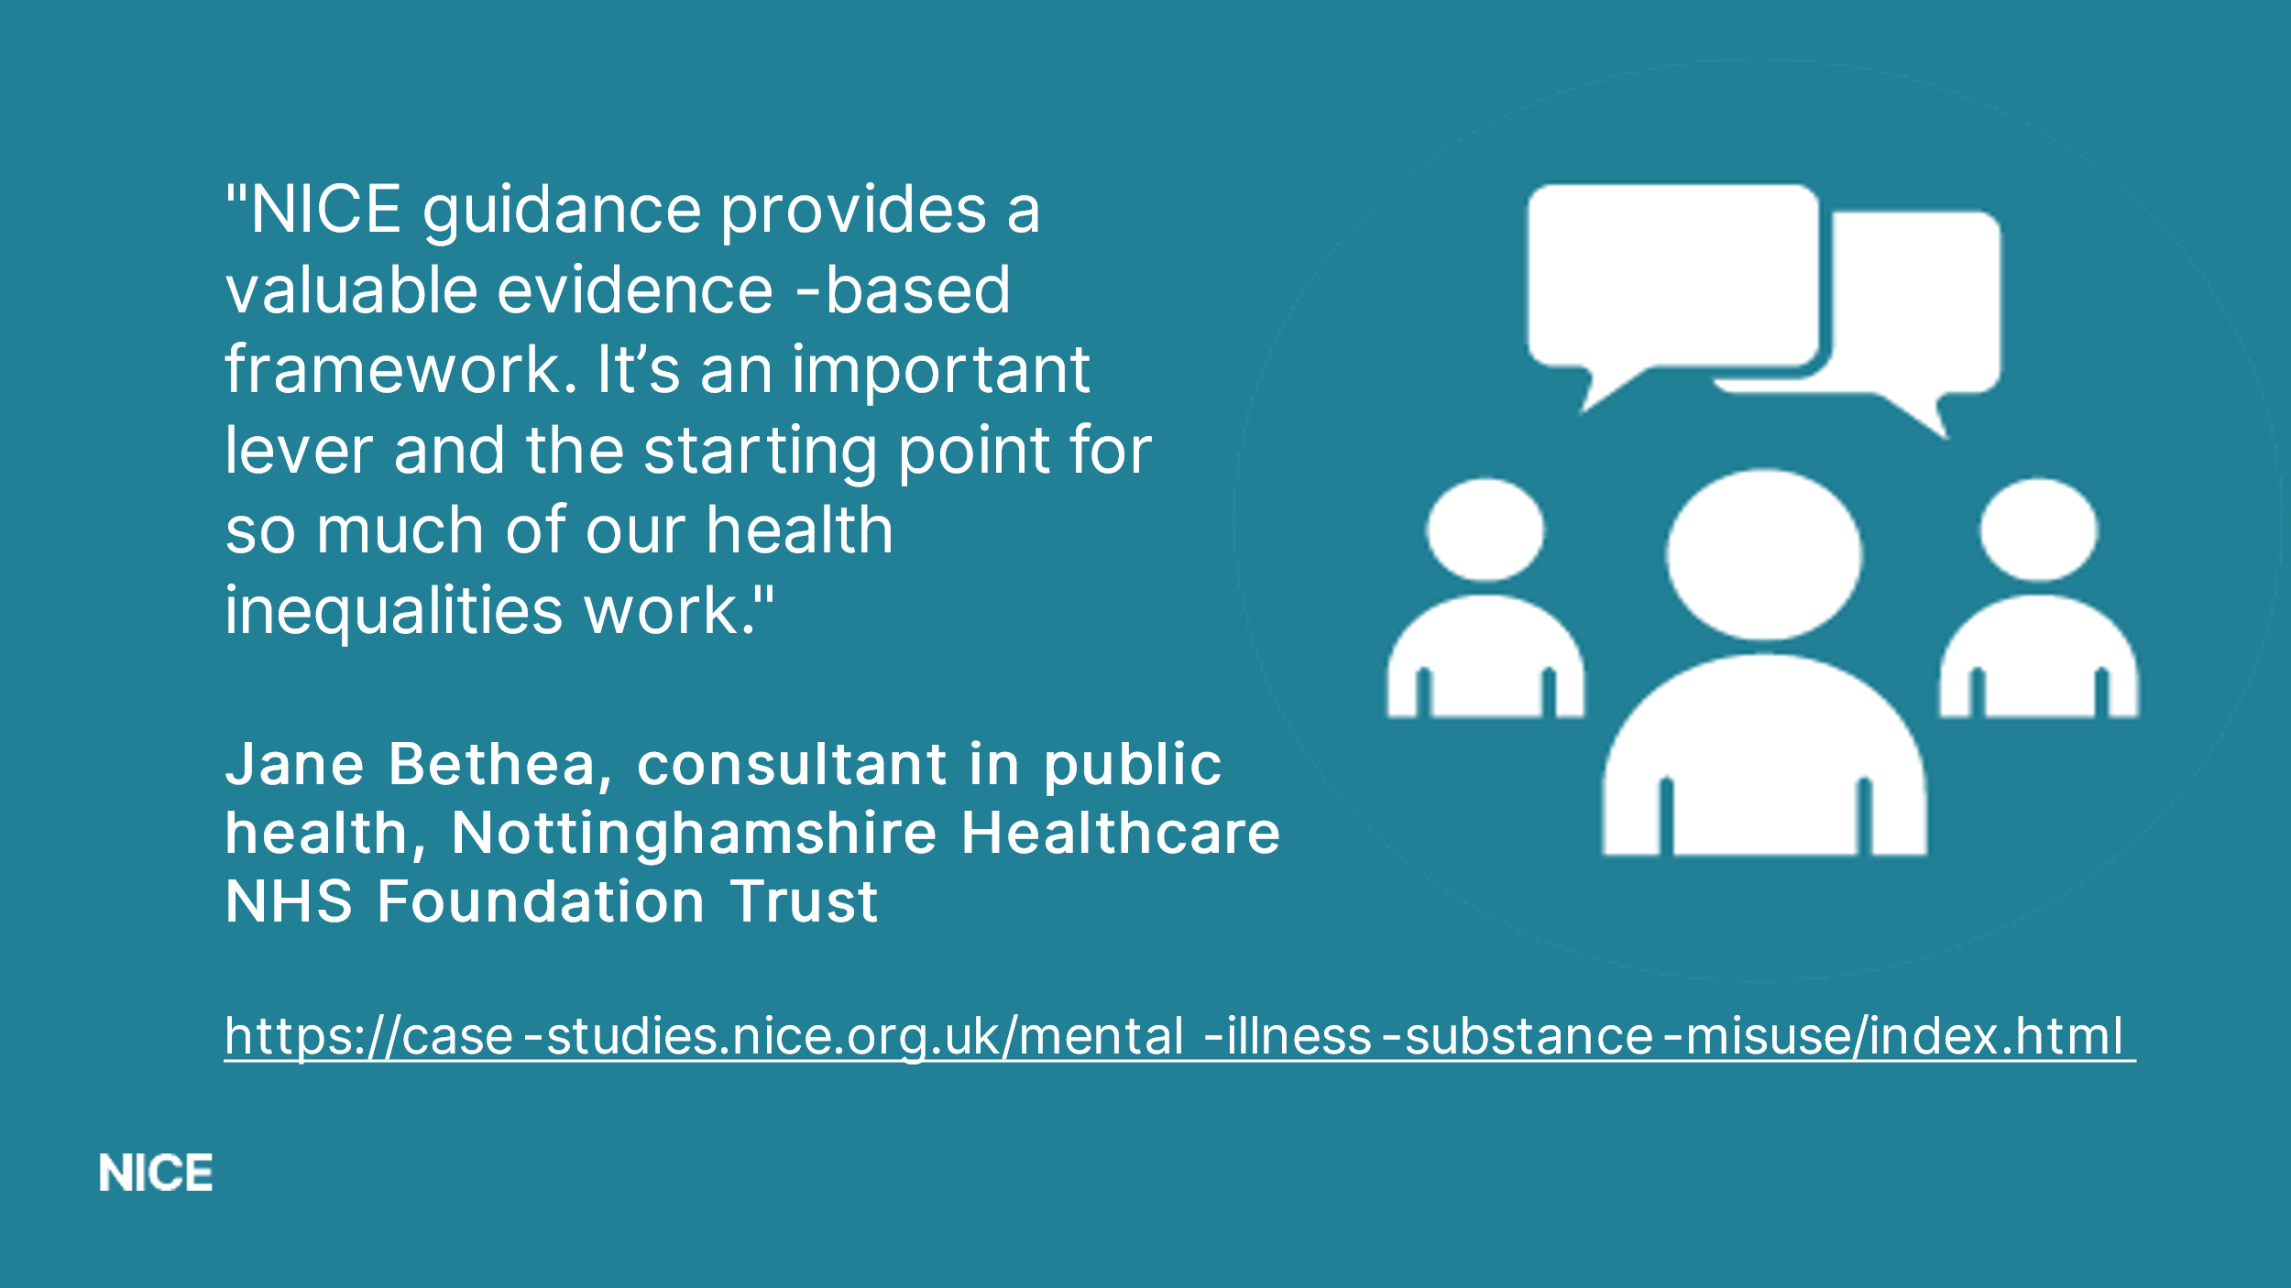

1. The NICE Listens health inequalities project made clear that the public expect that NICE considers health inequalities in all its work. Recommendations included ensuring greater involvement of those with lived experience when developing our guidance and communicating NICE’s role in addressing health inequalities.
2. This feedback and an internal review of our approaches led to the following objectives as agreed by the board in March 2022:
3. Systematically embed consideration of health inequalities in guidance production
4. Develop health inequalities briefings for living guidelines pilot topics
5. Make better and more consistent use of the Equality Impact Assessment (EIA) and build in health inequalities
6. Raise the profile of ‘our offer’ with a communications campaign and engage with the system to promote the fit of our guidance with system needs
7. Identify the evidence gaps and work with others to fill the gaps
8. Work with audit providers and others to gain better understanding of the impact of NICE recommendations on health inequalities
9. Ensure that lessons learned from Covid guidance and health inequalities are embedded in the guideline manual update.

Progress to date: Strengthening our approach

Progress to date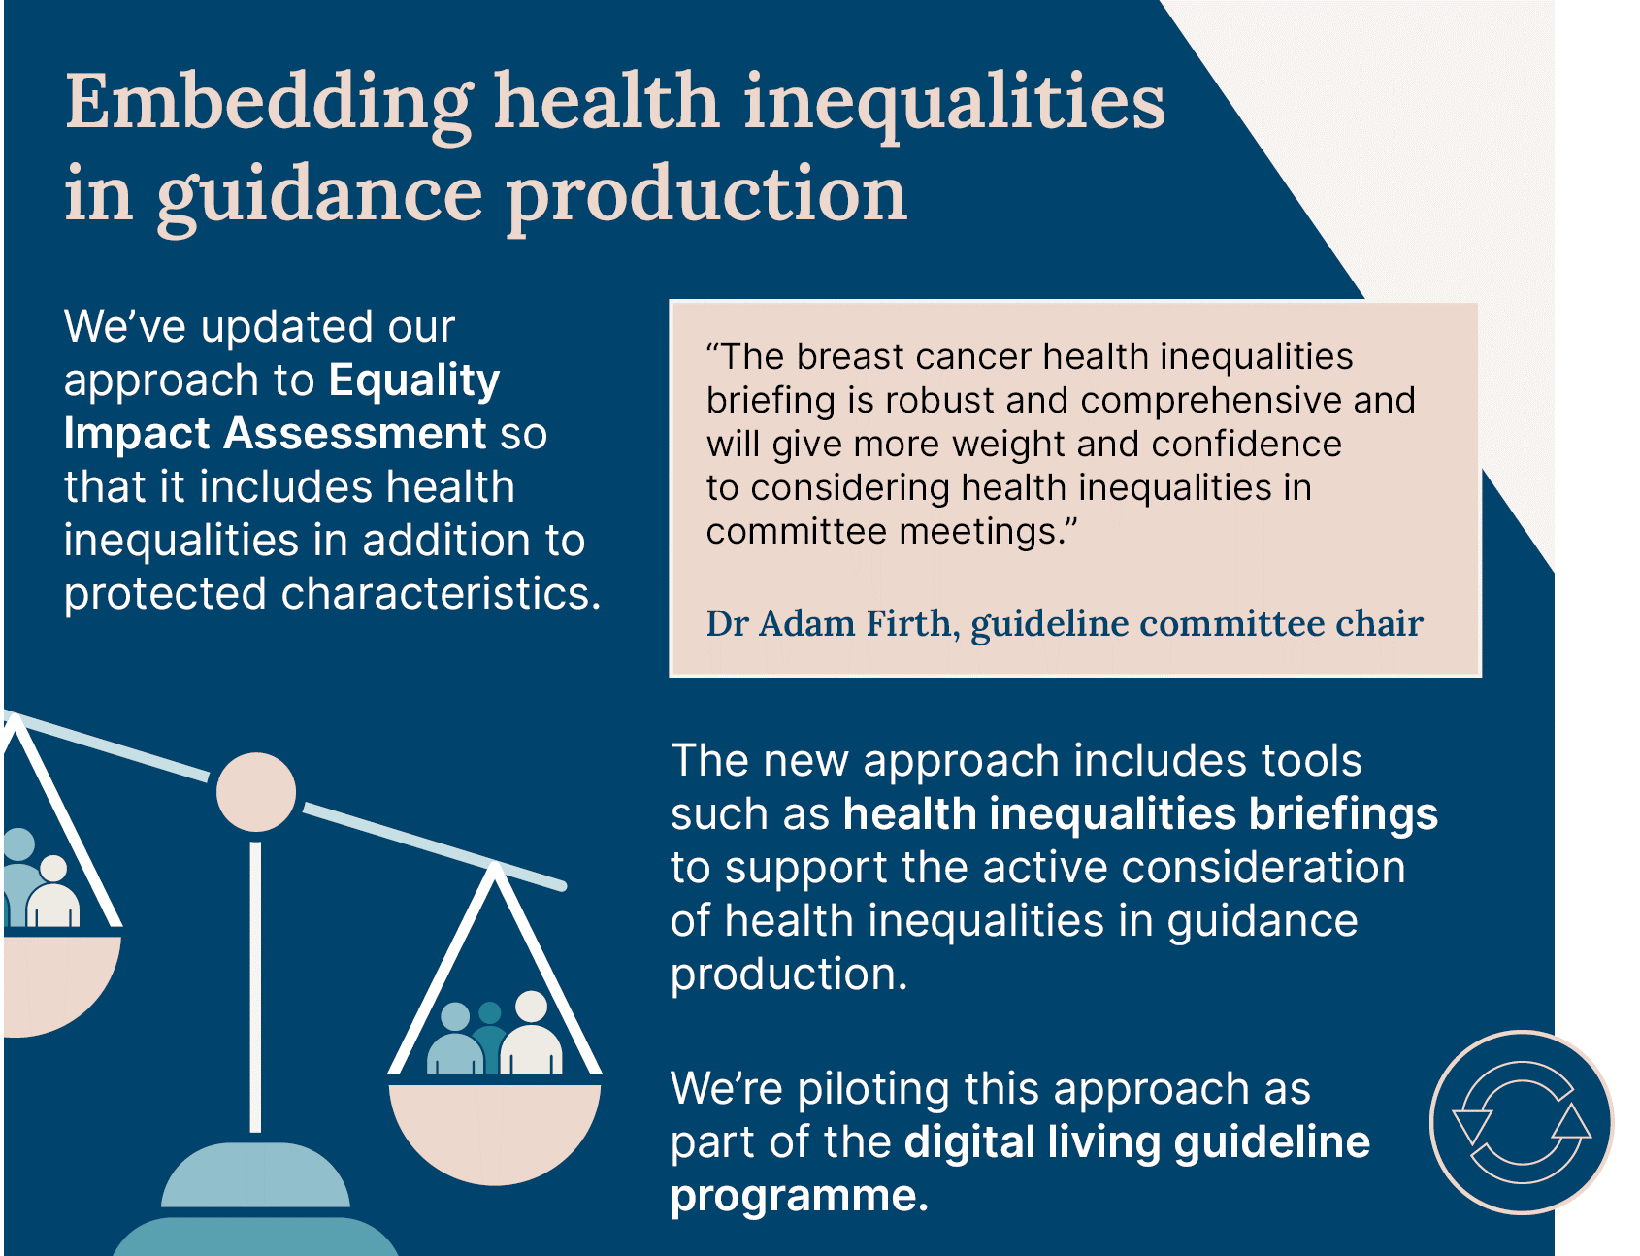

1. We have revised the Equality Impact Assessment (EIA) to include consideration of health inequalities in addition to protected characteristics. A guideline support document and training have been developed to aid completion of the assessment form and proactive consideration of health inequalities.
2. The approach is being piloted as part of the digital living guideline programme and the weight management, eczema and type 2 diabetes guideline updates.
3. Health inequality briefings have been developed to inform consideration of health inequalities throughout guideline development as well as prioritisation and surveillance. Processes have been developed to ensure consistency and quality assurance of the briefings.
4. The revised approach to EHIA will be reflected in the updated centre for guidelines methods manual to ensure it is embedded in practice. This will also provide external stakeholders with the opportunity to comment on the revised process, via consultation on the manual update.
5. We are now progressing with piloting a proportionate approach to EHIA in the centre for health technology evaluation, using the agreed framework.

**Prototype health inequality calculator**

1. The prototype tool allows users to explore the potential impact of NICE recommendations on health inequalities. It could also highlight opportunities to improve health inequalities in an efficient way.
2. Access to data to support the modelling has been a significant constraint. We recently secured funding for CPRD (Clinical Practice Research Datalink, a real-world research service supporting retrospective and prospective public health and clinical studies) which will allow further development of the tool.

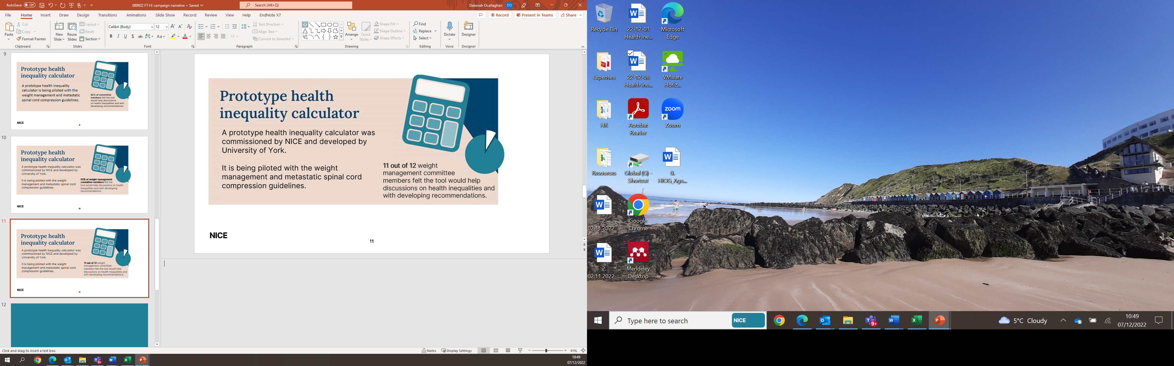

**Communication campaign and launch of a new online HI resource**

1. An integrated, multi-channelled communication and marketing campaign has raised the profile of the role we play in reducing health inequalities.
2. The campaign included a social media push, virtual event, stakeholder marketing activity and a launch of a new online resource [www.NICE.org.uk/health-inequalities](http://www.NICE.org.uk/health-inequalities).
3. The online resource provides a dedicated place on our website for people to access NICE recommended approaches to addressing health inequalities. The page is aligned to system priorities and recognises health inequalities frameworks including Labonte, Marmot and CORE20Plus5.
4. The response to the launch of the resource has been positive in terms of both reach and sentiment.

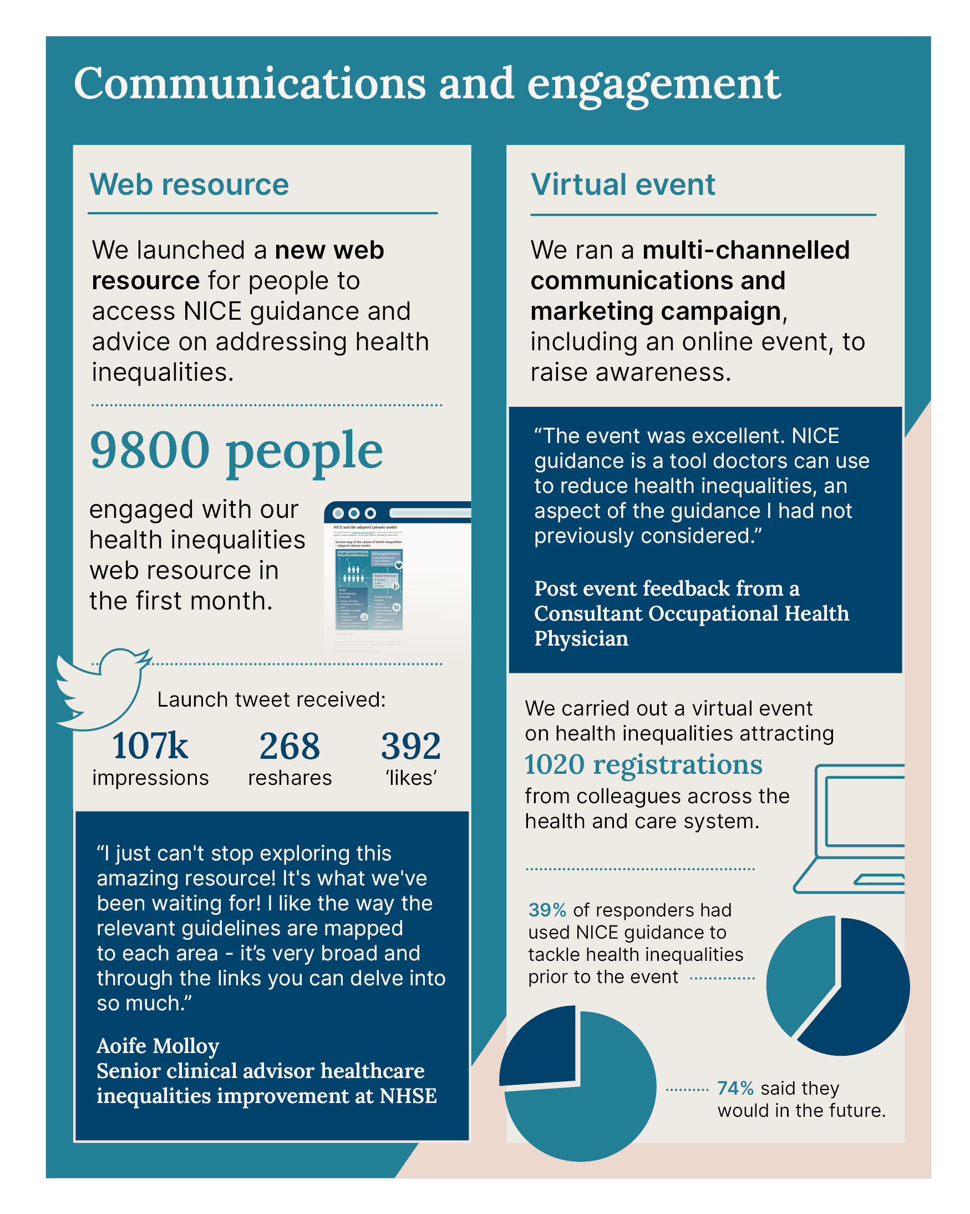

**Next steps**

1. We propose that the following actions should be the focus for the rest of 2022/23 and into 2023/24:
2. Ensure systematic and transparent consideration of health inequalities is embedded in guideline development
3. Develop in-depth training to support guideline developers and committees with consideration of health inequalities issues and how to address them
4. Progress with EHIA pilot in appraisals of medicines and medical technologies
5. Use communications channels to drive people to NICE health inequalities web resource, evaluate use and adapt accordingly
6. Test our support offer with ICBs, working up further case-studies to show where implementation of our guidance makes a difference
7. Support launch of national Core20PLUS5 for children and young people and raise awareness of NICE resources aligned to the 5 clinical priorities
8. Consider options and propose how to reduce evidence gaps
9. Collaborate with key partners, for example, with the Institute of Health Equity and Race and Health Observatory.

Board action required

1. The Board is asked to approve and support the next steps for the health inequalities work programme.

Authors of paper

Deborah O’Callaghan, Associate Director Field Team (Midlands and East) and public health sector lead, SRO for health inequalities programme

Lesley Owen, Technical Advisor – Methods and Economics team, lead for HI methods and processes work

Sian Corrigan, Senior communications manager (brand and events)

© NICE 2022. All rights reserved. [Subject to Notice of rights](https://www.nice.org.uk/terms-and-conditions#notice-of-rights).

Appendix 1

Prototype health Inequalities impact tool (calculator)

The protype tool allows users to explore the potential impact of NICE recommended interventions/technologies on health inequalities. Developed by the University of York, it calculates potential health inequality impacts due to an intervention by providing a breakdown of the net health effects across index of multiple deprivation (IMD) quintiles where IMD 1 = most deprived and IMD 5 = least deprived. The data inputs required for the tool are shown in figure 1 below.

**Figure 1: Prototype health inequalities impact tool (calculator)**

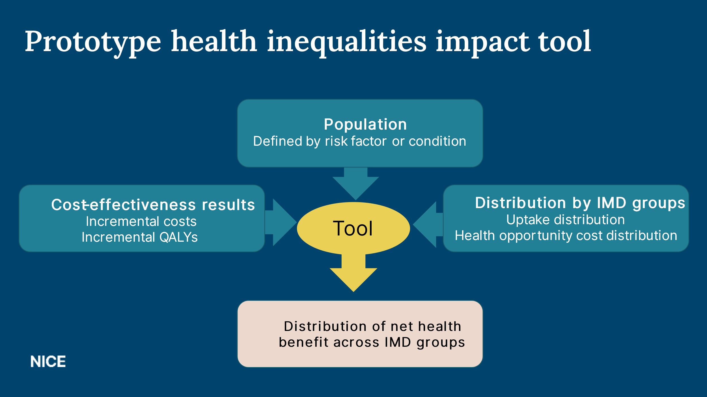

The tool is being piloted with two guideline updates: (i) weight management and (ii) metastatic spinal cord compression. A third pilot may be undertaken for the digital living guideline on breast cancer dependent on data availability. The next section provides a summary of some of the findings.

# Weight management suite – case study

Prevalence of obesity is highest in the most deprived groups. Compared with less deprived groups uptake of weight management interventions is greater but completion rates are lower in the more deprived groups.

The tool was used to explore the impact of the difference in uptake and completion rates on the potential heath gains of a weight management intervention. It showed that the average health gain per person is lower for the most deprived groups (see Figure 2). This is due to the lower completion rates amongst these groups.

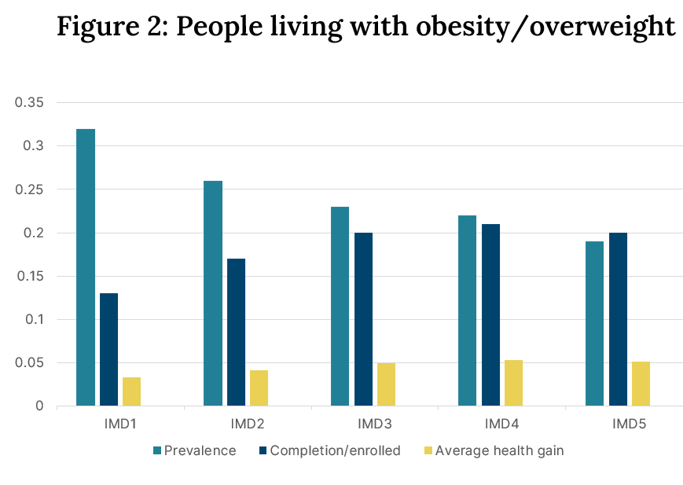

However, although the average per person health gains are lowest in the more deprived groups when the prevalence of obesity and overweight is taken into account, the absolute gains are largest in the most deprived groups.

Several scenario analyses were undertaken to explore the impact of changing completion rates. In one scenario the same completion rate (100%) was applied across all groups. This results in the same (0.044) average per person QALY gains across all groups and leads to a substantial increase in the net benefits that accrue to the most disadvantaged groups. For the most deprived group the net benefit increased from 27 QALYs gained to 87 QALYs gained for current and 100% completion rates respectively.

Presenting results of the tool led to a robust committee discussion about multiple issues including the potential of the intervention to have differential impacts at the population and individual level and how the tool can be used alongside other evidence to develop recommendations to address poor completion amongst the most disadvantaged groups. There was also some discussion about the data utilised in the tool and its strengths and weaknesses. A key benefit was the ability to explore the impact of an intervention at a more granular level.

Feedback on the usefulness of the tool was obtained using an online questionnaire that was completed at the end of the committee meeting. Figures 3 and 4 show that the vast majority (92%) agreed the tool will help facilitate discussions on health inequalities and will help when developing recommendations.

**Evaluation of HI prototype tool – weight management suite**

Bar chart outlining committee views on the usefulness of the tool.  To what extent do you agree or disagree with the following statements about the health inequalities tool: (the tool will help to facilitate discussions on health inequalities).  Agree 50%, strongly agree 42%, don't know 8%**Figures 3 & 4 Committee views on the usefulness of the tool**

 Bar chart outlining committee views on the usefulness of the tool.  To what extent do you agree or disagree with the following statements about the health inequalities tool: (the tool will help when developing recommendations). Agree 50%, strongly agree 42%, don't know 8%