Board meeting

17 July 2024

Business Case - Improving timeliness of guidance development

Purpose of paper
For approval

Board action required
The Board is asked to approve the business case and proposals within.

Brief summary
The aim of this programme of work is to improve the timeliness of guidance production across guidelines, health tech and medicines whilst maintaining the quality of our guidance. We also aim to improve staff experience and increase throughput of guidance producing centres.
Improved timeliness will be achieved through standardising and improving processes across the guidance producing centres. Improvement and standardisation of guidance producing processes will be enabled by:
- agreement on common elements of these NICE-wide services that underpin guidance production and are enabled by digital tools
- a NICE-wide project management and quality improvement methodology.
The digital tools we initially employ will be simple out-of-the box tools. A further phase of investment will be required following this programme to deploy the next generation of enterprise-wide digital tools.
This is proposed to be a 2-year programme to be delivered in four phases of improvement, ending in March 2026. Each of the four phases will start by identifying the common NICE-wide elements and stages of guidance production and the digital tools that will be made available to support this process, before moving into a series of continuous improvement cycles to optimise how teams manage these stages. This will culminate in an agreed NICE-wide design for the process that can be used to procure the next phase of digital tools.
The known programme will cost £2.2m over 2 years (£1.3m in 24/25, £0.9m in 25/26), with a recurrent cost of £0.3m thereafter. The non-recurrent costs of this programme will be funded through our increase in grant in aid funding due to the McLean review, £0.7m of this cost has already been included in our 24/25 budget. Recurrent costs of this programme are to be covered through improved throughput of 2 topics p.a. in medicines appraisals which will lead to improved cost recovery.

Board sponsor
Sam Roberts, Chief Executive

Improving timeliness of guidance development

Business Case

Executive Team Leads: Sam Roberts, CEO
Senior Responsible Officer / Digital Senior Lead/ Improvement Lead:
Jenniffer Prescott, Programme Director, HTA Process & Operations
Alison Liddell, Deputy Director, DIT
Auz Chitewe, Programme Director of Improvement, People and Places
Directorate: Digital, Information and Technology (DIT) / Medicines / HealthTech / Centre for Guidelines / People and Places

Version: | 1.0
Author: | Jenniffer Prescott, Alison Liddell, Martin Davison, Auz Chitewe
Date: | 09 July 2024

1. Executive summary
Our aim: is to improve the timeliness of guidance production across medicines, health tech and guidelines whilst maintaining the quality of our guidance. Secondary aims are to improve staff experience and increase throughput of guidance producing centres.
Proposed approach: Improved timeliness will be achieved through standardising and improving processes across the guidance producing centres, including the following guidance development ‘services’:
  - Topic management
  - Committee management
  - Stakeholder management
  - Guidance generation
  - Content creation
  - Generation and use of management information.
Improvement and standardisation of guidance producing processes will be enabled by:
  - agreement on common elements of these NICE-wide services that underpin guidance production and are enabled by digital tools
  - a NICE-wide project management and quality improvement methodology.
Given we are starting from a low baseline in terms of digitally-enabled services, the digital tools we initially employ will be simple out-of-the box tools. A further phase of investment will be required following this programme to deploy the next generation of enterprise-wide digital tools.
Workplan: This is a 2-year programme to be delivered in four phases of improvement, ending in March 2026. Each of the four phases will:
  - Cover 1-2 of the services outlined above, starting in September 2024 with topic management and committee management.
  - Start by identifying the common NICE-wide elements of this service and the digital tools that will be made available to support this process, before moving into a series of continuous improvement cycles to optimise how teams manage these services, culminating in an agreed NICE-wide design for the service that can be used to procure the next phase of digital tool
Costs and funding: The known programme will cost £2.2m over 2 years (£1.3m in 24/25, £0.9m in 25/26), with a recurrent cost of £0.3m thereafter. The non-recurrent costs of this programme will be funded through our increase in grant in aid funding due to the McLean review, £0.7m of this cost has already been included in our 24/25 budget. Recurrent costs of this programme are to be covered through improved throughput of 2 topics p.a. in medicines appraisals which will lead to improved cost recovery in the order of £0.4m p.a recurrently from 2026.
This business case includes an estimate of the known programme management, implementation and quality improvement costs for the 2-year programme. Detailed costs for the digital tools to be deployed in the first of the four phases of improvement have been included, however estimated costs for tools and digital enabling costs for the later phases of this programme are not yet known. This information should be available for 2025/26 business planning and budget setting.
Benefits: The primary benefit is improvements in timeliness of guidance measured as:
  - Improvement in mean and median time in guidance producing processes
  - 90% optimal appraisals of medicines meeting target time between marketing authorisation and technology appraisal (target time is currently 90 days but will be reviewed in September 2024)
  - Year on year improvement in % of guidelines meeting target of 6 months between topic prioritisation and guidance production
Secondary benefits are improvement in staff engagement in guidance producing functions and increased throughput of medicines and health tech guidance.
By implementing digital tools (such as MS Project online) we can create a baseline of guidance production activity. This will provide the ability to further understand the costs associated with guidance production to inform future management and improvement objectives.
We are seeking Board approval of the overall approach and funding envelope proposed in this business case and delegation of authority to the Executive team to sign off the specific digital costs in the second, third and fourth phases of this programme if they are less than £350k, in line with our SFIs.
2. The strategic case
NICE’s transformation aims to deliver high quality guidance that is increasingly relevant, timely, useable and impactful, delivered by a brilliant organisation.
In terms of improving timeliness, this business case supports the delivery of a priority business plan objective for 24/25: aligning and digitising our guidance producing processes. It brings together work in the three guidance producing programmes, with early steps of digital transformation from the DIT directorate and a NICE-wide approach to improvement from the People and Places directorate.
In terms of building a brilliant organisation, this programme aims to improve staff experience by removing manual work and retiring legacy digital tools that increase the burden on teams. These legacy tools are a long-standing operational risk for NICE, with the ‘planning tools’ in particular posing a risk of potential critical failure. Failure of these tools would lead to both a reputational risk associated with significant delays in guidance production as well as a financial risk associated with loss of income from the Technology Appraisals programme.
Alongside the strategic ambition, this programme aims to prepare the medicines and healthtech directorate for an ever-growing pipeline of products by enabling increased throughput without expanding resource (cost avoidance). Additionally, it will deliver the first step in aligning guidance producing processes where possible, which is an essential pre-requisite to more fundamental digital transformation. Over time and through working in silos, the different guidance producing programmes have developed multiple warranted and unwarranted variations to practice. This programme provides an opportunity for those variations to be surfaced and alignment sought (where appropriate) via continuous improvement methods.
This programme will also act as an enabler for the ambition to create a single methods and process manual that will establish a common approach across all of the NICE guidance products. Work to create the single manual will commence in 25/26.
3. Options and recommendation
This programme balances a significant investment in continuous quality improvement expertise with roll out of basic digital tools. We considered options that struck a different balance between continuous improvement and digital investment as outlined below.
Options considered included:
- Do nothing. This option should be discounted as it does not enable NICE to meet its strategic goal of improving timeliness of guidance production.
  - Costs – No additional investment costs in 24/25. However, staff costs in guidance producing centres continuing to undertake manual processes will increase as throughput increases, particularly in the medicines and health tech directorates. Additionally, ongoing support to existing legacy tools will increase over time. Missed opportunity cost in the inability to exploit full functionality of existing licencing of M365 and modern ways of working.
  - Risks – that the business experiences critical failure of the legacy systems, that the staff experience further deteriorates and that the absence of standardisation across the business means the objectives of NICE’s digital transformation cannot be achieved.
  - Benefits – none.
- Prioritise significant strategic enterprise solutions through a procurement exercise, followed by continuous quality improvement once the enterprise solution is fully deployed. This option is not recommended as it is unlikely to improve timeliness in the next 18 months, will be very costly to deploy due to limited process standardisation across NICE. Additionally, it does not address the immediate operational risks associated with legacy bespoke digital tools.
  - Costs – significant investment required to capture, procure and implement an enterprise solution including addressing process variation and supporting the business change required.
  - Risks – that the scale of change for the organisation is not achievable in one phase without substantial investment and procurement of a delivery partner. Risk that the pace of this delivery does not mitigate the ongoing risks in the use of existing tools.
  - Benefits – provides opportunity for greater gains in timeliness and throughput if the enterprise solution is fully deployed.
- Deliver some improvements in timeliness through significant investment in continuous quality improvement approaches and capability building alongside roll out of basic digital tools, including some automation. This approach will inform further additional technology requirements (potentially an enterprise-wide digital solution in a subsequent programme), provides standardisation of guidance producing processes and builds the capabilities for process and digital improvement across almost half of NICE’s staff.
  - Costs – incremental approach to costs through blended delivery model of DIT, Improvement and guidance producing team members working together to deploy largely out-of-the box digital tools and some automation to support continuous quality improvement. However, the planned digital tools deployed are an interim solution to support process redesign and standardisation and will require additional investment in a subsequent programme to deliver optimally timely and efficient guidance production.
  - Risks –in the absence of a full strategic digital transformation, a piecemeal approach may mean that objectives take longer to achieve, and duplication of stages is required. Risk that the business does not achieve process redesign but instead approaches a new tool as ‘like for like’.
  - Benefits – opportunity to deliver improvements in timeliness in-year, improve staff experience and mitigate the immediate operational risk of the existing legacy tools. In addition, provides an opportunity for a standard process to be created, which is a pre-requisite for more fundamental digital transformation.
It is recommended that option 3 be progressed.
This will also mean that as longer-term digital transformation opportunities are identified market engagement activity will commence in advance of future transformation activity (e.g. undertake market engagement in 25/26 to enable future digital transformation in 26/27).

4. The financial case
The following priorities for financial and time investment are detailed in this business case:

- Costs associated with general process improvement and wider staff skill building via delivery of formal continuous quality improvement training and coaching.
- License and technical advisory costs to facilitate exploration, configuration and iterative business testing of digital tools in the first phase of the programme which focuses on topic management and committee management (i.e. MS Project Online, ‘associates solution’ and some automation)
- Staff costs to support medicines and healthtech capacity to dedicate subject matter expert resource to this programme. Staff costs for guidelines are included in their 24/25 baseline budget.
- Programme management costs required to achieve this coordinated set of objectives across multiple directorates.

Subsequent license and technical advisory costs for the later stages of the programme (phases 2-4) are not yet known. In the 24/25 budget, £0.5m had been set aside for delivering phases 1 and 2 once the outcome of pilots and digital discovery had taken place in the initial preparation phase. These will be clarified through the ongoing programme and separate investment cases produced when/if appropriate. The investment needs will also be noted ahead of 25/26 business planning and budget setting.

Cost impact

The projects identified in this business case will require upfront investment in the current financial year and early in 2025/26, along with a likely commitment to recurrent licensing and support costs.

Table 2: Summary of investment costs

Category | 2024-25 £'000 | 2025-26 £'000 | 2026+ recurrent costs  £'000
Overarching project delivery and quality improvement resources (multi-phase) | 725 | 620 | 60
Initial license costs (including DIT support)* | 216 | 228 | 228
Digital enabling costs* | 320 | 50 | -
Less estimated savings* |  | -186 | -414
Net improvement cost / saving | 1,261 | 712 | -126
*Costs of initial commitments. Costs (year 2 and recurrent costs) and potential efficiency savings will increase as progress is made through each improvement cycle.

The costs associated with this business case are mainly attributable to:
- Procurement of technical advisory support for DIT on an outcome basis
- Recruitment of temporary project resource to undertake digitally-enabled improvement within directorates
- Estimated licence costs associated with the two services included in phase 1 (topic management and committee management), including maintenance and support
- Additional capacity and external advisory support to provide coaching and training in continuous quality improvement
A breakdown of the resource allocated to each category of spend is provided in Appendix A.

Sources of funding

The project will be funded from several sources over the lifetime of the business case.

Current financial year
In the funding settlement for 24/25, we received additional GIA funding to support recommendations within the McLean / Vallance review into Life Sciences. This included funding allocated for investment in improvements in our digital infrastructure, including our topic management tools. Following a prioritisation exercise, £0.7m was set aside from this funding for the topic management, committee management and automation solutions that form the basis of much of this business case, subject to the business case being approved by the board.

The financial impact of the investment in guidance development and quality improvement and estimated of some digital enabling costs emerged after the NICE business plan and budget was agreed, but the emerging additional cost (£0.5m) can be funded from unallocated reserves.

Future years
The future costs are assumed to be funded from several sources:
- The additional GIA funding awarded this year was requested on a recurrent basis, however this has currently only been confirmed for 24/25. If funding is confirmed, the year 2 costs of £0.7m will be a first call on this funding. If it is not confirmed, one of the other sources listed below may need to be called upon and / or the pace or change (phases 3 and 4) reviewed.
- The investment in topic management is expected to increase throughput in the TA/HST programme. This should speed up the time it takes for the programme to achieve full-cost recovery, thus releasing GIA funds for investment. It is estimated that the throughput will increase by 2 topics as a result of this investment – such an improvement would close the cost recovery gap by approximately £0.2m (part-year effect, £0.4m recurrently from 2026), some of which could be used to contribute to this investment from 2025/26.
- Some of the recurrent costs will be offset by cash releasing efficiencies through decommissioning existing services (e.g. savings in DIT developer time and license costs).
- The Centre for Guidelines has front-loaded savings in its recent restructure that will provide financial headroom next year to contribute to the investment in improvements in guidance development.

Further investment in digital tools is expected in Phases 2-4 of this programme. The costs for this are unknown at present and will be refined as part of the work to prepare further business cases for investment.

Capital planning
None identified for 2024/25

Procurement and contract approach
The programme team will use existing Managed Service Provider contracts where in scope and CCS IT/Digital Frameworks as appropriate for sourcing 3rd party suppliers if required.
Where spend controls are required (e.g. technology spend or external resources) these will be managed via the existing spend control processes via the DDAT Assurance Board or with the commercial team.

5. Project management and governance case
Phasing
The programme will be delivered in five phases (Figure 1):
- June to September 2024: Preparation phase including:
  - Surfacing the ‘as is’ guidance development process through the roll out of MS Project in all guidance producing teams
  - Agreeing digital tools that can support committee management, called the ‘associates solution’
  - Identifying requirements to retire the legacy planning tools by March 2025
  - Defining a NICE-wide approach to project management (agile) and continuous quality improvement and procuring support to train and coach staff undertaking subsequent phases of the programme in these methods
- September 2024 to January 2025: Improvement phase 1 focused on the first two guidance-producing services: topic management and committee management
- February to May 2025: Improvement phase 2 focused on next two services: stakeholder management and management information
- June to September 2025: Improvement phase 3 focused on guidance development
- October 2025 to January 2026: Improvement phase 4 focused on content generation
Figure 1: Programme phasing
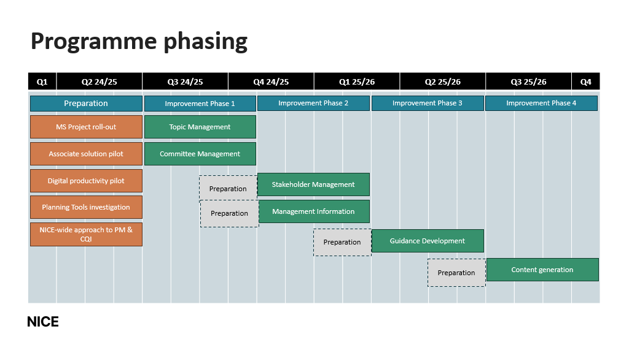
Each of the four improvement phases will:

- Have a preparation phase before the improvement cycles begin that focuses on:
  - a NICE-wide articulation of the common elements of the service and
  - identification of the digital tools that are available for the teams to use to improve that service (e.g. MS Project)

- This will be followed by generation of ideas for improvement of this service. Ideas for improvement will be categorised into those that:
  - can be delivered without any additional digital investment
  - require increased use of an available technology (e.g. automation using the Office 365 suite)
  - require significant additional technology investment.

- Improvement ideas will then be prioritised. Prioritised ideas that can be delivered without any additional digital investment or require increased use of an available technology will be taken forward by delivery teams in 90-day improvement cycles, supported by an improvement coach and digital delivery manager. The individual improvement cycles will also independently identify and measure relevant benefits.

- Prioritised improvement ideas that require significant additional technology investment will be explored further by the technical delivery owner, with a decision made on whether to procure additional tools for the service or whether to delay until the subsequent larger enterprise technology investment from 2026 onwards.

This approach is illustrated in Appendix B.
Governance
The programme will be managed using agile methodology with key roles and responsibilities outlined in Appendix C.
Programme assurance is through:
- the monthly High Quality Timely Programme Board which is chaired by the Chief Executive, which reports to the formal Executive team meeting once a month
- exception reporting and performance on timeliness of guidance production reported to the Board through the Integrated Performance Report
Programme delivery is through the Improving Timeliness Oversight Group, which meets bi-weekly to manage delivery progress, programme budget, programme risk and reporting. Programme Delivery is co-ordinated by the SRO (Jen Prescott), with leadership support from an improvement delivery owner (Auz Chitewe, Programme Director, Improvement) and a technical delivery owner (Alison Liddell, Deputy Director, DIT).

Figure 2 – Programme governance structure
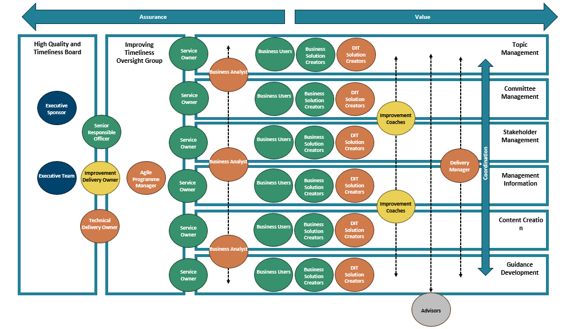

Improvement of each service will be led by a service owner, who will bring together small teams comprised of business users, business solution creators and DIT solution creators (with additional support from an improvement coach, business analyst and delivery manager) will be brought together with the teams tasked with leading improvement through 90-day improvement cycles. These teams will be empowered to make day-to-day decisions and will be managed through agile ceremonies (e.g. stand ups/sprint planning) with escalation to the Improving Timeliness Oversight Group as required. Where immediate escalation and decision making is required, this will be flagged directly by the Service Owner to the SRO. A member of the NICE Executive team will also be assigned to work with and support the Service Owner.
Team roles and responsibilities are outlined in Appendix C.
High level milestones

Theme | Delivery Milestone | Timeframe
Preparation/ Discovery phases | Understanding the problem in topic management and committee management– visualise the system, collect data, understand demand and capacity.  Recruiting teams into the collaborative learning system. | July – August 2024
Preparation Phase | All guidance teams (and supporting teams) have an agreed common planning and timeline management principles, frameworks and reporting approach. | End August 2024
Preparation Phase | All guidance teams and cross functional support teams using MS Project Online for the planning of all new and live topics | End October 2024
Improvement Phase 1 - Topic Management and Committee Management | Developing strategy and change ideas. Moving into Testing using PDSA cycles and then implementation to embed change and scaling up the change to other teams. | Sept 2024 – January 2025
Preparation phase 2 – Stakeholder Management and Management Information | Understanding the problem – visualise the system, collect data, understand demand and capacity.  Recruiting teams into the collaborative learning system | December 2024 – January 2025
Improvement Phase 2 – Stakeholder Management and Management Information | Developing strategy and change ideas. Moving into Testing using PDSA cycles and then implementation to embed change and scaling up the change to other teams. | February – May 2025
Topic Management, Committee Management and Stakeholder Management | Retire the planning capabilities from the legacy planning tools (IP, TA & HST, CfG) | End March 2025
Preparation phase 3 – Guidance Development | Understanding the problem– visualise the system, collect data, understand demand and capacity.  Recruiting teams into the collaborative learning system | April – May 2025
Improvement phase 3 – Guidance development | Developing strategy and change ideas. Moving into Testing using PDSA cycles and then implementation to embed change and scaling up the change to other teams. | June – September 2025
Preparation Phase 4 – Content generation | Understanding the problem – visualise the system, collect data, understand demand and capacity.  Recruiting teams into the collaborative learning system | August – September 2025
Improvement phase 4 - Content generation | Developing strategy and change ideas. Moving into Testing using PDSA cycles and then implementation to embed change and scaling up the change to other teams. | October 2025 – January 2026

6. Benefits realisation
The primary benefit is improvements in timeliness of guidance measured as:
- Improvement in mean and median time in guidance producing process
- 90% optimal appraisals of medicines meeting target time between marketing authorisation and technology appraisal (target time is currently 90 days but will be reviewed in September 2024)
- Year on year improvement in % of guidelines meeting target of 6 months between topic prioritisation and guidance production
Secondary benefits are improvement in staff engagement in guidance producing functions and increased throughput of medicines and health tech guidance.
KPI | Measure | Type | Baseline | Proposed KPI Owner
Improve the average (mean and median) time taken in guidance production for guidelines | Improvement in 2024/25 (against 2023/24)  Improvement in 2025/26 (against 2024/25) | Improving timeliness | Q4 2023/24 | Jonathan Benger
Year on year improvement in % of guidelines meeting target of 6 months between topic prioritisation and guidance production | Improvement in 2025/26 (against 2024/25) | Improving timeliness | Q4 2024/25 | Jonathan Benger
Improve the average (mean and median) time taken in guidance production in healthtech | Improvement in 2024/25 (against 2023/24)  Improvement in 2025/26 (against 2024/25) | Improving timeliness | Q4 2023/24 | Mark Chapman
Improve the average (mean and median) time taken in guidance production in medicines | Improvement in 2024/25 (against 2023/24)  Improvement in 2025/26 (against 2024/25) | Improving timeliness | Q4 2023/24 | Helen Knight
90% optimal appraisals of medicines meeting target time between marketing authorisation and technology appraisal (target time is currently 90 days but will be reviewed in September 2024) | Achievement of target in 24/25 (noting potential change in target time during year)  Achievement of target in 25/26 | Improving timeliness | 90 days | Helen Knight
Improve the time (mean and median) between Marketing Authorisation and final guidance for in medicines | Improvement in 24/25 (against 23/24)  Improvement in 25/26 (against 24/25) | Improving timeliness | Q4 2023/24 | Helen Knight
Healthtech to increase to 50 outputs per year from 2025/26 onwards (set as 40 outputs in 24/25) | Improvement in 25/26 (against 24/25) | Productivity | Q4 2024/25 | Mark Chapman
Healthtech to increase number of technologies and companies that are included in overall guidance production from 2025/26 onwards | Improvement in 25/26 (against 24/25) | Productivity | Q4 2024/25 | Mark Chapman
Medicines to increase to 82 units of output per year from 2025/26 onwards (set as 80 units in 24/25) | Improvement in 25/26 (against 24/25) | Productivity | Q4 2024/25 | Helen Knight
CfG to maintain units of output per year | Improvement in 25/26 (against 24/25) | Productivity | Q4 2024/25 | Jonathan Benger
“NICE encourages trying new things” | 5% Improvement against baseline created in 2023 (last reported as 66% in July 2023) | Staff experience | July 2023 | Jenniffer Prescott
“My innovation is valued” | 5% Improvement against baseline created in 2023 (last reported as 65% in July 2023) | Staff experience | July 2023 | Jenniffer Prescott
“I have what I need to do my job well” | 5% Improvement against baseline created in 2023 (last reported as 64% in July 2023) | Staff experience | July 2023 | Jenniffer Prescott
“I have enough training and info to do my job well” | 5% Improvement against baseline created in 2023 (last reported as 67% in July 2023) | Staff experience | July 2023 | Jenniffer Prescott
Reduce DDAT resource utilised in maintenance of the existing planning tools by archiving them by end March 2025. | Timesheet entries tracking the cumulative DIT hours spent supporting the planning tools  (Average of 110 days or 0.5 FTE over last 3 business years until end March 24) | Efficiency | 1st April 2024 | Alison Liddell
Timeliness and throughput data is collected from directorates monthly and reported by the Delivery team in Strategy, Policy and International. Staff experience is collected annually by the People and Places Directorate.
All metrics will be reported and discussed in the following fora:
- Monthly at the High Quality Timely Programme Board
- Monthly at the formal Executive Team meeting
- Every two months at individual clinical guidelines, healthtech and medicines directorate accountability meetings
- Exception reporting and performance on timeliness of guidance production is reported to the Board through the Integrated Performance Report.

Appendix A: Detailed costs breakdown
 | Cost element |  | 2024-25 £'000 | 2025-26 £'000 | 2026+ recurrent costs  £'000
Overarching project delivery and quality improvement resources (multi-phase) | CQI: External partner support |  | 115 | 140
 | CQI: Digital platform |  | 10 | 10
 | CQI: Secondments |  | 100 | 160
 | CHTE project and data expertise resource |  | 260 | 60 | 60
 | Digital delivery programme management |  | 170 | 250
 | DIT external technical advisory |  | 70 | TBC
Initial license costs (including DIT support)  Could increase as phase 2, 3, 4 plans emerge | MS Projects |  | 75 | 80 | 80
 | Associates solution |  | 70 | 75 | 75
 | Automation power tools |  | 35 | 35 | 35
 | Licenses phases 2,3,4 |  | TBC | TBC | TBC
 | DIT license support / maintenance costs |  | 36 | 38 | 38
Digital enabling costs per 'service' ¹  Costs uncertain until discovery takes place. Year 1 costs estimated at ~£0.2m (total) in 24/25 planning exercise. | DIT digital discovery: £25k per 'service'. |  | 100 | 50
 | Year 1 | Topic Management | ~£220k budget
 | Year 1 | Committee Management | ~£220k budget
 | Year 1-2 | Stakeholder Management | ~£220k budget | TBC
 | Year 1-2 | Management Information | ~£220k budget | TBC
 | Year 2 | Guidance Development |  | TBC
 | Year 2 | Content generation |  | TBC
 |  | Total costs | 1,261 | 898 | 288
Estimated savings² | Reduction in DIT support costs (post-decommissioning)) |  |  |  | -36
Estimated savings² | Discontinued license costs |  |  |  | -6
Estimated savings² | Increased TA/HST throughput (release GIA) |  |  | -186 | -372
 |  | Total savings | 0 | -186 | -414
 |  | Net cost impact | 1,261 | 712 | -126

Notes:
- Digital enabling costs are expected to be less than £350k per 'service', but this cannot be confirmed.
- Timing of savings from decommissioning existing tools is uncertain. A prudent approach has been taken to assume a delay in savings and a lag in recognised TA/HST income.
Appendix B: Approach to Improvement Phases
Figure B1: Preparation for service improvement phase
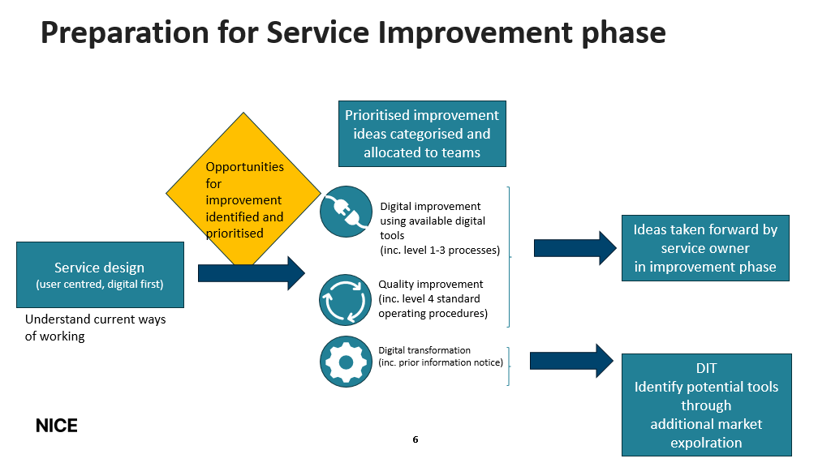

Figure B2: Service improvement phase

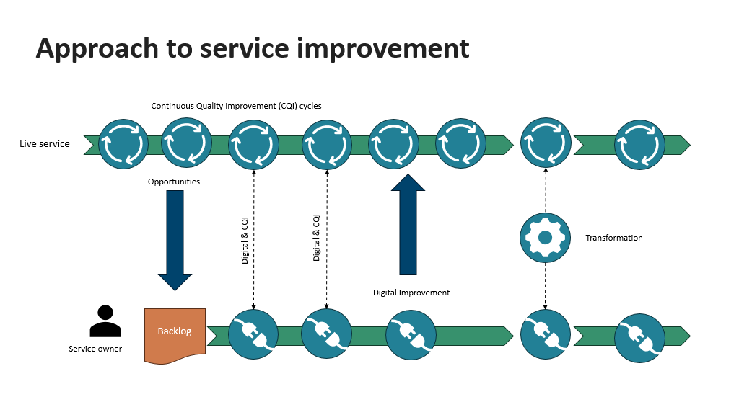

Figure B3: Example of topic management service improvement phase
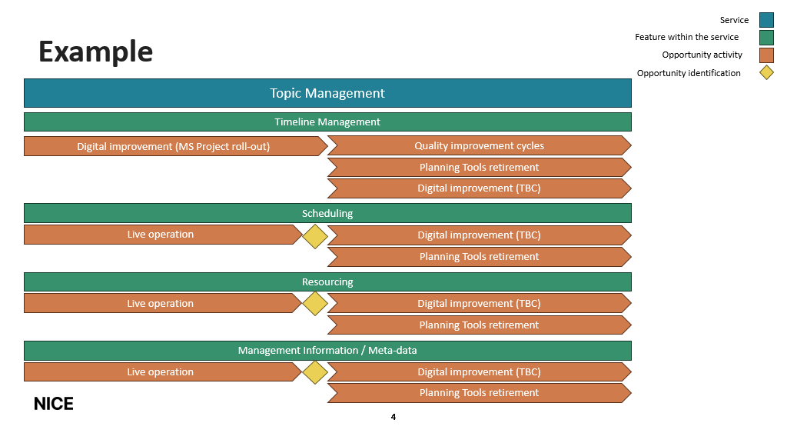

Appendix C – Agile roles and responsibilities
Role Title | Responsibility | Assigned staff name and job title
Business Sponsor | Programme champion | Sam Roberts – Chief Executive (TBC)
Senior Responsible Officer | - Delivering the clear vision and strategic direction of the sponsor.  - Ensure service designs consistent approaches to deliver business value and benefits.  - Assures strategic connection.  - Most senior person responsible for business case and budget.  - Chairs programme board to provide oversight of the programme delivery to outcomes.  - Accountable for overall programme outcomes and benefits. | Jenniffer Prescott – Programme Director, CHTE
Technical Delivery Owner | - Technical authority and vision  - Accountable for non-functional requirements  - Responsible for overall programme delivery and PMO  - Accountable for alignment with existing enterprise architecture, standards, systems scope/options and procurement.  - Partners with IDO to ensure a common business process handbook and integrates digital tools into the improvement process/approach.  - Digital Service Owner | Alison Liddell – Deputy Director, DIT
Improvement Delivery Owner | - Continuous Quality Improvement authority and vision.  - Ensures programme meets standards & advises on methods, decision and improvement.  - Partners with TDO to ensure a common business process handbook and integrates digital tools into the improvement process/approach. | Auz Chitewe – Programme Director, People and Places
Agile Programme Manager | - Manages overall programme plan including risks, issues, dependency identification, benefits tracking, budget spend and reporting to the HQT on behalf of the programme. | TBC – DIT provided
Business Service Owner  (Significant capacity release required) | - Owns end to end business requirement/process design/governance model for the service in question at NICE including overall framework of steps, use of technology, governance, management of information within the service etc.  - Provides heavy input into requirements and prioritisation involved in day-to-day detail to deliver change and own the business service requirements as part of the embedded multi-disciplinary team.  - Manages oversight of any variations to the process or delivery of the service to assess impact on overall service process/design.  - Decision maker to ensure the service is fit for purpose based on the outcomes achieved from the project team.  - Accountable for the impact assessment of the change to the service provision, creation of approaches to and adoption of new ways of working. Champions rollout and uptake of their service.  - Monitoring levels and quality of service usage and actively supporting ongoing uptake  - Leads business case development for ongoing investment in the service (supported by other roles)  - Face of the service to the users, provide communications and engagement about the service delivery.  - Responsible for realisation of service level outcomes and benefits  - Manage and prioritise the backlog of improvements and service developments that are identified. | Topic Management – Jenna Dilkes (Associate Director – Planning and operations)  Committee Management – TBC (CfG)  Stakeholder Management – Hazmin Ahamed (Operations Manager)  Management Information – Lori Farrar (Associate Director)  Content Creation – TBC  Guidance Development – TBC
Agile Delivery Manager(s) | - Servant leader.  - Ensure team functions and meets objectives. Plan and coordinate detailed delivery.  - Unblocks/escalates as required.  - Manages transition to ‘live/BAU’ for scaling once alpha/initial roll out undertaken. | Peter Hough - Senior Service Delivery Manager, DIT
Improvement Coach | - A member of the CQI team or an adequately trained Change Agent who will teach and explain CQI tools and methods, facilitate the team to develop their strategy and test ideas, supports the development and use of project measures and charts and supports progress along the sequence of improvement that is measured against a standard 5-point scale for CQI projects. | Various – coaching provided by the CQI team
Agile project team - Business Analyst | - Facilitates relationship between business and technical.  - Ensures accurate needs analysis and supports impact assessment to existing business usage across systems and process for business/service owners to consider. | Various – Business Analysts provided from the DIT team
Agile project team - Business solution developers | - Business representatives who design and test new ways of working to achieve the desired outcomes using the digital tools and improvement techniques provided.  - Identify the change impact and implementation needs to achieve the newly designed service to the service owner. | Various – Solution developers provided from the relevant team
Agile project team - DIT solution developers | - Technical team members who support configuration of tools based on ‘test/learn’ of the business solution developers to achieve the outcomes required.  - Provide digital adoption methodology and technical implementation support. | Various – Solution developers provided from the DIT team
Digital Adoption Team (DIT) | - Provide methodologies and tools to support adoption of digital first ways of working.  - Offer coaching, support and advise to business users and service owner on how they can achieve this | Various – DIT lead
Business users | - Performs user testing/parallel running to provide feedback in accordance with agreed strategy.  - Support adoption across business teams as ambassadors of new ways of working | Various – dependencies in line with improvement ideas
Advisor | Specialist advice e.g. 3rd party digital partner / legal / regulatory/ | TBD – advisory sought as appropriate

