Board meeting

22 March 2023

Health Technology Evaluation: update on implementation of new manual/methods and proposed approach for modular updates

Purpose of paper
For review and consideration

Board action required
The Board is asked to note early findings from our implementation of the new manual for Health Technology Evaluation and consider the proposed approach to future modular updates. Next steps are for the evaluation teams to engage with stakeholders on the proposed approach and begin developing the systems required to deliver it.

Brief summary
This report outlines progress so far in implementation of the new manual/methods for Health Technology Evaluation in 2022. It also describes a draft proposed framework to identify and conduct modular updates for the NICE technology evaluation programmes in future.
Implementation of new manual: The updated methods are working well so far. Based on a quaterly review, 20 topics have been considered using them. The severity modifier has been successfully applied (including x1.7) to support patient access to severe disease medicines. It is too soon to assess the system-level impacts of the methods due to the small number of medicines considered so far. In parallel, proportionate approaches to technology appriaisal and Early Value Assessment of MedTech have been piloted and are being finalised to begin roll-out from April. The approaches piloted will be the topics of our first modular update.
Further modular updates: Following the publication of the 2022 manual for technology evaluations, NICE outlined its vision to move towards a more modular approach to updating its processes and methods. That is, updating specific modules or subjects of the manual, as and when needed. We have presented a framework to undertake the modular updates. Following engagement with stakeholders, we will finalise the process and develop the systems required to deliver it during 2023.

Board sponsor
Helen Knight, Director of Medicines Evaluation

Health Technology Evaluation: update on implementation of new manual/methods and proposed approach for modular updates

Progress to date on implementation of the current manual for health technology evaluation
- The updated NICE manual applies to all topics starting 1 February 2022 onwards. NICE has gathered information within Technology Appraisals to identify early insights into the impact of the changes and to ensure we can best support implementation. This includes observing multiple committees, receiving regular feedback from NICE teams, quantitative data collection, and qualitative interviews with key internal and external stakeholders, including committee members, External Assessment Groups (EAGs), NHS England and industry. Up to and including December 2022, 20 technology appraisal topics have been reviewed by NICE using the new methods and processes. The very small sample size means that both the quantity and the range of topics are too small to draw firm conclusions on the system-level impact of the new manual. Ongoing data collection, collated on a quaterly basis, will help inform future review.

Decision modifiers and flexibilities
- Five topics applied for the severity modifier up to December 2022 (Figure 1).
- Committee accepted the highest severity modifier in 2 of the 3 topics which applied for it. Of the 3 topics where severity was not fully accepted:
  - 2 committees have requested more information (that is, the decision on severity is not yet final)
  - 1 committee discussion was complex: the modifier was not convincingly met but applied in some scenarios (recommended in managed access).
- Where the severity modifier was fully or partially accepted, it supported a positive recommendation and patient access.
- Given the small sample size, it is too soon to establish whether the rate of application of the modifier is consistent with predictions.

Figure 1: Topics where severity requested, and committee decision
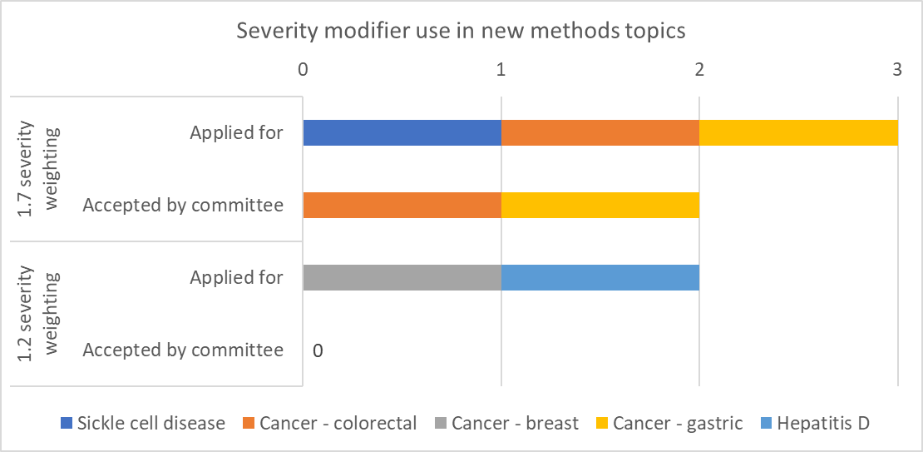
- Up to December 2022, no appraisals had yet arisen that required consideration of flexibilities specified in the updated manual (for example, quality of life or real-world evidence).

Qualitative feedback: Stakeholder interviews and NICE observations
- Stakeholder interviews collated broad qualitative feedback on a wide range of topics. Key findings from all qualitative feedback included:
- Industry interviewees were concerned it was going to be difficult to qualify for severity, especially x1.7. The severity modifier should indeed be applied only in exceptional circumstances; nevertheless it has been applied in 2 appraisals, providing reassurance that it is achievable.
- Patient representatives noted severity is a difficult area to understand and more lay-friendly explanations would be welcome.
- NICE teams are actively encouraging committees to consider additional flexibilities during decision making. NICE will be working on structured decision support guides for committee meetings.
- The new manual aims to front-load work pre-committee to ensure timeliness, however a lot of work still happens post-committee, including delays for commercial and managed access negotiations. Often, both companies and NHS England are keen to know committee’s preferred assumptions before deciding commercial next steps, which can negate any time savings from earlier engagement, delaying patient access.
- All stakeholders were happy with opportunities to take pragmatic approaches to speed up the process, for example, decision making outside of a formal committee in specific circumstances.

Conclusions and next steps on implementation of the current manual for technology evaluation
- We will continue to review the implementation of the manual, returning to the NICE Board after 1 year of committee meetings (quarter 4 2023) with a further update, including:
- Quantitative and qualitative data on use of the methods in practice
- Practical and operational challenges, requiring additional implementation support (e.g. training, resources, clarification, position statements)
- Methodological challenges, concerns or developments that may require consideration for modular updates.

Developing a framework for a modular update
A modular update is a review of the process and/or methods of technology evaluation that is limited to specific subject areas (e.g. children’s quality of life), which can be reviewed and updated as required, without needing a review of the full manual. Modular updates will be split into 3 main types:
- Quick wins – can be immediately implemented without engagement. For example, making changes to the manual such as correcting typos, fixing hyperlinks, correcting 'bugs' and adding clarification wording.
- Partial update – needs some form of review and engagement before deciding whether a change to the manual is needed. For example, providing clarification about a subject where there are areas of ambiguity.
- Full update – requires a full review and consultation before implementing a change to the manual. For example, assessing whether to consider an update to decision modifiers.
A subject area considered for a modular update may, or may not, result in changes to the written manual. For example the following may be determined, and which would not require a consultation:
- Updates to documents other than the manual are required. For example, updating company submission templates with additional detail, or developing a technical support document, rather than updating the manual.
- A change is required in how the manual is operationalised, rather than the wording in the manual.
- A decision of 'no change necessary' may be an appropriate conclusion.

Which teams will this framework be relevant for?
The existing manual for technology evaluation covers the following teams and programmes: commercial and managed access, diagnostic assessments, highly specialised technologies, medical technologies evaluations and technology appraisals. These will be the teams directly impacted by any modular updates to the manual. In addition, cross-NICE engagement will be undertaken for any partial or full modular updates to ensure consistency and alignment of NICE processes and methods wherever possible.

Overarching process
Table 1 outlines the expected major steps in the process. Not all modular updates will require all steps. A cross denotes whether the action is required for each type of update. Further detail on these process steps is outlined in the Appendix.
Timings for each step are not set out; it is expected that different modules will have different resource demands and so bespoke timelines would be generated for each modular update.

Table 1. Overarching process for modular updates for the manual for technology evaluation
No. | Step and description | Full modular update | Partial modular update | ‘Quick win’
1 | Horizon scanning: Engaging with internal and external stakeholders about which subject areas might be relevant for review | X | X | X
2 | Module selection: Identified subjects assessed for feasibility and prioritisation | X | X
3 | Module routing: Module handed over to appropriate work programme | X | X | X
4 | Scoping: Setting out the parameters of what will and will not be considered as part of the update | X | X
5 | Evidence development: Including literature review and engaging with stakeholders | X
6 | Stakeholder engagement: Liaising with key internal and external stakeholders to allow input into any draft recommendation where necessary | X | X
7 | Draft recommendation: Based on engagement and identified literature, appropriate changes proposed to manual (including ‘no change’) | X | X
8 | Equalities impact assessment (EIA): Consideration of whether the recommendations might impact on any protected characteristic groups | X | X
9 | Internal sign off: Sign off step for quality assurance and governance | X | X | X
10 | Executive sign off: Recommendations for change reviewed by guidance executive | X
11 | Consultation: Recommendations for change and EIA sent to key stakeholders for comment | X
12 | Post consultation updates: Changes made as appropriate | X
13 | Update: Any agreed changes made to the relevant documents, and published on the website | X | X | X

Progress to date on modular updates
The first modular updates considered by NICE have been proportionate approach to technology appraisals (PATT), and early value assessment for MedTech (EVA). More information about PATT and EVA has been and will be reported to the board separately.
- PATT has focussed on developing a proportionate approach so we can scale up our appraisals outputs to meet growing demand while maintaining our robust, evidence-driven approach. Several approaches have been explored, tested and refined in a short space of time, including streamlined approaches, pair appraisals and pathway appraisals.
EVA involves using real world evidence generation for MedTech to gather detailed evidence within a live environment. This approach is being piloted with at least 10 medical technologies, including digital health technologies. The pilots will run to the end of March 23.
Interim methods and processes for some of these workstreams are scheduled to be published and implemented from April 2023. NICE will aim to integrate these into final methods and processes through a modular update during the 2023/24 business year.

Future modular update work
Future modular updates to be explored over the next 12 months will include:
- Multiple medical technology guidance: To be done as part of a new 2023/24 business objective. The first phase of changes will be Q1/2 and the second phase will be Q4.
- Rapid entry to managed access: We are identifying a topic to pilot streamlined decision-making for managed access. This is taking time given the small number of topics that require managed access. A simulated pilot is being undertaken on a topic that has already been recommended for managed access to assess whether the streamlined decision-making approach will reach the same decision.
- Pathway appraisals: The first committee meeting for a pathways pilot for renal cell carcinoma is scheduled for September 2023.
The following represents areas we have previously identified for potential modular updates. The proposed framework described in this document will be used to prioritise areas for modular updates:
- Genomics
- Antimicrobials
- Health inequalities
- Digital technologies
- Further alignment of methods and processes for guidance producing programmes

Board action required
The Board is asked to note early findings from our implementation of the new manual for Health Technology Evaluation and consider the proposed approach to future modular updates. Next steps are for the evaluation teams to engage with stakeholders on the proposed approach and begin developing the systems required to deliver it.

Appendix 1: Progress steps for modular updates

Identification of modules
NICE will be responsible for identifying modules which might be suitable for an update. Interested stakeholders may notify NICE of potential modules via a website portal or a dedicated email address. NICE will proactively liaise with key internal and external stakeholders, including:
- Academia
- External Assessment Groups (EAGs)
- Industry
- International collaborators e.g., other health technology assessment bodies
- NHS England / Integrated Care Boards / Department of Health and Social Care (DHSC)
- NICE committees
- NICE Information Services
- NICE Listens
- NICE Science, Policy and Research and Scientific Advice programmes
- Patient and clinical organisations
- NICE guidance producing programmes
NICE may choose from ongoing internal research projects/pilots, collaborative work with other health technology assessment agencies, or may conduct independent research and discovery to inform potential modular updates.
NICE will collate a long list of all subject areas and forward this to the Modular Updates Selection Oversight Panel (MSOP) for shortlisting and prioritisation (see below). Any 'quick wins' may be identified and forwarded immediately to the appropriate team for final approval and immediate update. A quick win must meet all of the following criteria:
- No fundamental stage in the process is added or removed.
- No fundamental method, technique or step is either added or removed.
- No stakeholders will be obviously disadvantaged.
MSOP be responsible for prioritising modules proposed for an update, and routing to the appropriate work programme. The group will be made up of relevant NICE staff and other stakeholders (including NHS England, DHSC) and patient, clinical, and industry input will be sought.
MSOP will review all identified longlisted modules from horizon scanning, decide which should be prioritised, and, if a priority, route it to the appropriate work programme. When prioritising modules, the panel will take into account:
- Whether an update aligns to NICE’s strategic priorities
- Volume of requests received
- Breadth of stakeholder categories raising the request
- Seriousness of concern raised
- Number of appraisals, clinical guidelines etc. that would be affected by any change to the manual, and scale of this impact
- Volume of work and resources required in order to action the update
- Likelihood of a review leading to a change, including evidence availability
- Potential to positively impact the NICE Key Performance Indicators, timeliness and/or productivity
- Time since last reviewed
- Any ongoing work in this area
- Impact on any protected characteristics or health inequalities.
Modular updates will be categorised as either low, medium, or high priority for update, and as either 'quick win', partial update required, or full update required.

Stakeholder engagement
MSOP will be responsible for determining whether there is any directly or indirectly relevant ongoing work, to avoid duplication of effort, or to consider if the update can build on any existing learning. MSOP will produce a NICE-wide summary of activities and send to key internal contacts. This will be published on the NICE website.
For partial updates, stakeholder engagement will include liasing with key stakeholders including NHS England, DHSC, academia, patient and clinical groups, and industry, to allow input into the draft recommendation.
For full updates, during evidence development, stakeholder engagement will include working closely with stakeholders including NHS England, DHSC, academia, patient and clinical groups, and industry. This will include where necessary active participation of these stakeholders in the working groups responsible for evidence development/draft recommendations. It may also include submissions of evidence from companies or other stakeholders, and discussions with patient, commissioning, and clinical experts.
© NICE 2023. All rights reserved. Subject to Notice of rights.
March 2023

