Board meeting

19 March 2025

Guideline collaboration update

Purpose of paper
For information

Board action required
The Board is asked to receive this update.

Brief summary
The NICE accreditation programme was formally closed in July 2024 and then new ways of collaborating with external guideline developers have been established. This paper provides an overview of current guideline collaboration work and explores future work.

Board sponsor
Professor Jonathan Benger, Chief Medical Officer, Interim Director of the Centre for Guidelines and Deputy Chief Executive.

Introduction
To support our future work in guideline development, and to help facilitate partnership working, six approaches to guideline development and collaboration have been identified.
This paper provides the Board with an overview of the six approaches and provides practical examples of how they are already being used, and how they may be used in the future.

Background
The NICE accreditation programme was established in 2009, with a key aim of improving the quality of guideline development. When the programme was formally closed in July 2024 a total of 54 organisations had NICE accreditation. The accreditation programme was successful in many of its initial aims but did not meet the current needs of NICE and the users of NICE guidance.
In May 2024 the NICE Executive Team approved a new model for guideline collaboration including utilising externally produced guidance. This new approach should allow NICE to more efficiently maintain and expand its guideline portfolio, and better support health and care professionals and the people that use health and care services.
The ultimate aim with this work is to provide users with useful and useable guidance covering major healthcare themes in an efficient and sustainable manner.

New model for guideline collaboration
Six options for guideline collaboration have been created with input from across NICE. These options will provide the prioritisation board with the ability to listen to users and act to ensure our guideline portfolio remains current and impactful and we can respond in a timely manner to referrals. The 6 options are presented below and in figure 1 of this paper (see appendix).
  - Create de novo NICE guidance or follow the routine update process
  - Co-produce - Co-produce and co-badge a joint guideline or topic area with another reputable guidance producing organisation
  - Contextualise – Make use of external guidance or recommendations, either by adapting relevant evidence reviews to formulate NICE recommendations or contextualise external recommendations to fit our requirements
  - Cross-refer with support – Provide support and expertise in methods and processes to external guidance producers to develop or update their guidance or recommendations so they meet our requirements to cross-refer
  - Cross-refer without support – Link from our guidance to someone else’s recommendations, or link to whole guidance “as is” from our website or suite hub pages
  - Curate - present users with non-NICE guidelines or recommendations, overlaid with an accompanying review or critique by NICE.
We anticipate that the new model for guideline collaboration will bring a range of benefits to both NICE and the users of our guidance.
  - Timely guidance, this approach supports working at pace, getting the best care to people quickly
  - Sharing good practice, NICE can learn from national and international guideline developers and vice versa
  - Efficiency, reduce and remove duplication
  - Consistent messaging, reduce mixed messages through misaligned or conflicting guidance
  - Implementation, collaborating with key partners will help support implementation.

Examples of guideline collaboration work
The new approaches to guideline collaboration are already being used by the centre for guidelines, in some cases final guidance has been published in other examples work is ongoing. Examples are presented below and in figure 2 of this paper (see appendix).
  - Create de novo (routine process)
  - Co-produce - The latest asthma guideline was co-produced and co-badged with British Thoracic Society and SIGN
  - Contextualise - Currently exploring how a high-quality international guideline on polycystic ovary syndrome (PCOS) could be used to meet the requirements of the UK health and care system
  - Cross-refer with support – no examples to date
  - Cross-refer without support - The NICE guideline on prophylaxis against infective endocarditis cross refers to implementation advice provided by the Scottish Dental Clinical Effectiveness Programme
  - Curate - Currently working with DMD Care UK and the guidance they have published for people with Duchenne muscular dystrophy.

Next steps and future approaches
The oversight and implementation of the new approach will be through the Guidance Lifecycle workstream. The work on the contextualise approach (PCOS) and the curate approach (Duchenne) will be formally evaluated through this workstream and will oversee wider roll out of the approach, if successful.
New approaches to guideline collaboration are interlinked with the work of NICE’s prioritisation board, as the work of the board becomes more established these links will become increasingly important.
Initial work suggests that the curate approach may be a desirable way of expanding NICE’s portfolio to provide users with useful and useable guidance covering major healthcare themes in an efficient and sustainable manner.

Board action required
The Board is asked to receive this report and note the work to date.

© NICE 2025 All rights reserved. Subject to Notice of rights.
March 2025

Appendix

Figure 1. New model for guideline collaboration
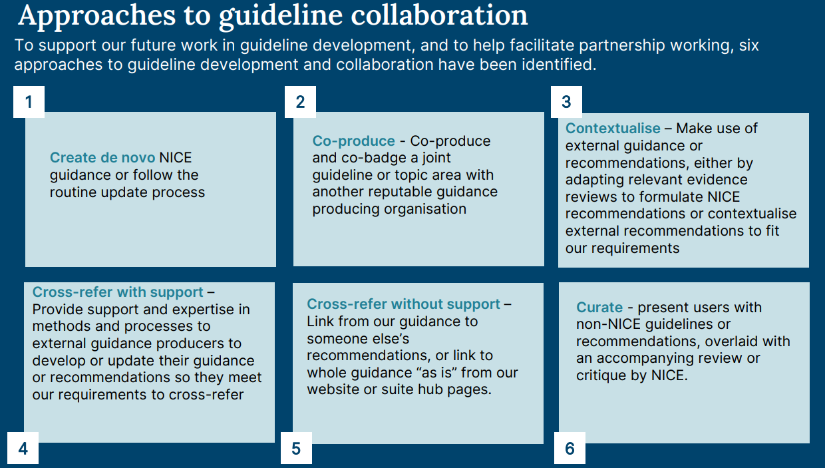

Figure 2. Examples of guideline collaboration work.
