Board meeting

17 May 2023

Data and Analytics update

Purpose of paper
For information

Board action required
The board is asked to note the summary of activities related to real-world evidence undertaken in the 2022/23 business year.

Brief summary
This paper summarises the activities related to data and real-world evidence undertaken by the Data and Analytics team in the past year and outlines our approach for this year.

Board sponsor
Felix Greaves, Director, Science, Evidence and Analytics

Introduction
NICE's 5-year strategy (2021 to 2026) announced our ambition to use real-world evidence (RWE) to fill evidence gaps and to speed up patient access to innovative interventions. NICE already actively uses RWE; a recent study found that by 2021, over 80% of single technology appraisals used RWE. We are working to maintain and enhance this position and demonstrate NICE's leadership as an organisation that constantly learns from data and implementation.

Looking back: Business year 2022/23
Over the past year, the Data and Analytics team has supported all 4 NICE priorities for 2022/23 in addition to business-as-usual delivery. The following is a brief overview:

Priority 1 – developing digital living guidelines recommendations
With NICE's Impact team, we co-delivered a pilot dashboard that allows visualisation of uptake of recommendations in NICE guideline 101 (Early and locally advanced breast cancer: diagnosis and management). The prototype demonstrated how measurable recommendations in guidelines can inform assessment of the level of uptake across time and regions. Importantly, the work contributed to the further development of technical and coding skills of NICE staff that will be needed as NICE begins to deliver an automated uptake and monitoring system as part of this year's priority that focuses on being part of a system that continually learns from data and implementation.

Priority 2 – proportionate approach to technology appraisals
More than 40% of our appraisals cover only 10 disease areas. One of the aims of priority 2 was to improve efficiency by combining several appraisals within a single disease pathway. To support the health economic modelling of disease pathways, we sourced high-quality RWE that will inform a new pathway model for renal cell carcinoma. This was delivered through establishment of a time-limited pilot collaboration with an external healthcare analytical company. As part of this work, we also provided advice to ensure that the work followed the best practice principles outlined in NICE's RWE framework.

Priority 3 – early value assessments for medtech
We worked with the Manged Access team to develop an approach to evidence generation for the Early Value Assessment (EVA) programme. This included developing new processes and methods for evidence generation as outlined in the EVA interim statement. An important aspect of EVA is cross-directorate working and, in collaboration with the Managed Access team and the Medtech and Diagnostic teams, we continue to develop evidence generation plans for topics going through EVA.

Priority 4 – transforming how we work
We provided support for NICE's crowdsourcing activities by collaborating with the transformation team on ways to capture data on decision making and progress and built a data visualisation tool to communicate the information to all NICE staff.
We provided advice on analytical environments needed for data science activities that are being developed by the Digital, Information and Technology (DIT) team.
We supported building cross-NICE capabilities in data science and informatics by:
- identifying suitable training materials and working with NICE's learning and developing team to establish NICE-wide access to training in data science;
- supporting upskilling in the use of statistical software and data analysis tools. This included delivering regular whole day training in the programming language 'R' and establishing a structured time for groups to undertake self-directed learning with support;
- running NICE's Coding club which provides a supportive environment for training, sharing best practice and ideas on how to approach work-related data problems.

NICE's RWE framework
We published the NICE RWE framework in June 2022 after public consultation. The framework was informed by existing best practice guidance and a series of literature reviews. After internal consultation, we undertook multistakeholder workshops including patient organisations, health charities, healthcare professionals, pharma and medtech, data controllers and contract research organisations, academia, international HTA bodies, NICE committee members, and UK health system partners.
Feedback from users and industry is positive. Our activities to support implementing the framework, included providing awareness-raising events and training for NICE technical teams, NICE committees and EAGs.
We supported practical application of the RWE framework in research projects and health technology assessments including by:
- attending live technology appraisal committee meetings and helping committee to interpret and critique the evidence. TA850 (amivantamab) and TA855 (mobocertinib) show direct application of the RWE framework and use of NICE's data transparency tool (DataSAT) by companies submitting evidence;
- supporting NICE scientific advice in advising companies on their evidence generation plans for collecting real-world data;
- advising Academic Health Science Networks (AHSNs) on their approach to RWE and data collection plans to support adoption and implementation of NICE recommendations;
- supporting NICE internal research projects, for example, applying the NICE RWE framework in analysis for the Centre for Guidelines and commissioned research to improve our use of national data collections in managed access.

Research
We are active in RWE research and have created partnerships with leading UK researchers. This includes participation in the NIHR-UKRI funded CONVALESCENCE study. The study uses primary care records within the OpenSAFELY platform, to investigate compliance with the NICE guidance on diagnosis and management of the long-term effects of COVID-19. The study also explores whether this differs by demographic, health, socioeconomic and regional characteristics.
NICE is also hosting Professor Laurie Tomlinson who recently has been awarded a NIHR Research Professorship worth £1.7m to explore how routinely-collected healthcare data can be used to improve clinical guidance.
Our current international partnerships cover clinical, academic, health informatics and data, and industry areas. Our ongoing projects include:
- research collaboration with international healthcare analytical companies Aetion and Cegedim to use primary-care data to answer questions relating to the comparative effectiveness of direct-oral anticoagulants for the prevention of stroke in non-valvular atrial fibrillation (Jaksa et al. 2022)
- research collaboration with analytical company Cytel, and leading academics to use international cancer data for a multi-RCT replication study using real-world external controls in non-small-cell lung cancer.
- research collaboration with Flatiron Health to explore the availability and transportability of international data and its contribution to NICE guidance.
- research collaboration with healthcare analytics company LOGEX to provide bespoke data that informs a new pathway model for renal cell carcinoma.
- collaboration with academics in Harvard University working on an ISPE-funded critical appraisal tool for RWE studies of comparative effects with a focus on utility for health-technology appraisal.
- We are part of several international networks such as the GetReal institute, RWE4decisions, and INAHTA. Activities include discussing issues related to real-world evidence, aligning guidance when appropriate, and sharing learning.
We attended key international conferences such as ISPOR, HTAi, and DIA to present the RWE framework and we actively provide feedback on the RWE guides produced by other regulators and HTA bodies such as in the USA (FDA) and Canada (CADTH).

Data access and NICE's data hub
We were one of the first UK organisation to secure access to NHS England's Secure Data Environments (SDE). SDE environments are now a key route to access NHS data, as set out in NHS England's data strategy Data Saves Lives. We influence the development the environment through membership of the Data Alliance Partnership Board and are supporting its expansion to include cancer data and other national data sources.
NHS England's SDE does not contain primary care data (except for COVID-19 research). Therefore, we:
- secured a multi-study license to CPRD to support our guidelines and indicators programmes,
- commissioned CPRD research services to link CPRD data to hospital episode statistics and ONS death registries for guidelines work on escalating lipid modifying therapy.
We set up an internal data service hub on the intranet where colleagues can request data in the SDE and CPRD datasets. We intend to develop the Data Hub concept further this business year to include broader range of datasets. To support internal use of RWE, we developed supporting materials and guides including:
- standard operating procedures for the data access process at NICE
- a guide to selected RWE datasets
- a guide for quality assurance of analytical projects in line with the UK government's functional standard.
We are working the London School of Hygiene and Tropical Medicines to develop a reproducible analytical pipeline that uses secure data to understand the effectiveness of COVID-19 treatments as new variants emerge.

Supporting NICE teams in using RWE
We supported internal RWE projects through data access, data science expertise, and methods advice to teams developing guidance and to decision making committees across NICE.
We undertook pilot projects to demonstrate the value of primary analysis of RWD in NICE guidance, and lay the groundwork for digital living guidelines. These are outlined in Appendix 1.

Looking forward: next 3–5 years

Overall approach
For the upcoming 3–5 years, prioritisation of our activities will be influenced by our users' needs as NICE seeks to increasingly use RWE in the development and monitoring of guidance. The programme of work will be incorporated into NICEs strategic plan to use RWE to improve our guidance. The 3-5 year plan is in development but will focus on the following areas:
- increase our capability in the appropriate use of RWE by upskilling staff and committees, working with assessment groups to improve their ability to evaluate RWE, enhance internal capability in data science and informatics, and strengthen research partnerships in RWE;
- lead and set standards for the use of RWE by evolving NICE's RWE framework and working with CHTE and CfG colleagues on our approach to updating methods guides with respect to RWE;
- develop access to useful RWE sources by developing further data partnerships and access agreements, and influencing NHS data structures so that they meet the needs of NICE;
- monitor uptake of NICE guidance and drive improvement by developing reproducible analytical pipelines for analysis of uptake data and develop uptake dashboards for priority disease areas;
- pilot post evaluation monitoring of effectiveness of technologies beyond initial NICE assessment.

The current planned phasing of delivery is shown below. This year, we will focus on:
- delivery of upskilling of staff and committees,
- extend the NICE RWE Framework,
- establish further data partnerships,
- pilot reproducible data pipelines that indicate uptake of NICE guidance,
- and start work to formalise our approach to updating NICE methods guides with regard to the use of RWE in decision making.

Figure 1. Real world evidence timeline 2023-2027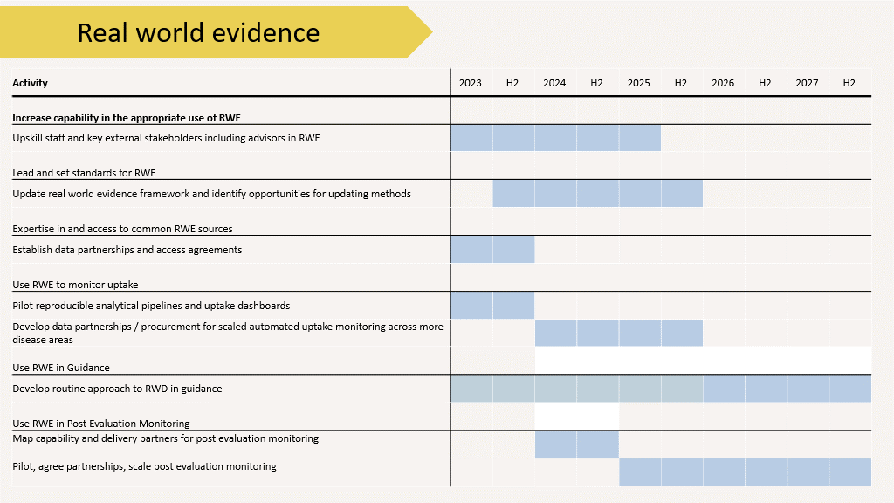

Risk assessment
The scale of change required to transform how NICE uses RWE in guidance is large, especially considering that introduction of RWE in evidence synthesis needs to consider the strengths and weaknesses of such evidence and real-world studies require high-quality study design, conduct and analysis. There is also no universal agreement on how such evidence is balanced against the more traditional randomised controlled data. NICE's strategic risk register outlines our current approach to mitigation to these risks (see table 2).
In terms of data access, NICE is dependent on accessing data provided through national infrastructure and other sources. We are working with NHSE and other partners to make sure future data and infrastructure is fit for purpose for NICE's use case.
This work also requires highly skilled workforce and the availability of people and skills is scarce and internal capacity is relatively small, which has an influence on the pace of transformation. Capacity this year also means that decisions regarding prioritisation need to take place, with activities such as alignment with the MHRA on RWE methods needing to be deprioritised. We are also limited in our capacity to provide support to our committees regarding the use of RWE in live guidance production, in a way that we did during the mobocertinib and amivantamab appraisals.

Board action required
The board is asked to note the summary of activities related to real-world evidence undertaken in the 2022/23 business year.

© NICE 2023. All rights reserved. Subject to Notice of rights.
May 2023

Appendix 1: Internal RWE analysis projects for guidance producing centres 22/23
Table 1 Internal RWE analysis projects for guidance producing centres 22/23
Guideline | Data source | Project aims
Weight management (PH53) | THIN (primary care data) | Exploring BMI by demographic characteristics and overlap with comorbidities
Type 2 diabetes mellitus (NG28) | Discover-NOW (primary care, north-west London) | Establish prevalence and incidence of comorbidities in the diabetic population and across several subgroups
Stroke rehabilitation (CG162) | SSNAP | Understand how patients that participate in RCTs differ from those receiving care in real-world clinical practice in England to determine the proportion of stroke patients in the real-world who would be ineligible for trials
Lipid modification (CG67) | CPRD | Informing the cost effectiveness model for a sequence of cholesterol lowering therapies in people who have had a CVD event and are on a statin
Gout (NG219) | CPRD | Understanding comorbidities and prescribing and assessing how patients participating in RCTs differ from those receiving care in real-world clinical practice in England to determine the proportion of gout patients in the real-world who would be ineligible for trials
Renal cell carcinoma (proportionate approach to technology appraisals) | Logex | Working with a healthcare analytical company to understand patient characteristics to populate the economic "reference" model for RCC.

Appendix 2: Strategic risk register regarding the use of real-world data
Risk | Current mitigation, controls and assurance | Current: Impact | Current: Likelihood | Current: Score | Further actions to strengthen mitigations | Target: Impact | Target: Likelihood | Target: Score
Use of real world data  An inability to access or make use of real world data in guidance development and impact measurement means we fail to capture the latest information to inform our recommendations and target improvement activity, reducing our impact on the health and care system | Advise on RWD in decision making  Published the first draft of the NICE RWE framework in response to feedback and user experience  Training and upskilling  Provided NICE-wide staff access to the Government Analysis Learning Hub and explored further training provisions  Maintain an active peer-support for data analysts through the NICE Coding Club (ongoing)  Governance  Meet the compulsory elements of the Government Functional Standard for analytics | 3 | 4 | 12 | Advise on RWD in decision making  Update the NICE RWE framework in response to user experience (2024/25)  Strengthen skillset  Establish Data Hub and recruit additional staff to support evidence generation plans for EVA (Q2)  Build in-house capability to support committee RWE decision making during live guidance production (Q4)  Data access  Enable routine access to NHSD TRE (Q1)  Develop strategic partnership with national and commercial providers of data (2024/25)  Extensive cross-system engagement including with DHSC and NHSE to ensure future national data structure meets our requirements (Q2)  Governance  Develop an action for the ‘advisory’ elements of the Functional Standard for analytics (Q1- 2) | 3 | 2 | 6

