National Institute for Health and Care Excellence

Communications Directorate progress report

Summary of activity
This report provides an update on key issues and developments in the Communications Directorate in the period March - April 2021. Communications to enable the successful launch of the new 5-year strategy represent the most significant area of work during this period.

Notable issues and developments

5-year strategy launch
More than 3,332 people from 53 countries registered in advance for the event. The registered delegate breakdown is as follows:

An on-demand version of the event was also uploaded to NICE’s YouTube channel on the same day, this has been viewed 979 times (as of 28 April).
We received 174 questions/comments from the audience, some of which were answered during the event. We are analysing and grouping the questions into themes, and alongside responses to a post-event survey, these will be used to inform future communication activities about our new strategic priorities.
In the weeks before the event we launched a paid digital marketing campaign, consisting of advertising on social media channels, Google search, re-marketing (web banners served to those who visited specific pages on the NICE website) and display banners on publication sites. The post-launch awareness-raising phase of the campaign will run until Sunday 16 May.
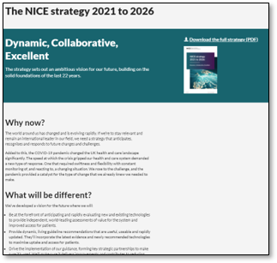
In support of the launch, the web team produced a number of new landing pages including a revamped events page, a new strategy launch page and a significantly redesigned and refreshed homepage.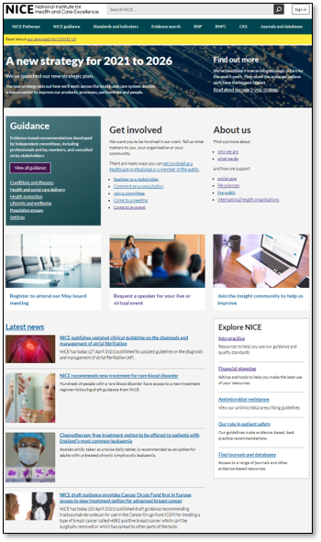
One week after the launch, the strategy page had received 9,245 unique page views with users, from 51 countries, spending an average of over 4 minutes on the page. The strategy document was downloaded by over 1500 unique users.
In addition, we created a new strategy hub for our intranet NICE Space. This provides staff with the opportunity to re-watch the launch event as well as with resources such as a presentation, graphics and an email banner. This hub will continue to grow to encourage further engagement with the strategy.
The publication of our strategy launch gained widespread trade media coverage, and the reaction on social media has been broadly positive with several key stakeholders engaging with the posts put out on the day to support the launch, including Lord Bethell, who retweeted about his own involvement in the launch event. The story was covered in National Health Executive, Health Tech Newspaper, Pharma Field, Pharmacy Magazine, PharmaTimes, The BioIndustry Association and BIVDA. The Pharma Times also published a piece from NICE Chairman Sharmila Nebhrajani, looking at the strategy launch and why it is a necessary for NICE to evolve, particularly against the backdrop of the COVID-19 pandemic.
On 28 April, the NICE chairman and chief executive presented our new 5-year strategy to an interested group of MPs and peers, in a special session of the All-Party Parliamentary Health Group, chaired by Baroness Walmsley.

Marketing communications
Based on user insights research we launched a refreshed section of the website for NICE International in April. In the first 3 weeks, page views were up over 450% compared to April 2020. In May, we will add additional content including a series of case studies and an interactive world map providing further information on NICE International engagements by country.
During the reporting period we made further progress with improving the content and data management of our corporate newsletters. We intend to standardise our newsletter data capture forms and are reviewing opt-ins with the aim of delivering data-driven marketing communications in the future.

Stakeholder events and speaking engagements
The chief executive took part in a plenary panel discussion at the ABPI's annual conference alongside senior colleagues from the MHRA and NHS England; the deputy chief executive chaired a plenary session at the World EPA (Evidence, Pricing and Access) Congress; Paul Chrisp, director of the Centre for Guidelines, took part in a debate about chronic pain hosted by the British Pain Society; and Jeanette Kusel, director, NICE Scientific Advice, gave a keynote speech at a Spanish Health Economics Association event about the evaluation of AI technologies.
We prepared briefings for the chairman's meetings with the Association of British Pharmaceutical Industries (ABPI), the American Pharmaceutical Group, MSD, the Early Cancer Diagnostics Treatment Programme Board, Genomics plc and University College London.
We responded to two stages of the All-Party Parliamentary Group (APPG) on Access to Medicines and Medical Devices' call for written evidence on 'Post Brexit and post COVID reviews and consultations.'

Enquiries
We responded to 1221 enquiries during this period. 93% were answered within 18 days, including 37 requests for information under the Freedom of Information Act, 24 MP letters, and 13 parliamentary questions.

We responded to 3 coroner’s reports:
  - A coroner’s report following the death of a 3-month-old child which was associated with severe vitamin D deficiency.
  - In response to a coroner's report relating to the death of a 9-year-old boy, DHSC asked for our contribution on the recognition of total body potassium depletion in children with myopathies (diseases of muscle tissue).
DHSC also asked for input in the case of a psychiatric inpatient whose cause of death was bilateral pulmonary embolism and deep vein thrombosis.

Media
Sentiment percentages for media coverage in March and April were as follows: positive 79%; neutral 9%; negative 12%.
In April, we issued a press release and published a news story on NICE’s final guidance on chronic pain management. This received widespread coverage, including articles in the BMJ, Telegraph, the Times the i, the Sun, Pharmaceutical Journal, OnMedica, Health Business, GM Journal, Pharmacy.Biz, Drink and Drugs News, Health Club Management, Training Matters Magazine, and Pharmafile (no link). The Independent highlighted the concerns of people currently receiving painkillers for their chronic primary pain who are critical of the decision not to prescribe these. A separate article in the Independent also highlights the guideline’s main recommendations.

Audience insights
We have now commissioned an agency to run the reputation research (scheduled for Q2 2021). This is a biennial review, and our new contract provides us with three waves that will help measure perception and progress across the 5-year strategy period.
We are also refreshing and growing the insight community (our panel of approximately 1,800 users from across the health and care system) to enable us to quickly and effectively conduct research on specific activities or projects.

Risks
The main risk to the Communications Directorate continues to be one of insufficient capacity to fully support the implementation of the 5-year strategic plan. We are addressing this risk with changes to the way we work across the directorate and recruiting an additional senior post in Q1 of 2021-22.

NICE 2021. All rights reserved. Subject to Notice of rights.
May 2021

