National Institute for Health and Care Excellence

NICE Listens: policy development through interactive conversations with the public

This report proposes a new and flexible process for deliberative public engagement on moral, ethical and social value issues. This process will be used when needed to ensure that NICE's policies on complex and controversial issues reflect the values of informed members of the public.

The Board is asked to approve the proposed process.

Felix Greaves

Director, Science, Evidence and Analytics

November 2020

Introduction

1. One of the principles at the heart of NICE is meaningful public engagement. Currently, we do this in several ways.

* Guidance-producing programmes consult the public on draft guidance and changes to our methods and processes.
* The Public Involvement Programme supports patients, service users, carers and members of the public who are involved in guidance production, scientific advice and methods development.
* The Audience Insights programme conducts polls, interviews and focus groups to help understand audience perceptions (including the public) about the Institute and to improve NICE products and services.

These forms of engagement are fit for purpose in relation to guidance development, methods changes and service improvement. However, NICE does not have a process for engaging with the public to debate and discuss moral and ethical issues from a societal perspective. This form of engagement is known as 'deliberative public engagement'. The key defining factors are:

* recruiting a representative sample of the public
* supporting them to understand complex policy issues
* allowing them time to debate and explore others' points of view, and
* supporting them to consider trade-offs carefully.

Internationally and in the UK, policy makers increasingly use deliberative public engagement to gather advice or recommendations to inform their response to controversial or challenging issues (OECD 2020, [NHSX](https://www.thersa.org/globalassets/reports/2019/patient-ai-report.pdf), [NHS England and NHS Improvement](https://www.england.nhs.uk/wp-content/uploads/2017/04/ppp-policy.pdf)).

Benefits of deliberative public engagement

Deliberative public engagement offers NICE several potential advantages:

* Better policy decisions because deliberation results in considered and informed advice from the public
* Greater legitimacy for NICE to make hard choices
* Enhanced public trust in NICE
* A visible demonstration that NICE works with people, rather than imposing policies on them
* Engaging a diverse and inclusive group of people in policy making (because members of the public are invited to participate at random)
* Involving lay people in our corporate decisions, in line with our [Public Involvement Policy](https://www.nice.org.uk/about/nice-communities/nice-and-the-public/public-involvement/public-involvement-programme/patient-public-involvement-policy).

Previous forms of deliberative engagement

In the past, NICE used the Citizens Council to inform the NICE Principles and our evaluation methods. The Citizens Council is often referred to in documents and by staff to justify our approach to challenging issues. The Citizens Council approach was ground-breaking and widely admired. But the set-up was inflexible and it was sometimes unclear how NICE had responded to the public's advice. The Council has been dormant since 2015.

Need for deliberative engagement by NICE

NICE and the wider health and social care landscape are changing. In addition to the long-term impacts of COVID-19, transformative innovation is underway in healthcare services, technologies and regulatory science, and within NICE itself. These changes will throw up challenging moral, ethical and social value issues that NICE will need to address. For example, what is the public's tolerance of risk when artificial intelligence is used in health and care settings? Details of this and another potential topic are in appendix 1. Teams across NICE have suggested further subjects ranging from health inequalities to environmental impact to genome editing. These challenges cannot be resolved by scientific or economic analysis alone.

As a further example, deliberative public engagement could potentially inform which 'modifiers' NICE will use. That is, which populations, disease areas or technologies are considered to have a greater value to society and should be prioritised in NICE's decision making. The Centre for Health Technology Evaluation methods review found that research on the public's views is limited, of mixed quality and relevance, and has variable results. Whilst it is not appropriate to commit to new research whilst the methods review is ongoing, a deliberative engagement project on modifiers could fulfil an important research and policy need, and have a clear impact by informing future updates of the methods guide.

NICE Listens

This paper proposes a new process for deliberative public engagement by NICE, to be used when needed for challenging moral, ethical and social value issues. The proposed workstream name is 'NICE Listens: policy development through interactive conversations with the public'.

NICE Listens is a flexible resource that will complement our existing mechanisms for public engagement (figure 1). The aim is to use modern, high-quality deliberative engagement to understand the views of the public, and to use this information alongside other forms of evidence to inform NICE's policies. As a result, the policies will be defensible and more acceptable to the public. NICE is not mandated to follow the public's advice. But we will plan in advance how the advice will be used, commit to considering it seriously and be explicit about how we have taken it into account.

Figure 1. NICE Listens will complement the existing ways that NICE engages with the public.

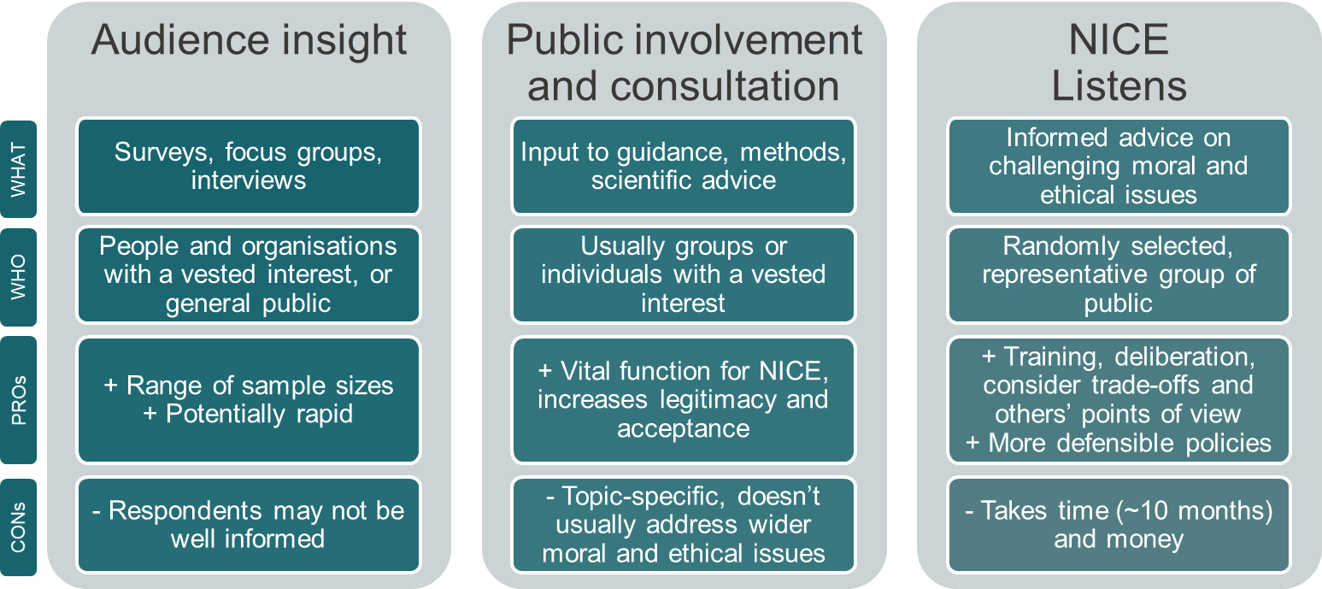

Our proposed process and methods are not fixed. We will tailor our approach to each project, research and use the latest methods of digital engagement, and continuously learn and improve. The core principles underlying our proposal are informed by:

* [Innovative Citizen Participation and New Democratic Institutions](https://read.oecd-ilibrary.org/governance/innovative-citizen-participation-and-new-democratic-institutions_339306da-en#page38) (OECD, 2020). Researchers reviewed almost 300 case studies and consulted experts to generate good-practice principles.
* The [People's Verdict](https://policynetwork.org/wp-content/uploads/2017/08/The-Peoples-Verdict.pdf), a report that reviewed about 50 case studies in Australia and Canada and interviewed those involved (Chwalisz 2017).
* Reflections from staff (past and present) on the Citizens Council.

Role of NICE staff and external contractor(s)

NICE Listens will be run by the Science Policy & Research and Public Involvement programmes, in collaboration with staff across the institute. NICE staff will do detailed preparatory work, plan how the outputs will be used, support implementation, and manage external communications.

We will contract external organisation(s) to manage recruitment, prepare materials, facilitate the meetings and write the report. Using external organisation(s) ensures the process is visibly independent. Furthermore, specialists will advise on methods and ensure meetings are well run with effective facilitation by trained moderators.

We will consider a range of contractors as part of an open tendering process. We will seek to appoint contractor(s) that can take a flexible approach and have experience of online deliberative engagement.

Topic selection and preparatory work

The Science Policy & Research and Public Involvement programmes will identify potential topics via existing horizon-scanning work. In addition, any team in NICE can identify a potential topic.

First, we will assess whether the issue requires complex moral, ethical or social value judgements (figure 2). Purely technical or scientific issues will be addressed via other means.

Second, we will choose between a deliberative process or audience insight approach (or choose to do both). A deliberative process is appropriate when:

* People require background information and training to understand the issues.
* It is a long-term issue (deliberation takes time, so is not suited to short‑term challenges).
* Deliberation is needed, for example because:
  + There are complex questions involving trade-offs and conflicting priorities.
  + There is evidence, or reason to expect, that some people change their minds once they are better informed and hear alternative opinions.

We are interested in the reasons behind public opinion, not just what the opinions are.

Third, we will decide whether it is useful and appropriate for NICE to do deliberative public engagement, checking against the criteria listed in figure 2. To inform this decision we will:

* Liaise with system partners to understand any limitations on NICE’s policy options.
* Explore opportunities for joint working with system partners, including with devolved nations (see section 19).
* Do a rapid literature review to see if existing research can provide the public insight NICE requires.
* Specify a clear mechanism for NICE to take account of the results.

Figure 2. Topic selection process for deliberative public engagement.

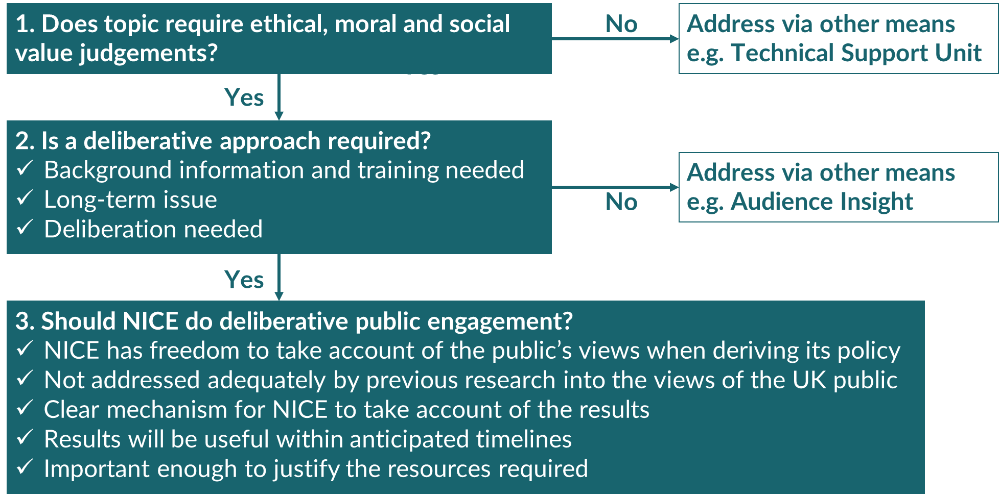

Governance

The Senior Management Team has approved an internal governance process that uses the existing Internal Research Advisory Group. The Senior Management Team would approve each project, checking against the criteria in figure 2.

Opportunities for joint working

For each project we will explore opportunities for joint working with system partners, including the devolved nations. We have already been approached by organisations wanting to partner with us. Joint working should reduce the project costs to NICE but probably would not reduce the need for NICE staff time.

Recruitment strategy

The aim is to recruit a representative sample of the population and not just those with an interest in NICE. We propose that the external contractor(s) should recruit using 'sortition'. First, a random sample of the population will be sent letters of invitation. Second, from the respondents a sample will be selected that is representative of the population.

We propose to recruit new participants for each topic, from England only (unless a project is run in partnership with the devolved nations in which case the recruitment area would be expanded).

Previously, NICE's Citizens Council excluded healthcare workers because they may have more knowledge about the topics for discussion and potentially dominate the group sessions. However, approximately 2.8 million people work in health and social care in England (Skills for care 2019, NHS Digital 2020) of whom a greater percentage are from black, Asian and minority ethnic groups than in the population as a whole (NHS Digital 2019). We propose to include health and social care workers. Effective facilitation should address concerns around background knowledge and dominant voices. We will manage conflicts of interest in line with NICE's [policy on declaring and managing interests for NICE advisory committees](https://www.nice.org.uk/about/who-we-are/policies-and-procedures).

Sample size

We will tailor the sample size to the topic. We propose a minimum sample size of 24, in line with the smaller past Citizens Council meetings; we judge that sample sizes below this level are not appropriate given the aim is to inform NICE policy. We will consider larger samples for high-profile topics that may have a substantial impact on NICE.

Format

This workstream will seek to be creative in its approach and digital by default: that is, we will interact with the public online unless there is a compelling need for face-to-face meetings. Deliberative public engagement has traditionally been done face-to-face, but there is increasing interest in online engagement. Whilst virtual meetings are essential to allow us to run projects during the COVID-19 pandemic, there are wider benefits to an online approach. By removing the need to travel, we may attract a wider range of members of the public and expert witnesses. Sessions could be spaced out throughout the week to offer more flexibility to people who have other commitments. The software used for online meetings may also offer benefits such as enhanced transparency, easier sharing of materials, improved communication with participants and opportunities for a more in-depth analysis of the findings.

If possible, we will appoint an external organisation that has experience of online deliberative engagement in order to minimise the associated risks, such as excluding those with limited internet access or lack of digital skills. We will also carefully consider ways to enhance the personal connection between participants and encourage empathy and communication amongst people from different backgrounds.

For maximum transparency and accountability, meetings would be held in public. But some people might not wish to be identified or to speak in front of large audiences and may be put off by this approach. Accordingly, we propose that the introductory and training sessions will be open to public observers and video recordings will be available online. The deliberative sessions will not be open to the public and videos of these sessions will not be available online. Instead, the deliberative sessions will be summarised in the project report.

Outputs and implementation

Before embarking on the deliberation, we will plan how to use the outputs. The most common scenario is to inform methods updates, but some projects may be intended to inform NICE's overall strategy. Advice or recommendations from the public will be considered alongside other forms of evidence (such as a literature review, audience insight work, or stakeholder consultation).

For deliberative public engagement to work well, policy makers should publicly commit to responding or acting on participants' recommendations in a timely manner (OECD 2020). Policy makers “do not need to promise to abide by the recommendations, simply to engage with them seriously, explaining why they can or cannot adopt certain ideas” (Chwalisz 2017). A public commitment to respond reduces the potential for public engagement to be seen as a public relations exercise for a decision that has already been made. We recommend that each report from a public engagement project should be followed within 6 months by a statement from NICE, explaining how we have (or will) take account of the findings. If we are unable to follow the public's advice, we should explain why.

We will undertake an evaluation at the end of each project to understand what went well and how to improve future practice. There will be an anonymous evaluation to gather feedback from participants.

Timelines

The duration of projects will vary depending on their complexity; as a rough guide we anticipate that each will take about 10 months (Appendix 2).

The timings could be shortened if the Senior Management Team indicates that a deliberative process is needed urgently. We would fast-track the preparatory work and impose tighter timelines on the external contractor, meaning the project would take about 7 months. We do not recommend the fast-tracked process routinely because it allows little time to liaise with the Senior Management Team and system partners to understand limitations on NICE's policy response; there is also little time to define the key questions for the public and to plan how the outputs will be used.

Financial/HR/Legal implications

Investment in this workstream will help to create robust and defensible policy solutions that reflect the values of the public.

We will initiate this work using existing staff capacity and then review to consider whether further resource is required. We anticipate that this work will require staff time continuously (to support topic selection, engagement with system partners etc) and more intensively during each project. We will seek to make the most efficient use of staff time and will promote working across teams.

The non-staffing costs of each project (such as the external contractor and honoraria to participants) will vary depending on scale and complexity. It is hard to estimate the cost of online engagement projects, as methods are still emerging and NICE has no past projects to inform cost estimates. For business planning purposes the Senior Management Team has agreed to allocate a budget of £50,000 per annum to cover the variable costs of NICE Listens. The team is expected to deliver this activity within the allocated budget. If in exceptional circumstances additional funds are needed (for example, several large meetings for a high-impact project) we will ask the Senior Management Team for additional funding. If costs are lower, budget will be returned to central reserves.

Next steps

We will release external communications explaining that: NICE values input from the public, we gather that input in many ways, and we have a process in place to engage deliberatively with the public on complex moral, ethical and social value issues. But we will not set expectations around the nature and timing/frequency of public engagement events.

We will work with the communications team to consider whether the proposed name, NICE Listens, adequately conveys the aims of the workstream. We will consider external communications and updates to the website to bring together and explain the different ways in which NICE engages with the public.

We will take the first 2 or 3 project proposals through the topic-selection process outlined in this paper (expecting that some will not be selected). Once the first project is approved by the Senior Management Team, we will tender for an external organisation to run the project. We will review this workstream and its staffing levels after the first 1 or 2 projects have been completed.

Conclusion

NICE Listens is a new process for deliberative public engagement on moral, ethical and social value issues. We will use a flexible format, with the scale of activity tailored to each question and using the latest methods for online interaction. We will plan in advance how the outputs will be used and explain to the public how we have taken their advice into account. The results will be used alongside other evidence to inform NICE methods and policies. This new process will help us to create robust and defensible policies that reflect the views of informed members of the public.

Issues for decision

The Board is asked to approve the proposals for deliberative public engagement.

References

Chwalisz C (2017) [The People's Verdict: Adding Informed Citizen Voices to Public Decision-Making](https://policynetwork.org/wp-content/uploads/2017/08/The-Peoples-Verdict.pdf). London: Rowman & Littlefield.

NHS Digital (2019), [NHS Workforce Statistics - March 2019](https://digital.nhs.uk/data-and-information/publications/statistical/nhs-workforce-statistics/nhs-workforce-statistics---march-2019-provisional-statistics)

NHS Digital (2020), [NHS Workforce Statistics - April 2020](https://digital.nhs.uk/data-and-information/publications/statistical/nhs-workforce-statistics/april-2020)

OECD (2020) [Innovative Citizen Participation and New Democratic Institutions: Catching the Deliberative Wave](https://doi.org/10.1787/339306da-en). Paris: OECD Publishing.

Skills for Care (2019), [The state of the adult social care sector and workforce in England](http://www.skillsforcare.org.uk/stateof), Leeds, 2019.

© NICE 2020. All rights reserved. [Subject to Notice of rights](https://www.nice.org.uk/terms-and-conditions#notice-of-rights).

November 2020

Appendix 1: Potential topics for deliberative public engagement

Topic 1: Weighing up the risks: What does the public think about artificial intelligence in healthcare?

Why is it important?

The potential benefits of artificial intelligence (AI) to health and social care are huge, ranging from assisting diagnoses and drug discovery to forecasting disease outbreaks. Integration of AI into the health system is a key goal in the [NHS Long Term Plan](https://www.longtermplan.nhs.uk/wp-content/uploads/2019/08/nhs-long-term-plan-version-1.2.pdf). However, the growing sophistication of AI technologies across sectors is closely matched by public concern and mistrust, particularly around the risk of unintended consequences. In healthcare, these could include increased health inequalities through algorithmic bias and overcautious criteria generating false-positive diagnoses.

A better understanding of the public’s appetite for risk in the context of various benefits will enable NICE to undertake more informed and person-centered evaluations of AI technologies. This may lead to greater acceptance by patients, which is [thought to be a key driver](https://www.thersa.org/discover/publications-and-articles/reports/patient-ai-innovation-nhs) for adoption.

Questions for the public to consider

Should we exercise more caution for technologies that make automated decisions? Should our standards be different if there is also a human involved in the decision? How does the public’s appetite for risk differ between the various uses of AI in health and social care (e.g. forecasting disease outbreaks, diagnostics, social care surveillance etc.)?

What form should the engagement take?

Case studies of real technologies and interventions would be developed to cover the different uses of AI in health and social care. A randomly selected, representative sample of the public would be invited to join a series of online meetings. Experts working in the fields of AI, medical ethics and data protection would explain the issues and the case studies. Trained facilitators would support an online deliberate process that aimed to generate policy advice.

How will the public’s views be used by NICE?

The findings will be considered when developing methods to evaluate AI technologies or interventions. For example, as part of future methods reviews or research on methods for evaluating AI technologies.

Topic 2: Estimating the health-related quality of life of children and young people - whose views count?

Why is this important?

To assess the cost-effectiveness of a healthcare intervention, one requires information about the health-related quality of life of people with the condition. Normally people in trials complete questionnaires, then a value set converts the questionnaire responses into utility values that are used to calculate quality-adjusted life years. The value set is based on the views of the public about how good or bad hypothetical states of health are.

There are established methods for generating value sets for questionnaires for adults. But there is no consensus about which methods should be used for children’s questionnaires. The choice of methods is not just a scientific one: it reflects our social values. Who should tell us how good or bad hypothetical states of child health are? Should it be adults, because they are taxpayers and this is the age group that normally completes valuation studies? Or should it be children and young people, because they have a better understanding of the impact of poor health on their age group’s quality of life? Academics and pharmaceutical companies have asked NICE for guidance but we cannot give a robust answer without public input.

Questions for the public to consider

Who should value children’s health states: children, adults, or both? If adults, should they imagine that the hypothetical state of health applies to themselves or to a child? Should NICE prioritise considering children’s views or using consistent methods across all age groups? If adult and child utility values for the same condition are different, how should NICE committees interpret that difference?

What form should engagement take?

A randomly selected, representative sample of the public would be invited to join a series of online meetings. Academic experts would explain valuation methods and help participants to complete an example valuation exercise. Patient and/or parent experts would give evidence on the impact of poor health on children's quality of life. Trained facilitators would then support an online deliberate process that aimed to generate policy advice. Facilitators would help people to consider the likely implications of their choices, guided by analysis from the Decision Support Unit. The group could include both children and adults, or adults could consider the results of a separate focus group of children.

How will the public’s views be used by NICE?

The findings would be considered alongside technical considerations and stakeholder engagement, to inform an update to our manuals outlining NICE’s preferred methods for valuing children’s health-related quality of life. The public's advice would also inform our input to academic studies and our scientific advice to companies.

Appendix 2: timelines

Figure 1. Timelines for standard projects.

A timeline for a standard project

IRAG: internal research advisory group. SMT: senior management team.

Figure 2. Timelines for fast-track projects.

A timeline for fast-track projects

IRAG: internal research advisory group. SMT: senior management team.