National Institute for Health and Care Excellence

Patient safety annual update 2021
This report outlines the patient safety activity of NICE in fulfilment of the 2021/22 business objective to: Develop and communicate NICE's approach to patient safety in the light of the Independent Medicines and Medical Devices Safety (IMMDS) review.
The Board is asked to receive this update on patient safety activity at NICE and endorse the proposed approach for managing future patient safety matters and suggested priorities for the next 12 months.

Professor Kevin Harris
NICE Senior Responsible Officer (SRO) for Patient Safety
Dr Judith Richardson
Acting Director, Health and Social Care
September 2021

Introduction
Patient safety is an intrinsic part of the NHS' definition of quality in healthcare, alongside effectiveness and patient experience. The NHS is implementing a Patient Safety Strategy and safety remains at the forefront of health and social care practice and planning.
In July 2021 the Government published its response to recommendations from the Independent Medicines and Medical Devices Safety Review (IMMDS) led by Baroness Cumberlege which was set up to address how concerns about the safety of particular clinical interventions are dealt with.
NICE engages with several key partners which have a specific role with respect to patient safety. This includes:
  - providing input to an expanding number of investigations led by the Healthcare Safety Investigation Branch (HSIB) which is expected to become a statutory organisation within the next year.
  - developing cross-system collaboration with bodies including the Medicines and Healthcare Products Regulatory Agency (MHRA), Care Quality Commission (CQC), the General Medical Council (GMC) and NHS Resolution
  - being a member of several cross-system committees with a safety focus including the National Patient Safety Committee, National Quality Board and the NHS Digital working group to establishing a national Medical Device Information System (MDIS).
- Within NICE, patient safety is a feature of our new five-year strategy and a strategic priority for the organisation.

Background
The first patient safety SRO annual update to the NICE Executive Team (ET) and the Board in September 2020 identified the following four priorities for the following year to September 2021:
Establishing a dedicated patient safety group
Representing NICE externally
Responding to the IMMDS review
Defining a role for NICE in patient safety and developing a sustainable working model

Establishing the PSOG and representing NICE externally
The Patient Safety Oversight Group (PSOG), led by the SRO for patient safety and consisting of a small, representative multi-disciplinary cross-Institute team was established in autumn 2020 and has overseen NICE's response to the IMMDS review. This activity has included the development of a co-ordinated approach to working with the external safety system and our SRO for patient safety, Professor Kevin Harris leading our engagement with key partners.

Responding to the IMMDS review
The IMMDS Review examined how the healthcare system in England responds to reports about harmful side effects from medicines and medical devices. It considered how the system could respond more quickly and effectively in the future, making 9 specific recommendations. A summary of actions for NICE was identified by the patient safety SRO and approved by the Board on 16 September 2020. A brief overview of progress made against these are listed in Appendix 1.
Developing NICE’s approach to patient safety in light of the IMMDS review is also a component of the first year of NICE’s strategy for 2021 to 2026. This is captured in the business plan for 2021 and 2022, with the objective to develop and communicate the approach by Quarter 2.
Learning from the Institute's response to the IMMDS Review and a cross-directorate review of patient safety activity at NICE led by the PSOG has informed the development of a sustainable pan-organisational structure for patient safety.
The following sections outline NICE's role in patient safety before describing the systematic and sustainable model that we are operationalising to successfully deliver our role.

Defining a role for NICE in patient safety
The cross-directorate review of patient safety activity at NICE highlighted the need for a clear definition of NICE's role in patient safety for internal and external use.
At an organisational level, NICE's patient safety role is to inform quality health and care practice through it's areas of expertise, standard practices and processes, and governance procedures.
Patient safety is concerned with reducing the risk of harm associated with delivering health care. This is done by creating a system of care delivery that (i) prevents errors, (ii) learns from the errors that do occur and (iii) builds a culture of safety through collaboration between healthcare professionals, organisations and patients.
Therefore, NICE's role in patient safety is shaped by two key factors:
NICE's statutory duty to deliver evidence-based guidance, advice and standards in relation to the provision of NHS, public health and social care services. This includes the quality of health and care where quality is defined as safe and effective care with positive patient experience
NICE's influence as a member and partner of the wider health and care system

The granular detail of NICE's role in patient safety is formed of the different processes through which it:
- Delivers and promotes evidence-based guidance, advice, quality standards and health technology assessment influencing provision of health and social care.
- Monitors for and responds to safety signals, in order to update those products.

A systemic and sustainable patient safety model for NICE
A systematic and sustainable patient safety model has been developed, informed by our response to the IMMDS Review and a review of patient safety activity across NICE, including how we respond to Her Majesty's Coroners' Regulation 28 reports.
The model is designed to align with NICE's patient safety role while also complementing the structures and processes through which NICE delivers its duties.
The model's activities are divided into two groups: internal activity within NICE and bridging activity between NICE and the external health and care system. The activities to be delivered by the model are detailed in Figure 1.

Figure 1: Key activities of the patient safety model
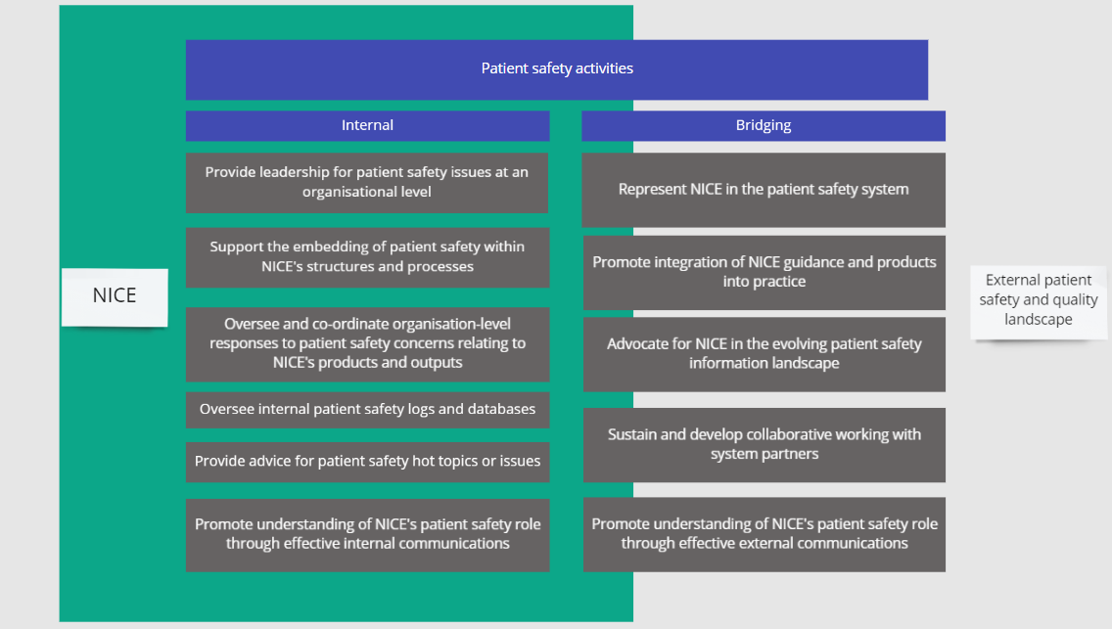

How the model is systematic
The review of patient safety activity at NICE highlighted a range of established mechanisms within each directorate. The model complements these mechanisms, with the PSOG providing an oversight and assurance function at an organisational-level, connecting directorates through its cross-Institute membership and links with key patient safety workstreams, as set out in Figure 2. This approach also provides a distinct patient safety structure for increased collaboration, scope and clarity.
The model aligns with NICE's 2021-2026 strategy, with relevance to each of its four overarching strategic pillars. In addition, it aligns with key external drivers such as the IMMDS Review recommendations and NHS England's Patient Safety Strategy, with its core themes of insight, involvement and improvement.

Figure 2: Cross-institute structure through links with key patient safety workstreams
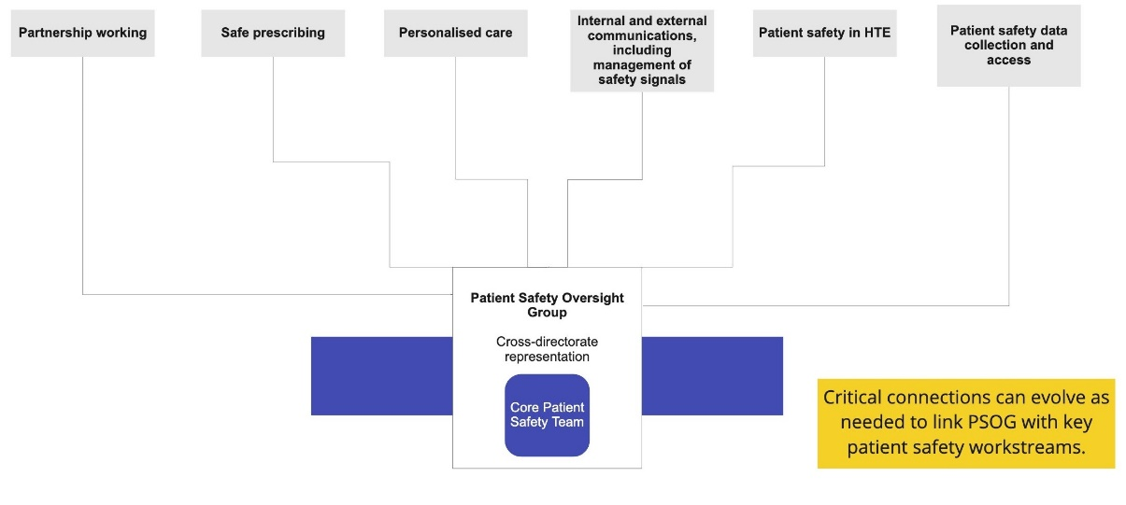

How the model is sustainable
The structure proposed is lightweight and flexible, allowing it to respond to emerging patient safety issues, organisational needs, NICE's transformation with it's 2021-26 strategy and the evolving external patient safety system.
As it is designed to complement existing processes within NICE, the model is not resource intensive. However, to be sustainable, resilient and effective, the model requires dedicated protected staffing in the form of a small core patient safety team. This team will consist of an SRO and Deputy SRO with ringfenced time for work on patient safety matters, a full-time programme manager, supported by a part-time administrator. The model will have clear governance and senior leadership support to ensure it becomes established and embedded as an intrinsic part of NICE's organisational culture over the next year.
In addition to the cross-directorate membership of PSOG, the patient safety programme will have clear representation at executive and board levels. This will embed the model within NICE's formal structures, while also providing channels for accountability, regular communication and learning, particularly as the approach is established and refined. The structure is summarised in Figure 3.
Figure 3. Patient safety model organogram
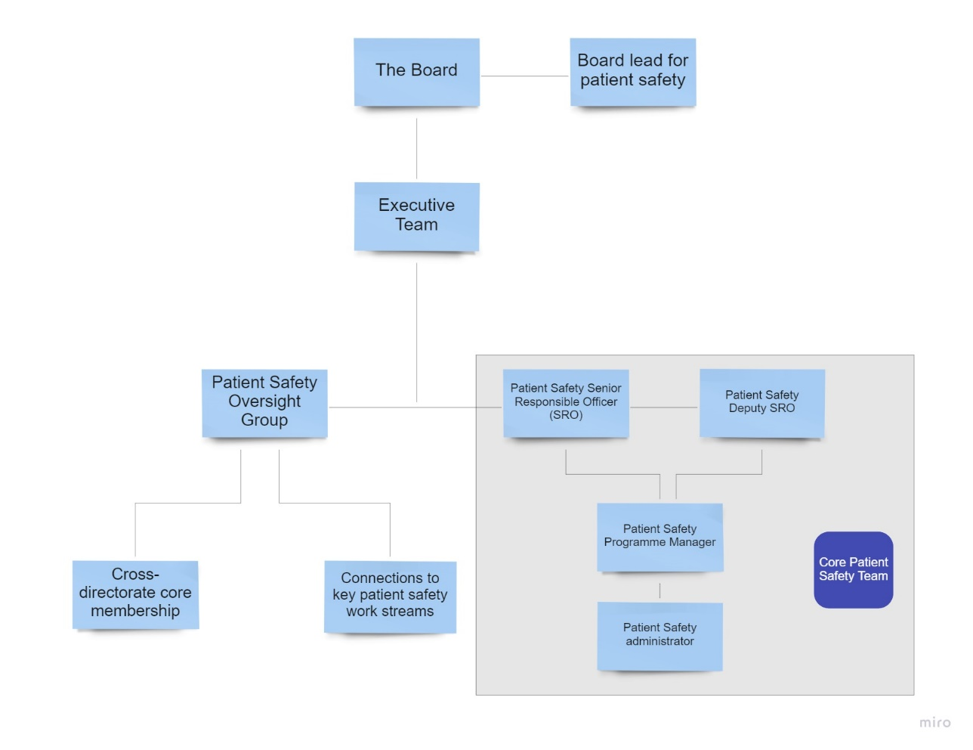

Governance
The core patient safety team and PSOG will be led by the patient safety SRO, who in turn reports to the Executive Team (ET). Ultimate responsibility for patient safety at NICE will remain with the Chief Executive.
The patient safety SRO will update ET on patient safety activity at NICE every six months, with an annual update submitted to the Board. When necessary the SRO will also escalate issues to relevant programme directors, ET, or directly to the Chief Executive, in between reports.

Conclusion
This report provides an annual update on patient safety matters at NICE from PSOG. It sets out a systematic and sustainable patient safety model, designed to ensure the delivery of NICE's role in patient safety.
Future priorities for the patient safety oversight group over the next year will include:
Operationalising and embedding the model in NICE's standard practices and working culture
Deepening and strengthening strategic partnerships with other key bodies and groups in the external patient safety system
Communicating NICE's role in patient safety through both internal and external communication opportunities to raise NICE's profile in the arena of patient safety.

Progress against these priorities will be reviewed after six months by the Executive Team and annually at the NICE Board.

Issues for decision
The Board is asked to receive this update on patient safety activity at NICE and endorse the proposed approach for managing future patient safety matters and suggested priorities for the next 12 months.

© NICE 2021. All rights reserved. Subject to Notice of rights.
September 2021

Appendix 1: Actions identified from the IMMDS Review report by NICE’s patient safety SRO and progress reported by the Patient Safety Oversight Group’s area lead

1) Sodium valproate

Action identified for NICE
Explore opportunities for NICE to work with other stakeholders including MHRA and patient groups to:
- Advise on the establishment of a prospective registry,
- Improve the Pregnancy Prevention Programme,
- Enable clinicians to follow guidance regarding prescribing.

Status
- Worked with partners in the establishment of the sodium valproate registry.
- Involved in the Safer Medicines in Pregnancy and Breastfeeding Information Consortium, overseen by the MHRA.
- Ongoing activity will be covered by PSOG’s medicines safety arm.

2) Surgical mesh

Action identified for NICE
- Undertake an exceptional review of NG123: urinary incontinence and pelvic organ prolapse in women: management.

Status
- Exceptional review undertaken, which did not support an update to the current guidance, with ongoing monitoring in place.
- The patient safety SRO has contributed to related Actions for Improvement overseen by the Department of Health and Social Care.

3) Patient Decision Aids (PDAs)

Action identified for NICE
- Scoping NICE’s potential role in leading a collaboration with the health system on the production of patient decision aids for each surgical procedure or intervention,
- SMT consideration of the form and resourcing of NICE’s interim role following completion of the scoping work,
- Explore links with NICE Connect, as it is envisioned that its functionality will be a significant enabler to this area

Status
- NICE have published two PDAs for use at specialist regional centres to provide treatment for women affected by complications from pelvic mesh.
- The patient safety SRO and area lead have contributed to the related DHSC Commission for Actions for Improvement.
- Ongoing activity will be covered by PSOG’s personalised care arm.

4) Data collection

Action identified for NICE
- Work with NHS X and other system partners to co-create databases and registries meeting the Review’s recommendations, which could be used to inform our guideline development.
- Work with MHRA on implementing necessary work on device regulation and approval.
- Consider the impact of the Medicines and Medical Devices Bill on implementation of an effective response to Recommendation.

Status
- Ongoing partnership work to support the development of relevant registries, databases and information systems.
- Patient safety is a joint strategic priority in NICE and NHS Digital’s 2021 collaboration agreement.
- Ongoing activity will be covered by PSOG’s data collection arm.

5) Guidance Implementation

Action identified for NICE
- Work with regulators and professional organisations to reinforce the use of NICE guidelines through their professional standards and inspection or accreditation processes

Status
Work undertaken to:
- Align patient safety with current implementation and engagement development at NICE.
- Map existing connections between NICE and the patient safety landscape.
- Partnership work with the GMC and CQC, including supporting the GMC to develop a series of scenarios to support clinicians in addressing the quality improvement domain of their appraisals.
- Ongoing activity will be covered by PSOG’s partnership work arm.
- Patient safety is a joint strategic priority in NICE and NHS Digital’s 2021 collaboration agreement.
- Ongoing activity will be covered by PSOG’s data collection arm.

6) Patient safety landscape

Action identified for NICE
- Consider position in relation to external patient safety bodies, particularly if landscape alters, for example, with potential introduction of Patient Safety Commissioner or revision of the MHRA.

Status
- Work undertaken to:
- Align patient safety with current implementation and engagement development at NICE.
- Map existing connections between NICE and the patient safety landscape.
- Partnership work with the GMC and CQC, including supporting the GMC to develop a series of scenarios to support clinicians in addressing the quality improvement domain of their appraisals.
- Ongoing activity will be covered by PSOG’s partnership work arm.
- Patient safety is a joint strategic priority in NICE and NHS Digital’s 2021 collaboration agreement.
- Ongoing activity will be covered by PSOG’s data collection arm.

Independent Medicines and Medical Devices Safety (IMMDS) Review recommendations
The IMMDS Review examines how the healthcare system in England responds to reports about harmful side effects from medicines and medical devices and considers how to respond to them more quickly and effectively in the future, making 9 specific recommendations:
Recommendation 1: The Government should immediately issue a fulsome apology on behalf of the healthcare system to the families affected by Primodos, sodium valproate and pelvic mesh.
Recommendation 2: The appointment of a Patient Safety Commissioner who would be an independent public leader with a statutory responsibility. The Commissioner would champion the value of listening to patients and promoting users’ perspectives in seeking improvements to patient safety around the use of medicines and medical devices.
Recommendation 3: A new independent Redress Agency for those harmed by medicines and medical devices should be created based on models operating effectively in other countries. The Redress Agency will administer decisions using a non-adversarial process with determinations based on avoidable harm looking at systemic failings, rather than blaming individuals.
Recommendation 4: Separate schemes should be set up for each intervention – HPTs, valproate and pelvic mesh – to meet the cost of providing additional care and support to those who have experienced avoidable harm and are eligible to claim.
Recommendation 5: Networks of specialist centres should be set up to provide comprehensive treatment, care and advice for those affected by implanted mesh; and separately for those adversely affected by medications taken during pregnancy.
Recommendation 6: The Medicines and Healthcare products Regulatory Agency (MHRA) needs substantial revision particularly in relation to adverse event reporting and medical device regulation. It needs to ensure that it engages more with patients and their outcomes. It needs to raise awareness of its public protection roles and to ensure that patients have an integral role in its work.
Recommendation 7: A central patient-identifiable database should be created by collecting key details of the implantation of all devices at the time of the operation. This can then be linked to specifically created registers to research and audit the outcomes both in terms of the device safety and patient reported outcomes measures.
Recommendation 8: Transparency of payments made to clinicians needs to improve. The register of the General Medical Council (GMC) should be expanded to include a list of financial and non-pecuniary interests for all doctors, as well as doctors’ particular clinical interests and their recognised and accredited specialisms. In addition, there should be mandatory reporting for the pharmaceutical and medical device industries of payments made to teaching hospitals, research institutions and individual clinicians.
Recommendation 9: The Government should immediately set up a task force to implement this Review’s recommendations. Its first task should be to set out a timeline for their implementation.

Aspden P, Corrigan J, Wolcott J, et al., editors. Patient safety: achieving a new standard for care. Washington, DC: National Academies Press; 2004
Department of Health and Social Care. Health and Social Care Act 2012 [Online]. Accessed 09 August 2021. Available from: https://www.legislation.gov.uk/ukpga/2012/7/section/234

