National Institute for Health and Care Excellence

Staff Survey 2021: Report and Action Plan

This report gives details of the results of NICE's 2021 staff survey, along with an action plan designed to continuously improve the working environment for our staff.
The Board is asked to receive this report and agree the action plan.

Nicole Gee
Chief People Officer
September 2021

Introduction
The 2021 annual staff survey process has been completed and the survey results are provided in Appendix 1, together with the proposed corporate 2021-2022 action plan at Appendix 2.
Overall, this is a very positive set of results in the context of a very difficult year, with many strengths identified, together with a few challenges.

Background
NICE once again commissioned Survey Solutions to carry out our annual staff survey this year, after it was paused and replaced in 2020 with more frequent pulse surveys, which provided real time data to help us to quickly understand and react to the pressures of the pandemic.
For openness and transparency purposes, the 2021 survey results were published on NICE Space in July. This is the first time that the results have been shared with colleagues before they are presented to Board.
Subsequently, consultation has taken place on the results with the Health and Wellbeing Strategy and Health and Safety Groups, UNISON colleagues and the Communications, HR, and Facilities teams. In addition, we have also engaged with one of our Non-Executive Directors and shared our progress to-date.
With input from these individuals and groups, a NICE-wide action plan has been developed, which specifically targets our lowest scoring and identified areas for improvement, and it is intended to ensure the continuous improvement of NICE as a place to work. There will also be nuances by directorate and local action planning will also take place, in addition to this corporate plan.
Based on the feedback received, our biggest area of concern and key priority area for action is work-life balance, wellbeing, and workload, particularly in the context of significant and ongoing organisational change. The survey results provide us with a snapshot of the mood of the organisation at a point in time and it is therefore vital that we undertake regular temperature checks over the coming months and respond quickly to the findings.
The corporate action plan is structured to show the new actions, together with activity that is also underway and ongoing. Other areas of focus are:
- Career framework / opportunities for career development.
- Communications.
- Equal opportunities and dignity at work, and,
- Strategy, values, and behaviour.
This paper highlights the key themes and achievements of this year's survey report, and the action plan proposes how the feedback will be used in a range of ways.

2021 Staff survey results
The overall engagement score for NICE remained stable at 79/100 (79 in 2019). The score is based on the results of 5 employee engagement index (EEI) questions:
- I am proud to work for NICE
- I would recommend NICE as an employer
- I am committed to doing my very best for NICE
- I intend to be working for NICE in 12 months' time
- Overall, I am satisfied working for NICE
When ranked against Survey Solutions' benchmark database, NICE has the 10th highest engagement index score, out of 62 organisations. This is compared to 9th out of 62 in 2019. Survey Solutions' database consists of a range of different public and private sector organisations.
Most questions record excellent to very good scores, and some areas present opportunities for improvement. Of the 53 questions this year, which asked for staff levels of agreement or satisfaction on a 5-point Likert scale, the responses were:
- 20 questions with excellent scores: mean score is 4.00 or above
- 13 questions with very good scores: mean score is 3.80 - 3.99
- 12 questions with average scores: mean score is 3.50 - 3.79
- 5 questions with lukewarm scores: mean score is 3.00-3.49
- 3 questions with a score of 2.99 or below - more negative than positive responses

Top 5 questions showing the greatest percentage improvement vs. 2019
Question | 2021 Mean Score | 2019 Mean Score | % Difference
Q7: I feel that the future of my job is secure | 3.6 | 3.5 | +2.9%
Q33: When there are important changes, they are communicated clearly | 3.6 | 3.5 | +2.6%
Q48: The opportunities for career development and promotion at NICE | 3.0 | 2.9 | +2.4%
Q26: I would be comfortable disclosing a mental health issue to my line manager or someone else at work, if this was affecting me | 3.8 | 3.8 | +2.2%
Q54: My manager gives me clear feedback on my work | 4.0 | 3.9 | +1.9%

Please note that whilst the 2021 and 2019 mean scores for Q26 in the table are both 3.8, these have been rounded to 1 decimal place and the difference shown is between the exact (unrounded) scores.

Top 5 questions showing the greatest percentage decrease in scores vs. 2019
Question | 2021 Mean Score | 2019 Mean Score | % Difference
Q5: I am confident in the way NICE is led | 3.8 | 4.0 | -5.9%
Q19: My job allows me to have an adequate work/life balance | 3.8 | 4.0 | -6.9%
Q20: I am able to take rest breaks away from my desk/computer screen | 3.8 | 4.1 | -7.7%
Q18: I do not feel pressure to work long hours | 3.3 | 3.7 | -10.3%
Q21: I regularly feel stressed because of the demands put on me by work | 3.0 | 3.3 | -10.7%

With regards to Q5 'I am confident in the way NICE is led', whilst this score has decreased since 2019, our 2021 mean score of 3.8 compares very favourably with the 6 organisations in our sector in Survey Solutions' database, where this question is asked. The highest score for our sector is 4.0 and the lowest is 2.9, with a mean score of 3.6.

External benchmarking
26 results can be directly compared with Survey Solutions' all sectors' database. 5 of these results are at least 5% above the benchmark:
- Q4: I would recommend NICE as an employer (+9.1%)
- Q3: I am proud to work for NICE (+8.6%)
- Q24: NICE cares about my wellbeing (+8.4%)
- Q58: My manager encourages staff to suggest new ideas for improving services (+6.9%)
- Q6: I am committed to doing my very best for NICE (+6.2%)
2 questions scored lower than the all-sectors' benchmark:
- Q37: I have clear, planned goals and objectives for my job (-8%)
- Q18: I do not feel pressure to work long hours (-9.3%)
Whilst Q37 referenced in paragraph 13 scores 8% below the all-sectors' benchmark, the mean score was relatively unchanged, at 3.8 in 2021 compared to 3.9 in 2019 (-1.3%).

Free text comments
Staff had the opportunity to provide free text comments saying what they enjoyed most about working at NICE and suggesting an important change which would help improve satisfaction with working for NICE.

What is the ONE factor you enjoy most about working for NICE?
Main themes are our people (colleagues, and more widely within the organisation) and the fact that the work NICE does contributes to the NHS and society in general.
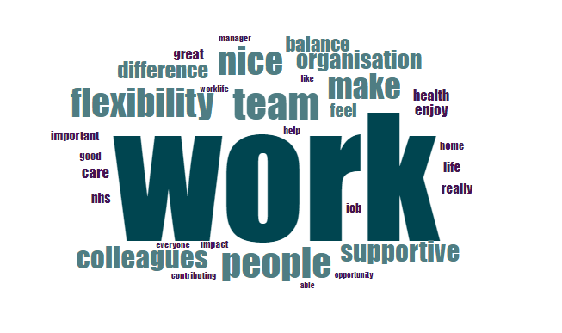
“There are a lot of really good people in the business who care deeply about the work they do and about making a difference to patients. A lot of them have done a lot of overtime during the past year to deliver the Covid guidelines at breakneck speed"
“Opportunity - I've been given lots of opportunity to get involved in different projects, develop and improve skills with the support and encouragement of the team”

“The people that work at NICE are fantastic! Everyone is so dedicated, helpful, and friendly. The work is really interesting too, but I think it's the people I work with that make it so enjoyable”

"I enjoy working on products that will hopefully impact on people's treatment / health / care. I really enjoy working with colleagues who are supportive and very committed to their jobs and being part of an organisation that's well respected world-wide and is valued by the NHS”

“Working for NICE makes me feel like my work has impact and contributes in some way to society”

“My team, my peers and my direct line manager are fantastic: so bright, dedicated, creative and committed to doing a good job - I feel strongly that we are all working here because we believe we can make a difference to people's lives”

What is the ONE most important change that would help improve your satisfaction with working for NICE?
Main themes are opportunities for career development, lighter workloads, staff empowerment/autonomy and better technology.
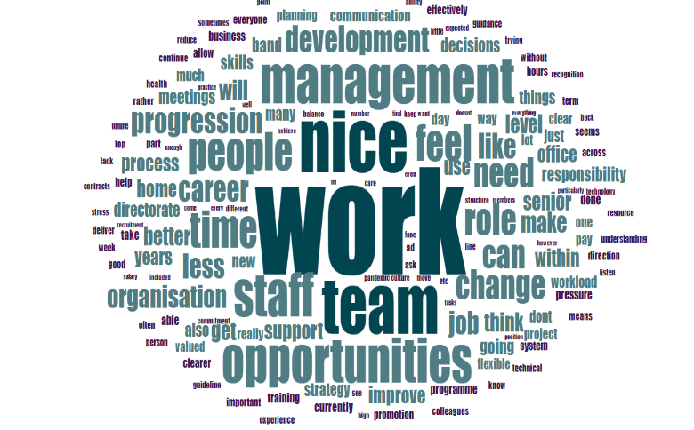
“Ensure that staff are given a workload that is sustainable. I've been involved in multiple projects at NICE which have not been resourced with enough time and/or staff to achieve the deliverable within working hours and know that it has affected my stress levels and the mental health of colleagues. Initiatives such as the mental health first aiders, healthy work weeks and mindfulness sessions all seem a bit like lip service when actions aren't taken to address the overworking of staff”

“At present there is a high level of work in the team and whilst this makes use of the skills within the team, the sheer amount of work can be overwhelming at times with a large number of similarly competing deadlines/priorities creating quite a lot of stress both personally and within the team itself"

“More career progression opportunities. It looks like the strategy focuses more on the technical skills and less on project management. More learning and development opportunities for project management professionals would improve satisfaction”

“Less manual work (more automated software etc) and less duplication”

“Less hierarchical structure. Trying to get anything signed off and out the door is a time-consuming and laborious process”

“Learning opportunities for staff in the lower bands (3-6)"

Conclusion and next steps
The HR and Communications teams will work together to promote the staff survey results and organisation-wide action plan and the latter, once agreed, will be published on NICE Space alongside the available results.
The action plan is a comprehensive and ambitious one and many of the actions will be ongoing into 2022-23.
Directorate-level breakdowns have been circulated to senior leaders and some directorates have already identified staff survey leads who have overall responsibility for developing local action plans and ensuring these are delivered. We will be refreshing the staff survey leads forum, to bring these colleagues together and provide a support network.
The Board is asked to receive this report and agree the action plan.

© NICE 2021. All rights reserved. Subject to Notice of rights
September 2021

