NATIONAL INSTITUTE FOR HEALTH AND CARE EXCELLENCE

Annual Equality Report 2021-22

Executive summary
- At the National Institute for Health and Care Excellence (NICE), we continue to strive to put equality, diversity and inclusion (EDI) at the heart of everything we do.
- The 2021/22 report highlights the work that NICE has undertaken to deliver its equality objectives and the associated performance data in that year. NICE’s equality objectives 2020-24 are:
- Guidance objective: to review and improve equality considerations throughout development of our guidance.
- Workforce objective: to develop our workforce and culture to be more equal, diverse and inclusive.
- During 2021/22, we have continued to deliver on the commitments set out in our 2020-24 equality objectives. While we have made progress in some important domains, we are disappointed not to have seen more positive changes in representation of Black, Asian and minority ethnic staff at senior levels within NICE, and of Black and Black British groups on our committees.
- A highlight of this year has been high levels of positive stakeholder engagement, both internal and external, to support the delivery of our workforce objective and our objective to increase diversity within our committees. This report explains the various initiatives that have been undertaken to implement our commitment to EDI.
- Although there have been positive changes in some areas, we recognise that we need to do more. The year ahead will see the implementation of 2 actions related to NICE’s objectives on guidance and workforce.

Jennifer Howells, director of Finance Strategy and Transformation
Nicole Gee, interim chief people officer
October 2022

Background
- As a public sector organisation NICE is subject to the legal obligations placed by the Equality Act 2010 to comply with public sector equality duty. NICE is committed to ensuring that equality, diversity and inclusion are central to everything that we do. This includes staff working within the organisation, independent members of our advisory committees, and those impacted by the use of our guidance and advice.
- The 2021/22 annual report presents our progress made during the second year since the equality objectives were set by NICE in 2020.

Progress against equality objective 1 - guidance

What is better than last year?
- There has been a notable, positive change in the delivery of our guidance objective.
Figure 1: Summary of key areas of improvement in 2021/22
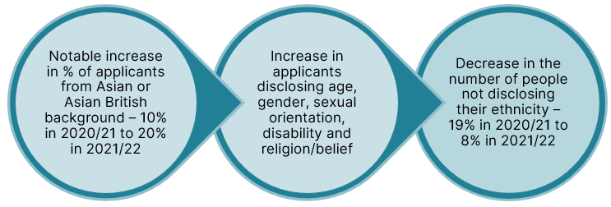

- The figure above summarises the progress made to deliver the equality objective related to increasing diversity within our committees.

Figure 2: Non-disclosure rates related to religion/belief and disability of advisory committee applicants (all roles) in 2021/22
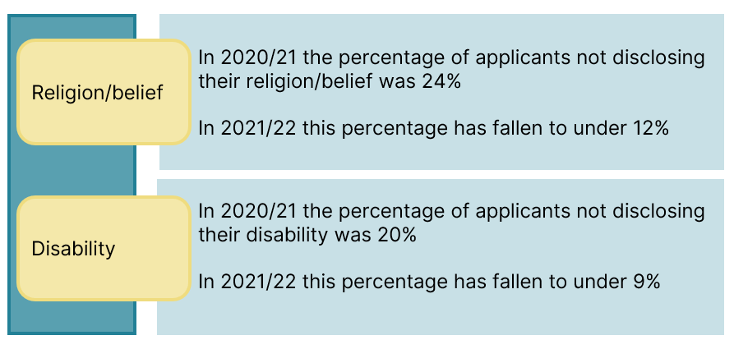
Figure 3: Ethnicity of all applicants in NICE advisory committees highlights a positive trend in 2021/22 when compared to 2020/21

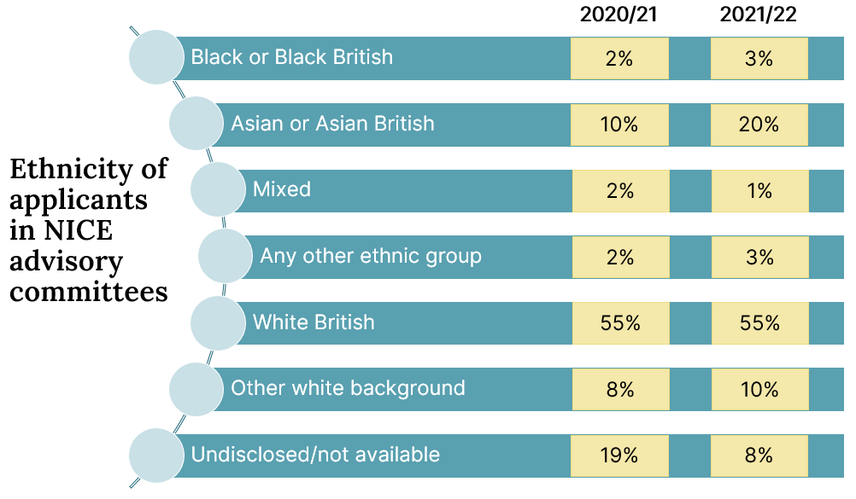
- The data show that more equality and health inequality issues were identified in 2021-22 than in 2020-21. This may in part be due to the increase in volume of guidance produced during 2021-22. It may also reflect work to strengthen our approach to considering equality and health inequalities during guidance development resulting in an increase in proactive identification of related issues to be considered by guidance committees.
- By identifying potential inequalities relating to guidance topics, we can seek to address them through guidance recommendations thus supporting the health and care system in their work to tackle health inequalities.
Figure 4: Summary of equality issues in 2021/22 compared to 2020/21
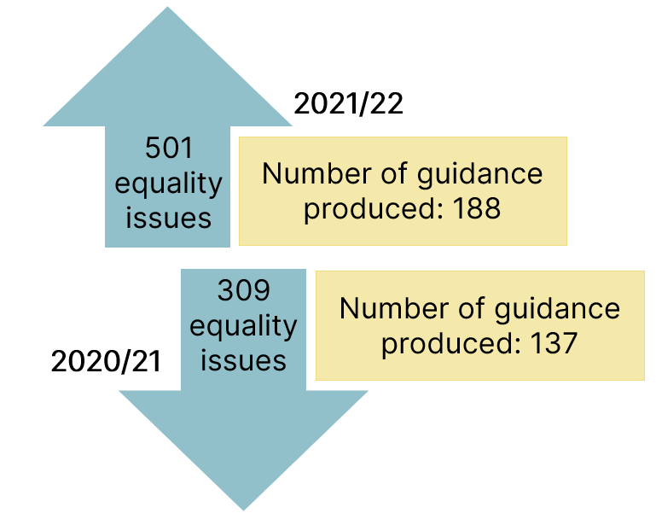
What is similar?
- This progress has, however, not been delivered across all groups, with applications from Black and Black British people remaining unchanged since last year.
Figure 5: Conversion rate of applicants to those appointed to committees

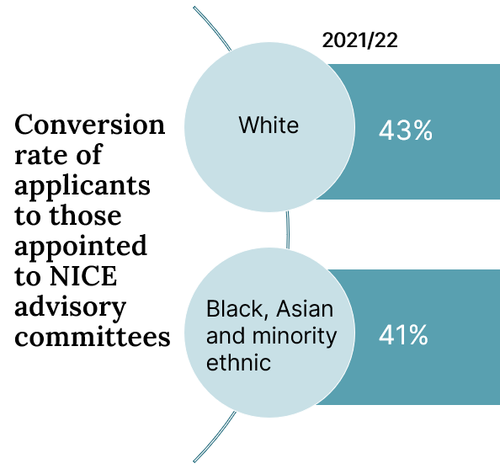

- Applicants who did not disclose their ethnicity were marginally more successful than those who did, which is consistent with previous years.
- There remains a lack of diversity amongst applicants and appointees in relation to sexual orientation, with around 85% of applicants and appointees identifying themselves as heterosexual (straight).

Progress against equality objective 2 - workforce

What is better than last year?
Figure 6: A positive trend in the percentage of staff from Black, Asian and ethnic minority backgrounds in 2021/22 in bands 1-7 and 8a-8d
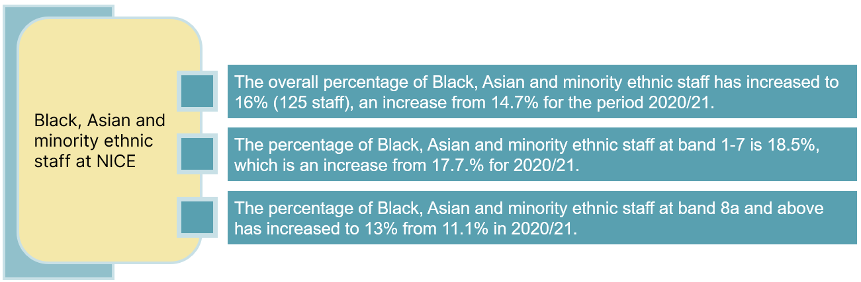
Figure 7: Non-disclosure rates across protected characteristics
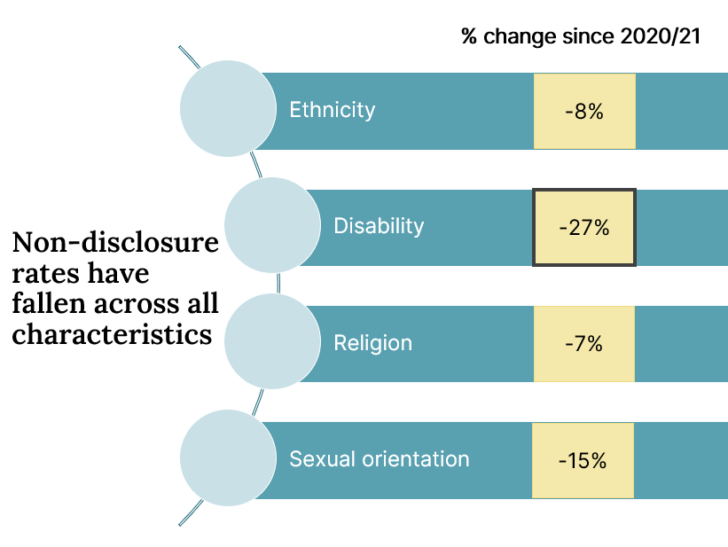
- A positive change is especially notable within the number of staff with a disability who have chosen to disclose this information in 2021/22.
Figure 8: Improvements made in reporting sexual orientation of staff in 2021/22
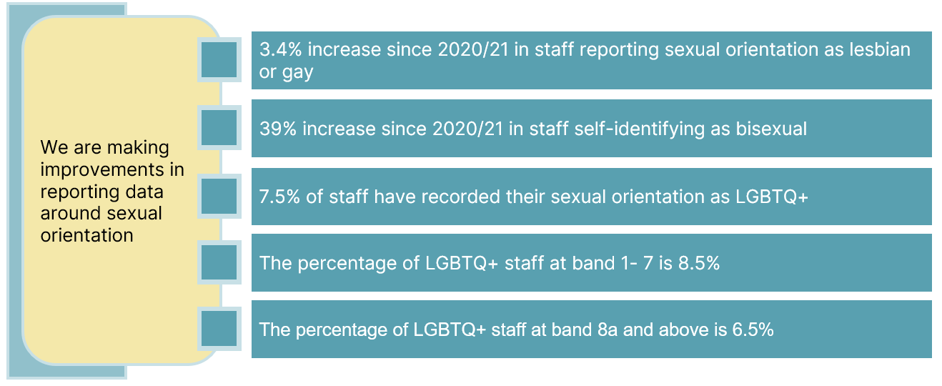
- The above figure highlights a positive first step in reporting data around sexual orientation of NICE staff.
- Consistent reporting in the future will allow for better comparison, enabling us to track progress.

Areas we need to improve
Figure 9: Black, Asian and minority ethnic staff continue to be underrepresented at bands 8d and 9
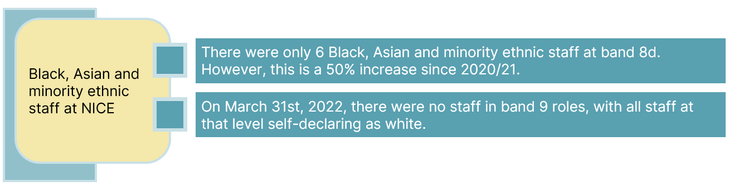
- On 31 March 2022 there were still no staff in band 9 roles and above from Black, Asian and minority ethnic backgrounds and across senior and very senior levels.
- As seen in figure 10 below, at interview stage, Black and Black British candidates are 5.7 times less likely, and Asian and Asian British are 2.7 times less likely, to be appointed than their white counterparts. Both of these figures have worsened since last year.
Figure 10: Relative likelihood of white candidates being appointed relative to their Black, Asian and minority ethnic counterparts
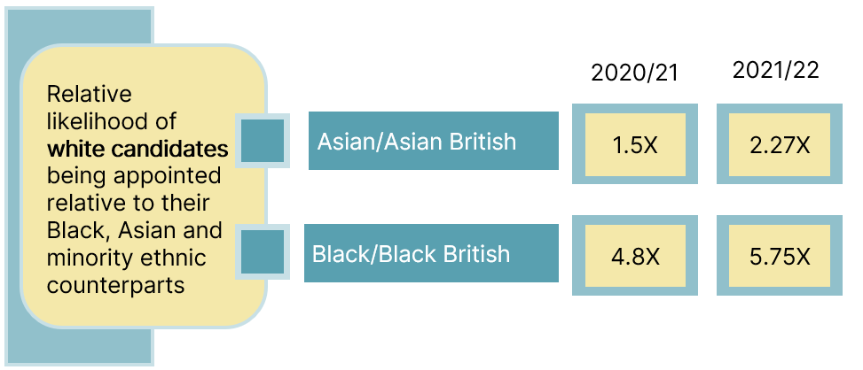
Figure 11: Experience measures for Black, Asian and minority ethnic staff
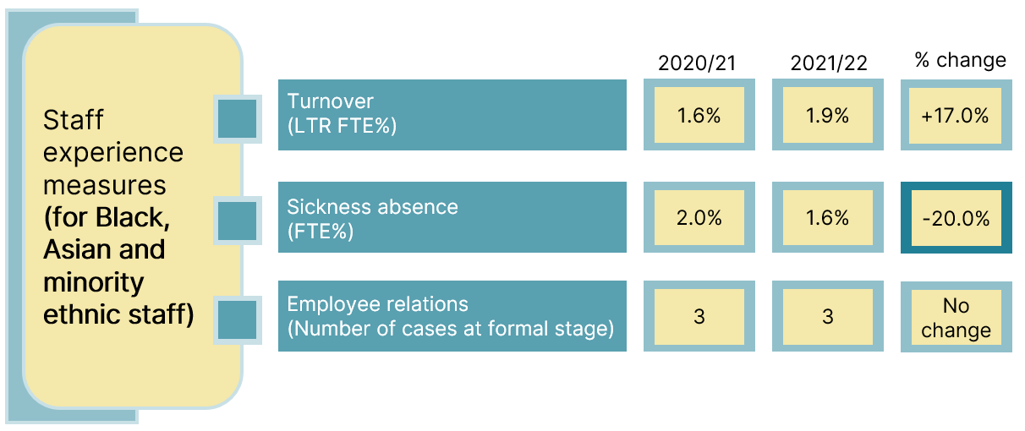
- As seen in figure 11 above, the turnover within Black, Asian and minority ethnic staff has gone up during 2021/22.
- In addition, there has been a 20% drop in Black, Asian and minority ethnic staff reporting sickness absence.
- Figure 12 below highlights that the turnover in staff with disabilities has also increased.
- There has also been a notable increase in sickness absence amongst staff self-identifying as disabled.
Figure 12: Staff experience measures for staff who self-identify as disabled
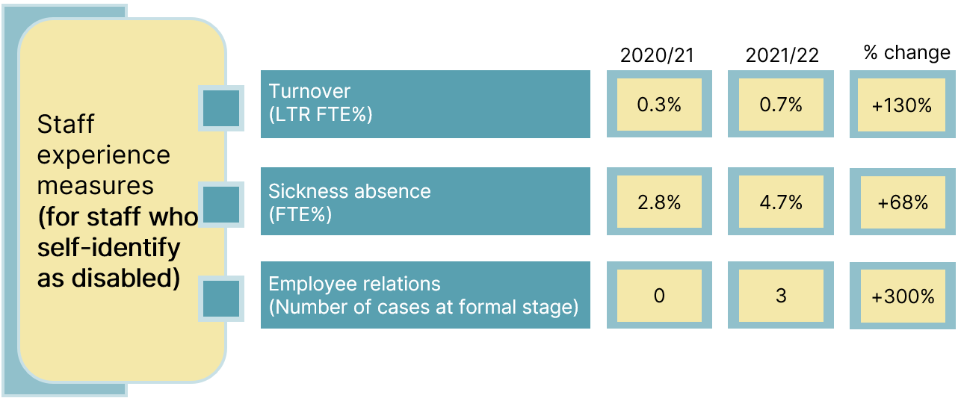

What actions are we taking to address these issues?

Guidance objective
- We will continue to deliver listening events with former and current committee members to discuss how to increase diversity within NICE’s advisory committees and during guidance development.
- We will implement an action plan that we have co-produced with professional and lay committee members to increase diversity within NICE’s advisory committees.
- We will simplify the process of recruiting and joining committees to make it more accessible. This will also enable more efficient data management and recording.
- NICE’s health inequalities programme has now put forth a combined approach to strengthen equalities and health inequalities (EHIA) in guidance development. The implementation of this approach will be reflected in next year’s report.

Workforce objective
- We have developed an EDI workforce Action Plan 2022/3 (developed with Staff Networks)
- All members of NICE’s executive team have individual objectives
- We will develop directorate-level key performance indicators (KPIs) and action plans
- We will review interview practice, with recommendations and actions to address barriers and challenges
- We will improve our ability to deliver effective workplace adjustments to those who request them
- We will develop and deliver a high-quality EDI development ‘offer’ for staff at all levels
- We will continue to empower and develop our Staff Networks

In addition to this, we have committed to:
- Establish a mechanism for creating more diversity within the executive team, if this is not possible through current recruitment (e.g. diversity advisers)
- Explore ways of developing strong and diverse talent pipelines to support a more intentional and structured approach to succession planning
- Reach out to other ALBs to seek out best practice and build relations that support our learning.

Abbreviations
Abbreviation | Description
ALBs | Arm’s length bodies
EDI | Equality, Diversity and Inclusion
EHIA | Equality and Health Inequality Impact Assessment
FTE | Full-Time Equivalent
LGBTQ+ | Lesbian, Gay, Bisexual, Transgender, Queer and others
LTR | Labour Turnover Rate
NICE | National Institute for Health and Care Excellence

© NICE 2022. All rights reserved. Subject to Notice of rights.

