Board meeting

22 September 2022

Executive team report
Purpose of paper
For discussion
Board action required
The Board is asked to review the report.
Brief summary
This is the Executive Team (ET) report to the Board. It updates the Board on the key priorities and areas of progress since the last Board meeting. It sits alongside the integrated performance report, which provides data on the status of our key performance indicators and business plan deliverables.
Board sponsor
Sam Roberts, Chief Executive
Mark Chapman, Interim Director, Medical Technology and Digital Evaluation
Paul Chrisp, Director, Centre for Guidelines
Nicole Gee, Interim Chief People Officer
Jane Gizbert, Director, Communications
Felix Greaves, Director, Science, Evidence and Analytics
Jennifer Howells, Director, Finance, Strategy and Transformation
Helen Knight, Acting Interim Director, Medicines Evaluation
Judith Richardson, Acting Director, Health and Social Care
Alexia Tonnel, Director, Digital, Information and Technology

Contents
Introduction from the Chief Executive 3
NICE highlights 5
Publication of NICE’s evidence standards framework for digital health technologies 5
New content model for lung cancer bringing together guideline recommendations and technology appraisal guidance 6
Enhancing our collaboration with the MHRA on the medtech access pathway 7
NICE brand refresh roll-out complete 8
Guidance highlights 9
NICE publishes first draft guidance from its Early Value Assessment pilot project recommending smartphone-linked ECG device 9
NICE recommends transplant with good bacteria taken from faeces to resolve recurrent Clostridium difficile infections 10
Key risks 10

Introduction from the Chief Executive
- The context in which NICE operates continues to change significantly, with a new Prime Minister, Secretary of State and plans still to be finalised regarding NICE’s sponsor Minister in the Department of Health and Social Care.
- In her inaugural speech, the Prime Minister noted three early priorities: growing the economy, tackling the energy crisis, and the NHS. NICE clearly has a role to play in both supporting the NHS and economic growth. In terms of supporting the NHS, we ensure patients get access to the best care through evidence-based decision making and advice. In terms of economic growth, gains in health have the potential to increase labour market participation and an effective life sciences ecosystem attracts investment by innovators providing the most clinically and cost-effective care.
- To achieve these aims, we hear consistently from patient organisations, clinicians, managers, policy makers and industry that NICE needs to prioritise three areas of transformation, including: i) focusing on what matters most, ii) creating useful and useable advice and, iii) continually learning from data and implementation. To deliver in these areas, we need to transform our internal behaviours, processes and technology.
- Over the summer we have been refining exactly what these changes would look like in practice through interviews with external stakeholders and staff and have summarised them into 10 key areas (see figure 1 below).
Figure 1: What is our ambition for NICE in the future?
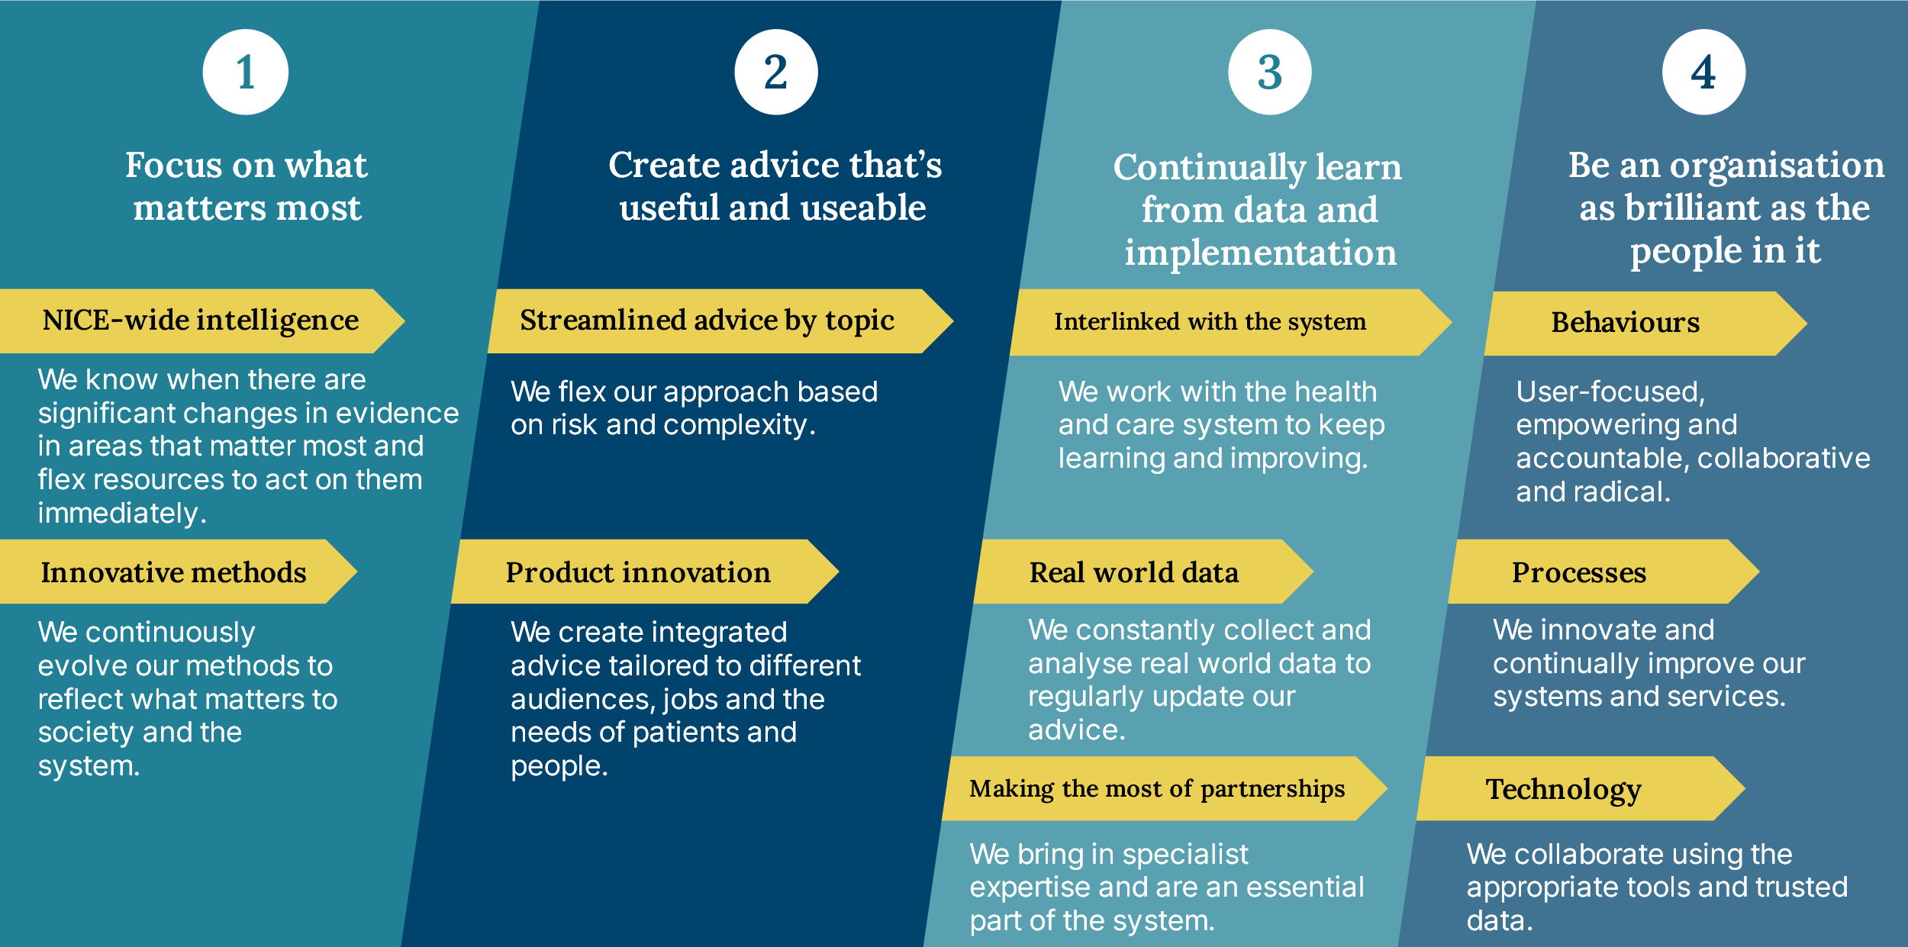
- Over the last two months we have made early progress in a couple of these areas:
  - Focusing on what matters most: Our Early Value Assessment Programme has successfully piloted a more proactive approach to horizon scanning and topic selection this year, aligned to areas of national need such as children and adolescents’ mental health. To expand this approach across NICE, we are appointing a substantive Chief Medical Officer to lead on horizon scanning and prioritisation of topics across the Institute.
  - Creating useful and useable advice: Our Proportionate Approach to Technology Appraisal programme is piloting three new approaches to technology appraisal of medicines, tailoring our appraisal based on complexity and risk.
  - Learning from data and implementation: We have made significant progress in developing an on-line resource to support ICS’s address health inequalities, a key implementation priority for these emerging systems. A new Director of Implementation and Partnerships will join NICE in December to lead the teams focusing on implementation, impact, and patient and public involvement. We are also increasing our focus on international partnerships, with Meindert Boysen appointed as the Head of International Affairs at NICE.
  - Building an organisation as brilliant as the people in it: We launched our management development training programme in September, which recognises the importance of managers’ roles in driving internal transformation. Over 70% of line managers have enrolled to complete this course in the next seven months. We have recruited a new Chief People Officer as well as an Organisational Transformation Lead, both of whom will start in November, as key leaders of the internal transformation effort.
- Navigating these changes in the external environment as well as an internal transformation mean that things don’t always go to plan. Some new approaches don’t work, some projects lead to a dead-end, but we constantly focus on what we can learn from these pilots and trials to ensure we fully realise the potential of NICE to serve the people of this country.
- The remainder of this paper highlights broader achievements across NICE in the last two months and our integrated performance report provides an honest assessment of where new approaches have succeeded and where we have more to learn.
NICE highlights

Publication of NICE’s evidence standards framework for digital health technologies
- NICE has published an updated Evidence Standards Framework (ESF) for digital health technologies (DHTs), including new sections to reflect the current digital landscape of artificial intelligence (AI) and data-driven technologies. The ESF is a set of evidence standards for a wide range of DHTs, designed for use by national and local partners including evaluators and decision makers in the health and care system, and companies that develop or distribute DHTs in the health and care system through:
  - providing a classification system that helps to assign specific technologies to one of the tiers of standards within the framework
  - providing a set of standards that can be consistently used by developers
  - making it easier to understand what good levels of evidence for digital health technologies look like.
- For companies that develop or distribute DHTs, the ESF also helps them understand how to demonstrate the effectiveness and value of a DHT when engaging with evaluators and decision makers in the health and care system.
- In developing the updated ESF, we worked with stakeholders and system partners, and collaborated with academics from Imperial University, Birmingham University, and the Turing Institute to identify standards for AI and data driven technology.
- The NHS AI Lab funded NICE to update the framework to include evidence requirements for artificial intelligence (AI) and data-driven technologies with adaptive algorithms, align classification with regulatory requirements, and make the ESF easier to use. Following an open consultation, the updated framework was published in August 2022. Questions relating to the ESF can be directed to digitalhealth@nice.org.uk.

New content model for lung cancer bringing together guideline recommendations and technology appraisal guidance
- We have added a new visual element to our guideline on the diagnosis and management of lung cancer, including a pathway illustration of treatment options for systemic anti-cancer therapy for advanced non-small-cell lung cancer. This is a presentational change only, and the recommendations from the source guidance still apply.
- In the new visual representation, we have produced new treatment pathways that bring together our existing guideline recommendations and technology appraisal guidance, covering the treatment options at each decision point. Treatment option summaries such as the lung cancer treatment pathways, potentially can be developed in fast moving, high priority clinical areas to present different sources of NICE content in a structured, coordinated, and clear way. They can be rapidly updated as new technology appraisals are published, supporting NICE’s living content ambition.
Figure 2: New treatment pathway visualisation bringing together our existing guideline recommendations and technology appraisal guidance
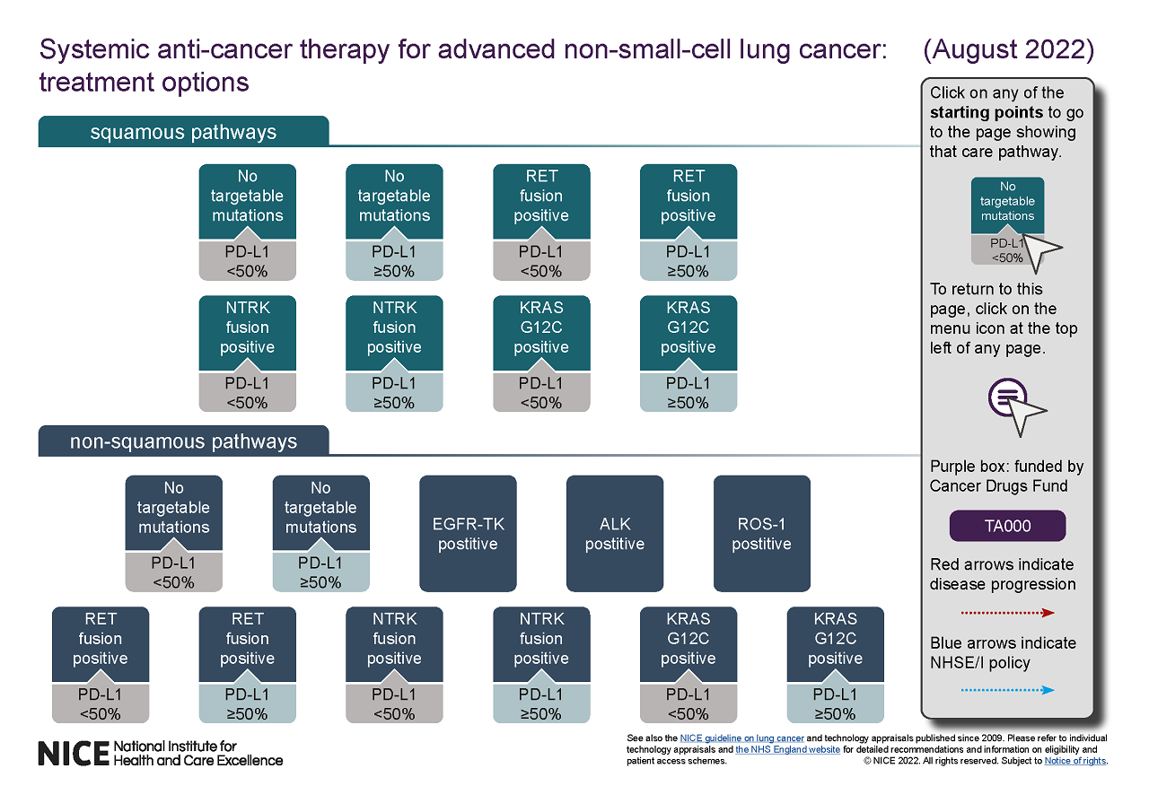
- We are seeking feedback on the useability of the treatment pathways and to evaluate if presenting content from different sources (NICE technology appraisal guidance, guideline recommendations, and validated with expert input) is beneficial for users. A pop-up survey is available on the page on systemic anti-cancer therapy for advanced non-small-cell lung cancer for this purpose and a targeted stakeholder survey is to be sent out following social media communication (September 2022).

Enhancing our collaboration with the MHRA on the medtech access pathway
- Over the summer we have been working to enhance our ongoing collaboration with the MHRA to support the transformation of regulation and access for the medtech pathway. This collaboration helps deliver the Life Sciences Vision’s aims for access and uptake of innovations in the NHS, through targeted support to establish novel and innovative regulation and access routes for medtech innovation.
- NICE’s work with MHRA in this space includes development of the Innovative Devices Access Pathway (IDAP), our business plan priorities of Early Value Assessment and the HTA Innovation Laboratory (which would be expanded to include medical technologies), as well as transforming the use of Real World Evidence for medical technologies. These programmes are underpinned by effective collaboration, coordination, and communication between NICE and MHRA, and help create a speedy and enabling pathway for regulation and assessment of medtech that supports the rapid adoption of effective new medical technologies.
- We are expecting a joint funding allocation from the OLS to support delivery of these ambitions and in the final stages of finalising our work programme, based on that funding.

NICE brand refresh roll-out complete
- On 10 August, NICE launched the refreshed brand identity across external channels, including the website and social media. This followed the internal launch on 27 July. Staff across the whole organisation have been provided with full brand guidelines, as well as training and templates from the brand and marketing team. A dedicated working group, with representation from staff across directorates and networks, was crucial to the development of these guidelines.
- This launch marks the completion of a broader piece of work to align our brand to our future-focused organisational strategy. The brand strategy was shared with 454 staff at the 10 August all staff meeting. More in depth presentations to the senior leaders forum and individual directorate meetings have also provided further opportunities to share and embed this work across teams. This includes work led by the brand and marketing team to define our brand proposition and brand personality, as well as the audience prioritisation and key messages developed by the Executive Team and Board.
- Providing this brand strategy and guidance will help staff across NICE to consistently communicate with our priority audiences. Response from NICE staff has been extremely positive, particularly the increased flexibility and accessibility of the guidelines.
Guidance highlights

NICE publishes first draft guidance from its Early Value Assessment pilot project recommending smartphone-linked ECG device
- NICE has issued draft guidance recommending a new digital technology addressing an unmet clinical need for more easily accessible and available ways to measure heart rhythm disturbance such as QT interval in the psychiatric service setting. The KardiaMobile 6L is a portable ECG recording device that is a less intrusive way of measuring heart changes that may affect the choice of medication taken for psychiatric disorders.
- People taking antipsychotic medication may need testing for heart problems before starting treatment and at regular intervals during their treatment. Detecting heart problems such as rhythm disturbances can inform the choice of medicines, their dosing, whether to stop them, and potentially avoid severe cardiac events. Current practice to measure QT interval is to use a 12-lead ECG device. This needs the person to partially undress and use conductive gel on the skin to create contact with the electrodes. This can cause reluctance and distress.
- Using KardiaMobile 6L, the ECG can be recorded in any psychiatric setting, including during a home visit by a community health professional which may reduce the stress and anxiety of people attending an outpatient’s appointment. The data are recorded and transmitted wirelessly to a mobile device such as a smartphone or tablet.
- This is the first recommendation to be issued by NICE’s diagnostics advisory committee via its Early Value Assessment pilot project. The NICE Early Value Assessment pilot project has been created to drive innovation into the hands of health and care professionals by actively drawing in digital products, medical devices and diagnostics that address national unmet needs. It will provide quicker assessments of early value to identify the most promising technologies that can be used in the NHS. It means clinicians and patients can benefit from medical technologies while further data is collected to inform a full NICE assessment of the device’s cost and clinical effectiveness.
- The recommendation is that using KardiaMobile 6L should be offered as an option in psychiatric services to measure heart rhythm disturbances, such as a QT interval, in people taking or about to take antipsychotic medication while further real-world evidence is generated. This is to address uncertainty around how well using KardiaMobile 6L works for measuring QT interval in the psychiatric service setting. Once real-world evidence is generated, the appraisal will return to the independent NICE committee for it to undergo full assessment.

NICE recommends transplant with good bacteria taken from faeces to resolve recurrent Clostridium difficile infections
- Hundreds of people with recurrent bacterial infections could be treated with gut bacteria taken from a healthy donor’s faeces following NICE’s recommendation that a faecal microbiota transplant (FMT) is offered to people who have been treated for two or more Clostridium difficile (C. diff) infections without success.
- C.diff is a bacterium that causes an infection if the balance of bacteria in the bowel changes, which leads to diarrhoea. Certain groups, such as older people, are at higher risk of C. diff infection. The infection most commonly affects people who are taking, or have recently taken, antibiotics, and can be transmitted very easily. It can range from mild to life threatening, and is treated with antibiotics in the first instance.
- FMT treatment aims to restore a healthy population of gut bacteria and involves transferring gut bacteria and other microorganisms from healthy donor faeces into the gut of the recipient. Clinical trial evidence showed that FMT treatment is significantly better than antibiotics alone at resolving a C. diff infection in people who have had two or more previous infections.
- Evidence presented to the NICE Medical Technologies Advisory Committee shows the treatment could save the NHS hundreds – or in some cases thousands – of pounds, lead to fewer antibiotics being used, and give patients a better quality of life.
Key risks
- NICE continues to monitor and manage key risks in a number of areas:
- Strategic relevance – the health and life sciences sector remain extremely fluid, experiencing rapid rates of change particularly in terms of emerging technology and patient need. NICE needs to continually evolve to meet the needs of users, national system partners and the life science sector. Ensuring our continued strategic relevance is one of the key drivers behind the business priorities we have outlined for 22/23, which are designed to help maintain our world leading position. New executive appointments, particularly the Chief Medical Officer and Director of Implementation and Partnerships, will have an important role in helping target NICE’s work towards the most relevant areas of clinical need and in maintaining an ongoing dialogue with our system partners.
- Financial sustainability - The economic challenges post-COVID have meant there is a need for ongoing restraint in public spending, to ensure the government finances are placed on a sustainable footing. We need to ensure we are able to continue to meet the requirement for efficiency savings across the public sector at the same time as securing the financial resources to invest in our long-term development in key areas. Through our rigorous financial planning processes and ongoing restraint in recruiting to unfilled vacancies and use of external consultants, we are now forecasting an underspend in 2022/23. We are closely monitoring our financial position and considering all relevant investment cases to ensure we strike the right balance of delivering efficiencies while allowing investment to deliver our business priorities, with an eye to our underpinning financial position in future years.
- Organisational transformation – As a result of NICE’s ambitious organisation-wide transformation programme, we may not have enough capacity to focus on transformation alongside business-as-usual work. As well as continuing to establish an organisational-wide transformation effort we are using mechanisms such as dialogic interventions and crowdsourcing of ideas to engage a broad base of staff. Alongside this we have appointed a new Organisational Transformation Lead who will work across the organisation to build momentum and staff ownership of our transformational vision, which aligns with our newly launched leadership and management development training.
© NICE 2022. All rights reserved. Subject to Notice of rights. September 2022

