NHS Digital
Indicator Supporting Documentation
IAP00070 Emergency admissions for acute conditions that should not usually require hospital admission

FIELD | CONTENTS
IAP Code | IAP00070
Title | Emergency admissions for acute conditions that should not usually require hospital admission
Published by | NHS Digital
Reporting period | Quarterly
Geographical Coverage | England
Reporting level(s) | CCG
Based on data from | Hospital Episode Statistics & National Health Application and Infrastructure Services, NHS Digital
Contact Author Name | Clinical Indicators Team, NHS Digital
Contact Author Email | clinical.indicators@nhs.net
Rating | Fit for use
Assurance date | 13/09/2018
Review date | 13/09/2023
Indicator set | CCGOIS
Brief Description | Some emergency admissions may be avoided for acute conditions that are usually managed in primary care. If there is a high number of emergency admissions for these types of conditions then there may be an issue with primary care provision that needs investigation
Purpose | Preventing conditions such as ear, nose or throat infections; kidney or urinary tract infections or heart failure from becoming more serious. Some emergency admissions may be avoided for acute conditions that are usually managed in primary care. If there is a high number of emergency admissions for these types of conditions then there may be an issue with primary care provision that needs investigation
Definition | Directly age and sex standardised admission rate for unplanned hospitalisation for acute conditions that should not usually require hospital admission per 100,000 registered patients, 95% confidence intervals (CI).  Rates are presented at one decimal place.
Data Source | Numerator – Hospital Episode Statistics Admitted Patient Care (HES APC), provided by NHS Digital  https://digital.nhs.uk/data-and-information/data-tools-and-services/data-services/hospital-episode-statistic.  Denominator – Registered patient counts by single year of age and sex from the National Health Application and Infrastructure Services NHAIS), commonly known as ‘Exeter’ System, provided by NHS Digital; extracted annually on 1 April for the forthcoming financial year  https://digital.nhs.uk/services/systems-and-service-delivery  Standard Population – European Standard Population (ESP) 2013
Numerator | The number of finished and unfinished admission episodes, excluding transfers, for patients with an emergency method of admission and with primary diagnoses for acute conditions that should not usually require hospital admission.  The indicator is based on the primary diagnosis field only which is defined as follows:  - The main condition treated or investigated during the relevant episode of healthcare, and  - Where there is no definitive diagnosis, the main symptom, abnormal findings or problem.  Given this indicator is measuring admissions for specific conditions, primary diagnosis is deemed the most appropriate measure.
Denominator | CCG level count of patients registered with the constituent GP Practices extracted from NHAIS (Exeter) Systems.  Counts of registered patients are extracted on 1st April each year, and GP practices are mapped to CCGs using the mapping on this date. When calculating indicators, the count of registered patients and the GP to CCG mapping are taken from the 1st April within the specific time period. For example, the 12-month period July 2016 to June 2017 would use the 1st April 2017 registered patient counts and the GP to CCG map as it was on this date.
Calculation | In both instances data is filtered as described, summed / counted and grouped by CCG. The coding to complete these extracts and aggregations are completed using database query tools.
Interpretation Guidelines | This indicator requires careful interpretation and should not be used in isolation. It should be taken in conjunction with other indicators and information from other sources (patient feedback, staff surveys and other such material) that together form a holistic view of CCG outcomes and a fuller overview of how CCG processes are impacting outcomes.  GP registered patients (denominator) and admission episode counts (numerator) are presented for each CCG, as well as at a national level to provide further information.  95% confidence intervals are also provided for the DSRs for further information.  CCGs can determine what good or bad performance may be, potentially benchmarking against other CCGs combined with local knowledge as to how services are run and any local circumstances that may influence rates.
Caveats | None.
Indicator Submission Form (IAP00070)
Section 1: Introduction and Overview
1.1 Indicator title |  | 1.2 Submission date | 14/06/2018
1.3 Requesting organisation | NHS Digital | 1.4 Request | Renewal
1.5 Topic area | Hospital admissions | 1.6 SRO / Sponsor | Name: Richard Owen  Title: Head of Quality Strategy  Email: richard.owen4@nhs.net
1.7 Frequency of reporting | Quarterly | 1.8 Indicator owner | Name: Clinical Indicators Team  Title: NHS Digital  Email: clinical.indicators@nhs.net
1.9 Alternate contact details | Name: n/a  Title: n/a  Email: n/a | 1.10 Set | CCGOIS
1.11 Domain | Domain 3 Helping people to recover | 1.12 Target assurance date | 13/09/2018
Explain if “Other”
Section 2: Rationale
2.1 Why is this indicator needed and why is it important that it be measured? | Preventing conditions such as ear, nose or throat infections; kidney or urinary tract infections or heart failure from becoming more serious. Some emergency admissions may be avoided for acute conditions that are usually managed in primary care. Rates of emergency admissions are therefore used as a proxy for outcomes of care.  The above information is as provided by NHS England on their website. The technical specification on the site is the most recent available for the Clinical Commissioning Group Outcomes Indicator Set (CCG OIS).  https://www.england.nhs.uk/resources/resources-for-ccgs/ccg-out-tool/ccg-ois/  If there is a high number of emergency admissions for these types of conditions then there may be an issue with primary care provision that needs investigation  The CCG OIS indicators were originally commissioned by NHS England; however, NHS England has not recommissioned these indicators as they are awaiting the outcome of the Kings Fund Report. In 2016 The King’s Fund were commissioned by the Department of Health and Social Care to conduct a review of how NHS performance frameworks are used, specifically the NHS Outcomes Framework (NHS OF), the CCG Outcomes Indicator Set (CCG OIS) and the CCG Improvement and Assessment Framework (IAF). The overall aim was to understand how they are used, ensure they remain relevant and examine whether rationalisation of the frameworks would improve their use by CCGs and thereby their impact. The results of this report have never been published and NHS Digital have continued to publish the framework indicators to ensure continuity in provision of data until such point that a decision is made as to their future.
2.2 Who would use this indicator and why?  For example, performance monitoring or as a management tool to prompt further investigation | The intended audience for the indicator is CCGs, the Department of Health and Social Care, provider managers, commissioning managers, clinicians, patients and the public.  It is expected that CCGs will use this to identify how improvements in care and the desired reduction in emergency hospital admissions will be delivered.
2.3 Is there clinical evidence (such as NICE) or professional opinion to support the need for this indicator? | NHS Digital worked in partnership with NHS England and the National Institute for Health and Care Excellence (NICE) on the development of the indicator set. The NICE CCG OIS Advisory Committee considers the suitability of a range of indicators and makes recommendations to NHS England who decide on the final set of indicators that are used.  The indicator definition is consistent with that used in the NHS Outcomes Framework (NHS OF). The definition of the NHS OF indicators was based on a definition used in a National Clinical and Health Outcomes Knowledge Base indicator (NCHOD) and the review of what to include also took account of the views of expert clinicians at the time. Maintaining this list of conditions ensures continuity across indicator sets.
2.4 Which governmental strategies or policies support the use of this indicator? | As above
2.5 Is there a relationship to other existing indicators?  For example, rationale for a new framework and how it fits in or if part of an existing framework, how does the indicator meet a different need? | The indicator forms part of the CCG OIS and forms one of a number of emergency admissions indicators within the indicator set. The methodology applied is consistent with these other emergency admission indicators. One such indicator has recently (May 2018) been approved by the Information Governance Board (IGB) as fit for use and the methodology outlined in this document remains predominantly unchanged from its initial assurance to continue alignment across the framework. The only change implemented is a change to the standard population, and again, this is consistent with the change made and accepted for indicator 2.6.
2.6 Comparability to other existing indicators  If similar, include justification as to why an additional indicator is required | PHE publish similar indicators for each of these conditions individually, the framework indicator provides a composite rate.
Section 3: Data
3.1 What is the source of the data and why should it be used?  For each dataset, justify the inclusions and exclusions | Denominator – Registered patient counts by single year of age and sex from the National Health Application and Infrastructure Services NHAIS), commonly known as ‘Exeter’ System, provided by NHS Digital; extracted annually on 1 April for the forthcoming financial year  https://digital.nhs.uk/services/systems-and-service-delivery  Numerator – Hospital Episode Statistics Admitted Patient Care (HES APC), provided by NHS Digital  https://digital.nhs.uk/data-and-information/data-tools-and-services/data-services/hospital-episode-statistics  Standard Population – European Standard Population (ESP) 2013  Hospital Episode Statistics – Admitted Patient Care  HES is a well-established administrative database for activity in NHS hospitals. It contains details of all admissions to NHS hospitals in England, including private patients treated in NHS hospitals, patients who are resident outside of England, and care delivered by treatment centres (including those in the independent sector) funded by the NHS.  HES is the data source for a wide variety of healthcare analysis for the NHS, Government, and many other organisations and individuals. The APC dataset includes details of episodes where the patient is admitted into hospital.  The data consist of individual records of patient care that are held within the HES database containing details including a patient’s diagnosis. Each record in the HES APC database is known as an episode – this is a continuous period of admitted patient care under the care of a consultant within one hospital provider. Provisional HES statistics are produced and published on a monthly basis and so are readily available for rolling quarterly publications of this indicator.  This indicator uses both finalised and provisional HES data, the provisional data is produced and published two months in arrears due to HES processing and quality controls. The final annual HES data is reported approximately seven months in arrears (October, following the financial year end) after the HES annual refresh. The annual refresh gives providers the opportunity to revise and update their submissions for the year.  Extracts and tabulations of data from HES are available to order for a charge. This is managed by the NHS Digital Data Access Request Service (DARS). (https://digital.nhs.uk/services/data-access-request-service-dars)  There is no other national data set to compare HES against to obtain an overall quantitative assessment of accuracy. The data are completed from administrative records recorded by each Trust on Patient Administration Systems (PAS) with the clinical information added by clinical coders based on doctors’ notes. The trusts are required to complete this information to inform how much they are paid under PbR. Historically, the Audit Commission ran a rolling programme of audits of organisations’ coding to check for accuracy. As of April 2015, this role was replaced by Public Sector Audit Appointments Ltd (PSAA). Further to this, from 2017/18 PSAA is no longer responsible for appointing auditors to NHS trusts and CCGs. Under the Local Audit and Accountability Act 2014, NHS trusts and CCGs must select and appoint their own auditors and directly manage their contracts for the audits for financial years starting from 1 April 2017.  The HES Processing Cycle and Data Quality report includes and explains the data cleaning process, the provider organisation code mapping and the derivation rules which include examples of correction and validation rules and derivation is available at the following link: https://digital.nhs.uk/data-and-information/data-tools-and-services/data-services/hospital-episode-statistics/the-processing-cycle-and-hes-data-quality  NHAIS – GP registered populations  NHAIS is a system implemented for managing patient registration details for England, Wales and Northern Ireland. The NHAIS system contains a wealth of secure information used by a range of bodies and professionals within the NHS. Access to patient data held on NHAIS systems via Open Exeter. Data are extracted as a quarterly snapshot in time from the GP Payments system (NHAIS) maintained by NHS Digital. This population has been consistently applied across all CCG OIS emergency admissions indicators, including indicator 2.6 assured in May 2018.  In 2016 ONS produced a document around quality assurance of administrative data used in population statistics, part of which covers potential issues when using the patient register The source data can have both under and over coverage issues. List inflation may occur for a number of reasons including, but not limited to; high turnover of patients followed by subsequent registrations not being processed in a timely manner, people who do not de-register, people who live abroad who fail to deregister, people with a temporary residence. Equally there may be under coverage for reasons including but not limited to; patients solely registered with private GPs, babies yet to be registered, migrants yet to register. Registered population is considered to be the most appropriate for this indicator which also uses CCG of responsibility rather than CCG of residence.  CCG level count of patients registered with the constituent GP Practices extracted from NHAIS (Exeter) Systems. Counts of registered patients are extracted on 1st April each year, and GP practices are mapped to CCGs using the mapping on this date. When calculating indicators, the count of registered patients and the GP to CCG mapping are taken from the 1st April within the specific time period. For example, the 12-month period July 2016 to June 2017 would use the 1st April 2017 registered patient counts and the GP to CCG map as it was on this date. An extract is taken quarterly and published in the same month, with all data tables available and free of charge  European Standard Population 2013  The current European Standard Population (ESP) was introduced in 2013 and is widely used to produce age standardised rates. This will also allow for time series comparison.
3.2 Was any other data source considered?  Why was it discarded? | ONS mid-year population estimates were considered as an alternative by which to standardise, however, following previous discussions in MRG and with a desire to ensure as standard an approach as possible across all indicators, it was agreed ESP was the most appropriate option.
3.3 What period coverage is required? | Data is currently published from 2010/11.  CCGs have existed since 1 April 2013. The data currently published was backdated at the time, based on appropriate mapping of CCGs, to allow for historic data to be included. Given the change to use of ESP to allow a time series comparison NHS Digital will re-state all years using ESP from the introduction of CCGs, i.e. 2013/14 onwards. It is not deemed necessary to include data prior to this point as a four-year time series was considered suitable for comparative purposes.
3.4 Is the indicator re-using an existing collection or extraction or is it primarily being collected for this indicator? | Reusing an existing collection
3.5 How will the data be extracted or collected?  Is the indicator re-using an existing collection or extraction or is it primarily being collected for this indicator? | The Clinical Indicators team will extract the data and perform all calculations to produce the indicator.
3.6 Data fields required  With justification | Details of HES fields and classifications are available in the HES Data Dictionary (https://digital.nhs.uk/data-and-information/data-tools-and-services/data-services/hospital-episode-statistics/hospital-episode-statistics-data-dictionary). The data used are as follows:  DIAG_3_01 – Primary diagnosis, 3 characters  DIAG_4_01 – Primary diagnosis, 4 characters  DIAG_3_CONCAT – Concatenated diagnosis, 3 characters  OPERTN_3_CONCAT – Concatenated procedure, 3 characters  STARTAGE – Age at the start of the episode  ADMIMETH – Method of admission  EPISTAT – Status of episode  ADMIDATE – Date of admission  SEX – Sex of patient  EPIORDER – Episode number within a spell  ADMICORC – Source of admission  EPITYPE – Type of admission  CLASSPAT – Patient classification  CCG_REPONSIBILITY – CCG of responsibility (CCG derived from the patient’s GP practice, or if this is not recorded, from their residence, of if this is not provided, from the location of the hospital provider supplying care).  EPIKEY – Unique record identifier
3.7 Are any data filters required?  With justification | Field Names: DIAG_3_01, DIAG_4_01, DIAG_3_CONCAT  Conditions: Any of (a) to (i) are true. Defined as follows:  a) (DIAG_3_01 is equal to any of: A36, A37, B05, B06, B26, J10, J11, J14  OR  DIAG_4_01 is equal to any of: B16.1, B16.9, J13X, J15.3, J15.4, J15.7, J15.9, J16.8, J18.1, J18.8, M01.4)  AND  DIAG_3_CONCAT does not contain: D57 [where DIAG_3_CONCAT is a concatenated field containing the values of all 20 diagnosis fields separated by commas. This condition excludes episodes with a subsequent diagnosis of D57 (Sickle-cell disorders)]  b) DIAG_4_01 is equal to any of: I24.0, I24.8, I24.9  AND  OPERTN_3_CONCAT does not contain: A, B, C, D, E, F, G, H, I, J, K, L, M, N, O, P, Q, R, S, T, V, W, X0, X1, X2, X4, X5. [where OPERTN_3_CONCAT is a concatenated field containing the values of all 24 operation/procedure fields, separated by commas].  c) DIAG_3_01 is equal to any of: A04, A08, A09, E86, K52  OR  DIAG_4_01 is equal to any of: A02.0, A05.9, A07.2  d) DIAG_3_01 is equal to any of: N10, N11, N12  OR  DIAG_4_01 is equal to any of: N13.6, N15.9, N30.0, N30.8, N30.9, N39.0  e) DIAG_3_01 is equal to either of: K20, K21  OR  DIAG_4_01 is equal to any of: K25.0, K25.1, K25.2, K25.4, K25.5, K25.6, K26.0, K26.1, K26.2, K26.4, K26.5, K26.6, K27.0, K27.1, K27.2, K27.4, K27.5, K27.6, K28.0, K28.1, K28.2, K28.4, K28.5, K28.6  f) (DIAG_3_01 is equal to any of: L01, L02, L03, L04, L88  OR  DIAG_4_01 is equal to any of: I89.1, L08.0, L08.8, L08.9, L98.0)  AND  (OPERTN_3_CONCAT does not contain: A, B, C, D, E, F, G, H, I, J, K, L, M, N, O, P, Q, R, S1, S2, S3, S41, S42, S43, S44, S45, S48, S49, T, V, W, X0, X1, X2, X4, X5)  g) DIAG_3_01 is equal to any of: H66, H67, J02, J03, J06  OR  DIAG_4_01 is equal to either of: J31.2, J04.0.  h) DIAG_3_01 is equal to any of: K02, K03, K04, K05, K06, K08, K12, K13  OR  DIAG_4_01 is equal to any of: A69.0, K09.8, K09.9  i) DIAG_3_01 is equal to either of: O15, R56  OR  DIAG_4_01 is equal to: G25.3.  Rationale: This gives the primary diagnosis of the patient in the episode.  Field Name STARTAGE  Conditions: Is between (inclusive): 0 and 120  OR  is between (inclusive): 7001 and 7007  Rationale This field describes the age of the patient at the start of their episode of care. For children under the age of one year, codes 7001 through 7007 may be used instead of 0 to describe their age in days.  Field Name ADMIMETH  Conditions: Is equal to the following: 21, 22, 23, 24, 25, 28, 2A, 2B, 2C, 2D  Rationale This restricts the data to emergency admissions only. 25, 2A, 2B, 2C and 2D are valid for data from 1st April 2013 and replace 28.  Field Name EPISTAT  Conditions: Is equal to: 1 OR 3  Rationale This includes both finished and unfinished episodes.  Field Name ADMIDATE  Conditions: Limited to admissions within the current rolling quarter year.  Rationale Data is presented annually with an admission date within the year of interest.  Field Name SEX  Conditions: Is equal to either: 1 or 2  Rationale Data is shown for males and females separately. Data for persons is the sum of males and females and excludes the small number of records where sex was unknown or unspecified.  Field Name EPIORDER  Conditions: Is equal to: 1  Rationale This restricts the data to the first episode of care in a hospital spell.  Field Name ADMISORC  Conditions: Is not equal to: 51, 52, 53  Rationale This excludes transfers  Field Name EPITYPE  Conditions: Is equal to: 1  Rationale This restricts the data to general episodes (excludes birth, delivery and mental health episodes).  Field Name CLASSPAT  Conditions: Is equal to: 1  Rationale This restricts the data to ordinary admissions (excludes day cases, regular day/night attenders and mothers and babies using only delivery facilities).  Field Name CCG_RESPONSIBILITY  Conditions: CCGs in England only. The list of CCGs used to calculate the indicator may vary between reporting periods due to some CCGs merging. The CCGs used for each reporting period align with those listed in the accompanying Excel file.  Rationale Excludes those patients who are registered with GPs outside England.
3.8 Are there any linkages to other datasets? | No
3.9 Further notes on data: | The monthly provisional HES data is subject to change; each extract is cumulative and contains data submitted for the financial year so far, i.e. Month 1 will only contain the data submitted with an activity date in April, but Month 6 will contain data submitted with an activity date from April to September. One of the reasons for this is that additional data may be needed to update patient records from earlier in the year, e.g. an episode may potentially run for several months or an amendment may need to be made as clinical coding takes place on discharge. After the 12 monthly submissions, there is an additional submission date to support what is called the Annual Refresh. This gives providers the opportunity to revise and update their submissions for the year prior to the final publication.  The final publication is subject to consultation and providers are given the opportunity to amend provider organisation code mapping or the removal of any duplicate records. HES data is fixed after the final publication.  As provisional HES data is subject to change it should be treated as an estimate until the final annual data is released. When the indicator is produced with finalised data previously reported provisional quarterly datasets are replaced with the single annual dataset.  Reporting periods are broken down as follows:  • Q1: July to June. Comprised of July to March (final) and April to June (provisional). The finalised annual figures for the previous year – April to March (final) are also released at this time.  • Q2: October to September. Comprised of October to March (final) and April to September (provisional)  • Q3: January to December. Comprised of January to March (final) and April to December (provisional)  • Q4: April to March. Comprised of April to March (provisional).  These indicators are official statistics and the publication date is pre-announced. There is no gap between the planned and actual publication date.
Section 4: Construction and Testing
4.1 How will the indicator measure be calculated / constructed? | Directly age and sex standardised admission rate for unplanned hospitalisation for acute conditions that should not usually require hospital admission per 100,000 registered patients, 95% confidence intervals (CI).  Rates are presented at one decimal place.
4.2 Numerator explanation | The number of finished and unfinished admission episodes, excluding transfers, for patients with an emergency method of admission and with primary diagnoses for acute conditions that should not usually require hospital admission.  The indicator is based on the primary diagnosis field only which is defined as follows:  - The main condition treated or investigated during the relevant episode of healthcare, and  - Where there is no definitive diagnosis, the main symptom, abnormal findings or problem.  Given this indicator is measuring admissions for specific conditions, primary diagnosis is deemed the most appropriate measure.
4.3 Denominator explanation | CCG level count of patients registered with the constituent GP Practices extracted from NHAIS (Exeter) Systems.  Counts of registered patients are extracted on 1st April each year, and GP practices are mapped to CCGs using the mapping on this date. When calculating indicators, the count of registered patients and the GP to CCG mapping are taken from the 1st April within the specific time period. For example, the 12-month period July 2016 to June 2017 would use the 1st April 2017 registered patient counts and the GP to CCG map as it was on this date.  The justification for use of NHAIS data is covered in Section 3.1.
4.4 Provide a worked example | In both instances data is filtered as described, summed / counted and grouped by CCG. The coding to complete these extracts and aggregations are completed using database query tools.
4.5 Could any risks be associated with the use of this indicator? | CCGs can have a different make up in terms of their population. Standardised rates are utilised as they allow for comparisons for emergency admissions for these conditions between different areas using the same population, in this case ESP.
4.6 Risk adjustment or standardisation type and methodology  Include the relevant methodology with justification or state why it is not relevant | The directly age and sex standardised rate (DSR) is the rate of events that would occur in a standard population if that population were to experience the age and sex specific rates of the subject population. The age and sex specific rates of the subject population are applied to the age and sex structure of the standard population.  $$DSR=\frac{1}{\sum_{i}{w_{i}}}×\sum_{i}{\frac{w_{i}O_{i}}{n_{i}}}$$  where:  Oi is the observed number of events in the local or subject population in age and sex group i;  ni is the number of individuals in the local or subject denominator population in age and sex group i;  wi is the number of individuals in the standard population in age and sex group i.  The standard population used for the direct method is the European Standard Population 2013.  The age groups used are 0-4, 5-9, 10-14 … 80-84, 85-89, 90+  Previously the age groups were to 85+, however, the indicator has been amended to 90+ in line with changes in indicator 2.6, as recommended by MRG.  Variables and methodology: Eayres D. Technical Briefing 3: Commonly used public health statistics and their confidence intervals. York: APHO; 2008. Available at http://webarchive.nationalarchives.gov.uk/20080728093252/http://www.apho.org.uk/resource/item.aspx?RID=48457
4.7 What are the confidence intervals and control limits and why have they been used?  Include the relevant methodology with justification or state why they are not relevant | 95% confidence intervals are calculated using Dobson’s and Byar’s method for large counts and Dobson and exact chi-squared for small counts (under 389).  Dobson’s method:  $${DSR}_{lower}=DSR+\sqrt{\frac{Var(DSR)}{Var(O)}}\left(O_{lower}-O\right)$$  $${DSR}_{upper}=DSR+\sqrt{\frac{Var(DSR)}{Var(O)}}\left(O_{upper}-O\right)$$  where: O is the total number of observed admissions in the subject population  $$Var(DSR)=\frac{\sum_{i}{\frac{{w_{i}}^{2}O_{i}}{{n_{i}}^{2}}}}{{\left(\sum_{i}{w_{i}}\right)}^{2}}$$  $$Var\left(O\right)=\sum_{i}{O_{i}}$$  Olower and Oupper are the lower and upper confidence limits for the observed number of events;  Exact chi-squared  When O < 389 then,  $$O_{lower}= \frac{χ_{lower}^{2}}{2}$$  $$O_{upper}= \frac{χ_{upper}^{2}}{2}$$  where:  𝜒2lower is the 97.5th percentile value from the 𝜒2 distribution with 2O degrees of freedom;  𝜒2upper is the 2.5th percentile value from the 𝜒2 distribution with 2O+2 degrees of freedom.  Byar’s method:  When O >= 389 then,  $$O_{lower}={O\left(1-\frac{1}{9O}-\frac{z}{3\sqrt{O}}\right)}^{3}$$  $$O_{upper}=(O+1){\left(1-\frac{1}{9\left(O+1\right)}+\frac{z}{3\sqrt{O+1}}\right)}^{3}$$  Where:  z is the 97.5th percentile value from the Standard Normal distribution.  The indicator is published with 95% confidence intervals recognising the existence of natural variation between the CCG populations, as specified in the ‘Commonly used public health statistics and their confidence intervals’ (Association of Public Health Observatories (APHO) (now Public Health England), March 2008).  The APHO guide recommends using Dobson and Byar’s methods for large counts and Dobson and exact chi-squared for small counts. Further information can be found by following the link below. http://webarchive.nationalarchives.gov.uk/20080728093252/http://www.apho.org.uk/resource/item.aspx?RID=48457
4.8 Could the indicator be manipulated to influence the outcome? | The coding is based on that which providers submit in their PAS systems on which audits will be carried out. This is addressed in Section 3.1.
Section 5: Presentation and interpretation
5.1 In what format will the indicator be presented? | The indicator is presented on the NHS Digital website in .csv and .xlsx formats. These files are accompanied by a specification and quality statement.  The data is presented with a detailed header including information on the statistic presented, the reporting period, level of coverage, publication date, data sources and any further notes to be aware of. Drop down filtering is also available.  The indicator is presented at England and CCG level (for all English CCGs) broken down by gender. Previously published historic data sets are also presented to enable time series analysis.  Data is reported quarterly on a rolling basis. Provisional HES data is used when final HES data is not available. When the indicator is produced with finalised data previously reported provisional quarterly datasets are replaced with the single annual data set.

The specific data fields included are:

Column name | Output
Reporting period | Period of coverage (years / rolling quarters)
Period of coverage | Start and end dates for the reporting period
Breakdown | National (all registered patients in England), CCG
ONS Code | ONS geography code
Level | CCG code
Level description | CCG name
Gender | Person, female, male
Indicator value | DSR per 100,000 registered patients
CI lower | DSR upper 95% confidence interval
CI upper | DSR upper 95% confidence interval
Denominator | Count of registered patients
Numerator | Number of unplanned hospitalisations for acute conditions that should not usually require hospitalisation

5.2 What contextual information will be provided alongside the indicator?  With justification | GP registered patients (denominator) and admission episode counts (numerator) are presented for each CCG, as well as at a national level to provide further information.  95% confidence intervals are also provided for the DSRs for further information.
5.3 Is there a target to be achieved? | The indicator is presented without target or ranking. If a CCG believes their figure to be disproportionately high / low, for example when compared to the national figure, the factors contributing to this can be investigated and appropriate action taken.
5.4 Are there any limitations or potential bias? | - This indicator requires careful interpretation and should not be used in isolation. It should be taken in conjunction with other indicators and information from other sources (patient feedback, staff surveys and other such material) that together form a holistic view of CCG outcomes and a fuller overview of how CCG processes are impacting outcomes.  - Standardisation is by age and sex and does not account for any other factors that could potentially influence the rate.  - Differences in casemix (beyond that accounted for by standardisation), such as comorbidities and other potential risk factors may also contribute to variation.  - There may be variation in the prevalence of particular conditions due to differing levels of deprivation, for other geodemographic reasons or between patients of different ethnic heritages. For example, Type 2 diabetes is up to six times more common in people if South Asian descent and up to three times more common among those of African and Afro-Caribbean origin.  - A number of factors outside the control of healthcare providers, such as the socio-economic mix of local populations, may determine whether a patient is admitted, this this could influence rates.  - The patterns of providing care may vary between organisations in terms of extent of treatment in primary care settings, referral policies and practices, hospital outpatient facilities / walk-in clinics; and hospital inpatient admission policies and practices.  - There may be local variation in data quality, particularly in terms of diagnostic and procedure coding.  - Some factors causing or exacerbating relevant conditions are outside the control and influence of the NHS and CCGs. These can vary by region, and may include environmental factors such as air quality, occupational hazards and deprivation.  - GP patient registration figures can be subject to over and under coverage issues. List inflation may occur for a number of reasons including but not limited to; high turnover of patients followed by subsequent registrations not being processed in a timely manner, people who do not de-register, people who live abroad who fail to deregister, people with a temporary residence. Equally there may be under coverage issues foe reasons including but not limited to; patients solely registered with private GPs, babies yet to be registered, migrants yet to register. The affects of this may vary between CCGs.
5.5 What is considered “good” performance? What is considered “bad” performance? | CCGs can determine what good or bad performance may be, potentially benchmarking against other CCGs combined with local knowledge as to how services are run and any local circumstances that may influence rates.
5.6 What actions can be taken to improve a “bad” result? | Any potential improvements or changes to how care is provided will be determined by CCGs, it is not the place of the framework to determine what action this might be.
5.7 How will any interested parties use the information provided by the indicator? | As per Section 2.2.
5.8 Consider how the results can be used for benchmarking and if so, what methodology will be used? | As per Section 5.5

To be completed by the Indicator Methodology and Assurance Service (IMAS)
Date rec’d | 14/06/2018 | Assigned to | David Wheatley | Target MRG | 28/08/2018 | Target IGB | 13/09/2018 | Indicator no | IAP00070

Suggested length of indicator accreditation | Five years | If Other, suggest length with justification

Assurance Type | Current status | RAG status
Library and Directory check  Is there anything already in the library or directory which is equal / similar? Is there enough of a distinction to add this indicator? | This indicator is identical in construct to IAP00032 - Emergency admissions for acute conditions that should not usually require hospital admission (NHSOF) | Green
DSAS check  Relationship to any standards, data sets or data collection | N/A | Green
Policy justification  Has an appropriate policy been selected? | Given the identical nature of this indicator to IAP00032, the justification given for the indicator as part of the NHS Framework was:  During the consultation process for the NHS Outcomes Framework there was wide checking of other indicator sets for overlap. This indicator was selected as being fit for the purpose of the NHS outcomes indicators  The NHS Consultation document set out a range of options for the future iterations of the Framework, which requires development of the underlying feedback/survey architecture to ensure that they are fit for purpose. These options were strongly supported in the consultation, and the Government response made a commitment to initiate this work.  CCG Outcomes Indicator Set measures are developed from NHS Outcomes Framework indicators that can be measured at clinical commissioning group level together with additional indicators developed by NICE and the Health and Social Care Information Centre.  All of the CCG outcomes indicators have been chosen on the basis that they contribute to the overarching aims of the five domains in the NHS Outcomes Framework. The Indicator Set does not in itself set thresholds or levels of ambition for CCGs, it is intended as a tool for CCGs to drive local improvement and set priorities. | Green
Patient safety check Will there be any associated patient safety implications? | N/A | Green
IG check  Are there any Information Governance (IG) considerations such as small numbers or sensitive information? | The indicator is calculated following the HES Analysis guide on suppression of small numbers. Where the indicator is calculated from a numerator of between one and five (inclusive), the value is suppressed and replaced with a ‘*’. This is in order to protect against the potential for disclosing the identity of an individual.  Secondary suppression is carried out where only one rate is suppressed for a certain breakdown and time period and this value could be calculated by differencing. This is to reduce the risk of one suppressed number being identifiable in isolation.  http://digital.nhs.uk/media/1592/HES-Analysisguide/pdf/HES_Analysis_Guide_March_2015.pdf | Green
Dependencies  On other indicators, programmes, standards, data sets | N/A | Green
Risk / impact  What level of risk is associated by using this indicator or the impact of using / not using? | N/A | Green
Data quality checks  How accurate and complete is the data? Are there any known constraints? Is there evidence that data is:  - available with sufficient frequency and timeliness  - robust enough | ☒ Coverage: 2016/17 HES APC data is available at CCG level from 2010/11 onwards. CCGs replaced Primary Care Trusts (PCTS) on 1 April 2013, HES processing allowed for the mapping of CCGs in years prior to this, back to 2010/11 HES is a mandated collection. Data quality issues are reviewed and fed back to providers to ensure continual improvement in all areas. Each release of HES APC data is accompanied by a data quality report. The 2016/17 data quality report is available via the following link: https://digital.nhs.uk/catalogue/PUB30098 and contained 19.7 million Finished Consultant Episodes (FCEs). More detailed HES data quality reports covering all data sets and all years are available here: http://content.digital.nhs.uk/article/1825/The-processing-cycle-and-HES-data-quality  ☒ Completeness: The completeness of individual fields within HES APC is generally very high, with fields for finished consultant episodes with a valid entry reported as being between 96 and 100% complete, as reported in https://files.digital.nhs.uk/pdf/0/8/hosp-epis-stat-admi-summ-rep-2016-17-rep.pdf.  Details of specific issues in the 2016/17 data set are outlined in the data quality report. NHS Digital has identified a data quality issue affecting HES data for Nottingham University Hospitals Trust (NUH) in 2016/17. Over 30% of records from this trust did not have a valid geography of residence assigned. Areas where 10%-20% of the previous year’s patients were treated at NUH have been flagged and should be treated with caution. For more details of the issue, see http://content.digital.nhs.uk/article/1825/The-processing-cycle-and-HES-data-quality  ☒ Validity: Healthcare providers collect administrative and clinical information locally to support the care of the patient. The data is submitted to the Secondary Uses Service (SUS), which as well as making it available to the commissioners, also copies the information to a database. At pre-arranged dates during the year, SUS takes an extract from their database and sends it to HES. HES then validate and clean the extract, before deriving new items and making the information available in the data warehouse. Data quality reports and checks are competed at various stages in the cleaning and processing cycle.  ☐ Default: Not applicable  ☒ Integrity: The HES Processing Cycle and Data Quality report includes and explains the data cleaning process, the provider organisation code mapping and the derivation rules which include examples of correction and validation rules plus derivation; it is available here. Any issues will be managed and mitigated through agreed engagement channels with the data suppliers. Data quality risks and issues will be owned by the Information Analysis Lead Manager, Clinical Indicators clinical.indicators@nhs.net  ☒ Timeliness: Aggregated reports of HES data are released on provisional monthly data approximately 2 months after the end of the reference month.  ☐ Linked to other data: Not applicable | Green
Overall analysis and recommendations | Byar’s method gives very accurate approximate confidence intervals for counts based on the assumption of a Poisson distribution. It is sufficiently accurate for counts as low as 5 (below 5, an exact method should be used, based on Poisson tables or the Chi-squared distribution) and is the preferred method for calculating confidence intervals for counts, crude rates, indirectly standardised rates and indirectly standardised ratios; it can also be used for proportions as long as the proportions are small (much closer to zero than to one). Potential caveats: * Hospital admission data can be coded differently in different parts of the country. In some cases, details of the patient’s residence are insufficient to allocate the patient to a particular area and in other cases, the patient has no fixed abode. These cases are not included in the figures. | Green

Appendix 1`
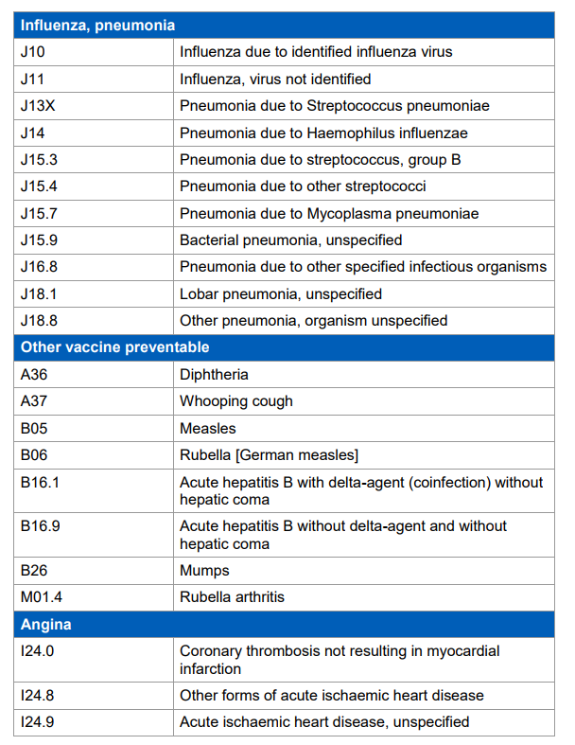

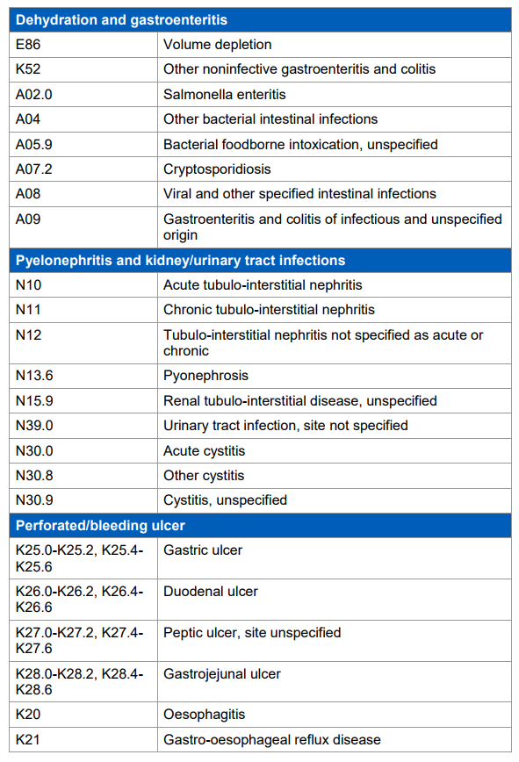
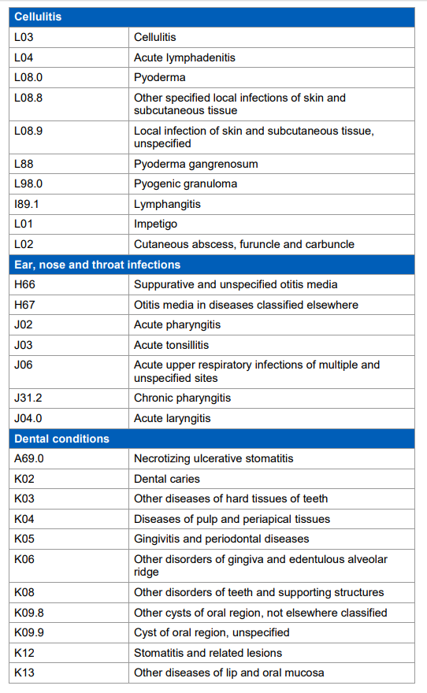

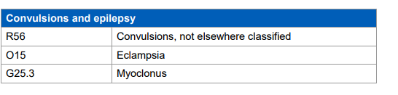

Indicator Assurance Report
IAP00070

Final Assurance Rating from the Indicator Governance Board - 13/09/2018

Reason for assessment | Scheduled review (review date reached)
Iteration | 1st IGB meeting
Ratings Against Assessment Criteria

Clarity | Fit for use
Rationale | Fit for use
Data | Fit for use
Construction | Fit for use
Presentation and Interpretation | Fit for use
Risks and Usefulness | Fit for use
Overall Rating | Fit for use

Outcome | This indicator has been approved for inclusion in the National Library of Quality Assured Indicators

Approval date | 13/09/2018
Review date | 13/09/2023

Details of Methodology Appraisal – 28/06/2018

Methodology appraisal body | NHS Digital Indicator Methodology and Assurance Service
Reason for assessment | Scheduled review (review date reached)
Iteration | 2nd MRG meeting
Suggested Assurance Rating by Methodology Appraisal Body

Ratings Against Assessment Criteria

Clarity | Fit for use
Rationale | Fit for use
Data | Fit for use
Construction | Fit for use
Presentation and Interpretation | Fit for use
Risks and Usefulness | Fit for use
Overall Rating | Fit for use

Summary Recommendation to Applicant:
MRG thanked the applicant for addressing the remaining outstanding issues in the appraisal log below. The application can progress to IGB for assurance and inclusion in the library of indicators as fit for use.
Summary Recommendation to IGB:
MRG recommend this indicator as fit for use.
Please find a detailed description of recommendations and actions in the appraisal log at the end of the document.
Details of Methodology Appraisal – 14/06/2018

Methodology appraisal body | NHS Digital Indicator Methodology and Assurance Service
Reason for assessment | Scheduled review (review date reached)
Iteration | 1st MRG meeting
Suggested Assurance Rating by Methodology Appraisal Body

Ratings Against Assessment Criteria

Clarity | Not enough information provided
Rationale | Not enough information provided
Data | Not enough information provided
Construction | Not enough information provided
Presentation and Interpretation | Not enough information provided
Risks and Usefulness | Not enough information provided
Overall Rating | Not enough information provided

Summary Recommendation to Applicant:
MRG thanked the applicant. It was agreed that there were a number of areas where more information was required. MRG notes that many of their concerns are outside the remit of Clinical Indicators and lie with the sponsor.
Summary Recommendation to IGB:
N/A

Please find a detailed description of recommendations and actions in the appraisal log at the end of the document.
What do the Assurance Ratings mean?

Rating | Description
Fit for use | This indicator can be used with confidence that it is constructed in a sound manner that is fit for purpose.
Fit for use with caveats | The indicator is fit for use, however users should be aware of caveats and/or recommendations for improvement that have been identified during the assurance process.
Use with caution – data quality issue | The indicator is based on a sound methodology for which the assurance process endorse the use, however issues have been identified with the national data source which have implications for its use as an indicator.
Not fit for use | Issues have been identified with the indicator which have resulted in the assurance process currently not endorsing its use as a quality indicator.
Not enough information provided | There has not been enough information supplied to the assurance process to be able to accurately give the indicator a level of assurance.

Appraisal Log

Clarity
Rec. no | Issue or recommendation | Raised by / Date | Response or Action taken by applicant | Response date | Resolved | Sign off by / Date
 | None |  |  |  | ☐
Rationale
Rec. no | Issue or recommendation | Raised by / Date | Response or Action taken by applicant | Response date | Resolved | Sign off by / Date
2a | The reasoning behind why the indicator could be more succinct and demonstrate how the indicator works in practice. (2.1) | MRG 14/06/2018 | Added text to say If there is a high number of emergency admissions for these types of conditions then there may be an issue with primary care provision that needs investigation | 20/06/2018 | ☒ | MRG 28/06/2018
2b | Is this indicator intended for patients and/or public? It seems to be quite statistical in nature and may be too in-depth for public consumption (2.2) | MRG 14/06/2018 | All the CCG OIS indicators aim to provide information to a wide audience. It is expected that CCGs will use the information to identify potential issues, however, the data is publicly available and used by various government departments, researches and the public. Having the data published on the NHS Digital ensures transparency, and all indicators have a point of contact should anyone, including the public, have any questions around the meaning or interpretation of the data. | 20/06/2018 | ☒ | MRG 28/06/2018
Data
Rec. no | Issue or recommendation | Raised by / Date | Response or Action taken by applicant | Response date | Resolved | Sign off by / Date
3a | The descriptions of the data are extensive but don’t say why the data should be used. (3.1) | MRG 14/06/2018 | HES is widely used as it is the best data source for this information and is recognised as the national data source for this information. NHSAIS was determined to be the most suitable to allow use for comparison purposes. It is also important in terms of consistency with other indicators based on this data. | 20/6/2018 | ☒ | MRG 28/06/2018
3b | Diagnosis codes need further explanation and it is suggested an appendix is added to the application to give definitions as to what diagnoses are being collected (3.7) | MRG 14/06/2018 | Noted, we will add an appendix to the application to describe the meaning of the diagnosis codes. | 20/6/2018 | ☒ | MRG 28/06/2018
3c | Why is gender broken down into male, female and persons? (3.7) | MRG 14/06/2018 | At the time this indicator was initially developed a decision was taken to include a gender breakdown. The reason for this decision is not documented therefore I am unable to comment on why the decision was made to include for this indicator. It may have been deemed part of the purpose of this indicator and the data is available at these levels. | 20/6/2018 | ☒ | MRG 28/06/2018
3d | The data is currently shown as rolling quarterly data. Could this be made into monthly rolling data, as this would be more useful for identifying season variation. (3.9) | MRG 14/06/2018 | Data for these indicators are presented as 12 month periods rather than individual months due to the potentially small size of the numerators if the data were broken down further. Also, to my knowledge, at the time of initial application, review of seasonal variation was not referenced as part of the purpose for this indicator. | 20/06/2018 | ☒ | MRG 28/06/2018
Construction
Rec. no | Issue or recommendation | Raised by / Date | Response or Action taken by applicant | Response date | Resolved | Sign off by / Date
4a | New guidance has been issued by PHE on confidence intervals. It would be good if the application could be updated to reflect the new guidance, which will be sent on to the applicant | MRG 14/06/2018 | We are using the current method in order to provide consistency with the other CCGOIS indicators and this can be revised at the next review. | 20/06/2018 | ☒ | MRG 28/06/2018
Presentation and Interpretation
Rec. no | Issue or recommendation | Raised by / Date | Response or Action taken by applicant | Response date | Resolved | Sign off by / Date
5a | Why is gender broken down into male, female and persons? (5.1)  See 3a | MRG 14/06/2018 | See above response. | 20/06/2018 | ☒ | MRG 28/06/2018
IMAS
Rec. no | Issue or recommendation | Raised by / Date | Response or Action taken by applicant | Response date | Resolved | Sign off by / Date
6a | Overall analysis section refers to Local Authority rather than CCG and patient residence. | MRG 14/06/2018 | Application amended. | 20/06/2018 | ☒ | MRG 28/06/2018

Any feedback should be made to the Indicator and Methodology Assurance Service (IMAS) Team at NHS Digital. Likewise, if you are unclear regarding any of the recommendations in this report or have any queries about the assurance process in general, please contact the IMAS team.

Indicator and Methodology Assurance Service
NHS Digital
1 Trevelyan Square, Boar Lane,
LEEDS
LS1 6AE.

Email: indicator.assurance@nhs.net
Website: https://digital.nhs.uk/systems-and-services/all-a-z/indicator-methodology-and-assurance-service

See our accessibility statement if you’re having problems with this document.

https://www.ons.gov.uk/peoplepopulationandcommunity/populationandmigration/populationestimates/methodologies/patientregisterqualityassuranceofadministrativedatausedinpopulationstatisticsdec2016
Dobson A et al. Confidence intervals for weighted sums of Poisson parameters. Stat Med 1991;10:457-62
Breslow NE, Day NE. Statistical methods in cancer research, volume II: The design and analysis of cohort studies. Lyon: International Agency for Research on Cancer, World Health Organization; 1987: 69.

