NATIONAL INSTITUTE FOR HEALTH AND CARE EXCELLENCE

INDICATOR DEVELOPMENT PROGRAMME

Consultation report

Indicator area: HIV testing in areas with high or extremely high HIV prevalence
Consultation period: 17 April – 16 May 2019
Date of Indicator Advisory Committee meeting: 5 June 2019
Output: Support for local measurement work

Contents
Introduction 2
Summary of indicators included in the consultation 4
IND5: HIV testing in newly registered patients 5
IND6: Annual HIV testing in patients having a blood test. 6
General comments 7
Appendix A: Consultation comments 8

Introduction
We consulted on 2 new HIV testing indicators to help support local implementation of NICE guidance in the small number of local authorities (79/325) with a high or extremely high prevalence of diagnosed HIV (Progress towards ending the HIV epidemic in the UK: 2018 report PHE, 2018). These two indicators are designed for these specific geographical locations and are not suitable for consideration for inclusion in the QOF.
Diagnosed HIV prevalence in England, 2017 (per 1,000 population aged 15 to 59 years)
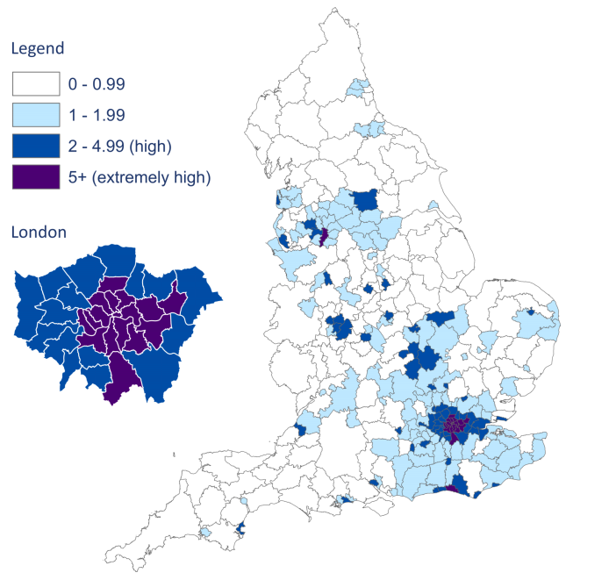
In England 79 of 325 local authorities have a high diagnosed prevalence (>2 per 1,000 population) of these 19 have an extremely high prevalence, defined as 5 per 1,000 population (Progress towards ending the HIV epidemic in the UK: 2018 report PHE, 2018).
Increasing the uptake of HIV testing is important to reduce late diagnosis. Early diagnosis improves treatment outcomes and reduces the risk of transmission. Late diagnosis is the most important predictor of morbidity and premature mortality among people with HIV infection. People diagnosed late are likely to have been living with an undiagnosed HIV infection for around 3 to 5 years and may have been at risk of passing HIV on to partners. One-year mortality among people diagnosed late in 2015 was 26.07 per 1000, compared to 1.62 per 1000 among people diagnosed promptly (HIV testing in England: 2017 report, PHE 2017).
Reducing HIV incidence and undiagnosed infection in high-risk populations are key aims of Public Health England (HIV testing in England: 2016 report, PHE 2016).
Offering HIV testing routinely in GP surgeries in areas of high and extremely high prevalence will help to ensure that an HIV test is regarded as routine practice and help reduce stigma.
People with late undiagnosed HIV have a greater chance of clinical deterioration and
opportunistic infections. Those who are detected much later also have a reduced
response to HIV treatments, meaning that there are additional costs associated with
treating opportunistic infections. Direct clinical costs for a person with a late HIV
diagnosis are also twice as high in the first year, in comparison to someone who is
diagnosed early. These costs are largely attributable to higher inpatient costs of
hospital admission, which is why testing early can have large economic benefits to both the person diagnosed and from a societal perspective. Interventions to expand testing beyond routine settings have been shown to be beneficial, feasible and also cost-effective to people being tested and to the staff involved. (HIV testing: increasing uptake among people who may have undiagnosed HIV economic report, NICE 2016)

Summary of indicators included in the consultation

ID | Indicator wording | Evidence source
IND5 | The percentage of adults and young people newly registered with a GP in an area of high or extremely high HIV prevalence who receive an HIV test within 3 months of registration. | NICE guidance NG60 (2016): HIV testing: increasing uptake among people who may have undiagnosed HIV. Recommendation 1.1.9.  NICE quality standard QS157 (2017): HIV testing: encouraging uptake. Statement 2.
IND6 | The percentage of adults and young people at a GP surgery in an area of high or extremely high HIV prevalence who have not had an HIV test in the last 12 months, who are having a blood test and receive an HIV test at the same time. | NICE guidance NG60 (2016): HIV testing: increasing uptake among people who may have undiagnosed HIV. Recommendation 1.1.9.  NICE quality standard QS157 (2017): HIV testing: encouraging uptake. Statement 2.

IND5: HIV testing in newly registered patients
The percentage of adults and young people newly registered with a GP in an area of high or extremely high HIV prevalence who receive an HIV test within 3 months of registration.
Rationale
Increasing the uptake of HIV testing reduces late diagnosis and the risk of transmission. When a new patient registers with a general practice, their overall health is assessed and this provides an opportunity in high or extremely high prevalence areas to promote HIV testing.
Summary of consultation comments
Stakeholders outlined the following concerns about the indicator:
- opposition to this indicator as it is seen as population screening which is excluded from the GMS contract
- the need for more evidence on the groups that would benefit from this indicator
- widespread introduction of testing in primary care requires discussion with hospital sexual health services that commonly carry out tests and manage patients
- unintended consequences relating to confidentiality, requirements for additional training for GP practice staff, insurance implications and possible stigma
- the concept of using defined high and extremely high prevalence areas to focus testing.
Considerations for the advisory committee
The committee is asked to consider:
  - if the indicator represents population screening and whether this is appropriate
  - should the target population be refined further
  - the potential unintended consequences of the indicator:
    - resource and training implications
    - the impact on sexual health services.

IND6: Annual HIV testing in patients having a blood test.
The percentage of adults and young people at a GP surgery in an area of high or extremely high HIV prevalence who have not had an HIV test in the last 12 months, who are having a blood test and receive an HIV test at the same time.
Rationale
Increasing the uptake of HIV testing reduces late diagnosis and the risk of transmission. When a patient has a blood test for another reason, it is an opportunity in high or extremely high prevalence areas to promote HIV testing.
Summary of consultation comments
Stakeholders outlined the following concerns about the indicator:
- the concept of using defined high and extremely high prevalence areas to focus testing
- the ability of primary care staff to provide an appropriate level of advice on the diagnosis, treatment and potential infection transfer for HIV compared to sexual health infections routinely seen in primary care.
Considerations for the advisory committee
The committee is asked to consider:
  - the use of high and extremely high prevalence areas
  - the ability to normalise HIV testing and long-term treatment with other sexual health infections treated in primary care.

General comments
The following is a summary of general comments on the draft indicators:
- a stakeholder suggested this could be done routinely on an opt-out basis by nurses and midwives in GP surgeries with the patient informed when blood is drawn. The lab costs of the tests should not penalise GPs
- a stakeholder commented that making HIV testing part of routine practice for patients who are having a blood test will reduce the stigma associated with HIV testing and reduce undiagnosed HIV
- a stakeholder felt that the indicator was really advocating opt out testing every time somebody has a blood sample taken
- a stakeholder queried whether these indicators have been discussed with BHIVA or PHE national infection service
- the central collation and publication of the data collected via these indicators would be welcomed
- the numerators and denominators should be broken down by gender, sexual orientation, ethnicity, age group and area, and it would be good to link the testing data with positivity data to inform future policies
- a stakeholder commented that national support and encouragement will be needed for CCGs to take this up
- 6 stakeholders supported these proposed indicators.

Appendix A: Consultation comments
ID | Indicator | Stakeholder | Comment
1 | General comment | British HIV Association (BHIVA) | - Do you think there are any barriers to implementing the care described by these indicators?  The most obvious issue facing GPs is the unsustainable increase in demand for their time and resources, coupled with a decline in their numbers. Unless this initiative is delivered in such a way that it has little or no impact on the quantity of extra work they are being asked to deliver, it will fail.  One possible solution is to approach this in the same way as antenatal HIV testing, where most testing is done routinely on an opt-out basis by nurses and midwives in GP surgeries. HIV testing could then be done as a routine part of care, with the patient informed when blood is drawn by whoever is doing it.  The lab costs of the routine opt-out tests must also not penalise GPs who participate. If these match the antenatal HIV screening costs, rather than are charged as stand-alone HIV testing costs, this will help.
2 | General comment | British HIV Association (BHIVA) | - Do you think there are potential unintended consequences to implementing/ using any of these indicators?  Making HIV testing part of routine practice for patients who are having a blood test will help destigmatise HIV testing and reduce undiagnosed HIV. One effect of this initiative over time could be the reduction in new positive diagnoses, which may lead some to question the value of testing for what will then be becoming an increasingly rare problem.
3 | General comment | British HIV Association (BHIVA) | - Do you think there is potential for differential impact (in respect of age, disability, gender and gender reassignment, pregnancy and maternity, race, religion or belief, and sexual orientation)? If so, please state whether this is adverse or positive and for which group.  Not if the testing is communicated as being part of routine practice and takes place in areas defined by evidence of high prevalence.
4 | General comment | British HIV Association (BHIVA) | - If you think any of these indicators may have an adverse impact in different groups in the community, can you suggest how the indicator might be delivered differently to different groups to reduce health inequalities?  Not if the testing is communicated as being part of routine practice and takes place in areas defined by evidence of high prevalence. Withholding testing from stigmatised groups in society doesn’t help anyone.
5 | General comment | British Infection Association | We strongly support this indicator to encourage increased HIV testing.
6 | General comment | Chelsea and Westminster NHS Foundation Trust - HIV Clinical Reference Group | HIV CRG supports these indicators although we understand that many challenges remain in their implementation. There is now a large evidence base supporting best practice relating to HIV testing in primary care and we hope that these indicators will support the expansion and maintenance of such testing.
7 | General comment | Coventry City Council, Public Health | Whilst we are very supportive of the indicator being used, it looks like it will not be part of the national QOF scheme, and so it is likely for local CCGs to decide if they wish to incentivise it locally. We would be interested in how national support for encouraging CCGs to do this could be provided, as we think it may help us get local support for it.  Overall our feedback is really one of support, but a caution that there needs to be national support and encouragement for CCGs to take this up.
8 | General comment | National AIDS Trust | NAT strongly supports the two proposed indicators relating to HIV testing in primary care.
9 | General comment | Public Health England | PHE supports the introduction of the two human immunodeficiency virus (HIV) testing indicators (HIV testing among newly registered people and among those having a blood test). PHE would welcome the central collation and publication of the data collected via these indicators. It would be important to see the numerators and denominators broken down by gender, sexual orientation, ethnicity, age group and area. If possible, it would be good to link the testing data with positivity data to inform future policies.
10 | General comment | Royal College of Pathologists | If what they are actually conceptually recommending is opt out testing every time somebody has a blood sample taken, they would be much advised to say so, quite how this would be encompassed within the current state of the NHS is anybody’s guess. Has this been discussed by BHIVA or indeed with PHE national infection service?
11 | IND5 | British Medical Association | IND5: The percentage of adults and young people newly registered with a GP in an area of high or extremely high HIV prevalence who receive an HIV test within 3 months of registration.  We oppose this indicator. This is a form of population screening and so should only take place if assessed as worthwhile by the UK National Screening Committee and with appropriate contracts in place to provide the service. Screening activities are excluded from the General Medical Services Contract and as such are not suitable for quality standards, unless a contracted service has been agreed.
12 | IND5 | National Pharmaceutical Advisers Group (PAG) | Agree with rationale however the widespread introduction of such testing in primary care would require careful consideration and discussion with hospital sexual health services that more commonly carry out tests and manage patients. There can be unintended consequences in relation to confidentiality, requirements for additional training for GP Practice staff and implications in relation to insurance implications and possible stigma and differential treatment by GP Practice Staff when dealing with patients who’s status becomes known.
13 | IND5 | Royal College of General Practitioners | IND5: The percentage of adults and young people newly registered with a GP in an area of high or extremely high HIV prevalence who receive an HIV test within 3 months of registration. New  We do not support this indicator. There needs to be more evidence on the groups that would benefit from this indicator. Factors such as high practice turnover need to be considered, as well as sufficient resources need to be in place to allow appropriate management following a diagnosis.
14 | IND5 | Royal College of Pathologists | What does an area of high or extremely high HIV prevalence mean? Yes, one can make statistical comments based on the number of known cases in a geographical area but this is so impacted upon by the size of the denominator population that it is of questionable value at all. The concept that you can usefully define in the UK “areas” of high endemicity is flawed from the start. Indeed I think the following rationale section is also flawed, presumably on the principle of wishing to “reduce stigma”. What surely would be more sensible, cost-effective and defensible would be to ensure that people at an increased risk of either acquiring or already being infected with HIV should be offered testing.
15 | IND6 | National Pharmaceutical Advisers Group (PAG) | As in 5 above however there may be a wider discussion to be had around diagnosis and treatment of HIV in primary care normalising it with other sexual health infections that may be treated in primary care. HIV is now considered a long-term manageable condition like many others and patients are now expected to reach normal life expectancy along with the ageing population and earlier diagnosis and treatment leads to reduced mortality and transfer of infection. This infection transfer is particularly important in areas of high prevalence.
16 | IND6 | Royal College of Pathologists | The same critique applies to the second section on requirement for measuring the annual testing rate in the population represented by “an area of high endemicity”. Nobody questions the value of early diagnosis and treatment, this goes without saying. The approach recommended by NICE does not seem to take any account of the compartmentalisation within the behavioural aspects of HIV transmission. It appears to be a response to statistical figuring of prevalence of HIV infection in various populations across the country and is of doubtful value.

