NORTH EAST QUALITY OBSERVATORY SERVICE (NATIONAL COLLABORATING CENTRE

FOR INDICATOR DEVELOPMENT)

FOR

NATIONAL INSTITUTE FOR HEALTH AND CARE EXCELLENCE

INDICATOR DEVELOPMENT PROGRAMME

Contextual data in support of piloted indicators

Topic area: Epilepsy

Pilot period: January – March 2022

IAC meeting date: 14th June 2022

Output: Supporting contextual information and findings from practice system clinical searches associated with the qualitative pilot to contribute towards recommendations for NICE indicator menu

Contents
Introduction | 3
Contextual information from publicly available data sources | 3
Epilepsy disease register (QOF 2020/21)  Epilepsy medication profiles  Epilepsy toolkit (RightCare) | 3  4  4
Contextual information from practice clinical searches | 5
Clinical search findings | 5
Summary of key findings | 7

Introduction
This paper presents publicly available data from NHS Digital, NHS RightCare and the OpenPrescribing website. Information from clinical system searches undertaken by pilot practices is presented and described from page 5 onwards.
The relevant key findings are summarised below.

Contextual information from publicly available data sources

Epilepsy disease register (QOF 2020/21)
Source: NHS Digital
The most recent QOF 2020/21 data shows a total number of 386,381 patients aged 18 or over recorded on practice registers as receiving drug treatment for epilepsy in England (Figure 1). This represents 0.80% of the practice list size, but will not represent the total population with epilepsy due to the restrictions of the indicator. This also varies between NHS Regions, from 0.54% in London to 0.93% in the North West.

Figure 1: Epilepsy prevalence by NHS Region
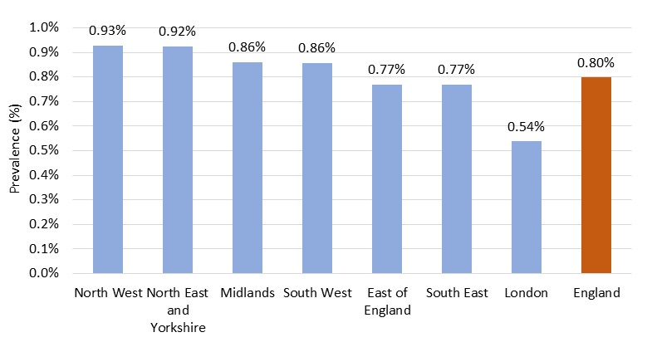

Epilepsy medication profiles
Between March 2017 and February 2022 approximately 2.05-2.70 million items of Antiepileptic drugs (BNF section 4.8) were prescribed each month across all GP practices in England based on data from OpenPrescribing. There is a slight upward trend in total items over the last five years to February 2022, with an average monthly spend on these items of around £27 million.

Epilepsy toolkit (RightCare)
NHS RightCare has developed an Epilepsy Toolkit which describes each of the system improvement priorities for epilepsy in order to support commissioners and other stakeholders in improving care and services.
One of the key areas for focus relates to Support for people with learning disabilities, with the Toolkit stating that 17.9% of patients with learning disabilities also have epilepsy, based on the findings from a 2017/18 study by NHS Digital.
The Toolkit also includes resources relating to medicines optimisation and co-ordination of care.

Contextual information from practice clinical searches

Clinical search findings
The indicator pilot described in this report was a partial pilot using qualitative methods only. However, in order to provide additional context to the pilot feedback, practices were asked to run simple clinical system searches (shown in Appendix E) and to share the results of these with NCCID for collation and analysis. Fifteen of the 16 participating practices provided their search findings as requested, including one practice which had recently merged their administration and submitted two returns, therefore 16 clinical search findings have been analysed here. Each clinical search return is referred to as a pilot practice in this section.
There were 165,711 registered patients aged 18 and above in the 16 practice returns combined, as of the end of January 2022 (as reported by the practices, with the exception of one practice which did not return a practice list size, therefore this was taken from the 1st February NHS Digital Patients Registered at a GP Practice publication).
The aim of the searches was to understand the size of the populations associated with the indicators and the extent to which patients are on multiple registers.
There were 1,320 patients from 16 pilot practices reported as being on the QOF epilepsy register at the end of January 2022 (Table 1). This is on average 0.8% of the practice populations (consistent with the national QOF prevalence figure described on page 3), and ranged from 0.3% to 1.2% across the 16 practices. Of the 1,320 patients, 405 (30.7%) were aged 65 years or over.
There were 150 patients (0.09% of the total practice populations) in the pilot practices who were on both the QOF epilepsy register and the QOF learning disability register, and 46 patients (0.03% of the total practice populations) who were on both the QOF epilepsy register and the QOF mental health register.
With regard to those with a current diagnosis code of epilepsy (irrespective of whether they were on the QOF epilepsy register or not) 1,878 patients aged 18 and over were identified by the pilot practices, 49.8% more than the number of patients on the QOF register (Table 1) (note that this calculation excludes 2 practices due to data quality concerns). Of this patient group (all those with a diagnosis of epilepsy) a slightly lower proportion (28.9%) were aged 65 or over.
There were 164 patients from these practices in the cohort ‘with a current diagnosis code for epilepsy’ who were also on the QOF learning disability register (0.11% of the total practice populations), whilst 52 patients had a current diagnosis code for epilepsy and were also on the QOF mental health register (0.03% of the total practice populations).
Table 1: Summary of epilepsy clinical search results
Practice | Total population | Patients on the QOF epilepsy disease register | Patients with a current diagnosis code of epilepsy (aged 18+)
1 | 16,591 | 140 (0.8%) | 242 (1.5%)
2 | 8,025 | 72 (0.9%) | 118 (1.5%)
3 | 5,808 | 52 (0.9%) | 82 (1.4%)
4 | 8,298 | 59 (0.7%) | 59 (0.7%)
5 | 7,047 | 24 (0.3%) | N/A
6 | 9,480 | 61 (0.6%) | 129 (1.4%)
7 | 12,025 | 85 (0.7%) | 140 (1.2%)
8 | 11,370 | 123 (1.1%) | 207 (1.8%)
9 | 19,537 | 120 (0.6%) | 120 (0.6%)
10 | 13,229 | 94 (0.7%) | 154 (1.2%)
11 | 6,910 | 40 (0.6%) | 70 (1.0%)
12 | 11,571 | 114 (1.0%) | 150 (1.3%)
13 | 9,800 | 80 (0.8%) | 148 (1.5%)
14 | 6,288 | 42 (0.7%) | N/A
15 | 6,745 | 63 (0.9%) | 108 (1.6%)
16 | 12,987 | 151 (1.2%) | 151 (1.2%)
Total | 165,711 | 1,320 (0.8%) | 1,878 (1.2%)*
* Practices marked N/A are excluded from the denominator for this percentage calculation
Applying these averages to a ‘standard practice’ of 10,000 patients we would expect approximately:
- 80 patients on the QOF epilepsy disease register
- 120 patients with a current diagnosis of epilepsy.

Summary of key findings
- 386,381 patients are on the QOF register of patients aged 18 or over recorded as receiving drug treatment for epilepsy, representing 0.8% of the population.
- Clinical searches from pilot practices found that 1,320 patients from 16 pilot practices were reported as being on the QOF epilepsy register at the end of January 2022. This is on average 0.8%, matching the overall QOF register prevalence, though there is variation between practices.
- Clinical searches from pilot practices found that 1,878 patients from 14 pilot practices were reported as having a current diagnosis of epilepsy. This represents 1.2% of the practice populations (aged 18 years and above).
- Based on data from clinical searches from pilot practices it is estimated that in a ‘standard practice’ of 10,000 patients there would be approximately 11 patients with a current diagnosis code of epilepsy (irrespective of whether they are currently on drug treatment for epilepsy) who were also on the QOF learning disability register, and approximately 3 patients with a current diagnosis code of epilepsy (irrespective of whether they are currently on drug treatment for epilepsy) who were also on the QOF mental health register.

https://digital.nhs.uk/data-and-information/data-tools-and-services/data-services/general-practice-data-hub/quality-outcomes-framework-qof
https://openprescribing.net/bnf/0408/
https://www.england.nhs.uk/rightcare/products/pathways/epilepsy-toolkit/
https://files.digital.nhs.uk/BA/4F4C1D/health-care-learning-disabilities-1718-sum.pdf
https://digital.nhs.uk/data-and-information/publications/statistical/patients-registered-at-a-gp-practice

