Introduction
There have been significant improvements, over the past 12 months, in the way NICE is managed and monitored within the organisation with the introduction of a Trust Lead for NICE and improved engagement from all Divisions and Services.
There are currently 650 pieces of NICE guidance which include:
- Clinical Guideline (CG/NG)
- Quality Standards (QS)
- Public Health Guidance (PH)
- Social Care Guidance (SC)
- Safer Staffing Guidance (SS)
- Technology appraisal guidance (TA)
- Interventional procedures guidance (IPG)
- Diagnostics (DG)
- Highly specialised technologies (HST)
- Medical technologies guidance (MT G)
Table 1.1

- Each publication is reviewed within Divisions/services and a NICE Guideline Lead is allocated – they review the guidance within the Multidisciplinary teams/external agencies/voluntary organisation (where appropriate).
- Table 1.1 highlights the number of guidelines by status showing that 40% have been signed off as compliant and 16% are partially compliant with action plans in place.
- There are 9 overdue reviews which have all been formally escalated by the Medical Director and Director of Governance to the NICE Guideline Lead and Divisional Triumvirate.
- Closed status refers to NICE’s advisory guidance which are for information only.
- The guidance is compliant when:
  - It has been fully reviewed
  - Evidence of compliance is available (where appropriate)
  - If an action plan has been developed it has been signed off
  - It has been signed off at Divisional DGAG/Relevant Meeting
- If Divisions decide that elements of NICE guidance should not be implemented they must provide rationale for the decision and complete an exception form. The Trust Lead for NICE will ensure that this has been fully reviewed by discussing with North West NICE Leads Forum and contacting NICE for guidance.
Improvements
- NICE guidance is now managed within the Ulysses system
- The development of an improved management system (Table 1.2) highlights when guidance is overdue and sends an automated email reminder and formal escalation letter. This reduces the amount of time needed on the day to day management of NICE.
- Divisions can now access live reporting via the SQL server (Table 1.3) which enables them to present at meetings, discuss with specialties and develop exception reports.
- Monthly Divisional NICE reports presented at Clinical Audit and Effectiveness are generated using the live reporting system
- Monthly meetings with Divisional NICE leads to ensure NICE guidance is progressed and/or escalated.
- Regular meetings with NICE guideline leads to support the review of guidance and collation of evidence.
- Increased references to NICE in complaint, incident and investigation responses.
- Links with Better Care Together to review NICE across the healthcare economy pathway rather than just acute care.
- Use of wide range of evidence, including audit, to demonstrate compliance.
- Automated reminder system for Divisions to revisit NICE guidance every 12 months.
- Automated email reminders for updated NICE guidance requiring re-review.
- Regular Weekly News articles highlighting developments.
- The organisation is now registered as a stakeholder and is beginning to make contributions to the development of new guidance and the review of existing guidance.
- Submissions for the NICE Shared Learning awards are in progress.
- The Executive and Quality dashboards are automatically updated monthly.
Table 1.2
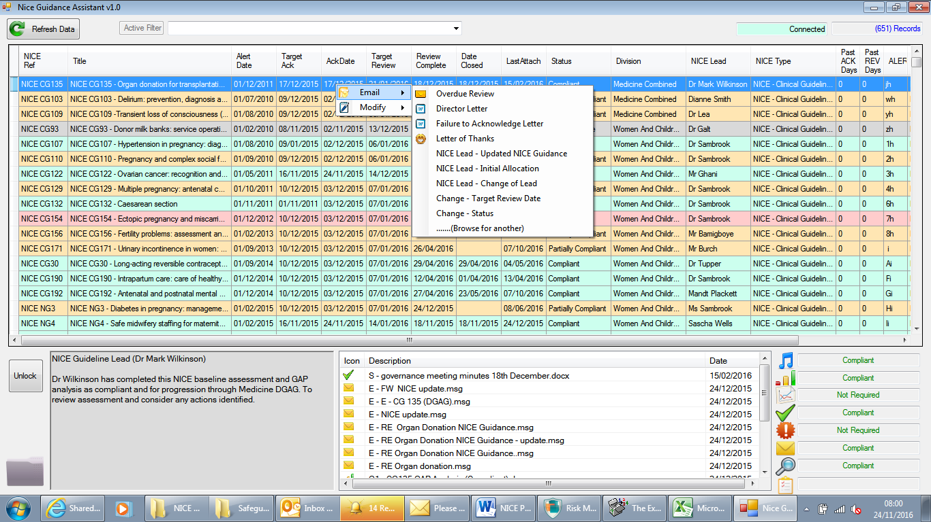
Table 1.3
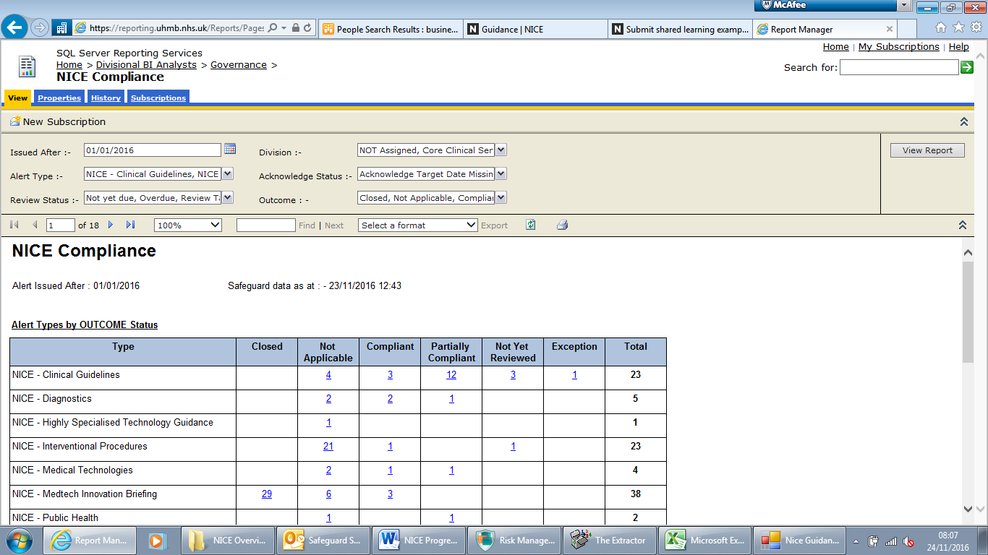
Future Developments
- Strengthen links with Bay Health and Care Partners to start reviewing all NICE Guidance as part of patient pathways.
- Engage with service users as part of guideline reviews.
- Further develop Divisional reviews of evidence of compliance to ensure that there is agreement of compliance and robust assurance.
- Continued involvement in NICE guideline consultations.
- Submit examples of successful and effective implementation of NICE guidance for NICE Shared Learning Examples and/or Quality and Productivity Cases.
- Continue to support the role of the Trust Lead for NICE.

