**Development of a Multidisciplinary Post-Critical Care Clinic at Guy’s & St Thomas’ NHS Foundation Trust**

NICE shared learning entry

Supplementary information

Guy's and St Thomas' NHS Foundation Trust home

Post Intensive Care Syndrome

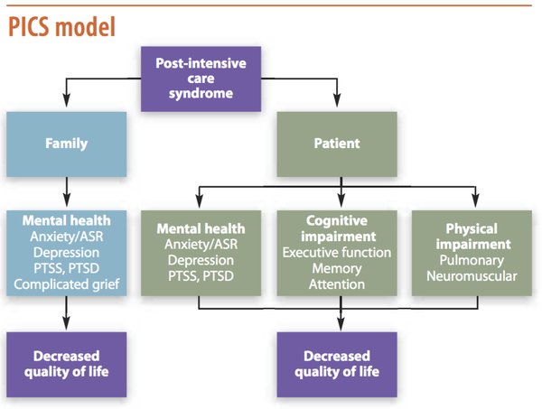

GSTFT post critical care clinic process map

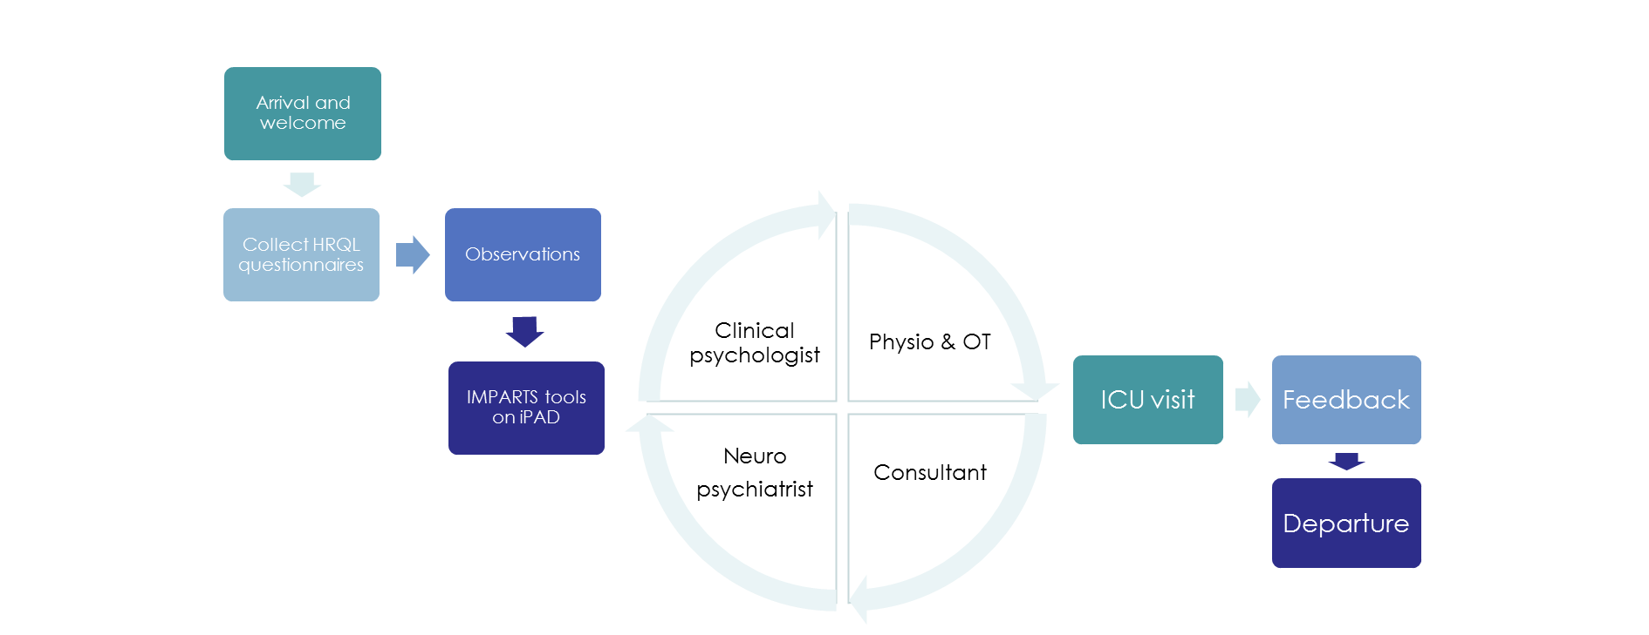

Multidisciplinary structure

**PICS**

Inclusion criteria

Patients discharged from critical care are invited to clinic 2-3 months post discharge if they meet meet any one or more of the following criteria:

|  |
| --- |
| Duration of mechanical ventilation > 72 hours |
| ECMO |
| Significant ICU delirium |
| Appropriate self-referral or colleague referral |

Exclusion criteria

Patients with any of the following features are considered for exclusion if deemed unlikely to benefit from the service:

|  |
| --- |
| Palliative care or progressive disease |
| Severe learning difficulties |
| Longstanding severe mental health issues |
| Neurorehabilitation pathway |
| Persistent substance abuse |

National benchmarking

We believe our service is unique in providing a comprehensive face-to-face multiprofessional assessment.

For comparison we have included here the 2016 national critical care non-medical workforce survey data which shows the relative scarcity of MDT member participation in post critical follow up services:

|  |  |  |
| --- | --- | --- |
|  | **No of units surveyed** | **% in follow up clinic** |
| Psychology | 135 | 13.0% |
| OT | 146 | 5.5% |
| Neuropsychiatry |  | ? not asked |
| Physiotherapy | 126 | 29% |

Functional assessment matrix

NICE CG83 statement 1.23 recommends a functional assessment of health and social care needs, to include sexual dysfunction. The guideline specifies the physical and non-physical dimensions that ought to be assessed. The following matrix shows how we achieve this in our clinic.

|  |  |  |
| --- | --- | --- |
| NICE CG 83 dimensions | Assessed by | Details of assessment |
| **Physical dimensions** | | |
| * Physical problems | PT, OT, Consultant, dietician, pharmacist | 6MWT  Grip strength  Chelsea Critical Care Physical Assessment Tool (CPAX)  Functional Independence Measure (FIM FAM)  Vital signs, weight, height  Food diary & MUST score  Medicines reconciliation and review  Spirometry |
| * Sensory problems | Consultant, PT | Pain assessment  Berg balance |
| * Communication problems | Nurse, OT, neuropsych, consultant |  |
| * Social care or equipment needs | OT, PT, nurse, consultant | EQ5D  SF36 |
| **Non physical dimensions** | | |
| * Anxiety, depression & PTS-related symptoms | Clin psych, neuropsych | Specialist psychiatric risk assessment  Completion of PHQ9, GAD7, PTSS14 scales  Visit to ICU |
| * Behavioural and cognitive problems | Neuropsych, OT, clin psych | Montreal cognitive assessment (MoCA)  Referral to neuropsych clinic if required |
| * Other psychosocial or psychological problems | Nurse, Clin psych, OT |  |
| **Other** | | |
| * Sexual dysfunction | Consultant | SCSM questionnaire  Referral to psychosexual service if required |
| * Driving | Consultant, OT | DVLA driving assessment if required |
| * Flight safety | Consultant | Aviation consultant referral if required |

Examples of interventions and referrals made to specialist rehabilitation services

NICE CG83 statement 1.25 recommends onward referral if recovery appears to be at a slower rate than anticipated or if the patient has developed new physical or non-physical morbidity. Here are example data from our MDT which demonstrate the range of interventions taking place both within clinic and through post-clinic onward referral.

 

Within-clinic interventions by OT Onward referrals generated by OT

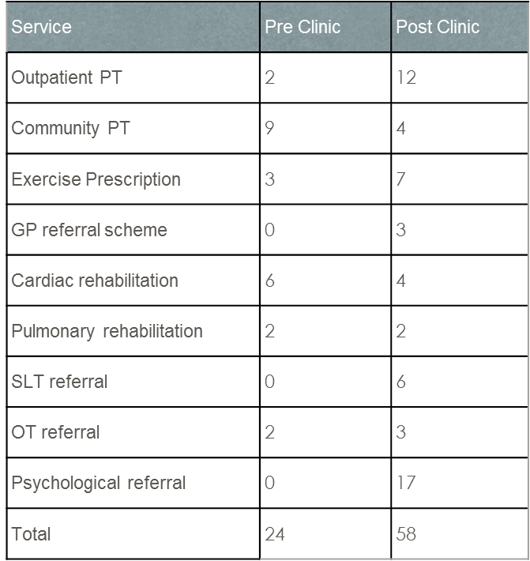

Onward referrals generated by physiotherapist

Onward destinations of patients seen by neuropsychiatry in clinic

Patient perspective on utility of clinical psychologist in clinic