NICE Shared Learning Example MISSION ABC
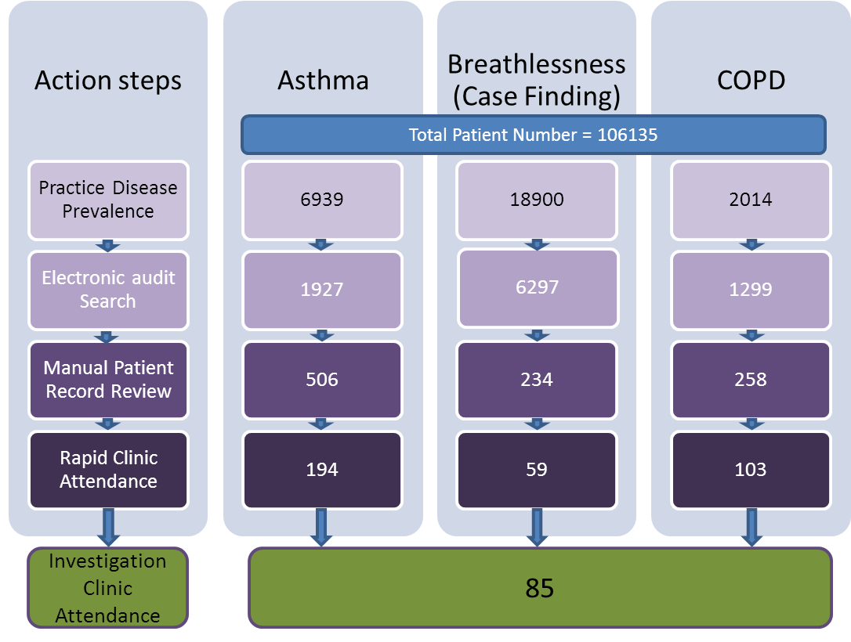
Figure 1.
Number of hospital admissions per pt per 3 months
Change in number of hospital admissions before and after MISSION
Figure 2. Run chart of mean hospital admissions.
Number of GP attendances per pt per 3 months
Change in number of unscheduled GP attendances before and after MISSION
Figure 3. Run chart of mean unscheduled GP visits.

