TalkCPR Project
Supplementary Files
Dr Mark Taubert
March 2016
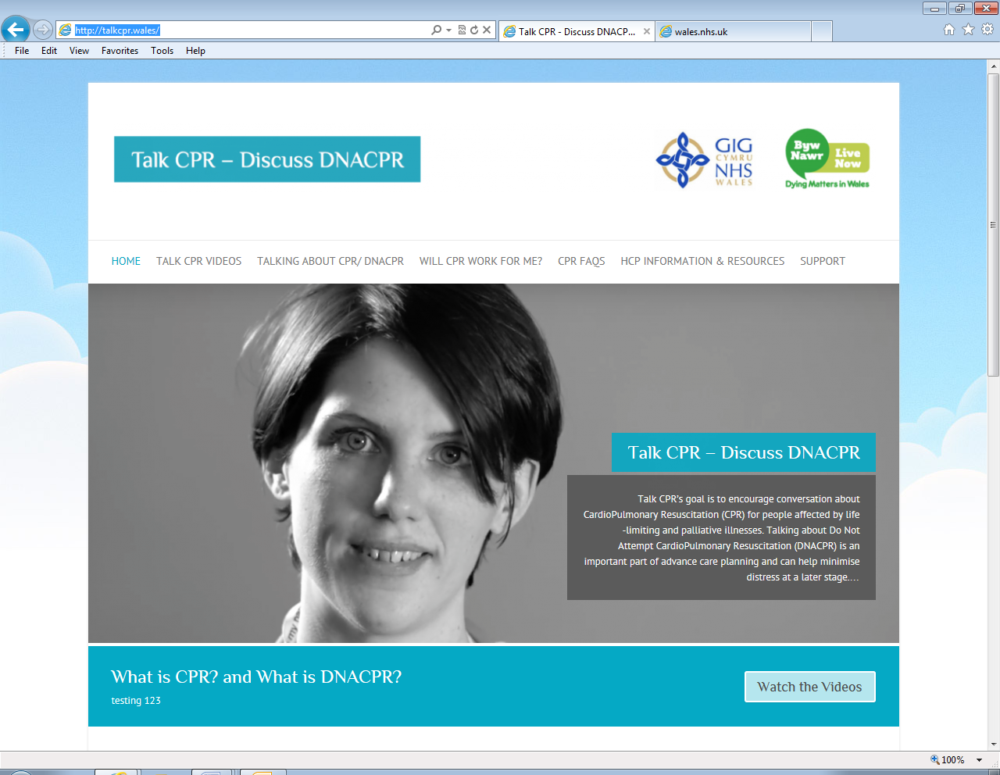
Image 1- TalkCPR website

The following figures, graphs and pictures are meant to supplement and inform the NICE Shared Learning TalkCPR project.

TalkCPR stakeholder groups
The following were identified as stakeholders and consulted in the production process.
- Patients/ Carers
- Doctors and nurses at frontline of medical delivery
- Palliative Care Reference Group
- Palliative Care Implementation Group
- End of Life Board for Wales (Chaired by Steve Ham)
- Byw Nawr Charity (Dying Matters in Wales)
- Resuscitation Officers
- All Wales DNACPR implementation group
- Medical Director at Velindre NHS Trust (Peter Barret-Lee) – Sponsor of this IQT project
- Velindre NHS Trust Quality Improvement Board
- Medical Directors for LHBs and Trusts in Wales
- Communications Department Leads in each Health Board/Trust
- Medical education leaders
- NHS Wales/ Welsh government representatives
- Bevan Commission/ Prudent Healthcare initiative

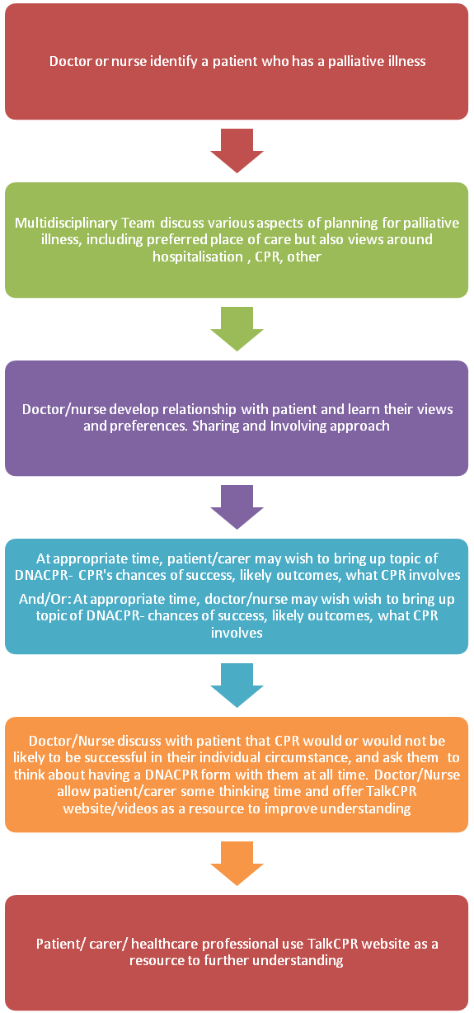
Process map of how DNACPR discussions with palliative patients can be approached in Wales
Aims Drivers Interventions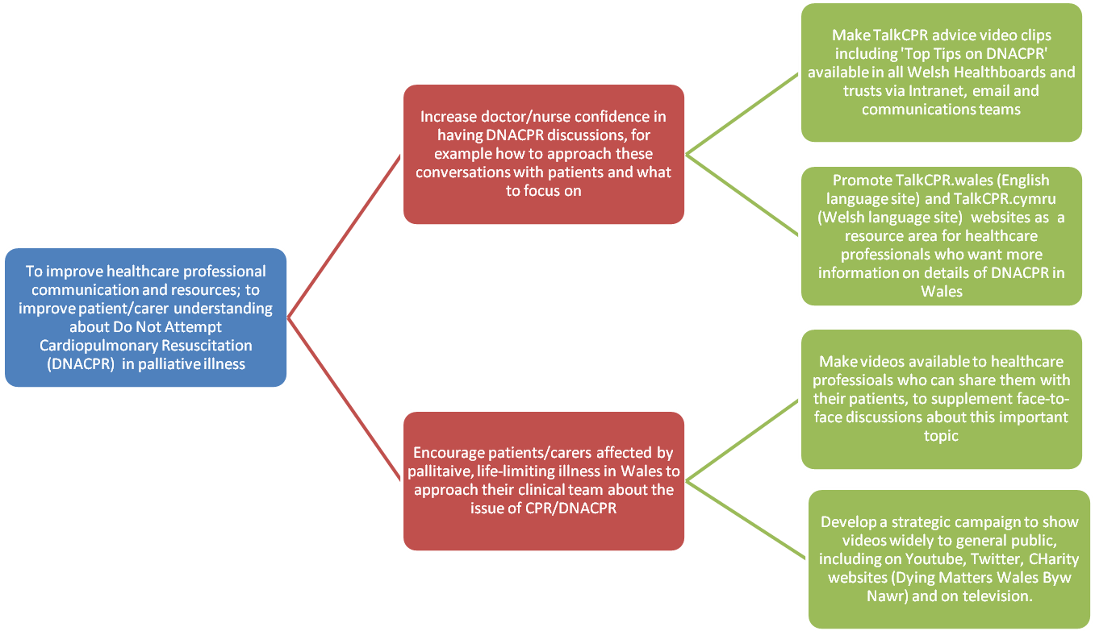
Driver diagram that helped set out strategic direction based on NICE Guideline QS 13 for TalkCPR project in Wales

Baseline Data on quality of DNACPR documentation:
Documentation of DNACPR forms- Data from previous DNACPR audits at Velindre NHS trust were analysed and collated as a run chart (chart 1). This shows an already demonstrable fall in times when a discussion about DNACPR could not be found documented in the medical notes, despite a form being in place. In 2003, 62% of forms and the corresponding medical notes made no mention of CPR/DNACPR having been addressed with patient and/or proxy. This had reduced to 58% in 2010 and then 31% in 2013.

Chart 1- Run chart of baseline data

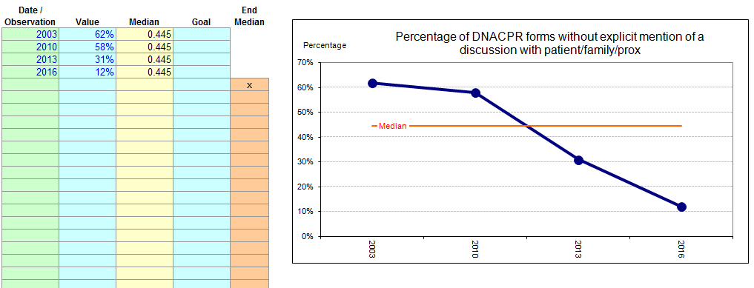
Post Improvement Data. Run chart of percentage of forms found in notes without explicit mention of a discussion with patient/family/proxy after TalkCPR videos were introduced in education sessions for staff. Fir the 2016 audit, in only 12% of cases no discussion had taken place with patient or proxy, but in each case the reason for this had been outlined, for instance ‘Discussion would cause intense psychological distress’.

Fishbone Diagram of TalkCPR’s Aims with Barriers and Countermeasures
Difficult to estimate how a palliative care patients life will end, ie fatal rhythm, pneumonia other
BARRIERS
AIDS
COUNTERMEASURES
AIM
Patients, carers and healthcare professionals can have open and fully informed talk about CPR and DNACPR
Patients fear that talking about dying/CPR is inappropriate and may upset others
Resources like TalkCPR videos and website open up discussions “I saw that video, doc..”
Doctors/nurses do not want to push DNACPR discussions onto patients/ carers
Interventionist work ethic, ie if no DNACPR form exists, assume full CPR if patient not known to emergency team
TalkCPR top tips video can provide ‘ways in’ to a difficult conversation for healthcare professionals
Makes confident use of DNACPR forms even more important. Increasing all doctors/nurses confidence with DNACPR discussions should be aided by TalkCPR website and videos
Lack of continuity of care, many different healthcare professionals
Difficulties in communicating actual DNACPR decisions to all Healthcare Professionals and others who need to know
Top tips TalkCPR video gives healthcare professionals information on treatment ladder approach, ie explore what patient finds acceptable?
New All Wales DNACPR policy uses one form across all settings, including a patient-carer-held-copy

Results from survey given to nurses measuring pre- and post TalkCPR video-viewing impact metrics:

A survey to measure impact of the videos was given to senior nursing professionals (n=25) with an interest in frailty and end-of-life care (see Picture 1) at a palliative care module course, open to nurses across Wales. Readiness of nursing staff members who had never seen these videos to engage in discussions regarding DNACPR increased significantly.
Question 1 prior to watching video “How ready do you feel to answer questions on Do Not Attempt CardioPulmonary Resuscitation (DNACPR) planning decisions from patients?” scored from 0-10 (0= not ready at all, 10 very ready) on average across 25 general nursing participants was 6.12 out of 10 initially, and increased to 8.28 after watching theTalkCPR videos. (see table 1)

Column1 | Column2 | Column3 | Column4 | Column5 | Column6 | Column7 | Column8 | Column9 | Column10 | Column11 | Column12 | Column13 | Column14 | Column15
1 | How ready do you feel to answer questions on Do Not Attempt CardioPulmonaryResuscitation (Dnacpr) planning decisions from patients?
2 | How ready or unready is the general public to see an information video on DNACPR?
3 | How ready are patients/carers to see a video about DNACPR in a clinical area, ie a hospital bed or GP practice waiting room?
4 | How ready would you be to show an information video to palliative patients/and or their carers on this topic, if you had a portable computer that made this easy?
5 | How ready would you feel to suggest a video on the topic of DNACPR to another member of staff?
6 | Do you think palliative care patients are ready for such a video, as a newer form of communicating complex areas of care if it can add-on to vital face-to-face discussions?
 |  | Scale0-10; 0=not ready at all and 10= very ready
 | BEFORE |  |  |  |  |  |  | AFTER
 | 1 | 2 | 3 | 4 | 5 | 6 |  | 1 | 2 | 3 | 4 | 5 | 6
 | 6 | 8 | 9 | 8 | 10 | 8 | 49 | 8 | 9 | 9 | 9 | 10 | 9 | 54
 | 7 | 5 | 5 | 5 | 5 | 5 | 32 | 8 | 8 | 8 | 8 | 10 | 9 | 51
 | 7 | 5 | 5 | 5 | 9 | 6 | 37 | 9 | 7 | 8 | 8 | 10 | 8 | 50
 | 4 | 4 | 5 | 6 | 6 | 6 | 31 | 8 | 8 | 9 | 9 | 8 | 8 | 50
 | 5 | 4 | 3 | 4 | 6 | 4 | 26 | 8 | 8 | 8 | 8 | 8 | 9 | 49
 | 6 | 4 | 4 | 3 | 9 | 5 | 31 | 7 | 7 | 6 | 7 | 10 | 7 | 44
 | 7 | 8 | 6 | 6 | 9 | 6 | 42 | 9 | 9 | 6 | 8 | 9 | 8 | 49
 | 7 | 8 | 3 | 6 | 10 | 8 | 42 | 8 | 8 | 5 | 9 | 10 | 9 | 49
 | 6 | 4 | 5 | 4 | 6 | 5 | 30 | 9 | 9 | 9 | 9 | 9 | 9 | 54
 | 8 | 6 | 4 | 4 | 7 | 8 | 37 | 8 | 6 | 6 | 7 | 9 | 7 | 43
 | 4 | 4 | 2 | 2 | 8 | 3 | 23 | 7 | 8 | 8 | 7 | 10 | 7 | 47
 | 5 | 6 | 4 | 8 | 6 | 5 | 34 | 8 | 7 | 8 | 8 | 8 | 7 | 46
 | 5 | 2 | 2 | 5 | 8 | 5 | 27 | 8 | 7 | 7 | 8 | 10 | 7 | 47
 | 6 | 8 | 4 | 8 | 9 | 5 | 40 | 8 | 8 | 8 | 8 | 9 | 9 | 50
 | 9 | 6 | 7 | 10 | 10 | 7 | 49 | 10 | 8 | 8 | 10 | 10 | 9 | 55
 | 4 | 3 | 5 | 3 | 4 | 4 | 23 | 8 | 7 | 8 | 7 | 8 | 9 | 47
 | 5 | 5 | 6 | 5 | 6 | 5 | 32 | 8 | 9 | 8 | 8 | 8 | 9 | 50
 | 8 | 9 | 9 | 6 | 9 | 3 | 44 | 10 | 9 | 9 | 10 | 9 | 7 | 54
 | 6 | 0 | 0 | 3 | 7 | 5 | 21 | 8 | 5 | 6 | 8 | 10 | 7 | 44
 | 6 | 6 | 6 | 3 | 4 | 5 | 30 | 8 | 8 | 8 | 6 | 8 | 8 | 46
 | 8 | 6 | 8 | 3 | 8 | 6 | 39 | 9 | 8 | 9 | 5 | 8 | 9 | 48
 | 4 | 9 | 5 | 6 | 6 | 5 | 35 | 8 | 10 | 9 | 9 | 8 | 10 | 54
 | 3 | 8 | 3 | 6 | 8 | 3 | 31 | 7 | 8 | 6 | 7 | 10 | 8 | 46
 | 7 | 4 | 4 | 8 | 7 | 3 | 33 | 8 | 6 | 7 | 8 | 9 | 8 | 46
 | 10 | 6 | 6 | 8 | 10 | 4 | 44 | 10 | 7 | 8 | 9 | 10 | 9 | 53
 |  |  |  |  |  |  |  |  |  |  |  |  |  | 0
Average | 6.12 | 5.52 | 4.8 | 5.4 | 7.48 | 5.16 |  | 8.28 | 7.76 | 7.64 | 8 | 9.12 | 8.24

Figure 4: Excel worksheet breakdown of responses by nursing staff to pre- and post video ‘readiness survey’

To make the Excel spreadsheet results more understandable, here is a graphic representation of nurses ‘readiness levels’ for each question before and after viewing TalkCPR videos (Graph 1 and 2):

Graph 1: Nurses’ Before and After questionnaire answers for each of the 6 questions asked

Graph 2: Nurses’ Percentage difference for each question in readiness to address issue stated in question.
Results from survey given to junior doctors measuring pre- and post TalkCPR video-viewing impact metrics

The above survey was also given to junior doctors (n=15) rotating through Velindre NHS Trust during 2015 and 2016 at the start of DNACPR teaching sessions, in induction week. (FY2- ST2 level).

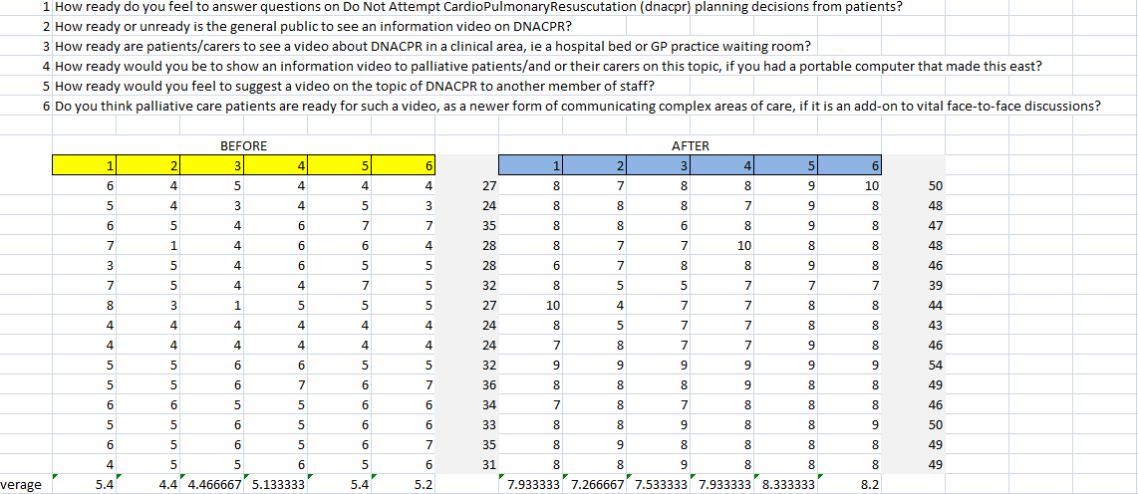

Figure 5: Excel worksheet breakdown of responses from junior doctors during late 2015 and early 2016

Again, to make these figures more interpretable, graphs 3 and 4 will be useful.

Graph 3: Doctors’ Before and After TalkCPR Video questionnaire answers for each of the 6 questions asked

Graph 4: Junior Doctors’ Percentage difference for each question in readiness to address issue stated in question.

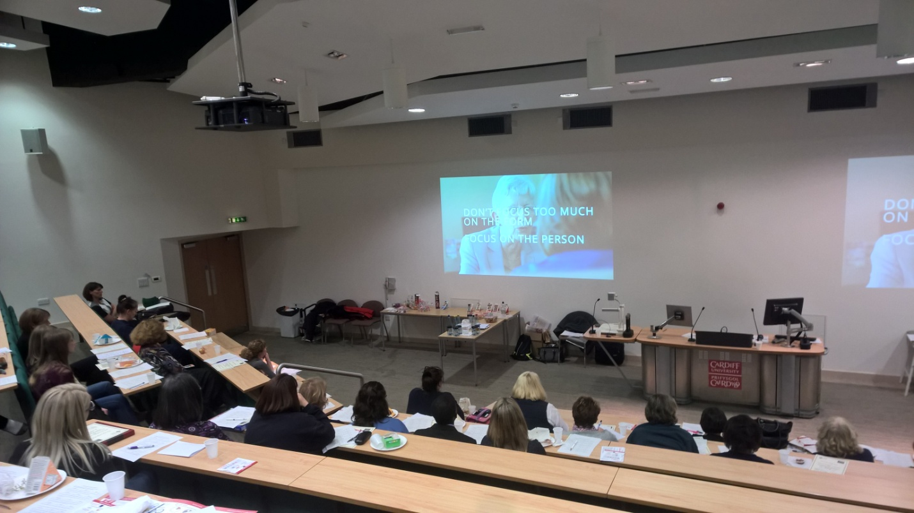

End of Life- Palliative Care Module nursing course in UHW Cardiff; attendees filled in a pre- and post-video survey.

The outcomes of the 4 different strands outlined in the results section, suggest a positive impact of TalkCPR videos on knowledge and readiness to address change regarding communication of this topic. Videos seemed acceptable to patients, carers, doctors and nurses. Implementation of a communication approach in our hospital led to an improvement in the documentation of whether DNACPR decisions had been communicated to patient and family.

Graph 5: Combined scores (nurses and doctors [n=40] answering pre-and post video survey questions)

The biggest change increase after watching the videos was for question 3 (“How ready are patients/carers to see a video about DNACPR in a clinical area, ie a hospital bed or GP practice waiting room?”) as illustrated in Graph 6. This was generally scored quite low prior to watching TalkCPR videos, but acceptability ratings then increased after having seen the actual video, and this was quite equal across both healthcare professional groups (Graph7). This could be seen as significant data if policy makers felt the sensitivities around this area are too considerable.

Graph 6: Combined difference for each question asked, pre-and post videos

Graph 7: Combined difference split into both groups as comparison

