Supporting Evidence 1

NCSCT Training

Very brief Advice (VBA): All frontline staff were offered the opportunity to complete the NCSCT VBA online training. (1530 staff have completed this to date). An update VBA is now available for staff to access yearly as a refresher session.

Brief Intervention (BI): More recently a 90 minute BI training has been included for staff to access to support learning and increase the number of staff trained to support smokers on admission to hospital. An additional BI training session was also developed for medical staff to access and delivered trust wide to over 200 medical staff.

Level 2- Practitioner Training: 189 staff completed their Level 2 training in preparation to go smokefree on 9th March 2016. Following their online training completion they then attended a half day face to face training session to further support their learning. Additional staff have now been identified to complete their training.

Smokefree Champions:
A key element of the project was to train staff as Level 2 Practitioners via the online NCSCT training package. Staff would then also receive a further face to face training session to support learning. All staff trained to Level 2 would then be offered the opportunity to become a Smokefree Champion and to date TEWV have 28 Champions who support the work of the Nicotine Management Team. Champions support Stoptober and National No Smoking Day events and provide regular guidance to staff within their areas linked to the smokefree agenda.

Away days are planned in January and July of 2017 for all Champions to attend where additional advice, learning and support will be available. This will also support networking for teams across the trust who can share best practice and lessons learnt.
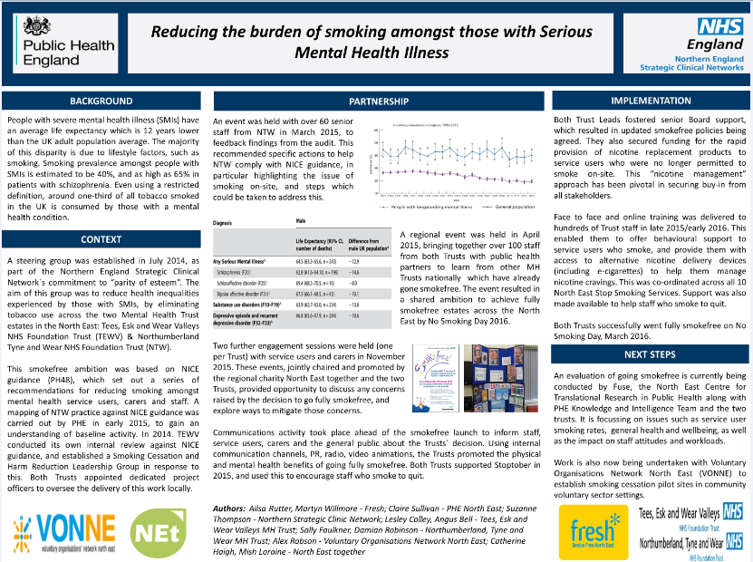
Supporting Evidence 2

Supporting Evidence 3

E-Cigarettes
E-cigarettes are becoming a rapidly accessible form of nicotine management with over 2.8 million users in the UK, almost half of whom have completely stopped smoking [ASH 2016] E-cigarettes offer a wide reach, low-cost, intervention to reduce smoking and improve health in disadvantaged groups who tend to be more dependent. Those with mental illness who are admitted to hospital often have to manage their crisis admission whilst also needing to consider the effects of nicotine withdrawal which manifests as irritability, agitation and on occasion aggression. Disposable e-cigarettes can offer a quick and easy form of nicotine to replace cigarettes and reduce the withdrawal symptoms often experienced.
There is ongoing debate as to whether e-cigarettes should be available within hospital settings. Many Mental Health Trusts Nationally have prohibited their use but following consultation with service users, carers and Trust staff the decision was taken to allow their use within this Trust.
Clear objectives for the use of e-cigarettes have been identified:

- To use as a harm reduction tool
- To provide nicotine management and smoking cessation support
- Support the reduction in second hand smoke exposure
- Support the reduction in smoking rates
- The Trust will make available all nicotine products as requested by service users

Benefits realisation:

- E-cigarettes are 95% safer than continuing to smoke tobacco (PHE)
- E-cigarettes support harm reduction
- E-cigarettes can support the reduction in nicotine withdrawal symptoms
The Nicotine Management Team are committed to providing a dedicated service improvement and to support the reduction in smoking within mental health services, leading to increased life expectancy whilst providing compassion and concern for those service users in our care who may struggle to remain smoke free.
Free disposable e-cigarettes were readily made available on all wards from the 9th March 2016 and feedback from both staff and service users has indicated that they have been an extremely useful resource in managing nicotine addiction and potential withdrawal.
Within the first week of going smoke free over 500 disposable e-cigarettes were ordered to stock identified wards and to date over 1,000 free e-cigarettes have been ordered and made available. Feedback from service users and staff regarding the benefits they have experienced following admission has shown them to be an extremely supportive measure for many vulnerable clients in a time of crisis.
A more recent innovation was to provide stocks of free e-cigarettes within Section 136 crisis suites. There was an immediate uptake from service users accessing this service with excellent feedback on their availability. The success of the initiative was measured by specific questions aimed at service user’s feedback on availability, use and effectiveness. To provide information on the use of e-cigarettes the Nicotine Management Team along with service users and carers have developed guidance on the use of e-cigarettes inclusive of a poster for display.
Work is now ongoing to look at the potential for crisis/street triage staff to carry small supplies of disposable e-cigarettes to enable them to offer these to service users in their own homes or on transfer to crisis 136 suites.
All models of e-cigarettes are allowed to be used within the Trust. Initially only the first two generations were available but following consultation with service users the 3rd generation e-cigarettes were also approved for use from October 2016. Especially within Adult Services, these have been identified as the most effective model for our more dependent smokers.
TEWV have also taken into consideration:
- Making a clear distinction between vaping and smoking
- The evidence behind second-hand smoke exposure and its harms v’s e-cigarettes vaping mist exposure (which is extremely low and insufficient to justify banning e-cigarettes)
- Use of e-cigarettes in young people’s mental health services- not currently available to offer to those in TEWV under 18 years
- E-cigarette use may support a smoker to remain smokefree in the longer term
- Vapers should not be required to use the same space as smokers, as this could undermine their ability to stay smokefree.

Supporting Evidence 4

Areas for concern and mitigation
Areas for concern: | Mitigation:
- Smoking at entrances  - Staff continue to facilitate smoking and some smoking in bedrooms identified  - Use of Section 17 leave to allow smoking to continue  - Staff attitude to the smokefree agenda and its implementation  - Some service users smoking with relatives/carers during evening visiting  - Still areas with cigarette butts outside main entrances even when cleared | - New large posters and signage displayed in entrances across the Trust  - Removal of contraband items to continue and must not be returned until final discharge (still pockets of staff refusing to remove contraband items and on occasion supporting service users to smoke by taking them outside hourly in the grounds/courtyards or facilitating smoking in bedrooms)  - Clarity on Section 17 leave and smoking-no patient either informal or detained to be allowed leave to smoke  - Meetings with staff and managers to support the change in staff perceptions and attitudes-individual assurance ward meetings planned Trust wide  - Ensure visitors/carers are clear on the Trust Policy  - To continue to link with estates regarding clearing of cigarette butts and targeting affected locations
Key learning points following review were:

- Staff are often the biggest barrier to the successful implementation of a nicotine management and smoking cessation policy
- It is crucial to involve service users and carers throughout the preparation phase to ensure they have a voice in the development and implementation of the policy, leaflets and available services
- Staff training is vital to ensure service users receive the appropriate support for nicotine management and smoking cessation
- Ensure service users, staff and carers throughout the process receive regular updates on progress
- Provide a conference to allow service users, carers and staff to voice any concerns regarding the implementation of the policy
- Freeing up staff resource allows for more beneficial activity / therapeutic patient and staff engagement
We remain mindful that this is a work in progress and that there are specific targets to achieve by 2020. Work is now underway to roll out the project to community teams Trustwide to ensure a seamless pathway of care for service users on discharge. The trust is fully aware that it may take many more years to change culture and embed policy fully to support this change.

