Some example screen shots are shown below.
- EMIS Web-based templates
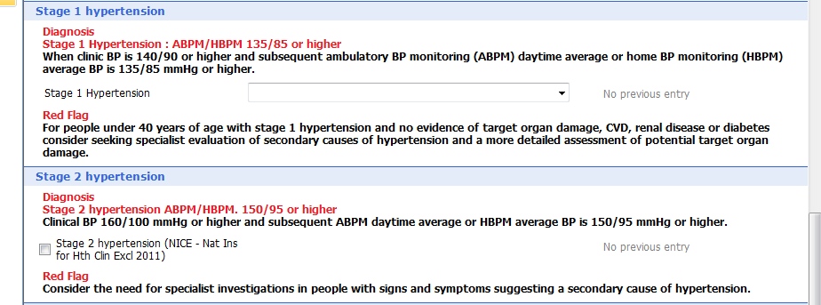

- Practice protocol
- Patient Information Prescription (prototype shown)

