NICE NG28. Type 2 diabetes in adults: Management
1.3.3 Encourage high-fibre, low-glycaemic-index sources of carbohydrate in the diet [2009]
1.3.6 Individualise recommendations for carbohydrate and alcohol intake [2009]

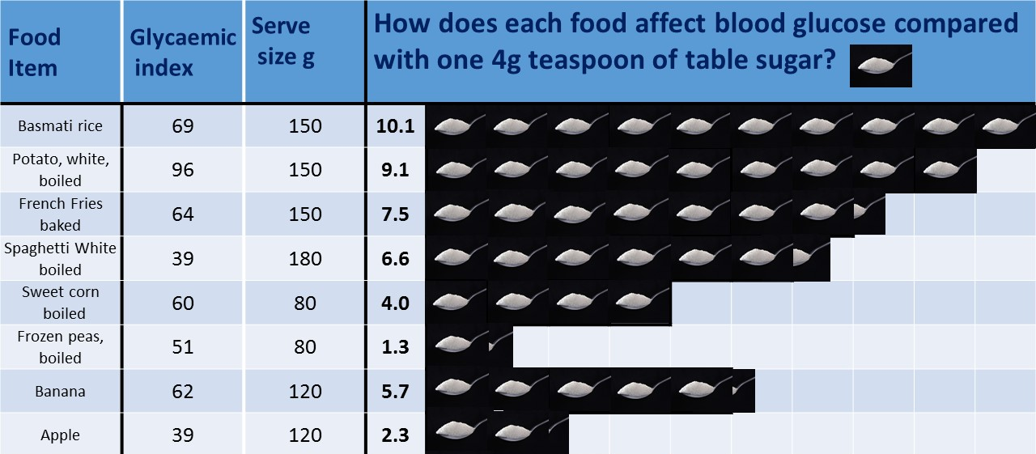

We produced many Infographics like this to help people use the glycaemic index and load to make better dietary choices. Calculations to be found in: It is the glycaemic response to, not the carbohydrate content of food that matters in diabetes and obesity: The glycaemic index revisited | Unwin | Journal of Insulin Resistance

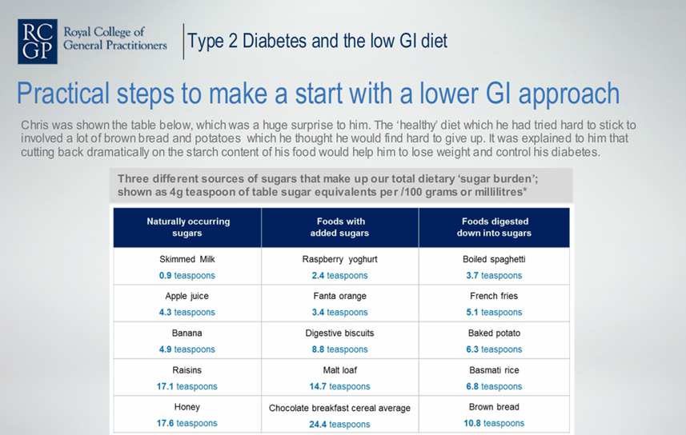
From our RCGP e-learning module based on the glycaemic index as per NICE published June 2018 Free to all 52,000 NHS GPs

A separate RCGP publication Dr Unwin produced this autumn. An Essential Knowledge Update screencast based on NICE guidelines for Type 2 diabetes Free for all to view here:
http://elearning.rcgp.org.uk/mod/page/view.php?id=8734

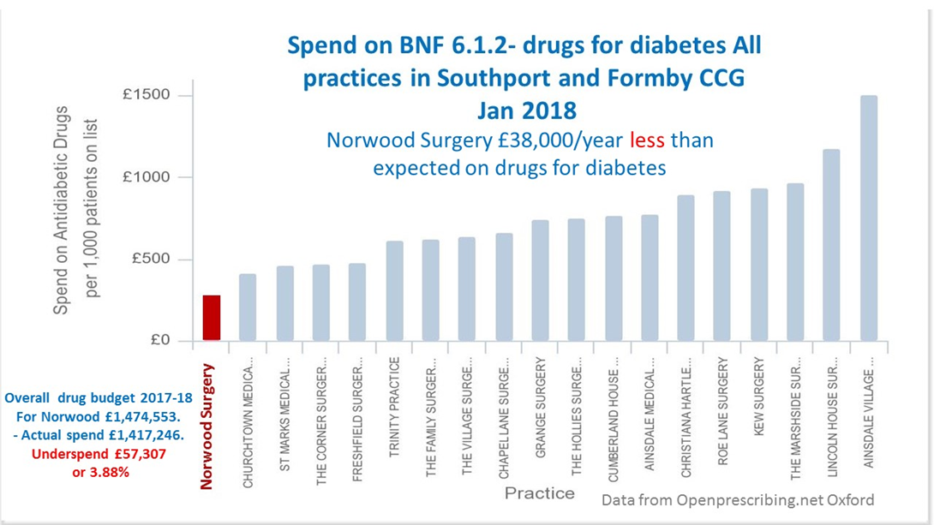

Our relevant peer reviewed publications
- Low carbohydrate diet to achieve weight loss and improve HbA1c in type 2 diabetes and pre‐diabetes: experience from one general practice. Practical Diabetes. Unwin D, Unwin J. 2014;31(2):76 https://onlinelibrary.wiley.com/doi/abs/10.1002/pdi.1835
- A patient request for some ‘deprescribing’. DJ Unwin & SM Tobin. BMJ 2015; 351 doi: http://dx.doi.org/10.1136/bmj.h4023 (Published 03 August 2015) This is about how diet can help a patient who wants to come off his medication for diabetes do it safely
- Outcomes of a Digitally Delivered Low-Carbohydrate Type 2 Diabetes Self-Management Program: 1-Year Results of a Single-Arm Longitudinal Study Saslow LR, Summers C, Aikens JE, Unwin DJ. JMIR Diabetes 2018;3(3):e12 http://diabetes.jmir.org/2018/3/e12
- It is the glycaemic response to, not the carbohydrate content of food that matters in diabetes and obesity: The glycaemic index revisited | Unwin | Journal of Insulin Resistance
http://insulinresistance.org/index.php/jir/article/view/8

