Figure 1: Current service within the trust prior to intervention
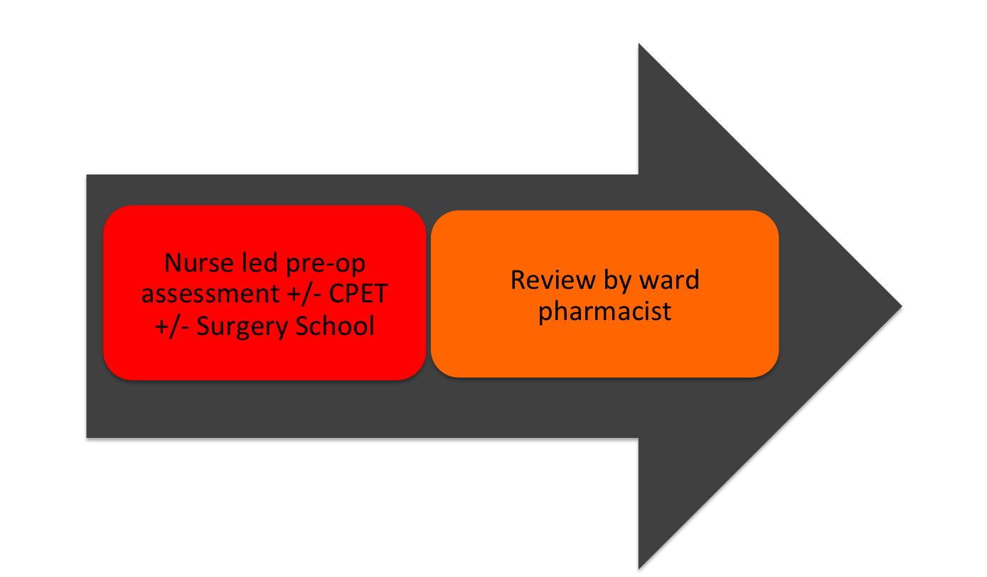

Figure 2: Implementation of ER Pharmacist service

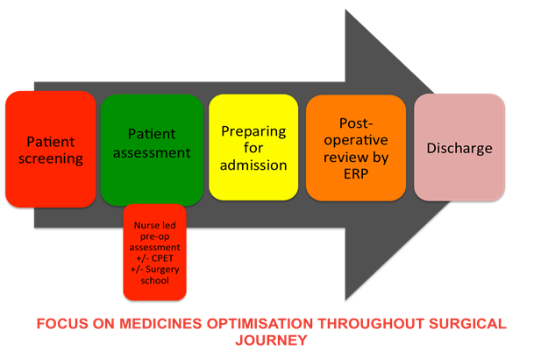

Figure 3: Summary of post-operative complications

