Figure 1: Traditional admission process on General Surgical Ward with identified sources of error and potential solutions to overcome these

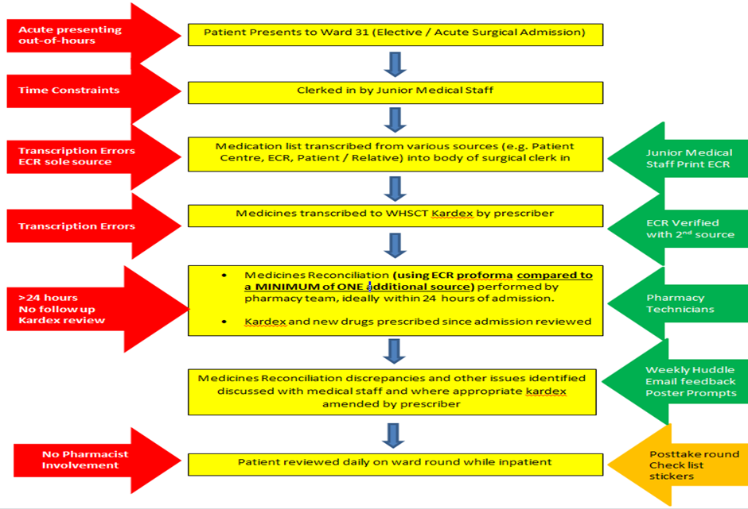

Figure 2: Project Driver Diagram

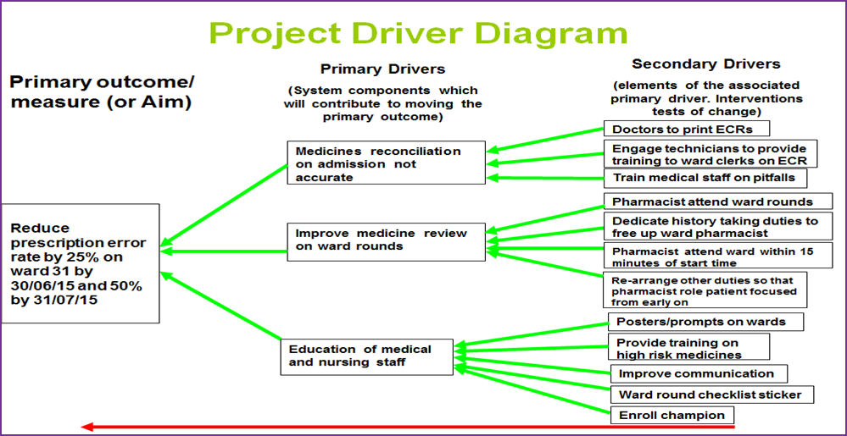

Figure 3: Strategic goals of Quality 2020 in relation to Medicines Reconciliation and impact on patient safety

Figure 4. Run Chart

