Table 1. Cardiometabolic risk status and self-reported lifestyle behaviours at baseline by gender.

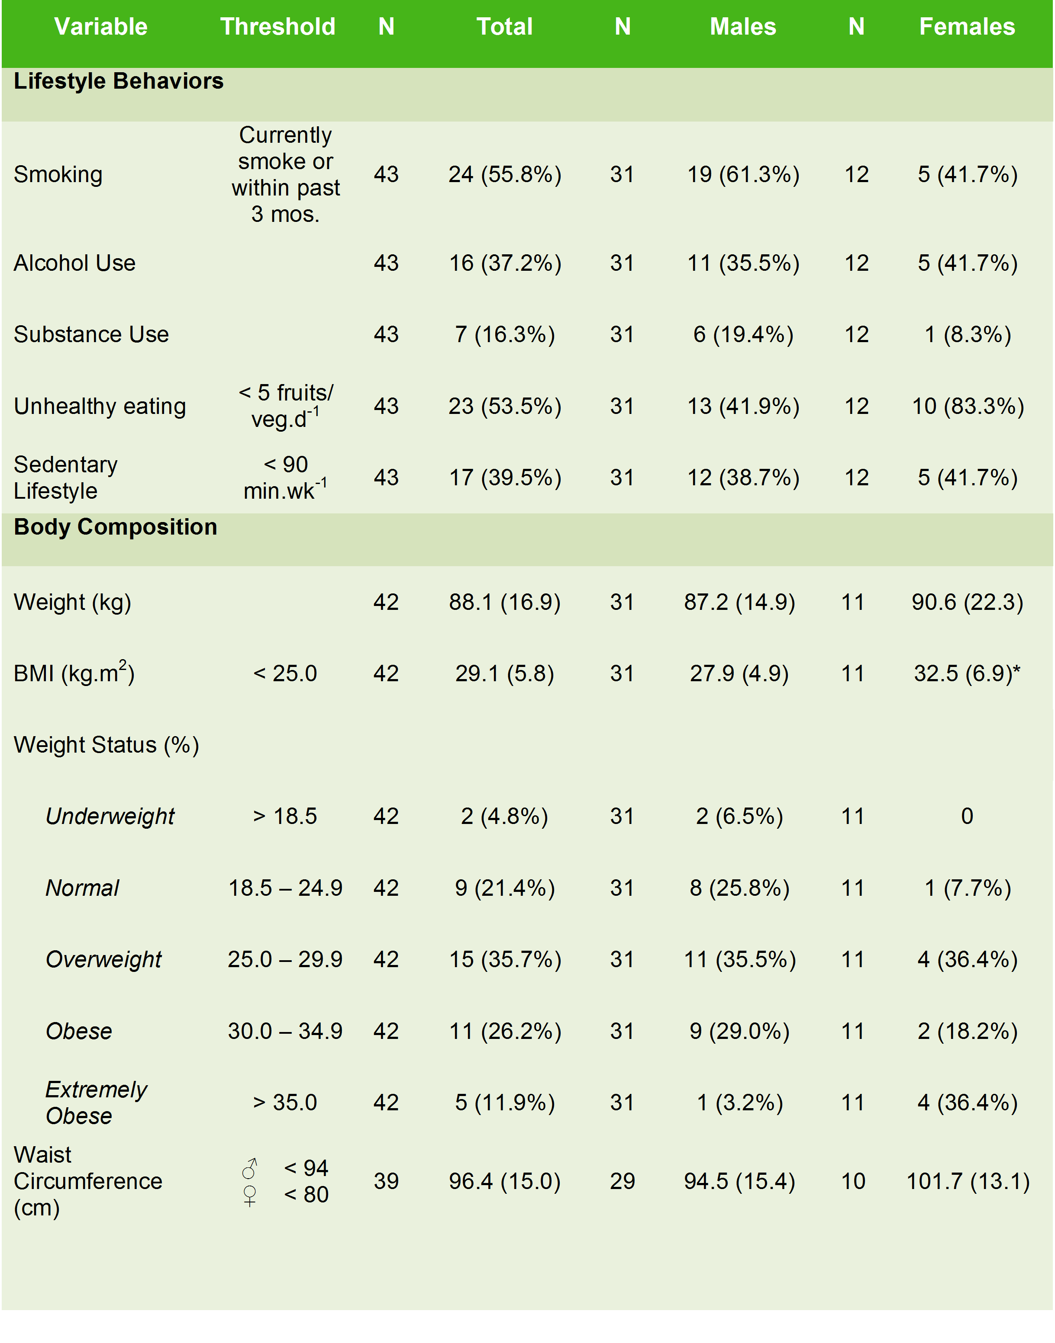

Table 2. Comparison of anthropometric measurements at baseline, 12 weeks and 12 months.

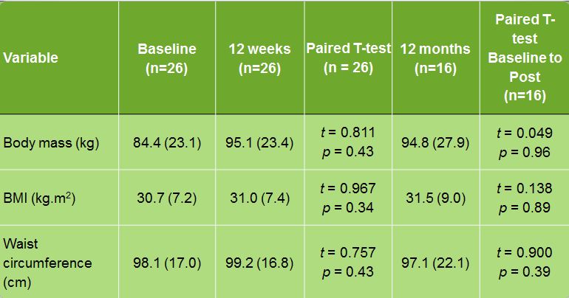

Table 3. Comparison of cardiometabolic markers at baseline and 12 months post-intervention.
Variable | N | Baseline | 12 months | Mean Change | P value
Body mass index | 16 | 31.4 (8.5) | 31.5 (9.0) | 0.09 (2.5) | 0.89
Waist circumference (cm) | ♂ 7  ♀ 7 | 100.2 (23.3)  90.7 (13.3) | 103.5 (27.5)  90. 7 (14.4) | 3.3 (8.0)  -0.04 (5.2) | 0.32  0.98
Systolic blood pressure (mm Hg) | 15 | 122.4 (17.0) | 125.2 (17.0) | 2.8 (15.3) | 0.49
Diastolic blood pressure (mm Hg) | 15 | 78.9 (9.2) | 79.4 (9.4) | 0.5 (9.5) | 0.85
Resting heart rate (beats.min⁻¹) | 13 | 84.7 (21.4) | 85.5 (21.3) | 0.8 (18.4) | 0.88
Total cholesterol (mmol.L⁻¹) | 9 | 4.4 (1.0) | 4.3 (1.0) | -0.2 (0.7) | 0.48
Triglycerides (mmol.L⁻¹) | 4 | 2.3 (1.9) | 2.0 (2.0) | -0.4 (1.5) | 0.64
HbA1_{C} (mmol.mol) | 7 | 31.8 (13.3) | 37.7 (9.7) | 5.9 (11.4) | 0.22
Prolactin (mIU/L⁻¹) | 6 | 852.0 (707.3) | 371.3 (239.1) | -480.7 (595.3) | 0.11

