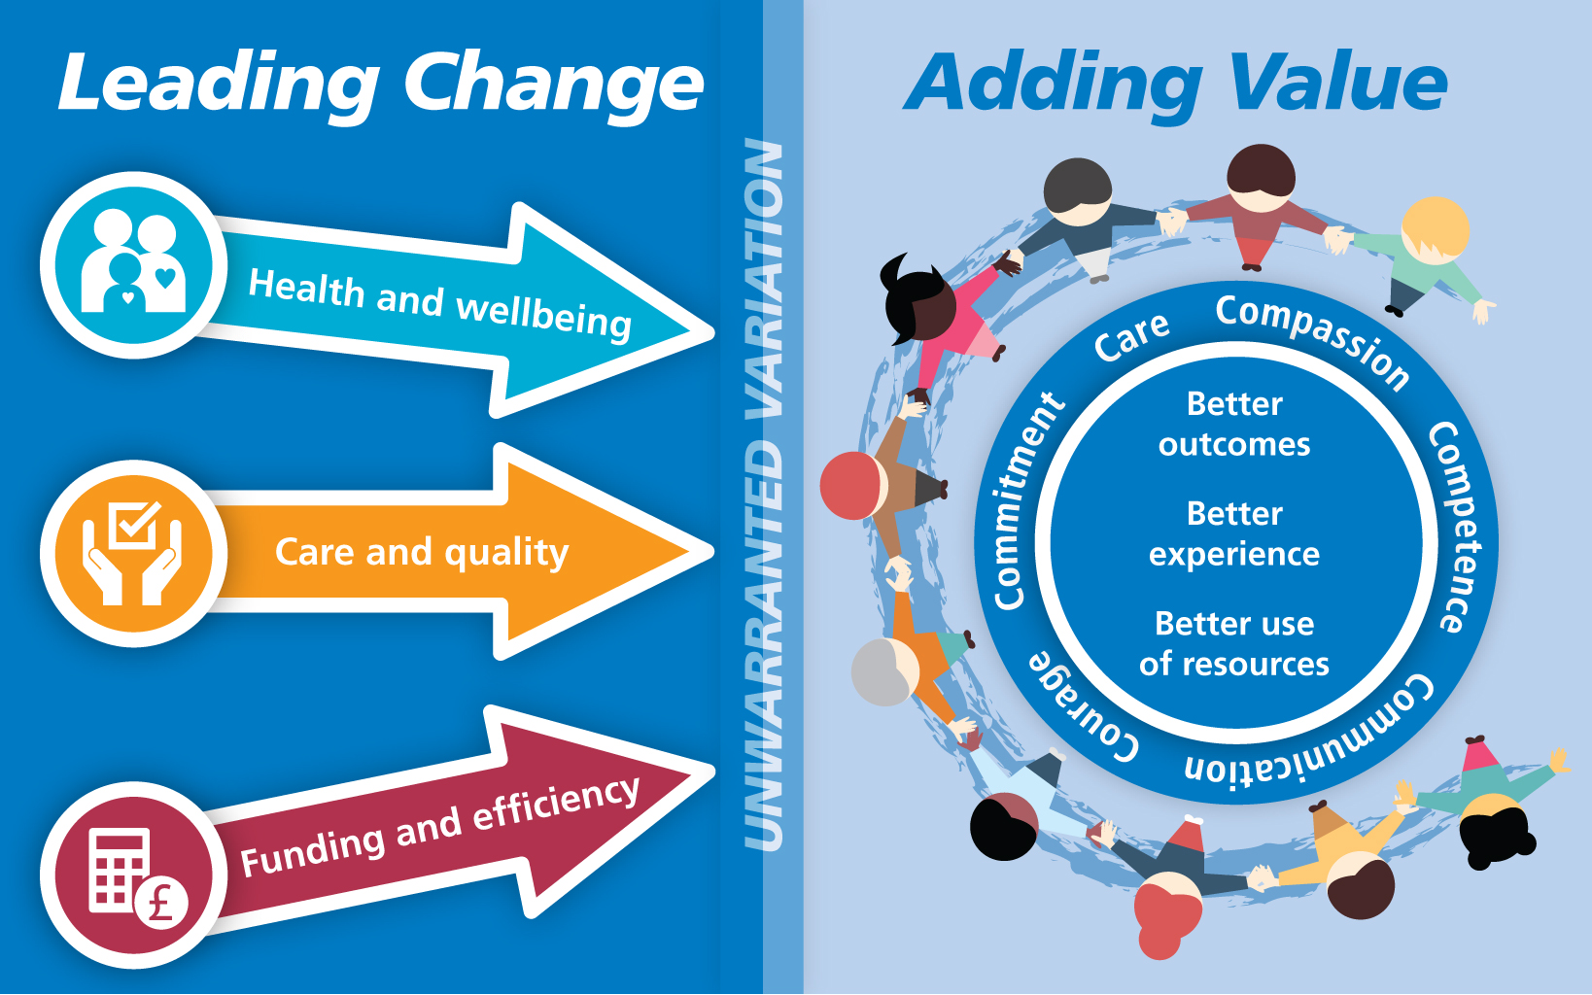

Supporting Carers in the Stroke Early Discharge Service (ESD)

Leading change
The Therapy Clinical Lead for Stroke Early Supported Discharge (ESD) at Royal Bournemouth & Christchurch Hospitals NHS Foundation Trust, led on a quality improvement initiative to improve carer support in Stroke ESD services. The initiative has led to improved outcomes, experiences and use of resources locally.

Where to look
Stroke is a major health problem in the UK. Each year, approximately 110,000 people in England, 11,000 people in Wales and 4,000 people in Northern Ireland have a first or recurrent stroke. Most people survive a first stroke but often have significant morbidity. More than 900,000 people in England are living with the effects of stroke (NICE 2013). Despite improvements in stroke mortality and morbidity since the 1960’s, people with stroke need access to effective rehabilitation services. Stroke rehabilitation is a multidimensional process, which is designed to facilitate restoration of, or adaptation to the loss of, physiological or psychological function when reversal of the underlying pathological process is incomplete. Rehabilitation aims to enhance functional activities and participation in society and thus improve quality of life. Key aspects of rehabilitation care include multidisciplinary assessment, identification of functional difficulties and their measurement, treatment planning through goal setting, delivery of interventions which may either effect change or support the person in managing persisting change, and evaluation of effectiveness.

NICE (2016) identifies that Early Supported Discharge (EDS) is an intervention for adults after a stroke that allows their care to be transferred from an inpatient environment to a community setting. It enables people who have a mild to moderate stroke with a resulting mild to moderate disability to continue their rehabilitation therapy at home beginning within twenty-four hours of discharge. EDS is linked to increased independent and living at home six months after their stroke and are more likely to express satisfaction with the services they received (Cochrane review 2005)

The Clinical Lead at Royal Bournemouth & Christchurch Hospitals NHS Foundation Trust identified that although informal carers play a vital role in the recovery of people with stroke discharge from hospital can be a particularly worrying time. Carer strain can be high, and for some, it is possible that accelerating discharge home exacerbates this. After collaboration with the University of Southampton, the lead decided to find out more about what extra carer support may be needed and how this could benefit individuals using the EDS.

What to change
Royal Bournemouth & Christchurch Hospitals NHS Foundation Trust provides health care for the residents of Bournemouth, Christchurch, East Dorset and part of the New Forest with a total population of around 550,000, which rises during the summer months. Some specialist services cover a wider catchment area, including Poole, the Purbecks and South Wiltshire. The Trust provides services to patients from the Royal Bournemouth and Christchurch Hospitals, which are located about three miles apart on the South Coast.

The Royal Bournemouth Hospital ESD Team provides an early, intensive specialist rehabilitation service for stroke and neurological patients for approximately two weeks. The team support patients to leave hospital more quickly and return to their own homes so they can maximise independence as quickly as possible after their stroke. Rehabilitation is centred around their individual goals and delivered in a setting that is meaningful to their lives. Patients are referred directly from the stroke unit and are usually seen on the same day of discharge or within 24 hours of returning home. The service uses a multidisciplinary team model made up of stroke specialist staff that covers a 7 day a week service to provide specialist rehabilitation. Rehabilitation goals will depend on the individual but tasks may include mobilising, activities of daily living, shopping, memory strategies, emotional support and care givers support, teaching and education. After support in the form of 2 weeks of rehabilitation in the persons own home referrals are made onto appropriate community services for on-going rehabilitation, care packages and additional support as needed.

Before the change, carer support included assessment of carer strain (using the Carer Strain Index) at the halfway point and the offer of a referral to social services for carer support. Education for carers was more informal and was planned as part of a patient session as indicated, but there were no stand-alone sessions for carers without the patient present.

Prior to the project, we felt that there may be an unmet need, as carers would talk about the emotional impact on them informally and also we had some comments regarding this on patient satisfaction feedback. We realised that we needed to specifically canvas carer’s opinions in order to evaluate their needs as well as their ideas to improve carer support during ESD.

A pre-intervention audit was designed to establish gaps in knowledge and what support carers felt would be required over 3 months. A carer questionnaire was developed with support of the Clinical Audit and Patient Experience Team which was circulated to carers. The results were:
- 1/3 of carers would have liked more opportunity to ask questions
- 1/4 of carers reported concerns about adjusting to changes in their lives
- 1/2 of respondents reported concerns regarding emotional management — the biggest worry highlighted
- 1/5 carers worried about leaving their family member alone after their stroke
- 1/5 of respondents wanted more information about rehabilitation and prognosis

How to change
To consider how to meet carer needs better the team held a carer focus group to help generate ideas for improvement. This session identified that carers wanted more information and felt that they would benefit from a one-to-one standalone session just for them. They asked for the following:
- Face to face session to be at the end of the two weeks ESD
- Book the session in at the start of ESD so carer is aware there will be dedicated time just for them and they can begin to consider the questions they would like to ask
- At the time of booking, inform carer there are options available for location of session i.e. home, café, walk etc.
- During ESD period, the carer can pass on any topics that they might like to discuss so that ESD team can be prepared with appropriate information
- Time to ask Questions and
- An open rather than structured format

Specialist Training form the Trusts Clinical Psychologist on communication and dealing with distress was rolled out to the team and planning begun as to how the sessions could be improved based upon the feedback.

A carer support planning questionnaire was co-designed with the Clinical Psychologist to understand the emotional needs of carers and rolled out across the team.
An information resource pack was also developed to cover 10 topics highlighted as crucial by carer and staff within the service: feeling frustrated, struggling to adjust, feeling overwhelmed, what the future holds, emergency situations, driving, fatigue, information about stroke and brain, leaving your relative alone and medications.

A follow up focus group to co-design the session was then held with carers with the following key elements raised:
- Carer sessions were started and offered to all carers to occur in the 2nd week of ESD input
- The sessions took place wherever the carer was most comfortable
- The patient had a treatment session taking place simultaneously from another member of the team so the carer could be released and so the patient would not miss out on therapy.

Adding value
To monitor the impact of the new approach a three month post-intervention audit was conducted asking the same questions as previously and is on-going.

- Better outcomes – The audit results indicate that a 34% increase to 100% of relatives reporting they have had enough opportunity to ask questions about their relative's care and 33% increase in time to ask about their needs as a carer. Carers report an increased confidence in caring for and supporting their relative using the new approach with now a 100% compliance with carer needs being met as well as significant improvement in carers reporting feeling involved in the input provided by the Stroke ESD service.

- Better experience – The new approach to carer support has been welcomed by the EDS team as well as wider teams with staff reporting they feel better equipped to support carers and to signpost to appropriate services.

Staff have embraced this new approach and welcomed the chance to develop their role so that carers have the opportunity for their needs to be addressed. Carers have fed back that they value the chance to voice their concerns and have their questions answered in a confidential setting of their choosing.

- Better use of resources –
This initiative has meant that resources can now be targeted to the topics which mean the most to individual carers. Because we inform and provide information about the carer session at the first visit, they know that they will have the opportunity to ask questions in a slot dedicated to them and regarding the topics which are concerning them the most. This has led to improved carer satisfaction and to less “ad hoc” queries which may take place in a rushed manner when the health professional does not have as much time to answer as they would prefer.

Challenges and lessons learnt for implementation
Emotional management was the biggest concern for carers of Stroke ESD patients which needs adequate time, thought and consideration when planning discharge from hospital.
Working collaboratively with carers, patients and relatives has been a real success of the programme and should be encouraged to start as early as possible.

For more information contact:
Michelle Heath - Clinical Leader, Neurotherapy ESD Team, Royal Bournemouth & Christchurch Hospitals NHS Foundation Trust
michelle.heath@rbch.nhs.uk

Tags: south west, acute, community, long term conditions,

