Hypertension Quality Improvement Project

Service Improvement project led by
Dr John Gnanakumar
Under supervision of Dr Majid Akram

The Deepings Practice

Why?

- First audit showed not all patients had all the investigations recommended by NICE when diagnosed with hypertension.

- Reducing the amount of ECGs and blood test for
patients with normal ABPM.
We were previously doing ECGs in all patients at the point of conducting ABPM which was unnecessary.

- Reducing the number of appointment and messages for patient with normal ABPM that were sent to GPs.

- Optimise patient care in line with guidance.
- Faster review and titration of medication

- Reduce burden on reception and secretaries for letters and appointment.

Pathway for new Hypertension

diagnosis and management

ABPM

- Patient will have blood pressure checked by GP or nurse or get BP self check in the waiting room

- If BP higher than 140/90 will need to book an appointment for ambulatory blood pressure monitoring (ABPM) or HBPM

ABPM interpretation

ABPM

Normal

<135/85

>= 135/85 >180/110

Offer repeat BP in 5 Give normal AMBP
years letter to patient

<40 yrs

Book appt with GP
(urgent)

>40 yrs old

Routinely do blood

tests*, urine dip *, ECG prior to appt with nurse

Urgent Same day GP
review

*Blood tests: FBC, U&Es, lipid profile, random glucose, LFTs *After urine dip (looking for blood and protein) send for ACR

If ABPM Normal
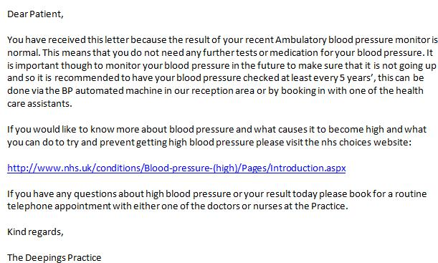

If >40 and ABPM raised

- Send letter for further investigations prior to Nurse led clinic

- Use New hypertension template during Nurse led clinic

- Use treatment algorithm to initiate treatment

- Follow up in 2 week to ensure BP controlled or up titrate medication

Letter for further investigations
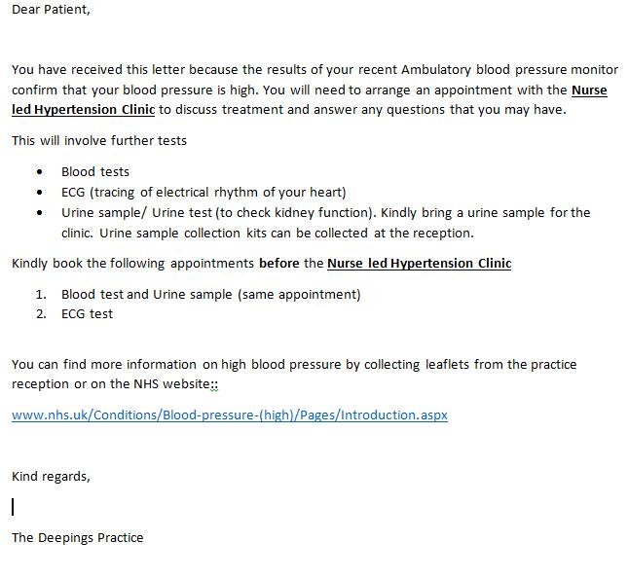

Assessment Of Hypertension

- Ensure delivery of Investigations to assess for target organ damage:

– ECG (e.g. to assess for LVH).

– Urine dip (checking for haematuria) + ACR (checking for AKI/CKD).

– Fundoscopy (assessing for hypertensive retinopathy).

– CVD Risk (QRISK), check BMI.

– Bloods: Fasting Glucose, serum total and HDL Cholesterol, electrolytes, Creatinine, eGFR.

Hypertension Treatment Algorithm

If ABPM > ¹³⁵/₈₅ to < ¹⁵⁰/₉₅

Only start antihypertensive if DM, CKD, | Otherwise | Offer lifestyle advice
CHD or QRisk > 20%

If ABPM ≥ ¹⁵⁰/₉₅
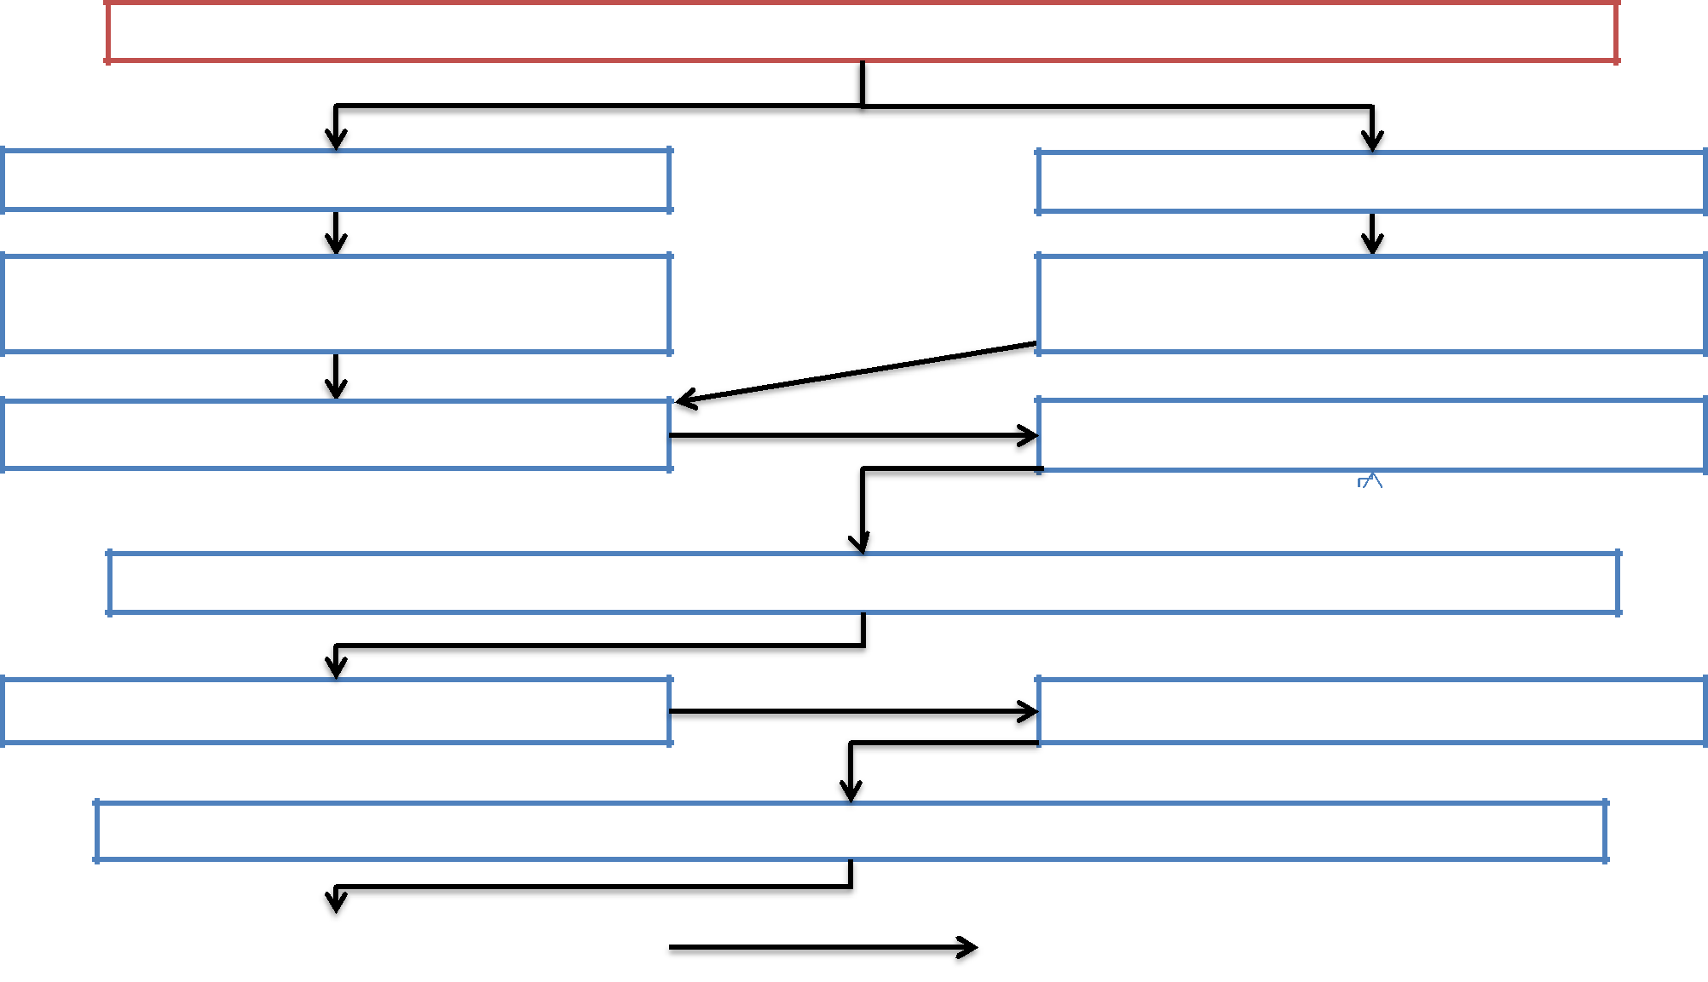

<55 years

- - Ramipril 2.5-10mg
Each time dose titrate check U+Es after 2 weeks

Re-check BP with HCA at 1/12 if BP
>140/90

*Consider ACEi (ramipril) as 1st line in all diabetics (any age)

>55 years or
Afro-caribbean any age

- – Felodipine 5-10mg
No need to check U+Es

Advice to book 20 mins HTN appointment
with Nurse

A + C

Advice to book 20 mins HTN appointment
Re-check BP at 1/12 if BP >140/90
with Nurse

A + C + D (D = Indapamide 2.5 mg)

Re-check BP at 1/12 if BP >140/90 |  | If remains >140/90 - Refer to GP

Titration and Follow up
(To be used in conjunction with the Hypertension Treatment Algorithm)

Titration of dose

- Ramipril –2.5mg, 5 mg, 7.25mg and 10 mg

- Felodipine start with 5mg, build to max dose of 10mg

- Indapamide – Use 2.5mg once daily dose

Followup

- Repeat BP 1/12 after changing medication

- U&E’s within 2 weeks of changes to Ramipril or Indapamide

Hypertension treatment algorithm
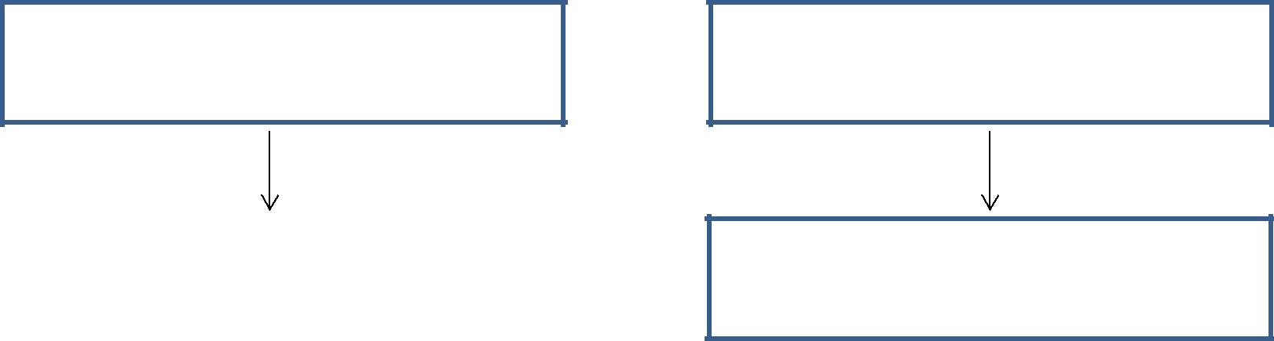

<55 years

- – Ramipril 2.5mg-10mg*

>55 years

or Afro-caribbean any age

- – Felodipine 5-10mg Ramipril 2.5mg
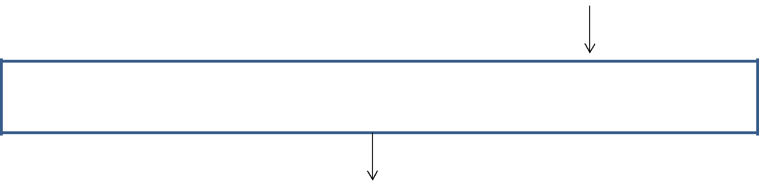

*Consider ACEi (ramipril) as 1st line in all diabetics (any age)

RamiprilA+C2.5mg

A + C + DRamipril(D=indapamide2.5g 2.5mg)

Refer to GP to consider secondary care referral or adding in Beta Ramipril 2.5mg
blocker, alpha blocker or spironolactone

Titration and Followup

Titration of dose

- Ramipril – 2.5mg, 5 mg, 7.5mg and 10 mg, needs repeat U&E’s within 2 weeks after each dose change

- Felodipine 5mg and 10mg

Followup
- Repeat BP 2 weeks after changing medication

- U&E’s within 2 weeks of changes to Ramipril or Indapamide

Yearly review

- Send patient letter for review and investigations prior to Nurse led clinic appointment

- Use Hypertension Review template on Emis

- Treat according to algorithm

Review letter
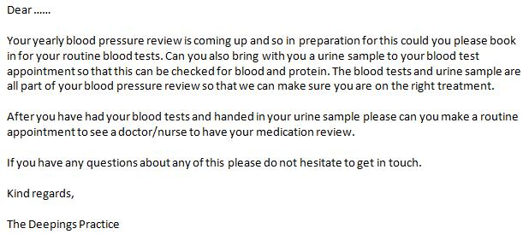

Hypertension treatment algorithm

<55 years

- – Ramipril 2.5mg-10mg*

>55 years

or Afro-caribbean any age

- – Felodipine 5-10mg Ramipril 2.5mg

*Consider ACEi (ramipril) as 1st line in all diabetics (any age)

RamiprilA+C2.5mg

A + C + DRamipril(D=indapamide2.5g 2.5mg)

Refer to GP to consider secondary care referral or adding in Beta Ramipril 2.5mg
blocker, alpha blocker or spironolactone

Results – Comparison pre and post

- Patients offered ambulatory blood pressure monitoring

Pre |  |  | Post
10% |  |  | 6%
 |  | Yes |  |  | Yes
90% |  | None | 94% |  | None
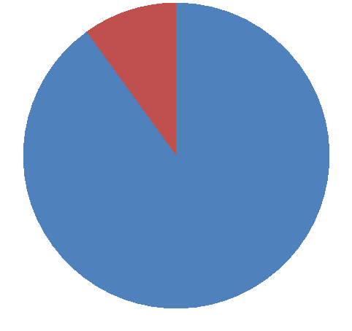
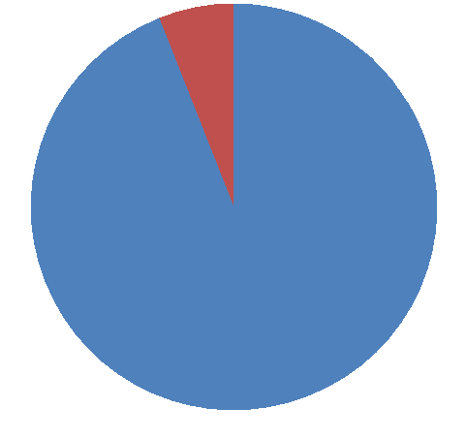

Measured urine albumin/creatinine
ratio

Pre Post
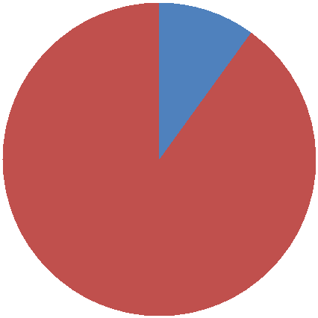
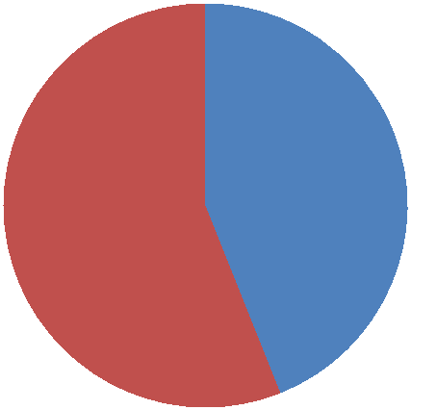

10%

Yes | 44% |  | Yes
None | 56% |  | None

90%

Urine dip done

Pre Post
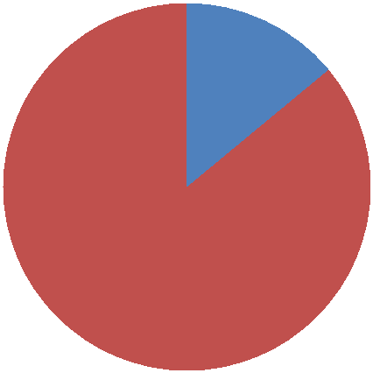
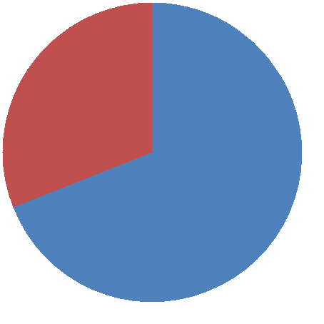

14%

 | 31%
Yes |  |  | Yes
None | 69% |  | None

86%

Fundoscopy documented, optician
review advice

Pre Post

0%
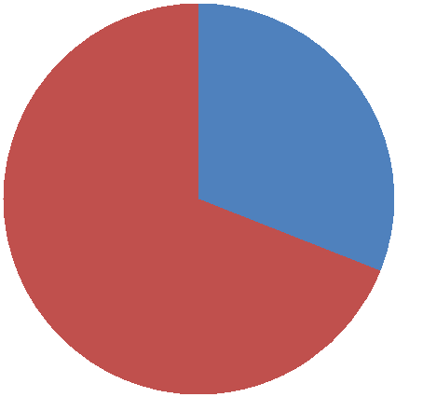

31%

Yes

None

69%

100%

Yes

None

ECG done

ECGs were done more appropriatley, and although it shows fewer ecgs after nurse clinic, most patients had prior ecgs for other reasons.

Pre Post

10%

25%

Yes

None

75%
90%

Yes

None

Qrisk calculated

Pre Post
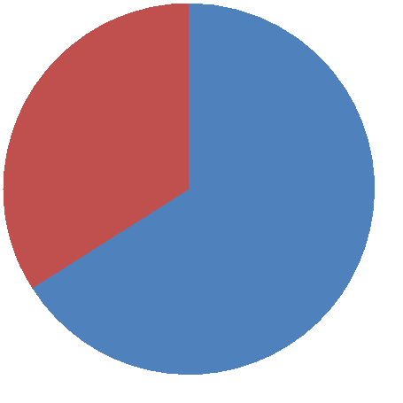

34% |  |  | 25%
 |  | Yes |  |  | Yes
66% |  | None |  |  | None
 |  |  | 75%

Blood tests

Pre Post

10%

 |  |  |  | 25%
19% |  |  | Yes |  |  |  | Yes
 |  |  | None |  |  |  | None
 |  |  | Partial | 13% | 63% |  | Partial
 | 71%

