Impact of Covid-19 on Carers

**Caring for Carers: *Can we be of help?***

*A Quality Improvement Audit at a GP Practice*

*(Newton Medical Centre)*

By

Dr Olukayode Adeeko

Dr Omon Imohi

Phillipa Caine - 5th year medical student

Maisy Lopez – 3rd year medical student

Samuel Roberts – 3rd year medical student

October 2020

**Contents:**

|  |  |
| --- | --- |
| **Section 1…………………………………………………………………………………** | **3-5** |
| Introduction………………………………………………………………………………. | 3 |
| Background………………………………………………………………………………. | 3 |
| **Section 2 …………………………………………………………………………………** | **5-8** |
| Aims & Objectives………………………………………………………………………. | 5 |
| Methods…………………………………………………………………………………... | 5 |
| **Section 3………………………………………………………………………………….** | **9-15** |
| Results……………………………………………………………………………………. | 9 |
| Discussion………………………………………………………………………………… | 13 |
| Conclusion ……………………………………………………………………………….. | 15 |
| **References………………………………………………………………………………...** | **16-18** |

**Section 1**

Introduction:

The most recent national census in 2011 revealed that there were 5.4 million carers in the United Kingdom of Great Britain (U.K)1. This number has increased throughout the decade and is now estimated to be around 8.8 million2, approximately 13% of the population. The National Health Service (NHS) and the Royal Collage of General Practitioners (RCGP) acknowledge therefore that a significant proportion of service users will have unpaid caring responsibilities3. A carer is defined by the NHS as anyone that looks after a family member or friend in need of help due to physical illness, psychological illness, or disability. Carers may be both adults and children and the recipients such care would not be able to otherwise cope without this support4. Clinicians have a duty to provide patient centred care in line with best evidence from contemporary scientific knowledge5. These principles must also be reflected in the looking after of carers who are registered with a General Practitioner (GP).

# NICE guideline [NG150] Supporting adult carers clearly state that..

‘This guideline covers support for adults (aged 18 and over) who provide unpaid care for anyone aged 16 or over with health or social care needs. It aims to improve the lives of carers by helping health and social care practitioners identify people who are caring for someone and give them the right information and support. It covers carers’ assessments, practical, emotional and social support and training, and support for carers providing end of life care.’

The recently discovered SARS-CoV-2 virus and resultant COVID-19 pandemic created many challenges for both the UK healthcare system and wider society. Social distancing, hand hygiene and the wearing of facemasks were introduced as a manner of mitigating the pressures on resources (Intensive Care Units and ventilators) while a safe and appropriate vaccination programme is developed6. In the primary care setting, there were additional changes to practice; in March 2020 GPs received specific guidance from NHS England that led to the replacement of many traditional ‘face to face’ consultations with telephone or video calls7. This decrease in footfall within practices has resulted in fewer interactions between GPs and carers who would normally attend appointments to support their dependents8. It is possible therefore that during this novel pandemic the changing needs of carers are being overlooked by clinicians, which could lead to detrimental outcomes within this highly valued cohort. This audit aims to assess the impacts of the pandemic on a cohort of carers registered with this practice and offer practical support.

Background:

The roles and responsibilities of the unpaid carer were traditionally overlooked by the wider health care system in the UK9. However, in May 2014 NHS England published an official framework that highlighted the lack of support and need for better recognition of carers. It stated that carers should be considered a hugely important asset to the NHS and therefore deserve respect and support from clinicians. This ‘Commitment to Carers’ documentation set out eight priorities to improve the experiences and lives of care givers. The fifth priority focused specifically on the primary care setting; supporting GPs to better identify carers and enhance the services available to them4. These recommendations echoed much of the information presented in the guidance released by the RCGP ‘Commissioning for Carers’ in 2013, a document that contained many examples of the challenges faced by those with lived experience of unpaid caring10. Although personal anecdotes can be perceived as overly emotive, in this documentation, they enhance the readers’ recognition of the need for additional support for carers.

A GP’s surgery is often the first point of contact for many carers and, as such, those working in these facilities play a vital role in supporting the provision of care and troubleshooting during a crisis10. There are many things that GPs usually facilitate to promote the well-being of carers, such as; annual influenza vaccination, health checks, signposting to support groups and organising respite time10.

GPs have developed many successful programmes to help carers, yet evidence shows that many carers still face difficulties in their daily lives and are unaware of much of the help available. Research has shown that many carers take an altruistic approach to their duties and, as such, may be reluctant to admit that they are facing difficulties or take time to prioritise their own physical and mental health needs9. As a result, clinicians are opportunistic in their approach to carers, consulting with them during consultations arranged for the recipient of care and arranging further appointments to discuss any seemingly ‘incidental’ findings. This could be criticised as a paternalistic approach; however, the actions of the GP are not deceitful and are supported by the honourable intention of ensuring the best care for both the patient and their carer.

The change in consultation style due to the COVID-19 pandemic has resulted in fewer patients, and therefore carers, attending practices for consultations7. As a result, there are fewer opportunities to meet carers in person which could result in the oversight of many concerns or problems. Furthermore, to mitigate risk in the early months of the pandemic, the government advised extremely vulnerable members of the population shield from the rest of society11. Many carers also had to isolate and would not have had the opportunity to attend face-to-face appointments for themselves. The most contemporary evidence suggests that isolation, loneliness and dramatic change has resulted in a stark rise in mental health problems12 and this could be affecting carers. GPs must therefore find novel methods to reach out to carers registered with their practice to ensure that they feel supported and safe.

**Section 2**

Aims & Objectives:

* To validate the register of carers in the practice - NICE guideline [NG150] 1.2.1-5
* To assess the needs (physical, psychological, emotional, financial etc) of the carers
* To assess the impact of Covid-19 on their role specifically
* To offer practical help where indicated and signpost them where appropriate

Methods:

This project aimed to contact all those registered as carers at the Newton Medical Centre in September and October 2020.

Data collection was carried out via telephone calls over a four-week period. An initial search of the EMIS database provided a list of individuals registered at the practice who identified as carers. This list was then searched to remove all individuals reported to no longer be caring for a dependent. Medical students attempted to telephone all 199 remaining individuals to gather data. A timeline was agreed by those involved in data collection and analysis to ensure that outcomes from the project are reached in a timely manner (See Figure 1).

Each carer received a telephone call to ascertain data regarding their current caring status and any concerns or issues they have faced due to the COVID-19 pandemic. The carers’ responses highlighted foci for quality improvement work that will lead to the implementation of changes at the practice in October 2020. Analysis of the results will ensure that each carer’s Egton Medical Information Systems (EMIS) record is up to date, while providing an opportunity for the sharing of concerns and suggestions for improvement to current practices.

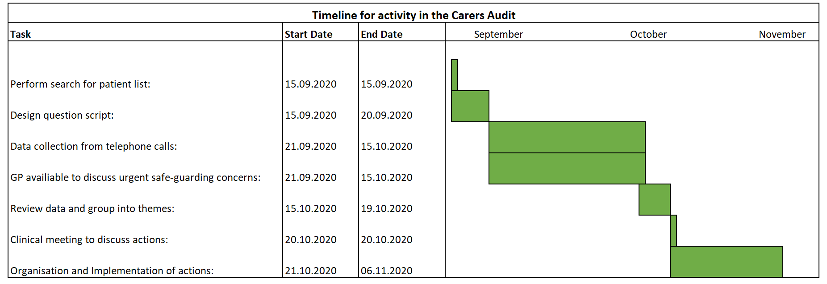

*Figure 1: A Gantt Chart demonstrating planned activity during the Carers Audit project.*

It is imperative that those invited to partake in medical questionnaires of any scale do so with consent that is both informed and voluntary13. All individuals contacted were provided with the rationale behind the project; the improvement of provisions for carers registered at the practice. They were informed of the voluntary nature of the survey and advised that responses would be shared with clinicians and other staff members following data collection. Verbal consent was obtained over the telephone and carers were reminded that they were under no obligation to answer all questions and could terminate the phone call at any point should they wish to do so.

To avoid bias and ensure repeatability the students used a predetermined script to provide a framework that took the form of a survey14, with a maximum of three questions (See Figure 2). The questions differed depending on the response to the first question “Are you currently a carer?”. Those who responded “Yes” were then asked, “Have there been any specific impacts on you, as a carer, from the COVID-19 pandemic?” and “Is there anything we could be doing as a practice to help you in your role as a carer at this time?”. Answers to the final two questions were summarised by the medical students and recorded in free text. Conversely, those that identified as “not currently caring” were asked “Would you mind sharing with us why that is?”. This response was recorded, and permission was sought to update their EMIS records with “No longer a carer”.

It was recognised that safeguarding concerns could be raised during the telephone calls, such as, an increased risk of suicide or self-harm that would need to be actioned in a timely and appropriate manner. One clinician volunteered to receive and review any immediate concerns from the data collection team. These patients would be contact separately if the clinician felt it to be necessary to provide additional support.

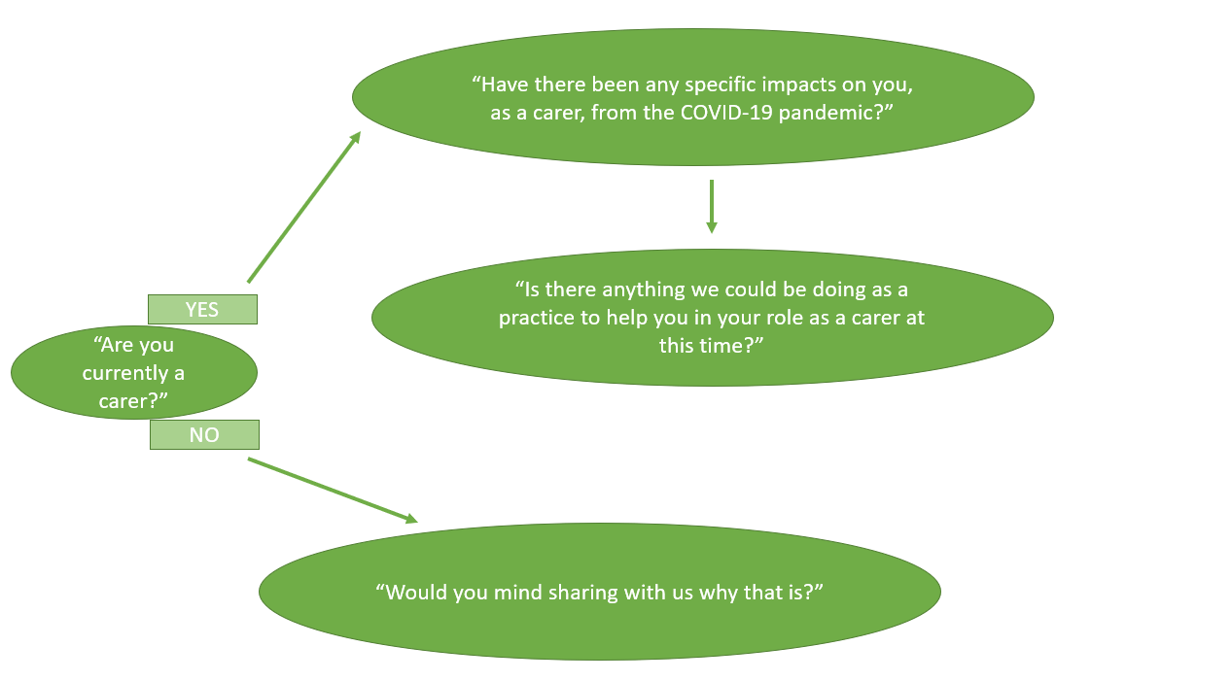

*Figure 2: A flowchart schematic of the questions asked to carers during the telephone calls*

**Section 3**

Results:

Of the 199 individuals called 139 patients answered the call and engaged with the survey. Of the 139 people called, 92 were currently carers and 47 no longer carers. Of those currently caring 54 described specific impacts of the COVID-19 pandemic and 30 carers had suggestions for the improvement of services at the practice.

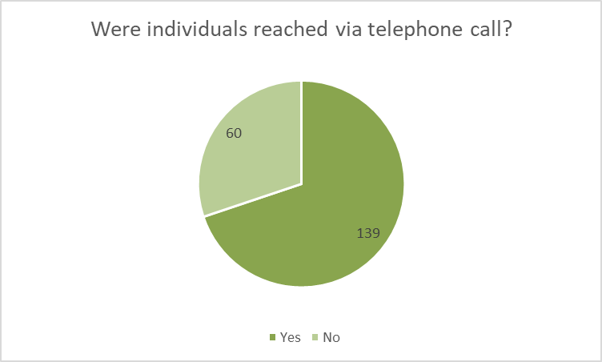

*Figure 3: A pie chart to show the number of individuals reached by telephone calls.*

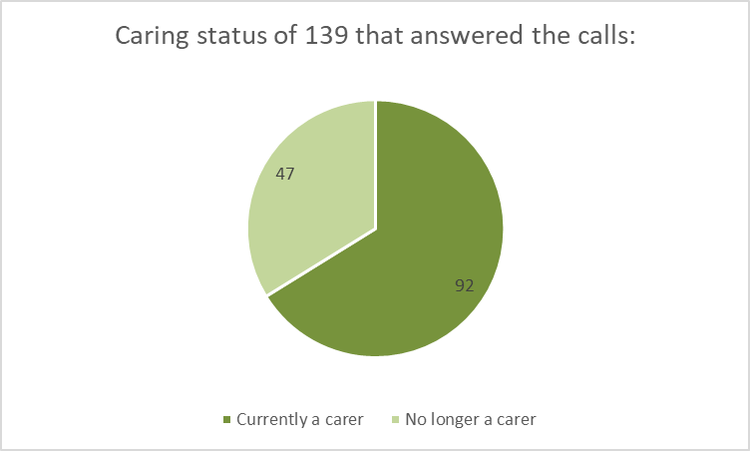

*Figure 4: A pie chart conveying the caring status of those who were reached by telephone*

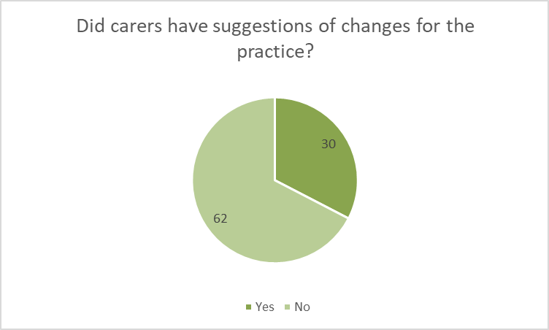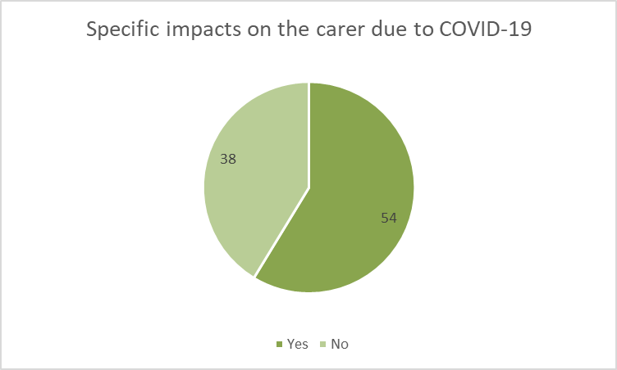*.*

*Figure 5: A pie chart highlighting the number of carers that experienced specific impacts of the COVID-19 pandemic.*

*Figure 6: A pie chart demonstrating the number of carers who had suggestions for improvement for the practice.*

Subjective data was themed before analysis, Figures 7 and 8 show both the themes and the number of carers who disclosed concerns relating to them. Some responses covered multiple themes, this accounts for the disparity between number of responders and number of responses.

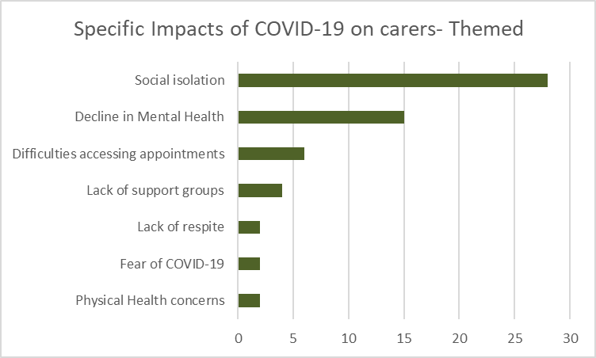*Figure 7: A bar chart to convey the themes highlighted by carers responses in investigating the specific impacts of COVID-19.*

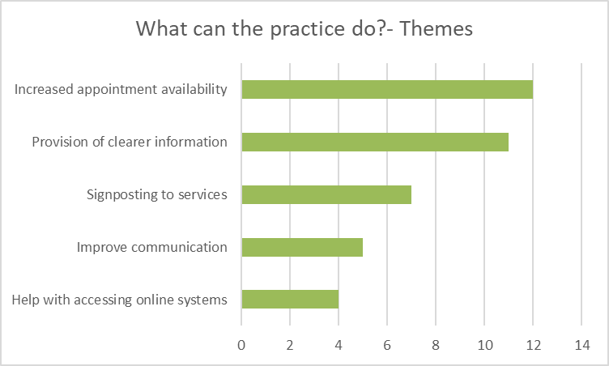

*Figure 8: A bar chart demonstrating the key themes in carers suggestions for improvements to current practice.*

Discussion:

Themes from the qualitative responses and concerns were discussed in a clinical meeting to establish actions that can be implemented as part of quality improvement within the practice. Quality improvement is integral to progressive practice and focuses on making small scale interventions to drive change in current systems and improve patient experience15. There are several straightforward actions that can be implemented on the grounds of results from this audit. General Medical Council guidance recommends that clinicians maintain accurate and up to date records16. The 47 individuals contacted that are no longer carers, will have their EMIS records updated accordingly. Although updating individual records can be time consuming17, in this instance it will prevent repetitive and potentially distressing conversations about the deaths of dependents, thus, improving the holistic approach towards the care of patients registered with the practice.

Logistical issues raised such as the need for increased access to appointments and better communication from the practice will be fed into a practice manager’s meeting to facilitate expert interventions that align to national guidance. Many carers reported difficulty using the online systems to make appointments and request prescriptions. Evidence has demonstrated that tutorial videos using screen capture technology, accompanied by voice over, can be an effective way of helping those who would not describe themselves as computer literate18. A plan has been implemented to support the creation of short, concise, tutorials that can be accessed either via the practice website or be sent directly by staff members via text message or email to those requiring additional support.

In late September 2020 there was a widespread misconception that GPs were interacting and caring for fewer patients as a result of the pandemic19. This is incorrect. Practices have merely altered consultation methods where appropriate and in line with contemporary guidance7. The 139 reached by telephone were reminded that they can still seek support and advice should they require it.

The 60 who were not reached by telephone during the data collection phase will receive correspondence from the practice. This will outline the reasons for the call which they missed and explain the aims of the audit. They will also be invited to share their feedback and ask for any additional support should it be required. In the interest in striving towards sustainable communication systems, this will be sent via email to all those who have expressed a willingness to be contacted in this manner. The practice recognises that 8% of the UK population still lack a basic computer literacy skills18. Therefore, paper copies will be delivered to those who have not registered an email address or mobile phone number with the practice.

Correspondence will also be sent to thank those who took part in the survey and highlight positive changes being made by the practice. This is likely to take the form of a hyperlink that will direct carers to an area on the practice’s website that is dedicated to their specific needs, such as; information regarding the annual influenza vaccination scheme and support groups that have continued to help carers during the pandemic. Carers UK is an example of such a support group. This charity is dedicated to giving expert advice and information to care givers20. They are also passionate about connecting individuals to create a network of carers to support one another and share experiences20. The latter may provide comfort for those carers who disclosed struggles relating the social isolation brought about by the pandemic.

Research undertaken by the World Health Organisation outlines a link between COVID-19 and an increase in those experiencing mental health problems12. Conservative measures introduced to help stop the spread of the virus may contribute to risk factors for both anxiety and depression21. For example, shielding results in feelings of isolation and job losses may precipitate feelings of hopelessness. Many carers in the survey described a decline in their mental health during the year, and so it is imperative that they recognise the provision of support available in the primary care setting.

Two carers that disclosed mental health struggles required additional assessment by the nominated GP. Further contact was made with both carers; one restarted antidepressant medication and the other was invited in for a face to face appointment for safeguarding and establishing a management plan. Both carers were at a high risk of suicide because they shared intent to harm themselves and the means they would use to end their lives22. The short conversations initiated by this audit enabled recognition of vulnerable individuals and may even have prevented untimely death. Worryingly these individuals with suicidal ideations accounted for 1% of the carers registered with the practice. It is possible that nationally, there are other carers experiencing similar mental health crises that remain undetected.

Conclusion:

This straightforward audit has allowed a practice to identify the specific impacts of the COVID-19 pandemic on carers. Changes have now be implemented to ensure that needs are met, and carers experience the support they deserve. This shared learning could enable other practices on a national scale to carry out similar projects. This would ensure that GPs are championing carers and recognising the vital role they play within society.

**References:**

1. White C. *2011 Census Analysis: Unpaid care in England and Wales, 2011 and comparison with 2001*.The Office for National Statistics. 2013. Available from: <https://webarchive.nationalarchives.gov.uk/20160109213406/http://www.ons.gov.uk/ons/dcp171766_300039.pdf> [Accessed 05.10.2020].
2. Carers UK. *Juggling work and unpaid care: A growing issue.* London. 2019. Available from: <http://www.carersuk.org/images/News_and_campaigns/Juggling_work_and_unpaid_care_report_final_0119_WEB.pdf> [Accessed 07.10.2020]
3. Medical directorate and Nursing directorate. *NHS England’s Commitment to carers.* NHS England. Leeds. 2014. Available from: <https://www.england.nhs.uk/wp-content/uploads/2014/05/commitment-to-carers-may14.pdf> [Accessed 10.10.2020].
4. Medical directorate and Nursing directorate. *Commissioning for Carers: Principles and resources to support effective commissioning for adult and young carers.* NHS England. Leeds. 2014. Available from: <https://www.england.nhs.uk/commissioning/wp-content/uploads/sites/12/2014/12/comm-carers-princ-091214.pdf> [Accessed 10.10.2020].
5. The General Medical Council. *The duties of a doctor registered with the General Medical Council.* Good Medical Practice. 2013. Available from: <https://www.gmc-uk.org/ethical-guidance/ethical-guidance-for-doctors/good-medical-practice> [Accessed 07.10.2020].
6. Public Health England: *COVID-19: guidance for households with possible coronavirus infection.* March 2020. Available from: <https://www.gov.uk/government/publications/covid-19-stay-at-home-guidance> [Accessed 10.10.2020].
7. Thornton J. Covid-19: how coronavirus will change the face of general practice forever. *British Medical Journal.* 2020. Available from: <https://doi.org/10.1136/bmj.m1279>
8. Royal College of General Practitioners. *Carers Support*. Available from: https://www.rcgp.org.uk/clinical-and-research/resources/a-to-z-clinical-resources/carers-support.aspx [Accessed 10.10.2020].
9. Larkin M and Milne A. Carers and empowerment in the UK: a critical reflection*.* *Social Policy and Society*, 13(1) pp. 25–38. 2014. Available from: https://doi.org/10.1017/S1474746413000262
10. Royal College of General Practitioners*. Commissioning for Carers*. 2013. Available from: <https://www.rcgp.org.uk/clinical-and-research/resources/a-to-z-clinical-resources/~/media/6C9C69A8CF64490594E464F6E611CC42.ashx> [Accessed 15.10.2020].
11. Department of Health & Social Care and Public Health England. *Guidance on shielding and protecting people who are clinically extremely vulnerable from COVID-19.* October 2020. Available from: <https://www.gov.uk/government/publications/guidance-on-shielding-and-protecting-extremely-vulnerable-persons-from-covid-19/guidance-on-shielding-and-protecting-extremely-vulnerable-persons-from-covid-19> [Accessed 15.10.2020].
12. The Lancet Infectious Disease. The intersection of COVID-19 and mental health. *The Lancet Infectious Disease*. 20 (11) pp. 1217. 2020. Available from: <https://doi.org/10.1016/S1473-3099(20)30797-0>
13. The Medical Research Council and NHS Health Research Authority. *Consent and Participant Information Guidance*. 2020. Available from: http://www.hra-decisiontools.org.uk/consent/docs/Consent%20and%20PIS%20Guidance.pdf [Accessed 15.10.2020].
14. Chirk J. Designing a Questionnaire. *Malaysian Family Physician : the Official Journal of the Academy of Family Physicians of Malaysia.* 1(1) pp32-35. 2006. Available from: <https://www.ncbi.nlm.nih.gov/pmc/articles/PMC4797036/pdf/MFP-01-32.pdf> [Accessed 17.10.2020].
15. The King’s Fund*. Making the case for quality improvement: lessons for NHS boards and leaders.* The King’s Fund. 2017. Available from: <https://www.kingsfund.org.uk/publications/making-case-quality-improvement> [Accessed on 19.10.2020].
16. General Medical Council. *Protecting Children and young people: Keeping Records*. 2012. Available from: <https://www.gmc-uk.org/-/media/documents/protecting-children-and-young-people---english-20200114_pdf-48978248.pdf?la=en&hash=662E8DA032529B8CCAF1B927AB09A60D00231877> [Accessed 19.10.2020].
17. Roth CP, Lim YW, Pevnick JM, Asch SM and McGlynn EA. The Challenge of Measuring Quality of Care from the Electronic Health Record. American Journal of Medical Quality. 24 (5) pp 385-394. 2009. Available from: <https://doi.org/10.1177%2F1062860609336627>
18. Serafino P. *Exploring the UK’s digital divide: The scale of digital exclusion in the UK; those who aren’t currently using the internet, how digital skills vary for different groups of the population and some of the barriers to digital inclusion.* The Office for National Statistics. 2019. Available from: <https://www.ons.gov.uk/peoplepopulationandcommunity/householdcharacteristics/homeinternetandsocialmediausage/articles/exploringtheuksdigitaldivide/2019-03-04> [Accessed 20.10.2020].
19. Royal College of General Practitioners. *‘Insult’ to GPs to imply they haven’t been doing their job properly during pandemic, says RCGP*. 2020. Available from: <https://www.rcgp.org.uk/about-us/news/2020/september/insult-to-gps-to-imply-they-havent-been-doing-their-job-properly-during-pandemic.aspx> [Accessed 20.10.2020].
20. Carers UK. What we do: Carers UK makes life better for carers. Available from: <https://www.carersuk.org/about-us/what-we-do> [Accessed 21.10.2020].
21. Hyland P, Shevlin M, McBride O, Murphy J, Karatzias T et al. Anxiety and depression in the Republic of Ireland during the COVID‐19 pandemic. *Acta Psychiatrica Scandinavica.* 142(3) pp.249-256. 2020. Available from: <https://doi.org/10.1111/acps.13219>
22. National Institute for Health and Care Excellence. *NICE guideline: Preventing suicide in community and criminal justice settings scope.* 2018. Available from: <https://www.nice.org.uk/guidance/ng105/documents/final-scope> [Accessed 20.10.2020].