1. First draft Care Bundle (April 2015)
2. Final CIWA-M (October 2018)
3. Final guideline summary (Oct2018)
4. Process Map (April 2015)
5. Action Effect Diagram (April 2016)
6. Alcohol related diagnoses (March 2017)
7. Findings: doses given vs use of bundle
8. Findings: duration of detox
9. Summary of project recommendations
10. Findings: run charts of diagnosis and length of stay (December 2018)

Alcohol withdrawal management on acute admission to hospital   
(and 24 hours later)  
Supporting information  
Adrian Brown  
ade.brown@nhs.net



First Draft Care Bundle

**

Final version of CIWA-M



Final guideline summary

Process map (April 2015)

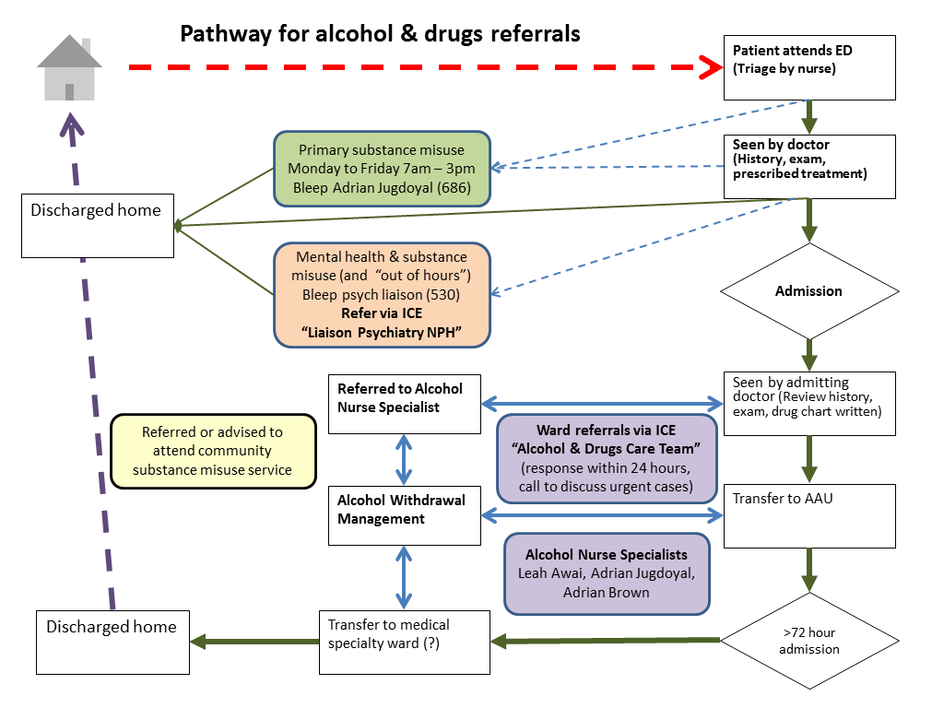

Action Effect Diagram (April 2016)

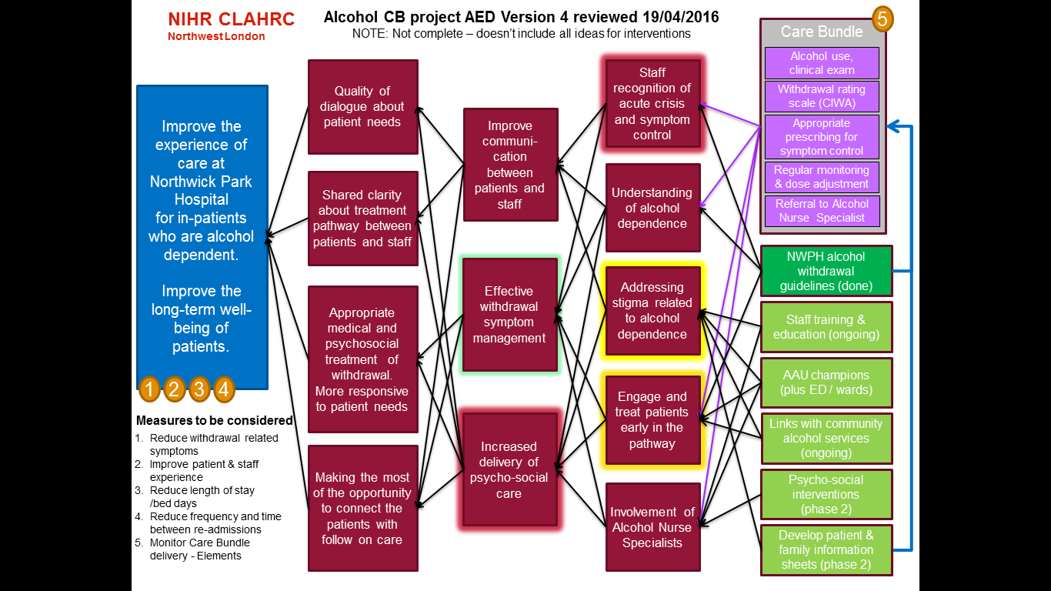

Alcohol related diagnoses (March 2017)

**From poster presented to CLAHRC Learning Event**

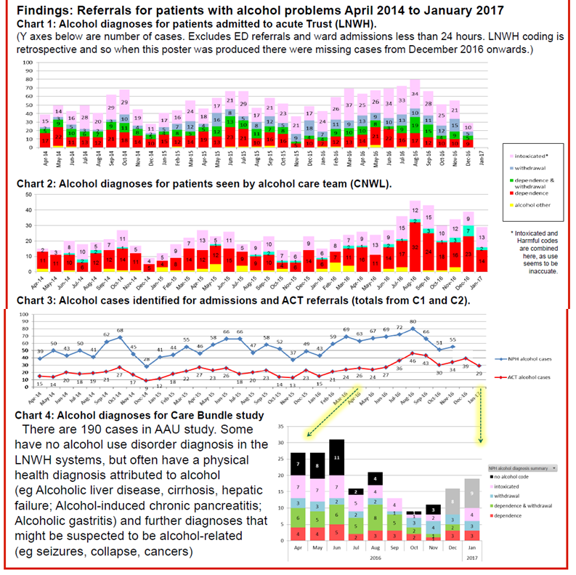

Findings: use of bundle

**Full Data Set 352 cases referred to Alcohol Care Team**  
**Notes missing -18** (not found or on loan, no evidence in scans)

**Exclusions -127** (reasons for exclusion agreed before project)

ED ONLY 46

Not AAU 60

Not detox 19

Died 2

**“Soft launch” cases -109**  (cases in data set, but before study care bundle finalised)

**STUDY SAMPLE 98 /352**

From these 98 cases

* + - 53 had Audit-C score clearly documented  
      (or sufficient info about frequency and amount of alcohol)
    - 45 Care Bundle followed,
    - 37 Care Bundle not followed, 16 CIWA not in notes
    - 11 had no CIWA, 11 not started in first 24 hours
    - 9 had no regular Chlordiazepoxide  
      7 had no PRN Chlordiazepoxide  
      1 had neither, but was prescribed Diazepam
    - 78 were prescribed correct doses of Pabrinex  
      14 had incorrect regimen or stopped too soon  
      6 had no Pabrinex prescribed
    - 65 received oral Thiamine afterwards  
      14 received oral Thiamine with Pabrinex (>one day)  
      18 received no oral Thiamine

Findings: duration of detox

* + - Average length of stay
      * If care bundle followed 7 days
      * If care bundle NOT followed 9 days
    - Average duration of detox
      * If care bundle followed 5 days 51% complete by Day 6
      * If care bundle NOT followed 6 days 39% complete by Day 6
    - Average doses Chlordiazepoxide
      * If care bundle followed 134 mg to 106mg by Day 3
      * If care bundle NOT followed 116 mg to 115mg by Day 3

Final project recommendations:

* STANDARD PROCESS for individualised care
* USE OF AUDIT-C ?
* We need better detection of who to monitor with CIWA
* Will be part of national CQUIN for ALL admissions
* USE OF CIWA
* CIWA triggered starting dose can mean earlier completion of detox
* Can also allow for earlier recognition of untreated withdrawals
* Standard Chlordiazepoxide regimen plus CIWA triggered PRN
  + Avoids “missed doses”
  + Avoids confusion about what to prescribe
  + Standard Pabrinex & Thiamine regimen
  + Confusional states can be treated sooner
  + Should not be written up to end on Day 3, should be reviewed on Day 3

Findings: run charts of diagnosis alcohol dependence (December 2018 not fully complete, so ignore)

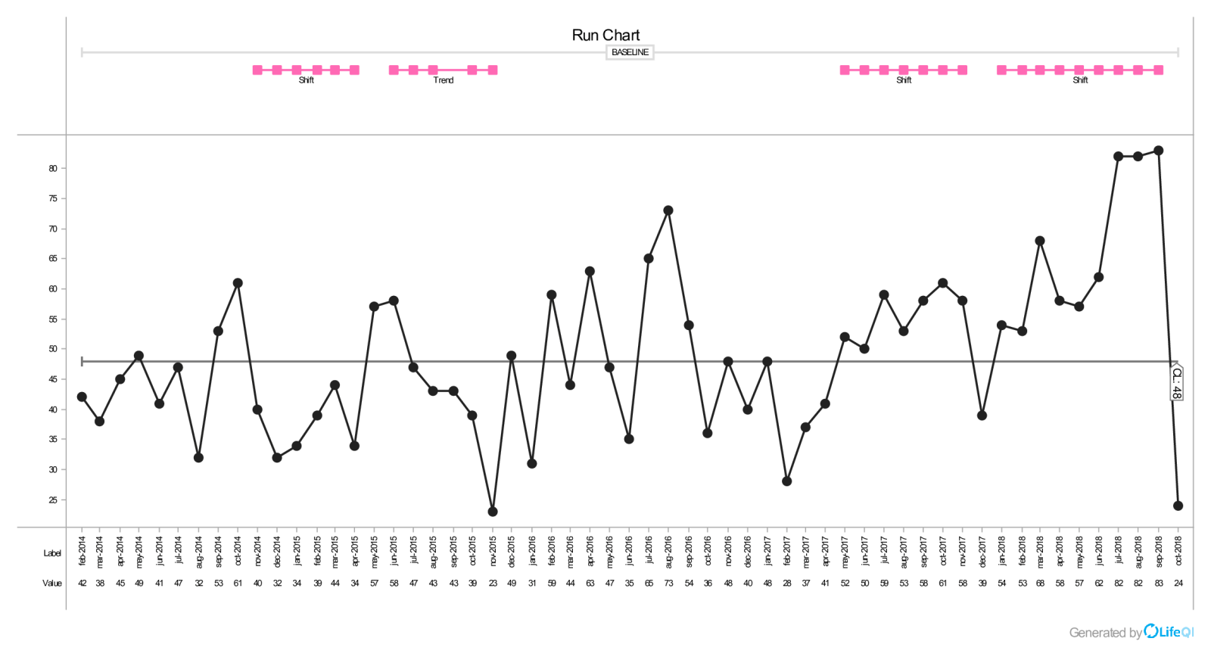

Y= number patients

Findings: run charts of monthly mean length of stay for these patients

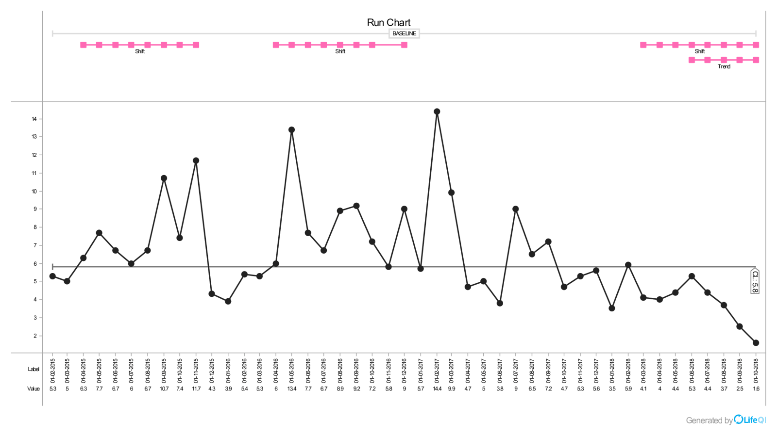

Y= days