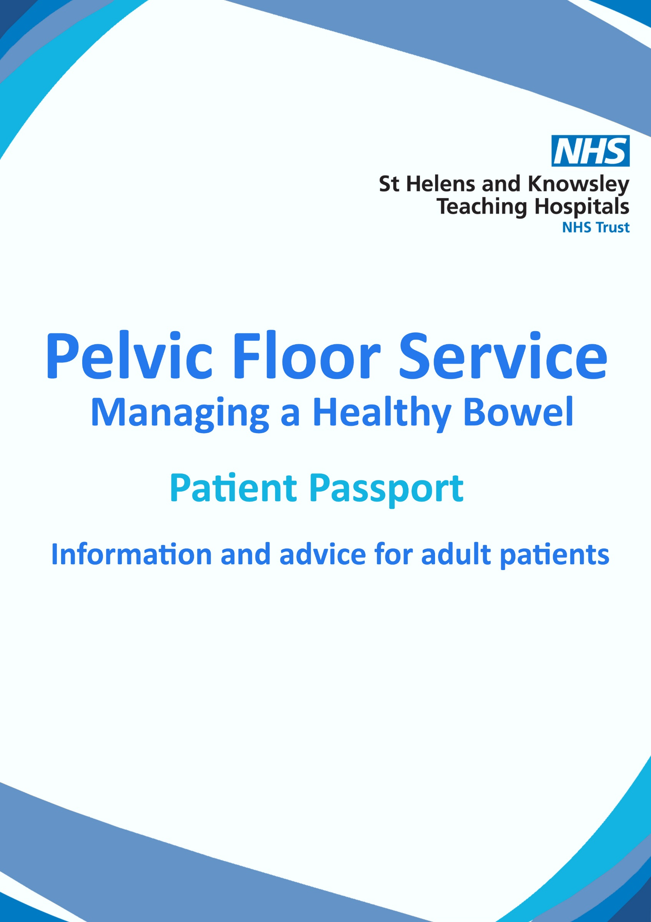

1 Small intestine
2 Large intestine
2a Caecum
2b Ascending colon
2c Transverse colon
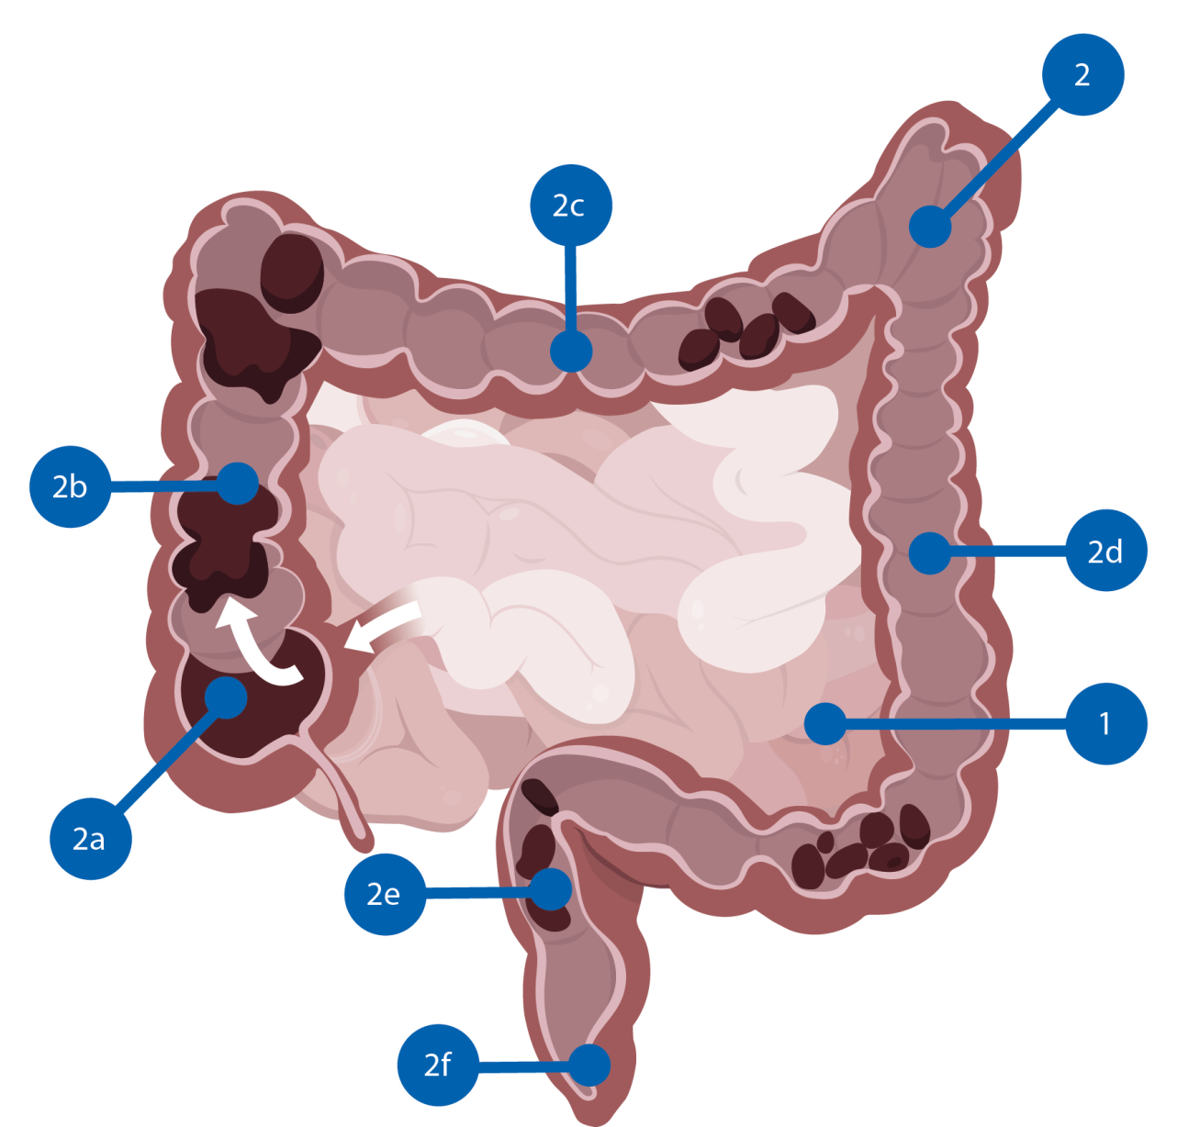
2d Descending colon
2e Rectum
2f Anal canal

This section presents a short introduction to how your digestive tract works. After food has been digested in the stomach, it passes into the small intestine (ileum), the main function is to absorb nutrition. The digested food moves into the colon.
The digestive tract
The colon absorbs salts and water and converts the remains into faeces. The transit time through the colon is about 1 to 3 days. Faeces is stored in the rectum, until a signal to the brain is given to defecate, and the faeces then exits through the anal canal.
What happens when it doesn’t work?

The digestive tract is controlled by the nervous system that goes through the spinal cord to the brain. If the neural pathways are interrupted, due to a central neurological disease or damage to the spinal cord or brain, the bowel may not work properly. As these nerves also control the bladder, many people with neurogenic bowel dysfunction also suffer from bladder problems.

Faecal incontinence is another common problem for people with neurogenic bowel dysfunction. The condition is characterised by involuntary release of faeces. You can become incontinent from constipation, where watery stool passes an impacted mass of hard stool, causing leakage. It is not uncommon to suffer from both of these disorders simultaneously.
Conditions or injuries that put people at high risk of neurogenic bowel dysfunction are spinal cord injuries, multiple sclerosis, Parkinson’s disease, spina bifida and diabetes type 1, but there are many other causes as well.
Faecal incontinence
Constipation
Constipation is very common if you have neurogenic bowel dysfunction. Constipation is characterized by infrequent and irregular bowel movements, resulting in hard, dry stools, which are difficult to pass. Constipation can cause the bowel to stretch and the muscles to weaken over time, or cause nerve damage leading to faecal incontinence.
Neurogenic bowel dysfunction can lead to constipation, faecal incontinence and/or defecation problems. Many of those affected spend a considerable amount of time trying to manage this problem.

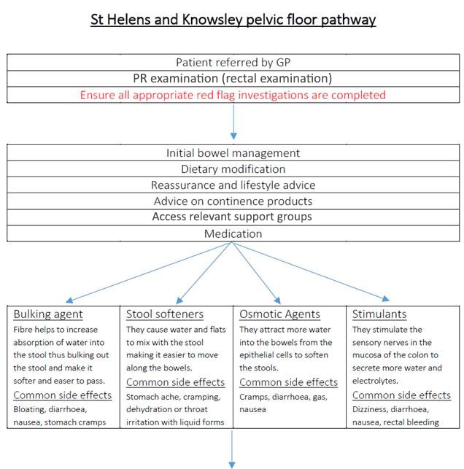
Nurse or therapist led training
If no improvement after three months may be considered for specialist management – Pelvic Floor Colorectal Triage
Bowel retraining/ Dietary Manipulation
Pelvic floor muscle training
MDT Recommendations
Posterior Tibial Nerve Stimulation (PTNS)
Transanal Irrigation
Biofeedback
Surgery e.g. VMR / Sphinkeeper / Botox

Patient details please use address ograph were possible
Patient name
……………………………………………………………………………………………………………
Date of birth
……………………………………………………………………………………………………………
Hospital number
…………………………………………………………………………………………………………..
Address
………………………………………………………………………………………………………….
………………………………………………………………………………………………………….
GP surgery
………………………………………………………………………………………………………..
Presenting complaint
History of presenting complaint

Laxatives
Please circle
Stimulant Senna Picolax Bisacodyl
Bulk forming Fybogel
Osmotic laxatives Lactulose Movicol Laxido
Enemas Micralax Phosphate Arachis oil
Constipating agents Codeine phosphate Loperamide

Other Medication
Prescribed
Over the counter etc.

Alcohol Yes No

Units per week ………………………………………………………………………………….

Smoking Yes NO

Weight …………………………………………………………………………………………….
Incontinence (please circle most appropriate)
Passive – You leak faeces liquid/solid without noticing
Urge – You pass faeces due to an inability to hold or the urge to open bowels
Post-defecation seepage – you leak moisture after opening your bowels, often straining and visiting the toilet several times without much result
1
Have you ever discussed your bowel problems with anybody?
A/ Family B/ GP
C/ Specialist D/ Other health professionals
2
Ladies please answer
A/ How many children have you given birth to?
B/ How many vaginal deliveries have you had?
C/ Were forceps or instruments used?
D/ Did you tear or have an episiotomy?
E/ What was the weight of your largest child?
F/ Have you had a hysterectomy? Please select abdominal vaginal
3
Have you ever had surgery on your bowel or anus? Please select
A/ Removal and re-joining of part of your bowel
B/ An anal fistula
C/ Operation on anal muscle
D/ Operation on haemorrhoids or skin tags
E/ Prostate operation or radiation
F/ Pelvic radiation
4
Have you ever had anal injuries? (Trauma, accidental or abuse)
A/ Yes B/ No
5
Do you ever experience loss of control of your bladder (When coughing sneezing laughing or physical activity)
A/ Yes B/ No
6
Do you get urgency to pass urine
A/ Yes B/ No
7
Do you have any of the following medical problems:
A/ Crohns/ colitis B/ Irritable bowel C/ Diabetes
D/ Stroke E/ Neurological condition F/ Reduced mobility

The Neurogenic Bowel Dysfunction score – NBD Score

1. How often do you defaecate?
Daily (score 0)
2-6 times per week (score 1)
Less than once per week (score 6)

2. How much time do you spend on each defaecation?
Less than 30 min. (score 0)
31-60 min. (score 3)
More than an hour (score 7)

3. Do you experience uneasiness, sweating or headaches during or after defaecation?
Yes (score 2)
No (score 0)

4. Do you take medication (tablets) to treat constipation?
Yes (score 2)
No (score 0)

5. Do you take medication (drops or liquid) to treat constipation?
Yes (score 2)
No (score 0)

6. How often do you use digital evacuation?
Less than once per week (score 0)
Once or more per week (score 6)

7. How often do you have involuntary defaecation?
Daily (score 13)
1-6 times a week (score 7)
3-4 times a month (score 6)
A few times a year or less (score 0)

8. Do you take medication to treat faecal incontinence?
Yes (score 4)
No (score 0)

9. Do you experience uncontrollable flatus?
Yes (score 2)
No (score 0)

10. Do you have peri-anal skin problems?
Yes (score 3)
No (score 0)

Total score (between 0 and 47)
TOTAL SCORE
Date:

General satisfaction
Please mark the scale with a cross (x) to represent your general satisfaction with your bowel management.
(Total dissatisfaction = 0 / Perfect satisfaction = 10) 0 1 2 3 4 5 6 7 8 9 10

Severity of bowel dysfunction
Score 0-6: Very minor / Score 7-9: Minor / Score 10-13: Moderate /Score 14+: Severe

11 – Do you go to the toilet more than once per day? Yes / No

Red flag symptoms Yes No
Details ……………………………………………………………………………………………………
…………………………………………………………………………………………………………………
………………………………………………………………………………………………………………..
Investigations Yes No
Flexible sigmoidoscopy
Colonoscopy
CT Colonoscopy
U/S Abdo
Proctogram
Endo anal u/s
Transit Studies
Comments ……………………………………………………………………………………………………………………………………………………………………………………………………………………………………………………………………………………………………………………………………………………………………………………………………………………………………………………………………………………………………………………………………………………………………………………………………………………………………………………………………………………………………………………………………………………………………………………………………………………………………………………………………………………………………………………………………………………………………………………………………………………

Examination

Findings ………………………………………………………………………………………………………………………
………………………………………………………………………………………………………………………..
Anal Tone
Skin Tags
Piles
Internal Pile Prolapse/Mucosa
..............................................................................................................................................................................................................................................................
Rectocele
Perineal Scar
Perineal Decent
…………………………………………………………………………………………………………………………………………………………………………………………………………………………………………………..
Recto Rectal intussusception
..............................................................................................................................................................................................................................................................

Anorectal Physiology Yes No
Readings ……………………………………………………………………………………………………………………………………………………………………………………………………………………

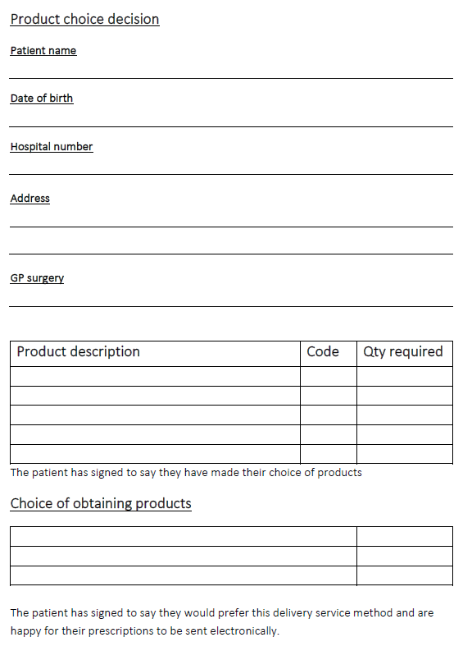
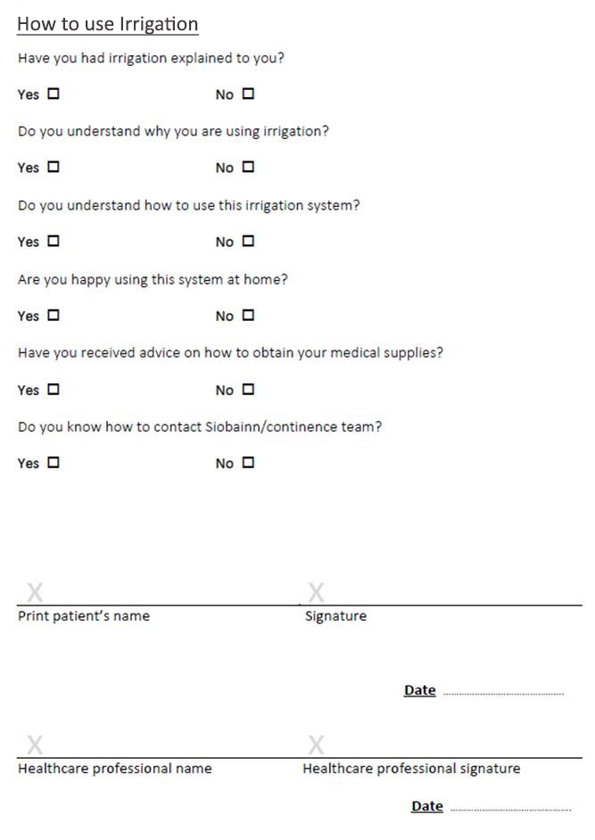
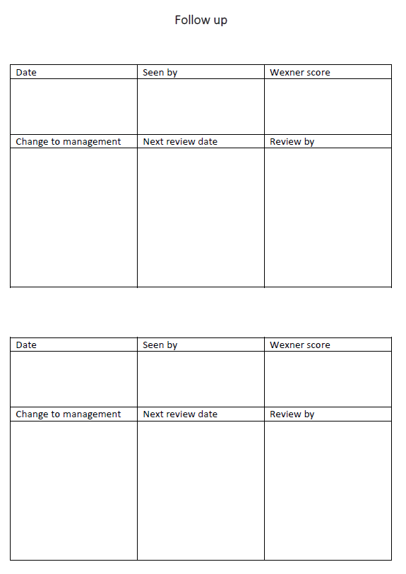

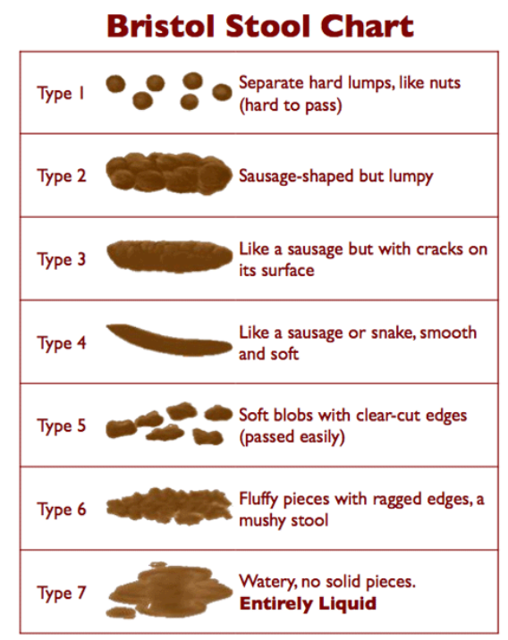

Bowel Dysfunction Score Tracker:
In the below table, please record your monthly bowel dysfunction score.
Use the same questions completed previously in the passport.
Please record the number of your score in the relevant box.
MONTH
NBD Score
14+
10-13
7-9
0-6
 | 1 | 2 | 3 | 4 | 5 | 6 | 7 | 8 | 9 | 10 | 11 | 12

Notes

Whiston Hospital St Helens Hospital
Warrington Road Marshalls Cross Road
Prescot St Helens
Merseyside Merseyside
L35 5DR WA9 3DA
0151 426 1600 01744 26633

This bowel passport was printed with support from Wellspect HealthCare.

