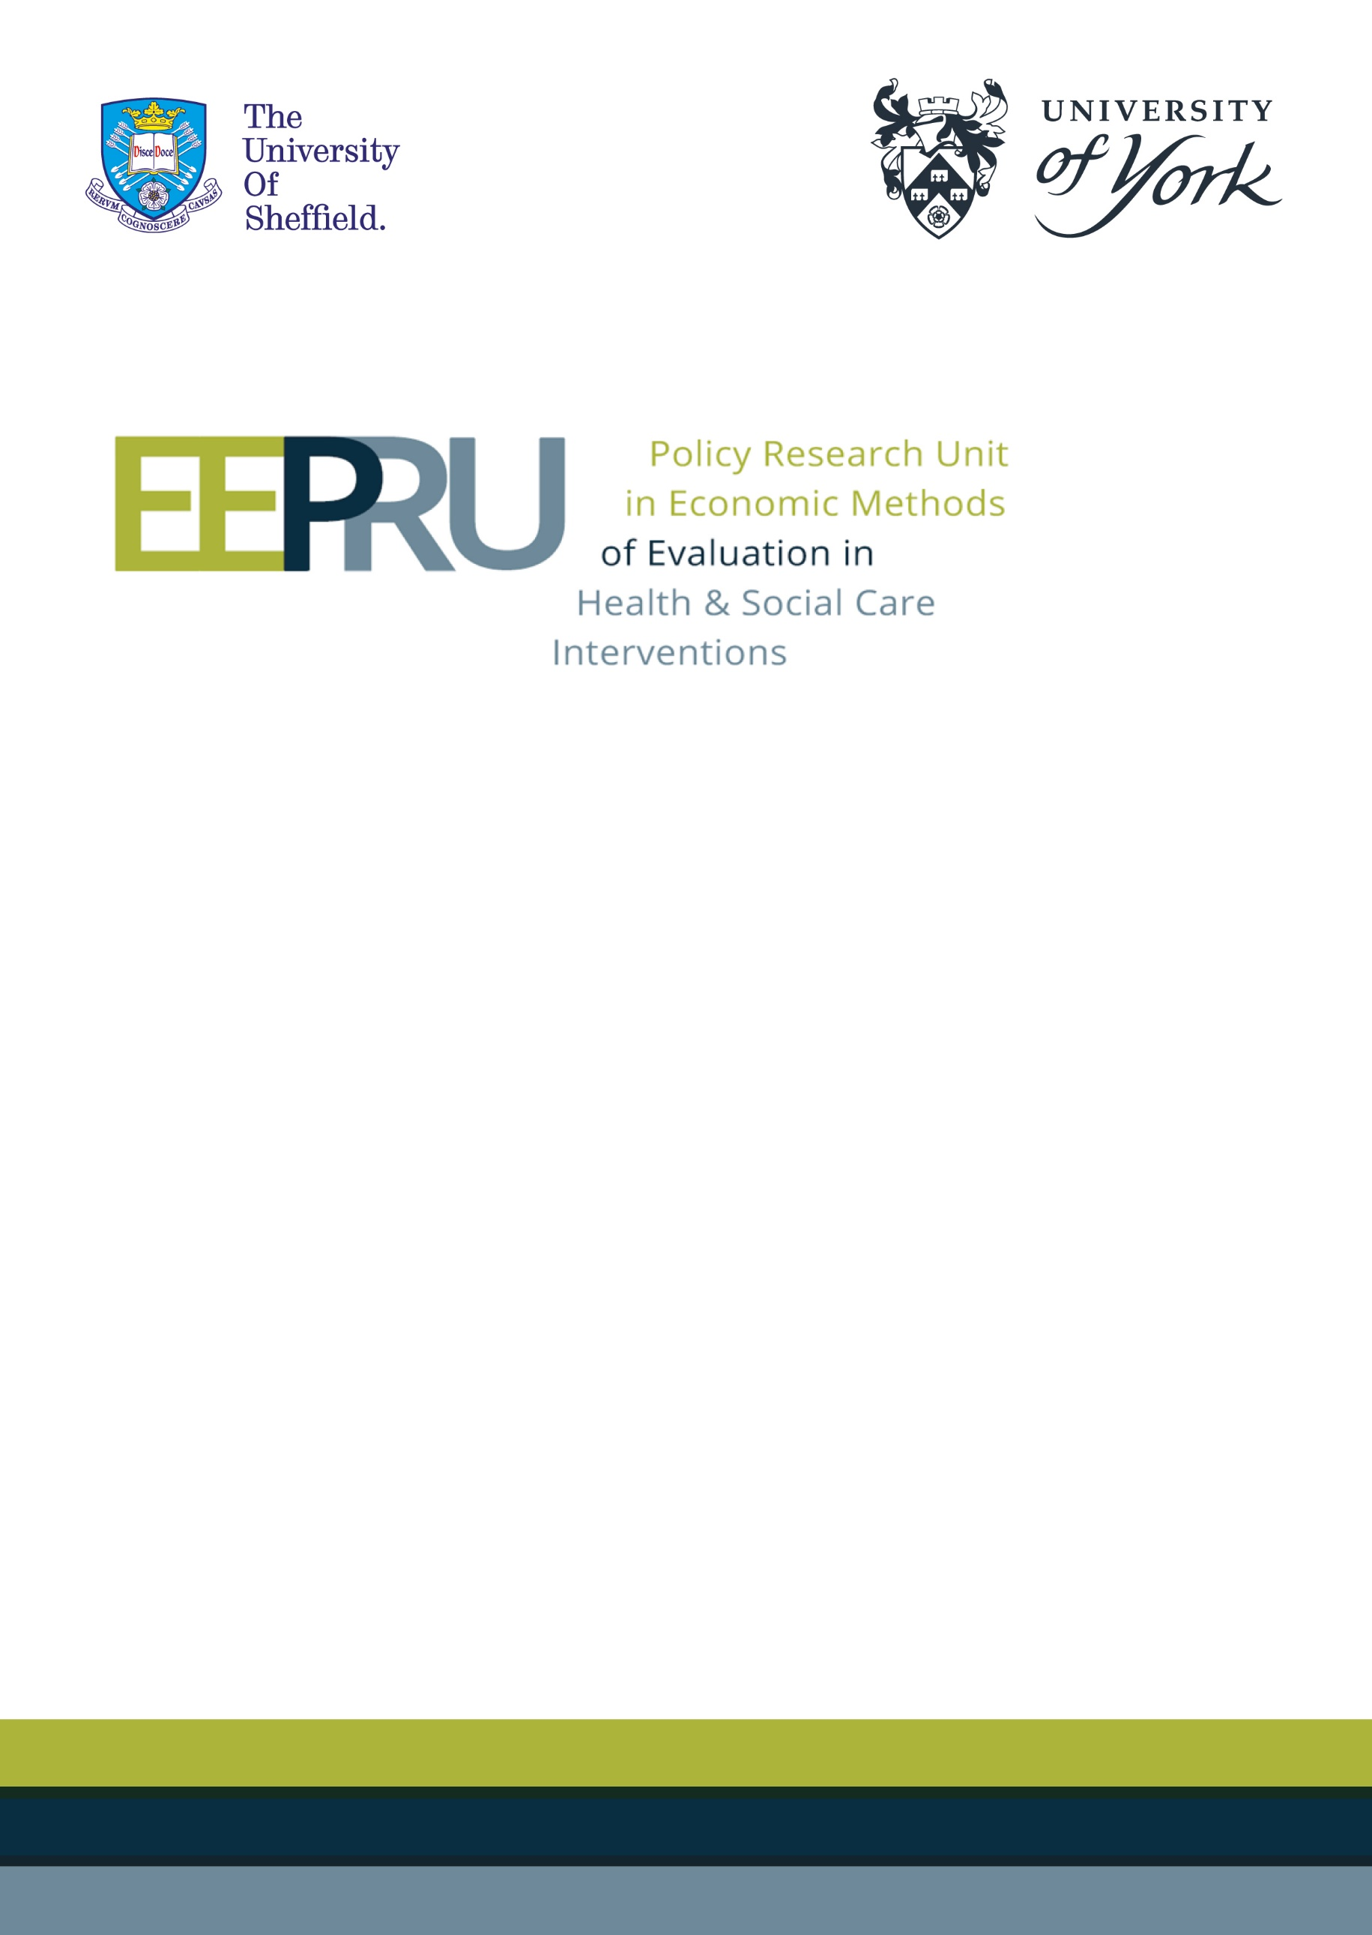

Final report for the technology evaluation of ceftazidime with avibactam for treating severe aerobic Gram-negative bacterial infections
October 2021
Sue Harnan², Ben Kearns², Alison Scope², Laetitia Schmitt¹, Dina Jankovic¹, Jean Hamilton², Ruth Wong², Tushar Srivastava², Harry Hill, Chu Chang Ku ², Kate Ren², Claire Rothery¹, Laura Bojke¹, Mark Sculpher¹, Beth Woods¹
¹ Centre for Health Economics, University of York, UK
² Health Economics and Decision Science, School of Health and Related Research, University of Sheffield, UK
This document uses different formatting to the original report supplied by EEPRU to NICE. The content is identical, but this version has been altered to improve the digital accessibility.


Funding
This research is funded by the National Institute for Health Research (NIHR) Policy Research Programme, conducted through the Policy Research Unit in Economic Methods of Evaluation in Health and Social Care Interventions, PR-PRU-1217-20401.

Acknowledgements
The views expressed are those of the author(s) and not necessarily those of the NHS, the National Institute for Health Research, the Department of Health and Social Care or its arm's length bodies, or other UK government departments. We are grateful for the support of our clinical advisors: Professors David Jenkins, William Hope, Philip Howard, Colm Leonard, Mark Wilcox; and Drs Alan Ashwoth and Andrew Bentley. Also, thanks for modelling advice to Professor Mark Jit and Dr Gwen Knight; and for comments on drafts we thank Professor Allan Wailoo, Dr James Fotheringham, Professor Simon Dixon, Rita Neves De Faria and Professor Stephen Palmer. Finally, we are grateful for support from Sarah Gerver and Rebecca Guy at UK Health Security Agency (formerly Public Health England). Finally, we thank Kath Devlin, Ruth Helstrip, Liz Mclintock, Steph Richards and Alex Rollinger for their support in developing this report. Any errors are the responsibility of the authors.

Executive summary

Background
The National Institute for Health and Care Excellence (NICE), National Health Service England (NHSE) and NHS Improvement are currently undertaking a project to assess the feasibility of innovative models that pay for antimicrobials (AMs) based on an evaluation of their value to the NHS as opposed to the volumes used. Following the selection of two products considered to be of high public health importance, this project involves evaluation of the selected products to inform commercial discussions regarding contract value for a period of up to 10 years. The selection process was a formal procurement exercise and aimed to identify one new AM and one existing but “nearly new” AM. The products selected by this process are, respectively, Cefiderocol (Fetcroja) which is manufactured by Shionogi; and ceftazidime with avibactam (Zavicefta), which is manufactured by Pfizer.
This report details the evaluation phase of this project for ceftazidime with avibactam (CAZ-AVI). CAZ-AVI received a marketing authorisation in June 2016 for treatment in adults and paediatric patients (>3 months) for complicated intra-abdominal infections (cIAI), complicated UTI (cUTI), hospital-acquired pneumonia, including ventilator-associated pneumonia (HAP/VAP), bacteraemia (adults only) associated with the aforementioned infections and treatment of infections caused by aerobic gram-negative organisms with limited treatment options.

Aim and objectives
The aim of this evaluation is to assess the value of CAZ-AVI to the NHS in England, for the treatment of severe aerobic Gram-negative bacterial infections when used within its licensed indications.
Specific objectives are:
- To identify two high value clinical scenarios (HVCSs), within its broad licensed indications, for which CAZ-AVI is expected to have a significant impact on patients’ outcomes in terms of reducing mortality risks and improving health-related quality of life.
- To undertake an ‘evidence mapping’ exercise and relevant systematic literature reviews to characterise the available clinical effectiveness evidence for the use of CAZ-AVI in the HVCSs.
- To establish an appropriate decision-analytic model to quantify the costs and health benefits of the use of CAZ-AVI under various usage scenarios compared with alternative treatments and management strategies (usage scenarios of other available AMs) in the HVCSs. The decision-analytic model was required to estimate costs and health effects at both the individual level and also at the aggregate population level, providing population incremental net health effects (INHEs).
- Drawing on the systematic reviews and evidence synthesis, national-level data on health-care associated infections, and other sources as needed, identify evidence to populate the decision-analytic models.
- To use structured expert elicitation as necessary to supplement the available evidence to populate the decision-analytic models at the levels of both the individual patients and populations.
- To use available evidence and where necessary expert opinion to quantitatively extrapolate estimated population INHEs associated with CAZ-AVI in the HVCSs to other expected uses for the product beyond the HVCSs and within the product’s licensed indications.

Expected usage and high-value clinical scenarios
The licensed indication for CAZ-AVI is broad. In practice, to control the spread of resistance to CAZ-AVI and to preserve its long-term viability as an effective treatment option against highly resistant pathogens, CAZ-AVI may be used in a more restricted group of patients than permitted by its license. Quantifying the health and cost implications of using CAZ-AVI across anticipated NHS usage, even within this restricted population, remains challenging, as use is expected in infections which differ in causative organism (pathogen, resistance mechanism), site of the infection, health care setting and other underlying features of the health status of the patient.
Using available evidence, this evaluation characterises the value of CAZ-AVI across its range of expected uses via a two-step approach. First, decision modelling is used to assess quantitatively the value of CAZ-AVI in a set of scenarios defined by features of the pathogen, site of infection, healthcare setting and other patient characteristics, considered to represent important uses of CAZ-AVI; referred to as the ‘high value clinical scenarios’ (HVCSs). Secondly, rescaling is used to estimate how this evidence can be used to provide quantitative assessments of value in the overall population expected to receive CAZ-AVI including patients who fall outside the HVCSs but whom are relevant to determining the overall value of CAZ-AVI to the English NHS.
The HVCS were selected to reflect areas of clinical use where there is a current significant burden from resistant infections, and CAZ-AVI is expected to offer significant improvements over existing treatments in terms of efficacy and/or safety. The HVCSs were selected based on feedback from the manufacturer, clinical advisors to the Policy Research Unit in Economic Methods of Evaluation in Health and Social Care Interventions (EEPRU) and broader stakeholders involved in the NICE scoping process. The HVCSs focus on the following patient populations:
- Empiric setting: patients with an infection strongly suspected to be caused by oxacillinase-48 (OXA-48) Enterobacterales in patients with hospital acquired pneumonia or ventilator associated pneumonia (HAP/VAP). In this patient group the pathogen, resistance mechanism and antibiotic susceptibility have not yet been established but treatment is initiated immediately due to the severity of the infection.
- Microbiology-directed setting: patients with an infection confirmed to be caused by OXA-48 Enterobacterales, where antibiotic susceptibility testing results are available, and where the site of infection is HAP/VAP or cUTI.
The resourcing for this project was equivalent to that of a diagnostic assessment review or multiple technology assessment for NICE, but the levels of analysis extend from the typical focus of those evaluations on a single type of patient for one indication and setting. In this evaluation, we also include health effects now and over time, and across several indications and settings. The objective is to use appropriate analyses of the available evidence at every level, but the detail in those analyses is inevitably constrained by the time and resources available for the project.

Clinical evidence

Methods
There are evidential challenges when evaluating the use of new or nearly new AMs to treat infections caused by multi-drug resistant pathogens. Randomised controlled trials (RCTs) are of generally low relevance as they tend not to recruit patients with multi-drug resistant pathogens. Therefore, relative treatment effects between the intervention and comparator cannot be generalised to multi-drug resistant pathogens, as this may overestimate the efficacy of the comparator.
Since it was anticipated that RCTs were unlikely to be the primary source of evidence, three approaches to estimating comparative efficacy between the intervention and comparators were considered. In approaches 1 and 2, RCTs and observational studies (Reviews 1 & 2, respectively), with data for patients with HAP/VAP or cUTI infections caused by OXA-48 Enterobacterales were considered. These could be used to construct a network meta-analysis (NMA) to compare the intervention and comparators. In Approach 3, in vitro susceptibility studies were considered. These studies provide evidence on the proportion of OXA-48 Enterobacterales isolates that are susceptible to treatments and comparators as an indication of relative efficacy (Review 3). This approach would require additional evidence to link susceptibility to clinical outcomes in cUTI and HAP/VAP (Reviews 4 & 5, respectively).
Susceptibility studies test isolates in vitro to ascertain the minimum concentration of any given treatment that is needed to inhibit growth of the microbe (the minimum inhibitory concentration (MIC)). If this is below the clinical breakpoint published by the European Committee on Antimicrobial Susceptibility Testing (EUCAST) (or by the Clinical Laboratory Standards Institute (CLSI) from the US), the isolate is considered susceptible, and likely to respond to treatment in vivo. In the UK, the British Society of Antimicrobial Chemotherapy recommends use of EUCAST guidelines.
A mapping review was conducted to identify relevant sources of evidence across the three reviews and ascertain which approach could inform an economic model. Systematic searches across relevant databases (Medline, Embase and Centre for Review and Dissemination (CRD) database) were conducted in March 2021. EEPRU also considered evidence submitted by Pfizer in their company submission, and made data requests to Pfizer, Shionogi (who were participating in the parallel evaluation of cefiderocol) and Public Health England (PHE). Records retrieved by the search were assessed for eligibility for inclusion in the mapping review by one reviewer, against pre-specified inclusion criteria. RCT and observational studies were eligible for mapping if they recruited patients with cUTI or HAP/VAP infections caused by OXA-48 Enterobacterales (microbiology-directed setting) or suspected carbapenem-resistant Enterobacterales (empiric setting), and compared CAZ-AVI to any comparator (RCTs) or any comparator or no comparator (observational studies). Susceptibility studies were eligible for mapping if they reported susceptibility for OXA-48 Enterobacterales isolates from any infection (clinical advisors indicated that infection site was not associated with susceptibility profile) to CAZ-AVI and at least one comparator as defined by the HVCSs (colistin, meropenem, tigecycline, aztreonam, fosfomycin, levofloxacin, ciprofloxacin, gentamicin, amikacin, tobramycin, ceftriaxone, cefepime, ceftazidime).
After mapping, only Review 3 was pursued, since there was insufficient evidence from Reviews 1 & 2 (see details in Results below). Susceptibility studies were further selected for inclusion based on susceptibility data format (proportion susceptible), avoidance of double counting and consideration of sources of heterogeneity, in consultation with clinical advisors. Risk of bias assessment was performed using a bespoke tool developed for this evaluation.
A NMA of susceptibility studies was conducted to allow a comprehensive synthesis of evidence on all relevant treatments. The NMAs were performed using a Bayesian Markov chain Monte Carlo (MCMC) approach assuming a random effects model to allow for heterogeneity in treatment effects across studies. Subgroup and sensitivity analyses were planned to investigate the impact of clinical sources of heterogeneity including: inclusion criteria (use of resistance to a comparator to select study sample); co-carriage of MBLs; the proportion who were carbapenem sensitive; whether the sample was recruited consecutively; and what laboratory methods and breakpoints were used to assess susceptibility.
Two additional reviews were conducted to provide evidence on the link between susceptibility and clinical outcomes (Review 4) and between susceptibility and long term outcomes (Review 5) in the sites of interest. Review 4 was widened to include any infections reporting outcomes for patients susceptible and non-susceptible to treatment regardless of the pathogen or resistance mechanism, since no evidence relating to OXA-48 Enterobacterales was identified by Reviews 1 and 2. Review 5 was widened to include any resistant infection since no evidence relating to long term outcomes were found by Reviews 1, 2 or 4. A further review (Review 6) was conducted to identify any important safety implications of CAZ-AVI.

Results
Approaches 1 and 2 (RCT and observational studies respectively) were not pursued since insufficient evidence from RCTs and observational studies was identified during the mapping review. The key limitation of the RCTs was that they included small numbers of OXA-48 Enterobacterales infections (n=3 in each of two RCTs; n=0 in two RCTs) and did not report these data as a subgroup analysis. The key limitation of the observational data was that they were not reported separately for the sites of interest (cUTI and HAP/VAP), the studies were small and highly heterogeneous with respect to prognostic factors, and individual patient data (IPD) data was not available within the timeframe of this evaluation.
In Approach 3 (susceptibility studies), 28 data sources met the initial inclusion criteria. One of these sources of evidence was obtained from PHE and included isolates submitted voluntarily to the Antimicrobial Resistance and Healthcare Associated Infections (AMHRAI) reference laboratory. This data set had high relevance, but some limitations: isolates were only for invasive infections and had not historically been routinely submitted by testing centres which may limit how representative these data are of the true distribution of OXA-48 susceptibilities in England; there was also variation in the testing methodologies used by local laboratories, which may affect estimates of comparative efficacy; isolates not tested for all comparators were excluded from the analysis, which may introduce selection bias; and the PHE data did not report sufficient data to inform susceptibility to fosfomycin, levofloxacin or ceftriaxone. Due to these limitations, EEPRU considered it relevant to include a broader set of evidence synthesised using network meta-analysis.
Sixteen studies and data sources met the further selection criteria (listed in the methods section), and were synthesised. Studies included relatively large samples of OXA-48 Enterobacterales isolates (n=11 to302, plus one academic-in-confidence study with n=319 isolates) obtained from a range of clinical sites of infection. Susceptibility (unlike clinical outcomes) was expected by clinical advisors to generalise across sites. After consistency checks (which resulted in two study arms being removed), and otherwise using the full analysis set (all 16 available studies), CAZ-AVI was associated with a statistically significantly higher susceptibility relative to colistin (odds ratio (OR) 7.24, 95% credible interval (CrI): 2.58 to 20.94). The remainder of the treatments were associated with lower susceptibility than colistin (OR <1). Heterogeneity was extremely high (standard deviation (SD) 1.56, 95% CrI: 1.28 to 1.93). A sensitivity analysis including only studies where no isolates co-carried both MBL and OXA-48 resistance mechanisms (n=6 studies) decreased heterogeneity (SD 1.38, 95% CrI: 0.95 to 2.06). It also produced a very high OR for CAZ-AVI versus colistin, but with a large amount of uncertainty (OR 35.83, 95% Cr: 7.91 to 165.60). Another sensitivity analysis, including only studies that used EUCAST laboratory methods and breakpoints (n=3 studies), reduced the heterogeneity further to SD 0.98 (95% CrI 0.62 to 1.65). CAZ-AVI was associated with a higher susceptibility relative to colistin (OR 2.15 95% CrI: 0.60, 8.01), however the magnitude of the point estimate was lower than that using the full analysis set (OR 7.24, 95% CrI: 2.58 to 20.94) and the result is not statistically significant.
Networks used in the economic evaluation: The EUCAST network was selected as the base case analysis to inform the economic evaluation since heterogeneity was lower and there was a clinical rationale to support restricting to studies that had used EUCAST laboratory methods and breakpoints as these are more commonly used in England. A scenario analysis was planned to include the result from the full analysis set. A further scenario was planned restricting to studies with no-MBLs and that had used EUCAST laboratory methods and breakpoints, which left one study (Vazquez-Ucha et al.).¹ This study did not report an estimate for tigecycline, but was the study with the lowest risk of bias as judged by the bespoke risk of bias tool developed for this evaluation. A further scenario analysis was planned using the PHE data alone, due to its high relevance to the evaluation.

Review 4 (link between susceptibility and clinical outcomes) identified two studies that reported mortality or hospital length of stay conditional on susceptibility to empiric treatment and were selected for use in the model for the empiric setting. No useful evidence relating to the microbiology-directed setting was identified. Review 5 (link between susceptibility and long-term clinical outcomes) did not identify any relevant literature, but an unpublished study (CARBAR) was submitted by Shionogi during the parallel appraisal of CAZ-AVI that contained useful data. Review 6 indicated that CAZ-AVI does not appear to increase the risk of acute kidney injury (AKI), C.difficile, or any other serious adverse events (SAE), compared to non-toxic comparators (i.e. comparators that were not colistin or an aminoglycoside). No study reported a comparison of CAZ-AVI exclusively to colistin or aminoglycosides. Event rates were generally very low or zero.
Discussion of clinical evidence: There were some limitations to the approach selected and analyses done. Key limitations include: susceptibility could be considered, at best, a surrogate outcome, but no pre-specified criteria for judging the suitability of the surrogate or the linking evidence were applied; linking data were limited and not specific to the pathogen-mechanism combination, and expert elicitation had to be relied upon to evidence the link in the microbiology-directed setting; breakpoints are set by experts in a subjective process and may not predict clinical response equally in all treatments; it was not clear which breakpoints and laboratory methods contributed to the PHE data; the network meta-analyses results were associated with high levels of heterogeneity.

Economic evidence

Methods
No published existing economic evaluations that assessed the use of CAZ-AVI in the HVCSs or areas of expected usage were identified by a systematic review conducted by EEPRU. The manufacturer submitted a cost-effectiveness model comparing treatment with CAZ-AVI to treatment with existing antimicrobials in a range of infection sites (cUTI, cIAI and HAP/VAP). The model used dynamic transmission modelling to reflect the implications of the introduction of CAZ-AVI for infection transmission and emergence of resistance to CAZ-AVI and comparators. This model estimated that introduction of CAZ-AVI was associated with an expected INHE benefit of approximately 20,000 Quality-Adjusted Life Years (QALYs) over a 10-year time horizon, based on a cost-effectiveness threshold of £30,000 per QALY. The model considers that a much broader population of patients would receive CAZ-AVI than considered appropriate by clinical advisors to EEPRU. The model makes several strong assumptions relating to the impact of CAZ-AVI on transmission (namely, that treatment can eradicate patients of colonisation) which were not thought to be credible to the clinical advisors to EEPRU. In the model, CAZ-AVI is associated with similar efficacy to comparator AMs and Pfizer has not provided an account of the processes driving the large health benefits estimated in the model.
We developed a de novo decision analytic model to predict the cost and health consequences (summarised as population level INHEs) of introducing CAZ-AVI within the HVCSs. The costs and health consequences of introducing CAZ-AVI are summarised as INHEs. These are estimates of the QALYs associated with introducing CAZ-AVI if it was supplied free of charge to the NHS, taking into account both its health benefits and the health benefits of freeing up NHS resources (e.g. via reduced time in hospital). The health benefits of freeing up NHS resources are calculated using an estimate of health opportunity cost to convert between cost savings and health benefits. In the base case analysis this estimate is £20,000/QALY. This means that for every £20,000 saved 1 QALY of health can be generated within the NHS. The estimates of population INHE will be used in subsequent negotiations to determine an appropriate payment level for CAZ-AVI.
This quantitative analysis comprises three components: an assessment of the INHEs of introducing CAZ-AVI within the HVCSs at the patient level; an assessment of INHEs within the HVCSs at the population level; and an assessment of how population INHEs within the HVCSs might appropriately be rescaled to reflect expected usage across the English NHS. A schematic describing the modelling approach and key evidence sources is provided as Figure 1.

Figure 1: Schematic of modelling approach and key sources of evidence

The patient-level component is structured similarly to decision models developed as part of other NICE processes and characterises the cost, mortality and morbidity consequences of introducing CAZ-AVI over a patient’s lifetime. Separate but related models are developed for the empiric and microbiology-directed settings. In the empiric setting, empiric treatment with CAZ-AVI is compared to: empiric treatment with a non-colistin/aminoglycoside-based treatment; empiric treatment with colistin/aminoglycoside-based treatment (considered more toxic); and to use of existing treatments in the empiric setting with CAZ-AVI restricted to use in the microbiology-directed setting. In the microbiology-directed setting we compare outcomes in the overall microbiology-directed cohort who receive tailored therapy with CAZ-AVI available as a treatment option, to outcomes in the overall microbiology-directed cohort who receive tailored therapy with existing AMs only.
In the empiric setting patients are suspected to have an infection caused by OXA-48 Enterobacterales, so it is necessary to model outcomes for both patients in whom this suspicion is confirmed and for those in whom this suspicion turns out to be incorrect. The probability of having the suspected pathogen/resistance mechanism is informed by Second Generation Surveillance System (SGSS) national surveillance data supplied by PHE for this evaluation. The key driver of effectiveness is in vitro susceptibility as estimated via the evidence syntheses discussed above. Higher susceptibility reduces mortality and length of stay in hospital. These relationships are based on a combination of evidence from the literature and structured expert elicitation. Colistin or aminoglycoside-based therapy is expected to be associated with higher rates of AKI than other agents (including CAZ-AVI), which has significant consequences for patients’ short and long-term mortality, morbidity and costs. Safety differences between colistin or aminoglycoside-based therapy and other agents are, therefore, modelled using evidence from published systematic reviews. At 30 days patients were classified as dead or alive with those alive sub-classified according to their history of AKI. These outcomes were then used to predict patients’ lifetime costs, quality of life and mortality accounting for the highly comorbid nature of the patient population with AM-resistant infections and the increased risk of chronic kidney disease resulting from AKI.
The population-level component uses a forecast-based approach to aggregate the patient-level predictions to the population level accounting for the size of, and growth over time in, the eligible patient population in England within each HVCS. This component also reflects how resistance is likely to develop to CAZ-AVI and existing AMs over time. Current numbers of patients within the HVCSs were based on evidence from SGSS. Future growth in the number of patients in the HVCSs was based on statistical forecasting models fitted to time series data from the national reference laboratory dataset held by the AMRHAI and supplied by PHE for this evaluation. A series of scenarios reflect the potential emergence of resistance to CAZ-AVI with resistance emergence at 20 years of 1%, 5%, 10% and 30%. These scenarios were informed by international data on the emergence of resistance to existing AMs. Predictions of population INHE are presented for patients initiated on treatment with CAZ-AVI over the next 20 years. This time horizon was chosen pragmatically to explore the long-term value of CAZ-AVI whilst avoiding additional uncertainties associated with very long-term population-level predictions. We did not model changes in resistance to existing AMs over time due to the sparsity of evidence available to inform these forecasts.
Predicted overall population INHEs corresponding to the expected use of CAZ-AVI in the English NHS were generated by rescaling the population INHEs from the HVCSs to reflect additional areas of expected usage. These areas of expected usage were selected based on feedback from the manufacturer, clinical advisors to EEPRU and broader stakeholders involved in the NICE scoping process. These included patients with known or suspected OXA-48 Enterobacterales with bloodstream and intra-abdominal infections. This rescaling was based on population size estimates from SGSS and the use of expert opinion to inform the similarity in per patient INHEs between the patients falling within the HVCSs and these additional sites of interest.
The literature on the economic evaluation of AMs has described a range of elements of value associated with these products that are not relevant to evaluations of other health care interventions. We also, therefore, summarise the extent to which these elements of value are captured within the quantitative estimates and, where this has not been possible, whether they are likely to substantively modify the quantitative estimates of value presented.

Results
Table 1 summarises the patient level INHEs for CAZ-AVI in the HVCS. The benefits of CAZ-AVI are driven by similar susceptibility but improved safety compared to colistin/aminoglycoside-based treatments, and, in the empiric setting, by higher susceptibility than non-colistin/aminoglycoside-based treatment. The two most significant sources of uncertainty relate to the empiric setting and are (1) the preferred source of susceptibility evidence, (2) the proportion of patients in the empiric setting who are suspected of having OXA-48 Enterobacterales who are later confirmed to have this resistant pathogen. Using the results of the susceptibility evidence synthesis that included all studies regardless of breakpoints (EUCAST or CLSI) and using the single Vasquez-Ucha study to inform susceptibility increased the patient-level INHEs from 0.16 to 0.21 and 0.23 QALYs, respectively, as susceptibility to CAZ-AVI relative to comparators is higher in these scenarios. Conversely, if the proportion of individuals suspected to have an infection caused by OXA-48 Enterobacterales who are confirmed to have this pathogen-mechanism falls to 10% the patient-level INHEs fall to 0.08 QALYs.

Table 1: Summary of patient-level INHEs (QALYs) by HVCS subgroup, results presented as base case (scenario range)
 | Empiric setting HAP/VAP | Microbiology-directed setting HAP/VAP | Microbiology-directed setting cUTI
OXA-48 Enterobacterales | 0.16 (0.08-0.23) | 0.06 (0.05-0.10) | 0.05 (0.04-0.09)

EEPRU were unable to select a base case for the population-level results. Population-level results are, therefore, presented for two different approaches to estimating current OXA-48 Enterobacterales infection numbers (based on different methods to classify infections from clinical specimen sites), two alternative approaches to forecasting increases in infections over time (based on whether observed trends are assumed to persist indefinitely or not), and three different trajectories with respect to resistance emergence (1%, 5% and 10% at 20 years). These results are summarised in Table 2.
Table 2 shows that assumptions about baseline population size and growth are strong drivers of population INHEs which vary from 587 to 2,211 QALYs depending on the scenario. The results are particularly sensitive to the assumption about which clinical specimen sites are indicative of HAP/VAP, with the more conservative definition provided by PHE indicating 24 suspected OXA-48 HAP/VAP infections per annum; and the broader definition provided by our clinical advisors indicating 166 suspected OXA-48 HAP/VAP infections per annum.
Departures from the base case assumptions in the patient-level model also had substantive effects on population INHEs.

Table 2: Summary of population-level INHEs (QALYs)
Baseline population | Population growth rate | Predicted patients initiating CAZ-AVI over 20 years | Range of population INHEs across resistance scenarios 1%, 5%, and 10% at 20 years (base case assumptions used for patient-level model)
PHE categorisation of infection sites | Model with damped trends | 5,287 | 587-629
PHE categorisation of infection sites | Model with persistent trends | 11,742 | 1,190-1,299
Clinical advisors’ categorisation of infection sites | Model with damped trends | 9,056 | 998-1,070
Clinical advisors’ categorisation of infection sites | Model with persistent trends | 20,112 | 2,025-2,211

The population size estimates used to generate the estimates of population INHEs are subject to considerable uncertainties relating to the completeness of the national data, how accurately specimen types represent the infection sites of interest, whether all tested patients would fall within the HVCS population for empiric treatment, the potential double counting of samples from the same infectious episode, and inherent uncertainties in forecasting population size over time.
In addition, estimates of population INHEs were generated using a number of strong assumptions about how evidence can be generalised between settings. Namely, that patient level INHE of CAZ-AVI in patients with bloodstream infections can be approximated based on outcomes in HAP/VAP patients, and that the patient level INHE of CAZ-AVI in patients with intra-abdominal infections can be proxied by that in patients with cUTIs. These assumptions were based on discussions with clinical experts.
Table 3 summarises where EEPRU has been able to quantify the additional elements of value and, for those elements where this has not been feasible, provides an indication of their likely importance. Overall, EEPRU considers that the main areas of uncertainty are enablement value and transmission value. EEPRU considers it unlikely that transmission value is a significant driver of population INHE, though this remains an area of uncertainty. EEPRU considers that it is possible that, by treating pre-operative infections and offering the possibility of an effective low toxicity option for treating MDR infections, CAZ-AVI will facilitate additional or at least more prompt receipt of required treatments/procedures for certain groups. EEPRU considers that the magnitude of these population INHE remains highly uncertain.

Table 3: Additional elements of value
Element of value | Summary of importance in modifying quantitative estimates of population INHEs, * indicates areas of high uncertainty
Enablement value | Benefits of improved treatment of post-operative infections quantified  Benefits of improved treatment of pre-operative infections partially quantified*  Benefits of increasing number of procedures that can go ahead not quantified*  Benefits of keeping wards open during MDR infection outbreaks unlikely to be a significant driver of population INHEs  Benefits of reduced use of hospital resources quantified
Diversity value | Unlikely to be a significant driver of population INHEs
Insurance value | Quantified
Transmission value | Unlikely to be a significant driver of population INHEs *
Spectrum value | Unlikely to be a significant driver of population INHEs

Conclusion
The quantitative assessment of value in this report indicates that CAZ-AVI is associated with a base case population INHE across its areas of expected usage of 587 to 2,211 QALYs over 20 years. These quantitative assessments of value were informed by a series of interlinked decision analytic models informed by evidence collated via systematic reviews of the literature and evidence synthesis, additional national data provided by PHE, structured expert elicitation and, where necessary, assumptions informed by clinical opinion.
This work has provided quantitative estimates of the value of CAZ-AVI within its areas of expected usage within the NHS. A broader and important question is “what would represent the “optimal” scope of usage for CAZ-AVI?” Further methodological and quantitative work is required to address this question.

Content
1
Executive summary 3
Background 3
Aim and objectives 3
Expected usage and high-value clinical scenarios 4
Clinical evidence 5
Methods 5
Results 7
Economic evidence 9
Methods 9
Results 12
Conclusion 14
Content 1
1. Introduction 15
1.1. Antimicrobial resistance 15
1.2. New antimicrobials 17
2. Aims and objectives 18
3. Decision problem 19
3.1. Decision making context 19
3.2. High value clinical scenarios 22
3.2.1 Pathogen and resistance mechanisms 22
3.2.2 Availability of susceptibility data during the course of an infection 22
3.2.3 Overview of high value clinical scenarios 23
4. Clinical evidence 28
4.1. Approaches to estimating comparative effectiveness 28
4.1.1 Sources of evidence 28
4.1.2 Producing comparative efficacy estimates 31
4.2 Review questions 32
4.2.1 Review 1 32
4.2.2 Review 2 33
4.2.3 Review 3 33
4.3. Review methods 34
4.3.1 Search strategy 35
4.3.2 Keyword mapping, study selection, data extraction and quality assessment 36
4.4 Review results 40
4.4.1 Study selection results (reviews 1-3) 40
4.4.2 Reviews 1 & 2 43
4.4.3 Review 3 43
4.5 Statistical synthesis 54
4.5.1 Statistical synthesis plan 54
4.5.2 Statistical synthesis methods 56
4.5.3 Susceptibility data entering the network meta-analysis 58
4.5.4 Results of the network meta-analysis 61
4.6 Additional review questions for Approach 3 68
4.6.1 The additional review questions 68
4.6.2 Review 4 69
4.6.3 Review 5 72
4.6.4 Review 6 73
4.7 Overview and critique of evidence in Pfizer’s submission to NICE 77
4.8 Discussion and conclusions 77
5. Structured expert elicitation 81
5.1 Methods 82
5.1.1 Approach to elicitation 82
5.1.2 Expert recruitment 83
5.1.3 Parameters elicited 83
5.2 Results 84
5.2.1 Completion rate 84
5.2.2 Group summaries 84
5.3.3 Validation of experts’ estimates 86
6. Economic evidence 87
6.1 Assessment of existing cost-effectiveness evidence and modelling approaches 87
6.1.1 Review 1: existing cost-effectiveness evidence for CAZ-AVI 87
6.1.2 Review 2: review of existing approaches for resistance modelling 88
6.1.3 Review 3: existing cost-effectiveness models in HAP/VAP 88
6.1.4 Review 4: existing cost-effectiveness models in cUTI 88
6.1.5 Manufacturer economic model for CAZ-AVI 89
6.1.5.1 Summary of the company’s model 89
6.1.5.2 Pathways to health effect in the model 92
6.1.5.3 Detailed explanation of model structure 93
6.1.5.4 Overview of economic results 95
6.1.5.5 Areas of inconsistency or lack of clarity in the company submission 98
6.1.5.6 Other concerns with the model 102
6.1.5.7 Conclusion 103
7 Methods for EEPRU quantitative assessment of value 104
7.1 Overview of EEPRU approach 104
7.2 Modelling direct patient net health effects (NHE) in HVCS 105
7.2.1 Relationship with decision problem 105
7.2.1.1 Population 105
7.2.1.2 Intervention 105
7.2.1.3 Comparators 106
7.2.2 Model structure 106
7.2.2.1 Model structure for microbiology directed setting 107
7.2.2.2 Model structure for the risk-based empiric setting (ES) 111
7.2.3 Sources of evidence 119
7.2.3.1 Identification of evidence 119
7.2.3.2 Clinical parameters – susceptibility evidence 119
7.2.3.3 Clinical parameters – linking susceptibility to 30-day outcomes in the MDS 124
7.2.3.4 Clinical parameters – AKI risk and subsequent outcomes 124
7.2.3.5 Clinical parameters – linking susceptibility to 30-day outcomes in the ES 127
7.2.3.6 Clinical evidence – long-term mortality 129
7.2.3.7 Health-related quality of life 133
7.2.3.8 Resource use and costs 134
7.2.4 Model outputs and uncertainty analysis 139
7.2.5 Modelling direct population net health effects in HVCS 140
7.2.5.1 Predicting the future sizes of the HVCS 141
7.2.5.2 Predicting future rates of resistance for current practice 144
7.5.2.3 Predicting future resistance trajectories for CAZ-AVI 145
7.5.2.4 Predicting the impact of reduced drug use on resistance 148
7.5.2.5 Extrapolation from HVCS to expected usage 148
7.5.2.6 Areas of expected usage 149
7.5.2.7 Quantitative extrapolation to expected usage 151
8 Results of quantification of value 158
8.1 Direct patient net health effects in HVCS 158
8.1.1 OXA-48 Empiric setting HAP/ VAP 158
8.1.2 OXA-48 Microbiology-directed setting HAP/VAP and cUTI 163
8.2 Direct population net health effects in HVCS and broader areas of expected usage 167
8.3 Additional elements of value relevant to AMs 174
8.3.1 Conceptualisation of additional elements of value 174
8.3.2 Importance and quantification of additional elements of value 175
8.3.2.1 Enablement value 175
8.3.2.2 Diversity value 176
8.3.2.3 Insurance value 177
8.3.2.4 Transmission value 177
8.3.2.5 Spectrum value 178
8.3.1 Summary 179
9. Discussion and conclusion 180
9.1 Conclusion 183
10. References 184
11. Appendices 196
Appendix 1: Search strategies 196
A1.1 CAZ/AVI 196
A1.2 CAZ/AVI CEA models 204
A1.3 Non-Clinical Evidence 206
Appendix 2: Data requests 220
A2.1 Submitted to NICE for the attention of Pfizer on 21st May 2021 – request for any data relating to observational studies they may have access to IPD for 220
A2.2 Submitted to NICE for the attention of Pfizer on 18th June 2021 – Any OXA-48 Enterobacterales susceptibility data they had access to, for CAZ-AVI and the HVCS comparators 221
A2.3 Data request to PHE 225
A2.4 Further information on PHE data 229
Appendix 3: Data extraction fields 231
Appendix 4: Risk of bias assessment tool and scores 233
A4.1 The bespoke risk of bias assessment tool 233
A4.2 Risk of bias scores with reasons 236
Appendix 5: Data sources excluded from susceptibility review 243
A5.1 Susceptibility studies excluded on the basis of their full text (n=32) 243
A5.2 Surveillance study databases excluded from the review 243
A5.3 Studies excluded from the meta-analysis (n=12) 244
Appendix 6: Reviews 1 & 2 results 249
A6.1 Review 1: RCTs in HAP/VAP and/or cUTI 249
A6.2 Summary of results for the phase II study (Vazquez et al. 2012)34 not included in the Pfizer company submission 252
A6.3 Review 2: Observational studies 254
Appendix 7: Susceptibility synthesis methods and sensitivity analysis results 257
A7.1 Statistical model for the network meta-analysis 257
A7.2 Sensitivity analysis NMA results 257
A7.3 Inconsistency checks 272
Appendix 8: Additional content for review 4 274
A8.1 Quality assessment of Bassetti et al. 2020. 274
A8.2 Other searches conducted 277
Appendix 9: Structured expert elicitation 279
A9.1 Description of elicited parameters 279
A9.2 Protocol for elicitation 279
A9.2.1Selecting the quantities (preparation and design stage) 280
A9.2.2 Methods to encode judgements (preparation and design stage) 280
A9.2.3 Validation (preparation and design stage) 280
A9.2.4 Selecting experts (preparation and design stage) 280
A9.3 Pilot exercise (preparation and design stage) 281
A9.3.2 Training and preparation for experts (preparation and design stage) 281
A9.3.2 Level of elicitation (elicitation stage) 281
A9.3.3 Mode of administration (elicitation stage) 281
A9.3.4 Feedback to experts and revision (elicitation stage) 282
A9.4 Results 283
A9.4.1 Group summaries - base case 283
A9.4.2 Group summaries - all experts included 287
Appendix 10: Structured expert elicitation: background information provided to clinicians 289
A10.1 Introduction 289
A10.2 Background information 289
A10.3 What do we mean by microbiology-directed treatment? 289
A10.4 Outcomes of interest 290
A10.5 Existing literature 290
Appendix 11: Training slides 292
Appendix 12: Review of existing economic evaluations 302
A12.1 Introduction and objectives 302
A12.2 Methods 302
A12.3 Review 1: existing cost-effectiveness evidence for CAZ-AVI 302
A12.4 Review 2: modelling studies considering resistance 306
A12.5 Review 3: modelling studies focused on HAP/VAP 308
A12.6 Review 4: modelling studies focused on cUTI 312
Annex 1 to Appendix 12: Search strategies 314
Cefiderocol CEA models 314
CAZ/AVI CEA models 317
Appendix 13: Incorporating susceptibility evidence into the economic model 324
A13.1. Evidence on conditional susceptibilities 324
Empiric setting 324
Microbiology-directed setting 326
CAZ-AVI 326
A13.2. Scenario analyses for susceptibility evidence 326
Appendix 14: Drug acquisition costs 328
Appendix 15: Further details on Modelling direct population net health effects in HVCS 329
A15.1. Predicting the future sizes of the HVCS 329
Time-series models 329
Incorporating forecasts in the economic model 330
A15.2. Predicting future rates of resistance for current practice 331
A15.3. Predicting future resistance trajectories for CAZ-AVI 333
Supporting evidence 333
Use-resistance association: statistical models considered 338
Appendix 16: Transmission model linking usage to resistance 340
A16.1 Methods 340
A16.2. Results: simulation study 342
Appendix 17: Implementing the relationship between drug use and resistance. 347
Appendix 18: Plots of antimicrobial resistance over time: Public Health England data. 349
Appendix 19: Plots of antimicrobial resistance over time: surveillance data. 350
Appendix 20: Total population INHE across the first 10 years of usage 363

List of Tables
Table 1: PICOS for the HVCS 25
Table 2 Example of a susceptibility study data table 29
Table 3 Summary of the approaches to estimating comparative efficacy and safety 32
Table 4: Inclusion criteria at each stage of the mapping review 37
Table 5: Additional study selection and prioritisation criteria for the review of susceptibility, developed through clinical advice 38
Table 6 Study characteristics of studies reporting susceptibility of CAZ-AVI in OXA-48 Enterobacterales isolates, eligible for inclusion in the meta-analysis 45
Table 7 Reviewer judgement of risk of bias in studies included in the meta-analysis, or reporting outbreaks, according to a bespoke tool 50
Table 8 Summary of planned analyses 54
Table 9 Susceptibility of OXA-48 isolates to CAZ-AVI and comparators 58
Table 10: Summary of key NMA analyses 60
Table 11: Inclusion criteria for the review of susceptibility and clinical outcomes 69
Table 12: Inclusion criteria for the review of the long term risk of mortality for patients with carbapenem-resistant cUTI or HAP/VAP 71
Table 13 Summary of adverse event data in RCTs of CAZ-AVI in cUTI and HAP/VAP 73
Table 14. Proportion (%) of hospital stay spent on ICU, HDU and general medical ward. 85
Table 15: Description of key elements of the company model 89
Table 16: Summary of baseline resistance and treatment efficacy parameters included in the CAZ-AVI model 92
Table 17: Base case analysis results; 1,000 patients over a 10-year horizon giving 93,432 beds occupied (from Table 62 of the company submission) 95
Table 18: Summary of intervention technology and comparators across indications 101
Table 19: HVCS patient populations modelled 105
Table 20: Subgroups within the MDS and their treatment choices 107
Table 21: Comparator treatment pathways in the ES 112
Table 22: Susceptibility parameters by pathogen-mechanism subgroup (all evidence was from a combination of PHE data and the NMA) 120
Table 23: Sources and assumptions for susceptibility data 123
Table 24: Susceptibility values used in the economic model 123
Table 25: Parameters informing the 30-day MDS decision tree 126
Table 26: Parameters informing the 30-day ES tree (HAP/VAP only) 128
Table 27: Summary of survival analytic model fit to CARBAR data 130
Table 28: Post-30 day outcomes for patients with history of AKI 132
Table 29 CCI-related HRQoL weights 134
Table 30: Hospitalisation duration and unit costs 136
Table 31. Drug acquisition cost for a full course of treatment, or five days of treatment while awaiting sensitivity results in ES. 139
Table 32: Within-sample goodness of fit statistics 142
Table 33. Classification of infection sites according to specimen type 152
Table 34. Number of infections of interest (per annum) 153
Table 35. Total number of patients initiating CAZ-AVI over 20 years 156
Table 36: Per patient base-case results: OXA-48 Enterobacterales HAP/VAP empiric setting (probabilistic, 2,000 simulations). Note incremental values for CAZ-AVI used in the MDS not shown for parsimony 159
Table 37: Per patient scenario analyses: OXA-48 Enterobacterales HAP/VAP empiric setting (deterministic) 161
Table 38: Per patient base-case results: OXA-48 Enterobacterales HAP/VAP and cUTI microbiology-directed setting (probabilistic, 2,000 simulations) 163
Table 39: Per patient scenario analyses: OXA-48 HAP/VAP and cUTI MDS (deterministic). 165
Table 40. Total INHE across 20 years of usage 169
Table 41: Population-level INHE (QALYs) for patient-level scenario analyses (deterministic) – range derived from different assumptions about the population size (scenarios P1G1 and P2G2 in Figure 22). 172
Table 42: Conceptualisation of additional elements of value 174
Table 43: Summary of importance of additional elements of value 179
Table 44: Summary of patient-level INHEs (QALYs) by HVCS subgroup, results presented as base case (scenario range) 180
Table 45: Summary of population-level INHEs (QALYs), range in brackets shows variation according to CAZ-AVI resistance levels 181
Table 46: Additional elements of value 183
Table 47 - Number of records retrieved 196
Table 48 Number of records retrieved 206
Table 49 Bespoke risk of bias assessment tool for in vitro susceptibility studies. 233
Table 50 Reviewer’s risk of bias scores with reasons 236
Table 51 Studies excluded from the susceptibility sift after consulting their full text 243
Table 52 Studies that met the inclusion criteria for the review, but were excluded from the meta-analysis 246
Table 53: RCT studies reporting treatment of patients with CAZ-AVI in HAP/VAP or cUTI 250
Table 54 Vazquez 2012³⁴ RCT summary of results 252
Table 55: Observational studies reporting treatment of patients with CAZ-AVI 255
Table 56. AMSTAR-2 quality assessment of the Bassetti et al. (2020) systematic review 275
Table 57. Proportion (%) of hospital stay spent on ICU, HDU and general medical ward. 285
Table 58 Proportion (%) of hospital stay spent on ICU, HDU and general medical ward. 287
Table 59. Proportion (%) of hospital stay spent on ICU, HDU and general medical ward. 288
Table 60: Summary of included cost-effectiveness studies of CAZ-AVI 305
Table 61: Summary of included resistance modelling studies (including those from CAZ-AVI cost-effectiveness studies review in Table 53). 306
Table 62: Summary of included HAP/VAP modelling studies based on in the review by Wagner et al¹¹¹ 310
Table 63: Summary of included cUTI modelling studies in addition to those in Review 1 313
Table 64 Absolute and conditional susceptibility evidence from Vasquex-Ucha et al ¹. 325
Table 65: Overview of susceptibility data from Public Health England 332
Table 66: Studies assessing the relationship between antimicrobial use and rates of resistance 333
Table 67: Summary of estimates of the relationship between AM use and AM resistance 337
Table 68. Total INHE across 10 years of usage 363

List of figures
Figure 1: PRISMA Flow diagram for the CAZ-AVI Clinical Effectiveness Review 42
Figure 2: Network diagram of all studies contributing to the NMA 61
Figure 3: Network diagram of using reduced dataset contributing to the NMA 63
Figure 4: Forest plot of OR vs colistin for reduced data set, NMA model 64
Figure 5: Network diagram studies contributing to the NMA restricted to EUCAST breakpoints 66
Figure 6: Forest plot of OR vs colistin for EUCAST studies subgroup 67
Figure 7. 30 day surivival with HAP/VAP combined 85
Figure 8. Expected LOS with HAP/VAP combined. 85
Figure 9: Diagram of the transmission pathway structure (from Figure 13 of the company submission) 92
Figure 10: Overview of transmission in the infectious environment (from Figure 4 of the company submission Appendix K) 94
Figure 11: Overview of the treatment pathway (from Figure 13 of the company submission) 94
Figure 12: Tornado diagram showing uncertainty analysis (from Figure 17 of the company submission) 97
Figure 13: Annual NMB outcomes based on the uncertainty analysis on key model parameters (from Figure 16 of the company submission) 97
Figure 14: 30-day outcomes in the MDS 110
Figure 15: Decision tree used to calculate impact of AKIs on 30-day outcomes in MDS 111
Figure 16: Markov model used to calculate post-30-day outcomes in patients with recovered renal function and irreversible renal failure 112
Figure 17: First component of 30-day outcomes model for ES: risk of carrying pathogen-mechanism of concern 115
Figure 18: Second component of 30-day outcomes model for ES: outcomes at the point at which patients are assessed for MD treatment. Note that mortality (p_bgrd_Dst_S and p_bgrdDst_nonS) is also adjusted to reflected differences in mortality due to AKI, in the same way as shown in Figure 6, but this is not shown for parsimony. 117
Figure 19: Third component of 30-day outcomes model for ES: 30-day outcomes following assessment for MDS treatment 119
Figure 20: Change in population size over time (top pane = invasive isolates, bottom = screening isolates) 144
Figure 21. Population size. 156
Figure 22: Distribution of per patient INHEs of CAZ-AVI in OXA-48 HAP/VAP empiric setting compared to (a) non-colistin/aminoglycoside-based therapy and (b) colistin/aminoglycoside-based therapy and (2,000 simulations) 161
Figure 23: Distribution of INHEs of introducing CAZ-AVI in to the MDS compared to existing therapies: (a) OXA-48 Enterobacterales HAP/VAP and (b) OXA-48 Enterobacterales cUTI (2,000 simulations) 165
Figure 24. Population INHE (QALYs) over 20 years based on two population size scenarios. P1: baseline population based on PHE categorisation of infection sites; P2: baseline population based on clinical advisors’ categorisation of infection sites; G1: damped growth rate; G2: growth rate not damped; R1: 1% resistance after 20 years; R2: 10% resistance after 20 years; R3: 30% resistance after 20 years 169
Figure 25. Distribution of total population INHEs of CAZ-AVI (2,000 simulations) 171
Figure 26: Forest plot of OR vs colistin for reduced dataset, meta-regression model for unusual inclusion criteria 259
Figure 27: Forest plot of OR vs colistin for reduced dataset, subgroup analysis for unusual inclusion criteria 260
Figure 28: Forest plot of OR vs colistin for reduced dataset, NMA model for MBL cocarriage subgroup 262
Figure 29: Forest plot of OR vs colistin for reduced dataset, meta-regression model for carbapenum susceptibility 263
Figure 30: Forest plot of OR vs colistin for reduced dataset, meta-regression model for consecutive samples 265
Figure 31: Forest plot of OR vs colistin for full data, NMA model 266
Figure 32: Forest plot of OR vs colistin for full dataset, meta-regression model for unusual inclusion criteria 268
Figure 33: Forest plot of OR vs colistin for full dataset, subgroup analysis for unusual inclusion criteria 269
Figure 34: Forest plot of OR vs colistin for full dataset, NMA model for MBL cocarriage subgroup 270
Figure 35: Forest plot of OR vs colistin for full dataset, meta-regression model for carbapenum susceptibility 271
Figure 36: Forest plot of OR vs colistin for full dataset, meta-regression model for consecutive samples 272
Figure 37:Deviance contribution plot for the full data analysis 273
Figure 38:Deviance contribution plot for the reduced data analysis 273
Figure 39. 30-day survival 285
Figure 40 Expected LOS 286
Figure 41 30-day survival with HAP/VAP combined. 287
Figure 42 Expected LOS with HAP/VAP combined. 287
Figure 43 30-day mortality - all experts. 288
Figure 44 Expected LOS - all experts 289
Figure 45 length of time-series and convergence 344
Figure 46 Resistance development, natural mutation (θ) 345
Figure 47 Resistance development, amplification (δ) 346
Figure 48 Resistance loss (σ) 347

Abbreviations
AE | Adverse event
AIC | Akaike’s information criteria
AKI | Acute kidney injury
AM | Antimicrobial
AmpC | Ampicillinase C
AMRHAI | Antimicrobial resistance and healthcare associated infections
AST | Antimicrobial susceptibility testing
ATLAS | ATLAS
AWARE | European Surveillance of Antimicrobial Consumption Network
BSAC | British Society for Antimicrobial Chemotherapy
BSI | Blood stream infections
CAZ-AVI | Ceftazidime-avibactam
CCI | Charlson comorbidity index
CKD | Chronic kidney disease
CLSI | Clinical Laboratory Standards Institute
cIAI | Complicated intra-abdominal infections
CRD | Centre for Reviews and Dissemination
CrI | Credible intervals
CMY | Cephamyacinases
CPE | Carbapenemases-producing Enterobacterales
CRE | Carbapenem resistant Enterobacterales
cUTI | Complicated UTI
DDD | Defined daily dose
DIC | Deviance information criterion
EARS-Net | European Antimicrobial Resistance Surveillance Network
EEPRU | Policy research unit in economic methods of evaluation in health and social care interventions
EKHUFT | East Kent Hospitals University NHS Foundation Trust
ERS | Electronic reporting system
ES | Empiric setting
ESAC-Net | European Surveillance of Antimicrobial Consumption Network
Esbl | Extended-spectrum β-lactamase
ESPAUR | English Surveillance Programme for Antimicrobial Utilisation and Resistance
ESRD | End-stage renal disease
EUCAST | European Committee on Antimicrobial Susceptibility Testing
EUNETHTA | European Network for Health Technology Assessment
GES | Guiana extended-spectrum β-lactamase
GIM | Germany imipenemase
HAP | Hospital-acquired pneumonia
HDU | High dependency units
HRQoL | Health-related quality of life
HSE | Health survey for England
HTA | Health technology assessment
ICU | Intensive care unit
IMI/NMC | Imipenemase/non-metallocarbapenemase-A
IMP | Imipenemase
INFORM | International Network for Optimal Resistance Monitoring
INHE | Incremental net health effects
IPD | Individual patient data
KPC | Klebsiella pnuemoniae carbapenemase
LOS | Length of stay
MBL | Metallo-beta-lactamases
MCMC | Markov chain Monte Carlo
MDR | Multi-drug resistant
MDS | Microbiology-directed setting
MIC | Minimum inhibitory concentration
MRC | Medical Research Council
MIC 50 | Minimum inhibitory concentration 50%
MIC 90 | Minimum inhibitory concentration 90%
NDM | New Delhi Metallo-beta-lactamase
NHE | Net health effects
NHS | National Health Service
NHSE | National Health Service England
NMA | Network meta analysis
NMC | Non-metallocarbapenemase-A
NICE | National Institute for Health and Care Excellence
OR | Odds ratios
OXA-48 | Oxacillinase-48
PA | Pseudomonas aeruginosa
PCR | Polymerase chain reaction
PD | Pharmacodynamic
PICOS | Population, intervention, comparator, outcome, study design
PK | Pharmacokinetic
PHE | Public Health England
PrI | Prediction intervals
PRISMA | Preferred reporting items for systematic reviews and meta-analyses
PROSPERO | International prospective register of systematic reviews
QALY | Quality-adjusted life-year
R&D | Research and development
RCT | Randomised controlled trials
RE | Random effects
SAE | Serious adverse event
SD | Standard deviation
SGSS | Second generation surveillance system
SME | Serratia marcescens enzyme
SPM | Sao Paulo MBL
TEST | Tigecycline Evaluation Surveillance Trial
TSD | Technical support document
UME | Unrelated mean effects
UTI | Urinary tract infections
VAP | Ventilator-associated pneumonia
VIM | Verona integrated-encoded Metallo-beta-lactamase
WHO | World Health Organisation
XDR | Extensively-drug resistant

Introduction

Antimicrobial resistance
Antimicrobial (AM) resistance develops when bacteria with mutations that prevent the activity of AMs emerge through selection pressure exerted by the use of AM agents. There are two major genetic processes involved: mutations in the genes native to the organism usually associated with the mechanism of action of the compound; and acquisition of foreign DNA coding for resistance determinants through horizontal gene transfer of plasmids / genes (e.g., transposons).^{2,3} The majority of pathogenic microorganisms appear to have the capability to develop resistance to at least some AM agents. Mechanisms of resistance include limiting uptake of a drug by the microbe, modification of a drug target, inactivation of a drug and active efflux of a drug. Resistance to multiple agents can develop via successive mutations, through the dissemination of genes or through a combination of both processes.
The increased mobility of the global population has had the effect of promoting the evolution and movement of antibiotic resistance genes. For example, very high rates of extended-spectrum β-lactamase (ESBL) production among Enterobacterales strains in Asian countries has resulted in substantial use of carbapenem antibiotics worldwide, leading to the emergence of plasmid-mediated resistance to carbapenems.⁴ These have spread across the globe and between species. Multidrug-resistant bacteria can also spread rapidly within both hospitals and community settings, further contributing to increased AM use and heightened resistance,⁵ and narrowing the choices available for antibiotic treatment.
Gram-negative bacteria pose a significant public health problem due to their increasing levels of resistance to antibiotics. This can lead to severe consequences where infections cannot be treated effectively, or where the increased risk of mortality and morbidity from infection can prevent life-saving procedures such as transplants or other invasive procedures. Enterobacterales account for many gram-negative infections in humans, including urinary tract infections (UTIs), pneumonia, diarrhoea, meningitis, and sepsis, whilst the non-fermenter gram-negative bacilli account for the largest share of infections caused by carbapenem-resistant Gram-negative bacteria.⁶
Carbapenem resistance is a particular problem in Gram-negative bacteria, since this constitutes the most reliable drug class for treating bacterial infections. There are two main types of carbapenem resistance, and these can be expressed in multiple pathogens:
- Carbapenemase-mediated carbapenem resistance occurs when the microorganism produces an enzyme (carbapenemase) that hydrolyses carbapenem antibiotics (such as penicillins, cephalosporins, monobactams, and carbapenems) and renders them ineffective. There are multiple carbapenemase enzymes, and these are grouped based upon the similarity of their amino acid sequences according to the Ambler classification system as class A, B, C or D. Class A, C and D enzymes have a serine-based hydrolytic mechanism, while class B enzymes are metallo-beta-lactamases (MBL) that contain zinc in the active site. Each class comprises a number of variants, which include:
  - Class A: Klebsiella pnuemoniae carbapenemase (KPC), Guiana extended-spectrum β-lactamase (GES), Imipenemase/non-metallocarbapenemase-A (IMI/NMC), and Serratia marcescens enzyme (SME)
  - Class B (MBLs): New Delhi MBL (NDM), Verona integrated-encoded MBL (VIM), Imipenemase (IMP), Sao Paulo MBL (SPM), and Germany imipenemase (GIM)
  - Class C: Ampicillinase C (AmpC), cephamycinases (CMY)
  - Class D: Oxacillinase (OXA)-23, OXA-24, OXA-48, OXA-58, and related enzymes
Carbapenemases are produced by a small but growing number of Enterobacterales strains, especially Escherichia coli and Klebsiella pneumoniae, and some non-fermenter organisms such as Pseudomonas aeruginosa (P. aeruginosa) and Acinetobacter baumannii (A. baumannii). Bacteria producing carbapenemases may cause serious drug-resistant infections, though the profile of resistance is different for each specific variant and is influenced by the pathogen expressing the resistance, and other resistance genes the organism may have. Of the Ambler Class A carbapenemases, the KPC carbapenemases are the most prevalent, found mostly on plasmids in Klebsiella pneumoniae. The class D carbapenemases are frequently detected in A. baumannii. The class B (MBLs) have been detected primarily in P. aeruginosa; however, there are increasing numbers of reports worldwide of this group of β-lactamases in the Enterobacterales. The main serine-carbapenemases among carbapenemases-producing Enterobacterales (CPE) in the UK are OXA-48 and KPC. The main MBLs in the UK are NDM, VIM and IMP.⁷ Specifically, 12.5% of CPE are KPC, 36.5% are OXA-48-like, and 43.2% MBL (mostly NDM) in the UK.⁶
- Non-carbapenemase carbapenem resistance occurs through a variety of nonenzymatic mechanisms which include reduced cell membrane permeability to carbapenems through downregulation of porins (membrane proteins that allow carbapenems into the cell), or overexpression of efflux pumps which remove carbapenems from the periplasmic space. Such mechanisms are often considered to produce low-level resistance, and generally more treatment options are available that maintain activity against these mechanisms.
The World Health Organisation (WHO) maintains a list of priority pathogens where, due to the development of resistance, new AMs are urgently needed. The pathogens that the WHO deems ‘critical’ priorities are: carbapenem-resistant A. baumannii; carbapenem-resistant P. aeruginosa; carbapenem-resistant Enterobacterales (CRE) (where Klebsiella pneumonia and Escherichia coli account for the large majority of Enterobacterales). These pathogens are typically multidrug-resistant Gram-negative bacteria that can cause severe infections in secondary care settings, such as pneumonia and bloodstream infections (bacteraemia), that can often be fatal.^{8,9}
Early, targeted, effective and safe AM treatment is key for the management of patients infected with carbapenemase-producing carbapenem-resistant bacteria; however, reliable AM treatment options remain scarce. Therefore, individual treatment options tailored to susceptibilities of pathogens and severity of infection are the mainstay of clinical practice ⁷. Carbapenems are a class of β-lactams that are often reserved as a last-line treatment option for infections that are resistant to other β-lactams with a narrower spectrum of action ¹⁰. Carbapenems are considered one of the most reliable drugs for treating bacterial infections ², therefore the emergence and spread of resistance to these antibiotics is particularly concerning, especially resistance mediated via carbapenemase which renders other treatment options ineffective. This constitutes a major public health problem due to the morbidity and mortality associated with ineffectively treated infections by these bacteria.

New antimicrobials
There is widespread recognition that the pipeline for new AMs is poor with few AM agents currently in clinical development. A range of policies have been implemented to address this lack of investment, however these have focuses on “push incentives” that lower the costs of research and development (R&D). In 2015 a joint government and industry antimicrobial resistance working group was established that highlighted the need for the development of “pull mechanisms” and in particular a more appropriate payment model for new AMs. The payment model should align payment with value, support stewardship goals by delinking payment from drug sales volumes and provide smooth revenue from the point of approval even for AMs which are expected to be subject to strict stewardship and only used as drug-resistance increases.
The National Institute for Health and Care Excellence (NICE), National Health Service (NHS) England and NHS Improvement are currently undertaking a project to assess the feasibility of innovative models that pay for AMs based on an evaluation of their value to the NHS as opposed to the volumes used. Following the selection of two products considered to be of high public health importance, this project involves evaluation of the selected products to inform commercial discussions regarding contract value for a period of up to 10 years. The selection process was a formal procurement exercise and aimed to identify one new AM and one existing but “nearly new” AM. The products selected by this process are cefiderocol (Fetcroja) which is manufactured by Shionogi and received its marketing authorisation in April 2020; and ceftazidime with avibactam (Zavicefta), which is manufactured by Pfizer and received its marketing authorisation in June 2016. This report details the evaluation phase of this project for ceftazidime with avibactam (CAZ-AVI).
CAZ-AVI is a combination AM that consists of ceftazidime and avibactam. Ceftazidime is an established third generation cephalosporin that inhibits bacterial peptidoglycan cell wall synthesis following binding to penicillin binding proteins, leading to bacterial cell lysis and death ¹¹. Avibactam is a non-beta-lactam beta-lactamase inhibitor that protects ceftazidime from hydrolysis by a wide range of serine beta-lactamases. Importantly, the range of inhibition of avibactam includes class A extended spectrum-beta-lactamases and carbapenemases (for example Klebsiella pneumoniae carbapenemase), class C beta-lactamases and some class D oxacillinases and carbapenemases.¹² CAZ-AVI is administered by intravenous infusion. CAZ-AVI is not active against MBLs but is active against serine-carbapenemases.
The CAZ-AVI license permits use in adults and paediatric patients (>3 months) for complicated intra-abdominal infections (cIAI), complicated UTI (cUTI), hospital-acquired pneumonia, including ventilator-associated pneumonia (HAP/VAP), bacteraemia (adults only) associated with the aforementioned infections and treatment of infections caused by aerobic gram-negative organisms with limited treatment options.
In a series of in vitro and in vivo studies, CAZ-AVI was shown to be active against ceftazidime-resistant, and many carbapenem-resistant clinical isolates of Enterobacterales and Pseudomonas aeruginosa. It has been studied in several clinical trials, compared with either carbapenems or ‘best available’ AM treatment (colistin-based or non-colistin-based) in adults with HAP, VAP and healthcare-associated pneumonia, bloodstream infection or sepsis, or cUTI. Efficacy has been demonstrated in clinical studies against the following pathogens: Citrobacter freundii, Enterobacter cloacae, Escherichia coli, Klebsiella oxytoca, Klebsiella pneumoniae, Pseudomonas aeruginosa, Proteus mirabilis, and Serratia marcescens. In vitro studies have suggested that CAZ-AVI might also be efficacious against Citrobacter koseri, Enterobacter aerogenes, Morganella morganii, Proteus vulgaris and Providencia rettgeri.

Aims and objectives

The aim of this technology assessment is to assess the value of CAZ-AVI to the NHS in England for the treatment of severe aerobic Gram-negative bacterial infections when used within its licensed indications.
Specific objectives are:
- To identify two high value clinical scenarios (HVCSs), within its broad licensed indications, for which CAZ-AVI is expected to have a significant impact on patients’ outcomes in terms of mortality risks and health-related quality of life (HRQoL).
- To undertake an ‘evidence mapping’ exercise and relevant systematic literature reviews to characterise the available clinical effectiveness evidence.
- To establish an appropriate decision-analytic model as a framework to quantify the costs and health benefits of the use of CAZ-AVI under various usage scenarios compared with alternative treatments and management strategies (usage scenarios of other available AMs) in the HVCSs.
To use the model to estimate costs and health effects at the individual level, but also to aggregate these to a population level in the form of population incremental net health effects (INHEs).
- Drawing on the systematic reviews, to identify evidence to populate each decision-analytic model in the HVCSs.
- To use structured expert elicitation as necessary to supplement the available evidence to populate the decision-analytic models at the levels of the individual patient and populations in the HVCSs.
- To use available evidence and where necessary expert opinion to quantitatively extrapolate estimated population INHEs associated with CAZ-AVI in the HVCSs to other expected uses for the product beyond the HVCSs and within the product’s licensed indications.

Decision problem

Decision making context
The overarching purpose of the health technology assessment (HTA) is to inform funding arrangements for CAZ-AVI in England. The drug’s funding will differ from that of drugs evaluated under NICE Technology Appraisals in two important ways. Firstly, the payment for CAZ-AVI will be delinked from usage volumes and, instead, represent a fixed annual payment over the term of the agreement (3 years in the first instance, followed by a potential extension to 10 years). Secondly, in a NICE HTA, the price is proposed by the manufacturer, whereas here the payment will be agreed via commercial discussions between the manufacturer (Pfizer) and NHS England, informed by this evaluation. The role of the evaluation and subsequent NICE Committee deliberations will be to provide guidance on the value of CAZ-AVI to the NHS in England to inform these commercial discussions. This will include providing advice on the preferred usage of CAZ-AVI including the role of stewardship strategies (i.e. policies to ensure appropriate prescribing).
In previous work, the Policy Research Unit in Economic Methods of Evaluation in Health and Social Care Interventions (EEPRU) set out principles for quantitively evaluating the value of a new AM ¹³. The starting point for this is to identify the range of ways in which CAZ-AVI can be used and to compare these scenarios to the range of ways in which other comparator AMs can be used (usage scenarios).
Value is defined as the expected impact of each usage scenario on population INHEs; value is defined at the population rather than individual-patient level as payments to the manufacturer will reflect overall value. Population INHEs reflect expected population-level health benefits to patients and the wider population, expected population-level costs borne by (or savings accruing to) the NHS, and a measure of the health opportunity cost of health-care funds which allows NHS costs to be converted to health foregone. As the purpose of the evaluation work is to inform a value-based payment for CAZ-AVI, the drug acquisition cost for CAZ-AVI is excluded from the calculation of population INHE. The incremental value of CAZ-AVI is the difference between the population net health effect (NHE) associated with a given CAZ-AVI usage scenario and the highest population NHE for clinically relevant usage scenarios that include only comparator AMs. This is shown in Box 1.

Box 1: Assessing value in terms of population net health effects
Assume a number of strategies are being compared for a given indication. AM(N)i represent strategies using the new AM and AM(E)i are strategies for existing treatments. The table below provides illustrative estimates of the expected per patient treated costs (Column A) and health effects in terms of QALYs per patient (Column B), over the relevant time horizon. The costs of the new AM strategies assume zero acquisition cost for the new product. Any indirect effects on others through changes in resistance are assumed to be reflected in the QALYs per patient treated.

A | B | C | D | E
Strategy | Expected costs, PPT | Expected QALYs, PPT | Expected net health benefit (QALYs) PPT | Expected population net health benefit (QALYs)
AM(N)1 | 6800 | 9.0 | 8.547 | 51280
AM(N)2 | 7000 | 9.3 | 8.833 | 53000
AM(N)3 | 7240 | 9.5 | 9.017 | 54104
AM(E)1 | 7500 | 8.9 | 8.400 | 50400
AM(E)2 | 7800 | 8.5 | 7.980 | 47880
AM(E)3 | 7600 | 8.4 | 7.893 | 47360

Column D shows the expected per patient NHEs in terms of QALYs. This is calculated as $QALYs-\frac{Cost}{K}$, where k is the estimate of health opportunity cost which in this illustration is £15,000 per QALY. Column E details the expected population NHEs in QALYs assuming the potential to benefit 6000 patients over the time horizon of the analysis. AM(N)3 represents the best of the strategies involving the new AM, with an expected population NHE of 54,104 QALYs for the new AM. To calculate the value of the new drug in NHEs the difference in population NHE between AM(N)3 and the best of the strategies using existing treatments is calculated (54,104 – 50,400 = 3,704 QALYs). This is the population INHE that is the focus of the current assessment as it will inform the value-based payment for the new treatment.

As the population INHEs will inform the value-based payment to the manufacturer, they should reflect the overall value resulting from expected NHS usage. Expected NHS usage, in principle, reflects both the preferred usage specified in NICE guidance and the implications of clinical decisions taken locally.
As documented in Section ‎1, the licensed indication for CAZ-AVI is fairly broad, being available to any patient with limited treatment options, regardless of the site of the infection. In practice, to control the spread of resistance to CAZ-AVI and to preserve its long-term viability as an effective treatment option, CAZ-AVI is expected to be used in a more restricted group of patients than permitted by its license. Quantifying the health and cost implications of using CAZ-AVI across anticipated NHS usage, even within this restricted population, remains challenging as use is expected across infections which differ in causative organism (pathogen, susceptibility and resistance mechanism), site of the infection, health care setting and other underlying features of the health status of the patient.
This evaluation will seek to characterise the value of CAZ-AVI across its range of expected uses using two approaches. Firstly, decision modelling will be used to evaluate quantitatively the value of CAZ-AVI in two scenarios defined by features of the pathogen, site of infection, healthcare setting and other patient characteristics, considered to represent important uses of CAZ-AVI (referred to as the ‘high value clinical scenarios’ (HVCSs)). Secondly, we will provide additional information and quantitative estimates to support the NICE Committee in assessing value in the overall population expected to receive CAZ-AVI including patients who fall outside the HVCSs.
The literature on the economic evaluation of AMs has described a range of elements of value associated with these products that are not relevant to other interventions and previous work by EEPRU has sought to explain how these elements of value can be quantified in terms of population INHEs.¹³ As part of the current report we assess the extent to which these additional elements of value are likely to apply in the context of CAZ-AVI and quantify them where this is feasible and they are expected to be quantitatively important.
The resourcing for this project was equivalent to that of a diagnostic assessment review or multiple technology assessment for NICE, but the levels of analysis extend from the typical focus of those evaluations on a single type of patient for one indication and setting. In this evaluation, we also include population level health effects now and over time, and across several indications and settings. The objective is to use appropriate analyses of the available evidence at every level, but the detail in those analyses is inevitably constrained by the time and resources available for the project.

High value clinical scenarios

3.2.1 Pathogen and resistance mechanisms
An important determinant of the efficacy of existing treatment and, therefore, to defining those patients most likely to benefit from CAZ-AVI, is the pathogen causing the infection and its mechanism of resistance.
Feedback during the NICE scoping consultation for CAZ-AVI, and subsequent consultation with clinical experts, has emphasised that CAZ-AVI should be prioritised for the treatment of patients with infections with confirmed or suspected carbapenem-resistant Gram-negative bacteria in secondary/tertiary care. Carbapenem resistant pathogens can be categorised according to two main classes of resistance mechanisms as discussed in detail in Section ‎1: non-carbapenemase carbapenem resistance and carbapenemase-mediated carbapenem resistance. For infections caused by carbapenem-resistant organisms with non-carbapenemase resistance mechanisms, a range of treatment options remains available. Infections caused by carbapenemase-producing pathogens have fewer treatment options. There are two main classes of carbapenemase-producers: serine-carbapenemases and MBLs. The main serine-carbapenemases among CREs in the UK are OXA-48 and KPC. The main MBLs in the UK are NDM, VIM and IMP. CAZ-AVI is not active against MBLs but is active against serine-carbapenemases ⁴.
CAZ-AVI is effective in Enterobacterales and Pseudomonas Aeruginosa but not A. Baumanni.¹⁴ Since carbapenemase are infrequent mechanisms of carbapenem resistance in Pseudomonas aeruginosa, and when there is carbapenemase it is typically MBL against which CAZ-AVI has no activity, the focus here is on Enterobacteriaceae but not Pseudomonas aeruginosa within the economic modelling.^{15,16}

3.2.2 Availability of susceptibility data during the course of an infection
Infections in secondary/tertiary care are typically initially treated with empirically-chosen antibiotics. At this stage of treatment there is limited information available to inform treatment choice. Indicators of an elevated risk of carbapenem-resistance at this stage include a range of patient- and setting-specific risk factors. Patient-level factors include prior microbiology history, recent history of hospital or long-term care admissions or regular hospital-based treatments, epidemiological links to other carriers, international travel, immunosuppression and recent broad-spectrum antibiotic exposure. Setting-specific factors include being admitted to augmented care or high-risk units and local epidemiology (e.g. previous history of outbreaks).¹⁷
In some hospitals and tertiary care centres, screening for carriage of carbapenem resistant pathogens is carried out. Routine screening for colonisation with CPEs at the point of admission has recently been recommended by Public Health England (PHE) for specific high-risk patients and health care settings.¹⁷ The objective of this screening is primarily to support enhanced infection control measures, surveillance and outbreak management efforts. However, information obtained via screening may also support treatment choice as colonisation with CPE is a risk factor for a CPE infection. Currently, implementation of screening for CPE is variable in the UK despite the PHE guideline,¹⁷ and the level and timing of information provided via screening also varies.
At the point an invasive bacterial infection is suspected, where possible, specimens are obtained to support further diagnostic work. Various diagnostic technologies can be used to better understand the causative pathogen and how it may respond to treatment. There are broadly three layers to this:
- A culture is undertaken to understand the type of pathogen causing the infection.
- Antimicrobial-susceptibility testing (AST) is conducted to assess the in vitro activity of a range of AMs against the pathogen in question.
- Gene testing may also be conducted to establish the presence of specific resistance mechanisms.
Cultures are typically available relatively quickly with AST and gene testing taking longer (typically more than 48 hours, although this depends on local availability of testing technology and laboratory capacity; e.g. centres with access to polymerase chain reaction (PCR) testing may have information much more quickly). The availability of gene testing also varies geographically. There may be an increase in the use of gene testing in the UK in the future as PHE has recently recommended routine use of molecular or immunochromatographic assays to detect the main carbapenemase producers.¹⁸
Overall, variability in local practice, laboratory capacity and availability of diagnostic technologies means that there is likely to be significant variation in the nature and timing of the information available to inform treatment decisions.

3.2.3 Overview of high value clinical scenarios
Based on feedback from stakeholders via the NICE scoping consultation and further discussion with clinical experts, EEPRU has identified two HVCSs for use of CAZ-AVI: microbiology-directed treatment and risk-based empiric treatment. We explain these separately here but, in practice, they are often linked in a single patient pathway.
Microbiology-directed treatment refers to the use of CAZ-AVI in individuals with infections caused by a pathogen confirmed to have a specific pathogen and resistance mechanism. This group of patients has undergone susceptibility testing and gene testing to understand specific resistance mechanisms. As this usage of CAZ-AVI will require susceptibility/gene testing to have been undertaken prior to receipt of CAZ-AVI, this clinical scenario will focus predominantly on individuals with severe but non-critical infections at presentation with infection. Section ‎3.2.3.1 describes in more detail the specific Population, Intervention, Comparison, Outcomes, Study designs (PICOS) considered for this scenario.
Risk-based empiric treatment refers to use of CAZ-AVI in the empiric setting (ES) for clinically urgent patients with high suspicion (i.e., a high risk) of specific carbapenem resistance based on patient phenotype but for whom information about the pathogen is currently very limited (susceptibility data and gene testing not yet available). Use within this HVCS should be restricted only to those patients in whom microbiology-directed treatment is likely to be considered inappropriate due to the potential delay in time to appropriate therapy. The risk-based empiric treatment HVCS is, therefore, focused on patients who meet two criteria: (i) the infection is considered clinically urgent based on a range of information including infection site and severity, and broader information relating to the health status of the patient; and (ii) the patient is considered at elevated risk of a specific type of carbapenem-resistant infection using the type of risk markers described in Section ‎3.2.2. Section ‎3.2.3.1 describes in more detail the PICOS for this scenario.

3.2.3.1 PICOS for high value clinical scenarios
Based on feedback from stakeholders via the NICE scoping consultation and further discussion with clinical experts, EEPRU has defined the PICOS for HVCS for the microbiology-directed and risk-based empiric treatment pathways (Table 1). The PICOS refine the NICE scope (which is broad and reflects the license of CAZ-AVI) to reflect the HVCS.
Microbiology-directed treatment: In the microbiology-directed usage scenario, feedback from stakeholders and clinical experts indicated that cUTIs have high-prevalence and a slower clinical course than, for example, HAP and VAP. They are also responsible for a high proportion of blood stream infections (BSI), the reduction of which is a key priority for the National Health Service England (NHSE). cUTI infections were therefore selected as the infection site for the microbiology-directed HVCS, with additional analysis also provided for HAP/VAP in the microbiology-directed setting (MDS).
Clinical and stakeholder advice also indicated that CAZ-AVI would be reserved for infections with limited treatment options, where susceptibility is demonstrated. This suggests CAZ-AVI should be reserved to treat infections caused by carbapenemase-producing pathogens. As discussed in Section ‎3.2.1, CAZ-AVI is not active against MBL mechanisms, or against A. Baumannii pathogens, and serine carbapenemase mechanisms are not often found in Pseudomonas aeruginosa. The patient group for the HVCS will, therefore, be limited to patients with infections caused by serine Enterobacterales. For this patient group, OXA-48 and KPC resistance mechanisms are most predominant. Patients with pathogens with KPC generally have more treatment options than those with OXA-48 and we therefore focus on OXA-48 in the HVCS.
CAZ-AVI can be used as a monotherapy but may also be used in combination with other treatments, as indicated by microbiology and gene testing. In clinical practice, alternative treatment options (comparators) would be defined by the results of susceptibility and gene testing.
Risk-based empiric treatment: In the risk-based empiric usage scenario, feedback from stakeholders and clinicians indicated that the most frequent clinically urgent infections are HAP/VAP and BSI. cUTI infections were not considered relevant in this setting since they have a slower clinical course, giving time for AST to be performed. Given the time and resources available for this project, the focus was on the HAP/VAP sites as this was considered the most common indication for empirical antibiotics in high risk patients such as those in the intensive care units/high dependency units (ICU/HDU) (whereas patients with BSI are more likely to have had microbiology). Patients will be those who have a high risk of an OXA-48 Enterobacterales. Focusing on this high-risk group was highlighted by the clinical advisors to this project as preferable to considering a broader group of patients with suspected carbapenem resistance, even if deteriorating rapidly on current therapy, as the latter group would be difficult to define and may lead to high levels of prescribing with associated risks of resistance emergence. Three patient characteristics were considered as relevant by our clinical advisors in identifying patients at high risk of an OXA-48 infection: a high rate of OXA-48 Enterobacterales in a health care setting where the patient was previously admitted, an outbreak of OXA-48 Enterobacterales in the ward where the patient is currently admitted, or previous cultures (taken during the current or previous hospital stays) showing the patient was colonised by an OXA-48 Enterobacterales. CAZ-AVI may be used as monotherapy in this usage scenario, or may be used in combination with other treatments to provide a broader spectrum of coverage. A range of comparators are relevant in this setting. Once microbiology has confirmed the susceptibility profile and mechanisms of resistance of the pathogen, treatment may be continued or stopped, dosage may be altered, or different AMs may be initiated.

Table 1: PICOS for the HVCS
Element | Microbiology-directed setting (MDS) | Risk-based empiric setting (ES)
Population - Patients | Where microbiological susceptibility testing and gene testing has been performed | With clinically urgent disease with high risk of an infection caused by a resistant pathogen. Suspicion of infection may be based on knowledge of the local epidemiology where a patient was previously hospitalised, outbreak in the ward where the patient is currently admitted, or previous cultures (taken during the current or previous hospital stays) showing the patient was colonised by an OXA-48 Enterobacterales.
Population -Pathogen-mechanism | Patients with Enterobacterales which have OXA-48 mechanisms of resistance | Infections suspected to be caused by Enterobacterales which have OXA-48 mechanisms of resistance
Population - Site of infection | - cUTI  - HAP/VAP | HAP/ VAP
Intervention | CAZ-AVI alone or in combination | CAZ-AVI alone or in combination
Comparators  These comparators reflect NHS practice based on clinical advice. The available evidence will determine which of those listed (and possible additional products including combinations) will be formally incorporated into the modelling | Comparators used in clinical practice in England, as defined by susceptibility testing and/or gene testing and considering infection site and infiltration data. Potential comparators include:  - meropenem + colistin  - fluoroquinolones (levoflaxin, ciproflaxin) + meropenem  - aminoglycosides (gentamicin, amikacin, tobramycin)  If low risk of ESBL and AmpC beta- lactamase suggested by susceptibility testing:  - cephalosporins (ceftriaxone, cefepime, ceftazidime)  - astreonam + fosfomycin  - astreonam + colistin  For HAP/VAP the following comparators may be included also:  - tigecycline + colistin  - tigecycline + meropenem + colistin  - aminoglycosides (gentamicin, amikacin, tobramycin) may be used in combination with fosfomycin instead of as monotherapy | Potential comparators in the risk-based empiric HVCS include:  - meropenem + colistin  - fluoroquinolones (levoflaxin, ciproflaxin) + meropenem  - aminoglycosides (gentamicin, amikacin, tobramycin) + fosfomycin  - tigecycline + colistin  - tigecycline + meropenem + colistin
Outcomes | The outcome measures to be considered include:  - All-cause mortality  - Clinical cure (complete resolution of signs/symptoms of the index infection such that no further antimicrobial therapy is needed)  - Microbiologic eradication  - Emergence of resistance  - Hospital days  - ICU days  - Readmission rate within 90 days of treatment  - Number of treatment days  - Health-related quality of life  - Adverse events (AE) (including those associated with Clostridium Difficile infection and renal toxicity) | Same as for microbiology-directed treatment
Study designs | The types of studies and data to be considered include:  - RCTs  - Observational studies  - In-vitro susceptibility data  - National, regional or international datasets  - PK/PD studies | Same as for microbiology-directed treatment
AmpC, amphicillinase C; CAZ-AVI, ceftazidime-avibactam; cUTI, Complicated urinary tract infection; ES, empíric setting; ESBL, extended spectrum beta-lactamase; HAP, Hospital-associated pneumonia; HVCS, high value clinical scenario; ICU, intensive care unit; MDS, microbiology-directed setting; OXA-48oxacillinase-48-like carbapenemase; PK/PD, Pharmacokinetic and pharmacodynamic; RCTs, Randomised controlled trials; VAP, Ventilator associated pneumonia

Clinical evidence
The evidence reviews reported within this section focus on the clinical evidence required to inform the patient-level component of the decision-analytic modelling. This includes estimating the comparative effectiveness of treatments, including both efficacy and safety, and the consequences of treatments in terms of long-term clinical outcomes, for both efficacy and safety. Clinical evidence that informs the population-level components of the analysis is described in Section 7.2.5.

Approaches to estimating comparative effectiveness

4.1.1 Sources of evidence
In comparison to a standard HTA, the data available for evaluating new AMs are less straightforward. This has been discussed in detail in EEPRU’s framework.¹³ This is largely because the randomised controlled trial (RCT) evidence is primarily generated for regulatory purposes, to demonstrate safety and efficacy against a range of pathogens. Trials are usually non-inferiority in design (usually with a -10% margin), and the comparators tend to be best available therapy. Patients with extensively drug resistant infections, such as those with OXA-48 infections, are usually excluded from these trials because it would be unethical to randomise patients to an ineffective comparator treatment, and testing patients to find out which treatments they are susceptible to could introduce critical time delays in treatment of very ill patients. Therefore, trials tend to recruit patients who are expected to be susceptible to the intervention and the comparator, i.e. not extensively drug resistant. The relative treatment effect generated by such trials cannot be generalised to resistant populations, since this would overestimate the efficacy of the comparators, as resistant patients are unlikely to respond as well to best available therapy. In addition, best available therapy may not match clinical practice in England since best practice is highly variable due to local protocols reflecting testing capacities and the microbiological epidemiology in a given area. Regulatory trials also do not tend to address differences in treatment pathways, such as are found between the MDS and risk-based ES, or differences in stewardship protocols, such as rotation of AMs, mixing treatments, or combination therapies. For the assessment within the MDS, RCTs and observational studies are required that report outcomes in patients with the confirmed pathogen-mechanism combination of interest, whilst in the ES, patients will only be suspected of having an infection with the pathogen-mechanism combination of interest.
As such, from the outset, EEPRU were aware that additional sources of evidence may be required to fulfil the comparative effectiveness component, since it was unlikely that the RCTs would have been performed in patients with infections caused by the specific pathogen-mechanisms of interest. The next levels of evidence in the evidence hierarchy are non-randomised studies and observational studies. EEPRU’s earlier work¹³ also highlighted the potential for using susceptibility studies to supplement clinical data. We therefore aimed to identify all these possible sources of evidence in our review (see Section 4.3). In the next section, a brief description of susceptibility studies is provided, since this study design is one not commonly encountered. Following this, a discussion of how the different study designs might be used to produce effectiveness estimates is provided (Section 4.1.2).

4.1.1.1 Susceptibility studies, PK/PD studies and breakpoints
Susceptibility studies are in vitro studies that report the results of AST. AST is a laboratory method where isolates taken from patients (from infections, or during screening) are grown in vitro (cultured), and tested for their susceptibility to various AM treatments. The AM being tested is applied at increasing concentrations to separate cultures of the sampled isolate, and the degree to which microbial growth is inhibited at each concentration is assessed. The lowest concentration at which microbial growth is inhibited is known as the minimum inhibitory concentration, or MIC.
Clinical breakpoints distinguish between isolates where there is a likelihood of treatment success from those where treatment is more likely to fail.¹⁹ If the MIC of a given isolate is at or below the breakpoint, the isolate is judged to be “susceptible”. If it is above the breakpoint, the isolate is judged to be “resistant” . For some antimicrobials, there is also an intermediate category, which more recently has become “susceptible – increased exposure” indicating that a higher dose of the drug should be used to elicit a response. They may also report the concentration at which 50% of isolates were inhibited (MIC 50), and the concentration at which 90% were inhibited (MIC 90).
The methods for setting breakpoints are not standardised. Currently, they are generally set by considering²⁰:
- The pharmacokinetic (PK) data: how the body affects the drug with respect to absorption, distribution, metabolism, and excretion, usually obtained from studies in healthy volunteers
- The pharmacodynamic (PD) data: how the drug affects the body (efficacy and toxicity) at its site(s) of action, usually obtained from in vitro studies, hollow fibre studies, animal studies, and human studies. This data is used to set PD targets e.g. for time above MIC
- Mathematical models (e.g. Monte Carlo simulation) to assess the likelihood of achieving the targets suggested by the PD data
- Any available clinical data linking treatment to clinical outcomes (e.g. from RCTs or observational studies).
PK/PD studies are conducted to estimate how much drug will be available at the site of interest, and for what period of time at a given dose. One of its primary uses is by manufacturers and regulatory bodies to decide on the appropriate dose and dose frequency of the drug, such that it is likely to be available at concentrations that are likely to have an effect at the sites of interest.
There are two main organisations that set breakpoints, the Clinical Laboratory Standards Institute (CLSI) in the US, and the European Committee on Antimicrobial Susceptibility Testing (EUCAST) in Europe. These two organisations use different methodologies to set breakpoints, leading to differences in the breakpoints set both in absolute and relative terms, between treatments. They also describe different laboratory methods to assess MICs. In addition, many labs may use commercial assays, conducted according to manufacturer’s instructions. Clinical advisors to EEPRU indicated that it was unclear to what extent CLSI, EUCAST and commercial methods would produce the same absolute values, and in the event that values were different, whether relative values between treatments would also be different (i.e. the difference in absolute values was not consistent across treatments). In the UK, the British Society for Antimicrobial Chemotherapy (BSAC) now recommends use of EUCAST methods and breakpoints.
Susceptibility studies tend to report the proportion S, I and R, or list the number of isolates at each MIC. An example is given in Table 2. Here, for cefepime, the breakpoint is 1mg/L, and since all isolates had MICs higher than the breakpoint, none were susceptible. For CAZ-AVI, with a breakpoint of 8mg/L, 90.9% were susceptible, since only one isolate had a MIC above this point.
Table 2 Example of a susceptibility study data table
Treatment;  Breakpoint | Number susceptible  Cumulative % susceptible
Drug concentration (mg/L) | ≤0.06 | 0.12 | 0.25 | 0.5 | 1 | 2 | 4 | 8 | 16 | 32 | >32 | Susceptible
Cefepime (n=11)  BP: 1mg/L |  |  |  |  |  |  |  | 4  36 | 3  64 | 1  73 | 3  100 | 0%
Meropenem (n=11)  BP: 2mg/L | 4  36 | 3  64 | 0  64 | 1  73 | 3  100 |  |  |  |  |  |  | 100%
CAZ-AVI (n=11)  BP: 8mg/L | 1  9 | 0  9 | 0  9 | 1  18 | 0  18 | 3  45 | 5  91 | 0  91 | 0  91 | 0  91 | 1  100 | 90.9%
BP, breakpoint; MIC, minimum inhibitory concentration; S, susceptible

4.1.2 Producing comparative efficacy estimates
Three main approaches, relating to the three main types of evidence available were developed:
- Approach 1: Review RCTs for any subgroup data relating to the pathogen-mechanisms-sites defined in the HVCSs and use these estimates to inform the model. A network meta analysis (NMA) would likely be needed to provide estimates for the intervention and comparators, and all these studies would also need to be in the pathogen-mechanisms-sites defined in the HVCSs.
- Approach 2: Construct a network of observational studies relating to the pathogen-mechanism-sites defined in the HVCSs, treated with CAZ-AVI and comparators. Individual patient data (IPD) data would be required for at least one study to adjust for confounders.
- Approach 3: Use susceptibility studies (see section 4.1.1.1 above), i.e. those that have tested relevant treatments in OXA-48 Enterobacterales isolates in vitro, to provide estimates of relative treatment effects. Conduct a NMA of susceptibility evidence if necessary, to link the intervention and its comparators. Link in vitro susceptibility to clinical outcomes. Two approaches to linking susceptibility to clinical outcomes were considered:
- Assume that, for patients who are susceptible to the treatment they are given, clinical outcomes would be similar regardless of the treatment received
- Assume that different treatments may result in different outcomes even amongst those susceptible to the treatment. Use evidence from an NMA of RCTs (in any susceptible pathogen-mechanism, not just those considered within our HVCS) to estimate differences in treatment outcomes amongst susceptible patients. These relative treatment effects would then be applied to the proportion susceptible to the intervention and comparators, taken from the susceptibility NMA or epidemiological data.
Each of these approaches has its own merits and challenges.
In Approach 1, the difficulties with recruiting resistant patients means subgroup data from RCTs may be underpowered and under-representative of the full spectrum of infections. Where available, however, they could provide estimates with high internal validity (low risk of bias). Equivalent data for comparators from RCTs may be missing in the pathogen-mechanism-sites of interest.
In Approach 2, comparative observational studies are often at high risk of confounding due to imbalances between prognostic and/or predictive factors at baseline, whilst comparisons across single arm studies would require advanced synthesis techniques to mitigate against any apparent imbalances. Results from such analyses can be prone to a high degree of uncertainty and there may be residual confounding, e.g. from imbalances in unknown or unobserved confounders. However, such studies may be able to include higher numbers of patients, since the barriers to recruitment described for RCTs are reduced.
In Approach 3, susceptibility studies have the advantage of testing all the treatments in the same sample of isolates, thereby reducing the chance of heterogeneity in patient samples between arms introducing confounding. They also tend to include higher numbers of patients/isolates. However, any given susceptibility study will have its own distribution of susceptibilities for each treatment, which give rise to the comparative treatment effects as expressed by % susceptibility, and this may not match the susceptibility profile of pathogens circulating in the UK, or that are likely to circulate in the future. In addition, susceptibility studies are in vitro, and no clinical outcomes are reported. In order to use this approach in the model, additional evidence requirements would be created since susceptibility can be considered a surrogate endpoint. It would be necessary to link susceptibility to clinical outcomes such as clinical cure, 30-day mortality, 90-day mortality, hospital length of stay (LOS), long term mortality and recurrence of infections (see questions 4-6 below). As noted above, this approach would assume that, conditional upon susceptibility, clinical outcomes are similar across different antimicrobials. An extension to this approach would be to use evidence from a NMA of RCTs (in broader populations than those considered within our HVCS) to estimate differences in treatment outcomes amongst susceptible patients regardless of the pathogen-mechanism they are infected by, but dependent on the AM they were treated with. This would assume that relative treatment effects between antimicrobials are generalisable across pathogen-mechanisms, so long as patients were susceptible to the treatment they were given. For both approaches, these assumptions would need to be supported by empirical evidence and/or expert opinion.

4.2 Review questions
For each approach, a corresponding review question was developed (see Table 3). This section briefly states each review question, whilst Sections 4.3 and 4.6 describe the PICOS and methods of evidence retrieval for each question. Subsequently, Section 4.6 describes three additional reviews (Reviews 4-6) relating to Approach 3.

4.2.1 Review 1
Review question: Based on RCT evidence, what is the comparative effectiveness of the intervention and comparators in patients with cUTI or HAP/VAP caused by an OXA-48 Enterobacterales infection?
As well as recruiting patients infected with the relevant pathogen-mechanism combination, the ideal study would be based on treatment in the UK or a country with a similar demographic and healthcare system, to reduce the impact of other factors on patient outcomes. Only evidence relating to the sites of interest would be relevant, since the risk of mortality and morbidity from infections at other sites is likely to be different.

4.2.2 Review 2
Review question: Based on observational studies, what is the comparative effectiveness of the intervention and comparators in patients with cUTI or HAP/VAP caused by an OXA-48 Enterobacterales infection?
Again, as well as recruiting patients infected with the relevant pathogen-mechanism combination, the ideal study would include patients in the UK or a country with a similar demographic and healthcare system, and would be in the sites of interest.

4.2.3 Review 3
Review question: What is the comparative effectiveness of the treatment and comparators based on in-vitro susceptibility studies?
Because of their in vitro nature, and since clinical experts to EEPRU indicated that the site of the infection the isolate was obtained from was unlikely to affect the susceptibility profile of the infecting pathogen, isolates could be collected from any site.
Table 3 Summary of the approaches to estimating comparative efficacy and safety
Approach number | Study designs | Review question and number | Analytical approach | Taken forward (with reasons)? | Results
1 | RCTs | 1. Based on RCT evidence, what is the comparative effectiveness of the intervention and comparators in patients with cUTI or HAP/VAP caused by an OXA-48 Enterobacterales infection? | NMA to estimate comparative efficacy | No, insufficient evidence in patients with OXA-48 infections | Section 4.4.2
2 | Observational studies | 2. Based on observational studies, what is the comparative effectiveness of the intervention and comparators in patients with cUTI or HAP/VAP caused by an OXA-48 Enterobacterales infection? | Matched analysis | No, small studies, data not reported specific to the sites of interest; IPD not available | Section 4.4.2
3 | Susceptibility studies | 3. What is the comparative effectiveness of the treatment and comparators based on in vitro susceptibility studies? | NMA to estimate comparative efficacy from susceptibility studies; link susceptibility to clinical outcomes | Yes | Sections 4.4.3 – 4.5.4
3 (continued) | Any clinical study | 4. What is the link between in vitro susceptibility and clinical outcomes from the published literature? | MA to estimate comparative efficacy from susceptibility studies; link susceptibility to clinical outcomes | Yes | Sections 4.6.2
3 (continued) | Any clinical study | 5. What is the long-term risk of mortality (and other outcomes) for patients with carbapenem-resistant cUTI or HAP/VAP? | To supplement approaches 1-3 | Yes | Sections 4.6.3
3 (continued) | RCTs | 6. What are the important safety implications of CAZ-AVI? | To supplement approaches 1-3 | Yes | Sections 4.6.4
CAZ-AVi, ceftazidime-avibactam; cUTI, complicated urinary tract infection; HAP/VAP, hospital associate pneumonia/ventilator associated pneumonia; IPD, individual patient data; NMA, network meta-analysis; OXA-48 oxacillinase 48; RCT, randomised controlled trial

4.3. Review methods
Since review questions 1-3 were of central importance to estimating the comparative efficacy of treatments, a de novo search from database inception was undertaken to address all three questions. The nature and suitability of the evidence base was unknown but as already discussed, there was a strong expectation that RCT evidence would not be of high relevance, that is to say, would not have recruited patients with Enterobacterales infections carrying OXA-48. It was also unclear to what extent multiple HVCSs (e.g. including KPC, including BSI) could be addressed in the evaluation (see Table 4 below). Therefore, a map of the available evidence was first constructed to maintain flexibility, and to aid an informed focusing of the inclusion criteria as the project proceeded (see Table 4 below). This methodology has been used elsewhere, and is especially suited to topics such as this where the initial scope is broad.^{21,22} The map comprised data extraction of key study characteristics. It was based on systematic literature searches of key bibliographic databases (see Section 4.3.1) supplemented by evidence submitted by experts and stakeholders, including the submission received from Pfizer and data requests to PHE, Pfizer and Shionogi (who were participating in a concurrent EEPRU evaluation of cefiderocol). Evidence was then selected for further consideration according to a balance of relevance with study quality, as recommended in the Decision Support Unit Technical Support Document (TSD) 13²³. Where preferred sources did not yield data, additional focused searches were employed to ensure studies had not been missed or to fill evidence gaps. Where additional searches still did not yield data, elicitation was performed to fulfil the evidence requirement (see Chapter 5).

4.3.1 Search strategy
An initial search for studies on CAZ-AVI without study design filters was performed. The first 200 records were reviewed before undertaking searches combined with study design filters (RCTs, observational studies and systematic reviews) and susceptibility studies terms.
To ensure that all susceptibility studies from the UK were identified, a search iteration was conducted. Additional terms were included in the iteration, and these were based on a review of susceptibility studies that were identified by sifting the first 200 citations retrieved by the search without study design filters. The iteration included terms for CAZ/AVI AND a UK filter AND (broader OXA-terms OR AM susceptibility terms).
The following electronic databases were searched from database inception:
- MEDLINE and Epub Ahead of Print, In-Process, In-Data-Review & Other Non-Indexed Citations, Daily and Versions: Ovid, 1946 to Present
- EMBASE: Ovid, 1980 to present
- The University of York Centre for Reviews and Dissemination (CRD) platform
  - Database of Abstracts of Reviews of Effects (DARE): CRD, 1994 to 2015
  - Health Technology Assessment Database (HTA): CRD, 1989 to 2018
  - NHS Economic Evaluation Database (NHS EED): CRD, 1972 to 2015
The search strategies are provided in Appendix 1.
In addition to the database searches, the following unpublished data was requested (see Appendix 2):
- Public Health England
Evidence on susceptibility to OXA-48 Enterobacterales for CAZ-AVI and the comparators defined by the HVCS were requested from PHE. This is detailed in Appendix 2.3 and 2.4.
- Data request to Pfizer
  - Submitted to NICE on 21st May 2021: request for any data relating to observational studies for which they had access to IPD
  - Submitted to NICE on 18th June 2021: request for any OXA-48 Enterobacterales susceptibility data they had access to, for CAZ-AVI and the HVCS comparators

Two surveillance databases were also identified and queried for data that could be included in the review (Antimicrobial Testing Leadership And Surveillance (ATLAS) and SENTRY).^{24,25}

4.3.2 Keyword mapping, study selection, data extraction and quality assessment
Citations retrieved by the search were uploaded in Endnote (Clarivate Analytics), deduplicated, and considered for inclusion in the review.
Keyword mapping: Citations that met the inclusion criteria listed in Table 4 were tagged in Endnote (Clarivate Analytics) by one reviewer, according to key study characteristics: treatment (CAZ-AVI); study design (RCT, observational, susceptibility, PK/PD); mechanism (OXA-48, KPC, other); pathogen (Enterobacterales, other); and site (cUTI, HAP/VAP, BSI, other). All potential sources of evidence, including RCTs, observational studies, in vitro studies and national, local or international datasets identified in the grey literature were included in this stage of mapping.
Key characteristics mapping: A subset of studies that met the inclusion criteria listed in Table 4 were selected for key characteristics tabulation by one reviewer. The full text of RCT and observational studies identified as being potentially relevant based on their title and abstract were consulted in the first instance, and studies were tabulated and assessed for relevance against the key characteristics mapping criteria, and for relevance to the model. Since an assessment of this map concluded that insufficient relevant in vivo evidence was identified (see Section 4.4.2), the next level of evidence (susceptibility studies) was also tabulated.
Key study characteristics tailored to the study designs of interest (e.g., sample size, population, pathogen, mechanism, site, outcomes reported, susceptibility methodology, see Appendix 3) were tabulated by one reviewer. Data relating to numeric outcomes were not extracted and quality assessment was not performed at this stage.
Study selection: At the final stage of study selection, only susceptibility studies were considered since other sources did not meet the requirements of the project. The reasons for this decision are detailed in Section 4.4.2. The inclusion criteria are listed in Table 4.
Advice was sought from clinical advisors to aid the assessment of the relevance of susceptibility studies to the HVCSs, and to inform the final selection of evidence. Factors including location, date of recruitment, OXA-48 versus OXA-48-like mechanisms, sampling strategy, screening and outbreak populations, and susceptibility testing methodologies were considered, and decisions made (see Table 5). At this point a decision was made not to review the PK/PD data, since this data is reviewed when setting breakpoints, and since clinical advisors to EEPRU stated that since the treatment and comparators penetrate to the sites of interest it was therefore reasonable to link directly between susceptibility and clinical outcomes (see Table 5).
Due to time restrictions on the project, only studies reporting susceptibility to both CAZ-AVI and also to any one of the comparators listed in Table 1 were included. This is a pragmatic approach to evidence retrieval, since ideally all susceptibility data relating to all comparators would have been included in the evidence synthesis, but searches to identify this evidence would have been large. No studies reported combinations of AMs, the process for estimating efficacy for combination treatments using the results of the evidence synthesis are described in Section 7.2.3.2. Consequently, studies reporting susceptibility to both CAZ-AVI and also to any one of the comparators listed in Table 1 were included.
Data extraction: Data sources selected for inclusion in the review were data extracted by one reviewer and extractions were checked by a second. The initial key characteristics tabulation was expanded to include numerical outcome data for the susceptibility studies, and data were checked by a second reviewer. Data sources not selected for use in the model or clinical review were tabulated and reasons for their exclusion provided but were not assessed further.
Quality assessment: Since there is no published quality assessment tool for susceptibility studies, a bespoke set of questions were developed and applied, relating to internal bias and relevance. This tool was developed by consulting two tools developed for the assessment of prevalence studies ^{26,27}(since studies report the prevalence of susceptibility), the risk of bias in non-randomised studies (ROBINS)-1 checklist²⁸ for non-randomised studies (since the studies are comparative, but non-randomised), Cochrane’s risk of bias 2 (RoB2)²⁹ tool (since the network meta-analysis will assume the study arms are equivalent to randomised arms of an RCT), and the Newcastle Ottowa Scale³⁰ (since these are observational studies). Questions from all tools were considered for inclusion, and adapted to the specifics of this review. The tool was reviewed by other members of the reviewing team, but no further validation work was undertaken. The final tool is reported in Appendix 4. Risk of bias was assessed using this tool by one reviewer.
Table 4: Inclusion criteria at each stage of the mapping review
Characteristic | Keyword mapping* | Key characteristics tabulation* | Selection for synthesis
Population
Patients | Adults or children | Adults | Isolates from adults or children recruited consecutively, purposively, by convenience or as part of another study, e.g. RCT  Screened or invasive samples
Pathogen-mechanism | MDS: CPE with OXA-48 or OXA-48-like; CPE with KPC**  ES: suspected CRE treated empirically | MDS: CPE with OXA-48 or OXA-48-like  ES: suspected CRE treated empirically | CPE with OXA-48 or OXA-48-like
Site of infection | RCTs: any site  Observational studies and case-series:  cUTI, HAP/VAP or BSI**  Susceptibility studies: any site | RCTs, observational studies and case-series: cUTI, HAP/VAP.  Susceptibility studies: any site | Susceptibility studies: any site
Setting | MDS or ES | MDS or ES | Any country; UK, Europe, USA, Canada, Australia, Asia and Middle East have highest relevance
Intervention
 | CAZ-AVI | CAZ-AVI | CAZ-AVI
Comparators
 | Any | Any | At least one of: colistin, meropenem, tigecycline, aztreonam, fosfomycin, levofloxacin, ciprofloxacin, gentamicin, amikacin, tobramycin, ceftriaxone, cefepime, ceftazidime
Outcomes
 | As listed in Table 1 | As listed in Table 1 | In vitro susceptibility reported as proportion susceptible (not including intermediate) according to EUCAST or CLSI criteria  Studies only reporting MIC50 and/or MIC90 with range were excluded
Study designs
 | RCT, observational studies, case series, susceptibility, PK/PD | RCT, observational studies, case series, susceptibility, PK/PD | Susceptibility studies where isolates were collected and tested retrospectively or prospectively
Abbreviations: BSI, blood stream infection; CAZ-AVI, ceftazidime-avibactam; CLSI, Clinical Laboratory Standards Institute; CPE, carbanemase-producing Enterobacterales; cUTI, complicated urinary tract infection; ES, empiric setting; EUCAST, European Committee on Antimicrobial Susceptibility Testing; HAP, hospital-acquired pneumonia; KPC, klebsiella pneumoniae carbapenemase; OXA-48, oxacillinase-48; PK, pharmacokinetic; PD, pharmacodynamic; MDS, microbiology-directed setting; MIC50, minimum inhibitory concentration 50%; MIC90, minimum inhibitory concentration 90%; RCT, randomised controlled trial; VAP, ventilator-associated pneumonia

* where it was not possible to tell if a study met the inclusion criteria from the title or abstract, the study remained included at this stage.
**included in mapping review, when scope was kept intentionally wide. Ultimately, the scope was narrowed to exclude studies only relating to these criteria
Table 5: Additional study selection and prioritisation criteria for the review of susceptibility, developed through clinical advice
Topic | Summary of clinical response
Location | Europe, USA, Canada, Australia, the Middle East and Asia have the most relevance since pathogens tend to arrive in the UK from these countries. South America to a lesser extent.
Date of recruitment | Studies from 2012 onwards have highest relevance. Likely to observe increases in resistance over time.
OXA-48 versus OXA-48-like | Data relating to either OXA-48 or OXA-48-like isolates should be included, since PHE’s categorisation is OXA-48-like, and since only OXA-163 has a different susceptibility profile and should generally be exclude from the OXA-48-like category.
Sampling strategy and outbreaks | Consecutive sampling (which is often associated with studies of outbreaks) not necessarily more generalisable, since outbreaks will reflect a narrow spectrum of pathogens and may therefore underestimate diversity of susceptibility; multi-centre studies should be more reflective of the diversity of isolates and should include outbreaks proportionate to their occurrence.
Isolates from screening | These are relevant since they will reflect the diversity of susceptibility found. Development of an infection is not dependent on the pathogen or mechanism per se, and so screening samples should be generalizable to infected patients.
AST laboratory methodologies | There are differences between EUCAST and CLSI methodologies (see Section 4.1.1.1), and it is unclear whether the two methodologies result in the same distribution of MICs at the same values for a given set of isolates. If the distribution or absolute values differ, the methodologies cannot be considered interchangeable. EEPRU were unable to identify any literature directly comparing the two methodologies for the treatments in the HVCSs and concluded methodologies could not be assumed to be interchangeable.
Breakpoints | Expert advice indicated that CLSI and EUCAST breakpoints differ and cannot be assumed to be interchangeable (see Section 4.1.1.1). It is unclear whether studies using EUCAST laboratory methods and breakpoints would return the same % susceptible as studies using CLSI laboratory methods and breakpoints. It cannot be assumed that breakpoints from one guideline can be applied where laboratory methods from the other guideline have been used.
PK/PD data | Clinical advisors stated that the methodologies for conducting PK/PD data are not standardised and it is difficult to ascertain whether a study has been conducted well. Since the breakpoints set by EUCAST and CLSI are based on an assessment of the available PK/PD data, and as long as the treatment is known to infiltrate the appropriate site, it is reasonable to assume that susceptibility can be linked directly to clinical outcomes without further explicit consideration of PK/PD evidence. The advisors stated that CAZ-AVI and the comparators for each site penetrate to the sites of interest and it was therefore considered unnecessary to review this data.
Abbreviations: AST, antimicrobial susceptibility testing; CAZ-AVI, ceftazidime-avibactam; CLSI, Clinical Laboratory Standards Institute; CPE, carbanemase-producing Enterobacterales; EUCAST, European Committee on Antimicrobial Susceptibility Testing; MIC, minimum inhibitory concentration; OXA, oxacillinase; PK, pharmacokinetic; PD, pharmacodynamic

4.4 Review results

4.4.1 Study selection results (reviews 1-3)
A Preferred Reporting Items for Systematic Reviews and Meta-Analyses (PRISMA) flow diagram outlining the process of identifying relevant literature is provided in Figure 1. The electronic database searches, following the removal of duplicates, identified 612 records relating to CAZ-AVI. Seven additional records were identified from other sources, (Pfizer³¹ procurement documentation, n=2; searches for the assessment of cefiderocol, performed by EEPRU, n=3; data request to Pfizer, n=1; data request to PHE n=1), meaning a total of 619 records were assessed. After examination of the titles and abstracts, 277 records met the keyword mapping criteria (see Table 4) including 101 observational and case-control studies, 26 reports of RCTs (some reanalyses of the same study) and 179 susceptibility studies (NB, some citations could count in multiple categories, e.g. an observational study that also reported susceptibility), whilst 342 records were excluded on the basis of their title and abstract. At this point, the decision was made to focus on OXA-48 infections in cUTI and HAP/VAP (i.e. exclude KPC and BSI studies), and not to review PK/PD data (see Table X). Consequently, 7 RCTs (across multiple reports), 92 observational or case-control studies, and 119 susceptibility studies were excluded because their title or abstract indicated that they did not meet the inclusion criteria for the key characteristics mapping stage. The full texts of the remaining studies were obtained, and these were tabulated in the key characteristics map. The map included 4 RCTs, 9 observational and case-control studies and 60 susceptibility studies. The RCTs and observational case-control studies were assessed for relevance to the model (see Section 4.4.2). Ultimately, it was not possible to use these studies in the modelling and the focus of the review became susceptibility studies. In the final susceptibility synthesis, 16 studies were retained (Table 6). The reasons for exclusion of the 44 other susceptibility studies are provided in Appendix 5.
Figure 1: PRISMA Flow diagram for the CAZ-AVI Clinical Effectiveness Review
Main search
Records identified through database searching
(Medline n=279
Embase n=448)
Screening
Eligibility
Identification
Additional records identified through other sources.
(Company submissions: n=3
Cefiderocol searches: n=3
PHE data: n=1)
Records after duplicates removed
(n=619)
Records screened by title and abstract
(n=619)
Records that did not meet the key characteristics criteria

RCTs n=7 studies (across multiple reports)
Observational and case-control studies n=92
Susceptibility studies n=119

Articles included in the key characteristics mapping
RCTs: n=4 studies
Observational and case-control studies: n=9
Susceptibility studies: n=60
Articles that did not meet the synthesis criteria
Susceptibility studies: n=44 (see Appendices 5.1 and 5.3)
Studies included in the susceptibility synthesis
n=16
N=16 in the network meta-analysis
Iteration
(susceptibility, UK)
Records identified through database searching
(Medline n=65
Embase n=177)
Records that met the keyword mapping criteria
(n=277, some studies in multiple categories)
RCT reports and secondary analyses n=26 citations
Observational and case-control studies n=101
Susceptibility studies n=179
Records that did not meet keyword mapping criteria
(n=342)

RCTs and observational studies discussed narratively, excluded from synthesis
RCTs: n=4 (see Appendix 6, Table 53)
Observational and case-control studies: n=9 (see Appendix 6)

4.4.2 Reviews 1 & 2
The results of review questions 1 & 2 are reported in full in Appendix 6. A brief summary of the findings for each is provide here.
Review 1: Four ³²⁻³⁵ RCTs in cUTI and HAP/VAP were identified, but recruited largely carbapenem-susceptible infections and therefore had low relevance to the HVCSs. Two trials^{32,35} reported a small number of OXA-48 infections (Table 6, n=3 in each study, see Table 53 in the appendices for further detail), but outcome data was not reported for these patients separately. The RCTs indicated CAZ-AVI was an effective treatment in the sites of interest.
Review 2: Six ³⁶⁻⁴¹ observational studies reporting outcomes for patients with OXA-48 infections treated with CAZ-AVI were identified. However, all reported infections across a range of sites, and in none of these was it possible to separate out patients with cUTI or HAP/VAP. Three observational studies reported outcomes for patients treated on the suspicion of a carbapenem-resistant infection, which may have been relevant to the ES. However, again, no studies reported results for HAP/VAP or cUTI alone and two ^{42,43} reported a mixture of patients treated in the MDS and ES; there was insufficient time to obtain IPD. The studies were of a small sample size and were highly heterogeneous in terms of key characteristics that are prognostic and expected to modify treatment response (e.g. site, pathogen, treatment line), limiting the conclusions that could be drawn from them and increasing the likely uncertainty associated with any synthesis performed.
Approaches 1 and 2 could therefore not be pursued since there was a lack of evidence relating to cUTI and HAP/VAP infections caused by OXA-48s to inform an assessment of comparative effectiveness. Approach 3 was considered the most viable option, and reviews relating to this approach are described in the remainder of this chapter (Chapter 4).

4.4.3 Review 3

4.4.3.1 Studies reporting the susceptibility of OXA-48 Enterobacterales isolates to CAZ-AVI and at least one comparator
Fifty-eight studies that met or potentially met the inclusion criteria on the basis of their abstract were selected from the mapping review. A further two datasets were obtained, one through a data request to PHE (see Appendix 2 for details),⁴⁴ and one through a data request to Pfizer,⁴⁵ meaning a total of 60 sources were appraised for relevance. After consideration of their full text, 28^{1,37,39,40,44-67} met the inclusion criteria for the review and thirty-two studies were excluded (see Table 43, Appendix 5.1).
Two surveillance databases were also considered for inclusion in the review (ATLAS and SENTRY)^{24,25}. Both were excluded to avoid double counting, and to avoid underestimation of between study heterogeneity since published studies (providing more isolates, or more information) drawing from these databases were already included in the review. Full details are provided in Appendix 5.2.
EEPRU first considered whether any one of the studies met all the requirements of the assessment (ideally consecutive English data from a multi-site study reporting outcomes for all relevant comparators, using BSAC/EUCAST breakpoints and laboratory methods), and could fulfil the evidence needs of the project without need of a meta-analysis. The data requested from PHE⁴⁴ was the most relevant source of evidence since it is derived from English isolates. However, it also had several limitations: isolates have not historically been routinely submitted by testing centres which may limit how representative this data is of the true distribution of OXA-48 susceptibilities in England. In addition, there is inconsistency in the testing methodologies used by local laboratories (albeit the majority use EUCAST).⁶⁸ This presents problems as outlined in Table 5; Finally, not all isolates were tested for each comparator, and a compromise had to be made in conducting the analysis whereby to preserve internal validity only isolates tested amongst all comparators were included (see Appendix 2) which may have introduced selection bias; the PHE data did not report susceptibility for levofloxacin or ceftriaxone. Four other studies ^{58-60,64} reported data from the PHE Antimicrobial resistance and healthcare associated infections (AMRHAI) programme, and all were subject to similar limitations. Due to these limitations, EEPRU considered it prudent to review and synthesise in a network meta-analysis other available evidence on the susceptibility of OXA-48 Enterobacterales to CAZ-AVI, to supplement the PHE data and to fill evidence gaps for fosfomycin, levofloxacin and ceftriaxone (the PHE data included evidence for fosfomycin, but the numbers were deemed too small to reliably use, with only eight isolates included).

4.4.3.2 Characteristics of studies entering the network meta-analysis
Of the 28^{1,37,39,40,44-67} data sources identified, twelve 39,40,47-49,54,55,58,59,63,64,67 were excluded from the meta-analysis. The reasons for these exclusions, and Table 44 detailing the characteristics of these studies can be found in Appendix 5.3. Seven ^{47,54-56} ^{58,59,64} were excluded to avoid double counting of isolates, three ^{39,40,63} were excluded as they related to outbreaks, and two ^{48,67} were excluded as they reported MIC50 and MIC90, but not percent susceptible. Consequently, between the 28 data sets and the two surveillance databases identified, sixteen 1,37,44-46,50-53,56,57,60-62,65,66 were eligible for inclusion in the statistical synthesis (Table 6).
Across the sixteen studies,1,37,44-46,50-53,56,57,60-62,65,66 sample size ranged from n=319 isolates⁴⁵ to n=11 isolates⁴⁶ (studies with <10 isolates were excluded from the analysis due to time constraints (see Appendix 5.3 and one study in Table 44), with three studies^{1,45,56} reporting >300 isolates. Two ^{44,60} included only isolates submitted to the PHE AMRHAI laboratory because of suspected unusual carbapenem resistance, and were of high relevance to the HVCS. However, one ⁶⁰ of these studies included isolates that were collected at least as long ago as 2008, which is before CAZ-AVI began being investigated, and this diminishes the relevance of this study since resistance in response to use of CAZ-AVI was unlikely to have emerged at this point. Consequently, a modelling scenario was planned using just the more recent PHE data to inform comparator susceptibility, rather than a synthesis of the two English studies, but the older study was retained in the full evidence synthesis analysis (see next paragraph). The remaining 14 studies collected isolates internationally (n=5),^{45,53,56,57,61} from multi-site locations in a single country (two from Spain,^{1,51} and one study from each of China,⁵², Greece,⁵⁰ and India⁴⁶) from a single site in a single country (one study from each of France,⁶⁶ and Spain³⁷), or were unclear on the number of sites included (one study from each of Turkey,⁶² and Australia⁶⁵). Expert advice indicated that resistant infections tend to arrive in the UK from around the world, and consequently isolates collected from any location were of relevance to the assessment. All studies were therefore retained in the analysis.
Isolates were generally collected since 2012, with two exceptions: the UK study already noted above, ⁶⁰ and an international study which used isolates collected between 2002 and 2017. Expert advice indicated that isolates collected since 2012 were of highest (but not exclusive) relevance, and since the numbers of isolates collected before this period were likely to be small (69 isolates collected between 2002-2017,⁵³ and 19 isolates collected at unknown time points⁶⁰), all studies were retained in the analysis.

Table 6 Study characteristics of studies reporting susceptibility of CAZ-AVI in OXA-48 Enterobacterales isolates, eligible for inclusion in the meta-analysis
Study  location | Study | Country, multi-site?  Year(s) of recruitment | N  Includes OXA-48-like? | Inclusion criteria/ β-lactamase testing selection criteria | Consecutive sample? | % Mero non-susceptible | MBL co-carriage? | Laboratory methods  Breakpoints | Source of study | Included in network meta-analyses?
UK study | PHE data⁴⁴  PHE | UK, multi-site  2014-2021* | 85  Y | CPE isolates submitted to PHE AMRHAI with suspected CR tested for CAZ-AVI susceptibility | Unclear | 46% | NR | Unclear | PHE data request | Y: EUCAST; full
UK study | Livermore 2011⁶⁰  NR | UK, multi-site  Unclear, at least 2008 | 19  Unclear | CPE isolates (all were KP) submitted to PHE AMRHAI with suspected CR | Unclear | 68% | NR | CLSI  EUCAST (reviewer-applied) | EEPRU search | Y, full
Non-UK study | Deshpande unpublished⁴⁵  Pfizer | International (mostly Europe), multi-site  2016-2018 | 319  Y | CPE isolates, unclear how selected | Unclear | 36.1% | 0% | CLSI  CLSI, EUCAST for colistin | CS | Y, full
Non-UK study | Kazmierczak 2018⁵⁶  (INFORM)  AstraZeneca | International, multi-site  2012-2015 | 265**  303***  Y | CPE - CR or ceftazidime-resistant, or positive for ESBL by clavulanic acid testing | No - Selected predefined # per species | 73.6% | 0%**  9.01%*** | CLSI  CLSI, EUCAST for colistin, US FDA for TIG and CAZ-AVI (≤8 mg/L) | EEPRU search | Y, full
Non-UK study | Vazquez-Ucha 2021¹  MSD | Spain, multi-site  2018 | 302**  305***  Y | CPE above meropenem screening cut-off (NR) tested | Unclear (states "representative" sample) | 20.7% | 0%**  0.98% | EUCAST  EUCAST | EEPRU search | Y: EUCAST;  Full;  no-MBL (EUCAST)
Non-UK study | Garcia-Castillo, 2018 (iCREST - Spain)⁵¹  AstraZeneca + other research bodies | Spain, multi-site  2016 | 164  Unclear | CPE – screened for CPE using commercial assay | Y | 12.2% | NR | NR  EUCAST | EEPRU search | Y, full
Non-UK study | Longshaw 2020 (SIDERO-CR 2014-16)⁶¹  Shionogi | European, multi-site  2014-16 | 85  Y | CPE, tested meropenem resistant (>2mg/L) | No - Selected on susceptibility phenotype and/or species | 87.1% | 9.4% | CLSI  EUCAST | EEPRU search | Y, full
Non-UK study | Mataraci 2020⁶²  Bilimsel Aras¸ tirma Projeleri Birimi | Turkey, unclear if multi-site  2017 | 74  Unclear | KP, E.coli or E.cloacae - unclear how selected for testing | Unclear | NR | NR | EUCAST  EUCAST | EEPRU search | Y: EUCAST; full
Non-UK study | Han 2020⁵²  NNSFC | China, multi-site  2016-2018 | 68  Y | CPE - resistant to one or more carbapenem, or producing a carbapenemase | Y | 95.6% | 0% | CLSI  CLSI, US FDA for TIG | EEPRU search | Y, full
Non-UK study | Johnston 2020⁵³  Shionogi | USA and International, multi-site  2002-2017 | 64  Unclear | CR E.coli, various criteria to select for testing | No, mix of consecutive & unknown (voluntary submissions to Minnesota DoH) | 24% | NR | CLSI  CLSI | EEPRU search | Y, full
Non-UK study | Kazmierczak 2019⁵⁷ (SIDERO-WT)  Shionogi | International, multi-site  2014 | 32  Y | CPE, meropenem-resistant or colistin -resistant selected for testing | No - Selected predefined # per species | 100% | 15.6% | CLSI  CLSI, EUCAST for colistin | EEPRU search | Y, full
Non-UK study | Viala 2019⁶⁶  None | France, single-site  2015-2017 | 27  Unclear | CPE - OXA-48, unclear how selected for testing | Y | 40% | NR | NR  EUCAST | EEPRU search | Y, full
Non-UK study | De la Calle, 2019³⁷  None | Spain, single site  2014-16 | 24  Y | CPE –isolates with reduced susceptibility to carbapenems (EUCAST breakpoint) tested, only included those who received CAZ-AVI | Y | 54.2% | NR | NR  EUCAST | EEPRU search | Y, full
Non-UK study | Galani, 2019⁵⁰  MSD | Greece, multi-site  2014-16 | 19  Y | KP, carbapenem non-susceptible isolates tested | Y | 100% | 0% | CLSI  EUCAST | EEPRU search | Y, full
Non-UK study | Sherry 2018⁶⁵  AstraZeneca | Australia, unclear if multi-site  2012-2015 | 14  Y | CPE (E.coli or KP recruited), unclear how selected for testing | No, selected diverse “representative” sample | NR | NR | CLSI  CLSI, FDA/EUCAST for CAZ-AVI | EEPRU search | Y, full
Non-UK study | Bhagwat 2020⁴⁶  Wockhardt Ltd | India, multi-site  2016-18 | 11**  26***  Y | E. coli with aztreonam-avibactam MICs 1 mg/L | Unclear | 0% | 0%**  57.7%*** | CLSI  EUCAST (reviewer-applied) | EEPRU search | Y, full
* Entire dataset is April 2014 to April 2021. Unclear what period the subset analysed covers
** excluded data for isolates with MBL co-carriage
***include data for isolates with MBL co-carriage
ARHAI, antimicrobial resistance and healthcare associated infections; BSAC, British Society for Antimicrobial Chemotherapy; CLSI, Clinical Laboratory Standards Institute; CPE, carbapenemase-producing Enterobacterales; CS, company submission; DoH, department of health; EUCAST, European Committee on Antimicrobial Susceptibility Testing; KP, Klebsiella pneumonae; PHE, Public Health England; MBL, metallo-β-lactamase; Mero, meropenem; MNS, meropenem non-susceptible; MSD, Merck Sharp & Dohme; NNSFC, National Natural Science Foundation of China; NR, not reported; PHE, Public Health England; TIG, tigecycline; US FDA, United State Food and Drug Administration; Y, ye

4.4.3.3 Quality assessment of studies entering the meta-analysis
The sixteen studies 1,37,44-46,50-53,56,57,60-62,65,66 included in the meta-analysis were assessed for internal and external risk of bias using a bespoke tool developed for this project (see Section 4.3.2 and Appendix 4.1). A summary of scores in provided in Table 7. Across these studies, no one study scored well for all risk of bias items. There was a high proportion of categories scored “unclear” across the assessment (35/64, 55%), which may reflect the current lack of standardisation around bias assessment and reporting for susceptibility studies. The study that had the lowest overall risk of bias was Vazquez-Ucha 2021, ¹ which scored low risk for three of the summary items (target population, outcome measurement and missing data) and unclear risk for one (sampling strategy) because it was not clear if the sample was consecutive or representative, and therefore whether it was an unbiased representation of the distribution of susceptibility. The majority of studies scored low risk for two categories overall, but there was no consistency as to which two categories scored well. Outcome measurement scored high risk most often, with 5 out of 16 studies scoring high risk, largely due to studies using laboratory methods from a different guideline than the breakpoints used. Missing data scored low risk most often with 13 out of 16 studies scoring low risk, since usually all isolates were tested for all treatments. Target population was unclear in 12 out of 16 studies, due to studies not being clear if they included isolates with co-carriage of MBLs, or how they selected isolates for mechanism testing. The strategy for sampling isolates from the population was unclear in 11 studies. Reasons for the scores are provided in Table 42, Appendix 4.2.

Table 7 Reviewer judgement of risk of bias in studies included in the meta-analysis, or reporting outbreaks, according to a bespoke tool
Study ID | 1. Target population |  |  |  |  |  |  | 2. Sampling strategy: |  | 3. Outcome measurement |  |  |  |  | 4. Missing data
 | Is the target population of the study broadly appropriate to the HVCS? | Were isolates selected based on resistance to comparators? | Was there appropriate inclusion or exclusion of isolates with co-carriage of other significant mechanisms, as per HVCS? | Were all isolates tested for the pathogen-mechanism of interest in a standard way, and does this match the HVCS? | Was the beta-lactamase test appropriate? | Were data collected over an appropriate time period? | Overall judgment | Were isolates sampled from the target population in an appropriate way? | Overall judgment |  | Was susceptibility measured in an appropriate, standard way? | Does the study demonstrate selective analysis reporting, with respect to S, I and R? | Were S, I and R reported consistently for all treatments? | Overall judgment | Is there a risk of bias from missing data? | Overall judgment
UK studies
PHE data | U | U | U | L | U | L | U | U | U |  | U | L | L | U | U | U
Livermore 2011 | U | L | U | L | L | U | U | U | U |  | H | L | L | H | L | L
Non-UK studies (in order of size)
Deshpande unpublished  Pfizer | L | U | L | U | U | L | U | U | U |  | U | L | L | U | U | L
Kazmierczak 2018  (INFORM) | L | H | L | L | L | L | H | U | U |  | U | L | L | U | L | L
Vazquez-Ucha 2021 | L | L | L | L | L | L | L | U | U |  | L | L | L | L | L | L
Garcia-Castillo, 2018 (iCREST - Spain) | L | L | U | L | L | L | U | L | L |  | U | L | L | U | L | L
Longshaw 2020 (SIDERO-CR 2014-16)44 | L | L | H | L | L | L | H | U | U |  | H | L | L | H | L | L
Mataraci 20204 | L | U | U | U | L | L | U | U | U |  | L | L | L | L | L | L
Han 20203 | L | L | L | U | L | L | U | L | L |  | U | L | L | U | L | L
Johnston 2020 | L | U | U | L | L | U | U | U | U |  | H | L | L | H | L | L
Kazmierczak 2019 (SIDERO-WT) | L | H | H | L | L | L | H | U | U |  | U | L | L | U | L | L
Viala 2019 | L | U | U | U | L | L | U | L | L |  | U | L | L | U | U | U
De la Calle, 2019 | L | L | U | L | U | L | U | L | L |  | U | L | L | U | L | L
Galani, 2019 | L | U | U | U | L | L | U | L | L |  | H | L | L | H | L | L
Sherry 2018 | L | U | U | U | L | L | U | U | U |  | U | L | L | U | L | L
Bhagwat 2020 | L | U | L | U | L | L | U | U | U |  | H | L | L | H | U | U

H, high risk of bias; HVCS, high value clinical scenario; I, intermediate or increased exposure; L, low risk of bias; R, resistant; S, susceptible; U, unclear risk of bias

4.5 Statistical synthesis

4.5.1 Statistical synthesis plan
Α network meta-analysis was planned to synthesise all studies identified by the review. Several sources of clinical heterogeneity were identified though the quality assessment and consideration of the study characteristics. As detailed in Table 5, location, whether the sample included screened isolates, and whether the sample included OXA-48 or OXA-48-like isolates were not considered to be important sources of heterogeneity by clinical advisors. This section details the sources of heterogeneity that were considered potentially important by clinical advisors or EEPRU, the reasons why they were considered important, and the sensitivity analyses planned relating to these. A summary of the planned analyses is provided in Table 8. Section 4.5.1-4.5.2 details the statistical methods used to conduct the network meta-analysis, Section 4.5.3 reports which studies entered each analysis, and Section 4.5.4 details the results of these analyses, and which were used in the decision analytic model.
- Studies with unusual inclusion criteria: Some studies selected isolates on the basis of resistance to other treatments. Where this included one of the HVCS-defined comparators, this may have affected the comparative efficacy estimates for those treatments. The affected arms (i.e. the treatment arm for the treatment that was used to select isolates for testing) were consequently excluded from all analyses, and an analysis performed to exclude these studies in case the inclusion criteria affected the relative efficacy of the other treatments they tested.
- MBL co-carriage: Isolates can co-carry both MBLs and OXA-48’s, and those co-carrying MBLs will generally not be susceptible to CAZ-AVI. In the MDS, such isolates would not be treated with CAZ-AVI, and in the ES, where the mechanism-pathogen combination is highly suspected, the same would probably apply. Therefore, studies including isolates with co-carriage of MBLs may report different absolute and potentially relative treatment effects for CAZ-AVI and comparators. A subgroup analysis of studies which excluded MBL co-carriage was therefore planned.
- Proportion with carbapenem susceptibility: An analysis of both the PHE IPD and the IPD from Vazquez-Ucha et al indicated that selection of meropenem-resistant isolates may impact on estimates of treatment efficacy for CAZ-AVI. As such, a meta-regression based on the proportion of meropenem non-susceptible isolates per study was planned.
- Consecutive sample recruitment: Since susceptibility estimates are essentially a prevalence statistic, ideally isolates would have been collected consecutively, or selected to maintain a representative sample through, for example, random sampling. EEPRU considered that although a consecutive sample may over select for an outbreak and therefore underrepresent the diversity of susceptibility, a non-consecutive sample would not be reflective of any real-world population, unless carefully planned to maintain proportionality. A sensitivity analysis was therefore planned to investigate whether sample consecutiveness affected estimates of comparative efficacy.
- Laboratory methodology and breakpoints used: As detailed in Table 5, it cannot be assumed that all laboratory methods and breakpoints are interchangeable. In England, BSAC guidelines have recommend since 2016⁶⁹ that laboratories should use EUCAST laboratory methods and breakpoints. Therefore, currently in England, studies using EUCAST methods and breakpoints have the highest clinical relevance. However, in their response to EEPRU’s data request, PHE noted that not all English laboratories comply with this guideline, and it is unclear to what extent CLSI and potentially other methods, implemented by commercial assays, may have been included in the PHE data. This is an insurmountable issue with the PHE data, and with respect to this evaluation leaves EEPRU with two main options: A) include all studies regardless of which methods and breakpoints have been used, since across England there is likely to be a mixture, and B) only include studies that use EUCAST or BSAC methodologies, since it can be assumed that the majority of centres will comply with BSAC/EUCAST recommendations. Both analyses were therefore planned.

Table 8 Summary of planned analyses
Analysis | Data set | Description | Rationale
Main analysis | Full data set | All studies included (n=16), excluding only the treatment arm for any treatments that were used to select isolates for testing (see first bullet point above). | To include all available evidence
Main analysis | Reduced data set | An inconsistency check was conducted and study arms that were inconsistent were removed (n=16) | To include all available evidence which were consistent
Sensitivity analysis | Unusual inclusion criteria | Subgroup analysis of studies without unusual inclusion criteria (n=13); meta-regression (n=16) | To check if studies with unusual inclusion criteria affected the results of the network
Sensitivity analysis | MBL co-carriage | Only studies that excluded MBL co-carriage (n=6) | To check if co-carriage of MBLs affected the results of the network
Sensitivity analysis | Proportion with carbapenem susceptibility | Meta-regression based on % meropenem susceptible, including studies that reported this covariate (n=14) | To check if proportion with carbapenem resistance affected the results of the network
Sensitivity analysis | Consecutive sample recruitment | Meta-regression (n=16) | To check if consecutive recruitment of samples affected the results of the network
Sensitivity analysis | EUCAST subgroup | Only studies using EUCAST or BSAC laboratory methods and breakpoints (n=3) | To check if laboratory methods and breakpoints affected the results of the network

4.5.2 Statistical synthesis methods
A network meta-analysis (NMA) was conducted to determine the relative susceptibility of CAZ-AVI and listed comparators. The data generation process was assumed to follow a Binomial likelihood with probabilities modelled using a logit link function. Random effect (RE) models were assumed to allow for expected between-study heterogeneity in relative effects. Further details of the statistical model are given in Appendix 7.
Potential treatment effect modifiers listed in Section 4.5.1 were assessed using subgroup analyses and meta-regression.⁷⁰ Where appropriate, meta-regressions were performed in preference to subgroup analyses since this provides a test for interactions between the treatment effects and trial level covariates. Different assumptions can be made about the relationship between the interaction terms for each comparator, and a common interaction for each comparator was assumed. Where this was not considered appropriate, subgroup analyses were presented instead as more complex meta-regression models were ruled out due to the complexity of the network/sparsity of covariate information.
All analyses were conducted in the freely available software package WinBUGS⁷¹ and R⁷² using the R2Winbugsinterface package. Code was modified from NICE TSD 2 example 1c (RE models).⁷³
Convergence to the target posterior distributions was assessed using the Gelman-Rubin statistic,⁷⁴ as modified by Brooks and Gelman, for two chains with different initial values. For all outcomes, a burn-in of 80,000 iterations of the Markov chain was used with a further 20,000 iterations retained to estimate parameters using one chain and thinning every 5 iterations.
The absolute goodness of fit was checked by comparing the total residual deviance to the total number of data points included in an analysis. The deviance information criterion (DIC) provides a relative measure of goodness-of-fit that penalises complexity and was used to compare different models for the same likelihood and data.⁷⁵ Lower values of DIC are favourable, suggesting a more parsimonious model.
Inconsistency between direct and indirect evidence can arise because of an imbalance in treatment
effect modifiers across studies comparing different pairs of treatments.^{76,77} Consistency between direct and indirect evidence can be assessed where there are “loops” of evidence in the network informed by separate, independent trials, so that both direct and indirect estimates are available. Inconsistency was assessed by fitting unrelated mean effects (UME) models, based on code from NICE TSD 4.⁷⁶ In the UME model the direct and indirect relative treatment effects are not constrained to be consistent with each other. This is equivalent to having separate, unrelated, meta-analyses for every pairwise contrast and with a common variance parameter in random effects models. To explore whether the direct and indirect evidence for particular treatment comparisons is inconsistent, the contribution to the posterior mean residual deviance was plotted for the UME model against the NMA model in a deviance contribution plot.^{76,77}
Results are presented using the posterior median treatment effects, 95% credible intervals (CrI) and 95% prediction intervals (PrI). The 95% PrI indicates the extent of between study heterogeneity by illustrating the range of odds ratios (ORs) that might be expected in a future study. Probabilities of treatment rankings were computed by counting the proportion of iterations of the Markov chain in which each intervention had each rank. Median treatment rankings and the probabilities of each treatment being the best treatment (i.e., ranks the first) are presented.
The estimated between-study standard deviation,$τ$ for each analysis is also presented. Values below 0.05 are considered to indicate low heterogeneity. Values between 0.05 and 0.5 are considered to indicate moderate heterogeneity. Values between 0.5 and 1.0 are considered to indicate high heterogeneity. Values above 1.0 are considered to indicate extremely high heterogeneity.
In the case of zero events, a continuity correction was applied by adding 1 to the denominator and 0.5 to the numerator as suggested as a solution by NICE Decision Support Unit ⁷³

4.5.3 Susceptibility data entering the network meta-analysis
Table 9 presents the susceptibility data from the 16 studies 1,37,44-46,50-53,56,57,60-62,65,66 included in the network meta-analysis. Data was available from at least one study for all HVCS comparators, but was particularly sparse for Fosfomycin (n=3 studies) ^{1,37,50} and for ceftriaxone (n=2 studies) ^{45,52}. Susceptibility to CAZ-AVI was 100% in six studies ^{37,46,50-52,60,65} and above 90% in a further seven studies.^{1,45,46,53,56,57,66} The lowest reported susceptibility (60.8%) was from a Turkish study which recruited 74 isolates and used EUCAST lab methods and breakpoints, but which was unclear on a number of other methodological points, including whether isolates co-carried MBLs. Comparators with generally good susceptibility included colistin (9/11 estimates >60%), tigecycline (6/9 estimates >60%) and amikacin (5/8 estimates >60%).

Table 9 Susceptibility of OXA-48 isolates to CAZ-AVI and comparators
In the following table % susceptible is populated if the number in analysis is different from N.
Study | NMA | N | C-A % | Col % |  | Mer % | Tig % | Az % | Fos % | Levo % | Cipro % | Gent % | Ami % | Tob % | Ctx % | Cefe % | CAZ %
PHE data⁴⁴ | E; Full | 85 | 87.1 |  | 81.2 | 54.1 | 58.8 | 20.0 |  |  | 10.6 | 31.8 | 56.5 | 22.4 |  | 22.4 | 22.4
Livermore 2011⁶⁰ | Full | 19 | 100 |  |  | 32 |  | 57.9 |  |  |  |  |  |  |  |  | 57.9
Deshpande unpublished (SENTRY) | Full | 319 | 99.10 |  | 81.7 (317) | 25.1 | 95.6 | 17.90 |  | 11.0 (317) | 6.90 | 35.40 | 57.1 | 16.90 | 7.50 | 15.00 | 20.40
Kazmierczak 2018⁵⁶  (INFORM) | Full | 303 | 99.3 |  | 80.2 | 26.4 | 93.7 | 14.2 |  |  |  |  | 80.2
Vazquez-Ucha 2021¹ | E; Full;  MBL | 302 | 98.7 |  | 88.1 | 79.8 |  | 11.3 | 47.4 |  | 6.6 | 36.7 | 79.1 | 33.8 |  | 12.6 | 9.6
Garcia-Castillo, 2018 (iCREST - Spain)⁵¹ | Full | 164 | 100 |  | 87.2 | 87.8 | 66.5 | 23.8 |  | 14.6 |  |  |  |  |  |  | 0
Longshaw 2020 (SIDERO-CR 2014-16)⁶¹  (SIDERO-CR 2014-16) | Full | 85 | 88.2 |  | 67.1 | 12.9 |  |  |  |  | 1.2 |  |  |  |  | 1.2
Mataraci 2020⁶² | E; Full | 74 | 60.8 |  | 64.9 |  | 24.3 |  |  | 10.8 |  |  |  | 20.3 |  |  | 5.4
Han 2020⁵² | Full | 68 | 100 |  |  | 4.4 | 100 | 0 |  | 0 | 0 | 0 | 0 |  | 0 | 0 | 0
Johnston 2020⁵³ | Full |  | 91 |  | 0 | 76 | 100 |  |  | 26 |  | 52 | 87 |  |  |  | 39
Kazmierczak 2019⁵⁷ (SIDERO-WT) | Full | 32 | 90.6 |  | 78.10 | 0 |  |  |  |  | 3.10 |  |  |  |  | 12.5
Viala 2019⁶⁶ | Full | 27 | 96 |  |  |  |  |  |  |  |  | 43 (7) | 86 (7) |  |  | 40 (25) | 37
De la Calle, 2019³⁷ | Full | 24 | 100 |  | 94.1 (17) | 45.8 | 50 (18) |  | 9.1 (11) |  |  | 70.80 | 79.20 |  |  |  | 4.20
Galani, 2019⁵⁰ | Full | 19 | 100 |  | 42.10 | 0 | 63.20 |  | 68.40 |  |  | 21.10
Sherry 2018⁶⁵ | Full | 14 | 100 |  |  |  |  |  |  |  |  |  |  |  |  |  | 43
Bhagwat 2020⁴⁶ | Full | 11 | 90.9 |  |  | 100 |  |  |  |  |  |  |  |  |  | 0
Ami, amikacin; AZ, aztreonam; C-A, ceftazidime avibactam; CAZ, ceftazidime; Cefe cefepime; Cipro, ciproflaxin; Col, colistin; Ctx, Ceftriaxone; Gent, gentamicin; Levo, levoflaxin; Mer, meropenem; Tob, tobramycin

4.5.4 Results of the network meta-analysis
Sixteen studies contributed to the NMA, considering a total of 14 comparators, and the full network diagram is shown in Figure 2. Nine of the studies contained zero susceptibility counts for one or more of the included comparators and therefore had a continuity correction applied prior to synthesis.
A summary of the key NMA results is presented in Table 10. The NMA results informing the decision analytic model are presented in detail below (i.e. the reduced data set; and EUCAST subgroup). Additional results supporting the described analysis choices are presented in Appendix 7.2.
Figure 2: Network diagram of all studies contributing to the NMA
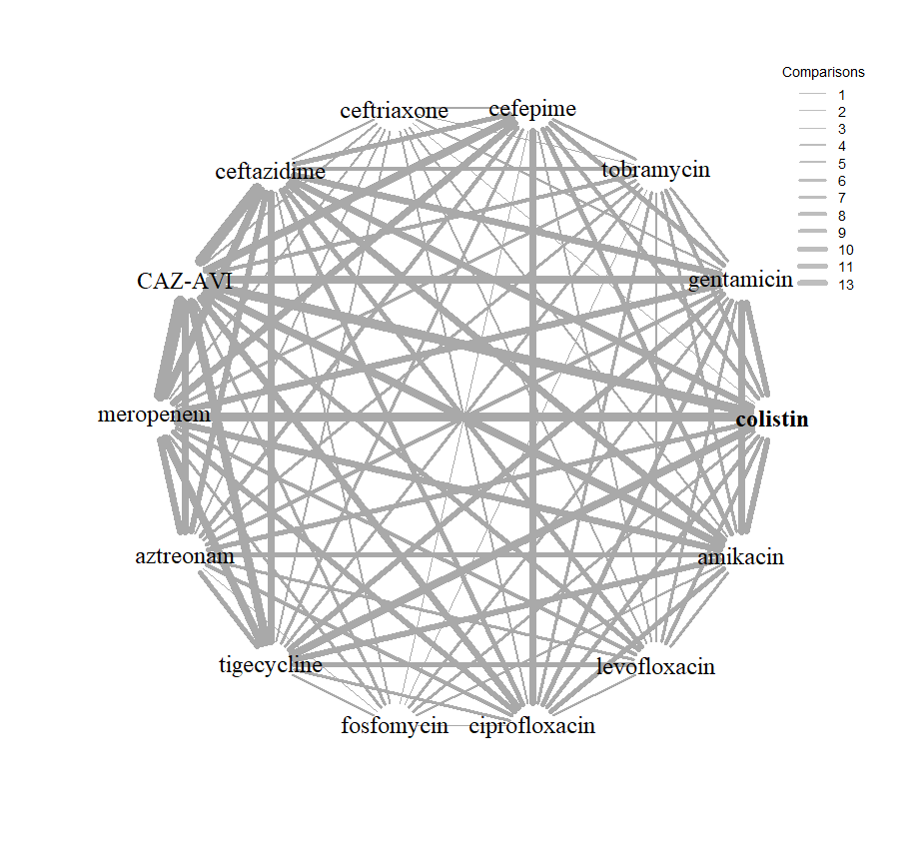
Table 10: Summary of key NMA analyses
 | Model description*** | Studies | Absolute model fit |  | Model comparison | Heterogeneity
 | Model description*** | Studies | DP | TRD | DIC | SD (95 % CrI)
 | Main analyses
Main analyses | Full data set, NMA model | 16 | 111 | 110.9 | 616.82 | 1.99 (1.64, 2.44)
Main analyses | Full data set, UME model | 16 | 111 | 120.8 | 626.05 | 1.71 (1.38, 2.14)
Main analyses | Reduced data set*, NMA model | 16 | 109 | 109.9 | 608.14 | 1.56 (1.28, 1.93)
 | Reduced data set*, UME model | 16 | 109 | 131.5 | 629.31 | 1.38 (1.08, 1.78)
 | Sensitivity analyses**
 | Unusual inclusion criteria, MR model | 16 | 109 | 109.3 | 607.41 | 1.57 (1.28, 1.95)
 | Unusual inclusion criteria subgroup | 13 | 96 | 95.42 | 537.45 | 1.51 (1.22, 1.89)
 | MBL cocarriage, subgroup**** | 6 | 49 | 50.8 | 287.398 | 1.38 (0.95, 2.06)
 | Carbapenum susceptibility, MR model | 14 | 101 | 101.7 | 563.03 | 1.56 (1.26, 1.96)
 | Consecutive samples. MR model | 16 | 109 | 109.4 | 607.63 | 1.57 (1.28 1.95)
 | EUCAST, subgroup | 3 | 28 | 28.21 | 189.39 | 0.98 (0.62, 1.65)
 | CrI, credible interval; DIC, deviance information criterion; DP, data points; NMA, network meta-analysis; SD, standard deviation; TRD, total residual deviance (mean); SD, standard deviation (median); UME, unrelated mean effects.
 | * Reduced data with inconsistent observations removed
** Conducted using reduced dataset. Results using full data shown in appendices.
***Analyses in bold used to inform the economic model.
**** The results of this analysis indicated that the estimated odds ratio vs colistin was increased compared to the model with all studies included, therefore an analysis was planned using studies with 0% MBLs and using EUCAST methods and breakpoints. This resulted in one study being selected (Vazquez-Ucha 2021) ¹.

4.5.4.1 NMA including all studies
The analysis including the full data from all 16 studies indicated an extremely high amount of heterogeneity, with the between-study standard deviation (SD) estimated to be 1.99 (95% CrI: 1.64 to 2.44). Results from the UME model suggested possible inconsistency in the network. Although the DIC of the UME model was substantially higher than the NMA model, suggesting a poorer model fit, the between-study SD was smaller. Inconsistency was therefore explored further by inspecting the deviance contribution plot (Appendix 7.3, Figure 33). Two data points were highlighted as having substantially lower deviance contributions under the UME model: the tigecycline arm of Han 2020⁵² and the colistin arm of Johnston.⁵³ The NMA model was re-fitted on a reduced data set with these two inconsistent observations removed. No further inconsistency was detected following the removal of these data points (Appendix 7.3 Figure 34).
Sixteen studies contributed to the NMA using reduced data, considering a total of 14 comparators, and the full network diagram is shown in Figure 3. Nine of the studies ^{37,50,51,60,65,78-81} contained zero susceptibility counts for one or more of the included comparators and therefore had a continuity correction applied prior to synthesis.

Figure 3: Network diagram of using reduced dataset contributing to the NMA
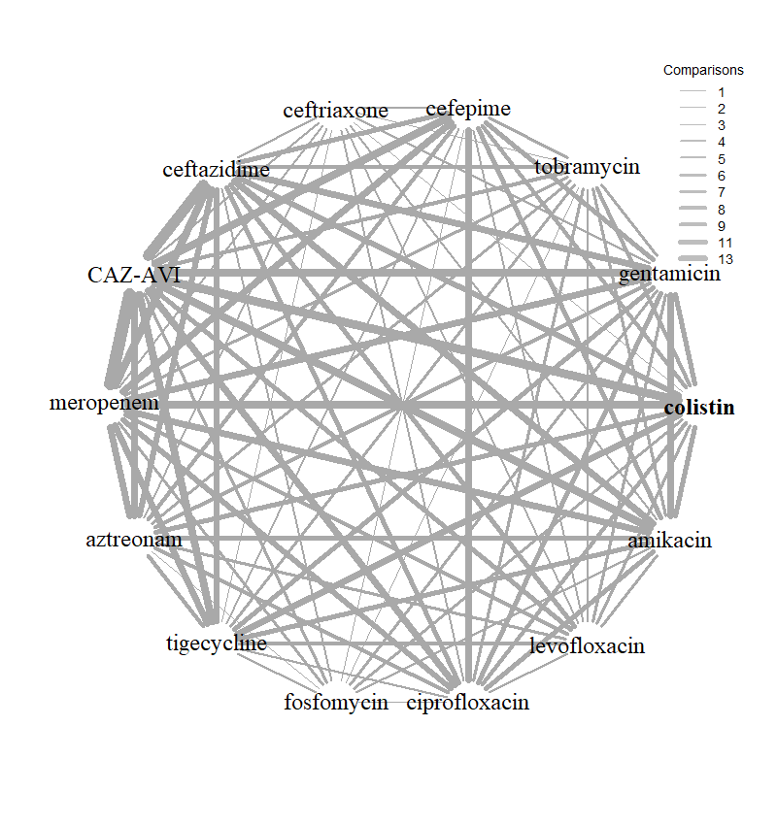
The relative susceptibility for each comparator relative to colistin are shown in Figure 4. The model fitted the data well, with a total residual deviance of 109.9, which was close to the number of data points included in the analysis of 109. The between-study SD was 1.56 (95% CrI: 1.28 to 1.93) which, while still indicating extremely high heterogeneity, offers a noticeable reduction compared to the full analysis including the inconsistent data points. CAZ-AVI was associated with a statistically significant higher susceptibility relative to colistin (OR 7.24, 95% CrI: 2.58 to 20.94) with probability 100% of being the most effective treatment; median rank 1. The remainder of the treatments were associated with lower susceptibility than colistin (OR <1) although this was not statistically significant for tigecycline or amikacin based on the 95% CrI. For all comparators the extremely high between-study SD results in wide 95% PrI.
Selection of the reduced data set (with inconsistent observations removed) was based on the statistical identification of inconsistency in the network. Inclusion of these observations resulted in extremely high heterogeneity and unfeasibly large uncertainty estimates for the relative effects. No data extraction errors, or reasons to exclude the entire studies (rather than individual arms) based on the inclusion/exclusion criteria were identified. The planned meta-regression and subgroup analyses were therefore conducted using both the full dataset as planned (in an attempt to explain the identified inconsistency, results shown in Appendix 7.3) and the reduced dataset. The conclusions of the analyses were consistent between using the full dataset and reduced dataset. The reduced data set was selected for use in the decision analytic model scenario analyses.

Figure 4: Forest plot of OR vs colistin for reduced data set, NMA model
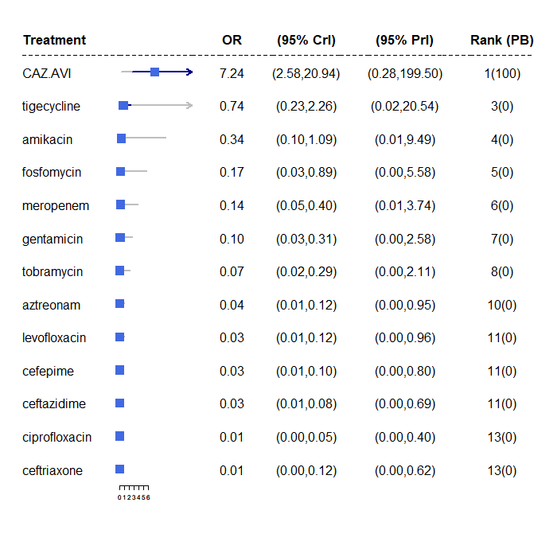

Sensitivity analyses
The meta-regression and/or subgroup analysis investigating the potential sources of heterogeneity due to studies with unusual inclusion criteria, MBL co-carriage, proportion with carbapenem susceptibility, consecutive sample recruitment and laboratory methodology and breakpoints used shows that 1) there was no evidence to suggest that the relative treatment effects differ according to the identified unusual inclusion criteria; 2) there was no conclusive evidence that co-carriage of MBLs has a statistically significant effect on the resulting relative effects, but the estimated OR vs colistin was increased compared to the model with all studies included, and the heterogeneity SD was decreased; 3) there was no evidence to suggest that the relative treatment effects differ according to the proportion with carbapenem susceptibility; 4) there was no conclusive evidence that laboratory methodology and breakpoints used had a statistically significant effect on the resulting relative effects, but the estimated OR vs colistin was decreased compared to the model with all studies included (see details of the results below) and the heterogeneity SD was decreased.
Based on the findings from the sensitivity analyses, for the cost-effectiveness modelling it was decided to use the EUCAST subgroup results in the base-case and to include a scenario analysis based on studies which recruited 0% MBL co-carriage and used EUCAST methods and breakpoints to inform the relative effectiveness on susceptibility (see Section 7.2.3 for details of further sensitivity analyses undertaken for the cost-effectiveness modelling). This resulted in one study being selected (Vazquez-Ucha 2021) ¹ for this scenario analysis – see Table 9 for the evidence used. The details of the sensitivity analysis relating to laboratory methods and breakpoints (which produced the EUCAST subgroup analysis) are described next, whilst the details of the other sensitivity analyses, including the MBL co-carriage analysis, are reported in Appendix 7.2.

4.5.4.2 NMA using EUCAST subgroup
Six studies^{45,52,53,56,57,65} used CLSI breakpoints and methodologies, two^{1,62} used EUCAST or BSAC breakpoints and methodologies, three ^{50,60,61} used CLSI methods, but EUCAST breakpoints, one⁴⁶ used CLSI methods and EEPRU applied EUCAST breakpoints and three^{37,51,66} did not report one or both elements. As already noted, it was unclear what methods were used by the submitting laboratories in the PHE data,⁴⁴ it was assumed that the majority would comply with BSAC recommendations and use EUCAST methods and breakpoints.
A subgroup analysis containing only the two EUCAST and one PHE study was performed. The network diagram for this subgroup of studies shown in Figure 5. The susceptibility to each comparator relative to colistin are shown in Figure 6. The model fitted the data well, with a total residual deviance of 28.21, which was close to the number of data points included in the analysis of 28. The between-study SD was 0.98 (95% CrI: 0.62 to 1.63) indicating high, but noticeably reduced, heterogeneity compared to the analysis including all 16 studies.
CAZ-AVI was associated with a higher susceptibility relative to colistin (OR 2.15, 95% CrI: 0.60 to 8.01), however the magnitude of the point estimate is lower than that of the full analysis and the result is not statistically significant. The remainder of the treatments were associated with lower susceptibility than colistin (OR <1) although this was not statistically significant for amikacin or meropenem based on the 95% CrI.
Figure 5: Network diagram studies contributing to the NMA restricted to EUCAST breakpoints
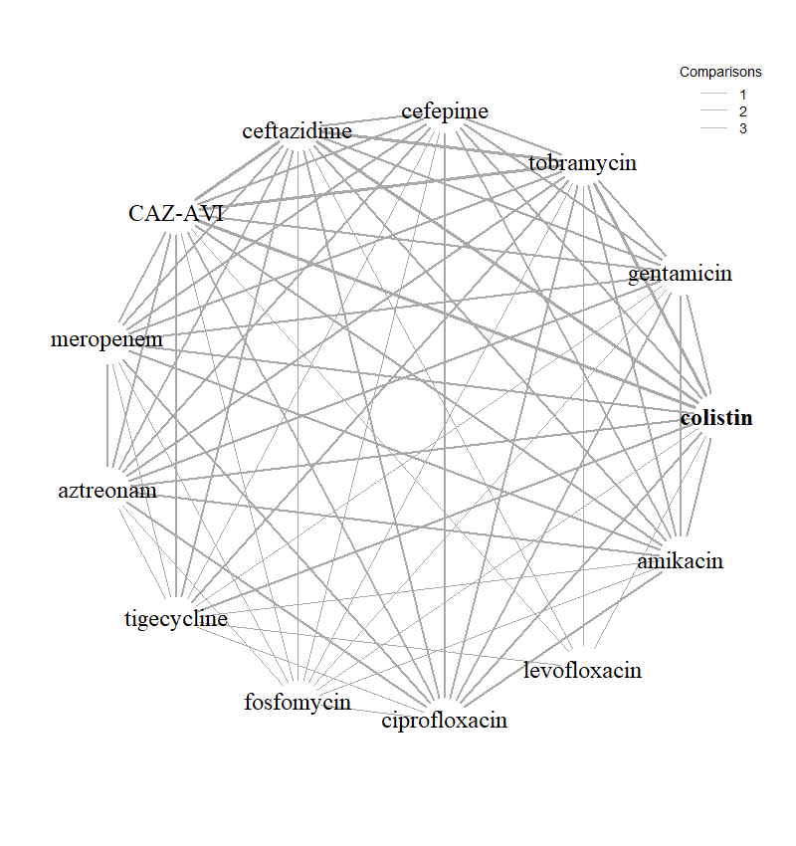

Figure 6: Forest plot of OR vs colistin for EUCAST studies subgroup
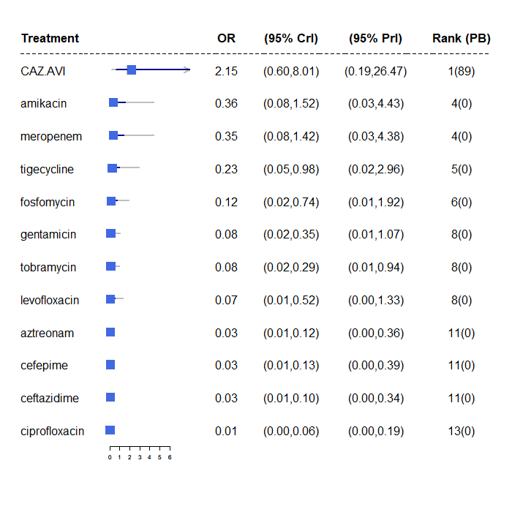

4.6 Additional review questions for Approach 3
Review questions 4-6 were defined in order to supply estimates to populate the decision-analytic model. Section 4.6.1 describes the rationale for and requirements of each additional question, whilst sections 4.6.2 to 4.6.4 describe the methods and results for each question. The approach to evidence identification and selection differed for each of these three questions, due to their perceived importance to the model, time constraints, and the availability of existing reviews.

4.6.1 The additional review questions
Additional questions generated by Approach 3 were:
Review 4. What is the link between in vitro susceptibility and clinical outcomes from the published literature, in the sites of relevance, in patients according to their susceptibility to the treatment they were given?
As described above in section 4.1.1.1, susceptibility studies do not report clinical outcomes, therefore it was necessary to establish the link between susceptibility in vitro, and clinical outcomes. Two approaches to evidencing this link were proposed:
  - assume that clinical outcomes do not differ according to the specific antibiotic used or the specific pathogen-mechanism causing the infection, conditional upon susceptibility to that antibiotic. This assumption was validated by our clinical experts.
  - assume that different treatments may result in different outcomes, conditional on susceptibility to the antibiotic given.
In both approaches, studies should have tested the susceptibility of a patient to the treatment they were given, and report clinical outcomes for those susceptible or not in cUTI and HAP/VAP separately. In approach b) data on effectiveness conditional upon susceptibility would be required for the intervention and comparators, and would need to comprise a viable NMA. Initial scoping work based on a previous systematic review (reported as part of Shionogi’s application to European Network for Health Technology Assessment (EUNETHTA) (Project PTJA11))⁸² indicated that the RCTs in the HVCS sites provided poor coverage of the comparators of interest. Clinical advisors were also supportive of approach a), and consequently approach b) was not pursued further.
Review 5. What is the long-term risk of mortality (and other outcomes) for patients with carbapenem-resistant cUTI or HAP/VAP?
This question became necessary since review question 4 did not identify any studies that reported long term clinical outcomes. The question was widened to include any carbapenem-resistant infections.
Review 6. What are the important safety implications of CAZ-AVI?
This question was required to inform the modelling of important adverse events (AEs).

4.6.2 Review 4
What is the link between in vitro susceptibility and clinical outcomes from the published literature, in the sites of relevance, in patients according to their susceptibility to the treatment they were given?

4.6.2.1 Methods
As detailed in Section 4.6.2, of the two proposed approaches, only approach a. was taken forward. In this approach, it is assumed that clinical outcomes would be similar regardless of the treatment received, conditional upon susceptibility. This review included studies of any design linking susceptibility (to any antibiotic) to clinical outcomes in cUTI or HAP/VAP caused by any pathogen-mechanism (Table 11). Three approaches were used to identify evidence relating to this question.
- A systematic review update of Bassetti et al. 2020.⁸³
- Searching and screening of additional databases and review of studies included within Bassetti et al. 2020.⁸³
- Review of the RCTs identified in Review 1 for any subgroup data.

- Bassetti et al 2020⁸³ systematically reviewed the impact of appropriate and inappropriate antibacterial therapy on clinical outcomes of patients with severe bacterial infections, where appropriate therapy was defined as treatment with an antibiotic the isolate was susceptible to. The review was assessed for quality and relevance (see Appendix 8.1) and was judged to be of good quality and suitable for updating. The original review covered the period from 2007 (to ensure clinical practices were contemporary) and the searches were performed in 2018. For the update, given resource and time constraints the search strategy was restricted to terms relating to the UK (since clinical practice may differ in other countries), the sites of interest (cUTI, HAP/VAP), and to remove terms relating to treatment delay, which were included in Bassetti et al 2020⁸³ to address a separate review question (the effect of delayed appropriate antibiotic therapy) addressed in Zasowski et al 2020.⁸⁴ The adapted search strategy was run from 2007 to June 2021, to capture any new studies, as well as any studies the adapted strategy identified that were missed by the previous review (between 2007-2018). It was further noted that the original search strategy did not include search terms relating to susceptibility, and therefore an additional search, using this search term, was conducted to capture any additional studies from 2007 onwards. The search strategies are presented in Appendix 1.3.4 and were run in Ovid MEDLINE and Epub Ahead of Print, In-Process, In-Data-Review & Other Non-Indexed Citations, Daily and Versions: Ovid, 1946 to Present. Studies included in the original review and citations identified by the search strategy were assessed for relevance against pre-specified inclusion criteria listed in Table 11.

- In addition to the update of Bassetti et al.,⁸³ a number of other approaches were taken to identify relevant studies (more detail is provided in Appendix 8.2):
- A large database (3172 references) was created, based on search terms for the mechanisms of resistance relevant to the two concurrent EEPRU evaluations relating to CAZ-AVI and cefiderocol (namely MLB, NDM, VIM and IMP). This database was then searched using a series of keywords and phrases to identify relevant studies. The search strategy is presented in Appendix 1.3.2.
- Screening, citation searching and reference checking of studies retrieved by a search for cost-effectiveness models (66 references) (see Section 6.1)
- Keyword search of the Endnote library provided by Shionogi as part the EEPRU evaluation of cefiderocol (1261 references),
- Screening the list of key references provided by Shionogi as part the EEPRU evaluation of cefiderocol (45 references),
- Keyword search of references provided by Pfizer as part of the EEPRU evaluation of CAZ-AVI (299 references),
- Screening the studies included in two systematic review articles provided by Shionogi as part the EEPRU evaluation of cefiderocol (Zasowski et al., 2020;⁸⁴ Bassetti et al., 2020).⁸³

- In addition to the two previous approaches, the RCTs identified for the intervention were examined for any additional data relating to this question (see Appendix 6.1 and Table 46).
Table 11: Inclusion criteria for the review of susceptibility and clinical outcomes
Item | Inclusion criteria | Exclusion criteria
Population | cUTI or HAP/VAP  Any infective pathogen | Other sites
Exposure | Treatment with any antibiotic that the isolate is susceptible to | Treatment with an antibiotic that the isolate has intermediate susceptibility to
Comparison | Treatment with any antibiotic that the isolate is not susceptible to (resistant or intermediate/increased exposure) | No comparison provided
Outcomes | Mortality, hospitalization, length of stay (LOS), bloodstream infections (BSI) or other subsequent infections, health related quality of life (HRQoL) | Short term outcomes such as clinical cure
Setting | MDS or ES  UK studies | Not UK (only applied to search update)
Study design | Experimental or observational studies that assessed susceptibility to treatment prospectively or retrospectively | Published prior to 2010
cUTI, complicated urinary tract infection; ES, empiric setting; HAP/VAP, hospital-acquired pneumonia/ventilator-associated pneumonia; MDS, microbiology-directed setting

4.6.2.2 Results
1. Systematic review update of Bassetti et al. (2020)
The searches for the systematic review update yielded 172 citations, the screening process did not result in any studies that met the inclusion criteria.
2. Searching and screening additional databases
Eight studies were extracted in total, of which four and five studies reported outcomes in patients with cUTIs and HAP/VAP, respectively. None of the studies were conducted in the UK. None of the studies on patients with cUTIs included patients who received microbiology-directed treatment. In studies on patients with HAP/VAP, three studies only included patients on empiric treatment ⁸⁵⁻⁸⁷, one study ⁸⁸ included patients both on microbiology-directed and empiric treatment (it did not report outcomes conditional on this factor), and one study ⁸⁹ did not report whether treatment was microbiology-directed or empiric. Of the three studies conducted in empiric setting, one ⁸⁵ reported ICU mortality, hospital mortality, mechanical ventilation, LOS and ICU LOS, one study ⁸⁶ reported 30-day mortality only, and one ⁸⁷ reported Kaplan-Meyer curves for 30-day mortality.

3. Review of RCTs.
No data was identified relating to variation in clinical outcomes according to susceptibility (see Appendix 6.1 and Table 46).

4.6.3 Review 5
What is the long-term risk of mortality (and other outcomes) for patients with carbapenem-resistant cUTI or HAP/VAP?

4.6.3.1 Methods
The previous reviews did not identify any long-term mortality data. Given the paucity of data in this area, the scope of this review question was widened to include any carbapenem-resistant infections treated with any treatment, under the assumption this data could be generalised to OXA-48 Enterobacterales infections. A focussed search was conducted to identify UK studies reporting long-term (>3 months) mortality and other outcomes such as hospitalisation, subsequent infection, costs and AEs for patients with carbapenem-resistant (including multi-drug resistant (MDR) and extensively-drug resistant (XDR)) cUTI or HAP/VAP. The search strategy comprised terms for (Carbapenem Resistance OR mechanisms) AND (sites [UTI/HAPVAP]) AND filters. The search scope was limited using terms for the UK, and the search was run from 2010 to ensure clinical practices were contemporary. Since no UK studies were identified, the search was expanded to include studies from Europe. The search strategy is presented in Appendix 1.3.3. The inclusion criteria for this review are reported in Table 12. Studies were assessed for eligibility against the inclusion criteria by one reviewer.
Table 12: Inclusion criteria for the review of the long term risk of mortality for patients with carbapenem-resistant cUTI or HAP/VAP
Item | Inclusion criteria | Exclusion criteria
Population | CR, XDR or MDR cUTI or HAP/VAP infections | Infections at sites other than cUTI or HAP/VAP
Exposure | Any treatment or no treatment
Outcomes | Mortality measured more than 3 months after treatment  Other long-term outcomes such as hospitalisations, subsequent infections, costs, adverse events | Outcomes measured at or before 3 months after treatment
Setting | UK, expand to Europe if no UK studies
Study design | Experimental or observational studies or datasets | Studies published prior to 2010
CR, carbapenem-resistant; MDR, multi-drug resistant; cUTI, complicated urinary tract infection; HAP/VAP, hospital-acquired pneumonia/ventilator-associated pneumonia

4.6.3.2 Results

The electronic database searches, following the removal of duplicates, identified 76 records relating to long term outcomes for patients with carbapenem-resistant cUTI or HAP/VAP. After examination of the title and abstracts, 76 records were excluded because they did not meet the inclusion criteria.

4.6.4 Review 6
What are the important safety implications of CAZ-AVI?

4.6.4.1 Methods
A comprehensive review of the safety of comparators was not possible within the timeframe of this evaluation. Adverse events included in the model for the intervention and comparators are described in Section 7.2. Clinical advisors to EEPRU indicated that CAZ-AVI is predominantly a safe treatment, but that colistin and aminoglycosides have significant AEs relating to acute kidney injury (AKI). Another key AE related to antibiotic use is the emergence of C.difficile in a patient’s digestive tract, which can lead to diarrhoea and serious damage to the colon. EEPRU conducted a review of the RCT trial evidence for CAZ-AVI to establish whether it supported the clinical view that CAZ-AVI is a safe treatment. EEPRU were especially interested in establishing safety comparative to toxic alternatives (colistin and aminoglycosides) and the other “safer” treatments used in the HVCSs.
Rates of serious treatment-related AEs, nephrotoxicity AEs, and C. difficile infections were extracted from the included RCT publications and/or their ClinicalTrials.gov NCT record. Only RCTs relating to the sites of interest were reviewed, due to time and resource constraints. Only RCTs were considered as these give comparative data. In the absence of nephrotoxicity events, other kidney and renal AEs were extracted. The data was then synthesised narratively for any important safety signals.

4.6.4.2 Results
The extracted AE data in the RCTs for CAZ-AVI are presented in Table 13.
As described in section 4.2.1, there were three RCTs in cUTI^{32,34,35} and one in VAP.³³ Statistical comparisons were not reported for AE rates in any of the trials.
The proportion of patients with serious adverse events (SAEs) was numerically similar or slightly higher when compared to best available therapy (4.61% and 3.27%),³² doripenem (4.1% and 2.4%)³⁵ And meropenem (19% and 13%), ³³ and appeared numerically higher when compared to imipenem-cilastatin (8.82% and 2.99%).³⁴ However, doripenem and imipenem-cilastatin are not comparators within the HVCSs.
Amongst renal AEs, rates were very low, and were in some studies a little higher in CAZ-AVI arms (see RECAPTURE 1 & 2 and REPROVE in Table 13); whereas in one trial they were lower (see REPRISE in Table 13).³² This may be due to the small proportion of patients in the best available therapy arm who received colistin or aminoglycosides (3.6%).
Only one study reported C.difficile rates. Again, the event rates were extremely low, with one event (0.4%) in the CAZ-AVI arm, and zero in the doripenem arm.³⁵
Event rates were generally low for other AEs in both arms.
Overall, no strong signal for additional AEs to be included in the modelling were identified. The data appeared to bear out the clinical view that CAZ-AVI is a largely safe treatment with no or extremely little effect on renal AEs or on the emergence of C.difficile when used to treat infections at the sites of interest.
Table 13 Summary of adverse event data in RCTs of CAZ-AVI in cUTI and HAP/VAP
Author (date) Acronym | AE | Intervention | Comparator
Carmeli et al. (2016)³² REPRISE (NCT01644643)  cUTI | Serious Treatment related AE (total safety pop) n (%) | CAZ-AVI 7/152 (4.61%) | Best available therapy  5/153 (3.27%)
Carmeli et al. (2016)³² REPRISE (NCT01644643)  cUTI | Nephrotoxicity n (%) | Renal failure  0/152 (0%) | Renal failure  1/153 (0.66%)
Carmeli et al. (2016)³² REPRISE (NCT01644643)  cUTI | C Diff infection n (%) | NR | NR
Carmeli et al. (2016)³² REPRISE (NCT01644643)  cUTI | Any other AEs of concern* (name, n/N and %) | Infections and infestations  Incision site infection 0/152 (0.00%)  Oral herpes 0/152 (0.00%)  Orchitis 0/152 (0.00%)  Respiratory tract infection viral 0/152 (0.00%)  Respiratory, thoracic and mediastinal disorders  Acute respiratory failure 0/152 (0.00%)  Pneumonia aspiration 0/152 (0.00%)  Pulmonary embolism 0/152 (0.00%)  Respiratory failure 0/152 (0.00%) | Infections and infestations  Incision site infection 0/153 (0.00%)  Oral herpes 0/153 (0.00%)  Orchitis 0/153 (0.00%)  Respiratory tract infection viral 0/153 (0.00%)  Respiratory, thoracic and mediastinal disorders  Acute respiratory failure 1/153 (0.65%)  Pneumonia aspiration 1/153 (0.65%)  Pulmonary embolism 1/153 (0.65%)  Respiratory failure 0/153 (0.00%)
Wagenlehner et al. (2016)³⁵ RECAPTURE 1 & 2 (NCT01595438 and NCT01599806)  cUTI | Serious Treatment related AE (total safety pop) n (%) | CAZ-AVI  21/511 (4.1%) | Doripenem  12/509 (2.4%)
 | Nephrotoxicity n (%) | NCT01595438 and NCT01599806  CAZ-AVI  Calculus ureteric 1/511 (0.20%)  Hydronephrosis 1/511 (0.20%)  Nephrolithiasis 3/511 (0.59%)  Renal failure chronic 0/511 (0.00%)  Renal impairment 1/511 (0.20%) | NCT01595438 and NCT01599806  Doripenem  Calculus ureteric 0/509 (0.00%)  Hydronephrosis 0/509 (0.00%)  Nephrolithiasis 0/509 (0.00%)  Renal failure chronic 1/509 (0.20%)  Renal impairment 0/509 (0.00%)
 | C Diff infection n (%) | CAZ-AVI  2/511 (0.4%) | Doripenem  0/509 (0%)
 | Any other category that is important (name, n/N and %) | Infections and infestations  Abdominal abscess 1/511 (0.20%)  Appendicitis 0/511 (0.00%)  Cellulitis 1/511 (0.20%)  Chronic hepatitis C 1/511 (0.20%)  Clostridium difficile colitis 1/511 (0.20%)  Diverticulitis 1/511 (0.20%)  Gastroenteritis 1/511 (0.20%)  Orchitis 0/511 (0.00%)  Pneumonia 0/511 (0.00%)  Urinary tract infection 0/511 (0.00%)  Respiratory, thoracic and mediastinal disorders  Acute pulmonary oedema 0/511 (0.00%)  Hyperventilation 1/511 (0.20%) | Infections and infestations  Abdominal abscess 0/509 (0.00%)  Appendicitis 1/509 (0.20%)  Cellulitis 0/509 (0.00%)  Chronic hepatitis C 0/509 (0.00%)  Clostridium difficile colitis 0/509 (0.00%)  Diverticulitis 0/509 (0.00%)  Gastroenteritis 0/509 (0.00%)  Orchitis 1/509 (0.20%)  Pneumonia /509 (0.20%)  Urinary tract infection 1/509 (0.20%)  Respiratory, thoracic and mediastinal disorders  Acute pulmonary oedema 1/509 (0.20%)  Hyperventilation 0/509 (0.00%)
Vázquez et al (2012)³⁴ (NCT00690378)  cUTI | Serious Treatment related AE (total safety pop) n (%) | CAZ-AVI  6/68 (8.82%) | Imipenem–cilastatin  2/67 (2.99%)
Vázquez et al (2012)³⁴ (NCT00690378)  cUTI | Nephrotoxicity n (%) | Rénal Failure Acute  1/68 (1.47%)  Renal Impairment  1/68 (1.47%) | Renal Failure Acute  0/67 (0.00%)  Renal Impairment  0/67 (0.00%)
Vázquez et al (2012)³⁴ (NCT00690378)  cUTI | C Diff infection n (%) | NR | NR
Vázquez et al (2012)³⁴ (NCT00690378)  cUTI | Any other category that is important (name, n/N and %) | Infections and infestations  Urosepsis  0/68 (0%) | Infections and infestations  Urosepsis  0/67  (0%)
Torres et al. (2018)³³ REPROVE (NCT01808092)  VAP | Serious Treatment related AE (total safety pop) n (%) | CAZ-AVI  75/405 (19%) | Meropenem  54/403 (13%)
Torres et al. (2018)³³ REPROVE (NCT01808092)  VAP | Nephrotoxicity n (%) | NCT01808092  CAZ-AVI  Acute kidney injury 2/405 (0.49%)  Renal failure 1/405 (0.25%)  Renal impairment 0/405 (0.00%) | NCT01808092  Meropenem  Acute kidney injury 1/403 (0.25%)  Renal failure 0/403 (0.00%)  Renal impairment 1/403 (0.25%)
Torres et al. (2018)³³ REPROVE (NCT01808092)  VAP | C Diff infection n (%) | NR | NR
Torres et al. (2018)³³ REPROVE (NCT01808092)  VAP | Any other category that is important (name, n/N and %) | Infections and infestations  Urinary tract infection 11/405 (2.72%)  Respiratory, thoracic and mediastinal disorders  Pleural effusion 9/405 (2.22%) | Infections and infestations  Urinary tract infection 14/403 (3.47%)  Respiratory, thoracic and mediastinal disorders  Pleural effusion 7/403 (1.74%)
CAZ-AVI, ceftazidime-avibactam; c.diff; Clostridium difficile; NR, not reported
* AEs of concern were any AE that was serious, and either was higher in one arm than the other, or was high in both arms.

4.7 Overview and critique of evidence in Pfizer’s submission to NICE
In their submission, Pfizer include evidence on CAZ-AVI from RCTs, non-RCTs and real world evidence. Pfizer’s modelling took a different approach (see Section 6.1.5) and included a wider population than EEPRU’s, and their evidence requirements were therefore wider. No systematic review methodology is reported to support the clinical section of their submission, and it is therefore unclear to what extent the evidence submitted is comprehensive with respect to their wider scope.
EEPRU checked that the evidence submitted by Pfizer that was relevant to the HVCSs was captured by their own systematic searches and found that all relevant studies were present, unless unpublished. Some RCTs cited by Pfizer were not considered relevant to the EEPRU HVCSs, since they were in the wrong site or the wrong population. For example, several RCTs were not relevant since they recruited patients with intra-abdominal infections, ^{90,91} or were conducted in children (unpublished ANDI20 trial). RCTs^{32,33,35} in the correct site and population were included in EEPRU’s review, as was one phase 2 study that did not feature in Pfizer’s submission, but met EEPRU’s selection criteria.³⁴ Of the six^{40,41,92-95} observational studies discussed by Pfizer, only two reported a subgroup of data relating to OXA-48s,^{40,41} and both were included in EEPRU’s review (see section 4.2.2). The four⁹²⁻⁹⁵ remaining were considered as sources of evidence for Review 4 (link between susceptibility and clinical outcomes), and one⁹⁴ was included as part of that review since the other three were based on the sites outside the HVCS^{92,93} or mixed sites.⁹⁵ The real world data⁴³ discussed in Pfizer’s submission was also included in EEPRU’s review.

4.8 Discussion and conclusions
There are evidential challenges when evaluating the use of new antimicrobials to treat infections caused by MDR pathogens. RCTs are of generally low relevance as they tend not to recruit patients with MDR pathogens. Therefore, relative treatment effects between the intervention and comparator cannot be generalised to multi-drug resistant pathogens, as this may overestimate the efficacy of the comparator.
Since it was anticipated that RCTs were unlikely to be the primary source of evidence, three approaches to estimating comparative efficacy between the intervention and comparators were considered. In Approach 1 and 2, RCTs and observational studies (respectively), with data for patients with HAP/VAP or cUTI infections caused by OXA-48 Enterobacterales, could be used to construct a network meta-analysis to compare the intervention and comparators. In Approach 3, in vitro susceptibility studies could be used to indicate the proportion of OXA-48 Enterobacterales that are susceptible to treatment; additional evidence would be required to link susceptibility to clinical outcomes in cUTI and HAP/VAP.
Approaches 1 and 2 were not pursued since insufficient evidence from RCTs and observational studies was identified during the mapping review. The key limitation of the RCTs was that they included small numbers of OXA-48 infections (n=3 in each of two RCTs) and did not report this data separately. The key limitation of the observational data was that it was not reported separately for the sites of interest (cUTI and HAP/VAP) and there was insufficient time to obtain IPD.
In Approach 3, relatively large samples of OXA-48 Enterobacterales isolates obtained from a range of clinical sites of infection were available from several in vitro susceptibility studies and susceptibility (unlike clinical outcomes) was expected to generalise across sites. Therefore, a network meta-analysis of susceptibility studies was conducted. This included English-specific susceptibility evidence provided by PHE. Sixteen studies met the inclusion criteria and were synthesised. A series of sensitivity analyses was conducted to ascertain the impact of several sources of clinical heterogeneity, including: inclusion criteria (use of resistance to a comparator to select study sample); co-carriage of MBLs; the proportion who were carbapenem sensitive; whether the sample was recruited consecutively; and what laboratory methods and breakpoints were used to assess susceptibility.
After consistency checks (which resulted in two study arms being removed), and otherwise using the full analysis set (all available studies), CAZ-AVI was associated with a statistically significantly higher susceptibility relative to colistin (OR 7.24, 95% CrI: 2.58 to 20.94). The remainder of the treatments were associated with lower susceptibility than colistin (OR <1). Heterogeneity was extremely high (SD 1.56, 95% CrI: 1.28 to 1.93). A sensitivity analysis including only studies where no isolates co-carried both MBL and OXA-48 resistance mechanisms (n=6 studies) decreased heterogeneity (SD 1.38, 95% CrI: 0.95 to .06). It also produced a very high OR for CAZ-AVI versus colistin, but with a large amount of uncertainty (OR 35.83, 95% Cr: 7.91 to 165.60). Another sensitivity analysis, including only studies that used EUCAST laboratory methods and breakpoints (n=3 studies), reduced the heterogeneity further to SD 0.98 (95% CrI 0.62 to 1.65). CAZ-AVI was associated with a higher susceptibility relative to colistin (OR 2.15 95% CrI: 0.60, 8.01), however the magnitude of the point estimate was lower than that using the full analysis set (OR 7.24, 95% CrI: 2.58 to 20.94) and the result is not statistically significant.
Networks used in the economic evaluation: The EUCAST network was selected as the base case analysis to inform the economic evaluation since heterogeneity was lower and there was a clinical rationale to support restricting to studies that had used EUCAST laboratory methods and breakpoints as these are more commonly used in England. A scenario analysis was planned to include the result from the full analysis set. A further scenario was planned restricting to studies with no-MBLs and that had used EUCAST laboratory methods and breakpoints, which left one study (Vazquez-Ucha et al.).¹ This study did not report an estimate for tigecycline, but was the study with the lowest risk of bias as judged by the bespoke risk of bias tool developed for this evaluation. A further scenario analysis was planned using the PHE data alone, due to its high relevance to the evaluation.
Three additional clinical reviews were conducted to support Approach 3. In Review 4, evidence relating to the link between in vitro susceptibility and clinical outcomes in the sites of relevance was sought, since susceptibility studies do not report clinical outcomes. In Review 5, evidence relating to the long-term risk of mortality (and other clinical outcomes such as hospital LOS) for patients with carbapenem-resistant cUTI or HAP/VAP was sought, since no evidence relating to long term outcomes was identified by Review 4. In Review 6, the important safety implications of CAZ-AVI, as reported by RCTs conducted in the sites of interest, were reviewed. Clinical advisors indicated that colistin and aminoglycosides (comparators in the HVCSs) increase the risk of acute kidney injury (AKI), but that CAZ-AVI did not. C.difficile infections were highlighted in the NICE scope as a potential consequence of treatment with broad spectrum antibiotics. Data was sought relating to AKI or related AEs, to C.difficile rates, and to any other serious AEs reported in the literature.
Review 4 (link between susceptibility and clinical outcomes) identified two studies that reported mortality or hospital LOS conditional on susceptibility to empiric treatment and were selected for use in the model for the ES. No useful evidence relating to the MDS was identified. Review 5 (link between susceptibility and long term clinical outcomes) did not identify any relevant literature, but an unpublished study (CARBAR) ⁹⁶ was submitted by Shionogi during the parallel appraisal of CAZ-AVI that contained useful data. Review 6 indicated that CAZ-AVI does not appear to increase the risk of AKI, C.difficile, or any other serious AEs, compared to non-toxic comparators (i.e. comparators that were not colistin or an aminoglycoside). No study reported a comparison of CAZ-AVI exclusively to colistin or aminoglycosides. Event rates were generally very low or zero.
Strengths The clinical review was conducted using a mapping approach based on robust systematic searches to capture relevant literature. This allowed EEPRU to focus resources from a relatively early stage on a viable approach to deriving clinical efficacy estimates, whilst still conducting a comprehensive search despite a paucity of high-quality evidence. Data extractions were checked by a second reviewer to ensure data integrity, and statistical analyses were performed using standard network meta-analysis approaches. At all stages of the clinical review, clinical advisors were consulted where there was uncertainty, and the resulting methods of synthesis have attempted to account for clinical sources of heterogeneity where feasible. Susceptibility studies, whilst not reporting clinical outcomes, have the advantage of testing all the treatments in the same sample of isolates, thereby reducing the chance of heterogeneity in patient samples between arms introducing confounding. They also tend to include a higher numbers of patients/isolates compared to RCTs and observational studies.
Limitations There are limitations to the clinical review, largely due to the availability of evidence and time available to conduct the evaluation.
A lack of availability of relevant RCT or observational evidence has meant that in vitro susceptibility, which can be considered, at best, a surrogate outcome, has been relied upon. A link was then made between susceptibility and clinical outcomes using published data and expert elicitation. No pre-specified criteria for judging the suitability of the surrogate or the linking evidence were applied. The data available to evidence the link between susceptibility and clinical outcomes was sparse and was not specifically for the pathogen-mechanism of interest. For the microbiology-directed setting, expert elicitation was used to derive the link between susceptibility and clinical outcomes (see Chapter 5).
Other limitations relate to the review methods applied in this evaluation. Because this was the first evaluation of this type commissioned by NICE, and because EEPRU could not foresee the evidence and synthesis requirements at the inception of the project, no registration with the International prospective register of systematic reviews (PROSPERO) was performed. The statistical analysis plan was made in response to the available data, rather than being formulated a priori, since the types of heterogeneity that would be encountered and their importance were largely unknown at the project outset. Due to time constraints, many stages of the review process were done by only one reviewer, which introduces a risk of inaccuracy. Data were checked by a second reviewer for the susceptibility review, but study selection and risk of bias assessment were conducted by only one. Since there was no suitable risk of bias tool available, EEPRU created a bespoke tool. This was done by consulting other available tools, but no face validity checks were performed by experts in susceptibility testing, and no other validation of the tool has been undertaken. This could be an area of future research. To allow for this, risk of bias scores were not used in the statistical synthesis to weight studies, subgroup studies or exclude studies, and instead aspects of clinical heterogeneity were considered in sensitivity analyses individually.
In terms of the statistical synthesis, there were also some limitations introduced by time constraints. The review only included studies that reported data for CAZ-AVI and at least one comparator, whereas ideally all susceptibility evidence for all comparators would have been sought to construct the network, regardless of whether CAZ-AVI had also been tested.
There were also some limitations introduced by problems inherent to susceptibility testing, and clinical practice in England. Setting clinical breakpoints is a subjective process conducted by relevant experts taking in to account a range of evidence, which may have been generated differently for different comparators. Therefore, any given breakpoint may not reflect the true activity of a treatment in clinical practice, and the extent to which it does may vary between treatments. Breakpoints also change over time, as pathogens increasingly acquire resistance. EEPRU were not able to resolve whether it is better to use breakpoints contemporaneous to the sample collection date, or apply current breakpoints to the available data (where data allowed), and for pragmatic reasons used data as reported in the published reports. Laboratory methods of susceptibility testing recommended by EUCAST and CLSI have also changed over time, and before 2016 BSAC had its own set of methods, which may have affected the estimates of susceptibility derived before and since then, as practice did not change immediately. As noted in Section 4.5.1, PHE data were a mixture of BSAC, CLSI and EUCAST methods, which will potentially affect the estimates of susceptibility derived. Clinical advisors also noted that in vitro susceptibility to meropenem in particular does not always indicate how well a patient will respond to this treatment in clinical practice.
Conclusions Susceptibility estimates have been used to estimate the clinical effectiveness of CAZ-AVI and its comparators in the HVCSs. Several sensitivity analyses were conducted as part of the NMA. In the majority of the analyses CAZ-AVI had higher susceptibility relative to colistin, but this was not always statistically significant. Heterogeneity in all analyses was high, but was lower in some. Relevant base case and scenario analyses for the model were selected based on heterogeneity and clinical rationales. These included a network of studies which used EUCAST laboratory methods and breakpoints, a consideration of all the studies in the network (removing two arms with large inconsistency), one study that reported no MBL co-carriage and used EUCAST laboratory methods and breakpoints, and using the PHE data alone. There was no signal that CAZ-AVI was associated with an increase in AKI or C.difficile infections compared to other non-toxic treatments.
- Structured expert elicitation

As detailed in Section 4.6.1, it is assumed that clinical outcomes would be similar regardless of the treatment received, conditional upon susceptibility. Review 4 did not identify any studies that informed clinical outcomes in HAP/VAP and cUTI patients conditional upon susceptibility, following microbiology-directed treatment. In absence of empiric evidence, outcomes were informed by eliciting judgments of individuals who have expertise on the subject matter. The outcomes of interest were consistent with those available for the ES, and included mortality, hospital LOS, and the type of ward these patients would stay on in hospital.

5.1 Methods
A structured elicitation process was used to improve accountability and transparency. Specifically, the reference methods developed at York as part of the Medical Research Council (MRC) elicitation work ⁹⁷ were employed. The full elicitation protocol is presented in Appendices 9-10.

5.1.1 Approach to elicitation
Clinical experts were recruited to take part in the elicitation exercise, and their beliefs were elicited individually and remotely using an application developed in R, SHINY package.⁹⁸
Experts were trained in the approach to elicitation prior to the task, using an online training webinar (slides are presented in Appendix 11). Experts were asked to express their uncertainty about the outcomes of interest using a histogram (chips and bins approach).⁹⁹ This approach has been shown to work well for experts not trained in probabilities and statistics.⁹⁷ Experts were first asked to express the range for their beliefs, the minimum, which is the value such that the experts believes that there is a 1% probability that the proportion is less than that value; and the maximum, a value, such that the experts believe that there is a 1% probability that the proportion is more than that value. Grids were then generated based on this range and experts were asked to place ‘chips’ on this grid to represent their beliefs. Once experts had completed the grid, a summary of their answers was relayed to them. This provided the following information:

Your answers imply that (example quantities given)
● there is a 17% probability that the proportion of patients is between 19 and 20%
● there is a 50% probability that the proportion of patients is between 20 and 21%
● there is a 33% probability that the proportion of patients is between 21 and 22%

Once experts were individually asked to express their beliefs, these were then aggregated using linear opinion pooling. First, a probability distribution was fitted to each expert’s beliefs from the histogram and then these were pooled, assuming that each expert contributed equally to the group overall distribution.
This overall distribution was then relayed back to experts, and they were given the opportunity to revise their own beliefs on the histograms they previously completed. This approach has been shown to generate less biased parameters when the quantities elicited are unobserved by the experts.⁹⁷ Following this revision, expert’s beliefs were aggregated using the same approach, linear opinion pooling, and the final group distributions were used in the model.

5.1.2 Expert recruitment
Experts recruited to take part in the elicitation exercise included medical consultants, ICU consultants, pulmonary consultants and microbiologists. The literature suggests that around 10 experts should be included in an individual elicitation, and that recruitment should strive for a representative sample.⁹⁷ To this end we sought to recruit experts from across the UK using our clinical leads. We approached experts directly and asked for their participation. Experts that agreed to participate were invited to attend a training webinar. The majority of experts attended this session, with a few choosing to view the pre-recorded slides instead. Experts’ identities were known to the modelling team, however in aggregating, feeding back and reporting, all experts identities were anonymised.

5.1.3 Parameters elicited
The elicitation was conducted to inform outcomes in HAP, VAP and cUTIs caused by carbapenem-resistant Gram-negative bacteria of interest, following microbiology-directed treatment. The elicitation exercise was used to inform outcomes in two distinct reports where the pathogens of interest included Enterobacterales OXA-48, MBL Enterobacterales or MBL Pseudomonas aeruginosa.
For each of the three sites of infections, we elicited outcomes depending on whether the infectious pathogen is susceptible to treatment. Therefore, outcomes only depend on whether a patient is susceptible to treatment or not, and not to the specific treatment given. The outcomes of interest were 30-day mortality, LoS in hospital, and the type of ward these patients would stay on in hospital.
As background information we presented several related studies to experts (see Appendix 10 for details). In these studies, infecting pathogens were not confirmed to be susceptible to the antibiotics administered; however, in our assessment, they are likely to have been susceptible.
For HAP, VAP and cUTI experts were first provided with some context, as follows (example given is HAP only, the questions were repeated separately for each site):
“The following questions refer to outcomes in patients with HAP caused by CPE [Enterobacterales] with an OXA-48 or MBL resistance mechanism, or by Pseudomonas aeruginosa with a MBL resistance mechanism, who receive a treatment to which they are susceptible as microbiology-directed treatment.”
Then, the following questions were asked of experts:
Question 1. In this patient population, what proportion of patients will still be alive 30 days after starting microbiology directed treatment?
Question 2. In the patient population described, what will be the average length of stay?
Question 3. In the patient population described, what proportion of hospital stay would be spent on each of the following wards? This number should represent the average for all such patients, regardless of their outcome.
The questions were repeated for patients who are not susceptible. Specifically, the experts were provided the following context:
“The following questions refer to exactly the same patients as the previous section - with HAP caused by CPE [Enterobacterales] with an OXA-48 or MBL resistance mechanism, or by Pseudomonas aeruginosa with a MBL resistance mechanism.
In these patients, what would be their outcomes if they were not susceptible to any existing antibiotics (including CAZ-AVI and cefiderocol), and they received multi-drug salvage therapy instead?”

5.2 Results

5.2.1 Completion rate
Eleven experts agreed to take part in the elicitation task and took part in the training. Of these eleven, 9 experts attempted the task. The experts included medical consultants (n=2), microbiologists (n=5), ICU consultants (n=1) and pulmonary consultants (n=1). Seven experts completed the task, while two terminated it before answering all questions. Responses from the two experts who terminated the task before answering all questions, were included in the analysis for all outcomes where they provided an estimate for both susceptible and not susceptible populations. Following the elicitation task, experts were sent group summaries and asked if they would like to revise their responses. Only two experts responded that they reviewed the group summaries, and one adjusted their initial responses in light of group summaries.
Two experts were removed from the sample in the base case analysis. They both indicated that the probability of survival was lower in patients who were susceptible to treatment than those who were not susceptible, for two sites of infection. This was judged to be implausible.

5.2.2 Group summaries
Pooled summaries for each elicited quantity are shown in Appendix 9. The group summaries on 30-day mortality indicate that survival is the lowest for VAP patients and highest for cUTI patients, and that susceptibility to treatment increases the probability of survival, for all three sites of infection. The group summaries on LOS indicate that the LOS is the shortest in patients with cUTIs and the longest for patients with VAP. For all three sites of infection, susceptibility to treatment decreased the LOS. The group summaries for the proportion of time spent on different types of wards indicate that patients with VAP spend the most time in ICU and the least time on general medical wards, followed by HAP, then cUTIs. Furthermore, patients who are susceptible to treatment are expected to spend more time on the general medical ward and less on ICU and HDU, for all three sites of infection.
In the model, outcomes of HAP and VAP were modelled together, and so experts’ responses were pooled. When pooling, outcomes for HAP and VAP were weighted by their relative occurrence in Tumbarello et al. (2013) - 0.283 (28/99) for HAP and 0.617 (71/99) for VAP. Tumbarello was chosen as the study where participants were the most representative of patients in the HVCSs that reported the proportion of patients with HAP that was ventilator-associated.

The pooled results for expert beliefs are shown in Figure 7 and Figure 8 and summarised in Table 14.

Figure 7. 30 day surivival with HAP/VAP combined
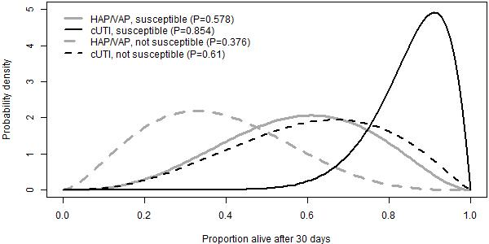
cUTI, complicated urinary tract infection; HAP/VAP, hospital-acquired pneumonia or ventilator-associated pneumonia; P, proportion

Figure 8. Expected LOS with HAP/VAP combined.
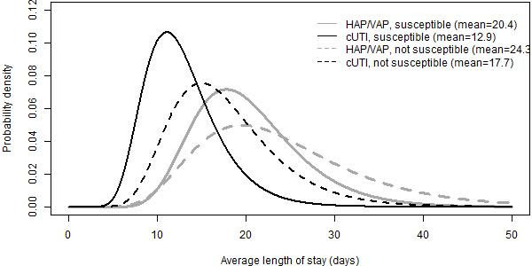
cUTI, complicated urinary tract infection; HAP/VAP, hospital-acquired pneumonia or ventilator-associated pneumonia

Table 14. Proportion (%) of hospital stay spent on ICU, HDU and general medical ward.
 | ICU | HDU | General medical ward
HAP/VAP, susceptible | 49.90 | 14.94 | 35.16
HAP/VAP, not susceptible | 58.92 | 17.21 | 23.86
cUTI, susceptible | 15.00 | 17.00 | 68.00
cUTI, not susceptible | 23.33 | 18.33 | 58.33
cUTI, complicated urinary tract infection; HAP/VAP, hospital-acquired pneumonia or ventilator-associated pneumonia; HDU, high dependency unit; ICU, intensive care unit

5.3.3 Validation of experts’ estimates
We explored alternative sources of evidence to inform LOS in the model, in order to validate the elicitation results. In particular, we considered two UK-based studies that reported LOS in patients with carbapenem-resistant organisms – CARBAR ¹⁰⁰ and Merrick ¹⁰¹, and the study by Muscedere ¹⁰² that was used to derive the relative reduction in the LOS associated with appropriate empiric therapy in the ES (further detail provided in section 7.2.3).

The mean LOS in CARBAR ¹⁰⁰ was 47.2 days. The median LOS in Muscedere ¹⁰² in patients who received appropriate and inappropriate empiric treatment was 27.9 and 42.2 days, respectively. This was estimated to equate to the mean LOS of 43.1 days and 85.7 days, respectively (further detail provided in section 7.2.3). The LOS in both studies was considerably longer than experts’ estimates (~20 and ~24 days from the start of microbiology directed treatment in susceptible and resistant patients, respectively). However, the LOS in both studies was measured from hospital admission, rather than from the start of microbiology directed treatment following infection onset.

CARBAR reported that the average time between hospitalisation and infection was 8 days (median) for all patients, 16.8 days (mean) time for infections diagnosed from sputum samples and 13.9 days for UTI-related samples. In addition, the median time between infection onset and microbiology directed treatment in CARBAR was 5 days. Assuming that 13 (8 + 5) to 21.8 (16.8+5) days passed between admission and administration of microbiology directed treatment, the LOS from the start of microbiology directed treatment in CARBAR (25.4 to 34.2 days) was comparable to experts’ estimates. Muscedere did not report the time between admission and infection onset, and so could not be directly compared to experts’ estimates. In Merrick ¹⁰¹, the median LOS after infections caused by carbapenem resistant organisms was 24 days, comparable to the mean estimates from experts. The authors did not report the mean.

- Economic evidence

6.1 Assessment of existing cost-effectiveness evidence and modelling approaches
A series of reviews of existing cost-effectiveness evidence and modelling approaches was conducted:
- A review of existing cost-effectiveness evidence for CAZ-AVI with a focus on studies that include decision-analytic models. The aims were to establish the existence of potentially policy-relevant models to guide NICE and NHS decisions; and to identify relevant analytical methods and data sources.
- A review of existing approaches to modelling the existence of resistant pathogens in the target population, currently and over time. The aim of this review was to identify methods that could be adopted for this purpose in EEPRU’s modelling.
- A review of existing cost-effectiveness models in HAP/VAP to understand modelling approaches and data sources.
- A review of existing cost-effectiveness models in cUTI. Again, the purpose was to understand modelling approaches and data sources.
Each review involved searches of bibliographic databases using standardized search terms, selection of studies based on explicit inclusion criteria and data extraction using an agreed template. Details of each review are provided in Appendix 12. Here the key results of each review are outlined.
    - Review 1: existing cost-effectiveness evidence for CAZ-AVI
A total of 89 potentially relevant papers or abstracts were identified for the review. When the various levels of screening were complete, 5 studies were included.^{14,103-106} All studies considered costs and benefits at a patient-level with no attempt to aggregate across the licensed CAZ-AVI indications likely to represent the product’s expected population. All studies had relatively short-term time horizons (3-5 years) and no attempt was made to consider the value of CAZ-AVI as resistance to the new and existing therapies increases over time. Three analyses made assumptions (rather than drawing on evidence) about the proportions of patients with resistant infection in the relevant population, and the impact of resistance on clinical parameters.^{14,103,104} The other two studies drew on evidence from observational studies to quantify the impact of resistance on relevant parameters in the modelling.^{105,106} The wider set of sources of value for novel antibiotics mentioned in Section 3.1 was not considered in any of the studies. None of the analyses related to clinical practice or evidence from the UK. As such, their relevance to this evaluation of CAZ-AVI is very limited.

    - Review 2: review of existing approaches for resistance modelling
Nine studies were included in this review. Note that this includes the 5 papers already identified from Review 1. As discussed under Review 1, the 5 studies looking at the cost-effectiveness of CAZ-AVI provided limited insights regarding how to reflect resistance in the modelling and no attempt was made to consider the implications of changes in resistance over time. The additional four studies in this review provided some indications of how resistance could be captured. One study assessed the appropriateness of alternative empiric therapies based on susceptibility data from a specific Taiwanese hospital.¹⁰⁷ Another looked at Procalcitonin-guided antibiotic stewardship and estimated the correlation between the percentage reduction in days of antibiotic use resulting from the Procalcitonin-guided test and antibiotic resistance.¹⁰⁸

The other two studies in this review attempted to deal with resistance through mechanistic infectious disease modelling. One used hypothetical data for illustrative purposes.¹⁰⁹ The other (which is a key source for the model detailed in the CAZ-AVI manufacturer’s submission – see Section 6.1.5) used the combination of a dynamic transmission model and a treatment pathway model as a generic framework to evaluate antibiotics for different indications and pathogens.¹¹⁰ In principle, such a model could be capable of quantifying not just the direct health effects of a new antibiotic, but also the indirect impacts via any reduction in transmission of relevant pathogens. It could also reflect changes in resistance over time in response to different stewardship strategies and the introduction of new antimicrobials. However, whether the model can achieve this in practice will inevitably depend on the available evidence and the assumptions necessary to address the evidence gaps.
    - Review 3: existing cost-effectiveness models in HAP/VAP
This review used an earlier systematic review ¹¹¹ to extract information on the characteristics of three relevant studies including target population, modelling assumptions, model structure and key evidence.¹¹²⁻¹¹⁴ All of these studies included standard cost-effectiveness models and did not consider the impact of alternative therapies on resistance patterns over time. One study attempted to include transmission rates in the modelling but this was not extrapolated to estimate population-level health effects.¹¹⁴ As a UK study, one study provided some potentially useful evidence sources for the current evaluation.¹¹²
    - Review 4: existing cost-effectiveness models in cUTI
One study was identified ¹¹⁵ in addition to the models in cUTI identified in Reviews 1 and 2 ^{104,106,107,110,116} As for Review 3, the UK-based studies provided some insights on evidence sources. The additional study,¹¹⁵ was US-based and used micro-simulation to track patients allowing for treatment switching as microbiological information becomes available. A surveillance dataset was used to sample isolates and to determine susceptibility to different treatments. This use of susceptibility data rather than standard in vivo evidence from RCTs and other designs is novel and has the potential to address modelling challenges.
    - Manufacturer economic model for CAZ-AVI
To support this assessment, the CAZ-AVI’s manufacturer submitted a model to evaluate the value of CAZ-AVI. This section provides an overview of the company’s submitted model. As shall be seen, there were high-level concerns about the relevance of the company’s submitted model and evaluation. In addition, for some areas, there was a lack of transparency on the processes that are driving the economic results. Because of these issues, this section does not provide a detailed critique of the company’s submitted model and evaluation.

The company’s submitted economic model considers CAZ-AVI as an additional treatment line for patients with three types of infections (cIAI, cUTI and HAP/VAP) caused by three Gram-negative bacterial species (E. coli, K. pneumoniae and Pseudomonas aeruginosa) for 1,000 patients in a single hospital. The comparator treatment is meropenem and either piperacillin/tazobactam (for cIAI or cUTI) or colistin (for HAP/VAP). The hospital is modelled as an infectious environment, with the transmission of infection occurring at a constant proportion of the infected population. Consequently, patients’ exposure to up to three AMs (when CAZ-AVI is used) is influenced by treatment efficacy and the prevalence of AMR in the infected population.

This section begins with an overview of the decision problem considered in the evaluation, followed by details of the submitted model structure (including its processes and results), followed by a discussion of areas where there was a lack of transparency in the model description and an explanation of the most substantive issues identified. It finishes with an overview of other issues of concern with the submitted model.

6.1.5.1 Summary of the company’s model
A summary of the model, including key elements of the decision problem (population, intervention, comparison and outcomes) is provided in Table 15.

The economic model’s estimate of the cost-effectiveness of CAZ-AVI accounts for the efficacy of CAZ-AVI and diversification strategies to prevent the development of AMR across all available treatment lines. The model is based on a multi-state disease transmission model which estimates the incidence and prevalence of bacterial infections within a single hospital infectious environment. Infections are caused by transmission from patient interactions, and environmental exposure. The multi-state disease transmission module is linked to a decision-tree treatment pathway module to determine the health economic impact of empiric usage of CAZ-AVI in all patients with cIAI, cUTI, and HAP/VAP. The model has a three lines strategy when examining the introduction of CAZ-AVI and two-line strategy examining the comparators. The model has a diversity-based strategy, where multiple AMs are used in the same line of the treatment pathway. The baseline diversity strategy means that patients are distributed evenly between each of the following treatment sequences in the CAZ-AVI arm:
- Treatment A → Treatment B → Treatment C
- Treatment B → Treatment A → Treatment C
- Treatment C → Treatment A → Treatment B

For example, the treatment lines for HAP/VAP when CAZ-AVI is introduced as an additional line is:
- Colistin → Meropenem → CAZ-AVI
- Meropenem → Colistin → CAZ-AVI
- CAZ-AVI → Colistin → Meropenem

The comparator line is without CAZ-AVI, and the treatment line is a sequence of two antibiotics:
- Colistin → Meropenem
- Meropenem → Colistin

Table 15: Description of key elements of the company model
Element | Description
Setting | 1,000 patients in a single hospital with an infectious environment. It was assumed that the number of admissions and discharges are equal in each cycle (i.e., the total number of patients modelled in the infectious environment is constant). Results are scaled-up to reflect 93,432 beds being occupied over a 10-year horizon.
Patients | Alive patients can be in one of three main health states: susceptible (not colonised or infected with a pathogen of interest); infected with a pathogen of interest; and colonised (but not infected). For infected and colonised patients a distinction is made between if the pathogen is sensitive or resistant.
Treatment pathways for high value clinical scenarios | Mainly risk-based empiric treatment pathways: 20% receive directed treatment (i.e. microbiological susceptibility testing has been performed) and 80% have empiric treatment (i.e. the pathogen and susceptibility profile of the infection are not yet known). It is unclear how ‘risk-based’ is defined.
Pathogen-mechanism | The economic analysis considers infection with three Gram-negative bacterial species across each indication:  - Escherichia coli  - Klebsiella pneumoniae  - Pseudomonas aeruginosa
Site of infection | Patients with the following common healthcare-associated infections:  - cIAI  - cUTI  - HAP/VAP
Intervention | CAZ-AVI as an additional treatment line (in combination with comparators)
Comparators | Meropenem and either piperacillin/tazobactam (for cIAI or cUTI) or colistin (for HAP/VAP) used in sequence
Outcomes | The economic analysis outputs were expressed in population NMB, with the effectiveness input measured in QALYs (and an assumed willingness to pay of £30,000 per QALY), to inform the potential annual value, estimated both over the full-time horizon of the economic model and the potential 10-year contract period.  In addition, the following outcomes are considered:  - Number of deaths  - Number of infections  - Number of patients eligible for CAZ-AVI  - LYs/QALYs lost due to infection
Elements of value as set out in the Evaluation Framework | Diversity value and transmission value are included in the modelled analysis. Both insurance and enablement value are only reflected in the modelled analysis to a very limited capacity
Study designs | The types of studies and data used to parametrise to the model are:  - RCTs  - Observational studies  - National and international datasets
cIAI, complicated intraabdominal infection; cUTI, complicated urinary tract infection; HAP/VAP, hospital-acquired pneumonia or ventilator-associated pneumonia; LYs, life years; NMB, net monetary benefit, QALYs, quality adjusted life years; RCTs, randomised controlled trials

The model has a time horizon of 10 years with monthly cycles. The transmission model pathway structure is outlined in Figure 9. During each model cycle, patients may move between discrete health states representing the following states: susceptible, colonised, infected health states, or death. Susceptible is the absence of infection and pathogen, colonised patients have a pathogen without clinical symptoms of infection and infected individuals carry the pathogen and have symptomatic infection. The colonised and infected health states are sub-divided according to whether pathogen is sensitive or resistant to specific antibiotics. Colonised or infected with a sensitive pathogen means there is no resistance to any of the modelled treatments while colonisation or infected with a resistant pathogen means resistance to either one, two, or three of the modelled treatments.

Figure 9: Diagram of the transmission pathway structure (from Figure 13 of the company submission)
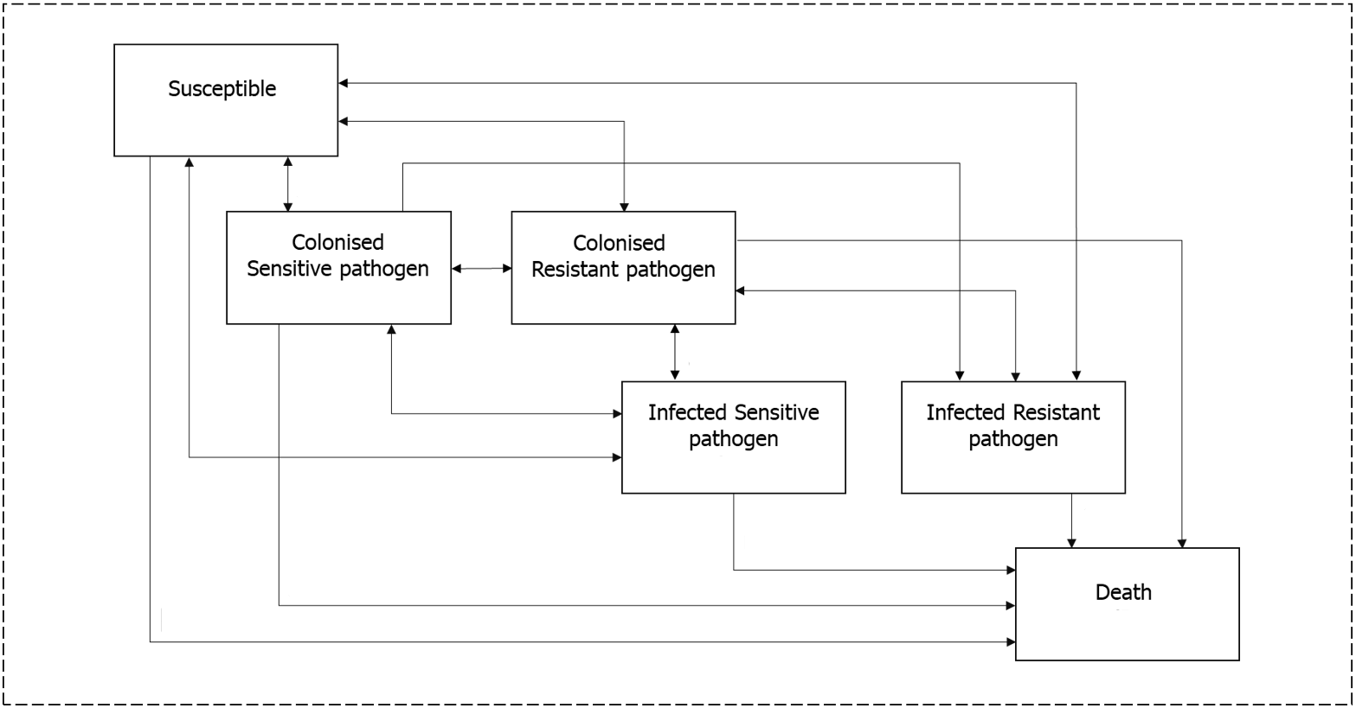

6.1.5.2 Pathways to health effect in the model
Health effects are the main drivers of cost-effectiveness results and are generated in the model from baseline resistance and treatment efficacy inputs. These inputs are summarised in Table 16 for CAZ-AVI and comparator treatments. There are five pathways to health effect all of which are influenced by the efficacy of, and baseline resistance to, the treatments. With greater efficacy and a lower level of baseline resistance the following health effects can occur:
- Direct patient benefits – clinical efficacy: it is more likely an infection will be cured without the need for any further treatment. This lowers the period of exposure to infection-related mortality, as patients in the infected health state incur a daily probability of mortality.
- Indirect patient benefits – additional treatment: it is less likely that the patient will be exposed to the assumption of immediate mortality from treatment failure across all lines; patients who have exhausted all available antibiotic treatment options and fail to clear the infection naturally are assumed to die three days after their last available line of treatment.
- Population-level benefits – infection transmission: a shorter period of infection resulting in fewer person-to-person transmissions of infections and a reduction in infection mortality.
- Population-level benefits – diversification and resistance development. It is more likely an infection will be cured without the need any further treatment. This reduces the selection pressure that would otherwise benefit resistance-giving mutations (since each additional treatment exerts its own selection pressure). The reduced selection pressure results in lower resistance levels and consequently infections are cured more often and more quickly, resulting in less mortality. In addition, a shorter period of infection means a greater chance of clearing pathogens naturally resulting in lower resistance levels. This is because when infections are cleared patients move to colonised or susceptible, and colonised patients then have an opportunity to clear pathogens naturally. In contrast patients who remain infected are assumed to be subject only to the efficacy of the treatment.

Table 16: Summary of baseline resistance and treatment efficacy parameters included in the CAZ-AVI model
Type of model input | Infection and pathogen | Piperacillin/  tazobactam | Meropenem | Colistin | CAZ-AVI
Baseline resistance | E.coli | 8.89% | 0.09% | 1.06% | 0.57%
Baseline resistance | K. pneumoniae | 14.62% | 0.87% | 3.15% | 5.31%
Baseline resistance | P. aeruginosa | 6.57% | 6.87% | 1.22% | 3.79%
Efficacy | In cUTI – E coli. | 91.6% | 71.9% | - | 78.4%
Efficacy | In cUTI – K. pneumoniae | 91.6% | 62.5% | - | 75.0%
Efficacy | In cUTI – P. aeruginosa | 91.6% | 75.0% | - | 66.7%
Efficacy | In cIAI – E coli. | 82.4% | 87.4% | - | 80.4%
Efficacy | In cIAI – K. pneumoniae | 82.4% | 75.5% | - | 78.4%
Efficacy | In cIAI – P. aeruginosa | 82.4% | 94.4% | - | 85.7%
Efficacy | In HAP/VAP – E coli. | - | 80.0% | 75.0% | 76.5%
Efficacy | In HAP/VAP – K. pneumoniae | - | 74.6% | 75.0% | 62.7%
Efficacy | In HAP/VAP – P. aeruginosa | - | 38.3% | 75.0% | 37.9%
cIAI, complicated intraabdominal infection; cUTI, complicated urinary tract infection; HAP/VAP, hospital-acquired pneumonia or ventilator-associated pneumonia

6.1.5.3 Detailed explanation of model structure
Patients who are susceptible or colonised may or may not become infected or colonised at the end of a cycle, as illustrated in Figure 10. Susceptible or colonised patients who are infected (at the end of a given cycle) move to the infected state at the start of the next cycle and will receive all lines of treatment within a single cycle. The spread and treatment of infection within the hospital environment is illustrated in Figure 10, and the pathway from first line of treatment is illustrated in Figure 11. Only infected patients receive active treatment.

Figure 10: Overview of transmission in the infectious environment (from Figure 4 of the company submission Appendix K)
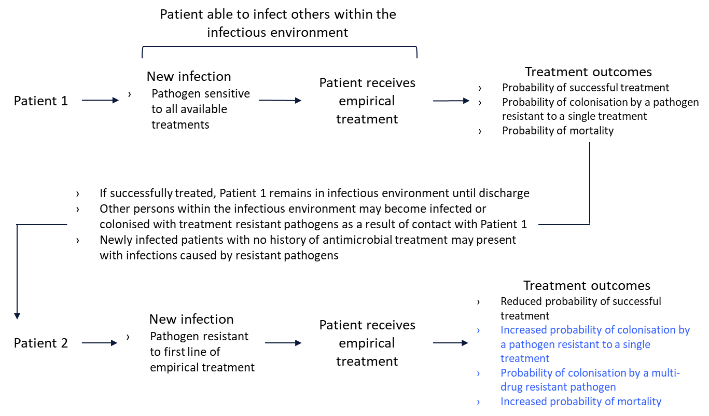

Figure 11: Overview of the treatment pathway (from Figure 13 of the company submission)
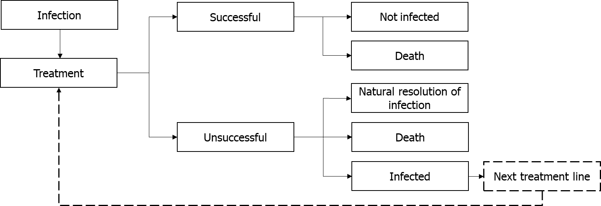

There are two pathways to the spread of infections and colonisations in a cycle. A susceptible patient may become infected or gain a pathogen (without infection) from direct transmission from patients who are infected or colonised, respectively, and this probability increases with the number of infected or colonised patients within the hospital. Colonised patients can become infected via direct contact with patients with the same strain (sensitive or resistant) of bacteria, and this probability of infection rises with the number of infected patients within the hospital. A constant proportion of colonised patients will also become infected from environmental exposure (with the proportion varying by type of pathogen). This represents spontaneous infection development in colonised patients from causes other than person-to-person transmission. In the absence of treatment, resistance in colonised patients is gradually lost at a fixed rate over time, which represents the pathogen being outcompeted by sensitive pathogens. As colonised patients do not receive AMs this is the only process by which they can be cleared of a resistant pathogen. There is no gradual loss of resistance in infected patients.

Infection may be viewed as a temporary state, as patients do not remain in it for more than one cycle (Figure 9). Clinical success is accounted for as clearance of symptoms of an infection, which may or may not result in the patient no longer being colonised by pathogen. If the infection is not cleared, the patient will move to the next line of treatment to which they may be sensitive, and any resistant pathogens will be retained. Infected patients who are resistant to their current antibiotic treatment regimen or exhausted all treatment options have a probability of naturally clearing their infection and pathogen while receiving treatment. Infected patients for whom the last available line of treatment was unsuccessful are assumed to die. These patients are replaced in the next cycle by new admissions that are in the susceptible or colonised state. Hence the number of individuals in the hospital remains constant (at 1000) and all infections are acquired within the hospital environment from person-to-person transmission rather than from admissions.

6.1.5.4 Overview of economic results
The economic results show the effect of adding CAZ-AVI as an additional treatment line to form a three-line diversified treatment strategy compared to a non-diversified two-line treatment strategy made up of existing drugs. The base case analysis is shown in Table 17. The introduction of CAZ-AVI had the greatest clinical benefits when used for treating HAP/VAP. When a weighted analysis was performed, combining results from all pathogens for each indication, the net monetary benefit (NMB) estimate was £598,779,222 over a 10-year time horizon at a cost per QALY threshold of £30,000.

Table 17: Base case analysis results; 1,000 patients over a 10-year horizon giving 93,432 beds occupied (from Table 62 of the company submission)
Infection | Treatment | QALYs lost due to infection | Incremental costs (£) | Incremental QALYs saved via infections avoided | NMB at cost per QALY threshold of £30,000
cUTI | CAZ-AVI | 3,392 | 9034.97 | 5,529 | £156,835,028
cUTI | No CAZ-AVI | 8,921 | 9034.97 | 5,529 | £156,835,028
cIAI | CAZ-AVI | 1,687 | 827.25 | 4,747 | £141,582,748
cIAI | No CAZ-AVI | 6,434 | 827.25 | 4,747 | £141,582,748
HAP/VAP | CAZ-AVI | 10,090 | 5968.55 | 10,211 | £300,361,446
HAP/VAP | No CAZ-AVI | 20,302 | 5968.55 | 10,211 | £300,361,446
All indications above combined | CAZ-AVI | 15,169 | 15830.78 | 20,487 | £598,779,222
All indications above combined | No CAZ-AVI | 35,657 | 15830.78 | 20,487 | £598,779,222
cIAI, complicated intraabdominal infection; cUTI, complicated urinary tract infection; HAP/VAP, hospital-acquired pneumonia or ventilator-associated pneumonia; NMB, net monetary benefit; QALYs, quality adjusted life years

A probabilistic sensitivity analyses was not conducted due to limited uncertainty information for parameters. Scenario analyses were conducted by altering the following base case values by +/- 10%: baseline resistance; infection incidence; treatment efficacy; treatment/hospital duration; rate of death; costs; utilities; inputs related to Clostridium difficile infections; inputs related to disease transmission parameters; patients with known resistance status (i.e., directed treatment).

In addition, a scenario explored the impact of varying the discount rate on costs and benefits at 1.5% and 5%. The results are presented in Tornado diagram (Figure 12). The major influences on NMB were treatment efficacy, discounting, utility, life expectancy and the transmission and clearance rate.

The following scenario analysis analyses were also considered: varying the baseline resistance by ± 20%; varying the percentage of patients receiving targeted treatment to 15% and 25%, applying a 3-year time horizon. The results are presented in Figure 13 and show minor variation across the scenarios with the results most sensitive to the 3-year time horizon scenario.

Figure 12: Tornado diagram showing uncertainty analysis (from Figure 17 of the company submission)
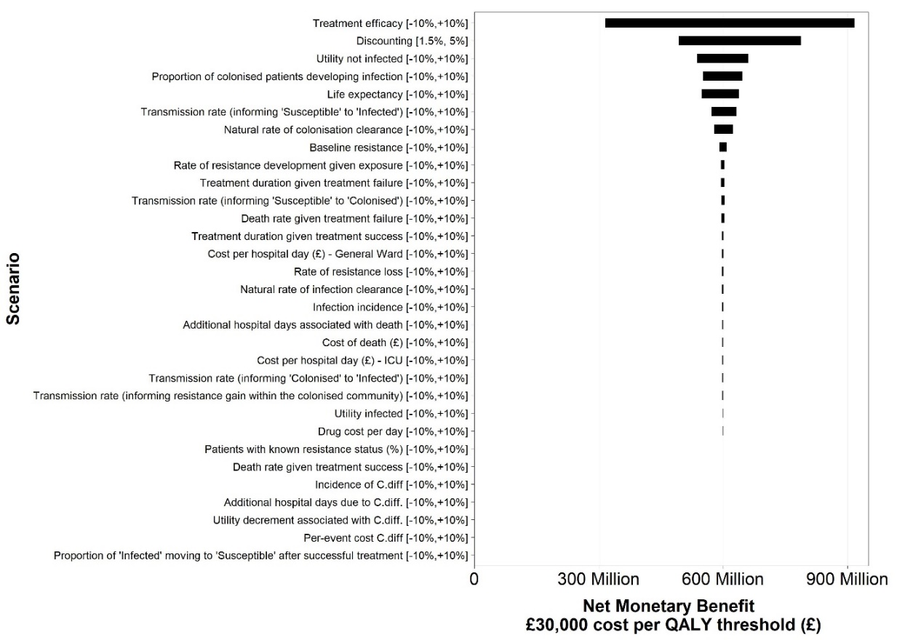

Figure 13: Annual NMB outcomes based on the uncertainty analysis on key model parameters (from Figure 16 of the company submission)
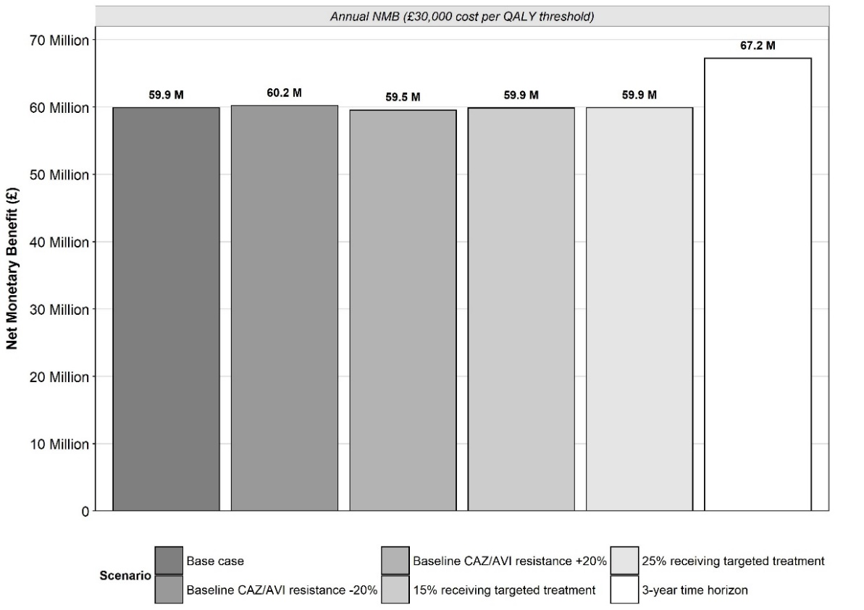

6.1.5.5 Areas of inconsistency or lack of clarity in the company submission
There were some key processes of the company’s submitted model which it was difficult to understand based on the submitted documentation. The following are key aspects of the model that were not transparent from the description provided in the submission:
- During the treatment pathway, a patient with an infection and sensitive pathogen may develop resistance from treatment and become infected with a resistant pathogen. Such changes are not represented in the model. The model structure necessitates the full treatment pathway (Figure 11) to be completed before there is a movement to a different health state (Figure 9).
- The model assumptions appear to be inconsistent regarding the transmission of resistant pathogens between colonised patients. The company submission states that “Patients may not move directly between different colonised health states” (p.182). This appears to contradict the model schematic.
- There is a transition from infected with a sensitive pathogen to colonised with a sensitive pathogen. The submission does not explain the mechanism of this transition.
- The description of treatment success is ambiguous in places: “after a patient is successfully treated, they may return to the susceptible or colonised health states” (p.160) is in contrast to a suggestion that the pathogen is always eliminated: “The proportion of infections cleared, denoted by the symbol φ, corresponds to the likelihood that a patient has been successfully treated, resulting in the patient no longer being infected or colonised by the pathogen.” (p.11, Appendix K)
- The model can allow treatment cycling to examine the impact of different stewardship strategies. The approach to treatment cycling adopted in the model is explained in detail in the submission. However, it appears that all results are presented without any form of treatment cycling because cycling is not mentioned in the company’s results section. Therefore, it is unclear why different approaches to treatment cycling were outlined.

Issues identified by the review group with the company’s model
A detailed discussion of key concerns is followed by a brief overview of other issues with the model.

- The company’s interpretation of the population considered likely to receive CAZ-AVI and the setting in which it would be received
In comparison to the PICOS developed for this assessment (see Table 1), the analyses submitted by the company capture a broader population of all patients with certain (cIAI, cUTI and HAP/VAP) hospital infections. Use in this population creates the risk of rapid emergence of resistance to CAZ-AVI and the treatment becoming obsolete.

The model assumes that on presentation, 20% of patients have known resistance and receive directed treatment rather than empirical treatment, meaning that they will not receive an antibiotic to which the infectious pathogen is resistant. Directed treatment in the model probably represents the proportion of first-line treatment that is informed by microbiology-testing. Based on clinical advice EEPRU considers that a more plausible model assumption is that most patients receive microbiology-directed treatment at the second line (that is, patients receive empiric treatment followed by microbiology-directed treatment where needed). The expected effect of this assumption in the model could be to reduce the level of infection and resistance in the hospital due to patients receiving an appropriate treatment by at least the second treatment line, resulting in lower infection related mortality which in turn reduces the health gains that can be attributable to the addition of CAZ-AVI. This approach (which corresponds to the modelling approach used by EEPRU) would also mean that only two treatment lines need modelling, again reducing the modelled benefits of CAZ-AVI which arise by virtue of it resulting in a third treatment line.

For those patients who receive first-line directed treatment, the model does not account for a delay of three to five days for the test results to be produced during which a patient may die from infection and incur hospital costs due to bed occupancy. Further, no evidence is provided for the assumed 20% rate of directed testing. The clinical advisors to EEPRU believe that the rates testing vary greatly across the UK. The variation in microbiology-directed testing rates may be due to variation across hospital in type of infection. Alternatively, delaying treatment to wait for test results may not be considered an option when an infection is life threating. For this reason, it is preferable that the economic model considers a wide range of different rates for directed testing.

Modelling assumptions concerning eradication of colonisation
A potentially important assumption within the model is that there can be complete eradication of colonisation with any pathogen (sensitive or resistant), and that treatment increases the likelihood of this occurring. The clinical advisors to EEPRU believe that complete eradication is unlikely to happen as there will always be a reservoir of the pathogen remaining in the gut. The influence on results of introducing this alternative assumption into the model is difficult to know due to the dynamic-transmission aspects of the model. However, if it is assumed that discharged patients are prone to developing the same pathogen again (and that this can further infections) the result will be a lower population health benefit from treatment including from the introduction of CAZ-AVI.

Issues with absence of information on the key drivers of net monetary benefit
The base-case NMB estimate, at a cost per QALY threshold of £30,000, was £598,779,222 for the three indications cUTI, cIAI, and HAP/VAP combined, in the population of England, over a 10-year time horizon. These results are shown in Table 17. The magnitude of the NMB is likely to be driven by additional health gains (QALYs) with the use of CAZ-AVI as the incremental costs are comparably small in the absence of CAZ-AVI acquisition costs. The incremental QALY gains are likely to be driven by differences in mortality rather than changes in utility during infection because the duration of disutility due to an infection is short: the duration of treatment is assumed to be two days for unsuccessful treatment and less than 10 days for successful treatment, whilst mortality occurs three days after the final unsuccessful treatment. If the NMB of CAZ-AVI is driven by differences in mortality from infection, it is unclear how these results were obtained. This is because CAZ-AVI is never the most effective treatment option, and any improvements in efficacy over comparators is modest (see Table 16). Similarly, CAZ-AVI never has the lowest rates of baseline resistance, and values are generally very similar to those for meropenem and colistin (see Table 16). This lack of clarity is compounded as the company’s submission does not go to reasonable lengths to provide a detailed analysis of what is driving this outcome.

The company presents a range of sensitivity analysis analyses of changes in key parameter values and the NMB results are found to be most sensitive to treatment efficacy as shown in Figure 12. However, absent from the sensitivity analysis is information on the relative contribution to incremental QALYs from treatment-related causes that are most likely to be driving mortality and hence the NMB results. The company submission is not transparent on how much of the improvement in mortality with CAZ-AVI is due to static effects in the model (direct patient benefits from the relative clinical efficacy of CAZ-AVI) and how much is due to the different dynamic aspects of the model that influence population-level benefits such as the health benefits from reduced infection transmission and from diversity strategies. To validate the plausibility of the economic results, information is needed on the QALYs gained in each distinct pathway of treatment effect on mortality. A potential explanation for the large NMB attributable to CAZ-AVI may be the specification of the comparators in the decision problem, as discussed next.

Implications of a two-line comparator treatment sequence
The comparators used in the company submission are shown in Table 18. This suggests that the company’s model applies a two-line sequence as the comparator (it is unclear if a treatment could be used twice). A clear justification for choice of comparators is not provided in the company’s submission. In addition, the assumption of a two-line comparator sequence is not supported by evidence as several antibiotics are likely to be effective in the non-resistance enriched patient population considered by the model. For example, the EEPRU’s PICOS in Table 1 lists several AMs. The inclusion of one of these would allow for treatment sequences with three (or more) treatments in the company’s model.

Patients who have exhausted all available antibiotic treatment options and fail to clear the infection naturally are assumed to die after three days. Hence the addition of any drug to a treatment sequence is expected to generate an advantage when compared to a two-line sequence. Further, it is unclear if person-to-person transmission of resistance is greater in two-line treatment lines compared to a three-line sequence in the company’s model. A difference would be due to the reduced benefit from diversification: there is less opportunity in a two-line sequence for infected patients to move to the colonised state before exhausting available treatments, and patients are assumed to gradually lose resistance at a fixed rate over time only when in a colonised state.

As previously noted, clinical advisors to EEPRU suggest that microbiologic testing is appropriate for the infections considered. The company considers a broadly empiric strategy for all treatment lines, this will enhance the relative benefits of a three-line treatment sequence compared to a two-line comparator sequence.

Table 18: Summary of intervention technology and comparators across indications
Intervention | Indication cIAI | Indication cUTI | Indication HAP/VAP
Piperacillin/tazobactam (Pip/Taz)
Colistin
Meropenem
CAZ-AVI
cIAI, complicated intraabdominal infection; cUTI, complicated urinary tract infection; HAP/VAP, hospital-acquired pneumonia or ventilator-associated pneumonia

Further sources of concern in the NMB calculation
There is uncertainty in the appropriateness of the population size used in the NMB calculations, which is not fully justified. The company submission states that the population level in England was “based on 2019 overnight hospital bed occupancy where it was assumed 93,432 beds in England are constantly occupied in the general and acute wards” (p.159) and that approximately 3,100 patients per annum over a 10-year period were used (p16). The sources and calculations used to establish the overall population size are not clearly stated. If the population size is unreasonably large, this will magnify the NMB of CAZ-AVI. Further, as previously noted, the submitted analyses consider an indication for CAZ-AVI that is broader than that expected by the clinical advisors to EEPRU. An increase in patient numbers receiving CAZ-AVI will contribute to health gains associated with the CAZ-AVI arm and hence NMB.

The model appears to have overestimated the health losses of patients from mortality, which is expected to advantage the per patient NMB of introducing CAZ-AVI. This is because the corresponding QALY decrement was derived by comparing the health utility and life expectancy of infected patients to the general population. A more accurate comparison would be to people who are in contact with the health system and at high risk of infection; such patients are likely to have a worse quality of life and life expectancy than the general population. Furthermore, it is unclear if discounting was applied to each additional year of expected survival of non-infected patients. The choice of a cost-effectiveness threshold of £30,000 is also not justified.

6.1.5.6 Other concerns with the model
The following are additional limitations of the model:
- All transition parameters were established from calibration to infection incidence and resistance development time-series data reported by PHE and Fingertips. Model calibration is conducted with reference to national resistance and incidence data in all settings. Calibration to the subset of data available from hospital settings (acute trusts) is more appropriate given that the model simulates a hospital environment and the greater use of antibiotics in hospital environments means the rates of resistance are typically larger than in the community.
- The model requires evidence for a large number of parameters to allow the prediction of outcomes. As such, a significant number of data-related assumptions was required to produce the published outcomes. There do not appear to be any formal structured expert elicitation exercises to reduce this reliance on assumptions. This is a concern as there is no validation of the model outcomes to additional data sources. This may be because of the limited range of data sources on resistance and incidence. Validation of the model could assess the extent it can predict historical time trends outside the range of years used in calibration (i.e. prior to 2013 and after the year 2018) from the same data sources.
- The model assumes that AM use drives resistance. The reverse may also hold, for example due to considerations of AM stewardship, known resistance may lead to reduced use of an AM. Therefore, it is preferable if calibration is to data that includes the rate of consumption of antibiotics in hospitals to allow the model to construct a more complete picture of the ecological forces that drive the spread of antibiotic resistance.
- The output of the model does not include any estimate of uncertainty from a probabilistic sensitivity analysis.
- The base case NMB estimates appear to be for a scenario without any treatment cycling. However, the benefits of treatment cycling may already be accounted for in the results because the rate of resistance data used in calibration to determine key transmission parameters in the model will include any cycling behaviour between antibiotics that has taken place in England.

6.1.5.7 Conclusion
The company has submitted a dynamic cohort-based model to analyse the NMB associated with the introduction of CAZ-AVI. The model considers changing the pattern of use of existing AMs in an infectious environment with a constant number of patients but changing proportions that are susceptible, colonised and infected. Pathogens may be resistant or sensitive to treatment. The base-case NMB estimate was £598,779,222 (at a cost-effectiveness threshold of £30,000/QALY) for the three indications cUTI, cIAI, and HAP/VAP combined in the population of England over a 10-year time horizon.

There is concern that the population considered in the model diverges from the guidance provided by clinical advisors to EEPRU, where usage of CAZ-AVI would be restricted to patients that are suspected of having a carbapenem-resistant infection. The broader use of CAZ-AVI in the company’s model will contribute to an increased population NMB estimate. In addition, the model assumes that treatment can completely eradicate patients of colonisation with a sensitive or resistant pathogen. This also diverges from the clinical advice given to EEPRU.

Single use of CAZ-AVI compared to a single comparator could be expected to generate broadly similar rates of mortality given the broadly similar efficacy and baseline resistance of CAZ-AVI and alternative treatments. Therefore, the large NMB may be accounted for by the dynamic aspects of the model such as the diversification stewardship strategy and the company’s approach to the decision problem, with no microbiology-directed tested treatment sequence, and a three-line treatment sequence with CAZ-AVI compared to a two-line comparator. The company has not provided an account of the processes driving the large health benefits in the model.

- Methods for EEPRU quantitative assessment of value
  - Overview of EEPRU approach
The quantitative economic analysis developed for this appraisal comprises three components: an assessment of the INHEs of introducing CAZ-AVI within the HVCSs at the patient level; an assessment of INHEs within the HVCSs at the population level; and an assessment of how population-level INHEs within the HVCSs might appropriately be rescaled to reflect expected usage across the NHS. An overview of each component is provided below, and the methods for each component are described in the following sections of Section 7.1. In line with the NICE Reference Case, the model perspective is the NHS and Personal and Social Services, health benefits are expressed in terms of quality-adjusted life years (QALYs) and both costs and QALYs are discounted at a rate of 3.5% per annum.
The patient-level component of the model is structured similarly to models developed as part of other NICE programmes, and characterises the likely comparative effectiveness of CAZ-AVI and existing AM usage scenarios; also the impact of CAZ-AVI and existing AM usage scenarios on costs, HRQoL and mortality over the lifetime of the patient.
The population-level component aggregates the patient-level predictions to the population level accounting for the size of, and growth over time in, the eligible patient population in England within each HVCS. This component also reflects how resistance is likely to develop to CAZ-AVI and existing AMs over time. The previous EEPRU framework outlined two broad approaches to modelling this: mechanistic dynamic transmission modelling, which attempts to explain the way in which susceptible and resistant pathogens spread through the population; and statistical forecasting models which predict the number of people with infections with specific resistance profiles without explicitly modelling the underlying mechanistic processes of pathogen transmission and resistance acquisition.¹³ We considered both approaches, but ultimately used a forecast-based approach, for reasons detailed below.
The use of a transmission model was considered but not pursued on three grounds. Firstly, developing a mechanistic transmission model that characterises the spread of carbapenem-resistant organisms, with an adequate level of detail to model the introduction of CAZ-AVI, and that is appropriately calibrated to historical epidemiological data was not considered feasible within the time and resources available for this 9-month project. Secondly, our clinical advisors considered that the direction and magnitude of the effects of the new treatments on transmission were uncertain and not well evidenced (see Section 8.3). Thirdly, advice during our previous EEPRU work ¹³ indicated that transmission modelling in AMR is an evolving science where the degree of parameter and structural uncertainty can lead to instability in model predictions and that, although there is no guarantee that a forecast-based approach will offer more certain or robust predictions, it should offer greater transparency. The company submitted a transmission model which we review in detail in Section 6.1.5. This highlighted some of the challenges of developing and communicating these types of models in a way that allows appropriate levels of scrutiny of their outputs.
The final quantitative assessment performed is to rescale the population INHEs observed in the HVCSs to reflect expected usage. This part of the quantitative assessment takes a very pragmatic approach seeking to identify the range of clinical scenarios in which CAZ-AVI is expected to be used, enumerate the corresponding population sizes using the best available evidence, and rescale the population INHEs estimated for the HVCS accordingly.
The literature on the economic evaluation of AMs has described a range of elements of value associated with these products that are not relevant to and therefore do not feature in evaluations of other drugs and health technologies.^{13,117} Following presentation of the quantitative assessments of value, we therefore discuss whether these additional elements of value might be delivered via use of CAZ-AVI, the extent to which they are captured by our quantitative assessments, and where they are not captured whether they are likely to substantively modify the estimates of value presented (see Section 8.3
  - Modelling direct patient net health effects (NHE) in HVCS

7.2.1 Relationship with decision problem

7.2.1.1 Population
The patient populations modelled align with the decision problem outlined in Section 3. These are summarised in Table 19.
Table 19: HVCS patient populations modelled
Site | Pathogen | Mechanism | Setting
HAP/VAP | Enterobacterales | OXA-48 | Microbiology-directed
HAP/VAP | Enterobacterales | OXA-48 | Risk-based empiric treatment
cUTI | Enterobacterales | OXA-48 | Microbiology-directed
cUTI, complicated urinary tract infection; HAP/VAP, hospital-acquired pneumonia or ventilator-associated pneumonia; OXA, oxicillinase

7.2.1.2 Intervention
CAZ-AVI is considered as monotherapy only due to a lack of in vivo or in vitro evidence about how it performs in combination with other agents. The clinical advisors confirmed that monotherapy was more likely to be used in practice.

7.2.1.3 Comparators
A wide range of drugs is considered relevant in the HVCS, and different drugs were considered relevant depending on the site, pathogen, mechanism and setting. The full list of comparators is provided in Section 3. Due to the paucity of data available to inform the comparative effectiveness assessment (see Chapter 4), and our reliance on in vitro susceptibility data to inform comparative effectiveness, it was possible to take a simplified approach to modelling these comparators rather than conducting a fully incremental analysis of all available AM options as is typically recommended in economic evaluation. The approach taken is documented in the following section.

7.2.2 Model structure
The model structure differs according to the setting (MDS or ES) but not the site, pathogen or mechanism of resistance. We describe the structure for the MDS first as it is more straightforward and forms part of the ES model structure.
Due to the paucity of in vivo data relevant to the modelled HVCS (see Section 4.4.2), we have assumed that differences across treatments in in vitro susceptibility are predictive of in vivo clinical outcomes. This was considered reasonable by the clinical advisors to this project, and evidence relating to treatment susceptibility as a surrogate for clinical outcomes is reviewed in Section 4.6.2. We link susceptibility to time in hospital and mortality. We do not model the development of infection sequalae such as sepsis. This would have required a range of additional evidence including the rate of development of sepsis, how this relates to susceptibility to the treatment administered, and mortality and hospitalisation outcomes conditional upon whether a patient developed sepsis. Given the sparsity of evidence available, including these additional parameters was not considered appropriate. We would, however, expect 30-day mortality and hospitalisation outcomes to implicitly reflect the possibility that patients will develop additional complications including sepsis. Repeat infection following discharge was also not explicitly modelled (though will be implicitly reflected in the mortality data) as these were considered unlikely to be a significant driver of population INHEs in the HVCS.
As well as differences in effectiveness, we model differences in treatment safety. We focus on nephrotoxicity and, in particular, the occurrence of AKI. This was considered to have the most significant implications for the modelling in terms of driving treatment choices (with clinicians keen to avoid highly nephrotoxic comparator drugs), and influencing INHEs as CAZ-AVI is expected to be associated with lower rates of nephrotoxicity than some comparators.
Ototoxicity was raised by our clinical advisors as a safety concern associated with use of aminoglycosides. This was not modelled as it was expected that significant hearing impairment associated with aminoglycosides would be rare in this patient group.¹¹⁸ Reduced rates of clostridium difficile infection were highlighted by a number of stakeholders as a potential benefit of the new drugs. This was not included in the modelling as rates of clostridium difficile are very low,¹¹⁹ (Section 4.6.4).

7.2.2.1 Model structure for microbiology directed setting
In the MDS, each patient’s susceptibility to available treatment options is known, and treatment can be tailored accordingly. Based on feedback from our clinical advisors, the two main reasons for initiating treatment with CAZ-AVI (provided patients are susceptible to it) within the MDS HVCS would be that patients are either: (i) not susceptible to any other available treatment options (i.e., patients are completely MDR to relevant existing treatment options); or (ii) that the only other treatments to which they are susceptible carry an elevated risk of nephrotoxicity. We include colistin and aminoglycosides within the category of nephrotoxic drugs as our clinical advisors indicated that they are likely to be associated with elevated levels of nephrotoxicity. To reflect these considerations, patients within the MDS are divided into three categories based on their susceptibility to existing therapies and, within each category, further subdivided according to their susceptibility to CAZ-AVI. Table 20 shows these subgroups, how they determine treatment choice under existing care, and how that would change if CAZ-AVI was to become available to this patient group. The groups for which a switch to CAZ-AVI is expected are highlighted in bold.
In the group of patients who are susceptible only to colistin or an aminoglycoside, and susceptible to CAZ-AVI, CAZ-AVI offers a safety advantage. In the group of patients who are not susceptible to any available treatment options and, in the absence of the new treatments under evaluation, would receive multi-drug salvage therapy, CAZ-AVI offers a safety and efficacy advantage. This is because, for many patients, multi-drug salvage therapy would be expected to include a colistin or aminoglycoside component. Throughout the modelling, isolates classed as intermediate resistant are grouped with those which are resistant as patients infected with intermediate resistant and resistant pathogens are expected to experience similar outcomes in the HVCS based on feedback from EEPRU’s clinical advisors, and much of the data relating mortality and hospitalisation to susceptibility follows this grouping. Our clinical advisors noted that it may be possible to overcome intermediate resistance via higher dosing, but also considered that it would be difficult to evidence this within the model. Given the diverse range of data sources informing susceptibility and the link between susceptibility and outcomes, and the level of reporting within these studies, it was not feasible to explore the implications of differential outcomes between intermediate resistant and resistant patients.
In the MDS the model is, therefore, driven by the proportion of individuals within each category of “susceptibility to existing drugs” and the proportion of individuals susceptible to CAZ-AVI. This is based on susceptibility data as documented in Sections 4.4.2 to 4.5.4. The comparison made within the model is between the overall MDS cohort who receive tailored therapy with the new drug available (column four of Table 20) and the overall MDS cohort who receive tailored therapy under existing treatment options only (column 3 of Table 20).

Table 20: Subgroups within the MDS and their treatment choices
Susceptibility to existing drugs | Susceptibility to CAZ-AVI | Therapy under existing care | Therapy with new drug available
Susceptible to one or more non-colistin/aminoglycosides option | Susceptible | Non-colistin/amino | Non-colistin/amino
 | Resistant | Non-colistin/amino | Non-colistin/amino
Susceptible only to colistin or aminoglycosides | Susceptible | Colistin/amino-based | CAZ-AVI
Susceptible only to colistin or aminoglycosides | Resistant | Colistin/amino-based | Colistin/amino-based
Not susceptible to any available treatment options | Susceptible | Multi-drug salvage | CAZ-AVI
Not susceptible to any available treatment options | Resistant | Multi-drug salvage | Multi-drug salvage
Notes: orange indicates that clinician initiates treatment with drug with poor safety, red indicates that clinician initiates treatment with drug with poor efficacy (and possibly safety). Bold indicates patient groups for whom susceptibility evidence would initiate a switch to CAZ-AVI.

Importantly, the fact that the susceptibility profile is known prior to initiation of treatment in the MDS, alongside the assumption that susceptibility is the sole predictor of treatment effectiveness, means that we do not need to model each individual treatment option within the MDS. For example, it is not relevant (to clinical outcomes) whether a patient is susceptible to fosfomycin or aztreonam, as susceptibility to these treatments would be assumed to result in the same outcomes. Although there are differences in the costs of therapies, these are modest in relation to other costs such as that of hospitalisations which may include periods in the ICU/HDU. In practice, patients may receive a combination of agents, but this is not modelled explicitly due to a lack of evidence. The clinical advisors considered it reasonable to assume that, in the MDS, patients susceptible to a single AM within a multi-agent regimen perform as well as those susceptible to all components of that regimen (i.e. it does not matter if you are susceptible to drug A, drug B or drug A and B as long as you are susceptible to one of the agents received).
Following receipt of treatment in the MDS, patients are modelled to experience one of four alternative 30-day outcomes which determine their long-term outcomes (Figure 14). A decision tree is used to determine the distribution of patients across these categories at 30 days. This is as shown in (Figure 15). Probabilities highlighted in bold differ by treatment in this figure. In the MDS we only model one line of treatment explicitly, though hospitalisation and mortality evidence will reflect the fact that some patients entering the MDS receive multiple lines of therapy.
All patients face a risk of death due to their infection and comorbidities (p_bgrdD30d_MDS). The risk differs according to whether patients have received a treatment to which they are susceptible or not. In the MDS, given that treatments are tailored according to patients’ known susceptibility profiles, only patients infected with a fully MDR infection (who receive multi-drug salvage treatment) are expected to face the elevated risk of death of those non-susceptible to treatment. The efficacy advantage of CAZ-AVI is, therefore, driven by the proportion of people who switch from “multi-drug salvage” to CAZ-AVI in Table 20 as these patients switch from experiencing the mortality of non-susceptible patients to experiencing the mortality of susceptible patients.
In addition, patients face differing drug-related risks of experiencing an AKI. Patients who experience an AKI face an elevated risk of death compared to those who do not. When modelling the effect of AKI on mortality, we account for the fact that the available mortality data already reflect both the underlying risk of AKI associated with currently available non-colistin/aminoglycoside AMs and the background risk of AKI associated with patients underlying comorbidities and infection (see Figure 15.). Patients who experience an AKI and survive until 30 days face a risk of adverse long-term outcomes according to whether they have: (i) recovered their renal function; or (ii) suffered irreversible renal failure i.e., developed chronic kidney disease (CKD).

Figure 14: 30-day outcomes in the MDS
1- Dead

3- Alive post- AKI with recovered renal function
‘
4- Alive post- AKI with irreversible renal failure
‘
2- Alive no AKI
‘
1- Dead

3- Alive post- AKI with recovered renal function
‘
4- Alive post- AKI with irreversible renal failure
‘
2- Alive no AKI
‘

Figure 15: Decision tree used to calculate impact of AKIs on 30-day outcomes in MDS

At 30 days, patients who are discharged alive without renal dysfunction are assigned a comorbidity-adjusted QALY outcome estimated using an alive-dead area-under-the-curve approach. This is independent of the assigned treatment, as patients alive at 30 days without a history of AKI are assumed to experience similar outcomes regardless of the treatment they received for their infection.
Patients discharged with recovered renal function face the same HRQoL outcomes, but they face an additional risk of progressing to CKD and elevated mortality. Patients discharged with CKD or who develop CKD face further elevated mortality, reduced HRQoL and additional health care costs. The experience of the two groups of patients with a history of AKI is modelled as a semi-Markov process (with transition probabilities dependent on time in model) for all transitions as shown in Figure 16.

Figure 16: Markov model used to calculate post-30-day outcomes in patients with recovered renal function and irreversible renal failure

7.2.2.2 Model structure for the risk-based empiric setting (ES)
The approach taken in the ES is similar to that taken in the MDS in terms of the possible 30-day outcomes patients can experience and the long-term implications of these outcomes. However, the decision tree describing differences across comparators in the first 30-days is more complex for two reasons. Firstly, there is a need to model outcomes both in those correctly identified as having the pathogen-mechanism combination suspected, as well as those who were labelled as high-risk but in fact have a different causative pathogen or mechanism. Secondly, there is a need to model both the ES phase of treatment, and progression of some patients to the MDS for further treatment.
Unlike in the MDS, in the ES the susceptibility of patients to treatments provided is unknown at the time of initiating empiric treatment. It is, therefore, necessary to model the probability of susceptibility to individual treatment combinations as this determines clinical outcomes and, in particular, the need for further treatment. Since, as documented in Section 3.2.3.1, there are a number of feasible treatment combinations for these patients, to simplify the modelling we compare empiric use of CAZ-AVI in the ES to two alternative treatment options:
- The non-colistin or aminoglycoside-based treatment combination with the current highest estimated susceptibility in the UK population.
- The colistin or aminoglycoside-based treatment combination with the current highest estimated susceptibility in the UK population.
When considering possible treatment pathways in the ES, three possible pathways are relevant:
ES1: empiric use of CAZ-AVI followed by existing treatments in the MDS.
ES2: empiric treatment using existing therapies followed by CAZ-AVI in the MDS.
ES3: use of existing therapies in both the ES and MDS.
The full list of comparators in the ES is summarised in Table 21 alongside their shorthand labels which are used in the results section.

Table 21: Comparator treatment pathways in the ES
Empiric treatment | MDS treatment | Shorthand label
CAZ-AVI | Existing therapies | E1
Non-colistin or aminoglycoside-based | Existing therapies | E2nca
Colistin or aminoglycoside-based | Existing therapies | E2ca
Non-colistin or aminoglycoside-based | CAZ-AVI used if indicated in the MDS (see Table 20) | E3nca
Colistin or aminoglycoside-based | CAZ-AVI used if indicated in the MDS (see Table 20) | E3ca
ES, empiric setting; MDS, microbiology-directed

Repeated usage of CAZ-AVI in the MDS for patients who fail CAZ-AVI in the ES was not modelled as this was not considered to represent a priority use for CAZ-AVI.
Thirty-day outcomes in the ES are determined by a decision tree which comprises three-subcomponents:
- the risk of carrying the pathogen-mechanism of concern;
- outcomes at the point at which patients are assessed for MDS treatment, i.e. at around 3-5 days when susceptibility results report; and
- 30-day outcomes following MDS assessment.

Each of these is considered in more detail below.

- Risks of carrying the pathogen-mechanism of concern
Patients may or may not have the suspected pathogen-mechanism of concern. We assume that patients who do not have the pathogen-mechanism of interest experience the same effectiveness outcomes regardless of the choice of empiric treatment (though safety differs), as our clinical advisors confirmed that these patients represented a broadly susceptible population (rather than a population enriched with pathogens carrying other resistance mechanisms) and that for this reason effectiveness is likely to be similar across all empiric treatment options considered. For simplicity we assume that patients who have a different pathogen-mechanism experience the susceptibility associated with colistin/aminoglycoside-based therapy in people with the pathogen-mechanism of interest regardless of the choice of treatment. Colistin/aminoglycoside-based therapy was chosen as more representative of outcomes across susceptible patients as this treatment class showed robust and high susceptibility across subgroups and scenarios. The structure of this element of the ES model is presented as Figure 17.

Figure 17: First component of 30-day outcomes model for ES: risk of carrying pathogen-mechanism of concern

- Outcomes at the point at which patients are assessed for MD treatment
At initiation of empiric treatment patients are classified by the model as susceptible or non-susceptible to their empiric therapy (Figure 18). As in the MDS, susceptibility is the driver of differences in effectiveness across treatments. Note that we are able to model differences in susceptibility across treatments used in the ES dependent on whether a patient is susceptible or non-susceptible, even though clinicians will not observe this information until patients enter the MDS.
At the point at which patients’ microbiology results become available, patients may have died, may require initiation of a new AM treatment (e.g., due to lack of efficacy) or may complete their course of empiric treatment (Figure 18). The probability of these three outcomes depends on whether patients were susceptible to their empiric treatment or not, but not directly on the choice of specific treatment. Patients who have received empirically a treatment to which they are later found not to be susceptible are all assumed to require further treatment in the MDS, provided they survive until microbiology results are available. This assumption is based on evidence presented in Tumbarello et al 2013 which found that all patients who received inappropriate empiric treatment and survived until their microbiology results were received switched to appropriate therapy (further details on Tumbarello are provided in section 7.2.3.3).¹²⁰

Figure 18: Second component of 30-day outcomes model for ES: outcomes at the point at which patients are assessed for MD treatment. Note that mortality (p_bgrd_Dst_S and p_bgrdDst_nonS) is also adjusted to reflected differences in mortality due to AKI, in the same way as shown in Figure 6, but this is not shown for parsimony.

- 30-day outcomes following assessment for MD treatment
People who survive until the time point of assessment for MD treatment enter the third part of the decision tree which is shown in Figure 19. Those requiring no further treatment face a risk of dying between this point and 30 days which depends on whether they experienced an AKI. Those surviving to 30 days face the possibility of entering the (i) alive; (ii) alive with recovered renal function or (iii) alive with irreversible renal failure health states described in Figure 19. Whilst patients may experience an AKI following empiric treatment, clinicians confirmed that in this patient group, where treatment options are limited, the AKI alone would not typically trigger a treatment switch, provided the treatment was effective.
Patients who require further treatment enter the MDS component of the model. Their outcomes depend on whether they experienced an AKI following first-line treatment (i.e., this is “remembered” within the model) as this determines both their outcomes (patients who experience an AKI experience elevated mortality and the implications of reversible or irreversible kidney damage) and their choice of treatment in the MDS. Our clinical advisors informed us that patients requiring further treatment in the MDS, who experienced an AKI following treatment in the ES are unlikely to receive colistin- or aminoglycoside-based treatment in the MDS. Patients who fit this profile, and are only susceptible to colistin or aminoglycoside-based treatment are, therefore, assumed to receive multi-drug salvage therapy in the MDS, or the new drug if available. For these patients, multi-drug salvage therapy is assumed not to include colistin or an aminoglyscoside. Instead, they are assumed to receive the outcomes of multi-drug salvage therapy without elevated risk of AKI.

Figure 19: Third component of 30-day outcomes model for ES: 30-day outcomes following assessment for MDS treatment

In the absence of evidence to support more detailed modelling, we assume that a patient’s susceptibility to treatment is the same in the ES and MDS. In reality, patients entering the MDS who were already assessed as high-risk of carrying a highly resistant pathogen in the ES are likely to receive aggressive treatments in the ES which may change their resistance profile in the MDS. The nature of the effects on individual resistance are hard to predict as they are influenced by the treatment received in the ES, the effectiveness of this treatment and the development of acquired resistance. These are not, therefore, considered within the model.

7.2.3 Sources of evidence

7.2.3.1 Identification of evidence
Susceptibility evidence and evidence linking susceptibility to mortality and hospitalisation was obtained via the systematic reviews and structured expert elicitation described in Sections 4 and 5. Other key clinical parameters were obtained from existing systematic reviews where possible, otherwise clinical parameters were obtained from existing UK cost-effectiveness models. HRQOL weights (utilities) were obtained from a systematic review (described below) and cost parameters via targeted searches.

7.2.3.2 Clinical parameters – susceptibility evidence
The susceptibility data used in the model base case analysis are summarised in Table 22. These represent the mean values of the samples used in the probabilistic sensitivity analysis, along with 95% percentile-based confidence intervals. Five key susceptibility parameters inform the model:
- One parameter describes susceptibility to CAZ-AVI in the MDS and ES.
- Two parameters describe susceptibility to colistin/aminoglycoside-based therapy and to non-colistin/aminoglycoside-based therapy in the ES.
- Two parameters describe the number of individuals in each category of susceptibility in the MDS as shown in Table 20 (namely susceptible to a non-colistin/aminoglycoside AM, susceptible only to a colistin/aminoglycoside AM).
Susceptibility to existing drugs is obtained from both the analysis of PHE data and the NMA, as described in Section 4.5. These analyses can be combined to provide evidence on absolute rates of susceptibility to AMs for the HVCSs. This evidence required further adjustment before it could be used in the economic model, with different adjustments for the ES and MDS. The methods employed to obtain estimates for these two settings are discussed in turn, with further details provided in Appendix 13. Of note, whilst evidence on susceptibility to meropenem was available, this was not used in the economic modelling. This is because clinical advice was that, for meropenem, susceptibility amongst carabepenem-producing pathogens was not a good surrogate predictor of clinical outcomes. This reflects advice in the literature.^{64,121} Hence, whilst meropenem is included as a comparator in the PICOS, it is assumed to have zero efficacy in the economic modelling (and so not actively modelled).
Susceptibility is estimated to be specific to the pathogen-mechanism subgroup of interest, but is assumed to generalise across sites and settings. This was considered a reasonable assumption by our clinical advisors and preferable to further subgrouping the susceptibility data given the small sample sizes available to inform these parameter estimates for the HVCSs. Due to this assumption there was one deviation from the PICOS, with tigecycline used for both sites (cUTI and HAP/VAP). In the PICOS, tigecylcline was only included for HAP/VAP.

Table 22: Susceptibility parameters by pathogen-mechanism subgroup (all evidence was from a combination of PHE data and the NMA)
Pathogen-mechanism subgroup | Description | Value | 95% CI
Enterobacterales/OXA-48 | Proportion of isolates susceptible to one or more non-colistin/aminoglycosides option | 65% | 55% to 75%
Enterobacterales/OXA-48 | Proportion of isolates susceptible only to colistin or aminoglycosides | 35% | 25% to 45%
Enterobacterales/OXA-48 | Proportion of isolates susceptible to CAZ-AVI | 92% | 77% to 98%
Enterobacterales/OXA-48 | Proportion of isolates susceptible to the most effective non-colistin/aminoglycoside-based empiric treatment | 35% | 7% to 79%
Enterobacterales/OXA-48 | Proportion of isolates susceptible to the most effective colistin/aminoglycoside-based empiric treatment | 94% | 88% to 98%

CI: Confidence interval; OXA, oxicillinase
NB: For the MBL population the PICOS does not include any treatments in the ES that do not include colistin or an aminoglycoside.

Susceptibility for antimicrobials used in the empiric setting
Clinical advice, as reflected in the PICO, was that combination treatment was frequently used in the ES. Hence evidence on absolute susceptibilities for individual drugs needed to be converted to evidence on overall susceptibility to combination treatments, to identify the most effective combination treatments. This requires information on conditional susceptibility (e.g., for combination treatment of AM ‘X’ and AM ‘Y’, evidence is required on the susceptibility to AM ‘Y’ conditional on being resistant to AM ‘X’). For use in the model, the most effective ES treatment which did not include colistin or an aminoglycoside was considered, as well as the most effective ES which did. A discussion of the available evidence on conditional susceptibility is provided in Appendix 13.
For the base-case analysis, evidence on absolute susceptibilities for combination treatments and monotherapies was obtained from the NMA based on EUCAST studies (Section 4.5) applied to the absolute colistin susceptibility from the PHE data (colistin was chosen as the reference AM as it appeared in the majority of studies, and susceptibility to this AM was relatively constant over time as illustrated by an analysis of PHE data; see Appendix 18). Where the NMA provided evidence for multiple AMs within the same class (such as aminoglycosides), the most effective AM was used. The assumption of independence of absolute susceptibilities was relaxed in scenario analyses, as detailed in Appendix 13.
There are two main approaches for defining breakpoints for susceptibility evidence (which in turn affect relative and absolute rates of susceptibility): EUCAST and CLSI (see Section 4.1.1). The former was judged to be of the most relevance to the UK, hence evidence from studies using EUCAST breakpoints were used in the base-case. A scenario analysis included all studies regardless of breakpoint (with the exclusion of selected arms based on their inconsistency with the overall evidence base, as detailed in Section 4.5).
Another scenario analysis used only evidence from PHE, as this represents UK-specific evidence. As there was insufficient evidence for fosfomycin in the PHE data, this scenario assumes that fosfomycin is not used. A further analysis was restricted to the EUCAST studies for which co-carriage of MBL was not present (due to a concern that CAZ-AVI would not be used where co-carriage is known). This only left the study by Vasquez-Ucha et al.¹ This study does not have evidence for tigecycline, so it was assumed that this AM is not used in this scenario.
For the PSA (which was performed for the base-case analysis only), two sources of uncertainty were considered:
- Uncertainty in the ORs obtained from the NMA posterior distribution.
- Uncertainty in the absolute susceptibility of colistin (to which ORs are applied), obtained from PHE data and modelled using a beta distribution.

Susceptibility for antimicrobials used in the microbiology-directed setting
When microbiology test results are available it is assumed that patients will receive an AM to which they are susceptible (if they are susceptible to an AM). It was further assumed that, given their toxicity, use of either colistin or an aminoglycoside would be reserved for when a patient was not susceptible to any other relevant AMs. Hence, for use in the economic model, it was necessary to convert absolute susceptibility evidence for each AM into the proportion of patients falling into each of the following mutually exclusive groups:
- Susceptible to an AM that is not colistin or an aminoglycoside
- Susceptible only to colistin or an aminoglycoside
- Not susceptible to any available treatment options
The AMs contributing to the first susceptibility grouping are:
- Aztreonam
- Cephalosporins
- Fluoroquinolones
- Fosfomycin
- Tigecycline
In the ES, for the base case analysis susceptibility to a given AM was assumed independent of susceptibility to any other AM. This assumption could also be used to derive the proportion in each susceptibility group for the MDS. A discussion of the appropriateness of this assumption is provided in Appendix 13. This suggested that, in the MDS, the assumption of independence did not hold. Instead, evidence from PHE was used to estimate the bias arising when assuming independence to derive the proportion in each susceptibility group. This bias was then used to adjust estimates of the proportion in each susceptibility group obtained from the NMA using an assumption of independence of susceptibilities. Scenario analyses that only used isolate-level data from either PHE or Vasquez-Ucha et al to directly estimate the MDS groupings were also considered.¹ Due to a lack of evidence, these scenarios assume that fosfomycin and tigecycline are not used, respectively.
For the PSA, two primary sources of uncertainty were considered:
- Uncertainty in the ORs obtained from the NMA posterior distribution.
- Uncertainty in the scaling factor used. This in turn had two components: variation in the true proportions in each susceptibility group from the PHE data (modelled using a Dirichlet distribution), and variation in the absolute susceptibility to each AM in the PHE data (modelled using a beta distribution).

Overview of options for including susceptibility data in the economic model
The evidence sources and assumptions used when generating susceptibility data for use in the economic model (for both CAZ-AVI and the comparators) are described in Table 23 with resulting deterministic input values provided in Table 24.
CAZ-AVI susceptibility is 88-99% across scenarios for both the ES and MDS. In the ES CAZ-AVI is associated with similar susceptibility to the best available colistin or aminoglycoside-based therapies, which across scenarios is 89-97%. The best available non-colistin or aminoglycoside-based therapy is associated with lower and more variable susceptibility across scenarios of 7-35%. In the MDS, scenarios 1 to 3 indicate that 65-73% of patients will be susceptible to a non-colistin/aminoglycoside-based treatment, and 27-35% only to a colistin/aminoglycoside-based treatment. Scenario 4 indicates poorer susceptibility with 44% susceptible only to a colistin/aminoglycoside-based treatment. This is primarily due to the exclusion of tigecycline in this scenario due to a lack of evidence.

Table 23: Sources and assumptions for susceptibility data
Scenario | Source of susceptibility data | Empiric setting: assume independence?
Base-case | Network meta-analysis: EUCAST studies | Yes
S1 | Network meta-analysis: EUCAST studies | No
S2 | Network meta-analysis: include all studies regardless of breakpoints, excluding specific arms due to inconsistency | Yes
S3 | PHE isolate-level data (excludes fosfomycin) | No
S4 | Vasquez-Ucha et al. isolate-level data (excludes tigecycline) | No
EUCAST, European Committee on Antimicrobial Susceptibility Testing; PHE, Public Health England
Table 24: Susceptibility values used in the economic model
 | Base-case | S1 | S2 | S3 | S4
Empiric treatment setting
Susceptibility to the most effective non-colistin/ aminoglycoside | 35% | 35% | 18% | 23% | 7%
Most effective non-colistin/ aminoglycoside | Levofloxacin | Levofloxacin | Levofloxacin | Ciprofloxacin | Ciprofloxacin
Susceptibility to the most effective colistin/ aminoglycoside | 94% | 93% | 97% | 94% | 89%
Most effective colistin/ aminoglycoside | Colistin + tigecycline | Colistin + tigecycline | Colistin + tigecycline | Colistin + tigecycline | Amikacin + fosfomycin
Microbiology-directed setting
Susceptibility to a non-colistin/ aminoglycoside | 65% | 65% | 73% | 65% | 55%
Susceptibility to colistin/ aminoglycoside | 35% | 35% | 27% | 35% | 44%
Susceptibility to CAZ-AVI % | 92% | 92% | 97% | 88% | 99%
Notes on the evidence:
- In the NMA of EUCAST studies (used for the base-case and S1), two fluoroquinolones are included: levofloxacin and ciprofloxacin, with odds ratios of 0.07 and 0.01, respectively. In the NMA of CLSI studies (used for S2) these odds ratios are 0.03 and 0.01, respectively. In both cases the most effective aminoglycoside was retained.
- S3: the PHE evidence does not include fosfomycin or levofloxacin, so it is assumed that these drugs are not used.
- S4: the evidence from Vasquez-Ucha et al does not include tigecycline or levofloxacin, so it is assumed that these drugs are not used.

7.2.3.3 Clinical parameters – linking susceptibility to 30-day outcomes in the MDS
The remaining clinical evidence predicting 30-day outcomes in the MDS is presented in Table 25. 30-day mortality differs across comparators via two mechanisms in the MDS. 30-day mortality does not differ in the MDS setting if infections are susceptible to existing treatments because patients will be treated with the correct AM, though it does differ if patients have infections resistant to existing options but susceptible to CAZ-AVI, as their recovery will be more likely if they take CAZ-AVI. In addition, patients’ mortality risk varies according to the AKI-rate associated with the AM used.
As documented in Section 4.6.2, several studies have explored the link between whether patients have been administered a treatment to which they are susceptible and their 30-day mortality outcomes in the infection sites of interest for the HVCSs. However, these studies have focused on the empiric setting and none was available relating specifically to the MDS where outcomes are expected to differ substantively. Patients in the MDS who receive an inappropriate drug are much more likely to be MDR than patients receiving inappropriate treatment in the ES and are more likely to be in critical state that reduces the possibility for further treatment.
This data gap is perhaps unsurprising as multi-drug resistance (including to colistin) remains rare and it may, therefore, be difficult to recruit or include sufficient patients in this setting. Given the absence of data to inform this important parameter, a structured expert elicitation exercise was conducted. The methods and results of the expert elicitation are described in Chapter 5. These estimates were elicited separately for cUTI, HAP and VAP as these infection sites are expected to have quite different mortality rates. Separate estimates were not produced by causative pathogen-mechanism. This is because, amongst those receiving a treatment to which they are susceptible, outcomes are expected to be similar across the pathogen-mechanism combinations relevant to the CAZ-AVI HVCSs. Similarly, amongst patients receiving multi-drug salvage therapy due to multi-drug resistance, outcomes are expected to be similar across the pathogen-mechanism combinations relevant to the CAZ-AVI HVCSs.

7.2.3.4 Clinical parameters – AKI risk and subsequent outcomes
Rates of nephrotoxic-drug induced AKI and their implications are assumed to generalise across sites, pathogens and mechanisms in the absence of subgroup-specific data. The evidence from the CAZ-AVI RCTs did not provide any meaningful evidence on the safety implications of aminoglycoside/colistin use (see Section 4.6.4) and these data were not considered by our advisors to be generalisable to the highly comorbid patients who tend to acquire carbapenem-resistant infections. These parameters were therefore obtained from existing systematic reviews where possible or, if not available, from UK-specific sources.
Several recent systematic reviews and meta-analyses estimated the pooled cumulative incidence of AKI in patients treated with colistin or polymyxins B¹²²,¹²³,¹²⁴,¹²⁵ and two of these reported differences in the rates of AKI between colistin or polymyxin B based therapy and other agents.¹²³,¹²⁴ The absolute risk of an AKI and the likelihood that an AKI resulted in irrecoverable kidney damage was derived from Sisay 2021¹²² as this study had the most recent searches, included a broad range of study designs and was restricted to studies using the Risk Injury Failure Loss end-stage renal disease (ESRD) (RIFLE) criteria. The difference between colistin (or polymyxin B, a similar drug from the same class) based therapy and other agents was obtained from Chien et al 2020¹²⁴ as this review made some attempt to control for confounding. Chien et al 2020¹²⁴ included both RCTs and comparative cohort studies but excluded studies considered poor quality as assessed by the Newcastle-Ottawa scale (in particular the authors state that only cohort studies of parallel design with patients of comparable clinical characteristics were included). Alternative sources for these parameters are explored as scenario analyses.
The excess death from AKI was derived by comparing in-hospital mortality rates in the UK for individuals who experienced an AKI as defined by the Acute Kidney Injury Network (AKIN) criteria and individuals without AKI using the East Kent Hospitals University NHS Foundation Trust (EKHUFT) dataset from Kerr et al 2014.¹²⁶ The latter gathers admission records from three inpatient hospitals in the South of England. The analysis of the EKHUFT dataset was deemed more appropriate than that obtained using the HES dataset as EKHUFT includes older and more comorbid patients that are, therefore, more similar to our patient population, and is more likely to include all AKIs than the HES dataset.

The impact of AKI on mortality was estimated by the authors adjusting for a range of covariates including history of hospital admission, comorbidities and primary diagnosis. We assumed the relative increase in mortality associated with AKI observed in the Kerr et al. analysis¹²⁶ applied to the baseline risk of mortality in our HVCS despite the patients within our HVCS exhibiting a much higher baseline mortality risk. AKI is more prevalent in patients with poor prognosis, although Kerr et al. attempted to adjust for these factors the elevated mortality estimated was considered high by expert advisors.¹²⁶ A scenario analysis was, therefor,e run whereby the excess mortality associated with AKI was halved from the reported value.

Table 25: Parameters informing the 30-day MDS decision tree
Site | Parameter name | Description | Value | Uncertainty (measure) | Source
cUTI | p_bgrdS30d_MDS_S | 30-day survival in cUTI patients receiving a treatment to which they are susceptible | 0.854 | Beta (12.10, 2.07)  95% CI (0.636 to 0.979) | Structured expert elicitation
cUTI | p_bgrdS30d_MDS_nonS | 30-day survival in cUTI patients receiving a treatment to which they are resistant | 0.610 | Beta (3.55, 2.27)  95% CI (0.227 to 0.923) | Structured expert elicitation
HAP/VAP | p_bgrdS30d_MDS_S | 30-day survival in HAP/VAP patients receiving a treatment to which they are susceptible | 0.578 | Beta (3.99, 2.91)  95% CI (0.226 to 0.888) | Structured expert elicitation
HAP/VAP | p_bgrdS30d_MDS_nonS | 30-day survival in HAP/VAP patients receiving a treatment to which they are resistant | 0.376 | Beta (2.71, 4.51)  95% CI (0.090 to 0.726) | Structured expert elicitation
All | p_AKI_ca | Risk of AKI in patients receiving colistin or an aminoglycoside | 0.45 | 95% CI: (0.41-0.49) | Sisay 2021¹²²
All | OR_AKI_ca | Elevation in risk of AKI associated with colistin or aminoglycosides compared to other less nephrotoxic therapies | 1.81 | 95% CI: (1.13, 2.92) | Chien 2020¹²⁴
All | OR_AKI_death | Odds ratio of mortality for AKI compared to no AKI | 5.11 | 95% CI: (4.23, 6.17) | Kerr 2014¹²⁶
HAP/VAP | p_AKIirrec | Proportion of individuals who experience an AKI who have ESRD | 0.003 | 0.002 | Sisay, 2021¹²²
cUTI | p_AKIirrec | Proportion of individuals who experience an AKI who have ESRD | 0.001 | 0.002 | Sisay, 2021¹²²

AKI, acute kidney injury; CI, confidence intervals; cUTI, complicated urinary tract infection; ESRD, end-stage renal disease; HAP/VAP, hospital-acquired pneumonia or ventilator-associated pneumonia

7.2.3.5 Clinical parameters – linking susceptibility to 30-day outcomes in the ES

The evidence informing the decision tree predicting 30-day outcomes in the ES is presented in Table 26. The mechanisms database described in Section 4.6.2 and Appendix 8 was searched to identify papers providing quantitative estimates of the risk of carrying the pathogen-mechanism of interest among patients with specific characteristics. This was supplemented by papers known to the study team. Two searches were conducted. The first was to identify UK-specific studies. This had two concepts; the first was to identify ‘risk’ studies (any field containing any of “risk”, “prevalence”, “incidence”, “character*”, or “outbreak”), returning 1,696 studies. The second concept was for UK studies (abstract contains any of (“United Kingdom”, “Great Britain”, “England”, “UK”, “NHS”, “Trust”, “London”, “*Shire”), returning 119 studies. Combining both concepts provided 61 studies for the first search. The second search was expanded to identify non-UK risk models and returned 51 studies based on their title containing “Risk”. No risk models were identified from either search. Indeed, even in the wider population of patients at risk of a carbapenem-resistant infection, there is a paucity of UK data available to estimate the risk of having a carbapenem-resistant infection amongst patients with relevant risk factors.¹²⁷
The probability that a patient entering the ES who actually has the suspected pathogen-mechanism was obtained from the Second Generation Surveillance System (SGSS) data supplied by PHE as shown in Table 26 (for further discussion see Section 7.2.6.2). These data provide the number of tests for a given mechanism of resistance and the proportion of those tests that returned a positive result. These data are unlikely solely to reflect the ES HVCS of focus in the current analysis. For example, testing may be conducted due to a suspicion in the lab rather than at the level of the treating clinician (e.g. a lab finding of carbapenem non-susceptibility might trigger a test), some tests may be run following treatment failure or may be run in the ES but at a lower level of suspicion than considered in our HVCS.
Given these uncertainties in the available data, we also conducted a survey of the mailing list of the BSAC. This survey asked microbiologists and infectious disease specialists how many times they saw patients who would fall into our ES HVCS of interest, and the proportion of those who had the pathogen-mechanism of interest. A survey was used in preference to the structured expert elicitation as this parameter was expected to vary according to local epidemiology and history of outbreaks of resistant infections and it was not considered realistic that the expert elicitation exercise could include enough experts to adequately reflect this geographical heterogeneity. Unfortunately, the response to the survey was low with only 9 experts providing usable responses. On average these experts reported that, of the OXA-48 Enterobacterales HAP/VAP seen where there was a high suspicion of the mechanism of interest, 57% of patients would be confirmed as having the mechanism. These values are used in a sensitivity analysis. Given the high level of uncertainty around this parameter, sensitivity analysis results are shown for a wide range of alternative values.
Mortality at the time of assessment for entry to the MDS conditional upon susceptibility status, and 30-day mortality among patients not requiring further treatment, was obtained from Tumbarello 2013.¹²⁰ This study was conducted in 110 ICU patients with confirmed Pseudomonas aeruginosa pneumonia in a hospital in Italy and compared 30-day mortality in patients who were susceptible to initial empiric treatment and those who were not. Surviving patients who were not susceptible to empiric treatment were switched to definitive therapy, on average ~62hrs after symptom onset. Tumbarello 2013¹²⁰ was chosen as it reported a relatively high incidence of multidrug resistant strains in infecting organisms (42/110) compared to the other studies identified in the review and was the only study reporting Kaplan Meier curves (see Section 4.6.2 for details). No UK studies were identified.
The probability of requiring further treatment for susceptible patients was taken from the CAZ-AVI arm of the APEKS-NP study.¹²⁸ Within the studies included in the CAZ-AVI mappings, this was identified as the only study representing a predominantly empirically treated susceptible population of HAP/VAP patients that also reported subsequent treatment rates.

Table 26: Parameters informing the 30-day ES tree (HAP/VAP only)
Pathogen / mechanism subgroup | Parameter name | Description | Value | Uncertainty (measure) | Source
Enterobacterales/OXA-48 | p_bug_mech_EOXA | Proportion of people in ES who have the suspected pathogen-mechanism | 0.20 | 97 (n) | PHE SGSS*
All | p_bgrdDst_S | Proportion of patients who received a treatment to which they are susceptible who are dead at the point MDS results become available (assumed to be at 5 days based on CARBAR study) | 0.03 | 0.02 (se) | Tumbarello 2013¹²⁰
All | p_bgrdDst_nonS | Proportion of patients who received a treatment to which they are not susceptible who are dead at the point MDS results become available (assumed to be at 5 days based on CARBAR study) | 0.11 | 0.04 (se) | Tumbarello 2013¹²⁰
All | prtxF_S | Proportion of patients who received a treatment to which they are susceptible who require further treatment | 0.07 | 0.02 (se) | APEKS-NP ¹²⁸
All | p_bgrdD30d_S | Proportion of patients who survive to MDS assessment, and do not require further treatment who die by 30 days | 0.32 | 0.06 (se) | Tumbarello 2013¹²⁰ outcomes from susceptible cohort
Abbreviations: ES, empiric setting; MDS, microbiology-directed setting; PHE, Public Health England; SGSS, Second Generation Surveillance System
* Note that the type of specimen within SGSS was used to determine whether an isolate should be considered as HAP/VAP. The original mapping between the type of specimen and infection type provided very low numbers of HAP/VAP making the estimation of the proportions of people with the pathogen-mechanism of interest highly uncertain. A sensitivity analysis was conducted using a revised mapping from specimen type to infection site, as this contained larger numbers and the estimates were more consistent across pathogen-mechanism subgroups these values were used for these parameters. These analyses are discussed in more detail in Section 7.5.2.5.

7.2.3.6 Clinical evidence – long-term mortality
All patients surviving to 30 days face an ongoing mortality risk based on the CARBAR⁹⁶ and Merrick¹⁰¹ studies. Both studies included UK patients with infections caused by carbapenem resistant organisms and were, therefore, considered relevant in terms of capturing the highly comorbid nature of patients who acquire these infections. Searches were conducted as described in Section 4.6.3 but did not identify any further evidence of relevance. A targeted search indicated a lack of data on long-term outcomes in both HAP/VAP and cUTI. It also seemed unlikely that outcomes in all-comer HAP/VAP and cUTI patients would reflect those of MDR patients who tend to have developed MDR infections as a result of multiple contacts with the health systems reflecting a wide range of comorbidities. We therefore chose to focus our review of long-term mortality on patients with resistant infections.
CARBAR⁹⁶ was used to inform mortality in the base case as it included more geographically diverse patients, had a longer follow up (2 years compared to 1 year in Merrick) and provided continuous survival estimates over time (i.e. Kaplan Meier curves). Merrick¹⁰¹ reported all-cause mortality at 1 year of 31% which is similar to the 1-year mortality in CARBAR of 34%.
Kaplan Meier curves from CARBAR were digitized and we used a published algorithm to recover pseudo individual patient data from the Kaplan Meier curve for analysis. We fitted parametric survival models to this data to facilitate extrapolation beyond the observed data. Data from 30 days onwards were used as these were of most relevance to the model. We followed guidance from the NICE Technical Support¹²⁹ document and fitted a range of parametric survival models: exponential, Weibull, Gompertz, log-logistic, lognormal and generalised gamma. Model fit was assessed according to Akaike’s Information Criteria (AIC), log-cumulative hazard plots, hazard plots, and visual assessment of the concordance between model predictions and Kaplan Meier plots. No specific external data were identified to support validation of long-term predictions, so probabilities of death predicted by each model were compared to general population mortality over 20 years to assess plausibility. A summary of these assessments is provided in Table 27. Overall, the Weibull, Log-logistic and log-normal models were all considered plausible candidates and in the absence of further evidence log-normal was selected to offer a middle ground with the Weibull and log-logistic trialled in scenario analyses. Mortality is restricted so that it too remains above that in the general population within the model.
Table 27: Summary of survival analytic model fit to CARBAR data
Distribution | AIC | Visual assessment of fit | Comparison with external data and assessment of face validity
Exponential | 953 | Poor | No convergence with general population mortality
Weibull | 935 | Moderate | Converges towards general population mortality but annual probability of death always greater
Gompertz | 952 | Poor | Converges with general population mortality at 9 years
Log-logistic | 938 | Moderate | Converges with general population mortality at 15 years
Log-normal | 953 | Moderate | Converges with general population mortality at 13 years
Generalised Gamma | 933 | Poor | Rapidly accelerating mortality and divergence with general population mortality
AIC, Akaike’s Information Criteria

In addition, patients alive with recovered renal function face an elevated risk of death and a risk of developing irreversible renal failure (CKD).¹³⁰ Patients alive with irreversible renal failure face the elevated risk of death of CKD-patients.
A recent body of evidence, with which our group of experts agreed, suggests that AKI and CKD are closely linked and interconnected, whereby CKD is a risk factor for experiencing subsequent AKI and AKI is a promoter or instigator of CKD. It was, therefore, considered important to capture the fact that AKI is not a ‘self-limited process’ and that patients with recovered renal function post-AKI are at risk of adverse renal outcomes and of developing CKD.
In our literature searches to identify evidence of the impact of AKI on the development of CKD and on long term survival, we looked for studies that would control for the confounding impact of comorbidities as stringently as possible as we aimed to estimate the causal effect of AKI on subsequent outcomes. The US study by Bucaloiu 2012¹³⁰ was selected as it compared outcomes of patients with hospital-associated AKI (with recovered renal function) against a non-AKI patient population matched for a wide range of relevant clinical and demographic characteristics. 1,610 patients with AKI and 3,652 without were followed up from 90 days post-discharge to approximately 6 years. A limitation of this study is that the propensity score matching process excluded the most comorbid patients due to a lack of sufficiently closely matching controls, and the study excluded patients with impaired kidney function prior to hospitalisation. This evidence was used to inform the increased risk of death and the increased risk of developing CKD in patients with recovered renal function after an AKI. Relevant parameters are shown in Table 28.
There are several limitations to the approach taken to reflect the long-term implications of AKI within the model:
- The CARBAR data will have included patients who experienced AKI and, therefore, including additional mortality risk associated with AKI and CKD development is likely to exaggerate mortality risk in the model.
- The risk of CKD development is likely to be higher than estimated from Bucaloiu¹³⁰ in the highly comorbid patient group considered within the HVCS.
- The hazard ratios on mortality are applied multiplicatively despite the much higher baseline risk of death in the patient population considered within the HVCS.
Scenarios are explored to address each of these assumptions in turn:
- CARBAR mortality rate reduced by 10% reflecting an assumed AKI rate of 20% and an assumed excess mortality associated with AKI of 1.48 (95% CI 1.19, 1.82) based on Bucaloiu 2012.¹³⁰
- Patients in HVCS face double risk of CKD compared to patients in Bucaloiu 2012.
- Patients in HVCS face absolute increase in mortality risk observed in Bucaloiu 2012.
- All of the above applied simultaneously.
We did not account for life years accrued within the first 30 days in the model as these were expected to have a marginal effect on the model results.

Table 28: Post-30 day outcomes for patients with history of AKI
Site | Pathogen / mechanism subgroup | Parameter name | Description | Value | Uncertainty (measure) | Source
All | All | TPnoAKItoCKD | 1-year absolute probability of experiencing CKD in non-AKI patients  Approach to computation: baseline risk of CKD development in non-AKI: 1218 events over a median follow-up of 4.3 years in 3652 individuals (=1218/(4.3x3652)). | 0.078 | SE for baseline risk assumed 10% of mean. | Bucaloiu 2012¹³⁰  (note that these probabilities are assumed to apply from the second cycle onwards as Bucaloiu measured outcomes from 90 days post-discharge)
All | All | TPAKItoCKD | 1-year absolute probability of experiencing CKD in post-AKI patients with recovered renal function  Approach to computation: baseline risk of CKD development in non-AKI (0.078) multiplied by adjusted HR 1.91 (95% CI 1.75 – 2.09). | 0.143 | SE around HR of CKD development: 0.087, se for baseline risk assumed 10% of mean. | Bucaloiu 2012¹³⁰
All | All | AKIodeath | 1-year probability of death in post-AKI patients with recovered renal function  Derived by multiplying the mortality from CARBAR by the HR of excess death adjusted for de novo CKD development from Bucaloiu 2012: 1.18 (95% CI 0.95- 1.46) | 1.18 * mortality rate in non-AKI | SE 0.119 for HR | Bucaloiu 2012¹³⁰
All | All | TPCKDtodeath | 1-year probability of death in CKD patients  Derived by multiplying AKI mortality by the HR of excess death in CKD patients compared to AKI patients in Bucaloiu 2012: 3.65 (95% CI 2.42, 5.52) | 3.65 * mortality rate in AKI | SE 0.783 for HR | Bucaloiu 2012¹³⁰

AKI, acute kidney injury; CKD, chronic kidney disease; HR, hazard ratio; SE, standard error

7.2.3.7 Health-related quality of life
We do not model the HRQoL implications of the infection as these are expected to be short-lived and, therefore, are not expected to impact substantively on the model results. However, to quality-adjust the life expectancy estimates accurately, we did consider it important to reflect the underlying comorbidities of the patients within the HVCS. We did not identify any relevant utility data from existing models, most of which assumed that post-infection patients would return to the HRQoL of the general population. Therefore, we conducted a review of utility studies that provide evidence according to the Charlson Comorbidity Index (CCI). The CCI is a summary score of comorbidity based on 17 included comorbidities. The comorbidities considered in the CCI have been selected and then weighted based on their ability to predict 1-year mortality among hospitalised patients. Importantly, the CCI is reported within the CARBAR study for patients with infections caused by carbapenem resistant organisms, allowing utility values presented by CCI score to be re-weighted to reflect the CCI scores in a population similar to that included in our HVCSs. The methods for this review are described in Appendix 12. This identified two studies reporting utilities by CCI in the general population. Both studies were based on large national surveys in France and Germany and estimated the SF-6D based on the SF-36 and SF-12, respectively.^{131,132} The French study was chosen in preference to the German study as the latter controlled for several variables likely to be associated with CCI (pain level, socio-demographic variables and health behaviours).

HRQoL values by CCI score are reported in Table 29. These are weighted by the distribution of CCI scores observed in CARBAR, also shown in Table 29. This produced an overall weighted utility score of 0.66 for the CARBAR population based on their comorbidities, this is intended to reflect their long-term HRQoL rather than the immediate impact of infection. This was used to compute a multiplicative reduction in HRQoL associated with comorbidities by comparing the CARBAR population to the general population (assumed to have a CCI score of 0). This resulted in a utility-multiplier of 0.66/0.73 = 0.90. This was applied to the age and gender-specific EQ-5D HRQoL weights of the general UK population. The latter were derived from a regression model estimated by Ara et al 2010¹³³ using Health Survey for England (HSE) survey data for the years 2003 and 2006 (n = 26,679). This produced a baseline utility value of 0.73 for all patients.

Table 29 CCI-related HRQoL weights
CCI-score | SF-6D score  (Hadjiat 2018)¹³¹ | Proportion of people within each CCI score  (CARBAR)⁹⁶
CCI 0 | 0.729 | 20%
CCI 1-2 | 0.667 | 31%
CCI 3-4 | 0.621 | 21%
CCI 5+ | 0.615 | 28%
CCI, Charlson Comorbidity Index

Patients who have recovered their renal function post AKI are not expected to experience further reductions in HRQoL (disutility) unless they develop CKD. The HRQoL decrement applied to the CKD patients is computed using pooled estimates from a systematic review and meta-analysis by Wyld et al (2011).¹³⁴ The authors reported HRQoL decrements of 0.02 (-0.04, 0.09) for those in CKD pre-treatment and of 0.11 (0.08, 0.15) for those with CKD in dialysis –where the latter was estimated to represent 2% of the diagnosed CKD population based on UK data.¹³⁵ These were applied to the baseline utility value of 0.73 such that the utility of those with CKD pre-treatment was 0.71 and the utility of those with CKD in dialysis was 0.62.

7.2.3.8 Resource use and costs
The model includes costs relating to hospital stay, infection control during hospitalisation, AKI-related costs during hospitalisation, long-term costs associated with CKD and costs relating to use of existing AMs. The purchase price of CAZ-AVI is not included in the costings as the objective of the value assessment is to inform the payment for CAZ-AVI. Costs relating to testing (for pathogen, resistance mechanism or AM susceptibility) were not included as, in the HVCS populations, these tests were expected to be conducted to the same degree regardless of the introduction of CAZ-AVI.
An important cost driver in the model is time spent in hospital. Data on time in hospital for patients according to their treatment pathway and outcomes are presented in Table 30. As for 30-day mortality, we did not identify any studies in the MDS linking treatment susceptibility to duration or type of hospitalisation. This was, therefore, elicited as part of the structured expert elicitation exercise. LOS and the proportion of time spent in ICU or HDU was estimated conditional upon susceptibility for patients with cUTI and HAP/VAP separately. In the base case, all patients in the ES were assumed to spend 5 days in hospital prior to receipt of their microbiology results, the median wait reported in CARBAR.⁹⁶
The LOS for patients successfully treated in the ES was estimated from the LOS in patients who are susceptible to treatment in the MDS based on structured expert elicitation, the time to receiving MDS from CARBAR⁹⁶ and the relative reduction in the LOS associated with receiving appropriate empiric treatment from Muscedere 2012.¹⁰² The proportion of time spent in the ICU for patients who received a treatment to which they are susceptible and who did not require further treatment was derived from Muscedere 2012.¹⁰² The study was conducted in 350 adult ICU patients with VAP (any pathogen and resistance profile) in Canada who received empiric treatment with meropenem or meropenem + ciprofloxacin. The study reported hospital and ICU LOS in patients who were susceptible to their empiric treatment and those who were not. Muscedere¹⁰² was chosen as it was the only study identified in the review in Section 4.6.2 that reported LOS conditional upon AM susceptibility in patients with HAP/VAP. The LOS reported by Muscedere 2012 was skewed. The mean LOS was derived by fitting a lognormal distribution to the reported median and interquartile range. The derived mean LOS in patients who received appropriate and inappropriate treatment (43.1 days and 85.7 days, respectively) were used to derive the relative reduction in the LOS associated with receiving appropriate treatment. The derived mean LOS and stay in ICU were used to derive the proportion of hospital stay that was spent in ICU.
The additional hospitalisation costs associated with in-hospital AKI are informed by estimates derived from Kolhe et al. 2014.¹³⁶ This study used the NHS costing system’s relative value units that capture cost information associated with several cost items including LOS on wards, drugs, physiotherapy, radiology and medical staff costs. Unit costs were obtained from standard sources and in consultation with those suggested in the manufacturer submissions. Where necessary, costs were adjusted to 2019/2020 prices using standard sources.¹³⁷ The daily cost of cUTIs treated on general medical wards was derived from the weighted average cost of non-elective short stay for kidney or urinary tract infections with/without interventions (LA04H to LA04S). The daily cost of HAP/VAP treated on general medical wards was derived from the cost of non-elective short stay bronchopneumonia with or without interventions (DZ23H to DZ23N). The daily cost of ICU was assumed to be the weighted average cost of non-specific, general adult critical care (CCU01) with zero to six organs supported (XC01Z to XC07Z), assuming that ventilation cost is reflected in the organ support costs. The daily cost of HDU was assumed to be the weighted average cost of medical adult patients in critical care (CCU03) with zero to six organs supported (XC01Z to XC07Z). Weighting was based on the overall volume of each type of organ support reported for the NHS. The daily cost of isolation was derived from Knight et al 2018,¹³⁸ and included the cost of gloves, aprons and infectious waste stream. We assumed that all patients would be subject to isolation measures as they are either highly suspected of having or confirmed to have an MDR infection. One off costs of stock disposal are not included as these are assumed to apply equally to all patients.
Table 30: Hospitalisation duration and unit costs
Site | Parameter name | Description | Value | Uncertainty (measure) | Source (costing year)
cUTI | los_MDS_S | LOS following treatment in the MDS for cUTI patients who received a treatment to which they are susceptible (days) | 12.9 | Lnorm (2.507, 0.321)  95% CI: (6.54 to 23.02) | Structured expert elicitation
cUTI | los_MDS_nonS | LOS following treatment in the MDS for cUTI patients who received a treatment to which they are not susceptible (days) | 17.7 | Lnorm (2.817, 0.334)  95% CI: (8.68 to 32.2) | Structured expert elicitation
cUTI | p_ICU_MDS_S | Proportion of time in hospital in ICU for cUTI patients who received a treatment to which they are susceptible | 0.150 | NA* | Structured expert elicitation
cUTI | P_ICU_MDS_nonS | Proportion of time in hospital in ICU for cUTI patients who received a treatment to which they are not susceptible | 0.233 | NA* | Structured expert elicitation
cUTI | p_HDU_MDS_S | Proportion of time in hospital in HDU for cUTI patients who received a treatment to which they are susceptible | 0.170 | NA* | Structured expert elicitation
cUTI | p_HDU_MDS_nonS | Proportion of time in hospital in HDU for cUTI patients who received a treatment to which they are not susceptible | 0.183 | NA* | Structured expert elicitation
HAP/VAP | los_prior_ast | Time from empiric treatment initiation to receiving microbiology results (days) | 5** | NA | CARBAR⁹⁶
HAP/VAP | los_txsucc1 | Relative reduction in LOS for patients not requiring further treatment | 0.503 | NA | Muscedere 2012¹⁰²
HAP/VAP | LOS_ES_success | LOS in empiric setting for patients not requiring further treatment (days) | 12.8 | Assume uncertainty as for LOS HAPVAP_MDS_S, with fixed time to MDS (5 days) and relative reduction in LOS (0.503) | Derived from structured expert elicitation and Muscedere 2012¹⁰²  .
HAP/VAP | p_ICU_tx_succ1 | Proportion of time in ICU following receipt of empiric treatment for patients not requiring further treatment | 0.300*** | NA* | Derived from Muscedere 2012¹⁰²
HAP/VAP | los_MDS_S | LOS following treatment in the MDS for HAP/VAP patients who received a treatment to which they are susceptible (days) | 20.4 | Lnorm (2.971, 0.298)  95% CI: (10.88 to 34.97) | Structured expert elicitation
HAP/VAP | los_MDS_nonS | LOS following treatment in the MDS for HAP/VAP patients who received a treatment to which they are not susceptible (days) | 24.3 | Lnorm (3.118, 0.380)  95% CI: (10.73 to 47.63) | Structured expert elicitation
HAP/VAP | p_ICU_MDS_S | Proportion of time in hospital in ICU for HAP/VAP patients who received a treatment to which they are susceptible | 0.499 | NA* | Structured expert elicitation
HAP/VAP | P_ICU_MDS_nonS | Proportion of time in hospital in ICU for HAP/VAP patients who received a treatment to which they are not susceptible | 0.589 | NA* | Structured expert elicitation
HAP/VAP | p_HDU_MDS_S | Proportion of time in hospital in HDU for HAP/VAP patients who received a treatment to which they are susceptible | 0.149 | NA* | Structured expert elicitation
HAP/VAP | p_HDU_MDS_nonS | Proportion of time in hospital in HDU for HAP/VAP patients who received a treatment to which they are not susceptible | 0.172 | NA* | Structured expert elicitation
All | c_AKI | Increase in in-hospital cost associated with experiencing an AKI | £5,138 | (4,724 – 5,548) | Kolhe 2014¹³⁶ (2008 prices updated to 2019)
cUTI | c_genward | Unit cost per day for cUTI patient on general ward | £687.08 | NA | NHS reference costs
HAP/VAP | c_genward | Unit cost per day for HAP/VAP patient on general ward | £870.51 | NA | NHS reference costs
All | c_ICU | Unit cost per day for person in ICU | £1,689.09 | NA | Derived from NHS reference costs and CARBAR
All | c_HDU | Unit cost per day for HDU | £1,299.67 | NA | NHS reference costs
All | c_Isolation | Daily cost of isolation | £21.96 | NA | Knight 2018¹³⁸
Abbreviations: AKI, acute kidney injury; cUTI, complicated urinary tract infection; HAP/VAP, hospital-acquired pneumonia or ventilator-associated pneumonia; HDU, high dependency unit; ICU, intensive care unit; LOS, length of stay; MDS, microbiology-directed setting
* Uncertainty around the proportion of time spent in ICU and HDU was not elicited to limit participant burden.
** The distribution of time spent in ICU/HDU and on a general ward were assumed to be as per the MDS for patients receiving a treatment to which they were susceptible.
*** No information on time spent in HDU reported, the ratio of the proportion of time spent in HDU to time spent in ICU was therefore assumed to be as per the MDS for patients receiving a treatment to which they were susceptible.

Following discharge, patients’ long-term costs are determined by their health state. Patients alive without a history of AKI, or with recovered renal function, experience no further costs. Patients with irreversible renal failure (i.e., CKD) face a weighted average cost that reflects the CKD-severity distribution in England and requirement for dialysis. Kerr et al 2012¹³⁵ estimated the annual per patient NHS expenditure on CKD direct care, dialysis and transplants. The mean annual cost of direct CKD care per patient not on dialysis (that is anti-hypertensive drugs, primary care tests and consultations, nephrology consultations and cost due to excess incidence of cardiovascular events) was estimated at £278, whilst the annual cost of CKD-related care for a patient on dialysis was estimated at £31,933. As for HRQoL, 2% of the diagnosed CKD population were estimated to be receiving dialysis based on UK data.¹³⁵ The clinical advisors to EEPRU for this project indicated that this may be an overestimate but use of a lower value is unlikely to substantively change the results of the modelling. Our clinical advisors expected that, in the highly comorbid group considered within the HVCSs, transplantation would be rare, so the costs of transplantation were not included in the CKD cost estimates. This results in a weighted average cost of CKD of £911 per annum in 2019/20 prices.

We did not include differential rates of discharge to long-term care facilities in the base case analysis as no evidence was found comparing UK usage of care amongst those with and without AKI that adjusted for differences between patients with and without AKI. US data suggest that AKI is associated with an elevated risk of discharge to long-term care even with adjustment for other predictive factors. Liangos 2006 found that 8.9% of patients without AKI will be discharged to long-term care and this is elevated to 17.8% in those with an AKI (reflecting an adjusted odds ratio of 2.2 (95% CI 2.1, 2.2)). We combine this with information on the costs of long-term care and model a scenario based on this. We use a weekly cost of £1,049 (average of private sector nursing home, and local-authority own-provision residential care for older people,¹³⁷) and apply this for the lifetime of the patient. This is likely to be an overestimate as some patients may be discharged from long-term care and the full cost of this care may not fall on the NHS / PSS budgets.

We did not include the cost of end of life or palliative care as this was considered unlikely to substantively influence model outcomes.

Drug acquisition costs were based on the cost of the daily dose derived from published sources,^{103,139} the daily doses reported by WHO Collaboration Centre for Drug Statistics Methodology¹³ and the treatment duration derived from published literature.^{105,106,116,139} When more than one formulation or pack size was available, we based costs on the largest pack size and IV formulations. When the treatment duration was provided as a range, we used the longest duration, to reflect the high severity of infections. When more than one AM was available for treatment in a particular setting (e.g., colistin or aminoglycocides for the treatment of HAP/VAP in MDS), the most expensive treatment was chosen to reflect that often combination or higher doses of therapy may be used. In the ES, patients who require a treatment switch following availability of their susceptibility results are assumed to receive 5 days of treatment, whereas those who do not require a treatment switch receive the full course.

The unit cost of all comparators is shown in Appendix 14. The drug acquisition costs used in the model are summarised in Table 31.
Table 31. Drug acquisition cost for a full course of treatment, or five days of treatment while awaiting sensitivity results in ES.
 | Colistin/ aminoglycocide-based treatment in ES | nca-based ES | Colistin/ aminoglycocide-based treatment in MDS | nca-based MDS | Salvage
OXA-48 Enterobacterales | Full course:  £452.10  (colistin +tigecycline)  Five-days:  £187.50 | Full course:  £10.57 (ciprofloxacin)  Five-days:  £7.55 | £232.30 (amikacin) | £280.00 (cefepime) | £397.78
ES, empiric setting; MDS, microbiology-directed setting; OXA, oxicillinase

Drug administration costs were assumed to be included in the cost of hospital stay, where patients are assumed to be treated.

7.2.4 Model outputs and uncertainty analysis
Per patient lifetime costs, QALYs and NHEs are presented for each subgroup described in Table 20. For the subgroups of patients eligible for treatment in the MDS, incremental results are presented for the comparison of the overall MDS cohort who receive tailored therapy with the new drug available to the overall cohort who receive tailored therapy under existing treatment options only. For patients eligible for treatment in the ES, incremental results are presented for the pathway including CAZ-AVI as an empiric treatment, and the pathway including CAZ-AVI as an MDS treatment, each compared to the treatment pathways including only existing AMs. These estimates represent the INHEs offered by CAZ-AVI over and above existing therapeutic options.

Calculation of NHEs requires a measure of health opportunity cost to convert additional health-care costs (or savings) to health foregone (or accrued). We present estimates of NHEs using a measure of health opportunity cost of £20,000/QALY as specified in the NICE scope for this evaluation¹⁴⁰ with scenarios presented using £15,000 to reflect empirical estimates of health opportunity cost used by the department of health (see for example¹⁴¹) and £30,000/QALY to reflect the upper bound of the approval norm used by NICE in its technology appraisal process.¹⁴²

Results are presented using the base case assumptions and data sources outlined above. In addition, a series of scenarios is generated to address uncertain assumptions and reflect alternative plausible evidence sources. Parameter uncertainty is quantified using probabilistic sensitivity analysis (PSA). Results of the PSA are presented as distributions of INHEs.

    - Modelling direct population net health effects in HVCS
Two key drivers of estimates of population INHEs are the size of the affected population, and the efficacy of AMs in this population. Both drivers are expected to vary over time. Increasing rates of resistance to carbapenems (due to an OXA-48 mechanism) will increase the population that could benefit from treatment with a newer AM. For CAZ-AVI, and potentially for the comparators, it is anticipated that resistance will change over time, with some of this change driven by changes in rates of AM use. The focus of this section is to describe the methods used to obtain quantitative estimates of changes in the affected population and AM efficacy over time. These estimates are used to generate predictions of the total population INHEs for CAZ-AVI over 20 years. This time horizon was chosen pragmatically to explore the long-term value of CAZ-AVI whilst avoiding additional uncertainties associated with very long-term population-level predictions.

There are four main aims of this section:
- Predict how the number of people in each HVCS will change in the future.
- Predict how rates of resistance to existing AMs will change within the HVCS in the future if CAZ-AVI is not used (‘current practice’ scenario).
- Predict how resistance will increase over time for CAZ-AVI.
- Predict the impact, if any, on resistance of reducing current levels of AM use due to the introduction of CAZ-AVI.
There is a degree of overlap in the above aims. For example, aims 2 to 4 each involve the prediction of how resistance to an AM will change over time. In addition, for aims 1 and 2, the evidence sources were time-series data for the HVCSs. These time-series were made available by PHE and these were analysed using time-series methods. For aims 3 and 4, a range of potential evidence sources was considered. These sources included the published literature and publicly available surveillance data, and in general were for a population that was more broadly defined than the HVCS. Evidence for a broader patient population was considered as it included evidence on both AM use and AM resistance and so allowed for an estimate of how these two factors interact (this evidence was not available for the population of interest). As there are distinct modelling challenges associated with each aim, they are discussed in turn. A brief overview is presented here, with more details provided in Appendix 13.

7.2.5.1 Predicting the future sizes of the HVCS
The objective of this analysis was to statistically model changes in the number of patients within the HVCS over time, to inform a quantitative forecast of the number of patients presenting in the HVCS over the next 20 years.

Data on the number of infections over time for the mechanisms of interest were provided as a time-series by PHE. One population was included:
- CPE with an OXA-48 mechanism

Data were supplied for invasive infections which are predominantly infections where the specimen sample relates to a BSI or cerebrospinal fluid infection. It was assumed that, for each pathogen-mechanism of interest, the trends in population size for invasive infections generalise to the HVCS. This was considered reasonable by the clinical advisors to the project. The small number of invasive infections made it challenging to reliably identify if there was a trend in the growth of the HVCS. As such, this analysis is supplemented by a secondary analysis which looks at trends in the number of screening isolates. These isolates are from screening specimen sites. Screening samples were broadly categorised as samples from swabs, wounds, and the lower gastro-intestinal tract. It includes potential infections as well as isolates from people who don’t have infections but may be colonised by a MDR pathogen. These screening isolates were only used to confirm or refute the potential presence of a trend rather than inform the growth estimates as they may be influenced by screening policy changes over time which may not feed through to changes in identified infections. Data on both invasive infections and screening isolates were obtained from the AMRHAI national reference laboratory. These data were provided by PHE as monthly counts and are available from 2004 to April 2021. During 2018, guidance on which samples should be sent to AMRHAI changed, and charges were introduced. This led to a gradual “artificial” decrease in referrals. Further detail on the nature of this dataset is provided in Appendix 2.

Due to small numbers, data on invasive infections were aggregated to quarterly for analyses and restricted to October 2012 onwards. The last observations used were for March 2018 (inclusive), as after this point the observed numbers decreased. For screening isolates numbers were larger so monthly data were used. For these, the first observation was set to be the first time-point for which there were no future months with zero counts (June 2013).

Time-series (state-space exponential smoothing) models were used to forecast the isolate data. For the invasive isolates the use of other time-series models were also considered. Further details on the models considered and the justification and implementation of the state-space models is provided in Appendix 15. Three state-space models were considered. These varied with regards to the assumptions made about any long-term trends in the growth of the HCVS:
- No growth (no trend).
- Growth in the short-term that in the long-term changes to no growth (a ‘damped trend’ model; the degree of dampening is estimated from the data and influences how quickly the growth tends to zero).
- Persistent growth (trend that is not damped).

Within-sample goodness of fit statistics (Akaike’s information criteria, for which lower values indicates better fit) for the three models and the two datasets are provided in Table 32. Estimates of population growth are provided in Figure 21. Figure 1 shows the change in population size over time for both the dataset of invasive infections and the screening isolates.

Table 32: Within-sample goodness of fit statistics
Model | Invasive isolates | Screening isolates
No trend | 120.80 | 307.09
Damped trend | 118.62 | 308.54
Trend | 115.31 | 302.18

Figure 20: Change in population size over time (top pane = invasive isolates, bottom = screening isolates)
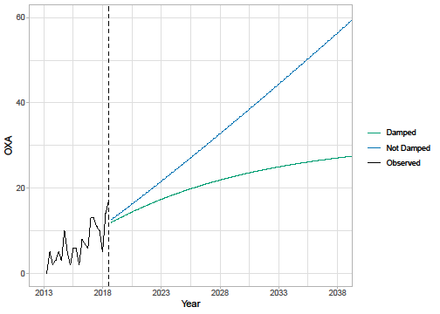

Table 32 (for which comparisons should only be made within columns) shows that for both isolate types, the model with a persistent trend provides the best within-sample fit. However, the difference between values is relatively small, whilst the differences in extrapolations are very large. The largest population growth was estimated for the screening isolates with a non-damped trend and the smallest (non-constant) population growth was for the invasive isolates with a damped trend model. For the screening isolates it is unclear if long-term increases in the mechanism reflect genuine increases or the results of increased testing. It is also unclear if any genuine increases would persist into the future. As long-term estimates were very sensitive to the choice of model, and there were few statistical grounds to choose between the two models both the damped trend and trend models for invasive isolates were considered within the decision analytic modelling.

Details on how the estimates of future change in the HVCS were used in the economic model are provided in Appendix 16.

7.2.5.2 Predicting future rates of resistance for current practice
The objective of this analysis was to characterise historical changes in resistance to existing AMs amongst patients with OXA-48 Enterobacterales to inform a quantitative forecast of how resistance might change in the future.

This analysis used time-series data provided by PHE, obtained from the same evidence sources as described in the previous sub-section (i.e., the AMRHAI national reference unit). Analyses were restricted to comparators used in the economic model. Resulting data were available for:

- Aminoglycosides (gentamicin, amikacin, tobramycin)
- Aztreonam
- Cephalosporins (cefotaxime, ceftazidime, cefepime)
- Ciprofloxacin
- Colistin
- Tigecycline

For AM classes with evidence from multiple AMs, the most resistant result was retained in the supplied data. It is not expected that retaining the least resistant result would have a noticeable impact on estimates of resistance over time. As already described, isolates that were reported as ‘intermediate’ resistant were assumed to represent resistant isolates for the purpose of this analysis. Hence any tested isolate was either categorised as ‘susceptible’ or ‘resistant’ for this analysis. Combining ‘intermediate’ and ‘resistant’ categories was based on advice from clinical advisors. It is, however, noted that current EUCAST guidance is to combine ‘intermediate’ and ‘susceptible’ when only two categories are used.¹⁴³ The methods used to generate forecasts are broadly the same as those considered in the previous section, and are discussed in more detail in Appendix 15. Due to the sparsity of the available evidence trends in the resistance (or susceptibility) to comparator AMs were not incorporated in to the decision analytic model.

7.5.2.3 Predicting future resistance trajectories for CAZ-AVI
The time-series data on susceptibility provided by PHE (as detailed in the previous sub-section) includes CAZ-AVI. Hence, one approach is to use the forecasts from the previous sub-section as inputs to the economic model. However, the economic modelling explores different scenarios of CAZ-AVI use, such as in the ES or MDS. As CAZ-AVI has high rates of susceptibility in the HVCSs (and a good safety profile), then without penalising drug use, the scenarios with the highest levels of CAZ-AVI would provide the greatest health benefits. A disbenefit of increased AM use is the potential for increased levels of resistance, which would decrease the future effectiveness of CAZ-AVI. There is a large body of evidence demonstrating a relationship between AM use (and prescribing) and the development of AM resistance.¹⁴⁴⁻¹⁴⁶ However, this relationship has been shown to vary by both type of AM and geographical setting and, in some situations, there is no apparent relationship.^{145,147,148} Hence there is uncertainty about the relationship between CAZ-AVI use (in the economic model) and subsequent changes in rates of resistance.

Evidence on trends in CAZ-AVI resistance for the UK in the HVCSs are available from PHE but there is no corresponding evidence on CAZ-AVI use for this population. These data also did not suggest that there was any trend in resistance to CAZ-AVI over time. Data sources are available for other AMs and other patient populations (henceforth referred to as ‘external AM use-resistance data’) which include both use and resistance, but their relevance to CAZ-AVI in this HVCS is unclear.

Two approaches were used to identify external AM use-resistance data that may inform the use-resistance association. First, the entire database of studies that were used during the reviewing process (for both CAZ-AVI and cefiderocol) was searched. Studies were filtered to include those which included “use”, “usage”, “volume” or “consumption” and these were searched for any relevant evidence. In addition, to identify any English studies (which may use evidence from Public Health England, or the online portal ‘fingertips’) a Web of Science search was conducted with the terms “(antimicrobial* OR antibiotic* OR resistant*) AND (fingertip OR "Public health England")”. These searches were complemented by any studies that were identified via other reviewing activities or already known to the study team. As a result, three studies were identified that, whilst not using data in the public domain, provided information on a use-resistance relationship¹⁴⁹⁻¹⁵¹. Details of these studies are provided in Appendix 16. These existing studies informed the de novo analyses reported here by suggesting that ARIMA models would be suitable time-series models for capturing use-resistance associations, with a lag of one year between use and resistance when using annual data.

In addition, several studies used publicly available surveillance data.^{147,152-156} These data were re-analysed for this project to identify potentially useful associations. For this project there were two types of data that were of interest:
- English data on AM use and AM resistance, from the ‘AMR local indictors profile’.¹⁵⁷
- European data on AM use and AM resistance from the European Antimicrobial Resistance Surveillance Network (EARS-Net) and European Surveillance of Antimicrobial Consumption Network (ESAC-Net), respectively.^{158,159} These are available as annual data.

Further details on these evidence sources are provided in Appendix 17. For CAZ-AVI, increases in resistance will be from a low starting point. Observed trajectories for external evidence which also showed an increase from a low starting point were only identified for the European data, so this was used in subsequent analyses.

Thirty countries from the European Union contribute data to EARS-Net on AM resistance for up to eight pathogens.¹⁶⁰ These data were further filtered based on the following criteria:
- Pathogen is included in the HVCS (Escherichia coli as a CPE).
- Data were available for both AM use and AM resistance (cephalosporins of all types, and carbapenems).
- Countries with at least 5,000 isolates were tested, baseline resistance (average over the first three years of available data) was less than 3% (CPE), with at least 10 years of observations for carbapenems and 15 years of observations for cephalosporins (these did not have to be consecutive).
This resulted in the following 16 pathogen-drug-country combinations:
- Escherichia coli, carbapenems: France, Greece, Netherlands, Norway.
- Escherichia coli, cephalosporins: Bulgaria, Croatia, Estonia, Finland, France, Greece, Ireland, Luxembourg, Malta, Norway, Slovenia, Sweden.

For these countries, ARIMA models were used to estimate the impact of increasing AM use (defined daily doses per 1,000 inhabitants per day) in a given year on resistance to that AM in the following year. Of the 16 combinations considered:
- Half provided a significant association (8/16; Escherichia coli = 2 /4 for carbapenems and 6 / 12 for cephalosporins).
- Of the 8 significant associations, four were positive associations (increasing use led to an increase in resistance), whilst four were negative (decreasing use led to an increase in resistance). All of the negative associations were for Escherichia coli cephalosporins.

Hence this analysis resulted in up to four significant positive associations that could be used to link increases in AM use to AM resistance in the economic model. Increases in AM use are driven by increases in the eligible population over time.

Projections of expected usage for CAZ-AVI from Section 2.1.3 were linked to these estimates of the relationship between usage and resistance to predict emergence of resistance to CAZ-AVI over time. Even under more extreme usage predictions and the strongest associations between usage and resistance emergence this predicted modest absolute increases in resistance of less than 1% over 20 years (see Appendix 17 for more details). EEPRU considered that this may represent an underestimate of the potential for resistance emergence for two reasons. Firstly, the spread of MDR infections is influenced by international travel and the “importation” of MDR pathogens. Resistance emergence may, therefore, be influenced by CAZ-AVI usage outside the UK which is not accounted for in these projections.

Secondly, the relationships between usage and resistance characterised in the available data reflect all tested isolates in the community and hospital settings. Resistance emergence may be much higher within the HVCSs where usage will be concentrated. For this reason, EEPRU has conducted a range of scenario analyses to characterise the potential emergence of resistance to CAZ-AVI. These were informed by considering the absolute increases in resistance for the drug-pathogen combinations and countries discussed above, where there was a statistically significant increase (see Appendix 17 for more details). The highest absolute increase in resistance (an annual absolute increase of 1.65%, leading to a projected 20-year increase of 33%) was used to bound these analyses. The second largest increase was 0.95% per year (19% over 20 years). Based on these considerations, EEPRU ran analyses with resistance emergence reaching 1%, 5%, 10% and 30% at 20 years. It is noted that the upper scenario may be very extreme.

Of note, this analysis was focused on datasets which demonstrated an increase in resistance overtime. Hence any significant associations between AM use and decreasing resistance were not explored. As an alternative to an ARIMA model, a dynamic differential equations model was also developed. This was designed to incorporate AM use and resistance, as well as the spontaneous loss or gain of resistance over time as well as the impact of deaths. Details of this model are provided in Appendix 15; when evaluated in a simulation study it was shown to provide biased parameter estimates. This was potentially due to the non-identifiability of the model (due to the number of potential AM drivers considered), so this model was not considered further.

As a face-validity check of the estimates of AM use employed in the model, these were compared to hospital inpatient drug use as reported in the 2019/20 ESPAUR report.⁶ This provided an estimate of 2.4 defined daily doses (DDD) /1000 inhabitants for all AMs used in an inpatient setting. Drug use during the first year of the economic model for both CAZ-AVI and cefiderocol (combining results from both evaluations) for the sites cUTI, IAI, HAP/VAP, and BSI (all four in CPE, pseudomonas, and stenotrophomonas) was estimated to be 0.00018 DDD/1000 inhabitants, hence representing 0.01% of all hospital inpatient AM use. This estimate, as an upper-bound on the potential use of both cefiderocol and CAZ-AVI, was felt by the modelling team to have face validity.

7.5.2.4 Predicting the impact of reduced drug use on resistance
Introducing CAZ-AVI (compared with the situation when it is not available) may lead to a reduced use of comparator AMs. As the economic model includes an association between increased use of CAZ-AVI and increased resistance (as described in the previous subsection), then intuitively a decrease in AM use would be expected to lead to a decrease in resistance. However, AM use in the population of interest is only one of a multitude of potential drivers for increases in AM resistance. Other potential drivers include the number of invasive procedures, AM use in other countries, environmental factors, and AM use in animals.^{161,162} The existing evidence on the effect of reduced AM use on AM resistance is mixed,¹⁶³ with findings including no decrease, a decrease, and even an increase in AM resistance.¹⁶⁴⁻¹⁶⁶ Hence, whilst the introduction of a new AM is expected to lead to an increase in resistance over time, reducing AM use has less predictable effects on resistance. Due to the heterogeneity in the existing literature and the lack of evidence for the population and AMs of interest, it was assumed that reductions in use of existing AMs did not lead to reductions in resistance over time.

      - Extrapolation from HVCS to expected usage
An important part of understanding the value of CAZ-AVI is understanding the range of patients in whom it is expected to be used. This is also relevant in understanding how resistance to CAZ-AVI is likely to emerge over time (as higher usage is likely to contribute to higher resistance). To inform this assessment we provide a qualitative description of the range of ways (outside of the HVCS) that CAZ-AVI is expected to be used. This is informed by discussions with our clinical advisors, the manufacturer submission for CAZ-AVI, and input by other stakeholders during the NICE process to identify patient groups in whom CAZ-AVI may offer significant improvements in HRQoL and mortality compared to existing therapies.

Following this, for those areas of usage considered by the clinical advisors and study team to be most significant in terms of population size and potential impact on INHEs, we have quantified the likely size of the populations who would receive CAZ-AVI. This is based on data from PHE, where available, and supplemented by data from the literature and expert opinion where necessary. These estimates are then used to rescale the population INHEs from the HVCS.

7.5.2.6 Areas of expected usage
Infection sites and patient characteristics
Outside of the HVCSs, the following infection sites were considered to be most important in driving expected usage and INHEs: bloodstream infections (BSI) and intrabdominal infections (IAI). Our clinical advisors emphasised the importance of CAZ-AVI in treating BSIs. The incremental value of CAZ-AVI (and AMs in general) in IAI is less clear as the quality of surgical procedures used to manage IAI was considered more important than the choice of AM and identifying MDR infections is more challenging. The clinical advisors also emphasised the importance of CAZ-AVI in treating patients who are immunocompromised (e.g., haematology, transplant), patients with cystic fibrosis and patients with burn injuries who are predisposed to acquiring resistant infections. In immunocompromised patients, BSIs are of particular concern, while in patients with cystic fibrosis, chronic respiratory infections are of particular concern. Patients with a higher propensity for renal complications and those with renal impairment may receive more significant benefits from CAZ-AVI, as renal complications may rule out or increase the toxicity of agents that remain effective in treating MDR infections (i.e., colistin, aminoglycosides). Other sites of infection discussed by the manufacturer were skin and soft-tissue, bone and joint, and meningitis. The clinical advisors considered that MDR infections at these sites would be very rare.

MDR pathogens/mechanisms
Outside of the HVCSs the following pathogen-mechanism combinations were discussed as relevant areas for usage for CAZ/AVI:
- Non-MBL pseudomonas.
- Pathogens with other serine carbapenemases (e.g., KPC) or non-carbapenemase causes of carbapenem resistance (e.g. porin and efflux pump mechanisms).
Our clinical advisors considered that, in both of these pathogen-mechanism combinations, patients had available other treatment options and that they were not, therefore, a priority area of usage for CAZ-AVI. The exception to this was infections that were MDR due to multiple types of carbapenem resistance (e.g., serine, porin and efflux pump) in whom CAZ-AVI may represent an important treatment option.

Empiric usage
During these evaluations there was substantial debate about the appropriate definition of the ES. Stakeholders were broadly aligned that the risk-based ES should be driven by the severity of the clinical scenario rather than the site of infection alone.

The manufacturer and the clinical advisors to this project presented differing perspectives on how to define a patient as at high risk of carbapenem-resistance for the purposes of identifying patients that might appropriately receive risk-based empiric treatment with CAZ-AVI. As documented throughout this report, the clinical advisors to this project considered that it was appropriate to restrict usage in the ES to patients with a high risk of an infection caused by OXA-48 Enterobacterales where this high risk was based on one of three factors:

- The patient was previously hospitalised in a healthcare setting with high prevalence of CPE with OXA-48.
- There had been an outbreak of infection with CPE with OXA-48 on a ward where the patient has stayed during their current admission.
- Previous cultures (taken during the current or previous hospital stays) show that the patient was previously colonised/infected by CPE with OXA-48.

This view was based on the desire to restrict usage to those in whom benefit was most significant, thus controlling the emergence of resistance, the clinical advisors also expressed concerns that a broader definition could lead to stewardship challenges.

The manufacturer considered a broader definition of patients at high risk of a drug-resistant infection. This included patients at risk of resistance due to “previous admission to ICU, longer admission times, critical illness, use of invasive devices and prior antibiotic therapy including cephalosporin, carbapenem or fluoroquinolone use” and “symptoms or signs starting more than 5 days after hospital admission, relevant comorbidity such as severe lung disease or immunosuppression, recent use of broad-spectrum antibiotics, colonisation with multi-drug-resistant bacteria, and recent contact with a health or social care setting before current admission”. No evidence was presented quantifying the likelihood that patients with these characteristics have a MDR infection, which is likely to reflect the paucity of evidence available.¹²⁷

The clinical advisors considered that usage under a broader suspicion of resistance should only be considered in exceptional cases. The appropriateness of a wider definition of empiric usage is, in principle, a question that could be addressed empirically, by assessing the health benefits of a more inclusive definition, against the health costs of treating more patients who do not have a resistant infection with CAZ-AVI and therefore contributing to higher levels of long-term resistance. This trade-off was not addressed quantitively by EEPRU or the manufacturer, largely reflecting the difficulties in accurately quantifying the long-term implications of different levels of usage for the emergence of resistance to CAZ-AVI.

7.5.2.7 Quantitative extrapolation to expected usage
Current population sizes
The aim was to estimate the number of infections in the HVCS and other important areas of expected usage. Based on feedback from our clinical advisors, the majority of CAZ-AVI use in HAP/VAP and BSIs was expected to be in the ES, and the majority of CAZ-AVI use in cUTI and IAI was expected to be in the MDS. We therefore set out to estimate the number of patients with the following characteristics:
- HAP/VAP and BSIs with suspected infection caused by OXA48, according to the criteria outlined in Section 3.2.3.1; and
- cUTIs and IAIs caused by OXA48, as confirmed by resistance mechanism testing.
The current population size was derived from SGSS data (AMR module) supplied by PHE. SGSS is a national database of laboratory data provided by approximately 98% of hospital microbiology laboratories in England.⁶ It contains resistance mechanism and antibiotic susceptibility testing for all submitted isolates. We analyse data for the period between October 2020 and April 2021 as from October 2020 reporting of acquired carbapenemse-producing Gram-negative bacteria by laboratories become mandatory.

The SGSS dataset includes anonymised patient ID, specimen type, species, referral location, laboratory, resistance mechanism tested and mechanism results. The site of infection was not available directly; instead it was inferred from the specimen types.

Clinical advisors to the project highlighted that there is considerable uncertainty in the categorisation of infection sites according to the specimen type. To reflect this uncertainty we explored two separate classifications in scenario analyses, shown in Table 33. The classification in Scenario 1 was derived by PHE, based on a set of specimens that map directly to infection sites. The scenario excluded all specimens from female patients in cUTIs except nephrostomy specimens, and all sputum samples. The sputum samples were removed following a clinical review (discussed in more detail in ESPAUR report 2021⁶) because a large number of sputum samples are considered to be contaminants without further evidence of clinical infection. The clinical advisors to EEPRU considered this classification to be conservative and derived a broader classification in Scenario 2 with guidance from clinical advisors. Scenario 2 included sputum samples, and urine samples from both male and female patients where the medical requestor is ‘acute’ care, as a proxy for hospitalised patients. The scenario is likely to capture other relevant infections excluded from Scenario 1 but may include some specimens that do not relate to the infection types of interest.
Table 33. Classification of infection sites according to specimen type
 | HAP/VAP | cUTIs | BSIs | IAIs
Specimen types in scenario I1 | Lower respiratory tract (bronchial) | Urine/kidney specimens from all male patients, irrespective of setting (urine, CSU, MSU, urinary catheter, suprapubic aspirate, bladder, kidney, urethra, urine/kidney, spa, ureter, urethral swab, EMU, ileal/bladder conduit, perinephric, first void, pus associated kidney/urinary tract);  Nephrostomy specimens in male and female patients | Blood samples (blood, plasma, dried blood spot, haematoma, cord blood, foetal blood) | Wound specimens (surgical and traumatic wounds)
Additional specimen types in scenario I2 | Lower respiratory tract (alveolar lavage, trachea, BAL, chest, lung, lower respiratory tract, tracheal aspirate), sputum (sputum, endotracheal secretions, endotracheal aspirate, endotracheal tube, induced sputum), swab (lung swab) | Urine/kidney specimens in scenario 1 in all hospitalised* patients (both male and female), upper genital tract in male and female hospitalised* patients | Heart/heart valve (heart, heart valve, mitral valve), intra-vascular line (TIP-NOS, arterial line/tip, Hickman line, CVP line tip, aortic valve, Venflon, aorta, haemodialysis access, arterio-venous shunt), pacemaker, catheter swab, aortic tissue, heart valve prosthesis (cardiac prosthesis, heart valve prosthesis), vascular graft (vascular graft), liver/bile (bile, gall bladder), hip tissue, hip swab, skin/wound (pressure sore), bone (bone, bone/joint, vertebra), bone marrow, bone pin/plate (prosthesis pin, bone pin/plate, prosthesis plate), joint prosthesis (artificial joint), intervertebral disc (intervertebral disc), IUCD, peritoneum, foreign body, implant NOS, CSF shunt (ventriculo-atrial valve), bone biopsy sample | None
Abbreviations: BAL, bronchoscopy and bronchoalveolar lavage; BSIs, bloodstream infections; CSF, cerebrospinal fluid; CSU, catheter specimen of urine; cUTIs, complicated urinary tract infections; EMU, early morning urine; HAP/VAP, hospital-acquired pneumonia or ventilator associated pneumonia; IAIs intraabdominal infections; IUCD, intra-uterine contraceptive device; MSU, midstream specimen of urine
* Specimens referred from acute care assumed to represent infections in hospitalised patients.

In the dataset, repeated entries were only removed if they were directly repeated for the same patient, species, specimen, referral location, laboratory, mechanism, and mechanism results. However, it is possible that reported numbers included multiple entries from the same infectious episode if multiple specimen samples were analysed (e.g., on different days).

The number of specimens tested for OXA48 was used to approximate the population size in ES. This reflects an assumption that all of the mechanism testing conducted was initiated following high suspicion of that resistance mechanism by the treating clinicians for the reasons specified in Section 3.2.3.1. The number of isolates confirmed to have the resistance mechanism was used to approximate the population size in the MDS. The derived population sizes are shown in Table 34. The specimen types included did not impact on the number of BSIs and IAIs.

It should be noted that the sum of population sizes for individual infection sites may overestimate the total population size, if the same infection presents at multiple sites. For example, BSIs are often sequelae of other infections. If a BSI develops from HAP/VAP following unsuccessful treatment with CAZ-AVI. It would likely be treated with an alternative AM, despite having the resistance mechanism of interest.

Table 34. Number of infections of interest (per annum)
 | HAP/VAP (tested) | cUTIs (confirmed positive) | BSIs (tested) | IAIs (confirmed positive)
Scenario P1 | 24 | 82 | 161 | 36
Scenario P2 | 166 | 132 | 161 | 36
BSIs, bloodstream infections; cUTIs, complicated urinary tract infections; HAP/VAP, hospital-acquired pneumonia or ventilator associated pneumonia; IAIs intraabdominal infections; MDS, microbiology-directed setting

The estimates in Table 34 are associated with considerable uncertainty due to uncertainty in the completeness of the SGSS dataset (labs may not submit all specimens to SGSS), uncertainty in how accurately specimen types represent the infection sites of interest, uncertainty about whether all tested patients would fall within our the defined target population for empiric treatment, and the potential double counting of samples from the same infectious episode.

To provide an alternative estimate of the population size, we conducted a survey (mentioned in Section 1.1.4.3) about the number of HAP/VAP infections eligible for treatment in the ES. The survey targeting infectious disease specialists and collected information about the participants’ place of work (number of hospital beds, and the number of other infectious disease specialists), and the number of suspected and confirmed HAP/VAP infections caused by CPE OXA48 they encountered per annum. The survey was disseminated to infectious disease consultants and microbiologists who were members of the British Society for Antimicrobial Chemotherapy (BSAC), to clinical advisors to the project, and to experts recommended by the clinical advisors. The infection numbers were scaled to country-level estimates using the number of hospital beds per infectious disease specialist (derived from the survey responses) and the unweighted average number of hospital beds in England for four quarters in 2020/21.¹⁶⁷

In total, 25 participants started the survey, of which nine provided information required to estimate the total number of patients eligible for treatment in ES in England. The estimates varied considerably between experts (with responses implying 0 to 13,422 suspected and 0 to 6,711 confirmed infections in England). The weighted average (5,099 suspected and 2,922 confirmed infections) was considered to be implausibly high by clinical advisors to the project, possibly because of higher survey take up among experts who are more likely to encounter the infections of interest and these estimates were not therefore taken forward to the decision analytic modelling.

The population size over 20 years was derived by applying the year-on-year population growth detailed in Section 7.2.5 to the current annual population size (Table 34). The population size estimates are used to rescale the estimates of patient-level INHEs and are presented in Figure 22. Four scenarios are used to model the eligible population over time. Scenario P1G1 is the most conservative, as it uses the conservative baseline number of infections (scenario P1 in Table 30), and the population growth derived from a time series model with a damped trend (see Section 7.2.5 for details). Scenario P2G2 is the least conservative, as it uses the larger baseline number of infections (scenario P2 in Table 30), and the population growth derived from a time series without a damped trend (see Section 7.2.5 for details). The difference between the scenarios is largely driven by the assumptions about long term growth in infection numbers. When using the model with a damped trend, the total population size across all sites of infection increased from between 303 and 495 (P1G1 and P2G1) in year 1 to between 377 and 615 in year 20. The model with the non-damped trend increased the total population size substantially, from between 303 and 495 (P1G2 and P2G2) in year 1 to between 1,340 and 11,053 in year 20.

Figure 21. Population size.
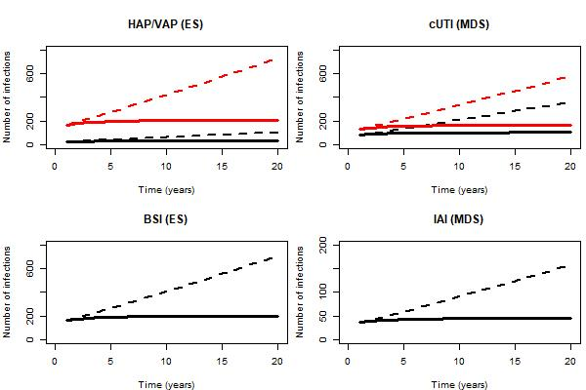
P1G1: baseline population based on PHE categorisation of infection sites, damped growth rate; P1G2: baseline population based on PHE categorisation of infection sites, growth rate not damped; P2G1: Baseline population based on clinical advisors’ categorisation of infection sites, damped growth rate; P2G2: Baseline population based on clinical advisors’ categorisation of infection sites, growth rate not damped.

In addition, we derive estimates of expected total drug usage for CAZ-AVI as these influence some of the scenarios relating to resistance emergence (see Section 7.2.5). Expected usage of CAZ-AVI was derived by adjusting the population size for the proportion eligible for treatment with CAZ-AVI. In ES, all infections were assumed to be eligible for empiric treatment. In MDS, infections confirmed to have the relevant resistance mechanisms were adjusted for the mean proportion of patients who were not susceptible to non-colistin/aminoglycocide-based treatments, but were susceptible to CAZ-AVI, as described in Section 7.2.2.1. When deriving expected usage, susceptibility was assumed to be static over time for simplicity, as susceptibility changes over time were expected to have a small impact on usage.

The total expected usage over 20 years is shown in Table 35.

Table 35. Total number of patients initiating CAZ-AVI over 20 years
 | HAP/VAP | cUTI | BSI | IAI
Scenario P1G1 | 576 | 588 | 3,866 | 257
Scenario P1G2 | 1,279 | 1,306 | 8,586 | 571
Scenario P2G1 | 3,990 | 943 | 3,866 | 257
Scenario P2G2 | 8,860 | 2,095 | 8,586 | 571
Abbreviations: BSIs, bloodstream infections; cUTIs, complicated urinary tract infections; HAP/VAP, hospital-acquired pneumonia or ventilator associated pneumonia; IAIs intraabdominal infections; MDS, microbiology-directed setting
P1G1: baseline population based on PHE categorisation of infection sites, damped growth rate; P1G2: baseline population based on PHE categorisation of infection sites, growth rate not damped; P2G1: Baseline population based on clinical advisors’ categorisation of infection sites, damped growth rate; P2G2: Baseline population based on clinical advisors’ categorisation of infection sites, growth rate not damped.

Extrapolation of INHEs between populations
Population-level INHEs were derived by multiplying patient-level INHEs by the population size. Patient-level INHE, derived from the model described in Section 7.2, was conditional on the site of and the treatment setting (ES or MDS). Patient-level INHEs for cUTIs in the MDS and for HAP/VAP in the ES were estimated by the model. Patient-level INHEs in BSI and IAIs were assumed to be the same as in HAP/VAP and cUTIs, respectively, based on feedback from our clinical advisors. BSI and HAP/VAP are both severe infections where CAZ-AVI is expected to be used predominantly empirically. Although the consequences of IAI can be more severe than the consequences of cUTI as they are very difficult to treat (requiring a combination of ABs and surgery), on the other hand the benefits of CAZ-AVI may be smaller due to the complexity of treating these infections and the lesser role of AMs compared to other treatment modalities in their management.
Population-level INHEs in years 1-20 were discounted at an annual rate of 3.5% to account for the delayed start of treatment.

Probabilistic analysis
The parameters included in the probabilistic analysis were chosen pragmatically. The analysis incorporated uncertainty in the patient-level INHE (as described in Section 7.2) and uncertainty in the population growth. The probabilistic analysis did not reflect uncertainty in the current population size, instead this was explored in scenario analyses outlined above. Expected usage and the link between this and resistance was not made probabilistic for simplicity and due to the challenges in characterising with any accuracy the uncertainty around emergence of resistance, again this was explored via scenario analyses outlined in Section 2.1.2.

7.5.3 Additional elements of value for new AMs
The literature on the economic evaluation of AMs has described the different sources of value associated with these products.¹³ ¹¹⁷ In EEPRU’s earlier work on evaluation methods ¹³ the principles by which each of these ‘elements of value’ can be reflected in models focused on estimating the impact of new products on population NHEs was discussed.

In Section 8.3 we present a summary of how the different elements of value are conceptualised in the literature, within the manufacturer submission and how they are understood by our clinical advisory group. We summarise the extent to which each element of value is reflected in the quantitative assessments of value for the HVCSs, or quantitative evidence presented in the manufacturer submission. For each element of value for which a quantitative assessment was not conducted we provide a discussion of the extent to which that element of value is likely to be quantitively important in influencing the assessment of population INHEs for CAZ-AVI. This is based on evidence from the literature, evidence presented in the manufacturer submission and the views of our clinical advisors.
7.5.4 Validation
To ensure the appropriateness of the decision problem, scope of the decision model, model structure, and evidence used we consulted extensively with microbiologists and clinicians involved in treating serious drug-resistant infections, and in related research, those with expertise in transmission modelling and those with expertise in specific types of evidence. Given the complexity of the appraisal and the multiple components of the work this required approximately ten separate calls on different aspects of the work.

A technical validation of the data analyses, synthesis and decision analytic modelling conducted by EEPRU was conducted. This comprised a review of the code by a second reviewer.

- Results of quantification of value
  - Direct patient net health effects in HVCS
    - OXA-48 Empiric setting HAP/ VAP
The base case results are shown in Table 36 for patients correctly suspected as having OXA-48 Enterobacterales, those wrongly suspected of having OXA-48 Enterobacterales, and in the average patient suspected to have OXA-48 Enterobacterales in the ES (whose outcomes are a weighted average of those with and without OXA-48 Enterobacterales).

CAZ-AVI is associated with similar susceptibility to colistin/aminoglycoside-based therapy but improved safety in both individuals with and without OXA-48 Enterobacterales. The per patient INHE is, therefore, similar in patients with OXA-48 Enterobacterales, without OXA-48 Enterobacterales and the average ES patient at 0.16 – 0.19 QALYs. The safety advantage delivers a small cost saving as cost savings associated with reduced rates of AKI are offset by longer time spent in hospital for patients receiving CAZ-AVI, which is a result of the slightly higher susceptibility to colistin (94% compared to 92% for CAZ-AVI) and the fact that preventing AKIs lowers early in-hospital mortality thus prolonging hospital stay. The safety advantage delivers a substantive QALY gain due to the reduced mortality associated with AKI in the short and long-term.

Amongst patients with OXA-48 Enterobacterales, CAZ-AVI is associated with improved susceptibility and comparable safety to non-colistin/aminoglycoside-based therapy. The large difference in susceptibility between these comparators (92% vs. 35%) drives a large per patient INHE of 0.81 QALYs in this group. This reflects both the QALY gain associated with the higher susceptibility (0.40) and the substantive cost saving associated with a reduced LOS (£9,108). In patients without OXA-48 Enterobacterales, CAZ-AVI and non-colistin/aminoglycoside-based therapy offer similar susceptibility and safety.

In the average ES patient suspected of having OXA-48 Enterobacterales, use of CAZ-AVI in the ES is associated with a per patient INHE gain of 0.19 QALYs compared to colistin/aminoglycoside-based therapy and of 0.16 QALYs compared to non-colistin or aminoglycoside-based therapy.

Restricting use of CAZ-AVI to patients who fail empiric treatment and require treatment in the MDS is associated with a small increase in INHE benefit compared to existing therapies. This is attributable to several factors. Many patients can be treated effectively in the empiric setting with existing treatment or die prior to reaching the MDS (i.e. not all patients progress to the MDS), many patients do not have OXA-48 Enterobacterales and are not, therefore, eligible to receive CAZ-AVI in the MDS, and amongst those with OXA-48 Enterobacterales the majority (68%) are susceptible to a non-colistin-based treatment option and, therefore, do not receive CAZ-AVI in the model when they reach the MDS.

Table 36: Per patient base-case results: OXA-48 Enterobacterales HAP/VAP empiric setting (probabilistic, 2,000 simulations). Note incremental values for CAZ-AVI used in the MDS not shown for parsimony
 | Comparator treatment strategies in the empiric setting |  |  |  |  | Incremental results
 | E1 | E2nca | E2ca | E3nca | E3ca | E1-E2nca | E1-E2ca
Patients with OXA-48 Enterobacterales
Summary of in-hospital outcomes (proportions) across both lines of treatment available
Death | 0.361 | 0.463 | 0.409 | 0.450 | 0.407 | -0.102 | -0.049
Survival no AKI | 0.514 | 0.403 | 0.423 | 0.417 | 0.425 | 0.111 | 0.090
Survival AKI | 0.125 | 0.135 | 0.167 | 0.133 | 0.168 | -0.009 | -0.042
Survival CKD | 0.000 | 0.000 | 0.000 | 0.000 | 0.000 | 0.000 | 0.000
Economic outcomes (all discounted)
Treatment costs | £39 | £177 | £440 | £125 | £430 | -£138 | -£402
AKI costs hospital | £1,735 | £2,356 | £2,318 | £2,256 | £2,305 | -£621 | -£583
Other costs hospital | £17,543 | £26,651 | £16,803 | £26,289 | £16,694 | -£9,108 | £739
Long-term costs | £641 | £553 | £617 | £564 | £620 | £88 | £24
Total costs | £19,957 | £29,737 | £20,179 | £29,234 | £20,049 | -£9,779 | -£221
Life years | 2.880 | 2.421 | 2.662 | 2.480 | 2.675 | 0.459 | 0.218
QALYs | 2.024 | 1.702 | 1.871 | 1.743 | 1.880 | 0.322 | 0.152
Per person NHE (QALYs) | 1.026 | 0.215 | 0.862 | 0.281 | 0.878 | 0.811 | 0.163
Patients without OXA-48 Enterobacterales
Summary of in-hospital outcomes (proportions) across both lines of treatment available
Death | 0.357 | 0.357 | 0.409 | 0.357 | 0.409 | 0.000 | -0.052
Survival no AKI | 0.517 | 0.517 | 0.423 | 0.517 | 0.423 | 0.000 | 0.094
Survival AKI | 0.125 | 0.125 | 0.167 | 0.125 | 0.167 | 0.000 | -0.042
Survival CKD | 0.000 | 0.000 | 0.000 | 0.000 | 0.000 | 0.000 | 0.000
Economic outcomes (all discounted)
Treatment costs | £34 | £44 | £440 | £44 | £440 | -£10 | -£406
AKI costs hospital | £1,714 | £1,714 | £2,318 | £1,714 | £2,318 | £0 | -£604
Other costs hospital | £17,213 | £17,213 | £16,803 | £17,213 | £16,803 | £0 | £409
Long-term costs | £644 | £644 | £617 | £644 | £617 | £0 | £27
Total costs | £19,604 | £19,614 | £20,179 | £19,614 | £20,179 | -£10 | -£574
Life years | 2.895 | 2.895 | 2.662 | 2.895 | 2.662 | 0.000 | 0.233
QALYs | 2.034 | 2.034 | 1.871 | 2.034 | 1.871 | 0.000 | 0.163
Per person NHE (QALYs) | 1.054 | 1.053 | 0.862 | 1.053 | 0.862 | 0.001 | 0.192
All patients presenting in the ES
Total costs | £19,674 | £21,601 | £20,179 | £21,503 | £20,153 | -£1,928 | -£505
QALYs | 2.032 | 1.969 | 1.871 | 1.977 | 1.873 | 0.063 | 0.161
Per person NHE (QALYs) | 1.049 | 0.889 | 0.862 | 0.901 | 0.865 | 0.160 | 0.186
Abbreviations: AKI, acute kidney injury; CKD, chronic kidney disease; NHE, net health effect; QALYs, quality-adjusted life years
Comparators: E1 = empiric treatment with CAZ-AVI, followed by existing therapies in MDS if not susceptible; E2nca = non-colistin or aminoglycoside-based empiric treatment, followed by existing therapies MDS if needed; E2ca = colistin or aminoglycoside-based empiric treatment, followed by existing therapies MDS if needed; E3nca = non-colistin or aminoglycoside-based empiric treatment, followed by followed by CAZ-AVI in MDS if needed; E3ca = colistin or aminoglycoside-based empiric treatment, followed by CAZ-AVI MDS if needed. Net health effects derived using threshold of £20,000/QALY.

There is a large degree of parameter uncertainty around the incremental per patient INHEs of CAZ-AVI. The distribution of per patient INHEs is shown in Figure 23. This reflects uncertainty in the probability a patient has OXA-48 Enterobacterales, the relative susceptibility of these treatment options, their safety and the benefits of avoided AKIs.
Figure 22: Distribution of per patient INHEs of CAZ-AVI in OXA-48 HAP/VAP empiric setting compared to (a) non-colistin/aminoglycoside-based therapy and (b) colistin/aminoglycoside-based therapy and (2,000 simulations)

(a) (b)
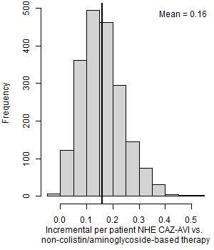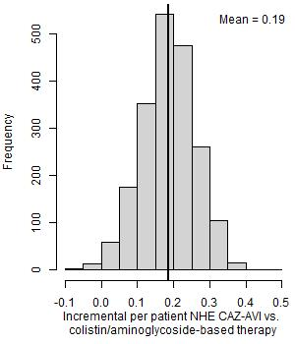
NHE, net health effects

Scenario analyses that modified the deterministic base case INHE by more than 10% (and three scenario analyses requested by NICE marked by *) are shown in Table 37. The main areas of uncertainty relate to the probability an individual has OXA-48 Enterobacterales, the susceptibility scenarios and long-term survival following discharge from hospital.

When the probability of having OXA-48 Enterobacterales is low, the preferred existing treatment option is to use non-colistin/aminoglycoside-based therapy and the efficacy and safety advantage of CAZ-AVI is reduced. This results in per patient INHEs of 0.01 and 0.08 QALYs when the probability of having OXA-48 Enterobacterales is 0 and 0.10, respectively.

When susceptibility was informed using the all-studies network meta-analysis (scenario S2), PHE isolate-level data (scenario S3) or the Vazques Ucha study (scenario S4) in place of the EUCAST network meta-analysis, the per patient INHE increased to 0.18-0.23 QALYs, reflecting the decrease in susceptibility to non-colistin/aminoglycoside-based treatment under these scenarios. The increase in the per patient INHE was particularly high in scenarios S2 and S4 where susceptibility to CAZ-AVI also increased from 92% to 97% and 99%. In these scenarios, the substantial reduction in susceptibility to non-colistin/aminoglycoside-based treatments (from 35% to 18% and 7%), along with the increase in susceptibility to colistin/aminoglycosides in scenario 2, meant that colistin/aminoglycosides became the best existing treatment.

The results were also sensitive to the parametric survival model used to predict long-term survival post-discharge. Use of the Weibull model reduced the per patient INHE gain to 0.14 QALYs.

The per patient INHEs are lower as the cost-effectiveness threshold is increased. In the base case increasing the cost-effectiveness threshold reduces the amount of health generated by the cost savings generated by CAZ-AVI. Using a lower discount rate of 1.5% for costs and outcomes increases the per- patient INHEs to 0.17 QALYs.

Table 37: Per patient scenario analyses: OXA-48 Enterobacterales HAP/VAP empiric setting (deterministic)
Scenario name | Base case value/assumption | Scenario value/assumption | Best existing treatment | Patient-level INHE of CAZ-AVI
Base case | - | - | Non-colistin/amino-based | 0.159
p_bug_survey | Probability patient has OXA-48 Enterobacterales is 0.20 | Probability patient has MBL Enterobacterales is 0.57 based on BSAC survey data | Colistin/amino based | 0.191
p_bug_0 | Probability patient has OXA-48 Enterobacterales is 0.20 | Probability patient has OXA-48 Enterobacterales is 0.00 | Non-colistin/amino-based | 0.001
p_bug_10 | Probability patient has OXA-48 Enterobacterales is 0.20 | Probability patient has OXA-48 Enterobacterales is 0.10 | Non-colistin/amino-based | 0.081
p_bug_30 | Probability patient has OXA-48 Enterobacterales is 0.20 | Probability patient has OXA-48 Enterobacterales is 0.30 | Colistin/amino based | 0.199
p_bug_40 | Probability patient has OXA-48 Enterobacterales is 0.20 | Probability patient has OXA-48 Enterobacterales is 0.40 | Colistin/amino based | 0.196
p_bug_50 | Probability patient has OXA-48 Enterobacterales is 0.20 | Probability patient has OXA-48 Enterobacterales is 0.50 | Colistin/amino based | 0.194
p_bug_60 | Probability patient has OXA-48 Enterobacterales is 0.20 | Probability patient has OXA-48 Enterobacterales is 0.60 | Colistin/amino based | 0.191
p_bug_70 | Probability patient has OXA-48 Enterobacterales is 0.20 | Probability patient has OXA-48 Enterobacterales is 0.70 | Colistin/amino based | 0.188
p_bug_80 | Probability patient has OXA-48 Enterobacterales is 0.20 | Probability patient has OXA-48 Enterobacterales is 0.80 | Colistin/amino based | 0.185
p_bug_90 | Probability patient has OXA-48 Enterobacterales is 0.20 | Probability patient has OXA-48 Enterobacterales is 0.90 | Colistin/amino based | 0.182
p_bug_100 | Probability patient has OXA-48 Enterobacterales is 0.20 | Probability patient has OXA-48 Enterobacterales is 1.00 | Colistin/amino based | 0.179
S2 | Susceptibility based on network meta-analysis of EUCAST studies | Network meta-analysis: include all studies regardless of breakpoints, excluding specific arms due to inconsistency | Colistin/amino based | 0.210
S3 | Susceptibility based on network meta-analysis of EUCAST studies | Susceptibility based on PHE isolate-level data (excludes fosfomycin) | Non-colistin/amino based | 0.179
S4 | Susceptibility based on network meta-analysis of EUCAST studies | Susceptibility based on Vasquez-Ucha et al isolate-level data (excludes tigecycline) | Colistin/amino based | 0.234
Weibull | Log-normal model fit to CARBAR survival data | Weibull model fit to CARBAR survival data | Non-colistin/amino-based | 0.135
thresh15* | Cost-effectiveness threshold £20,000 | Cost-effectiveness threshold £15,000 | Non-colistin/amino-based | 0.190
thresh30* | Cost-effectiveness threshold £20,000 | Cost-effectiveness threshold £30,000 | Non-colistin/amino-based | 0.126
dr1.5* | Discount rate for costs and benefits 3.5% | Discount rate for costs and benefits 1.5% | Non-colistin/amino-based | 0.167
Abbreviations: EUCAST, European Committee on Antimicrobial Susceptibility Testing; INHE, incremental net health effects; PHE, Public Health England
NB: Net health effects derived using threshold of £20,000/QALY.

8.1.2 OXA-48 Microbiology-directed setting HAP/VAP and cUTI
The probabilistic base case results are shown in Table 38 for patients with confirmed OXA-48 Enterobacterales in the MDS who have HAP/VAP or cUTI. The advantages of CAZ-AVI are smaller in the MDS as once susceptibility results are known, many patients (65%) can be treated with a non-colistin/aminoglycoside-based option to which they are susceptible and do not receive CAZ-AVI. The per patient INHE associated with CAZ-AVI are driven by avoided safety issues related to use of colistin and aminolygocides in those susceptible to these agents (35% of the MDS cohort). Overall, the per patient INHE associated with using CAZ-AVI in the MDS are 0.06 QALYs for HAP/VAP and 0.05 QALYs for cUTI.

Table 38: Per patient base-case results: OXA-48 Enterobacterales HAP/VAP and cUTI microbiology-directed setting (probabilistic, 2,000 simulations)
 | MDS pathway with CAZ-AVI | MDS pathway without CAZ-AVI | Incremental values
HAP/VAP
Summary of in-hospital outcomes (proportions) across both lines of treatment available
Death | 0.373 | 0.388 | -0.014
Survival no AKI | 0.497 | 0.466 | 0.030
Survival AKI | 0.130 | 0.146 | -0.016
Survival CKD | 0.000 | 0.000 | 0.000
Economic outcomes (all discounted)
Treatment costs | £189 | £264 | -£74
AKI costs hospital | £1,673 | £1,884 | -£211
Other costs hospital | £34,723 | £34,737 | -£15
Long-term costs | £632 | £627 | £5
Total costs | £37,218 | £37,512 | -£295
Life years | 2.823 | 2.759 | 0.064
QALYs | 1.984 | 1.939 | 0.045
Per person NHE | 0.123 | 0.063 | 0.060
cUTI
Summary of in-hospital outcomes (proportions) across both lines of treatment available
Death | 0.125 | 0.136 | -0.011
Survival no AKI | 0.646 | 0.607 | 0.039
Survival AKI | 0.228 | 0.257 | -0.028
Survival CKD | 0.000 | 0.000 | 0.000
Economic outcomes (all discounted)
Treatment costs | £189 | £264 | -£74
AKI costs hospital | £1,673 | £1,884 | -£211
Other costs hospital | £17,344 | £17,355 | -£11
Long-term costs | £904 | £907 | -£4
Total costs | £20,110 | £20,410 | -£300
Life years | 3.944 | 3.896 | 0.049
QALYs | 2.772 | 2.738 | 0.034
Per person NHE | 1.767 | 1.718 | 0.049
AKI, acute kidney injury; CKD, chronic kidney disease; cUTI, complicated urinary tract infections; HAP/VAP, hospital-acquired pneumonia or ventilator-associated pneumonia; MDS, microbiology-directed setting; NHE, net health effect; QALYs, quality-adjusted life years
NB: Net health effects derived using threshold of £20,000/QALY.

There is a moderate degree of uncertainty around the per patient INHEs of CAZ-AVI compared to the existing treatment options. The distribution of per patient INHEs is shown in Figure 24.

Figure 23: Distribution of INHEs of introducing CAZ-AVI in to the MDS compared to existing therapies: (a) OXA-48 Enterobacterales HAP/VAP and (b) OXA-48 Enterobacterales cUTI (2,000 simulations)

(a) HAP/VAP (b) cUTI
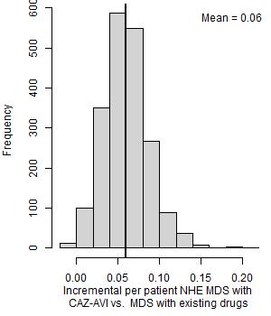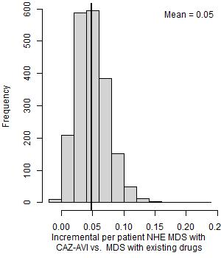
MDS, microbiology-directed setting; NHE, net health effects

Scenario analyses that modified the deterministic base case INHE by more than 10% (and three scenario analyses requested by NICE marked by *) are shown in Table 39. The main areas of uncertainty relate to the susceptibility scenarios, the impact of colistin/aminoglycoside-based therapy on AKI risk and its long-term implications, and long-term survival following discharge from hospital.

In both HAP/VAP and cUTI when the network meta-analysis of susceptibility data included all studies regardless of breakpoints (S2), the per patient INHEs were lower at 0.06 and 0.05 QALYs for HAP/VAP and cUTI respectively. In this scenario although susceptibility to CAZ-AVI is higher the proportion susceptible to a non-colistin/aminoglycoside-based treatment is also higher so a smaller proportion of individuals receive CAZ-AVI in the model. The per patient INHEs were higher when using the Vasquez-Ucha data (S4) to inform susceptibility at 0.10 and 0.09 QALYs for HAP/VAP and cUTI respectively. This reflects the higher proportion of individuals who are only susceptible to a colistin/aminoglycoside-based therapy in this scenario and who are therefore eligible to receive CAZ-AVI within the model (though we note that this is largely driven by the fact that tigecycline is not available in this scenario).

Using the Wagenlehner 2021 meta-analysis to inform the effect of colistin/aminoglycoside-based therapy on AKI risk rather than the Chien meta-analysis also increased the INHEs to 0.09 and 0.07 QALYs in HAP/VAP and cUTI, respectively. Similar effects were observed for HAP/VAP when exploring alternative assumptions about the long-term implications of AKIs. Reduced within-hospital mortality from AKI decreased the INHE to 0.05 for HAP/VAP and 0.04 for cUTI as this reduces the safety advantage of CAZ-AVI.

Using a Weibull model to inform long-term mortality reduced the per patient INHEs to 0.05 QALYs in HAP/VAP and 0.04 in cUTI.

Table 39: Per patient scenario analyses: OXA-48 HAP/VAP and cUTI MDS (deterministic).
Scenario name | Base case value/assumption | Scenario value/assumption | INHE per patient: HAP/VAP | INHE per patient: cUTI
Base case | - | - | 0.069 | 0.058
S2 | Susceptibility based on network meta-analysis of EUCAST studies | Network meta-analysis: include all studies regardless of breakpoints, excluding specific arms due to inconsistency | 0.057 | 0.048
S4 | Susceptibility based on network meta-analysis of EUCAST studies | Susceptibility based on Vasquez-Ucha et al isolate-level data | 0.104 | 0.088
p_AKI_Chien | Probability of AKI with colistin/aminoglycoside therapy based on Sisay 2021 (0.45) | Probability of AKI with colistin/aminoglycoside therapy based on Chien (0.32) | 0.058 | 0.049
OR_AKI_Wagenlehner | Odds ratio comparing AKI for colistin/ aminoglycoside-based therapy to non-colistin/aminoglycoside-based therapy from all studies analysis in Chien 2020 (1.81) | Odds ratio comparing AKI for colistin/ aminoglycoside-based therapy to non-colistin/aminoglycoside-based therapy from all studies analysis in Wagenlehner 2021 (2.23) | 0.089 | 0.074
OR_AKI_ChienRIFLE | Odds ratio comparing AKI for colistin/ aminoglycoside-based therapy to non-colistin/aminoglycoside-based therapy from all studies analysis in Chien 2020 (1.81) | Odds ratio comparing AKI for colistin/ aminoglycoside-based therapy to non-colistin/aminoglycoside-based therapy from RIFLE criteria studies analysis in Chien 2020 (1.61) | 0.057 | 0.048
OR_AKI_death_halved | Odds ratio of mortality for AKI compared to no AKI derived from Kerr (2014) (5.11) | Odds ratio of mortality for AKI compared to no AKI halved (2.56) | 0.049 | 0.037
double.ckd.risk | Risk of CKD as observed in Bucaloiu 2012 | Risk of CKD doubled to reflect potential higher propensity for CKD in HVCS | 0.061 | 0.053
abs.increase | Odds ratios on mortality associated with nephrotoxicity from Bucaloiu 2012 are applied multiplicatively to underlying risk in HVCS | Absolute risk increases in Bucaloiu 2012 are assumed to apply | 0.083 | 0.073
all.aki.lt | Base case assumptions with respect to long-term effects of AKI | Applying a range of alternative assumptions to model the long-term effects of AKI | 0.083 | 0.073
Weibull | Log-normal model fit to CARBAR survival data | Weibull model fit to CARBAR survival data | 0.050 | 0.044
lt.care | No costs of long-term care | Costs of discharge to long-term care included | 0.077 | 0.080
thresh15* | Cost-effectiveness threshold £20,000 | Cost-effectiveness threshold £15,000 | 0.074 | 0.062
thresh30* | Cost-effectiveness threshold £20,000 | Cost-effectiveness threshold £30,000 | 0.064 | 0.053
dr1.5* | Discount rate for costs and benefits 3.5% | Discount rate for costs and benefits 1.5% | 0.078 | 0.066
AKI, acute kidney injury; CKD, chronic kidney disease; EUCAST, European Committee on Antimicrobial Susceptibility Testing; HVCS, high value clinical scenario; INHE, incremental net health effects; PHE, Public Health England
NB: Net health effects derived using threshold of £20,000/QALY.

  - Direct population net health effects in HVCS and broader areas of expected usage
Figure 25 shows the population INHE over 20 years, derived using alternative assumptions about the population size (based on different categorisation of specimen types), population growth (derived with different models for the population growth predictions) and resistance emergence (reaching 1%, 10% and 30% at 20 years – 5% scenario not shown for parimony). Population INHE declines year on year in scenarios where the discount rate exceeds the rate of population growth in all period; rises and then declines in scenarios where the population growth rate exceeds the discount rate in earlier periods but then falls below the discount rate in later periods; and rises year on year in scenarios where the rate of population growth exceeds the discount rate. Table 40 shows the total discounted populatoin INHE aggregated over the 20 year period.

HAP/VAP and BSIs, are the key drivers of population-level benefit consistently across all scenarios due to the population size. The impact of the population size is evident when comparing results across different scenarios, where different categorisations of specimen types (which determine the baseline number of infections) have the greatest impact, changing the total 20 year population INHE from between 493 and 1299 to between 837 and 2,211 QALYs. Population growth impacts population level INHE to a greater extent than resistance, as shown by the red and black lines which represent different population growth scenarios diverging more than the solid and dashed lines which represent different resistance scenarios. Resistance between 1% and 10% results in similar total INHE.

Figure 24. Population INHE (QALYs) over 20 years based on two population size scenarios. P1: baseline population based on PHE categorisation of infection sites; P2: baseline population based on clinical advisors’ categorisation of infection sites; G1: damped growth rate; G2: growth rate not damped; R1: 1% resistance after 20 years; R2: 10% resistance after 20 years; R3: 30% resistance after 20 years

a) PHE categorisation
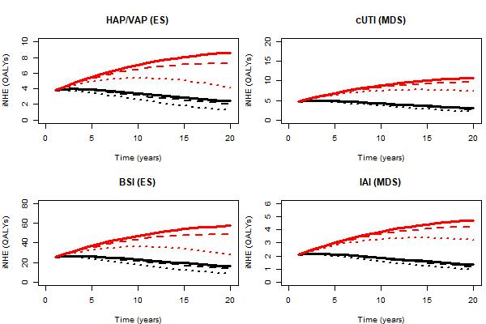

b) Expert-guided categorisation of specimen types
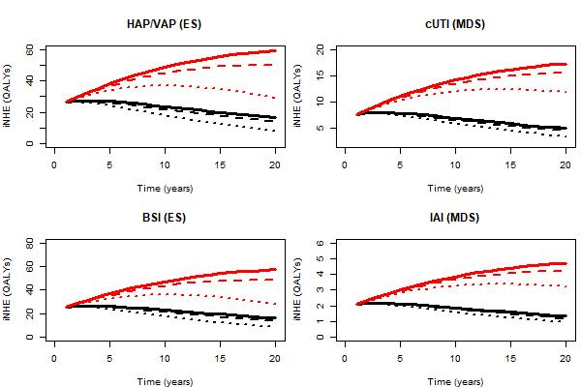

Table 40. Total INHE across 20 years of usage
Baseline population | Population growth rate | Change in resistance | HAP/VAP | cUTI | BSI | IAI | Total
PHE categorisation of infection sites  (scenario P1) | Model with damped effect  (scenario G1) | 1% (R1) | 66 | 83 | 444 | 36 | 629
Scenario P1 | Scenario G1 | 5% (R2) | 64 | 81 | 429 | 36 | 610
Scenario P1 | Scenario G1 | 10% (R3) | 61 | 79 | 412 | 35 | 587
Scenario P1 | Scenario G1 | 30% (R4) | 51 | 71 | 341 | 31 | 493
Scenario P1 | Model without damped effect  (scenario G2) | 1% (R1) | 137 | 171 | 916 | 75 | 1299
Scenario P1 | Scenario G2 | 5% (R2) | 131 | 167 | 880 | 73 | 1250
Scenario P1 | Scenario G2 | 10% (R3) | 124 | 161 | 834 | 71 | 1190
Scenario P1 | Scenario G2 | 30% (R4) | 97 | 140 | 652 | 61 | 950
Clinical advisors’ categorisation of infection sites  (scenario P2) | Model with damped effect  (scenario G1) | 1% (R1) | 458 | 133 | 444 | 36 | 1,070
Scenario P2 | Scenario G1 | 5% (R2) | 443 | 130 | 429 | 36 | 1,038
Scenario P2 | Scenario G1 | 10% (R3) | 425 | 127 | 412 | 35 | 998
Scenario P2 | Scenario G1 | 30% (R4) | 352 | 113 | 341 | 31 | 837
Scenario P2 | Model without damped effect  (scenario G2) | 1% (R1) | 946 | 274 | 916 | 75 | 2,211
Scenario P2 | Scenario G2 | 5% (R2) | 908 | 267 | 880 | 73 | 2,128
Scenario P2 | Scenario G2 | 10% (R3) | 861 | 259 | 834 | 71 | 2,025
Scenario P2 | Scenario G2 | 30% (R4) | 673 | 225 | 652 | 61 | 1,611
BSI, bloodstream infection; cUTI, complicated urinary tract infection; HAP/VAP, hospital-acquired pneumonia or ventilator-associated pneumonia; IAI, intraabdominal infection; PHE, Public Health England

We also estimated how much of the value of CAZ-AVI accrues to patients initiating treatment in the first ten years of use, as this is the period of the contract for the delinked payment. Full results are presented in Appendix 20. Across scenarios relating to baseline population, population growth and resistance emergence, the proportion of value that accrues in the first 10 years of use is 41%-65%. With the exception of the scenarios examining very high rates of emergence to resistance, the proportion of value accruing in the first 10 years is less than might be expected for other pharmaceuticals. For a pharmaceutical where population size is expected to be stable over time we would expect 59% of the value to accrue in the first 10 years.
Following a request from NICE we also assessed the impact on the population-level results of using a 1.5% discount rate. These results reflect an assumption of zero emergence of resistance to CAZ-AVI and are intended to give an indication of the broad effect of a lower discount rate. Across the scenarios relating to population size and population growth the 20-year population-level INHE ranged from 808-2,953 when using a 1.5% discount rate. This indicates a substantive increase compared to the results observed using a 3.5% discount rate.
There is a large degree of uncertainty around the population-level INHEs of CAZ-AVI. The distribution of population INHEs for two population size scenarios (P1G1, P2G2) under a scenario of no resistance emergence to CAZ-AVI, is shown in Figure 26. The distribution of population INHE reflects the per patient INHE parameter uncertainty discussed in Sections 3.1.1-3.1.2, as well as uncertainty in the rate of population growth over time. The difference in dispersion (range) between two histograms indicates the uncertainty in population growth between the two scenarios.

Figure 25. Distribution of total population INHEs of CAZ-AVI (2,000 simulations)
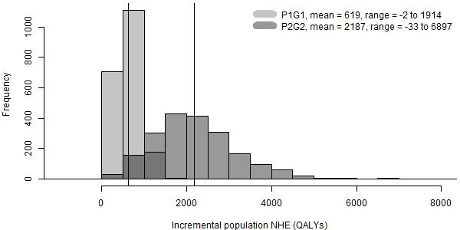

P1G1: baseline population (point estimate) based on PHE categorisation of infection sites, growth rate damped (uncertain); P2G2: baseline population (point estimate) based on clinical advisors’ categorisation of infection sites, growth rate not damped (uncertain).

Patient-level scenario analyses that modified the total base case population INHE by more than 10% are shown in Table 41. The results are presented as the range based on most and least conservative assumptions about the population size (scenarios P1G1 and P2G2 in Figure 22) and assuming zero resistance emergence. The scenarios assume that, where applicable the same assumptions apply across populations e.g., if a certain assumption is considered more appropriate for HAP/VAP ES patients it is also considered more appropriate for BSI ES patients.
Population growth impacts population level INHE to a greater extent than scenarios in the patient-level model, as the variation in the total INHE across different population size scenarios of 633 to 2,231 QALYs (the base case range in Table 41) is more substantial than the variation across different rows in the table (e.g. 383 to 941 QALYs in the more conservative scenario about the population size).
The main areas of uncertainty relate to the probability that a patient has OXA-48 Enterobacterales, and the susceptibility scenarios. These were the most impactful scenarios in patient-level results in ES
(Section 3.1.1), the setting with the greatest population size.
Table 41: Population-level INHE (QALYs) for patient-level scenario analyses (deterministic) – range derived from different assumptions about the population size (scenarios P1G1 and P2G2 in Figure 22).
Scenario name | Base case value/assumption | Scenario value/assumption | HAP/VAP (ES) | cUTI (MDS) | BSI (ES) | IAI (MDS) | Total
Base case | - | - | 67-955 | 83-276 | 447-925 | 36-75 | 633-2,231
p_bug_survey | Probability patient has OXA-48 Enterobacterales is 0.20 | Probability patient has OXA-48 Enterobacterales is 0.57 based on BSAC survey data | 80-1,152 | 83-276 | 539-1,116 | 36-75 | 738-2,619
p_bug_10 | Probability patient has OXA-48 Enterobacterales in ES is 0.20 | Probability patient has OXA-48 Enterobacterales is 0.10 | 34-490 | 83-276 | 230-475 | 36-75 | 383-1,316
p_bug_30 | Probability patient has OXA-48 Enterobacterales in ES is 0.20 | Probability patient has OXA-48 Enterobacterales is 0.30 | 84-1,199 | 83-276 | 562-1,162 | 36-75 | 765-2,712
p_bug_40 | Probability patient has OXA-48 Enterobacterales in ES is 0.20 | Probability patient has OXA-48 Enterobacterales is 0.40 | 82-1,182 | 83-276 | 553-1,145 | 36-75 | 754-2,678
p_bug_50 | Probability patient has OXA-48 Enterobacterales in ES is 0.20 | Probability patient has OXA-48 Enterobacterales is 0.50 | 81-1,164 | 83-276 | 545-1,128 | 36-75 | 745-2,643
p_bug_60 | Probability patient has OXA-48 Enterobacterales in ES is 0.20 | Probability patient has OXA-48 Enterobacterales is 0.60 | 80-1,147 | 83-276 | 537-1,111 | 36-75 | 736-2,609
p_bug_70 | Probability patient has OXA-48 Enterobacterales in ES is 0.20 | Probability patient has OXA-48 Enterobacterales is 0.70 | 79-1,129 | 83-276 | 529-1,095 | 36-75 | 727-2,575
p_bug_80 | Probability patient has OXA-48 Enterobacterales in ES is 0.20 | Probability patient has OXA-48 Enterobacterales is 0.80 | 78-1,112 | 83-276 | 521-1,078 | 36-75 | 718-2,541
p_bug_90 | Probability patient has OXA-48 Enterobacterales in ES is 0.20 | Probability patient has OXA-48 Enterobacterales is 0.90 | 76-1,095 | 83-276 | 513-1,061 | 36-75 | 708-2,507
S2 | Susceptibility based on network meta-analysis of EUCAST studies | Susceptibility based on network meta-analysis of all studies regardless of breakpoints (excludes inconsistent arms) | 88-1,264 | 69-229 | 592-1,224 | 30-63 | 779-2,780
S3 | Susceptibility based on network meta-analysis of EUCAST studies | Susceptibility based on PHE isolate-level data | 75-1,076 | 83-275 | 504-1,043 | 36-75 | 698-2,469
S4 | Susceptibility based on network meta-analysis of EUCAST studies | Susceptibility based on Vasquez-Ucha et al isolate-level data | 98-1,409 | 127-422 | 660-1,366 | 56-115 | 941-3,312
abs.increase | Odds ratios on mortality associated with nephrotoxicity from Bucaloiu 2012 are applied multiplicatively to underlying risk in HVCS | Absolute risk increases in Bucaloiu 2012 are assumed to apply | 71-1,023 | 105-347 | 479-992 | 46-95 | 701-2,457
all.aki.lt | Base case assumptions with respect to long-term effects of AKI | Applying a range of alternative assumptions to model the long-term effects of AKI | 72-1,027 | 104-347 | 481-995 | 46-95 | 703-2,464
Weibull | Log-normal model fit to CARBAR survival data | Weibull model fit to CARBAR survival data | 57-813 | 64-211 | 381-788 | 28-58 | 530-1,870
OR_AKI_death_halved | Odds ratio of mortality for AKI compared to no AKI derived from Kerr (2014) (5.11) | Odds ratio of mortality for AKI compared to no AKI halved (2.56) | 62-889 | 53-176 | 416-861 | 23-48 | 554-1,974
AKI, acute kidney injury; BSI, bloodstream infection; cUTI, complicated urinary tract infection; ES, empiric setting; EUCAST, European Committee on Antimicrobial Susceptibility Testing; HAP/VAP, hospital-acquired pneumonia or ventilator-associated pneumonia; HVCS, high value clinical scenario; IAI, intraabdominal infection; MDS, microbiology-directed setting; PHE, Public Health England

  - Additional elements of value relevant to AMs

8.3.1 Conceptualisation of additional elements of value
The conceptualisation of each additional element of value, and how these additional elements of value may influence the INHEs associated with CAZ-AVI are presented in Table 42. These reflect the different viewpoints on the additional elements of value found in the literature, presented by the manufacturer, and discussed by the clinical advisors and other stakeholders to this project.
Table 42: Conceptualisation of additional elements of value
Element of value | What this represents | Specific pathways to INHEs¹
Enablement value | Impact on population health from additional medical procedures being possible as a result of CAZ-AVI being available to manage otherwise resistant infections with few alternative treatment options. | - Improved treatment of post-operative infections  - Improved treatment of pre-operative infections  - Ability to treat MDR infections increasing number of procedures that can go ahead  - Ability to treat MDR infections keeping wards open during an outbreak of MDR infections  - Reduced use of hospital resources leading to enablement of procedures and health care for other patients
Diversity value | Impact on population health over time as a result of CAZ-AVI being available and adding to the range of treatments currently available. This can result in a reduction in selection pressure on and resistance to other available treatments, hence retaining their effectiveness for longer. | - Diverse prescribing² leading to reduced numbers of drug resistant infections over time  - Reduced usage of existing drugs leading to reduced emergence of drug resistant infections over time
Insurance value | Insurance value is presented in the literature in different ways (19). One relates to the impact on population health over time as a result of CAZ-AVI being ‘held back’ in reserve until resistance to existing treatments effectively eliminates the latter as options. Resistance to CAZ-AVI would be limited due to being used less.  A second meaning is that CAZ-AVI would ameliorate a potentially catastrophic situation where multi-drug resistance becomes so widespread that CAZ-AVI is the only option across a large number of clinical scenarios. This is a low probability but high consequence outcome. | - Restricting usage to preserve efficacy in the long term  - Avoidance of catastrophic health losses, potential for differential societal valuation of this
Transmission value | The impact on population health over time as a result of CAZ-AVI reducing the rate of transmission of a given pathogen from patients treated with that product to other individuals, potentially reducing the rate of resistant infections. | - Reduced number of resistant infections
Spectrum value | Benefits of CAZ-AVI replacing broad spectrum AMs and the problems associated with their over-use: potential collateral damage to the human microbiome resulting in a greater chance of developing resistance to AMs used in the future. | - Reduced number of resistant infections
Abbreviations: INHE, incremental net health effect
¹ Enablement value may also include the benefits of antibiotics used prophylactically to prevent bacterial infections relating to treatments or procedures. The use of CAZ-AVI as a prophylactic is considered outside of the scope of the drugs license and is not, therefore, discussed further.
² For example rotation of AMs and mixing protocols where a fraction of the population receives different AMs.

The manufacturer also discussed productivity and fiscal benefits associated with the use of CAZ-AVI. These are not considered within the NICE reference case, and it is not clear why AMs would be considered differently with respect to these effects.

8.3.2 Importance and quantification of additional elements of value

8.3.2.1 Enablement value
Improved treatment of pre- and post-operative MDR infections is included within our HVCS and expected usage projections. There is some uncertainty as to whether the full benefits of treatment of pre-operative infections are reflected within our analysis. We assume that all patients who are alive at 30 days experience the same survival. If, however, the speed of resolution of an infection influences whether a procedure or treatment can go ahead, then it is possible that 30 day survival is longer for patients whose infection resolves more quickly as they may be more likely to receive procedures. The magnitude of this effect is uncertain due to uncertainties about the number of patients who experience infections pre-operatively, the impact of infection duration on the likelihood that operations will go ahead, and the implications of operations not going ahead (which will depend on the type of procedure, and whether the procedure is not conducted at all or delayed).

Enablement value may be also realised if the risk of MDR infection and clinicians ability to treat an MDR infection influences a decision about whether to bring a patient in for a procedure. An example of this scenario was provided by our clinical advisory group, whereby if an MDR infection is known to be circulating in a haematology unit, certain patients may not receive planned procedures or treatments. This is particularly likely to apply for patients in whom existing antibiotics for MDR infections are not an option. Here, the specific example of myeloma patients was highlighted as myeloma patients are predisposed to renal impairment which rules out key effective treatments for MDR infections such as colistin. There is uncertainty with respect to the number of patients who would be affected as this would depend on both the number of patients whose treatment would be impacted by an outbreak and the frequency of outbreaks in key units such as haematology. There is also uncertainty about the consequences for patients not receiving planned therapy, as this will depend on the nature of the procedure/treatment and whether therapy is not received at all or delayed. These effects are not captured within the EEPRU modelling or any quantitative assessments submitted by the manufacturer.

A related way in which enablement value may be realised is if the availability of effective treatments for MDR infections allows wards to be kept open in the face of outbreaks. EEPRU considers it unlikely that CAZ-AVI would have this effect as most patients with drug-resistant infections do have alternative (albeit more toxic) treatment options - namely colistin. These effects are not captured within the EEPRU modelling or any quantitative assessments submitted by the manufacturer.

A final way in which enablement value may be realised is by use of CAZ-AVI freeing up healthcare resources. For example, use of CAZ-AVI may reduce time in hospital (alleviating pressure on beds) including time in the ICU/HDU. This may be particularly important where patients with MDR infections consume additional resources and staff time due to the need for additional infection control procedures including isolation measures. Any freed-up resources can then be repurposed to provide care for other patients within the hospital. To the extent possible, the impact of CAZ-AVI on resource use has been captured in the EEPRU modelling. When calculating the INHEs of CAZ-AVI we have translated cost savings to health benefits using standard measures of health opportunity cost (which allow monetary savings in health care resources to be translated to health gains across the NHS).

8.3.2.2 Diversity value
Our clinical advisors indicated that, within the HVCS, diverse prescribing strategies (e.g. randomly allocating patients with similar clinical indications to different treatments) were unlikely to be appropriate given the lack of safe and effective alternative treatments. They were not supportive of the use of CAZ-AVI in broader populations as part of a diverse prescribing strategy due to the desire to reduce emergence of resistance to CAZ-AVI and concerns that the evidence for diverse prescribing was uncertain. This in contrast to the views of the manufacturer who emphasised the potential for CAZ-AVI to be used alongside other therapeutic options in patients at high risk of a resistant infection. Diverse prescribing strategies were not, therefore, included in our quantitative assessments of population INHEs. Diverse prescribing strategies were included in the quantitative modelling presented by the manufacturer. However, as presented in Section 6.1.5, EEPRU has concerns about the extent to which that modelling appropriately reflected likely uses of CAZ-AVI within the NHS, the conceptualisation of the model, and the lack of clarity about what was driving the model results. No information was presented by the manufacturer on the extent to which diversity value was driving the model results.

There is uncertainty about how reduced use of existing agents (e.g. colistin) due to availability of the CAZ-AVI will contribute to the emergence of resistance to these drugs. Due to these uncertainties this was not reflected in the EEPRU modelling. If reduced use of existing agents reduces resistance to existing drugs within areas of expected usage for CAZ-AVI this will reduce the INHEs associated with CAZ-AVI, however, if resistance reduces outside areas of expected usage for CAZ-AVI this will increase the INHEs associated with CAZ-AVI. Given the potential for these countervailing effects, and the wide range of factors driving resistance to existing drugs, this is not expected to have a large impact on INHEs. Again, this was captured within the manufacturers quantitative modelling but the same caveats apply.

8.3.2.3 Insurance value
Although we do not model a scenario where use of CAZ-AVI is completely held back to preserve its effectiveness, the scenarios modelled can be considered to reflect this form of insurance value as they involve heavily restricting usage to preserve long-term effectiveness.

It is generally agreed that the value of CAZ-AVI will depend on the trajectory of emergence of MDR infections over time. Within the HVCS we have used statistical forecasting methods and explored uncertainty around these to understand the possibility that CAZ-AVI results in the avoidance of significant/catastrophic health losses. This is presented as distributions of population INHEs to inform the committee’s deliberations about whether avoidance of these extreme events should be considered differentially to other forms of health losses. There is uncertainty around whether these distributions adequately reflect the uncertainty around high-consequence/low probability outcomes.

8.3.2.4 Transmission value
Our clinical advisors indicated that the direction of effect of introduction of CAZ-AVI on transmission was uncertain, but that overall, the magnitude of effect was expected to be small. This reflects the fact that introducing a new effective drug for the treatment of MDR infections has a number of countervailing effects. If the drugs reduce time in hospital this is expected to reduce transmission. However, amongst MDR patients with poor prognosis, more effective treatments may, feasibly, increase time spent in hospital by reducing mortality. In addition, where use of the new drugs reduces mortality this will increase the number of people returning colonised to the community as CAZ-AVI was considered unlikely to eradicate colonisation by the clinical advisors to this project. This may contribute to increased transmission in the community or via further hospitalisations in this highly co-morbid population.

The key drivers of transmission of OXA-48 Enterobacterales, are broad and driven by transmission in populations beyond the HVCS (e.g. colonised individuals in the community and in the hospital, and importation of drug-resistance from abroad), making this a challenging area to model. Given the views of our clinical advisors that this would not be a key driver of population INHE and these modelling challenges we did not attempt to quantify transmission value using transmission modelling.

To support the committee in its decision making we do, however, provide a summary of the impact of each drug on time in hospital and time alive post discharge. Briefly, CAZ-AVI led to a short reduction in the hospital LOS of 0 – 1.1 days, and increased the length of life by up to 33 days (0.05 to 0.09 years). We note that time post discharge is likely to include further periods spent in hospital given the patient population though we did not quantify these.

A number of advisors discussed the substantial impact of outbreaks of MDR infections in terms of disrupting healthcare provision and incurring large costs due to the need for more extensive infection control measures. However, no evidence was provided that CAZ-AVI would substantially impact on the likelihood of an outbreak or its spread. The possibility of outbreaks leading to large numbers of cases and the additional potential value of CAZ-AVI as a treatment in this scenario is discussed under insurance value.

Transmission effects were included in the quantitative modelling presented by the manufacturer. However, as presented in Section 6.1.5, EEPRU has concerns about the extent to which that modelling appropriately reflected likely uses of CAZ-AVI within the NHS, the conceptualisation of the model, and the lack of clarity about what was driving the model results. No information was presented by the manufacturer on the extent to which transmission value was driving the model results.
      - Spectrum value
Our clinical advisors and other stakeholders did not consider spectrum value to be a significant consideration for CAZ-AVI which has a broad spectrum of activity. Therefore, this was not considered in our quantitative assessments of population INHE.

    - Summary
Table 43 summarises where EEPRU has been able to quantify the additional elements of value and, for those elements where this has not been feasible, provides an indication of their likely importance. Overall, EEPRU considers that the main areas of uncertainty are enablement value and transmission value. EEPRU considers it unlikely that transmission value is a significant driver of population INHE, though this remains an area of uncertainty. EEPRU considers that it is possible that, by treating pre-operative infections and offering the possibility of an effective low toxicity option for treating MDR infections, CAZ-AVI will facilitate additional or at least more prompt receipt of required treatments/procedures for certain groups. EEPRU considers that the magnitude of these population INHE remain highly uncertain.

Table 43: Summary of importance of additional elements of value
Element of value | Specific pathways to INHEs | Quantified in HVCS? EEPRU assessment of importance if not quantified.
Enablement value | Improved treatment of post-operative infections | Quantified in HVCS and extrapolation to expected usage
Enablement value | Improved treatment of pre-operative infections | Partially quantified in HVCS and extrapolation to expected usage (area of uncertainty)
Enablement value | Ability to treat MDR infections increasing number of procedures that can go ahead | Potential significant driver of population INHEs (area of uncertainty)
Enablement value | Ability to treat MDR infections keeping wards open during an outbreak of MDR infections | Unlikely to be significant driver of population INHEs
Enablement value | Reduced use of hospital resources leading to enablement of procedures and health care for other patients | Quantified in HVCS
Diversity value | Diverse prescribing leading to reduced numbers of drug resistant infections over time | Diverse prescribing not considered appropriate for CAZ-AVI
Diversity value | Reduced usage of existing drugs leading to reduced emergence of drug resistant infections over time | Unlikely to be significant driver of population INHEs
Insurance value | Restricting usage to preserve efficacy in the long term | Quantified in HVCS
Insurance value | Avoidance of catastrophic health losses, potential for differential societal valuation of this | Quantified in HVCS (though no differential valuation applied)
Transmission value | Reduced number of resistant infections | Unlikely to be significant driver of population INHEs (area of uncertainty)
Spectrum value | Reduced colonisation with drug-resistant bacteria, leading to reduced drug-resistance of future infections | Unlikely to be significant driver of population INHEs
HVCS, high value clinical scenarios; INHE, incremental net health effect

9. Discussion and conclusion

Table 44 summarises the patient level INHEs for CAZ-AVI in the HVCS. The benefits of CAZ-AVI are driven by similar susceptibility but improved safety compared to colistin/aminoglycoside-based treatments, and, in the ES, by higher susceptibility than non-colistin/aminoglycoside-based treatment. The two most significant sources of uncertainty relate to the ES and are (1) the preferred source of susceptibility evidence; (2) the proportion of patients in the ES who are suspected of having OXA-48 Enterobacterales who are later confirmed to have this resistant pathogen. Using the results of the susceptibility evidence synthesis that included all studies regardless of breakpoints (EUCAST or CLSI) and using the single Vasquez-Ucha study to inform susceptibility increased the patient-level INHEs from 0.16 up to 0.21 and 0.23 QALYs, respectively, as susceptibility to CAZ-AVI relative to comparators is higher in these scenarios. Conversely, if the proportion of individuals suspected to have an infection caused by OXA-48 Enterobacterales who are confirmed to have this pathogen-mechanism falls to 10% the patient-level INHEs fall to 0.08 QALYs.

Table 44: Summary of patient-level INHEs (QALYs) by HVCS subgroup, results presented as base case (scenario range)
 | Empiric setting HAP/VAP | Microbiology-directed setting HAP/VAP | Microbiology-directed setting cUTI
OXA-48 Enterobacterales | 0.16 (0.08-0.23) | 0.06 (0.05-0.10) | 0.05 (0.04-0.09)
cUTI, complicated urinary tract infections; HAP/VAP, hospital acquired pneumonia or ventilator-associated pneumonia; MBL, metallo-beta-lactamases

In addition to these uncertainties, the modelling approach makes a number of important assumptions which were not amenable to sensitivity analysis or scenario testing within the scope of this project: (i) patients with intermediate resistance are assumed to respond as per those with resistant infections; (ii) patients receiving multi-AM regimens perform as well if they are susceptible to one component, two components or more components of the regimen; (iii) the use of meropenem in OXA-48 Enterobacterales confers no clinical benefit; (iv) patients AM susceptibility remains stable between the empiric and microbiology-directed settings; and (v) patients who are suspected to have OXA-48 Enterobacterales who have another pathogen-mechanism are broadly susceptible and experience the same outcomes regardless of the choice of empiric treatment.
Due to the scope of work required to produce the population-level estimates of INHE, comprehensive reviews were not possible for all parameters, and it is possible that additional evidence was missed. In particular, we were reliant on existing systematic reviews and meta-analyses to quantify the safety implications of alternative treatments. A preferred approach would have been to conduct a de novo systematic review and synthesis tailored to the current decision problem; however, this was not feasible. There were limitations to the evidence underpinning the model and, in particular, the surrogacy relationships between susceptibility and mortality/hospitalisation were informed by a combination of evidence of associations at the individual patient level, and structured expert elicitation.
EEPRU were unable to select a base case for the population-level results. Population-level results are, therefore, presented for two different approaches to estimating current OXA-48 Enterobacterales infection numbers (based on different methods to classify infections from clinical specimen sites), two alternative approaches to forecasting increases in infections over time (based on whether observed trends are assumed to persist indefinitely or not), and three different trajectories with respect to resistance emergence (1%, 5% and 10% at 20 years). These results are summarised in Table 2.
Table 45 shows that assumptions about baseline population size and growth are strong drivers of population INHEs which vary from 587 to 2,211 QALYs depending on the scenario. The results are particularly sensitive to the assumption about which clinical specimen sites are indicative of HAP/VAP, with the more conservative definition provided by PHE indicating 24 suspected OXA-48 HAP/VAP infections per annum; and the broader definition provided by our clinical advisors indicating 166 suspected OXA-48 HAP/VAP infections per annum.
Departures from the base case assumptions in the patient level model also had substantive effects on population INHEs.

Table 45: Summary of population-level INHEs (QALYs), range in brackets shows variation according to CAZ-AVI resistance levels
Baseline population | Population growth rate | Predicted patients initiating CAZ-AVI over 20 years | Range of population INHEs across resistance scenarios 1%, 5%, and 10% at 20 years (base case assumptions used for patient level model)
PHE categorisation of infection sites | Model with damped trends | 5,287 | 587-629
PHE categorisation of infection sites | Model with persistent trends | 11,742 | 1,190-1,299
Clinical advisors’ categorisation of infection sites | Model with damped trends | 9,056 | 998-1,070
Clinical advisors’ categorisation of infection sites | Model with persistent trends | 20,112 | 2,025-2,211
INHEs, incremental net health effects; PHE, Public Health England

The population size estimates used to generate the estimates of population INHEs are subject to considerable uncertainties relating to the completeness of the national data, how accurately specimen types represent the infection sites of interest, whether all tested patients would fall within the HVCS population for empiric treatment, the potential double counting of samples from the same infectious episode, and inherent uncertainties in forecasting population size over time.
In addition, estimates of population INHEs were generated using a number of strong assumptions about how evidence can be generalised between settings. Namely, that patient level INHE of CAZ-AVI in patients with bloodstream infections can be approximated based on outcomes in HAP/VAP patients, and that the patient level INHE of CAZ-AVI in patients with intra-abdominal infections can be proxied by that in patients with cUTIs. These assumptions were based on discussions with clinical experts.
Table 46 summarises where EEPRU has been able to quantify the additional elements of value and, for those elements where this has not been feasible, provides an indication of their likely importance. Overall, EEPRU considers that the main areas of uncertainty are enablement value and transmission value. EEPRU considers it unlikely that transmission value is a significant driver of population INHE, though this remains an area of uncertainty. EEPRU considers that it is possible that, by treating pre-operative infections and offering the possibility of an effective low toxicity option for treating MDR infections, CAZ-AVI will facilitate additional or at least more prompt receipt of required treatments/procedures for certain groups. EEPRU considers that the magnitude of these population INHE remains highly uncertain.

Table 46: Additional elements of value
Element of value | Summary of importance in modifying quantitative estimates of population INHEs, * indicates areas of high uncertainty
Enablement value | Benefits of improved treatment of post-operative infections quantified  Benefits of improved treatment of pre-operative infections partially quantified*  Benefits of increasing number of procedures that can go ahead not quantified*  Benefits of keeping wards open during MDR infection outbreaks unlikely to be a significant driver of population INHEs  Benefits of reduced use of hospital resources quantified
Diversity value | Unlikely to be a significant driver of population INHEs
Insurance value | Quantified
Transmission value | Unlikely to be a significant driver of population INHEs *
Spectrum value | Unlikely to be a significant driver of population INHEs
INHEs, incremental net health effects

9.1 Conclusion
The quantitative assessment of value in this report indicates that CAZ-AVI is associated with a base case population INHE across its areas of expected usage of 587 to 2,211 QALYs over 20 years. These quantitative assessments of value were informed by a series of interlinked decision analytic models informed by evidence collated via systematic reviews of the literature and evidence synthesis, additional national data provided by PHE, structured expert elicitation and, where necessary, assumptions informed by clinical opinion.
This work has provided quantitative estimates of the value of CAZ-AVI within its areas of expected usage within the NHS. A broader and important question is “what would represent the “optimal” scope of usage for CAZ-AVI?” Further methodological and quantitative work is required to address this question.

- References

1. Vazquez-Ucha JC, Seoane-Estevez A, Rodino-Janeiro BK, et al. Activity of imipenem/relebactam against a Spanish nationwide collection of carbapenemase-producing Enterobacterales. Journal of Antimicrobial Chemotherapy 2021;03:03.
2. Hawkey PM, Warren RE, Livermore DM, et al. Treatment of infections caused by multidrug-resistant gram-negative bacteria: Report of the British society for antimicrobial chemotherapy/healthcare infection society/british infection association joint working party. Journal of Antimicrobial Chemotherapy 2018;73:iii2-iii78.
3. Munita JM, Arias CA. Mechanisms of Antibiotic Resistance. Microbiol Spectr 2016;4.
4. Hawkey PM. Multidrug-resistant Gram-negative bacteria: a product of globalization. J Hosp Infect 2015;89:241-7.
5. McNulty CAM, Boyle P, Nichols T, Clappison P, Davey P. Don't wear me out—the public's knowledge of and attitudes to antibiotic use. Journal of Antimicrobial Chemotherapy 2007;59:727-38.
6. Public Health England. English Surveillance Programme for Antimicrobial Utilisation and Resistance (ESPAUR) Report 2019 to 2020. London; 2020.
7. Hughes S, Gilchrist M, Heard K, Hamilton R, Sneddon J. Treating infections caused by carbapenemase-producing Enterobacterales (CPE): a pragmatic approach to antimicrobial stewardship on behalf of the UKCPA Pharmacy Infection Network (PIN). JAC-Antimicrobial Resistance 2020;2.
8. World Health Organisation. ‘WHO publishes list of bacteria for which new antibiotics are urgently needed’; 2017.
9. World Health Organisation. Global priority list of antibiotic-resistant bacteria to guide research, discovery, and development of new antibiotics. Geneva, Switzerland.
10. Tan X, Kim HS, Baugh K, et al. Therapeutic Options for Metallo-β-Lactamase-Producing Enterobacterales. Infect Drug Resist 2021;14:125-42.
11. Medicines.org.uk. Zavicefta 2 g/0.5g powder for concentrate for solution for infusion- Summary of Product Characteristics (SPC) - (eMC); 2021.
12. European Medicines Agency. European Public Assessment Reports - Zavicefta - EMEA/H/C/004027 - II/0015; 2021.
13. Rothery C, Woods B, Schmitt L, Claxton K, Palmer S, Sculpher M. Framework for Value Assessment of New Pharmaceuticals: Implications of alternative funding arrangements for NICE Appraisal. http://www.eepru.org.uk/article/framework-for-value-assessment-of-new-antimicrobials-implications-of-alternative-funding-arrangements-for-nice-appraisal/: EEPRU; 2018.
14. Pogue JM, Bonomo RA, Kaye KS. Ceftazidime/avibactam, meropenem/vaborbactam, or both? Clinical and formulary considerations. Clinical Infectious Diseases 2019;68:519-24.
15. Schäfer E, Malecki M, Tellez-Castillo CJ, et al. Molecular surveillance of carbapenemase-producing Pseudomonas aeruginosa at three medical centres in Cologne, Germany. Antimicrobial Resistance & Infection Control 2019;8:1-7.
16. Tamma PD, Hsu AJ. Defining the Role of Novel β-Lactam Agents That Target Carbapenem-Resistant Gram-Negative Organisms. J Pediatric Infect Dis Soc 2019;8:251-60.
17. Public Health England. Framework of actions to contain carbapenemase-producing enterobacterales. London; 2020.
18. Public Health England. UK Standards for Microbiology Investigations: Detection of bacteria with carbapenem-hydrolysing β-lactamases (carbapenemases). London; 2020.
19. https://www.ncbi.nlm.nih.gov/pmc/articles/PMC1932754/. (Accessed at https://www.ncbi.nlm.nih.gov/pmc/articles/PMC1932754/.)
20. https://www.eucast.org/fileadmin/src/media/PDFs/EUCAST_files/EUCAST_SOPs/EUCAST_SOP_1.3_Setting_breakpoints_new_agents_20191023.pdf. (Accessed at https://www.eucast.org/fileadmin/src/media/PDFs/EUCAST_files/EUCAST_SOPs/EUCAST_SOP_1.3_Setting_breakpoints_new_agents_20191023.pdf.)
21. Harnan SE, Cooper K, Jones SL, Jones E. Pruning and prioritising: a case study of a pragmatic method for managing a rapid systematic review with limited resources. Evidence & Policy: A Journal of Research, Debate and Practice 2015;11:589-601.
22. Uttley L, Whiteman BL, Woods HB, et al. Building the evidence base of blood-based biomarkers for early detection of cancer: a rapid systematic mapping review. EBioMedicine 2016;10:164-73.
23. Kaltenthaler E, Tappenden P, Paisley S, Squires H. NICE DSU technical support document 13: identifying and reviewing evidence to inform the conceptualisation and population of cost-effectiveness models. Sheffield: Decision Support Unit, ScHARR, University of Sheffield 2011.
24. https://atlas-surveillance.com/#/login. (Accessed 2021, at
25. https://sentry-mvp.jmilabs.com/. (Accessed 2021, at
26. https://www.sciencedirect.com/science/article/pii/S0895435612000790?casa_token=6ZUDkp72kDQAAAAA:g41_SmUvOR2rA_T2Ckeni84rHu8BYNnk7cxUM3xJ_fsO76kqdjkuc4DslE4lqHZVhn1LXdN_. (Accessed at https://www.sciencedirect.com/science/article/pii/S0895435612000790?casa_token=6ZUDkp72kDQAAAAA:g41_SmUvOR2rA_T2Ckeni84rHu8BYNnk7cxUM3xJ_fsO76kqdjkuc4DslE4lqHZVhn1LXdN_.)
27. https://jbi.global/critical-appraisal-tools. (Accessed 2021, at https://jbi.global/critical-appraisal-tools.)
28. Hinneburg I. ROBINS-1: A tool for asssessing risk of bias in non-randomised studies of interventions. Med Monatsschr Pharm 2017;40:175-7.
29. Sterne JA, Savović J, Page MJ, et al. RoB 2: a revised tool for assessing risk of bias in randomised trials. bmj 2019;366.
30. Peterson J, Welch V, Losos M, Tugwell P. The Newcastle-Ottawa scale (NOS) for assessing the quality of nonrandomised studies in meta-analyses. Ottawa: Ottawa Hospital Research Institute 2011:1-12.
31. Pfizer. Evidence Submission to NICE. Ceftazidime with avibactam for treating severe aerobic Gram-negative bacterial infections; 2021 3 June 2021.
32. Carmeli Y, Armstrong J, Laud PJ, et al. Ceftazidime-avibactam or best available therapy in patients with ceftazidime-resistant Enterobacteriaceae and Pseudomonas aeruginosa complicated urinary tract infections or complicated intra-abdominal infections (REPRISE): a randomised, pathogen-directed, phase 3 study. The Lancet Infectious Diseases 2016;16:661-73.
33. Torres A, Zhong N, Pachl J, et al. Ceftazidime-avibactam versus meropenem in nosocomial pneumonia, including ventilator-associated pneumonia (REPROVE): a randomised, double-blind, phase 3 non-inferiority trial. The Lancet Infectious Diseases 2018;18:285-95.
34. Vazquez JA, Gonzalez Patzan LD, Stricklin D, et al. Efficacy and safety of ceftazidime-avibactam versus imipenem-cilastatin in the treatment of complicated urinary tract infections, including acute pyelonephritis, in hospitalized adults: results of a prospective, investigator-blinded, randomized study. Curr Med Res Opin 2012;28:1921-31.
35. Wagenlehner FM, Sobel JD, Newell P, et al. Ceftazidime-avibactam Versus Doripenem for the Treatment of Complicated Urinary Tract Infections, Including Acute Pyelonephritis: RECAPTURE, a Phase 3 Randomized Trial Program. Clinical Infectious Diseases 2016;63:754-62.
36. Alraddadi BM, Saeedi M, Qutub M, Alshukairi A, Hassanien A, Wali G. Efficacy of ceftazidime-avibactam in the treatment of infections due to Carbapenem-resistant Enterobacteriaceae. BMC Infectious Diseases 2019;19.
37. De la Calle C, Rodriguez O, Morata L, et al. Clinical characteristics and prognosis of infections caused by OXA-48 carbapenemase-producing Enterobacteriaceae in patients treated with ceftazidime-avibactam. International Journal of Antimicrobial Agents 2019;53:520-4.
38. Katchanov J, Asar L, Klupp EM, et al. Carbapenem-resistant Gram-negative pathogens in a German university medical center: Prevalence, clinical implications and the role of novel beta-lactam/beta-lactamase inhibitor combinations. PLoS ONE [Electronic Resource] 2018;13:e0195757.
39. Lim FH, Modha DE, Collins E, Westmoreland D, Ashton C, Jenkins DR. An outbreak of two strains of OXA-48 producing Klebsiella pneumoniae in a teaching hospital. Infection Prevention in Practice 2020;2.
40. Sousa A, Perez-Rodriguez MT, Soto A, et al. Effectiveness of ceftazidime/avibactam as salvage therapy for treatment of infections due to OXA-48 carbapenemase-producing Enterobacteriaceae. Journal of Antimicrobial Chemotherapy 2018;73:3170-5.
41. Temkin E, Torre-Cisneros J, Beovic B, et al. Ceftazidime-Avibactam as Salvage Therapy for Infections Caused by Carbapenem-Resistant Organisms. Antimicrob Agents Chemother 2017;61:02.
42. Karaiskos I, Daikos GL, Gkoufa A, et al. Ceftazidime/avibactam in the era of carbapenemase-producing Klebsiella pneumoniae: experience from a national registry study. Journal of Antimicrobial Chemotherapy 2021;76:775-83.
43. Nwankwo L, Butt Z, Schelenz S. Experience of Ceftazidime/avibactam in a UK tertiary cardiopulmonary specialist center. Expert Rev Anti Infect Ther 2021;19:101-8.
44. England PH. OXA-48 isolates. In; 2021.
45. Deshpande L. Comparison of the activity of ceftazidime-avibactam and meropenem-vaborbactam against Enterobacterales isolates carrying blaOXA-48-like genes. Final report. North Liberty, Iowa, USA; 2021.
46. Bhagwat SS, Hariharan P, Joshi PR, et al. Activity of cefepime/zidebactam against MDR Escherichia coli isolates harbouring a novel mechanism of resistance based on four-amino-acid inserts in PBP3. Journal of Antimicrobial Chemotherapy 2020;75:3563-7.
47. de Jonge BL, Karlowsky JA, Kazmierczak KM, Biedenbach DJ, Sahm DF, Nichols WW. In Vitro Susceptibility to Ceftazidime-Avibactam of Carbapenem-Nonsusceptible Enterobacteriaceae Isolates Collected during the INFORM Global Surveillance Study (2012 to 2014). Antimicrob Agents Chemother 2016;60:3163-9.
48. Dobias J, Denervaud-Tendon V, Poirel L, Nordmann P. Activity of the novel siderophore cephalosporin cefiderocol against multidrug-resistant Gram-negative pathogens. European Journal of Clinical Microbiology and Infectious Diseases 2017;36:2319-27.
49. Galani I, Karaiskos I, Karantani I, et al. Epidemiology and resistance phenotypes of carbapenemase-producing Klebsiella pneumoniae in Greece, 2014 to 2016. Eurosurveillance 2018;23.
50. Galani I, Souli M, Nafplioti K, et al. In vitro activity of imipenem-relebactam against non-MBL carbapenemase-producing Klebsiella pneumoniae isolated in Greek hospitals in 2015-2016. Eur J Clin Microbiol Infect Dis 2019;38:1143-50.
51. Garcia-Castillo M, Garcia-Fernandez S, Gomez-Gil R, et al. Activity of ceftazidime-avibactam against carbapenemase-producing Enterobacteriaceae from urine specimens obtained during the infection-carbapenem resistance evaluation surveillance trial (iCREST) in Spain. International Journal of Antimicrobial Agents 2018;51:511-5.
52. Han R, Shi Q, Wu S, et al. Dissemination of Carbapenemases (KPC, NDM, OXA-48, IMP, and VIM) Among Carbapenem-Resistant Enterobacteriaceae Isolated From Adult and Children Patients in China. Frontiers in Cellular & Infection Microbiology 2020;10:314.
53. Johnston BD, Thuras P, Porter SB, et al. Activity of cefiderocol, ceftazidime-avibactam, and eravacycline against carbapenem-resistant escherichia coli isolates from the united states and international sites in relation to clonal background, resistance genes, coresistance, and region. Antimicrobial Agents and Chemotherapy 2020;64.
54. Karlowsky JA, Kazmierczak KM, Bouchillon SK, de Jonge BLM, Stone GG, Sahm DF. In Vitro Activity of Ceftazidime-Avibactam against Clinical Isolates of Enterobacteriaceae and Pseudomonas aeruginosa Collected in Asia-Pacific Countries: Results from the INFORM Global Surveillance Program, 2012 to 2015. Antimicrob Agents Chemother 2018;62:07.
55. Karlowsky JA, Kazmierczak KM, Bouchillon SK, de Jonge BLM, Stone GG, Sahm DF. In Vitro Activity of Ceftazidime-Avibactam against Clinical Isolates of Enterobacteriaceae and Pseudomonas aeruginosa Collected in Latin American Countries: Results from the INFORM Global Surveillance Program, 2012 to 2015. Antimicrob Agents Chemother 2019;63:04.
56. Kazmierczak KM, Bradford PA, Stone GG, de Jonge BLM, Sahm DF. In Vitro Activity of Ceftazidime-Avibactam and Aztreonam-Avibactam against OXA-48-Carrying Enterobacteriaceae Isolated as Part of the International Network for Optimal Resistance Monitoring (INFORM) Global Surveillance Program from 2012 to 2015. Antimicrob Agents Chemother 2018;62:12.
57. Kazmierczak KM, Tsuji M, Wise MG, et al. In vitro activity of cefiderocol, a siderophore cephalosporin, against a recent collection of clinically relevant carbapenem-non-susceptible Gram-negative bacilli, including serine carbapenemase- and metallo-beta-lactamase-producing isolates (SIDERO-WT-2014 Study). International Journal of Antimicrobial Agents 2019;53:177-84.
58. Livermore DM, Meunier D, Hopkins KL, et al. Activity of ceftazidime/avibactam against problem Enterobacteriaceae and Pseudomonas aeruginosa in the UK, 2015-16. Journal of Antimicrobial Chemotherapy 2018;73:648-57.
59. Livermore DM, Mushtaq S, Warner M, Vickers A, Woodford N. In vitro activity of cefepime/zidebactam (WCK 5222) against Gram-negative bacteria. Journal of Antimicrobial Chemotherapy 2017a;72:1373-85.
60. Livermore DM, Mushtaq S, Warner M, et al. Activities of NXL104 combinations with ceftazidime and aztreonam against carbapenemase-Producing Enterobacteriaceae. Antimicrob Agents Chemother 2011;55:390-4.
61. Longshaw C, Manissero D, Tsuji M, Echols R, Yamano Y. In vitro activity of the siderophore cephalosporin, cefiderocol, against molecularly characterized, carbapenem-non-susceptible Gram-negative bacteria from Europe. JAC Antimicrobial Resistance 2020;2.
62. Mataraci Kara E, Yilmaz M, Istanbullu Tosun A, Ozbek Celik B. Evaluation of the synergy of ceftazidime/avibactam in combination with colistin, doripenem, levofloxacin, tigecycline, and tobramycin against OXA-48 producing Enterobacterales. Journal of Chemotherapy 2020;32:171-8.
63. Mavroidi A, Katsiari M, Likousi S, et al. Changing Characteristics and In Vitro Susceptibility to Ceftazidime/Avibactam of Bloodstream Extensively Drug-Resistant Klebsiella pneumoniae from a Greek Intensive Care Unit. Microb Drug Resist 2020;26:28-37.
64. Mushtaq S, Garello P, Vickers A, Woodford N, Livermore DM. Activity of cefepime/zidebactam (WCK 5222) against 'problem' antibiotic-resistant Gram-negative bacteria sent to a national reference laboratory. Journal of Antimicrobial Chemotherapy 2021;24:24.
65. Sherry NL, Baines SL, Howden BP. Ceftazidime/avibactam susceptibility by three different susceptibility testing methods in carbapenemase-producing Gram-negative bacteria from Australia. International Journal of Antimicrobial Agents 2018;52:82-5.
66. Viala B, Zaidi FZ, Bastide M, et al. Assessment of the In Vitro Activities of Ceftolozane/Tazobactam and Ceftazidime/Avibactam in a Collection of Beta-Lactam-Resistant Enterobacteriaceae and Pseudomonas aeruginosa Clinical Isolates at Montpellier University Hospital, France. Microb Drug Resist 2019;25:1325-9.
67. Delgado-Valverde M, Del Carmen Conejo M, Serrano L, Fernandez-Cuenca F, Pascual A. Activity of cefiderocol against high-risk clones of multidrug-resistant Enterobacterales, Acinetobacter baumannii, Pseudomonas aeruginosa and Stenotrophomonas maltophilia. Journal of Antimicrobial Chemotherapy 2020;75:1840-9.
68. Public Health England. English Surveillance Programme for Antimicrobial Utilisation and Resistance (ESPAUR) Report 2018 to 2019. London; 2020.
69. Brown DFJ, Wootton M, Howe RA. Antimicrobial susceptibility testing breakpoints and methods from BSAC to EUCAST. Journal of Antimicrobial Chemotherapy 2015;71:3-5.
70. Dias S, Sutton, A.J., Welton, N.J., Ades, A.E. NICE DSU Technical Support Document 3: Heterogeneity: subgroups, meta-regression, bias and bias-adjustment. http://www.nicedsu.org.uk; 2011.
71. Lunn DJ, Thomas, A., Best, N. & Spiegelhalter, D. WinBUGS – a Bayesian modelling framework: concepts, structure, and extensibility. Statistics and computing 2000;10:325-37.
72. Dias S WNJ, Sutton A.J & Ades A.E. NICE Technical Support Document 2. A Generalised Linear Modelling Framework for Pairwise and Network Meta-Analysis of Randomised Controlled Trials; 2011 Updated 2016.
73. Dias S, Welton NJ, Sutton AJ, Ades A. NICE DSU Technical Support Document 2: A generalised linear modelling framework for pairwise and network meta-analysis of randomised controlled trials: National Institute for Health and Care Excellence (NICE) London; 2014.
74. Brooks SG, A. General Methods for Monitoring Convergence of Iterative Simulation. Journal of Computational and Graphical Statistics 2021;7:434-55.
75. Spiegelhalter DJ, Best, N. G., Carlin, B. P. & Linde, A. V. D. . Bayesian measures of model complexity and fit. Journal of the Royal Statistical Society: Series B (Statistical Methodology) 2002;64:583-639.
76. Dias S, et al. NICE DSU Technical Support Document 4: Inconsistency in networks of evidence based on randomised controlled trials; 2011.
77. Daly C DB, Welton NJ. A Practical Guide to Inconsistency Checks in Bayesian Network Meta-Analysis.
78. Kazmierczak K.M TM, Wise M.G, Hackel M, Yamano Y, Roger Echols D.F. In vitro activity of cefiderocol, a siderophore cephalosporin, against a recent collection of clinically relevant carbapenem-non-susceptible Gram-negative bacilli, including serine carbapenemase- and metallo-β-lactamase-producing isolates (SIDERO-WT-2014 Study),. Journal of Antimicrobial Agents 2019;53:177-84.
79. Bhagwat SS, Hariharan P, Joshi PR, et al. Activity of cefepime/zidebactam against MDR Escherichia coli isolates harbouring a novel mechanism of resistance based on four-amino-acid inserts in PBP3. J Antimicrob Chemother 2020;75:3563-7.
80. Han R, Shi Q, Wu S, et al. Dissemination of Carbapenemases (KPC, NDM, OXA-48, IMP, and VIM) Among Carbapenem-Resistant Enterobacteriaceae Isolated From Adult and Children Patients in China. Front Cell Infect Microbiol 2020;10:314.
81. Johnston BD, Thuras P, Porter SB, et al. Activity of Cefiderocol, Ceftazidime-Avibactam, and Eravacycline against Carbapenem-Resistant Escherichia coli Isolates from the United States and International Sites in Relation to Clonal Background, Resistance Genes, Coresistance, and Region. Antimicrob Agents Chemother 2020;64.
82. https://www.eunethta.eu/wp-content/uploads/2020/07/PTJA11_Final-Assesssment-Report_v1.1.pdf. (Accessed at https://www.eunethta.eu/wp-content/uploads/2020/07/PTJA11_Final-Assesssment-Report_v1.1.pdf.)
83. Bassetti M, Rello J, Blasi F, et al. A systematic review on the impact of appropriate versus inappropriate initial antibiotic therapy on the outcomes of patients with severe bacterial infections. International Journal of Antimicrobial Agents 2020:106184.
84. Zasowski EJ, Bassetti M, Blasi F, et al. A systematic review of the effect of delayed appropriate antibiotic treatment on the outcomes of patients with severe bacterial infections. Chest 2020;158:929-38.
85. Muscedere JG, Shorr AF, Jiang X, Day A, Heyland DK, Group CCCT. The adequacy of timely empiric antibiotic therapy for ventilator-associated pneumonia: an important determinant of outcome. Journal of critical care 2012;27:322. e7-. e14.
86. Herkel T, Uvizl R, Doubravska L, et al. Epidemiology of hospital-acquired pneumonia: Results of a Central European multicenter, prospective, observational study compared with data from the European region. 2016.
87. Tumbarello M, De Pascale G, Trecarichi EM, et al. Effect of Aerosolized Colistin as Adjunctive Treatment on the Outcomes of Microbiologically Documented Ventilator-Associated Pneumonia Caused by Colistin-Only Susceptible Gram-Negative Bacteria. Chest 2013;144:1768-75.
88. Pena C, Gómez-Zorrilla S, Oriol I, et al. Impact of multidrug resistance on Pseudomonas aeruginosa ventilator-associated pneumonia outcome: predictors of early and crude mortality. European journal of clinical microbiology & infectious diseases 2013;32:413-20.
89. Amaral AC, Holder MW. Timing of antimicrobial therapy after identification of ventilator-associated condition is not associated with mortality in patients with ventilator-associated pneumonia: a cohort study. PLoS One 2014;9:e97575.
90. Mazuski JE, Gasink LB, Armstrong J, et al. Efficacy and Safety of Ceftazidime-Avibactam Plus Metronidazole Versus Meropenem in the Treatment of Complicated Intra-abdominal Infection: Results From a Randomized, Controlled, Double-Blind, Phase 3 Program. Clinical Infectious Diseases 2016;62:1380-9.
91. Qin X, Tran BG, Kim MJ, et al. A randomised, double-blind, phase 3 study comparing the efficacy and safety of ceftazidime/avibactam plus metronidazole versus meropenem for complicated intra-abdominal infections in hospitalised adults in Asia. International Journal of Antimicrobial Agents 2017;49:579-88.
92. Caston JJ, Lacort-Peralta I, Martin-Davila P, et al. Clinical efficacy of ceftazidime/avibactam versus other active agents for the treatment of bacteremia due to carbapenemase-producing Enterobacteriaceae in hematologic patients. Int J Infect Dis 2017;59:118-23.
93. Shields RK, Nguyen MH, Chen L, et al. Ceftazidime-Avibactam Is Superior to Other Treatment Regimens against Carbapenem-Resistant Klebsiella pneumoniae Bacteremia. Antimicrob Agents Chemother 2017;61:08.
94. Tumbarello M, Trecarichi EM, Corona A, et al. Efficacy of Ceftazidime-Avibactam Salvage Therapy in Patients With Infections Caused by Klebsiella pneumoniae Carbapenemase-producing K. pneumoniae. Clinical Infectious Diseases 2019;68:355-64.
95. van Duin D, Lok JJ, Earley M, et al. Colistin Versus Ceftazidime-Avibactam in the Treatment of Infections Due to Carbapenem-Resistant Enterobacteriaceae. Clinical Infectious Diseases 2018;66:163-71.
96. OPEN VIE Ltd. UK DRAFT STUDY REPORT. CARBAR. A retrospective study to evaluate the epidemiology, standard of care, outcomes and resource use associated with patients who have or are at risk of, infection with carbapenem non-susceptible Gram-negative organisms of interest (Enterobacterales, Pseudomonas spp., Stenotrophomonas spp. and Acinetobacter spp.); 2020.
97. Bojke L, Soares MO, Claxton K, et al. Developing a reference protocol for structured expert elicitation in health-care decision-making : a mixed-methods study. Health Technol Assess 2021;25:1-124.
98. Chang W, Cheng J, Allaire J, Xie Y, McPherson J. shiny: Web
Application Framework for R. R package version 1.5.0. In; 2020.
99. O'Hagan A, Buck CE, Daneshkhah A, et al. Uncertain judgements: eliciting experts' probabilities. Chichester, England: John Wiley & Sons Ltd; 2006.
100. Abdul-Mutakabbir JC, Alosaimy S, Morrisette T, Kebriaei R, Rybak MJ. Cefiderocol: A Novel Siderophore Cephalosporin against Multidrug-Resistant Gram-Negative Pathogens. Pharmacotherapy 2020;40:1228-47.
101. Merrick B, Tan MKI, Bisnauthsing K, Goldenberg SD. Healthcare resource use in hospitalized patients with carbapenem-resistant Gram-negative infections. Journal of Hospital Infection 2021;110:7-14.
102. Muscedere JG, Shorr AF, Jiang X, Day A, Heyland DK. The adequacy of timely empiric antibiotic therapy for ventilator-associated pneumonia: An important determinant of outcome. J Crit Care 2012;27:322.e7-.e14.
103. Tichy E, Torres A, Bassetti M, et al. Cost-effectiveness Comparison of Ceftazidime/Avibactam Versus Meropenem in the Empirical Treatment of Hospital-acquired Pneumonia, Including Ventilator-associated Pneumonia, in Italy. Clin Ther 2020;42:802-17.
104. Kongnakorn T, Wagenlehner F, Falcone M, et al. Cost-effectiveness analysis of ceftazidime/avibactam compared to imipenem as empirical treatment for complicated urinary tract infections. International Journal of Antimicrobial Agents 2019;54:633-41.
105. Simon MS, Sfeir MM, Calfee DP, Satlin MJ. Cost-effectiveness of ceftazidime-avibactam for treatment of carbapenem-resistant Enterobacteriaceae bacteremia and pneumonia. Antimicrob Agents Chemother 2019;23:23.
106. Nguyen CP, Dan Do TN, Bruggemann R, et al. Clinical cure rate and cost-effectiveness of carbapenem-sparing beta-lactams vs. meropenem for Gram-negative infections: A systematic review, meta-analysis, and cost-effectiveness analysis. Int J Antimicrob Agents 2019;54:790-7.
107. Chen GJ, Pan SC, Foo J, Morel C, Chen WT, Wang JT. Comparing ceftolozane/tazobactam versus piperacillin/tazobactam as empiric therapy for complicated urinary tract infection in Taiwan: A cost-utility model focusing on gram-negative bacteria. J Microbiol Immunol Infect 2019;52:807-15.
108. Mewes JC, Pulia MS, Mansour MK, Broyles MR, Nguyen HB, Steuten LM. The cost impact of PCT-guided antibiotic stewardship versus usual care for hospitalised patients with suspected sepsis or lower respiratory tract infections in the US: A health economic model analysis. PLoS ONE [Electronic Resource] 2019;14:e0214222.
109. Nelson RE, Ray W, Rubin MA, Schweizer M. Evaluating the cost-effectiveness of decolonization for prevention of MRSA infections using a dynamic tran smission model. Antimicrobial Resistance and Infection Control Conference: 5th International Conference on Prevention and Infection Control, ICPIC 2019;8.
110. Gordon J, Darlington O, McEwan P, et al. Estimating the Value of New Antimicrobials in the Context of Antimicrobial Resistance: Development and Application of a Dynamic Disease Transmission Model. Pharmacoeconomics 2020;38:857-69.
111. Wagner AP, Enne VI, Livermore DM, Craig JV, Turner DA. Review of health economic models exploring and evaluating treatment and management of hospital-acquired pneumonia and ventilator-associated pneumonia. Journal of Hospital Infection 2020;106:745-56.
112. Edwards SJ, Wordsworth S, Clarke MJ. Treating pneumonia in critical care in the United Kingdom following failure of initial antibiotic: a cost-utility analysis comparing meropenem with piperacillin/tazobactam. Eur J Health Econ 2012;13:181–92.
113. Grau S, Alvarez-lerma F, Del castillo A, Neipp R, Rubio-terrés C. Cost-effectiveness analysis of the treatment of ventilator-associated pneumonia with linezolid or
vancomycin in Spain. Journal of Chemotherapy;17:203-11.
114. Kongnakorn T, Mwamburi M, Merchant S, Akhras K, Caro JJ, Nathwani D. Economic evaluation of doripenem for the treatment of nosocomial pneumonia in the US: discrete event simulation. Curr Med Res Opin 2010;26:17-24.
115. Kauf TL, Prabhu VS, Medic G, et al. Cost-effectiveness of ceftolozane/tazobactam compared with piperacillin/tazobactam as empiric therapy based on the in-vitro surveillance of bacterial isolates in the United States for the treatment of complicated urinary tract infections. BMC Infectious Diseases 2017;17:314.
116. Lopes S, Franceschini M, Han Y, Green W, Dymond A, Gill A. Economic evaluation of cefiderocol for the treatment of carbapenem resistant infections in the United States. AMCP Nexus 2020 Virtual,. Oct 19-23, 2020 2020. Poster.; 2020.
117. Schaffer SK, West P, Towse A, et al. Assessing the value of new antibiotics: additional elements of value for health technology assessment decisions. London: Office of Health Economics 2017.
118. Aminoglycosides (gentamicin, amikacin, tobramycin, and neomycin): increased risk of deafness in patients with mitochondrial mutations. GOV.UK, 2021. (Accessed 17th September 2021, 2021, at https://www.gov.uk/drug-safety-update/aminoglycosides-gentamicin-amikacin-tobramycin-and-neomycin-increased-risk-of-deafness-in-patients-with-mitochondrial-mutations.)
119. Limited P. National Institute of Health and Care Excellence, antimicrobial health technology evaluation: Ceftazidime with avibactam for treating severe aerobic Gram-negative bacterial infections. Company evidence submission, document A.; 2021.
120. Tumbarello M, De Pascale G, Trecarichi EM, et al. Clinical outcomes of Pseudomonas aeruginosa pneumonia in intensive care unit patients. Intensive Care Med 2013;39:682-92.
121. Livermore DM, Nicolau DP, Hopkins KL, Meunier D. Carbapenem-resistant Enterobacterales, carbapenem resistant organisms, carbapenemase-producing Enterobacterales, and carbapenemase-producing organisms: terminology past its “sell-by date” in an era of new antibiotics and regional carbapenemase epidemiology. Clinical Infectious Diseases 2020;71:1776-82.
122. Sisay M, Hagos B, Edessa D, Tadiwos Y, Mekuria AN. Polymyxin-induced nephrotoxicity and its predictors: a systematic review and meta-analysis of studies conducted using RIFLE criteria of acute kidney injury. Pharmacological Research 2021;163:105328.
123. Wagenlehner F, Lucenteforte E, Pea F, et al. Systematic review on estimated rates of nephrotoxicity and neurotoxicity in patients treated with polymyxins. Clinical Microbiology and Infection 2021;27:671-86.
124. Chien H-T, Lin Y-C, Sheu C-C, Hsieh K-P, Chang J-S. Is colistin-associated acute kidney injury clinically important in adults? A systematic review and meta-analysis. International Journal of Antimicrobial Agents 2020;55:105889.
125. Oliota AF, Penteado ST, Tonin FS, Fernandez-Llimos F, Sanches AC. Nephrotoxicity prevalence in patients treated with polymyxins: a systematic review with meta-analysis of observational studies. Diagnostic Microbiology and Infectious Disease 2019;94:41-9.
126. Kerr M, Bedford M, Matthews B, O'Donoghue D. The economic impact of acute kidney injury in England. Nephrology Dialysis Transplantation 2014;29:1362-8.
127. Palacios-Baena ZR, Giannella M, Manissero D, et al. Risk factors for carbapenem-resistant Gram-negative bacterial infections: a systematic review. Clinical Microbiology and Infection 2020.
128. Wunderink RG, Matsunaga Y, Ariyasu M, et al. Cefiderocol versus high-dose, extended-infusion meropenem for the treatment of Gram-negative nosocomial pneumonia (APEKS-NP): a randomised, double-blind, phase 3, non-inferiority trial. The Lancet Infectious Diseases 2021;21:213-25.
129. Latimer N. NICE DSU Technical Support Document 14: Survival Analysis For Economic Evaluations Alongside Clinical Trials - Extrapolation With Patient-Level Data NICE Decision Support Unit 2011.
130. Bucaloiu ID, Kirchner HL, Norfolk ER, Hartle JE, II, Perkins RM. Increased risk of death and <em>de novo</em> chronic kidney disease following reversible acute kidney injury. Kidney Int 2012;81:477-85.
131. Hadjiat Y, Serrie A, Treves R, Chomier B, Geranton L, Billon S. Pain associated with health and economic burden in France: results from recent National Health and Wellness Survey data. ClinicoEcon 2018;10:53-65.
132. Langley PC. The societal burden of pain in Germany: health-related quality-of-life, health status and direct medical costs. J Med Econ 2012;15:1201-15.
133. Ara R, Brazier JE. Populating an economic model with health state utility values: moving toward better practice. Value Health 2010;13:509-18.
134. Wyld M, Morton RL, Hayen A, Howard K, Webster AC. A systematic review and meta-analysis of utility-based quality of life in chronic kidney disease treatments. 2012.
135. Kerr M, Bray B, Medcalf J, O'Donoghue DJ, Matthews B. Estimating the financial cost of chronic kidney disease to the NHS in England. Nephrology Dialysis Transplantation 2012;27:iii73-iii80.
136. Kolhe NV, Eldehni MT, Selby NM, McIntyre CW. The reimbursement and cost of acute kidney injury: a UK hospital perspective. Nephron Clin Pract 2014;126:51-6.
137. Curtis L, Burns A. Unit Costs of Health & Social Care PSSRU, University of Kent; 2020.
138. Knight GM, Costelloe C, Deeny SR, et al. Quantifying where human acquisition of antibiotic resistance occurs: a mathematical modelling study. BMC Medicine 2018;16:137.
139. Kongnakorn T, Eckmann C, Bassetti M, et al. Cost-effectiveness analysis comparing ceftazidime/avibactam (CAZ-AVI) as empirical treatment comparing to ceftolozane/tazobactam and to meropenem for complicated intra-abdominal infection (cIAI). Antimicrobial Resistance & Infection Control 2019;8:204.
140. Antimicrobial Health Technology Evaluation: Ceftazidime with avibactam for treating severe aerobic Gram-negative bacterial infections: Final scope 2021. (Accessed at Available from: https://www.nice.org.uk/about/what-we-do/life-sciences/scientific-advice/models-for-the-evaluation-and-purchase-of-antimicrobials/ceftazidime-with-avibactam. Accessed 17th October 2021.)
141. Department of Health and Social Care. Impact Assessment 9553: 2018 Statutory Scheme – Branded Medicines Pricing: UK Government 2018.
142. National Institute for Health and Care Excellence. NICE Guide to the Methods of Technology Appraisal. London: National Institute for Health and Care Excellence. . Available at https://www.nice.org.uk/process/pmg9/chapter/foreword. [Accessed 10 March 2018]. 2013.
143. New S, I and R definitions. 2021. (Accessed at https://www.eucast.org/newsiandr/.)
144. Costelloe C, Metcalfe C, Lovering A, Mant D, Hay AD. Effect of antibiotic prescribing in primary care on antimicrobial resistance in individual patients: systematic review and meta-analysis. Bmj 2010;340.
145. Bell BG, Schellevis F, Stobberingh E, Goossens H, Pringle M. A systematic review and meta-analysis of the effects of antibiotic consumption on antibiotic resistance. BMC infectious diseases 2014;14:1-25.
146. Bakhit M, Hoffmann T, Scott AM, Beller E, Rathbone J, Del Mar C. Resistance decay in individuals after antibiotic exposure in primary care: a systematic review and meta-analysis. BMC medicine 2018;16:1-19.
147. Jeffrey B, Aanensen DM, Croucher NJ, Bhatt S. Predicting the future distribution of antibiotic resistance using time series forecasting and geospatial modelling. Wellcome Open Research 2020;5:194.
148. Development. OfEC-oa. Stemming the Superbug Tide: Just a Few Dollars More. https://www.oecd.org/health/stemming-the-superbug-tide-9789264307599-en.htm; 2019.
149. Ortiz-Brizuela E, Caro-Vega Y, Bobadilla-del-Valle M, et al. The influence of hospital antimicrobial use on carbapenem-non-susceptible Enterobacterales incidence rates according to their mechanism of resistance: a time-series analysis. Journal of Hospital Infection 2020;105:757-65.
150. Gharbi M, Moore LS, Gilchrist M, et al. Forecasting carbapenem resistance from antimicrobial consumption surveillance: Lessons learnt from an OXA-48-producing Klebsiella pneumoniae outbreak in a West London renal unit. International Journal of Antimicrobial Agents 2015;46:150-6.
151. Berger P, Pascal L, Sartor C, et al. Generalized additive model demonstrates fluoroquinolone use/resistance relationships for Staphylococcus aureus. European journal of epidemiology 2004;19:453-60.
152. McDonnell L, Armstrong D, Ashworth M, Dregan A, Malik U, White P. National disparities in the relationship between antimicrobial resistance and antimicrobial consumption in Europe: an observational study in 29 countries. Journal of Antimicrobial Chemotherapy 2017;72:3199-204.
153. Pouwels KB, Freeman R, Muller-Pebody B, et al. Association between use of different antibiotics and trimethoprim resistance: going beyond the obvious crude association. Journal of Antimicrobial Chemotherapy 2018;73:1700-7.
154. Colson AR, Megiddo I, Alvarez-Uria G, et al. Quantifying uncertainty about future antimicrobial resistance: Comparing structured expert judgment and statistical forecasting methods. PloS one 2019;14:e0219190.
155. Durham L, Ge M, Cuccia A, Quinn J. Modeling antibiotic resistance to project future rates: quinolone resistance in Escherichia coli. Eur J Clin Microbiol Infect Dis 2010;29:353-6.
156. Goossens H, Ferech M, Vander Stichele R, Elseviers M, Group EP. Outpatient antibiotic use in Europe and association with resistance: a cross-national database study. The Lancet 2005;365:579-87.
157. Johnson AP, Muller-Pebody B, Budd E, et al. Improving feedback of surveillance data on antimicrobial consumption, resistance and stewardship in England: putting the data at your Fingertips. Journal of Antimicrobial Chemotherapy 2017;72:953-6.
158. European Surveillance of Antimicrobial Consumption Network (ESAC-Net). 2021. (Accessed at https://www.ecdc.europa.eu/en/about-us/partnerships-and-networks/disease-and-laboratory-networks/esac-net.)
159. European Antimicrobial Resistance Surveillance Network (EARS-Net). 2021. (Accessed at https://www.ecdc.europa.eu/en/about-us/partnerships-and-networks/disease-and-laboratory-networks/ears-net.)
160. Control ECfDPa. Antimicrobial resistance in the EU/EEA (EARS-Net) - Annual Epidemiological Report for 2019. https://www.ecdc.europa.eu/en/publications-data/surveillance-antimicrobial-resistance-europe-2019; 2020.
161. Morel CM, Alm RA, Årdal C, et al. A one health framework to estimate the cost of antimicrobial resistance. Antimicrobial Resistance & Infection Control 2020;9:1-14.
162. Chatterjee A, Modarai M, Naylor NR, et al. Quantifying drivers of antibiotic resistance in humans: a systematic review. The Lancet Infectious Diseases 2018;18:e368-e78.
163. Schuts EC, Boyd A, Muller AE, Mouton JW, Prins JM. The effect of antibiotic restriction programs on prevalence of antimicrobial resistance: a systematic review and meta-analysis. In: Open forum infect; 2021: Oxford University Press US; 2021. p. ofab070.
164. Holmes AH, Moore LS, Sundsfjord A, et al. Understanding the mechanisms and drivers of antimicrobial resistance. The Lancet 2016;387:176-87.
165. Enne VI, Livermore DM, Stephens P, Hall LM. Persistence of sulphonamide resistance in Escherichia coli in the UK despite national prescribing restriction. The lancet 2001;357:1325-8.
166. Nasrin D, Collignon PJ, Roberts L, Wilson EJ, Pilotto LS, Douglas RM. Effect of βlactam antibiotic use in children on pneumococcal resistance to penicillin: prospective cohort study. Bmj 2002;324:28.
167. https://www.england.nhs.uk/statistics/statistical-work-areas/bed-availability-and-occupancy/bed-data-overnight/. (Accessed at https://www.england.nhs.uk/statistics/statistical-work-areas/bed-availability-and-occupancy/bed-data-overnight/.)
168. Duncan LR, Streit JM, Castanheira M, Sader HS. Antimicrobial activity of ceftazidimeavibactam and comparator agents against pseudomonas aeruginosa and enterobacterales causing pneumonia in cystic fibrosis patients. Pediatric Pulmonology 2020;55 (SUPPL 2):162.
169. Hujer A, Long W, Olsen R, et al. Predicting beta-lactam resistance using whole genome sequencing (WGS) in Klebsiella pneumoniae: The challenge of beta-lactam inhibitors. Open forum infect 2018;5 (Supplement 1):S70.
170. Rubio Lopez MI, Lopez Sanchez M, Blanco Huelga CM. Carbapenemase-producing enterobacteriaceae in the intesive care unit. Intensive Care Medicine Experimental Conference: 30th Annual Congress of the European Society of Intensive Care Medicine, ESICM 2017;5.
171. Lyman M, Walters M, Lonsway D, Rasheed K, Limbago B, Kallen A. Notes from the Field: Carbapenem-resistant Enterobacteriaceae Producing OXA-48-like Carbapenemases--United States, 2010-2015. MMWR Morb Mortal Wkly Rep 2015;64:1315-6.
172. Sahu C, Pal S, Patel SS, Singh S, Gurjar M, Ghoshal U. Phenotypic synergy testing of ceftazidime-avibactam with aztreonam in a university hospital having high number of metallobetalactamase producing bacteria. Infect Dis (Lond) 2020;52:801-7.
173. Lopes E, Saavedra MJ, Costa E, de Lencastre H, Poirel L, Aires-de-Sousa M. Epidemiology of carbapenemase-producing Klebsiella pneumoniae in northern Portugal: Predominance of KPC-2 and OXA-48. Journal of Global Antimicrobial Resistance 2020;22:349-53.
174. Both A, Buttner H, Huang J, et al. Emergence of ceftazidime/avibactam non-susceptibility in an MDR Klebsiella pneumoniae isolate. The Journal of antimicrobial chemotherapy 2017;72:2483-8.
175. Bradford PA, Huband MD, Stone GG. A systematic approach to the selection of the appropriate avibactam concentration for use with ceftazidime in broth microdilution susceptibility testing. Antimicrobial Agents and Chemotherapy 2018;62.
176. Canver MC, Satlin MJ, Westblade LF, et al. Activity of Imipenem-Relebactam and Comparator Agents against Genetically Characterized Isolates of Carbapenem-Resistant Enterobacteriaceae. Antimicrob Agents Chemother 2019;63:09.
177. Giani T, Antonelli A, Sennati S, et al. Results of the Italian infection-Carbapenem Resistance Evaluation Surveillance Trial (iCREST-IT): activity of ceftazidime/avibactam against Enterobacterales isolated from urine. Journal of Antimicrobial Chemotherapy 2020;75:979-83.
178. Hujer AM, Long SW, Olsen RJ, et al. Predicting beta-lactam resistance using whole genome sequencing in Klebsiella pneumoniae: the challenge of beta-lactamase inhibitors. Diagn Microbiol Infect Dis 2020;98:115149.
179. MacVane SH, Crandon JL, Nichols WW, Nicolau DP. In vivo efficacy of humanized exposures of Ceftazidime-Avibactam in comparison with Ceftazidime against contemporary Enterobacteriaceae isolates. Antimicrob Agents Chemother 2014;58:6913-9.
180. Marshall S, Hujer AM, Rojas LJ, et al. Can ceftazidime-avibactam and aztreonam overcome beta-lactam resistance conferred by metallo-beta-lactamases in Enterobacteriaceae? Antimicrobial Agents and Chemotherapy 2017;61.
181. Pragasam AK, Veeraraghavan B, Shankar BA, et al. Will ceftazidime/avibactam plus aztreonam be effective for NDM and OXA-48-Like producing organisms: Lessons learnt from In vitro study. Indian Journal of Medical Microbiology 2019;37:34-41.
182. Satlin MJ, Chen L, Weston G, et al. Impact of rapid diagnostics and Ceftazidime-Avibactam on mortality after bacteremia caused by carbapenem-resistant enterobacteriaceae. Open forum infect 2019;6 (Supplement 2):S41.
183. Senchyna F, Gaur RL, Sandlund J, et al. Diversity of resistance mechanisms in carbapenem-resistant Enterobacteriaceae at a health care system in Northern California, from 2013 to 2016. Diagnostic Microbiology and Infectious Disease 2019;93:250-7.
184. Canton R, Loza E, Arcay RM, et al. Antimicrobial activity of ceftolozane-tazobactam against Enterobacterales and Pseudomonas aeruginosa recovered during the Study for Monitoring Antimicrobial Resistance Trends (SMART) program in Spain (2016-2018). Rev Esp Quimioter 2021;01:01.
185. Dupont H, Gaillot O, Goetgheluck AS, et al. Molecular Characterization of Carbapenem-Nonsusceptible Enterobacterial Isolates Collected during a Prospective Interregional Survey in France and Susceptibility to the Novel Ceftazidime-Avibactam and Aztreonam-Avibactam Combinations. Antimicrob Agents Chemother 2016;60:215-21.
186. Jean SS, Lu MC, Shi ZY, et al. In vitro activity of ceftazidime-avibactam, ceftolozane-tazobactam, and other comparable agents against clinically important Gram-negative bacilli: results from the 2017 Surveillance of Multicenter Antimicrobial Resistance in Taiwan (SMART). Infect 2018;11:1983-92.
187. Jiang B, Du P, Jia P, et al. Antimicrobial Susceptibility and Virulence of mcr-1-Positive Enterobacteriaceae in China, a Multicenter Longitudinal Epidemiological Study. Frontiers in Microbiology 2020;11:1611.
188. Liao CH, Lee NY, Tang HJ, et al. Antimicrobial activities of ceftazidime-avibactam, ceftolozane-tazobactam, and other agents against Escherichia coli, Klebsiella pneumoniae, and Pseudomonas aeruginosa isolated from intensive care units in Taiwan: results from the Surveillance of Multicenter Antimicrobial Resistance in Taiwan in 2016. Infect 2019;12:545-52.
189. Woodford N, Xu-McCrae L, Mushtaq S, et al. Prevalence of carbapenem resistance and carbapenemase production among Enterobacteriaceae isolated from urine in the UK: results of the UK infection-Carbapenem Resistance Evaluation Surveillance Trial (iCREST-UK). Journal of Antimicrobial Chemotherapy 2018;73:698-702.
190. Di Domenico EG, Cavallo I, Sivori F, et al. Biofilm Production by Carbapenem-Resistant Klebsiella pneumoniae Significantly Increases the Risk of Death in Oncological Patients. Frontiers in Cellular and Infection Microbiology 2020;10 (no pagination).
191. The InterTASC Information Specialists' Sub-Group; 2006. 2021. (Accessed at https://sites.google.com/a/york.ac.uk/issg-search-filters-resource/home. .)
192. Tselepis L, Langley GW, Aboklaish AF, et al. In vitro efficacy of imipenem-relebactam and cefepime-AAI101 against a global collection of ESBL-positive and carbapenemase-producing Enterobacteriaceae. International Journal of Antimicrobial Agents 2020;56.
193. Mora-Guzman I, Rubio-Perez I, Domingo-Garcia D, Martin-Perez E. [Infections by OXA-48 carbapenemase-producing Enterobacteriaceae in surgical patients: antibiotic consumption and susceptibility patterns]. Rev Esp Quimioter 2020a;33:448-52.
194. Lomovskaya O, Nelson KJ, Rubio-Aparicio D. Potency of the beta-lactamase inhibitor QPX7728 is minimally affected by KPC mutations that reduce potency of ceftazidime-avibactam. Open forum infect 2019;6 (Supplement 2):S326.
195. Niu S, Wei J, Zou C, et al. In vitro selection of aztreonam/avibactam resistance in dual-carbapenemase-producing Klebsiella pneumoniae. Journal of Antimicrobial Chemotherapy 2020;75:559-65.
196. Vasoo S, Cunningham SA, Cole NC, et al. In Vitro Activities of Ceftazidime-Avibactam, Aztreonam-Avibactam, and a Panel of Older and Contemporary Antimicrobial Agents against Carbapenemase-Producing Gram-Negative Bacilli. Antimicrob Agents Chemother 2015;59:7842-6.
197. Shea BJ, Reeves BC, Wells G, et al. AMSTAR 2: a critical appraisal tool for systematic reviews that include randomised or non-randomised studies of healthcare interventions, or both. bmj 2017;358.
198. Grupper M, Nicolau DP, Aslanzadeh J, Tanner LK, Kuti JL. Effects of Clinically Meaningful Concentrations of Antipseudomonal beta-Lactams on Time to Detection and Organism Growth in Blood Culture Bottles. Journal of Clinical Microbiology 2017;55:3502-12.
199. BNF: British National Formulary - NICE. 2021. (Accessed at https://bnf.nice.org.uk/.)
200. Kallel H, Hergafi L, Bahloul M, et al. Safety and efficacy of colistin compared with imipenem in the treatment of ventilator-associated pneumonia: a matched case-control study. INtensive Care Med 2007;33:1162-67.
201. Department of Health and Social Care. Drugs and pharmaceutical electronic market information tool (eMIT). In; 2021.
202. World Health Organisation. WHO Collaboration Centre for Drug Statistics Methodology. In; 2021.
203. Renascience Pharma Ltd. Renapime 1g Powder for solution for injection/infusion: SmPC.
204. Hyndman RJ, Athanasopoulos G. Forecasting: principles and practice: OTexts; 2018.
205. Liboschik T, Fokianos K, Fried R. tscount: An R package for analysis of count time series following generalized linear models. Journal of Statistical Software 2017;82:1-51.
206. Aliabadi S, Anyanwu P, Beech E, et al. Effect of antibiotic stewardship interventions in primary care on antimicrobial resistance of Escherichia coli bacteraemia in England (2013–18): a quasi-experimental, ecological, data linkage study. The Lancet Infectious Diseases 2021.
207. Kearns B, Stevenson MD, Triantafyllopoulos K, Manca A. Generalized linear models for flexible parametric modeling of the hazard function. Med Decis Making 2019;39:867-78.
208. AMR local indicators. 2021. (Accessed at https://fingertips.phe.org.uk/profile/amr-local-indicators.)
209. England PH. Escherichia coli (E. coli): guidance, data and analysis. In; 2017.
210. Sharland M, Pulcini C, Harbarth S, et al. Classifying antibiotics in the WHO Essential Medicines List for optimal use—be AWaRe. The Lancet Infectious Diseases 2018;18:18-20.
211. OpenPrescribing.net. 2021. (Accessed at https://openprescribing.net/.)
212. Davey P, Brown E, Charani E, et al. Interventions to improve antibiotic prescribing practices for hospital inpatients. Cochrane database of systematic reviews 2013.
213. Bhattacharya A, Hopkins S, Sallis A, Budd EL, Ashiru-Oredope D. A process evaluation of the UK-wide Antibiotic Guardian campaign: developing engagement on antimicrobial resistance. Journal of Public Health 2017;39:e40-e7.
214. McKenzie E, Gardner Jr ES. Damped trend exponential smoothing: a modelling viewpoint. International Journal of Forecasting 2010;26:661-5.
215. Spicknall IH, Foxman B, Marrs CF, Eisenberg JN. A modeling framework for the evolution and spread of antibiotic resistance: literature review and model categorization. Am J Epidemiol 2013;178:508-20.
- Appendices

Appendix 1: Search strategies
Table 47 - Number of records retrieved
# | Search | Results*
# | Search | MEDLINE | Embase | CRD | WoS-CPCI
 | Clinical: sampling search (1-200 records) | 738 | 1524 | 0 | NS
 | Clinical: RCTs and observational | 222 | 358 | NS | NS
 | Clinical: CAZ/AVI susceptibility studies search | 57 | 90 | NS | NS
 | Clinical: first iteration of the susceptibility searches | 65 | 179 | NS | NS
 | CEA models | 16 | 56 | 0 | 14
NS is not searched; *numbers retrieved before removal of duplicate titles.

A1.1 CAZ/AVI

A1.1.1 sampling search (first 1-200 records)

Term group(s): CAZ/AVI AND filter
Filters: Exclusions filter (MEDLINE, Embase)
Limits: None

A total of 2214 records were retrieved and 1478 are unique. Only first 200 records were reviewed to inform the antibiotic susceptibility studies searches (2.3).

Ovid MEDLINE(R) and Epub Ahead of Print, In-Process, In-Data-Review & Other Non-Indexed Citations, Daily and Versions(R) 1946 to March 17, 2021 (searched via the Ovid SP platform)
17th March 2021

# | Searches | Results
1 | ceftazidime.mp. | 10237
2 | Ceftazidime/ | 4055
3 | 1 or 2 | 10237
4 | avibactam.mp. | 974
5 | 3 and 4 | 797
6 | ceftazidime-avibactam.mp. | 718
7 | zavicefta.mp. | 2
8 | avycaz.mp. | 9
9 | (ctz-avi or caz-avi).mp. | 65
10 | or/5-9 | 800
11 | Letter/ | 1127089
12 | Historical article/ | 362579
13 | 11 or 12 | 1482068
14 | exp Animals/ | 23901218
15 | Humans/ | 19100537
16 | 14 not (14 and 15) | 4800681
17 | 13 or 16 | 6235842
18 | 10 not 17 | 738

Embase 1974 to 2021 March 16 (searched via the Ovid SP platform)
17th March 2021

# | Searches | Results
1 | ceftazidime.mp. | 45294
2 | ceftazidime/ | 43140
3 | 1 or 2 | 45294
4 | avibactam.mp. | 1916
5 | 3 and 4 | 1630
6 | ceftazidime-avibactam.mp. | 973
7 | zavicefta.mp. | 18
8 | avycaz.mp. | 61
9 | (ctz-avi or caz-avi).mp. | 161
10 | or/5-9 | 1639
11 | Abstract report/ or letter/ | 1192921
12 | editorial.pt. | 688595
13 | animal/ | 1511248
14 | human/ | 22017643
15 | 13 not (13 and 14) | 1106807
16 | 11 or 12 or 15 | 2971223
17 | 10 not 16 | 1524

CRD database (searched via the University of York CRD platform)
1st March 2021
sf
# | Searches | Results
1 | (ceftazidime) | 49
2 | MeSH DESCRIPTOR Ceftazidime EXPLODE ALL TREES | 12
3 | #1 OR #2 | 49
4 | (avibactam) | 0
5 | #3 AND #4 | 0
6 | (ceftazidime-avibactam) | 0
7 | (zavicefta) | 0
8 | (avycaz) | 0
9 | ((ctz-avi or caz-avi)) | 0
10 | #5 OR #6 OR #7 OR #8 OR #9 | 0

A1.1.2 CAZ/AVI RCTs, observational, susceptibility studies search

Term group(s): CAZ-AVI AND filters OR focused OXA-48/antimicrobial susceptibility search terms
Filters: RCTs, observational studies filter
Limits: None

Ovid MEDLINE(R) and Epub Ahead of Print, In-Process, In-Data-Review & Other Non-Indexed Citations, Daily and Versions(R) 1946 to April 21, 2021 (searched via the Ovid SP platform)
29th March 2021 and 22nd April 2021

# | Searches | Results
1 | ceftazidime.mp. | 10296
2 | Ceftazidime/ | 4067
3 | 1 or 2 | 10296
4 | avibactam.mp. | 997
5 | 3 and 4 | 815
6 | ceftazidime-avibactam.mp. | 736
7 | zavicefta.mp. | 2
8 | avycaz.mp. | 9
9 | (ctz-avi or caz-avi).mp. | 67
10 | or/5-9 | 818
11 | Randomized Controlled Trial.pt. | 527450
12 | Controlled Clinical Trial.pt. | 94123
13 | Clinical Trial.pt. | 528337
14 | exp Clinical Trials as Topic/ | 355534
15 | Placebos/ | 35440
16 | Random Allocation/ | 105128
17 | Double-Blind Method/ | 163610
18 | Single-Blind Method/ | 30020
19 | Cross-Over Studies/ | 49955
20 | ((random$ or control$ or clinical$) adj3 (trial$ or stud$)).tw. | 1326053
21 | (random$ adj3 allocat$).tw. | 38558
22 | placebo$.tw. | 224234
23 | ((singl$ or doubl$ or trebl$ or tripl$) adj (blind$ or mask$)).tw. | 179495
24 | (crossover$ or (cross adj over$)).tw. | 90299
25 | or/11-24 | 2133174
26 | animals/ not humans/ | 4781769
27 | 25 not 26 | 2002497
28 | Observational Studies as Topic/ | 6139
29 | Observational Study/ | 96666
30 | Epidemiologic Studies/ | 8624
31 | exp Case-Control Studies/ | 1160431
32 | exp Cohort Studies/ | 2116863
33 | Cross-Sectional Studies/ | 360619
34 | Controlled Before-After Studies/ | 604
35 | Historically Controlled Study/ | 197
36 | Interrupted Time Series Analysis/ | 1190
37 | Comparative Study.pt. | 1887768
38 | case control$.tw. | 136555
39 | case series.tw. | 82265
40 | (cohort adj (study or studies)).tw. | 232629
41 | cohort analy$.tw. | 8972
42 | (follow up adj (study or studies)).tw. | 50946
43 | (observational adj (study or studies)).tw. | 120378
44 | longitudinal.tw. | 263982
45 | prospective.tw. | 606748
46 | retrospective.tw. | 584947
47 | cross sectional.tw. | 391367
48 | or/28-47 | 4885385
49 | ("phase 3" or "phase three").tw. | 16551
50 | 25 or 48 or 49 | 6204759
51 | 10 and 50 | 222
52 | (oxa-48 or "oxa 48" or oxacillinase-48 or "oxacillinase 48").tw. | 1210
53 | (antibiotic* or antimicrob* or anti-microb* or antibact* or anti-bacter* or "in vitro").tw. | 1750265
54 | (susceptib* or "minimum inhibitory concentration" or sensitiv* or resistan* or activ* or isolate or isolates).tw. | 7084782
55 | 53 and 54 | 945882
56 | 10 and 52 and 55 | 57
57 | 51 or 56 | 261
Strategy adapted from: NICE (2017) Ceftazidime/avibactam Evidence review on ceftazidime/avibactam Evidence review. NICE evidence summary 16.

Embase 1974 to 2021 April 21 (searched via the Ovid SP platform)
29th March 2021 and 22nd April 2021

# | Searches | Results
1 | ceftazidime.mp. | 44756
2 | ceftazidime/ | 42587
3 | 1 or 2 | 44756
4 | avibactam.mp. | 1875
5 | avibactam/ | 738
6 | 4 or 5 | 1875
7 | 3 and 6 | 1596
8 | ceftazidime-avibactam.mp. | 1025
9 | zavicefta.mp. | 16
10 | avycaz.mp. | 60
11 | (ctz-avi or caz-avi).mp. | 177
12 | or/7-11 | 1606
13 | Randomization/ | 92650
14 | Placebo/ | 370211
15 | Double Blind Procedure/ | 185230
16 | Single Blind Procedure/ | 42836
17 | Crossover Procedure/ | 66963
18 | ((random$ or control$ or clinical$) adj3 (trial$ or stud$)).tw. | 1860752
19 | (random$ adj3 allocat$).tw. | 48808
20 | placebo$.tw. | 328545
21 | ((singl$ or doubl$ or trebl$ or tripl$) adj (blind$ or mask$)).tw. | 253412
22 | (crossover$ or (cross adj over$)).tw. | 113308
23 | or/13-22 | 2287059
24 | nonhuman/ not human/ | 4849224
25 | 23 not 24 | 2188317
26 | Clinical study/ | 154534
27 | Case control study/ | 169380
28 | Family study/ | 25397
29 | Longitudinal study/ | 151121
30 | Retrospective study/ | 1057830
31 | comparative study/ | 867060
32 | Prospective study/ | 682380
33 | Randomized controlled trials/ | 200667
34 | 32 not 33 | 674399
35 | Cohort analysis/ | 687697
36 | cohort analy$.tw. | 14572
37 | (Cohort adj (study or studies)).tw. | 342114
38 | (Case control$ adj (study or studies)).tw. | 147652
39 | (follow up adj (study or studies)).tw. | 66592
40 | (observational adj (study or studies)).tw. | 190068
41 | (epidemiologic$ adj (study or studies)).tw. | 111957
42 | (cross sectional adj (study or studies)).tw. | 251201
43 | case series.tw. | 115673
44 | prospective.tw. | 927526
45 | retrospective.tw. | 980960
46 | or/26-31,34-45 | 4350379
47 | ("phase 3" or "phase three").tw. | 43241
48 | 25 or 46 or 47 | 5859476
49 | 12 and 48 | 358
50 | (oxa-48 or "oxa 48" or oxacillinase-48 or "oxacillinase 48").tw. | 1508
51 | (antibiotic* or antimicrob* or anti-microb* or antibact* or anti-bacter* or "in vitro").tw. | 2208761
52 | (susceptib* or "minimum inhibitory concentration" or sensitiv* or resistan* or activ* or isolate or isolates).tw. | 8842097
53 | 51 and 52 | 1221015
54 | 12 and 50 and 53 | 90
55 | 49 or 54 | 424

A1.1.3 First iteration of the susceptibility searches

Term group(s): CAZ/AVI AND UK filter AND (broader OXA-48 [statements 11 & 12] OR antimicrobial susceptibility [statement 27])
Filters: UK
Limits: None

Ovid MEDLINE(R) and Epub Ahead of Print, In-Process, In-Data-Review & Other Non-Indexed Citations, Daily and Versions(R) 1946 to May 11, 2021 (searched via the Ovid SP platform)
12th May 2021

# | Searches | Results
1 | ceftazidime.mp. | 10338
2 | Ceftazidime/ | 4079
3 | 1 or 2 | 10338
4 | avibactam.mp. | 1015
5 | 3 and 4 | 831
6 | ceftazidime-avibactam.mp. | 749
7 | zavicefta.mp. | 2
8 | avycaz.mp. | 9
9 | (ctz-avi or caz-avi).mp. | 68
10 | or/5-9 | 834
11 | (oxa-48* or "oxa 48*" or oxacillinase-48* or "oxacillinase 48*").tw. | 1233
12 | (blaoxa-48* or "blaoxa 48*").tw. | 509
13 | 11 or 12 | 1569
14 | exp Great Britain/ | 373468
15 | (national health service* or nhs*).ti,ab,in. | 218667
16 | (english not ((published or publication* or translat* or written or language* or speak* or literature or citation*) adj5 english)).ti,ab. | 40422
17 | (gb or "g.b." or britain* or (british* not "british columbia") or uk or "u.k." or united kingdom* or (england* not "new england") or northern ireland* or northern irish* or scotland* or scottish* or ((wales or "south wales") not "new south wales") or welsh*).ti,ab,jw,in. | 2176325
18 | (bath or "bath's" or ((birmingham not alabama*) or ("birmingham's" not alabama*) or bradford or "bradford's" or brighton or "brighton's" or bristol or "bristol's" or carlisle* or "carlisle's" or (cambridge not (massachusetts* or boston* or harvard*)) or ("cambridge's" not (massachusetts* or boston* or harvard*)) or (canterbury not zealand*) or ("canterbury's" not zealand*) or chelmsford or "chelmsford's" or chester or "chester's" or chichester or "chichester's" or coventry or "coventry's" or derby or "derby's" or (durham not (carolina* or nc)) or ("durham's" not (carolina* or nc)) or ely or "ely's" or exeter or "exeter's" or gloucester or "gloucester's" or hereford or "hereford's" or hull or "hull's" or lancaster or "lancaster's" or leeds* or leicester or "leicester's" or (lincoln not nebraska*) or ("lincoln's" not nebraska*) or (liverpool not (new south wales* or nsw)) or ("liverpool's" not (new south wales* or nsw)) or ((london not (ontario* or ont or toronto*)) or ("london's" not (ontario* or ont or toronto*)) or manchester or "manchester's" or (newcastle not (new south wales* or nsw)) or ("newcastle's" not (new south wales* or nsw)) or norwich or "norwich's" or nottingham or "nottingham's" or oxford or "oxford's" or peterborough or "peterborough's" or plymouth or "plymouth's" or portsmouth or "portsmouth's" or preston or "preston's" or ripon or "ripon's" or salford or "salford's" or salisbury or "salisbury's" or sheffield or "sheffield's" or southampton or "southampton's" or st albans or stoke or "stoke's" or sunderland or "sunderland's" or truro or "truro's" or wakefield or "wakefield's" or wells or westminster or "westminster's" or winchester or "winchester's" or wolverhampton or "wolverhampton's" or (worcester not (massachusetts* or boston* or harvard*)) or ("worcester's" not (massachusetts* or boston* or harvard*)) or (york not ("new york*" or ny or ontario* or ont or toronto*)) or ("york's" not ("new york*" or ny or ontario* or ont or toronto*))))).ti,ab,in. | 1504740
19 | (bangor or "bangor's" or cardiff or "cardiff's" or newport or "newport's" or st asaph or "st asaph's" or st davids or swansea or "swansea's").ti,ab,in. | 59745
20 | (aberdeen or "aberdeen's" or dundee or "dundee's" or edinburgh or "edinburgh's" or glasgow or "glasgow's" or inverness or (perth not australia*) or ("perth's" not australia*) or stirling or "stirling's").ti,ab,in. | 222632
21 | (armagh or "armagh's" or belfast or "belfast's" or lisburn or "lisburn's" or londonderry or "londonderry's" or derry or "derry's" or newry or "newry's").ti,ab,in. | 28291
22 | or/14-21 | 2735913
23 | (exp africa/ or exp americas/ or exp antarctic regions/ or exp arctic regions/ or exp asia/ or exp oceania/) not (exp great britain/ or europe/) | 2999329
24 | 22 not 23 | 2603545
25 | 10 and 13 | 91
26 | 24 and 25 | 8
27 | (susceptib* or inhibit* or mic or mics or isolat* or in-vitro or "in vitro" or activ*).tw. | 7765079
28 | 10 and 27 | 689
29 | 24 and 28 | 65
MELDINE UK search filter: Ayiku L, Levay P, Hudson T, Craven J, Barrett E, Finnegan A, Adams R. The Medline UK filter: development and validation of a geographic search filter to retrieve research about the UK from OVID Medline. Health Information & Libraries Journal. 2017 Sep;34(3):200-16.

Embase 1974 to 2021 May 11 (searched via the Ovid SP platform)
12th May 2021

# | Searches | Results
1 | ceftazidime.mp. | 46493
2 | ceftazidime/ | 44258
3 | 1 or 2 | 46493
4 | avibactam.mp. | 2029
5 | avibactam/ | 775
6 | 4 or 5 | 2029
7 | 3 and 6 | 1740
8 | ceftazidime-avibactam.mp. | 1031
9 | zavicefta.mp. | 18
10 | avycaz.mp. | 65
11 | (ctz-avi or caz-avi).mp. | 178
12 | or/7-11 | 1749
13 | (oxa-48* or "oxa 48*" or oxacillinase-48* or "oxacillinase 48*").tw. | 1521
14 | (blaoxa-48* or "blaoxa 48*").tw. | 818
15 | 13 or 14 | 2042
16 | United Kingdom/ | 396661
17 | (english not ((published or publication* or translat* or written or language* or speak* or literature or citation*) adj5 english)).ti,ab. | 48166
18 | (gb or "g.b." or britain* or (british* not "british columbia") or uk or "u.k." or united kingdom* or (england* not "new england") or northern ireland* or northern irish* or scotland* or scottish* or ((wales or "south wales") not "new south wales") or welsh*).ti,ab,jx,in,ad. | 3375725
19 | (bath or "bath's" or ((birmingham not alabama*) or ("birmingham's" not alabama*) or bradford or "bradford's" or brighton or "brighton's" or bristol or "bristol's" or carlisle* or "carlisle's" or (cambridge not (massachusetts* or boston* or harvard*)) or ("cambridge's" not (massachusetts* or boston* or harvard*)) or (canterbury not zealand*) or ("canterbury's" not zealand*) or chelmsford or "chelmsford's" or chester or "chester's" or chichester or "chichester's" or coventry or "coventry's" or derby or "derby's" or (durham not (carolina* or nc)) or ("durham's" not (carolina* or nc)) or ely or "ely's" or exeter or "exeter's" or gloucester or "gloucester's" or hereford or "hereford's" or hull or "hull's" or lancaster or "lancaster's" or leeds* or leicester or "leicester's" or (lincoln not nebraska*) or ("lincoln's" not nebraska*) or (liverpool not (new south wales* or nsw)) or ("liverpool's" not (new south wales* or nsw)) or ((london not (ontario* or ont or toronto*)) or ("london's" not (ontario* or ont or toronto*)) or manchester or "manchester's" or (newcastle not (new south wales* or nsw)) or ("newcastle's" not (new south wales* or nsw)) or norwich or "norwich's" or nottingham or "nottingham's" or oxford or "oxford's" or peterborough or "peterborough's" or plymouth or "plymouth's" or portsmouth or "portsmouth's" or preston or "preston's" or ripon or "ripon's" or salford or "salford's" or salisbury or "salisbury's" or sheffield or "sheffield's" or southampton or "southampton's" or st albans or stoke or "stoke's" or sunderland or "sunderland's" or truro or "truro's" or wakefield or "wakefield's" or wells or westminster or "westminster's" or winchester or "winchester's" or wolverhampton or "wolverhampton's" or (worcester not (massachusetts* or boston* or harvard*)) or ("worcester's" not (massachusetts* or boston* or harvard*)) or (york not ("new york*" or ny or ontario* or ont or toronto*)) or ("york's" not ("new york*" or ny or ontario* or ont or toronto*))))).ti,ab,in,ad. | 2611006
20 | (bangor or "bangor's" or cardiff or "cardiff's" or newport or "newport's" or st asaph or "st asaph's" or st davids or swansea or "swansea's").ti,ab,in,ad. | 106769
21 | (aberdeen or "aberdeen's" or dundee or "dundee's" or edinburgh or "edinburgh's" or glasgow or "glasgow's" or inverness or (perth not australia*) or ("perth's" not australia*) or stirling or "stirling's").ti,ab,in,ad. | 359669
22 | (armagh or "armagh's" or belfast or "belfast's" or lisburn or "lisburn's" or londonderry or "londonderry's" or derry or "derry's" or newry or "newry's").ti,ab,in,ad. | 48772
23 | or/16-22 | 4091713
24 | (exp "arctic and antarctic"/ or exp oceanic regions/ or exp western hemisphere/ or exp africa/ or exp asia/) not (united kingdom/ or europe/) | 3115003
25 | 23 not 24 | 3874523
26 | 12 and 15 and 25 | 25
27 | (susceptib* or inhibit* or mic or mics or isolat* or in-vitro or "in vitro" or activ*).tw. | 9609593
28 | 12 and 27 | 1268
29 | 12 and 25 and 28 | 177
Embase UK search filter: Ayiku L, Levay P, Hudson T, Craven J, Finnegan A, Adams R, Barrett E. The Embase UK filter: validation of a geographic search filter to retrieve research about the UK from OVID Embase. Health Information & Libraries Journal. 2019 Jun;36(2):121-33.

A1.2 CAZ/AVI CEA models

Term group(s): CAZ/AVI AND filters
Filters: Economic (MEDLINE, Embase), Exclusion (Embase)
Limits: None

Ovid MEDLINE(R) and Epub Ahead of Print, In-Process, In-Data-Review & Other Non-Indexed Citations, Daily and Versions(R) 1946 to February 26, 2021 (searched via the Ovid SP platform)
1st March 2021

# | Searches | Results
1 | ceftazidime.mp. | 10210
2 | Ceftazidime/ | 4047
3 | 1 or 2 | 10210
4 | avibactam.mp. | 964
5 | 3 and 4 | 789
6 | ceftazidime-avibactam.mp. | 711
7 | zavicefta.mp. | 2
8 | avycaz.mp. | 8
9 | (ctz-avi or caz-avi).mp. | 65
10 | or/5-9 | 792
11 | exp "Costs and Cost Analysis"/ | 242835
12 | Economics/ | 27294
13 | exp Economics, Hospital/ | 24969
14 | exp Economics, Medical/ | 14242
15 | Economics, Nursing/ | 4002
16 | exp models, economic/ | 15443
17 | Economics, Pharmaceutical/ | 2971
18 | exp "Fees and Charges"/ | 30592
19 | exp Budgets/ | 13800
20 | budget*.tw. | 30546
21 | ec.fs. | 431631
22 | cost*.ti. | 125579
23 | (cost* adj2 (effective* or utilit* or benefit* or minimi*)).ab. | 157179
24 | (economic* or pharmacoeconomic* or pharmaco-economic*).ti. | 50939
25 | (price* or pricing*).tw. | 42703
26 | (financial or finance or finances or financed).tw. | 97358
27 | (fee or fees).tw. | 18704
28 | (value adj2 (money or monetary)).tw. | 2515
29 | quality-adjusted life years/ | 12949
30 | (qaly or qalys).af. | 11325
31 | (quality adjusted life year or quality adjusted life years).af. | 19387
32 | or/11-31 | 801858
33 | 10 and 32 | 16

Embase 1974 to 2021 February 26 (searched via the Ovid SP platform)
1st March 2021

# | Searches | Results
1 | ceftazidime.mp. | 45327
2 | ceftazidime/ | 43189
3 | 1 or 2 | 45327
4 | avibactam.mp. | 1893
5 | 3 and 4 | 1609
6 | ceftazidime-avibactam.mp. | 955
7 | zavicefta.mp. | 18
8 | avycaz.mp. | 62
9 | (ctz-avi or caz-avi).mp. | 156
10 | or/5-9 | 1618
11 | "cost benefit analysis"/ | 87111
12 | "cost effectiveness analysis"/ | 158540
13 | economics/ | 241957
14 | health economics/ | 33700
15 | pharmacoeconomics/ | 7505
16 | fee/ | 14329
17 | budget/ | 30564
18 | budget$.tw. | 40639
19 | cost$.ti. | 168111
20 | (cost$ adj2 (effective$ or utilit$ or benefit$ or minimi$)).ab. | 218259
21 | (economic$ or pharmacoeconomic$ or pharmaco-economic$).ti. | 64563
22 | (price$ or pricing$).tw. | 60859
23 | (financial or finance or finances or financed).tw. | 135326
24 | (fee or fees).tw. | 25728
25 | (value adj2 (money or monetary)).tw. | 3455
26 | health care quality/ | 247699
27 | quality adjusted life year/ | 28517
28 | (qaly or qalys).tw. | 21188
29 | (quality adjusted life year or quality adjusted life years).tw. | 20472
30 | or/11-29 | 1102354
31 | letter.pt. | 1185036
32 | editorial.pt. | 691062
33 | historical article.pt. | 0
34 | or/31-33 | 1876098
35 | 30 not 34 | 1021484
36 | animals/ | 1253461
37 | humans/ | 13458185
38 | 36 not (36 and 37) | 965742
39 | 35 not 38 | 1010813
40 | 10 and 39 | 56

CRD database (searched via the University of York CRD platform)
1st March 2021

# | Searches | Results
1 | (ceftazidime) | 49
2 | (avibactam) | 0
3 | (ceftazidime-avibactam) | 0
4 | (zavicefta) | 0
5 | (avycaz) | 0
6 | ((ctz-avi or caz-avi)) | 0

Web of Science - Conference proceedings index (searched via the Clarivate Analytics platform)
1st March 2021

# | Searches | Results
# 1 | TOPIC: (ceftazidime) | 9,711
# 2 | TOPIC: (avibactam) | 1,167
# 3 | #2 AND #1 | 984
# 4 | TOPIC: (ceftazidime-avibactam) | 919
# 5 | TOPIC: (zavicefta) | 2
# 6 | TOPIC: (avycaz) | 6
# 7 | TOPIC: ((ctz-avi or caz-avi) ) | 59
# 8 | #7 OR #6 OR #5 OR #4 OR #3 | 14

A1.3 Non-Clinical Evidence
Systematic searches were conducted from March until July 2021 to identify non-clinical evidence for relating to the evaluation.
The following electronic databases were searched from database inception:
- MEDLINE and Epub Ahead of Print, In-Process, In-Data-Review & Other Non-Indexed Citations, Daily and Versions: Ovid, 1946 to Present
- EMBASE: Ovid, 1980 to present
- The University of York Centre for Reviews and Dissemination (CRD) platform
  - Database of Abstracts of Reviews of Effects (DARE): CRD, 1994 to 2015
  - Health Technology Assessment Database (HTA): CRD, 1989 to 2018
  - NHS Economic Evaluation Database (NHS EED): CRD, 1972 to 2015

Table 48 Number of records retrieved
# | Search | MEDLINE Results | Embase Results | CRD Results
 | AMR models search | 26 | 67 | 2
 | OXA-48 MBL search for dredging | 2507 | 3047 | 0
 | Outcomes search: Long-term outcomes | 23 | 72 | 0
 | Outcomes search: Medium outcomes | 562 | NS | NS
 | Utilities search | 367 | NS | NS
NS is not searched; *numbers retrieved before removal of duplicate titles.

A1.3.1 Focused AMR models search

Term group(s): Focused antimicrobial resistance AND modelling AND filter
Filters: Pragmatic economic filter (MEDLINE, Embase)
Limits: 2011-present, English language

Ovid MEDLINE(R) and Epub Ahead of Print, In-Process, In-Data-Review & Other Non-Indexed Citations, Daily and Versions(R) 1946 to March 31, 2021 (searched via the Ovid SP platform)
1st April 2021

# | Searches | Results
1 | ((antimicrobial or antibiotic or antibacterial) and resistan*).mp. | 148175
2 | (model* or "population dynamic*" or simulat*).ti. | 718508
3 | 1 and 2 | 2671
4 | limit 3 to yr="2011 -Current" | 1901
5 | limit 4 to english language | 1884
6 | Cost-benefit analysis/ | 83842
7 | Economic value of life/ | 5741
8 | Quality-adjusted life years/ | 13042
9 | exp models, economic/ | 15508
10 | cost utilit$.tw. | 4939
11 | cost benefit$.tw. | 11329
12 | cost minim$.tw. | 1563
13 | cost effect$.tw. | 143618
14 | economic evaluation$.tw. | 12455
15 | or/6-14 | 213673
16 | 5 and 15 | 26

Embase 1974 to 2021 March 31 (searched via the Ovid SP platform)
1st April 2021

# | Searches | Results
1 | ((antimicrobial or antibiotic or antibacterial) and resistan*).mp. | 298764
2 | (model* or "population dynamic*" or simulat*).ti. | 863662
3 | 1 and 2 | 4531
4 | limit 3 to yr="2011 -Current" | 3042
5 | "cost benefit analysis"/ | 86983
6 | Economic value of life/ | 145299
7 | quality adjusted life year/ | 28664
8 | exp economic model/ | 2513
9 | cost utilit$.tw. | 7843
10 | cost benefit$.tw. | 15750
11 | cost minim$.tw. | 2664
12 | cost effect$.tw. | 198907
13 | economic evaluation$.tw. | 17713
14 | ("quality adjusted life year*" or qaly or qalys).tw. | 26170
15 | or/5-14 | 433603
16 | 4 and 15 | 67

CRD database (searched via the University of York CRD platform)
1st April 2021

# | Searches | Results
1 | (((antimicrobial or antibiotic or antibacterial) and resistan*)) | 459
2 | ((model* or "population dynamic*" or simulat*)):TI | 1554
3 | #1 AND #2 | 8
5 | (#3) FROM 2011 TO 2021 | 2

A1.3.2 Broad OXA-48 MBL search for database dredging

Term group(s): Mechanisms [OXA-48, NDM, VIM, IMP] AND Germ [enterobacteria, E. coli, K. pneumonia, P. aeruginosa] AND filters
Filters: Reviews, RCTs, observational studies filter (MEDLINE, Embase)
Limits: None

Ovid MEDLINE(R) and Epub Ahead of Print, In-Process, In-Data-Review & Other Non-Indexed Citations, Daily and Versions(R) 1946 to March 29, 2021 (searched via the Ovid SP platform)
7th April 2021

# | Searches | Results
1 | (oxa-48 or "oxa 48" or oxacillinase-48 or "oxacillinase 48").tw. | 1202
2 | (("new delhi" or ndm or "verona integrated-encoded" or vim or imipenemase or imp) and (mbl or "metallo-beta-lactamase" or "metallo beta lactamase")).tw. | 1867
3 | 1 or 2 | 2969
4 | Enterobacteriaceae/ | 19296
5 | Escherichia coli/ | 271295
6 | Klebsiella pneumoniae/ | 14859
7 | Pseudomonas aeruginosa/ | 43940
8 | (enterobact* or enterobacteriaceae or "escherichia coli" or "e. coli" or "klebsiella pneumoniae" or "k. pneumoniae" or "pseudomonas aeruginosa" or "p. aeruginosa").tw. | 399190
9 | or/4-8 | 495144
10 | 3 and 9 | 2507
11 | (MEDLINE or systematic review).tw. or meta analysis.pt. | 312794
12 | Randomized Controlled Trial.pt. | 526445
13 | Controlled Clinical Trial.pt. | 94120
14 | Clinical Trial.pt. | 528138
15 | exp Clinical Trials as Topic/ | 354862
16 | Placebos/ | 35413
17 | Random Allocation/ | 105006
18 | Double-Blind Method/ | 163341
19 | Single-Blind Method/ | 29950
20 | Cross-Over Studies/ | 49836
21 | ((random$ or control$ or clinical$) adj3 (trial$ or stud$)).tw. | 1322185
22 | (random$ adj3 allocat$).tw. | 38452
23 | placebo$.tw. | 223839
24 | ((singl$ or doubl$ or trebl$ or tripl$) adj (blind$ or mask$)).tw. | 179179
25 | (crossover$ or (cross adj over$)).tw. | 90152
26 | ("phase 3" or "phase three").tw. | 16453
27 | or/12-26 | 2134299
28 | animals/ not humans/ | 4776462
29 | 27 not 28 | 2002988
30 | Observational Studies as Topic/ | 6077
31 | Observational Study/ | 95871
32 | Epidemiologic Studies/ | 8608
33 | exp Case-Control Studies/ | 1155597
34 | exp Cohort Studies/ | 2110104
35 | Cross-Sectional Studies/ | 359015
36 | Controlled Before-After Studies/ | 605
37 | Historically Controlled Study/ | 196
38 | Interrupted Time Series Analysis/ | 1184
39 | Comparative Study.pt. | 1886769
40 | case control$.tw. | 136201
41 | case series.tw. | 81917
42 | (cohort adj (study or studies)).tw. | 231371
43 | cohort analy$.tw. | 8925
44 | (follow up adj (study or studies)).tw. | 50873
45 | (observational adj (study or studies)).tw. | 119734
46 | longitudinal.tw. | 263046
47 | prospective.tw. | 604957
48 | retrospective.tw. | 582233
49 | or/30-48 | 4760829
50 | 10 and 11 | 11
51 | 10 and 29 | 80
52 | 10 and 49 | 311

Embase 1974 to 2021 April 06 (searched via the Ovid SP platform)
7th April 2021

# | Searches | Results
1 | (oxa-48 or "oxa 48" or oxacillinase-48 or "oxacillinase 48").tw. | 1483
2 | (("new delhi" or ndm or "verona integrated-encoded" or vim or imipenemase or imp) and (mbl or "metallo-beta-lactamase" or "metallo beta lactamase")).tw. | 2156
3 | 1 or 2 | 3502
4 | Enterobacteriaceae/ | 24817
5 | Escherichia coli/ | 355829
6 | Klebsiella pneumoniae/ | 44139
7 | Pseudomonas aeruginosa/ | 102141
8 | (enterobact* or enterobacteriaceae or "escherichia coli" or "e. coli" or "klebsiella pneumoniae" or "k. pneumoniae" or "pseudomonas aeruginosa" or "p. aeruginosa").tw. | 446239
9 | or/4-8 | 573320
10 | 3 and 9 | 3045
11 | (meta-analysis or systematic review).tw. | 352331
12 | Randomization/ | 90999
13 | Placebo/ | 367151
14 | Double Blind Procedure/ | 183893
15 | Single Blind Procedure/ | 42628
16 | Crossover Procedure/ | 66858
17 | ((random$ or control$ or clinical$) adj3 (trial$ or stud$)).tw. | 1846260
18 | (random$ adj3 allocat$).tw. | 48159
19 | placebo$.tw. | 325978
20 | ((singl$ or doubl$ or trebl$ or tripl$) adj (blind$ or mask$)).tw. | 251245
21 | (crossover$ or (cross adj over$)).tw. | 112515
22 | or/12-21 | 2272133
23 | nonhuman/ not human/ | 4810057
24 | 22 not 23 | 2173105
25 | Clinical study/ | 157356
26 | Case control study/ | 171323
27 | Family study/ | 26257
28 | Longitudinal study/ | 153994
29 | Retrospective study/ | 1061177
30 | comparative study/ | 895931
31 | Prospective study/ | 678405
32 | Randomized controlled trials/ | 201238
33 | 31 not 32 | 670835
34 | Cohort analysis/ | 693427
35 | cohort analy$.tw. | 14434
36 | (Cohort adj (study or studies)).tw. | 338607
37 | (Case control$ adj (study or studies)).tw. | 146583
38 | (follow up adj (study or studies)).tw. | 66194
39 | (observational adj (study or studies)).tw. | 188213
40 | (epidemiologic$ adj (study or studies)).tw. | 111182
41 | (cross sectional adj (study or studies)).tw. | 248198
42 | case series.tw. | 114881
43 | prospective.tw. | 921226
44 | retrospective.tw. | 972633
45 | or/25-30,33-44 | 4373011
46 | 10 and 11 | 13
47 | 10 and 24 | 80
48 | 10 and 45 | 382

CRD database (searched via the University of York CRD platform)
30th March 2021

# | Searches | Results
1 | ((oxa-48 or "oxa 48" or oxacillinase-48 or "oxacillinase 48")) | 0
2 | ((("new delhi" or ndm or "verona integrated-encoded" or vim or imipenemase or imp) and (mbl or "metallo-beta-lactamase" or "metallo beta lactamase"))) | 0

A1.3.3 Focused long-term outcomes search

Term group(s): (Carbepenem resistance OR mechanisms) AND (sites [UTI/HAPVAP]) AND filters
Filters: UK (MEDLINE, Embase), Europe (unvalidated)
Limits: 2010-present, English language

Ovid MEDLINE(R) and Epub Ahead of Print, In-Process, In-Data-Review & Other Non-Indexed Citations, Daily and Versions(R) 1946 to June 10, 2021 (searched via the Ovid SP platform)
11th June 2021

# | Searches | Results
1 | (carbapenem-resistan* or "carbapenem resistan*" or carbapenemase).tw. | 10189
2 | (carbapenem* and (non-susceptib* or "non susceptib*" or nonsusceptib*)).tw. | 674
3 | (oxa-48* or "oxa 48*" or oxacillinase-48* or "oxacillinase 48*" or blaoxa-48* or "blaoxa 48*").tw. | 1595
4 | (("new delhi" or ndm or "verona integrated-encoded" or vim or imipenemase or imp) and (mbl or "metallo-beta-lactamase" or "metallo beta lactamase")).tw. | 1900
5 | or/1-4 | 11737
6 | (cohort* or longitudinal or prospective or retrospective or follow-up or "follow up" or long-term or "long term" or year).tw. | 4211288
7 | (mortality or death* or survival).tw. | 2271430
8 | Urinary Tract Infections/ | 39976
9 | urinary tract infection*.tw. | 42419
10 | (uti or utis or cuti or cutis).tw. | 17460
11 | exp Pneumonia/ | 178125
12 | pneumon*.tw. | 202270
13 | exp Intensive Care Units/ | 91189
14 | ((hospital* or ventilator* or icu or intensive care) adj3 (acquired or associat*)).tw. | 49009
15 | Pneumonia, Ventilator-Associated/ | 3704
16 | (hap or vap).tw. | 10159
17 | (11 or 12) and (13 or 14) | 17397
18 | 8 or 9 or 10 or 15 or 16 or 17 | 91038
19 | 5 and 6 and 7 and 18 | 160
20 | limit 19 to english language | 154
21 | limit 20 to yr="2010 -Current" | 146
22 | exp Great Britain/ | 374892
23 | (national health service* or nhs*).ti,ab,in. | 220908
24 | (english not ((published or publication* or translat* or written or language* or speak* or literature or citation*) adj5 english)).ti,ab. | 40760
25 | (gb or "g.b." or britain* or (british* not "british columbia") or uk or "u.k." or united kingdom* or (england* not "new england") or northern ireland* or northern irish* or scotland* or scottish* or ((wales or "south wales") not "new south wales") or welsh*).ti,ab,jw,in. | 2187630
26 | (bath or "bath's" or ((birmingham not alabama*) or ("birmingham's" not alabama*) or bradford or "bradford's" or brighton or "brighton's" or bristol or "bristol's" or carlisle* or "carlisle's" or (cambridge not (massachusetts* or boston* or harvard*)) or ("cambridge's" not (massachusetts* or boston* or harvard*)) or (canterbury not zealand*) or ("canterbury's" not zealand*) or chelmsford or "chelmsford's" or chester or "chester's" or chichester or "chichester's" or coventry or "coventry's" or derby or "derby's" or (durham not (carolina* or nc)) or ("durham's" not (carolina* or nc)) or ely or "ely's" or exeter or "exeter's" or gloucester or "gloucester's" or hereford or "hereford's" or hull or "hull's" or lancaster or "lancaster's" or leeds* or leicester or "leicester's" or (lincoln not nebraska*) or ("lincoln's" not nebraska*) or (liverpool not (new south wales* or nsw)) or ("liverpool's" not (new south wales* or nsw)) or ((london not (ontario* or ont or toronto*)) or ("london's" not (ontario* or ont or toronto*)) or manchester or "manchester's" or (newcastle not (new south wales* or nsw)) or ("newcastle's" not (new south wales* or nsw)) or norwich or "norwich's" or nottingham or "nottingham's" or oxford or "oxford's" or peterborough or "peterborough's" or plymouth or "plymouth's" or portsmouth or "portsmouth's" or preston or "preston's" or ripon or "ripon's" or salford or "salford's" or salisbury or "salisbury's" or sheffield or "sheffield's" or southampton or "southampton's" or st albans or stoke or "stoke's" or sunderland or "sunderland's" or truro or "truro's" or wakefield or "wakefield's" or wells or westminster or "westminster's" or winchester or "winchester's" or wolverhampton or "wolverhampton's" or (worcester not (massachusetts* or boston* or harvard*)) or ("worcester's" not (massachusetts* or boston* or harvard*)) or (york not ("new york*" or ny or ontario* or ont or toronto*)) or ("york's" not ("new york*" or ny or ontario* or ont or toronto*))))).ti,ab,in. | 1514463
27 | (bangor or "bangor's" or cardiff or "cardiff's" or newport or "newport's" or st asaph or "st asaph's" or st davids or swansea or "swansea's").ti,ab,in. | 60165
28 | (aberdeen or "aberdeen's" or dundee or "dundee's" or edinburgh or "edinburgh's" or glasgow or "glasgow's" or inverness or (perth not australia*) or ("perth's" not australia*) or stirling or "stirling's").ti,ab,in. | 223983
29 | (armagh or "armagh's" or belfast or "belfast's" or lisburn or "lisburn's" or londonderry or "londonderry's" or derry or "derry's" or newry or "newry's").ti,ab,in. | 28507
30 | or/22-29 | 2749551
31 | (exp africa/ or exp americas/ or exp antarctic regions/ or exp arctic regions/ or exp asia/ or exp oceania/) not (exp great britain/ or europe/) | 3021384
32 | 30 not 31 | 2615096
33 | 21 and 32 | 10
34 | (europe* or austria* or belgium* or "czech republic*" or france* or paris* or germany* or berlin* or ireland* or greece* or athens* or hungary* or italy* or rome* or netherlands* or luxembourg* or poland* or portugal* or scandinav* or denmark* or estonia* or finland* or iceland* or norway* or sweden* or "slovak republic*" or slovenia* or spain* or switzerland* or turkey* or israel*).ti,ab,tw. | 905468
35 | 21 and 34 | 17
36 | 33 or 35 | 23

Embase 1974 to 2021 June 10 (searched via the Ovid SP platform)
11th June 2021
# | Searches | Results
1 | (carbapenem-resistan* or "carbapenem resistan*" or carbapenemase).tw. | 13503
2 | (carbapenem* and (non-susceptib* or "non susceptib*" or nonsusceptib*)).tw. | 1006
3 | (oxa-48* or "oxa 48*" or oxacillinase-48* or "oxacillinase 48*" or blaoxa-48* or "blaoxa 48*").tw. | 2084
4 | (("new delhi" or ndm or "verona integrated-encoded" or vim or imipenemase or imp) and (mbl or "metallo-beta-lactamase" or "metallo beta lactamase")).tw. | 2210
5 | or/1-4 | 15369
6 | (cohort* or longitudinal or prospective or retrospective or follow-up or "follow up" or long-term or "long term" or year).tw. | 6159657
7 | (mortality or death* or survival).tw. | 3257266
8 | urinary tract infection/ | 108436
9 | urinary tract infection*.tw. | 63504
10 | (uti or utis or cuti or cutis).tw. | 29713
11 | exp pneumonia/ | 330487
12 | pneumon*.tw. | 280722
13 | exp intensive care unit/ | 217620
14 | ((hospital* or ventilator* or icu or intensive care) adj3 (acquired or associat*)).tw. | 75142
15 | ventilator associated pneumonia/ | 11398
16 | (hap or vap).tw. | 14412
17 | (11 or 12) and (13 or 14) | 37422
18 | 8 or 9 or 10 or 15 or 16 or 17 | 175174
19 | 5 and 6 and 7 and 18 | 413
20 | limit 19 to english language | 400
21 | limit 20 to yr="2010 -Current" | 386
22 | United Kingdom/ | 391825
23 | (english not ((published or publication* or translat* or written or language* or speak* or literature or citation*) adj5 english)).ti,ab. | 48212
24 | (gb or "g.b." or britain* or (british* not "british columbia") or uk or "u.k." or united kingdom* or (england* not "new england") or northern ireland* or northern irish* or scotland* or scottish* or ((wales or "south wales") not "new south wales") or welsh*).ti,ab,jx,in,ad. | 3336942
25 | (bath or "bath's" or ((birmingham not alabama*) or ("birmingham's" not alabama*) or bradford or "bradford's" or brighton or "brighton's" or bristol or "bristol's" or carlisle* or "carlisle's" or (cambridge not (massachusetts* or boston* or harvard*)) or ("cambridge's" not (massachusetts* or boston* or harvard*)) or (canterbury not zealand*) or ("canterbury's" not zealand*) or chelmsford or "chelmsford's" or chester or "chester's" or chichester or "chichester's" or coventry or "coventry's" or derby or "derby's" or (durham not (carolina* or nc)) or ("durham's" not (carolina* or nc)) or ely or "ely's" or exeter or "exeter's" or gloucester or "gloucester's" or hereford or "hereford's" or hull or "hull's" or lancaster or "lancaster's" or leeds* or leicester or "leicester's" or (lincoln not nebraska*) or ("lincoln's" not nebraska*) or (liverpool not (new south wales* or nsw)) or ("liverpool's" not (new south wales* or nsw)) or ((london not (ontario* or ont or toronto*)) or ("london's" not (ontario* or ont or toronto*)) or manchester or "manchester's" or (newcastle not (new south wales* or nsw)) or ("newcastle's" not (new south wales* or nsw)) or norwich or "norwich's" or nottingham or "nottingham's" or oxford or "oxford's" or peterborough or "peterborough's" or plymouth or "plymouth's" or portsmouth or "portsmouth's" or preston or "preston's" or ripon or "ripon's" or salford or "salford's" or salisbury or "salisbury's" or sheffield or "sheffield's" or southampton or "southampton's" or st albans or stoke or "stoke's" or sunderland or "sunderland's" or truro or "truro's" or wakefield or "wakefield's" or wells or westminster or "westminster's" or winchester or "winchester's" or wolverhampton or "wolverhampton's" or (worcester not (massachusetts* or boston* or harvard*)) or ("worcester's" not (massachusetts* or boston* or harvard*)) or (york not ("new york*" or ny or ontario* or ont or toronto*)) or ("york's" not ("new york*" or ny or ontario* or ont or toronto*))))).ti,ab,in,ad. | 2582812
26 | (bangor or "bangor's" or cardiff or "cardiff's" or newport or "newport's" or st asaph or "st asaph's" or st davids or swansea or "swansea's").ti,ab,in,ad. | 105817
27 | (aberdeen or "aberdeen's" or dundee or "dundee's" or edinburgh or "edinburgh's" or glasgow or "glasgow's" or inverness or (perth not australia*) or ("perth's" not australia*) or stirling or "stirling's").ti,ab,in,ad. | 355745
28 | (armagh or "armagh's" or belfast or "belfast's" or lisburn or "lisburn's" or londonderry or "londonderry's" or derry or "derry's" or newry or "newry's").ti,ab,in,ad. | 48430
29 | or/22-28 | 4048950
30 | (exp "arctic and antarctic"/ or exp oceanic regions/ or exp western hemisphere/ or exp africa/ or exp asia/) not (united kingdom/ or europe/) | 3102680
31 | 29 not 30 | 3833270
32 | 21 and 31 | 25
33 | (europe* or austria* or belgium* or "czech republic*" or france* or paris* or germany* or berlin* or ireland* or greece* or athens* or hungary* or italy* or rome* or netherlands* or luxembourg* or poland* or portugal* or scandinav* or denmark* or estonia* or finland* or iceland* or norway* or sweden* or "slovak republic*" or slovenia* or spain* or switzerland* or turkey* or israel*).ti,ab,tw. | 1633082
34 | 21 and 33 | 52
35 | 32 or 34 | 72

CRD database (searched via the University of York CRD platform)
11th June 2021

# | Searches | Results
1 | ((carbapenem-resistan* or "carbapenem resistan*" or carbapenemase)) | 5
2 | ((carbapenem* and (non-susceptib* or "non susceptib*" or nonsusceptib*))) | 0
3 | ((oxa-48* or "oxa 48*" or oxacillinase-48* or "oxacillinase 48*" or blaoxa-48* or "blaoxa 48*")) | 0
4 | ((("new delhi" or ndm or "verona integrated-encoded" or vim or imipenemase or imp) and (mbl or "metallo-beta-lactamase" or "metallo beta lactamase"))) | 0
5 | ((cohort* or longitudinal or prospective or retrospective or follow-up or "follow up" or long-term or "long term" or year)) | 29687
6 | ((mortality or death* or survival)) | 16968
7 | #1 AND #5 AND #6 | 0

A1.3.4.Focused medium outcomes search

Search terms adapted from Bassetti et al., (2021): Sites (UTI/HAPVAP) AND (inappropriate OR appropriate antibiotics)/susceptibility AND hospitalisation AND filter
Filters: UK
Limits: MEDLINE only, 2007-present

Ovid MEDLINE(R) and Epub Ahead of Print, In-Process, In-Data-Review & Other Non-Indexed Citations, Daily and Versions(R) 1946 to June 30, 2021 (searched via the Ovid SP platform)
1st July 2021

# | Searches | Results
1 | urinary tract infection/ | 40171
2 | urinary tract infection*.tw. | 42550
3 | (uti or utis or cuti or cutis).tw. | 17530
4 | exp pneumonia/ | 182723
5 | pneumon*.tw. | 202985
6 | exp intensive care unit/ | 91779
7 | ((hospital* or ventilator* or icu or intensive care) adj3 (acquired or associat*)).tw. | 49262
8 | ventilator associated pneumonia/ | 3730
9 | (hap or vap).tw. | 10187
10 | (4 or 5) and (6 or 7) | 17538
11 | 1 or 2 or 3 or 8 or 9 or 10 | 91372
12 | ((inappropriat$ or inadequat$ or ineffectiv$ or discordan$ or incorrect$ or appropriat$ or adequate$ or concordan$) and (antibiotic$ or anti-biotic$ or antimicrobial$ or anti-microbial$ or antibacterial$ or anti-bacterial$ or bacteriocid$ or antimycobacterial$ or anti-mycobacterial$)).ti. | 1302
13 | ((inappropriat$ or inadequat$ or ineffectiv$ or discordan$ or incorrect$ or appropriat$ or adequate$ or concordan$) adj3 (antibiotic$ or anti-biotic$ or antimicrobial$ or anti-microbial$ or antibacterial$ or anti-bacterial$ or bacteriocid$ or antimycobacterial$ or anti-mycobacterial$)).ab,kf. | 16750
14 | 12 or 13 | 17382
15 | exp Hospitalization/ | 259764
16 | exp Hospitals/ or exp Hospital Units/ | 395569
17 | (hospital$ or inhospital$).ti,ab,kf,hw. | 1709507
18 | secondary care/ or tertiary healthcare/ or ((secondary or tertiary) adj (care or healthcare or health care)).ti,ab,kf. | 61580
19 | (ward or wards or infirmary or infirmaries).ti,ab,kf. | 67375
20 | (inpatient$ or in-patient).ti,ab,kf. | 184282
21 | (ER or ERs or emergency room$1 or emergency department$1 or ED or EDs or casualty department$1 or "accident and emergency" or "A&E" or "A & E" or triage).ti,ab,kf. | 316488
22 | (admission$1 or admitted$1 or readmission$1 or readmitted$1).ti,ab,kf. | 424729
23 | (nosocomial or healthcare associated or health care associated or ventilator associated).ti,ab,kf. | 45058
24 | exp Critical Care/ | 61100
25 | exp Intensive Care Units/ | 91779
26 | (acute care or critical care or critically ill or critical illness$).ti,ab,kf. | 106880
27 | (high dependency adj2 (care or unit$1)).ti,ab,kf. | 955
28 | intensive care.ti,ab,kf. | 161143
29 | intensive therapy unit$1.ti,ab,kf. | 646
30 | recovery room$.ti,ab,kf. | 3442
31 | (ITU or ICU or CCU or CICU or CITU or HDU or ITUs or ICUs or CCUs or CICUs or CITUs or HDUs).ti,ab,kf. | 71336
32 | (level 2 care or level 3 care or level two care or level three care).ti,ab,kf. | 41
33 | or/15-32 | 2397151
34 | 11 and 14 and 33 | 1226
35 | limit 34 to yr="2007 -Current" | 889
36 | exp Great Britain/ | 375996
37 | (national health service* or nhs*).ti,ab,in. | 222142
38 | (english not ((published or publication* or translat* or written or language* or speak* or literature or citation*) adj5 english)).ti,ab. | 40948
39 | (gb or "g.b." or britain* or (british* not "british columbia") or uk or "u.k." or united kingdom* or (england* not "new england") or northern ireland* or northern irish* or scotland* or scottish* or ((wales or "south wales") not "new south wales") or welsh*).ti,ab,jw,in. | 2194256
40 | (bath or "bath's" or ((birmingham not alabama*) or ("birmingham's" not alabama*) or bradford or "bradford's" or brighton or "brighton's" or bristol or "bristol's" or carlisle* or "carlisle's" or (cambridge not (massachusetts* or boston* or harvard*)) or ("cambridge's" not (massachusetts* or boston* or harvard*)) or (canterbury not zealand*) or ("canterbury's" not zealand*) or chelmsford or "chelmsford's" or chester or "chester's" or chichester or "chichester's" or coventry or "coventry's" or derby or "derby's" or (durham not (carolina* or nc)) or ("durham's" not (carolina* or nc)) or ely or "ely's" or exeter or "exeter's" or gloucester or "gloucester's" or hereford or "hereford's" or hull or "hull's" or lancaster or "lancaster's" or leeds* or leicester or "leicester's" or (lincoln not nebraska*) or ("lincoln's" not nebraska*) or (liverpool not (new south wales* or nsw)) or ("liverpool's" not (new south wales* or nsw)) or ((london not (ontario* or ont or toronto*)) or ("london's" not (ontario* or ont or toronto*)) or manchester or "manchester's" or (newcastle not (new south wales* or nsw)) or ("newcastle's" not (new south wales* or nsw)) or norwich or "norwich's" or nottingham or "nottingham's" or oxford or "oxford's" or peterborough or "peterborough's" or plymouth or "plymouth's" or portsmouth or "portsmouth's" or preston or "preston's" or ripon or "ripon's" or salford or "salford's" or salisbury or "salisbury's" or sheffield or "sheffield's" or southampton or "southampton's" or st albans or stoke or "stoke's" or sunderland or "sunderland's" or truro or "truro's" or wakefield or "wakefield's" or wells or westminster or "westminster's" or winchester or "winchester's" or wolverhampton or "wolverhampton's" or (worcester not (massachusetts* or boston* or harvard*)) or ("worcester's" not (massachusetts* or boston* or harvard*)) or (york not ("new york*" or ny or ontario* or ont or toronto*)) or ("york's" not ("new york*" or ny or ontario* or ont or toronto*))))).ti,ab,in. | 1520233
41 | (bangor or "bangor's" or cardiff or "cardiff's" or newport or "newport's" or st asaph or "st asaph's" or st davids or swansea or "swansea's").ti,ab,in. | 60441
42 | (aberdeen or "aberdeen's" or dundee or "dundee's" or edinburgh or "edinburgh's" or glasgow or "glasgow's" or inverness or (perth not australia*) or ("perth's" not australia*) or stirling or "stirling's").ti,ab,in. | 224761
43 | (armagh or "armagh's" or belfast or "belfast's" or lisburn or "lisburn's" or londonderry or "londonderry's" or derry or "derry's" or newry or "newry's").ti,ab,in. | 28660
44 | or/36-43 | 2757556
45 | (exp africa/ or exp americas/ or exp antarctic regions/ or exp arctic regions/ or exp asia/ or exp oceania/) not (exp great britain/ or europe/) | 3038160
46 | 45 not 44 | 2902099
47 | 35 and 46 | 172
48 | (susceptib$ and (antibiotic$ or anti-biotic$ or antimicrobial$ or anti-microbial$ or antibacterial$ or anti-bacterial$ or bacteriocid$ or antimycobacterial$ or anti-mycobacterial$)).ti. | 10075
49 | (susceptib$ adj3 (antibiotic$ or anti-biotic$ or antimicrobial$ or anti-microbial$ or antibacterial$ or anti-bacterial$ or bacteriocid$ or antimycobacterial$ or anti-mycobacterial$)).ab,kf. | 27690
50 | 48 or 49 | 32247
51 | 11 and 33 and 50 | 1563
52 | 46 and 51 | 520
53 | limit 52 to yr="2007 -Current" | 425
Strategy adapted from: Bassetti M, Rello J, Blasi F, Goossens H, Sotgiu G, Tavoschi L, Zasowski EJ, Arber MR, McCool R, Patterson JV, Longshaw CM. A systematic review on the impact of appropriate versus inappropriate initial antibiotic therapy on the outcomes of patients with severe bacterial infections. International Journal of Antimicrobial Agents. 2020 Oct 9:106184.

A1.3.5 Utilities search: Charlson Comorbidity Index

Search terms: Charlson Comorbidity Index and utility filter
Filters: Health State Utility Value filter by Arber et al., (2017)
Limits: MEDLINE, English language

Ovid MEDLINE(R) and Epub Ahead of Print, In-Process, In-Data-Review & Other Non-Indexed Citations, Daily and Versions(R) 1946 to July 12, 2021
13th July 2021

# | Searches | Results
1 | Quality-Adjusted Life Years/ | 13500
2 | Value of Life/ | 5752
3 | (qaly* or qald* or qale* or qtime*).ti,ab,kf. | 12063
4 | (quality adjusted or adjusted life year*).ti,ab,kf. | 18964
5 | disability adjusted life.ti,ab,kf. | 3946
6 | daly*1.ti,ab,kf. | 3468
7 | ((index adj3 wellbeing) or (quality adj3 wellbeing) or qwb).ti,ab,kf. | 868
8 | (multiattribute* or multi attribute*).ti,ab,kf. | 1013
9 | (utility adj3 (score*1 or scoring or valu* or measur* or evaluat* or scale*1 or instrument*1 or weight or weights or weighting or information or data or unit or units or health* or life or estimat* or elicit* or disease* or mean or cost* or expenditure*1 or gain or gains or loss or losses or lost or analysis or index* or indices or overall or reported or calculat* or range* or increment* or state or states or status)).ti,ab,kf. | 37081
10 | utility.ab. /freq=2 | 19465
11 | utilities.ti,ab,kf. | 7876
12 | disutili*.ti,ab,kf. | 515
13 | (HSUV or HSUVs).ti,ab,kf. | 84
14 | health*1 year*1 equivalent*1.ti,ab,kf. | 40
15 | (hye or hyes).ti,ab,kf. | 75
16 | (hui or hui1 or hui2 or hui3).ti,ab,kf. | 1679
17 | (illness state*1 or health state*1).ti,ab,kf. | 7144
18 | (euro qual or euro qual5d or euro qol5d or eq-5d or eq5-d or eq5d or euroqual or euroqol or euroqual5d or euroqol5d).ti,ab,kf. | 12834
19 | (eq-sdq or eqsdq).ti,ab,kf. | 1
20 | (short form* or shortform*).ti,ab,kf. | 37135
21 | (sf36* or sf 36* or sf thirtysix or sf thirty six).ti,ab,kf. | 23718
22 | (sf6 or sf 6 or sf6d or sf 6d or sf six or sfsix or sf8 or sf 8 or sf eight or sfeight).ti,ab,kf. | 3519
23 | (sf12 or sf 12 or sf twelve or sftwelve).ti,ab,kf. | 5294
24 | (sf16 or sf 16 or sf sixteen or sfsixteen).ti,ab,kf. | 30
25 | (sf20 or sf 20 or sf twenty or sftwenty).ti,ab,kf. | 344
26 | (15D or 15-D or 15 dimension).ti,ab,kf. | 5601
27 | (standard gamble* or sg).ti,ab,kf. | 11912
28 | (time trade off*1 or time tradeoff*1 or tto or timetradeoff*1).ti,ab,kf. | 2046
29 | or/1-28 | 160013
30 | ("charlson comorbidity index" or "charlson index" or (cci and (comorbid* or "co morbid*" or multimorbid* or "multi morbid*"))).mp. | 8444
31 | 29 and 30 | 387
32 | limit 31 to english language | 368
Health state utility studies filter from: Arber M, Garcia S, Veale T, Edwards M, Shaw A, Glanville J. Performance of Ovid medline search filters to identify health state utility studies. International Journal of Technology Assessment in Healthcare 2017 Jan;33(4):472-480. doi: 10.1017/S0266462317000897.

Appendix 2: Data requests
This appendix details two data requests to Pfizer, one to Shionogi and one to PHE as follows:
- Submitted to NICE for the attention of Pfizer on 21st May 2021 – request for any data relating to observational studies they may have access to IPD for
- Submitted to NICE for the attention of Pfizer on 18th June 2021 – Any OXA-48 Enterobacterales susceptibility data they had access to, for CAZ-AVI and the HVCS comparators.
- Submitted to PHE on 15th June 2021 (updated version of request originally made 7th May 2021) for evidence on susceptibility and numbers in the HVCS.

A2.1 Submitted to NICE for the attention of Pfizer on 21st May 2021 – request for any data relating to observational studies they may have access to IPD for

EEPRU’s data request:
“Our systematic review work has identified a number of small observational studies relating to the use of CAZ-AVI in patients with OXA-48, see related publications below. In order to help plan our work we were wondering whether Pfizer has access to the individual patient data for these studies or others containing OXA-48 patients and has (or is planning to), conduct any form of adjusted comparison of these data with comparator data. Given our time constraints, there would be no prospect of EEPRU agreeing and implementing data access with the lead investigators for all these studies and undertaking relevant analyses for our final reports. Therefore, any access to data or the results of analyses planned or undertaken by Pfizer would be potentially valuable.”

De la Calle, Cristina, et al. "Clinical characteristics and prognosis of infections caused by OXA-48 carbapenemase-producing Enterobacteriaceae in patients treated with ceftazidime-avibactam." International journal of antimicrobial agents 53.4 (2019): 520-524.

Sousa, Adrian, et al. "Effectiveness of ceftazidime/avibactam as salvage therapy for treatment of infections due to OXA-48 carbapenemase-producing Enterobacteriaceae." Journal of Antimicrobial Chemotherapy 73.11 (2018): 3170-3175.

Temkin, Elizabeth, et al. "Ceftazidime-avibactam as salvage therapy for infections caused by carbapenem-resistant organisms." Antimicrobial agents and chemotherapy 61.2 (2017).

Alraddadi, Basem M., et al. "Efficacy of ceftazidime-avibactam in the treatment of infections due to Carbapenem-resistant Enterobacteriaceae." BMC infectious diseases 19.1 (2019): 1-6.

Castón, Juan J., et al. "Clinical efficacy of ceftazidime/avibactam versus other active agents for the treatment of bacteremia due to carbapenemase-producing Enterobacteriaceae in hematologic patients." International Journal of Infectious Diseases 59 (2017): 118-123.

Lim, F. H., et al. "An outbreak of two strains of OXA-48 producing Klebsiella pneumoniae in a teaching hospital." Infection Prevention in Practice 2.3 (2020): 100033.

Response from Pfizer received 21st June:
The listed research studies were all independent and Pfizer was not able to provide individual patient data.

A2.2 Submitted to NICE for the attention of Pfizer on 18th June 2021 – Any OXA-48 Enterobacterales susceptibility data they had access to, for CAZ-AVI and the HVCS comparators

- EEPRU’s initial data request:
We are interested in how susceptibility to caz-avi varies according to an isolate’s susceptibility to other agents. We are requesting these data for any studies reporting susceptibility that you have access to which report OXA-48 and separately for OXA-48-like Enterobacterales.
Please supply data for each study separately. Please use breakpoints contemporary to the time the isolate was collected/analysed if possible, or indicate what breakpoints were used in the analysis. Please indicate which published study each data set is derived from, or if unpublished please provide patient and study characteristics such as mean age, gender etc and selection criteria.
We are interested in the following data:
- The proportion of isolates fully susceptible (intermediate resistance being counted as resistant) to caz-avi amongst those not susceptible to any other drug tested.
- The proportion of isolates fully susceptible to caz-avi amongst those only fully susceptible to colistin and/or an aminoglycoside and not to other drugs.
- The proportion of isolates fully susceptible to caz-avi amongst those fully susceptible to at least one agent that is not colistin or aminoglycosides.
- The table below indicates how the data might look for a given group e.g., OXA-48 Enterobacterales (dummy data for illustration).

Grouping | N isolates | % susceptible to caz-avi
Isolates not susceptible to any of the non-caz-avi drugs listed in the following two rows | 30 | 70%
Isolates susceptible to colistin and/or an aminoglycoside but not susceptible to any of the drugs listed below | 100 | 80%
Isolates susceptible to any of the following drugs:  meropenem, fluoroquinolones, tigecycline, fosfomycin, cephalosporins, aztreonam, meropenem | 50 | 90%

Pfizer’s response, received 25th June 2021:
Pfizer was not able to provide the level of information in the required format. However, Pfizer provided additional studies reporting susceptibility data to support EEPRU’s analysis. Data from these reports is included where appropriate throughout the EEPRU report.
a. EEPRU’s data request clarification 30th June 2021
Thank you for your response to our data request.

We thought it might be worth clarifying that the types of studies that we were expecting data to come from are susceptibility studies, such as the Kazmierczak paper and Deshpande's unpublished data that you highlight. We are not interested in clinical outcomes in this data request, just in vitro susceptibility.

We were hoping for an analysis that subgroups patients according to the susceptibility profiles listed in the request, and then provides the susceptibility to caz-avi according to these groups. If you have access to the IPD data for either of these studies, we believe this analysis should be fairly straightforward. We would also be interested in analyses from any other studies you have similar IPD data for. Our reviewing work has found that the following studies were funded or part-funded by AstraZeneca and reported data for OXA-48-(Like) isolates. We assumed such studies would have been passed to Pfizer along with the marketing rights for the drug? There may also be additional studies not included in our reviewing work that contain OXA-48 isolates, which could be re-analysed to provide the relevant data, e.g. large surveillance studies.

INFORM studies | Kazmierczak 2018 (INFORM) | Kazmierczak KM, Bradford PA, Stone GG, de Jonge BL, Sahm DF. In vitro activity of ceftazidime-avibactam and aztreonam-avibactam against OXA-48-carrying Enterobacteriaceae isolated as part of the International Network for Optimal Resistance Monitoring (INFORM) global surveillance program from 2012 to 2015. Antimicrobial agents and chemotherapy. 2018 Nov 26;62(12):e00592-18.
INFORM studies | de Jonge 2016 (INFORM) | de Jonge BL, Karlowsky JA, Kazmierczak KM, Biedenbach DJ, Sahm DF, Nichols WW. In vitro susceptibility to ceftazidime-avibactam of carbapenem-nonsusceptible Enterobacteriaceae isolates collected during the INFORM global surveillance study (2012 to 2014). Antimicrobial agents and chemotherapy. 2016 May 1;60(5):3163-9.
INFORM studies | Karlowski 2019 (INFORM latin America) | Karlowsky JA, Kazmierczak KM, Bouchillon SK, de Jonge BL, Stone GG, Sahm DF. In vitro activity of ceftazidime-avibactam against clinical isolates of Enterobacteriaceae and Pseudomonas aeruginosa collected in Latin American countries: results from the INFORM global surveillance program, 2012 to 2015. Antimicrobial agents and chemotherapy. 2019 Mar 27;63(4):e01814-18
iCREST studies | Garcia-Castillo,2018 (iCREST - Spain) | García-Castillo M, García-Fernández S, Gómez-Gil R, Pitart C, Oviaño M, Gracia-Ahufinger I, Díaz-Regañón J, Tato M, Cantón R, Bou G, Rodríguez JG. Activity of ceftazidime-avibactam against carbapenemase-producing Enterobacteriaceae from urine specimens obtained during the infection-carbapenem resistance evaluation surveillance trial (iCREST) in Spain. International journal of antimicrobial agents. 2018 Mar 1;51(3):511-5.
iCREST studies | Giani 2020 (iCREST – Italy) | Giani T, Antonelli A, Sennati S, Di Pilato V, Chiarelli A, Cannatelli A, Gatsch C, Luzzaro F, Spanu T, Stefani S, Rossolini GM. Results of the Italian infection-Carbapenem Resistance Evaluation Surveillance Trial (iCREST-IT): activity of ceftazidime/avibactam against Enterobacterales isolated from urine. Journal of Antimicrobial Chemotherapy. 2020 Apr 1;75(4):979-83.
 | Sherry 2018 | Sherry NL, Baines SL, Howden BP. Ceftazidime/avibactam susceptibility by three different susceptibility testing methods in carbapenemase-producing Gram-negative bacteria from Australia. International journal of antimicrobial agents. 2018 Jul 1;52(1):82-5.

To illustrate the type of analysis we were hoping for, please find attached some shell data tables we hope will be useful.

Inc. carbapenems as comparators in the analsysis |  |  | Count | CAZ-AVI sus
Susceptible to a non-toxic HVCS comparator (meropenem, fluoroquinolones (levofloxacin and ciprofloxacin), tigecycline, fosfomycin,
cephalosporins (ceftriaxone, cefepime, ceftazidime, exc. caz-avi), aztreonam)
Susceptible to only colistin / aminoglycoside (gentamycin, amikacin)
Not susceptible to any of the above

Exc. Carbapenems as comparators |  |  | Count | CAZ-AVI sus
Susceptible to a HVCS drug (fluoroquinolones (levofloxacin and ciprofloxacin), tigecycline, fosfomycin,
cephalosporins (ceftriaxone, cefepime, ceftazidime, exc. caz-avi), aztreonam)
Susceptible to only colistin / aminoglycoside (gentamycin, amikacin)
Not susceptible to any of the above

Pfizer’s response received 30th July 2021:
Pfizer provided a summary of the isolate susceptibility information requested, based on data held within ATLAS. Pfizer provided the data in a different format than requested by EEPRU. Pfizer highlighted it is a summary of the global data.

 |  | Paper Summary | Comment from Pfizer
INFORM studies | Kazmierczak 2018 (INFORM) | Kazmierczak KM, Bradford PA, Stone GG, de Jonge BL, Sahm DF. In vitro activity of ceftazidime-avibactam and aztreonam-avibactam against OXA-48-carrying Enterobacteriaceae isolated as part of the International Network for Optimal Resistance Monitoring (INFORM) global surveillance program from 2012 to 2015. Antimicrobial agents and chemotherapy. 2018 Nov 26;62(12):e00592-18. | ATLAS data, analysis provided
INFORM studies | de Jonge 2016 (INFORM) | de Jonge BL, Karlowsky JA, Kazmierczak KM, Biedenbach DJ, Sahm DF, Nichols WW. In vitro susceptibility to ceftazidime-avibactam of carbapenem-nonsusceptible Enterobacteriaceae isolates collected during the INFORM global surveillance study (2012 to 2014). Antimicrobial agents and chemotherapy. 2016 May 1;60(5):3163-9. | ATLAS data, analysis provided in part for OXA-48 bugs only
INFORM studies | Karlowski 2019 (INFORM latin America) | Karlowsky JA, Kazmierczak KM, Bouchillon SK, de Jonge BL, Stone GG, Sahm DF. In vitro activity of ceftazidime-avibactam against clinical isolates of Enterobacteriaceae and Pseudomonas aeruginosa collected in Latin American countries: results from the INFORM global surveillance program, 2012 to 2015. Antimicrobial agents and chemotherapy. 2019 Mar 27;63(4):e01814-18 | ATLAS data, analysis provided in part for OXA-48 bugs only
iCREST studies | Garcia-Castillo,2018 (iCREST - Spain) | García-Castillo M, García-Fernández S, Gómez-Gil R, Pitart C, Oviaño M, Gracia-Ahufinger I, Díaz-Regañón J, Tato M, Cantón R, Bou G, Rodríguez JG. Activity of ceftazidime-avibactam against carbapenemase-producing Enterobacteriaceae from urine specimens obtained during the infection-carbapenem resistance evaluation surveillance trial (iCREST) in Spain. International journal of antimicrobial agents. 2018 Mar 1;51(3):511-5. | Specific data not available
iCREST studies | Giani 2020 (iCREST – Italy) | Giani T, Antonelli A, Sennati S, Di Pilato V, Chiarelli A, Cannatelli A, Gatsch C, Luzzaro F, Spanu T, Stefani S, Rossolini GM. Results of the Italian infection-Carbapenem Resistance Evaluation Surveillance Trial (iCREST-IT): activity of ceftazidime/avibactam against Enterobacterales isolated from urine. Journal of Antimicrobial Chemotherapy. 2020 Apr 1;75(4):979-83. | Specific data not available
 | Sherry 2018 | Sherry NL, Baines SL, Howden BP. Ceftazidime/avibactam susceptibility by three different susceptibility testing methods in carbapenemase-producing Gram-negative bacteria from Australia. International journal of antimicrobial agents. 2018 Jul 1;52(1):82-5. | Specific data not available

A2.3 Data request to PHE
We have several different evidential requirements, which will require different data sources / breakdowns of the data. Hence this request is broken-down by type of evidence. For all the following, we do not require a geographic breakdown (so data are requested for all of England).

1) Mechanisms of interest: changes in incidence of carbapenem-resistant gram-negative bacteria over time.
We are interested in the following five mechanism/pathogen combinations:
- Carbapenemase-producing enterobacteriaceae (CPE) with an OXA-48 mechanism
- CPE with a New Delhi metallo-beta-lactamase (NDM) mechanism
- CPE with a non-NDM metallo-beta-lactamase (MBL) e.g. VIM, IMP mechanism
- Pseudomonas with an NDM mechanism.
- Pseudomonas with a non-NDM MBL mechanism.
If numbers are too small to split the MBL into (NDM, other), then please use MBL as a whole (which would give three mechanism/pathogen combinations)..

Hence, we would like information about the number of infections for which the isolate is confirmed as having one of the above mechanism/pathogen combinations (we do not require any data on patients who were colonised only / tested as part of screening, although see later low-priority request). Isolates that exhibit co-existence of the above categories (if any) may be reported as a separate category or, if present in small numbers, contribute to multiple categories.

Relevant datasets:
-We would like this data from the Reference laboratory (AMRHAI) from as early as possible to current. We would ideally like this as a time-series (one per each of the three mechanism/pathogen combinations) with the smallest possible time intervals available (such as monthly or quarterly). We appreciate that numbers may be small for certain combinations, so different time intervals could be used for each combination.

-Given that the AMHRAI dataset may have an artificial drop off from 2018 and is unlikely to be nationally representative, we would like to also request this evidence from the SCGSS for the time period Oct/Dec 2020 quarter to present. This does not need to be reported as a time-series.

As a low-priority request, we are also interested in numbers of individuals colonised for the above five categories (again as a time-series - from as early as possible to current). As this is low-priority, this could be received after the other evidence that we are requesting.

2) Mechanisms of interest: changes in susceptibility patterns over time.
For isolates (infections) within each of the five mechanism/pathogen combinations listed above, we would want to know their susceptibility to the following drugs / classes of drug (where available):
- Polymyxin (e.g. colistin)
- Aminoglycosides
- Cephalosporins (3rd / 4th generation, excluding ceftazidime-avibactam)
- Ceftazidime-avibactam
- Fluoroquinolones
- Tigecycline
- Fosfomycin
- Aztreonam
- Meropenem.
- Cefiderocol

Again, we would like this as a time-series from AMRHAI (with different time intervals per mechanism-drug combination if needed. See first example table shell), and from the SGSS (not as a time series). For both, the time periods are the same as the previous section.
Also, if you have information on which drug(s) are tested for within each class that would be good to know.

When reporting the number of isolates that are resistant, except for meropenem, please include those isolates classified as ‘intermediate’with the resistant group. For meropenem, however, we would be interested in keeping those ‘intermediate’ as a separate category (so three rows for meropenem)

Example table shells:

- Resistance to a single drug:
CPE with OXA-48 | Time interval 1 (e.g. January 2003, or 2003 Quarter 1, or 2003) | Time interval 2 | Time interval 3 | ...etc
Aminoglycosides: number resistant
Aminoglycosides: number susceptible
Fluoroquinolones: number resistant
Fluoroquinolones: number susceptible
...etc

We are also interested in the proportion of isolates that exhibit multi-drug resistance. but have changed this to now request two different tables (see Shells B and C). For both, example table shells are provided, and we do not need these as time-series, so data may be pooled over time (but we would still like these separately for each five mechanism/pathogen combinations).
- Multidrug resistance: matrix of susceptibility given resistance.

 | Of the isolates that are resistant to the drug listed in each column…
…the % that are susceptible to the drug listed in each row |  | Colistin | Aminoglycosides | Cephalosporins (exc. Caz-avi) | Ceftazidime-avibactam | Fluoroquinolones
…the % that are susceptible to the drug listed in each row | Colistin | -
…the % that are susceptible to the drug listed in each row | Aminoglyc.. |  | -
…the % that are susceptible to the drug listed in each row | Cephalosp.. (exc. Caz-avi) |  |  | -
…the % that are susceptible to the drug listed in each row | Caz-avi |  |  |  | -
…the % that are susceptible to the drug listed in each row | Fluoroquin… |  |  |  |  | -
…the % that are susceptible to the drug listed in each row | Tigecycline
…the % that are susceptible to the drug listed in each row | Fosfomycin
…the % that are susceptible to the drug listed in each row | Aztreonam
…the % that are susceptible to the drug listed in each row | Meropenem intermediate susceptible
…the % that are susceptible to the drug listed in each row | Meropenem fully susceptible
…the % that are susceptible to the drug listed in each row | Cefiderocol
(the above table also included columns for: Tigecycline, Fosfomycin, Aztreonam, Meropenem, (intermediate resistant), Meropenem (fully resistant), and Cefiderocol

- Multidrug resistance: categories of resistance:

Total number of isolates | Number fully susceptible to one or more of the below listed agents:  - fluoroquinolones, fosfomycin, cephalosporins, aztreonam, or tigecycline (OXA-48 mechanisms only)  OR  - fosfomycin, aztreonam, or tigecycline (MBL mechanisms only)  OR  - meropenem (full or intermediate susceptible - all mechanisms) | Number susceptible to only colistin or an aminoglycoside | Number not susceptible to any of the previously listed drugs

If possible, we would like two versions of table shell C. One where meropenem susceptibility includes ‘intermediate susceptible’ and one where meropenem susceptibility excludes ‘intermediate susceptible’

3) Distributions of mechanisms across clinical sites.
- We would like this information for the following pathogen-mechanisms combinations (note that there are two new categories with the inclusion of Stenotrophomonas and non-MBL Pseudomonas and that for this we do not require the split of MBL isolates) OXA-48 CPE
- MBL CPE
- MBL Pseudomonas
- Non-MBL Pseudomonas
- Stenotrophomonas

For these mechanism/pathogen combinations we would like to know how many infections are found by clinical site (as determined by the specimen source), grouped as:
- Pneumonia.
- Complicated urinary tract infection (we understand you may have an existing definition of ‘complicated’, which we are happy for you to use. If not, let us know and we can try to define this).
- Other (if you can further sub-divide this by clinically meaningful sites, such as BSI, that would be useful).

This would use data from the SGSS from the Oct/Dec 2020 quarter to present. This does not need to be reported as a time-series. Hence it could be presented as a cross-tabulation (rows = mechanism, columns = site, cells = count or % whichever’s easiest). See example table shell.

 | Pneumonia (% or count) | cUTI (% or count) | Other (% or count) | TOTAL across sites (n)
OXA-48 CPE
MBL CPE
MBL Pseudomonas
Non-MBL Pseudomonas
Stenotrophomonas

A2.4 Further information on PHE data
As noted in the request, data come from two evidence sources: AMRHAI and the SCGSS. The AMRHAI represents the longest time series of pathogen-mechanism data available to PHE and is, therefore, used to understand trends over time in numbers of individuals with the infections of interest. It is not used to inform estimates of the absolute size of the population as the reference laboratory only receives selected samples. In addition, during 2018, guidance on which samples should be sent to AMRHAI changed, and charges were introduced. This led to an “artificial” decrease in referrals. This decrease was gradual, so it was not possible to identify an exact time-point at which temporal trends became affected by this decrease.
Cross-sectional data on the size of the HVCS population were also available from the Second Generation Surveillance System (SGSS), which is the successor to the Electronic Reporting System (ERS) (120). This is a national surveillance system. It is primarily voluntary, with varying levels of engagement from microbiology laboratories over time. In 2020, acquired carbapenemase-producing Gram-negative bacteria were added to the Health Protection Regulations, making it a legal requirement for laboratories to report these organisms to the SGSS, and reporting levels were expected to be almost complete by October 2020 (120, 121). Hence data were provided from October 2020 to March 2021 for invasive isolates. These data represent the baseline numbers of infections of interest to which the growth rates obtained from the AMRHAI time series analysis are applied. The analysis of the SGSS data includes patients both within the HVCS and in the areas of wider expected usage
The AMRHAI data was analysed to provide estimates for the network meta-analysis. Multiple AMs were included in the aminoglycoside group (amikacin, gentamicin, tobramycin) and the cephalosporin group (cefotaxime, ceftazidime, cefepime, cefpirome). Of the fluoroquinolones, there was only evidence for ciprofloxacin. The time-series data only provided data at the group level, for which results for the most resistant individual AM were used. For the isolate data results were available for each individual AM and so the preferred approach of using the most susceptible AM was used. As the time-series data were only used to inform future relative rates of change in susceptibility (not absolute levels of susceptibility) the impact of using the most resistant AM on results is expected to be negligible. For both types of data reporting for fosfomycin was very low (e.g. in the isolate-level dataset there were eight isolates with fosfomycin susceptibility data). There were concerns that this fosfomycin data may not be representative (that missing evidence was not at random), so the fosfomycin data from PHE was not used further.
Susceptibility testing was inconsistent across isolates. For example, one isolate may have only been tested for susceptibility to a single isolate, whilst another isolate may have been tested for susceptibility to all relevant comparators. The PHE data included evidence for CAZ-AVI, which is a relatively new AM. To remove any potential confounding by time when comparing the susceptibility of AMs, it was decided to first restrict the dataset to isolates which had been tested for CAZ-AVI susceptibility. This resulted in 105 isolates, of which 85 had been tested for all of the comparator AMs. Hence, to increase comparability across isolates, analyses of absolute susceptibility and susceptibility groups were restricted to isolates with full testing for all the AMs in the PICO, excluding fosfomycin (due to the paucity of reported tests for this AM). This included testing for each of the individual AMs amongst the aminoglycosides and the cephalosporins.
All of the supplied data were for invasive infections only, and there was no de-duplication. In the entire dataset were 21 isolates with co-carriage of OXA-48 and an MBL. It was not possible to identify isolates with co-carriage in the analysis, so there was no removal of these.

Appendix 3: Data extraction fields
Data extraction fields
RCTs and Observational studies

Study details
- Author (date) Acronym
- Limitations (factors that may limit relevance to project research questions)
Study design
- Study objectives
- Study design
- Country
- Date of recruitment
- Intervention
- Comparator
Study design: population recruitment
- Site of infection (and outcome data available by site or pathogen)
- Inclusion criteria
- Exclusion criteria
- Pathogen(s) - what pathogens were eligible for inclusion. What pathogens were included
- Mechanism(s) - what mechanisms were eligible for inclusion. What mechanisms were reported. How diagnosed
- Any subgroups reported
- Empiric or MD treatment in the study
- Line of treatment
Patient characteristics
- Patients randomised / included
Outcomes
- Co-morbidities
- Primary outcomes
- Secondary outcomes
- Adverse events
Susceptibility outcomes
- Susceptibility population number of isolates
- Susceptibility data
- Susceptibility treatments tested
Resistance outcomes
- Data unique to susceptibility

Caz-avi susceptibility data
Study details
- Author (date) Acronym
- Funding
- Country
- Start date
- End date
Recruitment
- Recruitment (Consecutive or Multi-site, single-site, outbreak organism(s))
- Definition of selection criteria
- % meropenem resistant
- % meropenem non-susceptible; if not meropenem, imipenem data
Mechanisms
- OXA-48 CPE N
- OXA-48-like CPE N
- unclear if oxa-48 or oxa-48-like
- MBL+ OXA-48 co-carriage?
- n/N (%) co-carriage
- MIC methodology
- Breakpoint
- Estimated by reviewer
- Same method and breakpoint
- Pros
- Cons
- Contingent data
- CAZ-AVI
Monotherapies tested (later expanded to include susceptibility data)
- Colistin
- Meropenam
- Tigecycline
- Aztreonam
- Fosfomycin
- Levofloxacin
- Ciprofloxacin
- Gentamicin
- Amikacin
- Tobramycin
- Ceftriaxone
- Cefepime
- Ceftazidime
- Number of comparators

Appendix 4: Risk of bias assessment tool and scores

A4.1 The bespoke risk of bias assessment tool
Table 49 Bespoke risk of bias assessment tool for in vitro susceptibility studies.
Questions | Score  Low risk  Unclear risk  High risk
- Target population
Is the target population of the study broadly appropriate to the HVCS? Consider:
- Location – in our case, UK based or country with high levels of travel to UK (Europe, India, Asia, Middle East, North America, Australia, Africa)
- Not based on outbreak samples, or an over-representation of outbreak samples, unless this is the HVCS.

Were isolates selected based on resistance to comparators?
- Score high risk if isolates selected on resistance to comparators, or resistance to treatments that may affect susceptibility to comparators (e.g. in the same class)
- Selection based on carbapenem-resistance may be appropriate since this is how patients are generally selected for treatment.
Was there appropriate inclusion or exclusion of isolates with co-carriage of other significant mechanisms, as per HVCS?
- Where co-carriage with a particular mechanism would preclude treatment with the drug being assessed, it may be appropriate for these isolates to be excluded
Were all isolates tested for the pathogen-mechanism of interest in a standard way, and does this match the HVCS?
- All eligible isolates tested for beta-lactamases, or screening methodology applied matches HVCS practice and likely to capture all beta-lactamase carriage.
- If it is not clear whether the screening methodology applied would capture all beta-lactamases, score unclear risk of bias. Where a low carbapenem MIC screening threshold (thresholds 1mg/L or less) was used, score low risk of bias.
- The definition of the target beta-lactamase is consistent with the definition in the HVCS, e.g. OXA-48 or OXA-48-like. In our case, either is eligible.

Was the beta-lactamase test appropriate?
- Score low risk if PCR or validated test assay
- Score high risk if based on susceptibility phenotype only

Were data collected over an appropriate time period? Consider
- Start and end dates of isolate recruitment, with respect to recency and introduction of changes (e.g. to clinical practice) that may affect resistance profiles

Target population overall judgement
- If any item scores high risk or unclear risk, the overall judgement should be high or unclear risk respectively.
- If all items score low risk, the overall judgement should be low risk
- Sampling strategy
Were isolates sampled from the target population in an appropriate way?
- Random sample from a large target population
- Consecutive samples from a number of different sites
NB
- Purposive sampling is thought unlikely to result in a sample that is representative of any true population and should score high or unclear risk unless a convincing case is made to support the sampling strategy.
Sampling strategy overall judgement
If any item scores high risk or unclear risk, the overall judgement should be high or unclear risk respectively.
If all items score low risk, the overall judgement should be low risk
- Outcome measurement
Was susceptibility measured in an appropriate, standard way? Consider:
- Which guidelines are followed locally, e.g. EUCAST, CLSI. If the guideline used in the study differs from that used in the target population, and the equivalence of the guidelines not known, score unclear risk of bias. If the equivalence of the guidelines has been demonstrated or the guidelines are the same as those used in the target population, score low risk of bias. If there are known differences in the proportion scored susceptible when comparing the guideline used in the study to that used in the target population, score high risk of bias.
- Whether lab methods and breakpoints from the same guideline group have been applied. Score unclear risk of bias if different sources have been used for lab methods compared to breakpoints, and the equivalence of the measurement system and breakpoints have not been demonstrated. Score high risk bias if different sources have been used for lab methods compared to breakpoints, and if there are known differences between guideline groups in either the breakpoints, or the absolute values produced by the lab methods
- Whether lab methods and breakpoints from the same guideline were used for all treatments, or where unavailable, an appropriate alternative used e.g. were some breakpoints from CLSI, whilst some were from EUCAST? If some lab methods or breakpoints were from one guideline, and some from another, this may differentially advantage treatments and should be scored high risk. Where a guideline does not publish a lab method or breakpoint, and another has been used, it is acceptable to score “unclear risk” or “low risk”
Does the study demonstrate selective analysis reporting, with respect to S, I and R?
Susceptibility testing reports either S, I and R, or where no I category is defined by the guideline group, just S and R. Selective analysis reporting may occur where I is reported as S or R inappropriately for all treatments. Inappropriate would depend on the review question, in our context this would be to report I and S as one category.
Were S, I and R reported consistently for all treatments?
- Where I is treated as S for some treatments but not others, score high risk of bias
- (nb. Where there is no I category for a treatment, S and R can be reported and this item can score low risk)

Outcome measurement overall judgement
- If any item scores high risk or unclear risk, the overall judgement should be high or unclear risk respectively.
- If all items score low risk, the overall judgement should be low risk
- Missing data
Is there a risk of bias from missing data?
Were all isolates tested for all treatments? Where this isn’t the case, is it likely that missingness was associated with treatment outcome? Where some isolates were not tested for some treatments, and reasons were not provided, score unclear risk of bias. Where some isolates were not tested for some treatments, and the reasons for this were due to expected susceptibility, score high risk of bias.
Missing data overall judgement
- If any item scores high risk or unclear risk, the overall judgement should be high or unclear risk respectively. If all items score low risk, the overall judgement should be low risk

A4.2 Risk of bias scores with reasons
Table 50 Reviewer’s risk of bias scores with reasons
Study ID | 1. Target population |  |  |  |  |  |  | 2. Sampling strategy |  | 3. Outcome measurement |  |  |  | 4. Missing data
 | Is the target population of the study broadly appropriate to the HVCS? | Were isolates selected based on resistance to comparators? | Was there appropriate inclusion or exclusion of isolates with co-carriage of other significant mechanisms, as per HVCS? | Were all isolates tested for the pathogen-mechanism of interest in a standard way, and does this match the HVCS? | Was the beta-lactamase test appropriate? | Were data collected over an appropriate time period? | Target population overall judgement | Were isolates sampled from the target population in an appropriate way? | Sampling strategy: Overall judgment | Was susceptibility measured in an appropriate, standard way? | Does the study demonstrate selective analysis reporting, with respect to S, I and R? | Were S, I and R reported consistently for all treatments? | Outcome measurement: Overall judgment | Is there a risk of bias from missing data? | Missing data: Overall judgment
Uk studies
PHE data | Unclear - not clear if outbreaks will be over-represented | Unclear - isolates submitted to PHE for suspected carbapenemases, unclear how this judged | Unclear - not clear if MBLs were included | low risk - all isolates were tested for beta-lactamases | Unclear what methodology used? | Low risk - 2014 to 2021 | Unclear risk | Unclear - unclear if all isolates that met PHE criteria for submission were submitted since submission was voluntary | Unclear risk | Unclear - PHE do not have access to the methods of susceptibility testing by each lab | Low risk | Low risk | unclear risk | U - the analysis excluded isolates not tested for all treatments, but it was not clear why some isolates were not tested | Unclear risk
Livermore 2011 | Unclear - not clear if outbreaks will be over-represented | low risk - submitted due to carbapenem resistance | Unclear - not clear if MBLs were include | low risk - all isolates were tested for beta-lactamases | Low risk - PCR | Unclear - dates of recruitment not fully reported | Unclear risk | Unclear - unclear if all isolates that met PHE criteria for submission were submitted since submission was voluntary | Unclear risk | High risk - EUCAST and CLSI not interchangeable (clinical opinion) | Low risk | Low risk | High risk | low risk | low risk
Non-UK studies (in order of size)
Kazmierczak 2018  (INFORM) | low risk | High risk - some isolates selected on basis of ceftazidime resistance | low risk - data without MBL co-carriage reported | low risk - methodology likely to capture all beta-lactamases since it includes CR | Low risk - PCR | Low risk - 2012 to 2015 | High risk | Unclear - selected on basis of predefined # per species - unclear if this would produce a representative sample | Unclear risk | Unclear risk - used CLSI, EUCAST for colistin, FDA for Tigecyclin and caz-avi as no breakpoints from CLSI, unclear if CLSI equivalent to EUCAST | Low risk | Low risk | Unclear risk | low risk | low risk
Vazquez-Ucha 2021 | low risk | low risk - screening threshold for CR | low risk - data without MBL co-carriage reported | low risk - methodology likely to capture all beta-lactamases since used screening cut off | Low risk - whole genome sequencing | low risk - 2018 | low risk | Unclear - not clear if consecutive or what "representative" means | Unclear risk | low risk - EUCAST for both methods and breakpoints | Low risk | Low risk | low risk | low risk | low risk
Garcia-Castillo, 2018 (iCREST - Spain) | low risk | low risk - consecutive, then screened for CPE using commerical assay | Unclear | low risk - consecutive, then screened for CPE using commerical assay | Low risk - used molecular characterisation, and whole genome sequencing | low risk - 2016 | Unclear risk | low risk - consecutive | low risk | Unclear - lab method not reported | Low risk | Low risk | Unclear risk | low risk | low risk
Longshaw 2020 (SIDERO-CR 2014-16)44 | low risk | Low risk - meropenm non-susceptible | high risk - includes MBLs | low risk - all meropenem non-susceptible tested | Low risk - PCR | low risk - 2014 to 2016 | high risk | Unclear - selected from surveillance collection based on AST or species, unclear if the sample will therefore be representative | Unclear risk | High risk - EUCAST and CLSI not interchangeable (clinical opinion) | Low risk | Low risk | high risk | low risk | low risk
Mataraci 20204 | low risk | Unclear - not reported | Unclear - not reported | Unclear - not reported | Low risk - PCR | low risk - 2017 | Unclear risk | Unclear - not reported | Unclear risk | low risk - EUCAST for both methods and breakpoints | Low risk | Low risk | low risk | low risk | low risk
Han 20203 | low risk | Low risk - not selected on resistance to comparators | Low risk - none co-carried MBLs | Unclear - unclear how isolates were selected for genetic testing | low risk - PCR | low risk - 2016 to 2018 | Unclear risk | low risk - consecutive | low risk | Unclear risk - used CLSI, FDA for Tigecycline, unclear if CLSI equivalent to EUCAST | Low risk | Low risk | Unclear risk | low risk | low risk
Johnston 2020 | low risk | unclear - not clear how some isolates selected | Unclear - not reported | low risk - all CR tested | low risk - PCR | Unclear risk - 2002 - 2017 | Unclear risk | Unclear - some isolates submitted voluntarily which may skew population | Unclear risk | High risk - EUCAST and CLSI not interchangeable (clinical opinion) | Low risk | Low risk | high risk | low risk | low risk
Kazmierczak 2019(SIDERO-WT) | low risk | high risk - may overselect for colistin resistant isolates | high risk - includes MBLs | low risk - methodology likely to capture all beta-lactamases since it includes CR | low risk - PCR | low risk - 2014 | high risk | Unclear - selected on basis of predefined # per species - unclear if this would produce a representative sample | Unclear risk | Unclear - CLSI lab, CLSI breakpoints, EUCAST for colistin (no breakpoint from CLSI), unclear if CLSI equivalent to EUCAST | Low risk | Low risk | unclear risk | low risk | low risk
Viala 2019 | low risk | Unclear risk - unclear how selected for study | Unclear - not reported | Unclear risk - unclear how selected for testing | low risk - PCR | low risk - 2015 to 2014 | Unclear risk | low risk - consecutive | low risk | Unclear - lab method not reported | Low risk | Low risk | unclear risk | unclear risk - missing data for high proportion of isolates for 3 comparators | unclear risk
De la Calle, 2019 | low risk | Low risk - meropenm non-susceptible | Unclear - not reported | low risk - methodology likely to capture all beta-lactamases since it includes CR | Unclear risk - some isolates only tested using rapid immunochromatographic test | low risk - 2014 to 2016 | Unclear risk | low risk - consecutive | low risk | Unclear - lab method not EUCAST | Low risk | Low risk | unclear risk | low risk | low risk
Galani, 2019 | low risk | Unclear - unclear how isolates were selected | Unclear - not reported | Unclear risk - unclear how selected for testing | low risk - whole genome sequencing | low risk - 2014 to 2016 | Unclear risk | low risk - consecutive | low risk | High risk - EUCAST and CLSI not interchangeable (clinical opinion) | Low risk | Low risk | high risk | low risk | low risk
Sherry 2018 | low risk | Unclear - unclear how isolates were selected | Unclear - not reported | Unclear risk - unclear how selected for testing | low risk - PCR | Low risk - 2012 to 2015 | Unclear risk | Unclear - not reported | Unclear risk | Unclear risk - used CLSI, FDA for CAZ-AVI, unclear if CLSI equivalent to EUCAST | Low risk | Low risk | unclear risk | low risk | low risk
Bhagwat 2020 | low risk | unclear risk - isolates selected on basis of aztreonam-avibactam resistance, not clear if this will affect susceptibility | low risk - data without MBL co-carriage reported | Unclear risk - unclear how selected for testing | low risk - whole genome sequencing | low -risk 2017 to 2018 | unclear risk | Unclear - not clear how isolates were chosen for inclusion | Unclear risk | High risk - EUCAST and CLSI not interchangeable (clinical opinion) | Low risk | Low risk | high risk | unclear risk - missing data for high proportion of isolates for 3 comparators | unclear risk

Appendix 5: Data sources excluded from susceptibility review

A5.1 Susceptibility studies excluded on the basis of their full text (n=32)
Table 51 Studies excluded from the susceptibility sift after consulting their full text
Reason for exclusion | Excluded studies
No comparator data | Alraddadi 2019³⁶
Conference abstract | Duncan 2020¹⁶⁸  Hujer 2018¹⁶⁹  Rubio Lopez 2017¹⁷⁰
No useable data on CAZ-AVI | Karaiskos 2021⁴²  Lyman 2015¹⁷¹  Sahu 2020¹⁷²  Lopes 2020¹⁷³
Ten or fewer isolates | Both 2017¹⁷⁴  Bradford 2018¹⁷⁵  Canver 2019¹⁷⁶  Giani, 2020 (iCREST - Italy)¹⁷⁷  Hujer 2020¹⁷⁸  MacVane 2014¹⁷⁹  Marshall 2017¹⁸⁰  Pragasam 2019¹⁸¹  Satlin 2017¹⁸²  Senchyna 2019¹⁸³
No data by bug-mech | Canton, 2021 (SMART)¹⁸⁴  Dupont 2016¹⁸⁵  Jean 2018¹⁸⁶  Jiang 2020¹⁸⁷  Katchanov 2018³⁸  Liao 2019¹⁸⁸  Woodford 2018 (iCREST - UK)¹⁸⁹  Di Domenico 2020¹⁹⁰
No all OXA-48 | Mora-Guzman 2020b¹⁹¹  Tselepis 2020¹⁹²
Non-English language | Mora-Guzman 2020a¹⁹³
No data on OXA-48s | Lomovskya 2019¹⁹⁴  Niu 2020¹⁹⁵
Unclear if double counting | Vasoo 2015¹⁹⁶

A5.2 Surveillance study databases excluded from the review
The two surveillance programmes that were identified during the course of the review were also assessed.
SENTRY is a long-running (since 1997) surveillance programme which operates worldwide and is managed by JMI laboratories. An open access, searchable database is provided online. EEPRU accessed the database on 26th August 2021 and were able to retrieve data relating to 279 relevant OXA-48 Enterobacterales in total, but at least 262 of these reported no CAZ-AVI data. The study⁴⁵ provided by Pfizer in response to a data request by EEPRU reported a much higher number of OXA-48 isolates with CAZ-AVI data (n=319) derived from the SENTRY programme, and therefore this study was included instead of data from the SENTRY database.
ATLAS also has a fully searchable open access database of isolates, and appears to draw isolates from three different surveillance programmes (TEST (Tigecycline Evaluation Surveillance Trial) surveillance program; AWARE (Assessing Worldwide Antimicrobial Resistance Evaluation); and INFORM (International Network for Optimal Resistance Monitoring) programs). EEPRU accessed the database on 4th August 2021. Pooling data from all three studies naively could underestimate between study heterogeneity, and it was not possible to retrieve data for each study separately (INFORM and AWARE could only be retrieved together). It was not clear whether the study methodologies for INFORM and AWARE were sufficiently similar to be considered the same study. The systematic review conducted by EEPRU had identified studies reporting data from INFORM.^{47,54-56} To avoid the potential for double counting, and underestimating between study heterogeneity, and because more information about study methodologies was available from the published papers, data retrieved from ATLAS was not included in the review and the published sources were included instead.^{47,54-56} Ultimately, one published study⁵⁶ from ATLAS was included, as detailed in Table 9.

A5.3 Studies excluded from the meta-analysis (n=12)
This section details the 12 studies that met the inclusion criteria for the review, but which were excluded from the meta-analysis, and provides the rationale for their exclusion. Table 45 details study characteristics.
In accordance with expert advice outlined in Table 5, three studies,^{39,40,63} each relating to a separate outbreak, were excluded from the statistical synthesis since they were likely to underestimate the diversity of isolates’ susceptibility profiles, and other included studies are likely to include outbreaks proportionate to their occurrence in clinical practice. Three studies^{58,59,64} that tested English isolates (almost) exclusively were excluded since the data obtained from PHE was likely to include some or all of the same isolates, as collection dates overlapped, and whilst the UK published studies were larger, they reported very limited comparators (meropenem, cefepime and ceftazidime), making the PHE data the preferable source. Four^{47,54-56} studies were all derived from the international INFORM surveillance programme, using different sample collection dates and locations. Since expert advice indicated that location and age of isolates were not reasons to exclude data, three data sets ^{47,54,55} were excluded from the analysis as they only reported data for Asia-Pacific,⁵⁴ Latin America⁵⁵ or for fewer years,⁴⁷ and the largest, which included global isolates over more years,⁵⁴ was retained. One study⁴⁹ from Greece was excluded from the analysis since it overlapped with a larger, more recent analysis.⁵⁰ Two studies^{48,67} only reported MIC50 and MIC90, not % susceptibility, and whilst these metrics, along with the reported range, could have been used to reconstruct the distribution curves and apply a breakpoint to generate an estimated % susceptibility, this was thought to introduce too much uncertainty to the estimates and the studies were therefore excluded.

Table 52 Studies that met the inclusion criteria for the review, but were excluded from the meta-analysis
Study ID  Funding | Country  Multi-site?  Year(s) of recruitment | N  Includes OXA-48-like? | Inclusion criteria/ β-lactamase testing selection criteria | Consecutive sample? | % Mero non-susceptible | MBL co-carriage? | Laboratory methods  Breakpoints | Source of study | Included in network meta-analyses?
Excluded from meta-analysis (reported MIC50 and MIC90 but not % susceptible)
Dobias 2017⁴⁸  Shionogi | International | 154  Y | CPE, unclear how selected for testing | No, selected for “most widespread and broad spectrum resistance” | NR | NR | CLSI  CLSI | EEPRU search | N, only reported MIC 50/90
Delgado-Valverde, 2020⁶⁷  Shionogi | Spain | 57  Unclear | KP, ESBL &/or carbapenemase producer, unclear how selected for testing | No, selected on various criteria | NR | 1.8% | CLSI  CLSI | EEPRU search | N, only reported MIC 50/90
UK studies excluded from meta-analysis due to overlap with PHE data
Livermore 2018⁵⁸  PHE & MSD | UK (PHE), 1%, International, multi-site  2015-16 | 333  Y | CPE isolates submitted to PHE AMRHAI with suspected CR | Unclear | NR | NR | BSAC  EUCAST | EEPRU search | Excluded - overlap with PHE dataset
Mushtaq 2021⁶⁴  Wockhardt Ltd | UK (PHE), multi-site  2015-16 | 250**  274***  Y | CPE isolates submitted to PHE AMRHAI with suspected CR | Unclear | 27.2% | 0%**  8.75%*** | BSAC  EUCAST | EEPRU search | Excluded - overlap with PHE dataset
Livermore 2017a⁵⁹  Wockhardt Ltd | UK (PHE), multi-site  NR | 15  Y | CPE (isolates submitted to PHE AMRHAI with suspected CR + resistance surveys (unclear how selected for testing)) | Unclear | 86.7% | NR | CLSI  EUCAST | EEPRU search | Excluded - overlap with PHE dataset
Studies excluded to avoid double counting of isolates
de Jonge 2016 (INFORM)⁴⁷  AztraZeneca | International, multi-site  2012-2016 | 134  Y | CPE, Meropenem non-susceptible tested | Assume same as Kazmierczak 2018⁵⁶ | 100% | 0% | CLSI  CLSI, EUCAST col, FDA TIG, CAZ-AVI | EEPRU search | No, overlap with Kazmierczak 2018⁵⁶
Karlowsky 2019 (INFORM latin america)⁵⁵ | Latin America, multi-site  2012-2015 | 14  Y | CPE - CR or ceftazidime-resistant, or positive for ESBL by clavulanic acid testing | No - Selected predefined # per species | 14.3% | unclear | CLSI  CLSI, EUCAST col, FDA TIG, CAZ-AVI | EEPRU search | No, overlap with Kazmierczak 2018⁵⁶
Karlowsky 2018 (INFORM Asia-Pacific)⁵⁴ | Asia-Pacific | Data extraction not performed as n<10. Reported here as relates to INFORM study. |  |  |  |  |  | EEPRU search | No, overlap with Kazmierczak 2018⁵⁶  N<10
Galani 2018⁴⁹ | Greece, multi-site  2014-16 | 14  Y | CR KP, non-suscepitlbe to any carbapenem were tested | Y | 100% | 0% | CLSI  EUCAST | EEPRU search
Outbreaks
Lim 2020³⁹  NR | UK, single-site  2018 | 60  Unclear | KP OXA-48 outbreak, then all medical wards were screened (not all screened were KP) | Y | 10% | NR | EUCAST  EUCAST | EEPRU search | N, outbreak study
Sousa 2018⁴⁰  Internal hospital funding | Spain, single-site  2016-17 | 57  Unclear | KP- outbreak | Y | 98% | NR | CLSI  CLSI | EEPRU search | N, outbreak study
Mavroidi 2020⁶³ | Greece, single-site  2014-2016 | 23  Unclear | KP outbreak, then retrospective screening of frozen isolates and testing of colistin-resistant isolates | Y | 0% | 0% | CLSI  CLSI, EUCAST for colistin and TIG | EEPRU search | N, outbreak study
Col, colistin; CPE, carbapenemase-producing Enterobacterales; TIG, tigecycline; CAZ-AVI ceftazidime-avibactam; Chemotherapy; CLSI, Clinical Laboratory Standards Institute; CPE, carbapenemase-producing Enterobacterales; DoH, department of health; EUCAST, European Committee on Antimicrobial Susceptibility Testing; KP, Klebsiella pneumonae; Mero, meropenem; MBL, metallo-β-lactamase; Y, yes

Appendix 6: Reviews 1 & 2 results

A6.1 Review 1: RCTs in HAP/VAP and/or cUTI
Based on RCT evidence, what is the comparative effectiveness of the intervention and comparators in patients with cUTI or HAP/VAP caused by an OXA-48 Enterobacterales infection?
Of the studies included in the key characteristics mapping, four³²⁻³⁵ were RCTs (three phase III,^{32,33,35} one phase II³⁴) reporting outcomes for adult patients with cUTI^{32,34,35} or HAP/VAP³³ who had been treated with CAZ-AVI (Table 46). Three^{32,33,35} recruited patients with infections caused by Enterobacterales or Pseudomonas aeruginosa, and one³⁴ recruited patients with any Gram negative organism. The comparator in the four trials varied, including best available therapy (meropenem, imipenem, doripenem, colistin, and (for cIAI) tigecycline)³², doripenem³⁵, meropenem³³ and imipenem-cilastatin.³⁴ All trials aimed to recruit patients who were expected to be responsive to the study treatments, based on the treating physician’s judgement or known susceptibility. Consequently, all trials recruited largely carbapenem-susceptible infections and therefore had low relevance to the HVCSs. Two trials^{32,35} reported a small number of OXA-48 infections (Table 46, n=3 in each study), but outcome data was not reported for these patients separately.
Although the RCTs have low relevance to the HVCSs due to the low numbers of OXA-48 or carbapenem-resistant infections, it is important to establish that CAZ-AVI is an effective treatment in the sites of interest (HAP/VAP and cUTI). The four trials³²⁻³⁵ at these sites reported similar or non-inferior efficacy (Table 46) between CAZ-AVI and comparator arms, as determined by the primary outcome measure (clinical cure,^{32,33} patient-reported symptomatic resolution,³⁵ or microbiological response³⁴). In the interest of brevity, and to allow a more detailed consideration of the evidence that is used in the EEPRU CE model, more detail about the clinical outcomes of these studies is not reported here, but can be found in the company submission¹¹⁹ sections: REPROVE in section 3.1.1 (outcomes reported in Tables 12 & 13), RECAPTURE 1&2 reported in section 3.3.1 (outcomes reported in Tables 33 & 34), REPRISE reported in section 3.3.2 (outcomes for REPRISE reported in Table 37). Vazquez et al 2012 was not listed in the company submission¹¹⁹, but is detailed in Table 47 of this report. Outcomes for RCTs not included in this review because they were performed in the sites outside the HVCS are also available from the company submission. ¹¹⁹ The safety of CAZ-AVI is addressed by Review 6 in the main report.

Table 53: RCT studies reporting treatment of patients with CAZ-AVI in HAP/VAP or cUTI
Setting | Author, year, study acronym | Country; study design | Key Inclusion criteria | Site of infection  Pathogens  OXA-48 (N) | Intervention, comparator (N randomised) | Limitations in terms of HVCSs | Data for R4?** | Primary outcome
HAP/VAP | Torres et al. (2018)³³ REPROVE (NCT01808092)  N=879 | Multicentre; multinational; phase III RCT | GNOs not likely to be CAZ-AVI or meropenem resistant: (suspected CPE excluded at baseline) | HAP/VAP  Enterobacterales and PA  OXA-48: N=0 | CAZ-AVI (n=409)  Meropenem (n=408) | Suspected CPE (And therefore OXA-48) excluded at baseline | None | CC at ToC  CAZ-AVI: 245/356 (68.8%)  Mero: 270/370 (73.0%)  Difference: 4-4.2% (95% CI –10.8 to 2.5%)
cUTI | Carmeli et al. (2016)³² REPRISE (NCT01644643)  N=333 | Multicentre; multinational; phase III RCT | 18-80 years with cUTI or IAI, ceftazidime-resistant | cUTI or cIAI  Enterobacterales and PA  OXA-48: N=3 | CAZ-AVI (n=165)  BAT* (n=168) | Only 3 OXA-48 infections | None | CC at ToC  CAZ-AVI 140/154 (91%; 95% CI 85·6–94·7)  BAT: 135/148 (91%; 85·9–95·0)  Difference NR
cUTI | Wagenlehner et al. (2016)³⁵ RECAPTURE 1 & 2 (NCT01595438 and NCT01599806)  N=1033 | Multicentre; multinational; phase III RCT | cUTI and for whom study drugs were considered appropriate empiric therapy | cUTI  Enterobacterales and PA  OXA-48: N=3 | CAZ-AVI (n=516)  DPM (n=517) | Only 3 OXA-48 infections | None | Patient-reported symptomatic resolution  CAZ-AVI: 276/393 (70.2%)  DPM 276/417 (66.2%)  Difference: 4% (95% CI -2.39 to 10.42%)
cUTI | Vazquez et al (2012)³⁴ (NCT00690378)  N=137 | Multicentre; multinational; phase II RCT | GNOs likely to be susceptible to study drugs; excluded known CRO | cUTI  GNOs  OXA-48: N=0 | CAZ-AVI (N=69)  Imi-cil (N=68) | Known CR infections excluded at baseline; zero OXA-48 infections | None | Microbiological response  CAZ-AVI: 19/27 (70.4%)  Imi-cil: 25/35 (71.4%)  Difference: -1.1% (95% CI -27.2 to 25.0%)
BAT, best available therapy; CAZ-AVI, ceftazidime-avibactam; CC, clinical cure; CRO, carbapenem-resistant organism; cUTI, complicated urinary tract infection; DPM, doripenem; GNO, Gram negative organism; HVCS, high value clinical scenario; IAI, intraabdominal infection; Imi-cil, imipenem-cilastatin; N, number; OXA-48, oxacillinase-48; PA, pseudomonas aeruginosa; ToC, test of cure
* (meropenem, imipenem, doripenem, colistin, and (for cIAI) tigecycline)
**Q5a: what is the link between susceptibility and clinical outcomes? RCTs were checked for subgroup data relating to patients from either arm who were susceptible to the treatment they received.

A6.2 Summary of results for the phase II study (Vazquez et al. 2012)34 not included in the Pfizer company submission
Table 54 Vazquez 2012³⁴ RCT summary of results
Outcomes | Results
Efficacy results- primary endpoint | - Favourable microbiological response in the ME population at the TOC visit was observed in 19/27 (70.4%) patients in the CAZ-AVI arm and 25/35 (71.4%) in the imipenem–cilastatin arm (observed difference -1.1% [95% CI: -27.2%, 25.0%])
Efficacy results - key secondary endpoint(s) | ME population  - Favourable microbiological response rates at the end of iv therapy were 25/26 (96.2%) and 34/34 (100%) in the CAZ-AVI and imipenem–cilastatin arms, respectively  - At the LFU visit, 3/26 (11.5%) and 2/30 (6.7%) patients in the CAZ-AVI and imipenem–cilastatin arms, respectively, reported a recurrence, while 8/26 (30.8%) and 10/30 (33.3%), respectively, were diagnosed with persistent infections  CE population  - Favourable clinical response was observed in all patients in both treatment arms at the end of iv therapy.  - At the TOC visit, clinical response was maintained in 24/28 (85.7%) and 29/36 (80.6%) of patients in the CAZ-AVI and imipenem–cilastatin arms, respectively (observed difference 5.2 [95% CI: -16.3%, 26.6%]).  - At the LFU visit, sustained clinical responses were achieved in 20/27 (74.1%) and 24/ 36 (66.7%) patients in the CAZ-AVI and imipenem–cilastatin arms, respectively (observed difference 7.4 [95% CI: -18.4%, 33.2%]).  Microbiological and clinical responses  - Favourable microbiological and clinical responses were achieved in 18/27 (66.7%) ME patients treated with CAZ-AVI, and 21/35 (60.0%) ME patients treated with imipenem–cilastatin at the TOC visit (observed difference 6.7 [95% CI: -17.4%, 30.7%]).  - At the LFU visit, 14/26 (53.8%) and 18/30 (60%) of patients treated with CAZ-AVI and imipenem–cilastatin, respectively.  MITT population  - Favourable microbiological response (eradication) at the end of iv therapy was achieved in 40/46 (87.0%) of patients in the CAZ-AVI group and 45/49 (91.8%) of patients in the imipenem–cilastatin group (observed difference -4.0 [95% CI: -19.4%, 9.6%])  - At the TOC visit, eradication was reported in 31/46 (67.4%) of patients in the CAZ-AVI group and in 31/49 (63.3%) of patients in the imipenem–cilastatin group (observed difference 4.1 [95% CI: -17.1%, 25.4%]).  - At the LFU visit, sustained microbiologic eradication was observed in 23/46 (50.0%) of patients and 23/49 (46.9%) of patients in each group, respectively (observed difference 3.1 [95% CI: -19.1%, 25.3%]).
Safety results | - Over the course of the study, AEs were reported in 46/68 (67.6%) patients in the CAZ-AVI arm and 51/67 (76.1%) patients in the imipenem–cilastatin arm  - The most common AEs in both treatment arms included constipation, diarrhoea, abdominal pain, headache, anxiety, and injection/infusion site reactions  - Treatment-emergent serious AEs (SAEs) were reported in 6/68 (8.8%) and 2/67 (3.0%) of patients in the CAZ-AVI and imipenem–cilastatin arms, respectively, during the course of the study.  - Three of the SAEs in the CAZ-AVI arm were considered to be drug-related: renal failure, diarrhea, and accidental overdose of CAZ-AVI. One patient in the imipenem–cilastatin arm developed a drug-related SAE associated with an increase in serum creatinine level.
Conclusion(s) | CAZ/AVI and BAT led to the same proportion of patients achieving an overall clinical cure at the test-of-cure visit in the mMITT population (91% in both groups).  The efficacy and safety of CAZ-AVI may be similar to that of imipenem–cilastatin for the treatment of cUTI in adults, including those with ceftazidime-non-susceptible  pathogens.
CE: clinically evaluable; ME: microbiologically evaluable; LFU: late follow-up; MITT: modified intention-to-treat; TOC: test-of-cure

A6.3 Review 2: Observational studies
Based on observational studies, what is the comparative effectiveness of the intervention and comparators in patients with cUTI or HAP/VAP caused by an OXA-48 Enterobacterales infection?
Since the RCTs did not recruit or report outcomes for subgroups of patients with OXA-48 infections, and were largely in patients susceptible to carbapenems, Approach 2 was considered.
Of the studies included in the key characteristics mapping, 9^{36-43,96} were observational or case-control studies, reporting treatment with CAZ-AVI.
Of the nine observational studies^{36-43,96} (Table 48), six³⁶⁻⁴¹ reported outcomes for patients with OXA-48 infections. However, all reported infections across a range of sites, and in none of these was it possible to separate out patients with cUTI or HAP/VAP. In addition, five did not report comparator data, and as such it would have been necessary to obtain patient level data to at least one study in order to perform any (adjusted) form of synthesis; given the timescales of the project it was thought unlikely this could be achieved. A question was raised with the company regarding whether they had or would be conducting their own adjusted comparison, and whether they had access to the relevant IPD data (submitted to NICE on 21st May 2021, see Appendix 2), but the company were unable to help. Additionally, all studies were of a small sample size, limiting the conclusions that could be drawn from them due to the possibility of chance imbalances at baseline biasing results, and increasing the likely uncertainty associated with any synthesis performed.
The three remaining studies^{42,43,96} treated a wider selection of pathogens, which may have had relevance to the ES, where patients were treated on the suspicion of a carbapenem-resistant infection. However, again, no studies reported results for HAP/VAP or cUTI alone and two^{42,43} reported a mixture of patients treated in the MDS and ES. One (CARBAR)⁹⁶ only reported data for 3 patients treated with CAZ-AVI. It was therefore concluded that observational studies would not be able to fulfil the evidential requirements of an economic model.
Table 55: Observational studies reporting treatment of patients with CAZ-AVI
Author, year | Country | Site of infection | Intervention  Comparator | Pathogen-mechanism | Sample size** | Outcomes | Reason for exclusion
Studies reporting all or a subgroup of OXA-48 infections treated with CAZ-AVI
De la Calle et al. (2019)³⁷ | Spain | Any/mixed | CAZ-AVI; mono and combination  No comparator arm | OXA-48 Enterobacterales | 23 | 30-day and 90-day mortality  8.3% and 20.8%, respectively  Clinical cure at 30 days  62.5% of episodes | Mixed infection sites; no comparator arm; small number of patients
Sousa et al. (2018)⁴⁰ | Spain | Any/mixed (mortality by site) | CAZ-AVI; mono and combination  No comparator arm | OXA-48 Enterobacterales | 57 | 14 and 30 day all-cause mortality  14% and 22%, respectively  Clinical cure  77%  Microbiological cure  65% | Mixed infection sites; no comparator arm; small number of patients
Temkin et al. (2017)⁴¹ | Europe; Australia | Any/mixed | CAZ-AVI; mono and combination  No comparator arm | OXA-48 Enterobacterales | 38 | All-cause in-hospital mortality  39.5% (95% CI, 24.0 to 56.6%).  Clinical and/or microbiological cure  73.7% (95% CI,  56.9 to 86.6%) | Mixed infection sites; no comparator arm; small number of patients
Lim 2020³⁹ | UK | Screening, and 6 clinical isolates (4 urine, 1blood, 1 pus) | CAZ-AVI  No comparator arm | KP OXA-48 | 4 | Antibiotic susceptibility results for the OXAKp isolates  100% for CAZ-AVI appearing sensitive on disc diffusion testing (EUCAST  methodology) | Mixed infection sites; no comparator arm; small number of patients
Alraddadi et al. (2019)³⁶ | Saudi Arabia | Mixed; BSI; HAP; cUTI; cIAI; soft tissue infection | CAZ-AVI  Various comparators* | CRE OXA-48 | CAZ-AVI n=8  Comparator n=19 | Complete remission  CAZ-AVI: 80% (8/10)  Comparator: 53.6% (15/28)  P=0.14  Clinical cure without relapse or death within 30 days  CAZ-AVI: 40% (4/10)  Comparator: 39% (11/28)  P > 0.99  Other outcomes not extracted | Mixed infection sites; small number of patients
Katchanov 2018³⁸ | Germany | Any | CAZ-AVI  No comparator arm | KP OXA-48 | 5 | In-hospital mortality  100% | Mixed infection sites; small number of patients
Studies recruiting wider populations potentially applicable to the ES, treated with CAZ-AVI
Nwankwo 2021⁴³ | UK | Respiratory diseases not limited to HAP/VAP | CAZ-AVI  No comparator arm | NR (various) | 28 | Susceptibility  56% susceptibility (15/27 isolates) of MDR organisms | Not limited to HAP/VAP; mixture of MDS and ES treatment; unclear if any patients had OXA-48; outcomes reported for whole cohort
CARBAR (Shionogi submission)⁹⁶ | UK | Any/mixed | CAZ-AVI  Various comparators | CRE, CR Pseudomonas spp., CR Stenotrophomonas spp. and CR Acinetobacter spp. | 157 | Mortality  51% (76/148)  In-hospital mortality  26% (n=39/148)  Microbial cure  89% (33/37)  Comparator: | Mixed infection sites; only 3 patients were treated with CAZ-AVI, mechanism not reported
Karaiskos 2021⁴² | Greece | Any | CAZ-AVI  No comparator arm for the OXA-48 patients | KP OXA-48  KP KPC | 147  OXA-48 (n=7, 5%) | 14 and 28 day all-cause mortality  9% and 20%, respectively  Microbiological eradication  37.4% (55/147) | Mixed population of MDS and ES patients; not reported by site
CAZ-AVI, ceftazidime-avibactam; CR, crabapenem-resistant; ES, empiric setting; HAP/VAP, hospital acquired pneumonia/ventilator acquired pneumonia; KP, Klebsiella pneumoniae; MDR, multi-drug resistant;MDS, microbiology-directed setting; NR, not reported; OXA-48, oxacillinase 48;.
* Meropenem; Impenem (Colistin/Carbapenem; Colistin/Carbapenem/aminoglycoside; Colistin/Carbapenem/tigecycline; Colistin/tigecycline; Carbapenem/tigecycline; Colistin/Carbapenem/quinolone; Colistin/Carbapenem/trimethoprim/sulfamethoxazole; Colistin/Carbapenem/aztreonam; Colistin/tigecycline/aminoglycoside; Carbapenem/quinolone; Colistin/tigecycline/aminoglycoside; Quinolone/aminoglycosid

Appendix 7: Susceptibility synthesis methods and sensitivity analysis results

A7.1 Statistical model for the network meta-analysis
The data are presented as the total number susceptible $r_{ik}$ out of the total number of isolates, $n_{ik}$, for patients arm $k$ of study $i$. The data generation process is assumed to follow a Binomial likelihood such that
$r_{ik}\sim bin\left(p_{ik}, n_{ik}\right)$, | (1)
where $p_{i,k}$ represents the probability of an event in arm $k$ of trial $i$. The probabilities are modelled on the logit scale as
$$logit\left(p_{ik}\right)= μ_{i}+ δ_{i,1k}I_{k≠1},$$ | (2)
where the $μ_{i}$ are trial-specific baselines, representing the log-odds of response in the baseline treatment. The trial-specific treatment effects, $δ_{i,1k}$ , are log-odds ratios of response for the treatment in arm $k$, relative to the baseline treatment.
For the random effects model, the trial-specific treatment effects, $δ_{i,1k}$, are assumed to arise from a common random effects distribution
$δ_{i,1k}\sim N\left(d_{t_{i1}t_{ik}}, τ^{2}\right)$, | (3)
where $d_{t_{i1}t_{ik}}$represents the mean effect of the treatment in arm $k$ of study $i$,$t_{ik}$, compared to the treatment in arm $1$ of study $i$,$t_{i1}$, and $τ^{2}$ represents the between study variance in treatment effects (heterogeneity) which is assumed to be the same for all treatments.
The model was completed by specifying prior distributions for the parameters. Where there were sufficient sample data, conventional non-informative prior distributions were used:
- Trial specific baseline, $μ_{i} \sim N\left(0,{100}^{2}\right)$,
- Treatment effects relative to reference treatment, $d_{1k} \sim N\left(0,{100}^{2}\right)$,
- Between study standard deviation of treatment effects, $τ\sim U\left(0,3\right)$.

A7.2 Sensitivity analysis NMA results
A7.2.1 Sensitivity analyses
A.7.2.1.1 Studies with unusual inclusion criteria:
The methods of recruitment of isolates and identification of OXA-48 carriage were not always well reported,^{45,51,60,62,65,66} ⁶but generally isolates were selected for the more resource-intensive beta-lactamase testing through some form of screening process. In five studies, ^{1,37,50,52,53,61} this was by identification of carbapenem resistance or non-susceptibility, probably through AST, though this wasn’t always clear. Resistance to other treatments was used to select isolates for beta-lactamase testing in three cases (ceftazidime resistance,⁵⁶ meropenem or colistin resistance,⁵⁷ aztreonam-avibactam resistance,⁴⁶). In the NMA, the affected ceftazidime (along with the cefepime arm, since this is also a cephalosporin) and colistin arms were removed from the analysis altogether, since these relate to comparator treatments, and the three affected studies were removed in a sensitivity analysis.
A meta-regression model was fitted with a covariate indicating whether the study had unusual inclusion criteria ⁵⁶ ⁵⁷ ⁴⁶. Compared to the standard NMA model, the meta-regression model provided a similar fit to the data based on the DIC and did not reduce the estimated between-study SD (1.57, 95% CrI: 1.28 to 1.95). The coefficient from the meta-regression was not statistically significant (0.81, 95% CrI: -1.75 to 3.40). There was therefore no evidence to suggest that the relative treatment effects differ according to the identified unusual inclusion criteria.
Figure 26: Forest plot of OR vs colistin for reduced dataset, meta-regression model for unusual inclusion criteria
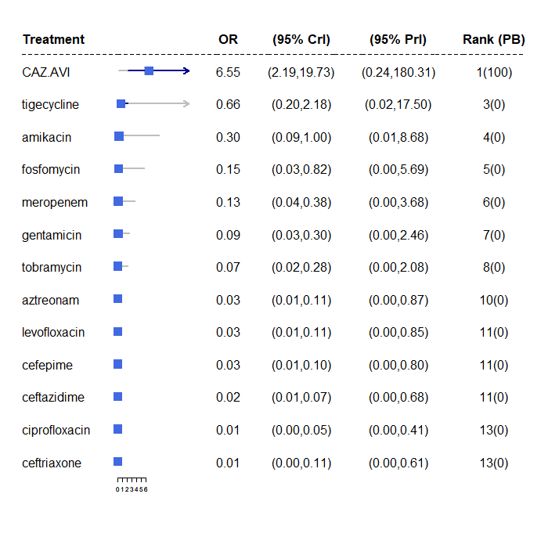
Abbreviations: OR, odds ratio; CrI, credible interval, PrI, prediction interval; PB, probability being the best treatment.

Figure 27: Forest plot of OR vs colistin for reduced dataset, subgroup analysis for unusual inclusion criteria
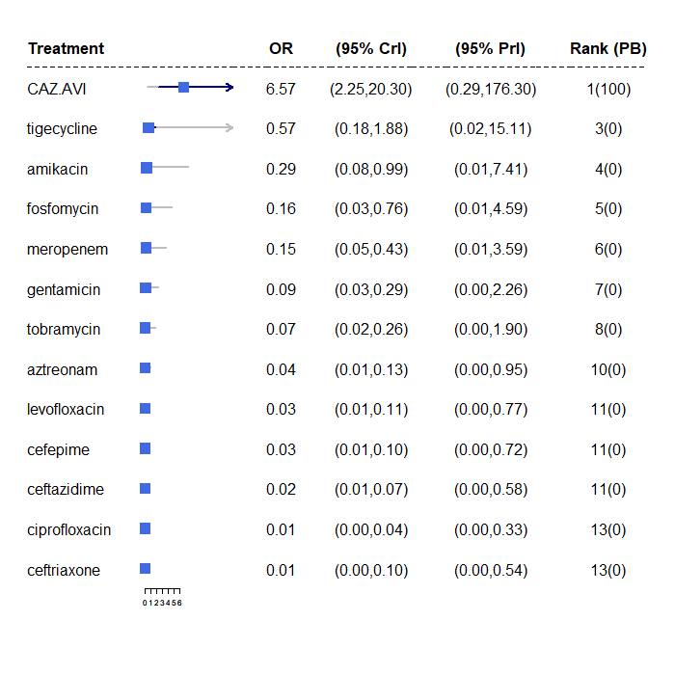
Abbreviations: OR, odds ratio; CrI, credible interval, PrI, prediction interval; PB, probability being the best treatment.

MBL co-carriage:
The majority of studies (eight)^{37,44,51,53,60,62,65,66} did not state whether isolates with MBL co-carriage were included. Two studies reported data both with and without MBL co-carriage^{46,56}and the IPD for one study¹ was reanalysed by EEPRU to exclude MBL co-carriage. Two studies^{57,61} included isolates with MBL co-carriage, and reported that 9.4%⁶¹ and 15.6%⁵⁷ of isolates co-carried MBLs. Two studies^{50,52} excluded isolates co-carrying MBLs from the analysis. One ACIC study⁴⁵ also reported only isolates without MBL co-carriage.
A subgroup analysis was performed including just the 6 studies that provided data with no co-carriage of MBLs. A meta-regression model was not considered appropriate in this instance since the direction of the interaction effect may differ for alternative comparators.
The estimated between-study SD was slightly reduced (1.38, 95% CrI: 0.95 to 2.06) compared to the standard NMA model, but with wider CrI and still classed as extremely high. Estimated OR vs colistin were increased compared to the model with all studies included, however there was a large amount of uncertainty. Although the analysis did not provide conclusive evidence that co-carriage of MBLs has a statistically significant effect on the resulting relative effects, the analysis further highlights the heterogeneity in treatment effects and since there was a good clinical rationale to support this analysis, a scenario analysis based on co-carriage of MBLs was planned in the modelling. Since it was also concluded that restricting to studies using EUCAST methods and breakpoints was the preferred approach (see Section 4.5.4) this left only one study (Vazquez-Ucha et al 2021)¹⁵ that both reported data with 0% MBLs and used EUCAST methods and breakpoints. A scenario analysis within the cost-effectiveness analysis based on this one study was therefore planned.

Figure 28: Forest plot of OR vs colistin for reduced dataset, NMA model for MBL cocarriage subgroup
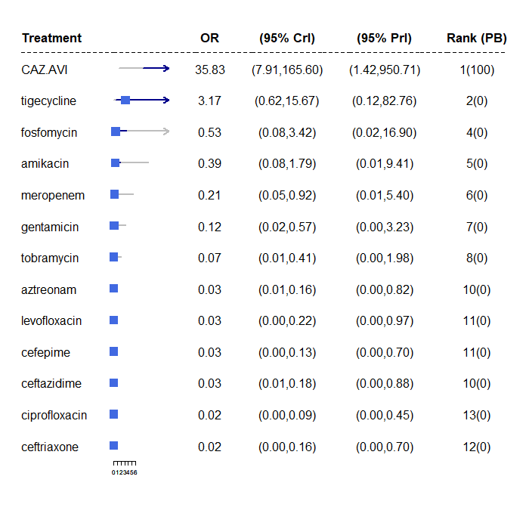
Abbreviations: OR, odds ratio; CrI, credible interval, PrI, prediction interval; PB, probability being the best treatment.

Proportion with carbapenem susceptibility:
To investigate the impact of the proportion of carbapenem non-susceptible isolates on CAZ-AVI susceptibility, the % non-susceptible to meropenem was extracted for each study as this was the most frequently reported statistic.
A meta-regression was performed including a covariate indicating the proportion of non-susceptible isolates for each study. Two studies did not provide information on carbapenem susceptibility and so were not included in the analysis.^{62,65} For the remaining 14 studies, the percentage non-susceptible ranged from 0%⁴⁶ to 100%,^{50,57} with mean 53.3% non-susceptible.
The meta-regression model did not reduce the estimated between-study SD (1.56, 95% CrI: 1.26 to 1.96) compared to the standard NMA model. The coefficient from the meta-regression was 0.30 (95% CrI: -2.60 to 3.24) which is close to zero and not statistically significant. There was therefore no evidence to suggest that the relative treatment effects differ according to the proportion with carbapenem susceptibility.
Figure 29: Forest plot of OR vs colistin for reduced dataset, meta-regression model for carbapenum susceptibility
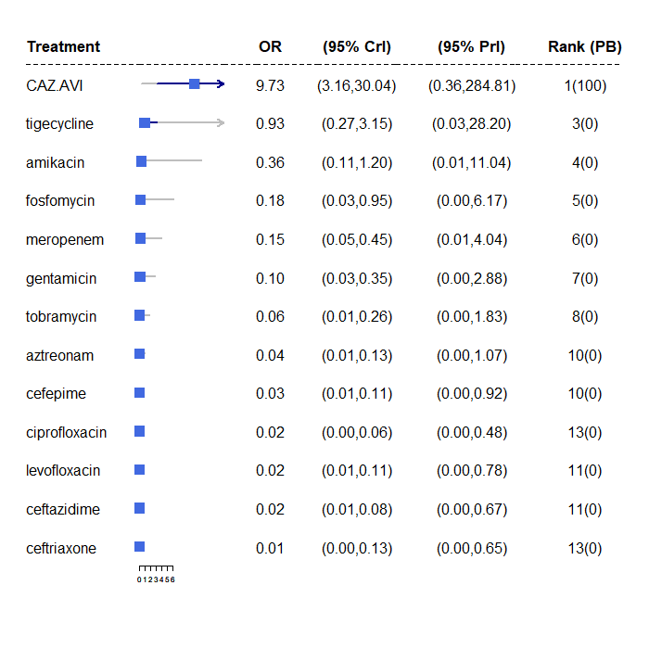
Abbreviations: OR, odds ratio; CrI, credible interval, PrI, prediction interval; PB, probability being the best treatment.
Consecutive sample recruitment:
Five studies^{37,50-52,66} selected consecutive isolates, whilst the remainder were either unclear^{1,44-46,60,62} how isolates were selected, or used specific criteria to do so.^{53,56,57,61,65} A meta-regression model was conducted comparing those studies with consecutive samples (the reference category) to those where sampling was either non-consecutive or unclear.
Compared to the standard NMA model, the meta-regression model provided a similar fit to the data based on the DIC and did not reduce the estimated between-study SD (1.57, 95% CrI: 1.28 to 1.95). The coefficient from the meta-regression was not statistically significant (-0.10, 95% CrI: -1.93 to 1.75). There was therefore no evidence to suggest that the relative treatment effects differ according to method of sample recruitment.

Figure 30: Forest plot of OR vs colistin for reduced dataset, meta-regression model for consecutive samples
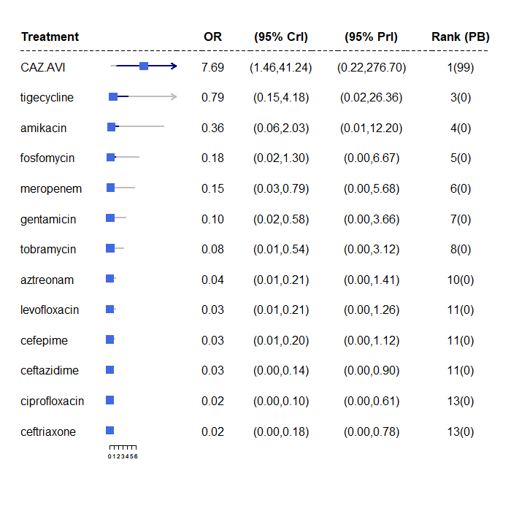
Abbreviations: OR, odds ratio; CrI, credible interval, PrI, prediction interval; PB, probability being the best treatment.

NMA results with full dataset
Figure 31: Forest plot of OR vs colistin for full data, NMA model
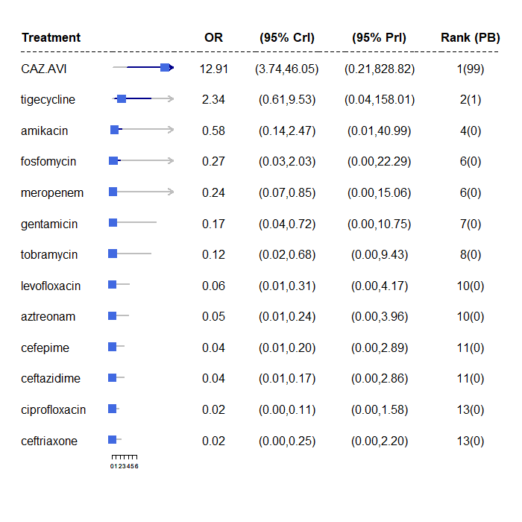
Abbreviations: OR, odds ratio; CrI, credible interval, PrI, prediction interval; PB, probability being the best treatment.

The conclusions of the sensitivity analyses using the full data were consistent with the analyses using the reduced data.
Model decription | Studies | Absolute model fit |  |  |  | Model comparison |  | Heterogeneity |  | meta-regression coefficient
Model decription | Studies | DP |  | TRD |  | DIC |  | SD (95 % CrI)
Sensitivity analyses using full data
Unusual inclusion criteria, meta-regression model | 16 | 111 |  | 110.3 |  | 616.57 |  | 2.01 (1.66, 2.46) |  | 0.05 (-3.16,3.49)
Unusual inclusion criteria subgroup | 13 | 98 |  | 96.96 |  | 547.13 |  | 2.01 (1.64, 2.50) |  | NR
MBL cocarriage, subgroup | 6 | 50 |  | 50.53 |  | 291.30 |  | 1.74 (1.22, 2.53) |  | NR
Carbapenum suscptibility, meta-regression model | 14 | 103 |  | 102.5 |  | 571.95 |  | 2.02 (1.65, 2.50) |  | -1.60 (-5.15,1.94)
Consecutive samples. meta-regression model | 16 | 111 |  | 110.9 |  | 617.301 |  | 2.00 (1.65, 2.46) |  | 0.91 (-1.20,3.28)
DP: data points, TRD: total residual deviance (mean), SD: standard deviation (median)

Figure 32: Forest plot of OR vs colistin for full dataset, meta-regression model for unusual inclusion criteria
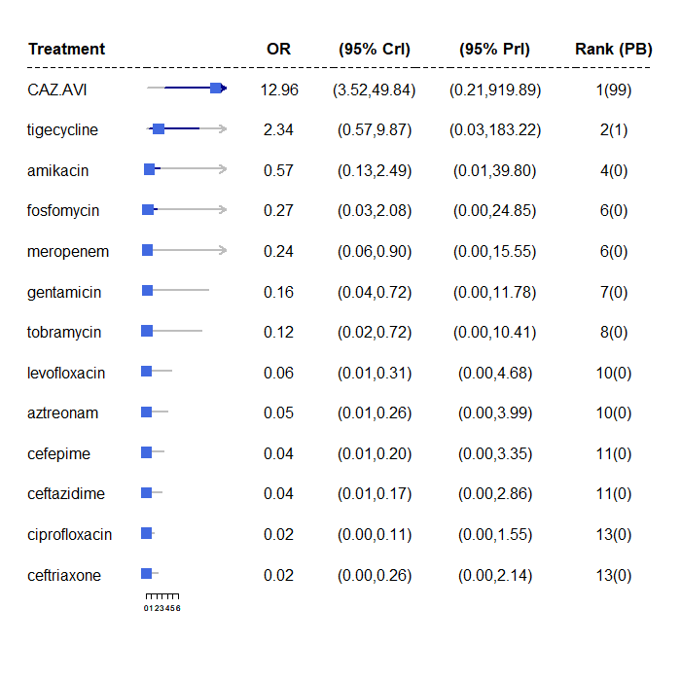
Abbreviations: OR, odds ratio; CrI, credible interval, PrI, prediction interval; PB, probability being the best treatment.

Figure 33: Forest plot of OR vs colistin for full dataset, subgroup analysis for unusual inclusion criteria
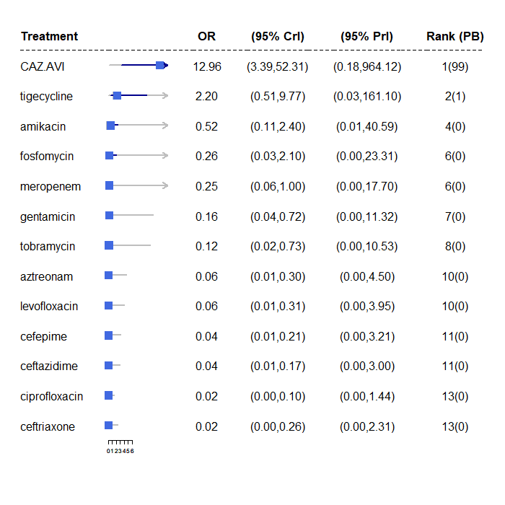
Abbreviations: OR, odds ratio; CrI, credible interval, PrI, prediction interval; PB, probability being the best treatment.

Figure 34: Forest plot of OR vs colistin for full dataset, NMA model for MBL cocarriage subgroup
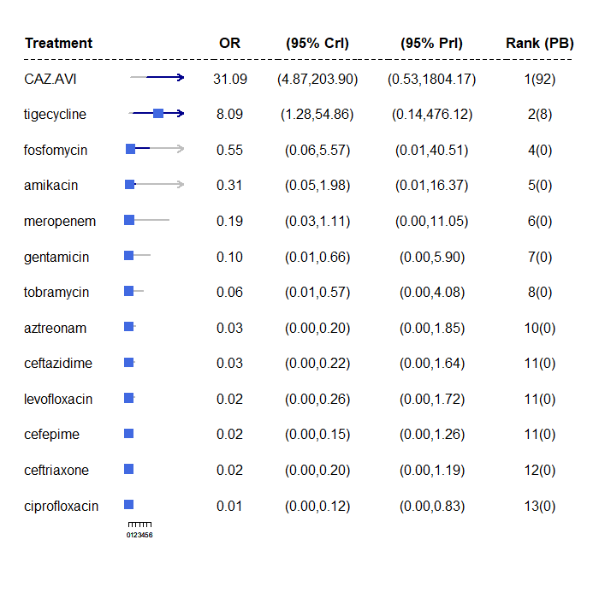
Abbreviations: OR, odds ratio; CrI, credible interval, PrI, prediction interval; PB, probability being the best treatment.

Figure 35: Forest plot of OR vs colistin for full dataset, meta-regression model for carbapenum susceptibility
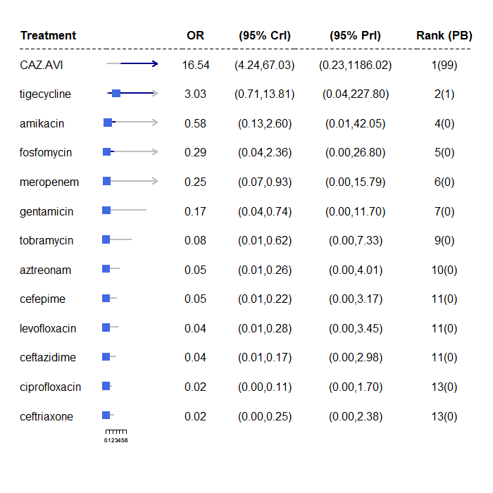
Abbreviations: OR, odds ratio; CrI, credible interval, PrI, prediction interval; PB, probability being the best treatment.

Figure 36: Forest plot of OR vs colistin for full dataset, meta-regression model for consecutive samples
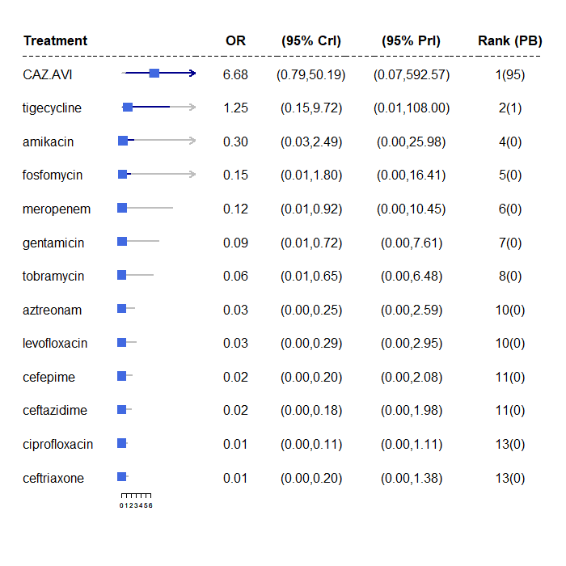
Abbreviations: OR, odds ratio; CrI, credible interval, PrI, prediction interval; PB, probability being the best treatment.

A7.3 Inconsistency checks
Figure 37: Deviance contribution plot for the full data analysis
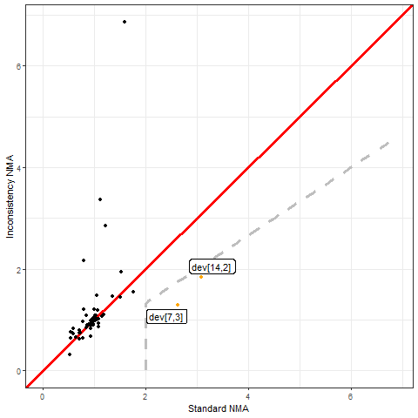

Figure 38: Deviance contribution plot for the reduced data analysis

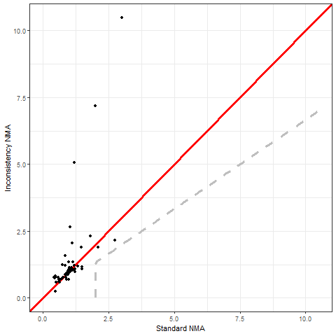

Appendix 8: Additional content for review 4

A8.1 Quality assessment of Bassetti et al. 2020.
Quality assessment of the Bassetti et al. (2020)⁸³ systematic review was undertaken using the AMSTAR-2 (A MeaSurement Tool to Assess systematic Reviews) critical appraisal tool for systematic reviews that include randomised or nonrandomised studies.¹⁹⁷ The tool comprises 16 questions that can elicit a yes, partial yes, no, or not undertaken response. The results from the AMSTAR-2 assessment, including the rationale for question responses, are presented in Table 49.
There were some issues with the quality of the review including a lack of detail about the included studies; poor reporting of the meta-analysis methodology; no assessment of the impact of risk of bias of the studies on the review findings; a lack of exploration of sources of heterogeneity and some limitations to the search strategy. Since the review did not report a meta-analysis of studies in the sites of interest in UK or European studies, and was therefore of primary use as a source of potentially relevant studies, most of the issues identified with quality were not of concern.
Some issues were identified with the robustness of the search strategy (see Table 49) in that it did not search reference lists of included studies, trail registers or grey literature, and did not contact experts. The period 2007 to present day was searched using an improved search strategy to capture any studies that may have been missed, but no additional search strategies were employed in our updated search due to time constraints.

Table 56. AMSTAR-2 quality assessment of the Bassetti et al. (2020) systematic review
AMSTAR-2 question | Response | Rationale
1. Did the research questions and inclusion criteria for the review include the components of PICO? | Yes | Studies were eligible for inclusion that reported the impact of delayed appropriate antibiotic therapy for hospitalised adult patients with severe bacterial infections, including but not limited to urinary tract infections (UTIs), nosocomial pneumonia, bacteraemia, intra-abdominal infections, central nervous system infections, skin and soft-tissue infections and endocarditis. Studies were required to report the appropriateness of antibiotic therapy, an identifiable delay to initiation of appropriate therapy, and at least one of the following outcomes: mortality, treatment success, infection progression, clinical cure, microbiological eradication, duration of antibiotic treatment, hospital or intensive care unit (ICU) LOS or healthcare costs
2. Did the report of the review contain an explicit statement that the review methods were established prior to the conduct of the review and did the report justify any significant deviations from the protocol? | Yes | The protocol detailing the review question, search strategy, inclusion and exclusion criteria, risk of bias assessment methods, and meta-analysis plane, was published on the PROSPERO database (CRD42018104669). Due to heterogeneity between studies, random-effects models were used for meta- analyses. There were no deviations from the published protocol evident in the peer-reviewed publication.
3. Did the review authors explain their selection of the study designs for inclusion in the review? | No | RCTs, non-randomised comparative studies and observational studies were eligible, but no rationale for inclusion of these study designs was reported.
4. Did the review authors use a comprehensive literature search strategy? | No | Although both MEDLINE and EMBASE were searched along with searching the reference lists of relevant systematic reviews and a citation search, there were no additional searches of the reference lists of included studies, trials registers or grey literature. There was also no consultation with topic experts to identify additional studies.
5. Did the review authors perform study selection in duplicate? | Yes | Two reviewers independently screened the titles and abstracts for inclusion and assessed potentially relevant full-texts against the eligibility cri- teria.
6. Did the review authors perform data extraction in duplicate? | Yes | One reviewer extracted data from eligible studies using a piloted data extraction form, and a second reviewer verified every data point.
7. Did the review authors provide a list of excluded studies and justify the exclusions? | No | The review flow diagram reports that 366 articles were excluded at the full-text stage along with the number for each reason for exclusion. However, there is no table of these studies, providing the author and a citation for each of the 366 articles.
8. Did the review authors describe the included studies in adequate detail? | No | Whilst there was a narrative summary and tabulation of the interventions, outcomes, settings, and study designs, there was limited detail on the populations in the included studies.
9. Did the review authors use a satisfactory technique for assessing the risk of bias (RoB) in individual studies that were included in the review? | Yes | Risk of bias was assessed using a relevant tool (Newcastle–Ottawa scale, CRD Cohort study checklist or Cochrane risk-of-bias tool)
10. Did the review authors report on the sources of funding for the studies included in the review? | No | The sources of funding of the included studies were not reported.
11. If meta-analysis was performed did the review authors use appropriate methods for statistical combination of results? | No | Although it was reported that odds ratios were combined in a meta-analysis applying random effects, the weighting method was not reported, and subgroup or sensitivity analyses to investigate potential sources of heterogeneity were not undertaken. There was also no justification for pooling data in a meta-analysis.
12. If meta-analysis was performed, did the review authors assess the potential impact of RoB in individual studies on the results of the meta-analysis or other evidence synthesis? | No | The authors did not performed any analyses to investigate possible impact of risk of bias on summary estimates of effect.
13. Did the review authors account for RoB in individual studies when interpreting/ discussing the results of the review? | No | There was no interpretation or discussion of RoB
14. Did the review authors provide a satisfactory explanation for, and discussion of, any heterogeneity observed in the results of the review? | No | Heterogeneity was noted in some analyses, but there was no exploration or discussion of the sources of heterogeneity.
15. If they performed quantitative synthesis did the review authors carry out an adequate investigation of publication bias (small study bias) and discuss its likely impact on the results of the review? | Yes | A funnel plot was generated to assess publication bias among studies reporting data for the impact of appropriate versus inappropriate therapy on mortality which was deemed to be symmetrical. The authors commented that interpretation of publication bias in this way should be performed with caution, which is an acceptable summary.
16. Did the review authors report any potential sources of conflict of interest, including any funding they received for conducting the review? | Yes | The study was reported as being funded by Shionogi BV. Competing interests were reported.

A8.2 Other searches conducted
The pragmatic searches were conducted using six distinct strategies:
- Interrogation of the Mechanisms of Resistance database (3172 references). The search terms for the database comprised of terms for Mechanisms [OXA-48, NDM, VIM, IMP] AND Germ [enterobacteria, E. coli, K. pneumonia, P. aeruginosa] AND Study design [Reviews, RCTs, observational studies] (see Appendix 1.3.2). Dredging of the database was conducted in two steps. First, the library was screened by searching for outcomes and infection sites of interest in the abstracts, using search terms (death or mortality or hospital) AND (cUTI or HAP or VAP). Then, the searches were repeated by searching for outcome only, following a low number of hits in the first step. The outcomes in the second step were adjusted to (death or mortality or fatal outcome or clinical outcome) to increase the specificity of the searches, as the term ‘hospital’ in the first step picked up many irrelevant studies. The hits were then screened in two stages – by abstract and by full text.
- Interrogation of the Cost-effectiveness Models database (66 references) created by EEPRU. The database was screened by abstract and by full text to identify studies previously used to model long-term outcomes of interest. Further two rounds of backward citation searches were performed on all included studies.
- Interrogation of the Endnote library provided by Shinogi (1261 references). The library was screened by searching for the following terms in the abstracts: (death or mortality or fatal outcome) AND (HAP or VAP or UTI or acute pyelonephritis). The hits were then screened in two stages – by abstract and by full text.
- Screening the list of key references provided by Shinogi for NICE (45 references). The references were screened in three steps: by title, abstract, and full text.
- Interrogation of the Pfizer Endnote library (81 references) and Pfizer Excel file of key papers (240 references) combined into a single Endnote library (299 references). The library was screened by searching for the following terms in the abstracts: (death or mortality or fatal outcome) AND (HAP or VAP or UTI or acute pyelonephritis). The hits were then screened in two stages – by abstract and by full text. Of the 299 references, 193 did not have an abstract; these were screened by title and full text.
- Screening the studies included in two systematic review articles provided by Shinogi (Zasowski et al., 2020; Bassetti et al., 2020). The reviews reported the effect of inappropriate antibiotic treatment (Zasowski 2020) and delayed antibiotic treatment (Bassetti 2020) on outcomes. The papers included in the review were screened by site, where only those that reported outcomes in HAP/VAP and cUTI were included.
The search strategies were divided between two reviewers (LS strategies 1 and 2, DJ strategies 3 - 6). Inclusion of any ‘grey area’ studies was determined through discussion with the wider team (BW, CR, BK).

Appendix 9: Structured expert elicitation

A9.1 Description of elicited parameters
We required outcomes for patients with Hospital Acquired Pneumonia (HAP), Ventilator Associated Pneumonia (VAP), and complicated urinary tract infections (cUTIs) caused by carbapenem-resistant gram negative bacteria. We were only interested in outcomes following microbiology-directed treatment for patients with an infection caused by Enterobacterales with an OXA-48 or MBL resistance mechanism, or Pseudomonas with a MBL resistance mechanism.

Outcomes were elicited depending on whether the infectious pathogen is susceptible to treatment. Therefore, outcomes only depend on whether a patient is susceptible to treatment or not, and not to the specific treatment given. The outcomes we were interested in were 30-day mortality, LOS in hospital, and the type of ward these patients would stay on in hospital.

As background information we provided experts with several related studies. In these studies, infecting pathogens were not confirmed to be susceptible to the antibiotics administered (cefiderocol or CAZ-AVI); however, in our assessment, they are likely to have been susceptible.

For HAP, VAP and cUTI, both for susceptible and not-susceptable patients, the following questions were asked of experts:

Question 1. In this patient population, what proportion of patients will still be alive 30 days after starting microbiology directed treatment?

Question 2. In the patient population described at the top of the page, what will be the average length of stay?

Question 3. In the patient population described at the top of the page, what proportion of hospital stay would be spent on each of the following wards? This number should represent the average for all such patients, regardless of their outcome.

A9.2 Protocol for elicitation
The following sections describe the details of the elicitation exercise, according to the elements as described in the MRC elicitation guidance.

A9.2.1Selecting the quantities (preparation and design stage)
The choice of quantity considered the following three objectives:⁵² fitness for purpose; directly observable and homogeneity in the quantities elicited. Eliciting the same summaries throughout will reduce the burden of training.²⁰¹

For question 1 the quantities elicited relate to the proportion of patients with an event at a certain time. Question 2 relates to a continuous outcome, length of stay (LOS), which, in principle, can take values up to ∞. Question 3 relates to the proportionate split of LOS between the three types of ward – general ward, HDU and ICU. As the total proportion must sum to 100, these quantities were not elicited with uncertainty, and instead a mean proportion elicited.

A9.2.2 Methods to encode judgements (preparation and design stage)
Either the Chips and Bins method or a Bisection method have been shown to work equally well in health care elicitation. The Chips and Bins approach however, is viewed as less complex and easier to complete by health care professionals, and so this method is used here.

Experts were first asked to express the range for their beliefs, the minimum, which is the value such that the experts believes that there is a 1% probability that the proportion is less than that value, and the maximum, a value, such that the experts believe that there is a 1% probability that the proportion is more than that value. Grids were then generated based on this range and experts were asked to place ‘chips’ on this grid to represent their beliefs.

A9.2.3 Validation (preparation and design stage)
At the end of each task, experts were given a qualitative summary of their responses. If experts felt that these did not represent their views they were encouraged to revise their responses. Experts also had an opportunity to revise their responses following the feedback round (see below).

A9.2.4 Selecting experts (preparation and design stage)
The models developed for this project span across HAP, VAP and cUTI and also relate to likely outcomes depending on susceptibility to treatment. Therefore there are multiple types of experts relevant for this task. Here we have included hospital consultants, microbiologists and pharmacists as experts. As part of the task, experts were asked to identify which of these disciplines they worked in. Experts were not expected to have any normative skills. Experts were recruited using recommendation from peers.

A9.3 Pilot exercise (preparation and design stage)
The wording of the questions was piloted for clarity and adequacy. The draft exercise was sent to a lead clinician and feedback sought. Following feedback the questions were modified, specifically the wording of the questions.

A9.3.2 Training and preparation for experts (preparation and design stage)
A narrated power-point training session was delivered to experts prior to the task (see Appendix 10). The training session described the objectives of the elicitation exercise, clarified concepts such as uncertainty, familiarised the experts with the quantities elicited, described and explained the impact of bias and heuristics, and trained experts on the methods of elicitation used. A recorded version of the training slides was also sent to the experts following the session and also key details from this repeated in the task itself.

Experts were also reminded throughout the SEE that they were to elicit uncertainty on their estimate rather than thinking about variability across this heterogeneous group of patients.

A9.3.2 Level of elicitation (elicitation stage)
Each expert elicited their judgements individually without interaction with other experts. Eliciting judgements individually reduced the risk of estimates being biased by a subset of experts. In the SEE elicitation literature, there are concerns that experts may not feel confident in eliciting judgements individually, however, the experts in this SEE process elicited their beliefs on a condition that they encounter regularly in general practice. Concerns regarding individual level elicitation and lower confidence amongst experts generally arises when dealing with problems/technologies or conditions that are new or unknown to the experts.

A9.3.3 Mode of administration (elicitation stage)
The elicitation exercise was administered via an application in SHINY. The task was delivered remotely, due to current restrictions on face to face meetings. Experts were offered the opportunity to complete the exercise remotely alongside one of the team. Email contacts were given to provide any support needed.

A9.3.4 Feedback to experts and revision (elicitation stage)
Once experts expressed their beliefs and completed each question, they were presented with graphical feedback of what their estimates looked like. Experts were able to see how the grid looked once they have placed all of their chips on it. In addition, once experts had completed the grid, a summary of their answers was relayed to them. This provided the following information:
Your answers imply that (example quantities given)
- There is a 17% probability that the proportion of patients is between 19 and 20%
- There is a 50% probability that the proportion of patients is between 20 and 21%
- There is a 33% probability that the proportion of patients is between 21 and 22%

Following the individual elicitation beliefs were then aggregated using linear opinion pooling. This overall distribution was then relayed back to experts and they were given the opportunity to revise their own beliefs on the histograms they previously completed. This approach has been show to generated less biased parameters when the quantities elicited are unknown to the experts. Following this revision, expert’s beliefs were aggregated using the same approach, linear opinion pooling, and the final parameter values determined.

A9.3.5 Opportunity for interaction (elicitation stage)
Given the individual level of elicitation that was chosen, there was no opportunity for interaction between the experts. The revision stage was done remotely so experts did not interact with each other.

A9.3.6 Feedback from experts on process (elicitation stage)
Qualitative feedback on the elicitation process was collected from the experts, including rationales for their responses. This was collected during the task using free text boxes. This form of validation helps to highlight if experts understood the task and responded as best they could.

A9.3.7 If/how to aggregate (aggregation, analysis and post- elicitation)
As an individual level of elicitation was chosen, mathematical aggregation was applied to generate the distributions, specifically linear opinion pooling using equal weighting of experts. First a probability distribution was fitted to each expert’s beliefs from the histogram and then these were pooled, assuming that each expert contributed equally to the group overall distribution.
This overall distribution was then relayed back to experts and they were given the opportunity to revise their own beliefs. Following this revision, expert’s beliefs were aggregated using the same approach, linear opinion pooling, and the final parameter values determined.

A9.3.8 Fit to distribution (aggregation, analysis and post-elicitation)
A Beta distribution was fitted to expert’s distributions for question 1 as these relate to proportions. For question 2 a lognormal distribution was fitted. Question 3 only asked for point estimates so not fitting was required.

A9.3.9 Data Protection and Anonymity (aggregation, analysis and post-elicitation)
Experts were asked to give their opinions individually (not in groups). The information provided, including personal details, is kept anonymous and confidential, stored securely and only accessed by those carrying out the study.

A9.4 Results
Eleven experts agreed to take part in the elicitation task and took part in the training. Of these eleven, 9 experts attempted the task. The experts included medical consultants (n=2), microbiologists (n=5), ICU consultants (n=1) and pulmonary consultants (n=1). Seven experts completed the task, while two terminated it before answering all questions. Responses from the two experts who terminated the task before answering all questions, were included in the analysis for all outcomes where they provided an estimate for both susceptible and not susceptible populations. Following the elicitation task, experts were sent group summaries and asked if they would like to revise their responses. Only two experts stated that they reviewed the group summaries, and one adjusted their initial responses in light of group summaries.
Two experts indicated that the probability of survival was lower in patients who were susceptible to treatment than those who were not susceptible, for two sites of infection. This was judged to be implausible, and so the two experts were removed from the sample in the base case.

A9.4.1 Group summaries - base case
The group summaries on 30-day mortality (Figure 40) indicate that survival is the lowest for VAP patients and highest for cUTI patients, and that susceptibility to treatment increases the probability of survival, for all three sites of infection. The group summaries on LOS (Figure 41) indicate that the LOS is the shortest in patients with cUTIs and the longest for patients with VAP. For all three sites of infection, susceptibility to treatment decreased the LOS.
The group summaries about the proportion of time spent on different types of wards is shown in Table 50. The summaries indicate that patients with VAP spend the most time in ICU and the least time on general medical wards, followed by HAP, then cUTIs. Furthermore, patients who are susceptible to treatment are expected to spend more time on the general medical ward and less on ICU and HDU, for all three sites of infection.
Figure 39. 30-day survival
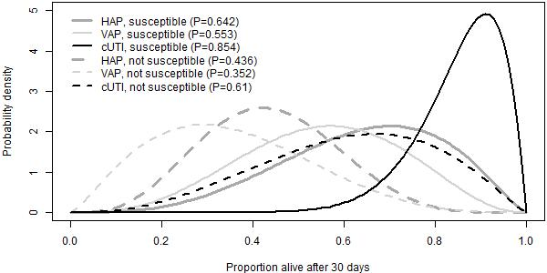
cUTI, complicated urinary tract infection; HAP, hospital-acquired pneumonia; VAP, ventilator-associated pneumonia; P, proportion

Figure 40 Expected LOS
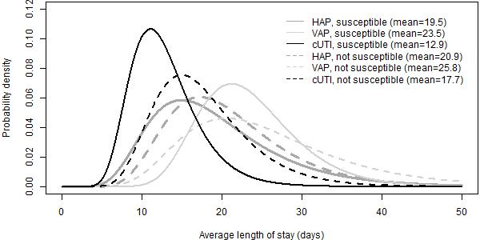
cUTI, complicated urinary tract infection; HAP, hospital-acquired pneumonia; VAP, ventilator-associated pneumonia

Table 57. Proportion (%) of hospital stay spent on ICU, HDU and general medical ward.
 | ICU | HDU | General medical ward
HAP, susceptible | 24.3 | 19.0 | 56.7
VAP, susceptible | 60.0 | 13.3 | 26.7
cUTI, susceptible | 15.0 | 17.0 | 68.0
HAP, not susceptible | 39.3 | 20.7 | 40.0
VAP, not susceptible | 66.7 | 15.8 | 17.5
cUTI, not susceptible | 23.3 | 18.3 | 58.3
cUTI, complicated urinary tract infection; HAP, hospital-acquired pneumonia; HDU, high dependency unit; ICU, intensive care unit; VAP, ventilator-associated pneumonia

In the model, outcomes of HAP and VAP were modelled together, and so experts’ priors on outcomes were pooled. When pooling the priors, outcomes for HAP and VAP were weighted by their relative occurrence in Tumbarello et al. (2013) - 0.283 (28/99) for HAP and 0.617 (71/99) for VAP. Tumbarello was chosen as the study where participants were the most representative of patients in our HVCS, that reported the proportion of patients with hospital acquired pneumonia that was ventilator-associated.
The pooled priors are shown in Figures 42 and 43 and
Figure 41 30-day survival with HAP/VAP combined.
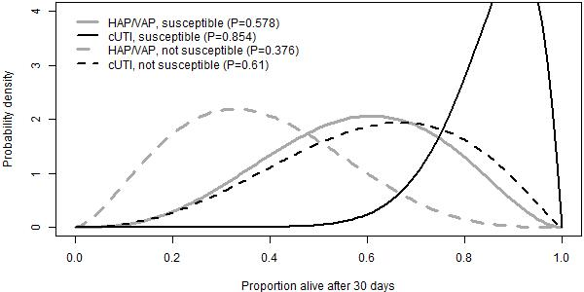
cUTI, complicated urinary tract infection; HAP/VAP, hospital-acquired pneumonia or ventilator-associated pneumonia; P, proportion

Figure 42 Expected LOS with HAP/VAP combined.
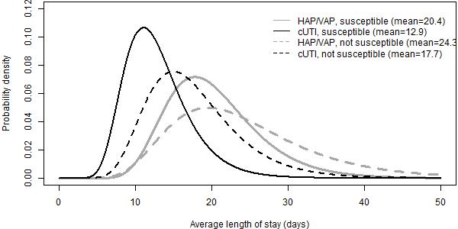
cUTI, complicated urinary tract infection; HAP/VAP, hospital-acquired pneumonia or ventilator-associated pneumonia
Table 58 Proportion (%) of hospital stay spent on ICU, HDU and general medical ward.
 | ICU | HDU | General medical ward
HAP/VAP, susceptible | 49.90 | 14.94 | 35.16
cUTI, susceptible | 15.00 | 17.00 | 68.00
HAP/VAP, not susceptible | 58.92 | 17.21 | 23.86
cUTI, not susceptible | 23.33 | 18.33 | 58.33
cUTI, complicated urinary tract infection; HAP, hospital-acquired pneumonia; HDU, high dependency unit; ICU, intensive care unit; VAP, ventilator-associated pneumonia

A9.4.2 Group summaries - all experts included
Results with all priors, including those that indicated that survival would be lower in susceptible patients, are shown in Figures 44 and 45, and Table 52. Overall, the priors indicate the same relative differences between outcomes and sites of infection.
Figure 43 30-day mortality - all experts.
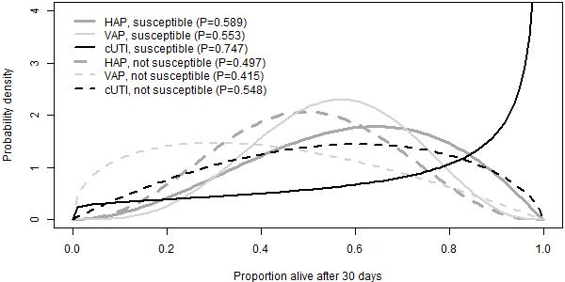
cUTI, complicated urinary tract infection; HAP, hospital-acquired pneumonia; VAP, ventilator-associated pneumonia; P, proportion

Figure 44 Expected LOS - all experts
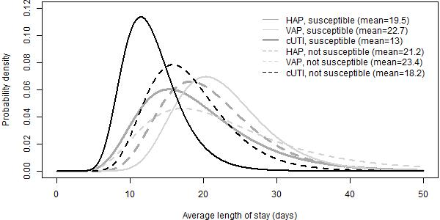
cUTI, complicated urinary tract infection; HAP, hospital-acquired pneumonia; VAP, ventilator-associated pneumonia

Table 59. Proportion (%) of hospital stay spent on ICU, HDU and general medical ward.
 | ICU | HDU | General medical ward
HAP, susceptible | 23.56 | 21.22 | 55.22
VAP, susceptible | 62.86 | 14.29 | 22.86
cUTI, susceptible | 13.57 | 16.00 | 70.43
HAP, not susceptible | 36.00 | 22.00 | 42.00
VAP, not susceptible | 68.57 | 16.43 | 15.00
cUTI, not susceptible | 21.43 | 18.57 | 60.00
cUTI, complicated urinary tract infection; HAP, hospital-acquired pneumonia; HDU, high dependency unit; ICU, intensive care unit; VAP, ventilator-associated pneumonia

Appendix 10: Structured expert elicitation: background information provided to clinicians

A10.1 Introduction
NICE, NHS England and NHS Improvement have commissioned a project to assess the feasibility of innovative models for reimbursing antimicrobials.
As part of the project, the University of Sheffield and the University of York are modelling outcomes of two antimicrobials that target infections caused by carbapenem-resistant gram negative bacteria. For this modelling we are focusing on patients with infections caused by the following pathogens:
- Cefiderocol (Fetcroja) targetting carbapenem-producing enterobacterales (CPE) and pseudomonas with metalo-beta-lactamase (MBL); and
- Ceftazidime with avibactam (CAZ-AVI, Zavicefta) targeting CPE with OXA-48.
This modelling work and subsequent NICE Committee deliberations will provide guidance on the value of each product to the NHS.
There are several model inputs for which data are limited or unavailable. As an alternative we require your expert opinion to inform these inputs. We are also interested in how uncertain you are about your opinions. The training seminar gave you guidance on how to express your uncertainty. We will use this approach here.
To begin, please click on the 'About you' tab at the top of the screen and proceed as advised thereafter.

A10.2 Background information
We are interested in outcomes for patients with Hospital Acquired Pneumonia (HAP), Ventilator Associated Pneumonia (VAP), and complicated urinary tract infections (cUTIs) caused by carbapenem-resistant gram negative bacteria. Specifically, we are interested in outcomes following microbiology-directed treatment for patients with an infection caused by CPE with an OXA-48 or MBL resistance mechanism, or pseudomonas with a MBL resistance mechanism.

A10.3 What do we mean by microbiology-directed treatment?
Patients in the microbiology-directed setting may have received empiric treatment with other antimicrobials prior to receiving microbiology results but require a change of treatment. This could be for a range of reasons including poor response to empiric treatment or adverse events requiring discontinuation of empiric treatment. Once the microbiology results are available, patients are assumed to be eligible to receive CAZ-AVI or cefiderocol (if found to be susceptible to them) if they meet either of the following criteria:
- Patients are susceptible only to colistin or aminoglycosides, and the new treatments offer improved safety.
- Patients are not susceptible to any existing treatment options, and the new treatments offer improved effectiveness and, possibly, safety.
Without the new treatments, patients who are not susceptible to any existing treatment options would be assumed to receive multi-drug salvage regimens.

A10.4 Outcomes of interest
For patients with HAP, VAP or cUTIs, whose infection is caused by CPE with an OXA-48 or MBL resistance mechanism or pseudomonas with a MBL resistance mechanism, and whose treatment is informed by microbiology results, we are interested in outcomes depending on whether the infectious pathogen is susceptible to treatment.
We will assume that outcomes only depend on whether a patient is susceptible to treatment or not, and not to the specific treatment given. We therefore leave aside toxicity issues and differing risks of adverse events across treatments for the moment. We also assume that these patients will not experience acute kidney injury.
Note that in this scenario, patients who are classified as not susceptible to any treatment are assumed to receive multi-drug salvage regimens.
The outcomes we are interested in are 30-day mortality, length of stay in hospital, and the type of ward these patients would stay on in hospital.

A10.5 Existing literature

We are not aware of any literature reporting our outcomes of interest in susceptible and not susceptible patients in the microbiology-directed setting, for patients with HAP, VAP, cUTIs caused by carbapenem-resistant gram negative bacteria.
We are therefore asking you to estimate these outcomes in this exercise and tell us how uncertain you are about your estimates.
As background we have identified several related studies that may help inform your answers, although they are not directly addressing the outcomes of interest. In these studies, infecting pathogens were not confirmed to be susceptible to the antibiotics administered (cefiderocol or CAZ-AVI); however, in our assessment they are likely to have been susceptible.

These studies are summarised in the table below.
Study | Site of infection and organism | Pathogen | Treatment received | Treatment history | Patient characteristics (mean) | Outcomes: HAP/VAP/ nosocomial pneumonia | Outcomes: cUTIs
APEKs-NP | HAP (n=59)  VAP (n=59)  HCAP (n=27) | Infections caused by Gram negative pathogens. Excluded patients known to have carbapenem-resistant pathogens at the time of ransomisation. | Cefiderocol | 33% had had empiric treatment failure | Age = 64.6  APACHE II = 16.0  SOFA = 4.7  CCI = NR | 14-day mortality  HAP: 10.2%  VAP: 15%  Total: 12.4%  28-day mortality  Total:21.0% | NA
CREDIBLE-CR | Nosocomial pneumonia (n=40)  cUTIs (n=17) bloodstream infections or sepsis (n=44) | Infections with evidence of a carbapenem-resistant Gram negative pathogen | Cefiderocol | 57% had had empiric treatment failure | Mean age = 63.1  APACHE II = 15.3  SOFA = 5.1  CCI = 5.5 | Nosocomial pneumonia  28-day mort: 33% | 28-day mort: 12%
REPRISE | cUTI (n=152) | Infections caused by ceftazidime-resistant Gram negative pathogens | CAZ-AVI | 50% had received prior empiric treatment | Mean age = 64.3  APACHE II = NR  SOFA = NR  CCI = NR | NA | 28-day mort: 2.1%
REPROVE | HAP/VAP  (ΩΑΠ ν=118;΄νον-ΩΑΠ ν=238) | Excluded infections caused by Gram positive pathogens only or other pathogens not expected to respond to CAZ-AVI and/or meropenem | CAZ-AVI | 34% had received no prior antibiotics | Mean age = 62.4  APACHE II = 14.5  SOFA = NR  CCI = NR | 28-day mort: 8.4% | NA
HAP =hospital acquired pneumonia; VAP = ventilator-associated pneumonia; HCAP = healthcare-associated pneumonia; cUTI = complicated urinary tract infection; APACHE II = Acute Physiology and Chronic Health Evaluation II; SOFA = Sequential Organ Failure Assessment; CCI = Charlson Comorbidity Index; NR = not reported.

Appendix 11: Training slides

Slide 1
Slide 2
Slide 3
Slide 4
Slide 5
Slide 6
Slide 7
Slide 8
Slide 9
Slide 10 |  | S
Slide 11
Slide 12
Slide 13
Slide 14
Slide 15
Slide 16
Slide 17
Slide 18
Slide 19
Slide 20
Slide 21
Slide 22
Slide 23
Slide 24
Slide 25
Slide 26
Slide 27
Slide 28
Slide 29

Appendix 12: Review of existing economic evaluations

A12.1 Introduction and objectives
A series of reviews of existing cost-effectiveness evidence and modelling approaches was conducted:
- A review of existing cost-effectiveness evidence for CAZ-AVI with a focus on studies that include decision-analytic models. The aims were to establish the existance of potentially policy-relevant models to guide NICE and NHS decisions; and to identify relevant analytical methods and data sources.
- A review of existing approaches for resistance modelling in the target population. The aim of this review was to identify methods that could be adopted for this purpose in EEPRU’s modelling.
- A review of existing cost-effectiveness models in HAP/VAP to understand modelling approaches and data sources.
- A review of existing cost-effectiveness models in cUTI. Again, the purpose was to understand modelling approaches and data sources.

A12.2 Methods
Each review involved searches of bibliographic databases using standardized search terms, selection of studies using explicit inclusion criteria and data extraction using an agreed template. Details of the bibliographic databases that were searched are provided in Annex 1 to this appendix.

A12.3 Review 1: existing cost-effectiveness evidence for CAZ-AVI
The objective of the first review was to identify existing cost-effectiveness modelling studies of CAZ-AVI from the published literature. A total of 89 potentially relevant papers or abstracts were identified for the review from the searches. All the publications were screened using their titles and abstracts. Of the 89 publications screened, 14 relevant publications were included and 74 were excluded. The major reasons for exclusion were that the studies did not use decision analytic models, did not consider a relevant target population or were duplicates of other studies. Full-text articles of the relevant publications were obtained for secondary screening. Out of the 14 studies included, 9 studies were excluded on the basis of the full-text. The major reason for exclusion of studies during secondary screening was that after further reading it was apparent that the study did not include decision modelling. The 5 studies included in the review are described in Table 53.
Three of five included studies took a conventional approach to health technology assessment and sought to estimate the cost-effectiveness of CAZ-AVI based on clinical and economic data collected in the product’s regulatory trials.^{14,103,104} As discussed elsewhere,¹³ such trials are problematic to assess the value of new antibiotics for two main reasons. The first is that they are non-inferiority studies and, as such, are not designed to estimate the incremental benefit that a new product typically requires to demonstrate value against less costly comparator treatments. The second is that, for ethical reasons, the patients included in regulatory trials generally need to be susceptible to the treatments in all arms of the study. As such, their populations are different to those relating to the HVCSs, who are either known or suspected of being resistant to many existing antibiotics. These three studies^{14,103,104} sought to address the second limitation by modelling a proportion of patients having resistant infections, which involved making assumptions about the proportion of patients with resistant infection in the relevant population, and the impact of resistance on clinical parameters including cure rates. These studies also tried to reflect the wider set of existing therapies used in clinical practice by drawing on non-RCT evidence in the target population.
The two remaining studies considered a broader evidence base than just regulatory trials to relate their analyses more directly to populations with a higher likelihood of pathogens resistant to existing therapies. Simon et al focused on the cost-effectiveness of CAZ-AVI in carbapenem-resistant Enterobacteriaceae pneumonia or bacteraemia, drawing on evidence from observational studies on the proportions of patients with different types of infection, mortality rates with the comparator (colistin-based) therapy and the absolute effect of CAZ-AVI on mortality.¹⁰⁵ The risk of nephrotoxicity with colistin-based therapy was also modelled using observational data. Nguyen et al considered the cost-effectiveness of CAZ-AVI (and other carbapenem-sparing beta-lactams) compared to meropenem in cUTI or intra-abdominal infections in ESBL/AmpC-producing pathogens which have a high risk of carbapenem resistance.¹⁰⁶ Both observational and RCT evidence was used for the analysis, although RCT evidence was used for the CAZ-AVI analysis which showed no significant difference in clinical cure versus meropenem with limited information about patients’ resistance status.
All studies considered costs and benefits at a patient-level with no attempt to aggregate across the licensed CAZ-AVI indications likely to represent the product’s expected population. All studies had relatively short-term time horizons (3-5 years) and no attempt was made to consider the value of CAZ-AVI as resistance to the new and existing therapies increases over time. There has been discussion in the literature of a wider set of sources of value for novel antibiotics including benefits associated with reducing transmission, enabling medical procedures and insuring against sudden future increases in resistance.¹³ These were not considered in any of the five studies included in the review. None of the analyses related to clinical practice or evidence from the UK. As such, their relevance to this evaluation of CAZ-AVI is very limited.

Table 60: Summary of included cost-effectiveness studies of CAZ-AVI
Author, year | Country | Population (Pathogen) | Comparator | Strategies modelled | Resistance infections considered | Main clinical endpoint for modelling treatment differences | Primary Evidence Source
Tichy et al 2020¹⁰³ | Italy | HAP/VAP  (K. pneumonia (37%), P. aeruginosa (26%), E. cloacae (14%), E coli (12%), and H. influenzae (9%).) | Meropenem | Empiric | Assumptions regarding efficacy | Clinical response and cure | RCT
Simon et al 2019¹⁰⁵. | United States | CRE Pneumonia, BSI,  (K pneumoniae, Enterobacteriaceae) | Colistin-based therapy | First-line | Use of observational evidence | Absolute mortality risk reduction | Observational study
Kongnakorn et al 2019¹³⁹ | Italy | cIAIs  (Escherichia coli, Streptococcus anginosus group, Klebsiella pneumoniae, Bacteroides fragilis, Pseudomonas aeruginosa) | Ceftolozane/tazobactam plus metronidazole; meropenem | Empiric | Assumptions regarding efficacy | Clinical response and cure; Recurrence | RCT
Kongnakorn et al 2019¹⁰⁴ | Italy | cUTI (Escherichia coli, Klebsiella pneumoniae, Pseudomonas aeruginosa, Proteus mirabilis, Enterobacter cloacae) | Imipenem | Empiric | Assumptions regarding efficacy | Clinical response and cure; Recurrence | RCT
Nguyen et al 2019¹⁰⁶ | Netherlands | cUTI, cIAI, BSI  (  ESBL/AmpC-producing Gram-negative pathogens) | Meropenem | Definitive | Not clear for CAZ-AVI | Clinical cure | SLR and Meta-Analysis
BSI, bloodstream infection; CRE, carbapenem-resistant Enterobacterales; cUTI, complicated urinary tract infection; ESBL, extended-spectrum beta-lactamase; HAP/VAP, hospital-acquired pneumonia or ventilator-associated pneumonia; RCT, randomised controlled trial; SLR, systematic literature review

A12.4 Review 2: modelling studies considering resistance
A second review was conducted to identify published economic evaluations of AMs that attempted to quantify the effects of resistance, with a focus on resistance modelling. A total of 89 potentially relevant studies or abstracts were identified from the searches. All the publications were screened using their titles and abstracts after which 9 studies were publications were included in the review, which are described in Table 54. Note that this includes the 5 papers already identified from Review 1.

Table 61: Summary of included resistance modelling studies (including those from CAZ-AVI cost-effectiveness studies review in Table 53).
Author, year | Country | Population (Pathogen) | Intervention | Comparator
Chen et al 2019 ¹⁰⁷ | Taiwan | cUTI  (E. Coli, K. Pneumoniae, P. Aeruginosa, P. Mirabilis) | Ceftolozane/  tazobactam | Piperacillin/  tazobactam
Nelson 2019¹⁰⁹ | US | CRE BSI | Hypothetical | Hypothetical
Mewes 2019 ¹⁰⁸ | US | Sepsis and lower respiratory tract infection  (C. Difficile) | Procalcitonin-algorithm | Standard of care
Gordon 2020 ¹¹⁰ | UK | cUTI, cIAI, HAP  (E.Coli, Pneumoniae, P. Aeruginosa) | Peperacillin/Tazobactam | Meropenem/(theoretical) new antimicrobial
Tichy et al 2020¹⁰³ | Italy | HAP/VAP  (K. pneumonia (37%), P. aeruginosa (26%), E. cloacae (14%), E coli (12%), and H. influenzae (9%).) | ceftazidime/avibactam (CAZ-AVI) | Meropenem
Simon et al 2019¹⁰⁵. | United States | CRE Pneumonia, BSI,  (K pneumoniae, Enterobacteriaceae) |  | Colistin-based therapy
Kongnakorn et al 2019¹⁹⁸ | Italy | cIAIs  (Escherichia coli, Streptococcus anginosus group, Klebsiella pneumoniae, Bacteroides fragilis, Pseudomonas aeruginosa) |  | Ceftolozane/tazobactam plus metronidazole; meropenem
Kongnakorn et al 2019¹⁰⁴ | Italy | cUTI (Escherichia coli, Klebsiella pneumoniae, Pseudomonas aeruginosa, Proteus mirabilis, Enterobacter cloacae) |  | Imipenem
Nguyen et al 2019¹⁰⁶ | Netherlands | cUTI, cIAI, BSI  (ESBL/AmpC-producing Gram-negative pathogens) |  | Meropenem
BSI, bloodstream infection; cIAI, complicated intraabdominal infection; CRE, carbapenem-resistant Enterobacterales; cUTI, complicated urinary tract infection; ESBL, extended-spectrum beta-lactamase; HAP, hospital-acquired pneumonia; VAP, ventilator-associated pneumonia

As discussed under Review 1, the 5 studies looking at the cost-effectiveness of CAZ-AVI provided limited insights regarding how to reflect resistance in the modelling and no attempt was made to consider the implications of changes in resistance over time. The additional four studies provide some indications of how these effects could be captured. Chen et al considered alternative antibiotics for complicated UTI in the ES.¹⁰⁷ They used a cohort study from a Taiwanese hospital to assess the appropriateness of each alternative empiric therapy based on clinical isolates. Specifically, each randomly drawn isolate from the cohort represents a specific patient in the model and their susceptibility to a given antibiotic was used to determine whether a patient remained on their initial therapy or switched to an alternative regimen or required salvage therapy.

In the economic evaluation of Procalcitonin-guided antibiotic stewardship, Mewes et al attempted to estimate the reduction in resistant infections resulting from the use of the biomarker.¹⁰⁸ The key parameter was an estimate of the correlation between the percentage reduction in days of antibiotic use resulting from use of the Procalcitonin-guided test and antibiotic resistance. This estimate was taken from secondary sources and the authors emphasised the weakness in the data.

The other two studies in this review attempted to deal with resistance through mechanistic infectious disease modelling. In a conference abstract, Nelson et al reported on the use of a compartmental model to show how the use of two hypothetical antibiotics for hospitalised patients with CRE could reduce transmission of this pathogen.¹⁰⁹ The ultimate purpose of the analysis was to describe the methods necessary to capture the transmission value of such products and the magnitude of this effect compared to the direct benefits of treatment. Hypothetical data were only used for illustrative purposes.

The study by Gordon et al (which is a key source of the model detailed in the CAZ-AVI manufacturer’s submission – see Section 6.1.5) also used the combination of a dynamic transmission model and a treatment pathway model as a generic framework to evaluate up to three lines of antibiotics in different indications and pathogens.¹¹⁰ This version of the model was applied to hospitalised patients in the UK with infections from a range of pathogens and in different sites. Transition parameters for the transmission model were derived using calibration from data from the English Surveillance Programme for Antimicrobial Utilisation and Resistance (ESPAUR) and the Public Health Profiles Fingertips tool on utilisation. In principle, this model could be capable of quantifying not just the direct health effects of a new antibiotic, but also the indirect impacts via any reduction in transmission of relevant pathogens. It could also reflect changes in resistance over time in response to different stewardship strategies and the introduction of new antimicrobials. However, whether the model can achieve this in practice will inevitably depend on the available evidence and the assumptions necessary given the evidence gaps.

A12.5 Review 3: modelling studies focused on HAP/VAP
A targeted review was also conducted of models specifically in HAP/VAP to expand our understanding of models relating to this site of infection given its relevance to the HVCSs. A recent systematic literature review of models in HAP/VAP by Wenger et al was identified with searches conducted in 2017.¹¹¹ In addition, a targeted search of HAP/VAP models published since 2017 was conducted but no additional relevant studies were identified except for Tichy et al¹⁰³ from Review 1. The review by Wagner et al was used to extract information on the target population, modelling assumptions, model structure, clinical evidence, healthcare resource use, costs. This information is summarized in Table 55.

Table 62: Summary of included HAP/VAP modelling studies based on in the review by Wagner et al¹¹¹
Author, year | Country | Population (Pathogen) | Intervention | Comparator | Strategies modelled | Resistance considered (Y/N) | Treatment Effectiveness | Evidence Source | Model Structure
Edwards et al 2012¹¹² | UK | HAP | Meropenem | Piperacillin/  tazobactam | Following failure of 1st line antibiotics | N | Clinical response; Diarrhoea | Literature review and meta-analysis | Markov model
Grau et al 2013¹¹³ | Spain | VAP | Linezolid | Vancomycin | Empiric | N | Clinical Cure, Survival Rates (for life-years and QALYs) | Retrospective analysis of RCTs | Decision Tree
Kongnakorn et al 2010¹¹⁴ | US | Nosocomial Pneumonia | Doripenem | Imipenem | Empiric | Y | Number of seizures, number of cases of emerging Pseudomonas aeruginosa resistance, length of stay at hospital, transmissions | RCT, Published sources | Patient-level simulation model
HAP, hospital-acquired pneumonia; VAP, ventilator-associated pneumonia; RCT, randomised controlled trial

Edwards et al compared meropenem and Piperacillin/ tazobactam for the treatment of pneumonia.¹¹² The cost-effectiveness modelling involved a standard Markov model with states based on location of care in hospital and mortality. Efficacy data were taken from a synthesis of RCT studies and allowance was made for relapse. Grau et al developed a decision tree model to evaluate linezolid compared with vancomycin in patients with VAP in Spain, distinguishing between different pathogens.¹¹³ Efficacy data relating to clinical cure were taken from two RCTs and mortality was conditional on Acute Physiology And Chronic Health Evaluation (APACHE) scores and secondary data on long-term effects of a serious septic condition. Kongnakorn et al used discrete event simulation to model the cost-effectiveness of doripenem compared with imipenem in nosocomial pneumonia.¹¹⁴ The model allowed for differences in baseline characteristics of nosocomial pneumonia type (without VAP, early-onset VAP, late-onset VAP) and PsA presence and PsA resistance to the given drug. Efficacy and risk equations for hospital discharge and mortality were estimated from regulatory RCTs. The number of PsA transmissions was estimated based on the efficacy of treatment.

All of these studies include standard cost-effectiveness models that did not consider the impact of alternative therapies on resistance patterns over time. Kongnakorn et al attempted to include transmission rates in the modelling but this was not extrapolated to estimate population-level health effects.¹¹⁴ As a UK study, Edwards et al provides some potentially useful evidence sources for the current evaluation.¹¹²

A12.6 Review 4: modelling studies focused on cUTI
A targeted review of models specifically in cUTI was undertaken to better understand the relevance of existing modelling assumptions, model structure, model inputs to the HVCSs. In addition to the models in cUTI identified in Reviews 1.^{104,106,107,110,116}, we identified one additional study which is summarised in Table 56.

Table 63: Summary of included cUTI modelling studies in addition to those in Review 1
Author, year | Country | Population (Pathogen) | Intervention | Comparator | Strategies modelled | Resistance considered (Y/N) | Treatment Effectiveness | Evidence Source | Model Structure
Kauf 2017¹¹⁵ | US | cUTI  (E. Coli, K. Pneumoniae, P. Aeruginosa, P. Mirabilis) | Ceftolozane/  tazobactam | Piperacillin/  tazobactam | Empiric | Y | Clinical cure; appropriate therapy | Susceptibility data from the PACTS dataset - Real-World Evidence | Patient-level simulation
cUTI, complicated urinary tract infection
Kauf et al used a micro-simulation model to evaluate empiric ceftolozane/tazobactam compared with piperacillin/ tazobactam as empiric therapy for hospitalized with cUTI.¹¹⁵ The model tracked patients over different assessment periods allowing for treatment switching as microbiological information becomes available. A surveillance dataset is used to sample isolates and to determine susceptibility to different treatments. Mortality rates and hospital LOS were taken from a single study. Although modelling patients included those with resistant pathogens, no attempt was made to model the effects of resistance over time.

Annex 1 to Appendix 12: Search strategies
Search of cost-effectiveness models
Searches for cost-effectiveness studies (either CAZ-AVI or cefiderocol) were conducted in MEDLINE, Embase, CRD and NHS EED. An additional search for HTA / regulatory agencies / conference proceedings was conducted using WoS. The search terms used are provided below.

Cefiderocol CEA models
Term group(s): Cefiderocol AND filter
Filters: Economic (MEDLINE, Embase), exclusion filter (Embase)
Limits: None

Ovid MEDLINE(R) and Epub Ahead of Print, In-Process, In-Data-Review & Other Non-Indexed Citations, Daily and Versions(R) 1946 to February 26, 2021 (searched via the Ovid SP platform)
1st March 2021

# | Searches | Results
1 | cefiderocol.mp. | 160
2 | fetroja.mp. | 4
3 | fetcroja.mp. | 0
4 | rsc-649266.mp. | 0
5 | or/1-4 | 160
6 | exp "Costs and Cost Analysis"/ | 242835
7 | Economics/ | 27294
8 | exp Economics, Hospital/ | 24969
9 | exp Economics, Medical/ | 14242
10 | Economics, Nursing/ | 4002
11 | exp models, economic/ | 15443
12 | Economics, Pharmaceutical/ | 2971
13 | exp "Fees and Charges"/ | 30592
14 | exp Budgets/ | 13800
15 | budget*.tw. | 30546
16 | ec.fs. | 431631
17 | cost*.ti. | 125579
18 | (cost* adj2 (effective* or utilit* or benefit* or minimi*)).ab. | 157179
19 | (economic* or pharmacoeconomic* or pharmaco-economic*).ti. | 50939
20 | (price* or pricing*).tw. | 42703
21 | (financial or finance or finances or financed).tw. | 97358
22 | (fee or fees).tw. | 18704
23 | (value adj2 (money or monetary)).tw. | 2515
24 | quality-adjusted life years/ | 12949
25 | (qaly or qalys).af. | 11325
26 | (quality adjusted life year or quality adjusted life years).af. | 19387
27 | or/6-26 | 801858
28 | 5 and 27 | 0

Embase 1974 to 2021 February 26 (searched via the Ovid SP platform)
1st March 2021

# | Searches | Results
1 | cefiderocol.mp. | 278
2 | fetroja.mp. | 9
3 | fetcroja.mp. | 1
4 | rsc-649266.mp. | 0
5 | or/1-4 | 278
6 | "cost benefit analysis"/ | 87111
7 | "cost effectiveness analysis"/ | 158540
8 | economics/ | 241957
9 | health economics/ | 33700
10 | pharmacoeconomics/ | 7505
11 | fee/ | 14329
12 | budget/ | 30564
13 | budget$.tw. | 40639
14 | cost$.ti. | 168111
15 | (cost$ adj2 (effective$ or utilit$ or benefit$ or minimi$)).ab. | 218259
16 | (economic$ or pharmacoeconomic$ or pharmaco-economic$).ti. | 64563
17 | (price$ or pricing$).tw. | 60859
18 | (financial or finance or finances or financed).tw. | 135326
19 | (fee or fees).tw. | 25728
20 | (value adj2 (money or monetary)).tw. | 3455
21 | health care quality/ | 247699
22 | quality adjusted life year/ | 28517
23 | (qaly or qalys).tw. | 21188
24 | (quality adjusted life year or quality adjusted life years).tw. | 20472
25 | or/6-24 | 1102354
26 | letter.pt. | 1185036
27 | editorial.pt. | 691062
28 | historical article.pt. | 0
29 | or/26-28 | 1876098
30 | 25 not 29 | 1021484
31 | animals/ | 1253461
32 | humans/ | 13458185
33 | 31 not (31 and 32) | 965742
34 | 30 not 33 | 1010813
35 | 5 and 34 | 3

CRD database (searched via the University of York CRD platform)
1st March 2021

# | Searches | Results
1 | (cefiderocol) | 0
2 | (fetroja) | 0
3 | (fetcroja) | 0
4 | (rsc-649266) | 0

Web of Science - Conference proceedings index (searched via the Clarivate Analytics platform)
1st March 2021

# | Searches | Results
# 1 | TOPIC: (cefiderocol) | 8
# 2 | TOPIC: (fetroja) | 0
# 3 | TOPIC: (fetcroja) | 0
# 4 | TOPIC: (rsc-649266) | 0
# 5 | #4 OR #3 OR #2 OR #1 | 8

CAZ/AVI CEA models
Term group(s): CAZ/AVI AND filters
Filters: Economic (MEDLINE, Embase), Exclusion (Embase)
Limits: None

Ovid MEDLINE(R) and Epub Ahead of Print, In-Process, In-Data-Review & Other Non-Indexed Citations, Daily and Versions(R) 1946 to February 26, 2021 (searched via the Ovid SP platform)
1st March 2021

# | Searches | Results
1 | ceftazidime.mp. | 10210
2 | Ceftazidime/ | 4047
3 | 1 or 2 | 10210
4 | avibactam.mp. | 964
5 | 3 and 4 | 789
6 | ceftazidime-avibactam.mp. | 711
7 | zavicefta.mp. | 2
8 | avycaz.mp. | 8
9 | (ctz-avi or caz-avi).mp. | 65
10 | or/5-9 | 792
11 | exp "Costs and Cost Analysis"/ | 242835
12 | Economics/ | 27294
13 | exp Economics, Hospital/ | 24969
14 | exp Economics, Medical/ | 14242
15 | Economics, Nursing/ | 4002
16 | exp models, economic/ | 15443
17 | Economics, Pharmaceutical/ | 2971
18 | exp "Fees and Charges"/ | 30592
19 | exp Budgets/ | 13800
20 | budget*.tw. | 30546
21 | ec.fs. | 431631
22 | cost*.ti. | 125579
23 | (cost* adj2 (effective* or utilit* or benefit* or minimi*)).ab. | 157179
24 | (economic* or pharmacoeconomic* or pharmaco-economic*).ti. | 50939
25 | (price* or pricing*).tw. | 42703
26 | (financial or finance or finances or financed).tw. | 97358
27 | (fee or fees).tw. | 18704
28 | (value adj2 (money or monetary)).tw. | 2515
29 | quality-adjusted life years/ | 12949
30 | (qaly or qalys).af. | 11325
31 | (quality adjusted life year or quality adjusted life years).af. | 19387
32 | or/11-31 | 801858
33 | 10 and 32 | 16

Embase 1974 to 2021 February 26 (searched via the Ovid SP platform)
1st March 2021

# | Searches | Results
1 | ceftazidime.mp. | 45327
2 | ceftazidime/ | 43189
3 | 1 or 2 | 45327
4 | avibactam.mp. | 1893
5 | 3 and 4 | 1609
6 | ceftazidime-avibactam.mp. | 955
7 | zavicefta.mp. | 18
8 | avycaz.mp. | 62
9 | (ctz-avi or caz-avi).mp. | 156
10 | or/5-9 | 1618
11 | "cost benefit analysis"/ | 87111
12 | "cost effectiveness analysis"/ | 158540
13 | economics/ | 241957
14 | health economics/ | 33700
15 | pharmacoeconomics/ | 7505
16 | fee/ | 14329
17 | budget/ | 30564
18 | budget$.tw. | 40639
19 | cost$.ti. | 168111
20 | (cost$ adj2 (effective$ or utilit$ or benefit$ or minimi$)).ab. | 218259
21 | (economic$ or pharmacoeconomic$ or pharmaco-economic$).ti. | 64563
22 | (price$ or pricing$).tw. | 60859
23 | (financial or finance or finances or financed).tw. | 135326
24 | (fee or fees).tw. | 25728
25 | (value adj2 (money or monetary)).tw. | 3455
26 | health care quality/ | 247699
27 | quality adjusted life year/ | 28517
28 | (qaly or qalys).tw. | 21188
29 | (quality adjusted life year or quality adjusted life years).tw. | 20472
30 | or/11-29 | 1102354
31 | letter.pt. | 1185036
32 | editorial.pt. | 691062
33 | historical article.pt. | 0
34 | or/31-33 | 1876098
35 | 30 not 34 | 1021484
36 | animals/ | 1253461
37 | humans/ | 13458185
38 | 36 not (36 and 37) | 965742
39 | 35 not 38 | 1010813
40 | 10 and 39 | 56

CRD database (searched via the University of York CRD platform)
1st March 2021

# | Searches | Results
1 | (ceftazidime) | 49
2 | (avibactam) | 0
3 | (ceftazidime-avibactam) | 0
4 | (zavicefta) | 0
5 | (avycaz) | 0
6 | ((ctz-avi or caz-avi)) | 0

Web of Science - Conference proceedings index (searched via the Clarivate Analytics platform)
1st March 2021

# | Searches | Results
# 1 | TOPIC: (ceftazidime) | 9,711
# 2 | TOPIC: (avibactam) | 1,167
# 3 | #2 AND #1 | 984
# 4 | TOPIC: (ceftazidime-avibactam) | 919
# 5 | TOPIC: (zavicefta) | 2
# 6 | TOPIC: (avycaz) | 6
# 7 | TOPIC: ((ctz-avi or caz-avi) ) | 59
# 8 | #7 OR #6 OR #5 OR #4 OR #3 | 14

Search of economic evaluations of antimicrobials that have explicitly modelled resistance
Searches were conducted in Medline, Embase and CRD.
Term group(s): Focused antimicrobial resistance AND modelling AND filter
Filters: Pragmatic economic filter (MEDLINE, Embase)
Limits: 2011-present, English language

Ovid MEDLINE(R) and Epub Ahead of Print, In-Process, In-Data-Review & Other Non-Indexed Citations, Daily and Versions(R) 1946 to March 31, 2021 (searched via the Ovid SP platform)
1st April 2021

# | Searches | Results
1 | ((antimicrobial or antibiotic or antibacterial) and resistan*).mp. | 148175
2 | (model* or "population dynamic*" or simulat*).ti. | 718508
3 | 1 and 2 | 2671
4 | limit 3 to yr="2011 -Current" | 1901
5 | limit 4 to english language | 1884
6 | Cost-benefit analysis/ | 83842
7 | Economic value of life/ | 5741
8 | Quality-adjusted life years/ | 13042
9 | exp models, economic/ | 15508
10 | cost utilit$.tw. | 4939
11 | cost benefit$.tw. | 11329
12 | cost minim$.tw. | 1563
13 | cost effect$.tw. | 143618
14 | economic evaluation$.tw. | 12455
15 | or/6-14 | 213673
16 | 5 and 15 | 26

Embase 1974 to 2021 March 31 (searched via the Ovid SP platform)
1st April 2021

# | Searches | Results
1 | ((antimicrobial or antibiotic or antibacterial) and resistan*).mp. | 298764
2 | (model* or "population dynamic*" or simulat*).ti. | 863662
3 | 1 and 2 | 4531
4 | limit 3 to yr="2011 -Current" | 3042
5 | "cost benefit analysis"/ | 86983
6 | Economic value of life/ | 145299
7 | quality adjusted life year/ | 28664
8 | exp economic model/ | 2513
9 | cost utilit$.tw. | 7843
10 | cost benefit$.tw. | 15750
11 | cost minim$.tw. | 2664
12 | cost effect$.tw. | 198907
13 | economic evaluation$.tw. | 17713
14 | ("quality adjusted life year*" or qaly or qalys).tw. | 26170
15 | or/5-14 | 433603
16 | 4 and 15 | 67

CRD database (searched via the University of York CRD platform)
1st April 2021

# | Searches | Results
1 | (((antimicrobial or antibiotic or antibacterial) and resistan*)) | 459
2 | ((model* or "population dynamic*" or simulat*)):TI | 1554
3 | #1 AND #2 | 8
5 | (#3) FROM 2011 TO 2021 | 2

Appendix 13: Incorporating susceptibility evidence into the economic model

A13.1. Evidence on conditional susceptibilities
In general, the review of susceptibility studies described in Section 4 (and subsequent NMA) provided evidence on absolute susceptibility to a given AM (or in statistical language, the marginal susceptibility). To use evidence on susceptibility in the economic modelling, information on conditional susceptibility is required. This required evidence takes two different forms depending on the treatment setting. In the ES many treatments are combinations of two AMs. For this, evidence is required on the susceptibility to one AM in the combination treatment, conditional on being resistant to the other AM in the combination (so collectively this evidence allows for a derivation of overall susceptibility to the combination treatment). In the MDS interest lies in the proportion of patients that are susceptible to at least one AM in a given group (where the groupings are one of ‘colistin or an aminoglycoside’, ‘a different AM’ or ‘no AMs’). Here the required evidence is again for susceptibility to an AM given resistance to other AMs, but now this resistance could be to multiple AMs. These two settings are discussed in turn, followed by a discussion of issues specific to CAZ-AVI.

The evidence used to inform estimates and assumptions about conditional susceptibilities was obtained from two primary sources. The first was the review of susceptibility studies described in Section 4 (approach 3). The second was de novo data requests, as described in Appendix 2.

Empiric setting
Two options were considered:
- Assume independence of absolute susceptibilities when determining overall susceptibility to combination treatments. Under this assumption, the susceptibility of a given isolate to a given AM is the same irrespective of what other AMs the isolate is susceptible to. With this assumption, obtain overall susceptibility to two AMs, the following equation is used:
Overall susceptibility = susceptibility to AM1 + (1 – susceptibility to AM1) * susceptibility to AM2
In other words, it is assumed that those not susceptible to AM1 have the same susceptibility to AM2 as the whole sample.
- Use observed evidence on overall susceptibility. This includes evidence on conditional susceptibility (susceptibility to an AM given resistance to another AM). Isolate-level data were available from two sources a de novo data request from PHE, and supplementary material from Vasquez-Ucha et al ¹. Under this second approach “susceptibility to AM2” becomes “susceptibility to AM2 given resistance to AM1”.

The second approach will provide more nuanced estimates of overall susceptibility to combination treatments by accounting for cross-resistance. However, it is restricted to AM combinations for which there is evidence and is reliant on smaller samples of susceptibility data. In particular, the NMA of susceptibility evidence described in the main text does not provide any evidence on overall or conditional susceptibility. In contrast, the first approach may be used with the NMA results and any other studies. The key assumption of the first approach is that of independence of absolute susceptibility. To assess the credibility of this assumption, analyses of the isolate-level data were performed.

Of the empiric combinations included in the PICOS, data from PHE included colistin with tigecycline. Amongst those who were resistant to colistin, susceptibility to tigecycline was 59%, compared to an absolute tigecycline susceptibility of 64% in the whole data set. Amongst those who were resistant to tigecycline, susceptibility to colistin was 82%, compared to an absolute colistin susceptibility of 85% in the whole data set. A two-sided z-test for a difference in proportions was not significant for either comparison, supporting the assumption of independence. The other combination treatment in the ES is fosfomycin with an aminoglycoside. The PHE data had very small numbers for fosfomycin (eight isolates), so was not used to examine combination treatment. Evidence on fosfomycin and aminoglycosides (amikacin, gentamicin and tobramycin) is available from Vasquez-Ucha et al ¹ and summarised in Table 57. This also suggests that, for the combination of treatments included in the PICO, an assumption of independence is tenable, since susceptibilities for all treatments were very similar in the absolute compared to the conditional groups.

Table 64 Absolute and conditional susceptibility evidence from Vasquex-Ucha et al ¹.
Drug | Absolute susceptibility: Isolates | Absolute susceptibility: Susceptibility | Conditional susceptibility: Isolates | Conditional susceptibility: Susceptibility | Conditional susceptibility: Resistant to
Amikacin | 302 | 79% | 159 | 79% | Fosfomycin
Gentamicin | 302 | 37% | 159 | 38% | Fosfomycin
Tobramycin | 302 | 34% | 159 | 31% | Fosfomycin
Fosfomycin | 302 | 47% | 63 | 48% | Amikacin
Fosfomycin | 302 | 47% | 191 | 48% | Gentamicin
Fosfomycin | 302 | 47% | 200 | 45% | Tobramycin

Microbiology-directed setting
In the MDS (for which it is assumed that individuals will receive any AM to which they are susceptible), one approach would be to also assume independence of susceptibilities when deriving susceptibility groups (susceptible to a non-colistin/aminoglycoside AM, susceptible to only colistin or an aminoglycoside, and not susceptible to any AM). The appropriateness of this assumption for the first group was checked using data from PHE (which includes all the comparators apart from fosfomycin) and Vasquez-Ucha et al (which includes all the comparators apart from tigecycline) ¹. Applying an assumption of independence to the PHE data resulted in 87% of patients being susceptible to a non-colistin/aminogycloside AM. The real value from PHE is 68%, suggesting that in this instance the assumption of independence does not hold. Similarly, applying an assumption of independence to the Vasquez-Ucha et al data resulted in 62% of patients being susceptible to a non- colistin/aminogycloside AM, compared with a true value of 55%. Hence the assumption of independence was not employed when deriving susceptibility for the groups. Instead, the PHE data were used to calculate the likely over-estimate when assuming independence. Hence, given the above numbers, the true value is likely to (68/87 =) 78% of the value obtained when assuming independence. As the NMA evidence does not capture dependencies amongst AMs, these estimates were first combined to obtain susceptibility groups assuming independence. The scaling factor from the PHE data was then applied to adjust for the likely over-estimate due to assuming independence. The same method was used to derive adjusted values for the second susceptibility group (with the third susceptibility group obtained by noting that the sum across the three groups had to sum to 100%).

CAZ-AVI
Isolate-level data from PHE and Vasquez-Ucha et al can provide some insight into these questions. Based on PHE data, the overall susceptibily to CAZ-AVI is 87.6%, whilst amongst patients resistant to all non-toxic AMs it is 86.8%. Susceptibilty values from Vasquez-Ucha et al are 97.7% and 97.0%, respectively. Fewer than five people were resistant to all AMs for both evidence sources, so susceptibility to CAZ-AVI in this sub-group could not be calculated. This suggests that, whilst there may be a very small decrease in susceptibility, as a simplifying assumption it is acceptable to assume that susceptibility to CAZ-AVI is independent of resistance to other AMs.

A13.2. Scenario analyses for susceptibility evidence
For the base-case analysis it was assumed that conditional susceptibilities were the same as absolute susceptibilities. This assumption was relaxed in the following scenario analyses:
- Scaling conditional susceptibility: with this scaling factor informed by PHE data, where available. For example, if in the PHE data, the conditional susceptibility to tigecycline amongst isolates that were resistant to colistin was 10% lower than the absolute susceptibility to tigecycline, then the absolute susceptibility to tigecycline obtained from the NMA was reduced by 10% to obtain the conditional susceptibility.
- Use of PHE data for both the absolute and conditional susceptibilities
- Use of data from Vasquez-Ucha et al for both the absolute and conditional susceptibilities ¹.
For the last two scenarios, conditional susceptibilities were obtained directly from the evidence used (PHE or Vasquez-Ucha et al) and hence not assumed to be the same as the absolute susceptibilities. The PHE data did not include fosfomycin, whilst the Vasquez-Ucha et al data did not include tigcycline ¹. Hence for the scenarios which used these evidence sources, it was assumed that the drugs without data were not used.

Appendix 14: Drug acquisition costs
AM | Price | Daily dose | Cost per day | Cost per course of treatment (treatment duration in days) | Cost per 5 days of treatment
Colistimethate sodium | £18.00 (10 x 1MU vial)¹⁹⁹ | 9MU | £16.20 | £153.9 (9.5 days²⁰⁰) | £81.00
Aminoglycosides (gentamicin) | £10.97 (20 x 360mg/120ml solution for infusion bags)²⁰¹ | 0.24g²⁰² | £10.97 | £76.79 (maximum IV treatment 7 days¹⁹⁹) | £54.85
Aminoglycosides (amikacin) | £38.72 (5 x 500mg/2ml vials)²⁰¹ | maximum dose 1.5g²⁰² | £23.23 | £232.30  (10 days¹⁹⁹) | £116.15
Aminoglycosides (tobramycin) | £10.69 (1 x 240mg/6ml solution for injection vials) ²⁰¹ | 0.24 g²⁰² | £10.69 | £74.83 (maximum IV treatment 7 days¹⁹⁹) | £53.45
Tigecycline | £106.52 (10 x 50mg vials) ²⁰¹ | 0.1g²⁰² | £21.30 | £298.20 (14 days¹⁹⁹) | £106.5
Fosfomycin | £4.86 (1 x 3g sachet)¹⁹⁹ | 3g (1 sachet)¹⁹⁹ | £4.86 | £9.66 (2 doses²) | £9.66
Fluoroquinolones  (ciprofloxacin) | £5.02 (10 x 400mg/200ml infusion) ²⁰¹ | 1.2g²⁰² | £1.51 | £10.57 (7 days¹⁹⁹) | £7.55
Fluoroquinolones  (levofloxacin) | £20.95 (10 x 500mg/100ml infusion bags) ²⁰¹ | 0.5g²⁰² | £2.10 | £29.40 (14 days¹⁹⁹) | £10.5
Cephalosporins (cefepime) | £70.00 (10 x 1g vial)¹⁹⁹ | 4g²⁰² | £28.00 | £280.00 (10 days²⁰³) | £140.00
Cephalosporins (ceftriaxone) | £5.25 (10 x 1g vial) ²⁰¹ | 4g²⁰² | £2.10 | £29.40 (14 days ¹⁹⁹) | £10.5
Aztreonam | £18.82 (2g powder for solution for injection) ¹⁹⁹ | 4g²⁰² | £37.64 | £263.48 (7 days, assumed) | £188.2
eMIT = Drugs and pharmaceutical electronic market information tool; BNF = British National Formulary

Appendix 15: Further details on Modelling direct population net health effects in HVCS

A15.1. Predicting the future sizes of the HVCS
Time-series data were provided by PHE. This included evidence on changes over time in both invasive infection isolates and screening isolates. Neither isolate type (invasive infections and screening) are the same as the isolate type included in the HVCS (all infections). Of the two types available, the invasive infections were the most similar to all infections, so were the primary focus of analyses. Screening isolates were considered in secondary analyses. Data were supplied from the Reference Laboratory provided by the AMRHAI national reference unit, with data available until April 2021

Further details on the analyses of invasive infections and screening isolates are provided in the subsequent sub-sections.

Time-series models
Time-series methods were used to generate future predictions of the population size. Three classes of model were considered:
- Exponential smoothing (state-space) models ²⁰⁴. This models variation in the data via variation in latent (unobserved) states representing a level (average) and trend. For extrapolations, predictions of these states are informed by all the available data, with more weight given to more recent observations and less weight given to older observations. The weight given to older observations decreases based on an exponential function, with the amount of decay estimated from the data. Use of this model assumes that extrapolations of (the logarithm of) the population follow a linear model. An alternative assumption is that the trend in the linear model is successively ‘damped’ over time so that eventually it becomes zero, and extrapolations become constant. This dampening can help to avoid forecasts becoming too large. Hence three exponential smoothing models were considered; a trend model, a damped-trend model, and a model with no trend.
- Autoregressive integrated moving average (ARIMA) models ²⁰⁴. These model the autocorrelations in the data. Unlike exponential smoothing models, ARIMA models do not incorporate a trend. Instead, they assume that after differencing the data (calculating the differences between observations; this is potentially repeated multiple times) there is no trend.
- Generalised linear models for count time series data ²⁰⁵. Poisson and Negative Binomial models were considered, with a logarithmic link for both. Hence for both models it is assumed that the logarithm of the counts follows a linear model. These models may be viewed as extending standard regression models to account for correlations amongst observations.

All models were fitted in R version 4.0.2, using the ‘forecast’ package for both exponential smoothing and ARIMA models, and the ‘tscount’ package for the generalised linear models ^{204,205}. The exponential smoothing and ARIMA models are for Gaussian (Normally distributed) outcomes. Count data are not Normally distributed, and due to the small numbers involved in the analysis the Normal distribution would not be a good approximation. Instead, the logarithm of the data was taken prior to fitting the exponential smoothing and ARIMA models.

Point-estimates from the three model types were generally very similar, as were model diagnostics (which included visual goodness of fit, statistical significance of the autocorrelation function, the distribution of residuals, and the Ljung-Box test). Initially none of the models identified a trend in the time-series, with forecasts being set to either the last observed value, or an average of the observed data. As such, subsequent analyses focused on exponential smoothing models, for the following reasons:
- The ability to specify models that include a trend (in contrast to ARIMA models which do not have an explicit trend parameter).
- Having analytical formulae to express uncertainty in forecasts (which was not available for the generalised linear models).
Exponential smoothing models with both damped and undamped additive trends were considered. The error type (additive or multiplicative) was chosen by the fitting software (based on model goodness-of-fit), as was a Box-Cox transformation.

Incorporating forecasts in the economic model
To incorporate the extrapolations within the economic model, these were converted into year-on-year relative changes. That is, the relative change in year ‘t’ was calculated as the forecast in year ‘t+1’ divided by the forecast in year ‘t’. For PSA, forecasts were obtained using the following process:
- Obtain the mean and standard deviation, both on the log-scale, at each time point. For example, to obtain forecasts for 20 years, 20 pairs of mean and standard deviation are obtained.
- Use these values to sample a value from a log-normal distribution. Hence for a 20 year forecast, for a single iteration of the PSA, 20 samples are obtained; one for each year where each year has its own unique mean and standard deviation.
Within a single iteration of the PSA the same random number was used for sampling. Different random numbers were used across PSA iterations. This ensured that trends in forecast were retained in the PSA.

A15.2. Predicting future rates of resistance for current practice

Two options were considered for which data to use:
- Forecast counts of both ‘susceptible’ (or ‘resistant’) as well as the denominator (susceptible plus resistant) and use the outputs from these forecasts to estimate future percentages of susceptibility or resistance. To reduce the noise in the data, forecasts would focus on the numerator for which there is the highest counts (for example, for drugs to which isolates are mainly susceptible, the forecast would be counts of susceptible isolates).
- Forecast the percentage susceptible (or resistant) directly.
An advantage of the first approach is that the data to be forecast (counts) are of the same type as the data forecast in the previous section, so the models of that section can also be considered. The main disadvantage of the first approach is that it ignores any correlations amongst the numerator and denominator, whereas by definition these are correlated. The second approach removes the need to consider correlations but has the main limitation it ignores evidence on the denominator (number of tests), which varies over time. As such, the second approach will give equal weight to each time-point, even if some are based on a larger number of tests.
Prior to generating forecasts, exploratory modelling of the susceptibility data was undertaken to visually assess if there was likely to be a trend in the available data. Due to the typically small numbers and high variation observed in the susceptibility data, a visual approach to identifying a trend was taken in preference to significance testing. A Poisson generalised additive model was used, with the number of susceptible tests as the outcome and the number of tests as the offset (so allowing for a derivation of the susceptibility rate). This statistical approach is consistent with a recent publication of susceptibility data, with a further improvement to make the statistical model more flexible and so less prone to model misspecification (by using a generalised additive model instead of a generalised linear model) ^{206,207}.
Graphs for each AM are provided in Appendix 18. Table 62 provides an overview of any trends in susceptibility using data from PHE. To add additional context, information on any trends in AM prescribing in secondary care in the time-period 2015 to 2019 (obtained from the ESPAUR report) is also included.
Table 65: Overview of susceptibility data from Public Health England
Antimicrobial | Trends in susceptibility (PHE data) | Trends in prescribing (ESPAUR report)
Aminoglycosides | No trend | Increase of 10.7% and 22.3% in inpatient and outpatient wards, respectively (2015 to 2019, statistical significance not stated).
Aztreonam | Decreasing susceptibility | No evidence provided
Cephalosporins | No trend | Significant increase in third, fourth, and fifth generation cephalosporins.
Ciprofloxacin | Decreasing susceptibility from 2015 | No evidence of change (statistical significance not stated).
Colistin | Potential decreasing susceptibility, but due to uncertainty data are also consistent with no trend. | Increase from 15.8 to 25.2 defined daily doses per 1,000 admission (2015 to 2019, statistical significance not stated).
Tigecycline | Potential decreasing susceptibility, but due to uncertainty data are also consistent with no trend. | Significant increase in tetracyclines.
CAZ-AVI | No trend | Increase from 0.1 to 0.5 defined daily doses per 1,000 admission (2016 to 2019, statistical significance not stated).
ESPAUR, English Surveillance Programme for Antimicrobial Utilisation and Resistance; PHE, Public Health England

In summary, there was evidence of decreasing susceptibility for aztreonam and ciprofloxacin. For colistin and tigecycline it was unclear if susceptibility was decreasing over time or not. For the remaining three AMs there was no evidence of a trend. Any interpretation of trends in susceptibility over-time is confounded by changes to EUCAST breakpoints for defining susceptibility. For example, for both ciprofloxacin and tigecycline the breakpoints at which a susceptible isolate becomes intermediate resistant (and at which an intermediate resistant isolate becomes resistant) changed during the period of interest; in 2017 for ciprofloxacin and 2019 for tigecycline. Because of this, and the large uncertainty in the susceptibility data (due to both small numbers and being restricted to invasive infections), it was decided that for the base-case analysis no trend would be used.

A15.3. Predicting future resistance trajectories for CAZ-AVI

Supporting evidence
An overview of the studies identified via literature searches is provided in Table 4.

Table 66: Studies assessing the relationship between antimicrobial use and rates of resistance

Study | Design | Population | Antimicrobials | Association
Ortiz-Brizuela 2020 ¹⁴⁹ | ARIMA models with lags between one and 12 months. | Carbapenem-non-susceptible Enterobacterales treated in a hospital setting in Mexico City between July 2013 to December 2018. N = 451 | Resistance for three populations: carbapenem-non-susceptible Enterobacterales, CPE, and OXA-232 CPE. Evaluated for 17 AMs (DDD per 100 hospital patient-days). | For each population a positive association was only found for Piperacilline-tazobactam at a six-month lag.
Gharbi 2015 ¹⁵⁰ | ARIMA models. Considered multiple yearly lags (not stated). | An outbreak of Klebsiella pneumoniae with OXA-48 in a London renal unit, January 2008 to April 2010, N = 13. | Meropenem consumption (DDD per 100 occupied bed days. | One-year lag had the largest correlation, with a coefficient from the ARIMA model of 1.07 (95% CI 0.10 to 2.05)
Berger 2004 ¹⁵¹ | Generalised additive model. Tested monthly lags. | Staphylococcus  Aureus treated in hospitals in France, July 1997 to June 2000. N = 1116. | Fluoroquinolone (DDD per 1000 days of hospitalisation) | The best fit was with a four-month lag. Increasing use from the 25th to 75th percentile had a relative risk of 1.27 (95% CI 1.13 to 1.42)
CI: Confidence interval. DDD: Defined daily dose.
Whilst these studies were not used to estimate the link between AM use and AM resistance, they informed the approach to subsequent analysis. Two model types were used to assess the relationship between use and resistance: ARIMA models and generalised additive models. Of these, only the former are time-series models in the sense that they can capture autocorrelations within the data. Hence this model type was retained for the de novo analyses reported here. With regards to the time-lag to use, findings from the studies in Table 4 suggest that for monthly data a lag of four-to-six months would be appropriate, whilst for annual data a one-year lag should be used.

When performing a de novo analysis, two types of publicly available evidence were available:
- English data on AM use and AM resistance, from the ‘AMR local indictors profile’ ¹⁵⁷.
- European data on AM use and AM resistance from EARS-Net and ESAC-Net, respectively ^{158,159}.

The England-specific data are made publicly available by PHE via the Fingertips database ²⁰⁸. Data on resistance are available for Escherichia coli bacteraemia for four AMs: gentamicin, ciproflaxin, piperacillin/tazobactam, and cephlasporins. Reporting of Escherichia coli has been mandatory for NHS acute trusts since June 2011, and Fingertips provides quarterly data since the last quarter of 2015 ²⁰⁹. Data on AM use cover both primary and secondary care. For primary care, data are available for both the total number of AM prescriptions and the total number of prescriptions of broad-spectrum AMs, defined as cephalosporins, fluoroquinolones, and co-amoxiclav. Secondary care AM use is available for the total number of AM prescriptions, the number of carbapenems prescriptions, and the number of prescriptions for each of the World Health Organisation’s access, watch, reserve categories ²¹⁰. An alternative data source for AM prescriptions is OpenPrescribing.net ²¹¹. This provides information on primary care prescriptions for the last five years in England. This source does not include secondary care prescriptions but does include some of the drugs that are included in the Fingertips resistance data (gentamicin, ciproflaxin, and piperacillin/tazobactam).

Thirty countries from the European Union contribute data to EARS-Net on AM resistance for up to eight pathogens ¹⁶⁰. The analyses reported here focused on two pathogens that overlapped with those in the HVCS: Escherichia coli, and Klebsiella pneumoniae (as Enterobacterales). There was initially no restriction on the time-periods, countries or AMs considered. The AMs for which resistance data are available are: Escherichia coli (aminoglycosides, aminopenicillins, carbapenems, fluoroquinolones, and cephalosporins), and Klebsiella pneumoniae (aminoglycosides, carbapenems, fluoroquinolones, and cephalosporins).

Data on AM consumption (defined daily doses per 1,000 inhabitants per day) were obtained from ESAC-Net, which provides use in both the community and hospitals ¹⁵⁸. Data are drawn from a variety of sources; for example, AM use in acute hospitals is based on a point-prevalence survey, whilst both sales and reimbursement data could contribute to overall estimates of use. Defined daily doses were developed by the World Health Organisation Collaborating Centre for Drug Statistics Methodology and are the average maintenance dose per day for a drug when used in its main adult indication. There were two AMs for which surveillance data on both consumption and resistance were available: cephalosporins and carbapenems, hence analyses were restricted to these. Data for cephalosporins included first, second, third and fourth generation cephalosporins, as well as ‘other cephalosporins and penems’.

The general aim was to identify trajectories of resistance to existing AMs, and for to assess the association with AM use. This would then provide a set of potential use-resistance trajectories which could then be applied to CAZ-AVI, for which levels of use would be estimated from the economic model. A two-stage approach was employed. In the first stage, resistance trajectories were visualised to identify any trajectories for which resistance started at a low level (as baseline resistance to CAZ-AVI was estimated to be 92% in Section 7.2.3). Trajectories were retained even if there was no apparent trend in resistance over time. This was because existing evidence suggested that for some AMs there may be no association between use and resistance ¹⁴⁷. Within the England-specific data there were no clear examples of when resistance increased from a low baseline. Hence subsequent analyses were restricted to the European surveillance data.

A visual inspection of the two Enterobacterales pathogens showed that low initial levels of resistance were more common for Escherichia coli than Klebsiella pneumoniae, hence only the former was retained. For Escherichia coli, an initial filter was applied to only retain countries for which at least 5,000 isolates were tested, and baseline resistance (average over the first three years of available data) was less than 3%. As a result, 27 countries were retained. After visually examining plots of AM use and AM resistance for these countries, it was decided to further filter the list of countries by restricting the evidence for carbapenems to countries with at least ten non-zero observations for both AM use and AM resistance. For cephalosporins at least 15 non-zero observations were required, due to the large list of retained countries. This resulted in the following 16 pathogen-drug-country combinations:
- Carbapenems: France, Greece, Netherlands, Norway.
- Cephalosporins: Bulgaria, Croatia, Estonia, Finland, France, Greece, Ireland, Luxembourg, Malta, Norway, Slovenia, Sweden

For these countries, time-series models were used to assess the association between drug use in one year and resistance in the following year. This was achieved by fitting ARIMA models for which resistance over time was the outcome, and the lagged time-series of drug use was the predictor. The regression coefficient for this predictor provides inferences: if it is significantly different to zero this suggests that there is an association between AM use and resistance, with positive coefficients indicating that an increase (decrease) in use will lead to an increase (decrease) in resistance in the following year. Conversely, a negative coefficient indicates that an increase (decrease) in use will lead to a decrease (increase) in resistance in the following year. An overview of the coefficients for each retained country is provided in Table 28. Corresponding graphs are provided in Appendix 19.

In summary, of the 16 combinations considered:
- Half provided a significant association (8/16;, Escherichia coli = 2 /4 for carbapenems and 6 / 12 for cephalosporins).
- Of the 8 significant associations, four seven were positive associations (increasing use led to an increase in resistance), whilst four five were negative (decreasing use led to an increase in resistance). All of the negative associations were for Escherichia-cephalosporins.
Of note, this analysis was focused on datasets which demonstrated an increase in resistance overtime. Hence any significant associations between AM use and decreasing resistance were not explored.

Table 67: Summary of estimates of the relationship between AM use and AM resistance
Combination | Country | Coefficient  (Standard error) | Interpretation
Escherichia coli, carbapenems | France | 1.07  (0.32) | Significant: increase in use → increase in resistance.
Escherichia coli, carbapenems | Greece | 7.06  (0.71) | Significant: increase in use → increase in resistance.
Escherichia coli, carbapenems | Netherlands | -5.5  (3.25) | Not significant
Escherichia coli, carbapenems | Norway | -1.21  (0.91) | Not significant
Escherichia coli, cephalsporins | Bulgaria | 5.78  (1.16) | Significant increase in use → increase in resistance.
Escherichia coli, cephalsporins | Croatia | 0.69  (0.76) | Not significant
Escherichia coli, cephalsporins | Estonia | 10.11  (1.59) | Significant increase in use → increase in resistance.
Escherichia coli, cephalsporins | Finland | -0.88  (1.62) | Not significant
Escherichia coli, cephalsporins | France | -1.11  (0.64) | Not significant
Escherichia coli, cephalsporins | Greece | 0.18  (0.67) | Not significant
Escherichia coli, cephalsporins | Ireland | -2.03  (1.59) | Not significant
Escherichia coli, cephalsporins | Luxembourg | -2.08  (0.93) | Significant: decrease in use → increase in resistance.
Escherichia coli, cephalsporins | Malta | 1.31  (0.77) | Not significant
Escherichia coli, cephalsporins | Norway | -27.69  (2.27) | Significant: decrease in use → increase in resistance.
Escherichia coli, cephalsporins | Slovenia | -11.29  (3.71) | Significant: decrease in use → increase in resistance.
Escherichia coli, cephalsporins | Sweden | -12.63  (2.01) | Significant: decrease in use → increase in resistance.

Based on this we decided to explore three associations between increasing AM use and resistance:
- No association.
- A weak positive association.
- A strong positive association.

There were four significant positive associations from the Escherichia coli analyses, ranging from 1.07 (France, carbapenems) to 10.11 (Estonia, cephalsporins). Hence these values were used to represent weak and strong associations for the CPE population respectively.

Use-resistance association: statistical models considered
Time series model
An ARIMA time-series model was used because, in contrast to exponential smoothing models, software exists to fit models that include covariate effects. This provides the time-series version of a linear regression for which the outcome is the rate of resistance, and the dependent variable is AM use over time ²⁰⁴.

An advantage of using time-series methods (in preference to regression models) is that they capture autocorrelations amongst the data. That is, observations closer together in time are likely to be more similar than observations further apart in time. Incorporating this temporal structure is of particular importance when producing estimates of future values (extrapolations). In general, the further into the future predictions are required, the more uncertain they will be. This extrapolation uncertainty is accommodated by time-series models, but not standard regression models.

A key property of time-series methods is that predictions of the future are based on the assumption that trends observed in the historical data will continue into the future. External factors may alter these trends and hence lead to inaccurate forecasts. For example, an increased use or effectiveness of antimicrobial stewardship strategies/campaigns may lead to a reduced rate of resistance gain ²¹². This may apply to both the AMs evaluated here and existing AMs such as carbapenems. UK examples of stewardship campaigns include the ‘Antibiotic Guardians’ and the Quality premium ^{206,213}. Use of a damped-trend model can partly mitigate against this, as it successively reduces the extrapolated trend as the extrapolated time horizon increases. There is also empirical evidence from the literature that long-term forecasts from a time series model with a damped trend will generally outperform similar models without a damped trend ²¹⁴.

Differential equations model
A de novo model was developed to link the rate of change in AM resistance to AM use and other factors: natural mutations leading to resistance, loss of resistance (reflecting ‘fitness’ cost) and deaths amongst people with a resistant infection. This model was developed to provide a more comprehensive quantification of the differing potential drivers of AM resistance. Model conceptualisation was informed by both an existing review-based modelling framework ²¹⁵, and a new literature search. The Appendix provides details on both the model specification and the supporting literature search.

Due to the relatively large number of parameters in the model, there was a danger that some of the parameters may lack identifiability (can not be estimated from the available data). To explore this possibility, a simulation study was conducted. This study (reported in the Appendix) had two objectives: first to identify the sample size required and secondly to quantify any bias in parameter estimates. This suggested that approximately fifteen observations were required, and that whilst estimates of rates of natural resistance gain and loss were unbiased, there was a persistent under-estimation of the effect of AM use on AM resistance. Due to this bias, the differential equations model was not pursued further.

Model of no association
The sensitivity analysis exploring no relationship between AM use and resistance was motivated by existing literature demonstrating no, or very weak, association in certain settings ^{147,148}. This is likely to be because there are many drivers of resistance beyond AM use. This includes use in other populations (including other countries) as well as natural mutations. Hence it may be that relative to these other drivers, use in the populations of interest plays a minimal role, so does not need to be explicitly modelled.

Appendix 16: Transmission model linking usage to resistance

A16.1 Methods
Population
The target population was people in hospital who would be eligible for susceptibility testing. We assumed that at the start of the model these people are either exposed to or colonised with the bacteria of interest, and at the end of the model have clearance of their colonisation, death, or discharge from hospital.

Mathematical model
We developed a statistical model to quantify the parameters driven the dynamics of the gain and loss of bacteria that are resistant to AMs. We aimed to apply the model when there is insufficient evidence in the literature to directly identify drivers of resistance and estimate their impact. In particular, this model focused on the impact of AM use on AM resistance

Key assumptions and components.
    - The proportional resistant for both incidence and prevalence are identical.
    - The effects of demographic dynamics can be ignored.
    - Resistance gained from transmission is considered with natural mutation (no transmission model component)

Equations
dX
= qX − θX − δTX + σY − γ_{x}X
dt
= −δTX + (q − θ − γ_{x})X + σY
dY
dt = qY + θX + δTX − σY − γ_{y}Y
= δTX + θX + (q − σ − γ_{y})Y X = π_{t} × (1 − P (Res))
Y = π_{t} × P (Res)
where X and Y indicate the prevalence of infected people bacteria without and with drug resistance respectively and T denote the use of antimicrobial; P (Res) is proportional resistant sourcing from data.

Parameters
π_{t} prevalence of the eligible population at time t q ratio of incidence over prevalence
θ rate of resistance development due to natural mutation
δ rate of resistance amplification due to respective antimicrobial treatment
σ rate of resistance loss
γ_{x} outflow rate of the drug susceptible, including self-clearance, death, treatment successful.
γ_{y} outflow rate of the drug resistant, including self-clearance, death, treatment successful.

Empirical model
We discretised the above differential equations with a central difference approach. That is, we can analogue a differential equation model with a difference equation:
du
= f (t)
dt
⇒ u_{t+∆t} − u_{t} = f (t + ∆t ) ~ f (t + ∆t) + f (t)
∆t
2
2

Therefore, our model can be reformatted as
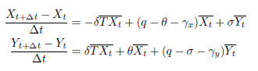
where ${\overline{X}}_{t}$= (X_{t+∆t} + X_{t})/2, ${\overline{Y}}_{t}$ = (Y_{t+∆t} + Y_{t})/2, and ${\overline{XT}}_{t}$ = (X_{t+∆t}T_{t+∆t} + X_{t}T_{t})/2; ∆t = 1 for
annually data and ∆t = 0.25 for quarterly data.

1.3.1 The Bayesian approach

We proposed the following Bayesian model with the time-series data of onset rates (Λ), proportional resistant P (Res), and .

Priors for the parameters with the log-Normal distribution

π ∼ Uniform(0, 1)
δ ∼ LogNormal(0, 1)
∼ LogNormal(0, 1) σ ∼ LogNormal(0, 1) γ_{x} ∼ LogNormal(0, 1) γ_{y} ∼ LogNormal(0, 1)
Priors for random errors with the inverse-Gamma distribution

E_{x} ∼ InvGamma(1, 1) E_{y} ∼ InvGamma(1, 1) ω ∼ InvGamma(1, 1)
Main model fitting to data We fixed q at 1 (or any other value with exogenous data source) for ensuring the identifiability of the other parameters. The main model links the parameters to data.
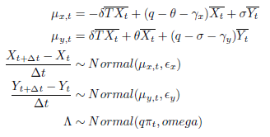

A16.2. Results: simulation study
We started with a simulation study for checking (1) sample size needed for this model and (2) potential bias of the parameter estimators. Firstly, we started with a parameter set of (theta = 0.02, delta = 0.02, sigma = 0.05) and tested the bias in percentage. 45 shows that the model estimators start to converge when the lengths of time-series larger than 15.

Figure 45 length of time-series and convergence

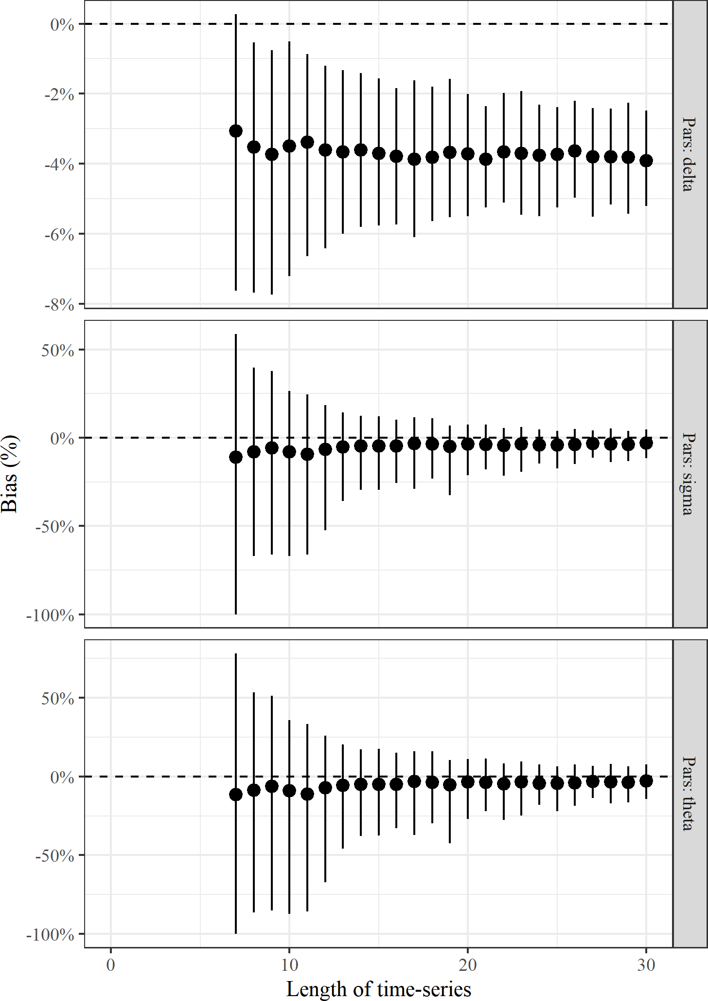
Then, we expanded the parameter space with θ ∈ (0.01, 0.05), δ ∈ (0.01, 0.05), and σ ∈ (0.01, 0.1) tocheck if the model can provide unbiased estimators. 46 and 47 demonstrate that θ and σ are unbiased while Figure 4suggests that there is a system bias of δ causing underestimation.

Figure 46 Resistance development, natural mutation (θ)

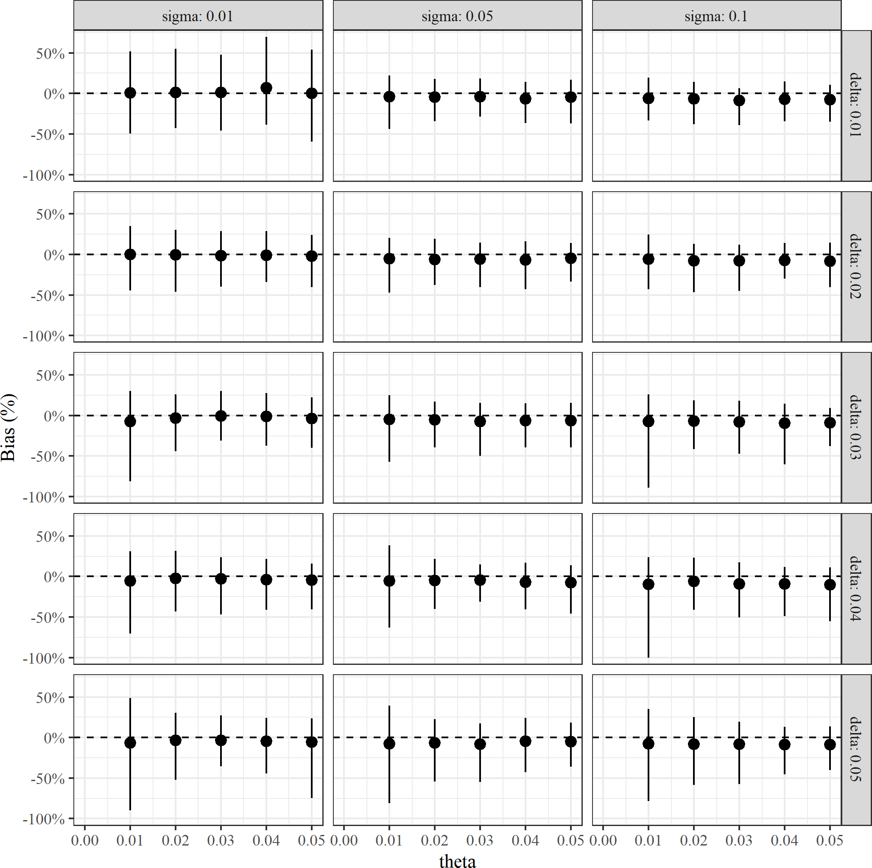

Figure 47 Resistance development, amplification (δ)

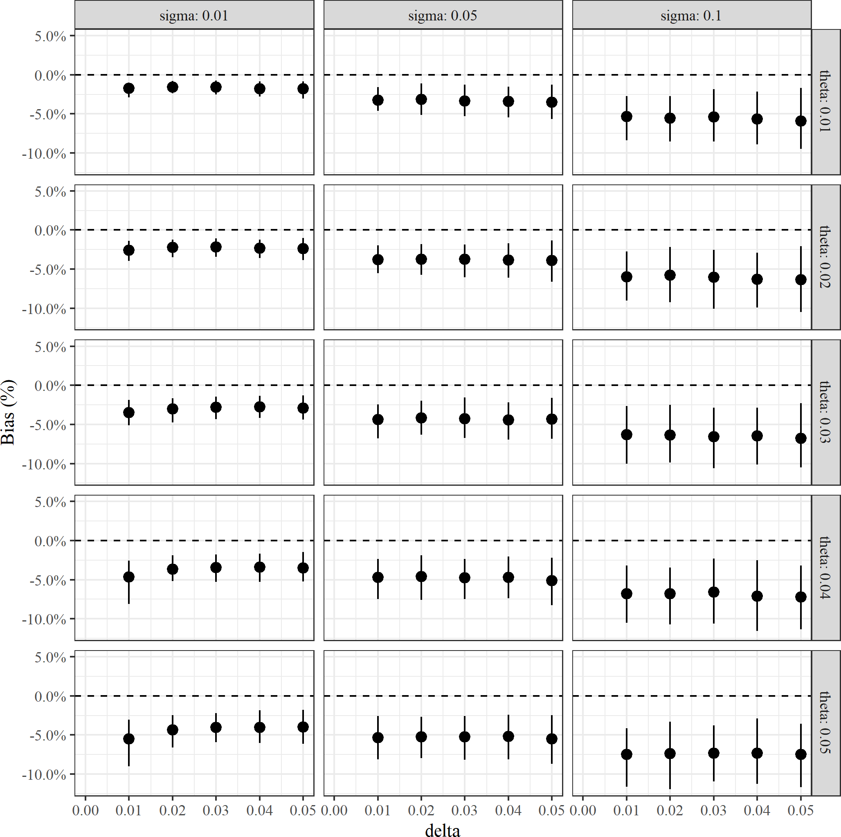

Figure 48 Resistance loss (σ)

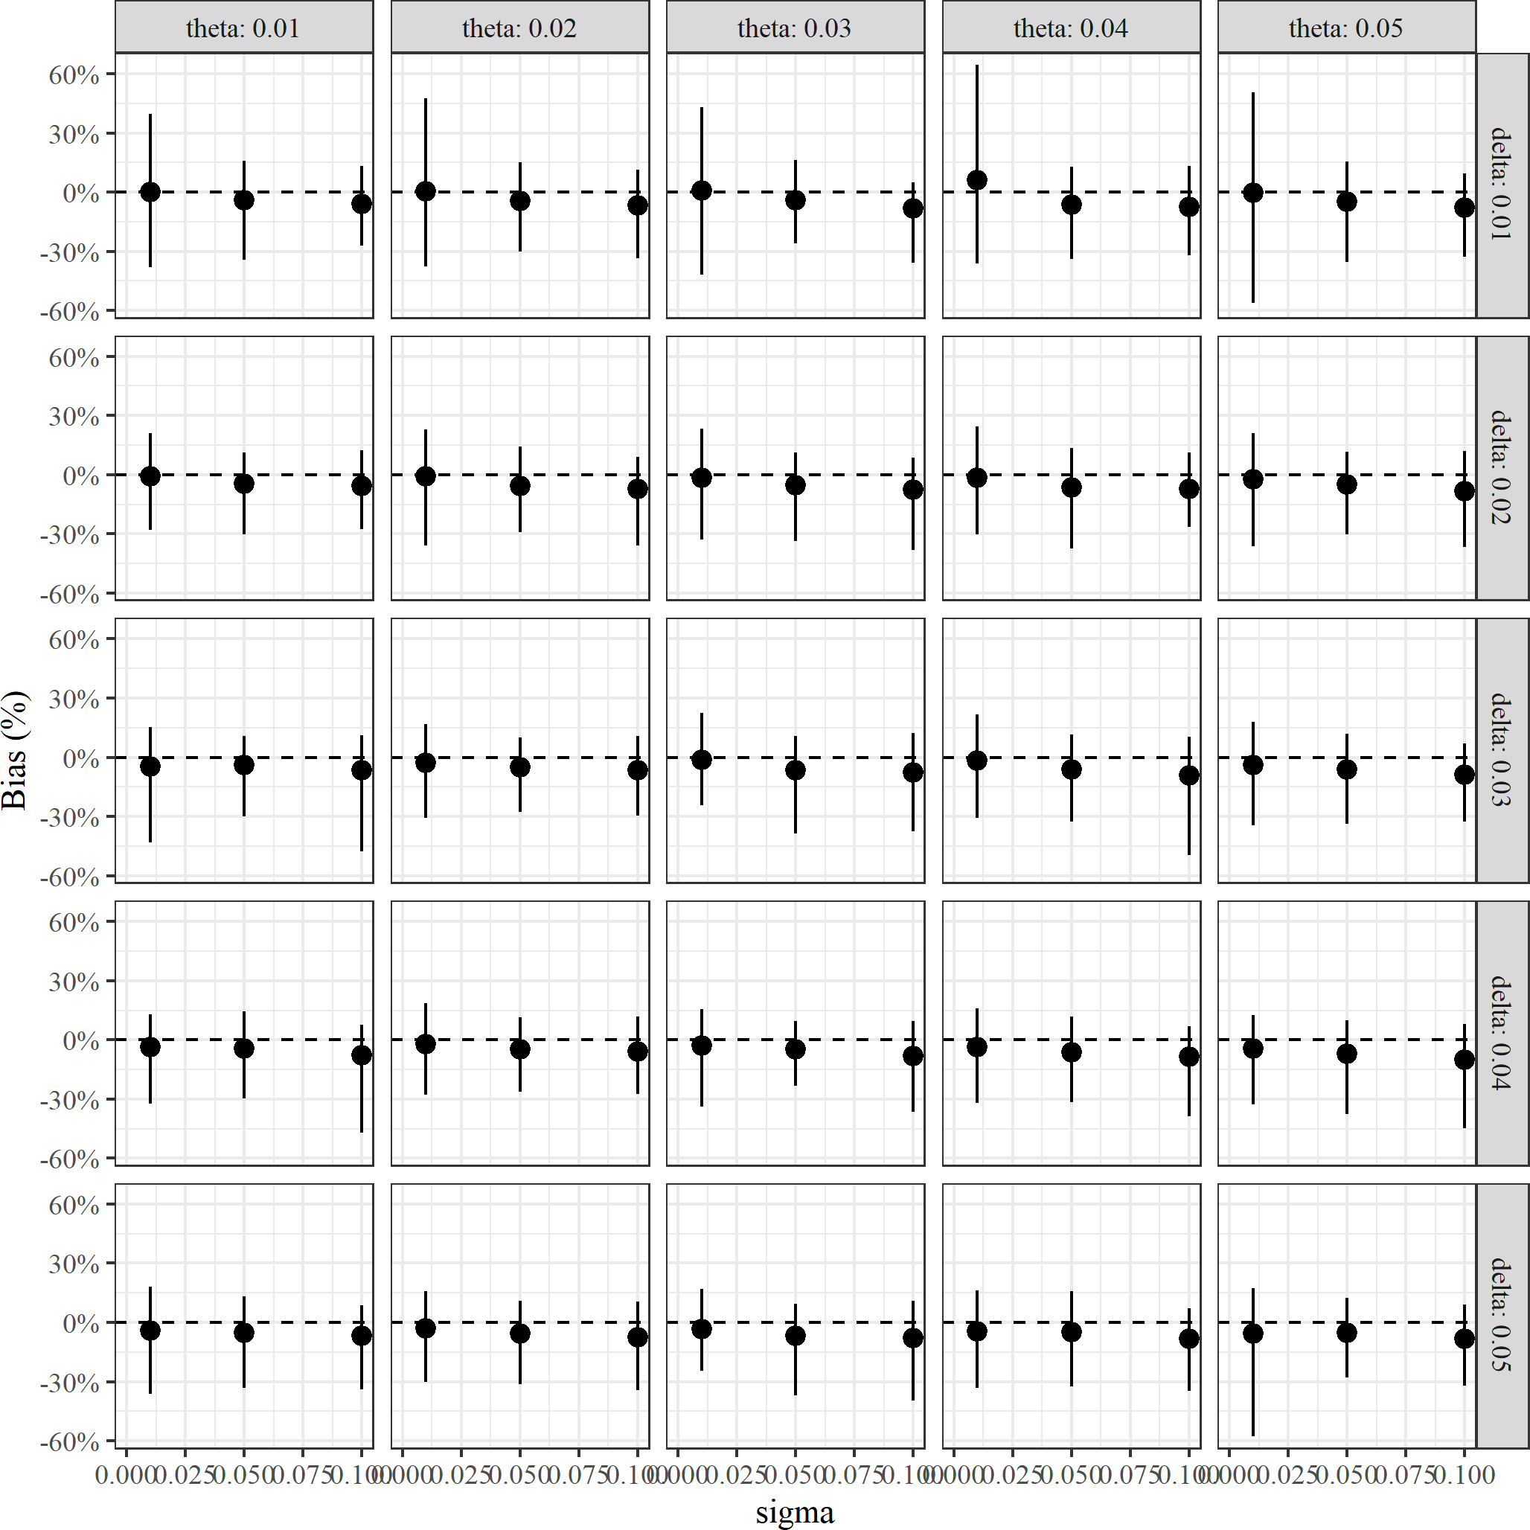

Appendix 17: Implementing the relationship between drug use and resistance.

For illustration, this will use the estimated strong association value from the Escherichia coli analyses (coefficient of 10.11). The following steps were implemented:
- Obtain estimates of the numbers treated per year with CAZ-AVI. The derivation of these estimates is described in Section 3.5.2.6. This was done separately for the two clinical sites of cUTI and HAP/VAP. To obtain an extreme estimate of the impact of AM use on resistance, it was assumed that these sites also included:
  - For cUTI, IAI was also included.
  - For HAP/VAP, BSI was also included.
- The impact of these assumptions were to concentrate all of the increase in resistance (due to use amongst a broad patient population) in the HVCS.
- Evidence on hospital LOS was obtained from Table 30.
- It was assumed that multiplying the number of people treated by their duration of treatment and dividing by 365.25 would provide the defined daily doses per day. To support this assumption, the recommended indications for each AM in the British National Formulary (BNF) were compared with defined daily doses (DDDs) provided by the World Health Organization (WHO). The two were deemed to be sufficiently similar. For example, for colistin (colistimethate sodium) the BNF provides an indication of 9 million units daily by intravenous infusion for adults with “serious infections due to selected aerobic Gram-negative bacteria in patients with limited treatment options”. This is the same as the DDD for colistin provided by the WHO. Similarly, the BNF indication for tigecycline is 0.1g per day by intravenous infusion for “complicated intra-abdominal infections (when other antibiotics are not suitable)”. This is again the same as the WHO DDD.
- This value was then multiplied by 1,000 and divided by the Office for National Statistics' Mid-Year Population Estimate for the United Kingdom (June 2020). The value for the entire population was used (67,081,234) for consistency with the definition of AM use provided by ESAC-Net.
- The year-on-year increase in resistance was calculated by mutlipling the year-on-year increase in AM use (DDD per 1,000 inhabitants) by the coefficient of 10.11. This provided the absolute increase in resistance. It was assumed that to begin with there was no use of CAZ-AVI. This will be a slight under-estimate and hence the subsequent increase in resistance will be a slight over-estimate.

This approach led to estimated very small increases in resistance: over 20 years the resistance to CAZ-AVI l increased by 0.03%. Hence alternative scenarios were considered to explore more extreme increases in resistance over time. An exploratory analysis used the same surveillance data (used to estimate the relationship between AM use and resistance) to inform absolute rates of change in susceptibility over time. This was motivated by noting that there are several potential drivers for AM resistance beyond AM use. For each country a linear regression was fit with resistance level as the outcome (range 0 to 100) and time in years as the independent variable. The statistical significance of the trend coefficient was used to identify countries for which there was a significant increase in resistance over time during the period for which data was available. Statistical significance was originally taken to be a p-value of less than 0.05. Of these significant associations, the most extreme (largest trend coefficient) was used to represent an extreme scenario of growth in susceptibility. For the Escherichia coli cephalosporins, all of the regressions were statistically significant, with trend coefficients ranging form 0.41 (Malta) to 1.65 (Bulgaria). The only significant positive association for the Escherichia coli carbapenems was for Greece (0.04). Hence, for the CPE analyses an increase in resistance of 1.65% per year was used.
Employing this absolute increase led to an absolute twenty-year increase in resistance of 33.07%. The second largest increase over 20 years was 19% for Greece. As a result, a twenty-year increase of 30% was viewed to represent the most extreme possible increase in resistance. Hence we considered scenarios in which the twenty-year increase in resistance to CAZ-AVI was 1%, 5%, 10%, and 30%.

Appendix 18: Plots of antimicrobial resistance over time: Public Health England data.
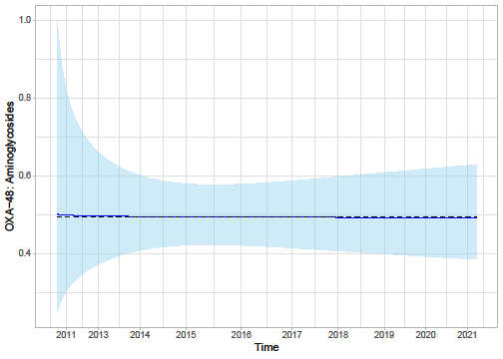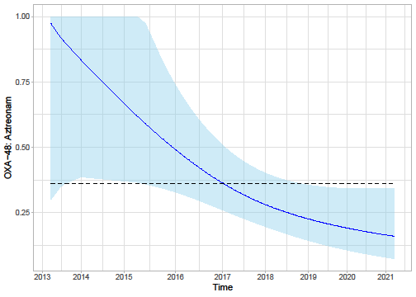
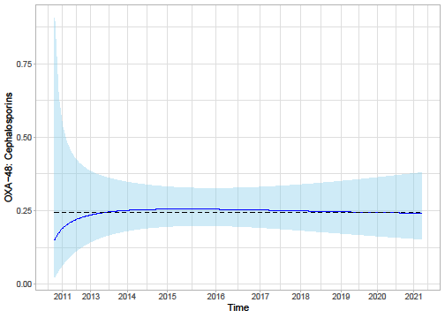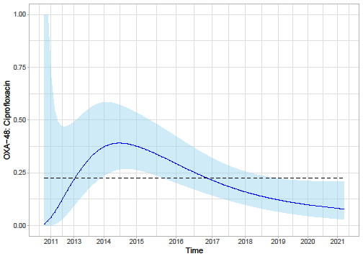
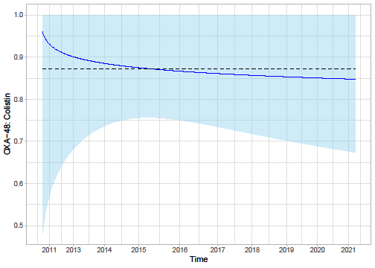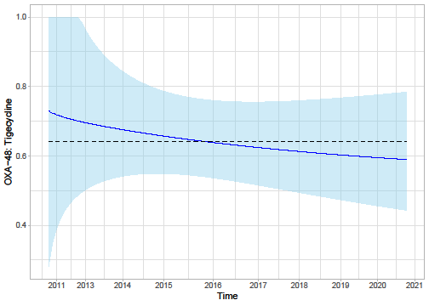

Appendix 19: Plots of antimicrobial resistance over time: surveillance data.
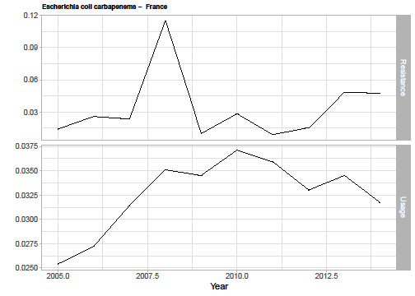
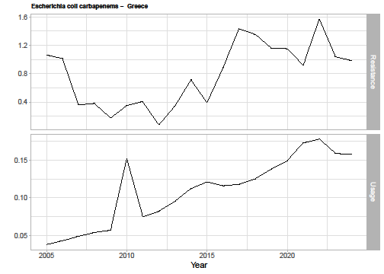
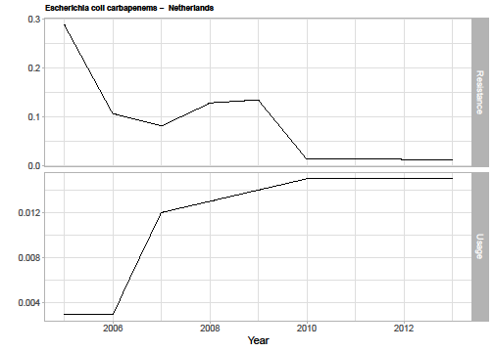
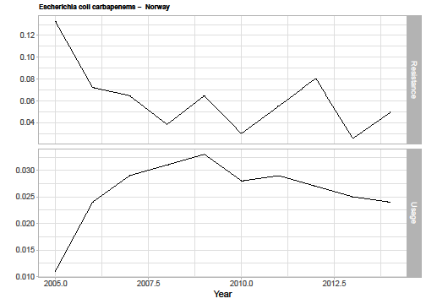
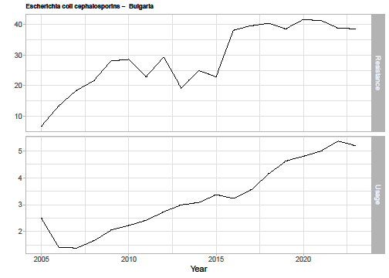
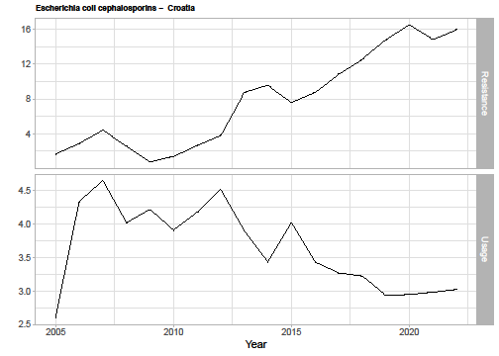
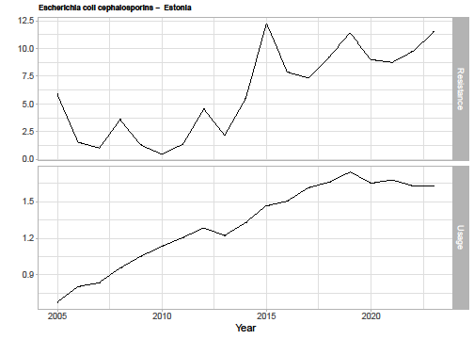
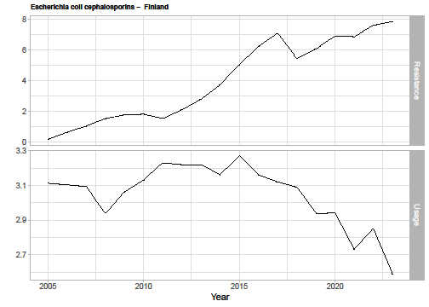
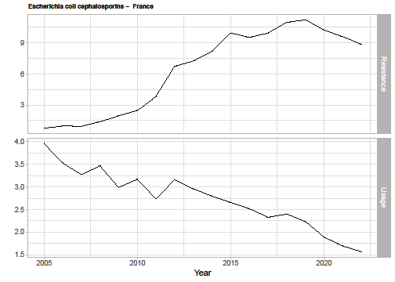
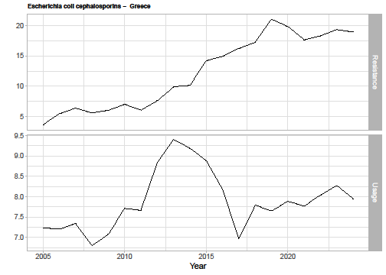
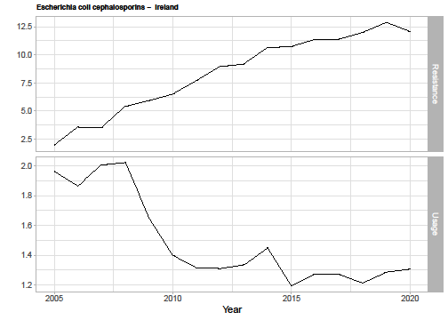
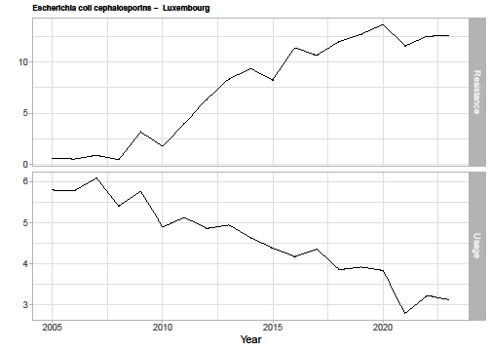
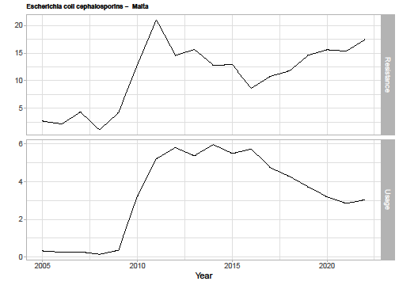
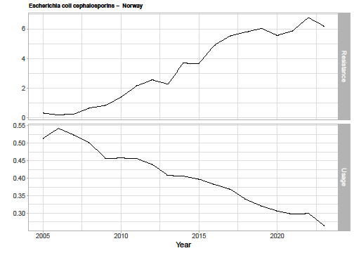
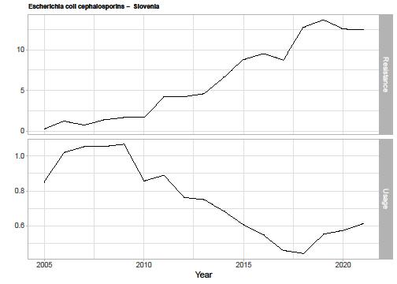
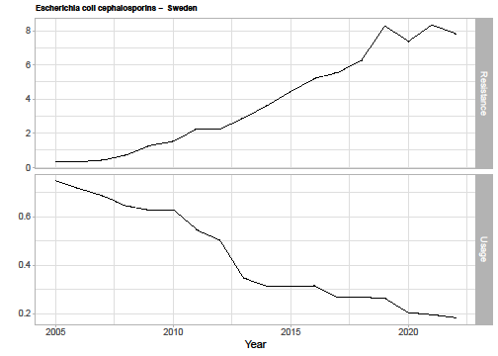
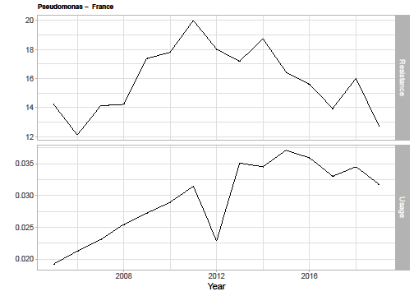
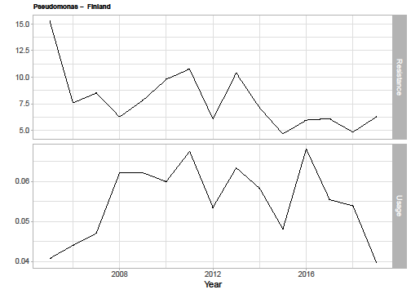
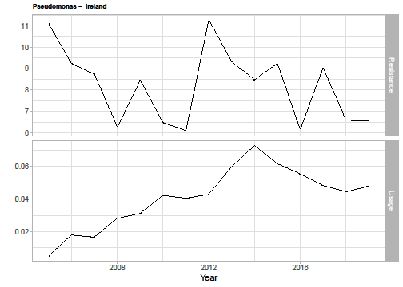
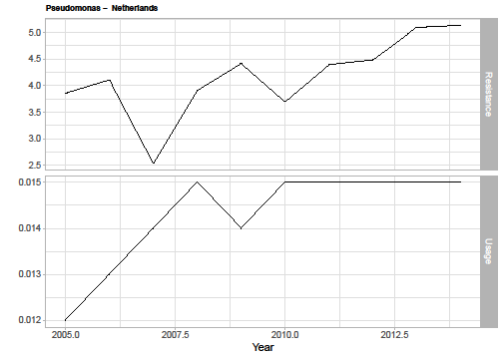
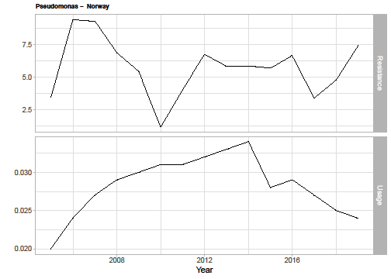
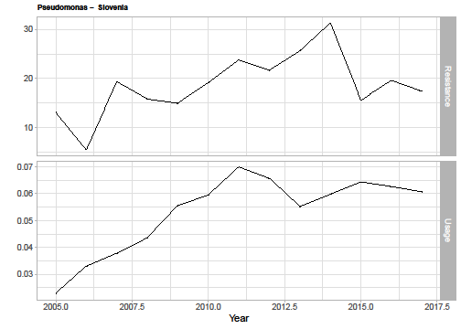

Appendix 20: Total population INHE across the first 10 years of usage
Table 68. Total INHE across 10 years of usage
Baseline population | Population growth rate | Change in resistance | HAP/VAP | cUTI | BSI | IAI | Total | Proportion of 20 year INHE (%)
PHE categorisation of infection sites  (scenario P1) | Model with damped effect  (scenario G1) | 1% (R1) | 38 | 47 | 253 | 21 | 359 | 57.1%
Scenario P1 | Scenario G1 | 5% (R2) | 37 | 47 | 249 | 20 | 353 | 57.9%
Scenario P1 | Scenario G1 | 10% (R3) | 36 | 46 | 244 | 20 | 346 | 58.9%
Scenario P1 | Scenario G1 | 30% (R4) | 33 | 44 | 223 | 19 | 319 | 64.7%
Scenario P1 | Model without damped effect  (scenario G2) | 1% (R1) | 56 | 70 | 375 | 31 | 532 | 41.0%
Scenario P1 | Scenario G2 | 5% (R2) | 55 | 69 | 369 | 30 | 523 | 41.8%
Scenario P1 | Scenario G2 | 10% (R3) | 54 | 68 | 360 | 30 | 512 | 43.0%
Scenario P1 | Scenario G2 | 30% (R4) | 48 | 64 | 325 | 28 | 465 | 48.9%
Clinical advisors’ categorisation of infection sites  (scenario P2) | Model with damped effect  (scenario G1) | 1% (R1) | 261 | 75 | 253 | 21 | 610 | 57.0%
Scenario P2 | Scenario G1 | 5% (R2) | 257 | 75 | 249 | 20 | 601 | 57.9%
Scenario P2 | Scenario G1 | 10% (R3) | 251 | 74 | 244 | 20 | 589 | 59.0%
Scenario P2 | Scenario G1 | 30% (R4) | 230 | 70 | 223 | 19 | 542 | 64.8%
Scenario P2 | Model without damped effect  (scenario G2) | 1% (R1) | 387 | 112 | 375 | 31 | 905 | 40.9%
Scenario P2 | Scenario G2 | 5% (R2) | 380 | 111 | 369 | 30 | 890 | 41.8%
Scenario P2 | Scenario G2 | 10% (R3) | 371 | 109 | 360 | 30 | 870 | 43.0%
Scenario P2 | Scenario G2 | 30% (R4) | 335 | 103 | 325 | 28 | 791 | 49.1%

