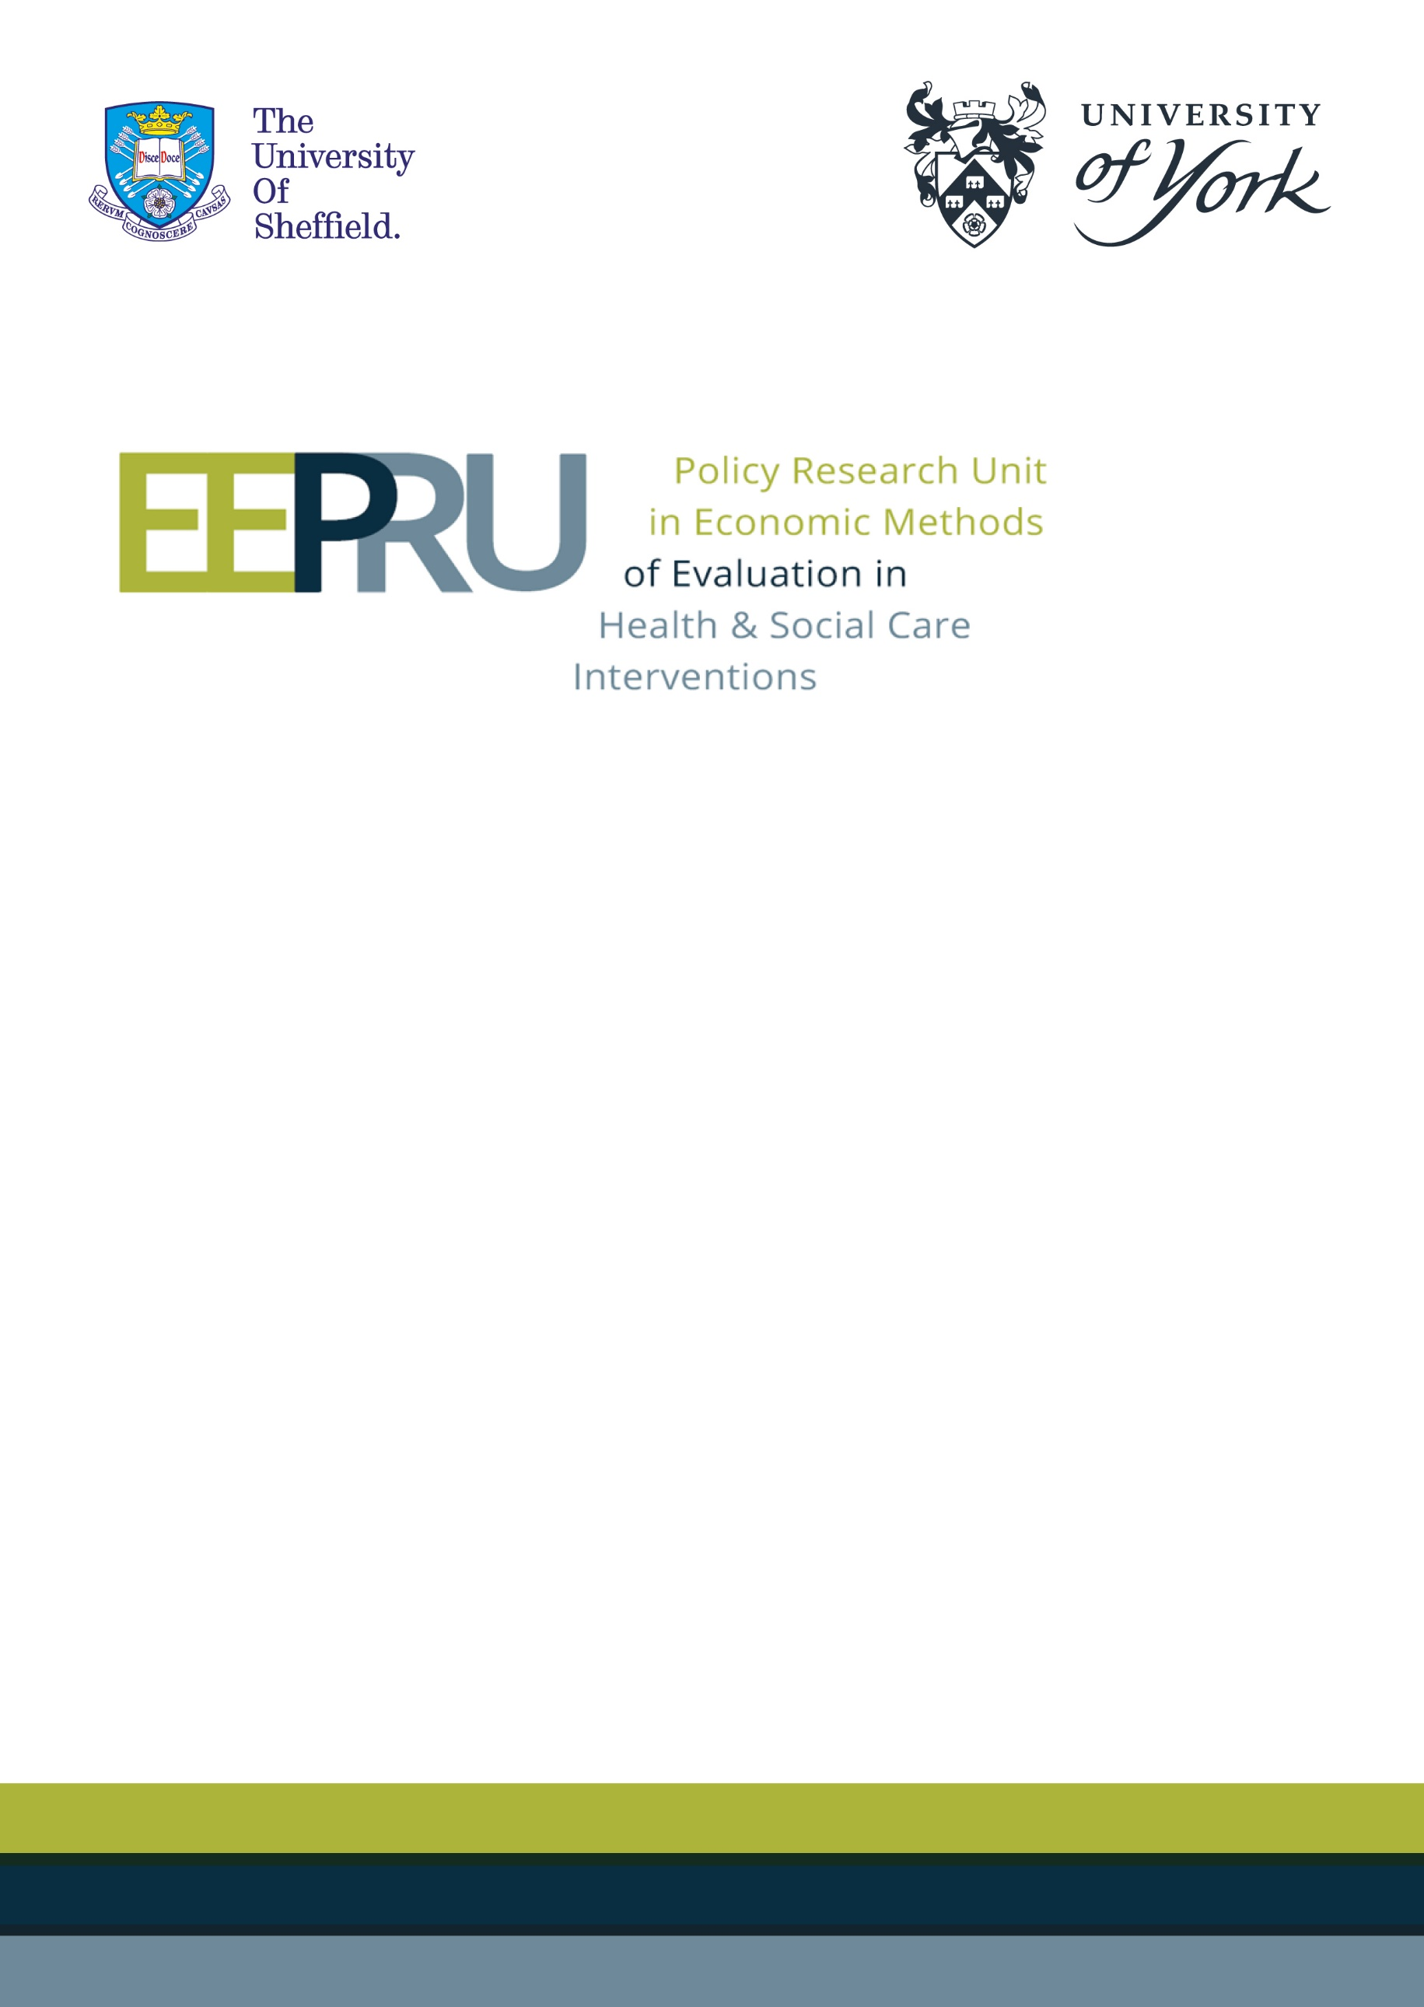

Final report for the technology evaluation of ceftazidime with avibactam for treating severe aerobic Gram-negative bacterial infections
21st January 2022



EEPRU model errors

An error in the EEPRU model relating to the long-term survival with acute kidney injury (AKI) and chronic kidney disease (CKD) impacted the long-term costs, and life year (LY) and quality-adjusted life year (QALY) gains for all comparators. Two further errors were identified by Shionogi, detailed in their consultee comments. This section outlines the impact of the errors on the model results.

Summary of results
The impact of model errors identified by Shionogi was detailed in the EEPRU’s documented responses to key consultee comments. In short, rectifying the errors had the following impact.
- No impact on expected outcomes in the base-case model.
- Negligible impact on uncertainty in patient-level incremental net health benefit (INHE) in the empiric setting.
- Decreased the patient-level benefit of CAZ-AVI in the scenario with higher costs of long-term care.

Correcting the additional error relating to the long-term survival with acute kidney injury (AKI) and chronic kidney disease (CKD) increased the patient level INHE in all scenarios. The changes in the base-case results are summarised in Table 1. In the scenario analyses in the empiric setting (ES) (Table 4 in Section 3.1), the error did not impact which of the scenarios modified the deterministic base-case INHE by more than 10%. In the scenario analyses in the microbiology directed setting (MDS) (Table 6 in Section 3.2) two scenarios (where absolute risk of CKD and odds ratios of mortality associated with nephrotoxicity were informed using alternative sources) no longer modified the deterministic base-case by more than 10%; while one additional scenario (when loglogistic distribution was fitted to data predicting long term outcomes) did impact the results.

Table 1. Basecase patient-level INHE (probabilistic, 2,000 simulations) in the EEPRU report and post-correction. (Update of Table 36 in EEPRU report)
 | INHE (QALYs) in EEPRU report (Table 36 in EEPRU report) | INHE (QALYs) corrected (Tables 3 and 5 in Addendum 2)
HAP/VAP ES, nca | 0.160 (Table 36) | 0.165 (Table 3)
HAP/VAP ES, ca | 0.186 (Table 36) | 0.215 (Table 3)
HAP/VAP MDS | 0.060 (Table 38) | 0.071 (Table 5)
cUTI MDS | 0.049 (Table 38) | 0.069 (Table 5)
ca, colistin/aminoglycoside therapy; cUTI, complicated urinary tract infections; ES, empiric setting; HAP/VAP, hospital-acquired pneumonia or ventilator-associated pneumonia; INHE, incremental net health effect; MDS, microbiology-directed setting; nca, non-colistin/aminoglycoside therapy; QALYs, quality-adjusted life years

When the corrected patient-level INHE was extrapoalted to the population in HVCS, the total population-level INHE increased, as shown in Table 2. The impact of the error is relatively small, with total population-level INHE changing from between 493 and 2,211 QALYs in the EEPRU report to between 531 and 2,342 post corrections, where ranges represent the mean INHE based on different assumptions about the population size (scenarios P1G1 and P2G2 in the EEPRU report). The relatively small impact of the error on the population-level results reflects the small impact of the error on the patient-level results in the ES that constitutes the largest proportion of the total population estimate. In the population-level scenario analyses, the error did not impact the scenarios that modified the deterministic base case INHE by more than 10%.

Table 2. Base-case population-level INHE (deterministic) in the EEPRU report and post-correction. Ranges represent different assumptions about the population size (scenarios P1G1 and P2G2 in the EEPRU report). (Update of Table 36 in EEPRU report)
 | INHE (QALYs) in EEPRU report  (Table 40 in EEPRU report) | INHE (QALYs) corrected  (Table 7 in Addendum 2)
HAP/VAP ES | 51 - 946 | 51 - 950
cUTI MDS | 71 - 274 | 95 - 370
BSI ES | 341 - 916 | 343 - 921
IAI MDS | 31 - 75 | 42 - 101
Total | 493 – 2,211 | 531 – 2,342
BSI, bloodstream infections, cUTI, complicated urinary tract infections; ES, empiric setting; HAP/VAP, hospital-acquired pneumonia or ventilator-associated pneumonia; IAI, intra-abdominal infections; INHE, incremental net health effect; MDS, microbiology-directed setting; nca, non-colistin/aminoglycoside therapy; QALYs, quality-adjusted life years
P1G1: baseline population (point estimate) based on PHE categorisation of infection sites, growth rate damped; P2G2: baseline population (point estimate) based on clinical advisors’ categorisation of infection sites, growth rate not damped.

The updated tables for all patient-level and population-level net health effects (NHE) in the high value clinical scenarios (HVCS) are presented below.

Updated figures and tables
    - Patient-level outcomes: basecase results in the ES

Table 3: Patient-level base-case results: OXA-48 Enterobacterales HAP/VAP empiric setting (probabilistic, 2,000 simulations). (Update of Table 36 in EEPRU report)
 | Comparator treatment strategies in the empiric setting |  |  |  |  | Incremental results
 | E1 | E2nca | E2ca | E3nca | E3ca | E1-E2nca | E1-E2ca
Patients with OXA-48 Enterobacterales
Summary of in-hospital outcomes (proportions) across both lines of treatment available
Death | 0.361 | 0.463 | 0.409 | 0.450 | 0.407 | -0.102 | -0.049
Survival no AKI | 0.514 | 0.403 | 0.423 | 0.417 | 0.425 | 0.111 | 0.090
Survival AKI | 0.125 | 0.135 | 0.167 | 0.133 | 0.168 | -0.009 | -0.042
Survival CKD | 0.000 | 0.000 | 0.000 | 0.000 | 0.000 | 0.000 | 0.000
Economic outcomes (all discounted)
Treatment costs | £39 | £177 | £440 | £125 | £430 | -£138 | -£402
AKI costs hospital | £1,735 | £2,356 | £2,318 | £2,256 | £2,305 | -£621 | -£583
Other costs hospital | £17,543 | £26,651 | £16,803 | £26,289 | £16,694 | -£9,108 | £739
Long-term costs | £601 | £510 | £563 | £521 | £566 | £91 | £37
Total costs | £19,917 | £29,694 | £20,125 | £29,191 | £19,996 | -£9,776 | -£208
Life years | 2.75 | 2.29 | 2.49 | 2.34 | 2.51 | 0.468 | 0.26
QALYs | 1.93 | 1.61 | 1.75 | 1.65 | 1.76 | 0.329 | 0.182
Per person NHE (QALYs) | 0.94 | 0.12 | 0.75 | 0.19 | 0.76 | 0.818 | 0.193
Patients without OXA-48 Enterobacterales
Summary of in-hospital outcomes (proportions) across both lines of treatment available
Death | 0.357 | 0.357 | 0.409 | 0.357 | 0.409 | 0 | -0.052
Survival no AKI | 0.517 | 0.517 | 0.423 | 0.517 | 0.423 | 0 | 0.094
Survival AKI | 0.125 | 0.125 | 0.167 | 0.125 | 0.167 | 0 | -0.042
Survival CKD | 0 | 0 | 0 | 0 | 0 | 0 | 0
Economic outcomes (all discounted)
Treatment costs | £34 | £44 | £440 | £44 | £440 | -£10 | -£406
AKI costs hospital | £1,714 | £1,714 | £2,318 | £1,714 | £2,318 | £0 | -£604
Other costs hospital | £17,213 | £17,213 | £16,803 | £17,213 | £16,803 | £0 | £409
Long-term costs | £604 | £604 | £563 | £604 | £563 | £0 | £40
Total costs | £19,564 | £19,574 | £20,125 | £19,574 | £20,125 | -£10 | -£561
Life years | 2.768 | 2.768 | 2.493 | 2.768 | 2.493 | 0 | 0.275
QALYs | 1.945 | 1.945 | 1.752 | 1.945 | 1.752 | 0 | 0.193
Per person NHE (QALYs) | 0.967 | 0.966 | 0.746 | 0.966 | 0.746 | 0.001 | 0.221
All patients presenting in the ES
Total costs | £19,634 | £21,575 | £20,125 | £21,476 | £20,100 | -£1,941 | -£491
QALYs | 1.943 | 1.878 | 1.752 | 1.886 | 1.754 | 0.065 | 0.191
Per person NHE (QALYs) | 0.961 | 0.799 | 0.746 | 0.812 | 0.749 | 0.163 | 0.215
Abbreviations: AKI, acute kidney injury; CKD, chronic kidney disease; NHE, net health effect; QALYs, quality-adjusted life years
Comparators: E1 = empiric treatment with CAZ-AVI, followed by existing therapies in MDS if not susceptible; E2nca = non-colistin or aminoglycoside-based empiric treatment, followed by existing therapies MDS if needed; E2ca = colistin or aminoglycoside-based empiric treatment, followed by existing therapies MDS if needed; E3nca = non-colistin or aminoglycoside-based empiric treatment, followed by followed by CAZ-AVI in MDS if needed; E3ca = colistin or aminoglycoside-based empiric treatment, followed by CAZ-AVI MDS if needed. Net health effects derived using threshold of £20,000/QALY.

Figure 1: Distribution of patient-level INHEs of CAZ-AVI in OXA-48 HAP/VAP empiric setting compared to (a) non-colistin/aminoglycoside-based therapy and (b) colistin/aminoglycoside-based therapy and (2,000 simulations). (Update of Figure 23 in EEPRU report)

(a) (b)
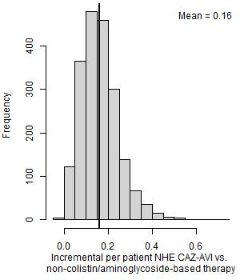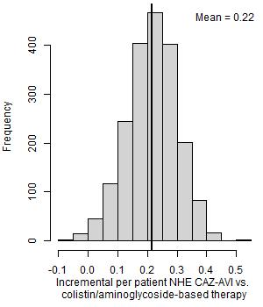
NHE, net health effects

Table 4: Patient-level scenario analyses: OXA-48 Enterobacterales HAP/VAP empiric setting (deterministic). (Update of Table 37 in EEPRU report)
Scenario name | Base case value/assumption | Scenario value/assumption | Best existing treatment | Patient-level INHE of CAZ-AVI
Base case | - | - | Non-colistin/amino-based | 0.159
p_bug_survey | Probability patient has OXA-48 Enterobacterales is 0.20 | Probability patient has MBL Enterobacterales is 0.57 based on BSAC survey data | Colistin/amino based | 0.222
p_bug_0 | Probability patient has OXA-48 Enterobacterales is 0.20 | Probability patient has OXA-48 Enterobacterales is 0.00 | Non-colistin/amino-based | 0.001
p_bug_10 | Probability patient has OXA-48 Enterobacterales is 0.20 | Probability patient has OXA-48 Enterobacterales is 0.10 | Non-colistin/amino-based | 0.082
p_bug_30 | Probability patient has OXA-48 Enterobacterales is 0.20 | Probability patient has OXA-48 Enterobacterales is 0.30 | Colistin/amino based | 0.230
p_bug_40 | Probability patient has OXA-48 Enterobacterales is 0.20 | Probability patient has OXA-48 Enterobacterales is 0.40 | Colistin/amino based | 0.227
p_bug_50 | Probability patient has OXA-48 Enterobacterales is 0.20 | Probability patient has OXA-48 Enterobacterales is 0.50 | Colistin/amino based | 0.225
p_bug_60 | Probability patient has OXA-48 Enterobacterales is 0.20 | Probability patient has OXA-48 Enterobacterales is 0.60 | Colistin/amino based | 0.222
p_bug_70 | Probability patient has OXA-48 Enterobacterales is 0.20 | Probability patient has OXA-48 Enterobacterales is 0.70 | Colistin/amino based | 0.219
p_bug_80 | Probability patient has OXA-48 Enterobacterales is 0.20 | Probability patient has OXA-48 Enterobacterales is 0.80 | Colistin/amino based | 0.216
p_bug_90 | Probability patient has OXA-48 Enterobacterales is 0.20 | Probability patient has OXA-48 Enterobacterales is 0.90 | Colistin/amino based | 0.213
p_bug_100 | Probability patient has OXA-48 Enterobacterales is 0.20 | Probability patient has OXA-48 Enterobacterales is 1.00 | Colistin/amino based | 0.210
S2 | Susceptibility based on network meta-analysis of EUCAST studies | Network meta-analysis: include all studies regardless of breakpoints, excluding specific arms due to inconsistency | Colistin/amino based | 0.217
S3 | Susceptibility based on network meta-analysis of EUCAST studies | Susceptibility based on PHE isolate-level data (excludes fosfomycin) | Non-colistin/amino based | 0.180
S4 | Susceptibility based on network meta-analysis of EUCAST studies | Susceptibility based on Vasquez-Ucha et al isolate-level data (excludes tigecycline) | Colistin/amino based | 0.263
Weibull | Log-normal model fit to CARBAR survival data | Weibull model fit to CARBAR survival data | Non-colistin/amino-based | 0.135
dr 1.5%
thresh15* | Cost-effectiveness threshold £20,000 | Cost-effectiveness threshold £15,000 | Non-colistin/amino-based | 0.191
thresh30* | Cost-effectiveness threshold £20,000 | Cost-effectiveness threshold £30,000 | Non-colistin/amino-based | 0.128
Abbreviations: EUCAST, European Committee on Antimicrobial Susceptibility Testing; INHE, incremental net health effects; PHE, Public Health England
NB: Net health effects derived using threshold of £20,000/QALY.

    - Patient-level outcomes: basecase results in the MDS
Table 5: Patient-level base-case results: OXA-48 Enterobacterales HAP/VAP and cUTI microbiology-directed setting (probabilistic, 2,000 simulations). (Update of Table 38 in EEPRU report)
 | MDS pathway with CAZ-AVI | MDS pathway without CAZ-AVI | Incremental values
HAP/VAP
Summary of in-hospital outcomes (proportions) across both lines of treatment available
Death | 0.373 | 0.388 | -0.014
Survival no AKI | 0.497 | 0.466 | 0.030
Survival AKI | 0.130 | 0.146 | -0.016
Survival CKD | 0.000 | 0.000 | 0.000
Economic outcomes (all discounted)
Treatment costs | £189 | £264 | -£74
AKI costs hospital | £1,673 | £1,884 | -£211
Other costs hospital | £34,723 | £34,737 | -£15
Long-term costs | £591 | £580 | £10
Total costs | £37,176 | £37,465 | -£289
Life years | 2.691 | 2.611 | 0.08
QALYs | 1.891 | 1.835 | 0.056
Per person NHE | 0.032 | -0.038 | 0.071
cUTI
Summary of in-hospital outcomes (proportions) across both lines of treatment available
Death | 0.125 | 0.136 | -0.011
Survival no AKI | 0.646 | 0.607 | 0.039
Survival AKI | 0.228 | 0.257 | -0.028
Survival CKD | 0.000 | 0.000 | 0.000
Economic outcomes (all discounted)
Treatment costs | £189 | £264 | -£74
AKI costs hospital | £1,673 | £1,884 | -£211
Other costs hospital | £17,344 | £17,355 | -£11
Long-term costs | £831 | £825 | £5
Total costs | £20,037 | £20,328 | -£291
Life years | 3.713 | 3.636 | 0.077
QALYs | 2.609 | 2.555 | 0.054
Per person NHE | 1.607 | 1.539 | 0.069
AKI, acute kidney injury; CKD, chronic kidney disease; cUTI, complicated urinary tract infections; HAP/VAP, hospital-acquired pneumonia or ventilator-associated pneumonia; MDS, microbiology-directed setting; NHE, net health effect; QALYs, quality-adjusted life years
NB: Net health effects derived using threshold of £20,000/QALY.

Figure 2: Distribution of INHEs of introducing CAZ-AVI in to the MDS compared to existing therapies: (a) OXA-48 Enterobacterales HAP/VAP and (b) OXA-48 Enterobacterales cUTI (2,000 simulations). (Update of Figure 24 in EEPRU report)

(a) HAP/VAP (b) cUTI
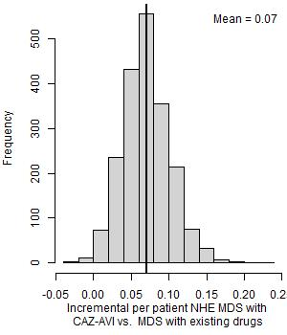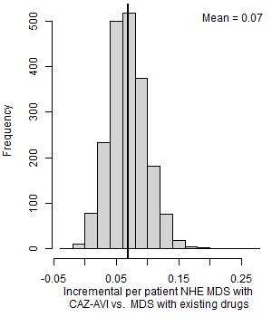
MDS, microbiology-directed setting; NHE, net health effects

Table 6: Per patient scenario analyses: OXA-48 HAP/VAP and cUTI MDS (deterministic). (Update of Table 39 in EEPRU report)
Scenario name | Base case value/assumption | Scenario value/assumption | INHE per patient: HAP/VAP | INHE per patient: cUTI
Base case | - | - | 0.080 | 0.078
S2 | Susceptibility based on network meta-analysis of EUCAST studies | Network meta-analysis: include all studies regardless of breakpoints, excluding specific arms due to inconsistency | 0.066 | 0.065
S4 | Susceptibility based on network meta-analysis of EUCAST studies | Susceptibility based on Vasquez-Ucha et al isolate-level data | 0.119 | 0.116
p_AKI_Chien | Probability of AKI with colistin/aminoglycoside therapy based on Sisay 2021 (0.45) | Probability of AKI with colistin/aminoglycoside therapy based on Chien (0.32) | 0.066 | 0.064
OR_AKI_Wagenlehner | Odds ratio comparing AKI for colistin/ aminoglycoside-based therapy to non-colistin/aminoglycoside-based therapy from all studies analysis in Chien 2020 (1.81) | Odds ratio comparing AKI for colistin/ aminoglycoside-based therapy to non-colistin/aminoglycoside-based therapy from all studies analysis in Wagenlehner 2021 (2.23) | 0.103 | 0.100
OR_AKI_ChienRIFLE | Odds ratio comparing AKI for colistin/ aminoglycoside-based therapy to non-colistin/aminoglycoside-based therapy from all studies analysis in Chien 2020 (1.81) | Odds ratio comparing AKI for colistin/ aminoglycoside-based therapy to non-colistin/aminoglycoside-based therapy from RIFLE criteria studies analysis in Chien 2020 (1.61) | 0.067 | 0.065
OR_AKI_death_halved | Odds ratio of mortality for AKI compared to no AKI derived from Kerr (2014) (5.11) | Odds ratio of mortality for AKI compared to no AKI halved (2.56) | 0.063 | 0.060
double.ckd.risk | Risk of CKD as observed in Bucaloiu 2012 | Risk of CKD doubled to reflect potential higher propensity for CKD in HVCS | 0.070 | 0.068
abs.increase | Odds ratios on mortality associated with nephrotoxicity from Bucaloiu 2012 are applied multiplicatively to underlying risk in HVCS | Absolute risk increases in Bucaloiu 2012 are assumed to apply | INHE changed by <10% | INHE changed by <10%-
all.aki.lt | Base case assumptions with respect to long-term effects of AKI | Applying a range of alternative assumptions to model the long-term effects of AKI | INHE changed by <10% | INHE changed by <10%
Weibull | Log-normal model fit to CARBAR survival data | Weibull model fit to CARBAR survival data | 0.055 | 0.054
loglogistic | Log-normal model fit to CARBAR survival data | loglogistic model fit to CARBAR survival data | 0.070 | 0.068
lt.care | No costs of long-term care | Costs of discharge to long-term care included | INHE changed by <10% | 0.091
thresh15* | Cost-effectiveness threshold £20,000 | Cost-effectiveness threshold £15,000
thresh30* | Cost-effectiveness threshold £20,000 | Cost-effectiveness threshold £30,000
dr1.5* | Discount rate for costs and benefits 3.5% | Discount rate for costs and benefits 1.5% | 0.090 | 0.089
AKI, acute kidney injury; CKD, chronic kidney disease; EUCAST, European Committee on Antimicrobial Susceptibility Testing; HVCS, high value clinical scenario; INHE, incremental net health effects; PHE, Public Health England
NB: Net health effects derived using threshold of £20,000/QALY.
    - Population-level outcomes
Figure 3. Population INHE (QALYs) over 20 years based on two population size scenarios. P1: baseline population based on PHE categorisation of infection sites; P2: baseline population based on clinical advisors’ categorisation of infection sites; G1: damped growth rate; G2: growth rate not damped; R1: 1% resistance after 20 years; R2: 10% resistance after 20 years; R3: 30% resistance after 20 years. (Update of Figure 24 in the EEPRU report)

- PHE categorisation
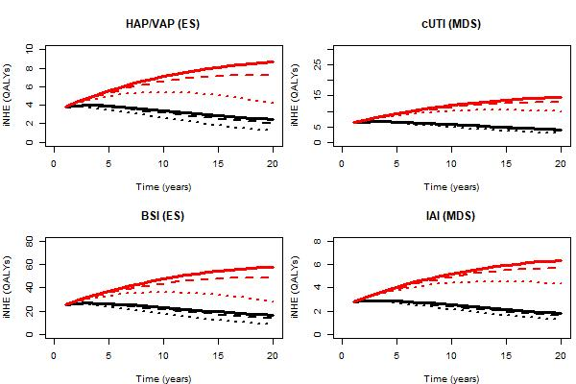

b) Expert-guided categorisation of specimen types
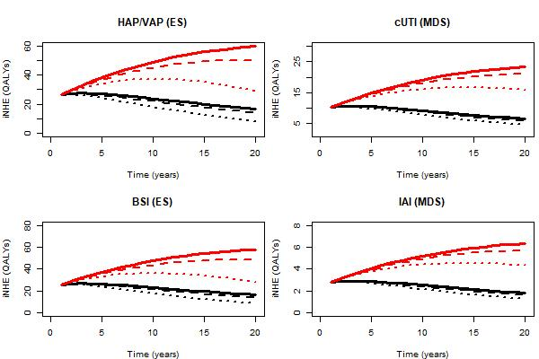

Table 7. Total INHE across 20 years of usage (Update of Table 40 in the EEPRU report)
Baseline population | Population growth rate | Change in resistance | HAP/VAP | cUTI | BSI | IAI | Total
PHE categorisation of infection sites  (scenario P1) | Model with damped effect  (scenario G1) | 1% (R1) | 66 | 112 | 446 | 49 | 673
PHE categorisation of infection sites  (scenario P1) | Model with damped effect  (scenario G1) | 5% (R2) | 64 | 109 | 432 | 48 | 653
PHE categorisation of infection sites  (scenario P1) | Model with damped effect  (scenario G1) | 10% (R3) | 61 | 107 | 414 | 47 | 630
PHE categorisation of infection sites  (scenario P1) | Model with damped effect  (scenario G1) | 30% (R4) | 51 | 95 | 343 | 42 | 531
PHE categorisation of infection sites  (scenario P1) | Model without damped effect  (scenario G2) | 1% (R1) | 137 | 231 | 921 | 101 | 1,390
PHE categorisation of infection sites  (scenario P1) | Model without damped effect  (scenario G2) | 5% (R2) | 132 | 225 | 885 | 98 | 1,340
PHE categorisation of infection sites  (scenario P1) | Model without damped effect  (scenario G2) | 10% (R3) | 125 | 218 | 839 | 95 | 1,277
PHE categorisation of infection sites  (scenario P1) | Model without damped effect  (scenario G2) | 30% (R4) | 98 | 189 | 656 | 83 | 1,026
Clinical advisors’ categorisation of infection sites  (scenario P2) | Model with damped effect  (scenario G1) | 1% (R1) | 460 | 179 | 446 | 49 | 1,134
 | Model with damped effect  (scenario G1) | 5% (R2) | 446 | 175 | 432 | 48 | 1,101
 | Model with damped effect  (scenario G1) | 10% (R3) | 427 | 171 | 414 | 47 | 1,059
 | Model with damped effect  (scenario G1) | 30% (R4) | 354 | 153 | 343 | 42 | 892
 | Model without damped effect  (scenario G2) | 1% (R1) | 950 | 370 | 921 | 101 | 2,342
 | Model without damped effect  (scenario G2) | 5% (R2) | 913 | 361 | 885 | 98 | 2,257
 | Model without damped effect  (scenario G2) | 10% (R3) | 866 | 349 | 839 | 95 | 2,149
 | Model without damped effect  (scenario G2) | 30% (R4) | 677 | 303 | 656 | 83 | 1,719
BSI, bloodstream infection; cUTI, complicated urinary tract infection; HAP/VAP, hospital-acquired pneumonia or ventilator-associated pneumonia; IAI, intraabdominal infection; PHE, Public Health England

Figure 4. Distribution of total population INHEs of CAZ-AVI (2,000 simulations). (Update of Figure 25 in the EEPRU report)
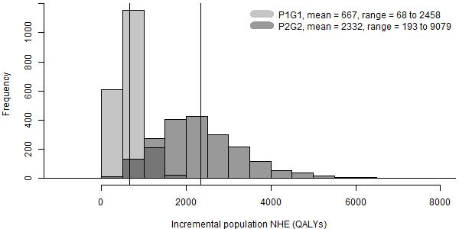
P1G1: baseline population (point estimate) based on PHE categorisation of infection sites, growth rate damped (uncertain); P2G2: baseline population (point estimate) based on clinical advisors’ categorisation of infection sites, growth rate not damped (uncertain).

Table 8. Total INHE across 10 years of usage. (Update of Table 68 in Appendix 20 of the EEPRU report)
Baseline population | Population growth rate | Change in resistance | HAP/VAP | cUTI | BSI | IAI | Total | Proportion of 20 year INHE (%)
PHE categorisation of infection sites  (scenario P1) | Model with damped effect  (scenario G1) | 1% (R1) | 38 | 63 | 254 | 28 | 383 | 56.9%
PHE categorisation of infection sites  (scenario P1) | Model with damped effect  (scenario G1) | 5% (R2) | 37 | 63 | 250 | 27 | 377 | 57.7%
PHE categorisation of infection sites  (scenario P1) | Model with damped effect  (scenario G1) | 10% (R3) | 36 | 62 | 245 | 27 | 370 | 58.7%
PHE categorisation of infection sites  (scenario P1) | Model with damped effect  (scenario G1) | 30% (R4) | 33 | 59 | 224 | 26 | 342 | 64.4%
PHE categorisation of infection sites  (scenario P1) | Model without damped effect  (scenario G2) | 1% (R1) | 56 | 94 | 377 | 41 | 568 | 40.9%
PHE categorisation of infection sites  (scenario P1) | Model without damped effect  (scenario G2) | 5% (R2) | 55 | 93 | 370 | 41 | 559 | 41.7%
PHE categorisation of infection sites  (scenario P1) | Model without damped effect  (scenario G2) | 10% (R3) | 54 | 92 | 362 | 40 | 548 | 42.9%
PHE categorisation of infection sites  (scenario P1) | Model without damped effect  (scenario G2) | 30% (R4) | 49 | 86 | 327 | 38 | 500 | 48.7%
Clinical advisors’ categorisation of infection sites  (scenario P2) | Model with damped effect  (scenario G1) | 1% (R1) | 262 | 102 | 254 | 28 | 646 | 57.0%
 | Model with damped effect  (scenario G1) | 5% (R2) | 258 | 101 | 250 | 27 | 636 | 57.8%
 | Model with damped effect  (scenario G1) | 10% (R3) | 253 | 100 | 245 | 27 | 625 | 59.0%
 | Model with damped effect  (scenario G1) | 30% (R4) | 232 | 94 | 224 | 26 | 576 | 64.6%
 | Model without damped effect  (scenario G2) | 1% (R1) | 389 | 151 | 377 | 41 | 958 | 40.9%
 | Model without damped effect  (scenario G2) | 5% (R2) | 382 | 150 | 370 | 41 | 943 | 41.8%
 | Model without damped effect  (scenario G2) | 10% (R3) | 373 | 147 | 362 | 40 | 922 | 42.9%
 | Model without damped effect  (scenario G2) | 30% (R4) | 337 | 139 | 327 | 38 | 841 | 48.9%

Table 9: Population-level INHE (QALYs) for patient-level scenario analyses (deterministic) – range derived from different assumptions about the population size (scenarios P1G1 and P2G2 in Figure 22). (Update of Table 41 in the EEPRU report)
Scenario name | Base case value/assumption | Scenario value/assumption | HAP/VAP (ES) | cUTI (MDS) | BSI (ES) | IAI (MDS) | Total
Base case | - | - | 67-960 | 112-372 | 449-930 | 49-102 | 677-2,364
p_bug_survey | Probability patient has OXA-48 Enterobacterales is 0.20 | Probability patient has OXA-48 Enterobacterales is 0.57 based on BSAC survey data | 93-1,338 | 112-372 | 627-1,297 | 49-102 | 881-3,109
p_bug_10 | Probability patient has OXA-48 Enterobacterales in ES is 0.20 | Probability patient has OXA-48 Enterobacterales is 0.10 | 34-493 | 112-372 | 231-478 | 49-102 | 426-1,445
p_bug_30 | Probability patient has OXA-48 Enterobacterales in ES is 0.20 | Probability patient has OXA-48 Enterobacterales is 0.30 | 97-1,386 | 112-372 | 649-1,343 | 49-102 | 907-3,203
p_bug_40 | Probability patient has OXA-48 Enterobacterales in ES is 0.20 | Probability patient has OXA-48 Enterobacterales is 0.40 | 95-1,368 | 112-372 | 641-1,326 | 49-102 | 897-3,168
p_bug_50 | Probability patient has OXA-48 Enterobacterales in ES is 0.20 | Probability patient has OXA-48 Enterobacterales is 0.50 | 94-1,351 | 112-372 | 633-1,309 | 49-102 | 888-3,134
p_bug_60 | Probability patient has OXA-48 Enterobacterales in ES is 0.20 | Probability patient has OXA-48 Enterobacterales is 0.60 | 93-1,333 | 112-372 | 624-1,292 | 49-102 | 878-3,099
p_bug_70 | Probability patient has OXA-48 Enterobacterales in ES is 0.20 | Probability patient has OXA-48 Enterobacterales is 0.70 | 92-1,316 | 112-372 | 616-1,275 | 49-102 | 869-3,065
p_bug_80 | Probability patient has OXA-48 Enterobacterales in ES is 0.20 | Probability patient has OXA-48 Enterobacterales is 0.80 | 91-1,299 | 112-372 | 608-1,258 | 49-102 | 860-3,031
p_bug_90 | Probability patient has OXA-48 Enterobacterales in ES is 0.20 | Probability patient has OXA-48 Enterobacterales is 0.90 | 89-1,281 | 112-372 | 600-1,241 | 49-102 | 850-2,996
S2 | Susceptibility based on network meta-analysis of EUCAST studies | Susceptibility based on network meta-analysis of all studies regardless of breakpoints (excludes inconsistent arms) | 91-1,308 | 93-309 | 613-1,268 | 41-84 | 838-2,969
S3 | Susceptibility based on network meta-analysis of EUCAST studies | Susceptibility based on PHE isolate-level data | 76-1,084 | 111-368 | 508-1,051 | 48-100 | 743-2,603
S4 | Susceptibility based on network meta-analysis of EUCAST studies | Susceptibility based on Vasquez-Ucha et al isolate-level data | 110-1,584 | 167-554 | 742-1,535 | 73-151 | 1,092-3,824
abs.increase | Odds ratios on mortality associated with nephrotoxicity from Bucaloiu 2012 are applied multiplicatively to underlying risk in HVCS | Absolute risk increases in Bucaloiu 2012 are assumed to apply | 71-1,023 | 105-347 | 479-992 | 46-95 | 701-2,457
all.aki.lt | Base case assumptions with respect to long-term effects of AKI | Applying a range of alternative assumptions to model the long-term effects of AKI | 72-1,027 | 104-347 | 481-995 | 46-95 | 703-2,464
Weibull | Log-normal model fit to CARBAR survival data | Weibull model fit to CARBAR survival data | 57-812 | 77-257 | 380-787 | 34-70 | 548-1,926
OR_AKI_death_halved | Odds ratio of mortality for AKI compared to no AKI derived from Kerr (2014) (5.11) | Odds ratio of mortality for AKI compared to no AKI halved (2.56) | 64-923 | 87-288 | 432-894 | 38-79 | 621-2,184
AKI, acute kidney injury; BSI, bloodstream infection; cUTI, complicated urinary tract infection; ES, empiric setting; EUCAST, European Committee on Antimicrobial Susceptibility Testing; HAP/VAP, hospital-acquired pneumonia or ventilator-associated pneumonia; HVCS, high value clinical scenario; IAI, intraabdominal infection; MDS, microbiology-directed setting; PHE, Public Health Engl

Table error
Table 35 in the EEPRU report relating to the total number of patients treated with CAZ-AVI over 20 years reported incorrect numbers. The error only affected the table; all subsequent analyses included the correct numbers. The corrected table is provided below in Table 10.

Table 10. Total number of patients initiating CAZ-AVI over 20 years. (Update of Table 35 in the EEPRU report)
 | HAP/VAP | cUTI | BSI | IAI
Scenario P1G1 | 576 | 1,974 | 3,866 | 864
Scenario P1G2 | 1,279 | 4,384 | 8,586 | 1,918
Scenario P2G1 | 3,990 | 3,167 | 3,866 | 864
Scenario P2G2 | 8,860 | 7,033 | 8,586 | 1,918
Abbreviations: BSIs, bloodstream infections; cUTIs, complicated urinary tract infections; HAP/VAP, hospital-acquired pneumonia or ventilator associated pneumonia; IAIs intraabdominal infections; MDS, microbiology-directed setting
P1G1: baseline population based on PHE categorisation of infection sites, damped growth rate; P1G2: baseline population based on PHE categorisation of infection sites, growth rate not damped; P2G1: Baseline population based on clinical advisors’ categorisation of infection sites, damped growth rate; P2G2: Baseline population based on clinical advisors’ categorisation of infection sites, growth rate not damped.

