**NATIONAL INSTITUTE FOR HEALTH AND CARE EXCELLENCE**

**Diagnostics Assessment Programme**

**EarlyCDT Lung for lung cancer risk classification of solid pulmonary nodules**

**Final scope**

February 2021

## Introduction

The EarlyCDT lung is manufactured by Oncimmune. The topic selection oversight panel selected and routed the EarlyCDT-Lung test for guidance development by the Diagnostics Assessment Programme on the basis of a MedTech innovation briefing. The final scope was informed by discussions at the scoping workshop held on 19 January 2021 and the assessment subgroup meeting held on 3 February 2021.

A glossary of terms and a list of abbreviations are provided in appendices A and B.

## Description of the technology

This section describes the properties of the diagnostic technology based on information provided to NICE from the manufacturers and on information available in the public domain. NICE has not carried out an independent evaluation of this description.

### Purpose of the medical technology

EarlyCDT Lung is a blood test that could be used to assess the malignancy risk of solid pulmonary nodules found by chest CT or X-ray. EarlyCDT Lung is non-invasive and could be used in addition to the standard care for early detection of lung cancer. Incidental findings of pulmonary nodules in asymptomatic individuals are an increasingly common clinical dilemma encountered by lung cancer clinicians. EarlyCDT Lung could help identify malignant pulmonary nodules that need immediate treatment or further tests such as PET‑CT or a biopsy. The test could result in treatment being offered earlier, giving improved patient outcomes. The company indicate that EarlyCDT Lung could also reduce the number of people on CT surveillance, patients waiting times and radiologist time, enabling efficient use of NHS resources.

### Product properties

The EarlyCDT Lung test uses a standard enzyme-linked immunosorbent assay (ELISA) method. It is manufactured by Oncimmune and is available as a CE-IVD kit. The test is not currently in use in clinical practice in the NHS.

EarlyCDT Lung measures the presence of autoantibodies to a panel of 7 lung cancer associated antigens (p53, NY-ESO-1, CAGE, GBU4-5, HuD, MAGE A4 and SOX2). Each EarlyCDT Lung test kit contains reagents used for the measurement of autoantibodies in up to 10 patient samples (depending on usage). The result of the EarlyCDT Lung test can be interpreted by laboratory staff and positive results would be reviewed by the lung cancer multi-disciplinary team. A blood sample is positive when at least one of the 7 autoantibodies is elevated above a pre-determined cut-off threshold (table 1). The thresholds were set to give a high specificity with the aim of detecting nodules that are likely to be malignant (a rule-in test).

Table 1: Recommended cut-offs for autoantibodies

|  |  |  |  |  |  |
| --- | --- | --- | --- | --- | --- |
| **Autoantibody** | **No significant level of autoantibodies detected** | **Low cut-off value** | **Moderate level result** | **High cut-off value** | **High level result** |
| CAGE | 4.25 | 5.27 |
| GBU4 5 | 4.36 | 5.92 |
| NYESO 1 | 3.02 | 4.27 |
| p53 | 5.79 | 6.47 |
| SOX2 | 5.48 | 5.58 |
| MAGE A4 | 6.19 | 7.94 |
| HuD | 7.31 | 8.15 |

Results of EarlyCDT Lung tests are reported as:

* No significant levels of autoantibodies detected (“flat”),
* positive-moderate, or
* positive-high.

The positive-high cut-off of the EarlyCDT Lung test is set at a specificity of 98% and the positive-moderate cut-off at a specificity of 93%. A patient will have a pre-test risk of lung cancer predicted by their gender, age, smoking history, and other risk factors alone, calculated by the Brock nodule malignancy risk calculator. The EarlyCDT Lung test result updates this pre-test risk to help clinicians make decisions about further testing or intervention.

A no significant level of autoantibodies detected result suggests the risk of having lung cancer is unchanged from the pre-test risk. This result would not rule out the possibility of having lung cancer. A positive-moderate result indicates that one or more autoantibodies were detected at an elevated level between the low and high cut off values. A positive-high result indicates that one or more autoantibodies were detected above the recommended high cut-off. A positive result, either moderate or high, suggests that the likelihood of lung cancer is greater than that predicted by the Brock nodule malignancy risk calculator. A positive result does not mean that lung cancer is present. A physician may recommend additional testing, including a PET-CT scan, bronchoscopy, needle biopsy, or other testing.

The adjustment to percentage risk of nodule malignancy is based on a baseline (pre-EarlyCDT Lung) risk calculated by the Brock nodule malignancy risk calculator. The EarlyCDT Lung test kit comes with a graph showing how the pre-test risk scores would be affected when the test result is applied (Figure 1).

Figure 1: EarlyCDT Lung risk of malignancy pre-test and at positive moderate and high levels

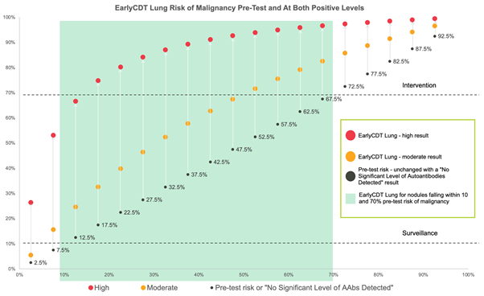

Oncimmune has stated that the black dots represent the baseline risk of malignancy. The orange dots represent the risk of malignancy across different baseline risks combined with a positive-moderate EarlyCDT Lung result. The red dots represent the risk of malignancy across different baseline risks combined with a positive-high EarlyCDT Lung result. Mathematically, the post-test risk (r1) is calculated from the baseline risk (r0), specificity and sensitivity (all on a scale of 0 to 1).

z=(r0/(1-r0))*(sens/(1-spec))

r1=z/(1+z)

The calculation of post-test mortality risk from the baseline risk and the EarlyCDT Lung test result is described in more in [Healey et al](https://www.researchgate.net/publication/317199179_Tumor-Associated_Autoantibodies_Re-Optimization_of_EarlyCDT-Lung_Diagnostic_Performance_and_Its_Application_to_Indeterminate_Pulmonary_Nodules). (2017).

The EarlyCDT Lung test should not be used in people with a previous history of cancer of any type, except for basal cell carcinoma. It should also not be used in people known to have diseases that result in an elevated level of serum total protein, for example, myeloma, amyloidosis, and monoclonal gammopathy of undetermined significance.

### *****Potential alternative technologies*****

There is a lot of ongoing research and developments in the area of risk assessment of pulmonary nodules, including artificial intelligence based radiomics methods and genomics-based tests. However, these technologies are too early in their stage of development to be considered within this assessment.

## Target conditions

### Lung cancer

Lung cancer is the third most common cancer in England and is the leading cause of cancer death. In 2017, there were almost 39,000 new cases of lung cancer and just over 28,000 related deaths ([National Cancer Registration and Analysis Service](https://www.gov.uk/guidance/national-cancer-registration-and-analysis-service-ncras)). There are many risk factors for lung cancer, including age, genetics, lifestyle (especially smoking) and occupation. Most lung cancers are associated with smoking. An estimated 89% of lung cancers are preventable ([NICE guideline on diagnosis and management of lung cancer 2019](https://www.nice.org.uk/guidance/ng122/chapter/Context)). Of the lung cancer that is preventable, 86% is linked to smoking, 13% to occupational exposure, 9% to dietary factors and 7.8% to air pollution. [NICE impact on lung cancer 2019](https://www.nice.org.uk/Media/Default/About/what-we-do/Into-practice/measuring-uptake/lung-cancer-impact-report/nice-impact-lung-cancer.pdf) recommends public awareness campaigns to boost recognition of the signs and symptoms of lung cancer, including in those who have never smoked.

Lung cancer has 2 main types: non-small-cell lung cancer (NSCLC) and small-cell lung cancer (SCLC). NSCLC is the most common type of lung cancer, accounting for 87% of cases ([Cancer research UK](https://www.cancerresearchuk.org/about-cancer/lung-cancer/stages-types-grades/types)). NSCLCs can be broken down into 2 major sub-types: adenocarcinoma (45%) and squamous cell carcinoma (45%). Large cell carcinoma makes up the remaining 10% of NSCLC. SCLC is less common, accounting for around 12% of lung cancers. Between 5% and 15% of people with NSCLC are diagnosed on routine chest radiographic examination, but most present with symptoms and signs related either to the site of the growth of the primary tumour, or to the effects of thoracic or metastatic spread. SCLC is usually caused by smoking. SCLCs are classed as neuroendocrine tumours; rare tumours that develop in cells of the neuroendocrine system ([Cancer Research UK](https://www.cancerresearchuk.org/about-cancer/lung-cancer/stages-types-grades/types)). SCLC is an aggressive cancer which spreads at an early stage and so is nearly always advanced at the time of diagnosis, leading to limited curative intent treatment options.

Survival of lung cancer is hugely influenced by stage at diagnosis. When diagnosed at an earlier stage, almost 6 in 10 (57%) people with lung cancer survive for 5-years or more, compared with less than 5% when the disease is diagnosed at a late stage ([Cancer Research UK](https://www.cancerresearchuk.org/health-professional/cancer-statistics/statistics-by-cancer-type/lung-cancer#heading-Two)). Prognosis for people with SCLC is poor. Without treatment, it has an aggressive clinical course with a life expectancy of approximately 3.5 months for limited-stage disease and 6 weeks for extensive-stage disease ([NICE guidance on Topotecan for the treatment of relapsed small-cell lung cancer 2009](https://www.nice.org.uk/guidance/ta184), revised 2013). The guidance states that the median survival with treatment is approximately 14–18 months for limited stage disease and 9–12 months for extensive-stage disease. Approximately 20–40% of patients with limited-stage disease and less than 5% of patients with extensive-stage disease survive for 2 years. Survivors often continue to relapse up to, and occasionally after, 5 years.

Pulmonary nodules are small growths found inside the lung ([British Thoracic Society Guidelines for the investigation and management of pulmonary nodules 2015](https://www.brit-thoracic.org.uk/quality-improvement/guidelines/pulmonary-nodules/)). They may not lead to symptoms and often are found during tests to diagnose another condition. While most pulmonary nodules are benign and are small, some may develop into cancerous tumours. These are associated with both SCLC and NSCLC. Pulmonary nodules can grow over time, causing breathing problems and other symptoms. If a pulmonary nodule is discovered during an imaging test, a clinician may want to monitor it to see whether it grows or changes shape. Getting a fast and accurate diagnosis is critical. People have more treatment options when the disease is diagnosed in its early stages than when it has advanced.

### Diagnostic and care pathway for lung cancer

#### 3.2.1 Diagnosis

Lung cancer is often diagnosed at a more advanced stage than other common cancers. [National Cancer Registration and Analysis Service](https://www.ons.gov.uk/peoplepopulationandcommunity/healthandsocialcare/conditionsanddiseases/bulletins/cancersurvivalinengland/stageatdiagnosisandchildhoodpatientsfollowedupto2018) data show that almost half of all lung cancers are diagnosed at stage 4. Late diagnosis, where curative treatment is not possible, is a contributing factor to poor survival rates for people with lung cancer. Early detection is key to improving outcomes. Diagnosis of lung cancer requires more than one investigation. Initial investigations involve history taking, an assessment of clinical symptoms and signs to exclude other illnesses, such as chest infections.

[NICE guidance on suspected cancer: recognition and referral 2020](https://www.nice.org.uk/guidance/ng12/chapter/1-Recommendations-organised-by-site-of-cancer#lung-and-pleural-cancers) recommends that people with unexplained symptoms are offered an urgent chest X-ray within 2 weeks to assess the risk of lung cancer. [NICE guidance on diagnosis and management lung cancer 2019](https://www.nice.org.uk/guidance/ng122/chapter/Context) also makes several recommendations that optimise the diagnostic pathway and allow flexibility for managing symptoms of lung cancer in a range of people. The guideline recommends that patients with suspected lung cancer should be urgently referred for a chest X‑ray. If the results suggest lung cancer, a contrast-enhanced CT scan of the chest, upper abdomen and lower neck is performed.

Further investigations to confirm a diagnosis and to provide information on the stage of the disease are then carried out. These investigations generally include a biopsy for histological confirmation and subtyping, and a positron emission tomography-computed tomography (PET-CT) scan for staging. This is recommended as a first test after CT scan ([British Thoracic Society Guidelines for the investigation and management of pulmonary nodules 2015](https://www.brit-thoracic.org.uk/quality-improvement/guidelines/pulmonary-nodules/)). Other methods that can diagnose and stage the disease are MRI, endobronchial ultrasound-guided transbronchial needle aspiration (EBUS-TBNA) and endoscopic ultrasound-guided fine-needle aspiration (EUS-FNA) ([NICE guideline on diagnosis and management of lung cancer 2019](https://www.nice.org.uk/guidance/ng122/chapter/Context)). This helps with diagnosis and choosing the best treatment ([NICE impact on lung cancer 2019](https://www.nice.org.uk/Media/Default/About/what-we-do/Into-practice/measuring-uptake/lung-cancer-impact-report/nice-impact-lung-cancer.pdf)).

#### 3.2.2 Diagnostic pathway for solid pulmonary nodules

Pulmonary nodules are managed in accordance with the [British Thoracic Society Guidelines for the investigation and management of pulmonary nodules (2015](https://www.brit-thoracic.org.uk/quality-improvement/guidelines/pulmonary-nodules/)). These are small growths in the lung, often found incidentally when having a chest X-ray or CT scan. They may be malignant or benign. The guideline recommends the same diagnostic approach for nodules detected incidentally and for those detected through screening. Figure 2 provides a recommended pathway for the initial approach to solid pulmonary nodules.

In America, the [Fleischner Society Guidelines for management of solid nodules](https://pubmed.ncbi.nlm.nih.gov/28240562/) (2005) are widely used, but these are not often followed in the UK.

Figure 2: Initial approach to solid pulmonary nodules ([British Thoracic Society guidelines 2015](https://www.brit-thoracic.org.uk/quality-improvement/guidelines/pulmonary-nodules/))

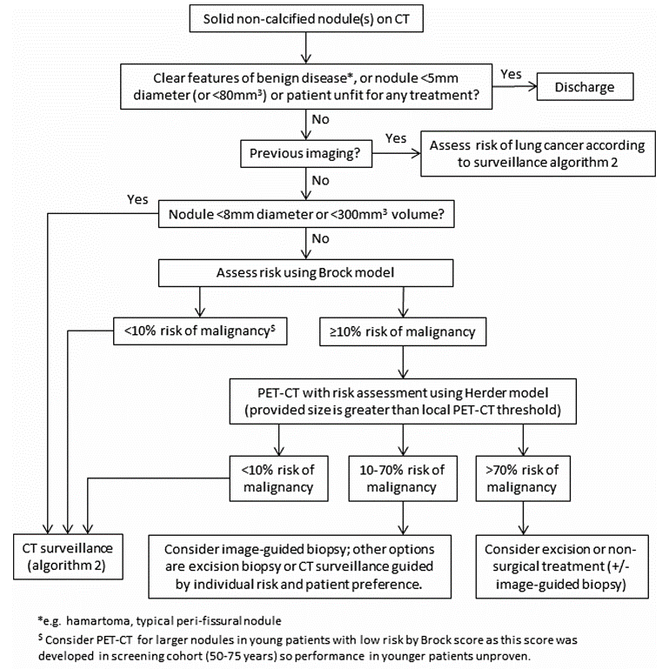

For nodules smaller than 5 mm (or 80 mm3), the British Thoracic Society recommend that people should be discharged with no follow up. Those that have nodules between 5mm and 8mm diameter or 80mm3 and <300mm3 volume are offered CT surveillance. For people with nodules of >8mm diameter the Brock model is used to assess risk. The [Brock model](https://pubmed.ncbi.nlm.nih.gov/16236914/) utilises key inputs including nodule size, location in the lung, age, smoking status, family history of lung cancer, sex, and nodule count. For nodules with <10% risk of malignancy using the Brock model, CT surveillance is offered. This involves repeat scanning at 3 months and 1 to 2 years to assess nodule volume doubling time.

People with ≥10% risk of malignancy using the Brock model are offered PET-CT with risk assessment using the Herder model (provided size is greater than local PET-CT threshold). The [Herder model](https://pubmed.ncbi.nlm.nih.gov/16236914/) predicts the risk of malignancy in solid pulmonary nodules using patient characteristics, nodules characteristics, and the degree of F-fluorodeoxyglucose uptake on PET-CT ([Al-Ameri et al. 2015](https://pubmed.ncbi.nlm.nih.gov/25864782/)). Those that have <10% risk of malignancy using the Herder model are offered CT surveillance. For people with 10-70% risk of malignancy using the Herder model, image guided biopsy, excision biopsy or CT surveillance guided by individual risk and patient preference is used. People with risk over 70% are considered for excision or non-surgical treatment (see figure 2 for more information).

#### 3.2.3 Position of the technology in the current diagnostic pathway

The company proposed position of EarlyCDT Lung test within the current British Thoracic Society pathway for solid pulmonary nodules is shown in figure 3. Oncimmune indicate that EarlyCDT Lung test could be used to assess people with solid non-calcified pulmonary nodules who have no previous imaging and no previous history of cancer. They have defined different routes for when PET-CT is available in a timely manner and when it is not. The company propose using EarlyCDT Lung in people with:

* Nodules 5-8mm in diameter or 80-300mm3 in volume
* Nodules >8mm in diameter or >300mm3 in volume with
  + <10% risk of malignancy using the Brock model
  + 10%- 70% risk of malignancy using the Brock model
* Nodules >8mm (300mm3) in diameter with
  + <10% risk of malignancy using the Herder model
  + 10%- 70% risk of malignancy using the Herder model

Clinical experts have indicated that PET-CT is widely available in a timely manner within the NHS and is always done when appropriate. Therefore, the suggestion of using EarlyCDT Lung in a pathway where PET-CT is not available in a timely manner should not be included in the assessment.

Clinical experts noted that EarlyCDT Lung could be done at the same time as PET-CT or after risk assessment with the Herder model (which incorporates the results of the PET-CT scan). These options can be explored in the assessment. In addition, PET-CT is not done for nodules <8mm in diameter and for nodules with <10% of malignancy. Clinical experts have noted that there may be less value from using in EarlyCDT Lung in these low-risk groups because it may not change decision making about further testing. This can also be explored in the assessment.

Therefore, relevant groups for the use of EarlyCDT Lung include people with:

* Nodules 5-8mm in diameter or 80-300mm3 in volume
* Nodules >8mm in diameter or >300mm3 in volume with
  + <10% risk of malignancy using the Brock model
  + ≥10% risk of malignancy using the Brock model
* Nodules >8mm in diameter or 300mm3 in volume with
  + <10% risk of malignancy using the Herder model
  + 10%- 70% risk of malignancy using the Herder model

Figure 3: The company’s proposed position of EarlyCDT Lung within the current BTS pathway for lung cancer



#### 3.2.4 Treatment pathway for lung cancer

Treatment for lung cancer includes surgery, chemotherapy, radiotherapy, immunotherapy and other targeted therapy drugs ([NICE guidance on diagnosis and management of lung cancer 2019](https://www.nice.org.uk/guidance/NG122/chapter/Rationale-and-impact" \l "first-line-treatment-for-limited-stage-disease-small-cell-lung-cancer-2)). People may be offered one or more different treatments depending on the stage and type of lung cancer as well as their general health. After diagnosis, treatment for lung cancer is based on several factors, such as overall health, the type, size, position, and stage of cancer.

#### 3.2.4.1 Non-small-cell lung cancer

Possible treatment for adults with NSCLC lung cancer includes treatment with curative intent, systemic anti-cancer therapy for advanced disease, ablation procedure for primary and secondary lung cancers and photodynamic therapy for localised inoperable endobronchial cancer (see figure 4).

Figure 4: Treatment pathway for adults with non-small-cell lung cancer ([NICE guidance on pathway for non-small cell lung cancer on treatment with curative intent](https://pathways.nice.org.uk/pathways/lung-cancer/non-small-cell-lung-cancer-treatments-with-curative-intent))

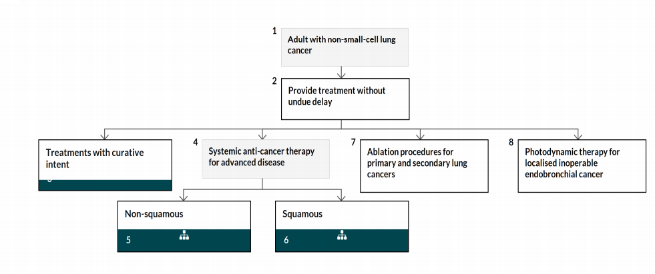

Possible treatment with curative intent for people with NSCLC includes surgery, radiotherapy, chemoradiotherapy and multimodality treatment ([NICE pathway on non-small cell lung cancer on treatment with curative intent](https://pathways.nice.org.uk/pathways/lung-cancer/non-small-cell-lung-cancer-treatments-with-curative-intent)).

Surgery for NSCLC has proven to be effective, with [National Cancer Registration and Analysis Service (NCRAS)](http://www.ncin.org.uk/cancer_type_and_topic_specific_work/cancer_type_specific_work/lung_cancer/) data showing that 45% of people with NSCLC were still alive 5 years post-surgery. Five-year survival rates for people with NSCLC who do not have surgery was 3%. Over the last 10 years, surgery rates for NSCLC have doubled, from around 9% in 2006 to over 18% in 2017, exceeding the target of 17% set by the [National Lung Cancer Audit 2019](https://www.rcplondon.ac.uk/projects/outputs/lung-cancer-clinical-outcomes-publication-2019-audit-period-2017). NICE recommends that people with NSCLC, who are well enough and for whom treatment with curative intent is suitable, should be offered a lobectomy (either open or thoracoscopic) ([NICE guidance on diagnosis and management of lung cancer 2019](https://www.nice.org.uk/guidance/NG122/chapter/Rationale-and-impact#first-line-treatment-for-limited-stage-disease-small-cell-lung-cancer-2)). An open lobectomy (thoracotomy) is the removal of a lobe of the lung through a cut made around the side of the chest.

For people with stage I–IIA (T1a–T2b, N0, M0) NSCLC who decline lobectomy or in whom it is contraindicated, the guidance recommends offering radical radiotherapy with stereotactic ablative radiotherapy (SABR) or sublobar resection. For eligible people with stage IIIA or IIIB NSCLC who cannot tolerate or who decline chemoradiotherapy (with or without surgery), radical radiotherapy should be considered (either conventional or hyperfractionated).

For more advanced NSCLC, surgery or radiotherapy alone is often not appropriate as the cancer has spread too far for it to be possible or effective. Chemotherapy should be offered to people with stage III or IV NSCLC with the aim of improving survival, disease control and quality of life. Treatment with curative intent is not possible for these people. First-line chemotherapy should be a combination of a single third-generation drug (docetaxel, gemcitabine, paclitaxel or vinorelbine) and a platinum drug. People who are unable to tolerate a platinum combination may be offered single-agent chemotherapy with a third-generation drug. Chemotherapy is followed by durvalumab (used within the Cancer Drugs Fund) ([NICE technology appraisal guidance on durvalumab for treating locally advanced unresectable NSCLC after platinum-based chemoradiation](http://www.nice.org.uk/guidance/TA578)).

The [National Lung Cancer Audit 2019](https://www.rcplondon.ac.uk/projects/outputs/lung-cancer-clinical-outcomes-publication-2019-audit-period-2017) reports that 34% of people with stage IIIA NSCLC and good performance status received treatment with chemotherapy and either radical radiotherapy or surgery in 2017.

[NICE guidance on diagnosis and management for lung cancer 2019](https://www.nice.org.uk/guidance/NG122/chapter/Rationale-and-impact" \l "first-line-treatment-for-limited-stage-disease-small-cell-lung-cancer-2) sets out treatment options for advanced stage of NSCLC lung cancer. These are determined by whether the cancer is squamous or non-squamous. For squamous disease there are further treatment decisions based on whether the individual is PD-L1< 50%, and PD-L1≥ 50%, and their response to those treatments, for further information see [Systemic anti-cancer therapy: management options for people with squamous non-small-cell carcinoma – October 2020 update](https://www.nice.org.uk/guidance/ng122/resources/systemic-anticancer-therapy-management-options-for-people-with-squamous-nonsmallcell-carcinoma-pdf-6722110910). For non-squamous there are further treatment decisions determined by the type of lung cancer, ROS1 status, EGFR-TK mutation, NTRK fusion and ALK status (for further information see [NICE pathway on advanced non-squamous (stages IIIB and IV) non-small-cell lung cancer: systemic anti-cancer therapy](https://pathways.nice.org.uk/pathways/lung-cancer/advanced-non-squamous-stages-iiib-and-iv-non-small-cell-lung-cancer-systemic-anti-cancer-therapy)).

#### 3.2.4.2 Small cell lung cancer

Treatment for adults with SCLC involves first line treatment for early stage and limited stage disease, first line treatment for extensive stage disease and ablation procedure (see figure 5).

Figure 5: Treatment pathway for adults with small-cell lung cancer ([NICE pathway for treating SCLC](https://pathways.nice.org.uk/pathways/lung-cancer/non-small-cell-lung-cancer-treatments-with-curative-intent#path=view%3A/pathways/lung-cancer/treating-small-cell-lung-cancer.xml&content=view-index))

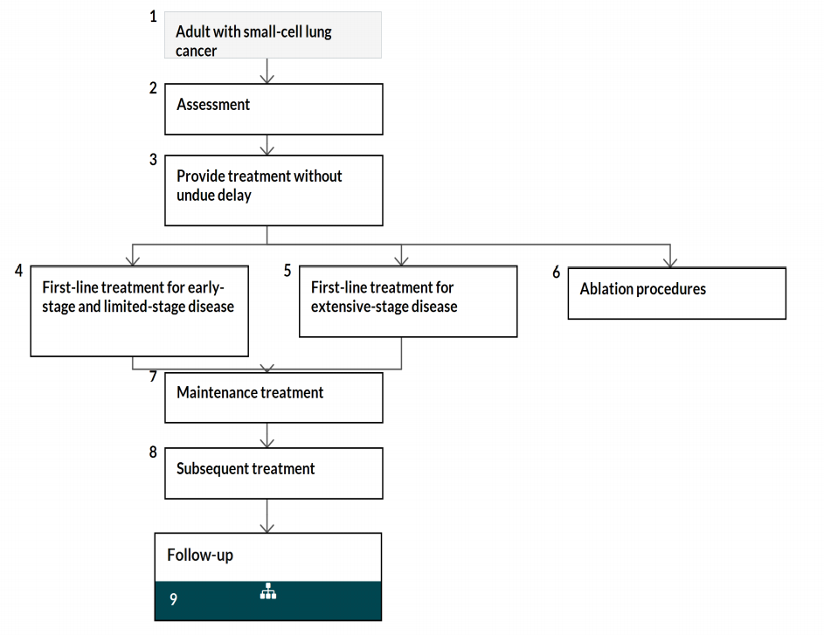

Around 30% of small cell lung cancer (SCLC) cases are detected at stage I-III. For those detected early enough, surgery is considered as a treatment. NICE also recommends that twice-daily radiotherapy with concurrent chemotherapy should be offered to people with limited-stage disease SCLC ([NICE pathway for treating SCLC](https://pathways.nice.org.uk/pathways/lung-cancer/non-small-cell-lung-cancer-treatments-with-curative-intent#path=view%3A/pathways/lung-cancer/treating-small-cell-lung-cancer.xml&content=view-index)). In 2017, 42% of people with stage I– III SCLC with a performance status of 0–2 received treatment with chemotherapy and radical radiotherapy or occasionally surgery ([National Lung Cancer Audit](https://www.rcplondon.ac.uk/projects/national-lung-cancer-audit)). For SCLCs that are detected at a late stage, chemotherapy and radiotherapy can be used to improve quality of life and chances of medium-term survival. [NICE guidance on diagnosis and management of lung cancer 2019](https://www.nice.org.uk/guidance/NG122/chapter/Rationale-and-impact#first-line-treatment-for-limited-stage-disease-small-cell-lung-cancer-2) recommends that people with limited-stage SCLC should be offered 4 to 6 cycles of cisplatin-based combination chemotherapy and people with extensive-stage SCLC should be offered a platinum-based combination chemotherapy. NICE also recommends atezolizumab with carboplatin and etoposide as an option for untreated extensive-stage small-cell lung cancer in adults, only if people have an Eastern Cooperative Oncology Group (ECOG) performance status of 0 or 1 ([NICE technology appraisal on Atezolizumab with carboplatin and etoposide for untreated extensive-stage small-cell lung cancer 2020)](https://www.nice.org.uk/guidance/ta638/chapter/1-Recommendations).

Where the cancer has relapsed after first line treatment and a second line treatment is required it is recommended to offer people assessment by a thoracic oncologist. For those in whom chemotherapy is suitable, treatment with an anthracycline-containing regimen or further treatment with a platinum-based regimen to a maximum of 6 cycles is recommended. For palliation of local symptoms radiotherapy should be offered. Oral Topotecan is recommended as an option in people for whom retreatment with the first line regimen is not considered appropriate and the combination of cyclophosphamide, doxorubicin and vincristine is contraindicated. Palliative care should be provided by general and specialist care providers in line with the [NICE guidance on improving supportive and palliative care for adults with cancer](https://www.nice.org.uk/guidance/csg4).

### Patient issues and preferences

Lung cancer is the most common cause of cancer-related death in the UK because around three-quarters of lung cancer cases are diagnosed at a late stage. Treatment options have increased in recent years and include surgery, radiotherapy, chemotherapy, and immunotherapy. Treatment can improve survival but can have many side effects ([NICE impact on lung cancer](https://www.nice.org.uk/Media/Default/About/what-we-do/Into-practice/measuring-uptake/lung-cancer-impact-report/nice-impact-lung-cancer.pdf)). Progress of the disease, severity of its symptoms, and side effects of treatment can decrease the quality of life in some people with the disease.

A patient expert noted that people with lung cancer may feel stigmatised because of the link between smoking and lung cancer; both smokers and non-smokers may perceive that they are blamed for causing their cancer.

Surveillance of indeterminate pulmonary nodules is done by [CT scans](https://www.nhs.uk/conditions/ct-scan/). These are quick, painless and generally safe, but there is a small risk of allergic reaction to the contrast dye used. CT scans also involve exposure to X-ray radiation, which could slightly increase the risk of developing cancer in the future, although this risk is thought to be very small (less than 1 in 2,000). The potential benefits of having a CT scan to monitor pulmonary nodules are likely to outweigh the risks. Some people feel that 2 years of CT surveillance negatively affects their mental wellbeing, whereas others feel reassured that it could help to diagnose cancer at an earlier stage or could help to rule out cancer if the CT scans shows no growth in the size of the nodule. CT scans would probably need to be done at the hospital and may lead to patient concerns over travel and parking. The EarlyCDT Lung test may reduce the number of CT scans needed.

The EarlyCDT Lung test is a blood test; if it is shown to be an accurate and effective test, it is likely to be acceptable to most people due to the ease and familiarity of a blood test.

The EarlyCDT Lung test could result in treatment being offered earlier and treatment could be less aggressive, giving improved patient outcomes. However, it could potentially result in overdiagnosis, leading to overtreatment of benign and indolent cancers. This would put some people at risk of having unnecessary treatment or intervention, which bring with them a risk of side effects.

## Comparator

In the UK, the Brock model and the Herder model are used to estimate pulmonary nodule risk of malignancy as part of current clinical practice.

## Scope of the assessment

Table 2: Scope of the assessment

|  |  |
| --- | --- |
| Decision question | What is the clinical and cost effectiveness of EarlyCDT Lung test for the investigation and diagnosis of lung cancer in people with pulmonary nodules? |
| Populations | People who do not have a previous history of cancer and have pulmonary nodules:   * 5 - 8mm diameter or 80 - 300mm3 volume * >8mm diameter or >300mm3 volume plus:   + <10% risk of malignancy using the Brock model, or   + ≥10 risk of malignancy using the Brock model   + <10% risk of malignancy using the Herder model, or   + 10-70% risk of malignancy using the Herder model   If data are available, the following subgroups will be analysed:   * Incidentally detected pulmonary nodules * Pulmonary nodules identified through screening * Pulmonary nodules in people who have symptoms of lung cancer |
| Intervention | EarlyCDT Lung test |
| Comparators | Current clinical practice in the NHS to assess risk of malignancy without use of EarlyCDT Lung:   * Brock model * Herder model |
| Healthcare setting | Secondary care |
| Outcomes | Intermediate measures for consideration may include:   * Test accuracy * Time to test result * Impact of test result on clinical decision-making * Number of cancers detected and stage * Use of further tests |
| Clinical outcomes for consideration may include:   * Mortality * Morbidity * Disease free survival * Overall survival * Adverse events (during or after testing) |
| Patient-reported outcomes for consideration may include:   * Health-related quality of life * Acceptability of test (such as anxiety about the testing procedure, acceptability of time to test result) * Side effects of testing |
| Costs will be considered from an NHS and Personal Social Services perspective. Costs for consideration may include:   * Cost of testing for lung cancer * Staff time and time for training * Surveillance costs * Cost of treatment and follow-up |
| The cost-effectiveness of interventions should be expressed in terms of incremental cost per quality-adjusted life year (ICER). |
| Time horizon | The time horizon for estimating clinical and cost effectiveness should be sufficiently long to reflect any differences in costs or outcomes between the technologies being compared |

## Other issues for consideration

### Alternative use of EarlyCDT Lung

### The EarlyCDT Lung test could be used for screening high risk populations for lung cancer. However, this use is outside the scope of the assessment.

### Ongoing clinical outcome studies

Spain - REFINE (REgistry and Follow up of Indeterminate Nodules using EarlyCDT) involves the design and maintenance of an anonymized web-based registry of patients with indeterminate pulmonary nodules tested with EarlyCDT Lung. People with nodules detected either incidentally or screening with low dose CT who are tested for autoantibodies will be included in the registry, and their clinical outcomes assessed. The project will include pulmonary nodules considered indeterminate in size and risk, measuring 6-15 mm in diameter. All testing will be performed as part of routine clinical practice. The registry will consider lung nodule follow up with imaging and/or invasive testing as mandated by current clinical guidelines and best practices.

The company has indicated that they are in the process of gathering evidence through ongoing pilot studies. Data from the studies will provide further information on the possible adjustment of the Herder risk score.

## Potential equality issues

NICE is committed to promoting equality of opportunity, eliminating unlawful discrimination, and fostering good relations between people with protected characteristics and others.

People with lung cancer may be classified as having a disability and therefore protected under the Equality Act 2010 from the point of diagnosis. Over time, lung cancer rates in females have increased by almost a third, and rates in males have decreased by a third. There are also differences in [the rates of lung cancer between ethnic groups](http://www.ncin.org.uk/cancer_type_and_topic_specific_work/cancer_type_specific_work/lung_cancer/). It is most common in White and men of Bangladeshi family origin. Rates for men of Indian, Pakistani, Black Caribbean, Black African and Chinese family origin are lower. In women, lung cancer is more common in White women than in women from other ethnic groups. Sex and race are protected characteristics under the Equality Act 2010. The incidence and mortality of lung cancer are higher in deprived populations.

## Potential implementation issues

There are no significant challenges anticipated to the adoption of EarlyCDT Lung in laboratories. Adoption levers suggest that the EarlyCDT Lung test would help identify indeterminate pulmonary nodules at the highest lung cancer risk, leading to earlier diagnosis and improved prognosis. The test would also provide clinical information which supports decisions for further invasive testing.

The adoption barriers of EarlyCDT Lung suggest that there is potentially limited evidence to support the use of EarlyCDT Lung and clinicians may not be confident to use the result of the test for decision making.

## Authors

**Jean Isaac**

Topic Lead

**Frances Nixon**

Health Technology Assessment Adviser

February 2021

Appendix A Glossary of terms

**Brock model**

The Brock model is a multivariable model that estimates the risk that a pulmonary nodule on CT scan is lung cancer. By providing an estimate of nodule lung cancer risk, the Brock model can assist in determining appropriate follow-up and management of pulmonary nodules detected on CT. The Brock model utilises key inputs including nodule size, location in the lung, age, smoking status, family history of lung cancer, sex, and nodule count.

**Endobronchial ultrasound (EBUS)**

Fine needle aspiration, in which a fine needle is inserted an area of abnormal swelling or lumps under the skin, such as cysts, nodules or masses, and enlarged lymph nodes

**Incremental cost-effectiveness ratio (ICER)**

The difference in the change in mean costs in the population of interest divided by the difference in the change in mean outcomes in the population of interest

**Quality-adjusted life year (QALY)**

A measure of the state of health of a person or group in which the benefits, in terms of length of life, are adjusted to reflect the quality of life. One QALY is equal to 1 year of life in perfect health. QALYs are calculated by estimating the years of life remaining for a patient following a particular treatment or intervention and weighting each year with a quality-of-life score (on a 0 to 1 scale). It is often measured in terms of the person’s ability to carry out the activities of daily life, and freedom from pain and mental disturbance.

**Standard care**

The best available current clinical practice diagnostic test, against which the technology under assessment is compared.

**Staging**

These are medical tests to establish the extent of a cancer. Staging is a way of describing the size and any spread of cancer and is an important factor in deciding the best treatment.

**Malignant**

This is a cancer. The word malignant describes the fact that the cancer is not under normal control and that it has the potential to spread both locally and to distant areas.

Appendix B Abbreviations

BTS British Thoracic Society

ELISA Enzyme-linked immunosorbent assay

IPN Indeterminate pulmonary nodule

NHS National Health Service

NICE National Institute for Health and Clinical Excellence

NLST National Lung Screening Trial

NSCLC Non-small cell lung cancer

QoL Quality of life

SCLC Small cell lung cancer

VDT Volume doubling time

|  |  |
| --- | --- |
|  |  |
|  |  |
|  |  |
|  |  |
|  |  |
|  |  |
|  |  |

Appendix C References

Al-Ameri A, Malhotra P, Thygesen H, Plant PK, Vaidyanathan S, Karthik S, Scarsbrook A, Callister ME. Risk of malignancy in pulmonary nodules: A validation study of four prediction models. Lung Cancer. 2015 Jul; 89(1):27-30.

Chen B, Yang L, Zhang R, Luo W, Li W. Radiomics: an overview in lung cancer management-a narrative review. Ann Transl Med. 2020;8(18):1191.

Edelsberg J, Weycker D, Atwood M, Hamilton-Fairley G, Jett JR. Cost-effectiveness of an autoantibody test (EarlyCDT-Lung) as an aid to early diagnosis of lung cancer in patients with incidentally detected pulmonary nodules. 2018; 13(5): e0197826.

Gaga M, Chorostowska-Wynimko J, Horváth Ió, et al. Validation of Lung EpiCheck®, a novel methylation-based blood assay, for the detection of lung cancer in European and Chinese high-risk individuals. Eur Respir J 2020; in press

He L, Huang Y, Ma Z, et al. Effects of contrast-enhancement, reconstruction slice thickness and convolution kernel on the diagnostic performance of radiomics signature in solitary pulmonary nodule. Sci Rep 2016;6:34921-. 10.

Herder GJ, van Tinteren H, Golding RP, Kostense PJ, Comans EF, Smit EF, Hoekstra OS Chest. Clinical prediction model to characterize pulmonary nodules: validation and added value of 18F-fluorodeoxyglucose positron emission tomography. 2005 Oct; 128(4):2490-6

Khawaja A, Bartholmai BJ, Rajagopalan S, Karwoski RA, Varghese C, Maldonado F, Peikert T. Do we need to see to believe?-radiomics for lung nodule classification and lung cancer risk stratification. J Thorac Dis. 2020 Jun;12(6):3303-3316

Yang B, Jhun BW, Shin SH, et al. Comparison of four models predicting the malignancy of pulmonary nodules: A single-center study of Korean adults. PLoS One. 2018;13(7): e0201242. Published 2018 Jul 31.