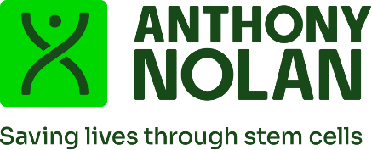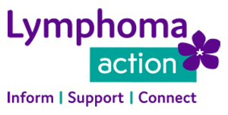

Dr Mark Chakravarty
Lead Non-executive Director NICE Appeals – Technology Appraisals and Highly Specialised Technologies

National Institute for Health and Care Excellence
2nd Floor
2 Redman Place
London E20 1JQ

Thursday 12 February 2026

Dear Dr Chakravarty,

Re: Final Draft Guidance – Brexucabtagene autoleucel for treating relapsed or refractory mantle cell lymphoma after 2 or more systemic treatments (review of TA677) [ID6325]

Thank you for your initial scrutiny letter of 29 January 2026, in response to the appeal letter lodged on behalf of our three charities and the mantle cell lymphoma patients for whom we advocate. We are grateful to you for taking the time to consider our appeal and explain your reasoning.

We are writing to confirm that we will not be providing further clarification and/or evidence on our specific appeal points. We are aware that the appeal is proceeding to a hearing on 30 March and will be attending as observers.

We wish to restate that withdrawing brexucabtagene autoleucel will have a devastating impact on patients with mantle cell lymphoma. This therapy is the last chance of potential long-term remission.

Between our charities’ support services, we have been inundated with patients expressing their worry and concern. Patients’ comments have included:
- “I feel like the rug has been pulled from under me, I feel sick”
- “It may not come to needing CAR-T, but it was always there, the safety net, survival and now it’s potentially gone.”
- “That knowledge [of knowing brexu-cel was available] gave us hope and helped us plan for the future.”

This is a rare cancer with relatively small numbers of patients receiving CAR-T per year (we believe it to be well under 50) – if more data is required, and more time needed than the Cancer Drugs Fund can provide, then we urge NICE to think out of the box and find a path to that data which Committee members, clinicians and patients need.
We also want to note our general disappointment in the manner in which patient experts and patient organisations have been treated in the course of this appraisal. One of our patient experts was not able to attend the first committee meeting due to being unfamiliar with the Zoom platform and with technology in general, including emails. We contacted NICE requesting that a written statement be read out at the meeting and were informed that was acceptable as long as there was a formal nomination as a patient expert. This was done straight away but we were then told, four weeks later and less than five working days before the committee meeting, that his statement would not be accepted if he did not return personal declaration and confidentiality agreement forms. We were unable to provide the necessary support for him to do this within the time available and so his prepared and approved statement was not provided to the committee. We were also given just one week in which to find and nominate an alternative patient expert, despite requesting confirmation weeks in advance.
Furthermore, when the negative decision was released, NICE contacted our patient expert directly and informed them of the outcome prior to telling us, the nominating organisations. We were unable to support our patient expert who was very upset by the news.
We understand that these points are outside of the appeals process but wish to have them noted in some way.
Kind regards,
Anna Grint, Lymphoma Action
Hilary Webb, Blood Cancer UK
Yasmin Sheikh, Anthony Nolan

