jean

Authors: Beth Woods¹, Laetitia Schmitt¹, Dina Jankovic¹, Ben Kearns², Alison Scope², Kate Ren², Ruth Wong², Tushar Srivastava², Chu Chang Ku², Jean Hamilton², Claire Rothery¹, Laura Bojke¹, Mark Sculpher¹, Sue Harnan²

¹ Centre for Health Economics, University of York, UK
² Department of Economics and Related Studies, University of York, York, UK
This document uses different formatting to the original report supplied by EEPRU to NICE. The content is identical, but this version has been altered to improve the digital accessibility.

Appendices to the final report for the technology evaluation of cefiderocol for treating severe aerobic Gram-negative bacterial infections
October 2021
Funding
This research is funded by the National Institute for Health Research (NIHR) Policy Research Programme, conducted through the Policy Research Unit in Economic Methods of Evaluation in Health and Social Care Interventions, PR-PRU-1217-20401.

Acknowledgements
The views expressed are those of the author(s) and not necessarily those of the NHS, the National Institute for Health Research, the Department of Health and Social Care or its arm's length bodies, or other UK government departments. We are grateful for the support of our clinical advisors: Professors David Jenkins, William Hope, Philip Howard, Colm Leonard, Mark Wilcox; and Drs Alan Ashworth and Andrew Bentley. Also, thanks for modelling advice to Professor Mark Jit and Dr Gwen Knight; and for comments on drafts we thank Professor Allan Wailoo, Dr James Fotheringham, Professor Simon Dixon, Dr Rita Neves De Faria and Professor Stephen Palmer. We are also grateful for support from Sarah Gerver and Rebecca Guy at UK Health Security Agency (formerly Public Health England). Finally, we thank Kath Devlin, Ruth Helstrip, Liz Mclintock, Steph Richards and Alex Rollinger for their support in developing this report. Any errors are the responsibility of the authors.

Appendix 1: Search strategies

A1.1 Clinical searches
Number of records retrieved
# | Search | Results*
 |  | MEDLINE | Embase | CRD | WoS-CPCI
 | Clinical evidence | 143 | 257 | 0 | NS
 | CEA models | 0 | 3 | 0 | 8
*numbers retrieved before removal of duplicate titles.

A1.1.1 Cefiderocol clinical searches
Term group(s): Cefiderocol AND filter
Filters: Exclusions filter (MEDLINE, Embase)
Limits: None

Ovid MEDLINE(R) and Epub Ahead of Print, In-Process, In-Data-Review & Other Non-Indexed Citations, Daily and Versions(R) 1946 to March 05, 2021 (searched via the Ovid SP platform)
8th March 2021
# | Searches | Results
1 | cefiderocol.mp. | 160
2 | fetroja.mp. | 4
3 | fetcroja.mp. | 0
4 | rsc-649266.mp. | 0
5 | or/1-4 | 160
6 | Case report.tw. | 328791
7 | Letter/ | 1125503
8 | Historical article/ | 362469
9 | 6 or 7 or 8 | 1800153
10 | exp Animals/ | 23873090
11 | Humans/ | 19076531
12 | 10 not (10 and 11) | 4796559
13 | 9 or 12 | 6547157
14 | 5 not 13 | 143

Embase 1974 to 2021 March 05 (searched via the Ovid SP platform)
8th March 2021
# | Searches | Results
1 | cefiderocol.mp. | 281
2 | fetroja.mp. | 9
3 | fetcroja.mp. | 1
4 | rsc-649266.mp. | 0
5 | or/1-4 | 281
6 | Case study/ | 76989
7 | Case report.tw. | 442512
8 | Abstract report/ or letter/ | 1190878
9 | editorial.pt. | 686858
10 | (case$ and series).tw. | 282645
11 | animal/ | 1510117
12 | human/ | 21955778
13 | 11 not (11 and 12) | 1106000
14 | or/6-10,13 | 3696820
15 | 5 not 14 | 257

CRD database (searched via the University of York CRD platform)
8th March 2021
# | Searches | Results
1 | (cefiderocol) | 0
2 | (fetroja) | 0
3 | (fetcroja) | 0
4 | (rsc-649266) | 0

A1.1.2 Fosfomycin search strategy
Searched using Pubmed on 26th August 2021, from database inception.
Search number | Search term used in Pubmed | Terms Pubmed searched | hits
1 | Fosfomycin | "fosfomycin"[MeSH Terms] OR "fosfomycin"[All Fields] OR "fosfomycine"[All Fields] | 3,802
2 | (metallo beta lactamase) OR (MBL) | ("metallo"[All Fields] AND ("beta lactamases"[MeSH Terms] OR "beta lactamases"[All Fields] OR ("beta"[All Fields] AND "lactamase"[All Fields]) OR "beta lactamase"[All Fields])) OR ("mol biol los angel"[Journal] OR "mbl"[All Fields]) | 8,805
3 | ((susceptibility) OR (resistance)) OR (antibiogram) OR ((susceptib*) OR (resistan*)) OR (AM susceptibility[MeSH Terms]) | "susceptib*"[All Fields] OR "resistan*"[All Fields] OR (("anti infective agents"[Pharmacological Action] OR "anti infective agents"[MeSH Terms] OR ("anti infective"[All Fields] AND "agents"[All Fields]) OR "anti infective agents"[All Fields] OR "AM"[All Fields] OR "AMs"[All Fields] OR "AMly"[All Fields]) AND "disease susceptibility"[MeSH Terms]) OR ("disease susceptibility"[MeSH Terms] OR ("disease"[All Fields] AND "susceptibility"[All Fields]) OR "disease susceptibility"[All Fields] OR "susceptibilities"[All Fields] OR "susceptibility"[All Fields] OR "susceptible"[All Fields] OR "susceptibles"[All Fields] OR "susceptive"[All Fields] OR "susceptivity"[All Fields] OR ("resist"[All Fields] OR "resistance"[All Fields] OR "resistances"[All Fields] OR "resistant"[All Fields] OR "resistants"[All Fields] OR "resisted"[All Fields] OR "resistence"[All Fields] OR "resistences"[All Fields] OR "resistent"[All Fields] OR "resistibility"[All Fields] OR "resisting"[All Fields] OR "resistive"[All Fields] OR "resistively"[All Fields] OR "resistivities"[All Fields] OR "resistivity"[All Fields] OR "resists"[All Fields]) OR ("microbial sensitivity tests"[MeSH Terms] OR ("microbial"[All Fields] AND "sensitivity"[All Fields] AND "tests"[All Fields]) OR "microbial sensitivity tests"[All Fields] OR "antibiogram"[All Fields] OR "antibiograms"[All Fields])) | 1,733,217
4 | #1 and #2 and #3 |  | 84
5 | (review, systematic[MeSH Terms]) OR (systematic review) | (("review"[Publication Type] OR "review literature as topic"[MeSH Terms] OR "review"[All Fields]) AND "classification"[MeSH Terms]) OR ("systematic review"[Publication Type] OR "systematic reviews as topic"[MeSH Terms] OR "systematic review"[All Fields]) | 241,211
6 | #1 and #3 and #5 |  | 30
7 | #4 and #5 |  | 113

A1.2. Cefiderocol CEA models
Term group(s): Cefiderocol AND filter
Filters: Economic (MEDLINE, Embase), exclusion filter (Embase)
Limits: None

Ovid MEDLINE(R) and Epub Ahead of Print, In-Process, In-Data-Review & Other Non-Indexed Citations, Daily and Versions(R) 1946 to February 26, 2021 (searched via the Ovid SP platform)
1st March 2021
# | Searches | Results
1 | cefiderocol.mp. | 160
2 | fetroja.mp. | 4
3 | fetcroja.mp. | 0
4 | rsc-649266.mp. | 0
5 | or/1-4 | 160
6 | exp "Costs and Cost Analysis"/ | 242835
7 | Economics/ | 27294
8 | exp Economics, Hospital/ | 24969
9 | exp Economics, Medical/ | 14242
10 | Economics, Nursing/ | 4002
11 | exp models, economic/ | 15443
12 | Economics, Pharmaceutical/ | 2971
13 | exp "Fees and Charges"/ | 30592
14 | exp Budgets/ | 13800
15 | budget*.tw. | 30546
16 | ec.fs. | 431631
17 | cost*.ti. | 125579
18 | (cost* adj2 (effective* or utilit* or benefit* or minimi*)).ab. | 157179
19 | (economic* or pharmacoeconomic* or pharmaco-economic*).ti. | 50939
20 | (price* or pricing*).tw. | 42703
21 | (financial or finance or finances or financed).tw. | 97358
22 | (fee or fees).tw. | 18704
23 | (value adj2 (money or monetary)).tw. | 2515
24 | quality-adjusted life years/ | 12949
25 | (qaly or qalys).af. | 11325
26 | (quality adjusted life year or quality adjusted life years).af. | 19387
27 | or/6-26 | 801858
28 | 5 and 27 | 0

Embase 1974 to 2021 February 26 (searched via the Ovid SP platform)
1st March 2021

# | Searches | Results
1 | cefiderocol.mp. | 278
2 | fetroja.mp. | 9
3 | fetcroja.mp. | 1
4 | rsc-649266.mp. | 0
5 | or/1-4 | 278
6 | "cost benefit analysis"/ | 87111
7 | "cost effectiveness analysis"/ | 158540
8 | economics/ | 241957
9 | health economics/ | 33700
10 | pharmacoeconomics/ | 7505
11 | fee/ | 14329
12 | budget/ | 30564
13 | budget$.tw. | 40639
14 | cost$.ti. | 168111
15 | (cost$ adj2 (effective$ or utilit$ or benefit$ or minimi$)).ab. | 218259
16 | (economic$ or pharmacoeconomic$ or pharmaco-economic$).ti. | 64563
17 | (price$ or pricing$).tw. | 60859
18 | (financial or finance or finances or financed).tw. | 135326
19 | (fee or fees).tw. | 25728
20 | (value adj2 (money or monetary)).tw. | 3455
21 | health care quality/ | 247699
22 | quality adjusted life year/ | 28517
23 | (qaly or qalys).tw. | 21188
24 | (quality adjusted life year or quality adjusted life years).tw. | 20472
25 | or/6-24 | 1102354
26 | letter.pt. | 1185036
27 | editorial.pt. | 691062
28 | historical article.pt. | 0
29 | or/26-28 | 1876098
30 | 25 not 29 | 1021484
31 | animals/ | 1253461
32 | humans/ | 13458185
33 | 31 not (31 and 32) | 965742
34 | 30 not 33 | 1010813
35 | 5 and 34 | 3

CRD database (searched via the University of York CRD platform)
1st March 2021
# | Searches | Results
1 | (cefiderocol) | 0
2 | (fetroja) | 0
3 | (fetcroja) | 0
4 | (rsc-649266) | 0

Web of Science - Conference proceedings index (searched via the Clarivate Analytics platform)
1st March 2021
# | Searches | Results
# 1 | TOPIC: (cefiderocol) | 8
# 2 | TOPIC: (fetroja) | 0
# 3 | TOPIC: (fetcroja) | 0
# 4 | TOPIC: (rsc-649266) | 0
# 5 | #4 OR #3 OR #2 OR #1 | 8

A1.3 NON-CLINICAL EVIDENCE
Systematic searches were conducted from March until July 2021 to identify non-clinical evidence for relating to the evaluation.
The following electronic databases were searched from database inception:
- MEDLINE and Epub Ahead of Print, In-Process, In-Data-Review & Other Non-Indexed Citations, Daily and Versions: Ovid, 1946 to Present
- EMBASE: Ovid, 1980 to present
- The University of York Centre for Reviews and Dissemination (CRD) platform
  - Database of Abstracts of Reviews of Effects (DARE): CRD, 1994 to 2015
  - Health Technology Assessment Database (HTA): CRD, 1989 to 2018
  - NHS Economic Evaluation Database (NHS EED): CRD, 1972 to 2015

Number of records retrieved
# | Search | Results*
 |  | MEDLINE | Embase | CRD
 | AMR models search | 26 | 67 | 2
 | OXA-48 MBL search for dredging | 2507 | 3047 | 0
 | Outcomes search: Long-term outcomes | 23 | 72 | 0
 | Outcomes search: Medium outcomes | 562 | NS | NS
 | Utilities search | 367 | NS | NS
NS, not searched;
*numbers retrieved before removal of duplicate titles.

A1.3.1 Focused AMR models search

Term group(s): Focused AM resistance AND modelling AND filter
Filters: Pragmatic economic filter (MEDLINE, Embase)
Limits: 2011-present, English language

Ovid MEDLINE(R) and Epub Ahead of Print, In-Process, In-Data-Review & Other Non-Indexed Citations, Daily and Versions(R) 1946 to March 31, 2021 (searched via the Ovid SP platform)
1st April 2021

# | Searches | Results
1 | ((AM or antibiotic or antibacterial) and resistan*).mp. | 148175
2 | (model* or "population dynamic*" or simulat*).ti. | 718508
3 | 1 and 2 | 2671
4 | limit 3 to yr="2011 -Current" | 1901
5 | limit 4 to english language | 1884
6 | Cost-benefit analysis/ | 83842
7 | Economic value of life/ | 5741
8 | Quality-adjusted life years/ | 13042
9 | exp models, economic/ | 15508
10 | cost utilit$.tw. | 4939
11 | cost benefit$.tw. | 11329
12 | cost minim$.tw. | 1563
13 | cost effect$.tw. | 143618
14 | economic evaluation$.tw. | 12455
15 | or/6-14 | 213673
16 | 5 and 15 | 26

Embase 1974 to 2021 March 31 (searched via the Ovid SP platform)
1st April 2021

# | Searches | Results
1 | ((AM or antibiotic or antibacterial) and resistan*).mp. | 298764
2 | (model* or "population dynamic*" or simulat*).ti. | 863662
3 | 1 and 2 | 4531
4 | limit 3 to yr="2011 -Current" | 3042
5 | "cost benefit analysis"/ | 86983
6 | Economic value of life/ | 145299
7 | quality adjusted life year/ | 28664
8 | exp economic model/ | 2513
9 | cost utilit$.tw. | 7843
10 | cost benefit$.tw. | 15750
11 | cost minim$.tw. | 2664
12 | cost effect$.tw. | 198907
13 | economic evaluation$.tw. | 17713
14 | ("quality adjusted life year*" or qaly or qalys).tw. | 26170
15 | or/5-14 | 433603
16 | 4 and 15 | 67

CRD database (searched via the University of York CRD platform)
1st April 2021

# | Searches | Results
1 | (((AM or antibiotic or antibacterial) and resistan*)) | 459
2 | ((model* or "population dynamic*" or simulat*)):TI | 1554
3 | #1 AND #2 | 8
5 | (#3) FROM 2011 TO 2021 | 2

A1.3.2 Broad OXA-48 MBL search for database dredging

Term group(s): Mechanisms [OXA-48, NDM, VIM, IMP] AND Germ [enterobacteria, E. coli, K. pneumonia, Pseudomonas aeruginosa] AND filters
Filters: Reviews, RCTs, observational studies filter (MEDLINE, Embase)
Limits: None

Ovid MEDLINE(R) and Epub Ahead of Print, In-Process, In-Data-Review & Other Non-Indexed Citations, Daily and Versions(R) 1946 to March 29, 2021 (searched via the Ovid SP platform)
7th April 2021

# | Searches | Results
1 | (oxa-48 or "oxa 48" or oxacillinase-48 or "oxacillinase 48").tw. | 1202
2 | (("new delhi" or ndm or "verona integrated-encoded" or vim or imipenemase or imp) and (mbl or "metallo-beta-lactamase" or "metallo beta lactamase")).tw. | 1867
3 | 1 or 2 | 2969
4 | Enterobacteriaceae/ | 19296
5 | Escherichia coli/ | 271295
6 | Klebsiella pneumoniae/ | 14859
7 | Pseudomonas aeruginosa/ | 43940
8 | (enterobact* or enterobacteriaceae or "escherichia coli" or "e. coli" or "klebsiella pneumoniae" or "k. pneumoniae" or "Pseudomonas aeruginosa" or "Pseudomonas aeruginosa").tw. | 399190
9 | or/4-8 | 495144
10 | 3 and 9 | 2507
11 | (MEDLINE or systematic review).tw. or meta analysis.pt. | 312794
12 | Randomized Controlled Trial.pt. | 526445
13 | Controlled Clinical Trial.pt. | 94120
14 | Clinical Trial.pt. | 528138
15 | exp Clinical Trials as Topic/ | 354862
16 | Placebos/ | 35413
17 | Random Allocation/ | 105006
18 | Double-Blind Method/ | 163341
19 | Single-Blind Method/ | 29950
20 | Cross-Over Studies/ | 49836
21 | ((random$ or control$ or clinical$) adj3 (trial$ or stud$)).tw. | 1322185
22 | (random$ adj3 allocat$).tw. | 38452
23 | placebo$.tw. | 223839
24 | ((singl$ or doubl$ or trebl$ or tripl$) adj (blind$ or mask$)).tw. | 179179
25 | (crossover$ or (cross adj over$)).tw. | 90152
26 | ("phase 3" or "phase three").tw. | 16453
27 | or/12-26 | 2134299
28 | animals/ not humans/ | 4776462
29 | 27 not 28 | 2002988
30 | Observational Studies as Topic/ | 6077
31 | Observational Study/ | 95871
32 | Epidemiologic Studies/ | 8608
33 | exp Case-Control Studies/ | 1155597
34 | exp Cohort Studies/ | 2110104
35 | Cross-Sectional Studies/ | 359015
36 | Controlled Before-After Studies/ | 605
37 | Historically Controlled Study/ | 196
38 | Interrupted Time Series Analysis/ | 1184
39 | Comparative Study.pt. | 1886769
40 | case control$.tw. | 136201
41 | case series.tw. | 81917
42 | (cohort adj (study or studies)).tw. | 231371
43 | cohort analy$.tw. | 8925
44 | (follow up adj (study or studies)).tw. | 50873
45 | (observational adj (study or studies)).tw. | 119734
46 | longitudinal.tw. | 263046
47 | prospective.tw. | 604957
48 | retrospective.tw. | 582233
49 | or/30-48 | 4760829
50 | 10 and 11 | 11
51 | 10 and 29 | 80
52 | 10 and 49 | 311

Embase 1974 to 2021 April 06 (searched via the Ovid SP platform)
7th April 2021

# | Searches | Results
1 | (oxa-48 or "oxa 48" or oxacillinase-48 or "oxacillinase 48").tw. | 1483
2 | (("new delhi" or ndm or "verona integrated-encoded" or vim or imipenemase or imp) and (mbl or "metallo-beta-lactamase" or "metallo beta lactamase")).tw. | 2156
3 | 1 or 2 | 3502
4 | Enterobacteriaceae/ | 24817
5 | Escherichia coli/ | 355829
6 | Klebsiella pneumoniae/ | 44139
7 | Pseudomonas aeruginosa/ | 102141
8 | (enterobact* or enterobacteriaceae or "escherichia coli" or "e. coli" or "klebsiella pneumoniae" or "k. pneumoniae" or "Pseudomonas aeruginosa" or "Pseudomonas aeruginosa").tw. | 446239
9 | or/4-8 | 573320
10 | 3 and 9 | 3045
11 | (meta-analysis or systematic review).tw. | 352331
12 | Randomization/ | 90999
13 | Placebo/ | 367151
14 | Double Blind Procedure/ | 183893
15 | Single Blind Procedure/ | 42628
16 | Crossover Procedure/ | 66858
17 | ((random$ or control$ or clinical$) adj3 (trial$ or stud$)).tw. | 1846260
18 | (random$ adj3 allocat$).tw. | 48159
19 | placebo$.tw. | 325978
20 | ((singl$ or doubl$ or trebl$ or tripl$) adj (blind$ or mask$)).tw. | 251245
21 | (crossover$ or (cross adj over$)).tw. | 112515
22 | or/12-21 | 2272133
23 | nonhuman/ not human/ | 4810057
24 | 22 not 23 | 2173105
25 | Clinical study/ | 157356
26 | Case control study/ | 171323
27 | Family study/ | 26257
28 | Longitudinal study/ | 153994
29 | Retrospective study/ | 1061177
30 | comparative study/ | 895931
31 | Prospective study/ | 678405
32 | Randomized controlled trials/ | 201238
33 | 31 not 32 | 670835
34 | Cohort analysis/ | 693427
35 | cohort analy$.tw. | 14434
36 | (Cohort adj (study or studies)).tw. | 338607
37 | (Case control$ adj (study or studies)).tw. | 146583
38 | (follow up adj (study or studies)).tw. | 66194
39 | (observational adj (study or studies)).tw. | 188213
40 | (epidemiologic$ adj (study or studies)).tw. | 111182
41 | (cross sectional adj (study or studies)).tw. | 248198
42 | case series.tw. | 114881
43 | prospective.tw. | 921226
44 | retrospective.tw. | 972633
45 | or/25-30,33-44 | 4373011
46 | 10 and 11 | 13
47 | 10 and 24 | 80
48 | 10 and 45 | 382

CRD database (searched via the University of York CRD platform)
30th March 2021

# | Searches | Results
1 | ((oxa-48 or "oxa 48" or oxacillinase-48 or "oxacillinase 48")) | 0
2 | ((("new delhi" or ndm or "verona integrated-encoded" or vim or imipenemase or imp) and (mbl or "metallo-beta-lactamase" or "metallo beta lactamase"))) | 0

A1.3.3 Focused long-term outcomes search

Term group(s): (Carbepenem resistance OR mechanisms) AND (sites [UTI/HAPVAP]) AND filters
Filters: UK (MEDLINE, Embase), Europe (unvalidated)
Limits: 2010-present, English language

Ovid MEDLINE(R) and Epub Ahead of Print, In-Process, In-Data-Review & Other Non-Indexed Citations, Daily and Versions(R) 1946 to June 10, 2021 (searched via the Ovid SP platform)
11th June 2021

# | Searches | Results
1 | (carbapenem-resistan* or "carbapenem resistan*" or carbapenemase).tw. | 10189
2 | (carbapenem* and (non-susceptib* or "non susceptib*" or nonsusceptib*)).tw. | 674
3 | (oxa-48* or "oxa 48*" or oxacillinase-48* or "oxacillinase 48*" or blaoxa-48* or "blaoxa 48*").tw. | 1595
4 | (("new delhi" or ndm or "verona integrated-encoded" or vim or imipenemase or imp) and (mbl or "metallo-beta-lactamase" or "metallo beta lactamase")).tw. | 1900
5 | or/1-4 | 11737
6 | (cohort* or longitudinal or prospective or retrospective or follow-up or "follow up" or long-term or "long term" or year).tw. | 4211288
7 | (mortality or death* or survival).tw. | 2271430
8 | Urinary Tract Infections/ | 39976
9 | urinary tract infection*.tw. | 42419
10 | (uti or utis or cuti or cutis).tw. | 17460
11 | exp Pneumonia/ | 178125
12 | pneumon*.tw. | 202270
13 | exp Intensive Care Units/ | 91189
14 | ((hospital* or ventilator* or icu or intensive care) adj3 (acquired or associat*)).tw. | 49009
15 | Pneumonia, Ventilator-Associated/ | 3704
16 | (hap or vap).tw. | 10159
17 | (11 or 12) and (13 or 14) | 17397
18 | 8 or 9 or 10 or 15 or 16 or 17 | 91038
19 | 5 and 6 and 7 and 18 | 160
20 | limit 19 to english language | 154
21 | limit 20 to yr="2010 -Current" | 146
22 | exp Great Britain/ | 374892
23 | (national health service* or nhs*).ti,ab,in. | 220908
24 | (english not ((published or publication* or translat* or written or language* or speak* or literature or citation*) adj5 english)).ti,ab. | 40760
25 | (gb or "g.b." or britain* or (british* not "british columbia") or uk or "u.k." or united kingdom* or (england* not "new england") or northern ireland* or northern irish* or scotland* or scottish* or ((wales or "south wales") not "new south wales") or welsh*).ti,ab,jw,in. | 2187630
26 | (bath or "bath's" or ((birmingham not alabama*) or ("birmingham's" not alabama*) or bradford or "bradford's" or brighton or "brighton's" or bristol or "bristol's" or carlisle* or "carlisle's" or (cambridge not (massachusetts* or boston* or harvard*)) or ("cambridge's" not (massachusetts* or boston* or harvard*)) or (canterbury not zealand*) or ("canterbury's" not zealand*) or chelmsford or "chelmsford's" or chester or "chester's" or chichester or "chichester's" or coventry or "coventry's" or derby or "derby's" or (durham not (carolina* or nc)) or ("durham's" not (carolina* or nc)) or ely or "ely's" or exeter or "exeter's" or gloucester or "gloucester's" or hereford or "hereford's" or hull or "hull's" or lancaster or "lancaster's" or leeds* or leicester or "leicester's" or (lincoln not nebraska*) or ("lincoln's" not nebraska*) or (liverpool not (new south wales* or nsw)) or ("liverpool's" not (new south wales* or nsw)) or ((london not (ontario* or ont or toronto*)) or ("london's" not (ontario* or ont or toronto*)) or manchester or "manchester's" or (newcastle not (new south wales* or nsw)) or ("newcastle's" not (new south wales* or nsw)) or norwich or "norwich's" or nottingham or "nottingham's" or oxford or "oxford's" or peterborough or "peterborough's" or plymouth or "plymouth's" or portsmouth or "portsmouth's" or preston or "preston's" or ripon or "ripon's" or salford or "salford's" or salisbury or "salisbury's" or sheffield or "sheffield's" or southampton or "southampton's" or st albans or stoke or "stoke's" or sunderland or "sunderland's" or truro or "truro's" or wakefield or "wakefield's" or wells or westminster or "westminster's" or winchester or "winchester's" or wolverhampton or "wolverhampton's" or (worcester not (massachusetts* or boston* or harvard*)) or ("worcester's" not (massachusetts* or boston* or harvard*)) or (york not ("new york*" or ny or ontario* or ont or toronto*)) or ("york's" not ("new york*" or ny or ontario* or ont or toronto*))))).ti,ab,in. | 1514463
27 | (bangor or "bangor's" or cardiff or "cardiff's" or newport or "newport's" or st asaph or "st asaph's" or st davids or swansea or "swansea's").ti,ab,in. | 60165
28 | (aberdeen or "aberdeen's" or dundee or "dundee's" or edinburgh or "edinburgh's" or glasgow or "glasgow's" or inverness or (perth not australia*) or ("perth's" not australia*) or stirling or "stirling's").ti,ab,in. | 223983
29 | (armagh or "armagh's" or belfast or "belfast's" or lisburn or "lisburn's" or londonderry or "londonderry's" or derry or "derry's" or newry or "newry's").ti,ab,in. | 28507
30 | or/22-29 | 2749551
31 | (exp africa/ or exp americas/ or exp antarctic regions/ or exp arctic regions/ or exp asia/ or exp oceania/) not (exp great britain/ or europe/) | 3021384
32 | 30 not 31 | 2615096
33 | 21 and 32 | 10
34 | (europe* or austria* or belgium* or "czech republic*" or france* or paris* or germany* or berlin* or ireland* or greece* or athens* or hungary* or italy* or rome* or netherlands* or luxembourg* or poland* or portugal* or scandinav* or denmark* or estonia* or finland* or iceland* or norway* or sweden* or "slovak republic*" or slovenia* or spain* or switzerland* or turkey* or israel*).ti,ab,tw. | 905468
35 | 21 and 34 | 17
36 | 33 or 35 | 23

Embase 1974 to 2021 June 10 (searched via the Ovid SP platform)
11th June 2021
# | Searches | Results
1 | (carbapenem-resistan* or "carbapenem resistan*" or carbapenemase).tw. | 13503
2 | (carbapenem* and (non-susceptib* or "non susceptib*" or nonsusceptib*)).tw. | 1006
3 | (oxa-48* or "oxa 48*" or oxacillinase-48* or "oxacillinase 48*" or blaoxa-48* or "blaoxa 48*").tw. | 2084
4 | (("new delhi" or ndm or "verona integrated-encoded" or vim or imipenemase or imp) and (mbl or "metallo-beta-lactamase" or "metallo beta lactamase")).tw. | 2210
5 | or/1-4 | 15369
6 | (cohort* or longitudinal or prospective or retrospective or follow-up or "follow up" or long-term or "long term" or year).tw. | 6159657
7 | (mortality or death* or survival).tw. | 3257266
8 | urinary tract infection/ | 108436
9 | urinary tract infection*.tw. | 63504
10 | (uti or utis or cuti or cutis).tw. | 29713
11 | exp pneumonia/ | 330487
12 | pneumon*.tw. | 280722
13 | exp intensive care unit/ | 217620
14 | ((hospital* or ventilator* or icu or intensive care) adj3 (acquired or associat*)).tw. | 75142
15 | ventilator associated pneumonia/ | 11398
16 | (hap or vap).tw. | 14412
17 | (11 or 12) and (13 or 14) | 37422
18 | 8 or 9 or 10 or 15 or 16 or 17 | 175174
19 | 5 and 6 and 7 and 18 | 413
20 | limit 19 to english language | 400
21 | limit 20 to yr="2010 -Current" | 386
22 | United Kingdom/ | 391825
23 | (english not ((published or publication* or translat* or written or language* or speak* or literature or citation*) adj5 english)).ti,ab. | 48212
24 | (gb or "g.b." or britain* or (british* not "british columbia") or uk or "u.k." or united kingdom* or (england* not "new england") or northern ireland* or northern irish* or scotland* or scottish* or ((wales or "south wales") not "new south wales") or welsh*).ti,ab,jx,in,ad. | 3336942
25 | (bath or "bath's" or ((birmingham not alabama*) or ("birmingham's" not alabama*) or bradford or "bradford's" or brighton or "brighton's" or bristol or "bristol's" or carlisle* or "carlisle's" or (cambridge not (massachusetts* or boston* or harvard*)) or ("cambridge's" not (massachusetts* or boston* or harvard*)) or (canterbury not zealand*) or ("canterbury's" not zealand*) or chelmsford or "chelmsford's" or chester or "chester's" or chichester or "chichester's" or coventry or "coventry's" or derby or "derby's" or (durham not (carolina* or nc)) or ("durham's" not (carolina* or nc)) or ely or "ely's" or exeter or "exeter's" or gloucester or "gloucester's" or hereford or "hereford's" or hull or "hull's" or lancaster or "lancaster's" or leeds* or leicester or "leicester's" or (lincoln not nebraska*) or ("lincoln's" not nebraska*) or (liverpool not (new south wales* or nsw)) or ("liverpool's" not (new south wales* or nsw)) or ((london not (ontario* or ont or toronto*)) or ("london's" not (ontario* or ont or toronto*)) or manchester or "manchester's" or (newcastle not (new south wales* or nsw)) or ("newcastle's" not (new south wales* or nsw)) or norwich or "norwich's" or nottingham or "nottingham's" or oxford or "oxford's" or peterborough or "peterborough's" or plymouth or "plymouth's" or portsmouth or "portsmouth's" or preston or "preston's" or ripon or "ripon's" or salford or "salford's" or salisbury or "salisbury's" or sheffield or "sheffield's" or southampton or "southampton's" or st albans or stoke or "stoke's" or sunderland or "sunderland's" or truro or "truro's" or wakefield or "wakefield's" or wells or westminster or "westminster's" or winchester or "winchester's" or wolverhampton or "wolverhampton's" or (worcester not (massachusetts* or boston* or harvard*)) or ("worcester's" not (massachusetts* or boston* or harvard*)) or (york not ("new york*" or ny or ontario* or ont or toronto*)) or ("york's" not ("new york*" or ny or ontario* or ont or toronto*))))).ti,ab,in,ad. | 2582812
26 | (bangor or "bangor's" or cardiff or "cardiff's" or newport or "newport's" or st asaph or "st asaph's" or st davids or swansea or "swansea's").ti,ab,in,ad. | 105817
27 | (aberdeen or "aberdeen's" or dundee or "dundee's" or edinburgh or "edinburgh's" or glasgow or "glasgow's" or inverness or (perth not australia*) or ("perth's" not australia*) or stirling or "stirling's").ti,ab,in,ad. | 355745
28 | (armagh or "armagh's" or belfast or "belfast's" or lisburn or "lisburn's" or londonderry or "londonderry's" or derry or "derry's" or newry or "newry's").ti,ab,in,ad. | 48430
29 | or/22-28 | 4048950
30 | (exp "arctic and antarctic"/ or exp oceanic regions/ or exp western hemisphere/ or exp africa/ or exp asia/) not (united kingdom/ or europe/) | 3102680
31 | 29 not 30 | 3833270
32 | 21 and 31 | 25
33 | (europe* or austria* or belgium* or "czech republic*" or france* or paris* or germany* or berlin* or ireland* or greece* or athens* or hungary* or italy* or rome* or netherlands* or luxembourg* or poland* or portugal* or scandinav* or denmark* or estonia* or finland* or iceland* or norway* or sweden* or "slovak republic*" or slovenia* or spain* or switzerland* or turkey* or israel*).ti,ab,tw. | 1633082
34 | 21 and 33 | 52
35 | 32 or 34 | 72

CRD database (searched via the University of York CRD platform)
11th June 2021

# | Searches | Results
1 | ((carbapenem-resistan* or "carbapenem resistan*" or carbapenemase)) | 5
2 | ((carbapenem* and (non-susceptib* or "non susceptib*" or nonsusceptib*))) | 0
3 | ((oxa-48* or "oxa 48*" or oxacillinase-48* or "oxacillinase 48*" or blaoxa-48* or "blaoxa 48*")) | 0
4 | ((("new delhi" or ndm or "verona integrated-encoded" or vim or imipenemase or imp) and (mbl or "metallo-beta-lactamase" or "metallo beta lactamase"))) | 0
5 | ((cohort* or longitudinal or prospective or retrospective or follow-up or "follow up" or long-term or "long term" or year)) | 29687
6 | ((mortality or death* or survival)) | 16968
7 | #1 AND #5 AND #6 | 0

A1.3.4. Focused clinical outcomes search

Search terms adapted from Bassetti et al., (2021): Sites (UTI/HAPVAP) AND (inappropriate OR appropriate antibiotics)/susceptibility AND hospitalisation AND filter
Filters: UK
Limits: MEDLINE only, 2007-present

Ovid MEDLINE(R) and Epub Ahead of Print, In-Process, In-Data-Review & Other Non-Indexed Citations, Daily and Versions(R) 1946 to June 30, 2021 (searched via the Ovid SP platform)
1st July 2021

# | Searches | Results
1 | urinary tract infection/ | 40171
2 | urinary tract infection*.tw. | 42550
3 | (uti or utis or cuti or cutis).tw. | 17530
4 | exp pneumonia/ | 182723
5 | pneumon*.tw. | 202985
6 | exp intensive care unit/ | 91779
7 | ((hospital* or ventilator* or icu or intensive care) adj3 (acquired or associat*)).tw. | 49262
8 | ventilator associated pneumonia/ | 3730
9 | (hap or vap).tw. | 10187
10 | (4 or 5) and (6 or 7) | 17538
11 | 1 or 2 or 3 or 8 or 9 or 10 | 91372
12 | ((inappropriat$ or inadequat$ or ineffectiv$ or discordan$ or incorrect$ or appropriat$ or adequate$ or concordan$) and (antibiotic$ or anti-biotic$ or AM$ or anti-microbial$ or antibacterial$ or anti-bacterial$ or bacteriocid$ or antimycobacterial$ or anti-mycobacterial$)).ti. | 1302
13 | ((inappropriat$ or inadequat$ or ineffectiv$ or discordan$ or incorrect$ or appropriat$ or adequate$ or concordan$) adj3 (antibiotic$ or anti-biotic$ or AM$ or anti-microbial$ or antibacterial$ or anti-bacterial$ or bacteriocid$ or antimycobacterial$ or anti-mycobacterial$)).ab,kf. | 16750
14 | 12 or 13 | 17382
15 | exp Hospitalization/ | 259764
16 | exp Hospitals/ or exp Hospital Units/ | 395569
17 | (hospital$ or inhospital$).ti,ab,kf,hw. | 1709507
18 | secondary care/ or tertiary healthcare/ or ((secondary or tertiary) adj (care or healthcare or health care)).ti,ab,kf. | 61580
19 | (ward or wards or infirmary or infirmaries).ti,ab,kf. | 67375
20 | (inpatient$ or in-patient).ti,ab,kf. | 184282
21 | (ER or ERs or emergency room$1 or emergency department$1 or ED or EDs or casualty department$1 or "accident and emergency" or "A&E" or "A & E" or triage).ti,ab,kf. | 316488
22 | (admission$1 or admitted$1 or readmission$1 or readmitted$1).ti,ab,kf. | 424729
23 | (nosocomial or healthcare associated or health care associated or ventilator associated).ti,ab,kf. | 45058
24 | exp Critical Care/ | 61100
25 | exp Intensive Care Units/ | 91779
26 | (acute care or critical care or critically ill or critical illness$).ti,ab,kf. | 106880
27 | (high dependency adj2 (care or unit$1)).ti,ab,kf. | 955
28 | intensive care.ti,ab,kf. | 161143
29 | intensive therapy unit$1.ti,ab,kf. | 646
30 | recovery room$.ti,ab,kf. | 3442
31 | (ITU or ICU or CCU or CICU or CITU or HDU or ITUs or ICUs or CCUs or CICUs or CITUs or HDUs).ti,ab,kf. | 71336
32 | (level 2 care or level 3 care or level two care or level three care).ti,ab,kf. | 41
33 | or/15-32 | 2397151
34 | 11 and 14 and 33 | 1226
35 | limit 34 to yr="2007 -Current" | 889
36 | exp Great Britain/ | 375996
37 | (national health service* or nhs*).ti,ab,in. | 222142
38 | (english not ((published or publication* or translat* or written or language* or speak* or literature or citation*) adj5 english)).ti,ab. | 40948
39 | (gb or "g.b." or britain* or (british* not "british columbia") or uk or "u.k." or united kingdom* or (england* not "new england") or northern ireland* or northern irish* or scotland* or scottish* or ((wales or "south wales") not "new south wales") or welsh*).ti,ab,jw,in. | 2194256
40 | (bath or "bath's" or ((birmingham not alabama*) or ("birmingham's" not alabama*) or bradford or "bradford's" or brighton or "brighton's" or bristol or "bristol's" or carlisle* or "carlisle's" or (cambridge not (massachusetts* or boston* or harvard*)) or ("cambridge's" not (massachusetts* or boston* or harvard*)) or (canterbury not zealand*) or ("canterbury's" not zealand*) or chelmsford or "chelmsford's" or chester or "chester's" or chichester or "chichester's" or coventry or "coventry's" or derby or "derby's" or (durham not (carolina* or nc)) or ("durham's" not (carolina* or nc)) or ely or "ely's" or exeter or "exeter's" or gloucester or "gloucester's" or hereford or "hereford's" or hull or "hull's" or lancaster or "lancaster's" or leeds* or leicester or "leicester's" or (lincoln not nebraska*) or ("lincoln's" not nebraska*) or (liverpool not (new south wales* or nsw)) or ("liverpool's" not (new south wales* or nsw)) or ((london not (ontario* or ont or toronto*)) or ("london's" not (ontario* or ont or toronto*)) or manchester or "manchester's" or (newcastle not (new south wales* or nsw)) or ("newcastle's" not (new south wales* or nsw)) or norwich or "norwich's" or nottingham or "nottingham's" or oxford or "oxford's" or peterborough or "peterborough's" or plymouth or "plymouth's" or portsmouth or "portsmouth's" or preston or "preston's" or ripon or "ripon's" or salford or "salford's" or salisbury or "salisbury's" or sheffield or "sheffield's" or southampton or "southampton's" or st albans or stoke or "stoke's" or sunderland or "sunderland's" or truro or "truro's" or wakefield or "wakefield's" or wells or westminster or "westminster's" or winchester or "winchester's" or wolverhampton or "wolverhampton's" or (worcester not (massachusetts* or boston* or harvard*)) or ("worcester's" not (massachusetts* or boston* or harvard*)) or (york not ("new york*" or ny or ontario* or ont or toronto*)) or ("york's" not ("new york*" or ny or ontario* or ont or toronto*))))).ti,ab,in. | 1520233
41 | (bangor or "bangor's" or cardiff or "cardiff's" or newport or "newport's" or st asaph or "st asaph's" or st davids or swansea or "swansea's").ti,ab,in. | 60441
42 | (aberdeen or "aberdeen's" or dundee or "dundee's" or edinburgh or "edinburgh's" or glasgow or "glasgow's" or inverness or (perth not australia*) or ("perth's" not australia*) or stirling or "stirling's").ti,ab,in. | 224761
43 | (armagh or "armagh's" or belfast or "belfast's" or lisburn or "lisburn's" or londonderry or "londonderry's" or derry or "derry's" or newry or "newry's").ti,ab,in. | 28660
44 | or/36-43 | 2757556
45 | (exp africa/ or exp americas/ or exp antarctic regions/ or exp arctic regions/ or exp asia/ or exp oceania/) not (exp great britain/ or europe/) | 3038160
46 | 45 not 44 | 2902099
47 | 35 and 46 | 172
48 | (susceptib$ and (antibiotic$ or anti-biotic$ or AM$ or anti-microbial$ or antibacterial$ or anti-bacterial$ or bacteriocid$ or antimycobacterial$ or anti-mycobacterial$)).ti. | 10075
49 | (susceptib$ adj3 (antibiotic$ or anti-biotic$ or AM$ or anti-microbial$ or antibacterial$ or anti-bacterial$ or bacteriocid$ or antimycobacterial$ or anti-mycobacterial$)).ab,kf. | 27690
50 | 48 or 49 | 32247
51 | 11 and 33 and 50 | 1563
52 | 46 and 51 | 520
53 | limit 52 to yr="2007 -Current" | 425
Strategy adapted from: Bassetti M, Rello J, Blasi F, Goossens H, Sotgiu G, Tavoschi L, Zasowski EJ, Arber MR, McCool R, Patterson JV, Longshaw CM. A systematic review on the impact of appropriate versus inappropriate initial antibiotic therapy on the outcomes of patients with severe bacterial infections. International Journal of AM Agents. 2020 Oct 9:106184.

A1.3.5 Utilities search: Charlson Comorbidity Index

Search terms: Charlson Comorbidity Index and utility filter
Filters: Health State Utility Value filter by Arber et al., (2017)
Limits: MEDLINE, English language

Ovid MEDLINE(R) and Epub Ahead of Print, In-Process, In-Data-Review & Other Non-Indexed Citations, Daily and Versions(R) 1946 to July 12, 2021
13th July 2021

# | Searches | Results
1 | Quality-Adjusted Life Years/ | 13500
2 | Value of Life/ | 5752
3 | (qaly* or qald* or qale* or qtime*).ti,ab,kf. | 12063
4 | (quality adjusted or adjusted life year*).ti,ab,kf. | 18964
5 | disability adjusted life.ti,ab,kf. | 3946
6 | daly*1.ti,ab,kf. | 3468
7 | ((index adj3 wellbeing) or (quality adj3 wellbeing) or qwb).ti,ab,kf. | 868
8 | (multiattribute* or multi attribute*).ti,ab,kf. | 1013
9 | (utility adj3 (score*1 or scoring or valu* or measur* or evaluat* or scale*1 or instrument*1 or weight or weights or weighting or information or data or unit or units or health* or life or estimat* or elicit* or disease* or mean or cost* or expenditure*1 or gain or gains or loss or losses or lost or analysis or index* or indices or overall or reported or calculat* or range* or increment* or state or states or status)).ti,ab,kf. | 37081
10 | utility.ab. /freq=2 | 19465
11 | utilities.ti,ab,kf. | 7876
12 | disutili*.ti,ab,kf. | 515
13 | (HSUV or HSUVs).ti,ab,kf. | 84
14 | health*1 year*1 equivalent*1.ti,ab,kf. | 40
15 | (hye or hyes).ti,ab,kf. | 75
16 | (hui or hui1 or hui2 or hui3).ti,ab,kf. | 1679
17 | (illness state*1 or health state*1).ti,ab,kf. | 7144
18 | (euro qual or euro qual5d or euro qol5d or eq-5d or eq5-d or eq5d or euroqual or euroqol or euroqual5d or euroqol5d).ti,ab,kf. | 12834
19 | (eq-sdq or eqsdq).ti,ab,kf. | 1
20 | (short form* or shortform*).ti,ab,kf. | 37135
21 | (sf36* or sf 36* or sf thirtysix or sf thirty six).ti,ab,kf. | 23718
22 | (sf6 or sf 6 or sf6d or sf 6d or sf six or sfsix or sf8 or sf 8 or sf eight or sfeight).ti,ab,kf. | 3519
23 | (sf12 or sf 12 or sf twelve or sftwelve).ti,ab,kf. | 5294
24 | (sf16 or sf 16 or sf sixteen or sfsixteen).ti,ab,kf. | 30
25 | (sf20 or sf 20 or sf twenty or sftwenty).ti,ab,kf. | 344
26 | (15D or 15-D or 15 dimension).ti,ab,kf. | 5601
27 | (standard gamble* or sg).ti,ab,kf. | 11912
28 | (time trade off*1 or time tradeoff*1 or tto or timetradeoff*1).ti,ab,kf. | 2046
29 | or/1-28 | 160013
30 | ("charlson comorbidity index" or "charlson index" or (cci and (comorbid* or "co morbid*" or multimorbid* or "multi morbid*"))).mp. | 8444
31 | 29 and 30 | 387
32 | limit 31 to english language | 368
Health state utility studies filter from: Arber M, Garcia S, Veale T, Edwards M, Shaw A, Glanville J. Performance of Ovid medline search filters to identify health state utility studies. International Journal of Technology Assessment in Healthcare 2017 Jan;33(4):472-480. doi: 10.1017/S0266462317000897.

Appendix 2: Data requests
This appendix details two data requests to Shionogi as follows:
- Submitted to NICE on 14th June 2021 - susceptibility data contingent on susceptibility to comparators, and data relating to Merrick 2021 and CARBAR studies
- Submitted to NICE on 11th August 2021 - Data relating to susceptibility for cefiderocol and comparators
- Submitted to PHE on 15th June 2021 (updated version of request originally made 7th May 2021).

A2.1. Submitted to NICE on 14th June 2021
A2.1.1. Susceptibility data contingent on susceptibility to comparators
We are interested in how susceptibility to cefiderocol varies according to an isolate’s susceptibility to other agents. We are requesting these data for any studies reporting susceptibility that you have access to which report MBL Enterobacterales and MBL Pseudomonas aeruginosa.

For each study, please supply data separately for MBL Enterobacterales and MBL Pseudomonas aeruginosa. If possible, provide data for MBL broken down by MBL type, i.e., NDM, VIM and IMP. Please use breakpoints contemporary to the time the isolate was collected/analysed if possible, or indicate what breakpoints were used in the analysis. Please indicate which published study each data set is derived from, or if unpublished please provide patient characteristics such as mean age, gender etc and selection criteria.

We are interested in the following data:
- The proportion of isolates fully susceptible (intermediate resistance being counted as resistant) to cefiderocol amongst those not susceptible to any other drug tested.
- The proportion of isolates fully susceptible to cefiderocol amongst those only fully susceptible to colistin and/or an aminoglycoside and not to other drugs
- The proportion of isolates fully susceptible to cefiderocol amongst those fully susceptible to at least one agent that is not colistin or aminoglycosides.
- The table below indicates how the data might look for a given group e.g., MBL Enterobacterales (dummy data for illustration).

Grouping | N isolates | % susceptible to cefiderocol
Isolates not susceptible to any of the non-cefiderocol drugs listed in the following two rows | 30 | 70%
Isolates susceptible to colistin and/or an aminoglycoside but not susceptible to any of the drugs listed below | 100 | 80%
Isolates susceptible to any of the following drugs:  fosfomycin, tigecycline, aztreonam, meropenem | 50 | 90%

We would also ideally like further information on susceptibility to cefiderocol in OXA-48 (and separately for OXA-48-like) Enterobacterales isolates. The objective of this request is to inform the cefiderocol assessment and not the cefiderocol assessment. For any studies reporting OXA-48 Enterobacterales susceptibility testing we would like to understand the conditional susceptibility to cefiderocol according to the groupings above, with the following change
- The last row should change to read “Isolates susceptible to any of the following drugs: meropenem, fluoroquinolones, tigecycline, fosfomycin, cephalosporins, aztreonam, meropenem”.

- Data relating to CRO infected patients

We would like to request some further analysis of two Shionogi-funded studies (Merrick 2021, Carbar).

- Further analysis of Merrick 2021 mortality data

Merrick 2021 presents data on all-cause mortality at 30, 60, 90 days and 1 year in Table 1.
- Please could you supply these data by site (Respiratory tract, Urinary tract, Other). If possible, please report these analyses with time zero as the start of infection.
- Please could you confirm if any patients were lost to follow up during this period and, if so, provide Kaplan Meier estimates by site (Respiratory tract, Urinary tract, Other).

Note: we are interested in patients with HAP/VAP and cUTI. We have selected respiratory tract and urinary tract infection types to approximate these infection sites. However, if there is further information that would enable patients to be classified as HAP/VAP or cUTI, please use this.

- Further analysis of Merrick 2021 hospitalisation data

- Merrick 2021 also reports length of stay after infection and length of stay in ICU. As above, please could you supply these data by site (Respiratory tract, Urinary tract, Other). If possible, please only include days of hospitalisation/time in ICU following infection onset.
- Merrick 2021 also reports median total costs. Please could you supply mean total costs by site (Respiratory tract, Urinary tract, Other). If possible, please exclude costs incurred prior to infection onset.

- Further analysis of CARBAR mortality data

CARBAR presents data on mortality for infected patients.
- Please could you provide Kaplan Meier curves for all-cause mortality by site (sputum samples, urine samples, other). If possible, please report these analyses with time zero as the start of infection and by bug (three groups: ‘Stenotrophomonas’, ‘Pseudomonas’, ‘other’).

Note: we are interested in patients with HAP/VAP and cUTI. We have selected sputum and urine samples to approximate these infection sites. However, if there is further information that would enable patients to be classified as HAP/VAP or cUTI please use this.

- Further analysis of CARBAR hospitalisation data

CARBAR reports length of stay in hospital and length of stay in ICU.
- As above, please could supply these data by site (HAP/VAP and cUTI, or sputum samples, urine samples, other if HAP/VAP/cUTI not available). If possible, please only include days of hospitalisation/time in ICU following infection onset.
If possible, could evidence on length of stay in isolation and percentage requiring ventilator support also be reported by site (sputum samples, urine samples, other).

- Baseline characteristics from CARBAR
- Please supply the following baseline characteristics (for infected patients) by site (sputum samples, urine samples, other):
  - Mean Charlson comorbidity index score and distribution of scores.
  - Proportion of patients with impaired renal function (along with details on how this is defined).
  - Mean age.

A.2.2. Submitted to NICE on 11th August 2021

Data relating to susceptibility for cefiderocol and comparators

We thank you for your response to our data request. After consideration of the new data, we have identified some additional data that would help our synthesis. However, these would need to be provided to us extremely quickly in order for us to be able to include them in our analysis. We appreciate this may not be possible. The rationale for needing the data and the data required is described below. We would need data by Monday 16th August. If it is not possible to fulfil the entire data request, the priority would be for data that would allow us to include SIDERO-WT and Dobias et al. 2017 in our review, as detailed below

Rationale

• Data for SIDERO-WT from Kazmierczak et al 2019 does not report the susceptibility of cefiderocol for MBLs, and the data request response used a different data cut, which we think included more years of data, and possibly applied different inclusion criteria relating to carbapenem sensitivity. We currently cannot include SIDERO-WT in our synthesis since we do not have data for cefiderocol and comparators from the same data cut. To include SIDERO-WT, we would either need:
- the susceptibility of MBLs to cefiderocol, using the same data cut as Kazmierczak et al. 2019 (to complete the data reported for comparators in Kazmierczak et al)
- or the comparator data using the same data cut as the response to our data request (see “Data required” below).
• Data from SIDERO-CR from Longshaw et al 2020 covers only Europe, whereas the
data request shows that there is additional worldwide data. After consultation with our clinical advisers, ideally we would include all data in the synthesis.
- Data from Johnston et al. 2020 and Dobias et al. 2017 also appears to fit out inclusion
criteria, however the way the data are presented in the published reports prevents us from using them. Neither report EUCAST breakpoints, whilst Dobias et al does not report the percentage of isolates susceptible (only the range and MIC 50 and 90). If possible we would like both sets of data giving percent of isolates susceptible to cefiderocol and comparators using the breakpoint cut-offs as detailed in “Data required” below.

Data required

We are interested in data showing the percent of isolates that are susceptible to cefiderocol and any data for our comparators of interest from SIDERO-CR (worldwide if available, all available years), SIDERO-WT (worldwide if available, all available years), and the cohorts reported in Johnston et al. 2020; and Dobias et al. (if this is available to you) for MBLs:

- Reporting Enterobacterales and Pseudomonas aeruginosa separately
- Restricted to carriage or co-carriage of MBLs
- Report data using the EUCAST cut off for cefiderocol (2mg/L) and EUCAST cut-offs for comparators - NB the response to the data request lists breakpoints used, but these do not appear to match EUCAST breakpoints e.g. meropenem’s breakpoint for Enterobacterales has been 2mg/L since at least 2010, not 16 as reported in the data request; for colistin it has been 2mg/L since at least 2010 for Enterobacterales, not 4mg/L as stated in the response to the data request.
- Report data separately using the CLSI cut off for cefiderocol (4mg/L) and CLSI cut-offs for comparators
- not restricted by carbapenem sensitivity, or any other sensitivity or phenotype (where possible. Where criteria were used to select isolates, please detail what these were)
- counting intermediate susceptibility as resistant.

An example data table is provided below; please provide separate data tables for EUCAST and CLSI cut offs

 | Cefiderocol n/N (%) | Colistin  n/N (%) | Meropenem  n/N (%) | Tigecycline  n/N (%) | Aztreonam  n/N (%) | Fosfomycin  n/N (%) | Gentamicin  n/N (%) | Amikacin  n/N (%) | Tobramycin  n/N (%)
Breakpoints applied | EUCAST | EUCAST | EUCAST | EUCAST | EUCAST | EUCAST | EUCAST | EUCAST | EUCAST
SIDERO-WT
MBL Enterobacterales
PA MBL
SIDERO-CR
MBL Enterobacterales
PA MBL
Johnston et al. (2020)
MBL Enterobacterales
PA MBL
Dobias et al. (2017)
MBL Enterobacterales
PA MBL

 | Cefiderocol n/N (%) | Colistin  n/N (%) | Meropenem  n/N (%) | Tigecycline  n/N (%) | Aztreonam  n/N (%) | Fosfomycin  n/N (%) | Gentamicin  n/N (%) | Amikacin  n/N (%) | Tobramycin  n/N (%)
Breakpoints applied | CLSI | CLSI | CLSI | CLSI | CLSI | CLSI | CLSI | CLSI | CLSI
SIDERO-WT
MBL Enterobacterales
PA MBL
SIDERO-CR
MBL Enterobacterales
PA MBL
Johnston et al. (2020)
MBL Enterobacterales
PA MBL
Dobias et al. (2017)
MBL Enterobacterales
PA MBL

A2.3. Submitted to PHE on 15th June 2021
We have several different evidential requirements, which will require different data sources / breakdowns of the data. Hence this request is broken-down by type of evidence. For all the following, we do not require a geographic breakdown (so data are requested for all of England).

1) Mechanisms of interest: changes in incidence of carbapenem-resistant gram-negative bacteria over time.
We are interested in the following five mechanism/pathogen combinations:
- Carbapenemase-producing enterobacteriaceae (CPE) with an OXA-48 mechanism
- CPE with a New Delhi metallo-beta-lactamase (NDM) mechanism
- CPE with a non-NDM metallo-beta-lactamase (MBL) e.g. VIM, IMP mechanism
- Pseudomonas with an NDM mechanism.
- Pseudomonas with a non-NDM MBL mechanism.
If numbers are too small to split the MBL into (NDM, other), then please use MBL as a whole (which would give three mechanism/pathogen combinations)..

Hence, we would like information about the number of infections for which the isolate is confirmed as having one of the above mechanism/pathogen combinations (we do not require any data on patients who were colonised only / tested as part of screening, although see later low-priority request). Isolates that exhibit co-existence of the above categories (if any) may be reported as a separate category or, if present in small numbers, contribute to multiple categories.

Relevant datasets:
-We would like this data from the Reference laboratory (AMRHAI) from as early as possible to current. We would ideally like this as a time-series (one per each of the three mechanism/pathogen combinations) with the smallest possible time intervals available (such as monthly or quarterly). We appreciate that numbers may be small for certain combinations, so different time intervals could be used for each combination.

-Given that the AMHRAI dataset may have an artificial drop off from 2018 and is unlikely to be nationally representative, we would like to also request this evidence from the SCGSS for the time period Oct/Dec 2020 quarter to present. This does not need to be reported as a time-series.

As a low-priority request, we are also interested in numbers of individuals colonised for the above five categories (again as a time-series - from as early as possible to current). As this is low-priority, this could be received after the other evidence that we are requesting.

2) Mechanisms of interest: changes in susceptibility patterns over time.
For isolates (infections) within each of the five mechanism/pathogen combinations listed above, we would want to know their susceptibility to the following drugs / classes of drug (where available):
- Polymyxin (e.g. colistin)
- Aminoglycosides
- Cephalosporins (3rd / 4th generation, excluding ceftazidime-avibactam)
- Ceftazidime-avibactam
- Fluoroquinolones
- Tigecycline
- Fosfomycin
- Aztreonam
- Meropenem.
- Cefiderocol

Again, we would like this as a time-series from AMRHAI (with different time intervals per mechanism-drug combination if needed. See first example table shell), and from the SGSS (not as a time series). For both, the time periods are the same as the previous section.
Also, if you have information on which drug(s) are tested for within each class that would be good to know.

When reporting the number of isolates that are resistant, except for meropenem, please include those isolates classified as ‘intermediate’with the resistant group. For meropenem, however, we would be interested in keeping those ‘intermediate’ as a separate category (so three rows for meropenem)

Example table shells:

- Resistance to a single drug:
Enterobacterales with OXA-48 | Time interval 1 (e.g. January 2003, or 2003 Quarter 1, or 2003) | Time interval 2 | Time interval 3 | ...etc
Aminoglycosides: number resistant
Aminoglycosides: number susceptible
Fluoroquinolones: number resistant
Fluoroquinolones: number susceptible
...etc

We are also interested in the proportion of isolates that exhibit multi-drug resistance. but have changed this to now request two different tables (see Shells B and C). For both, example table shells are provided, and we do not need these as time-series, so data may be pooled over time (but we would still like these separately for each five mechanism/pathogen combinations).

- Multidrug resistance: matrix of susceptibility given resistance.

 | Of the isolates that are resistant to the drug listed in each column…
…the % that are susceptible to the drug listed in each row |  | Colistin | Aminoglycosides | Cephalosporins (exc. Caz-avi) | Ceftazidime-avibactam | Fluoroquinolones
 | Colistin | -
 | Aminoglyc.. |  | -
 | Cephalosp.. (exc. Caz-avi) |  |  | -
 | Caz-avi |  |  |  | -
 | Fluoroquin… |  |  |  |  | -
 | Tigecycline
 | Fosfomycin
 | Aztreonam
 | Meropenem intermediate susceptible
 | Meropenem fully susceptible
 | Cefiderocol
(the above table also included columns for: Tigecycline, Fosfomycin, Aztreonam, Meropenem, (intermediate resistant), Meropenem (fully resistant), and Cefiderocol

- Multidrug resistance: categories of resistance:

Total number of isolates | Number fully susceptible to one or more of the below listed agents:  - fluoroquinolones, fosfomycin, cephalosporins, aztreonam, or tigecycline (OXA-48 mechanisms only)  OR  - fosfomycin, aztreonam, or tigecycline (MBL mechanisms only)  OR  - meropenem (full or intermediate susceptible - all mechanisms) | Number susceptible to only colistin or an aminoglycoside | Number not susceptible to any of the previously listed drugs

If possible, we would like two versions of table shell C. One where meropenem susceptibility includes ‘intermediate susceptible’ and one where meropenem susceptibility excludes ‘intermediate susceptible’

3) Distributions of mechanisms across clinical sites.
- We would like this information for the following pathogen/mechanisms combinations (note that there are two new categories with the inclusion of Stenotrophomonas and non-MBL Pseudomonas and that for this we do not require the split of MBL isolates) OXA-48 Enterobacterales
- MBL Enterobacterales
- MBL Pseudomonas
- Non-MBL Pseudomonas
- Stenotrophomonas

For these mechanism/pathogen combinations we would like to know how many infections are found by clinical site (as determined by the specimen source), grouped as:
- Pneumonia.
- Complicated urinary tract infection (we understand you may have an existing definition of ‘complicated’, which we are happy for you to use. If not, let us know and we can try to define this).
- Other (if you can further sub-divide this by clinically meaningful sites, such as BSI, that would be useful).

This would use data from the SGSS from the Oct/Dec 2020 quarter to present. This does not need to be reported as a time-series. Hence it could be presented as a cross-tabulation (rows = mechanism, columns = site, cells = count or % whichever’s easiest). See example table shell.

 | Pneumonia (% or count) | cUTI (% or count) | Other (% or count) | TOTAL across sites (n)
OXA-48 Enterobacterales
MBL Enterobacterales
MBL Pseudomonas
Non-MBL Pseudomonas
Stenotrophomonas

A2.4 Further information on PHE data
As noted in the request, data come from two evidence souces: AMRHAI and the SCGSS. The AMRHAI represents the longest time series of pathogen-mechanism data available to PHE and is, therefore, used to understand trends over time in numbers of individuals with the infections of interest. It is not used to inform estimates of the absolute size of the population as the reference laboratory only receives selected samples. In addition, during 2018, guidance on which samples should be sent to AMRHAI changed, and charges were introduced. This led to an “artificial” decrease in referrals. This decrease was gradual, so it was not possible to identify an exact time-point at which temporal trends became affected by this decrease.

Cross-sectional data on the size of the HVCS population were also available from the Second Generation Surveillance System (SGSS), which is the successor to the Electronic Reporting System (ERS) (120). This is a national surveillance system. It is primarily voluntary, with varying levels of engagement from microbiology laboratories over time. In 2020, acquired carbapenemase-producing Gram-negative bacteria were added to the Health Protection Regulations, making it a legal requirement for laboratories to report these organisms to the SGSS, and reporting levels were expected to be almost complete by October 2020 (120, 121). Hence data were provided from October 2020 to March 2021 for invasive isolates. These data represent the baseline numbers of infections of interest to which the growth rates obtained from the AMRHAI time series analysis are applied. The analysis of the SGSS data includes patients both within the HVCS and in the areas of wider expected usage

Multiple AMs were included in the aminoglycoside group (amikacin, gentamicin, tobramycin) and the cephalosporin group (cefotaxime, ceftazidime, cefepime, cefpirome). Of the fluoroquinolones, there was only evidence for ciprofloxacin. The time-series data only provided data at the group level, for which results for the most resistant individual AM were used. For the isolate data results were available for each individual AM and so the preferred approach of using the most susceptible AM was used. As the time-series data were only used to inform future relative rates of change in susceptibility (not absolute levels of susceptibility) the impact of using the most resistant AM on results is expected to be negligible. For both types of data reporting for fosfomycin was very low (e.g. in the isolate-level dataset there were eight isolates with fosfomycin susceptibility data). There were concerns that this fosfomycin data may not be representative (that missing evidence was not at random), so the fosfomycin data from PHE was not used further.

Susceptibility testing was inconsistent across isolates. For example, one isolate may have only been tested for susceptibility to a single isolate, whilst another isolate may have been tested for susceptibility to all relevant comparators. Hence, to increase comparability across isolates, analyses of absolute susceptibility and susceptibility groups were restricted to isolates with full testing for all the AMs in the PICO, excluding fosfomycin (due to the paucity of reported tests for this AM). This included testing for each of the individual AMs amongst the aminoglycosides. For the Enterobacterales-MBL population this resulted in 159 isolates, whilst for the pseudomonas population this resulted in 86 isolates.

All of the supplied data were for invasive infections only, and there was no de-duplication. In the entire dataset were 21 isolates with co-carriage of OXA-48 and an MBL. It was not possible to identify isolates with co-carriage in the analysis, so there was no removal of these.

Appendix 3: Data extraction fields
Data extraction fields
RCTs and Observational studies

Study details
- Author (date) Acronym
- Limitations (factors that may limit relevance to project research questions)
Study design
- Study objectives
- Study design
- Country
- Date of recruitment
- Intervention
- Comparator
Study design: population recruitment
- Site of infection (and outcome data available by site or pathogen)
- Inclusion criteria
- Exclusion criteria
- Pathogen(s) - what pathogens were eligible for inclusion. What pathogens were included
- Mechanism(s) - what mechanisms were eligible for inclusion. What mechanisms were reported. How diagnosed
- Any subgroups reported
- Empiric or MD treatment in the study
- Line of treatment
Patient characteristics
- Patients randomised / included
Outcomes
- Co-morbidities
- Primary outcomes
- Secondary outcomes
- Adverse events
Susceptibility outcomes
- Susceptibility population number of isolates
- Susceptibility data
- Susceptibility treatments tested
Resistance outcomes
- Data unique to susceptibility

Cefiderocol susceptibility data

Study details
- Author (date) Acronym
- Funding
- Country
- Start date
- End date
Recruitment
- Recruitment (Consecutive or Multi-site, single-site, outbreak organism(s))
- Definition of selection criteria
- % meropenem resistant
- % meropenem non-susceptible; if not meropenem, imipenem data
Mechanisms
- MBL (mech) N
- MIC methodology
- Breakpoint
- Estimated by reviewer
- Same method and breakpoint
- Pros
- Cons
- Contingent data
- Cefiderocol
Monotherapies tested (later expanded to include susceptibility data)
- Colistin
- Meropenam
- Tigecycline
- Aztreonam
- Fosfomycin
- Levofloxacin
- Ciprofloxacin
- Gentamicin
- Amikacin
- Tobramycin
- Ceftriaxone
- Cefepime
- Ceftazidime
- Number of comparators

Appendix 4: Risk of bias assessment tool
Table A4.1: Bespoke risk of bias assessment tool for in vitro susceptibility studies.
Questions | Score  Low risk  Unclear risk  High risk
- Target population
Is the target population of the study broadly appropriate to the HVCS? Consider:
- Location – in our case, UK based or country with high levels of travel to UK (Europe, India, Asia, Middle East, North America, Australia, Africa)
- Not based on outbreak samples, or an over-representation of outbreak samples, unless this is the HVCS.

Were isolates selected based on resistance to comparators?
- Score high risk if isolates selected on resistance to comparators, or resistance to treatments that may affect susceptibility to comparators (e.g. in the same class)
- Selection based on carbapenem-resistance may be appropriate since this is how patients are generally selected for treatment.
Was there appropriate inclusion or exclusion of isolates with co-carriage of other significant mechanisms, as per HVCS?
- Where co-carriage with a particular mechanism would preclude treatment with the drug being assessed, it may be appropriate for these isolates to be excluded
Were all isolates tested for the pathogen-mechanism of interest in a standard way, and does this match the HVCS?
- All eligible isolates tested for beta-lactamases, or screening methodology applied matches HVCS practice and likely to capture all beta-lactamase carriage.
- If it is not clear whether the screening methodology applied would capture all beta-lactamases, score unclear risk of bias. Where a low carbapenem MIC screening threshold (thresholds 1mg/L or less) was used, score low risk of bias.
- The definition of the target beta-lactamase is consistent with the definition in the HVCS, e.g. OXA-48 or OXA-48-like. In our case, either is eligible.

Was the beta-lactamase test appropriate?
- Score low risk if PCR or validated test assay
- Score high risk if based on susceptibility phenotype only

Were data collected over an appropriate time period? Consider
- Start and end dates of isolate recruitment, with respect to recency and introduction of changes (e.g. to clinical practice) that may affect resistance profiles

Target population overall judgement
- If any item scores high risk or unclear risk, the overall judgement should be high or unclear risk respectively.
- If all items score low risk, the overall judgement should be low risk
- Sampling strategy
Were isolates sampled from the target population in an appropriate way?
- Random sample from a large target population
- Consecutive samples from a number of different sites
NB
- Purposive sampling is thought unlikely to result in a sample that is representative of any true population and should score high or unclear risk unless a convincing case is made to support the sampling strategy.
Sampling strategy overall judgement
If any item scores high risk or unclear risk, the overall judgement should be high or unclear risk respectively.
If all items score low risk, the overall judgement should be low risk
- Outcome measurement
Was susceptibility measured in an appropriate, standard way? Consider:
- Which guidelines are followed locally, e.g. EUCAST, CLSI. If the guideline used in the study differs from that used in the target population, and the equivalence of the guidelines not known, score unclear risk of bias. If the equivalence of the guidelines has been demonstrated or the guidelines are the same as those used in the target population, score low risk of bias. If there are known differences in the proportion scored susceptible when comparing the guideline used in the study to that used in the target population, score high risk of bias.
- Whether lab methods and breakpoints from the same guideline group have been applied. Score unclear risk of bias if different sources have been used for lab methods compared to breakpoints, and the equivalence of the measurement system and breakpoints have not been demonstrated. Score high risk bias if different sources have been used for lab methods compared to breakpoints, and if there are known differences between guideline groups in either the breakpoints, or the absolute values produced by the lab methods
- Whether lab methods and breakpoints from the same guideline were used for all treatments, or where unavailable, an appropriate alternative used e.g. were some breakpoints from CLSI, whilst some were from EUCAST? If some lab methods or breakpoints were from one guideline, and some from another, this may differentially advantage treatments and should be scored high risk. Where a guideline does not publish a lab method or breakpoint, and another has been used, it is acceptable to score “unclear risk” or “low risk”
Does the study demonstrate selective analysis reporting, with respect to S, I and R?
Susceptibility testing reports either S, I and R, or where no I category is defined by the guideline group, just S and R. Selective analysis reporting may occur where I is reported as S or R inappropriately for all treatments. Inappropriate would depend on the review question, in our context this would be to report I and S as one category.
Were S, I and R reported consistently for all treatments?
- Where I is treated as S for some treatments but not others, score high risk of bias
- (nb. Where there is no I category for a treatment, S and R can be reported and this item can score low risk)

Outcome measurement overall judgement
- If any item scores high risk or unclear risk, the overall judgement should be high or unclear risk respectively.
- If all items score low risk, the overall judgement should be low risk
- Missing data
Is there a risk of bias from missing data?
Were all isolates tested for all treatments? Where this isn’t the case, is it likely that missingness was associated with treatment outcome? Where some isolates were not tested for some treatments, and reasons were not provided, score unclear risk of bias. Where some isolates were not tested for some treatments, and the reasons for this were due to expected susceptibility, score high risk of bias.
Missing data overall judgement
- If any item scores high risk or unclear risk, the overall judgement should be high or unclear risk respectively. If all items score low risk, the overall judgement should be low risk

Appendix 5: Data sources for the susceptibility review

A5.1 Excluded Susceptibility and PK/PD studies with reasons.
Table A5.1: Excluded Susceptibility and PK/PD studies with reasons
Number | Author (Date) | Reason for exclusion
1 | Golden et al. (2020) | No data reported by mechanism
2 | Albano et al. (2020) | No data reported by mechanism
3 | Delgado-Valverde et al. (2020) | No data on MBL mechanisms.
4 | Hackel et al. (2017) SIDERO WT 2014 | No data reported by mechanism
5 | Hackel et al. (2018) | No data reported by mechanism
6 | Hackel et al. (2019) | Methods paper only
7 | Hsueh et al. (2019) | Not a relevant country (Taiwan)
8 | Huband et al. (2017) | Methods paper only
9 | Ito et al. (2018) | Not a relevant pathogen/mechanism.
10 | Iregui et al. (2020) | No data reported by mechanism
11 | Karlowsky et al. (2019) SIDERO WT 2015 | No data reported by mechanism
12 | Johnston et al. (2021) | Not a relevant pathogen/mechanism.
13 | Kawai et al. (2020) | Not a relevant pathogen/mechanism.
14 | Paul Morris et al. (2021) | No data reported by mechanism
15 | Rolston et al. (2020) | No data reported by mechanism
16 | Sato et al. (2020) | No mechanisms of interest
17 | Talan et al. (2021) | No data reported by mechanism
18 | Tsiplakou et al. (Falagas et al) (2017) (a | No data reported by mechanism
19 | Biagi et al. (2020) | Not a relevant pathogen/mechanism.
20 | Nath et al. (2018) | Not a relevant pathogen/mechanism
21 | Ghazi et al. (2018) | Animal model
22 | Ghazi et al. (2018) | Animal model
23 | Katsube et al (2017) | PKD data only
24 | Katsube et al (2019) | PKD data only
25 | Katsube et al (2017) | PKD data only
26 | Katsube et al (2019) | PKD data only
27 | Kawaguchi et al (2018) | PKD data only
28 | Kawaguchi et al (2021) | PKD data only
29 | Matsumoto et al. (2017) | PKD data only
30 | Candor Simulation - Retrospective analysis of cefiderocol and comparators by population PK/PD simulation: Shionogi data on file | PKD data only
31 | Sanabria et al. (2019) | PKD & AE data only
32 | Pybus et al. (2021) | Biofilm data only
33 | Pybus et al. (2019) | Biofilm data only
AE, adverse events; MBL, metallo-beta-lactamases; PKD Pharmacokinetic or pharmacodynamic

A5.2 Cefiderocol susceptibility studies considered for the susceptibility synthesis with reasons for exclusion/inclusion

Table A5.2: Cefiderocol susceptibility studies considered for the susceptibility synthesis
Author (date) Acronym | Country | Recruitment (Consecor Selected) (date) | Overall N (MBL N) | Data (MIC or %sus) | Intermediate | Breakpoint | Include in a sythesis
Susceptibility studies considered for the susceptibility synthesis
Dobias et al. (2017) | Multinational | Unclear, but sounds like selected to represent mechs of resistance(2000-2016 - majority 2012 -2016) | 753 multi-drug resistant GN | MIC50/90; range;  %sus - NR | NR | NA | No, % susceptible NR
Johnston et al. (2020) | US and international | Selected isolates from labs to represent all CR E.coli isolates. 2002-2017  Unclear if consecutive | 343 CR E.Coli | % sus only | I=R | CLSI, for cefi FDA criteria as of Nov 2019 (S 2 mg/liter, I or R 4 mg/liter; based on a dosage regimen of 2 g every 8 h administered over 3 h) | Yes, CLSI network only
Kazmierczak et al. (2019) SIDERO-WT 2014 | Europe and North America | Selected - SIDERO data 2014-2016 | 1272 (all mempenem non-sus CPE, PA, AB) | MIC50/90; range; %sus, for each | Yes | CLSI and EuCAST (for colistin) | Yes, data request used
Kohira et al (2016) | Multinational | 2 sets both selected from surveillance sets. (1 = range of paths few mechs 2009-2011; 2 = resistant 2000-2009) | 850 (all Enterobacterales)  (69) | MIC distributions - and resistance rate.  (MIC50/90 or range - NR) | NR | Resistance rate CLSI breakpoints | Yes, CLSI sensitivity analysis
Longshaw et al (2020) SIDERO CR 2014-2016 | Europe | Selected from SIDERO-CR surveillance collection(2014-2016) | 870 (178)  CPE n 457; PA n 177; AB n 236. | MIC50/90; range; %sus, for each | No intermediate breakpoint in EUCAST | EUCAST (except CLSI for cefepime) | Yes, data request used
Excluded from the synthesis
Jacobs et al (2019) | US | Selected - from collections to include carbapenem-resistant isolates | 1086 CR GN E and nonfermenters | MIC50/90; range;  %sus - NR | I=I but not by mech | CLSI | No, mechanism not reported for comparators.
Mushtaq et al. (2020) | UK | Selected | 515 (305 CPE;111 PA; 99 AB) | % at MIC 2 and 4; (no data for MIC50/90 and range) | No | Multiple | No, no comparator data for mechanisms of interest.
Kresken et al. (2020) | Excluded due to low numbers (<10 isolates)
Ito et al. (2018)
MBL, metallo-beta-lactamases; MIC50, minimum inhibitory concentration 50%; MIC90, minimum inhibitory concentration 90%; GN, Gram negative; CPE, carbapenemase-producing Enterobacterales; PA, Pseudomonas aeruginosa; AB, CLSI, Clinical Laboratory Standards Institute; NR, not reported; I, intermediate; R, resistant;

A5.3 Published studies meeting the inclusion and prioritisation criteria

Table A5.3: Study characteristics of the susceptibility studies reporting cefiderocol and meeting the (initial) inclusion and prioritisation criteria for the susceptibility review
Study ID  Funding | Country  Multi-site?  Year(s) of recruitment | N | Inclusion criteria/ β-lactamase testing selection criteria | Consecutive sample? | % Mero non-susceptible | Laboratory methods  Breakpoints | Source of study | Included in network meta-analyses?
Longshaw et al (2020) SIDERO CR 2014-2016 | Europe  Multi-site  2014-2016 | 870: CPE (n457); PA (n177) [VIM n 62(14%) and NDM n 37 (8%) in Enterobacterales, VIM n 73 (41%), NDM n 6 in Pseudomonas aeruginosa.] | CPE and PA isolates for a surveillance collection with known AM susceptibility phenotypes and/or their specifes identification. | Selected from SIDERO-CR surveillance collection (2014-2016) | CPE 95.2%  PA 98.6% | CLSI  EUCAST | EEPRU search | No; restricted to European data only
Kazmierczak et al. (2019) SIDERO-WT 2014 | Europe and North America  Multi-site  2014-2015 | 1272 (CPE; PA) | Non‑duplicate, non‑consecutive isolates of Gram-negative bacilli. | Selected - SIDERO data 2014-2016 (collected as part of the SIDEROWT-2014 surveillance study) | 100% | CLSI  EUCAST (reviewer-applied) | EEPRU search | No; no Cefiderocol outcome data, restricted data cut.
Dobias et al. (2017) | Multinational  2000-2016 - majority 2012 -2016 | 753 (E.coli (n = 164), K.pne (n = 298), Enterobacter sp. (n = 159), PA (n = 45) | MDR - GNO | Unclear | NR | CLSI  N/A | EEPRU searches | No; only reported MIC 50/90
Johnston et al. (2020) | Europe and North America  2002-2017 | 343 (all CPE) | Carbapenem-resistant (CR) clinical E. coli isolates | Consecutive | 100% | CLSI  CLSI; FDA for Cefiderocol | EEPRU searches | Yes, CLSI CPE network
CPE, carbapenemase-producing Enterobacterales; CLSI, Clinical Laboratory Standards Institute; EUCAST, European Committee on AM Susceptibility Testing; KP, Klebsiella pneumonae; MBL, metallo-β-lactamase; Y, yes; N, Number.

Appendix 6: Reviews 1 & 2

A6.1 Review 1: RCTs
Based on RCT evidence, what is the comparative effectiveness of the intervention and comparators in patients with cUTI or HAP/VAP caused by a Enterobacterales or Pseudomonas aeruginosa MBL infections?
Of the 53 studies included in the key characteristics mapping, three were RCTs (APEKS cUTI¹, APEKS NP², CREDIBLE CR³). Details of these three RCTs were examined against the inclusion and exclusion criteria presented in the PICOS (see Table 1 of the main report). All three RCTs recruited patients with infections caused by Gram negative organisms (GNO). In APEKs-cUTI¹ these were described as patients at risk of multi-drug resistant (MDR) Enterobacterales and Pseudomonas aeruginosa, in APEKs-NP² infections caused by any pathogen were eligible, whilst in CREDIBLE-CR³ patients with known carbapenem-resistant infections were included. The comparator in the three trials varied, including imipenem-cilastatin (APEKs-cUTI¹), meropenem (APEKs-NP²) and best available therapy (standard of care with either a polymyxin-based or non-polymyxin based regimen as determined by the investigator and consisting of 1 to 3 marketed antibacterial agent(s) (CREDIBLE-CR³)). APEKS cUTI¹ and APEKS NP²aimed to recruit patients who were expected to be responsive to the study treatments, based on the treating physician’s judgement or known susceptibility, and since both included carbapenems within the comparator arm, patients with known CR infections were excluded from these two trials. Outcome data was not reported for MBLs separately (APEKs-cUTI¹, APEKs-NP²), meaning these trials have low relevance to the HVCSs.
The third trial (CREDIBLE-CR³) had an objective to provide evidence potentially relating to the target population (MBLs), since it recruited those with a CR infection. Although clinical outcomes for the sites of interest were presented separately, the sample size was small (n=59 NP and n=22 cUTI) and provided only data relevant to the microbiology setting in that all pathogens were susceptible to cefiderocol. In their company submission (Section 2.3.4.1 of the CS), Shionogi presented numerical data on all cause mortality for MBL patients in CREDBLE-CR³. However, these data were based on a small number of patients (16 in the cefiderocol arm, 7 in the best available therapy arm) and were therefore not used in the evaluation due to the chance of baseline imbalances introducing bias. Consequently, across the trials the populations were largely carbapenem-susceptible infections, or were based on very small numbers in non-stratified subgroups, and therefore had low relevance or low quality with respect to the HVCSs.
Although the RCTs have low relevance to the HVCSs due to the low numbers of CR infections, it is important to establish that cefiderocol is an effective treatment in the sites of interest (HAP/VAP and cUTI). The three trials (APEKS NP², APEKS cUTI¹, CREDIBLE CR³) at these sites reported similar or non-inferior efficacy (Table A6.1) between Cefiderocol and comparator arms, as determined by the primary outcome measure (composite of clinical and microbiological response (CREDIBLE-CR³); 14 day all cause mortality (APEKS NP²) or clinical cure (APEKS cUTI¹). The safety of Cefiderocol is addressed by Review 6 (see Section 5.6.3 of main report).

Table A6.1: RCT studies reporting treatment of patients with Cefiderocol in HAP/VAP or cUTI
Author (Date) Acronym | Country | Total N | Intervention (n), comparator (n) | Site of infection | Pathogen(s) | MBL patients | Limitations in terms of HVCS | Data for Q3b?** | Primary outcome
Portsmouth et al (2018) APEKs-cUTI¹ | multicentre; multinational; not UK | 452 | Cefiderocol (n303) imipenem/cilistatin (n149) | cUTI | MDR GNO; EC; KP; PA; Proteus mirabilis; Enteobacter clocae comple; others | NR | CR patients were excluded. | NR | Composite of clinical and microbiological outcomes at ToC  Cefiderocol: 183/252 (73%)  Imipenem-cilastatin: 65/119 (55%)  Adjusted treatment difference 18·58% (95% CI 8·23–28·92; p=0·0004)
Wunderink et al. (2021) APEKs-NP² | multicentre; multinational; | 300 | Cefiderocol (n148), meropenem (n152) | HAP/VAP/HCAP, cUTI, or BSI/sepsis | GNO; Any eligible: A. baumannii; K.pneumoniae; Pseudomonas aeruginosa; S.maltophilia; Acinetobacter nosocomialis; Enterobacter cloacae; E.coli | NR | CR patients were excluded. | Meropenenem non-susceptible data. | 14 day all cause mortality  Cefiderocol: 18/145 (12·4%)  Meropenem: 17/146 (11·6%)  Adjusted treatment difference 0·8%, 95% CI –6·6 to 8·2; p=0·002
Bassetti et al. (2019;2020) CREDIBLE-CR³ | multicentre; multinational; including Europe | 152 | Cefiderocol (n101), BAT (n51)* | HAP/VAP/HCAP, cUTI, or BSI/sepsis | GNO; Any eligible: A. baumannii; K.pneumoniae; Pseudomonas aeruginosa; S.maltophilia; Acinetobacter nosocomialis; Enterobacter cloacae; E.coli | Cefiderocol (n=16); BAT (n=7) Includes IMP cefiderocol n=2; BAT n=3 NDM cefiderocol n=10; BAT n=5 VIM cefiderocol n=4; BAT n=0). | Only relevant to the MD setting – all pathogens susceptible to Cefiderocol. Small samples in sites of interest (n=59 in NP and n=22 in cUTI) | NR | CC at ToC (HAP/VAP/HCAP)  Cefiderocol: 20/40 (50%; 33·8–66·2)  BAT: 10/19 (53%; 28·9–75·6)  CC at ToC (BSI/Sepsis)  Cefiderocol: 10/23 (43%; 23·2–65·5)  BAT: 6/14 (43%; 17·7–71·1)  MC at ToC (cUTI)  Cefiderocol: 9/17 (53%; 27·8–77·0)  BAT: 1/5 (20%; 0·5–71·6)
*BAT, best available therapy: Standard of care with either a polymyxin-based or non-polymyxin based regimen as determined by the investigator and consisting of 1 to 3 marketed antibacterial agent(s). CC, clinical cure; MC, microbiological cure; CR, carbapenem-resistant; cUTI, complicated urinary tract infection; HAP, hospital acquired pneumonia; VAP, ventilator acquired pneumonia; HCAP, healthcare-associated pneumonia; BSI, blood stream infection; GNO, Gram negative organism; MDR, multidrug resistant; N, number; ToC, test of cure; EC, Escherichia coli; KP, Klebsiella pneumoniae; AB, Acinetobacter baumannii; PA, Pseudomonas aeruginosa; KPC, Klebsiella pneumoniae carbapenemase; OXA, oxacillinase; MBL, metallo-β-lactamase; VIM Verona Integron-encoded MB; NDM , New Delhi MBL; IM imipenemase P ,**Q3b: what is the link between susceptibility and clinical outcomes? RCTs were checked for subgroup data relating to patients from either arm who were susceptible to the treatment they received. No relevant susceptibility data by mechanism were available in these RCTs.

A6.2 Review 2: Observational studies
Based on observational studies, what is the comparative effectiveness of the intervention and comparators in patients with cUTI or HAP/VAP caused by a Enterobacterales or Pseudomonas aeruginosa MBL infections?
Since the RCTs did not recruit or report outcomes for subgroups of patients with Enterobacterales or Pseudomonas aeruginosa MBL infections, and were largely in patients susceptible to carbapenems, Approach 2 was considered. Of the 53 studies included in the key characteristics mapping, six were observational studies reporting treatment with cefiderocol. Details of these six studies ⁴⁻⁹ were examined against the inclusion and exclusion criteria presented in the PICOS (see Table 1 of the main report). All six observational studies were excluded.
Table A6.2 presents the reasons for exclusion. Of the six ⁴⁻⁹ observational studies, only three^{5,6,9} reported outcomes for patients with MBL infections. However, all reported infections across a range of sites, and it was not possible to separate out patients with cUTI or HAP/VAP. In addition, none of the studies reported data for a comparator, and as such it would have been necessary to obtain patient level data for at least one study in order to perform any (adjusted) form of synthesis. Given the timescales of the project this could not be achieved. All studies were of a small sample size (range from n=2-17 patients, with the majority including ten or fewer patients) and were highly heterogeneous in terms of key characteristics that are prognostic and expected to modify treatment response (e.g. site, pathogen/bug, treatment line), limiting the conclusions that could be drawn from them and increasing the likely uncertainty associated with any synthesis performed.

Table A6.2: Cefiderocol observational studies considered as part of the mapping exercise with reasons for exclusion.
Author (Date) | Country | Site of infection | Intervention | Comparator | Pathogen(s) | Mechanism | Sample size | Reasons for exclusion
Falcone et al. (2020)⁵ | Italy | Bacteremia or VAP | Cefiderocol | No comparator | CR  KP, AB, S. maltophilia | AB + NDM-producing K.P (n=1)  NDM-producing K.P (n=1)  NDM-producing K.P + S. malthophilia (n=1). | 10 | Small case series
Oliva et al. (2020)⁷ | Italy | VAP; BSI; Spinal implant infection and lung empyema caused by MRSA | Cefiderocol | No comparator | XDR/PDR  AB | NR | 3 | Small case series
Shields et al. (2020)⁸ | US | VAP;  cholangitis | Cefiderocol | No comparator | CR  PA | NR | 2 | Small case series
Zingg et al. (2020)⁹ | Switzerland | Acute osteomyelitis; Postoperative  implant-associated  surgical site infection; Pleural empyema | Cefiderocol | No comparator | XDR GNO | Case 1:A.B (OXA-23);E. cloacae (KPC); P.A (VIM)  Case 2: A.B (OXA-40, NDM)  Case 3: A.B (OXA-23, OXA-58) | 3 | Small case series
Bleibtreu et al. (2021)⁴ | France | Respiratory tract infections (RTI, n = 10); Intra-abdominal (n = 2); osteo-articular (n = 2), skin-and-skin structure (n = 1), and urinary tract (n = 1) | Cefiderocol | No comparator | MDR GNO PA | Carbapenemase-producing P.A (n = 9), A.B (n = 2), K.P (n = 1), and Enterobacter hormaechei (n = 1). | 12 | Case series; only 1 patient in site of interest
Haller et al. (2019)⁶ | Germany | Six cases presented clinical symptoms (sepsis, pneumonia, urinary tract infection), 11 colonised | Cefiderocol | No comparator | KP (ST307) | OXA-48 (and NDM-1) | 17 | Case series; site NR; 11 cases were colonised; most had severe underlying diseases
CR, carbapenem-resistant; cUTI, complicated urinary tract infection; HAP, hospital acquired pneumonia; VAP, ventilator acquired pneumonia; HCAP, healthcare-associated pneumonia; BSI, blood stream infection; GNO, Gram negative organism; MDR, multidrug resistant; XDR, extensively drug resistant ;PDR, Pan drug resistant; EC, Escherichia coli; KP, Klebsiella pneumoniae; AB, Acinetobacter baumannii; N, number; PA, Pseudomonas aeruginosa; KPC, Klebsiella pneumoniae carbapenemase; OXA, oxacillinase; MBL, metallo-β-lactamase; VIM Verona Integron-encoded MB; NDM , New Delhi MBL.

Appendix 7: Susceptibiltiy synthesis methods and sensitivity analysis results

A7.1 Statistical model for the network meta-analysis
The data are presented as the total number susceptible $r_{ik}$ out of the total number of isolates, $n_{ik}$, for patients arm $k$ of study $i$. The data generation process is assumed to follow a Binomial likelihood such that
$r_{ik}\sim bin\left(p_{ik}, n_{ik}\right)$, | (1)
where $p_{i,k}$ represents the probability of an event in arm $k$ of trial $i$. The probabilities are modelled on the logit scale as
$$logit\left(p_{ik}\right)= μ_{i}+ δ_{i,1k}I_{k≠1},$$ | (2)
where the $μ_{i}$ are trial-specific baselines, representing the log-odds of response in the baseline treatment. The trial-specific treatment effects, $δ_{i,1k}$ , are log-odds ratios of response for the treatment in arm $k$, relative to the baseline treatment.
For the random effects model, the trial-specific treatment effects, $δ_{i,1k}$, are assumed to arise from a common random effects distribution
$δ_{i,1k}\sim N\left(d_{t_{i1}t_{ik}}, τ^{2}\right)$, | (3)
where $d_{t_{i1}t_{ik}}$represents the mean effect of the treatment in arm $k$ of study $i$,$t_{ik}$, compared to the treatment in arm $1$ of study $i$,$t_{i1}$, and $τ^{2}$ represents the between-study variance in treatment effects (heterogeneity) which is assumed to be the same for all treatments.
The model was completed by specifying prior distributions for the parameters. Where there were sufficient sample data, conventional non-informative prior distributions were used:
- Trial specific baseline, $μ_{i} \sim N\left(0,{100}^{2}\right)$,
- Treatment effects relative to reference treatment, $d_{1k} \sim N\left(0,{100}^{2}\right)$,
- Between-study standard deviation of treatment effects, $τ\sim U\left(0,3\right)$.

A7.2 Summary of NMA analyses
Table A7.1: Summary of NMA analyses
Model description | Number of studies | Absolute model fit |  | Model comparison | Heterogeneity
 |  | DP | TRD | DIC | SD (95 % CrI)
SIDERO, fosfomycin and PHE studies
EUCAST breakpoint MBL Enterobacterales (base case model) | 8 | 35 | 33.50 | 188.54 | 1.45 (0.93, 2.35)
EUCAST breakpoint MBL Enterobacterales (UME model) | 8 | 35 | 33.14 | 187.76 | 1.08 (0.67, 1.82)
EUCAST breakpoint PA MBL  (base case model) | 3 | 11 | 9.3 | 40.00 | 0.87 (0.04, 2.76)
CrI, credible interval; DIC, deviance information criterion; DP, data points; NMA, network meta-analysis; TRD, total residual deviance (mean); SD, standard deviation (median).

A7.3 Sensitivity analysis NMA results

A7.3.1 EUCAST breakpoint, only studies that report cefiderocol data (SIDERO)
A7.3.1.1 MBL Enterobacterales using EUCAST breakpoints and only studies that report cefiderocol data (SIDERO)
Two studies contributed to the NMA of MBL Enterobacterales infections with EUCAST breakpoint for SIDERO studies only, considering a total of 2 comparators, and the full network diagram is shown in Figure A7.1.
The relative susceptibility for each comparator relative to colistin are shown in Figure A7.2. The model fitted the data well, with a total residual deviance of 5.17, which was close to the number of data points included in the analysis of 6. The between-study SD was 0.55 (95% CrI: 0.03 to 2.59), which indicates high heterogeneity. Cefiderocol was associated with a lower susceptibility relative to colistin (OR 0.33, 95% CrI: 0.06 to 1.65), but the result was not statistically significant. Cefiderocol also a 6% probability of being the most effective treatment; median rank 2. Meropenem was associated with lower susceptibility than colistin, and the result was not statistically significant. For all comparators the high between-study SD results in wide 95% PrI.
The sensitivity analysis restricting to comparators specific to the pathogen produced a very similar OR for cefiderocol (0.33 95% CrI 0.039 to 2.916). A plot could not be generated for this analysis as, after removal of meropenem, only cefiderocol and colistin remained in the network.

Figure A7.1: Network diagram of all studies contributing to the NMA (MBL Enterobacterales with EUCAST breakpoint for SIDERO studies only)
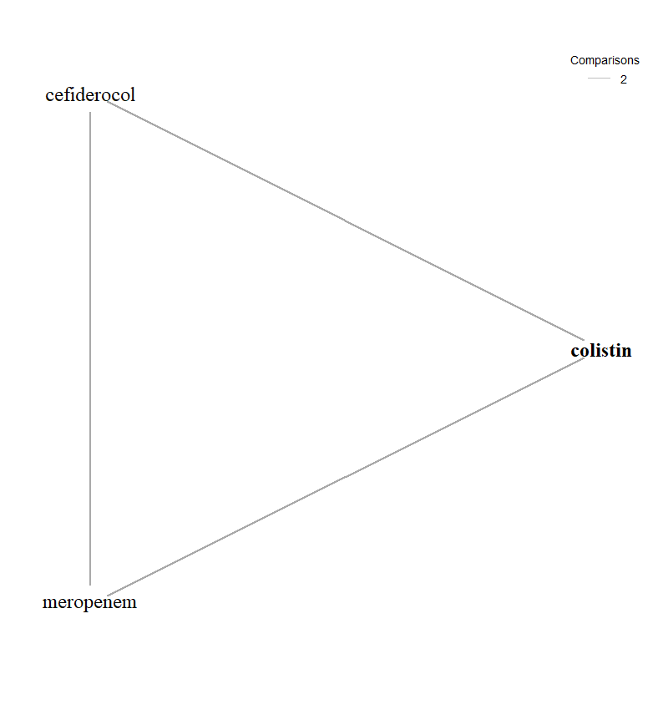

Figure A7.2: Forest plot of OR vs colistin for MBL Enterobacterales with EUCAST breakpoint (SIDERO studies only)
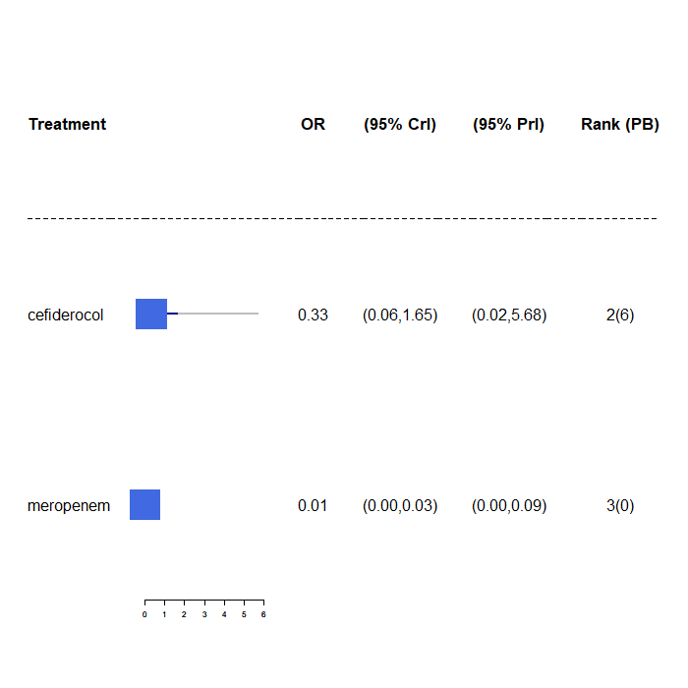
OR, odds ratio; CrI, credible interval, PrI, prediction interval; PB, probability being the best treatment.

A7.3.1.2 MBL Pseudomonas aeruginosa using EUCAST breakpoints and only studies that report cefiderocol data (SIDERO)
Two studies contributed to the NMA of Pseudomonas aeruginosa MBL infections with EUCAST breakpoint for SIDERO studies only, considering a total of 2 comparators, and the full network diagram is shown in Figure A7.3. One study (SIDERO WT data request) contained zero susceptibility counts and therefore had a continuity correction applied prior to synthesis.
The relative susceptibility for each comparator relative to colistin are shown in Figure A7.4. The model fitted the data well, with a total residual deviance of 4.38, which was close to the number of data points included in the analysis of 6. The between-study SD was 0.96 (95% CrI: 0.04 to 2.82), which indicates high heterogeneity. Cefiderocol was associated with a lower susceptibility relative to colistin (OR 0.49, 95% CrI: 0.03 to 5.29), but the result was not statistically significant. Cefiderocol also a 24% probability of being the most effective treatment; median rank 2. Meropenem was associated with no susceptibility. For all comparators the high between-study SD results in wide 95% PrI.
The network for the sensitivity analysis restricting to comparators specific to the pathogen was identical to the original network, since there were no data for comparators not in-scope for the pathogen.

Figure A7.3: Network diagram of all studies contributing to the NMA (Pseudomonas aeruginosa MBL with EUCAST breakpoint for SIDERO studies only)

Figure A7.4: Forest plot of OR vs colistin for Pseudomonas aeruginosa MBL with EUCAST breakpoint (SIDERO studies only)
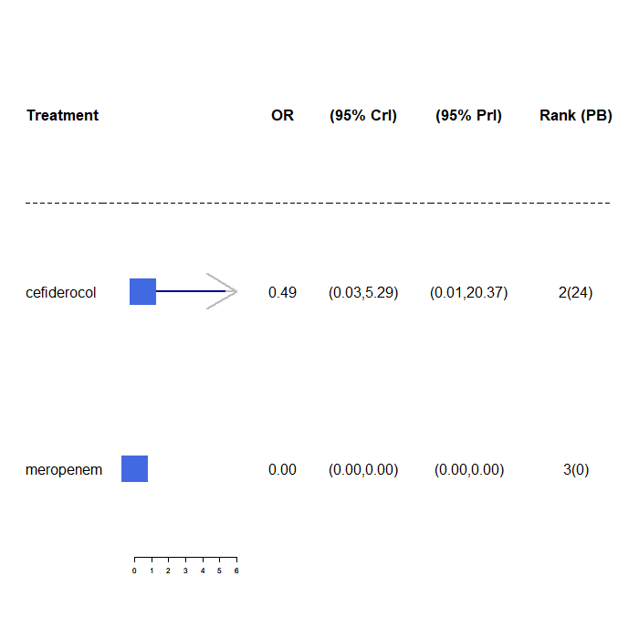
OR, odds ratio; CrI, credible interval, PrI, prediction interval; PB, probability being the best treatment.

A7.3.2 EUCAST breakpoint with fosfomycin studies only
Four studies contributed to the NMA of MBL Enterobacterales infections with EUCAST breakpoint for fosfomycin studies only, considering a total of 7 comparators, and the full network diagram is shown in Figure A7.5. Two studies^{10,11} contained 100% susceptibility counts for one or more of the included comparators and therefore had a continuity correction applied prior to synthesis.
The relative susceptibility for each comparator relative to colistin are shown in Figure A7.6a. The model fitted the data well, with a total residual deviance of 21.37, which was close to the number of data points included in the analysis of 23. The between-study SD was 2.04 (95% CrI: 1.20 to 2.91), which indicates extremely high heterogeneity. Fosfomycin was associated with a lower susceptibility relative to colistin (OR 0.24, 95% CrI: 0.02 to 3.09), but the result was not statistically significant. Fosfomycin also had a 10% probability of being the most effective treatment; median rank 2. The remainder of the treatments were associated with lower susceptibility than colistin, and the results were not statistically significant. For all comparators the high between-study SD results in wide 95% PrI.
The sensitivity analysis restricting to comparators specific to the pathogen produced a very similar OR for fosfomycin (0.23, 95% CrI: 0.02 to 2.36). The plot is displayed in Figure A7.6b.
There was only one study¹² included in the NMA of Pseudomonas aeruginosa MBL infections with EUCAST breakpoint for fosfomycin studies only. No synthesis was performed.

Figure A7.5: Network diagram of all studies contributing to the NMA (MBL Enterobacterales with EUCAST breakpoint for fosfomycin studies only)
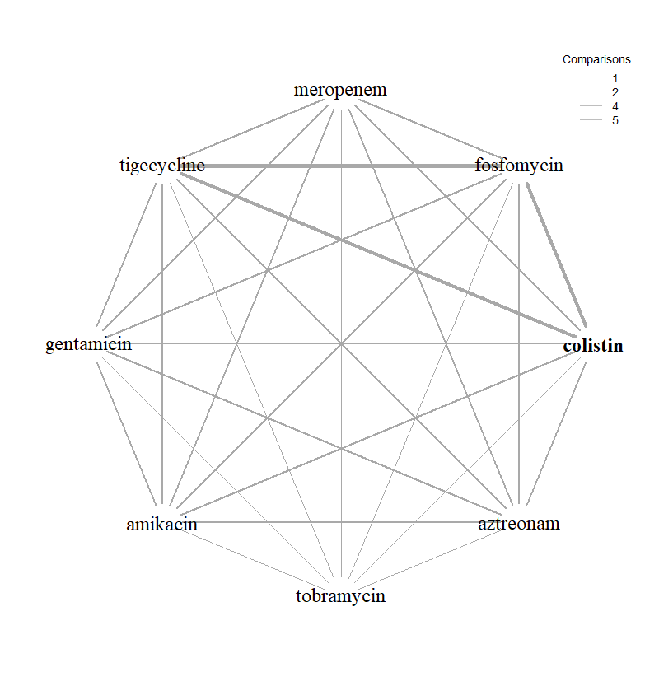

Figure A7.6: Forest plot of OR vs colistin for MBL Enterobacterales with EUCAST breakpoint (fosfomycin studies only)
- All comparators
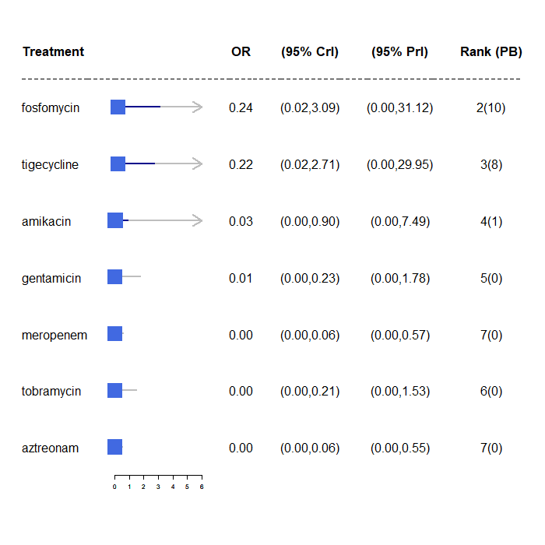
- Only comparators specific to the pathogen

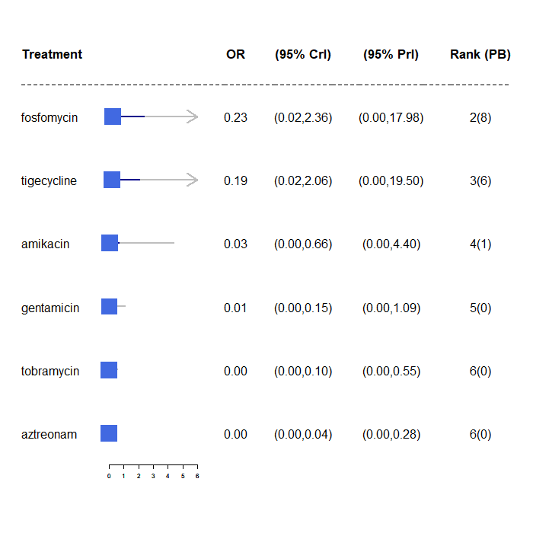

OR, odds ratio; CrI, credible interval, PrI, prediction interval; PB, probability being the best treatment.

A7.3.3 CLSI breakpoints sensitivity analysis
Section A7.3.3.1 details the Enterobacterales network, whilst A7.3.3.2 details the Pseudomonas aeruginosa network
A7.3.3.1 MBL Enterobacterales network including all studies using CLSI breakpoints
Six studies contributed to the NMA of MBL Enterobacterales infections with CLSI breakpoint for SIDERO and fosfomycin studies, considering a total of 8 comparators, and the full network diagram is shown in Figure A7.7. Four studies (SIDERO CR data request, Johnston 2020¹³, Aires 2017¹⁴ and Sonnevend 2020¹⁵) contained either zero susceptibility counts for one or more of the included comparators and therefore had a continuity correction applied prior to synthesis.
The relative susceptibility for each comparator relative to colistin are shown in Figure A7.8. The model fitted the data well, with a total residual deviance of 32.81, which was close to the number of data points included in the analysis of 33. The between-study SD was 2.38 (95% CrI: 1.70 to 2.96), which indicates extremely high heterogeneity. Cefiderocol was associated with a higher susceptibility relative to colistin (OR 5.11, 95% CrI: 0.38 to 71.34), but the result was not statistically significant. Cefiderocol was also associated with a 58% probability of being the most effective treatment; median rank 1. The remainder of the treatments, expect for fosfomycin and tigecycline, were associated with a lower susceptibility. But none of the results were statistically significant. For all comparators the high between-study SD results in wide 95% PrI.

Figure A7.7: Network diagram of all studies contributing to the NMA (MBL Enterobacterales with CLSI breakpoint for SIDERO and fosfomycin studies)
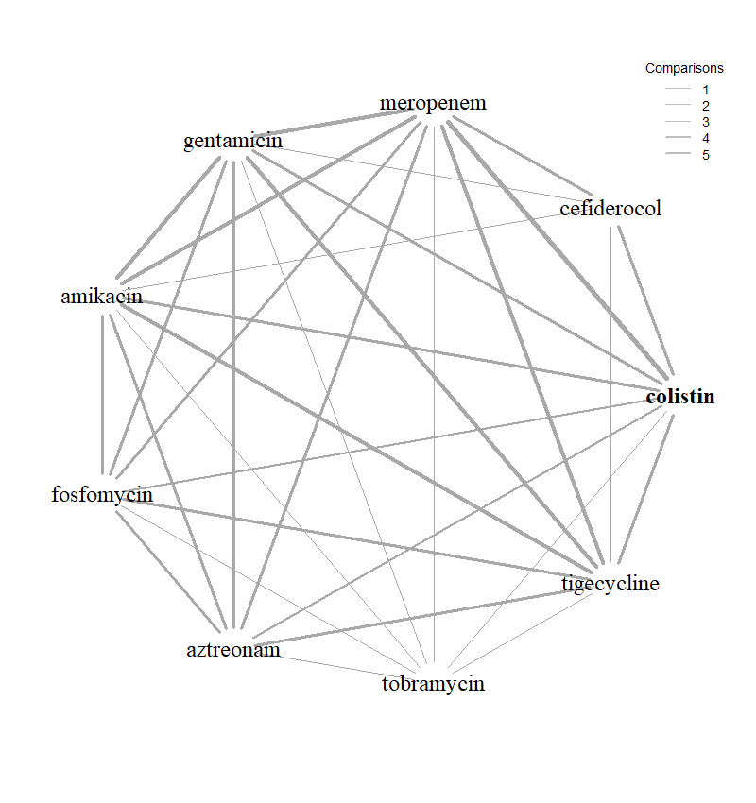

Figure A7.8: Forest plot of OR vs colistin for MBL Enterobacterales with CLSI breakpoint (SIDERO and fosfomycin studies)

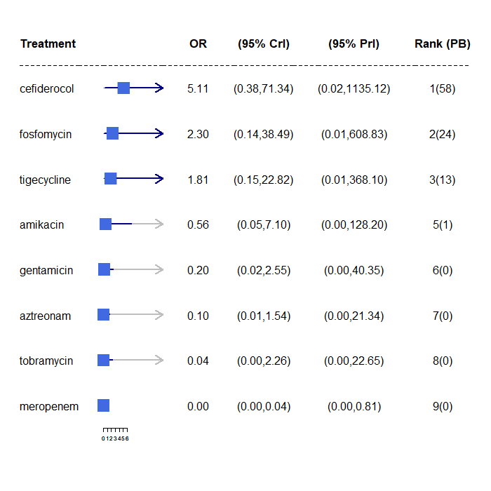
OR, odds ratio; CrI, credible interval, PrI, prediction interval; PB, probability being the best treatment.

Inconsistency checking was perform using the UME model. The model fits the data well and the DIC was similar to the base case NMA model (33 data points vs. 33.04 total residual deviance). The estimated between-study SD is slightly smaller from the UME model compared to the base case NMA model, but it still indicates extremely high heterogeneity (SD: 1.93 with 95% CrI 1.14 to 2.89). The deviance plot (Appendix 7.2) indicates the colistin arm from Johnston 2020 has an improvement in the fit when using the UME model. Additional NMA was conducted excluding the colistin arm from Johnston 2020.
Six studies contributed to the NMA of MBL Enterobacterales infections with CLSI breakpoint for SIDERO and fosfomycin studies without Johnston 2020 colistin arm, considering a total of 8 comparators, and the full network diagram is shown in Figure A7.9. Three studies (SIDERO CR data request, Aires 2017 ¹⁴ and Sonnevend 2020 ¹⁵) contained either zero susceptibility counts for one or more of the included comparators and therefore had a continuity correction applied prior to synthesis.
The relative susceptibility for each comparator relative to colistin are shown in Figure A7.10. The model fitted the data well, with a total residual deviance of 31.46 being close to the number of data points included in the analysis, which was 32. The between-study SD was 1.75 (95% CrI: 1.14 to 2.67), which indicates extremely high heterogeneity. Cefiderocol was associated with a higher susceptibility relative to colistin (OR 1.38, 95% CrI: 0.16 to 12.05), but the result was not statistically significant. Cefiderocol was also associated with a 50% probability of being the most effective treatment; median rank 1. The remainder of the treatments were associated with a lower susceptibility. But none of the results were statistically significant. For all comparators the high between-study SD results in wide 95% PrI.
When the missing study, Kohira 2016¹⁶ was included in the analysis, the OR for cefiderocol was 0.86 (0.11 to 7.05) (see Figure A7.10b).
When the network was restricted to comparators specific to the pathogen, the OR for cefiderocol was very similar to the original analysis (OR 1.30, CrI: 0.16 to 10.40), but fosfomycin’s OR indicated susceptibility higher relative to colistin, rather than lower ) (see Figure A7.10c).

Figure A7.9: Network diagram of all studies contributing to the NMA (MBL Enterobacterales with CLSI breakpoint for SIDERO and fosfomycin studies without Johnston 2020 colistin arm)
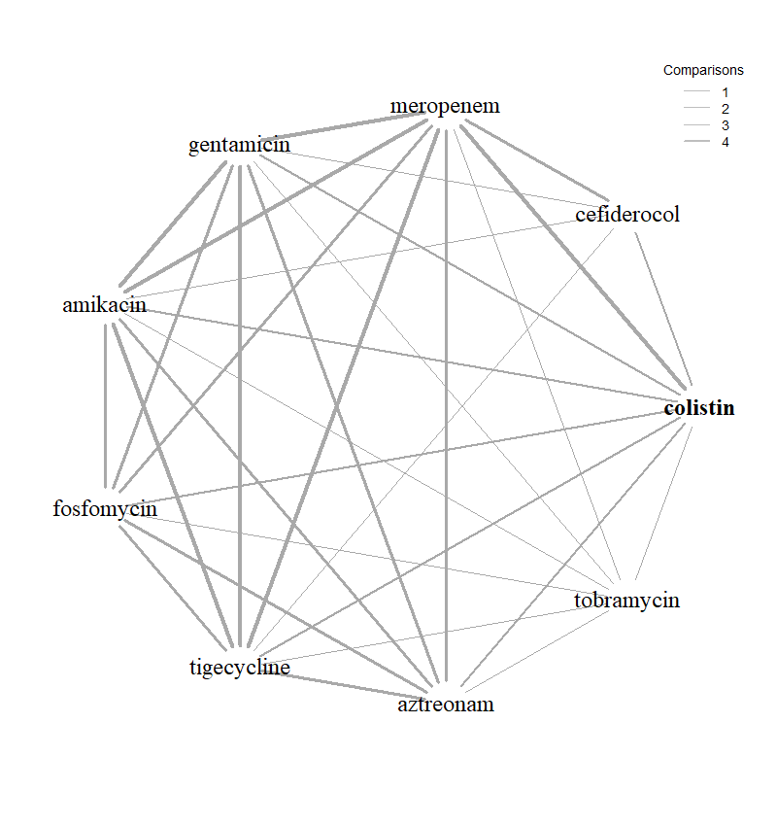
Figure A7.10: Forest plot of OR vs colistin for MBL Enterobacterales with CLSI breakpoint (SIDERO and fosfomycin studies without Johnston 2020 colistin arm)
- All comparators, without Kohira 2016¹⁷
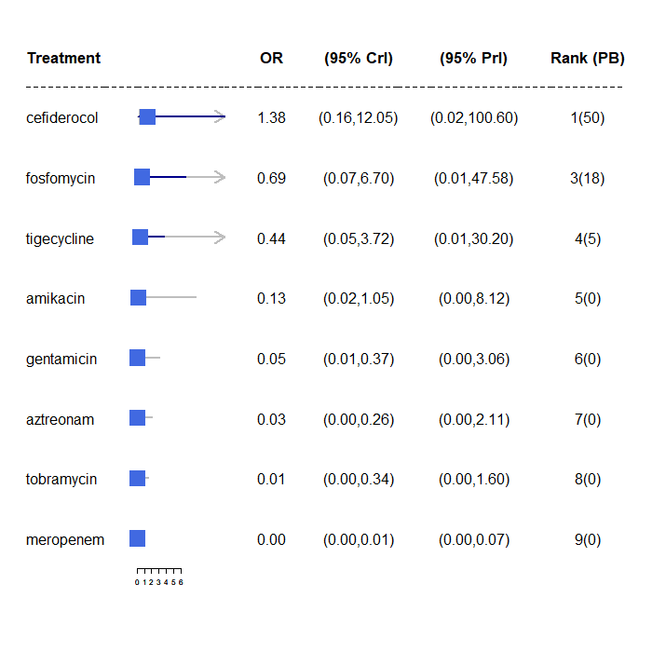
- All comparators with Kohira 2016¹⁷ included
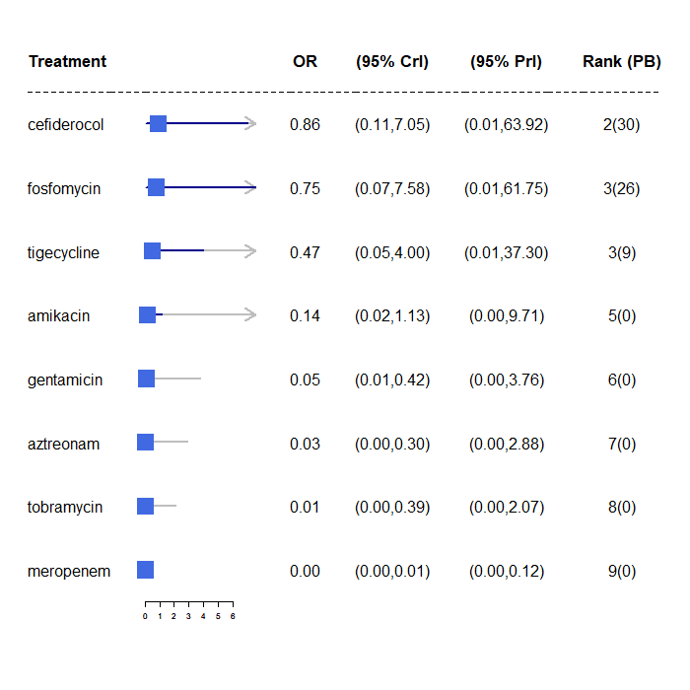
- Only comparators specific to the pathogen
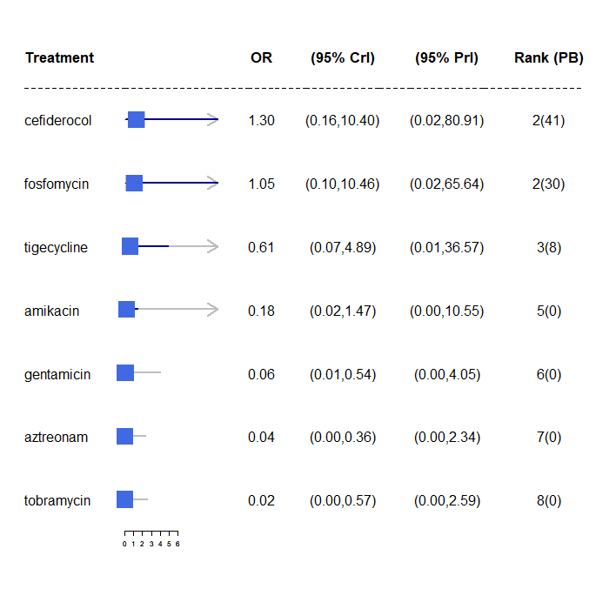
OR, odds ratio; CrI, credible interval, PrI, prediction interval; PB, probability being the best treatment.

A7.3.3.2 MBL Pseudomonas aeruginosa network including all studies using CLSI breakpoints
(no data for PHE)
Three studies contributed to the NMA of Pseudomonas aeruginosa MBL infections with CLSI breakpoint for SIDERO and fosfomycin studies, considering a total of 5 comparators, and the full network diagram is shown in Figure A7.11. All three studies (SIDERO WT data request, SIDERO CR data request, Jahan 2021¹⁸) contained either zero or 100% susceptibility counts for one or more of the included comparators and therefore had a continuity correction applied prior to synthesis.
The relative susceptibility for each comparator relative to colistin are shown in Figure A7.12. The model fitted the data well, with a total residual deviance of 9.23, which was close to the number of data points included in the analysis of 11. The between-study SD was 0.98 (95% CrI: 0.04 to 2.82) which, indicates high heterogeneity. Cefiderocol was associated with a statistically significant higher susceptibility relative to colistin (OR 71.34, 95% CrI: 4.33 to 5934.35). Cefiderocol was also associated with a 99% probability of being the most effective treatment; median rank 1. The remainder of the treatments were associated with a lower susceptibility. But none of the results were statistically significant. For all treatments the high between-study SD results in wide 95% PrI. The result for cefiderocol was still statistically significant using PrI.
When the network was restricted to comparators specific to the pathogen, the OR for cefiderocol was similar to the original analysis (OR 64.19, CrI: 4.28 to 3047.07), as were the ORs for the comparators.

Figure A7.11: Network diagram of all studies contributing to the NMA (Pseudomonas aeruginosa MBL with CLSI breakpoint for SIDERO and fosfomycin studies)
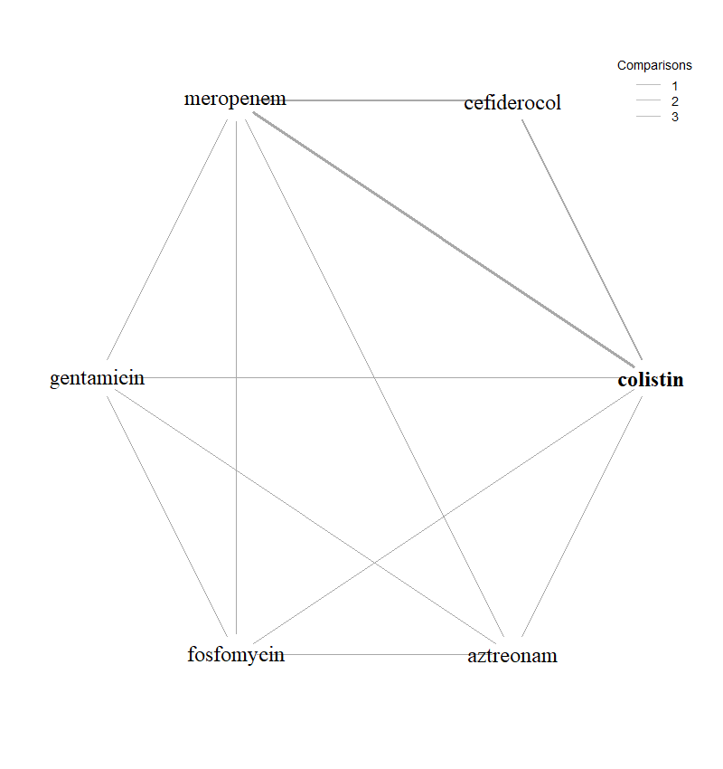

Figure A7.12: Forest plot of OR vs colistin for Pseudomonas aeruginosa MBL with CLSI breakpoint (SIDERO and fosfomycin studies (CLSI data not reported for PHE)
- All comparators
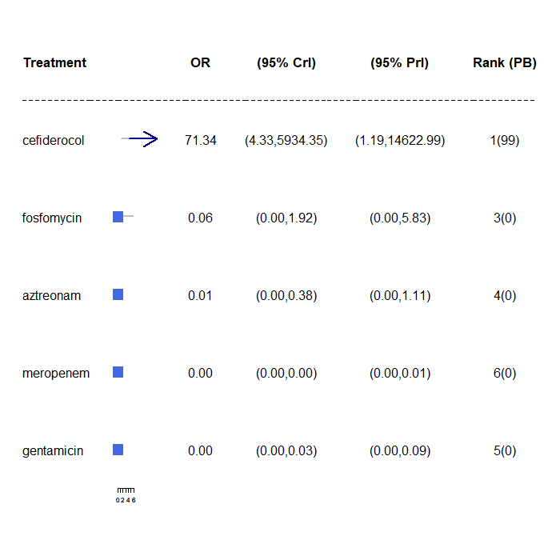
- Only comparators specific to the pathogen
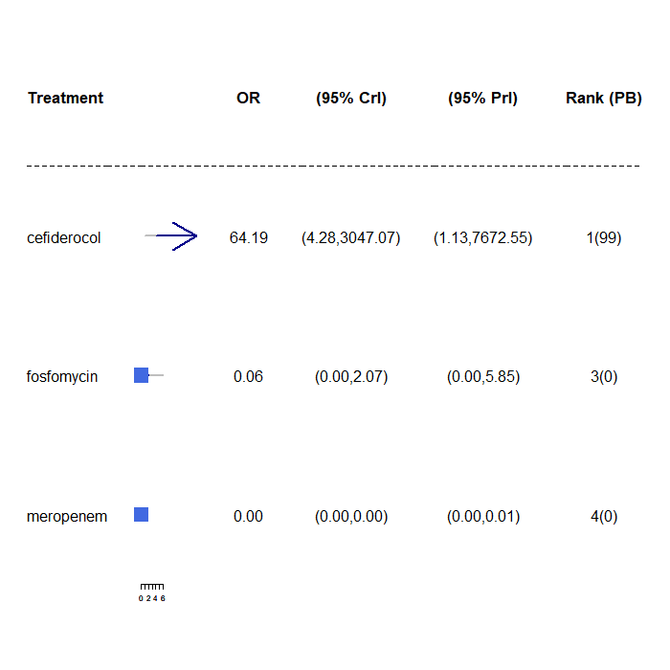
OR, odds ratio; CrI, credible interval, PrI, prediction interval; PB, probability being the best treatment.

A7.3.4 CLSI breakpoint with SIDERO studies only
A7.3.4.1 MBL Enterobacterales, CLSI breakpoints only studies that report cefiderocol data
Three studies contributed to the NMA of MBL Enterobacterales infections with CLSI breakpoint using only studies that report cefiderocol data, considering a total of 5 comparators, and the full network diagram is shown in Figure A7.13. Two studies (SDIERO CR data request, Johnston 2020) ¹³ contained zero susceptibility counts for one or more of the included comparators and therefore had a continuity correction applied prior to synthesis.
The relative susceptibility for each comparator relative to colistin are shown in Figure A7.14. The model fitted the data well, with a total residual deviance of 11.92, which was close to the number of data points included in the analysis of 12. The between-study SD was 2.56 (95% CrI: 1.59 to 2.98), which indicates extremely high heterogeneity. Cefiderocol was associated with a higher susceptibility relative to colistin (OR 15.70, 95% CrI: 0.83 to 320.72), but the result was not statistically significant. Cefiderocol also a 8% probability of being the most effective treatment; median rank 2. The remainder of the treatments, except for meropenem, were also associated with a higher susceptibility. Only the result for tigecycline was statistically significant. For all comparators the high between-study SD results in wide 95% PrI. The plot is provided in Figure A7.14a.
The sensitivity analysis restricting to comparators specific to the pathogen produced a very similar OR for cefiderocol (16.76 (95%CrI 1.19 to 285.30). The plot is provided in Figure A7.14b.
Figure A7.13: Network diagram of all studies contributing to the NMA (MBL Enterobacterales with CLSI breakpoint for SIDERO studies only)
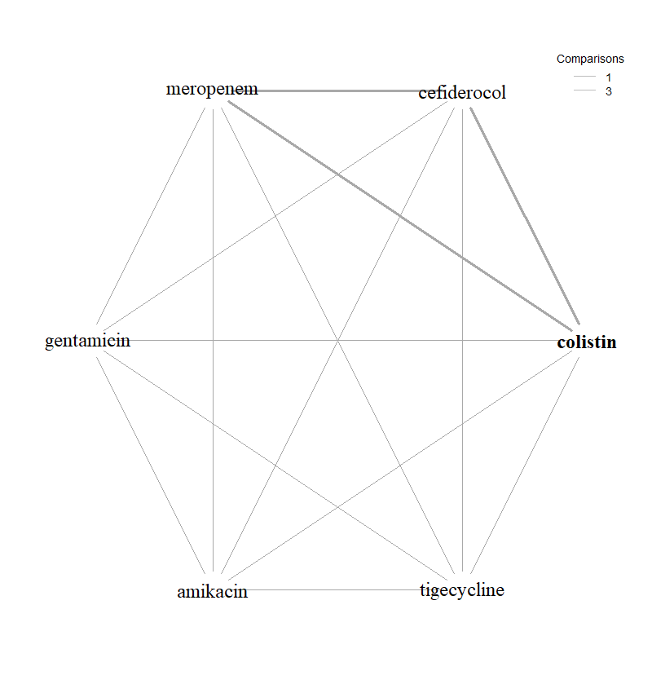

Figure A7.14: Forest plot of OR vs colistin for MBL Enterobacterales with CLSI breakpoint (SIDERO studies only)
- All comparators included in the network
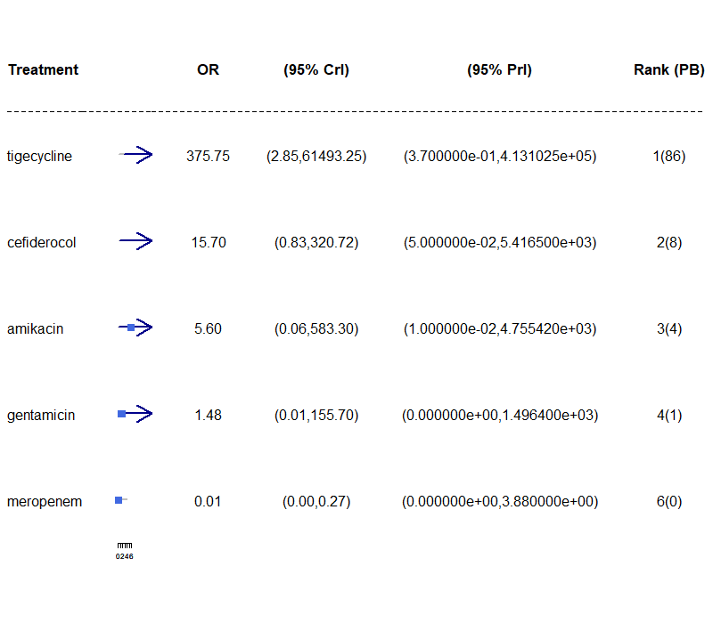
- Only comparators specific to the pathogen included in the network

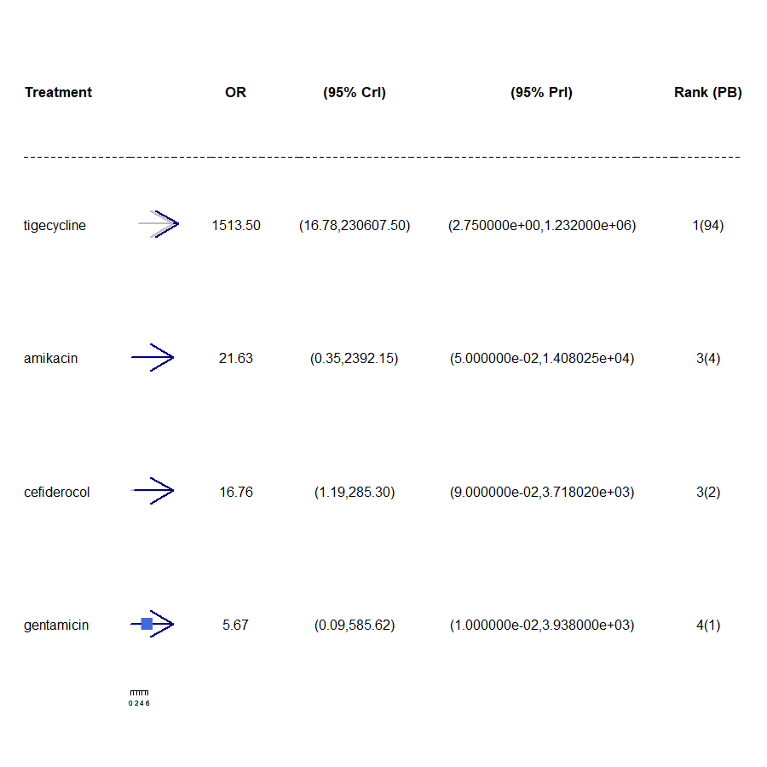
OR, odds ratio; CrI, credible interval, PrI, prediction interval; PB, probability being the best treatment.

A7.3.4.2 MBL Pseudomonas aeruginosa aeruginosa, CLSI breakpoints (SIDERO studies only)
Two studies contributed to the NMA of Pseudomonas aeruginosa MBL infections with CLSI breakpoint for SIDERO studies only, considering a total of 2 comparators, and the full network diagram is shown in Figure A7.15. All two studies (SIDERO WT data request and SIDERO CR data request) contained zero susceptibility counts for one or more of the included comparators and therefore had a continuity correction applied prior to synthesis.
The relative susceptibility for each comparator relative to colistin are shown in Figure A7.16. The model fitted the data well, with a total residual deviance of 4.75, which was close to the number of data points included in the analysis of 6. The between-study SD was 1.15 (95% CrI: 0.06 to 2.87) which, indicates extremely high heterogeneity. Cefiderocol was associated with a statistically significant higher susceptibility relative to colistin (OR 66.73, 95% CrI: 3.61 to 3284.37). Cefiderocol also a 100% probability of being the most effective treatment; median rank 1. Meropenem was associated with no susceptibility. For all comparators the high between-study SD results in wide 95% PrI.
The network for the sensitivity analysis restricting to comparators specific to the pathogen was identical to the original network, since there were no data for comparators not in-scope for the pathogen.

Figure A7.15: Network diagram of all studies contributing to the NMA (Pseudomonas aeruginosa MBL with CLSI breakpoint for SIDERO studies only)
Figure A7.16: Forest plot of OR vs colistin for Pseudomonas aeruginosa MBL with CLSI breakpoint (SIDERO studies only)
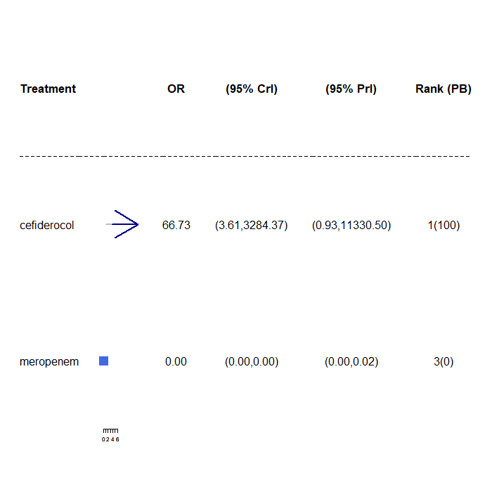
OR, odds ratio; CrI, credible interval, PrI, prediction interval; PB, probability being the best treatment.

CLSI breakpoint with fosfomycin studies only
Three studies contributed to the NMA of MBL Enterobacterales infections with CLSI breakpoint for fosfomycin studies only, considering a total of 7 comparators, and the full network diagram is shown in Figure A7.17. Two studies (Kasse 2015¹⁰ and Ojdana 2019¹⁹) contained 100% susceptibility counts for one or more of the included comparators and therefore had a continuity correction applied prior to synthesis.
The relative susceptibility for each comparator relative to colistin are shown in Figure A7.18. The model fitted the data well, with a total residual deviance of 21.72, which was close to the number of data points included in the analysis of23. The between-study SD was 1.34 (95% CrI: 0.67 to 2.50), which indicates extremely high heterogeneity. Fosfomycin was associated with a lower susceptibility relative to colistin (OR 0.52, 95% CrI: 0.06 to4.01), but the result was not statistically significant. Fosfomycin was also associated with a 23% probability of being the most effective treatment; median rank 2. The remainder of the treatments were also associated with lower susceptibility than colistin, and the results were not statistically significant. For all comparators the high between-study SD results in wide 95% PrI.

Figure A7.17: Network diagram of all studies contributing to the NMA (MBL Enterobacterales with CLSI breakpoint for fosfomycin studies only)
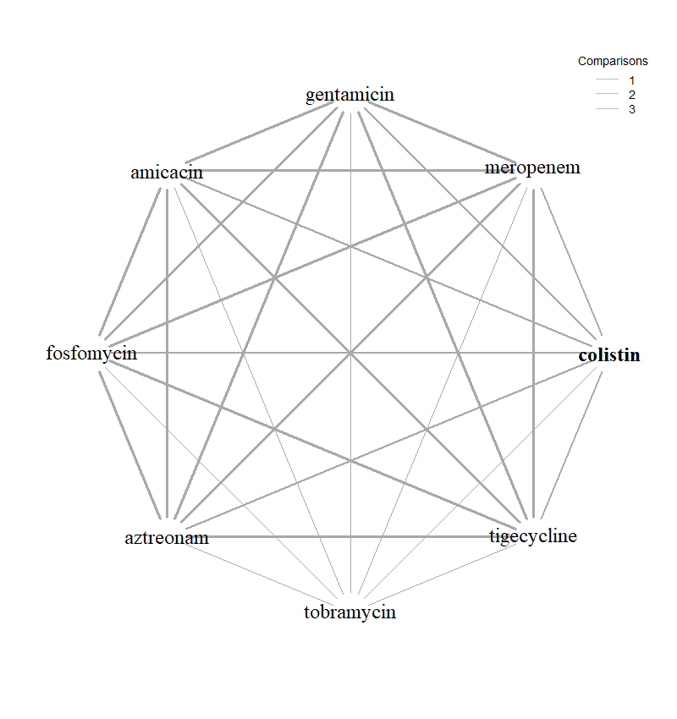

Figure A7.18: Forest plot of OR vs colistin for MBL Enterobacterales with CLSI breakpoint (fosfomycin studies only)
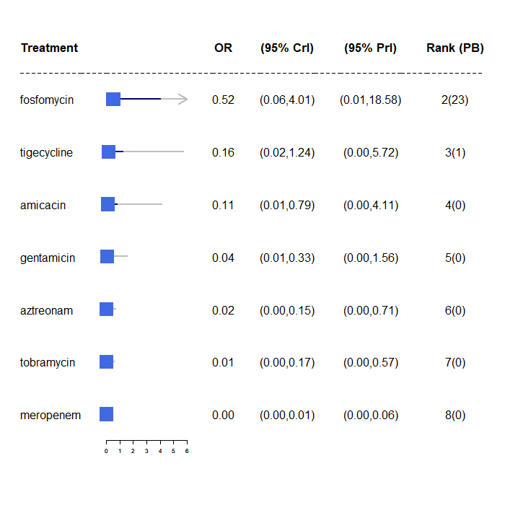
OR, odds ratio; CrI, credible interval, PrI, prediction interval; PB, probability being the best treatment.

There was only one study ¹⁸ included in the NMA of Pseudomonas aeruginosa MBL infections with CLSI breakpoint for fosfomycin studies only. No synthesis was performed.

A7.3.5 CLSI breakpoint with fosfomycin studies only
Three studies contributed to the NMA of Enterobacterales MBL infections with CLSI breakpoint for fosfo studies only, considering a total of 7 comparators, and the full network diagram is shown in Figure A7.19. Two studies^{10,11} contained 100% susceptibility counts for one or more of the included comparators and therefore had a numerical adjustment applied prior to synthesis.
The relative susceptibility for each comparator relative to colistin are shown in Figure A7.20 The model fitted the data well, with a total residual deviance of 21.72 being close to the number of data points included in the analysis, which was 23. The between study SD was 1.34 (95% CrI: 0.67, 2.50), which indicates extremely high heterogeneity. Fosfomycin was associated with a lower susceptibility relative to colistin (OR 0.52 95% CrI: 0.06, 4.01), but the result was not statistically significant. Fosfomycin was also associated with a 23% probability of being the most effective treatment; median rank 2. The remainder of the treatments were also associated with lower susceptibility than colistin, and the results were not statistically significant. For all comparators the high between study SD results in wide 95% PrI.
The sensitivity analysis restricting to comparators specific to the pathogen produced a very similar OR for fosfomycin (0.59, 95% CrI: 0.12 to 2.64). The plot is displayed in Figure A7.20.
There was only one study¹⁸ included in the NMA of Pseudomonas aeruginosa MBL infections with CLSI breakpoint for fosfo studies only. No synthesis was performed.

Figure A7.19 Network diagram of all studies contributing to the NMA (MBL Enterobacterales with CLSI breakpoint for fosfo studies only)

Figure A7.20: Forest plot of OR vs colistin for MBL Enterobacterales with CLSI breakpoint (fosfomycin studies only)
- All comparators
- Only comparators specific to the pathogen
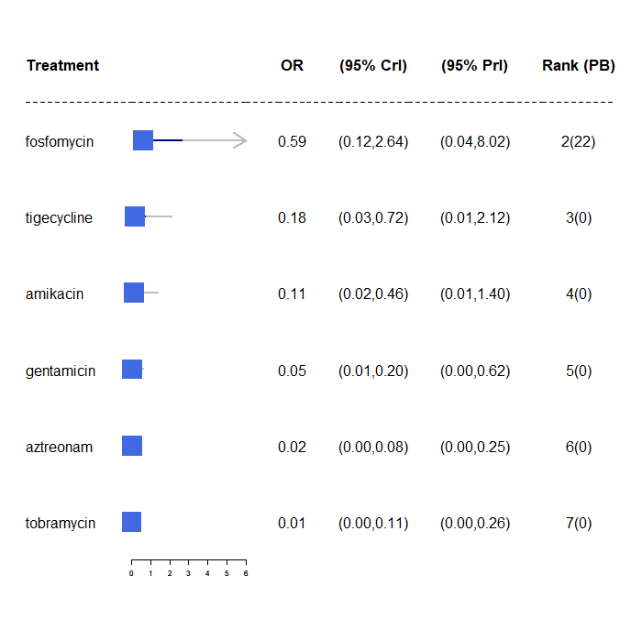

A7.4 Inconsistency checks
Appendix 16.3 Deviance plot for accessing inconsistency
Figure A7.21: Deviance plot for the NMA with MBL Enterobacterales (EUCAST breakpoint for SIDERO and fosfomycin and PHE studies)
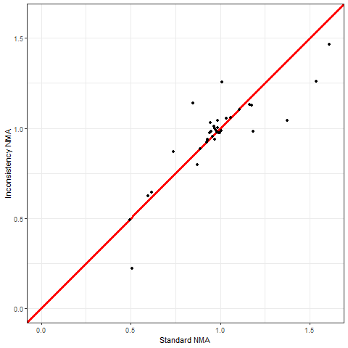

Figure A7.22: Deviance plot for the NMA with MBL Enterobacterales (CLSI breakpoint for SIDERO and fosfomycin studies only)
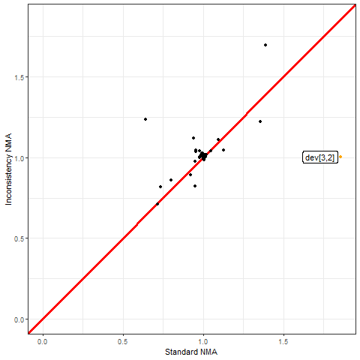

Appendix 8: Additional content for review 4

A8.1 Quality assessment of Bassetti et al. 2020.
Quality assessment of the Bassetti et al. (2020)²⁰ systematic review was undertaken using the AMSTAR-2 (A MeaSurement Tool to Assess systematic Reviews) critical appraisal tool for systematic reviews that include randomised or nonrandomised studies.²¹ The tool comprises 16 questions that can elicit a yes, partial yes, no, or not undertaken response. The results from the AMSTAR-2 assessment, including the rationale for question responses, are presented in Table A8.1.
There were some issues with the quality of the review including a lack of detail about the included studies; poor reporting of the meta-analysis methodology; no assessment of the impact of risk of bias of the studies on the review findings; a lack of exploration of sources of heterogeneity and some limitations to the search strategy. Since the review did not report a meta-analysis of studies in the sites of interest in UK or European studies, and was therefore of primary use as a source of potentially relevant studies, most of the issues identified with quality were not of concern.
Some issues were identified with the robustness of the search strategy (see Table A8.1) in that it did not search reference lists of included studies, trail registers or grey literature, and did not contact experts. The period 2007 to present day was searched using an improved search strategy to capture any studies that may have been missed, but no additional search strategies were employed in our updated search due to time constraints.

Table A8.1: AMSTAR-2 quality assessment of the Bassetti et al. (2020) systematic review
AMSTAR-2 question | Response | Rationale
1. Did the research questions and inclusion criteria for the review include the components of PICO? | Yes | Studies were eligible for inclusion that reported the impact of delayed appropriate antibiotic therapy for hospitalised adult patients with severe bacterial infections, including but not limited to urinary tract infections (UTIs), nosocomial pneumonia, bacteraemia, intra-abdominal infections, central nervous system infections, skin and soft-tissue infections and endocarditis. Studies were required to report the appropriateness of antibiotic therapy, an identifiable delay to initiation of appropriate therapy, and at least one of the following outcomes: mortality, treatment success, infection progression, clinical cure, microbiological eradication, duration of antibiotic treatment, hospital or intensive care unit (ICU) LoS or healthcare costs
2. Did the report of the review contain an explicit statement that the review methods were established prior to the conduct of the review and did the report justify any significant deviations from the protocol? | Yes | The protocol detailing the review question, search strategy, inclusion and exclusion criteria, risk of bias assessment methods, and meta-analysis plane, was published on the PROSPERO database (CRD42018104669). Due to heterogeneity between studies, random-effects models were used for meta- analyses. There were no deviations from the published protocol evident in the peer-reviewed publication.
3. Did the review authors explain their selection of the study designs for inclusion in the review? | No | Randomised controlled trials, non-randomised comparative studies and observational studies were eligible, but no rationale for inclusion of these study designs was reported.
4. Did the review authors use a comprehensive literature search strategy? | No | Although both MEDLINE and EMBASE were searched along with searching the reference lists of relevant systematic reviews and a citation search, there were no additional searches of the reference lists of included studies, trials registers or grey literature. There was also no consultation with topic experts to identify additional studies.
5. Did the review authors perform study selection in duplicate? | Yes | Two reviewers independently screened the titles and abstracts for inclusion and assessed potentially relevant full-texts against the eligibility cri- teria.
6. Did the review authors perform data extraction in duplicate? | Yes | One reviewer extracted data from eligible studies using a piloted data extraction form, and a second reviewer verified every data point.
7. Did the review authors provide a list of excluded studies and justify the exclusions? | No | The review flow diagram reports that 366 articles were excluded at the full-text stage along with the number for each reason for exclusion. However, there is no table of these studies, providing the author and a citation for each of the 366 articles.
8. Did the review authors describe the included studies in adequate detail? | No | Whilst there was a narrative summary and tabulation of the interventions, outcomes, settings, and study designs, there was limited detail on the populations in the included studies.
9. Did the review authors use a satisfactory technique for assessing the risk of bias (RoB) in individual studies that were included in the review? | Yes | Risk of bias was assessed using a relevant tool (Newcastle–Ottawa scale, CRD Cohort study checklist or Cochrane risk-of-bias tool)
10. Did the review authors report on the sources of funding for the studies included in the review? | No | The sources of funding of the included studies were not reported.
11. If meta-analysis was performed did the review authors use appropriate methods for statistical combination of results? | No | Although it was reported that odds ratios were combined in a meta-analysis applying random effects, the weighting method was not reported, and subgroup or sensitivity analyses to investigate potential sources of heterogeneity were not undertaken. There was also no justification for pooling data in a meta-analysis.
12. If meta-analysis was performed, did the review authors assess the potential impact of RoB in individual studies on the results of the meta-analysis or other evidence synthesis? | No | The authors did not performed any analyses to investigate possible impact of risk of bias on summary estimates of effect.
13. Did the review authors account for RoB in individual studies when interpreting/ discussing the results of the review? | No | There was no interpretation or discussion of RoB
14. Did the review authors provide a satisfactory explanation for, and discussion of, any heterogeneity observed in the results of the review? | No | Heterogeneity was noted in some analyses, but there was no exploration or discussion of the sources of heterogeneity.
15. If they performed quantitative synthesis did the review authors carry out an adequate investigation of publication bias (small study bias) and discuss its likely impact on the results of the review? | Yes | A funnel plot was generated to assess publication bias among studies reporting data for the impact of appropriate versus inappropriate therapy on mortality which was deemed to be symmetrical. The authors commented that interpretation of publication bias in this way should be performed with caution, which is an acceptable summary.
16. Did the review authors report any potential sources of conflict of interest, including any funding they received for conducting the review? | Yes | The study was reported as being funded by Shionogi BV. Competing interests were reported.
LoS, length of stay

A8.2 Other searches conducted
The pragmatic searches were conducted using six distinct strategies:
- Interrogation of the Mechanisms of Resistance database (3172 references). The search terms for the database comprised of terms for Mechanisms [OXA-48, NDM, VIM, IMP] AND Germ [enterobacteria, E. coli, K. pneumonia, Pseudomonas aeruginosa] AND Study design [Reviews, RCTs, observational studies] (see A1.3.2). Dredging of the database was conducted in two steps. First, the library was screened by searching for outcomes and infection sites of interest in the abstracts, using search terms (death or mortality or hospital) AND (cUTI or HAP or VAP). Then, the searches were repeated by searching for outcome only, following a low number of hits in the first step. The outcomes in the second step were adjusted to (death or mortality or fatal outcome or clinical outcome) to increase the specificity of the searches, as the term ‘hospital’ in the first step picked up many irrelevant studies. The hits were then screened in two stages – by abstract and by full text.
- Interrogation of the Cost-effectiveness Models database (66 references) created by EEPRU (see Appendix 1.3.1). The database was screened by abstract and by full text to identify studies previously used to model long-term outcomes of interest. Further two rounds of backward citation searches were performed on all included studies.
- Interrogation of the Endnote library provided by Shinogi (1261 references). The library was screened by searching for the following terms in the abstracts: (death or mortality or fatal outcome) AND (HAP or VAP or UTI or acute pyelonephritis). The hits were then screened in two stages – by abstract and by full text.
- Screening the list of key references provided by Shinogi for NICE (45 references). The references were screened in three steps: by title, abstract, and full text.
- Interrogation of the Pfizer Endnote library (81 references) and Pfizer Excel file of key papers (240 references) combined into a single Endnote library (299 references). The library was screened by searching for the following terms in the abstracts: (death or mortality or fatal outcome) AND (HAP or VAP or UTI or acute pyelonephritis). The hits were then screened in two stages – by abstract and by full text. Of the 299 references, 193 did not have an abstract; these were screened by title and full text.
- Screening the studies included in two systematic review articles provided by Shinogi (Zasowski et al., 2020; Bassetti et al., 2020). The reviews reported the effect of inappropriate antibiotic treatment (Zasowski 2020) and delayed antibiotic treatment (Bassetti 2020) on outcomes. The papers included in the review were screened by site, where only those that reported outcomes in HAP/VAP and cUTI were included.
The search strategies were divided between two reviewers (LS strategies 1 and 2, DJ strategies 3 - 6). Inclusion of any ‘grey area’ studies was determined through discussion with the wider team (BW, CR, BK).

Appendix 9: Structured expert elicitation

A9.1 Description of elicited parameters
We required outcomes for patients with Hospital Acquired Pneumonia (HAP), Ventilator Associated Pneumonia (VAP), and complicated urinary tract infections (cUTIs) caused by carbapenem-resistant gram negative bacteria. We were only interested in outcomes following microbiology-directed treatment for patients with an infection caused by Enterobacterales with an OXA-48 or MBL resistance mechanism, or Pseudomonas with a MBL resistance mechanism.

Outcomes were elicited depending on whether the infectious pathogen is susceptible to treatment. Therefore outcomes only depend on whether a patient is susceptible to treatment or not, and not to the specific treatment given. The outcomes we were interested in were 30-day mortality, length of stay in hospital, and the type of ward these patients would stay on in hospital.

As background information we provided experts with several related studies (see appendix 10). In these studies, infecting pathogens were not confirmed to be susceptible to the antibiotics administered (cefiderocol or CAZ-AVI); however, in our assessment, they are likely to have been susceptible.

For HAP, VAP and cUTI, both for susceptible and not-susceptable patients, the following questions were asked of experts:

Question 1. In this patient population, what proportion of patients will still be alive 30 days after starting microbiology directed treatment?

Question 2. In the patient population described at the top of the page, what will be the average length of stay?

Question 3. In the patient population described at the top of the page, what proportion of hospital stay would be spent on each of the following wards? This number should represent the average for all such patients, regardless of their outcome.

A9.2 Protocol for elicitation
The following sections describe the details of the elicitation exercise, according to the elements as described in the MRC elicitation guidance.

Selecting the quantities (preparation and design stage)
The choice of quantity considered the following three objectives:⁵² fitness for purpose; directly observable and homogeneity in the quantities elicited. Eliciting the same summaries throughout will reduce the burden of training.²⁰¹

For question 1 the quantities elicited relate to the proportion of patients with an event at a certain time. Question 2 relates to a continuous outcome, length of stay (LOS), which, in principle, can take values up to ∞. Question 3 relates to the proportionate split of LOS between the three types of ward – general ward, HDU and ICU. As the total proportion must sum to 100, these quantities were not elicited with uncertainty, and instead a mean proportion elicited.

Methods to encode judgements (preparation and design stage)
Either the Chips and Bins method or a Bisection method have been shown to work equally well in health care elicitation. The Chips and Bins approach however, is viewed as less complex and easier to complete by health care professionals, and so this method is used here.

Experts were first asked to express the range for their beliefs, the minimum, which is the value such that the experts believes that there is a 1% probability that the proportion is less than that value, and the maximum, a value, such that the experts believe that there is a 1% probability that the proportion is more than that value. Grids were then generated based on this range and experts were asked to place ‘chips’ on this grid to represent their beliefs.

Validation (preparation and design stage)
At the end of each task, experts were given a qualitative summary of their responses. If experts felt that these did not represent their views they were encouraged to revise their responses. Experts also had an opportunity to revise their responses following the feedback round (see below).

Selecting experts (preparation and design stage)
The models developed for this project span across HAP, VAP and cUTI and also relate to likely outcomes depending on susceptibility to treatment. Therefore there are multiple types of experts relevant for this task. Here we have included hospital consultants, microbiologists and pharmacists as experts. As part of the task, experts were asked to identify which of these disciplines they worked in. Experts were not expected to have any normative skills. Experts were recruited using recommendation from peers.

Pilot exercise (preparation and design stage)
The wording of the questions was piloted for clarity and adequacy. The draft exercise was sent to a lead clinician and feedback sought. Following feedback the questions were modified, specifically the wording of the questions.

Training and preparation for experts (preparation and design stage)
A narrated power-point training session was delivered to experts prior to the task. The training session described the objectives of the elicitation exercise, clarified concepts such as uncertainty, familiarised the experts with the quantities elicited, described and explained the impact of bias and heuristics, and trained experts on the methods of elicitation used. A recorded version of the training slides was also sent to the experts following the session and also key details from this repeated in the task itself.

Experts were also reminded throughout the SEE that they were to elicit uncertainty on their estimate rather than thinking about variability across this heterogeneous group of patients

Level of elicitation (elicitation stage)
Each expert elicited their judgements individually without interaction with other experts. Eliciting judgements individually reduced the risk of estimates being biased by a subset of experts. In the SEE elicitation literature, there are concerns that experts may not feel confident in eliciting judgements individually, however, the experts in this SEE process elicited their beliefs on a condition that they encounter regularly in general practice. Concerns regarding individual level elicitation and lower confidence amongst experts generally arises when dealing with problems/technologies or conditions that are new or unknown to the experts.

Mode of administration (elicitation stage)
The elicitation exercise was administered via an application in SHINY. The task was delivered remotely, due to current restrictions on face to face meetings. Experts were offered the opportunity to complete the exercise remotely alongside one of the team. Email contacts were given to provide any support needed.

Feedback to experts and revision (elicitation stage)
Once experts expressed their beliefs and completed each question, they were presented with graphical feedback of what their estimates looked like. Experts were able to see how the grid looked once they have placed all of their chips on it. In addition, once experts had completed the grid, a summary of their answers was relayed to them. This provided the following information:
Your answers imply that (example quantities given)
- There is a 17% probability that the proportion of patients is between 19 and 20%
- There is a 50% probability that the proportion of patients is between 20 and 21%
- There is a 33% probability that the proportion of patients is between 21 and 22%

Following the individual elicitation beliefs were then aggregated using linear opinion pooling. This overall distribution was then relayed back to experts and they were given the opportunity to revise their own beliefs on the histograms they previously completed. This approach has been show to generated less biased parameters when the quantities elicited are unknown to the experts. Following this revision, expert’s beliefs were aggregated using the same approach, linear opinion pooling, and the final parameter values determined.

Opportunity for interaction (elicitation stage)
Given the individual level of elicitation that was chosen, there was no opportunity for interaction between the experts. The revision stage was done remotely so experts did not interact with each other.

Feedback from experts on process (elicitation stage)
Qualitative feedback on the elicitation process was collected from the experts, including rationales for their responses. This was collected during the task using free text boxes. This form of validation helps to highlight if experts understood the task and responded as best they could.

If/how to aggregate (aggregation, analysis and post-elicitation)
As an individual level of elicitation was chosen, mathematical aggregation was applied to generate the distributions, specifically linear opinion pooling using equal weighting of experts. First a probability distribution was fitted to each expert’s beliefs from the histogram and then these were pooled, assuming that each expert contributed equally to the group overall distribution.
This overall distribution was then relayed back to experts and they were given the opportunity to revise their own beliefs. Following this revision, expert’s beliefs were aggregated using the same approach, linear opinion pooling, and the final parameter values determined.

Fit to distribution (aggregation, analysis and post-elicitation)
A Beta distribution was fitted to expert’s distributions for question 1 as these relate to proportions. For question 2 a lognormal distribution was fitted. Question 3 only asked for point estimates so not fitting was required.

Data Protection and Anonymity (aggregation, analysis and post-elicitation)
Experts were asked to give their opinions individually (not in groups). The information provided, including personal details, is kept anonymous and confidential, stored securely and only accessed by those carrying out the study.

A9.3 Results
Eleven experts agreed to take part in the elicitation task and took part in the training. Of these eleven, 9 experts attempted the task. The experts included medical consultants (n=2), microbiologists (n=5), ICU consultants (n=1) and pulmonary consultants (n=1). Seven experts completed the task, while two terminated it before answering all questions. Responses from the two experts who terminated the task before answering all questions, were included in the analysis for all outcomes where they provided an estimate for both susceptible and not susceptible populations. Following the elicitation task, experts were sent group summaries and asked if they would like to revise their responses. Only two experts stated that they reviewed the group summaries, and one adjusted their initial responses in light of group summaries.
Two experts indicated that the probability of survival was lower in patients who were susceptible to treatment than those who were not susceptible, for two sites of infection. This was judged to be implausible, and so the two experts were removed from the sample in the base case.

Group summaries - base case
The group summaries on 30-day mortality (Figure A9.1) indicate that survival is the lowest for VAP patients and highest for cUTI patients, and that susceptibility to treatment increases the probability of survival, for all three sites of infection. The group summaries on LOS (Figure A9.2) indicate that the length of stay is the shortest in patients with cUTIs and the longest for patients with VAP. For all three sites of infection, susceptibility to treatment decreased the length of stay.
The group summaries about the proportion of time spent on different types of wards is shown in Table A9.1. The summaries indicate that patients with VAP spend the most time in ICU and the least time on general medical wards, followed by HAP, then cUTIs. Furthermore, patients who are susceptible to treatment are expected to spend more time on the general medical ward and less on ICU and HDU, for all three sites of infection.
Figure A9.1: 30-day survival
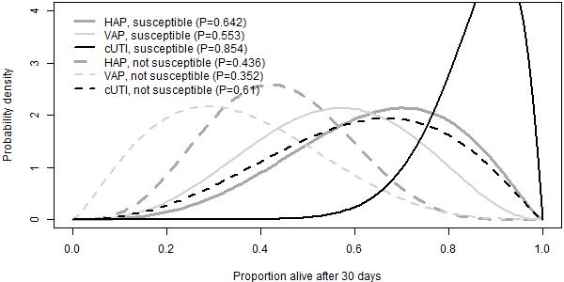
cUTI, complicated urinary tract infection; HAP, hospital-acquired pneumonia; VAP, ventilator-associated pneumonia; P, proportion

Figure A9.2: Expected LoS.
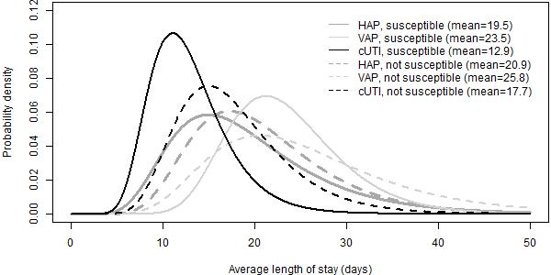
cUTI, complicated urinary tract infection; HAP, hospital-acquired pneumonia; VAP, ventilator-associated pneumonia

Table A9.1: Proportion (%) of hospital stay spent on ICU, HDU and general medical ward
 | ICU | HDU | General medical ward
HAP, susceptible | 24.3 | 19.0 | 56.7
VAP, susceptible | 60.0 | 13.3 | 26.7
cUTI, susceptible | 15.0 | 17.0 | 68.0
HAP, not susceptible | 39.3 | 20.7 | 40.0
VAP, not susceptible | 66.7 | 15.8 | 17.5
cUTI, not susceptible | 23.3 | 18.3 | 58.3
cUTI, complicated urinary tract infection; HAP, hospital-acquired pneumonia; HDU, high dependency unit; ICU, intensive care unit; VAP, ventilator-associated pneumonia

In the model, outcomes of HAP and VAP were modelled together, and so experts’ priors on outcomes were pooled. When pooling the priors, outcomes for HAP and VAP were weighted by their relative occurrence in Tumbarello et al. (2013) - 0.283 (28/99) for HAP and 0.617 (71/99) for VAP. Tumbarello was chosen as the study where participants were the most representative of patients in our HVCS, that reported the proportion of patients with hospital acquired pneumonia that was ventilator-associated.
The pooled priors are shown in Figure A9.3, Figure A9.4 and Table A9.2.
Figure A9.3: 30-day survival with HAP/VAP combined.
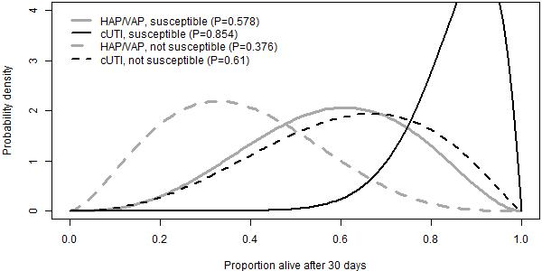
cUTI, complicated urinary tract infection; HAP/VAP, hospital-acquired pneumonia or ventilator-associated pneumonia; P, proportion

Figure A9.4: Expected LOS with HAP/VAP combined.
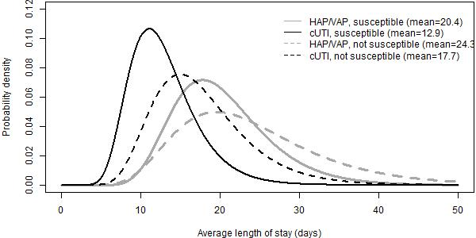
cUTI, complicated urinary tract infection; HAP/VAP, hospital-acquired pneumonia or ventilator-associated pneumonia

Table A9.2: Proportion (%) of hospital stay spent on ICU, HDU and general medical ward
 | ICU | HDU | General medical ward
HAP/VAP, susceptible | 49.90 | 14.94 | 35.16
cUTI, susceptible | 15.00 | 17.00 | 68.00
HAP/VAP, not susceptible | 58.92 | 17.21 | 23.86
cUTI, not susceptible | 23.33 | 18.33 | 58.33
cUTI, complicated urinary tract infection; HAP, hospital-acquired pneumonia; HDU, high dependency unit; ICU, intensive care unit; VAP, ventilator-associated pneumonia

Group summaries - all experts included
Results with all priors, including those that indicated that survival would be lower in susceptible patients, are shown in Figure A9.5, Figure A9.6, and Table A9.3. Overall, the priors indicate the same relative differences between outcomes and sites of infection.

Figure A9.5: 30-day mortality - all experts
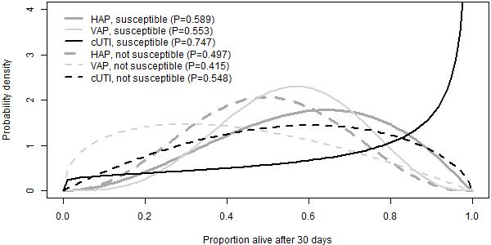
cUTI, complicated urinary tract infection; HAP, hospital-acquired pneumonia; VAP, ventilator-associated pneumonia; P, proportion

Figure A9.6: Expected LOS - all experts.
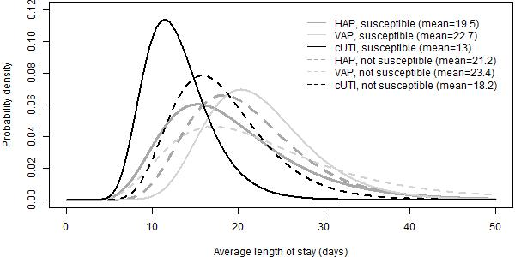
cUTI, complicated urinary tract infection; HAP, hospital-acquired pneumonia; VAP, ventilator-associated pneumonia

Table A9.3: Proportion (%) of hospital stay spent on ICU, HDU and general medical ward
 | ICU | HDU | General medical ward
HAP, susceptible | 23.56 | 21.22 | 55.22
VAP, susceptible | 62.86 | 14.29 | 22.86
cUTI, susceptible | 13.57 | 16.00 | 70.43
HAP, not susceptible | 36.00 | 22.00 | 42.00
VAP, not susceptible | 68.57 | 16.43 | 15.00
cUTI, not susceptible | 21.43 | 18.57 | 60.00
cUTI, complicated urinary tract infection; HAP, hospital-acquired pneumonia; HDU, high dependency unit; ICU, intensive care unit; VAP, ventilator-associated pneumonia

Appendix 10: Structured expert elicitation: background information provided to clinicians

Introduction
NICE, NHS England and NHS Improvement have commissioned a project to assess the feasibility of innovative models for reimbursing antimicrobials.
As part of the project, the University of Sheffield and the University of York are modelling outcomes of two antimicrobials that target infections caused by carbapenem-resistant gram negative bacteria. For this modelling we are focusing on patients with infections caused by the following pathogens:
- Cefiderocol (Fetcroja) targetting carbapenem-producing enterobacterales (CPE) and pseudomonas with metalo-beta-lactamase (MBL); and
- Ceftazidime with avibactam (CAZ-AVI, Zavicefta) targeting CPE with OXA-48.
This modelling work and subsequent NICE Committee deliberations will provide guidance on the value of each product to the NHS.
There are several model inputs for which data are limited or unavailable. As an alternative we require your expert opinion to inform these inputs. We are also interested in how uncertain you are about your opinions. The training seminar gave you guidance on how to express your uncertainty. We will use this approach here.
To begin, please click on the 'About you' tab at the top of the screen and proceed as advised thereafter.

Background information
We are interested in outcomes for patients with Hospital Acquired Pneumonia (HAP), Ventilator Associated Pneumonia (VAP), and complicated urinary tract infections (cUTIs) caused by carbapenem-resistant gram negative bacteria. Specifically, we are interested in outcomes following microbiology-directed treatment for patients with an infection caused by CPE with an OXA-48 or MBL resistance mechanism, or pseudomonas with a MBL resistance mechanism.

What do we mean by microbiology-directed treatment?
Patients in the microbiology-directed setting may have received empiric treatment with other antimicrobials prior to receiving microbiology results but require a change of treatment. This could be for a range of reasons including poor response to empiric treatment or adverse events requiring discontinuation of empiric treatment. Once the microbiology results are available, patients are assumed to be eligible to receive CAZ-AVI or cefiderocol (if found to be susceptible to them) if they meet either of the following criteria:
- Patients are susceptible only to colistin or aminoglycosides, and the new treatments offer improved safety.
- Patients are not susceptible to any existing treatment options, and the new treatments offer improved effectiveness and, possibly, safety.
Without the new treatments, patients who are not susceptible to any existing treatment options would be assumed to receive multi-drug salvage regimens.

Outcomes of interest
For patients with HAP, VAP or cUTIs, whose infection is caused by CPE with an OXA-48 or MBL resistance mechanism or pseudomonas with a MBL resistance mechanism, and whose treatment is informed by microbiology results, we are interested in outcomes depending on whether the infectious pathogen is susceptible to treatment.
We will assume that outcomes only depend on whether a patient is susceptible to treatment or not, and not to the specific treatment given. We therefore leave aside toxicity issues and differing risks of adverse events across treatments for the moment. We also assume that these patients will not experience acute kidney injury.
Note that in this scenario, patients who are classified as not susceptible to any treatment are assumed to receive multi-drug salvage regimens.
The outcomes we are interested in are 30-day mortality, length of stay in hospital, and the type of ward these patients would stay on in hospital.

Existing literature
We are not aware of any literature reporting our outcomes of interest in susceptible and not susceptible patients in the microbiology-directed setting, for patients with HAP, VAP, cUTIs caused by carbapenem-resistant gram negative bacteria.
We are therefore asking you to estimate these outcomes in this exercise and tell us how uncertain you are about your estimates.
As background we have identified several related studies that may help inform your answers, although they are not directly addressing the outcomes of interest. In these studies, infecting pathogens were not confirmed to be susceptible to the antibiotics administered (cefiderocol or CAZ-AVI); however, in our assessment they are likely to have been susceptible.

These studies are summarised in the table below.
Study | Site of infection and organism | Pathogen | Treatment received | Treatment history | Patient characteristics (mean) | Outcomes: HAP/VAP/ nosocomial pneumonia | Outcomes: cUTIs
APEKs-NP | HAP (n=59)  VAP (n=59)  HCAP (n=27) | Infections caused by Gram negative pathogens. Excluded patients known to have carbapenem-resistant pathogens at the time of ransomisation. | Cefiderocol | 33% had had empiric treatment failure | Age = 64.6  APACHE II = 16.0  SOFA = 4.7  CCI = NR | 14-day mortality  HAP: 10.2%  VAP: 15%  Total: 12.4%  28-day mortality  Total:21.0% | NA
CREDIBLE-CR | Nosocomial pneumonia (n=40)  cUTIs (n=17) bloodstream infections or sepsis (n=44) | Infections with evidence of a carbapenem-resistant Gram negative pathogen | Cefiderocol | 57% had had empiric treatment failure | Mean age = 63.1  APACHE II = 15.3  SOFA = 5.1  CCI = 5.5 | Nosocomial pneumonia  28-day mort: 33% | 28-day mort: 12%
REPRISE | cUTI (n=152) | Infections caused by ceftazidime-resistant Gram negative pathogens | CAZ-AVI | 50% had received prior empiric treatment | Mean age = 64.3  APACHE II = NR  SOFA = NR  CCI = NR | NA | 28-day mort: 2.1%
REPROVE | HAP/VAP  (VAP n=118; non-VAP n=238) | Excluded infections caused by Gram positive pathogens only or other pathogens not expected to respond to CAZ-AVI and/or meropenem | CAZ-AVI | 34% had received no prior antibiotics | Mean age = 62.4  APACHE II = 14.5  SOFA = NR  CCI = NR | 28-day mort: 8.4% | NA
HAP =hospital acquired pneumonia; VAP = ventilator-associated pneumonia; HCAP = healthcare-associated pneumonia; cUTI = complicated urinary tract infection; APACHE II = Acute Physiology and Chronic Health Evaluation II; SOFA = Sequential Organ Failure Assessment; CCI = Charlson Comorbidity Index; NR = not reported.

Appendix 11: Training slides for structured expert elicitation
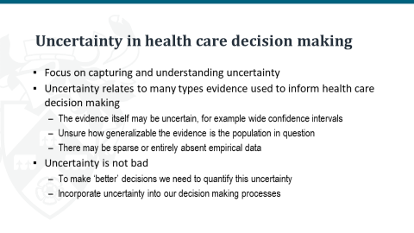
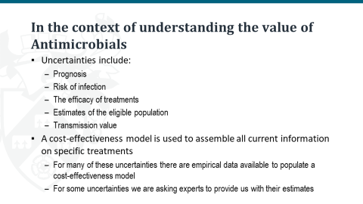
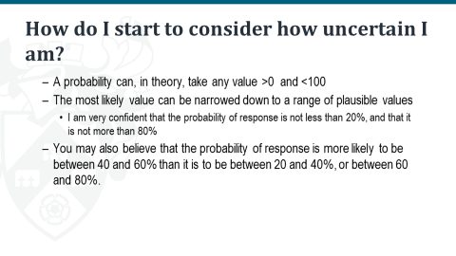
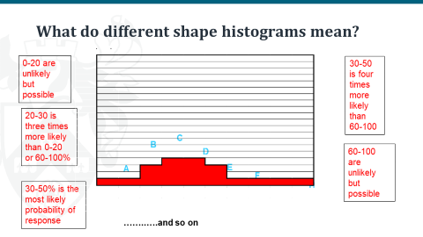
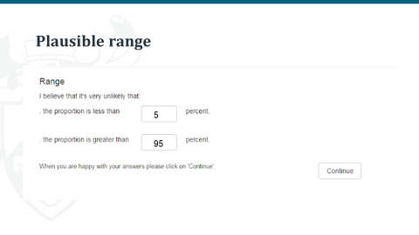
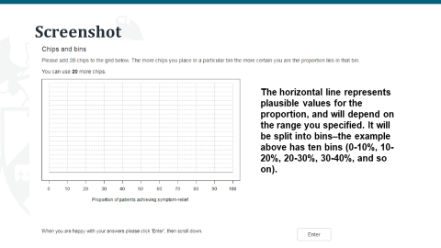
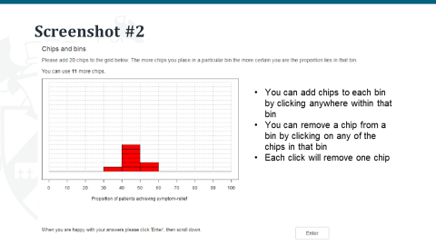
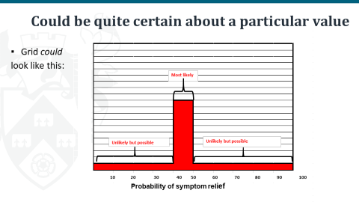
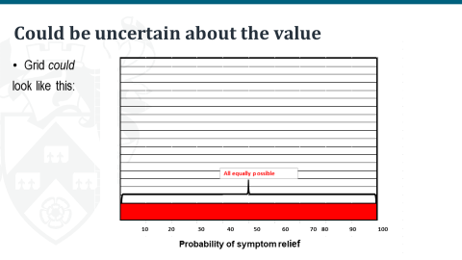
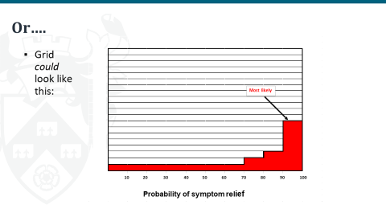
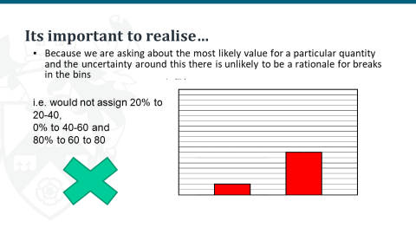
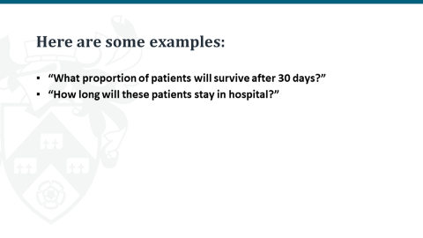
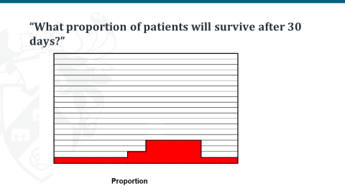
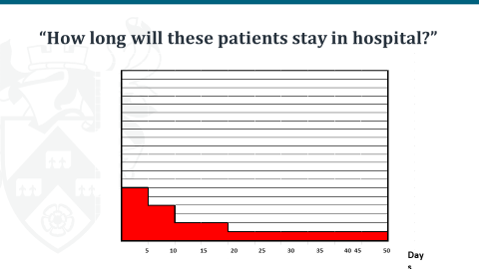

Appendix 12: Review of existing economic evaluations

A12.1 Introduction and objectives
A series of reviews of existing cost-effectiveness evidence and modelling approaches was conducted:
- A review of existing cost-effectiveness evidence for cefiderocol with a focus on studies that include decision-analytic models. The aims were to establish the existance of potentially policy-relevant models to guide NICE and NHS decisions; and to identify relevant analytical methods and data sources.
- A review of existing approaches for resistance modelling in the target population. The aim of this review was to identify methods that could be adopted for this purpose in EEPRU’s modelling.
- A review of existing cost-effectiveness models in HAP/VAP to understand modelling approaches and data sources.
- A review of existing cost-effectiveness models in cUTI. Again, the purpose was to understand modelling approaches and data sources.

A12.2 Methods
Each review involved searches of bibliographic databases using standardized search terms, selection of studies using explicit inclusion criteria and data extraction using an agreed template. Details of the bibliographic databases that were searched are provided in Annex 1 to this appendix.

A12.3 Review 1: existing cost-effectiveness evidence for cefiderocol
The objective of the first review was to identify existing cost-effectiveness modelling studies of cefiderocol. A total of 89 potentially relevant papers or abstracts were identified for the review from the searches. All the publications were screened using their titles and abstracts. Of the 89 publications that were screened, 1 relevant abstract on cefiderocol was included and 88 were excluded. The major reasons for exclusion were that the studies did not include a decision analytic model, did not consider a relevant target population and/or were duplicates of other studies. Table A11.1 summarises the included study. The only study identified was in the form of a poster and provided limited detail regarding the sources of clinical evidence and how these were used in the modelling.²² This, together with the study’s US focus, means it provides no basis to inform the current evalution of cefidercol.

Table A11.1: Summary of included cost-effectiveness studies of cefiderocol
Author, year | Country | Population (Pathogen) | Comparator | Strategies modelled | Did the model incorporate resistance? | Treatment Effect | Primary Evidence Source | Model Structure
Lopes 2020 ²² | United States | cUTI, HAP/VAP (CR Acinetobacter baumannii, CR Pseudomonas aeruginosa, CR Enterobacterales, and intrinsically CR Stenotrophomonas maltophilia) | Colistin based therapy;  cefiderocol | Microbiology directed treatment | N | Clinical cure rate | Not available | Decision tree

A11.4 Review 2: modelling studies considering resistance
A second review was conducted to identify published economic evaluations of AMs that attempted to quantify the effects of resistance, with a focus on resistance modelling. A total of 89 potentially relevant studies or abstracts were identified from the searches. All the publications were screened using their titles and abstracts after which 9 studies were publications were included in the review, which are described in Table A11.2.

Table A11.2: Summary of included resistance modelling studies
Author, year | Country | Population (Pathogen) | Intervention | Comparator
Chen et al 2019 ²³ | Taiwan | cUTI  (E. Coli, K. Pneumoniae, Pseudomonas aeruginosa, P. Mirabilis) | Ceftolozane/  tazobactam | Piperacillin/  tazobactam
Nelson 2019²⁴ | US | CRE BSI | Hypothetical | Hypothetical
Mewes 2019 ²⁵ | US | Sepsis and lower respiratory tract infection  (C. Difficile) | Procalcitonin-algorithm | Standard of care
Gordon 2020 ²⁶ | UK | cUTI, cIAI, HAP  (E.Coli, Pneumoniae, Pseudomonas aeruginosa) | Peperacillin/Tazobactam | Meropenem/(theoretical) new AM
Tichy et al 2020²⁷ | Italy | HAP/VAP  (K. pneumonia (37%), Pseudomonas aeruginosa (26%), E. cloacae (14%), E coli (12%), and H. influenzae (9%).) | ceftazidime/avibactam | Meropenem
Simon et al 2019²⁸. | United States | CRE Pneumonia, BSI,  (K pneumoniae, Enterobacteriaceae) |  | Colistin-based therapy
Kongnakorn et al 2019²⁹ | Italy | cIAIs  (Escherichia coli, Streptococcus anginosus group, Klebsiella pneumoniae, Bacteroides fragilis, Pseudomonas aeruginosa) |  | Ceftolozane/tazobactam plus metronidazole; meropenem
Kongnakorn et al 2019³⁰ | Italy | cUTI (Escherichia coli, Klebsiella pneumoniae, Pseudomonas aeruginosa, Proteus mirabilis, Enterobacter cloacae) |  | Imipenem
Nguyen et al 2019³¹ | Netherlands | cUTI, cIAI, BSI  (Extended-spectrum beta-lactamase (ESBL)/AmpC-producing Gram-negative pathogens) |  | Meropenem
AM, antimicrobial; BSI, bloodstream infection; cIAI, complicated intraabdominal infection; CRE, carbapenem-resistant Enterobacterales; cUTI, complicated urinary tract infection; HAP/VAP, hospital-acquired pneumonia or ventilator-associated pneumonia

The 5 studies modelling the cost-effectiveness of ceftazidime/avibactam (cefiderocol) did not assess the implications of changes in resistance over time. Three of these studies ^{27,32,30} made assumptions about the proportion of patients with resistant infection in the relevant population, and the impact of resistance on clinical parameters including cure rates. These studies also tried to reflect the wider set of existing therapies used in clinical practice by drawing on non-RCT evidence in the target population. The two remaining studies considered a broader evidence base than just regulatory trials to relate their analyses more directly to populations with a higher likelihood of pathogens resistant to existing therapies. Simon et al focused on the cost-effectiveness of cefiderocol in carbapenem-resistant Enterobacteriaceae pneumonia or bacteraemia, drawing on evidence from observational studies on the proportions of patients with different types of infection, mortality rates with the comparator (colistin-based) therapy and the absolute effect of cefiderocol on mortality.²⁸ Nguyen et al considered the cost-effectiveness of cefiderocol (and other carbapenem-sparing beta-lactams) compared to meropenem in cUTI or intra-abdominal infections in extended-spectrum beta-lactamase (ESBL)/AmpC-producing pathogens which have a high risk of carbapenem resistance.³¹ Both observational and RCT evidence was used for the analysis, although RCT evidence was used for the cefiderocol analysis which showed no significant difference in clinical cure versus meropenem with limited information about patients’ resistance status.

The additional four studies provide some indications of how these effects could be captured. Chen et al considered alternative antibiotics for complicated UTI in the empiric setting.²³ They used a cohort study from a Taiwanese hospital to assess the appropriateness of each alternative empiric therapy based on clinical isolates. Specifically, each randomly drawn isolate from the cohort represents a specific patient in the model and their susceptibility to a given antibiotic was used to determine whether a patient remained on their initial therapy or switched to an alternative regimen or required salvage therapy.

In the economic evaluation of Procalcitonin-guided antibiotic stewardship, Mewes et al attempted to estimate the reduction in resistant infections resulting from the use of the biomarker.²⁵ The key parameter was an estimate of the correlation between the percentage reduction in days of antibiotic use resulting from use of the Procalcitonin-guided test and antibiotic resistance. This estimate was taken from secondary sources and the authors emphasised the weakness in the data.

The other two studies in this review attempted to deal with resistance through mechanistic infectious disease modelling. In a conference abstract, Nelson et al reported on the use of a compartmental model to show how the use of two hypothetical antibiotics for hospitalised patients with carbapenem-resistant Enterobacteriaceae (CRE) could reduce transmission of this pathogen.²⁴ The ultimate purpose of the analysis was to describe the methods necessary to capture the transmission value of such products and the magnitude of this effect compared to the direct benefits of treatment. Hypothetical data were only used for illustrative purposes.

The study by Gordon et al also used the combination of a dynamic transmission model and a treatment pathway model as a generic framework to evaluate up to three lines of antibiotics in different indications and pathogens.²⁶ This version of the model was applied to hospitalised patients in the UK with infections from a range of pathogens and in different sites. Transition parameters for the transmission model were derived using calibration from data from the English Surveillance Programme for AM Utilisation and Resistance (ESPAUR) and the Public Health Profiles Fingertips tool on utilisation. In principle, this model could be capable of quantifying not just the direct health effects of a new antibiotic, but also the indirect impacts via any reduction in transmission of relevant pathogens. It could also reflect changes in resistance over time in response to different stewardship strategies and the introduction of new AMs. However, whether the model can achieve this in practice will inevitably depend on the available evidence and the assumptions necessary given the evidence gaps.

A12.5 Review 3: modelling studies focused on HAP/VAP
A targeted review was also conducted of models specifically in HAP/VAP to expand our understanding of models relating to this site of infection given its relevance to the HVCSs. A recent systematic literature review of models in HAP/VAP by Wenger et al was identified with searches conducted in 2017.33 In addition, a targeted search of HAP/VAP models published since 2017 was conducted but no additional relevant studies were identified except for Tichy et al27 from Review 2. The review by Wagner et al was used to extract information on the target population, modelling assumptions, model structure, clinical evidence, healthcare resource use, costs. This information is summarized in Table A11.3.

Table A11.3: Summary of included HAP/VAP modelling studies based on in the review by Wagner et al ³³
Author, year | Country | Population (Pathogen) | Intervention | Comparator | Strategies modelled | Resistance considered (Y/N) | Treatment Effectiveness | Evidence Source | Model Structure
Edwards et al 2012³⁴ | UK | HAP | Meropenem | Piperacillin/  tazobactam | Following failure of 1st line antibiotics | N | Clinical response; Diarrhoea | Literature review and meta-analysis | Markov model
Grau et al 2013³⁵ | Spain | VAP | Linezolid | Vancomycin | Empiric | N | Clinical Cure, Survival Rates (for life-years and QALYs) | Retrospective analysis of RCTs | Decision Tree
Kongnakorn et al 2010³⁶ | US | Nosocomial Pneumonia | Doripenem | Imipenem | Empiric | Y | Number of seizures, number of cases of emerging Pseudomonas aeruginosa resistance, length of stay at hospital, transmissions | RCT, Published sources | Patient-level simulation model

Edwards et al compared meropenem and Piperacillin/ tazobactam for the treatment of pneumonia.³⁴ The cost-effectiveness modelling involved a standard Markov model with states based on location of care in hospital and mortality. Efficacy data were taken from a synthesis of RCT studies and allowance was made for relapse. Grau et al developed a decision tree model to evaluate linezolid compared with vancomycin in patients with VAP in Spain, distinguishing between different pathogens.³⁵ Efficacy data relating to clinical cure were taken from two RCTs and mortality was conditional on Acute Physiology And Chronic Health Evaluation (APACHE) scores and secondary data on long-term effects of a serious septic condition. Kongnakorn et al used discrete event simulation to model the cost-effectiveness of doripenem compared with imipenem in nosocomial pneumonia.³⁶ The model allowed for differences in baseline characteristics of nosocomial pneumonia type (without VAP, early-onset VAP, late-onset VAP) and PsA presence and PsA resistance to the given drug. Efficacy and risk equations for hospital discharge and mortality were estimated from regulatory RCTs. The number of PsA transmissions was estimated based on the efficacy of treatment.

All of these studies include standard cost-effectiveness models that did not consider the impact of alternative therapies on resistance patterns over time. Kongnakorn et al attempted to include transmission rates in the modelling but this was not extrapolated to estimate population-level health effects.³⁶ As a UK study, Edwards et al provides some potentially useful evidence sources for the current evaluation.³⁴

A12.6 Review 4: modelling studies focused on cUTI
A targeted review of models specifically in cUTI was undertaken to better understand the relevance of existing modelling assumptions, model structure, model inputs to the HVCSs. In addition to the models in cUTI identified in Review 2,22,23,26,30,31 we identified one additional study which is summarised in Table A11.4.
Kauf et al used a micro-simulation model to evaluate empiric ceftolozane/tazobactam compared with piperacillin/ tazobactam as empiric therapy for hospitalized with cUTI.37 The model tracked patients over different assessment periods allowing for treatment switching as microbiological information becomes available. A surveillance dataset is used to sample isolates and to determine susceptibility to different treatments. Mortality rates and hospital length of stay were taken from a single study. Although modelling patients included those with resistant pathogens, no attempt was made to model the effects of resistance over time.

Table A11.4: Summary of included cUTI modelling studies in addition to those in Review 2
Author, year | Country | Population (Pathogen) | Intervention | Comparator | Strategies modelled | Resistance considered (Y/N) | Treatment Effectiveness | Evidence Source | Model Structure
Kauf 2017³⁷ | US | cUTI  (E. Coli, K. Pneumoniae, Pseudomonas aeruginosa, P. Mirabilis) | Ceftolozane/  tazobactam | Piperacillin/  tazobactam | Empiric | Y | Clinical cure; appropriate therapy | Susceptibility data from the PACTS dataset - Real-World Evidence | Patient-level simulation
cUTI, complicated urinary tract infection

Annex to Appendix 12: Search strategies

Search of cost-effectiveness models
Searches for cost-effectiveness studies (either cefiderocol or cefiderocol) were conducted in MEDLINE, Embase, CRD and NHS EED. An additional search for HTA / regulatory agencies / conference proceedings was conducted using WoS. The search terms used are provided below.

Cefiderocol CEA models
Term group(s): Cefiderocol AND filter
Filters: Economic (MEDLINE, Embase), exclusion filter (Embase)
Limits: None

Ovid MEDLINE(R) and Epub Ahead of Print, In-Process, In-Data-Review & Other Non-Indexed Citations, Daily and Versions(R) 1946 to February 26, 2021 (searched via the Ovid SP platform)
1st March 2021

# | Searches | Results
1 | cefiderocol.mp. | 160
2 | fetroja.mp. | 4
3 | fetcroja.mp. | 0
4 | rsc-649266.mp. | 0
5 | or/1-4 | 160
6 | exp "Costs and Cost Analysis"/ | 242835
7 | Economics/ | 27294
8 | exp Economics, Hospital/ | 24969
9 | exp Economics, Medical/ | 14242
10 | Economics, Nursing/ | 4002
11 | exp models, economic/ | 15443
12 | Economics, Pharmaceutical/ | 2971
13 | exp "Fees and Charges"/ | 30592
14 | exp Budgets/ | 13800
15 | budget*.tw. | 30546
16 | ec.fs. | 431631
17 | cost*.ti. | 125579
18 | (cost* adj2 (effective* or utilit* or benefit* or minimi*)).ab. | 157179
19 | (economic* or pharmacoeconomic* or pharmaco-economic*).ti. | 50939
20 | (price* or pricing*).tw. | 42703
21 | (financial or finance or finances or financed).tw. | 97358
22 | (fee or fees).tw. | 18704
23 | (value adj2 (money or monetary)).tw. | 2515
24 | quality-adjusted life years/ | 12949
25 | (qaly or qalys).af. | 11325
26 | (quality adjusted life year or quality adjusted life years).af. | 19387
27 | or/6-26 | 801858
28 | 5 and 27 | 0

Embase 1974 to 2021 February 26 (searched via the Ovid SP platform)
1st March 2021

# | Searches | Results
1 | cefiderocol.mp. | 278
2 | fetroja.mp. | 9
3 | fetcroja.mp. | 1
4 | rsc-649266.mp. | 0
5 | or/1-4 | 278
6 | "cost benefit analysis"/ | 87111
7 | "cost effectiveness analysis"/ | 158540
8 | economics/ | 241957
9 | health economics/ | 33700
10 | pharmacoeconomics/ | 7505
11 | fee/ | 14329
12 | budget/ | 30564
13 | budget$.tw. | 40639
14 | cost$.ti. | 168111
15 | (cost$ adj2 (effective$ or utilit$ or benefit$ or minimi$)).ab. | 218259
16 | (economic$ or pharmacoeconomic$ or pharmaco-economic$).ti. | 64563
17 | (price$ or pricing$).tw. | 60859
18 | (financial or finance or finances or financed).tw. | 135326
19 | (fee or fees).tw. | 25728
20 | (value adj2 (money or monetary)).tw. | 3455
21 | health care quality/ | 247699
22 | quality adjusted life year/ | 28517
23 | (qaly or qalys).tw. | 21188
24 | (quality adjusted life year or quality adjusted life years).tw. | 20472
25 | or/6-24 | 1102354
26 | letter.pt. | 1185036
27 | editorial.pt. | 691062
28 | historical article.pt. | 0
29 | or/26-28 | 1876098
30 | 25 not 29 | 1021484
31 | animals/ | 1253461
32 | humans/ | 13458185
33 | 31 not (31 and 32) | 965742
34 | 30 not 33 | 1010813
35 | 5 and 34 | 3

CRD database (searched via the University of York CRD platform)
1st March 2021

# | Searches | Results
1 | (cefiderocol) | 0
2 | (fetroja) | 0
3 | (fetcroja) | 0
4 | (rsc-649266) | 0

Web of Science - Conference proceedings index (searched via the Clarivate Analytics platform)
1st March 2021

# | Searches | Results
# 1 | TOPIC: (cefiderocol) | 8
# 2 | TOPIC: (fetroja) | 0
# 3 | TOPIC: (fetcroja) | 0
# 4 | TOPIC: (rsc-649266) | 0
# 5 | #4 OR #3 OR #2 OR #1 | 8

CAZ/AVI CEA models
Term group(s): CAZ/AVI AND filters
Filters: Economic (MEDLINE, Embase), Exclusion (Embase)
Limits: None

Ovid MEDLINE(R) and Epub Ahead of Print, In-Process, In-Data-Review & Other Non-Indexed Citations, Daily and Versions(R) 1946 to February 26, 2021 (searched via the Ovid SP platform)
1st March 2021

# | Searches | Results
1 | ceftazidime.mp. | 10210
2 | Ceftazidime/ | 4047
3 | 1 or 2 | 10210
4 | avibactam.mp. | 964
5 | 3 and 4 | 789
6 | ceftazidime-avibactam.mp. | 711
7 | zavicefta.mp. | 2
8 | avycaz.mp. | 8
9 | (ctz-avi or cefiderocol).mp. | 65
10 | or/5-9 | 792
11 | exp "Costs and Cost Analysis"/ | 242835
12 | Economics/ | 27294
13 | exp Economics, Hospital/ | 24969
14 | exp Economics, Medical/ | 14242
15 | Economics, Nursing/ | 4002
16 | exp models, economic/ | 15443
17 | Economics, Pharmaceutical/ | 2971
18 | exp "Fees and Charges"/ | 30592
19 | exp Budgets/ | 13800
20 | budget*.tw. | 30546
21 | ec.fs. | 431631
22 | cost*.ti. | 125579
23 | (cost* adj2 (effective* or utilit* or benefit* or minimi*)).ab. | 157179
24 | (economic* or pharmacoeconomic* or pharmaco-economic*).ti. | 50939
25 | (price* or pricing*).tw. | 42703
26 | (financial or finance or finances or financed).tw. | 97358
27 | (fee or fees).tw. | 18704
28 | (value adj2 (money or monetary)).tw. | 2515
29 | quality-adjusted life years/ | 12949
30 | (qaly or qalys).af. | 11325
31 | (quality adjusted life year or quality adjusted life years).af. | 19387
32 | or/11-31 | 801858
33 | 10 and 32 | 16

Embase 1974 to 2021 February 26 (searched via the Ovid SP platform)
1st March 2021

# | Searches | Results
1 | ceftazidime.mp. | 45327
2 | ceftazidime/ | 43189
3 | 1 or 2 | 45327
4 | avibactam.mp. | 1893
5 | 3 and 4 | 1609
6 | ceftazidime-avibactam.mp. | 955
7 | zavicefta.mp. | 18
8 | avycaz.mp. | 62
9 | (ctz-avi or cefiderocol).mp. | 156
10 | or/5-9 | 1618
11 | "cost benefit analysis"/ | 87111
12 | "cost effectiveness analysis"/ | 158540
13 | economics/ | 241957
14 | health economics/ | 33700
15 | pharmacoeconomics/ | 7505
16 | fee/ | 14329
17 | budget/ | 30564
18 | budget$.tw. | 40639
19 | cost$.ti. | 168111
20 | (cost$ adj2 (effective$ or utilit$ or benefit$ or minimi$)).ab. | 218259
21 | (economic$ or pharmacoeconomic$ or pharmaco-economic$).ti. | 64563
22 | (price$ or pricing$).tw. | 60859
23 | (financial or finance or finances or financed).tw. | 135326
24 | (fee or fees).tw. | 25728
25 | (value adj2 (money or monetary)).tw. | 3455
26 | health care quality/ | 247699
27 | quality adjusted life year/ | 28517
28 | (qaly or qalys).tw. | 21188
29 | (quality adjusted life year or quality adjusted life years).tw. | 20472
30 | or/11-29 | 1102354
31 | letter.pt. | 1185036
32 | editorial.pt. | 691062
33 | historical article.pt. | 0
34 | or/31-33 | 1876098
35 | 30 not 34 | 1021484
36 | animals/ | 1253461
37 | humans/ | 13458185
38 | 36 not (36 and 37) | 965742
39 | 35 not 38 | 1010813
40 | 10 and 39 | 56

CRD database (searched via the University of York CRD platform)
1st March 2021

# | Searches | Results
1 | (ceftazidime) | 49
2 | (avibactam) | 0
3 | (ceftazidime-avibactam) | 0
4 | (zavicefta) | 0
5 | (avycaz) | 0
6 | ((ctz-avi or cefiderocol)) | 0

Web of Science - Conference proceedings index (searched via the Clarivate Analytics platform)
1st March 2021

# | Searches | Results
# 1 | TOPIC: (ceftazidime) | 9,711
# 2 | TOPIC: (avibactam) | 1,167
# 3 | #2 AND #1 | 984
# 4 | TOPIC: (ceftazidime-avibactam) | 919
# 5 | TOPIC: (zavicefta) | 2
# 6 | TOPIC: (avycaz) | 6
# 7 | TOPIC: ((ctz-avi or cefiderocol) ) | 59
# 8 | #7 OR #6 OR #5 OR #4 OR #3 | 14

Search of economic evaluations of AMs that have explicitly modelled resistance
Searches were conducted in Medline, Embase and CRD.
Term group(s): Focused AM resistance AND modelling AND filter
Filters: Pragmatic economic filter (MEDLINE, Embase)
Limits: 2011-present, English language

Ovid MEDLINE(R) and Epub Ahead of Print, In-Process, In-Data-Review & Other Non-Indexed Citations, Daily and Versions(R) 1946 to March 31, 2021 (searched via the Ovid SP platform)
1st April 2021

# | Searches | Results
1 | ((AM or antibiotic or antibacterial) and resistan*).mp. | 148175
2 | (model* or "population dynamic*" or simulat*).ti. | 718508
3 | 1 and 2 | 2671
4 | limit 3 to yr="2011 -Current" | 1901
5 | limit 4 to english language | 1884
6 | Cost-benefit analysis/ | 83842
7 | Economic value of life/ | 5741
8 | Quality-adjusted life years/ | 13042
9 | exp models, economic/ | 15508
10 | cost utilit$.tw. | 4939
11 | cost benefit$.tw. | 11329
12 | cost minim$.tw. | 1563
13 | cost effect$.tw. | 143618
14 | economic evaluation$.tw. | 12455
15 | or/6-14 | 213673
16 | 5 and 15 | 26

Embase 1974 to 2021 March 31 (searched via the Ovid SP platform)
1st April 2021

# | Searches | Results
1 | ((AM or antibiotic or antibacterial) and resistan*).mp. | 298764
2 | (model* or "population dynamic*" or simulat*).ti. | 863662
3 | 1 and 2 | 4531
4 | limit 3 to yr="2011 -Current" | 3042
5 | "cost benefit analysis"/ | 86983
6 | Economic value of life/ | 145299
7 | quality adjusted life year/ | 28664
8 | exp economic model/ | 2513
9 | cost utilit$.tw. | 7843
10 | cost benefit$.tw. | 15750
11 | cost minim$.tw. | 2664
12 | cost effect$.tw. | 198907
13 | economic evaluation$.tw. | 17713
14 | ("quality adjusted life year*" or qaly or qalys).tw. | 26170
15 | or/5-14 | 433603
16 | 4 and 15 | 67

CRD database (searched via the University of York CRD platform)
1st April 2021

# | Searches | Results
1 | (((AM or antibiotic or antibacterial) and resistan*)) | 459
2 | ((model* or "population dynamic*" or simulat*)):TI | 1554
3 | #1 AND #2 | 8
5 | (#3) FROM 2011 TO 2021 | 2

Appendix 13: Incorporating susceptibility evidence into the economic model

A13.1 Evidence on conditional susceptibilities
In general, the review of susceptibility studies described in Section 4 (and subsequent NMA) provided evidence on absolute susceptibility to a given AM (or in statistical language, the marginal susceptibility). To use evidence on susceptibility in the economic modelling, information on conditional susceptibility is required. This required evidence takes two different forms depending on the treatment setting. In the ES many treatments are combinations of two AMs. For this, evidence is required on the susceptibility to one AM in the combination treatment, conditional on being resistant to the other AM in the combination (so collectively this evidence allows for a derivation of overall susceptibility to the combination treatment). In the MDS interest lies in the proportion of patients that are susceptible to at least one AM in a given group (where the groupings are one of ‘colistin or an aminoglycoside’, ‘a different AM’ or ‘no AMs’). Here the required evidence is again for susceptibility to an AM given resistance to other AMs, but now this resistance could be to multiple AMs. These two settings are discussed in turn, followed by a discussion of issues specific to cefiderocol.

The evidence used to inform estimates and assumptions about conditional susceptibilities was obtained from two primary sources. The first was the review of susceptibility studies described in Section 4 (approach 3). The second was de novo data requests, as described in Appendix 2.

Empiric setting
Two options were considered:

- Assume independence of absolute susceptibilities when determining overall susceptibility to combination treatments. Under this assumption, the susceptibility of a given isolate to a given AM is the same irrespective of what other AMs the isolate is susceptible to. With this assumption, obtain overall susceptibility to two AMs, the following equation is used:
Overall susceptibility = susceptibility to AM1 + (1 – susceptibility to AM1) * susceptibility to AM2
In other words, it is assumed that those not susceptible to AM1 have the same susceptibility to AM2 as the whole sample.
- Use observed evidence on overall susceptibility. This includes evidence on conditional susceptibility (susceptibility to an AM given resistance to another AM). Isolate-level data were available from one source: a de novo data request from PHE. Under this second approach “susceptibility to AM2” becomes “susceptibility to AM2 given resistance to AM1”.

The second approach will provide more nuanced estimates of overall susceptibility to combination treatments by accounting for cross-resistance. However, it is restricted to AM combinations for which there is evidence and is reliant on smaller samples of susceptibility data. In particular, the NMA of susceptibility evidence does not provide any evidence on overall or conditional susceptibility. In contrast, the first approach may be used with the NMA results and any other studies. The key assumption of the first approach is that of independence of absolute susceptibility. To assess the credibility of this assumption, analyses of the isolate-level data were performed.

Amongst the CPE population, evidence from PHE includes two of the three combination treatments listed in the PICOS. These werecolistin with tigecycline and colistin with aztreonam; there was no data for colistin with fosfomycin. There were decreases in susceptibility when assessing conditional values for all the drugs. For example, the absolute susceptibility for tigecycline was 70%, whilst conditional on being resistant to colistin it was 60%. However, numbers were generally small, and none of the decreases were statistically significant when a two-sided z-test for a difference in proportions was performed. For the pseudomonas population there was no evidence for colistin with fosfomycin.

Microbiology-directed setting
In the MDS (for which it is assumed that individuals will receive any AM to which they are susceptible), one approach would be to also assume independence of susceptibilities when deriving susceptibility groups (susceptible to a non-colistin/aminoglycoside AM, susceptible to only colistin or an aminoglycoside, and not susceptible to any AM). The appropriateness of this assumption for the first group was checked using data from PHE (which includes all the comparators apart from Fosfomycin. Assuming independence results in 77% of patients being in the non- colistin/aminogycloside group, compared with the true value of 75%. Whilst these numbers are very similar, they are only for two AMs (due to a lack of evidence) and it is unclear if the assumption of independence will hold for additional AMs. Hence the assumption of independence was not employed when deriving susceptibility for the groups. Instead, the PHE data were used to calculate the likely over-estimate when assuming independence. Hence, given the above numbers, the true value is likely to (75/77) 97% of the value obtained when assuming independence. As the NMA evidence does not capture dependencies amongst AMs, these estimates were first combined to obtain susceptibility groups assuming independence. The scaling factor from the PHE data was then applied to adjust for the likely over-estimate due to assuming independence. The same method was used to derive adjusted values for the second susceptibility group (with the third susceptibility group obtained by noting that the sum across the three groups had to sum to 100%).

Cefiderocol
There is limited evaluation in the literature of the susceptibility to cefiderocol of isolates that were resistant to other treatments. In a study by Johnson et al overall susceptibility to cefiderocol was 92%, with decreased susceptibility amongst isolates that were resistant to an aminoglycoside (88% and 81% for these resistant to gentamicin and amikacin, respectively). However, the Johnson et al study was of multiple resistance mechanisms, not just MBLs; for both cefiderocol and aminoglycosides susceptibility was statistically significantly reduced amongst isolates with an MBL mechanism (cefiderocol from 92% to 70%, gentamicin from 55% to 19%, and amikacin from 78% to 48%) compared to susceptibility amongst all isolates. Hence, in this study, resistance to an aminoglycoside may be confounded by an increased prevalence of MBLs. In the Kazmierczak et al study, the MIC 90 for cefiderocol was 4 μg/mL in the overall population and 2 μg/mL amongst colistin-resistant isolates, suggesting little impact of colistin resistance on cefiderocol resistance. In response to a data request, Shinogi provided evidence on susceptibility to cefiderocol conditional on resistance to other AMs. Susceptibility to cefiderocol was broadly unaffected by resistance to non-toxic AMs (those in the PICOS, excluding colistin or aminoglycosides). There was some evidence of a reduced susceptibility to cefiderocol amongst isolates resistant to all other AMs, but this was based on small numbers. Due to the uncertainty and lack of evidence to inform the effect of resistance on cefiderocol susceptibility, it was decided to assume that susceptibility to cefiderocol is independent of resistance to other AMs.

A13.2 Scenario analyses for susceptibility evidence
For the base-case analysis it was assumed that conditional susceptibilities were the same as absolute susceptibilities. This assumption was relaxed in the following scenario analyses:
- Scaling conditional susceptibility: with this scaling factor informed by PHE data, where available. For example, if in the PHE data, the conditional susceptibility to tigecycline amongst isolates that were resistant to colistin was 10% lower than the absolute susceptibility to tigecycline, then the absolute susceptibility to tigecycline obtained from the NMA was reduced by 10% to obtain the conditional susceptibility.
- For the CPE-MBL population, use of only PHE data. As there is no PHE evidence for fosfomycin, this scenario assumed that fosfomycin was not used.

As susceptibility to colistin was almost 100% in the basecase for the pseudomonas population, an additional scenario was explored which used the SIDERO-WT study for colistin susceptibility. This study was chosen as it reported the lowest colistin susceptibility of the EUCAST studies identified (80.9%).

In a further scenario analysis, evidence from just CLSI studies was used. For both the base-case analysis of EUCAST studies and the scenario of CLSI studies, additional scenarios were explored. For these additional scenarios, PHE data was used for all AMs apart from cefiderocol and fosfomycin. Evidence for these two AMs was obtained from their own network (keeping the cefiderocol and fosfomycin networks separate). These scenarios were motivated by noting that literature searches had only been conducted for cefiderocol and fosfomycin, so it may not be reasonable to obtain estimates for the other AMs from the NMA.

Appendix 14: Drug acquisition costs

Table A14.1: Drug acquisition costs.
AM | Price | Daily dose | Cost per day | Cost per course of treatment (treatment duration in days) | Cost per 5 days of treatment
Colistimethate sodium | £18.00 (10 x 1MU vial) ³⁸ | 9MU ³⁹ | £16.20 | £153.9 (9.5 days ⁴⁰) | £81.00
Aminoglycosides (gentamicin) | £10.97 (20 x 360mg/120ml solution for infusion bags) ⁴¹ | 0.24g ³⁹ | £10.97 | £76.79 (maximum IV treatment 7 days ³⁸) | £54.85
Aminoglycosides (amikacin) | £38.72 (5 x 500mg/2ml vials) ⁴¹ | maximum dose 1.5g ³⁹ | £23.23 | £232.30  (10 days ³⁸) | £116.15
Aminoglycosides (tobramycin) | £10.69 (1 x 240mg/6ml solution for injection vials) ⁴¹ | 0.24 g ³⁹ | £10.69 | £74.83 (maximum IV treatment 7 days ³⁸) | £53.45
Tigecycline | £106.52 (10 x 50mg vials) ⁴¹ | 0.1g ³⁹ | £21.30 | £298.20 (14 days ³⁸) | £106.5
Fosfomycin | £4.86 (1 x 3g sachet) ³⁸ | 3g (1 sachet) ³⁸ | £4.86 | £9.66 (2 doses ⁴²) | £9.66
Fluoroquinolones  (ciprofloxacin) | £5.02 (10 x 400mg/200ml infusion) ⁴¹ | 1.2g ³⁹ | £1.51 | £10.57 (7 days ³⁸) | £7.55
Fluoroquinolones  (levofloxacin) | £20.95 (10 x 500mg/100ml infusion bags) ⁴¹ | 0.5g ³⁹ | £2.10 | £29.40 (14 days ³⁸) | £10.5
Cephalosporins (cefepime) | £70.00 (10 x 1g vial) ³⁸ | 4g ³⁹ | £28.00 | £280.00 (10 days ⁴³) | £140.00
Cephalosporins (ceftriaxone) | £5.25 (10 x 1g vial) ⁴¹ | 4g ³⁹ | £2.10 | £29.40 (14 days ³⁸ | £10.5
Aztreonam | £18.82 (2g powder for solution for injection) ³⁸ | 4g ³⁹ | £37.64 | £263.48 (7 days, assumed) | £188.2
eMIT = Drugs and pharmaceutical electronic market information tool; BNF = British National Formulary

Appendix 15: Further details on Modelling direct population net health effects in HVCS

A15.1 Predicting the future sizes of the HVCS
Time-series data were provided by PHE. This included evidence on changes over time in both invasive infection isolates and screening isolates. Neither isolate type (invasive infections and screening) are the same as the isolate type included in the HVCS (all infections). Of the two types available, the invasive infections were the most similar to all infections, so were the primary focus of analyses. Screening isolates were considered in secondary analyses. Data were supplied from the Reference Laboratory provided by the AMRHAI national reference unit, with data available until April 2021.

Further details on the analyses of invasive infections and screening isolates are provided in the subsequent sub-sections.

Time-series models
Time-series methods were used to generate future predictions of the population size. Three classes of model were considered:
- Exponential smoothing (state-space) models ⁴⁴. This models variation in the data via variation in latent (unobserved) states representing a level (average) and trend. For extrapolations, predictions of these states are informed by all the available data, with more weight given to more recent observations and less weight given to older observations. The weight given to older observations decreases based on an exponential function, with the amount of decay estimated from the data. Use of this model assumes that extrapolations of (the logarithm of) the population follow a linear model. An alternative assumption is that the trend in the linear model is successively ‘damped’ over time so that eventually it becomes zero, and extrapolations become constant. This dampening can help to avoid forecasts becoming too large. Hence three exponential smoothing models were considered; a trend model, a damped-trend model, and a model with no trend.
- Autoregressive integrated moving average (ARIMA) models ⁴⁴. These model the autocorrelations in the data. Unlike exponential smoothing models, ARIMA models do not incorporate a trend. Instead, they assume that after differencing the data (calculating the differences between observations; this is potentially repeated multiple times) there is no trend.
- Generalised linear models for count time series data ⁴⁵. Poisson and Negative Binomial models were considered, with a logarithmic link for both. Hence for both models it is assumed that the logarithm of the counts follows a linear model. These models may be viewed as extending standard regression models to account for correlations amongst observations.

All models were fitted in R version 4.0.2, using the ‘forecast’ package for both exponential smoothing and ARIMA models, and the ‘tscount’ package for the generalised linear models ^{44,45}. The exponential smoothing and ARIMA models are for Gaussian (Normally distributed) outcomes. Count data are not Normally distributed, and due to the small numbers involved in the analysis the Normal distribution would not be a good approximation. Instead, the logarithm of the data was taken prior to fitting the exponential smoothing and ARIMA models.

Point-estimates from the three model types were generally very similar, as were model diagnostics (which included visual goodness of fit, statistical significance of the autocorrelation function, the distribution of residuals, and the Ljung-Box test). Initially none of the models identified a trend in the time-series, with forecasts being set to either the last observed value, or an average of the observed data. As such, subsequent analyses focused on exponential smoothing models, for the following reasons:
- The ability to specify models that include a trend (in contrast to ARIMA models which do not have an explicit trend parameter).
- Having analytical formulae to express uncertainty in forecasts (which was not available for the generalised linear models).
Exponential smoothing models with both damped and undamped additive trends were considered. The error type (additive or multiplicative) was chosen by the fitting software (based on model goodness-of-fit), as was a Box-Cox transformation.

Incorporating forecasts in the economic model
To incorporate the extrapolations within the economic model, these were converted into year-on-year relative changes. That is, the relative change in year ‘t’ was calculated as the forecast in year ‘t+1’ divided by the forecast in year ‘t’. For PSA, forecasts were obtained using the following process:
- Obtain the mean and standard deviation, both on the log-scale, at each time point. For example, to obtain forecasts for 20 years, 20 pairs of mean and standard deviation are obtained.
- Use these values to sample a value from a log-normal distribution. Hence for a 20 year forecast, for a single iteration of the PSA, 20 samples are obtained; one for each year where each year has its own unique mean and standard deviation.
Within a single iteration of the PSA the same random number was used for sampling. Different random numbers were used across PSA iterations. This ensured that trends in forecast were retained in the PSA.

A15.2 Predicting future rates of resistance for current practice

Two options were considered for which data to use:
- Forecast counts of both ‘susceptible’ (or ‘resistant’) as well as the denominator (susceptible plus resistant) and use the outputs from these forecasts to estimate future percentages of susceptibility or resistance. To reduce the noise in the data, forecasts would focus on the numerator for which there is the highest counts (for example, for drugs to which isolates are mainly susceptible, the forecast would be counts of susceptible isolates).
- Forecast the percentage susceptible (or resistant) directly.

An advantage of the first approach is that the data to be forecast (counts) are of the same type as the data forecast in the previous section, so the models of that section can also be considered. The main disadvantage of the first approach is that it ignores any correlations amongst the numerator and denominator, whereas by definition these are correlated. The second approach removes the need to consider correlations but has the main limitation it ignores evidence on the denominator (number of tests), which varies over time. As such, the second approach will give equal weight to each time-point, even if some are based on a larger number of tests.

Prior to generating forecasts, exploratory modelling of the susceptibility data was undertaken to visually assess if there was likely to be a trend in the available data. Due to the typically small numbers and high variation observed in the susceptibility data, a visual approach to identifying a trend was taken in preference to significance testing. A Poisson generalised additive model was used, with the number of susceptible tests as the outcome and the number of tests as the offset (so allowing for a derivation of the susceptibility rate). This statistical approach is consistent with a recent publication of susceptibility data, with a further improvement to make the statistical model more flexible and so less prone to model misspecification (by using a generalised additive model instead of a generalised linear model) ^{46,47}.
Graphs for each AM are provided in the Appendix. Table A15.2 provides an overview of any trends in susceptibility using data from PHE. To add additional context, information on any trends in AM prescribing in secondary care in the time-period 2015 to 2019 (obtained from the ESPAUR report) is also included.

Table A15.1: Overview of susceptibility data from Public Health England

AM | Trends in susceptibility (PHE data) | Trends in prescribing (ESPAUR report)
CPE-MBL population
Aminoglycosides | Potential increasing susceptibility, but due to uncertainty data are also consistent with no trend. | Increase of 10.7% and 22.3% in inpatient and outpatient wards, respectively (2015 to 2019, statistical significance not stated).
Aztreonam | Potential increasing susceptibility, but due to uncertainty data are also consistent with no trend. | No evidence provided
Colistin | No trend | Increase from 15.8 to 25.2 defined daily doses per 1,000 admission (2015 to 2019, statistical significance not stated).
Tigecycline | Potential increasing susceptibility, but due to uncertainty data are also consistent with no trend. | Significant increase in tetracyclines.
Pseudomonas population
Colistin | No trend | Increase from 15.8 to 25.2 defined daily doses per 1,000 admission (2015 to 2019, statistical significance not stated).
CPE, carbapenemases-producing Enterobacterales; ESPAUR, English Surveillance Programme for Antimicrobial Utilisation and Resistance; MBL, metallo-beta-lactamases; PHE, Public Health England

In summary, there was no trend for colistin susceptibility for either population. For the other three AMs in the CPE-MBL population, it was unclear if susceptibility was increasing over time or not. Due to the large uncertainty in the susceptibility data (due to both small numbers and being restricted to invasive infections), it was decided that for the base-case analysis no trend would be used.

A15.3 Predicting future resistance trajectories for cefiderocol cefiderocol

Supporting evidence
An overview of the studies identified via literature searches is provided in Table A15.2.

Table A15.2: Studies assessing the relationship between AM use and rates of resistance

Study | Design | Population | AMs | Association
Ortiz-Brizuela 2020 ⁴⁸ | ARIMA models with lags between one and 12 months. | Carbapenem-non-susceptible Enterobacterales treated in a hospital setting in Mexico City between July 2013 to December 2018. N = 451 | Resistance for three populations: carbapenem-non-susceptible Enterobacterales, CPE, and OXA-232 CPE. Evaluated for 17 AMs (DDD per 100 hospital patient-days). | For each population a positive association was only found for Piperacilline-tazobactam at a six-month lag.
Gharbi 2015 ⁴⁹ | ARIMA models. Considered multiple yearly lags (not stated). | An outbreak of Klebsiella pneumoniae with OXA-48 in a London renal unit, January 2008 to April 2010, N = 13. | Meropenem consumption (DDD per 100 occupied bed days. | One-year lag had the largest correlation, with a coefficient from the ARIMA model of 1.07 (95% CI 0.10 to 2.05)
Berger 2004 ⁵⁰ | Generalised additive model. Tested monthly lags. | Staphylococcus  Aureus treated in hospitals in France, July 1997 to June 2000. N = 1116. | Fluoroquinolone (DDD per 1000 days of hospitalisation) | The best fit was with a four-month lag. Increasing use from the 25th to 75th percentile had a relative risk of 1.27 (95% CI 1.13 to 1.42)
CI: Confidence interval. CPE, carbapenemase-producing enterbacterales; DDD: Defined daily dose. OXA, oxacillinase

Whilst these studies were not used to estimate the link between AM use and AM resistance, they informed the approach to subsequent analysis. Two model types were used to assess the relationship between use and resistance: ARIMA models and generalised additive models. Of these, only the former are time-series models in the sense that they can capture autocorrelations within the data. Hence this model type was retained for the de novo analyses reported here. With regards to the time-lag to use, findings from the studies in Table A15.2 suggest that for monthly data a lag of four-to-six months would be appropriate, whilst for annual data a one-year lag should be used.

When performing a de novo analysis, two types of publicly available evidence were available:
- English data on AM use and AM resistance, from the ‘AMR local indictors profile’ ⁵¹.
- European data on AM use and AM resistance from the European AM Resistance Surveillance Network (EARS-Net) and European Surveillance of AM Consumption Network (ESAC-Net), respectively ^{52,53}.

The England-specific data are made publicly available by PHE via the Fingertips database ⁵⁴. Data on resistance are available for Escherichia coli bacteraemia for four AMs: gentamicin, ciproflaxin, piperacillin/tazobactam, and cephlasporins. Reporting of Escherichia coli has been mandatory for NHS acute trusts since June 2011, and Fingertips provides quarterly data since the last quarter of 2015 ⁵⁵. Data on AM use cover both primary and secondary care. For primary care, data are available for both the total number of AM prescriptions and the total number of prescriptions of broad-spectrum AMs, defined as cephalosporins, fluoroquinolones, and co-amoxiclav. Secondary care AM use is available for the total number of AM prescriptions, the number of carbapenems prescriptions, and the number of prescriptions for each of the World Health Organisation’s access, watch, reserve categories ⁵⁶. An alternative data source for AM prescriptions is OpenPrescribing.net ⁵⁷. This provides information on primary care prescriptions for the last five years in England. This source does not include secondary care prescriptions but does include some of the drugs that are included in the Fingertips resistance data (gentamicin, ciproflaxin, and piperacillin/tazobactam).

Thirty countries from the European Union contribute data to EARS-Net on AM resistance for up to eight pathogens ⁵⁸. The analyses reported here focused on three pathogens that overlapped with those in the HVCS: Escherichia coli, Klebsiella pneumoniae (as Enterobacterales) and Pseudomonas aeruginosa. There was initially no restriction on the time-periods, countries or AMs considered. The AMs for which resistance data are available are: Escherichia coli (aminoglycosides, aminopenicillins, carbapenems, fluoroquinolones, and cephalosporins), Klebsiella pneumoniae (aminoglycosides, carbapenems, fluoroquinolones, and cephalosporins) and Pseudomonas aeruginosa (aminoglycosides, carbapenems, ceftazidime, fluoroquinolones, and piperacillin-tazobactam).

Data on AM consumption (defined daily doses per 1,000 inhabitants per day) were obtained from ESAC-Net, which provides use in both the community and hospitals ⁵². Data are drawn from a variety of sources; for example, AM use in acute hospitals is based on a point-prevalence survey, whilst both sales and reimbursement data could contribute to overall estimates of use. Defined daily doses were developed by the World Health Organisation Collaborating Centre for Drug Statistics Methodology and are the average maintenance dose per day for a drug when used in its main adult indication. There were two AMs for which surveillance data on both consumption and resistance were available: cephalosporins and carbapenems, hence analyses were restricted to these. Data for cephalosporins included first, second, third and fourth generation cephalosporins, as well as ‘other cephalosporins and penems’.

The general aim was to identify trajectories of resistance to existing AMs, and for to assess the association with AM use. This would then provide a set of potential use-resistance trajectories which could then be applied to cefiderocol, for which levels of use would be estimated from the economic model. A two-stage approach was employed. In the first stage, resistance trajectories were visualised to identify any trajectories for which resistance started at a low level (as baseline resistance to cefiderocol was estimated to be between 67% and 98% in Section 8.2.3). Trajectories were retained even if there was no apparent trend in resistance over time. This was because existing evidence suggested that for some AMs there may be no association between use and resistance ⁵⁹. Within the England-specific data there were no clear examples of when resistance increased from a low baseline. Hence subsequent analyses were restricted to the European surveillance data.

A visual inspection of the two Enterobacterales pathogens showed that low initial levels of resistance were more common for Escherichia coli than Klebsiella pneumoniae, hence only the former was retained. For Escherichia coli, an initial filter was applied to only retain countries for which at least 5,000 isolates were tested, and baseline resistance (average over the first three years of available data) was less than 3%. For Pseudomonas aeruginosa countries were retained if at least 5,000 isolates were tested, and baseline resistance was less than 15%. As a result, 37 countries were retained (27 for Escherichia coli and 10 for Pseudomonas aeruginosa). After visually examining plots of AM use and AM resistance for these countries, it was decided to further filter the list of countries by restricting the evidence for carbapenems to countries with at least ten non-zero observations for both AM use and AM resistance. For cephalosporins at least 15 non-zero observations were required, due to the large list of retained countries. This resulted in the following 23 pathogen-drug-country combinations:
- Pseudomonas aeruginosa, carbapenems: Finland, France, Ireland, Netherlands, Norway, Slovenia, Sweden.
- Escherichia coli, carbapenems: France, Greece, Netherlands, Norway.
- Escherichia coli, cephalsporins: Bulgaria, Croatia, Estonia, Finland, France, Greece, Ireland, Luxembourg, Malta, Norway, Slovenia, Sweden

For these countries, time-series models were used to assess the association between drug use in one year and resistance in the following year. This was achieved by fitting ARIMA models for which resistance over time was the outcome, and the lagged time-series of drug use was the predictor. The regression coefficient for this predictor provides inferences: if it is significantly different to zero this suggests that there is an association between AM use and resistance, with positive coefficients indicating that an increase (decrease) in use will lead to an increase (decrease) in resistance in the following year. Conversely, a negative coefficient indicates that an increase (decrease) in use will lead to a decrease (increase) in resistance in the following year. An overview of the coefficients for each retained country is provided in Table A15.3. Corresponding graphs are provided in Appendix 19.

In summary, of the 23 combinations considered:
- Just under half provided a significant association (12 / 23; pseudomonas = 4 / 7, Escherichia coli = 2 /4 for carbapenems and 6 / 12 for cephalosporins).
- Of the 12 significant associations, seven were positive associations (increasing use led to an increase in resistance), whilst five were negative (decreasing use led to an increase in resistance). Four of the negative associations were for Escherichia-cephalosporins, the remaining one was for pseudomonas.

Of note, this analysis was focused on datasets which demonstrated an increase in resistance overtime. Hence any significant associations between AM use and decreasing resistance were not explored.

Table A15.3: Summary of estimates of the relationship between AM use and AM resistance

Country | Coefficient  (Standard error) | Interpretation
Pseudomonas aeruginosa, carbapenems
Finland | -71.92  (63.7) | Not significant
France | 100.4  (108.79) | Not significant
Ireland | -0.67  (22.62) | Not significant
Netherlands | 295.97  (13.89) | Significant: increase in use → increase in resistance.
Norway | -337.17  (123.8) | Significant negative association: both an increase in use (→ a decrease in resistance) and a decrease in use (→ an increase in resistance) were observed (the option of having separate coefficients for these two negative associations was not explored).
Slovenia | 358.2  (26.32) | Significant: increase in use → increase in resistance.
Sweden | 180.51  (14.06) | Significant: increase in use → increase in resistance.
Escherichia coli, carbapenems
France | 1.07  (0.32) | Significant: increase in use → increase in resistance.
Greece | 7.06  (0.71) | Significant: increase in use → increase in resistance.
Netherlands | -5.5  (3.25) | Not significant
Norway | -1.21  (0.91) | Not significant
Escherichia coli, cephalsporins
Bulgaria | 5.78  (1.16) | Significant increase in use → increase in resistance.
Croatia | 0.69  (0.76) | Not significant
Estonia | 10.11  (1.59) | Significant increase in use → increase in resistance.
Finland | -0.88  (1.62) | Not significant
France | -1.11  (0.64) | Not significant
Greece | 0.18  (0.67) | Not significant
Ireland | -2.03  (1.59) | Not significant
Luxembourg | -2.08  (0.93) | Significant: decrease in use → increase in resistance.
Malta | 1.31  (0.77) | Not significant
Norway | -27.69  (2.27) | Significant: decrease in use → increase in resistance.
Slovenia | -11.29  (3.71) | Significant: decrease in use → increase in resistance.
Sweden | -12.63  (2.01) | Significant: decrease in use → increase in resistance.

Based on this we decided to explore three associations between increasing AM use and resistance:
- No association.
- A weak positive association.
- A strong positive association.

There were four significant positive associations from the Escherichia coli analyses, ranging from 1.07 (France, carbapenems) to 10.11 (Estonia, cephalsporins). Hence these values were used to represent weak and strong associations for the CPE population respectively. For the pseudomonas population, values of 180.51 (Sweden) and 358.2 (Slovenia) were used, respectively.

Use-resistance association: statistical models considered
Time series model
An ARIMA time-series model was used because, in contrast to exponential smoothing models, software exists to fit models that include covariate effects. This provides the time-series version of a linear regression for which the outcome is the rate of resistance, and the dependent variable is AM use over time ⁴⁴.

An advantage of using time-series methods (in preference to regression models) is that they capture autocorrelations amongst the data. That is, observations closer together in time are likely to be more similar than observations further apart in time. Incorporating this temporal structure is of particular importance when producing estimates of future values (extrapolations). In general, the further into the future predictions are required, the more uncertain they will be. This extrapolation uncertainty is accommodated by time-series models, but not standard regression models.

A key property of time-series methods is that predictions of the future are based on the assumption that trends observed in the historical data will continue into the future. External factors may alter these trends and hence lead to inaccurate forecasts. For example, an increased use or effectiveness of AM stewardship strategies/campaigns may lead to a reduced rate of resistance gain ⁶⁰. This may apply to both the AMs evaluated here and existing AMs such as carbapenems. UK examples of stewardship campaigns include the ‘Antibiotic Guardians’ and the Quality premium ^{46,61}. Use of a damped-trend model can partly mitigate against this, as it successively reduces the extrapolated trend as the extrapolated time horizon increases. There is also empirical evidence from the literature that long-term forecasts from a time series model with a damped trend will generally outperform similar models without a damped trend ⁶².

Differential equations model
A de novo model was developed to link the rate of change in AM resistance to AM use and other factors: natural mutations leading to resistance, loss of resistance (reflecting ‘fitness’ cost) and deaths amongst people with a resistant infection. This model was developed to provide a more comprehensive quantification of the differing potential drivers of AM resistance. Model conceptualisation was informed by both an existing review-based modelling framework ⁶³, and a new literature search. The Appendix provides details on both the model specification and the supporting literature search.

Due to the relatively large number of parameters in the model, there was a danger that some of the parameters may lack identifiability (can not be estimated from the available data). To explore this possibility, a simulation study was conducted. This study (reported in the Appendix) had two objectives: first to identify the sample size required and secondly to quantify any bias in parameter estimates. This suggested that approximately fifteen observations were required, and that whilst estimates of rates of natural resistance gain and loss were unbiased, there was a persistent under-estimation of the effect of AM use on AM resistance. Due to this bias, the differential equations model was not pursued further.

Model of no association
The sensitivity analysis exploring no relationship between AM use and resistance was motivated by existing literature demonstrating no, or very weak, association in certain settings ^{59,64}. This is likely to be because there are many drivers of resistance beyond AM use. This includes use in other populations (including other countries) as well as natural mutations. Hence it may be that relative to these other drivers, use in the populations of interest plays a minimal role, so does not need to be explicitly modelled.

Appendix 16: Transmission model linking usage to resistance

A16.1 Methods
Population
The target population was people in hospital who would be eligible for susceptibility testing. We assumed that at the start of the model these people are either exposed to or colonised with the bacteria of interest, and at the end of the model have clearance of their colonisation, death, or discharge from hospital.

Mathematical model
We developed a statistical model to quantify the parameters driven the dynamics of the gain and loss of bacteria that are resistant to AMs. We aimed to apply the model when there is insufficient evidence in the literature to directly identify drivers of resistance and estimate their impact. In particular, this model focused on the impact of AM use on AM resistance

Key assumptions and components.
    - The proportional resistant for both incidence and prevalence are identical.
    - The effects of demographic dynamics can be ignored.
    - Resistance gained from transmission is considered with natural mutation (no transmission model component)

Equations
dX
= qX − θX − δTX + σY − γ_{x}X
dt
= −δTX + (q − θ − γ_{x})X + σY
dY
dt = qY + θX + δTX − σY − γ_{y}Y
= δTX + θX + (q − σ − γ_{y})Y X = π_{t} × (1 − P (Res))
Y = π_{t} × P (Res)
where X and Y indicate the prevalence of infected people bacteria without and with drug resistance respectively and T denote the use of AM; P (Res) is proportional resistant sourcing from data.

Parameters
π_{t} prevalence of the eligible population at time t q ratio of incidence over prevalence
θ rate of resistance development due to natural mutation
δ rate of resistance amplification due to respective AM treatment
σ rate of resistance loss
γ_{x} outflow rate of the drug susceptible, including self-clearance, death, treatment successful.
γ_{y} outflow rate of the drug resistant, including self-clearance, death, treatment successful.

Empirical model
We discretised the above differential equations with a central difference approach. That is, we can analogue a differential equation model with a difference equation:
du
= f (t)
dt
⇒ u_{t+∆t} − u_{t} = f (t + ∆t ) ~ f (t + ∆t) + f (t)
∆t
2
2

Therefore, our model can be reformatted as
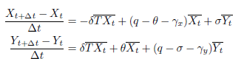
where ${\overline{X}}_{t}$= (X_{t+∆t} + X_{t})/2, ${\overline{Y}}_{t}$ = (Y_{t+∆t} + Y_{t})/2, and ${\overline{XT}}_{t}$ = (X_{t+∆t}T_{t+∆t} + X_{t}T_{t})/2; ∆t = 1 for
annually data and ∆t = 0.25 for quarterly data.

A16.1.1 The Bayesian approach

We proposed the following Bayesian model with the time-series data of onset rates (Λ), proportional resistant P (Res), and .

Priors for the parameters with the log-Normal distribution

π ∼ Uniform(0, 1)
δ ∼ LogNormal(0, 1)
∼ LogNormal(0, 1) σ ∼ LogNormal(0, 1) γ_{x} ∼ LogNormal(0, 1) γ_{y} ∼ LogNormal(0, 1)
Priors for random errors with the inverse-Gamma distribution

E_{x} ∼ InvGamma(1, 1) E_{y} ∼ InvGamma(1, 1) ω ∼ InvGamma(1, 1)
Main model fitting to data We fixed q at 1 (or any other value with exogenous data source) for ensuring the identifiability of the other parameters. The main model links the parameters to data.
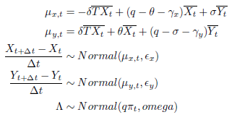

A16.2 Results: simulation study
We started with a simulation study for checking (1) sample size needed for this model and (2) potential bias of the parameter estimators. Firstly, we started with a parameter set of (theta = 0.02, delta = 0.02, sigma = 0.05) and tested the bias in percentage. Figure A16.1 shows that the model estimators start to converge when the lengths of time-series larger than 15.

Figure A16.1: Length of time-series and convergence
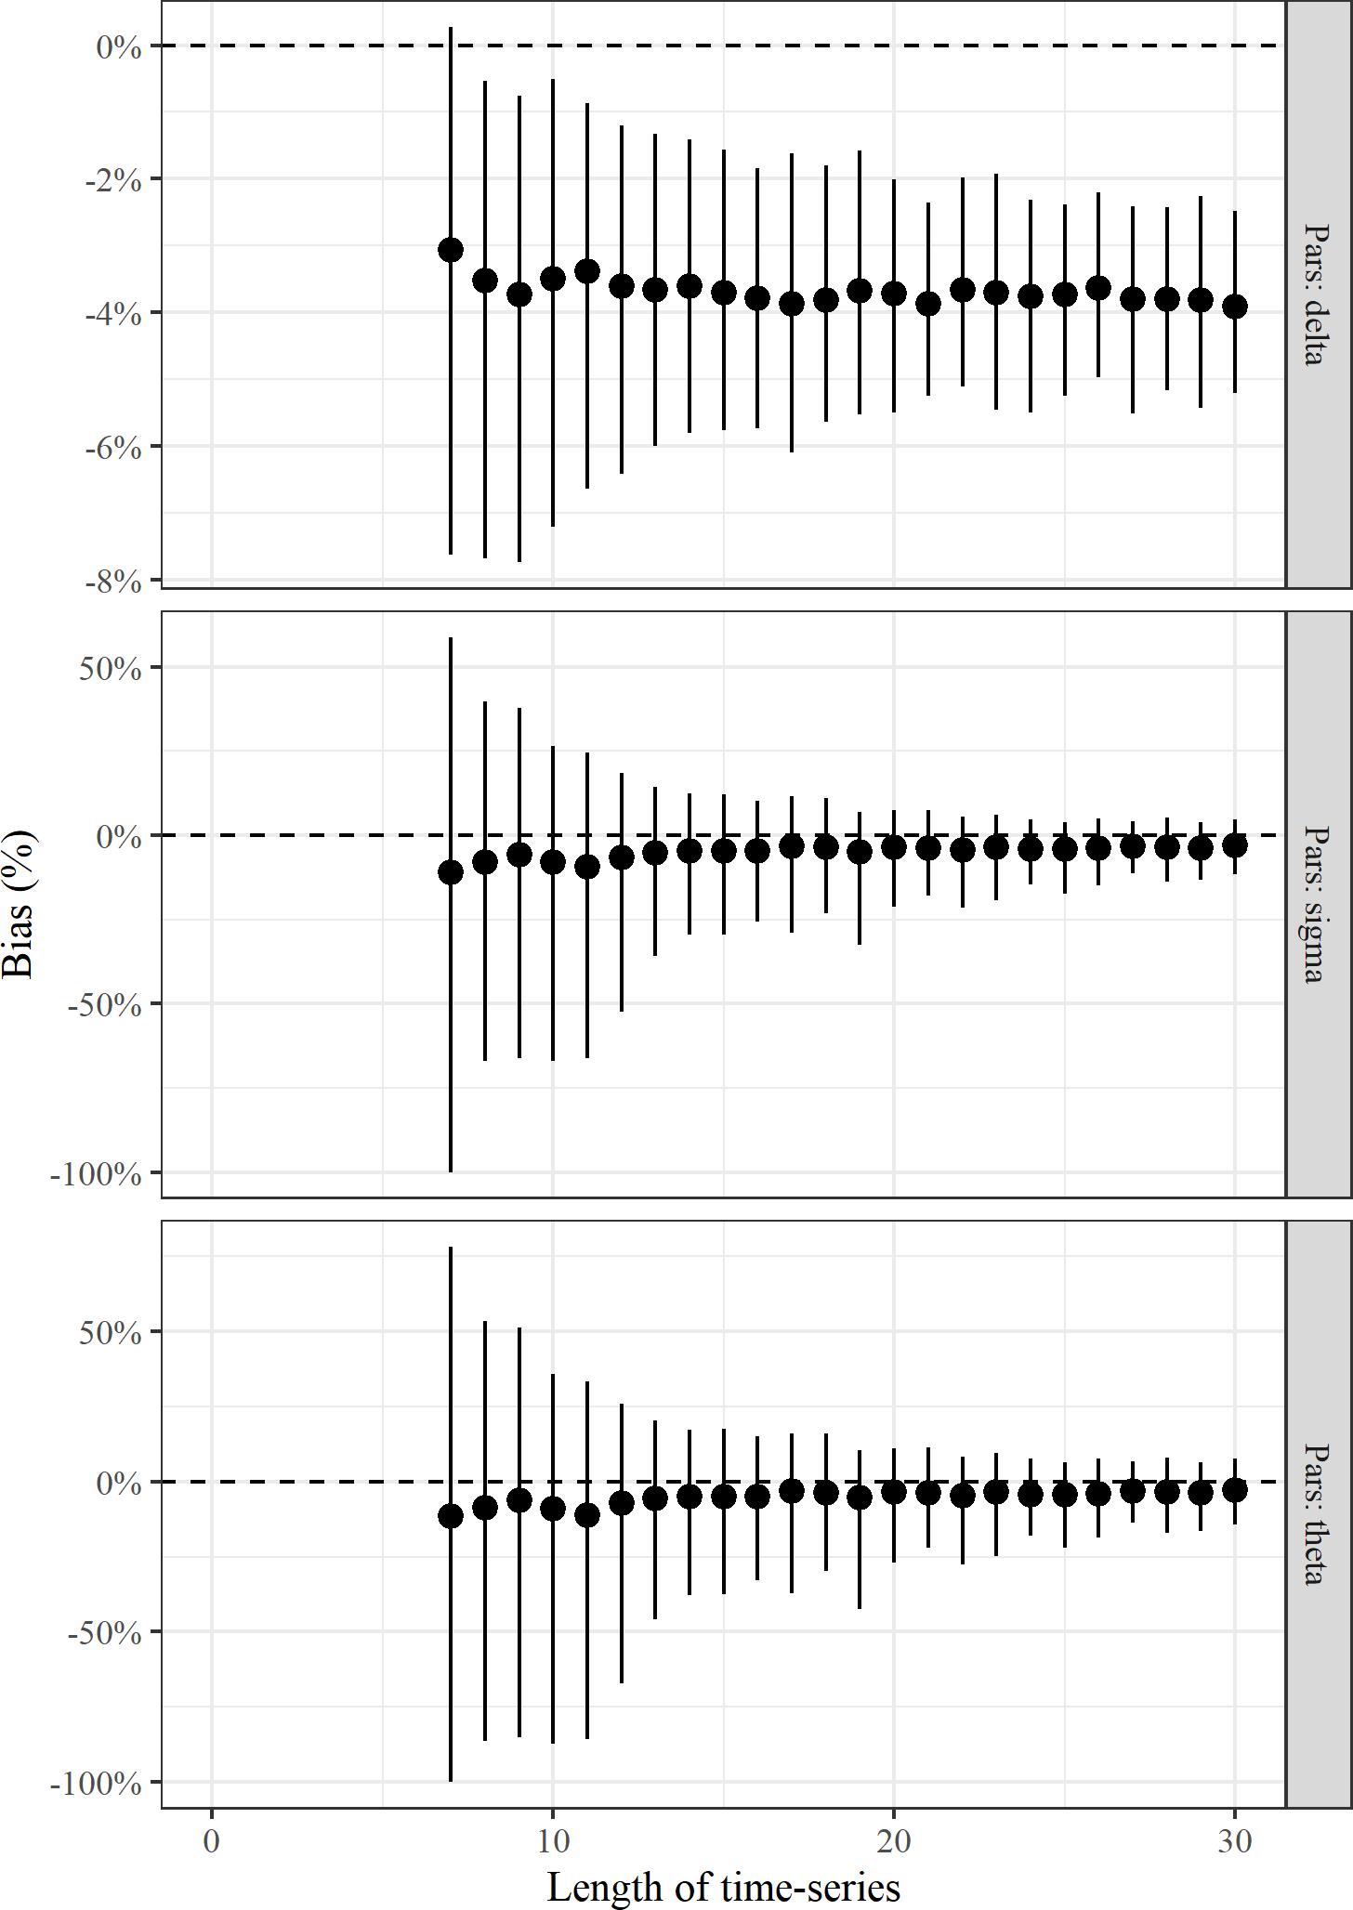
Then, we expanded the parameter space with θ ∈ (0.01, 0.05), δ ∈ (0.01, 0.05), and σ ∈ (0.01, 0.1) to
check if the model can provide unbiased estimators. Figure A16.2 and Figure A16.3 demonstrate that θ and σ are unbiased while Figure A16.4 suggests that there is a system bias of δ causing underestimation.

Figure A16.2: Resistance development, natural mutation (θ)
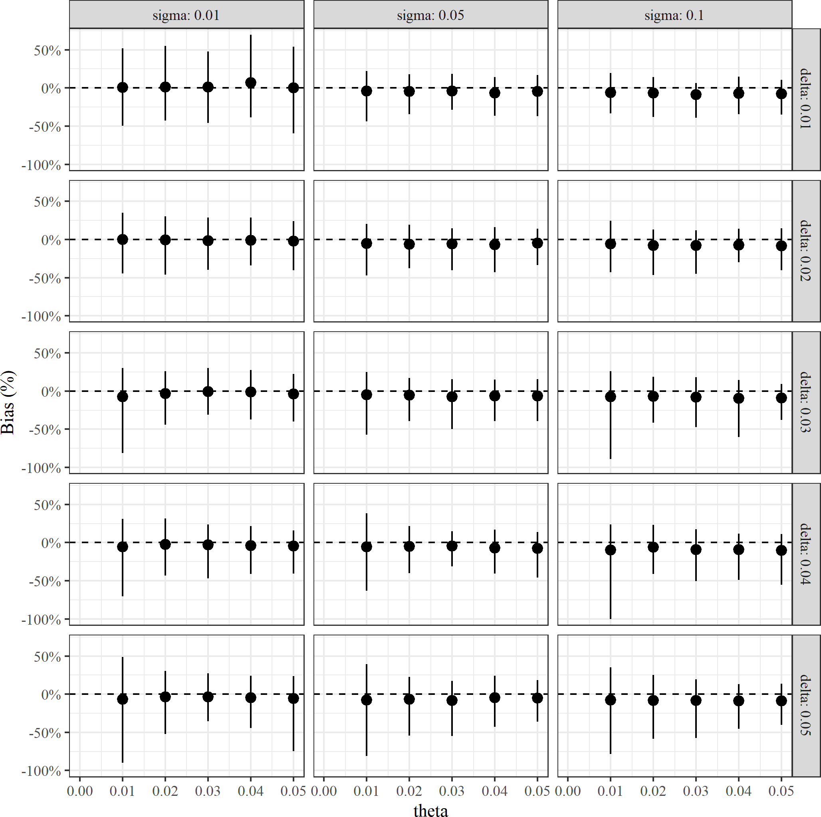

Figure A16.3: Resistance development, amplification (δ)
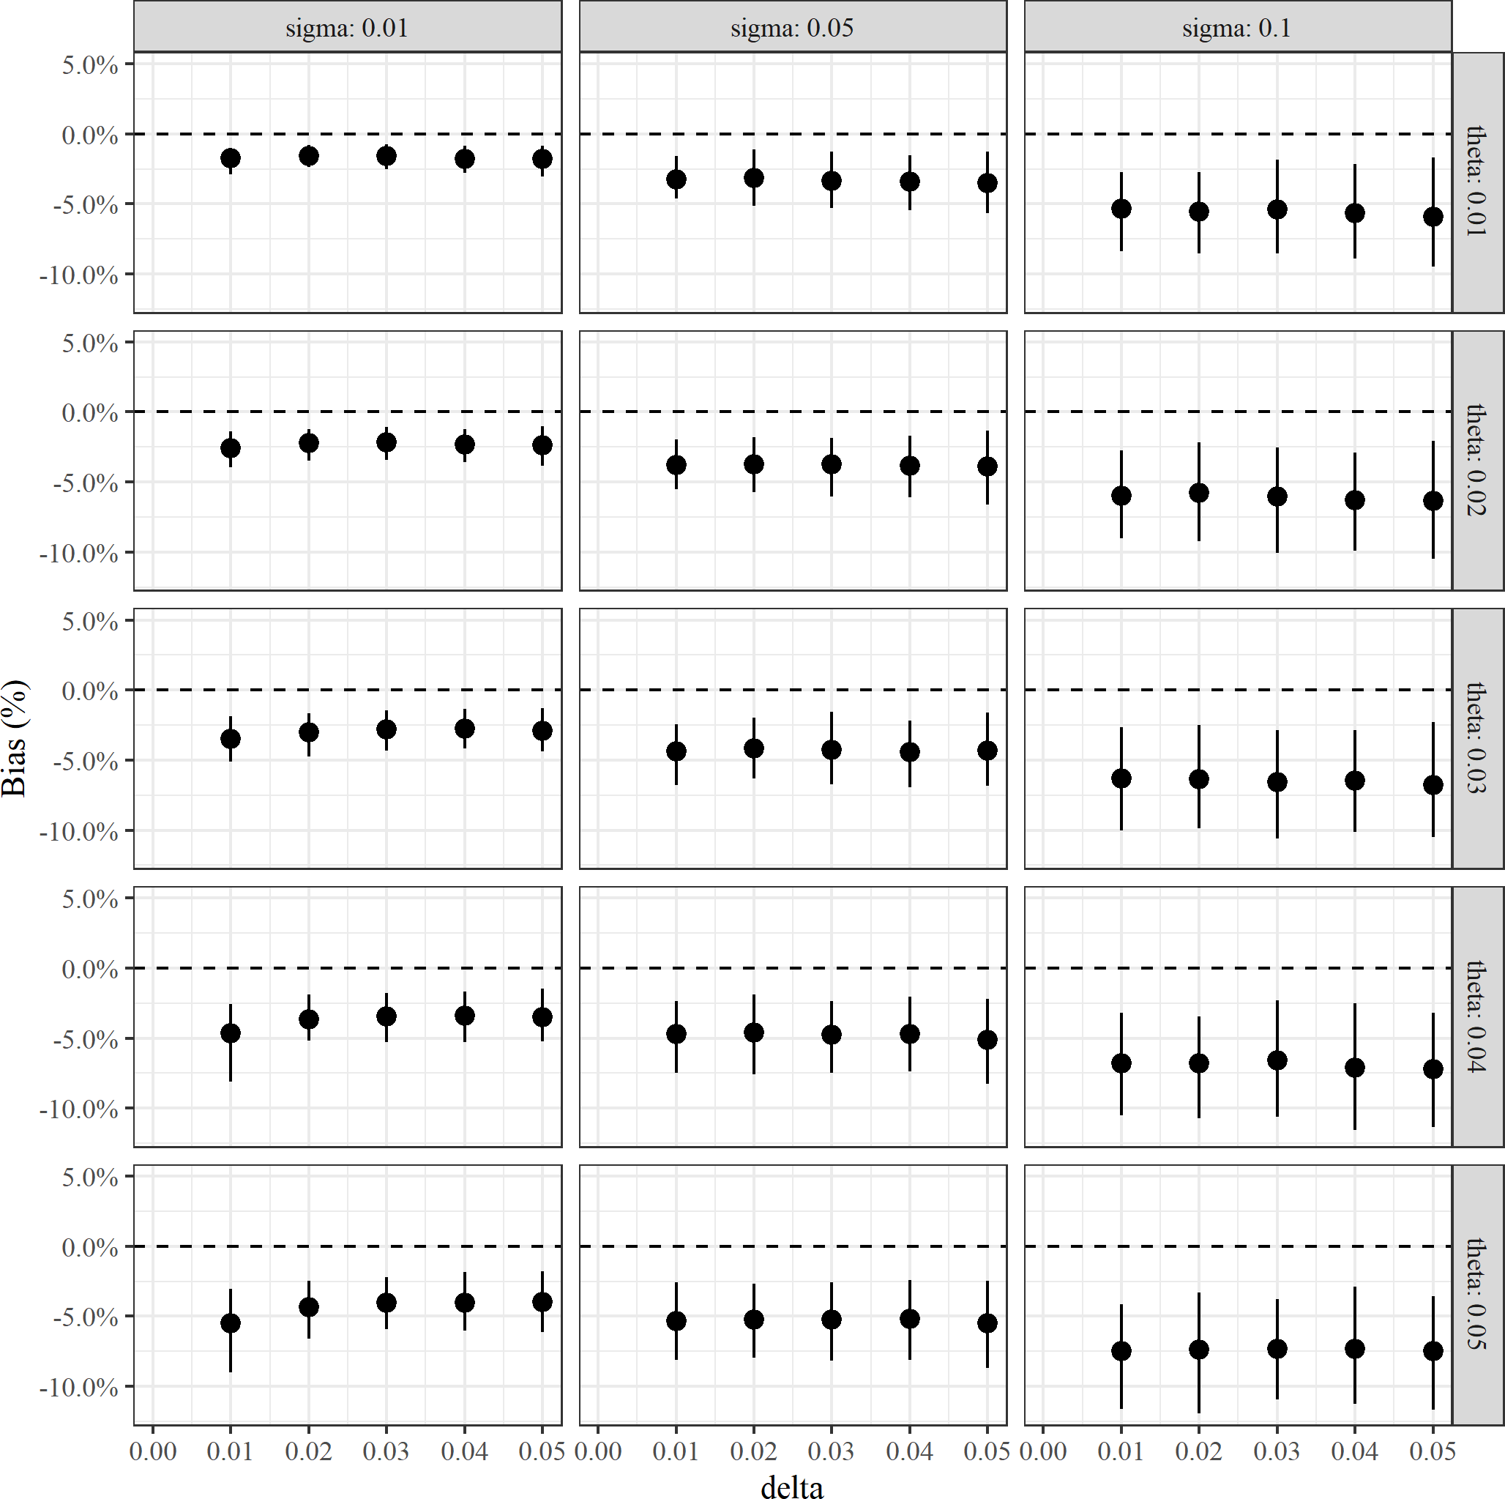

Figure A16.4: Resistance loss (σ)
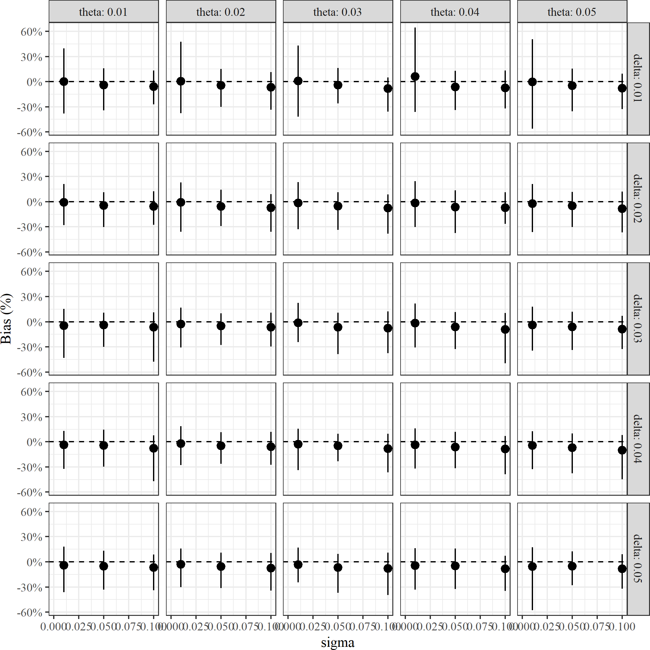

Appendix 17: Implementing the relationship between drug use and resistance.

For illustration, this will use the estimated strong association value from the Escherichia coli analyses (coefficient of 10.11). The following steps were implemented:
- Obtain estimates of the numbers treated per year with cefiderocol. The derivation of these estimates is described in the main text. This was done separately for the two clinical sites of cUTI and HAP/VAP. To obtain an extreme estimate of the impact of AM use on resistance, it was assumed that these sites also included:
  - For cUTI, IAI was also included.
  - For HAP/VAP, BSI was also included.
  - For the MBL Enterobacterales population, stenotrophomonas were also included.
- The impact of these assumptions were to concentrate all of the increase in resistance (due to use amongst a broad patient population) in the HVCS.
- Evidence on duration of treatment was taken from Section 8.2.3.6, with no difference by pathogen (CPE or psuedomona).
- It was assumed that multiplying the number of people treated by their duration of treatment and dividing by 365.25 would provide the defined daily doses per day. To support this assumption, the recommended indications for each AM in the British National Formulary (BNF) were compared with defined daily doses (DDDs) provided by the World Health Organization (WHO). The two were deemed to be sufficiently similar. For example, for colistin (colistimethate sodium) the BNF provides an indication of 9 million units daily by intravenous infusion for adults with “serious infections due to selected aerobic Gram-negative bacteria in patients with limited treatment options”. This is the same as the DDD for colistin provided by the WHO. Similarly, the BNF indication for tigecycline is 0.1g per day by intravenous infusion for “complicated intra-abdominal infections (when other antibiotics are not suitable)”. This is again the same as the WHO DDD.
- This value was then multiplied by 1,000 and divided by the Office for National Statistics' Mid-Year Population Estimate for the United Kingdom (June 2020). The value for the entire population was used (67,081,234) for consistency with the definition of AM use provided by ESAC-Net.
- The year-on-year increase in resistance was calculated by mutlipling the year-on-year increase in AM use (DDD per 1,000 inhabitants) by the coefficient of 10.11. This provided the absolute increase in resistance. It was assumed that to begin with there was no use of cefiderocol. This will be a slight under-estimate and hence the subsequent increase in resistance will be a slight over-estimate.

This approach led to estimated very small increases in resistance: over 20 years the resistance to cefiderocol increased by 0.12% 1.38%. Hence alternative scenarios were considered to explore more extreme increases in resistance over time. An exploratory analysis used the same surveillance data (used to estimate the relationship between AM use and resistance) to inform absolute rates of change in susceptibility over time. This was motivated by noting that there are several potential drivers for AM resistance beyond AM use. For each country a linear regression was fit with resistance level as the outcome (range 0 to 100) and time in years as the independent variable. The statistical significance of the trend coefficient was used to identify countries for which there was a significant increase in resistance over time during the period for which data was available. Statistical significance was originally taken to be a p-value of less than 0.05. Of these significant associations, the most extreme (largest trend coefficient) was used to represent an extreme scenario of growth in susceptibility. For the Escherichia coli cephalosporins, all of the regressions were statistically significant, with trend coefficients ranging form 0.41 (Malta) to 1.65 (Bulgaria). The only significant positive association for the Escherichia coli carbapenems was for Greece (0.04). Hence, for the CPE analyses an increase in resistance of 1.65% per year was used.
For the pseudomonas the only significant positive association was for the Netherlands (0.17). However, the value for Slovenia (0.83) was almost five times larger, with a p-value of 0.07. Hence for pseudomonas an increase in resistance of 0.83% per year was used. Employing these absolute increases led to an absolute twenty-year increase in resistance of 33.07% (for the CPE population) and 16.57% for the pseudomonas population. The second largest increase over 20 years was 19% for Greece. As a result, a twenty-year increase of 30% was viewed to represent the most extreme possible increase in resistance. Hence we considered scenarios in which the twenty-year increase in resistance to cefiderocol was 1%, 5%, 10%, and 30%.

Appendix 18: Plots of AM resistance over time: Public Health England data.

Figure A18.1: Resistance over time in CPE-MBL
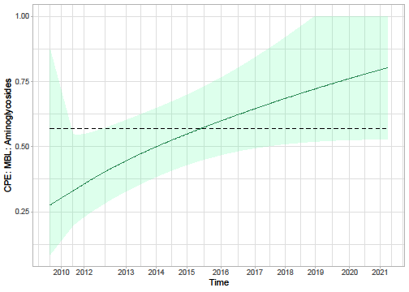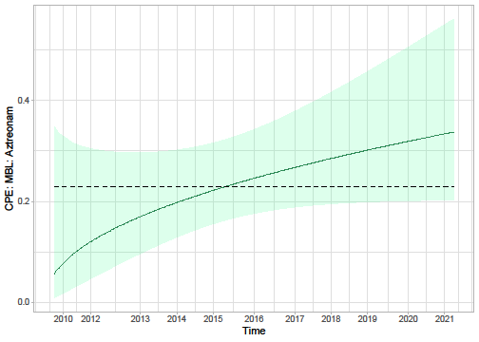
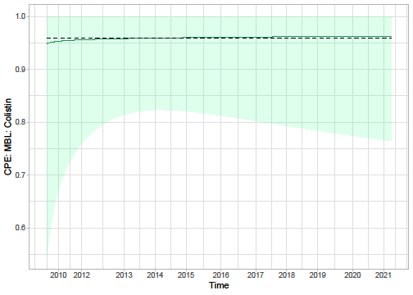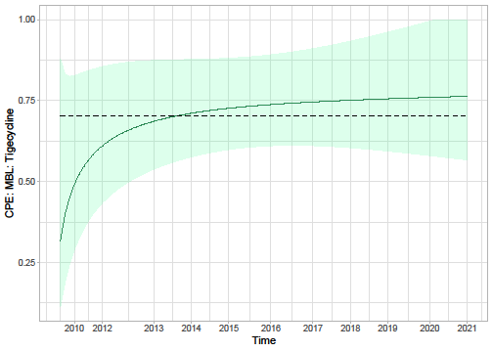
CPE, carbapenemase-producing Enterobacterales ;MBL, metallo-beta-lactamase

Figure A18.2: Resistance over time in Pseudomonas
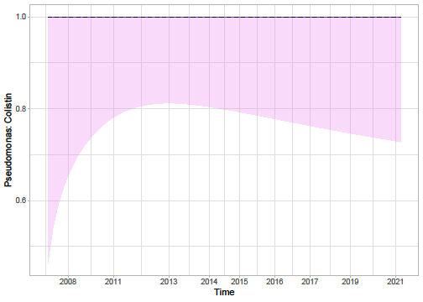

Appendix 19: Plots of AM resistance over time: surveillance data.
Figure A19.1: E. coli resistance to carbapenems in France
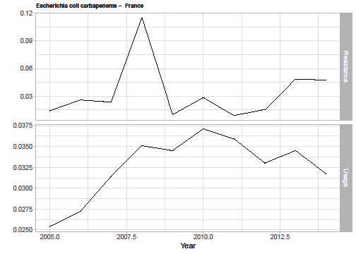
Figure A19.2: E. coli resistance to carbapenems in Greece
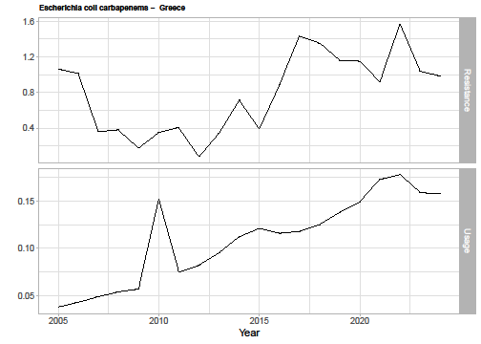
Figure A19.3: E. coli resistance to carbapenems in the Netherlands
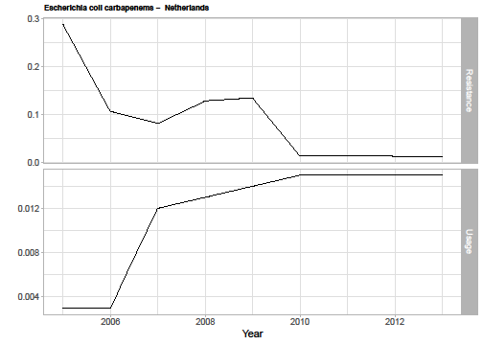
Figure A19.4: E. coli resistance to carbapenems in Norway
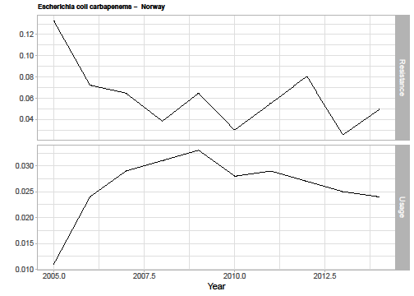
Figure 19.5: E. coli resistance to cephalosporins in Bulgaria
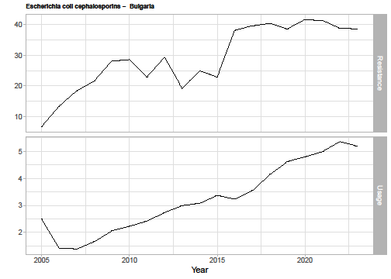
Figure A19.6: E. coli resistance to cephalosporins in Croatia
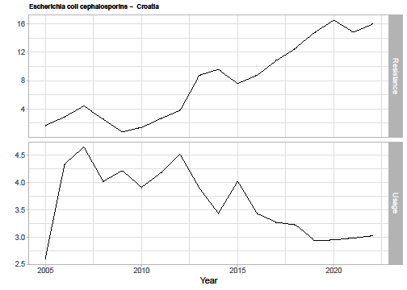
Figure A19.7: E. coli resistance to cephalosporins in Estonia
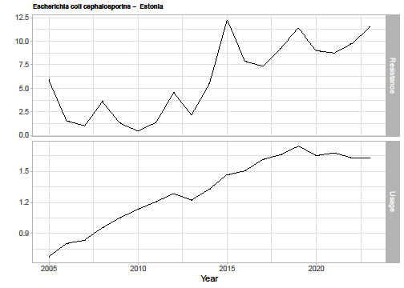
Figure A19.8: E. coli resistance to cephalosporins in Finland
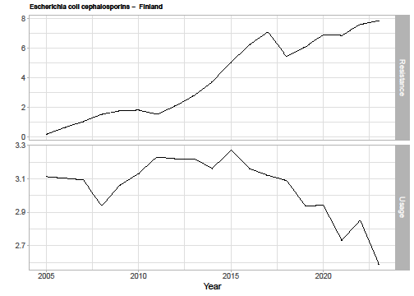

Figure A19.9: E. coli resistance to cephalosporins in France
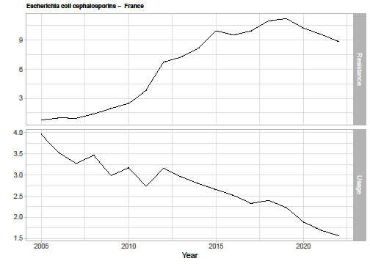
Figure A19.10: E. coli resistance to cephalosporins in Greece
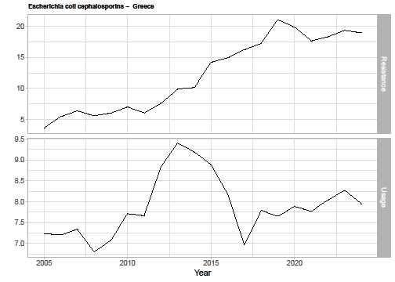
Figure A19.11: E. coli resistance to cephalosporins in Ireland
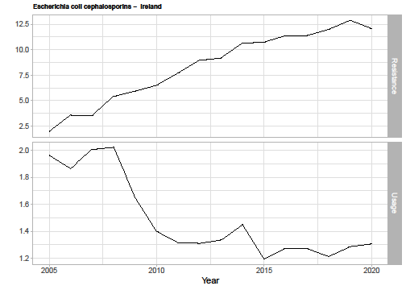
Figure A19.12: E. coli resistance to cephalosporins in Luxembourg
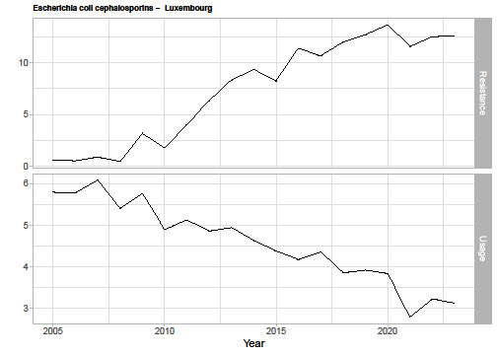
Figure A19.13: E. coli resistance to cephalosporins in Malta
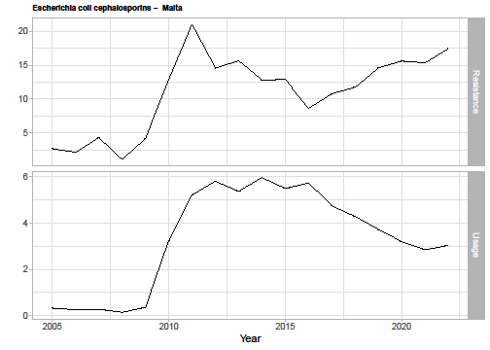
Figure A19.14: E. coli resistance to cephalosporins in Norway
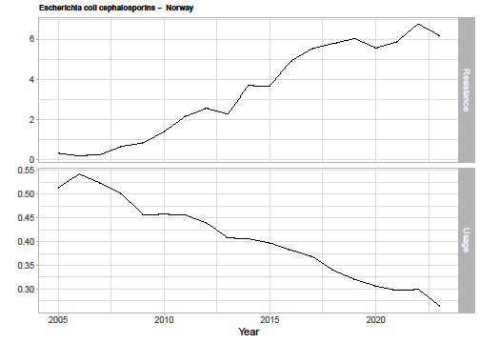
Figure A19.15: E. coli resistance to cephalosporins in Slovenia
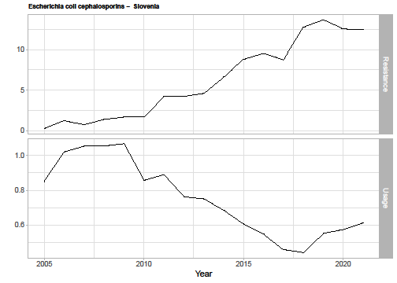
Figure A19.16: E. coli resistance to cephalosporins in Sweden
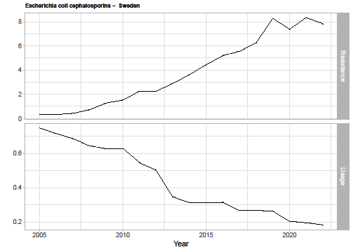
Figure A19.17: Pseudomonas resistance in France
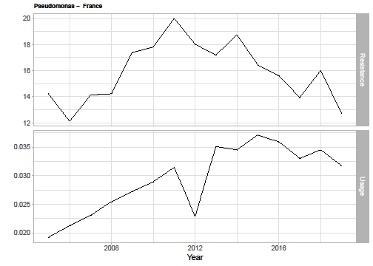
Figure A19.18: Pseudomonas resistance in Finland
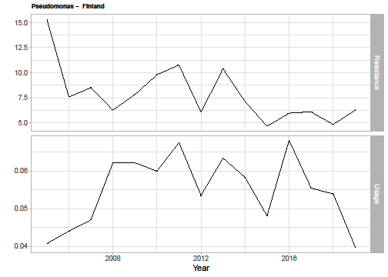
Figure A19.19: Pseudomonas resistance in Ireland
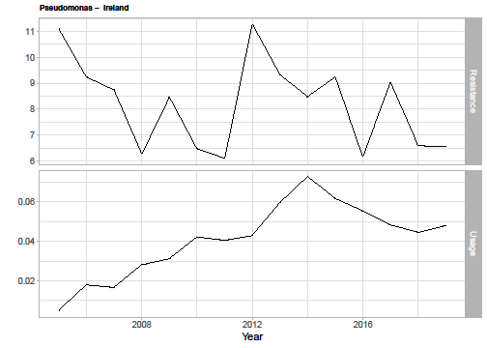
Figure A19.20: Pseudomonas resistance in The Netherlands
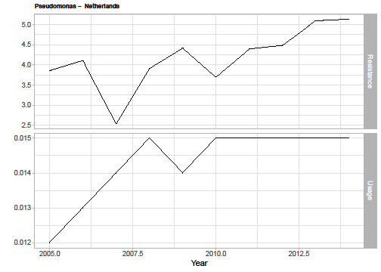
Figure A19.21: Pseudomonas resistance in Norway.
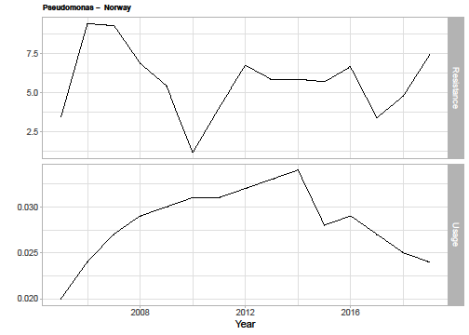
Figure A19.22: Pseudomonas resistance in Slovenia
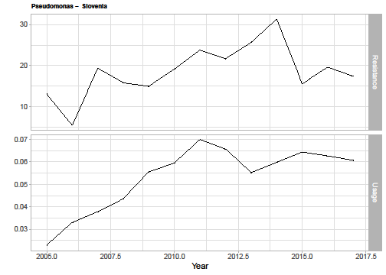
Figure A19.23: Pseudomonas resistance in Slovenia

Appendix 20: Total population INHE across the first 10 years of usage
Table A20.1: Total population INHE across the first 10 years of usage
Baseline population | Pop. growth rate | Change in resistance | HAP/ VAP (CPE MBL) | HAP/ VAP (Pseud. MBL) | HAP/ VAP (Sten.) | cUTI (CPE MBL) | cUTI (Pseud. MBL) | cUTI (Sten.) | BSI (CPE MBL) | BSI (Pseud. MBL) | BSI (Sten.) | IAI (CPE MBL) | IAI (Pseud. MBL) | IAI (Sten.) | Total | Proportion of 20 year INHE (%)
PHE categories of specimen types (scenario P1) | Model with damped effect G1) | 1% (R1) | 40 | 7 | 24 | 14 | 18 | 29 | 244 | 17 | 25 | 12 | 13 | 17 | 460 | 51.3%
 |  | 5% (R2) | 39 | 7 | 24 | 14 | 18 | 29 | 240 | 16 | 24 | 11 | 13 | 16 | 451 | 51.8%
 |  | 10% (R3) | 38 | 7 | 23 | 13 | 18 | 28 | 235 | 16 | 24 | 11 | 13 | 16 | 442 | 52.7%
 |  | 30% (R4) | 35 | 6 | 21 | 12 | 17 | 27 | 217 | 15 | 22 | 10 | 12 | 15 | 409 | 57.6%
 | Model without damped effect (G2) | 1% (R1) | 49 | 7 | 30 | 17 | 18 | 34 | 300 | 17 | 29 | 14 | 13 | 19 | 547 | 41.0%
 |  | 5% (R2) | 48 | 7 | 29 | 17 | 18 | 34 | 295 | 16 | 29 | 14 | 13 | 19 | 539 | 41.8%
 |  | 10% (R3) | 47 | 7 | 29 | 16 | 18 | 33 | 289 | 16 | 29 | 14 | 13 | 19 | 530 | 42.9%
 |  | 30% (R4) | 43 | 6 | 26 | 15 | 17 | 31 | 265 | 15 | 27 | 13 | 12 | 18 | 488 | 48.1%
Clinical advisors’ categories of specimen types (scenario P2) | Model with damped effect G1) | 1% (R1) | 247 | 108 | 366 | 19 | 11 | 22 | 244 | 17 | 25 | 12 | 13 | 17 | 1101 | 52.0%
 |  | 5% (R2) | 244 | 107 | 362 | 19 | 11 | 21 | 240 | 16 | 24 | 11 | 13 | 16 | 1084 | 52.6%
 |  | 10% (R3) | 239 | 105 | 357 | 18 | 11 | 21 | 235 | 16 | 24 | 11 | 13 | 16 | 1066 | 53.6%
 |  | 30% (R4) | 220 | 98 | 337 | 17 | 10 | 20 | 217 | 15 | 22 | 10 | 12 | 15 | 993 | 58.2%
 | Model without damped effect (G2) | 1% (R1) | 304 | 108 | 419 | 23 | 11 | 26 | 300 | 17 | 29 | 14 | 13 | 19 | 1283 | 42.9%
 |  | 5% (R2) | 299 | 107 | 414 | 23 | 11 | 26 | 295 | 16 | 29 | 14 | 13 | 19 | 1266 | 43.6%
 |  | 10% (R3) | 293 | 105 | 408 | 22 | 11 | 25 | 289 | 16 | 29 | 14 | 13 | 19 | 1244 | 44.6%
 |  | 30% (R4) | 268 | 98 | 384 | 21 | 10 | 24 | 265 | 15 | 27 | 13 | 12 | 18 | 1155 | 49.5%
BSI, bloodstream infection; CPE, carbapenem-producing Enterobacterales; cUTI, complicated urinary tract infection; HAP/VAP, hospital-acquired pneumonia or ventilator-associated pneumonia; IAI, intraabdominal infection; MBL, metallo-beta-lactamases; PHE, Public Health England; Pseud, Pseudomonas; Steno, Stenotrophomonas

References
1. Portsmouth S, van Veenhuyzen D, Echols R, et al. Cefiderocol versus imipenem-cilastatin for the treatment of complicated urinary tract infections caused by Gram-negative uropathogens: a phase 2, randomised, double-blind, non-inferiority trial. The Lancet Infectious Diseases 2018;18:1319-28.
2. Wunderink RG, Matsunaga Y, Ariyasu M, et al. Cefiderocol versus high-dose, extended-infusion meropenem for the treatment of Gram-negative nosocomial pneumonia (APEKS-NP): a randomised, double-blind, phase 3, non-inferiority trial. The Lancet Infectious Diseases 2021;21:213-25.
3. Bassetti M, Echols R, Matsunaga Y, et al. Efficacy and safety of cefiderocol or best available therapy for the treatment of serious infections caused by carbapenem-resistant Gram-negative bacteria (CREDIBLE-CR): a randomised, open-label, multicentre, pathogen-focused, descriptive, phase 3 trial. The Lancet Infectious Diseases 2021;21:226-40.
4. Bleibtreu A, Dortet L, Bonnin RA, et al. Susceptibility Testing Is Key for the Success of Cefiderocol Treatment: A Retrospective Cohort Study. Microorganisms 2021;9:30.
5. Falcone M, Tiseo G, Nicastro M, et al. Cefiderocol as rescue therapy for Acinetobacter baumannii and other carbapenem-resistant Gram-Negative infections in ICU patients. Clinical infectious diseases : an official publication of the Infectious Diseases Society of America 2020;17.
6. Haller S, Kramer R, Becker K, et al. Extensively drug-resistant Klebsiella pneumoniae ST307 outbreak, north-eastern Germany, June to October 2019. Eurosurveillance 2019;24.
7. Oliva A, Ceccarelli G, De Angelis M, et al. Cefiderocol for compassionate use in the treatment of complicated infections caused by extensively and pan-resistant Acinetobacter baumannii. Journal of Global Antimicrobial Resistance 2020;23:292-6.
8. Shields RK, Iovleva A, Kline EG, Kawai A, McElheny CL, Doi Y. Clinical evolution of AmpC-mediated ceftazidime-avibactam and cefiderocol resistance in enterobacter cloacae complex following exposure to cefepime. Clinical Infectious Diseases 2020;71:2713-6.
9. Zingg S, Nicoletti GJ, Kuster S, et al. Cefiderocol for Extensively Drug-Resistant Gram-Negative Bacterial Infections: Real-world Experience From a Case Series and Review of the Literature. Open forum infect 2020;7:ofaa185.
10. Kaase M, Pfennigwerth N, Lange F, Anders A, Gatermann SG. Molecular epidemiology of VIM-1 producing Escherichia coli from Germany referred to the National Reference Laboratory. Int J Med Microbiol 2015;305:784-9.
11. Ojdana D, Gutowska A, Sacha P, Majewski P, Wieczorek P, Tryniszewska E. Activity of Ceftazidime-Avibactam Alone and in Combination with Ertapenem, Fosfomycin, and Tigecycline Against Carbapenemase-Producing Klebsiella pneumoniae. Microb Drug Resist 2019;25:1357-64.
12. Cuba GT, Rocha-Santos G, Cayô R, et al. In vitro synergy of ceftolozane/tazobactam in combination with fosfomycin or aztreonam against MDR Pseudomonas aeruginosa. J Antimicrob Chemother 2020;75:1874-8.
13. Johnston BD, Thuras P, Porter SB, et al. Activity of cefiderocol, ceftazidime-avibactam, and eravacycline against carbapenem-resistant escherichia coli isolates from the united states and international sites in relation to clonal background, resistance genes, coresistance, and region. Antimicrobial Agents and Chemotherapy 2020;64.
14. Aires CA, Pereira PS, de Araujo CF, et al. Multiclonal Expansion of Klebsiella pneumoniae Isolates Producing NDM-1 in Rio de Janeiro, Brazil. Antimicrob Agents Chemother 2017;61.
15. Sonnevend Á, Ghazawi A, Darwish D, et al. In vitro efficacy of ceftazidime-avibactam, aztreonam-avibactam and other rescue antibiotics against carbapenem-resistant Enterobacterales from the Arabian Peninsula. Int J Infect Dis 2020;99:253-9.
16. Kohira N, Hackel MA, Ishioka Y, et al. Reduced susceptibility mechanism to cefiderocol, a siderophore cephalosporin, among clinical isolates from a global surveillance programme (SIDERO-WT-2014). Journal of Global Antimicrobial Resistance 2020;22:738-41.
17. Kohira N, West J, Ito A, et al. In Vitro Antimicrobial Activity of a Siderophore Cephalosporin, S-649266, against Enterobacteriaceae Clinical Isolates, Including Carbapenem-Resistant Strains. Antimicrob Agents Chemother 2016;60:729-34.
18. Jahan S, Davis H, Ashcraft DS, Pankey GA. Evaluation of the in vitro interaction of fosfomycin and meropenem against metallo-β-lactamase-producing Pseudomonas aeruginosa using Etest and time-kill assay. J Investig Med 2021;69:371-6.
19. Ojdana D, Gutowska A, Sacha P, Majewski P, Wieczorek P, Tryniszewska E. Activity of Ceftazidime-Avibactam Alone and in Combination with Ertapenem, Fosfomycin, and Tigecycline Against Carbapenemase-Producing Klebsiella pneumoniae. Microb Drug Resist 2019;25:1357-64.
20. Bassetti M, Rello J, Blasi F, et al. A systematic review on the impact of appropriate versus inappropriate initial antibiotic therapy on the outcomes of patients with severe bacterial infections. International Journal of Antimicrobial Agents 2020:106184.
21. Shea BJ, Reeves BC, Wells G, et al. AMSTAR 2: a critical appraisal tool for systematic reviews that include randomised or non-randomised studies of healthcare interventions, or both. bmj 2017;358.
22. Lopes S, Franceschini M, Han Y, Green W, Dymond A, Gill A. Economic evaluation of cefiderocol for the treatment of carbapenem resistant infections in the United States. AMCP Nexus 2020 Virtual,. Oct 19-23, 2020 2020. Poster.; 2020.
23. Chen GJ, Pan SC, Foo J, Morel C, Chen WT, Wang JT. Comparing ceftolozane/tazobactam versus piperacillin/tazobactam as empiric therapy for complicated urinary tract infection in Taiwan: A cost-utility model focusing on gram-negative bacteria. J Microbiol Immunol Infect 2019;52:807-15.
24. Nelson RE, Ray W, Rubin MA, Schweizer M. Evaluating the cost-effectiveness of decolonization for prevention of MRSA infections using a dynamic tran smission model. Antimicrobial Resistance and Infection Control Conference: 5th International Conference on Prevention and Infection Control, ICPIC 2019;8.
25. Mewes JC, Pulia MS, Mansour MK, Broyles MR, Nguyen HB, Steuten LM. The cost impact of PCT-guided antibiotic stewardship versus usual care for hospitalised patients with suspected sepsis or lower respiratory tract infections in the US: A health economic model analysis. PLoS ONE [Electronic Resource] 2019;14:e0214222.
26. Gordon J, Darlington O, McEwan P, et al. Estimating the Value of New Antimicrobials in the Context of Antimicrobial Resistance: Development and Application of a Dynamic Disease Transmission Model. Pharmacoeconomics 2020;38:857-69.
27. Tichy E, Torres A, Bassetti M, et al. Cost-effectiveness Comparison of Ceftazidime/Avibactam Versus Meropenem in the Empirical Treatment of Hospital-acquired Pneumonia, Including Ventilator-associated Pneumonia, in Italy. Clin Ther 2020;42:802-17.
28. Simon MS, Sfeir MM, Calfee DP, Satlin MJ. Cost-effectiveness of ceftazidime-avibactam for treatment of carbapenem-resistant Enterobacteriaceae bacteremia and pneumonia. Antimicrob Agents Chemother 2019;23:23.
29. Gifford DR, Furio V, Papkou A, Vogwill T, Oliver A, MacLean RC. Identifying and exploiting genes that potentiate the evolution of antibiotic resistance. Nat 2018;2:1033-9.
30. Kongnakorn T, Wagenlehner F, Falcone M, et al. Cost-effectiveness analysis of ceftazidime/avibactam compared to imipenem as empirical treatment for complicated urinary tract infections. International Journal of Antimicrobial Agents 2019;54:633-41.
31. Nguyen CP, Dan Do TN, Bruggemann R, et al. Clinical cure rate and cost-effectiveness of carbapenem-sparing beta-lactams vs. meropenem for Gram-negative infections: A systematic review, meta-analysis, and cost-effectiveness analysis. International Journal of Antimicrobial Agents 2019;54:790-7.
32. Kongnakorn T, Eckmann C, Bassetti M, et al. Cost-effectiveness analysis comparing ceftazidime/avibactam (CAZ-AVI) as empirical treatment comparing to ceftolozane/tazobactam and to meropenem for complicated intra-abdominal infection (cIAI). Antimicrobial Resistance & Infection Control 2019;8:204.
33. Wagner AP, Enne VI, Livermore DM, Craig JV, Turner DA. Review of health economic models exploring and evaluating treatment and management of hospital-acquired pneumonia and ventilator-associated pneumonia. Journal of Hospital Infection 2020;106:745-56.
34. Edwards SJ, Wordsworth S, Clarke MJ. Treating pneumonia in critical care in the United Kingdom following failure of initial antibiotic: a cost-utility analysis comparing meropenem with piperacillin/tazobactam. Eur J Health Econ 2012;13:181–92.
35. Grau S, Alvarez-lerma F, Del castillo A, Neipp R, Rubio-terrés C. Cost-effectiveness analysis of the treatment of ventilator-associated pneumonia with linezolid or
vancomycin in Spain. Journal of Chemotherapy;17:203-11.
36. Kongnakorn T, Mwamburi M, Merchant S, Akhras K, Caro JJ, Nathwani D. Economic evaluation of doripenem for the treatment of nosocomial pneumonia in the US: discrete event simulation. Curr Med Res Opin 2010;26:17-24.
37. Kauf TL, Prabhu VS, Medic G, et al. Cost-effectiveness of ceftolozane/tazobactam compared with piperacillin/tazobactam as empiric therapy based on the in-vitro surveillance of bacterial isolates in the United States for the treatment of complicated urinary tract infections. BMC Infectious Diseases 2017;17:314.
38. BNF: British National Formulary - NICE. 2021. (Accessed at https://bnf.nice.org.uk/.)
39. World Health Organisation. WHO Collaboration Centre for Drug Statistics Methodology. In; 2021.
40. Kallel H, Hergafi L, Bahloul M, et al. Safety and efficacy of colistin compared with imipenem in the treatment of ventilator-associated pneumonia: a matched case-control study. INtensive Care Med 2007;33:1162-67.
41. Department of Health and Social Care. Drugs and pharmaceutical electronic market information tool (eMIT). In; 2021.
42. Hawkey PM, Warren RE, Livermore DM, et al. Treatment of infections caused by multidrug-resistant gram-negative bacteria: Report of the British society for antimicrobial chemotherapy/healthcare infection society/british infection association joint working party. Journal of Antimicrobial Chemotherapy 2018;73:iii2-iii78.
43. Renascience Pharma Ltd. Renapime 1g Powder for solution for injection/infusion: SmPC.
44. Hyndman RJ, Athanasopoulos G. Forecasting: principles and practice: OTexts; 2018.
45. Liboschik T, Fokianos K, Fried R. tscount: An R package for analysis of count time series following generalized linear models. Journal of Statistical Software 2017;82:1-51.
46. Aliabadi S, Anyanwu P, Beech E, et al. Effect of antibiotic stewardship interventions in primary care on antimicrobial resistance of Escherichia coli bacteraemia in England (2013–18): a quasi-experimental, ecological, data linkage study. The Lancet Infectious Diseases 2021.
47. Kearns B, Stevenson MD, Triantafyllopoulos K, Manca A. Generalized linear models for flexible parametric modeling of the hazard function. Med Decis Making 2019;39:867-78.
48. Ortiz-Brizuela E, Caro-Vega Y, Bobadilla-del-Valle M, et al. The influence of hospital antimicrobial use on carbapenem-non-susceptible Enterobacterales incidence rates according to their mechanism of resistance: a time-series analysis. Journal of Hospital Infection 2020;105:757-65.
49. Gharbi M, Moore LS, Gilchrist M, et al. Forecasting carbapenem resistance from antimicrobial consumption surveillance: Lessons learnt from an OXA-48-producing Klebsiella pneumoniae outbreak in a West London renal unit. International Journal of Antimicrobial Agents 2015;46:150-6.
50. Berger P, Pascal L, Sartor C, et al. Generalized additive model demonstrates fluoroquinolone use/resistance relationships for Staphylococcus aureus. European journal of epidemiology 2004;19:453-60.
51. Johnson AP, Muller-Pebody B, Budd E, et al. Improving feedback of surveillance data on antimicrobial consumption, resistance and stewardship in England: putting the data at your Fingertips. Journal of Antimicrobial Chemotherapy 2017;72:953-6.
52. European Surveillance of Antimicrobial Consumption Network (ESAC-Net). 2021. (Accessed at https://www.ecdc.europa.eu/en/about-us/partnerships-and-networks/disease-and-laboratory-networks/esac-net.)
53. European Antimicrobial Resistance Surveillance Network (EARS-Net). 2021. (Accessed at https://www.ecdc.europa.eu/en/about-us/partnerships-and-networks/disease-and-laboratory-networks/ears-net.)
54. AMR local indicators. 2021. (Accessed at https://fingertips.phe.org.uk/profile/amr-local-indicators.)
55. England PH. Escherichia coli (E. coli): guidance, data and analysis. In; 2017.
56. Sharland M, Pulcini C, Harbarth S, et al. Classifying antibiotics in the WHO Essential Medicines List for optimal use—be AWaRe. The Lancet Infectious Diseases 2018;18:18-20.
57. OpenPrescribing.net. 2021. (Accessed at https://openprescribing.net/.)
58. Control ECfDPa. Antimicrobial resistance in the EU/EEA (EARS-Net) - Annual Epidemiological Report for 2019. https://www.ecdc.europa.eu/en/publications-data/surveillance-antimicrobial-resistance-europe-2019; 2020.
59. Jeffrey B, Aanensen DM, Croucher NJ, Bhatt S. Predicting the future distribution of antibiotic resistance using time series forecasting and geospatial modelling. Wellcome Open Research 2020;5:194.
60. Davey P, Brown E, Charani E, et al. Interventions to improve antibiotic prescribing practices for hospital inpatients. Cochrane database of systematic reviews 2013.
61. Bhattacharya A, Hopkins S, Sallis A, Budd EL, Ashiru-Oredope D. A process evaluation of the UK-wide Antibiotic Guardian campaign: developing engagement on antimicrobial resistance. Journal of Public Health 2017;39:e40-e7.
62. McKenzie E, Gardner Jr ES. Damped trend exponential smoothing: a modelling viewpoint. International Journal of Forecasting 2010;26:661-5.
63. Spicknall IH, Foxman B, Marrs CF, Eisenberg JN. A modeling framework for the evolution and spread of antibiotic resistance: literature review and model categorization. Am J Epidemiol 2013;178:508-20.
64. Development. OfEC-oa. Stemming the Superbug Tide: Just a Few Dollars More. https://www.oecd.org/health/stemming-the-superbug-tide-9789264307599-en.htm; 2019.

