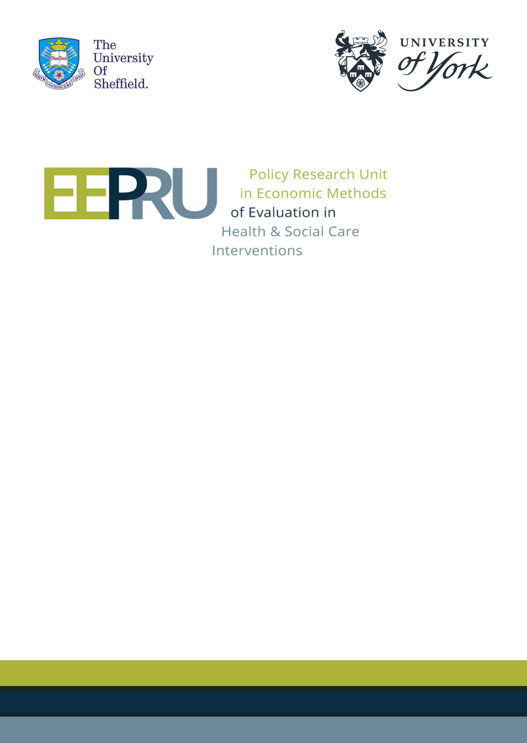

Final report for the technology evaluation of cefiderocol: addendum relating to scenario analyses
1st February 2022

Scenario 1: Future population health gains scenario

Background
Based on advice from clinical advisors, EEPRU has modelled a level of expected usage for the new antimicrobials (CAZ-AVI and cefiderocol) that reflects a relatively restrictive stewardship policy. An important expected benefit of such a policy is that future cohorts of patients can benefit from the new drugs as they will continue to be effective in the long term. These longer-term population health gains resulting from restricted short-term use have been described in the literature as ‘insurance value’. Feedback from NICE, the committee and consultees to the NICE process has questioned the extent to which the EEPRU evaluation work fully captures this aspect of benefit from the new products.

The EEPRU evaluation work has captured these long-term benefits to the extent that they accrue to patients within the quantified areas of expected usage, and assuming that, within these highly resistant infections, the level of resistance to existing drugs is constant over time. The latter assumption was based on available time series data on drug susceptibility.

There are several reasons why this may not fully quantify longer-term benefits:

- We may see higher levels of resistance to existing drugs within the areas of expected usage over time.
- We may see multi-drug resistant pathogens, against which the new drugs are effective, emerge that are currently rare or even unknown.
- We may see pathogens that are currently treatable with existing therapies (and are not therefore included in the areas of expected usage) become resistant.

If one or more of these factors emerge, they would be expected to occur in the long-term and quite possibly beyond 20 years.

Conducting quantitative modelling of these effects is unavoidably highly speculative; however, the committee may wish to reflect on these possibilities. Therefore, EEPRU has developed an additional scenario for exploring the magnitude of these effects.

Methods
The scenario aimed to explore the effect on incremental net health effects (INHEs) of cefiderocol in case of emergence of multi-resistant pathogens against which cefiderocol is the only effective treatment and, in that product’s absence, clinicians would be forced to use multidrug salvage therapy.

Patient-level benefit
The patient-level benefit was derived by adapting the model in the EEPRU report. Specifically, we assumed that, in patients with these new highly resistant infections, existing therapies are no longer effective. In this model, this was achieved by setting the susceptibility for all comparators to zero. Under this illustrative scenario, no safety differences are assumed as it is expected that, if treatments become completely ineffective, no treatment or only safe antimicrobials will be used. Furthermore, the susceptibility for cefiderocol is set to 90% (an estimate broadly reflecting the susceptibility across different scenarios in the report), and maintained at this level over the long-term, although we note that this is likely to overestimate INHEs as susceptibility to cefiderocol may be expected to wane over time.
In the ES, we assume everyone gets cefiderocol or non-colistin/aminoglycosides (comparator), then 5 days later they move into the MDS, and switch to the treatment they are susceptible to. For both cefiderocol and the comparator, 85% of the patients are assumed not have the target multidrug-resistant infection (as in the base-case modelling for MBL Enterobacterales) and these patients receive something else. When cefiderocol is available, the 15% who do have that target infection receive either cefiderocol (for 90% who are susceptible) or salvage therapy (for the 10% not susceptible to cefiderocol). When cefiderocol is not available, 100% of patients receive salvage therapy (the comparator).
In MDS we assume 90% cefiderocol/10% salvage therapy (when cefiderocol is available) or 100% salvage therapy (comparator).
The results represent the lifetime patient-level INHE of cefiderocol relative to multidrug salvage therapy expressed in QALYs.

Population-level benefit
To derive population-level benefits, patient level INHE is multiplied by the expected population size over the relevant time horizon and the probability of this scenario occurring. The patient-level INHE was assumed to remain constant over time. The population size is increased over time at a constant rate relative to baseline. Population benefits over time were discounted to reflect the delay in benefits received. Note that the relevant population here is not the same as the expected population in the main EEPRU report as these assumed to be entirely different pathogens.

The hypothetical nature of the scenario meant that there was no formal evidence to inform the extrapolation parameters and, as result, the parameter ranges were provided by the Committee. However, given the highly speculative nature of the analysis, EEPRU provided a flexible Excel-based tool, with user defined parameters, to support Committee deliberations in assessing the potential additional long-term health effects that may result from cefiderocol usage.

Table 1. Extrapolation parameters used in the base-case of the scenario and sensitivity analysis
User defined parameter | Base-case (range)
Probability of event (emergence of highly resistant strains) | 1% (0.5% - 5%)
Time of first event (from now) | 10 years (5 – 15 years)
The number of patients affected in the first year | 25 individuals (25-100)
The annual growth in the number of infections (from baseline) | 20% (3% - 30%)
Analysis time horizon (years) | 50 (20-50)
Population discount rate | 3.5%

The modifiable parameters in the Excel tool include the six extrapolation parameters: the probability of emergence of the highly resistant strains; the time of the first event; the number of patients affected in the first year; the annual growth rate in the number of infections (constant, relative to baseline); the analysis time horizon; and the discount rate.

In addition, the user can specify the site of infection and treatment setting reflected in the results (HAP/VAP empiric setting, HAP/VAP microbiology-directed setting and cUTI microbiology directed setting), or an alternative patient-level INHE reflecting the impact of these highly resistant infections in an alternative population.

The parameter estimates to use in the model were sought from the Committee and have been based on David Partridge’s email to NICE dated 30th December 2021 (Table 1).

Results
The patient-level INHEs in the base-case from the main EEPRU report and as used in this additional scenario, expressed in QALYs per patient, are shown in Table 2. In summary, assuming all specific existing treatment options have zero effectiveness increases the patient-level INHE for all sites and settings. The increase is greatest in the microbiology-directed setting, as all patients benefit from treatment with cefiderocol, compared to the empiric setting where only a proportion of people have the suspected pathogen-mechanism (as per EEPRU report, Table 22).

Table 2. Patient-level INHE (QALYs/patient)
 | Base-case | New scenario
HAP/VAP, ES | CPE: 0.147 (ca)  PsA: 0.153 (nca); 0.207 (ca) | 0.280
HAP/VAP, MDS | CPE: 0.021  PsA: 0.151 | 1.031
cUTI, MDS | CPE: 0.021  PsA: 0.147 | 1.032
ca, colistin/aminoglycosides; CPE, carbapenemase-producing Enterobacterales; cUTI, complicated urinary tract infection; ES, empiric setting; HAP/VAP, hospital acquired pneumonia/ventilator associated pneumonia; MDS, microbiology-directed setting; nca, non-colistin/aminoglycosides; PsA, Pseudomonas aeruginosa.

The population-level INHE (assuming patient-level benefit in cUTIs - the site with the highest patient-level INHE) is shown in Table 3 for a range of population-related scenarios. Overall, the benefit is relatively low (between 0.8 and 58.4 QALYs) compared to the expected benefit estimated in the EEPRU report (between 896 and 3,559 QALYs).

Table 3. Population-level results using the scenario base-case assumptions and sensitivity analyses
Value/assumption in base-case | Value/assumption in sensitivity analyses | Total number of patients | Total INHE (QALYs) conditional on event occurring | Expected INHE (QALYs)
Base-case, parameter values shown in Table 1 |  | 4,720 | 1460 | 14.6
Probability of event = 1% | Probability of event = 0.5% | 4,720 | 1460 | 7.3
Probability of event = 1% | Probability of event = 5% | 4,720 | 1460 | 73.0
Event occurs in 10 years | Event occurs in 5 years | 6,195 | 2180 | 21.8
Event occurs in 10 years | Event occurs in 15 years | 3,245 | 870 | 8.7
Number of patients in year 1 = 25 | Number of patients in year 1 = 100 | 18,880 | 5839 | 58.4
Population growth = 20% | Population growth = 3% | 1,388 | 452 | 4.5
Population growth = 20% | Population growth = 30% | 6,680 | 2053 | 20.5
Analysis time horizon = 50 years | Analysis time horizon = 20 years | 145 | 79 | 0.8
INHE, incremental net health effects; QALYs, quality adjusted life years.

Scenario 2: Accounting for the benefit in patients who cannot take colistin/aminoglycosides

Background
The analysis in the EEPRU report was based on a proportion of patients being resistant to existing therapies other than colistin/aminoglycosides. In which case it was assumed that, in the absence of cefiderocol, colistin/aminoglycosides would be administered to patients. The negative health effects and additional costs of renal toxicity associated with these products were explicitly modelled in assessing the patient-level INHEs of cefiderocol compared with existing therapies. Based the results of the network meta-analysis of EUCAST studies (Section 8.2.3.2 of the EEPRU report), 82% of patients shown to have MBL Pseudomonas aeruginosa in the ES were resistant to existing therapies other than colistin/aminoglycosides. For patients with suspected MBL Enterobacterales, all patients were assumed to receive colistin/aminoglycosides empirically, as outlined in Section 4.2.4 of the EEPRU report. In the MDS, 9% of patients with MBL Enterobacterales, and 72% of patients with MBL Pseudomonas aeruginosa were resistant to existing therapies other than colistin/aminoglycosides.

Consultees have indicated that, in terms of existing therapies (i.e., in a world without cefiderocol), there is a proportion of patients who would not receive colistin/aminoglycosides, even if no other effective therapy was available. This would be due to a patient’s high clinical risk of renal toxicity. For such patients, it can be assumed that they would only receive salvage therapy. The size of this sub-group of patients with an absolute contraindication to colistin/aminoglycosides was considered small by EEPRU’s clinical advisors. The Committee has requested a scenario which considers the magnitude of population-level INHEs for this sub-group using the Committee’s assumptions about the size of the cohort as a proportion of those estimated for the HVCSs in the report.

Methods
The scenario aimed to reflect the benefit of cefiderocol in patients who cannot take colistin and other aminoglycoside treatments and, therefore, without the new drug, would receive multidrug salvage therapy.

Patient-level benefit
For this scenario, the patient-level INHEs in those who can take colistin (the EEPRU base-case) and those who cannot are shown in Table 4. In the empiric setting, the incremental patient-level benefit of cefiderocol in HAP/VAP was derived by combining the EEPRU base-case and Scenario 1 above. In patients who were treated empirically and who were later confirmed to have an infection caused by the pathogens of interest (15% of patients with suspected MBL Enterobacterales and 14% of patients with suspected MBL Pseudomonas aeruginosa, as per Table 22 of the EEPRU report), outcomes were derived from Scenario 1 above, assuming that, without cefiderocol, all patients received ineffective empiric treatment. The incremental benefit of cefiderocol in this sub-group was 1.90 and 2.30 QALYs per person for MBL Enterobacterales and MBL Pseudomonas aeruginosa, respectively. In patients who were treated empirically and who were later confirmed not to have an infection caused by the pathogens of interest (85% of patients with suspected MBL Enterobacterales and 86% of patients with suspected MBL Pseudomonas aeruginosa), outcomes with colistin and with salvage therapy were assumed to be the same (0.21 QALYs for both pathogens, as per Table 3 and Table 7 of the EEPRU report Addendum 2).

In the MDS, without cefiderocol, patients who cannot take colistin/aminoglycosides were assumed to receive multidrug salvage therapy. The incremental benefit of cefiderocol was derived in Scenario 1 above (1.031 for HAP/VAP and 1.032 for cUTIs in Table 2). The net benefit was the same for both pathogens, as their susceptibility was assumed to be the same (90%).

Table 4. Patient-level INHE (QALYs/patient)
 | HAP/VAP ES¹ | HAP/VAP MDS² | cUTI, MDS³
Base-case | CPE: 0.147  PsA: 0.207 | CPE: 0.021  PsA: 0.151 | CPE: 0.021  PsA: 0.147
New scenario | CPE: 0.462  PsA: 0.503 | 1.031 | 1.032
Abbreviations: CPE, carbapenemase-resistant Enterobacterales; ES, empiric setting; MDS, microbiology-directed setting; PsA, Pseudomonas aeruginosa.
¹ Derived from the HAP/VAP model but applied to the population with HAP/VAP and BSI caused by MBL CPE and MBL Pseudomonas aeruginosa
² Derived from the HAP/VAP model but applied to the population with HAP/VAP and BSI caused by MDR Stenotrophomonas
³ Derived from the cUTI model but applied to all cUTI and IaI

Population-level benefit
The scenario was implemented by updating the Excel tool derived for Scenario 1 above, to reflect the updated patient-level INHE (Table 4) and the extrapolation parameters shown in Table 5. In the empiric setting, the patient-level benefit of cefiderocol in HAP/VAP was extrapolated to the population with HAP/VAP and BSI caused by MBL Enterobacterales and MBL Pseudomonas aeruginosa, as discussed in Section 8.2.6.3 of the EEPRU report. In the MDS, the patient-level benefit of cefiderocol in HAP/VAP was extrapolated to HAP/VAP and BSI caused by Stenotrophomonas, while the patient-level benefit in cUTI was extrapolated to all cUTI and IAI, as discussed in Section 8.2.6.3 of the EEPRU report.

The initial population size was site, setting, and pathogen specific, derived as described in the Section 8.2.6.3 of the EEPRU report. Two different scenarios for the initial population size were explored derived from different classifications of specimen samples in SGSS dataset (Scenarios P1 and P2 in Table 32 or the EEPRU report). The population growth rate was assumed to be the same across all sites of infection and settings, but pathogen-specific. It was approximated using the population size in year 1 and year 20 in the report (shown in Figure 15), assuming a constant rate of increase between those two time points. Two scenarios for the population growth rate were explored derived assuming damped and non-damped population growth trends (Scenarios G1 and G2 in Figure 15 in the EEPRU report) – these correspond to 5.5% and 19.1% annual increase on baseline in the Excel tool for MBL Enterobacterales infections. No growth was assumed for MBL Pseudomonas aeruginosa infections, as per EEPRU base-case (Section 8.2.5.1 in the EEPRU report). For Stenotrophomonas infections, the growth rate was the unweighted average of Enterobacterales and Pseudomonas aeruginosa infections (2.7% and 9.5% in scenarios G1 and G2, respectively).

Table 5. Extrapolation parameters
User defined parameter | Base-case (range)
Probability of event (emergence of highly resistant strains) | 100%
Time of event (from now) | 0 years
The number of patients affected in the first year | See Table 32 of the EEPRU report
The annual growth in the number of infections (from baseline) | CPE:5.5% or 19.1%  PsA: 0%  Stenotrophomonas:2.7% or 9.5%
Analysis time horizon (years) | 20
Population annual discount rate | 3.5%
Abbreviations: CPE, carbapenemase-resistant Enterobacterales; PsA, Pseudomonas aeruginosa.

The overall benefit was derived by averaging the total INHE from the base-case and the new scenario, weighted by the proportion of the total treated population who are susceptible to colistin/aminoglycosides but would be given salvage therapy due to colistin/aminoglycoside toxicity.

Considering the lack of empiric evidence, the NICE Committee suggested a plausible range (20% – 40%) for the proportion of patients who, despite being susceptible to colistin/aminoglycosides, would instead be given salvage therapy due to colistin/aminoglycoside toxicity, in the absence of cefiderocol.

In the empiric setting (HAP/VAP and BSIs caused by MBL Enterobacterales and MBL Pseudomonas aeruginosa), this represents 20% - 40% of the total treated population when colistin/aminoglycosides are used empirically.

In the microbiology-directed setting (HAP/VAP and BSIs caused by Stenotrophomonas and all cUTI and IAI), the scenario is assumed to be applicable to 20% - 40% of the patients who were not susceptible to non-colistin/aminoglycoside therapy assuming that all such patients would be considered for colistin/aminoglycoside therapy. The susceptible proportions were 9% (100% - 91%) of Enterobacterales and 72% (100% - 28%) of Pseudomonas aeruginosa, as per Table 18 of the EEPRU report, and 40.5% of Stenotrophomonas assuming the susceptibility was the weighted average of the former two pathogens.

Therefore, the proportion of the total sample in the MDS who would be in this sub-group was between 1.8% (= 0.2*9%) and 3.6% (= 0.4*9%) for Enterobacterales, between 14.4% (= 0.2*72%) and 28.8% (= 0.4*72%) for PsA and between 8.1% (=0.2*40.5%) and 16.2% (0.4*40.5%) for MDS Stenotrophomonas.

Results
Figure 1 shows how the total expected INHE changes with the proportion of patients who cannot take colistin, compared to the EEPRU base-case. In summary, reflecting the outcomes of patients who cannot take colistin/aminoglycosides increases the benefit of cefiderocol, and the benefit increases with the proportion of such patients. The absolute increase in INHE in this scenario increases with the population size, as shown by the orange solid and dashed lines (representing a scenario with a higher patient population) diverging more than the blue solid and dashed lines.

Figure 1. Change in total population-level INHE with varying proportion of patients who cannot take colistin, derived from different assumptions about the population size.
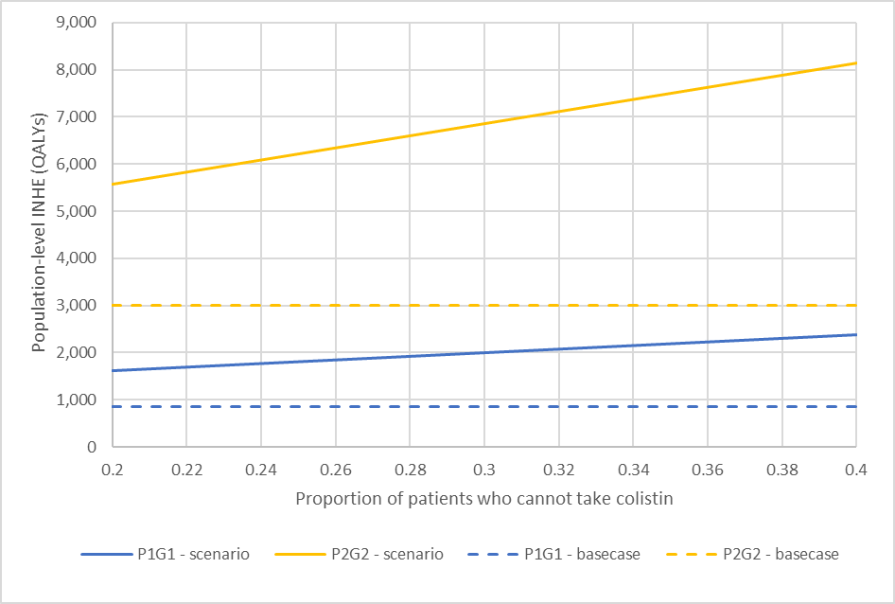
P1G1: baseline population (point estimate) based on PHE categorisation of infection sites, growth rate damped; P2G2: baseline population (point estimate) based on clinical advisors’ categorisation of infection sites, growth rate not damped.

Table 6 shows the breakdown of the population-level INHE for each pathogen and site of infection for a range of proportions of patients who cannot take colistin/aminoglycosides, compared to the EEPRU base-case. The change in INHE compared to the base-case is higher in the MDS (all cUTI and IAI, and HAP/VAP and BSI with Stenotrophomonas) than the ES (HAP/VAP and BSI with MBL Enterobacterales and MBL Pseudomonas aeruginosa) because the patient-level benefit of cefiderocol in patients who cannot take colistin is higher in the MDS than the ES (shown in Table 2).

Table 6. Total population-level INHE (QALYs) per site of infection¹
Pathogen |  | Site of infection | Proportion of susceptible patients who cannot take colistin/aminoglycosides
 |  |  | 0% (base-case)² | 20% | 40%
MBL Enterobacterales |  | HAP/VAP | 79 – 775 | 115 – 1,207 | 150 – 1,639
 |  | cUTI | 28 – 59 | 50 – 143 | 73 – 226
 |  | BSI | 448 – 764 | 677 – 1,198 | 906 – 1,632
 |  | IAI | 23 – 36 | 46 – 78 | 68 – 119
MBL Pseudomonas aeruginosa |  | HAP/VAP | 12 – 185 | 17 – 274 | 22 – 363
 |  | cUTI | 31 – 19 | 57 – 31 | 83 – 44
 |  | BSI | 28 – 28 | 45 – 45 | 61 – 61
 |  | IAI | 22 – 22 | 49 – 49 | 76 – 76
Stenotrophomonas |  | HAP/VAP | 48 – 925 | 191 – 2,003 | 334 – 3,081
 |  | cUTI | 57 – 64 | 148 – 207 | 246 - 349
 |  | BSI | 48 – 72 | 134 – 201 | 219 - 330
 |  | IAI | 32 – 46 | 89 – 131 | 145 - 217
Total |  |  | 856 – 2,995 | 1,616 – 5,566 | 2,383 – 8,138
Abbreviations: cUTI, complicated urinary tract infection; ca, colistin/aminoglycosides; HAP/VAP, hospital acquired pneumonia/ventilator associated pneumonia; INHE, incremental net health effects; QALYs, quality-adjusted life years.
P1G1: baseline population (point estimate) based on PHE categorisation of infection sites, growth rate damped; P2G2: baseline population (point estimate) based on clinical advisors’ categorisation of infection sites, growth rate not damped.
¹ Ranges represent mean INHE (QALYs) for the two most extreme scenarios regarding the population size and growth, P1G1 and P2G2 in the EEPRU report.
² In the base-case resistance to cefiderocol was assumed to increase by 1% over 20 years. This assumption was not applied in the new scenarios.

These expected population-level INHE may overestimate the total INHE for several reasons. Firstly, the 20%-40% proportion of patients who would not be given colistin/aminoglycosides because of toxicity fears in the absence of cefiderocol is high compared to the assessment of the clinical advisors consulted by EEPRU. Secondly, the scenario assumes that outcomes in patients who can and cannot take colistin/aminoglycosides are comparable, when, in practice, patients who cannot take colistin may have poorer prognoses than patients who can. Thirdly, the scenario assumes patients would be contraindicated to colistin and aminoglycosides, but clinical advisors to EEPRU (and consultation comments from the British Infection Association) suggested that most of the concern is about colistin.

Finally, the scenario results in Table 6 represent the benefit in HVCS when, in the ES, all patients with suspected infection are treated with colistin/aminoglycosides. In the EEPRU base-case, the empiric treatment of MBL Pseudomonas aeruginosa infections with non-colistin/glycoside therapy had a higher patient-level net benefit (and lower incremental benefit of cefiderocol) than treatment with colistin/glycosides, suggesting that, without cefiderocol, non-aminoglycosides are the preferred empiric treatment. The base-case results in the EEPRU report and in Table 6 reflect this lower incremental benefit of cefiderocol achieved when only non-colistin/aminoglycosides are used are first line empiric treatment.

The benefit of cefiderocol generated by patients who are susceptible to, but who cannot take, colistin/aminoglycosides in the ES is likely to be lower than the estimates in Table 6 if empiric treatment does not include colistin/aminoglycosides. This is because it would only apply to less than 1% of the total sample of patients in this setting (20% to 40% of the 1.8% (0.2 x 9%) who have the infection but are not susceptible to the empiric treatment with non-aminoglycosides). When MBL Pseudomonas aeruginosa infections are treated with non-colistin/aminoglycosides in the ES, the total net benefit of cefiderocol (derived using values in column 1 for rows 5 and 7, and columns 2 and 4 for all other rows in Table 6) was 1,594 – 5,461 QALYs if 20% of susceptible patients cannot take colistin/aminoglycosides, and 2,339 – 7,927 QALYs if that proportion is 40%.

